Name of journal: World Journal of Gastroenterology
Manuscript NO: 32302
Manuscript Type: ORIGINAL ARTICLE

Basic Study
Bone marrow-derived monocyte infusion improves hepatic fibrosis by decreasing osteopontin, TGF-β1, IL-13 and oxidative stress

de Souza VCA et al. Monocyte therapy improves hepatic fibrosis

Veruska Cintia Alexandrino de Souza, Thiago Almeida Pereira, Valéria Wanderley Teixeira, Helotonio Carvalho, Maria Carolina Accioly Brelaz de Castro, Carolline Guimarães D’assunção, Andréia Ferreira de Barros, Camila Lima Carvalho, Virgínia Maria Barros de Lorena, Vláudia Maria Assis Costa, Álvaro Aguiar Coelho Teixeira, Regina Celia Bressan Queiroz Figueiredo, Sheilla Andrade de Oliveira

Veruska Cintia Alexandrino de Souza, Camila Lima Carvalho, Virgínia Maria Barros de Lorena, Regina Celia Bressan Queiroz Figueiredo and Sheilla Andrade de Oliveira, Centro de Pesquisas Aggeu Magalhães, Fundação Oswaldo Cruz, Recife, Pernambuco 50740-465, Brazil

Thiago Almeida Pereira, Immunopathogenesis Section, Laboratory of Parasitic Diseases, National Institute of Allergy and Infectious Disease, National Institutes of Health, Bethesda, MD, USA and Laboratório de Doenças Parasitárias e infecciosas, Faculdade de Medicina, Universidade Federal de Minas Gerais, Belo Horizonte, Minas Gerais 31270-901, Brazil

Valéria Wanderley Teixeira, Carolline Guimarães D’assunção and Álvaro Aguiar Coelho Teixeira, Departamento de Morfologia e Fisiologia Animal, Universidade Federal Rural de Pernambuco, Recife, Pernambuco 50740-465, Brazil

Helotonio Carvalho, Departamento de Biofísica e Radiobiologia, Universidade Federal de Pernambuco, Recife, Pernambuco 50740-465, Brazil

Maria Carolina Accioly Brelaz de Castro, Centro Acadêmico de Vitória, Universidade federal de Pernambuco, Recife, Pernambuco 50740-465,Brazil

Vláudia Maria Assis Costa, Departamento de Medicina Tropical, Universidade Federal de Pernambuco, Recife 50740-465, Pernambuco, Brazil

Author contributions: Souza VCA performed the majority of experiments, analyzed the data and wrote the paper; Carvalho CL and Barros AF performed the immunologic investigations; D’Assunção CG participated in the treatment of animals; Pereira TA and Figueiredo RCBQ performed the immunohistochemistry assays; Carvalho H performed the biochemical investigations; Costa VMA, Lorena VMB and Castro MCAB performed the cellular isolation and characterization; Teixeira VW and Teixeira AAC performed the morphologic and morphometric investigations; Oliveira SA designed and coordinated the research.

Supported by the Oswaldo Cruz Foundation (FIOCRUZ); the Pernambuco Science and Technology Support Foundation (FACEPE); the National Council of Technological and Scientific Development (CNPq) (Processes APQ 0906-2.11/08); the National Council for the Improvement of Higher Education (CAPES); and the Intramural Research Program of the National Institutes of Health (LPD/NIAID/NIH).

Institutional animal care and use committee statement: All procedures involving animals were reviewed and approved by the Institutional Animal Care and Use Committee of the Aggeu Magalhães Research Center (protocol number 15/2011).

Conflict-of-interest statement: The authors disclose that they have no actual or potential conflicts of interest regarding this manuscript.

Data sharing statement: No additional data are available.

Open-Access: This article is an open-access article which was selected by an in-house editor and fully peer-reviewed by external reviewers. It is distributed in accordance with the Creative Commons Attribution Non Commercial (CC BY-NC 4.0) license, which permits others to distribute, remix, adapt, build upon this work non-commercially, and license their derivative works on different terms, provided the original work is properly cited and the use is non-commercial. See: http://creativecommons.org/licenses/by-nc/4.0/

Manuscript source: Unsolicited manuscript

Correspondence to: Sheilla Andrade de Oliveira, PhD, Departamento de Imunologia, Centro de Pesquisas Aggeu Magalhães, Fundação Oswaldo Cruz, Av. Professor Moraes Rego s/n, Cidade Universitária, Recife, Pernambuco 50740-465 , Brazil. sheilla@cpqam.fiocruz.br
Telephone: +55-81-21012581

Received: December 30, 2016
Peer-review started: January 4, 2017
First decision: February 9, 2017
Revised: February 22, 2017
Accepted: April 12, 2017
Article in press:
Published online:

Abstract
AIM
To evaluate the therapeutic effects of bone marrow-derived CD11b⁺ CD14⁺ monocytes in a murine model of chronic liver damage.

METHODS
Chronic liver damage was induced in C57BL/6 mice by administration of carbon tetrachloride and ethanol for six months. Bone marrow-derived monocytes isolated by immunomagnetic separation were used for therapy. The cell transplantation effects were evaluated by morphometry, biochemical assessment, immunohistochemistry and enzyme-linked immunosorbent assay.

RESULTS
CD11b⁺ CD14⁺ Monocyte therapy significantly reduced liver fibrosis and increased hepatic glutathione levels. Levels of proinflammatory cytokines, including tumor necrosis factor-α, interleukin (IL)-6 and IL-1β, in addition to pro-fibrotic factors, such as IL-13, transforming growth factor-β1 and tissue inhibitor of metalloproteinase-1 also decreased, while IL-10 and matrix metalloproteinase-9 increased in the monocyte-treated group. CD11b⁺ CD14⁺ Monocyte transplantation caused significant changes in the hepatic expression of α-smooth muscle actin and osteopontin.

CONCLUSION
The results show that monocyte therapy is capable of bringing about improvement of liver fibrosis by reducing oxidative stress and inflammation, as well as increasing anti-fibrogenic factors.

Key words: Monocytes; Bone marrow mononuclear cells; Cell therapy; Liver fibrosis; Macrophages; Glutathione

© The Author(s) 2017. Published by Baishideng Publishing Group Inc. All rights reserved.

Core tip: Chronic inflammation is now recognized as a central player in the development of liver fibrosis. Studies have shown that activated macrophages establish a link between chronic inflammation and fibrosis in various organs. The present study evaluated the therapeutic effects of bone marrow-derived CD11b⁺ CD14⁺ monocytes in a murine model of liver damage. The results show that mice with transplants showed improvement of liver fibrosis by way of a reduction in oxidative stress and inflammation and an increase in anti-fibrogenic factors. The study demonstrates the beneficial effects of cellular therapy in liver fibrosis and also reports on the important modulatory mechanisms involved.

de Souza VCA, Pereira TA, Teixeira VW, Carvalho H, de Castro MCAB, D’assunção CG, Barros AF, Carvalho CL, Lorena VMB, Costa VMA, Teixeira AAC, Figueiredo RCBQ, de Oliveira SA. Bone marrow-derived monocyte infusion improves hepatic fibrosis by decreasing osteopontin, TGF-β1, IL-13 and oxidative stress. World J Gastroenterol 2017; In press

INTRODUCTION
The abuse of alcohol, infections caused by hepatitis viruses B and C, and nonalcoholic steatohepatitis (NASH) are the main causes of liver tissue damage^{[1]}. These risk factors can lead to focal or diffuse hepatocellular degeneration and necrosis. Persistent inflammatory stimulus in the liver can induce the formation of fibrous tissue, and ultimately lead to the development of liver cirrhosis^{[2]}. Hepatic stellate cells (HSCs) play an important role in liver fibrogenesis because they are the main source of secreted extracellular matrix components (ECM)^{[3]}. When severe liver damage occurs, HSCs are activated, mainly by the action of transforming growth factor beta (TGF-β), tumor necrosis factor alpha (TNF-α) and reactive oxygen species (ROS), produced by damaged hepatocytes or liver-resident macrophages^{[4]}.
The ECM contain various types of proteins, including osteopontin (OPN)^{[5]}, a proinflammatory cytokine that modulates the pro-fibrogenic phenotype of HSCs and is involved in many physiological and pathological processes, including inflammation, fibrosis and angiogenesis^{[5,6]}. OPN has also been described as a mediator induced by the Hedgehog pathway (Hh) and plays an important role in the repair of acute and chronic liver damage, both in humans and experimental models^{[7,8]}.
The remodeling of fibrous tissue is a complex mechanism by which multiple cell types, producing molecules such as matrix metalloproteinases (MMPs) and tissue inhibitors of metalloproteinases (TIMPs), play an important role in the synthesis and degradation of the ECM^{[9]}. In chronic liver damage, the establishment of hepatic fibrosis is directly related to MMP/TIMP imbalance^{[10]}, thereby showing that MMPs and TIMPs may be potent therapeutic targets^{[11]}.
Although important advances in the knowledge of chronic liver diseases have been made, the existing treatments are still limited. New, more effective and less invasive therapeutic strategies are therefore needed. In this context, several studies of regenerative medicine have demonstrated the potential of cell therapy as a promising emerging treatment for liver diseases^{[12]} and various cell populations have been investigated to this end^{[12,13]}. Bone marrow mononuclear cells (BMMCs) have shown promising results in both experimental^{[14]} and clinical^{[15,16]} studies. Previous studies of experimental models of liver injury have demonstrated that cell therapy is able to decrease mortality^{[17]} and levels of hepatic fibrosis^{[14]}; improve biochemical parameters^{[18]}, increase MMP-9 expression^{[19]}; and reduce levels of TGF-β1^{[20]} and galectin-3 expression^{[14]}.
Identifying which components of the BMMC population are responsible for the beneficial effects of cell therapy is extremely important for clinical application. Recent studies have reported that monocytes may have important therapeutic potential in chronic liver diseases^{[21,22]}. These cells are the precursors of the heterogeneous macrophage population involved in liver repair responses. In the liver, macrophages perform various functions, such as phagocytosis and cytokine production, which are important in the inflammatory response to damage, liver fibrosis and degradation of ECM^{[23,24]}. In vitro assays have shown that monocytes maintained in culture supplemented with hepatocyte growth factor (HGF) exhibited similar behavior to those hepatic cells obtained from the liver culture^{[21]}. One preclinical study has shown that cellular therapy with cultured macrophages decreases murine liver fibrosis and this is followed by changes in the levels of some mediators involved in liver repair^{[22]}.
Although these findings are of great importance, information about the functions of monocyte/macrophage cell lineages in cell therapy for liver diseases is still limited. The present study evaluated the therapeutic potential of bone marrow-derived monocytes in a murine model of chronic liver damage induced by carbon tetrachloride (CCl₄) and ethanol (EtOH).

MATERIALS AND METHODS
Animals
Male C57BL/6 mice (4-6 wk of age), weighing 20-23 g were obtained from the Animal Breeding Center Laboratory (CECAL) Fundação Oswaldo Cruz (FIOCRUZ, Rio de Janeiro, Rio de Janeiro, Brazil), and housed in the animal research facility in the Aggeu Magalhães Research Center (CPqAM), (FIOCRUZ, Recife, Pernambuco, Brazil). The animal protocol was designed to minimize pain or discomfort to the animals, which were maintained in rooms with a controlled temperature (22 ± 2ºC) and humidity (55% ± 10%) environment under continuous air renovation conditions. Animals were housed in a 12-h light/12-h dark cycle and free access to food (Nuvilab, Curitiba, Paraná, Brazil) and water. Experimental procedures were in accordance with the ethical standards of the Oswaldo Cruz Foundation and approved by the Ethics Committee for the Certified Use of Animals (CEUA-CPqAM 15/2011).

Chronic liver damage and experimental design
Chronic liver damage in the mice was induced by orogastric administration of 200 µL of 20% carbon tetrachloride (CCl₄) solution diluted in olive oil in twice weekly doses^{[14]}. The mice also received a 5% ethanol solution in water ad libitum. CCl₄ treatment was carried out for six months. The mice were randomly divided into four experimental groups with chronic hepatic damage: Group I: Control mice (normal mice) (n = 5); Group II: Saline-treated mice (n = 5); Group III: Mice treated with BMMCs (n = 5); Group IV: Mice treated with BMMC-derived monocytes (n = 5).

Isolation of BMMCs and Monocytes
Bone marrow was harvested from the femurs and tibiae of donor C57BL/6 mice (n = 15) and BMMCs were purified by centrifugation in a Ficoll gradient (Histopaque 1119 and 1077, Sigma Aldrich, St Louis, MO, USA) at 1000 g, for 15 min. This protocol facilitates the rapid recovery of viable BMMCs using two ready-to-use separation mediums in conjunction. The BMMC preparation was used to isolate monocytes by way of the immunomagnetic cell separation system. For this, the BMMCs (approximately 10⁷ cells/mL) were incubated with anti-CD11b antibodies conjugated to magnetic microbeads (MACS units, Milteny Biotec™), washed and passed through a magnetic column (MACS, Milteny Biotec™), where CD11b⁺ monocytes were retained and recovered in a buffer (0.5% PBS/BSA 0.5% bovine serum albumin-BSA 2 mM EDTA+ 2 mM EDTA). Finally, the cells were washed and re-suspended in 0.9% sterile saline, which was later infused into the mice.

Cell characterization
The BMMCs and monocytes obtained by imunomagnetic separation were first incubated with Anti-CD11b (PE Rat Anti-Mouse CD11b, M1/70 clone, BD Pharmingen™), Anti-CD14 (FITC Rat Anti-Mouse CD14, rmC5-3 clone, BD Pharmingen™), Anti-CD45 (APC Rat Anti-Mouse CD45, 30-F11 clone, BD Pharmingen™), Anti- CD34 (PE Rat Anti-Mouse CD34, RAM34 clone, BD Pharmingen™) and Anti-Ly6A (FITC Rat Anti-Mouse Ly-6A/E, D& clone, BD Pharmingen™). After 30 minutes of incubation, cells were washed with 2mL of PBS wash (PBS 0.5% BSA 0.1% sodium azide), centrifuged at 400 × g for 5 min and then resuspended in 300µl of PBS wash. The samples were then phenotypically characterized by flow cytometry (FACS Calibur, BD Biosciences, San Jose, CA). A minimum of 10.000 events/sample were collected. The cell population obtained by immunomagnetic separation presented the following phenotype distribution: 99.12% CD11b⁺; 97.99% CD14⁺; 98.3% CD45⁺; 1.36% CD34⁺ and 1.81% Ly6A⁺ cells, differed from those of BMMC which were: 58.3% CD11b⁺; 47.76% CD14⁺; 79.4% CD45⁺; 3.6% CD34⁺ and 13.55% Ly6A⁺ cells, demonstrating an enrichment of homogeneous monocytes population in our cell preparation. Figure 1 shows representative FACS histograms of BMMCs and CD11b⁺ monocytes isolated by immunomagnetic separation.

Cell infusion in mice with chronic liver damage
Six months after treatment with CCl₄/ethanol, bone marrow-derived CD11b⁺ CD14⁺ monocytes and BMMCs were administered endovenously to the mice (10⁶ cells/animal) for three consecutive weeks. Two months after transplantation, mice were euthanized and the liver and the spleen were extracted for further analysis (Figure 2).

Morphometric evaluation
In order to characterize and quantify liver fibrosis, treated and non-treated samples were fixed for 24 h in 10% formalin, embedded in paraffin, sectioned (5 µm) and stained with picro-Sirius. The images were obtained using an optical microscope (DM LB 2, Leica Microsystems) equipped with LEICA JVC TK (model - C 1380, Pine Brook, NJ, USA) and analyzed using the Image Analysis Processing System LEICA QWIN, version 2.6 MC (Leica, Cambridge, UK). Ten microscopic fields (100 × magnification) containing fibrous tissue areas were chosen for quantification. To detect and quantify Kupffer cells, the histological sections were stained with haematoxylin and eosin (H&E) and observed under an optical microscope (DM LB 2, Leica Microsystems). The cell counts were performed in 10 fields/sections (400 × magnification).

Hydroxyproline assay
Liver samples (approximately 200 mg) were immersed in 6N HCl at approximately 120 ºC for 18 h followed by filtration. The hydroxyproline (Hyp) concentration was determined by a colorimetric assay at 558 nm as previously described^{[25]} and expressed as nMol/g liver.

Immunohistochemistry analysis
Immunohistochemistry was carried out to evaluate the activated HSCs (alpha-smooth muscle actin, α-SMA) and OPN. To stain α-SMA, liver sections (5 μm) were initially deparaffinized with xylene; dehydrated in increased concentration of ethanol; incubated overnight with biotinylated antibody anti-α-SMA (Santa Cruz Biotechnology, Santa Cruz, California, USA); and then incubated with streptavidin-peroxidase for 10 min. For OPN staining, the samples were incubated overnight with primary anti-OPN antibodies (AF808, R&D Systems, Minneapolis, MN, USA), as previously described^{[5]}. Thereafter, a secondary antibody bound to a synthetic polymer conjugate with peroxidase (HRP, horseradish peroxidase). 3,3'diaminobenzidine (DAB) was used for staining. The sections were counter-stained with Harris hematoxilin. The staining was measured in ten-fields/sections (200 × magnification) using an Image Analysis Processing System LEICA QWIN, version 2.6 MC (Leica Cambridge, Cambridge - UK).

GSH measurement
To evaluate oxidative stress, the amount of Glutathione (GSH) was quantified using liver fragments from mice submitted to the cell therapy and those that were not. The liver fragments were weighed, macerated in 5% metaphosphoric acid solution and centrifuged at 12000 g at 4 °C for 10 min. GSH was detected using the Glutathione Assay Kit (Sigma Aldrich, St Louis, MO, USA) and measured with a microplate reader (BioRad - 415 nm).

Enzyme-linked immunosorbent assay
Frozen liver fragments (~100 mg) were homogenized in a lysis buffer (50 mM Tris-HCl, 300 mM NaCl, 5 mM EDTA, 1% Triton X-100, 0.02% Sodium Azide) containing a protease inhibitor cocktail (Roche, Mannheim, Germany). The lysates were centrifuged at 16000 g for 15 min at 4 ºC and supernatants were used to quantify the levels of TNF-α, IL-6, IL-1β, IL-13, IL-10, IL-17, IL-23, TGF-β1, MMP-9 and TIMP-1 by way of a sandwich ELISA assay following the manufacturers’ instructions (IL-13, IL-17, IL-23, MMP-9 and TIMP-1: R&D Systems, Minneapolis, MN, USA; TGF-β1: Human/mouse TGF-beta1, e-Bioscience, San Diego, CA, USA; TNF-α, IL-1β, IL-6 and IL-10: BD OptEIA set mouse, San Diego, CA, USA). Samples were read at a 450 nm wavelength using a microplate reader (model 3550, Thermo Scientific). The concentration of TGF-β1 was also determined from supernatants of splenocyte culture obtained from mice used in the study, as previously described^{[26]}. The cytokine concentration was expressed in pg/mL.

Statistical analysis
Quantitative data were submitted to the normality test (Shapiro-Wilk). Differences were evaluated using the ANOVA test, for parametric analysis, and the Kruskal-Wallis test, with post-hoc Dunn, for non-parametric analysis. Statistical analyses were performed using Prism Software (version 5.0, GraphPad Software, San Diego, CA, USA) and Bioestat 5.3 (Mamirauá Institute, Manaus, AM, Brazil). A P value of < 0.05 was considered statistically significant. Data were expressed as mean values (mean ± SEM).

RESULTS
Monocyte therapy alters hepatic fibrosis
Morphometric analysis, two months after therapy, showed a significant decrease in fibrotic areas in the liver from CD11b⁺ CD14⁺ in the monocytes-treated group compared to the saline-treated group (P < 0.001; Figures 3B, 3D and 3E). This decrease was also found in mice treated with BMMCs (P < 0.05; Figures 3B, 3C and 3E). A marked reduction in the amount of hydroxyproline was also observed in the group that received monocyte treatment (P < 0.01; Figure 3F). The number of Kupffer cells significantly increased in the monocyte-treated (P < 0.001) and BMMC-treated (P < 0.01) groups, when compared to the saline-treated group (Figure 3G).
To test whether CD11b⁺ CD14⁺ monocyte transplantation was able to alter the number of activated HSCs, α-SMA positive cells were assessed by immunohistochemistry. As shown in Figure 4, α-SMA-positive cells in the hepatic parenchyma decreased in the mice that received monocytes (P < 0.01, Figures 4D-E) as well as in the BMMC-treated group (P < 0.05, Figures 4C-E) compared with the group treated with saline (Figures 4B-E). Furthermore, OPN also decreased after CD11b⁺ CD14⁺ monocyte therapy (Figure 5).

Monocyte transplantation reduces hepatic inflammatory and pro-fibrotic cytokine levels
To investigate the mechanisms involved in the improvement of hepatic fibrosis after CD11b⁺ CD14⁺ monocyte therapy, the levels of hepatic inflammatory and pro-fibrotic cytokine were quantified. The levels of TNF-α, IL-1β and IL-6 in liver lysates were significantly lower in the CD11b⁺ CD14⁺ monocytes -treated group (P < 0.05, Figure 6A-C). IL-13 (Figure 6D) and TGF-β1 (Figure 7A), important fibrogenic mediators, were significantly lower compared than in mice treated with saline (P < 0.05). In the supernatant splenocyte culture obtained from the monocyte- and BMMC-treated groups there was a significant decrease in TGF-β1 compared with the saline-treated mice (P < 0.0, Figure 7B). IL-17 cytokine levels were also lower in animals undergoing cell transplantation (P < 0.01, Figure 7C). A trend was also observed for decreased IL-23 cytokine levels (Figure 7D).
Monocyte therapy altered MMP-9, TIMP-1 and IL-10 hepatic levels
The levels of MMP-9 and TIMP-1, two relevant factors associated with liver fibrosis, were evaluated. A significant increase in the production of MMP-9 was found in animal treated with CD11b⁺ CD14⁺ monocytes and BMMC (P < 0.05, Figure 8A). Interestingly, TIMP-1 levels were significantly lower in CD11b⁺ CD14⁺ monocyte-treated mice (P < 0.05; Figure 8B). The monocyte-treated group also showed significantly increased levels of IL-10 in comparison with the saline-treated group (P < 0.05, Figure 8C).

Monocyte therapy increases GSH levels
GSH levels were determined to evaluate the influence of CD11b⁺ CD14⁺ monocyte therapy on oxidative stress. Monocyte-treated mice with chronic liver damage had significantly higher levels of this antioxidant molecule than the saline-treated group (P < 0.05, Figure 8D).

DISCUSSION
The present study corroborates the importance of monocytes/macrophages in liver repair. These may act to regulate some significant fibrogenic pathways, in a murine model of chronic liver damage. Monocytes/Macrophages are cells with great plasticity and, depending on the tissue microenvironment, may be caused to adopt a profile that contributes to resolution/regression of experimental hepatic fibrosis^{[24]}.
The results of the present study demonstrate that transplantation of BMMC-derived CD11b⁺ CD14⁺ monocytes had beneficial effects on liver lesions, thereby causing a significant reduction in fibrosis, mainly by regulating important cytokines involved in the liver repair process. Previous work carried out by our group has already shown a decrease in collagen levels in a liver undergoing BMMC therapy^{[14]}. However, the results obtained in the present study demonstrated an improvement in these parameters on BMMC-derived CD11b⁺ CD14⁺ monocyte infusion, with an almost twofold decrease in the collagen levels using the same experimental model.
Macrophages, important mediators of inflammatory responses, have a dichotomous response when activated, assuming a classical (M1) or alternative (M2) pathways phenotype depending on the environmental stimulus^{[27]}. The increase in the number of hepatic resident macrophages (Kupffer cells) after cell therapy observed in our study suggests that the subsets of restorative macrophages are involved in the tissue repair by inhibiting the production of proinflammatory cytokines (TNF-α, IL-1β and IL-6)^{[28]}. Previous studies have reported the role of macrophages in mediating liver fibrogenesis, and have proposed using macrophage subpopulations during liver damage and repair^{[23,29]}. Treatment carried out in experimental models have shown that the infusion of bone marrow-derived macrophages decreases fibrous tissue, and enhances hepatic regeneration^{[22,30,31]}.
The decrease in fibrous liver tissue observed in the present study may be associated with the lower number of activated HSCs found. The pro-fibrogenic role of this cell type has been already reported in the literature, indicating a direct relationship between murine liver fibrosis and the rise in the number of activated HSCs^{[3,4]}. In this regard, some studies have reported a decrease in the number of α-SMA⁺ cells in murine models of liver damage treated with BMCs. This decrease is probably due to an alteration in the modulation of HSCs by specific cytokines and growth factors, including TGF-β1, TNF-α, and also ROS, produced by hepatocytes in a damaged liver^{[32]}. As activation of HSCs mediated by autocrine and paracrine signaling and these cells not only secrete cytokines, but also respond to them^{[32]}, it was hypothesized that BMMC-derived CD11b⁺ CD14⁺ monocytes modulate the activity of HSCs by regulating the secretion of cytokines and growth factors.
The production of the proinflammatory cytokine profiles of TNF-α, IL-1β and IL-6 were inhibited in mice submitted to liver damage and treated with CD11b⁺ CD14⁺ monocytes. Furthermore, there was an increase in the synthesis of IL-10 cytokine, which is known for its Th2 profile and anti-inflammatory activity^{[33]}. These results show the influence of CD11b⁺ CD14⁺ monocyte infusion in the hepatic production of inflammation and fibrogenesis mediators. The modulation of inflammation during liver repair processes by way of increased expression of IL-10 and inhibition of the production of TNF-α, IL-1β and IL-6 is well described in the literature^{[34]}. Because of their role in activating and proliferating HSCs, these cytokines have been implicated in the pathogenesis of chronic liver inflammation, mainly by increasing the production of collagen and regulating MMPs and TIMPs in liver damage^{[35,36]}. Gene therapy studies have shown that the overexpression of IL-10 reduces the expression of pro-fibrotic molecules such as TGF-β1 and TNF-α^{[36]}, thereby downregulating the inflammatory response and reducing activated HSCs, which ultimately leads to the reestablishment of liver function^{[35,36]}.
The present study found a significant decrease in TGF-β1 levels in both the extracts of liver protein and the supernatant of cultured splenocytes. These results corroborate other findings of the study, thereby indicating that transplanted monocytes play an important anti-fibrogenic role. TGF-β1 is a growth factor which plays a crucial role in initiating and maintaining liver fibrogenesis^{[4]}. This factor is directly involved in activating HSCs and synthesizing ECM components, mostly in type I collagen^{[4]}. It also plays an important role in inhibiting the degradation of ECM, stimulating the decrease of MMP synthesis and increasing the production of TIMPs, which leads to excessive deposition of collagen and the establishment of hepatic fibrosis^{[2]}. Previous studies have associated the improvement of experimental liver fibrosis after BMMC-treatment with the reduction in TGF-β1 levels^{[20,22]}. The results of the present study suggest that monocyte therapy acts through this fibrogenic pathway, thereby contributing to reducing liver fibrosis in mice.
The present investigation showed that cell transplantation caused a significant decrease in IL-17 levels, an effector proinflammatory cytokine, produced by CD4⁺ T-cell^{[37]}. This mediator induces the recruitment of inflammatory into liver cells and also directly activates natural hepatic immunity systems, such as neutrophils and dendritic cells, to release cytokines that perpetuate chronic inflammation^{[389]}. Previous reports have reported that helper (Th) 17 T cells are able to participate in the pathogenesis of hepatic lesions associated with HBV^{[39]}. Recently, emerging evidence has indicated that IL- 17 may be implicated in the induction of liver fibrosis, contributing to the activation of HSCs in vitro^{[39]}.
OPN is a glycoprotein expressed in a variety of tissues, mainly found in MEC and the sites of healing wounds^{[40]}. Studies have shown that this protein is highly expressed in fibrotic liver tissue and influences the function of hepatic progenitors^{[41]}. Under this condition, increases in the level of TGF-β and activation of HSCs could be also observed^{[6,41]}. It thus seems reasonable to suppose that deactivation of OPN could lead to attenuation of liver fibrosis^{[1,8]}. The results of the present study accordingly showed a significant decrease in the production of OPN and in the number of activated HSCs
GSH is an important antioxidant molecule that acts as a modulator of redox signaling, cell proliferation, apoptosis, immune responses and fibrogenesis^{[42,43]}. Reduced levels of this molecule have been found in preclinical fibrosis models and in human fibrotic diseases^{[42]}. A previous study has shown that higher GSH production inhibits the fibrogenic activity of TGF-β1^{[43]}. The present study also found an increase in this molecule after CD11b⁺ CD14⁺ monocyte transplantation, suggesting an association between the anti-fibrotic effects observed in the monocyte-treated group and increased antioxidant activity of this cell population.
Alterations in the quantities of some molecules involved in fibrogenesis, as well as fibrous tissue remodeling, were assayed in this study. The CD11b⁺ CD14⁺ monocyte therapy in mice with chronic liver damage caused an increase in MMP-9 hepatic levels. Previous studies have associated reduced liver fibrosis with fibrous tissue degradation^{[3]}. MMP-9 plays an important role in resolving liver fibrosis and has been considered a potent therapeutic target^{[11]}. Yang et al^{[44]} suggest that, in the hepatic microenvironment, macrophage subpopulations play an anti-fibrotic role, as they express several MMPs, including MMP-9, which are directly involved in degrading ECM, facilitating the resolution of hepatic fibrosis.
CD11b⁺ CD14⁺ monocyte transplantation gave rise to a reduction in hepatic TIMP-1 and IL-13, two important pro-fibrogenic mediators. TIMPs are involved in the regulation of fibrogenic response by inhibiting the enzymatic activity of MMPs, having an anti-apoptotic effect on HSCs^{[9]}. The presence of high quantities of these inhibitors in chronically damaged hepatic tissue may contribute to the establishment of liver fibrosis^{[45]}. IL-13 is a cytokine associated with severe forms of schistosomal liver fibrosis as well as non-schistosomiasis liver diseases^{[46]}. IL-13 is considered one of the central mediators in liver pathogenesis and is involved in TGF-β1 production by liver cells, besides inducing progenitor cells to transdifferentiate into myofibroblasts, which produce collagen^{[47]}. The data produced by the present study corroborates the protective role of monocytes/macrophages in tissue repair processes, by way of fibrogenic pathways.
Several studies have attempted to identify and to correlate different macrophage profiles to tissue repair processes^{[29,30,48]}. Ramachandran et al^{[29]} found that Ly6C^{low} macrophages secrete large amounts of fibrolytic MMPs such as MMP-9 and MMP-13, as well as IL-10. Therefore the increase in secretion of MMP-9 and IL-10 observed in this study suggests a downregulation of the activation pathways that lead to the chronic inflammatory response.
In conclusion, the present study shows the important contribution of bone marrow-derived monocyte/macrophage cell therapy to improving the state of liver fibrosis in a murine model of chronic liver damage. These cells act to modulate inflammation and fibrogenesis and regulate the oxidative stress caused by damaged tissue. Further studies should be conducted to establish a promising therapeutic tool for treating chronic liver diseases.

ACKNOWLEDGMENTS
The authors would like to thank Mr Roni E. Araujo for the preparation of histological sections and the animal facility of the Oswaldo Cruz Foundation (Rio de Janeiro, Brazil) and Aggeu Magalhães Research Center, Oswaldo Cruz Foundation, in Recife, Brazil.

COMMENTS
Background
Chronic liver disease is characterized by alterations in the process of tissue repair, such as the excessive deposition of fibrous tissue and the inhibition of the dynamics of regeneration. The knowledge on bone marrow cell therapy has opened new perspectives towards treatment of hepatic diseases. However, the cell types are involved in liver recovery has not been fully elucidated. Monocytes have emerged as one set of potential candidates due to their plasticity and involvement in inflammation and tissue repair.
Research frontiers
Previous experiments have already showed that bone marrow cells transplantation promotes improvement in experimental model of liver fibrosis. Monocyte/macrophage lineage may have important therapeutic potential in chronic liver diseases.

Innovations and breakthroughs
This is an innovative study that evaluated the effects of monocyte transplantation isolated from bone marrow mononuclear cells, by morphological, biochemical and immunological assays.

Applications
Experimental hepatic fibrosis improvement after cell therapy reinforces the potential involvement of monocytes/macrophages in liver repair, being able to acquire pro-resolute profile, acting in the regulation of some relevant inflammatory and fibrogenic pathways.

Terminology
Bone marrow mononuclear cells (BMMCs) used to collectively denominate bone marrow cells whose nuclei are unilobulated and which lack granules in the cytoplasm. This cell population includes hematopoietic progenitor cells, lymphoid cells (lymphocytes, plasma cells) and monocytes.

Peer-review
The authors addressed an interesting, clinically relevant and important issue aiming to modify the state of chronic liver disease. To approach this goal the authors purified bone-marrow derived CD11bhigh monocytes, which were transfused to mice prior the administration of the provoking agents, i.e., ethanol and CCl4. Using a C57BL/6 mice model system they showed that the transfusion of monocytes was more effective to decrease IL-13 levels in the liver as compared to the infusion of BMMCs. The authors also demonstrated that monocyte transfusion could reduce the size of the fibrotic area, the amount of hydroxyproline and the concentration of pro-inflammatory cytokines, while the levels of IL-10 cytokine and the number of Kupffer cells in the liver were increased as compared to saline transfusion. Due to the limited information of cell based therapies in chronic inflammatory diseases, the identification of immunostimulatory and regulatory pathways in a preclinical setting and in the context of liver metabolism is of high importance.

REFERENCES
1 Wang P, Koyama Y, Liu X, Xu J, Ma HY, Liang S, Kim IH, Brenner DA, Kisseleva T. Promising Therapy Candidates for Liver Fibrosis. Front Physiol 2016; 7: 47 [PMID: 26909046 DOI: 10.3389/fphys.2016.00047]
2 Zhou WC, Zhang QB, Qiao L. Pathogenesis of liver cirrhosis. World J Gastroenterol 2014; 20: 7312-7324 [PMID: 24966602 DOI: 10.3748/wjg.v20.i23.7312]
3 Troeger JS, Mederacke I, Gwak GY, Dapito DH, Mu X, Hsu CC, Pradere JP, Friedman RA, Schwabe RF. Deactivation of hepatic stellate cells during liver fibrosis resolution in mice. Gastroenterology 2012; 143: 1073-83.e22 [PMID: 22750464 DOI: 10.1053/j.gastro.2012.06.036]
4 Jiang JX, Török NJ. Liver Injury and the Activation of the Hepatic Myofibroblasts. Curr Pathobiol Rep 2013; 1: 215-223 [PMID: 23977452 DOI: 10.1007/s40139-013-0019-6]
5 Pereira TA, Syn WK, Machado MV, Vidigal PV, Resende V, Voieta I, Xie G, Otoni A, Souza MM, Santos ET, Chan IS, Trindade GV, Choi SS, Witek RP, Pereira FE, Secor WE, Andrade ZA, Lambertucci JR, Diehl AM. Schistosome-induced cholangiocyte proliferation and osteopontin secretion correlate with fibrosis and portal hypertension in human and murine schistosomiasis mansoni. Clin Sci (Lond) 2015; 129: 875-883 [PMID: 26201095 DOI: 10.1042/CS20150117]
6 Seth D, Duly A, Kuo PC, McCaughan GW, Haber PS. Osteopontin is an important mediator of alcoholic liver disease via hepatic stellate cell activation. World J Gastroenterol 2014; 20: 13088-13104 [PMID: 25278703 DOI: 10.3748/wjg.v20.i36.13088]
7 Pritchett J, Harvey E, Athwal V, Berry A, Rowe C, Oakley F, Moles A, Mann DA, Bobola N, Sharrocks AD, Thomson BJ, Zaitoun AM, Irving WL, Guha IN, Hanley NA, Hanley KP. Osteopontin is a novel downstream target of SOX9 with diagnostic implications for progression of liver fibrosis in humans. Hepatology 2012; 56: 1108-1116 [PMID: 22488688 DOI: 10.1002/hep.25758]
8 Coombes JD, Choi SS, Swiderska-Syn M, Manka P, Reid DT, Palma E, Briones-Orta MA, Xie G, Younis R, Kitamura N, Della Peruta M, Bitencourt S, Dollé L, Oo YH, Mi Z, Kuo PC, Williams R, Chokshi S, Canbay A, Claridge LC, Eksteen B, Diehl AM, Syn WK. Osteopontin is a proximal effector of leptin-mediated non-alcoholic steatohepatitis (NASH) fibrosis. Biochim Biophys Acta 2016; 1862: 135-144 [PMID: 26529285 DOI: 10.1016/j.bbadis.2015.10.028]
9 Gao B, Bataller R. Alcoholic liver disease: pathogenesis and new therapeutic targets. Gastroenterology 2011; 141: 1572-1585 [PMID: 21920463 DOI: 10.1053/j.gastro.2011.09.002]
10 Das SK, Vasudevan DM. Genesis of hepatic fibrosis and its biochemical markers. Scand J Clin Lab Invest 2008; 68: 260-269 [PMID: 18609066 DOI: 10.1080/00365510701668516]
11 Pham Van T, Couchie D, Martin-Garcia N, Laperche Y, Zafrani ES, Mavier P. Expression of matrix metalloproteinase-2 and -9 and of tissue inhibitor of matrix metalloproteinase-1 in liver regeneration from oval cells in rat. Matrix Biol 2008; 27: 674-681 [PMID: 18678246 DOI: 10r.1016/j.matbio.2008.07.002]
12 Yarygin KN, Lupatov AY, Kholodenko IV. Cell-based therapies of liver diseases: age-related challenges. Clin Interv Aging 2015; 10: 1909-1924 [PMID: 26664104 DOI: 10.2147/CIA.S97926]
13 Chistiakov DA. Liver regenerative medicine: advances and challenges. Cells Tissues Organs 2012; 196: 291-312 [PMID: 22572238 DOI: 10.1159/000335697]
14 de Oliveira SA, de Freitas Souza BS, Sá Barreto EP, Kaneto CM, Neto HA, Azevedo CM, Guimarães ET, de Freitas LA, Ribeiro-Dos-Santos R, Soares MB. Reduction of galectin-3 expression and liver fibrosis after cell therapy in a mouse model of cirrhosis. Cytotherapy 2012; 14: 339-349 [PMID: 22149185 DOI: 10.3109/14653249.2011.637668]
15 Lyra AC, Soares MB, da Silva LF, Braga EL, Oliveira SA, Fortes MF, Silva AG, Brustolim D, Genser B, Dos Santos RR, Lyra LG.. Infusion of autologous bone marrow mononuclear cells through hepatic artery results in a short-term improvement of liver function in patients with chronic liver disease: A pilot randomized controlled study. Eur J Gastroenterol Hepatol 2010; 22 Suppl 1: 33-42 [DOI: 10.1097/MEG.0b013e32832eb69a]
16 Bai YQ, Yang YX, Yang YG, Ding SZ, Jin FL, Cao MB, Zhang YR, Zhang BY. Outcomes of autologous bone marrow mononuclear cell transplantation in decompensated liver cirrhosis. World J Gastroenterol 2014; 20: 8660-8666 [PMID: 25024623 DOI: 10.3748/wjg.v20.i26.8660]
17 de Freitas Souza BS, Nascimento RC, de Oliveira SA, Vasconcelos JF, Kaneto CM, de Carvalho LF, Ribeiro-Dos-Santos R, Soares MB, de Freitas LA. Transplantation of bone marrow cells decreases tumor necrosis factor-α production and blood-brain barrier permeability and improves survival in a mouse model of acetaminophen-induced acute liver disease. Cytotherapy 2012; 14: 1011-1021 [PMID: 22809224 DOI: 10.3109/14653249.2012.684445]
18 Ali G, Masoud MS. Bone marrow cells ameliorate liver fibrosis and express albumin after transplantation in CCl₄-induced fibrotic liver. Saudi J Gastroenterol 2012; 18: 263-267 [PMID: 22824770 DOI: 10.4103/1319-3767.98433]
19 Roderfeld M, Rath T, Pasupuleti S, Zimmermann M, Neumann C, Churin Y, Dierkes C, Voswinckel R, Barth PJ, Zahner D, Graf J, Roeb E. Bone marrow transplantation improves hepatic fibrosis in Abcb4-/- mice via Th1 response and matrix metalloproteinase activity. Gut 2012; 61: 907-916 [PMID: 21868490 DOI: 10.1136/gutjnl-2011-300608]
20 Oliveira SA, Souza BS, Guimaraes-Ferreira CA, Barreto ES, Souza SC, Freitas LA, Ribeiro-Dos-Santos R, Soares MB. Therapy with bone marrow cells reduces liver alterations in mice chronically infected by Schistosoma mansoni. World J Gastroenterol 2008; 14: 5842-5850 [PMID: 18855983 DOI: 10.3748/wjg.14.5842]
21 Yan L, Han Y, Wang J, Liu J, Hong L, Fan D. Peripheral blood monocytes from patients with HBV related decompensated liver cirrhosis can differentiate into functional hepatocytes. Am J Hematol 2007; 82: 949-954 [PMID: 17724706 DOI: 10.1002/ajh.21030]
22 Thomas JA, Pope C, Wojtacha D, Robson AJ, Gordon-Walker TT, Hartland S, Ramachandran P, Van Deemter M, Hume DA, Iredale JP, Forbes SJ. Macrophage therapy for murine liver fibrosis recruits host effector cells improving fibrosis, regeneration and function. Hepatology 2011; 53 Suppl 6: 2003-2015 [DOI: 10.1002/hep.24315]
23 Duffield JS, Forbes SJ, Constandinou CM, Clay S, Partolina M, Vuthoori S, Wu S, Lang R, Iredale JP. Selective depletion of macrophages reveals distinct, opposing roles during liver injury and repair. J Clin Invest 2005; 115: 56-65 [PMID: 15630444 DOI: 10.1172/JCI200522675]
24 Wynn TA, Vannella KM. Macrophages in Tissue Repair, Regeneration, and Fibrosis. Immunity 2016; 44: 450-462 [PMID: 26982353 DOI: 10.1016/j.immuni.2016.02.015]
25 Bergman I, Loxley R. Two improved and simplified methods for the spectrophometric determination of hydroxyproline. Ann Chem 1963; 35: 1961-1965
26 Barros AF, Oliveira SA, Carvalho CL, Silva FL, Souza VC, Silva AL, Araujo RE, Souza BS, Soares MB, Costa VM, Coutinho Ede M. Low transformation growth factor-β1 production and collagen synthesis correlate with the lack of hepatic periportal fibrosis development in undernourished mice infected with Schistosoma mansoni. Mem Inst Oswaldo Cruz 2014; 109: 210-219 [PMID: 24676664 DOI: 10.1590/0074-0276140266]
27 Mahbub S, Deburghgraeve CR, Kovacs EJ. Advanced age impairs macrophage polarization. J Interferon Cytokine Res 2012; 32: 18-26 [PMID: 22175541 DOI: 10.1089/jir.2011.0058]
28 Ju C, Tacke F. Hepatic macrophages in homeostasis and liver diseases: from pathogenesis to novel therapeutic strategies. Cell Mol Immunol 2016; 13: 316-327 [PMID: 26908374 DOI: 10.1038/cmi.2015.104]
29 Ramachandran P, Pellicoro A, Vernon MA, Boulter L, Aucott RL, Ali A, Hartland SN, Snowdon VK, Cappon A, Gordon-Walker TT, Williams MJ, Dunbar DR, Manning JR, van Rooijen N, Fallowfield JA, Forbes SJ, Iredale JP. Differential Ly-6C expression identifies the recruited macrophage phenotype, which orchestrates the regression of murine liver fibrosis. Proc Natl Acad Sci U S A 2012; 109: E3186-E3195 [PMID: 23100531 DOI: 10.1073/pnas.1119964109]
30 Suh YG, Kim JK, Byun JS, Yi HS, Lee YS, Eun HS, Kim SY, Han KH, Lee KS, Duester G, Friedman SL, Jeong WI. CD11b(+) Gr1(+) bone marrow cells ameliorate liver fibrosis by producing interleukin-10 in mice. Hepatology 2012; 56: 1902-1912 [PMID: 22544759 DOI: 10.1002/hep.25817]
31 Moore JK, Mackinnon AC, Wojtacha D, Pope C, Fraser AR, Burgoyne P, Bailey L, Pass C, Atkinson A, Mcgowan NW, Manson L, Turner ML, Campbell JD, Forbes SJ. Phenotypic and functional characterization of macrophages with therapeutic potential generated from human cirrhotic monocytes in a cohort study. Cytotherapy 2015; 17: 1604-1616 [PMID: 26342993 DOI: 10.1016/j.jcyt.2015.07.016]
32 Jang YO, Jun BG, Baik SK, Kim MY, Kwon SO. Inhibition of hepatic stellate cells by bone marrow-derived mesenchymal stem cells in hepatic fibrosis. Clin Mol Hepatol 2015; 21: 141-149 [PMID: 26157751 DOI: 10.3350/cmh.2015.21.2.141]
33 Yao L, Xing S, Fu X, Song H, Wang Z, Tang J, Zhao Y. Association between interleukin-10 gene promoter polymorphisms and susceptibility to liver cirrhosis. Int J Clin Exp Pathol 2015; 8: 11680-11684 [PMID: 26617910]
34 Ma HC, Wang X, Wu MN, Zhao X, Yuan XW, Shi XL. Interleukin-10 Contributes to Therapeutic Effect of Mesenchymal Stem Cells for Acute Liver Failure via Signal Transducer and Activator of Transcription 3 Signaling Pathway. Chin Med J (Engl) 2016; 129: 967-975 [PMID: 27064043 DOI: 10.4103/0366-6999.179794]
35 Robert S, Gicquel T, Bodin A, Lagente V, Boichot E. Characterization of the MMP/TIMP Imbalance and Collagen Production Induced by IL-1β or TNF-α Release from Human Hepatic Stellate Cells. PLoS One 2016; 11: e0153118 [PMID: 27046197 DOI: 10.1371/journal.pone.0153118]
36 Hung KS, Lee TH, Chou WY, Wu CL, Cho CL, Lu CN, Jawan B, Wang CH. Interleukin-10 gene therapy reverses thioacetamide-induced liver fibrosis in mice. Biochem Biophys Res Commun 2005; 336: 324-331 [PMID: 16126171 DOI: 10.1016/j.bbrc.2005.08.085]
37 Weaver CT, Hatton RD, Mangan PR, Harrington LE. IL-17 family cytokines and the expanding diversity of effector T cell lineages. Annu Rev Immunol 2007; 25: 821-852 [PMID: 17201677 DOI: 10.1146/annurev.immunol.25.022106.141557}.]
38 Yasumi Y, Takikawa Y, Endo R, Suzuki K. Interleukin-17 as a new marker of severity of acute hepatic injury. Hepatol Res 2007; 37: 248-254 [PMID: 17397512 DOI: 10.1111/j.1872-034X.2007.00040.x]
39 Wang L, Chen S, Xu K. IL-17 expression is correlated with hepatitis B-related liver diseases and fibrosis. Int J Mol Med 2011; 27: 385-392 [PMID: 21225222 DOI: 10.3892/ijmm.2011.594]
40 Subraman V, Thiyagarajan M, Malathi N, Rajan ST. OPN -Revisited. J Clin Diagn Res 2015; 9: ZE10-ZE13 [PMID: 26266236 DOI: 10.7860/JCDR/2015/12872.6111]
41 Lancha A, Rodríguez A, Catalán V, Becerril S, Sáinz N, Ramírez B, Burrell MA, Salvador J, Frühbeck G, Gómez-Ambrosi J. Osteopontin deletion prevents the development of obesity and hepatic steatosis via impaired adipose tissue matrix remodeling and reduced inflammation and fibrosis in adipose tissue and liver in mice. PLoS One 2014; 9: e98398 [PMID: 24871103 DOI: 10.1371/journal.pone.0098398]
42 Liu RM, Gaston Pravia KA. Oxidative stress and glutathione in TGF-beta-mediated fibrogenesis. Free Radic Biol Med 2010; 48: 1-15 [PMID: 19800967 DOI: 10.1016/j.freeradbiomed.2009.09.026]
43 Lu SC. Glutathione synthesis. Biochim Biophys Acta 2013; 1830: 3143-3153 [PMID: 22995213 DOI: 10.1016/j.bbagen.2012.09.008]
44 Yang L, Kwon J, Popov Y, Gajdos GB, Ordog T, Brekken RA, Mukhopadhyay D, Schuppan D, Bi Y, Simonetto D, Shah VH. Vascular endothelial growth factor promotes fibrosis resolution and repair in mice. Gastroenterology 2014; 146: 1339-50.e1 [PMID: 24503129 DOI: 10.1053/j.gastro.2014.01.061]
45 Elpek GÖ. Cellular and molecular mechanisms in the pathogenesis of liver fibrosis: An update. World J Gastroenterol 2014; 20: 7260-7276 [PMID: 24966597 DOI: 10.3748/wjg.v20.i23.7260]
46 Liu Y, Munker S, Müllenbach R, Weng HL. IL-13 Signaling in Liver Fibrogenesis. Front Immunol 2012; 3: 116 [PMID: 22593760 DOI: 10.3389/fimmu.2012.00116]
47 Pellicoro A, Ramachandran P, Iredale JP, Fallowfield JA. Liver fibrosis and repair: immune regulation of wound healing in a solid organ. Nat Rev Immunol 2014; 14: 181-194 [PMID: 24566915 DOI: 10.1038/nri3623]
48 Tacke F, Zimmermann HW. Macrophage heterogeneity in liver injury and fibrosis. J Hepatol 2014; 60: 1090-1096 [PMID: 24412603 DOI: 10.1016/j.jhep.2013.12.025]
P-Reviewer: Huber R, Rajnavolgyi E S-Editor: Yu J L-Editor: E-Editor:
Specialty type: Gastroenterology and hepatology
Country of origin: Brazil
Peer-review report classification
Grade A (Excellent): 0
Grade B (Very good): B
Grade C (Good): C
Grade D (Fair): 0
Grade E (Poor): 0

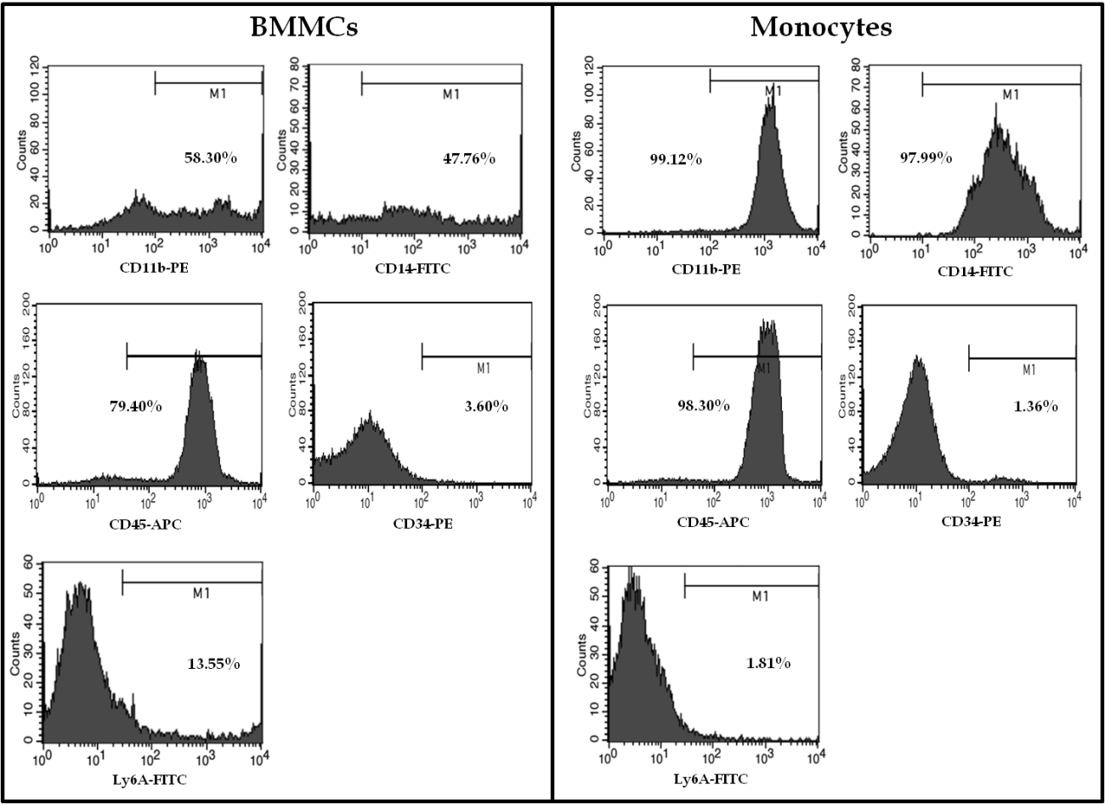

Figure 1 Representative FACS histograms of BMMCs and CD11b⁺ monocytes isolated by immunomagnetic separation.

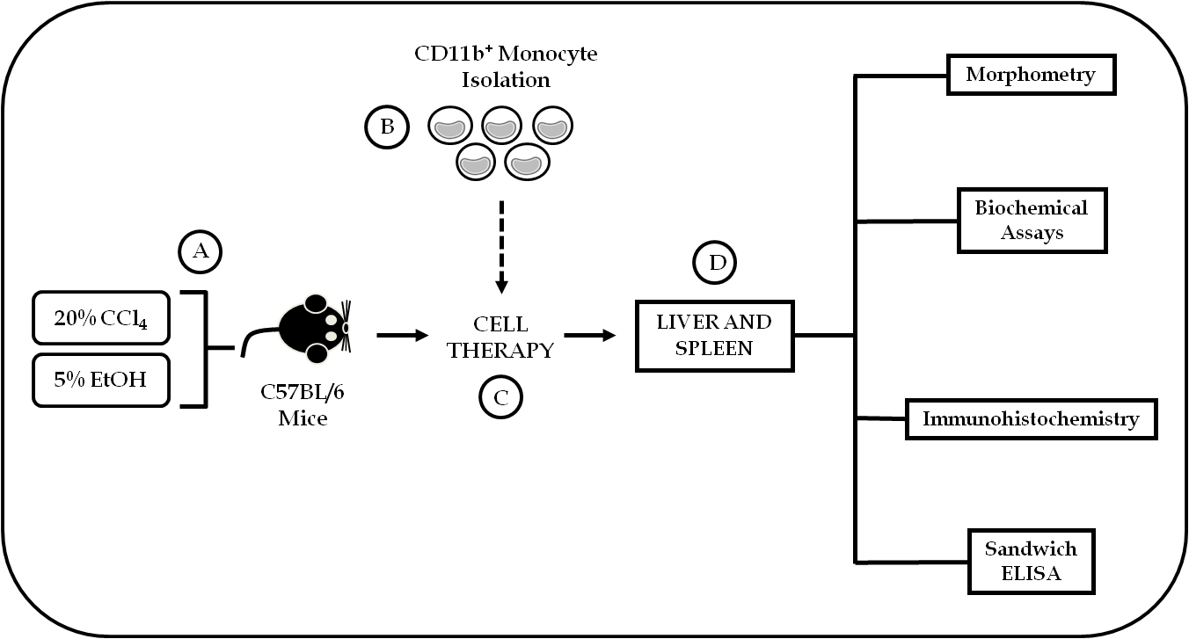
Figure 2 Schematic flowchart of experimental design. A: Male C57BL/6 mice underwent chronic administration of CCl₄ and EtOH solutions for 6 mo; B: BMMCs were harvested from C57BL/6 donor mice for CD11b⁺ monocyte isolation using immunomagnetic separation; C: Chronically liver damaged mice underwent cell therapy; D: And after two months the effects of the treatment were evaluated using morphometric, biochemical, immunohistochemistry and Sandwich ELISA analysis.

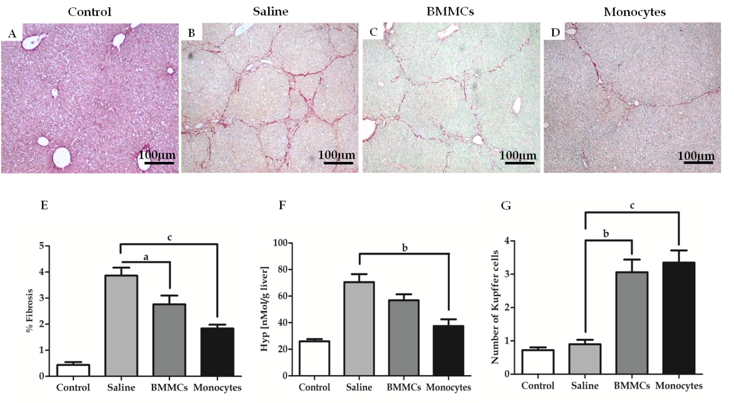
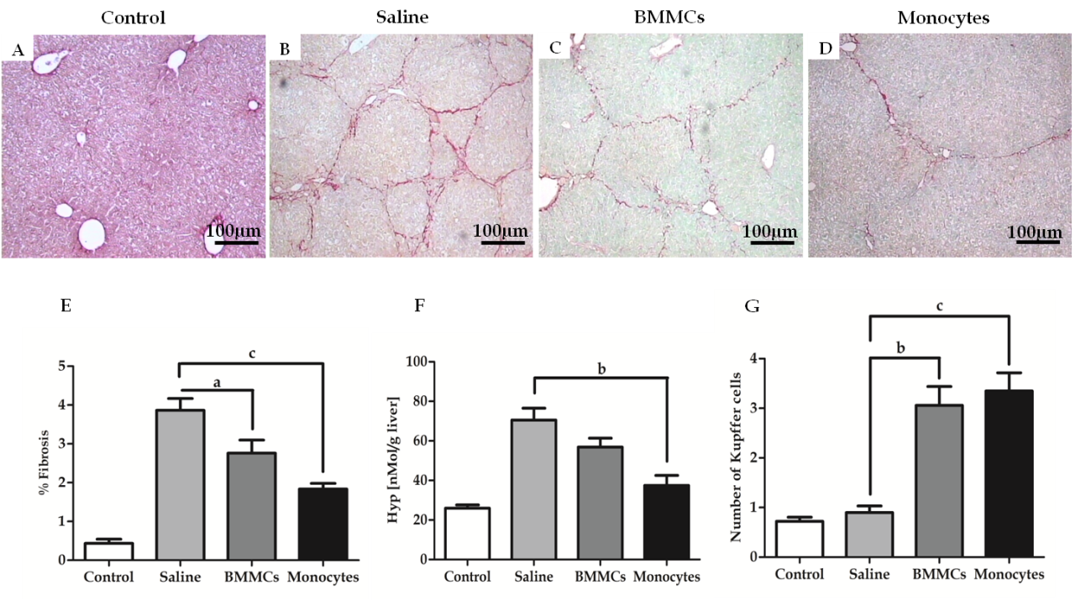
Figure 3 Photomicrographs of histological liver sections stained with picro-Sirius red. Showing hepatic collagens in (A) control mice, mice after CCl₄ administration and treated with (B) saline, (C) BMMCs, and (D) BMMC-derived monocytes (picro-Sirius red, 100X). Morphometric evaluation of picro-Sirius Red-stained sections (E). Hydroxyproline in liver fragments of mice undergoing cell transplantation (F). Kupffer cell count in hematoxylin-eosin-stained histological liver sections, in mice undergoing CD11b⁺ CD14⁺ monocyte therapy and BMMC-treated mice (G) (ªP < 0.05; ^{b}P < 0.01; ^{c}P < 0.001).

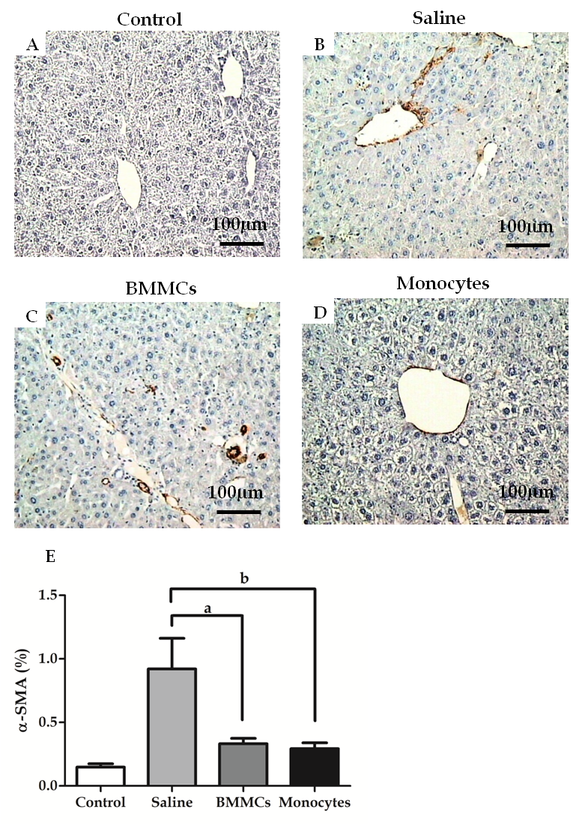
Figure 4 Immunohistochemistry for detection of α-SMA⁺ HSCs in histological sections. control mice (A), saline-treated (B), BMMCs-treated (C) and CD11b⁺ CD14⁺ (D)monocyte-treated groups (200 × magnification). Measuring of α-SMA⁺ HSCs two months after treatment with CD11b⁺ CD14⁺ monocytes and BMMCs (E) (ªP < 0.05; ^{b}P < 0.01).

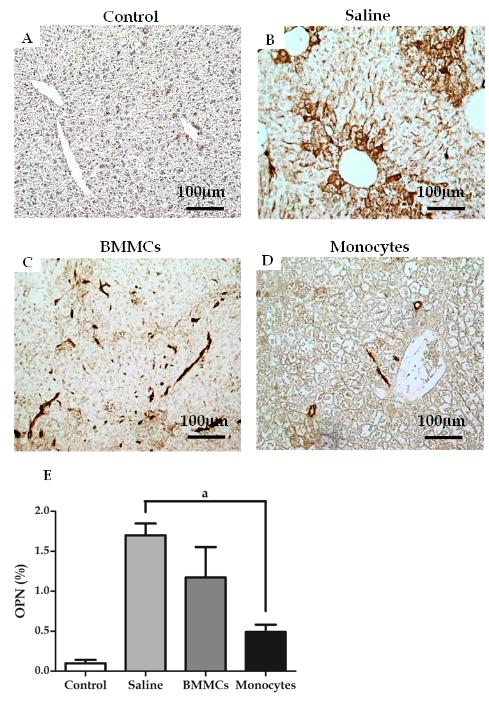
Figure 5 Immunohistochemistry for detection of OPN in histological sections. From control mice (A), saline-treated (B), BMMCs-treated (C) and CD11b⁺ CD14⁺ monocyte-treated groups (D) (200 × magnification). Levels of hepatic OPN two months after treatment with CD11b⁺ CD14⁺ monocytes (E) (ªP < 0.05).

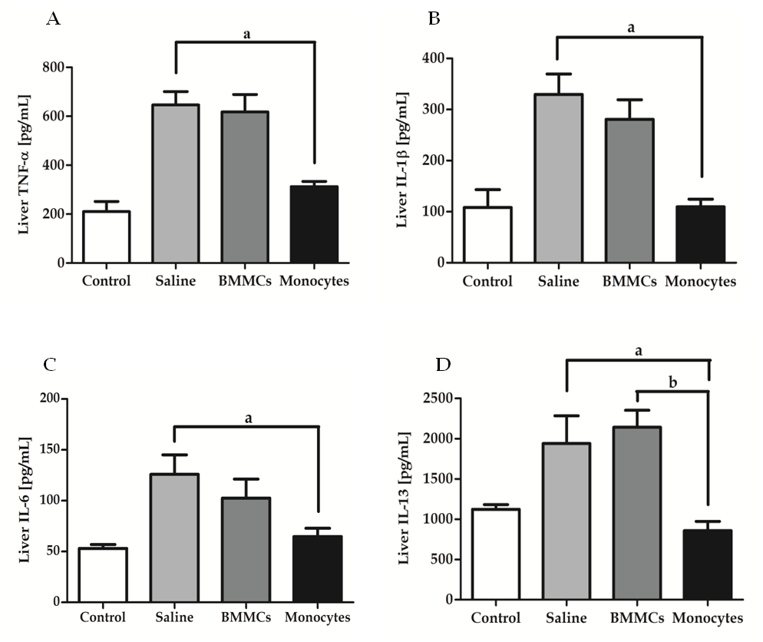
Figure 6 Effects of monocyte therapy on cytokine profile TNF-α(A), IL-1β(B), IL-6 (C) and IL-13 (D), as measured by ELISA. Data are represented graphically as the mean ± SEM of five mice/group (ªP < 0.05; ^{b}P < 0.01).

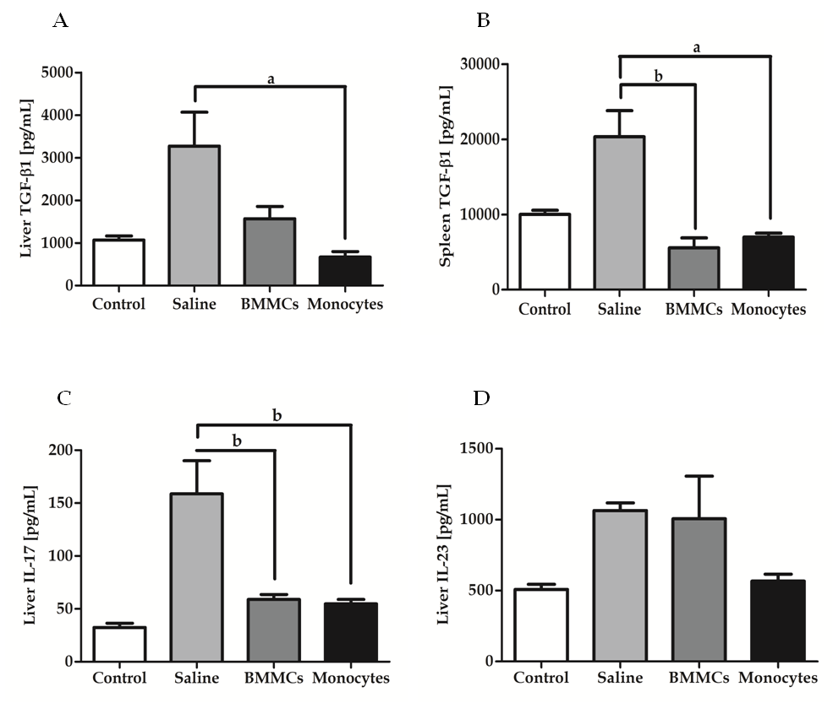
Figure 7 Effects of monocyte-based therapy on chronically liver damaged mice. hepatic levels of TGF-β1 (A); splenic levels of TGF-β1 (B); hepatic levels of IL-17 (C) and IL-23 (D) (ªP < 0.05; ^{b}P < 0.01).

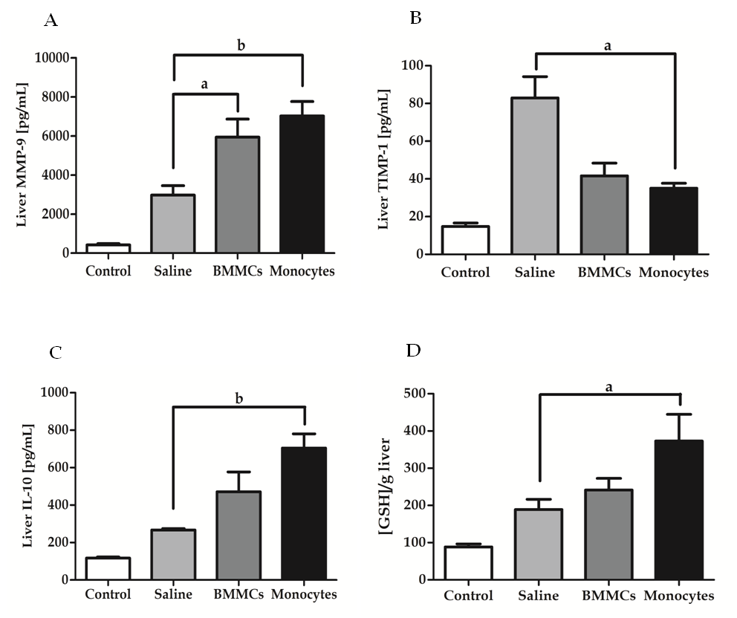
Figure 8 Effects of monocyte-based therapy on hepatic levels of MPP-9 (A), TIMP (B), IL-10 (C) and GSH (D), in chronically liver damaged mice. ªP < 0.05; ^{b}P < 0.01.

