Name of journal: World Journal of Gastroenterology
ESPS Manuscript NO: 13168
Columns: Original Articles

Significance of low level infliximab in the absence of anti-infliximab antibodies of inflammatory bowel disease

Ungar B et al. Low level infliximab in the absence of anti-infliximab antibodies

Bella Ungar, Adi Anafy, Henit Yanai, Yulia Ron, Miri Yavzori, Orit Picard, Ella Fudim, Ronen Loebstein, Uri Kopylov, Yehuda Chowers, Iris Dotan, Rami Eliakim, Shomron Ben-Horin

Bella Ungar, Adi Anafy, Miri Yavzori, Orit Picard, Ella Fudim, Uri Kopylov, Rami Eliakim, Shomron Ben-Horin, Department of Gastroenterology, Sheba Medical Center Tel Hashomer and Sackler School of Medicine, Tel-Aviv University, Tel-Aviv 6997801, Israel

Ronen Loebstein, Institute of Clinical Pharmacology, Sheba Medical Center Tel Hashomer and Sackler School of Medicine, Tel-Aviv University, Tel-Aviv 6997801, Israel

Henit Yanai, Yulia Ron, Iris Dotan, IBD Center, Department of Gastroenterology, Tel-Aviv Sourasky Medical Center and Sackler School of Medicine, Tel-Aviv University, Tel-Aviv 6997801, Israel

Yehuda Chowers, Rambam Health Care Campus and Bruce Rappaport School of Medicine, Technion Institute of Technology, Haifa 31999, Israel

Author contributions: Ungar B, Anafi A and Yanai H preformed analysis of the data; Ungar B drafted the manuscript; Yavzori M, Fudim E and Picard O performed laboratory research; Kopylov U, Ron Y, Loebstein R, Dotan I and Eliakim R assisted in data acquisition and drafted the manuscript; Ben-Horin S conceived the study, designed the research and drafted the manuscript.

Supported by (in part) “Talpiot” Medical Leadership program of the Sheba Medical Center (to SBH) and the Helmsley Charitable Trust (To SBH, RE, ID and YC)

Correspondence to: Bella Ungar, MD, Department of Gastroenterology, Sheba Medical Center Tel Hashomer and Sackler School of Medicine, Tel-Aviv University, Tel Hashomer 52621, Israel. bellageyshis@gmail.com

Telephone: +972-3-5302694 Fax: +972-3-5303160
Received: August 8, 2014 Revised: September 8, 2014
Accepted: October 14, 2014

Published online:

Abstract
Aim: To evaluate the prevalence of double negative (DN) sera and the mechanisms responsible for a DN status.

Methods: Sera of inflammatory bowel disease patients treated with infliximab (IFX) were tested for drug/antibodies to infliximab (ATI) trough levels and the rate of DN results was compared between a commercially available double antigen ELISA (with labeled IFX as the detection antibody) and an anti-lambda ELISA (with anti-human lambda chain detection antibody). Repeat testing with lower than customary serum dilution (1:10) was performed. Patients with DN status were matched with IFX+/ATI- controls and were followed for subsequent development of non transient ATI to explore if DN status may precede ATI.

Results: Of 67 sera obtained at time of loss of response, only 6/67 (9%) were DN by anti-lambda ELISA compared to 27/67 (40%) with double antigen ELISA (p < 0.001, Fisher Exact test). Of the latter 27 sera, 22% were also DN by anti-lambda ELISA, whereas 44% were actually IFX positive (IFX+ATI-), 30% were ATI positive (IFX-ATI+) and 4% were double positive (IFX+ATI+). Re-testing with 1:10 dilution converted most DN results into IFX+ and /or ATI+ status. Patients with DN status had shorter survival free of non transient ATI compared with matched controls (log rank test, p < 0.001). In 9/30 (30%) of these patients, non transient ATI occurred both before and after the event at which the DN serum was obtained, supporting the fact that a double negative result may represent a particular time-point along the two curves of ATI titer rise and infliximab drug level decline.

Conclusion: DN status may result from false negative detection of IFX or ATI by double antigen ELISA, suggesting a transitional state of low-level immunogenicity rather than non-immunological clearance.

© 2014 Baishideng Publishing Group Inc. All rights reserved.

Key words: Inflammatory bowel disease; Biologic therapy; Infliximab; Immunology; Drug response

Core tip: Ten percent-sixty percent of patients who lose response to infliximab (IFX) have low IFX levels in the absence of antibodies to infliximab (ATI) - double negative (DN) status. We decided to explore the prevalence and the mechanisms responsible for a DN status. We found that the prevalence of DN sera varies with the assay and dilution used. Patients with DN status had shorter survival free of ATI compared with matched controls (p < 0.001). We believe DN status may result from false negative detection of IFX or ATI by a conventional ELISA assay, suggesting a transitional state of low-level immunogenicity rather than non-immunological drug clearance.

Ungar B, Anafy A, Yanai H, Ron Y, Yavzori M, Picard O, Fudim E, Loebstein R, Kopylov U, Chowers Y, Dotan I, Eliakim R, Ben-Horin S. Significance of low level infliximab in the absence of anti-infliximab antibodies of inflammatory bowel disease. World J Gastroenterol 2014; In press

INTRODUCTION
Infliximab (IFX) is a chimeric mouse - human monoclonal immunoglobulin G1 (IgG1) antibody against tumor necrosis factor α (TNFα). It is effective in induction and maintenance of remission in Crohn's disease (CD) and ulcerative colitis (UC)^{[1-3]}. Between 30%-70% of patients who initially respond to IFX subsequently lose response and experience exacerbation of symptoms necessitating either dose escalation, switch to another anti-TNF agent, concomitant immunomodulator therapy or surgical intervention^{[4-6]}. Antibodies to infliximab (ATI) develop in approximately 40% of IFX treated patients and correlate with lower IFX trough levels and clinical loss of response (LOR)^{[7,8]}. In 10%- 60% of LOR patients pharmacokinetic tests reveal low IFX trough levels and absence of detectable ATI, designated double negative (DN) status (IFX-/ATI-)^{[5,9]}. Furthermore, several studies, including the SONIC trial, have demonstrated that among patients with LOR the DN status was in fact the more common scenario rather than the expected IFX-/ATI+ status^{[7,10]}.
There is paucity of data regarding the mechanisms responsible for the DN status and its consequence. DN status has been attributed to both immune and non-immune clearance of anti-TNF, as well as to technical limitations, such as non uniform timing of measurement (trough levels are more sensitive than in-between infusions)^{[5,11]}. The uncertainty about the causes and implications of an IFX-/ATI- status makes it hard to rationally advise about optimal strategies to prevent and/or manage LOR events in the presence of such a pharmacokinetic situation.
The aims of the present study were to evaluate the frequency and clinical significance of DN status among IFX-treated IBD patients (both in general and at time of LOR) and to investigate the impact of the diagnostic technique on the incidence of this phenomenon.

MATERIALS AND METHODS
Study design and patient population
The study population included IBD patients treated with IFX at the gastroenterology departments of Sheba medical center and the Tel-Aviv Sourasky Medical Center between February 2009 and October 2013, who had available sera stored. All participants provided a written informed consent and the study was approved by the ethics committee of the two medical centers. Pre-infusion sera were obtained and analyzed for trough IFX and ATI levels. Sera of patients whose infusions were delayed for over 2 weeks from the scheduled date were excluded.
The study consisted of two separated parts: (1) an analytical part, that targeted differences between assays and technical limitations; and (2) a clinical part, aiming to study the natural history of the DN phenomenon (Figure 1). In the first analytical part of the study, IFX and ATI trough levels of patients experiencing LOR were evaluated using two different ELISA assays: double antigen and anti-lambda ELISA. Subsequently, the fraction of IgG4 ATI was measured and compared in a sample of patients with discrepant results of the two ELISA assays in order to investigate if conflicting results stem from predominant monovalent IgG4 ATI response. Finally, in order to investigate the analytical accuracy of the anti-lambda ELISA this assay was repeated in 45 randomly selected DN sera using a serum dilution of 1:10 (rather than the conventional 1:100 dilution). Patients' sera in this analysis were tested regardless of response status, and sera of healthy volunteers unexposed to IFX served as controls.
The clinical part was a case control study; cases were patients with IBD who had at least one DN (IFX-ATI-) measurement during routine follow up (not necessarily at a point of LOR) and controls were IBD patients with positive drug levels without ATI (IFX+ATI-). The starting point of the analysis was defined as the month of the DN event in cases and the matching month in controls. The pharmacokinetics at the end of follow up were correlated to clinical outcome. Cases and controls were matched according to the duration of IFX therapy. Patients with unavailable subsequent measurements were excluded. Antibody formation was defined as positive when a patient tested positive for ATI during follow-up on more than two consecutive time points. Transient antibodies were defined as measurable ATI on up to two consecutive infusions, which disappeared on subsequent infusions without any alteration of therapy^{[8,12,13]}. Permanent, non-transient, ATI comprised the primary end point, while transient ATI were disregarded. Clinical response was defined by an improvement in disease activity indexes, the Harvey-Bradshaw index (HBI) score and the simple clinical colitis activity index (SCCAI) score for CD and UC patients respectively, coupled with a treating physician's decision to continue IFX therapy without alteration. Clinical response was evaluated on the day of IFX infusion. Secondary LOR was defined as increased disease activity (a rise of >3 points in HBI score or of >2 points in SCCAI score for CD and UC respectively) after achieving an appropriate induction response^{[14-16]}. When unavailable, clinical response was determined by the documented physician’s global assessment.

Measurement of IFX by TNF-α-blocker-monitoring infliximab drug level ELISA
IFX levels were measured by a commercially available quantitative ELISA, TNF-α-blocker-monitoring (Immundiagnostik, Bensheim, Germany). Instructions supplied by the manufacturer were followed. The assay's detection threshold was IFX > 1 µg/ml.

Measurement of ATI by TNF-α-blocker-ADA double antigen ELISA
ATI levels were measured by a commercially available qualitative TNF-α-blocker-ADA (antibodies against infliximab, Immundiagnostik, Bensheim, Germany). Instructions supplied by the manufacturer were followed. The assays detection threshold was ATI > 10AU/ml, which was standardized in our labs to 1 AU/ml.

In house determination of IFX levels
A volume of 100 µl of 1:100 diluted serum was added to pre-plated 750 ng/ml TNFα (Peprotech, Rocky Hill, New Jersey, United States) and incubated for 90 min. Following washing, horseradish peroxidase (HRP) labeled goat anti-human Fc fragment antibody (MP Biomedicals, Solon, Ohio, United States) at a concentration of 0.62 µg /ml was added for 60 min and reacted with tetramethylbenzidine (TMB) substrate. The results were then read on an ELISA reader. Quantization of the measured IFX concentration was done by calibration to standard curve in which exogenous IFX (Schering Plough, New Jersey, United States) was added at concentrations between 3 and 200 ng/ml. The assays detection threshold was IFX > 0.6 µg/ml.

Measurement of ATI by anti-human lambda chain detection antibody ELISA
ATI were determined as previously described^{[11,17]}. Briefly, IFX (0.1 mg/ml) was added to pre-plated TNFα (500 ng/ml) in 100 µl wells of ELISA plates (Nunc, Roskilde, Denmark). After drying, 100 µl of serum (1:100 dilution) was added and incubated for 90 min at room temperature. Plates were then washed and goat anti-human λ chain HRP-labelled antibody (Sertec, Oxford, United Kingdom) was added at a dilution of 2.5 × 10⁴ for 60 min and reacted with tetramethylbenzidine (TMB) substrate. The results were read by an ELISA reader EL-800 (Biotek Instruments, Winooski, United States) and expressed as mcg/ml-equivalent (mcg/ml-e) after normalisation versus results obtained using additions of graded concentrations between 9 and 600 ng/ml of horseradish peroxidase (HRP) labeled goat anti-human F(ab')2 fragment antibody (MP Biomedicals). The assay's detection threshold was ATI > 2.5 µg/ml-eq.

Measurement of IgG4 fraction of ATI
IFX (0.1 mg/ml) was added to pre-plated TNFα (500 ng/ml) in 100 µl wells of ELISA plates (Nunc, Roskilde, Denmark). After drying, 100 µl of diluted serum (1:100) was added and incubated at room temperature. Plates were then washed and HRP-labeled monoclonal antibody to human IgG4 (fc-specific, Acris antibodies CN AM20252HR-N) was added and reacted with tetramethylbenzidine (TMB) substrate. The results were read by an ELISA reader EL-800 (Biotek Instruments, Winooski, United States) and expressed as mcg/ml. Normalization was obtained using graded concentrations of Human IgG4 Kappa (Millipore CN AG508).

Statistical analysis
Categorical variables were analyzed by Fisher's exact test. Kaplan Meier survival curves were plotted to assess the temporal rate of events and log rank test was computed for the comparison between survival free durations. Odds ratio and 95% confidence intervals (CI) were computed for all variables compared. The analysis was performed using MedCalc software (version 12.2.1.0, Mariakerke, Belgium). A two-tailed P < 0.05 was considered statistically significant.

RESULTS
Prevalence of the DN status using two ELISA assays
Out of 188 sera obtained from patients with LOR during regular IFX therapy, 67 were randomly selected for comparative analysis by the two techniques (anti-lambda and double antigen ELISA, Figure 1). In this analysis, 27/67 sera (40%) tested IFX-/ATI- with double antigen-ELISA compared to 6/67 (9%) with anti-lambda-ELISA (p < 0.001, Fisher exact test). The calculated number needed to test (NNT) for a false-negative DN result by double-antigen ELISA was 3.2. As depicted in Figure 2, when applying anti-lambda-ELISA to the 27 sera that were IFX-/ATI- with the double antigen assay only 6 (22%) remained DN, while 12 (44%) were actually IFX positive (IFX+ATI-), 8 (30%) were ATI positive (IFX-ATI+) and 1 serum (4%) was double positive (IFX+ATI+).

Double negativity on 1:10 dilution anti-lambda ELISA
When investigating the occurrence of double negativity regardless of patients' response status, we found that only 92 of the 1495 sera (6%) analyzed at our center between 2009-2013 were DN by anti-lambda ELISA (Figure 1). To examine whether some of these DN sera may in fact represent low-titer ATI or low level IFX we randomly selected 45 DN sera and re-tested them at a 1:10 dilution to increase analytical sensitivity (compared to standard anti-lambda testing using 1:100 serum dilution). Upon this 1:10 dilution testing, 24 (53%) DN sera became IFX positive (IFX+ATI-), 15 (33%) were double positive (IFX+ATI+) and 5 (11%) were ATI positive (IFX-ATI+). Only one serum (2%) retained its double negativity on 1:10 dilution (Figure 3). This transformation into detectable levels on 1:10 dilution was primarily caused by the fact that all 30 sera of healthy controls unexposed to IFX remained DN when tested by 1:10 dilution, but with lower detection cut-off levels.

Determination of IgG4 versus IgG1 ATI
IgG4 are monovalent antibodies (as opposed to the bivalent IgG1), thereby detectable on a large part by the anti-lambda ELISA, rather than by the double antigen assay^{[18]}. We therefore set to determine whether a DN status on double antigen ELISA is a result of non-detection of IgG4 ATI. For this purpose, we analyzed 5 sera which were DN by the double antigen ELISA and ATI positive by the anti-lambda ELISA (IFX-ATI-), as well as 5 sera ATI positive on both assays (IFX-ATI+). Contrary to our assumption, IgG4 levels were higher among the double antigen ELISA ATI+ positive sera (Median 6.6, IQR 0.9-7.4 versus median 0.5, IQR 0.07-0.97, p = 0.047, respectively).

Subsequent ATI formation and clinical response rate in DN patients
To investigate whether the DN status is a harbinger of pending immunogenicity, we sought to determine whether patients with DN sera were predisposed to develop ATI compared to patients with measurable IFX (IFX+ATI-). During the study period 44 out of 155 patients on standard IFX regiment had at least one DN serum sample determined by anti-lambda ELISA (Figure 1). Fourteen of them were excluded from analysis due to missing data (10 were inconsistently followed, 2 were lost to follow up after the DN event and 2 received infusions outside our center). Thus, 30 patients (25 CD, 5 UC) were included, matched with 30 controls (27 CD, 3 UC). Median follow up time was 21 ± 25.1 mo vs time 20.75 ± 25.5 mo, respectively, p = 0.97. The patients' demographic and clinical characteristics are presented in Table 1.
ATI formation was significantly more frequent among the DN group compared with controls (OR = 11, 95%CI: 3.3-36.8, p ≤ 0.001). In 9/30 (30%) DN patients who developed non-transient ATI, ATI formation occurred both before and after the event at which the DN serum was obtained (Figure 4), supporting the fact that a double negative result may represent a particular time-point along the two curves of ATI titer rise and IFX drug level decline.
To investigate the temporal evolution of immunogenicity in DN patients, Kaplan-Meier analysis was performed. ATI free survival was significantly longer among controls (log rank test, p < 0.001, Figure 5A) than among DN cases. Of note, ATI appearance prior to the DN status was disregarded in this analysis. Nevertheless, when considering ATI existence before the starting point as positive, similar results were obtained (log rank test, p < 0.001). Secondary LOR was also more frequent among DN cases (OR = 4.66 95%CI: 1.57-13.86, p = 0.006) and survival free of secondary LOR was significantly shorter than among controls (p = 0.02, log rank test, Figure 5B).

DISCUSSION
A substantial portion of IFX treated patients develop low trough levels of IFX in the absence of measurable ATI (IFX-ATI-), i.e., a double negative (DN) status. Several studies have demonstrated that among patients with LOR, a DN result is more prevalent than antibody positive sera^{[10,19]}. The actual mechanism of LOR remains in doubt in most such cases, and the role – if any – of immunogenicity in instigating this phenomenon remains to be elucidated. Aside from assay limitations and irregular sampling time-points, DN status has been attributed to non-immune clearance of anti-TNF, high tissue inflammatory burden 'absorbing' anti-TNF drug and temporal "window phenomenon", which refers to sampling when all drug-ATI complexes have been cleared^{[5,11,20]}.
Studies which employed double antigen ELISA assay reported 20%-40% of the patients to be DN, regardless of response status^{[7,9,21,22]}. Vande Casteele et al^{[12]} have recently demonstrated a prevalence of only 11% using the homogeneous mobility shift assay (HMSA). Scarce data exists comparing different methods for IFX and ATI level measurement. Steenholdt et al^{[23]} have recently demonstrated lower detection rate of ATI using double-antigen ELISA than by other essays. In the current study, double negativity was significantly more prevalent when applying the double antigen ELISA compared to the anti-lambda ELISA (40% vs 9%, p < 0.001). Furthermore, when applying anti-lambda ELISA to the sera which were IFX-/ATI- by the double antigen assay, only 6 (22%) remained DN. We assume that the higher frequency of double negativity using double antigen ELISA stems at least partly from false negative detection of IFX or ATI. As IgG4-ATI levels were not higher among the double antigen ELISA DN sera, double negativity cannot be attributed to the technical inability of double antigen ELISA to detect ATI in patients with a predominance of IgG4-ATI.
Interestingly, only one serum out of 45 examined with 1:100 dilution anti-lambda ELISA retained its double negativity at 1:10 dilution anti-lambda. The other sera became mostly IFX+ATI- or IFX-ATI+. The fact that almost all sera "lost" their DN status at 1:10 dilution implies that at least part of this phenomenon probably arises from low drug and ATI levels close to the detection threshold of the more sensitive anti-lambda assay. These sera may reflect a transitional state of immunological equilibrium between antibody-mediated IFX clearance and endogenous ATI production, rather than genuine non-immunological drug clearance. Notably, in clinical practice, physicians should be cognizant that some patients may present with DN status at trough merely because of arriving late for a delayed infusion. Such cases were excluded from the present work.
Few studies have addressed the question of subsequent ATI development in patients with DN sera. Hanauer et al^{[7]} demonstrated that only 2.5% of the DN patients turned ATI+ at week 76, although IFX infusions were halted at week 46. In contrast, Seow et al^{[9]} have shown that 77% of DN UC patients later develop ATI, regardless of response status. In our study, double negativity was also predictive of future non-transient ATI formation. This re-enforces our conclusion that the DN status is an immunologically-mediated phenomenon, albeit with low titer antibodies close or below the detection level of the assay when employed by certain specifications. As previously demonstrated, transient ATI had little clinical and immunological significance^{[8,12,13]}.
There are several limitations to our study. Primarily, the results were obtained with the double antigen ELISA and the anti-lambda ELISA, but corroborating studies using other assays such as HMSA are pertinent. Secondly, because treating physicians were not kept blinded to the results one cannot exclude that the DN status of the sera analyzed may have influenced clinical management. However, LOR was defined per clinical indexes and constituted only the secondary outcome. Finally, previous events of positive ATI might influence future ATI formation. To neutralize such past effects we performed an analysis incorporating former ATI events as existent at time zero, which yielded similar results.
In conclusion, the type of assay employed influences the occurrence of the DN status. It is rarely observed when LOR patients' sera are analyzed by the sensitive anti-lambda assay, and in many cases it probably results from low-level immunogenicity rather than elusive non-immunogenic mechanisms. Future studies are required to better assess the immunological processes leading to the absence of both drug and ATI, to investigate possible drug clearance pathways and to define appropriate interventions in these patients.

comments
Background
Antibodies to infliximab (ATI) correlate with lower infliximab (IFX) trough levels and loss of response (LOR). However, 10-60% of LOR patients have low IFX levels in the absence of ATI - designated double negative (DN) status.

Research frontiers
The clinical and immunological significance of the DN status is currently unknown.

Innovations and breakthroughs
Only 9% of sera obtained at time of LOR were DN by anti-lambda ELISA compared to 40% with double antigen ELISA (p < 0.001, Fisher Exact test). Re-testing with 1:10 dilution converted most DN results into IFX+ and /or ATI+ status. Patients with DN status had shorter survival free of non transient ATI compared with matched controls (log rank test, p < 0.001).

Applications
The type of assay employed influences the occurrence of the DN status. It is rarely observed when LOR patients' sera are analyzed by the sensitive anti-lambda assay, and in many cases it probably results from low-level immunogenicity rather than non-immunogenic mechanisms. Future studies are required to better assess the immunological processes leading to the absence of both drug and ATI, to investigate possible drug clearance pathways and to define appropriate interventions in these patients.

Terminology
DN status: a serum sample which is negative both for infliximab and ATI (IFX-ATI). Double antigen ELISA: a commercially available ELISA assay for the detection of ATI, which incorporates infliximab as the detection antibody. Anti-lambda ELISA assay: an in-house developed ELISA assay for the detection of ATI, which incorporates anti-human λ chain as the detection antibody. LOR: loss of clinical response to infliximab therapy.

Peer review
This manuscript evaluates the prevalence and clinical significance of dn status among infliximab-treated inflammatory bowel disease patients. the article is well written, and suitable to be published.

REFERENCES
1 Hanauer SB, Feagan BG, Lichtenstein GR, Mayer LF, Schreiber S, Colombel JF, Rachmilewitz D, Wolf DC, Olson A, Bao W, Rutgeerts P; ACCENT I Study Group. Maintenance infliximab for Crohn's disease: the ACCENT I randomised trial. Lancet 2002; 359: 1541-1549 [PMID: 12047962 DOI: 10.1016/S0140-6736(02)08512-4]
2 Sands BE, Anderson FH, Bernstein CN, Chey WY, Feagan BG, Fedorak RN, Kamm MA, Korzenik JR, Lashner BA, Onken JE, Rachmilewitz D, Rutgeerts P, Wild G, Wolf DC, Marsters PA, Travers SB, Blank MA, van Deventer SJ. Infliximab maintenance therapy for fistulizing Crohn's disease. N Engl J Med 2004; 350: 876-885 [PMID: 14985485 DOI: 10.1056/NEJMoa030815]
3 Rutgeerts P, Sandborn WJ, Feagan BG, Reinisch W, Olson A, Johanns J, Travers S, Rachmilewitz D, Hanauer SB, Lichtenstein GR, de Villiers WJ, Present D, Sands BE, Colombel JF. Infliximab for induction and maintenance therapy for ulcerative colitis. N Engl J Med 2005; 353: 2462-2476 [PMID: 16339095 DOI: 10.1056/NEJMoa050516]
4 Kopylov U, Mantzaris GJ, Katsanos KH, Reenaers C, Ellul P, Rahier JF, Israeli E, Lakatos PL, Fiorino G, Cesarini M, Tsianos EV, Louis E, Ben-Horin S. The efficacy of shortening the dosing interval to once every six weeks in Crohn's patients losing response to maintenance dose of infliximab. Aliment Pharmacol Ther 2011; 33: 349-357 [PMID: 21118397 DOI: 10.1111/j.1365-2036.2010]
5 Ben-Horin S, Chowers Y. Review article: loss of response to anti-TNF treatments in Crohn's disease. Aliment Pharmacol Ther 2011; 33: 987-995 [PMID: 21366636 DOI: 10.1111/j.1365-2036.2011.04612]
6 Gisbert JP, Panés J. Loss of response and requirement of infliximab dose intensification in Crohn's disease: a review. Am J Gastroenterol 2009; 104: 760-767 [PMID: 19174781 DOI: 10.1038/ajg.2008.88]
7 Hanauer SB, Wagner CL, Bala M, Mayer L, Travers S, Diamond RH, Olson A, Bao W, Rutgeerts P. Incidence and importance of antibody responses to infliximab after maintenance or episodic treatment in Crohn's disease. Clin Gastroenterol Hepatol 2004; 2: 542-553 [PMID: 15224278 DOI: 10.1016/S1542-3565(04)00238-1]
8 Ungar B, Chowers Y, Yavzori M, Picard O, Fudim E, Har-Noy O, Kopylov U, Eliakim R, Ben-Horin S; ABIRISK consortium. The temporal evolution of antidrug antibodies in patients with inflammatory bowel disease treated with infliximab. Gut 2014; 63: 1258-1264 [PMID: 24041539 DOI: 10.1136/gutjnl-2013-305259]
9 Seow CH, Newman A, Irwin SP, Steinhart AH, Silverberg MS, Greenberg GR. Trough serum infliximab: a predictive factor of clinical outcome for infliximab treatment in acute ulcerative colitis. Gut 2010; 59: 49-54 [PMID: 19651627 DOI: 10.1136/gut.2009]
10 Colombel JF, Sandborn WJ, Reinisch W, Mantzaris GJ, Kornbluth A, Rachmilewitz D, Lichtiger S, D'Haens G, Diamond RH, Broussard DL, Tang KL, van der Woude CJ, Rutgeerts P. Infliximab, azathioprine, or combination therapy for Crohn's disease. N Engl J Med 2010; 362: 1383-1395 [PMID: 20393175 DOI: 10.1056/NEJMoa0904492]
11 Kopylov U, Mazor Y, Yavzori M, Fudim E, Katz L, Coscas D, Picard O, Chowers Y, Eliakim R, Ben-Horin S. Clinical utility of antihuman lambda chain-based enzyme-linked immunosorbent assay (ELISA) versus double antigen ELISA for the detection of anti-infliximab antibodies. Inflamm Bowel Dis 2012; 18: 1628-1633 [PMID: 22038899 DOI: 10.1002/ibd.21919]
12 Vande Casteele N, Gils A, Singh S, Ohrmund L, Hauenstein S, Rutgeerts P, Vermeire S. Antibody response to infliximab and its impact on pharmacokinetics can be transient. Am J Gastroenterol 2013; 108: 962-971 [PMID: 23419382 DOI: 10.1038/ajg.2013.12]
13 Steenholdt C, Al-khalaf M, Brynskov J, Bendtzen K, Thomsen OØ, Ainsworth MA. Clinical implications of variations in anti-infliximab antibody levels in patients with inflammatory bowel disease. Inflamm Bowel Dis 2012; 18: 2209-2217 [PMID: 22344964 DOI: 10.1002/ibd.22910]
14 Higgins PD, Schwartz M, Mapili J, Krokos I, Leung J, Zimmermann EM. Patient defined dichotomous end points for remission and clinical improvement in ulcerative colitis. Gut 2005; 54: 782-788 [PMID: 15888785 DOI: 10.1136/gut.2004.056358]
15 Harvey RF, Bradshaw JM. A simple index of Crohn's-disease activity. Lancet 1980; 1: 514 [PMID: 6102236 DOI: 10.1016/S0140-6736(80)92767-1]
16 Vermeire S, Schreiber S, Sandborn WJ, Dubois C, Rutgeerts P. Correlation between the Crohn's disease activity and Harvey-Bradshaw indices in assessing Crohn's disease severity. Clin Gastroenterol Hepatol 2010; 8: 357-363 [PMID: 20096379 DOI: 10.1016/j.cgh.2010.01.001]
17 Ben-Horin S, Yavzori M, Katz L, Kopylov U, Picard O, Fudim E, Coscas D, Bar-Meir S, Goldstein I, Chowers Y. The immunogenic part of infliximab is the F(ab')2, but measuring antibodies to the intact infliximab molecule is more clinically useful. Gut 2011; 60: 41-48 [PMID: 20519742 DOI: 10.1136/gut.2009.201533]
18 Nirula A, Glaser SM, Kalled SL, Taylor FR. What is IgG4? A review of the biology of a unique immunoglobulin subtype. Curr Opin Rheumatol 2011; 23: 119-124 [PMID: 21124094 DOI: 10.1097/BOR.0b013e3283412fd4]
19 Afif W, Loftus EV, Faubion WA, Kane SV, Bruining DH, Hanson KA, Sandborn WJ. Clinical utility of measuring infliximab and human anti-chimeric antibody concentrations in patients with inflammatory bowel disease. Am J Gastroenterol 2010; 105: 1133-1139 [PMID: 20145610 DOI: 10.1038/ajg.2010.9]
20 Ordás I, Feagan BG, Sandborn WJ. Therapeutic drug monitoring of tumor necrosis factor antagonists in inflammatory bowel disease. Clin Gastroenterol Hepatol 2012; 10: 1079-187; quiz 1079-187 [PMID: 22813440 DOI: 10.1016/j.cgh.2012.06.032]
21 Maser EA, Villela R, Silverberg MS, Greenberg GR. Association of trough serum infliximab to clinical outcome after scheduled maintenance treatment for Crohn's disease. Clin Gastroenterol Hepatol 2006; 4: 1248-1254 [PMID: 16931170 DOI: 10.1016/j.cgh.2006.06.025]
22 Pariente B, Pineton de Chambrun G, Krzysiek R, Desroches M, Louis G, De Cassan C, Baudry C, Gornet JM, Desreumaux P, Emilie D, Colombel JF, Allez M. Trough levels and antibodies to infliximab may not predict response to intensification of infliximab therapy in patients with inflammatory bowel disease. Inflamm Bowel Dis 2012; 18: 1199-1206 [PMID: 22127789 DOI: 10.1002/ibd.21839]
23 Steenholdt C, Ainsworth MA, Tovey M, Klausen TW, Thomsen OO, Brynskov J, Bendtzen K. Comparison of techniques for monitoring infliximab and antibodies against infliximab in Crohn's disease. Ther Drug Monit 2013; 35: 530-538 [PMID: 23765033 DOI: 10.1097/FTD.0b013e31828d23c3]

P-Reviewer: De Silva AP, Trifan A S-Editor: Ma YJ L-Editor: E-Editor:

Table 1 Background disposition and clinical characteristics n (%)
Parameter |  | Cases | Controls | P- value | OR (95%CI)
Gender | male | 15 (50) | 10 (33.3) | 0.19 | 2.0 (0.70-5.70)
 | female | 15 (50) | 20 (66.6)
Type of IBD | CD | 25 (83.3) | 27 (90) | 0.45 | 0.56 (0.12-2.57)
 | UC | 5 (16.7) | 3 (10)
Duration of IFX therapy¹ (mo) |  | 21 ± 25.1 | 20.75 ± 25.5 | 0.97
Concomitant therapy |  | 11 (36.7) | 11 (36.7) | 1.0 | 1 (0.35-2.86)
Episodic therapy |  | 6 (20) | 6 (20) | 1.0 | 1 (0.28-3.54)
Median age (yr) |  | 33 ± 15.2 | 28.5 ± 10.7 | 0.24
Median disease duration (yr) |  | 10.5 ± 9 | 9 ± 7.7 | 0.65
Median age at diagnosis (yr) |  | 22 ± 12.4 | 20 ± 9.7 | 0.19
CD - disease location | ileal | 9 (36) | 8 (29.7) | 0.62 | 1.30 (0.41-4.30)
 | ileo-colonic | 8 (32) | 11 (40.7) | 0.51 | 0.68 (0.22-2.10)
 | colonic | 8 (32) | 8 (29.6) | 0.85 | 1.10 (0.34-3.63)
Upper GI involvement |  | 2 (8) | 2 (7.4) | 0.93 | 1.08 (0.14-8.40)
Anal/perianal involvement |  | 13 (52) | 14 (51.8) | 0.99 | 1.00 (0.34-3.00)
CD - disease behavior | non stricturing non penetrating | 12 (48) | 12 (44.5) | 0.79 | 1.15 (0.38-3.43)
 | stricturing | 8 (32) | 10 (37) | 0.70 | 0.80 (0.25-2.50)
 | penetrating | 5 (20) | 5 (18.5) | 0.89 | 1.1 (0.28-4.40)
UC - disease location | proctitis | 0 | 0
 | left sided colitis | 2 (40) | 1 (33.3)
 | extensive colitis | 3 (60) | 2 (66.7)
Extra-intestinal manifestations |  | 15 (50) | 15 (50) | 1.0 | 1 (0.36-2.75)
Smoking |  | 2 (6.7) | 5 (16.7) | 0.24 | 0.3 (0.06-2.00)
Immunomodulator therapy prior to infliximab tx |  | 26 (86.7) | 23 (76.7) | 0.32 | 1.97 (0.51-7.63)
Adalimumab therapy prior to infliximab tx |  | 4 (13.3) | 0 | 0.12 | 10.30 (0.53-201.00)
Surgery prior to infliximab therapy |  | 8 (26.7) | 7 (23.3) | 0.76 | 1.19 (0.37-3.85)
¹All patients received infliximab infusions at a standard protocol of 5 mg/ kg at 0, 2, 6 and every 8 wk. IBD: Inflammatory bowel disease; CD: Crohn's disease; UC: Ulcerative colitis; GI: gastro-intestinal.
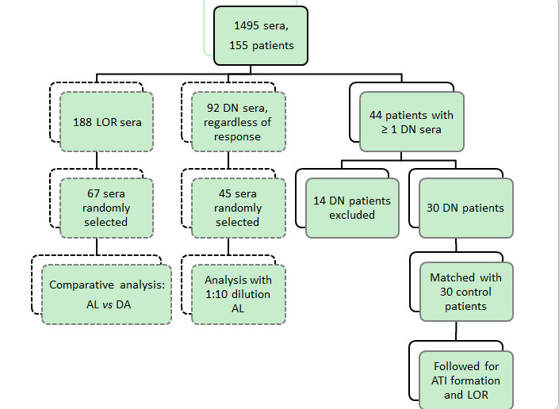
Figure 1 Flow chart of the patients included in the two parts of this study: The analytical part (dashed lines) which comprised comparison of two different assays and of two different serum dilutions; and the clinical part (solid lines) which followed up in a case-control study double negative patients versus patients with adequate infliximab levels for subsequent antibodies to infliximab formation and clinical outcome. DN: Double negative; LOR: Loss of response; AL: Anti-lambda; DA: Double-antigen; IFX: Infliximab; ATI: Antibodies to infliximab.

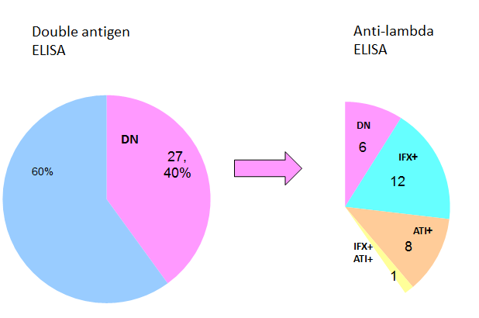
Figure 2 Out of 67 patients with loss of response, 27 (40%) were double negative with double antigen ELISA. Of those, only 6 (9%) were DN using anti-lambda ELISA. LOR: Loss of response; DN: Double negative; IFX: Infliximab; ATI: Antibodies to infliximab.

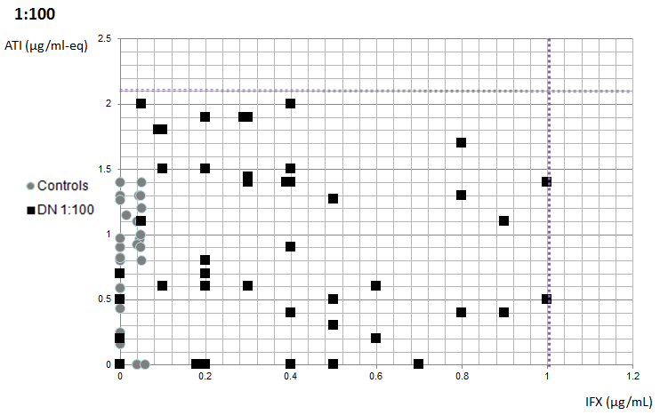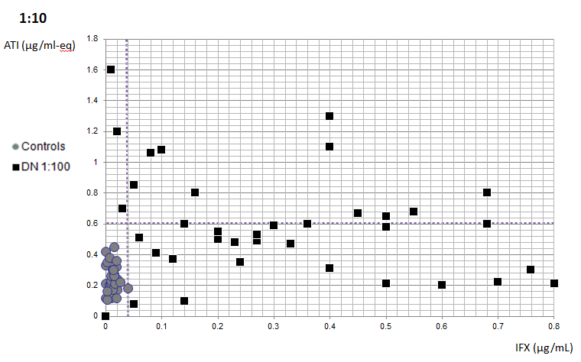
A B
Figure 3 To examine whether some of these double negative sera may in fact represent low-titer antibodies to infliximab or low level infliximab we randomly selected 45 double negative sera and re-tested them at a 1:10 dilution to increase analytical sensitivity (compared to standard anti-lambda testing using 1:100 serum dilution). A: IFX and ATI values of double negative vs healthy controls’ sera, analyzed at 1:100 dilution anti-lambda ELISA. Cut off values for double negativity: IFX < 1 µg/ml, ATI < 2.1 µg/ml-eq. DN sera - black squares, healthy controls - gray circles; B: IFX and ATI values of sera DN on 1:100 dilution vs healthy controls analyzed at 1:10 dilution anti-lambda ELISA. Cut off values for double negativity: IFX < 0.04 µg/ml, ATI < 0.6 µg/ml-eq. Previously DN sera (on 1:100 dilution) - black squares, healthy controls - gray circles. DN: Double negative; IFX: Infliximab; ATI: Antibodies to infliximab.

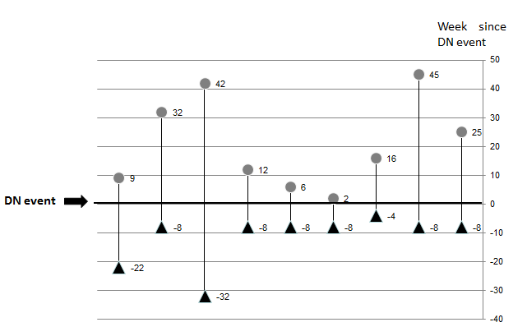
Figure 4 Temporal formation of antibodies to infliximab in 9 patients in whom antibodies to infliximab positive sera preceded double negative sera.
ATI formation before DN event (black triangles), ATI formation after DN event (gray circles). ATI: Antibodies to infliximab; DN: Double negative.

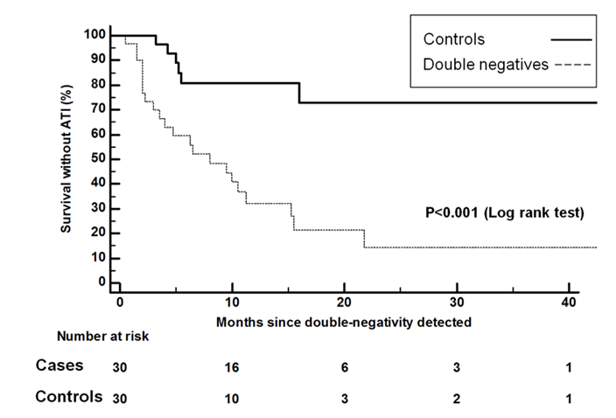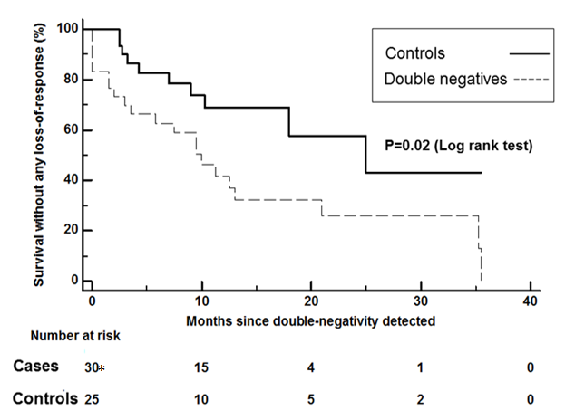
A B
Figure 5 Survival free. A: antibodies to infliximab development in cases vs controls; B: secondary loss of response in cases vs controls. The asterisk shows that five of the controls experienced secondary LOR at a time-point comparable to the double negative event. ATI: antibodies to infliximab; LOR: loss of response.

