Name of Journal: World Journal of Gastroenterology
Manuscript NO: 92217
Manuscript Type: CASE REPORT

Myocardial metastasis from ZEB1- and TWIST-positive spindle cell carcinoma of the esophagus: A case report

Shibata Y et al. Myocardial metastasis from esophageal SCC

Yoshihiro Shibata, Hirofumi Ohmura, Kazuki Komatsu, Kosuke Sagara, Atsuji Matsuyama, Ryuji Nakano, Eishi Baba

Yoshihiro Shibata, Kosuke Sagara, Department of Medical Oncology, Fukuoka Wajiro Hospital, Fukuoka 811-0213, Japan

Hirofumi Ohmura, Eishi Baba, Department of Oncology and Social Medicine, Kyushu University Graduate School of Medical Sciences, Fukuoka 812-8582, Japan

Kazuki Komatsu, Department of Pathology and Oncology, University of Occupational and Environmental Health, Kitakyushu 807-8555, Japan

Atsuji Matsuyama, Ryuji Nakano, Department of Diagnostic Pathology, Fukuoka Wajiro Hospital, Fukuoka 811-0213, Japan

Author contributions: Shibata Y, Ohmura H, and Baba E contributed to the design of the report and drafted the manuscript; Komatsu K, Sagara K, Matsuyama A, and Nakano R critically revised the manuscript.

Corresponding author: Eishi Baba, MD, PhD, Professor, Department of Oncology and Social Medicine, Kyushu University Graduate School of Medical Sciences, 3-1-1 Maidashi, Higashi-ku, Fukuoka 812-8582, Japan. baba.eishi.889@m.kyushu-u.ac.jp

Received: January 19, 2024
Revised: February 2, 2024
Accepted: March 7, 2024
Published online:

Abstract
BACKGROUND
Metastatic cardiac tumors are known to occur more frequently than primary cardiac tumors, however, they often remain asymptomatic and are commonly discovered on autopsy. Malignant tumors with a relatively high frequency of cardiac metastasis include mesothelioma, melanoma, lung cancer, and breast cancer, whereas reports of esophageal cancer with cardiac metastasis are rare.

CASE SUMMARY
The case of a 60-year-old man who complained of dysphagia is presented. Upper gastrointestinal endoscopy showed a submucosal tumor-like elevated lesion in the esophagus causing stenosis. Contrast-enhanced computed tomography showed left atrial compression due to the esophageal tumor, multiple liver and lung metastases, and a left pleural effusion. Pathological examination of a biopsy specimen from the esophageal tumor showed spindle-shaped cells, raising suspicion of esophageal sarcoma. The disease progressed rapidly, and systemic chemotherapy was deemed necessary, however, due to his poor general condition, administration of cytotoxic agents was considered difficult. Given his high Combined Positive Score, nivolumab was administered, however, the patient soon died from the disease. The autopsy confirmed spindle cell carcinoma (SCC) of the esophagus and cardiac metastasis with similar histological features. Cancer stem cell markers, ZEB1 and TWIST, were positive in both the primary tumor and the cardiac metastasis.

CONCLUSION
To the best of our knowledge, there have been no prior reports of cardiac metastasis of esophageal SCC. This case highlights our experience with a patient with esophageal SCC who progressed rapidly and died from the disease, with the autopsy examination showing cardiac metastasis.

Key Words: Spindle cell carcinoma; Esophagus; Myocardial metastasis; Epithelial-mesenchymal transition; Case report

Shibata Y, Ohmura H, Komatsu K, Sagara K, Matsuyama A, Nakano R, Baba E. Myocardial metastasis from ZEB1- and TWIST-positive spindle cell carcinoma of the esophagus: A case report. World J Gastroenterol 2024; In press

Core Tip: Spindle cell carcinoma (SCC) is rare, accounting for about 0.1%-1.5% of esophageal cancers. Tumor cells show sarcomatoid differentiation with spindle cells and are accompanied by components of conventional carcinoma including squamous cell carcinoma in some cases. Many of cardiac metastatic tumors are asymptomatic and are typically discovered through pathological autopsy, with metastatic cardiac tumors being identified in 2% to 18% of cancer patients undergoing autopsy. There has been no report of cardiac metastasis in esophageal SCC.

INTRODUCTION
Cardiac tumors are classified into primary tumors, originating within the heart, and metastatic tumors from other organs. Primary cardiac tumors include benign tumors, represented by myxoma, and malignant tumors, including sarcomas and lymphomas. Primary cardiac tumors are extremely rare, with prevalence rates ranging from 0.001% to 0.3% in autopsy studies. Furthermore, the proportion of malignant tumors among primary cardiac tumors is approximately 10%. On the other hand, metastatic cardiac tumors are much more frequent than primary cardiac tumors, with an estimated occurrence rate that is approximately 20 to 40 times higher. Many of these cases remain asymptomatic and are typically discovered on autopsy, with metastatic cardiac tumors being identified in 2% to 18% of cancer patients undergoing autopsy examination^{[1-3]}. Excluding direct infiltration from adjacent organs, the mechanisms of cardiac metastasis are considered to include lymphatic or hematogenous metastasis, as well as composite types. In cases with cardiac metastasis, 69.4% had pericardial metastasis, 34.2% had epicardial metastasis, 31.8% had myocardial metastasis, and endocardial metastasis was uncommon, at 5%. Malignant tumors reported to have a relatively high frequency of cardiac metastasis include malignant pleural mesothelioma, melanoma, lung cancer, and breast cancer, however, reports of cardiac metastasis in esophageal cancer are rare^{[2]}. Spindle cell carcinoma (SCC) is rare, accounting for about 0.1%-1.5% of esophageal cancers. Tumor cells show sarcomatoid differentiation with spindle cells and are accompanied by components of conventional carcinoma, including squamous cell carcinoma in some cases. There are reports of a high frequency of lymphatic metastasis and of a higher frequency of hematogenous metastasis^{[4]}.
The efficacy of 5-fluorouracil + cisplatin + anti-programmed cell death 1 antibody (nivolumab or pembrolizumab) and anti-programmed cell death 1 antibody + anti- cytotoxic T lymphocyte-associated antigen-4 antibody (nivolumab + ipilimumab) as first-line treatment has been demonstrated for metastatic/recurrent esophageal squamous cell carcinoma and adenocarcinoma, and they are standard treatments^{[5,6]}. However, a standard treatment for advanced SCC has not been established. There have been no previous reports of myocardial metastasis from esophageal SCC. A case of esophageal SCC with rapid disease progression leading to death that showed myocardial metastasis on autopsy is presented.

CASE PRESENTATION
Chief complaints
A 60-year-old man was admitted to our hospital with complaints of difficulty in swallowing and left chest pain.

History of present illness
The patient had a 6-month history of persistent, worsening difficulty in swallowing since December 2023.

History of past illness
The patient had no significant history.

Personal and family history
Mother of the patient had the history of uterine cancer.

Physical examination
The patient showed a poor general condition, with Eastern Comprehensive Oncology Group Performance Status (ECOG PS 3).

Laboratory examinations
Blood tests showed preserved bone marrow, liver, and kidney functions, without coagulation abnormalities. Serum levels of tumor markers (carcinoembryonic antigen, SCC) were not increased.

Imaging examinations
Upper gastrointestinal endoscopy showed a submucosal tumor-like protruding lesion, occupying nearly the entire lumen from the mid to lower thoracic esophagus, causing stenosis (Figure 1). Contrast-enhanced computed tomography (CT) showed esophageal tumor invasion into the left atrium, multiple liver and lung metastases, and a left pleural effusion (Figure 2). The biopsy specimen of the esophageal tumor showed spindle cells, positive for the mesenchymal marker vimentin and negative for epithelial markers including AE1/AE3, CAM5.2, p40, and cytokeratin 7, leading to a suspicion of esophageal sarcoma, and the patient was referred to our hospital for treatment. Cardiac ultrasonography showed a tumorous lesion on the posterior side of the left atrium, however, no invasion into the heart or intramyocardial tumor was observed. Chest X-ray and ultrasonography showed a pleural effusion, and thoracentesis was performed to alleviate symptoms and make a diagnosis, draining 1000 mL of slightly turbid, bloody pleural fluid. However, chest X-ray the next day showed re-accumulation of pleural fluid to the same degree as before drainage. Upper gastrointestinal endoscopy allowed passage of a slim scope, and biopsy of the primary lesion was performed. Histopathologically, atypical spindle cells and polymorphic cells, however, no epithelial components, were observed and immunohistological staining was negative for AE1/AE3, CAM5.2, cytokeratin 5/6, and p63, similar to the previous pathological report; thus, an epithelial malignant tumor could not be confirmed. The programmed death-ligand 1 Combined Positive Score (CPS) was ≥ 10. Pleural fluid cytology showed malignant cells, and cell block immunostaining showed similar findings to those of the primary lesion. Cancer stem cell markers including ZEB1 and TWIST were positive in both the primary and metastatic cardiac lesions (Figure 3).

FINAL DIAGNOSIS
Histopathologically, advanced esophageal squamous cell carcinoma or non-small round cell sarcoma was considered.

TREATMENT
Disease progression was aggressive; thus, systemic chemotherapy for advanced esophageal squamous cell carcinoma or non-small round cell sarcoma was considered, however, it was deemed infeasible due to the patient’s poor general condition (ECOG PS 3). Expecting efficacy of nivolumab monotherapy given the high CPS, administration of nivolumab was started in January 2023.

OUTCOME AND FOLLOW-UP
However, on the day of administration of nivolumab, the patient lost consciousness, developed lower jaw breathing, and then developed respiratory and cardiac arrest resulting in death. Pathological autopsy examination was performed with the prior written, informed consent from the patient and family to investigate the cause of death. In the pathological autopsy examination, A whitish, protruding lesion was observed from the mid to lower esophagus, mainly on the lateral to posterior walls, bulging into the lumen with severe stenosis of the esophageal lumen. Histologically, atypical epithelioid cells were densely proliferating with poor cohesion admixed with spindle cells and pleomorphic cells. Numerous mitotic figures were observed. The presence of an area considered to be carcinoma in situ at the border between tumor and non-tumor areas in the anterior and lateral esophageal walls, and partial positivity of the atypical cells for AE1/AE3 and cytokeratin 5/6 on immunohistochemistry, along with negative smooth muscle actin, desmin, c-kit, and no other distinct differentiation, led to a diagnosis of spindle cell squamous cell carcinoma arising from esophageal squamous cell carcinoma. The mediastinal lymph nodes were fused into a single mass by tumor metastases, with indistinct original nodal structures. Widespread tumor metastasis was observed in both lungs and the liver, accompanied by marked vascular invasion. In addition to a 15 mm × 12 mm nodular lesion in the left ventricular lateral wall, microscopic metastases were also observed in the left ventricular lateral and posterior walls and interventricular septum. Histologically, pleomorphic to spindle-shaped atypical cells with hyperchromatic nuclei, distinct nucleoli, and eosinophilic cytoplasm showed poorly cohesive proliferation, often admixed with polymorphic cells. There was no major histological difference between the primary and metastatic lesions. Numerous disseminated nodules were also observed in the left pleural cavity, with accumulation of a bloody pleural effusion. Death was ascribed to multi-organ tumor metastases, with respiratory failure due to pleural effusion also potentially contributing as a cause of death (Figure 4).

DISCUSSION
Cardiac metastasis occurs more often than primary cardiac tumors. In an autopsy study of 18751 cases, malignant tumors were identified in 7289 cases, of which 622 (9.1%) had cardiac metastases^{[2]}. The most common metastases to the pericardium are from mesothelioma, lung cancer, uterine cancer, gastric cancer, and prostate cancer. Metastases to the epicardium are most common from melanoma, squamous cell carcinoma, and adenocarcinoma of the lung. Myocardial metastases occur most often from melanoma and hematological malignancies, whereas endocardial metastases are most common from melanoma, renal cell carcinoma, and hepatocellular carcinoma. In a study of 111 autopsies of esophageal cancer patients, epicardial metastases were found in 13%, and no myocardial metastases or endocardial metastases were identified^{[7]}. Besides direct invasion, the mechanisms of cardiac metastasis are thought to include lymphatic spread, hematogenous spread, and their combination. Pericardial metastases, excluding direct invasion from intrathoracic or mediastinal tumors, are considered to arise from retrograde lymphatic spread from the trachea and mediastinal lymph nodes. Myocardial metastases and epicardial metastases may result from lymphatic spread and seeding from pericardial metastases. Hematogenous spread via the coronary arteries also contributes to myocardial metastases. In the present case, direct invasion and pericardial metastases were absent, and myocardial metastasis due to hematogenous spread was presumed.
SCC often shows positivity for vimentin and p53 on immunohistochemistry, whereas the epithelial component is frequently positive for pan cytokeratin (AE1/AE3). Li et al^{[8]} reported that, in 23.2% of cases of primary esophageal SCC, both the spindle cells and the epithelial cells were positive for AE1/AE3, and in 8.5% of cases, both components were also positive for vimentin. In the present case, AE1/AE3 expression was limited to only a small portion, with loss of epithelial characteristics in the majority, suggesting difficulty in making a definitive diagnosis on biopsy. ZEB1 and TWIST positivity in primary esophageal SCC has been reported, implicating the epithelial-mesenchymal transition in its pathogenesis. Both the primary and metastatic cardiac tumors in the present case were positive for ZEB1 and TWIST^{[9]}. To the best of our knowledge, this is the first analysis of these molecules in the rare occurrence of cardiac metastasis from primary esophageal SCC.
A previous report showed that primary esophageal SCC had a better prognosis than squamous cell carcinoma^{[10]}. SCC often forms intraluminal protruding lesions, leading to early symptoms of dysphagia, which may account for its detection at an early stage. It is usually diagnosed as early cancer, with a lower frequency of lymph node metastasis. Iyomasa et al^{[11]} compared 20 cases of carcinosarcoma to 773 cases of squamous cell carcinoma, reporting 3-year survival rates of 62.8% vs 28.1%, however, similar 5-year survival rates of 26.7% vs 22.4%, respectively^{[11]}. Most cases are diagnosed and surgically resected before developing distant metastases, and surgery remains the only curative treatment of SCC. Other therapies including radiation and chemotherapy have been reported, however, the roles of radiation therapy and chemotherapy are unclear because of insufficient evidence. Schizas et al^{[12]} reported that perioperative chemotherapy did not improve survival. Iwaya et al^{[13]} described failure to control tumor progression with radiation therapy. In contrast, Sanada et al^{[14]} reported tumor shrinkage with chemoradiation. Yamauchi et al^{[15]} observed tumor reduction with chemoradiotherapy followed by rapid regrowth, speculating that the squamous component responded to the therapy, however, the sarcomatous component did not^{[12-15]}. In the present case, biopsy pathology and the cell block of pleural fluid showed no epithelial component, suggesting sarcoma, and carcinosarcoma could not be ruled out. Standard therapy for sarcoma with doxorubicin alone or doxorubicin + ifosfamide could not be administered due to the patient’s poor general condition. A high CPS has been associated with response to immune checkpoint inhibitors (ICIs) in several cancers^{[16-18]}, and the CPS was greater than 10 in the present case, and a response to ICI therapy was expected. However, the disease progressed rapidly, and the patient died before a response to ICI therapy could be obtained. Although death on the day of ICI administration raises the possibility of a drug-related event, the patient’s vital signs were normal at the time of administration, without signs of allergy or anaphylaxis. Autopsy findings of rapid tumor progression and widespread dissemination support cancer death as the cause. Cardiac metastases are often asymptomatic and found incidentally on postmortem examination. Fluorodeoxyglucose positron emission tomography/CT has also shown asymptomatic myocardial metastases prior to death^{[19]}. When symptomatic, widespread metastases to other sites are usually present, and death more commonly results from metastases elsewhere rather than the cardiac metastasis. However, pericardial metastases can cause cardiac tamponade requiring emergency drainage^{[20]}. Myocardial metastases may cause symptoms mimicking myocardial infarction^{[21]}. Endocardial metastasis causing an intracavitary cardiac mass from esophageal cancer has been resected to prevent sudden death and potentially prolong survival^{[22,23]}. In the present case, the patient died before response assessment, and myocardial metastasis was found at autopsy, however, it did not appear to cause symptoms or affect prognosis.

CONCLUSION
Myocardial metastasis from esophageal cancer is rare, and among esophageal cancers, SCC is uncommon, so its metastatic patterns are unclear with no prior reports of myocardial metastasis. This report presents the first case of myocardial metastasis from ZEB1- and TWIST-positive esophageal SCC and characterizes its immunohistochemical profile.

ACKNOWLEDGEMENTS
The authors are grateful to the patient for granting us permission for this case report.

REFERENCES
1 Glancy DL, Roberts WC. The heart in malignant melanoma. A study of 70 autopsy cases. Am J Cardiol 1968; 21: 555-571 [PMID: 5650736 DOI: 10.1016/0002-9149(68)90289-0]
2 Centofanti P, Di Rosa E, Deorsola L, Dato GM, Patanè F, La Torre M, Barbato L, Verzini A, Fortunato G, di Summa M. Primary cardiac tumors: early and late results of surgical treatment in 91 patients. Ann Thorac Surg 1999; 68: 1236-1241 [PMID: 10543485 DOI: 10.1016/S0003-4975(99)00700-6]
3 Silverman NA. Primary cardiac tumors. Ann Surg 1980; 191: 127-138 [PMID: 7362282 DOI: 10.1097/00000658-198002000-00001]
4 Raza MA, Mazzara PF. Sarcomatoid carcinoma of esophagus. Arch Pathol Lab Med 2011; 135: 945-948 [PMID: 21732788 DOI: 10.5858/2010-0074-RSR.1]
5 Sun JM, Shen L, Shah MA, Enzinger P, Adenis A, Doi T, Kojima T, Metges JP, Li Z, Kim SB, Cho BC, Mansoor W, Li SH, Sunpaweravong P, Maqueda MA, Goekkurt E, Hara H, Antunes L, Fountzilas C, Tsuji A, Oliden VC, Liu Q, Shah S, Bhagia P, Kato K; KEYNOTE-590 Investigators. Pembrolizumab plus chemotherapy versus chemotherapy alone for first-line treatment of advanced oesophageal cancer (KEYNOTE-590): a randomised, placebo-controlled, phase 3 study. Lancet 2021; 398: 759-771 [PMID: 34454674 DOI: 10.1016/S0140-6736(21)01234-4]
6 Doki Y, Ajani JA, Kato K, Xu J, Wyrwicz L, Motoyama S, Ogata T, Kawakami H, Hsu CH, Adenis A, El Hajbi F, Di Bartolomeo M, Braghiroli MI, Holtved E, Ostoich SA, Kim HR, Ueno M, Mansoor W, Yang WC, Liu T, Bridgewater J, Makino T, Xynos I, Liu X, Lei M, Kondo K, Patel A, Gricar J, Chau I, Kitagawa Y; CheckMate 648 Trial Investigators. Nivolumab Combination Therapy in Advanced Esophageal Squamous-Cell Carcinoma. N Engl J Med 2022; 386: 449-462 [PMID: 35108470 DOI: 10.1056/NEJMoa2111380]
7 Mandard AM, Chasle J, Marnay J, Villedieu B, Bianco C, Roussel A, Elie H, Vernhes JC. Autopsy findings in 111 cases of esophageal cancer. Cancer 1981; 48: 329-335 [PMID: 6453643 DOI: 10.1002/1097-0142(19810715)48:2<329::AID-CNCR2820480219>3.0.CO;2-V]
8 Li XM, Song X, Zhao XK, Hu SJ, Cheng R, Lv S, Du DF, Zhang XY, Lu JL, Ku JW, Zhang DY, Zhang Y, Fan ZM, Wang LD. The alterations of cytokeratin and vimentin protein expressions in primary esophageal spindle cell carcinoma. BMC Cancer 2018; 18: 356 [PMID: 29609569 DOI: 10.1186/s12885-018-4301-1]
9 Nakazawa T, Nobusawa S, Ikota H, Kuwano H, Takeyoshi I, Yokoo H. Wide expression of ZEB1 in sarcomatous component of spindle cell carcinoma of the esophagus. Pathol Int 2015; 65: 635-643 [PMID: 26515382 DOI: 10.1111/pin.12354]
10 McCort JJ. Esophageal carcinosarcoma and pesudosarcoma. Radiology 1972; 102: 519-524 [PMID: 5060153 DOI: 10.1148/102.3.519]
11 Iyomasa S, Kato H, Tachimori Y, Watanabe H, Yamaguchi H, Itabashi M. Carcinosarcoma of the esophagus: a twenty-case study. Jpn J Clin Oncol 1990; 20: 99-106 [PMID: 2319703]
12 Schizas D, Mastoraki A, Bagias G, Ioannidi M, Kanavidis P, Moris D, Tsilimigras DI, Spartalis E, Arkadopoulos N, Liakakos T. Carcinosarcomas of the esophagus: systematic review of a rare nosologic entity. J BUON 2018; 23: 1432-1438 [PMID: 30570870]
13 Iwaya T, Maesawa C, Uesugi N, Kimura T, Ogasawara S, Ikeda K, Kimura Y, Mitomo S, Ishida K, Sato N, Saito K, Masuda T. True carcinosarcoma of the esophagus. Dis Esophagus 2006; 19: 48-52 [PMID: 16364045 DOI: 10.1111/j.1442-2050.2006.00538.x]
14 Sanada Y, Hihara J, Yoshida K, Yamaguchi Y. Esophageal carcinosarcoma with intramural metastasis. Dis Esophagus 2006; 19: 119-131 [PMID: 16643182 DOI: 10.1111/j.1442-2050.2006.00551.x]
15 Yamauchi T, Taniyama Y, Fujishima F, Sasano H, Unno M, Kamei T. Rapidly growing carcinosarcoma of the esophagus following definitive chemoradiotherapy: A case report and the literature review. Int J Surg Case Rep 2022; 94: 107116 [PMID: 35468385 DOI: 10.1016/j.ijscr.2022.107116]
16 Ulas EB, Hashemi SMS, Houda I, Kaynak A, Veltman JD, Fransen MF, Radonic T, Bahce I. Predictive Value of Combined Positive Score and Tumor Proportion Score for Immunotherapy Response in Advanced NSCLC. JTO Clin Res Rep 2023; 4: 100532 [PMID: 37681219 DOI: 10.1016/j.jtocrr.2023.100532]
17 Shin M, Ahn S, Jung J, Hyung S, Kim KM, Kim ST, Kang WK, Lee J. Impact of programmed death-ligand 1 (PD-L1) positivity on clinical and molecular features of patients with metastatic gastric cancer. Cancer Med 2023; 12: 18633-18642 [PMID: 37654198 DOI: 10.1002/cam4.6472]
18 Burtness B, Harrington KJ, Greil R, Soulières D, Tahara M, de Castro G Jr, Psyrri A, Basté N, Neupane P, Bratland Å, Fuereder T, Hughes BGM, Mesía R, Ngamphaiboon N, Rordorf T, Wan Ishak WZ, Hong RL, González Mendoza R, Roy A, Zhang Y, Gumuscu B, Cheng JD, Jin F, Rischin D; KEYNOTE-048 Investigators. Pembrolizumab alone or with chemotherapy versus cetuximab with chemotherapy for recurrent or metastatic squamous cell carcinoma of the head and neck (KEYNOTE-048): a randomised, open-label, phase 3 study. Lancet 2019; 394: 1915-1928 [PMID: 31679945 DOI: 10.1016/S0140-6736(19)32591-7]
19 Puranik AD, Purandare NC, Sawant S, Agrawal A, Shah S, Jatale P, Rangarajan V. Asymptomatic myocardial metastasis from cancers of upper aero-digestive tract detected on FDG PET/CT: a series of 4 cases. Cancer Imaging 2014; 14: 16 [PMID: 25608865 DOI: 10.1186/1470-7330-14-16]
20 Kishino T, Kumamoto K, Matsukawa H, Kondo A, Ando Y, Uemura J, Suto H, Asano E, Oshima M, Chiba Y, Ueno M, Nakagawa S, Kitamoto S, Yamashita Y, Horii T, Okano K. Constrictive pericarditis caused by pericardial metastasis from esophageal squamous cell carcinoma: a case report. Int Cancer Conf J 2022; 11: 172-177 [PMID: 35669905 DOI: 10.1007/s13691-022-00543-0]
21 Oliveira SM, Gonçalves A, Cruz C, Almeida J, Madureira AJ, Amendoeira I, Maciel MJ. Cardiac metastasis from epidermoid esophageal cancer mimicking anterior myocardial infarction. Rev Port Cardiol 2012; 31: 163-166 [PMID: 22222060 DOI: 10.1016/j.repc.2011.12.011]
22 Yamazaki I, Yanagi H, Goda M, Suzuki S, Masuda M. Isolated intracavitary metastatic esophageal cancer of the right atrium and right ventricle. Jpn J Cardiovasc Surg 2011; 40: 310-313 [DOI: 10.4326/jjcvs.40.310]
23 Kiryu K, Kadohama T, Yamaura G, Chida Y, Tanaka F, Takagi D, Itagaki Y, Yamamoto H. Tumorectomy to avoid sudden death by pulmonary embolism in a patient with a cardiac tumor originating from the esophagus. Jpn J Cardiovasc Surg 2019; 48: 170-172 [DOI: 10.4326/jjcvs.48.170]

Footnotes
Informed consent statement: Written, informed consent was obtained from the patient’s next of kin for publication of the details of the patient’s medical case and any accompanying images.

Conflict-of-interest statement: Hirofumi Ohmura has received speakers’ bureau from Ono Pharmaceutical; Eishi Baba has received honoraria from Ono Pharmaceutical and Bristol-Myers Squibb; All other authors have no conflicts of interest to report.

CARE Checklist (2016) statement: The authors have read CARE Checklist (2016), and the manuscript was prepared and revised according to CARE Checklist (2016).

Open-Access: This article is an open-access article that was selected by an in-house editor and fully peer-reviewed by external reviewers. It is distributed in accordance with the Creative Commons Attribution NonCommercial (CC BY-NC 4.0) license, which permits others to distribute, remix, adapt, build upon this work non-commercially, and license their derivative works on different terms, provided the original work is properly cited and the use is non-commercial. See: https://creativecommons.org/Licenses/by-nc/4.0/

Provenance and peer review: Unsolicited article; Externally peer reviewed.

Peer-review model: Single blind

Peer-review started: January 19, 2024
First decision: January 31, 2024
Article in press:

Specialty type: Gastroenterology and hepatology
Country/Territory of origin: Japan
Peer-review report’s scientific quality classification
Grade A (Excellent): 0
Grade B (Very good): B
Grade C (Good): 0
Grade D (Fair): 0
Grade E (Poor): 0

P-Reviewer: Huang LQ, China S-Editor: Li L L-Editor: A P-Editor:

Figure Legends
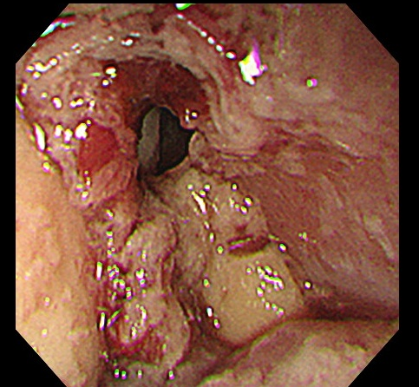
Figure 1 Imaging of primary lesion by upper gastrointestinal endoscopy. Upper gastrointestinal endoscopy shows a submucosal tumor-like protruding lesion occupying nearly the entire lumen from the mid to lower thoracic esophagus, causing stenosis.
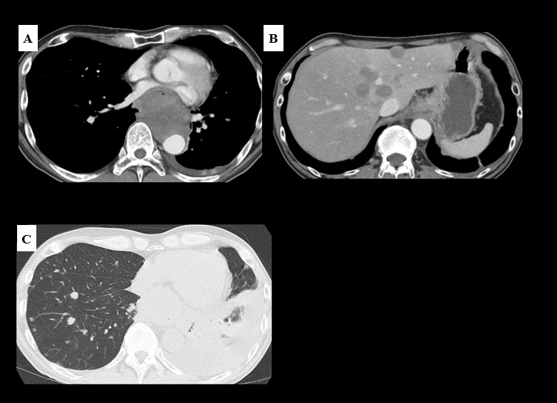
Figure 2 Imaging of primary and metastatic lesions by computed tomography. A: Contrast-enhanced computed tomography shows left atrial compression due to the esophageal tumor; B: Multiple liver metastases; C: Multiple lung metastases and left pleural effusion.
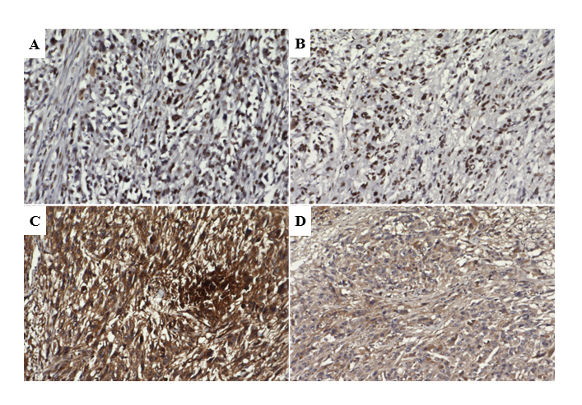
Figure 3 ZEB1 and TWIST in primary and metastatic cardiac lesions. Cancer stem cell markers ZEB1 and TWIST are immunohistologically positive in both the primary and metastatic cardiac lesions. A: ZEB1 staining of the primary lesion; B: ZEB1 staining of the cardiac lesion; C: TWIST staining of primary lesion; D: TWIST staining of the cardiac lesion.
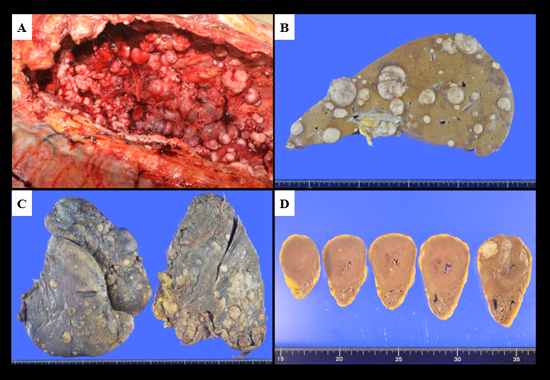
Figure 4 Autopsy examination findings. A: Numerous disseminated nodules are observed in the left pleural cavity; B: Multiple metastases in the liver; C: Multiple metastases in the lung; D: Multiple metastases in the heart.

