Name of Journal: World Journal of Clinical Oncology
Manuscript NO: 66908
Manuscript Type: ORIGINAL ARTICLE

Basic Study
Tumor specifically internalizing peptide ‘HN-1’: Targeting the putative receptor retinoblastoma-regulated discoidin domain receptor 1 involved in metastasis

Hong FU et al. DDR1 as putative HN-1 receptor

Frank-Un Hong, Miguel Castro, Klaus Linse

Frank-Un Hong, Miguel Castro, Klaus Linse, Research & Development, Bio-Synthesis, Inc., Lewisville, TX 75057, United States

Author contributions: Hong FU has worked on cancer genetics and molecular pharmacology; Castro M participated in therapeutics research; Linse K performed molecular modeling to predict the structure of peptides; Hong FU, Castro M, and Linse K meet the criteria for authorship established by the International Committee of Medical Journal Editors and verify the validity of the results reported; Hong FU wrote the manuscript; all authors approved the final version of the article.

Corresponding author: Frank-Un Hong, PhD, Research Scientist, Research & Development, Bio-Synthesis, Inc., 612 E Main St, Lewisville, TX 75057, United States. frank_hong@biosyn.com

Received: April 9, 2021
Revised: July 6, 2021
Accepted: April 22, 2022
Published online: May 24, 2022

Abstract
BACKGROUND
Less than 0.5% of intravenously injected drugs reach tumors, contributing to side effects. To limit damage to healthy cells, various delivery vectors have been formulated; yet, previously developed vectors suffer from poor penetration into solid tumors. This issue was resolved by the discovery of HN-1 peptide isolated via biopanning a phage-display library. HN-1 targets human head and neck squamous cell carcinoma (HNSCC) (breast, thyroid; potentially lung, cervix, uterine, colon cancer), translocates across the cell membrane, and efficiently infiltrates solid tumors. HN-1 peptide has been conjugated to various anticancer drugs and imaging agents though the identity of its receptor remained enigmatic.

AIM
To decipher the clues that pointed to retinoblastoma (Rb)-regulated discoidin-domain receptor 1 as the putative receptor for HN-1 is described.

METHODS
HN-1 peptide was synthesized and purified using reverse-phase high-performance liquid chromatography and gel electrophoresis. The predicted mass was confirmed by mass spectroscopy. To image the 3-dimensional structure of HN-1 peptide, PyMOL was used. Molecular modeling was also performed with PEP-FOLD3 software via RPBS bioinformatics web portal (INSERM, France). The immunohistochemistry results of discoidin domain receptor 1 (DDR1) protein were obtained from the publicly accessible database in the Human Protein Atlas portal, which contained the images of immunohistochemically labeled human cancers and the corresponding normal tissues.

RESULTS
The clues that led to DDR1 involved in metastasis as the putative receptor mediating HN-1 endocytosis are the following: (1) HN-1 is internalized in phosphate-buffered saline and its uptake is competitively inhibited; (2) HN-1 (TSPLNIHNGQKL) exhibits similarity with a stretch of amino acids in alpha5 beta3 integrin (KLLITIHDRKEF). Aside from two identical residues (Ile-His) in the middle, the overall distribution of polar and nonpolar residues throughout the sequences is nearly identical. As HN-1 sequence lacks the Arg-Gly-Asp motif recognized by integrins, HN-1 may interact with an "integrin-like" molecule. The tertiary structure of both peptides showed similarity at the 3-dimensional level; (3) HN-1 is internalized by attached cells but not by suspended cells. As culture plates are typically coated with collagen, collagen-binding receptor (expressed by adherent but not suspended cells) may represent the receptor for HN-1; (4) DDR1 is highly expressed in head and neck cancer (or breast cancer) targeted by HN-1; (5) Upon activation by collagen, DDR1 becomes internalized and compartmentalized in endosomes consistent with the determination of ’energy-dependent clathrin-mediated endocytosis’ as the HN-1 entry route and the identification of HN-1 entrapped vesicles as endosomes; and (6) DDR1 is essential for the development of mammary glands consistent with the common embryonic lineage rationale used to identify breast cancer as an additional target of HN-1. In summary, collagen-activated tyrosine kinase receptor DDR1 overexpressed in HNSCC assumes a critical role in metastasis. Further studies are warranted to assess HN-1 peptide’s interaction with DDR1 and the therapeutic potential of treating metastatic cancer. Additionally, advances in delivery (conformation, endocytic mechanism, repertoire of targeted cancers of HN-1 peptide), tracking (HN-1 conjugated imaging agents), and activity (HN-1 conjugated therapeutic agents) are described.

CONCLUSION
The discovery of DDR1 as HN-1 peptide’s putative receptor represents a significant advance as it enables identification of metastatic cancers or clinical application of previously developed therapeutics to block metastasis.

Key Words: HN-1 peptide; Solid tumor; Targeted drug delivery; Discoidin domain receptor 1; Tyrosine kinase; Metastasis

©The Author(s) 2022. Published by Baishideng Publishing Group Inc. All rights reserved.

Citation: Hong FU, Castro M, Linse K. Tumor specifically internalizing peptide ‘HN-1’: Targeting the putative receptor retinoblastoma-regulated discoidin domain receptor 1 involved in metastasis. World J Clin Oncol 2022; 13(5): 323-338
URL: https://www.wjgnet.com/2218-4333/full/v13/i5/323.htm
DOI: https://dx.doi.org/10.5306/wjco.v13.i5.323

Core Tip: The side effects associated with current drugs are exacerbated by the accumulation of administered drugs in non-tumor tissues. To guide, various tumor-homing vectors have been developed though their delivery efficacy is limited by poor penetration into solid tumors. To resolve, the ‘tumor specifically internalizing peptide’ HN-1 was isolated via biopanning a phage-display library. HN-1 peptide targets human head and neck squamous cell carcinoma (breast, thyroid, potentially cervical, lung, uterine, colon cancer), translocates across the cell membrane and effectively penetrates solid tumors. Here, deciphering of the clues that pointed to discoidin domain receptor 1 as the putative receptor for HN-1 is described.

INTRODUCTION
The genetic analysis of head and neck cancer has uncovered novel therapeutic targets. Head and neck cancer represents ~5% of all cancers diagnosed in the United States and the affected regions include the oral cavity, paranasal sinuses, pharynx, nasal cavity, larynx, thyroid gland, parathyroid gland, salivary gland, skin or cervical lymph nodes. Aesthetic loss or functional impairment (ex. difficulties with swallowing, speech, chewing) frequently accompany the disorder. Squamous cells constitute the mucosal membranes lining the lips, mouth, throat, breathing tubes, nose, eyelids, etc. and head and neck squamous cell carcinoma (HNSCC) (the second most common type of skin cancer) affects more men than women. Its mortality rate (~50%) has not changed significantly over the past several decades although early diagnosis may increase survival. Most HNSCC-associated deaths are caused by loco-regional recurrence or distant metastasis^{[1]}.
Epithelial carcinogenesis leading to head and neck cancer involves progression through multiple stages (from normal to hyperplasia to dysplasia to carcinoma to invasive carcinoma) accompanied by distinct genetic changes. Among the alterations are the loss of heterozygosity at chromosomal region 9p21 or 3p12-14 (squamous dysplasia, carcinoma in situ, invasive carcinoma), loss of heterozygosity at 9p21 or 3p14 (oral leukoplakia), and translocation between chromosomes 11 and 19 (mucoepidermoid carcinoma of the minor salivary gland). Microsatellite instability is observed in a subset of dysplastic, invasive, and aggressive lesions while aneuploidy is a frequent occurrence amongst HNSCC tumors^{[2]}.
The inactivation of retinoblastoma (Rb) function represents a critical step in HNSCC development. Briefly, following the identification of the prototypic tumor suppressor RB gene, its role in mammalian DNA damage checkpoint (in G1 or S phase) was elucidated^{[3]}. Rb’s ability to arrest at G1 is negatively regulated by distinct cyclin-dependent kinases (Cdks) through phosphorylation by cyclin D-Cdk4/6 at early G1 phase and cyclin E-Cdk2 late G1 phase^{[4,5]}. Cdks are, in turn, negatively regulated by p14^{Art}, p16^{INK4A}, or other factors including p21^{Cip1}, which is transactivated by p53. The above ‘Rb pathway’ is dysregulated in nearly all human cancers and is also targeted by oncogenic viruses (ex. papillomavirus, adenovirus) to transform human cells. In HNSCC, the loss of p16^{INK4A} is characteristic of hyperplasia and the loss of 3p21 and 17p13 (inactivates p53) is observed during progression to dysplasia. The amplification of the CCND1 gene (encodes cyclin D) and the loss of 11q13, 14q32, or 13q21 is associated with carcinoma. The loss of 6p, 4q27, 8 or 10q23 as well as the inactivation of phosphatase and tensin homolog (PTEN) has been documented in invasive carcinoma^{[6]}. In a significant fraction of HNSCC patients with poor prognosis, human papillomavirus DNA is found in tumors, whose gene product E7 inactivates Rb while E6 inactivates p53. Additionally, FAT1, NOTCH1, KMT2D, NSD1, TGFBR2, PIK3CA, and HER-2/neu are frequently upregulated in a subset of HNSCC.
The above advances have led to the development of targeted therapies, i.e., Cdk4/6 inhibitor, epidermal growth factor receptor inhibitor, etc. However, even with targeted drugs, the problem of side effects persists. Furthermore, less than 0.5% of systemically administered drugs reach tumors, requiring a higher dose for treatment which exacerbates side effects^{[7]}. To resolve, tumor-homing vectors are increasingly sought for targeted delivery of existing drugs. In the case of HNSCC, ‘sac’-like structures contain tumor cells enclosed within the basement membrane. The parenchyma is comprised of tumor cells with intercellular spaces. A solid tumor may contain multiple such ‘sacs’ interspersed within the stroma. Stroma is a complex structure comprised of cytokeratin and normal cells, ex. fibroblasts, endothelial cells, immune cells. As such, an ideal delivery vector should be capable of penetrating these barriers to reach tumor cells located at the interior of the sac-like structures.
For targeted delivery, antibodies recognizing tumor-specific antigens such as CD20 (B-cell lymphoma), HER-2 (breast cancer), CD33 (acute myeloid leukemia), epidermal growth factor receptor have been developed. Anticancer agents conjugated to these antibodies include radioactive isotopes (non-Hodgkin’s lymphoma) and chemotherapeutics, ex. doxorubicin, maytansine, and calicheamicin (acute myelogenous leukemia). Alternatively, larger molecules such as polyethylene glycol have been used as they can escape through leaky tumor vasculature to deposit on a tumor. The leakage occurs primarily at venules and small veins that are lined by a continuous endothelium. Their exiting route consists of a system of vesiculo-vacuolar organelles, cell junction, or endothelial fenestrae. Previously, polyethylene glycol has been conjugated to taxol or tumor-specific antibodies. Also, liposomes have been utilized as they can accumulate at the tumor due to enhanced permeability and retention. Liposomes deliver drugs via fusion, destabilization of the membrane or endocytosis. Liposomes conjugated to polyethylene glycol exhibit greater stability due to lesser removal by the reticuloendothelial system^{[8]}. Pegylated liposomes containing doxorubicin or cisplatin or liposomes coupled to tumor-targeting molecules have been developed.
However, the above delivery vectors face several limitations. For antibody vectors, its preparation or purification is complex due to the relative ease with which antibodies can denature. Other potential issues are immunogenicity (requires humanization) and the lack of internalization by the cancer cells. Poor penetration of solid tumors by antibodies further limits their use and may contribute to a higher level of drugs in circulation contributing to toxicity, ex. Herceptin antibody penetrates mere 38 micrometers after exiting blood vessels^{[9]}. For these reasons, its use has been limited to lymphocytic cancers. For minute micrometastasized tumors that rely on nutrients obtained from adjacent blood vessels via diffusion, nanoparticles such as polyethylene glycol or liposome-based vectors that escape through leaky tumor vasculature may find little utility. The use of liposomes is delimited by the inefficient release of the enclosed drugs^{[10]}. Overall, inefficient penetration of solid tumors has been a major issue with larger nanoparticles. As the interior of solid tumors may harbor hypoxic regions that give rise to refractory metastatic cancer cells to which patients ultimately succumb, the need to develop delivery vectors with greater infiltrating potential remains a priority^{[11]}.
The above issues have been largely resolved through the discovery of the prototypic ‘tumor specifically internalizing peptide’ HN-1, which was reported in Cancer Research in 2000^{[12]}. HN-1 peptide is unique as it provided multiple advantages including tumor-selectivity for HNSCC, the capacity to translocate across the cell membrane, and the ability to penetrate solid tumors to reach cancer cells located within the sac-like structures. Since its discovery, HN-1 has been conjugated to various agents for both cancer therapy (taxol, doxorubicin, protein kinase C inhibiting peptide, ribonucleotide reductase inhibiting siRNA, diphtheria toxin, polyethylene glycol linked to doxorubicin, graphene oxide nanoparticle-containing doxorubicin) and imaging (gamma-ray emitting isotopes for radiotherapy, near-infrared fluorescent dyes for surgical navigation) (see below). Recently, the target of HN-1 has been extended to breast cancer, thyroid cancer, and potentially cervical, lung, uterine, or colon cancer. Here, we describe the deciphering of clues that helped to unravel a 20 year-old enigma regarding the identity of the receptor mediating HN-1 endocytosis. Discoidin domain receptor 1 (DDR1) is a collagen tyrosine kinase overexpressed in head and neck cancer (also breast cancer), and the transcription of DDR1 gene is regulated by the RB-interacting protein E2F^{[13]}. DDR1 differs from conventional tyrosine kinases as it is activated by collagen, and plays a critical role in metastasis by facilitating invasion or migration, promoting epithelial-to-mesenchymal transition, reactivating previously disseminated metastasis-initiating cancer cells, etc. As such, it has become a novel therapeutic target of high importance for the pharmacological management of metastatic cancers (see below).

MATERIALS AND METHODS
Peptide
HN-1 peptide was synthesized and purified using reverse-phase high-performance liquid chromatography to attain ~95% purity. For in vivo application, it was further purified using gel electrophoresis. The predicted mass was confirmed by mass spectroscopy.

Molecular modeling
PyMOL (Python-enhanced molecular graphics) was used to image the 3-dimensional structure of the HN-1 peptide. Additional molecular modeling was performed using PEP-FOLD3 software via RPBS (Ressource Parisienne en Bioinformatique Structurale) bioinformatics web portal (INSERM, France) (https://bioserv.rpbs.univ-paris-diderot.fr/services/PEP-FOLD/)^{[14,15]}.

Immunohistochemistry
The immunohistochemistry images of DDR1 protein in a panel of human head and neck cancer specimens vs normal human oral mucosa were obtained from the publicly accessible database in the Human Protein Atlas portal (http://www.proteinatlas.org/). It contained the images of immunohistochemically labeled human cancers and the corresponding normal tissues.

RESULTS
Structure of HN-1 peptide
F. Hong (a.k.a. Frank Un, Frank D. Hong)’s contributions to the RB gene field was previously described^{[16]}. Briefly, for cancer biology and genetics, his works include the identification of the human RB gene and its sequence containing cyclin-dependent kinase recognition motifs^{[3]}, determination of RB genome structure including the promoter^{[17]} and its mutant in prostate cancer^{[18]}, the discovery of the DNA binding property of Rb protein indicative of its function as a transcription factor^{[19]}, uncovering of RB-to-RB self-interaction to form higher-ordered structures implicating its role in epigenetics, DNA replication, histone modification, heterochromatin, DNA condensation, etc^{[20-23]}. For cancer therapy, his works concerned elucidating the cytotoxic mechanism of anticancer drugs to solve the side effects or drug resistance problem. He discovered tumor-specific lytic path ‘hyperploid progression mediated death’ targeting G1 DNA damage checkpoint-defective RB or p53 mutants induced by antimicrotubule drugs (ex. Taxol)^{[24]}, RB’s role as the mediator of DNA crosslinking drug cytotoxicity (ex. cisplatin) in G1 checkpoint retaining human cancers^{[25]}, and the reversal of drug resistance to antimetabolite drugs (ex. hydroxyurea) via attenuating the Rb-associating protein ICBP90 (UHRF1)^{[26]}.
Following the identification of the human RB gene, W. Lee (University of California at San Diego, La Jolla, United States) collaborated with T. Friedmann (University of California at San Diego, La Jolla, United States) to develop a recombinant retrovirus expressing human RB or p53 gene during 1988-1993. The retrovirally expressed RB or p53 suppressed the formation of tumors derived from human retinoblastoma, breast, or prostate cancer cells in murine xenograft models^{[27-29]}. These works led to gene therapy clinical trials testing the efficacy of p53 expressing retrovirus or adenovirus in non-small cell lung cancer patients by J. Roth (University of Texas M. D. Anderson Cancer Center, Houston, United States) in 1996 and HNSCC patients by G. Clayman (University of Texas M. D. Anderson Cancer Center, Houston, United States) in 1998^{[30,31]}. The clinical trial was conducted in collaboration with W. K. Hong (University of Texas M. D. Anderson Cancer Center, Houston, United States), who pioneered the chemoprevention of cancer^{[32]}. Despite the therapeutic gains made in gene transduction, gene expression, and clinical response, further improvement was necessary regarding tumor specificity, solid tumor penetration, and in vivo stability.
The side effects occurred as the RB or p53 expressing recombinant virus indiscriminately infects both cancer and normal cells. To provide tumor specificity, F. Hong sought to identify a human HNSCC-specific peptide to be displayed on the surface of viral vectors. Earlier In 1984-1985, he used M13 single-stranded bacteriophage to perform site-directed mutagenesis at the Salk Institute (Molecular Biology & Virology Laboratory). Later, in 1993-1995, he worked with normal human fibroblasts while studying the mechanism of aging at the Salk Institute (Neurobiology Laboratory). During 1998-2000, F. Hong screened M13 bacteriophage-displayed random peptide libraries (2.5 × 10¹² random peptides) using live cancer cells at the University of Texas M. D. Anderson Cancer Center^{[12]}. Filamentous phages displaying peptides fused to coat proteins were designed by G. Smith (Nobel prize, 2018). The biopanning involved 5 successive rounds of selection using human HNSCC cells, followed by 3 cycles of subtraction using normal human fibroblasts in the presence of serum to ensure stability in vivo. It led to the discovery of HN-1 peptide (TSPLNIHNGQKL; ~1.2 kDa) that meets multiple criteria for targeted drug delivery into solid tumors: (1) Translocates drugs across the cell membrane into the cytosol; (2) Tumor specifically internalized; and (3) Capable of penetrating solid tumors. Further, HN-1 peptide is nontoxic, nonimmunogenic, stable in vivo, transports payload efficiently within 48 h, and does not trigger biological responses.
Recent researches increasingly indicate the dynamic nature of protein structures, i.e., ‘intrinsically disordered protein’^{[33]}. Despite the conformational flexibility, they can adopt a fixed or rigid structure upon recognizing the interacting target. Such properties have been harnessed by peptides, which provide further advantages over antibodies or small molecules for pharmaceutical treatment, resulting in the approval of > 60 peptide drugs worldwide in the last two decades. In the case of HN-1, computational modeling predicted several structural conformations. A 3-dimensional model depicting HN-1 peptide in a beta-sheet configuration is shown (Figure 1A). Alternate conformations of HN-1 peptide predicted by the PEP-FOLD modeling program are also shown (Figure 1B). Finally, a structural model consisting of a gamma-turn is shown (Figure 1C).

DDR1 may mediate HN-1 endocytosis
The treatment issue of recurrent metastatic cancer refractory to current drugs remains unresolved for HNSCC as well as breast cancer. The dysregulation of the extracellular matrix dynamics is thought to play a significant role in metastasis. The extracellular matrix is comprised of glycoproteins, proteoglycans, and other proteins that function in biomechanics, cell motility, growth factor reservoir, cell-to-cell communication, etc. An early event in tumor development involves neovascularization (for nutrient, oxygen, excretion), which requires the outgrowth of blood vessels via endothelial branching mediated by tip cells and stalk cells that depend on the extracellular matrix. The extracellular matrix also attracts immune cells and activates them to release cytokines and proteases (causes tumor-associated inflammation) while suppressing the activation of macrophages that lyse cancer cells. The dysregulated extracellular matrix exhibits altered activities of remodeling enzymes (ex. collagenase or metalloprotease secreted by stroma), excess deposition of the matrix components (ex. collagen types I, IV or XVII by tumor cells, cancer-associated fibroblasts or tumor-associated macrophages in colorectal cancer; heparan sulfate proteoglycan), stiffness through the crosslinking by lysyl oxidase, etc. Distinct collagen types found in the microenvironment of various cancers have been compiled, e.g., type I (head and neck squamous cell carcinoma, non-small cell lung cancer, breast cancer), type III (breast cancer), type IV (oral squamous cell cancer, colorectal cancer)^{[34]}. Other changes include the altered orientation (linearization) of collagen fibers, which facilitates tumor cell migration (for invasion into adjacent tissues following the breakdown of basement membrane by matrix metalloproteinase)^{[35]}. Further, the extracellular matrix is involved in the development of lymphatic vessels that serve as a conduit (in addition to the leaky tumor vasculature) for metastasis.
Discoidin domain receptors DDR1 and DDR2 are cell membrane-associated receptors with tyrosine kinase activity, whose extracellular domain resembles discoidin of Dictyostelium discoideum. DDR1 is activated by most collagen types including I and IV (abundant in the basement membrane) whereas DDR2 is activated by fibrillar collagen types I, III, and X but not II or IV^{[36]}. Discoidin domain receptors regulate cell adhesion, growth, polarity, and migration through sensing extracellular matrix and interacting with TGF-beta, Notch, or adhesive receptors for signaling. The stromal-epithelial interaction mediated by DDR1 is essential for the normal development of mammary glands in mice^{[37]}. DDR1 promotes cancer progression by facilitating the migration of squamous cell carcinoma cells^{[38]}, bone metastasis by lung cancer^{[39]}, lung metastasis by breast cancer^{[40]}, stroma-induced peritoneal metastasis of gastric cancer^{[41]}, and tissue invasion by metastatic colorectal cancer cells^{[42]}. Mechanistically, activation of DDR1 by collagen induces matrix metalloproteinase to degrade extracellular matrix^{[43]}. DDR1 overexpressed in oral squamous carcinoma is involved in angiolymphatic invasion^{[44]}. DDR1 is involved in invadosome formation via collagen-mediated activation of Rho-GTPase Cdc42^{[45]}. DDR1 facilitates the invasion of a collective group of tumor cells by modulating actomyosin contractility at the cell-cell contacts^{[38]}. Collagen type IV was shown to activate DDR1 to induce migration of breast cancer cells^{[46]}. The epithelial-to-mesenchymal transition represents a critical step for metastasis and is triggered by extracellular matrix molecules or growth factors. The triggering by collagen type I is mediated by DDR1, whose signaling is transduced by proline-rich tyrosine kinase 2 to upregulate N-cadherin^{[47]}. The DDR1 expression positively correlates with epithelial-to-mesenchymal transition in squamous cell carcinoma, breast cancer, ovarian cancer, and hepatoma^{[48]}. Additionally, DDR1 (activated by collagen type I) functions in the reactivation of previously disseminated metastasis-initiating cancer cells after dormancy^{[13,40]}.
Rb’s tumor-suppressing function extends to the genetic regulation of DDR1 to inhibit metastasis. Through associating with E2F, Rb inhibits the transactivation of DDR1 by E2F^{[49]}. The transcription of DDR1 is also regulated by p53 of the ‘Rb pathway’^{[50]}. The human DDR1 gene consists of 17 exons, which encode an extracellular domain (discoidin domain for ligand binding), a transmembrane domain, and an intracellular domain (tyrosine kinase). Alternative splicing generates multiple isoforms, which include DDR1c encoding the full-length receptor, DDR1b lacking 6 residues (between exon 13 and 14), DDR1a lacking these and additional 37 residues (juxtamembrane region), and DDR1d plus DDR1e (both tyrosine kinase-deficient due to C-terminal truncation)^{[48,51]}. DDR1 remains a dimer (N-glycosylated) without the bound ligand. Binding to collagen activates DDR1 via clustering, causing autophosphorylation to initiate signaling^{[43,52]}. DDR1 is overexpressed in head and neck, esophagus, lung, breast, ovarian, prostate, and brain cancers in addition to leukemia and lymphoma. DDR1 is also upregulated in osteosarcoma, endometrial cancer, primary central nervous system lymphoma, and liver cancer^{[13]}. It correlated with a reduced overall survival (e.g., metastatic colorectal cancer)^{[36]} and a poor prognosis (e.g., non-small cell lung cancer) for most cancers. Figure 2 shows the overexpression of DDR1 in human head and neck squamous cell carcinoma.
Multiple data indicate that the entry of HN-1 peptide is mediated by DDR1. First, HN-1 is internalized in phosphate-buffered saline (lacking the components of fetal bovine solution); plus, its uptake is competitively inhibited, indicating that specific interaction with cell surface receptor is necessary for its uptake^{[12]}. Second, a high degree of similarity was discovered between HN-1 (TSPLNIHNGQKL) and a stretch of amino acids in alpha5 beta3 integrin (KLLITIHDRKEF). Aside from two identical residues (Ile-His) in the middle, the overall distribution of polar and nonpolar residues throughout the sequences was nearly identical (Figure 3A). The tertiary structure of both peptides exhibited similarity at the 3-dimensional level (Figure 3B). The found motif represents the membrane-proximal sequence of the beta subunit’s cytoplasmic tail that interacts with the alpha subunit’s cytoplasmic tail, whose disruption changes the conformation of the extracellular domain to engage the ligand^{[53,54]}. As the HN-1 sequence lacks the Arg-Gly-Asp motif recognized by integrins, HN-1 may interact with an "integrin-like" molecule (instead of integrin). Third, HN-1 is uptaken by attached cells but not by suspended cells^{[55]}. As tissue culture plates are typically coated with collagen (type I or IV), it suggests that collagen-binding receptor (expressed by adherent but not suspended cells) may represent the receptor for HN-1. Fourth, DDR1 is overexpressed by head and neck cancer or breast cancer targeted by HN-1. Fifth, upon activation by collagen, DDR1 becomes internalized and compartmentalized in endosomes^{[56]}, which is consistent with the identification of energy-dependent clathrin-mediated endocytosis as the entry route of HN-1^{[57]} and the determination of HN-1 entrapped vesicles as endosomes^{[38]}. Sixth, DDR1 is essential for the development of mammary glands^{[37]} in keeping with the common embryonic lineage rationale used to identify breast cancer as an additional cancer target of HN-1^{[58]}. Taken together, these results suggest that DDR1 may mediate the endocytosis of the HN-1 peptide.

DISCUSSION
HN-1 peptide is preferentially internalized by cancer cells. HN-1 was internalized by almost all human HNSCC cell lines examined to date (MDA177Tu, MDA138Tu, MDA59Tu, MDA167Tu, MDA686Tu, MDA1986Tu, UMSCC1, UMSCC36)^{[12,59]}. UMB-SCC-745, UT-SCC-36, UT-SCC-38^{[60]}, SCC-25, Detroit 562^{[61]}, CAL-27, and SCC-25 human HNSCC cells^{[62]} also internalized HN-1. Recently, the uptake of HN-1 by human oral squamous cell carcinoma SCC-25 and CAL-27 cells was reported^{[63]}. Further, HN-1 was selectively internalized by human head and neck squamous cell carcinoma derived SCC4, SCC9, and CAL27^{[57]}. Little uptake of HN-1 was observed with MDA182Tu cells. Additionally, HN-1 peptide was internalized by human pharynx squamous cell carcinoma FaDu cells used in the mouse xenograft model study^{[64]}. In vivo, intravenously administered HN-1 selectively localized to human HNSCC-derived tumors in a mouse xenograft model^{[12,57,59,62,65]}. In contrast, HN-1 was poorly uptaken by their normal counterpart (human oral keratinocytes HOK16B, NOE human normal oral epithelial cells, NHDF normal human dermal fibroblasts)^{[12,58,59]}.
Recent works have uncovered additional cancer types targeted by HN-1 peptide (Figure 4A). HN-1 uptake was also observed with human large cell lung carcinoma H460a cells^{[64]}. Also, the HN-1 derived peptide HN17 (contains rearranged HN-1 sequence) was internalized by MZ-CRC 1 and TT human thyroid cancer cells^{[66]}. HN-1 was also shown to target breast cancer irrespective of their ‘triple status’. HN-1 or HN-1^{TYR} (HN-1 with two extra tyrosine residues added N-terminally) was internalized by MDA-MB231, SKBR3, MDA-MB-468, ZR-75-1, or MCF-7 breast cancer cells while MCF10A nontumorigenic mammary epithelial cells exhibited little HN-1 uptake^{[58,59]}. Additionally, HN-1 was internalized by MDA-MB-435, MDA-MB-231, and MTLn3 breast cancer cells^{[64]}. Further, HN-1 was internalized by KB cells^{[58]} (originally human oral epidermoid carcinoma cells but subsequently found to contain HeLa human cervical adenocarcinoma cells)^{[67]}, raising the prospect that HN-1 may target cervical cancer. For uterine cancer, HN-1 uptake by MES-SA/Dx5, a multi-drug resistant cell-line derived from the human uterine sarcoma cell line MES-SA, was documented^{[64]}. For gastrointestinal cancer, HN-1 uptake was observed with human colorectal carcinoma LS513 and LS1034 cells^{[64]}.
HN-1 peptide translocates across the cell membrane to facilitate drug delivery. Upon entry, HN-1 is localized in punctate particles, which were subsequently identified as endosomes^{[57,60]}. Multiple reports suggest that HN-1 is internalized via the ‘receptor-mediated endocytosis’: (1) The internalization of HN-1 is ‘specific’ (based on competition assay); (2) HN-1 can be uptaken in a serum-free medium (i.e., its receptor is cell-associated); (3) HN-1 is compartmentalized in endosomes after entry; and (4) Fusing the translocation domain of diphtheria toxin allows HN-1 to escape from the endosome into the cytosol. Using inhibitors of various entry routes (receptor-dependent endocytosis, pinocytosis, simple transmembrane diffusion, caveolae-mediated pathway), HN-1 uptake was shown to be mediated by ‘energy-dependent clathrin-mediated endocytosis’^{[57]}.
HN-1 efficiently penetrates tumor mass, which is significant as > 90% of human cancers are comprised of solid tumors. The intravenously injected HN-1 was localized at the interior of solid tumors derived from MDA177Tu or MDA167Tu human HNSCC cells in a mouse xenograft model^{[12]}. An independent report showed that the intravenously injected HN1 penetrates solid tumors derived from UMSCC1 human HNSCC cells in vivo^{[59]}. Using radiolabeled HN-5 peptide, a derivative of HN-1, its penetration into solid tumors formed by SCC4 human HNSCC cells was documented using a nude rat model^{[57]}. Further, nanoparticles displaying HN-1 peptide effectively penetrated solid tumors derived from human oral squamous cell carcinoma SCC-25 cells in a murine xenograft model^{[62]}. Through these works, the pharmacological properties of HN-1 have been confirmed globally.
The unique properties of HN-1 have been exploited to develop novel anticancer therapeutics (Figure 4B). In 2009, Henri et al^{[64]} (Tapestry Pharmaceuticals, Boulder, United States) developed targeted chemotherapy comprised of HN-1 peptide and taxol. Taxol is an antimicrotubule drug that induces lethality by triggering ‘hyperploid progression mediated death’ in G1 DNA damage checkpoint defective human cancer cells due to mutant Rb or p53 gene^{[16,24,68]}. The authors delineated a series of complex organic chemistry synthesis steps to conjugate HN-1 to taxol without affecting the latter’s antimicrotubule property. Using a murine xenograft model derived from human head and neck cancer FaDu cells, the authors demonstrated that the HN-1 peptide-to-taxol conjugate completely suppresses the growth of tumors. Further, it exhibited synergy with a second chemotherapeutic agent against breast, lung, uterine, or colon cancer cells. Of significance, the combined regimen increased growth inhibition from < 15% (by a single agent) to ~80% against breast cancer cells. For drug resistance, the conjugate showed activity against multi-drug resistant human uterine sarcoma cells.
In 2007, Zheng (University of Texas Health Science Center, San Antonio, United States) developed HN-5 (CYTSPLNIHNGQKL), a derivative of HN-1 peptide containing one cysteine and one tyrosine residue at the N terminus^{[57]}. Using HN-5 peptide radiolabeled with Cu-64 gamma-ray emitter, human HNSCC cell-derived tumor xenograft in a nude rat model was successfully imaged via positron emission tomography. HN-5 peptide exhibited specificity and affinity to HNSCC and exhibited a high diffusion capacity within a solid tumor. More significantly, by conjugating to HN-5, a significant reduction in the accumulation of unconjugated Cu-64 radioisotopes in the liver, heart, kidney, lung, and small intestine was observed. Subsequently, in 2013, Nordquist (University of Texas Health Science Center, San Antonio, United States) quantitatively documented selective accumulation of the radiolabeled HN-5 peptide in HNSCC-derived tumor xenografts. Of relevance, HN-4 peptide linked to the radioisotope Tc-99m has been presented at the 2007 American Association for Advancement of Science annual meeting.
In 2008, the HN-4 peptide was used to develop a human HNSCC-targeting liposome for targeted drug delivery. The components used to construct the liposomes included the lipids DPPC, DMPG, and PEG. The synthesis involved the preparation of lipid film, reconstitution in sucrose solution, and extrusion to limit particle size to 100 nm, which was presented at the 2008 Texas Science & Engineering Fair.
In 2010, Bao et al^{[59]} (Ohio State University Medical, Center, Columbus, United States) developed HN1-PKC(epsilon), a capped bi-functional peptide comprised of HN-1 peptide and PKC(epsilon)-inhibitory peptide connected through a linker. The bifunctional inhibitory peptide was selectively internalized by human HNSCC cells and suppressed the growth of HNSCC xenograft in nude mice. The report also extended the targets of HN1 peptide to breast cancer. Of clinical significance, whereas cisplatin alone inhibited the growth of HNSCC cells by 49%, combining cisplatin with the above bi-functional peptide suppressed growth by 72%.
In 2011, Potala et al^{[60]} (Indian Institute of Technology Madras, Chennai, India) developed a novel fusion toxin comprised of HN-1 peptide and diphtheria toxin. The fusion toxin displayed a high degree of selectivity towards HNSCC and exhibited IC₅₀ of 1-5 nM (nanomolar). They characterized ‘energy-dependent clathrin-mediated endocytosis’ as the HN-1 entry route and identified the intracellular punctate particles containing internalized HN-1 peptides as endosomes. The authors also found that the internalized fusion toxin utilized the translocation domain (of diphtheria toxin) to gain entry into the cytosol from endosomes.
In 2011, Dudas et al^{[55]} (Medical University Innsbruck, Innsbruck, Austria) reported that the pharmacological properties of HN-1 peptide could be recapitulated using distinct human HNSCC cells. Further, the authors reported a seminal finding that the binding of HN-1 peptide to human HNSCC cells occurred in attached but not suspended cells^{[55]}. It suggested that the expression level of the cognate cell surface receptor for HN-1 is governed by the presence of an extracellular matrix to which it adheres, providing an important clue for the discovery of DDR1 as the putative receptor for HN-1 peptide (see above).
In 2012, for gene therapy, Un et al^{[58]} (Beckman Research Institute of City of Hope National Medical Center, Duarte, United States) developed a therapeutic conjugate composed of HN-1(Tyr) and a siRNA targeting human ribonucleotide reductase subunit M2. HN-1(Tyr) contains two tyrosine residues added N-terminally to the HN-1 peptide^{[58]}. The siRNA(R) resistant to RNase degradation was designed by J. Rossi (City of Hope National Medical Center, Duarte, United States)^{[69]} and was able to suppress endogenously expressed ribonucleotide reductase in vivo after delivering in a nanoparticle constructed by M. Davis (California Institute of Technology, Pasadena, United States)^{[70]}. The clinical trial involving melanoma patients was conducted by Y. Yen (City of Hope National Medical Center, Duarte, United States), a former colleague of J. Doroshow (National Cancer Institute, Bethesda, United States). For RNA interference therapy, the HN-1(TYR)-anti-hRRM2 siRNA(R) construct moderatly suppressed the endogenously expressed ribonucleotide reductase M2 subunit in breast cancer cells.
In 2017, Wang et al^{[62]} (Tianjin Medical University, Tianjin, China) constructed a nanoparticle comprised of polyethylene glycol via self-assembly, which contained the chemotherapeutic doxorubicin. Doxorubicin’s primary anticancer activity is associated with its propensity to intercalate with double-stranded DNA and inhibit topoisomerase II, and it has been used to treat leukemia, breast, lung, bladder, and other cancers. The nanoparticle was further modified to display HN-1 peptide at the exterior^{[62,71]}. The spherical construct (~150 nanometers) exhibited HNSCC-specific uptake and cytotoxicity. In vivo, HN-1 peptide endowed greater HNSCC targeting capacity and tumor penetrating potential to the PEGylated nanoparticle. Whereas unconjugated doxorubicin remained at the periphery, HN-1 Linked nanoparticle readily infiltrated to deeper regions of the tumor. The clinical use of doxorubicin is hampered by side effects-especially, cardiac damage. Intriguingly, a significantly lower amount (~1/15 fold) of doxorubicin accumulated in the heart and other organs (ex. liver, kidney, spleen, lung) after administering the construct in a murine xenograft model.
In 2017, Rossfeld et al^{[66]} (Arthur G. James Comprehensive Cancer Center and Ohio State University, Columbus, United States) developed a conjugate comprised of the near-infrared dye IRdye800 and HN-17 (TLPNSNHI KQGL), a derivative of HN-1 peptide, for intraoperative fluorescence imaging of tumors for optical surgical navigation. HN-17 (also called Compound-17) differs significantly from HN-1 at the primary structural level as it consists of a differentially permutated version of the HN-1 sequence. Though the sequence of HN-17 is comprised of identical amino acids (or their representation) as HN-1, it may not necessarily utilize the same entry mechanism as HN-1 (as indicated by its considerably faster rate of uptake). Further, whether HN-17 targets the same types of cancer as HN-1 is not known. Nevertheless, the study demonstrated that HN-1 peptide or its derivatives target medullary thyroid cancer. Subsequently, in 2019, Ding et al^{[65]} (Ohio State University, Columbus, United States) demonstrated that IRdye800 conjugated HN-1 or HN-17 peptide could be used for fluorescence image guided resection of HNSCC during surgery using an animal model harboring an HNSCC-derived tumor xenograft.
In 2021, Li et al^{[63]} (Shanxi Medical University School and Hospital of Stomatology, Taiyuan, China) developed a pH-sensitive (for drug release) delivery vector comprised of HN-1 peptide and nanoscale graphene oxide. After introducing polyethylene glycol to stabilize nanoscale graphene oxide, the construct was further modified to display HN-1 peptide to provide specificity for oral squamous cell cancer and achieve greater penetration into solid tumors. Doxorubicin was then loaded through the formation of hydrogen bond and pie-bond, which is weakened in an acidic milieu to allow drug release. Nearly 70% release of loaded drugs occurred at pH 5.6 compared to a significantly lower percentage at pH 7.4. As the tumor tissue exhibits an acidic environment, lower toxicity of the doxorubicin-containing nanoparticle to normal tissues (displaying higher pH) is expected.

CONCLUSION
In closing, we would like to reiterate that the accumulation of systemically administered cytotoxic anticancer drugs at various normal tissues following the intravenous injection can be debilitating for many cancer patients. To a large extent, the failure to guide drugs to tumors (resulting in < 0.5% of drugs reaching tumors) represents one of the major causes of side effects. Given the number of obstacles that the microenvironment of solid tumors poses (ex. stroma, basement membrane, interstitial pressure), overcoming these hindrances remains a major challenge in drug delivery. To reduce side effects, tumor-homing vectors are increasingly sought for targeted delivery. The use of previously developed vectors has been limited by inefficient penetration into solid tumors. Through the isolation of tumor specifically internalizing peptides such as HN-1, we have begun to chip away at the formidable problem of eliminating side effects associated with current drugs--hence, providing a molecular biological solution to the drug delivery problem. Following its discovery, multiple laboratories located globally have developed HN-1 conjugated therapeutics to mitigate side effects^{[61]}. The international effort has been extended to developing imaging agents for tumor diagnosis as well as surgical navigation. Taken together, these works confirm the tumor specificity of the HN-1 peptide and underscore the expanding repertoire of its therapeutic application. Finally, the deciphering of clues that pointed to DDR1 tyrosine kinase as the putative receptor of HN1 may prove to be critical in moving toward clinical application. Further studies are planned to assess HN-1 peptide’s interaction with DDR1 and the therapeutic potential of treating metastatic cancer.

ARTICLE HIGHLIGHTS
Research background
The genetic basis of human cancers was elucidated via the identification of the prototypic human tumor suppressor retinoblastoma (Rb) gene by F. Hong (previously worked on phosphate transferase system governing diauxie at the Johns Hopkins University, whose alternate interpretation inspired operon concept) at the University of California at San Diego. His determination of the Rb gene sequence helped to uncover the central role of Rb in regulating the cell cycle as a component of DNA damage checkpoint at the G1 or S phase, which is regulated by cyclin-dependent kinase (Cdk) resulting in FDA-approved Cdk4/6 inhibitors for treating advanced-stage breast cancer. His discovery of Rb’s intrinsic properties to interact with DNA as well as to form oligomers like the breast cancer type 1 susceptibility protein C-terminus (BRCT) laid the foundation for understanding Rb’s function in regulating DNA replication, transcription (ex. E2F), epigenetics (histone modification), heterochromatin, and condensation. These works culminated in his discovery of the tumor-specific lytic path ‘hyperploid progression mediated death’ targeting Rb or p53 mutant cancers.

Research motivation
Metastatic cancer diagnosed in late-stage remains a formidable challenge, often resulting in mortality. Combinatorial regimens consisting of multiple chemotherapeutic agents administered to treat metastatic cancer incur an unacceptably high level of morbidity.

Research objectives
There is a great unmet need to direct or guide the intravenously injected drugs to tumors as less than 0.5% reach tumors currently, contributing to severe side effects.

Research methods
Harnessing the power of molecular biology, random peptide displaying M13 bacteriophage-based library was screened by F. Hong, who previously utilized the recombinant phages to determine the genomic sequence of avian infectious bronchitis virus’ spike protein for vaccine development at the Salk Institute, which predated the emergence of COVID-19 coronavirus. The screening was conducted at the University of Texas M. D. Anderson Cancer Center using live surgically derived human head and neck squamous cell carcinoma cells. After screening 2.5 × 10¹² random peptides, a single peptide TSPLNIHNGQKL (HN-1) was isolated, which is tumor-specific, translocates across the cell membrane, and capable of penetrating solid tumors for targeted drug delivery.

Research results
Through global participation, the above properties of the HN-1 peptide have been confirmed. The international endeavor also led to the development of numerous HN-1 peptide conjugated agents for therapy (taxol, doxorubicin, protein kinase C inhibiting peptide, ribonucleotide reductase inhibiting siRNA, diphtheria toxin, polyethylene glycol linked to doxorubicin, graphene oxide nanoparticle-containing doxorubicin) as well as imaging (gamma-ray emitting isotopes for radiotherapy, near-infrared fluorescent dyes for surgical navigation) of cancer. More significantly, we now know that HN-1 peptide also targets breast and thyroid (potentially cervical, lung, uterine, colon) cancers.

Research conclusions
While analyzing its amino acid content, an important clue was obtained that pointed to discoidin domain receptor 1 (DDR1) as the HN-1 peptide’s cognate receptor. The finding is in alignment with previously accrued experimental data globally concerning the uptake route of HN-1. The identification of Rb-regulated DDR1 as the putative receptor for HN-1 opens unexpected opportunities to block cancer progression via targeting the very protein mediating metastasis.

Research perspectives
Through abrogating metastasis, it may preempt the recurrence of refractory metastatic cancers, which inevitably arise due to the acquiring of drug resistance.

ACKNOWLEDGEMENTS
We are grateful to Tri Ngo (Bio-Synthesis, Lewisville, United States) and D. Root (University of North Texas, Denton, United States) for molecular modeling. Also acknowledged are R. Dulbecco (Nobel prize 1975, oncogenic virus) of Salk Institute (La Jolla, United States), and the staff at Geary’s (Beverly Hills, United States). The discovery of HN-1 peptide by F. Hong was preceded by his prior works on gene transfer using lambda bacteriophage with S. Roseman (Johns Hopkins University, Baltimore, United States) in 1981-82, M13 single-stranded bacteriophage with J. Rose (a former colleague of D. Baltimore, Nobel prize 1975, reverse transcriptase) at the Salk Institute (La Jolla, United States) in 1984-1985, retroviral gene therapy vector from D. Miller (a former colleague of I. Verma, Salk Institute) at the Fred Hutchinson Cancer Research Center (Seattle, United States) in 1993, baculovirus gene expression system with D. Schubert (a former colleague of F. Jacob, Nobel prize 1965, operon) at the Salk Institute (La Jolla, United States) in 1993-1995, and adenovirus gene delivery vector with P. Nisen (a former colleague of S. Cohen, Nobel prize 1986, epidermal growth factor) at the University of Texas Southwestern Medical Center (Dallas, United States) in 1996-1997. F. Hong (consultant to the Beckman Research Institute of City of Hope National Medical Center) is listed as an inventor in United States patent 6,919,425 for HN-1 peptide filed by Fulbright & Jaworski (United States Special Prosecutor during the Watergate Scandal, Richard Nixon presidency) law firm (Houston, United States).

REFERENCES
1 Vokes EE, Weichselbaum RR, Lippman SM, Hong WK. Head and neck cancer. N Engl J Med 1993; 328: 184-194 [PMID: 8417385 DOI: 10.1056/NEJM199301213280306]
2 Mao L, Lee JS, Fan YH, Ro JY, Batsakis JG, Lippman S, Hittelman W, Hong WK. Frequent microsatellite alterations at chromosomes 9p21 and 3p14 in oral premalignant lesions and their value in cancer risk assessment. Nat Med 1996; 2: 682-685 [PMID: 8640560 DOI: 10.1038/nm0696-682]
3 Lee WH, Bookstein R, Hong F, Young LJ, Shew JY, Lee EY. Human retinoblastoma susceptibility gene: cloning, identification, and sequence. Science 1987; 235: 1394-1399 [PMID: 3823889 DOI: 10.1126/science.3823889]
4 Dyson NJ. RB1: a prototype tumor suppressor and an enigma. Genes Dev 2016; 30: 1492-1502 [PMID: 27401552 DOI: 10.1101/gad.282145.116]
5 Dick FA, Goodrich DW, Sage J, Dyson NJ. Non-canonical functions of the RB protein in cancer. Nat Rev Cancer 2018; 18: 442-451 [PMID: 29692417 DOI: 10.1038/s41568-018-0008-5]
6 Johnson DE, Burtness B, Leemans CR, Lui VWY, Bauman JE, Grandis JR. Head and neck squamous cell carcinoma. Nat Rev Dis Primers 2020; 6: 92 [PMID: 33243986 DOI: 10.1038/s41572-020-00224-3]
7 Wolinsky JB, Colson YL, Grinstaff MW. Local drug delivery strategies for cancer treatment: gels, nanoparticles, polymeric films, rods, and wafers. J Control Release 2012; 159: 14-26 [PMID: 22154931 DOI: 10.1016/j.jconrel.2011.11.031]
8 Park JW. Liposome-based drug delivery in breast cancer treatment. Breast Cancer Res 2002; 4: 95-99 [PMID: 12052251 DOI: 10.1186/bcr432]
9 Lee SS, Bindokas VP, Kron SJ. Multiplex Three-Dimensional Mapping of Macromolecular Drug Distribution in the Tumor Microenvironment. Mol Cancer Ther 2019; 18: 213-226 [PMID: 30322947 DOI: 10.1158/1535-7163.MCT-18-0554]
10 Maeda H, Khatami M. Analyses of repeated failures in cancer therapy for solid tumors: poor tumor-selective drug delivery, low therapeutic efficacy and unsustainable costs. Clin Transl Med 2018; 7: 11 [PMID: 29541939 DOI: 10.1186/s40169-018-0185-6]
11 Ruenraroengsak P, Cook JM, Florence AT. Nanosystem drug targeting: Facing up to complex realities. J Control Release 2010; 141: 265-276 [PMID: 19895862 DOI: 10.1016/j.jconrel.2009.10.032]
12 Hong FD, Clayman GL. Isolation of a peptide for targeted drug delivery into human head and neck solid tumors. Cancer Res 2000; 60: 6551-6556 [PMID: 11118031]
13 Auguste P, Leitinger B, Liard C, Rocher V, Azema L, Saltel F, Santamaria D. Meeting report - first discoidin domain receptors meeting. J Cell Sci 2020; 133 [PMID: 32094286 DOI: 10.1242/jcs.243824]
14 Shen Y, Maupetit J, Derreumaux P, Tufféry P. Improved PEP-FOLD Approach for Peptide and Miniprotein Structure Prediction. J Chem Theory Comput 2014; 10: 4745-4758 [PMID: 26588162 DOI: 10.1021/ct500592m]
15 Thévenet P, Shen Y, Maupetit J, Guyon F, Derreumaux P, Tufféry P. PEP-FOLD: an updated de novo structure prediction server for both linear and disulfide bonded cyclic peptides. Nucleic Acids Res 2012; 40: W288-W293 [PMID: 22581768 DOI: 10.1093/nar/gks419]
16 Hong FU, Castro M, Linse K. Tumor-specific lytic path "hyperploid progression mediated death": Resolving side effects through targeting retinoblastoma or p53 mutant. World J Clin Oncol 2020; 11: 854-867 [PMID: 33312882 DOI: 10.5306/wjco.v11.i11.854]
17 Hong FD, Huang HJ, To H, Young LJ, Oro A, Bookstein R, Lee EY, Lee WH. Structure of the human retinoblastoma gene. Proc Natl Acad Sci USA 1989; 86: 5502-5506 [PMID: 2748600 DOI: 10.1073/pnas.86.14.5502]
18 Bookstein R, Rio P, Madreperla SA, Hong F, Allred C, Grizzle WE, Lee WH. Promoter deletion and loss of retinoblastoma gene expression in human prostate carcinoma. Proc Natl Acad Sci USA 1990; 87: 7762-7766 [PMID: 2217208 DOI: 10.1073/pnas.87.19.7762]
19 Lee WH, Shew JY, Hong FD, Sery TW, Donoso LA, Young LJ, Bookstein R, Lee EY. The retinoblastoma susceptibility gene encodes a nuclear phosphoprotein associated with DNA binding activity. Nature 1987; 329: 642-645 [PMID: 3657987 DOI: 10.1038/329642a0]
20 Hong F, Lee WH. Sequence similarity between part of human retinoblastoma susceptibility gene product and a neurofilament protein subunit. Biosci Rep 1991; 11: 159-163 [PMID: 1958811 DOI: 10.1007/BF01182484]
21 Hensey CE, Hong F, Durfee T, Qian YW, Lee EY, Lee WH. Identification of discrete structural domains in the retinoblastoma protein. Amino-terminal domain is required for its oligomerization. J Biol Chem 1994; 269: 1380-1387 [PMID: 8288605]
22 Lee WH, Hollingsworth RE Jr, Qian YW, Chen PL, Hong F, Lee EY. RB protein as a cellular "corral" for growth-promoting proteins. Cold Spring Harb Symp Quant Biol 1991; 56: 211-217 [PMID: 1819487 DOI: 10.1101/sqb.1991.056.01.026]
23 Lee WH, Xu Y, Hong F, Durfee T, Mancini MA, Ueng YC, Chen PL, Riley D. The corral hypothesis: a novel regulatory mode for retinoblastoma protein function. Cold Spring Harb Symp Quant Biol 1994; 59: 97-107 [PMID: 7587136 DOI: 10.1101/sqb.1994.059.01.013]
24 Hong FD, Chen J, Donovan S, Schneider N, Nisen PD. Taxol, vincristine or nocodazole induces lethality in G1-checkpoint-defective human astrocytoma U373MG cells by triggering hyperploid progression. Carcinogenesis 1999; 20: 1161-1168 [PMID: 10383885 DOI: 10.1093/carcin/20.7.1161]
25 Un F. G1 arrest induction represents a critical determinant for cisplatin cytotoxicity in G1 checkpoint-retaining human cancers. Anticancer Drugs 2007; 18: 411-417 [PMID: 17351393 DOI: 10.1097/CAD.0b013e32801429ed]
26 Un F, Qi C, Prosser M, Wang N, Zhou B, Bronner C, Yen Y. Modulating ICBP90 to suppress human ribonucleotide reductase M2 induction restores sensitivity to hydroxyurea cytotoxicity. Anticancer Res 2006; 26: 2761-2767 [PMID: 16886595]
27 Huang HJ, Yee JK, Shew JY, Chen PL, Bookstein R, Friedmann T, Lee EY, Lee WH. Suppression of the neoplastic phenotype by replacement of the RB gene in human cancer cells. Science 1988; 242: 1563-1566 [PMID: 3201247 DOI: 10.1126/science.3201247]
28 Bookstein R, Shew JY, Chen PL, Scully P, Lee WH. Suppression of tumorigenicity of human prostate carcinoma cells by replacing a mutated RB gene. Science 1990; 247: 712-715 [PMID: 2300823 DOI: 10.1126/science.2300823]
29 Chen PL, Chen YM, Bookstein R, Lee WH. Genetic mechanisms of tumor suppression by the human p53 gene. Science 1990; 250: 1576-1580 [PMID: 2274789 DOI: 10.1126/science.2274789]
30 Roth JA, Nguyen D, Lawrence DD, Kemp BL, Carrasco CH, Ferson DZ, Hong WK, Komaki R, Lee JJ, Nesbitt JC, Pisters KM, Putnam JB, Schea R, Shin DM, Walsh GL, Dolormente MM, Han CI, Martin FD, Yen N, Xu K, Stephens LC, McDonnell TJ, Mukhopadhyay T, Cai D. Retrovirus-mediated wild-type p53 gene transfer to tumors of patients with lung cancer. Nat Med 1996; 2: 985-991 [PMID: 8782455 DOI: 10.1038/nm0996-985]
31 Clayman GL, el-Naggar AK, Lippman SM, Henderson YC, Frederick M, Merritt JA, Zumstein LA, Timmons TM, Liu TJ, Ginsberg L, Roth JA, Hong WK, Bruso P, Goepfert H. Adenovirus-mediated p53 gene transfer in patients with advanced recurrent head and neck squamous cell carcinoma. J Clin Oncol 1998; 16: 2221-2232 [PMID: 9626224 DOI: 10.1200/JCO.1998.16.6.2221]
32 Hong WK, Sporn MB. Recent advances in chemoprevention of cancer. Science 1997; 278: 1073-1077 [PMID: 9353183 DOI: 10.1126/science.278.5340.1073]
33 van der Lee R, Buljan M, Lang B, Weatheritt RJ, Daughdrill GW, Dunker AK, Fuxreiter M, Gough J, Gsponer J, Jones DT, Kim PM, Kriwacki RW, Oldfield CJ, Pappu RV, Tompa P, Uversky VN, Wright PE, Babu MM. Classification of intrinsically disordered regions and proteins. Chem Rev 2014; 114: 6589-6631 [PMID: 24773235 DOI: 10.1021/cr400525m]
34 Xu S, Xu H, Wang W, Li S, Li H, Li T, Zhang W, Yu X, Liu L. The role of collagen in cancer: from bench to bedside. J Transl Med 2019; 17: 309 [PMID: 31521169 DOI: 10.1186/s12967-019-2058-1]
35 Lu P, Weaver VM, Werb Z. The extracellular matrix: a dynamic niche in cancer progression. J Cell Biol 2012; 196: 395-406 [PMID: 22351925 DOI: 10.1083/jcb.201102147]
36 Lafitte M, Sirvent A, Roche S. Collagen Kinase Receptors as Potential Therapeutic Targets in Metastatic Colon Cancer. Front Oncol 2020; 10: 125 [PMID: 32117772 DOI: 10.3389/fonc.2020.00125]
37 Vogel WF, Aszódi A, Alves F, Pawson T. Discoidin domain receptor 1 tyrosine kinase has an essential role in mammary gland development. Mol Cell Biol 2001; 21: 2906-2917 [PMID: 11283268 DOI: 10.1128/MCB.21.8.2906-2917.2001]
38 Hidalgo-Carcedo C, Hooper S, Chaudhry SI, Williamson P, Harrington K, Leitinger B, Sahai E. Collective cell migration requires suppression of actomyosin at cell-cell contacts mediated by DDR1 and the cell polarity regulators Par3 and Par6. Nat Cell Biol 2011; 13: 49-58 [PMID: 21170030 DOI: 10.1038/ncb2133]
39 Valencia K, Ormazábal C, Zandueta C, Luis-Ravelo D, Antón I, Pajares MJ, Agorreta J, Montuenga LM, Martínez-Canarias S, Leitinger B, Lecanda F. Inhibition of collagen receptor discoidin domain receptor-1 (DDR1) reduces cell survival, homing, and colonization in lung cancer bone metastasis. Clin Cancer Res 2012; 18: 969-980 [PMID: 22223527 DOI: 10.1158/1078-0432.CCR-11-1686]
40 Gao H, Chakraborty G, Zhang Z, Akalay I, Gadiya M, Gao Y, Sinha S, Hu J, Jiang C, Akram M, Brogi E, Leitinger B, Giancotti FG. Multi-organ Site Metastatic Reactivation Mediated by Non-canonical Discoidin Domain Receptor 1 Signaling. Cell 2016; 166: 47-62 [PMID: 27368100 DOI: 10.1016/j.cell.2016.06.009]
41 Jin H, Ham IH, Oh HJ, Bae CA, Lee D, Kim YB, Son SY, Chwae YJ, Han SU, Brekken RA, Hur H. Inhibition of Discoidin Domain Receptor 1 Prevents Stroma-Induced Peritoneal Metastasis in Gastric Carcinoma. Mol Cancer Res 2018; 16: 1590-1600 [PMID: 29866925 DOI: 10.1158/1541-7786.MCR-17-0710]
42 Jeitany M, Leroy C, Tosti P, Lafitte M, Le Guet J, Simon V, Bonenfant D, Robert B, Grillet F, Mollevi C, El Messaoudi S, Otandault A, Canterel-Thouennon L, Busson M, Thierry AR, Martineau P, Pannequin J, Roche S, Sirvent A. Inhibition of DDR1-BCR signalling by nilotinib as a new therapeutic strategy for metastatic colorectal cancer. EMBO Mol Med 2018; 10 [PMID: 29438985 DOI: 10.15252/emmm.201707918]
43 Gadiya M, Chakraborty G. Signaling by discoidin domain receptor 1 in cancer metastasis. Cell Adh Migr 2018; 12: 315-323 [PMID: 30187813 DOI: 10.1080/19336918.2018.1520556]
44 Chen YL, Tsai WH, Ko YC, Lai TY, Cheng AJ, Shiah SG, Hsiao JR, Chang JY, Lin SF. Discoidin Domain Receptor-1 (DDR1) is Involved in Angiolymphatic Invasion in Oral Cancer. Cancers (Basel) 2020; 12 [PMID: 32244515 DOI: 10.3390/cancers12040841]
45 Juin A, Di Martino J, Leitinger B, Henriet E, Gary AS, Paysan L, Bomo J, Baffet G, Gauthier-Rouvière C, Rosenbaum J, Moreau V, Saltel F. Discoidin domain receptor 1 controls linear invadosome formation via a Cdc42-Tuba pathway. J Cell Biol 2014; 207: 517-533 [PMID: 25422375 DOI: 10.1083/jcb.201404079]
46 Castro-Sanchez L, Soto-Guzman A, Navarro-Tito N, Martinez-Orozco R, Salazar EP. Native type IV collagen induces cell migration through a CD9 and DDR1-dependent pathway in MDA-MB-231 breast cancer cells. Eur J Cell Biol 2010; 89: 843-852 [PMID: 20709424 DOI: 10.1016/j.ejcb.2010.07.004]
47 Shintani Y, Fukumoto Y, Chaika N, Svoboda R, Wheelock MJ, Johnson KR. Collagen I-mediated up-regulation of N-cadherin requires cooperative signals from integrins and discoidin domain receptor 1. J Cell Biol 2008; 180: 1277-1289 [PMID: 18362184 DOI: 10.1083/jcb.200708137]
48 Yeh YC, Lin HH, Tang MJ. Dichotomy of the function of DDR1 in cells and disease progression. Biochim Biophys Acta Mol Cell Res 2019; 1866: 118473 [PMID: 30954568 DOI: 10.1016/j.bbamcr.2019.04.003]
49 Wang Z, Sun X, Bao Y, Mo J, Du H, Hu J, Zhang X. E2F1 silencing inhibits migration and invasion of osteosarcoma cells via regulating DDR1 expression. Int J Oncol 2017; 51: 1639-1650 [PMID: 29039472 DOI: 10.3892/ijo.2017.4165]
50 Ongusaha PP, Kim JI, Fang L, Wong TW, Yancopoulos GD, Aaronson SA, Lee SW. p53 induction and activation of DDR1 kinase counteract p53-mediated apoptosis and influence p53 regulation through a positive feedback loop. EMBO J 2003; 22: 1289-1301 [PMID: 12628922 DOI: 10.1093/emboj/cdg129]
51 Alves F, Saupe S, Ledwon M, Schaub F, Hiddemann W, Vogel WF. Identification of two novel, kinase-deficient variants of discoidin domain receptor 1: differential expression in human colon cancer cell lines. FASEB J 2001; 15: 1321-1323 [PMID: 11344127 DOI: 10.1096/fj.00-0626fje]
52 Corcoran DS, Juskaite V, Xu Y, Görlitz F, Alexandrov Y, Dunsby C, French PMW, Leitinger B. DDR1 autophosphorylation is a result of aggregation into dense clusters. Sci Rep 2019; 9: 17104 [PMID: 31745115 DOI: 10.1038/s41598-019-53176-4]
53 Stupack DG, Puente XS, Boutsaboualoy S, Storgard CM, Cheresh DA. Apoptosis of adherent cells by recruitment of caspase-8 to unligated integrins. J Cell Biol 2001; 155: 459-470 [PMID: 11684710 DOI: 10.1083/jcb.200106070]
54 Vinogradova O, Velyvis A, Velyviene A, Hu B, Haas T, Plow E, Qin J. A structural mechanism of integrin alpha(IIb)beta(3) "inside-out" activation as regulated by its cytoplasmic face. Cell 2002; 110: 587-597 [PMID: 12230976 DOI: 10.1016/s0092-8674(02)00906-6]
55 Dudas J, Idler C, Sprinzl G, Bernkop-Schnuerch A, Riechelmann H. Identification of HN-1-Peptide Target in Head and Neck Squamous Cell Carcinoma Cells. ISRN Oncol 2011; 2011: 140316 [PMID: 22084724 DOI: 10.5402/2011/140316]
56 Mihai C, Chotani M, Elton TS, Agarwal G. Mapping of DDR1 distribution and oligomerization on the cell surface by FRET microscopy. J Mol Biol 2009; 385: 432-445 [PMID: 19007791 DOI: 10.1016/j.jmb.2008.10.067]
57 Zheng X. Specificity and feasibility of HN-5 peptide for diagnosis and targeted therapy of head and neck squamous cell carcinomas. Thesis, The University of Texas Health Science Center at San Antonio, 2007. Available from: https://www.proquest.com/products-services/dissertations/Milestone-Editions-for-Authors.html
58 Un F, Zhou B, Yen Y. The utility of tumor-specifically internalizing peptides for targeted siRNA delivery into human solid tumors. Anticancer Res 2012; 32: 4685-4690 [PMID: 23155230]
59 Bao L, Gorin MA, Zhang M, Ventura AC, Pomerantz WC, Merajver SD, Teknos TN, Mapp AK, Pan Q. Preclinical development of a bifunctional cancer cell homing, PKCepsilon inhibitory peptide for the treatment of head and neck cancer. Cancer Res 2009; 69: 5829-5834 [PMID: 19567682 DOI: 10.1158/0008-5472.CAN-08-3465]
60 Potala S, Verma RS. Targeting head and neck squamous cell carcinoma using a novel fusion toxin-diphtheria toxin/HN-1. Mol Biol Rep 2011; 38: 1389-1397 [PMID: 20814829 DOI: 10.1007/s11033-010-0242-8]
61 Wright CL, Pan Q, Knopp MV, Tweedle MF. Advancing theranostics with tumor-targeting peptides for precision otolaryngology. World J Otorhinolaryngol Head Neck Surg 2016; 2: 98-108 [PMID: 29204554 DOI: 10.1016/j.wjorl.2016.05.006]
62 Wang Y, Wan G, Li Z, Shi S, Chen B, Li C, Zhang L, Wang Y. PEGylated doxorubicin nanoparticles mediated by HN-1 peptide for targeted treatment of oral squamous cell carcinoma. Int J Pharm 2017; 525: 21-31 [PMID: 28412450 DOI: 10.1016/j.ijpharm.2017.04.027]
63 Li R, Wang Y, Du J, Wang X, Duan A, Gao R, Liu J, Li B. Graphene oxide loaded with tumor-targeted peptide and anti-cancer drugs for cancer target therapy. Sci Rep 2021; 11: 1725 [PMID: 33462277 DOI: 10.1038/s41598-021-81218-3]
64 Henri JT, McChesney JD, Lamb R, Venkataraman SK. Molecular construct suitable for targeted conjugates. United States Patent Application 20090246211. Available from: https://www.freepatentsonline.com/20090246211.pdf
65 Ding H, Kothandaraman S, Gong L, Wright CL, Pan Q, Teknos T, Tweedle MF. Novel Peptide NIRF Optical Surgical Navigation Agents for HNSCC. Molecules 2019; 24 [PMID: 31450798 DOI: 10.3390/molecules24173070]
66 Rossfeld KK, Justiniano SE, Ding H, Gong L, Kothandaraman S, Sawant D, Saji M, Wright CL, Kirschner LS, Ringel MD, Tweedle MF, Phay JE. Biological Evaluation of a Fluorescent-Imaging Agent for Medullary Thyroid Cancer in an Orthotopic Model. J Clin Endocrinol Metab 2017; 102: 3268-3277 [PMID: 28591772 DOI: 10.1210/jc.2017-00573]
67 Vaughan L, Glänzel W, Korch C, Capes-Davis A. Widespread Use of Misidentified Cell Line KB (HeLa): Incorrect Attribution and Its Impact Revealed through Mining the Scientific Literature. Cancer Res 2017; 77: 2784-2788 [PMID: 28455420 DOI: 10.1158/0008-5472.CAN-16-2258]
68 Un F. Finding the genetic solution for cancer in the mechanism of Taxol cytotoxicity. In: Meszaros A, Balogh G. Multiple Drug Resistance. New York: Nova Science Publishers, 2010: 219-223
69 Heidel JD, Liu JY, Yen Y, Zhou B, Heale BS, Rossi JJ, Bartlett DW, Davis ME. Potent siRNA inhibitors of ribonucleotide reductase subunit RRM2 reduce cell proliferation in vitro and in vivo. Clin Cancer Res 2007; 13: 2207-2215 [PMID: 17404105 DOI: 10.1158/1078-0432.CCR-06-2218]
70 Davis ME, Zuckerman JE, Choi CH, Seligson D, Tolcher A, Alabi CA, Yen Y, Heidel JD, Ribas A. Evidence of RNAi in humans from systemically administered siRNA via targeted nanoparticles. Nature 2010; 464: 1067-1070 [PMID: 20305636 DOI: 10.1038/nature08956]
71 Liang J, Yang B, Zhou X, Han Q, Zou J, Cheng L. Stimuli-responsive drug delivery systems for head and neck cancer therapy. Drug Deliv 2021; 28: 272-284 [PMID: 33501883 DOI: 10.1080/10717544.2021.1876182]

Footnotes
Conflict-of-interest statement: Dr. Hong has received royalties from University of Texas M. D. Anderson Cancer Center patent covering materials related to HN-1 peptide. All other authors have nothing to disclose.

Data sharing statement: No additional data available.

Open-Access: This article is an open-access article that was selected by an in-house editor and fully peer-reviewed by external reviewers. It is distributed in accordance with the Creative Commons Attribution NonCommercial (CC BY-NC 4.0) license, which permits others to distribute, remix, adapt, build upon this work non-commercially, and license their derivative works on different terms, provided the original work is properly cited and the use is non-commercial. See: https://creativecommons.org/Licenses/by-nc/4.0/

Provenance and peer review: Invited article; Externally peer reviewed.
Peer-review model: Single blind

Peer-review started: April 9, 2021
First decision: June 28, 2021
Article in press: April 22, 2022

Specialty type: Oncology
Country/Territory of origin: United States
Peer-review report’s scientific quality classification
Grade A (Excellent): A
Grade B (Very good): 0
Grade C (Good): 0
Grade D (Fair): 0
Grade E (Poor): 0

P-Reviewer: Benekli M, Turkey S-Editor: Gong ZM L-Editor: A P-Editor: Gong ZM

Figure Legends
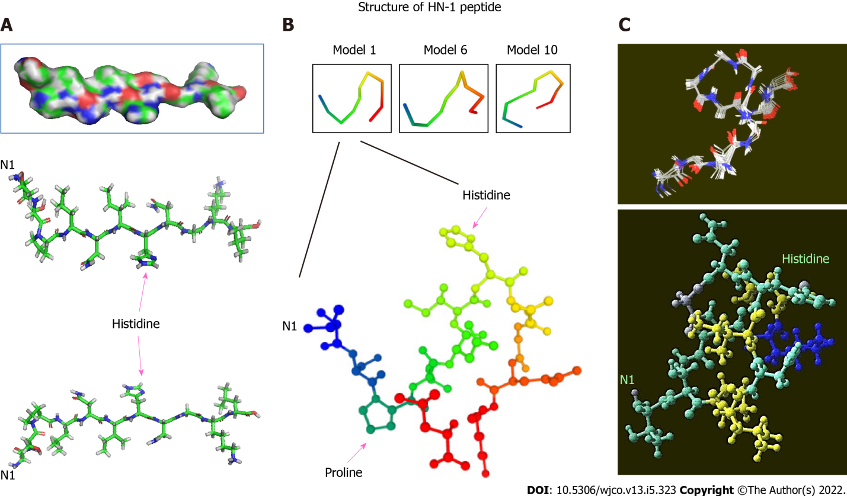
Figure 1 Three-dimensional structure of HN-1 peptide. A: A 3D model of HN-1 peptide generated using PyMol molecular graphics system, version 1.2r3pre, Schrödinger, LLC. All graphics depict an identical configuration with the bottom two panels in the opposite orientation; B: An ensemble of de novo conformations generated by PEP-FOLD (INSERM, France) in RPBS bioinformatics web portal: https://bioserv.rpbs.univ-paris-diderot.fr/services/PEP-FOLD/; C: A 3-dimensional profile of the lowest energy structure obtained for HN-1 peptide was viewed using Raswin computer modeling software. All structures were generated using TSPLNIHNGQKL as the raw input peptide sequence. N1: The N-terminal residue.
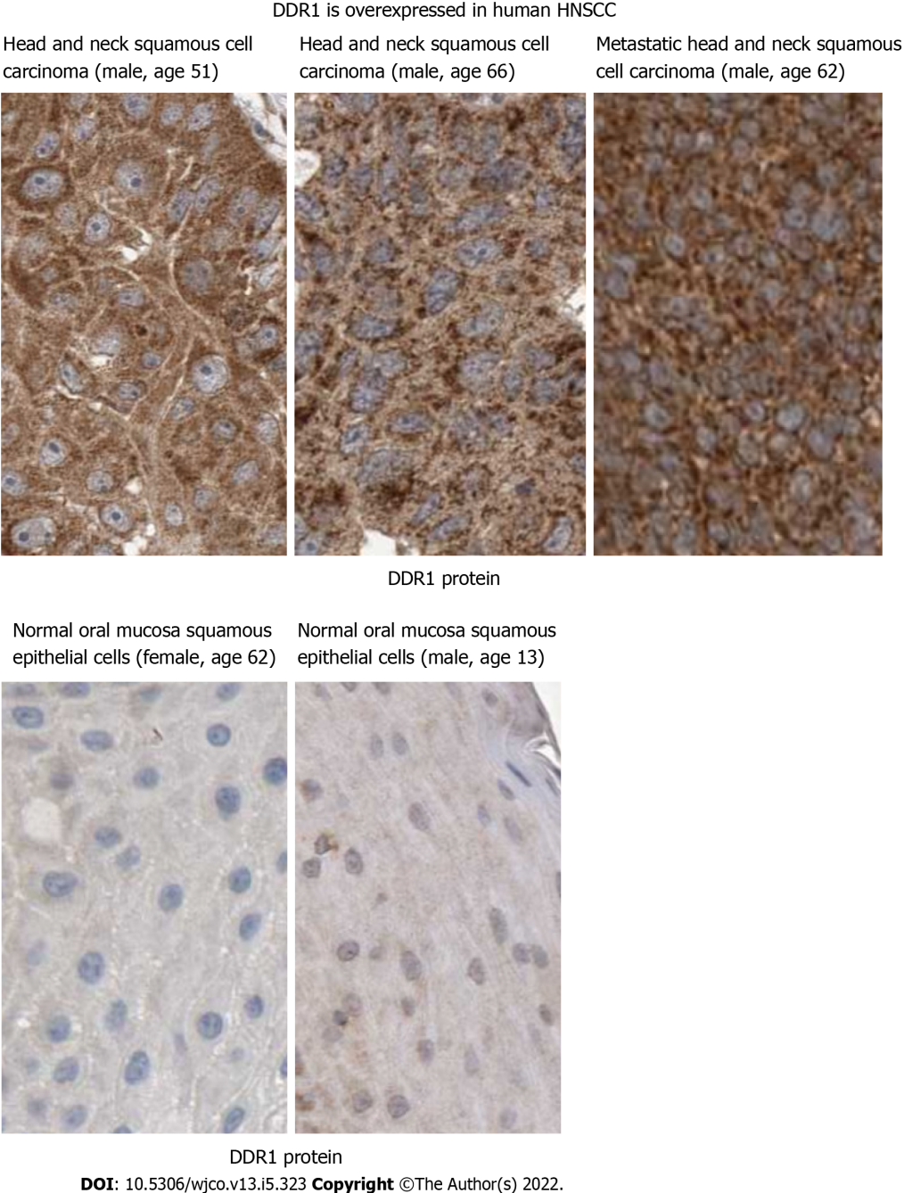
Figure 2 Discoidin domain receptor 1 may mediate HN-1 endocytosis. Discoidin domain receptor 1 (DDR1) protein is upregulated in human head and neck squamous cell carcinoma. Immunohistochemical analysis of DDR1 was conducted by comparing tumor vs normal tissues in Human Protein Atlas database (http://www.proteinatlas.org/). The results showed positive cytoplasmic and membranous staining. Bar: 25 micrometers; DDR1: Discoidin domain receptor 1.

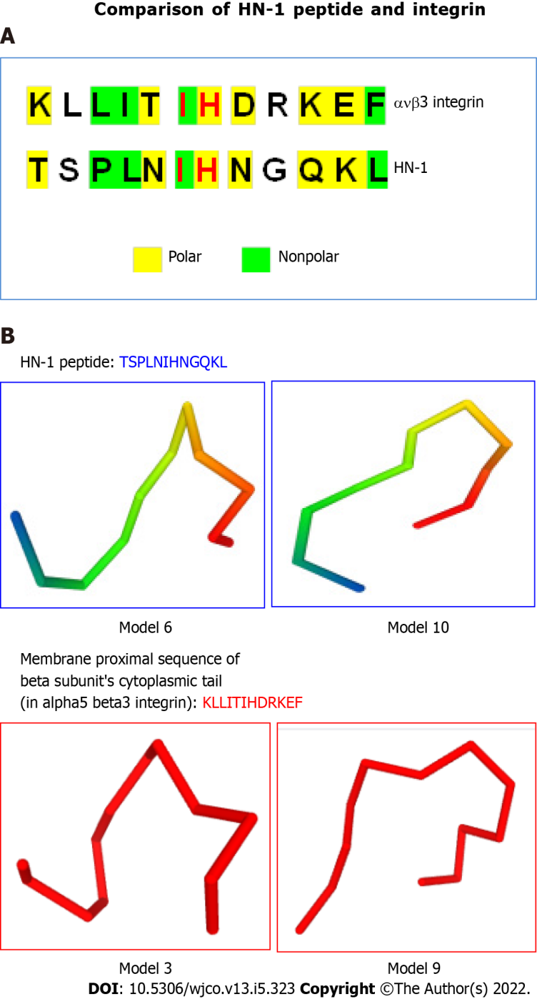
Figure 3 HN-1 peptide exhibits similarity to integrin peptide. A: The similarities between the HN-1 sequence (TSPLNIHNGQKL) and a stretch of amino acids in alpha5 beta3 integrin (KLLITIHDRKEF) are highlighted. As HN-1 peptide lacks the recognition motif (RGD) of integrin, HN-1 may interact with an "integrin-like" molecule. HN-1 is internalized by attached cells but not by suspended cells. As tissue culture plates are typically coated with collagen, collagen-binding DDR1 receptor (expressed by adherent but not suspended cells) may represent the receptor for HN-1 consistent with that DDR1 is overexpressed in human head and neck cancer (also breast cancer) targeted by HN-1. avb3: alpha5 beta3; B: Comparison of 3D models generated by PEP-FOLD (INSERM, France) in RPBS bioinformatics web portal: https://bioserv.rpbs.univ-paris-diderot.fr/services/PEP-FOLD/ TSPLNIHNGQKL: HN-1 peptide (top panels); KLLITIHDRKEF, membrane proximal sequence of beta subunit’s cytoplasmic tail in alpha5 beta3 integrin (bottom panels); TSPLNIHNGQKL: Thr-Ser-Pro-Leu-Asn-Ile-His-Asn-Gly-Gln-Lys-Leu; KLLITIHDRKEF: Lys-Leu-Leu-Ile-Thr-Ile-His-Asp-Arg-Lys-Glu-Phe.
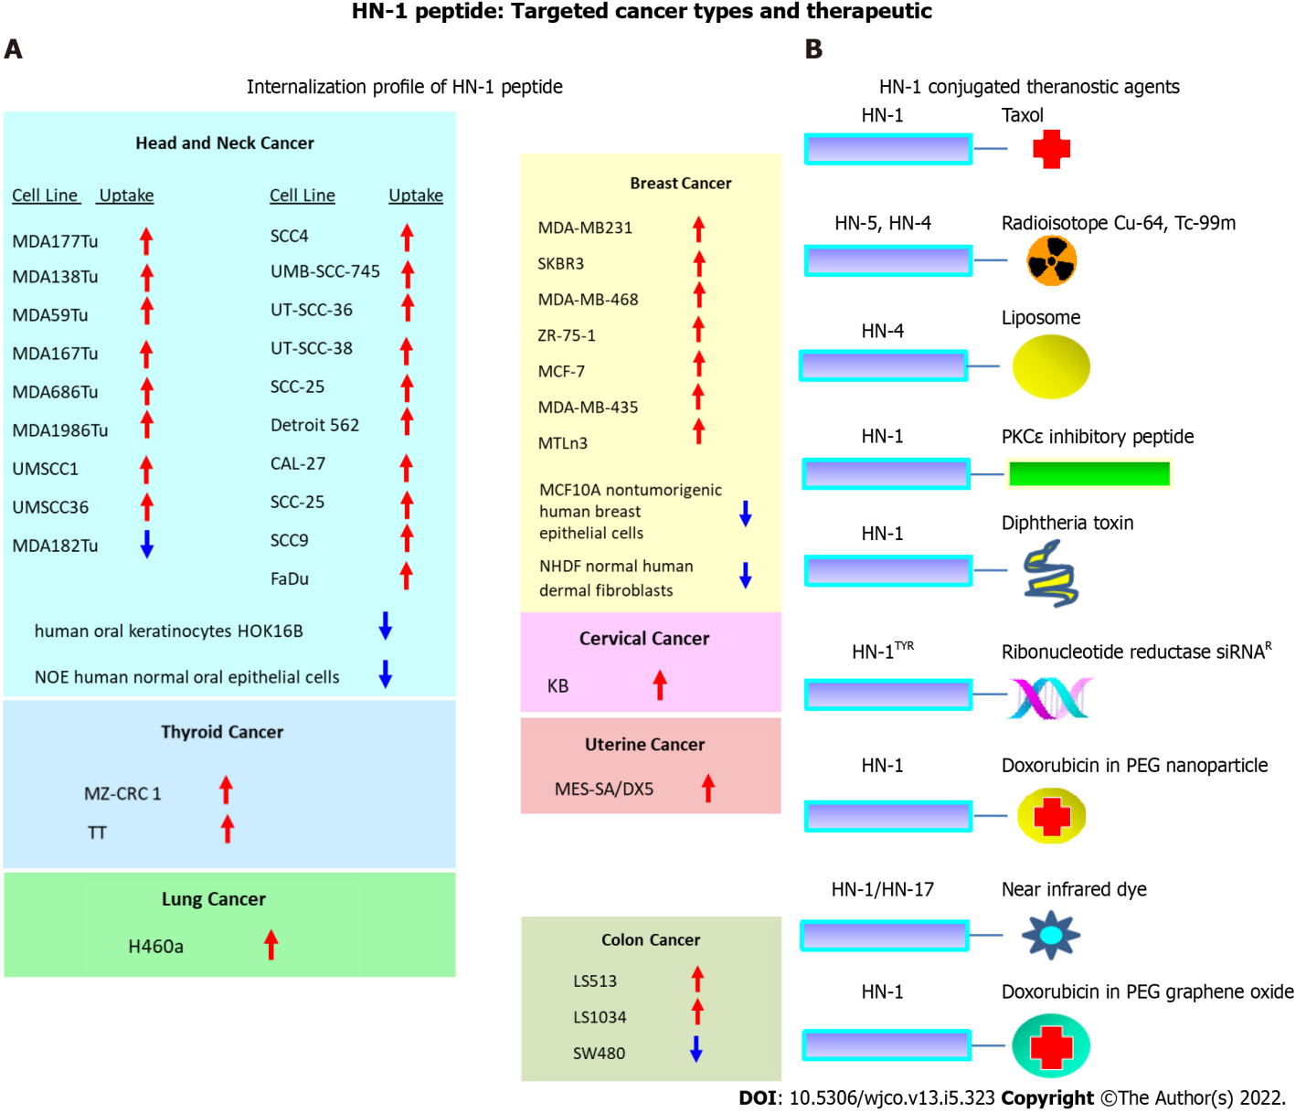
Figure 4 The repertoire of targeted cancers and therapeutic application of HN-1 peptide. A: HN-1 uptake profile. The internalization of HN-1 peptide by various human cancer cells vs the corresponding normal human cells was compared. HN-1 uptake: red arrow (internalized), blue arrow (undetectable); B: Previously developed HN-1 based conjugates for therapy or diagnosis. Note: whether HN-17 peptide (consisting of a permutated version of HN-1 sequence) enters cells via the same route as HN-1 peptide or through a distinct route is not known. HOK: Human oral keratinocyte; NOE: Normal oral epithelial; NHDF: Normal human dermal fibroblasts. Cu: Copper; Tc: Technetium; PKCe: Protein kinase C epsilon; siRNA: Small interfering RNA; PEG: Polyethylene glycol.

Published by Baishideng Publishing Group Inc
7041 Koll Center Parkway, Suite 160, Pleasanton, CA 94566, USA
Telephone: +1-925-3991568
E-mail: bpgoffice@wjgnet.com
Help Desk: https://www.f6publishing.com/helpdesk
https://www.wjgnet.com

© 2022 Baishideng Publishing Group Inc. All rights reserved.

