Name of Journal: World Journal of Gastroenterology
Manuscript NO: 62970
Manuscript Type: ORIGINAL ARTICLE

Basic Study
Fecal microbiota transplantation ameliorates experimental colitis via gut microbiota and T-cell modulation

Wen X et al. FMT ameliorates colitis

Xin Wen, Hong-Gang Wang, Min-Na Zhang, Meng-Hui Zhang, Han Wang, Xiao-Zhong Yang

Xin Wen, Hong-Gang Wang, Min-Na Zhang, Meng-Hui Zhang, Han Wang, Xiao-Zhong Yang, Department of Gastroenterology, The Affiliated Huaian No. 1 People’s Hospital of Nanjing Medical University, Huai'an 223300, Jiangsu Province, China

Author contributions: Wen X and Wang HG contributed equally to this work; Wen X, Zhang MN, Zhang MH and Wang H performed the experiments; Wen X analyzed the data, prepared figures and contributed to the drafting of the manuscript; Wang HG supervised this work and edited and revised the manuscript; Yang XZ initiated the project, designed the experiments and approved the final version of manuscript; All authors have approved the final version of the manuscript.

Supported by Scientific Research Project of Jiangsu Provincial Health Commission, No. H2018082; Huai'an Natural Science Research Project, No. HAB201926; and Scientific Research Project of Translational Medicine Innovation Team of Huai'an First People's Hospital, No. YZHT201905.

Corresponding author: Xiao-Zhong Yang, MD, PhD, Chief Doctor, Department of Gastroenterology, The Affiliated Huaian No. 1 People’s Hospital of Nanjing Medical University, No. 1 Huanghe Road West, Huai'an 223300, Jiangsu Province, China. hayyyxzh@njmu.edu.cn

Received: January 23, 2021
Revised: March 30, 2021
Accepted: April 28, 2021
Published online:

Abstract
BACKGROUND
Emerging evidence has demonstrated that fecal microbiota transplantation (FMT) has a promising therapeutic effect on mice with experimental colitis and patients with ulcerative colitis (UC), although the mechanism of FMT is unclear.

AIM
To evaluate the protective effect of FMT on UC and clarify its potential dependence on the gut microbiota, through association analysis of gut microbiota with colon transcriptome in mice.

METHODS
Dextran sodium sulfate (DSS)-induced experimental colitis was established and fecal microbiota was transplanted by gavage. Severity of colon inflammation was measured by body weight, disease activity index, colon length and histological score. Gut microbiota alteration was analyzed through 16S ribosomal ribonucleic acid sequencing. The differentially expressed genes (DEGs) in the colon were obtained by transcriptome sequencing. The activation status of colonic T lymphocytes in the lamina propria was evaluated by flow cytometry.

RESULTS
Compared with the DSS group, the weight loss, colon length shortening and inflammation were significantly alleviated in the FMT group. The scores of disease activity index and colon histology decreased obviously after FMT. FMT restored the balance of gut microbiota, especially by upregulating the relative abundance of Lactobacillus and downregulating the relative abundance of Clostridium_sensu_stricto_1 and Turicibacter. In the transcriptomic analysis, 128 DEGs intersected after DSS treatment and FMT. Functional annotation analysis suggested that these DEGs were mainly involved in T-lymphocyte activation. In the DSS group, there was an increase in colonic T helper CD4⁺ and T cytotoxic CD8⁺ cells by flow cytometry. FMT selectively downregulated the ratio of colonic CD4⁺ and CD8⁺ T cells to maintain intestinal homeostasis. Furthermore, Clostridium_sensu_stricto_1 was significantly related to inflammation-related genes including REG3G, CCL8 and IDO1.

CONCLUSION
FMT ameliorated DSS-induced colitis in mice via regulating the gut microbiota and T-cell modulation.

Key Words: Fecal microbiota transplantation; Colitis; Gut microbiota; Transcriptome sequencing; T lymphocyte

Wen X, Wang HG, Zhang MN, Zhang MH, Wang H, Yang XZ. Fecal microbiota transplantation ameliorates experimental colitis via gut microbiota and T-cell modulation. World J Gastroenterol 2021; In press

Core Tip: Previous studies shown that inflammatory bowel disease patients received satisfactory efficacy and safety after fecal microbiota transplantation (FMT) treatment. However, the mechanism of FMT remains unclear. Here, we set out animal experiments to explore the role of FMT in dextran sodium sulfate induced colitis in mice based on microbiome and transcriptome analysis.

INTRODUCTION
Inflammatory bowel disease (IBD) is a disease of global concern with a growing prevalence in young adults. The current treatments for IBD are not completely satisfactory. Modulating microbiota to correct dysbiosis is a new approach to treating IBD. Fecal microbiota transplantation (FMT) refers to infusion of a fecal suspension prepared from a healthy donor into the gut of a patient to restore a healthy composition and function of microbiota^{[1]}.
FMT has shown a valid therapeutic benefit after the onset of refractory recurrent Clostridium difficile infection by reintroducing a balanced microbiota to restore the gut microbial community. FMT has emerged as a highly effective treatment for refractory Clostridium difficile infection, achieving a cure rate of over 90%^{[2]}. Reconstructing the gut microbiota through FMT also has benefits for patients with IBD^{[3,4]}. The diversity of microbiota with FMT treatment increases to varying degrees among relieved patients. IBD patients show a decrease in overall biodiversity of the microbial ecosystem characterized by the loss of beneficial commensal microflora and the expansion of pathogenic bacteria^{[5]}. In our previous studies and others, IBD patients received satisfactory efficacy and safety after FMT treatment^{[6-8]}. However, the mechanism of FMT in the treatment of IBD is still unknown. In addition to reconstructing the gut microbiota, another role is that FMT activates a variety of anti-inflammatory mechanisms targeting mucosal immune cells^{[9]}. Nevertheless, we only have a partial understanding of how FMT functionally modulates the intestinal immune system at present.
This study used wild-type mice induced by dextran sodium sulfate (DSS) as a model of colitis in order to identify the role of gut microbiota in mediating the effect of FMT on DSS-induced colitis. We evaluated the protective effect of FMT on mice with DSS-induced colitis and identified the related gut microbiota and intestinal mucosal immune signaling pathway. Our findings will provide a basis for explaining the mechanism of FMT in the treatment of IBD.

MATERIALS AND METHODS
Animals
C57BL/10 mice (female; 7 wk to 8 wk of age; weighing 18-20 g; specific pathogen free grade) were purchased from the Model Animal Research Center of Nanjing University. All mice were reared in the experimental animal center of the Affiliated Huaian No.1 People’s Hospital of Nanjing Medical University in the specific pathogen free condition. Throughout the acclimatization and study periods, all animals were maintained on a 12 h light-dark cycle (21 ± 2 °C with a relatively constant humidity of 45% ± 10%) and had access to food and water ad libitum. Randomization was used to assign animals to the experimental groups. The animal experimental protocol was approved by experimental animal ethics committee of the Affiliated Huaian No.1 People’s Hospital of Nanjing Medical University, No: DW-P-2018-008-01.

DSS-induced colitis
To induce acute experimental colitis, mice were administered 2.5% (w/v) DSS (molecular weight, 36-50 kDa; MP Biomedicals, LLC, Irvine, CA, United States) in their drinking water and replaced it with normal water after 7 d. The mice in FMT group were fed with fecal microbiota from healthy mice from the 8th d, once every 2 d until the end of the experiment. The mice in the DSS group were fed normal saline as negative control at the same time. During intragastric administration, the procedures were strictly performed under sterile conditions. Animals were examined daily for change in net body weight and the disease activity index (DAI). The subsequent course of colitis development was evaluated daily by scoring via the DAI. DAI is a common index used to assess the severity of colitis combined with body weight loss, stool consistency and the presence of blood in the stool. The DAI score was calculated by grading on a 0-4 scale based on the following parameters: Change in bodyweight (1, 1%-5%; 2, 5%-10%; 3, 10%-15%; 4, ≥ 15%), stool consistency (0, normal; 2, loose stools; 4, diarrhea), and stool blood (0, no blood seen; 2, obvious blood with stool; 4, grossly bloody stool). At the end of the experiment, the mice were euthanized. The colon tissue was dissected; colons were measured for colon length, and tissues were examined for gross macroscopic appearance and stool consistency. Then, the colon was divided into different parts for different analysis and then fixed in 10% formalin for histological analysis or in ribonucleic acid (RNA) protective solution (Beyotime, Beijing, China) for transcriptomics analysis of colonic mucosa.

Feces preparation and transplantation
Feces were collected directly from healthy donor mice of the same strain. Fresh feces from 5 mice were pooled, mixed with sterile normal saline according to the concentration of 0.125 g/mL and homogenized immediately. The homogenate was centrifuged at 4 °C for 5 min at 1200 rpm, and the fecal sediment was used for transplantation. Gavage was carried out with a curved gavage needle appropriate for animal size. The volume of intragastric administration was 0.1 mL/10 g to each mouse, with care taken to avoid regurgitation. The two experimental groups stopped eating after 10:00 pm before transplantation, and FMT was always performed at 8:00 am.

Histopathology
The distal colon segments were placed in 10% neutral buffered formalin for 24 h, embedded in paraffin and cut into sections of 4 μm in thickness. The sections were then stained with hematoxylin and eosin (HE). HE-stained sections were examined for inflammation and tissue damage. Slices were evaluated by the experienced pathologist in a blinded manner, and histological score was assessed based on the following parameters according to previous research: Inflammation extent (0, none; 1, mild; 2, moderate; 3, severe), crypt aberrant (0, normal; 1, basal 1/3 damage; 2, basal 2/3 damage; 3, crypt lost and surface epithelium present; 4, crypt and surface epithelium lost), lymphocyte infiltration (0, 0%; 1, 10%; 2, 10%-25%; 3, 25%-50%; 4, > 50%) and colon wall aberrant (0, none; 1, mucosa; 2, submucosa; 3, transmural). The total histological score was the sum of all of the parameters evaluated^{[10]}.

Lamina propria mononuclear cells Isolation
To isolate lamina propria mononuclear cells, Peyer’s Patches were firstly removed and then colonic tissue was incubated with 5 mmol/L ethylenediamine tetraacetic acid (Biosharp, Sakai, Japan) and 1 mmol/L DTT (Biofroxx, Einhausen, Germany) at 37 °C for 30 min, followed by digestion with collagenase IV (0.3 mg/mL, Sigma, St. Louis, MO, United States), DNase I (0.25 mg/mL, Biosharp) and Dispase II (3 mg/mL, Shanghai YuanYe Biotechnology, Shanghai, China) (37 °C for 1 h). Colonic lamina propria lymphocytes were then separated with a Percoll gradient.

Flow cytometry analysis
For immunephenotyping, mononuclear cells isolated were stained with surface markers of APC-labeled anti-mouse CD4 (Biolegend, Cat. No. 100516, San Diego, CA, United States), FITC-labeled anti-mouse CD8a (Biolegend, Cat. No. 100706) for 30 min at 4 °C in the dark. Samples were passed on a FACSCanto II flow cytometer (BD). Data were analyzed using FlowJo v10 software (FlowJo, LLC, Ashland, OR, United States).

Fecal DNA extraction and 16S rRNA gene sequencing
Microbial community genomic deoxyribonucleic acid (DNA) was extracted from samples using the E.Z.N.A.® soil DNA Kit (Omega Bio-tek, Norcross, GA, United States) according to manufacturer’s instructions. The DNA extract was checked on 1% agarose gel, and DNA concentration and purity were determined with NanoDrop 2000 UV-vis spectrophotometer (Thermo Scientific, Wilmington, DE, United States). The hypervariable region V3-V4 of the bacterial 16S ribosomal RNA (rRNA) gene were amplified with primer pairs 338F (5'-ACTCCTACGGGAGGCAGCAG-3') and 806R(5'-GGACTACHVGGGTWTCTAAT-3') by an ABI GeneAmp® 9700 PCR thermocycler (Applied Biosystems, Foster City, CA, United States). The polymerase chain reaction (PCR) amplification of 16S rRNA gene was performed as follows: Initial denaturation at 95 °C for 3 min, followed by 27 cycles of denaturing at 95 °C for 30 s, annealing at 55 °C for 30 s and extension at 72 °C for 45 s, single extension at 72 °C for 10 min, and end at 4 °C. The PCR mixtures contain 5 × TransStart FastPfu buffer 4 μL, 2.5 mmol/L dNTPs 2 μL, forward primer (5 μmol/L) 0.8 μL, reverse primer (5 μmol/L) 0.8 μL, TransStart FastPfu DNA Polymerase 0.4 μL, template DNA 10 ng and finally ddH₂O up to 20 μL. PCR reactions were performed in triplicate. The PCR product was extracted from 2% agarose gel and purified using the AxyPrep DNA Gel Extraction Kit (Axygen Biosciences, Union City, CA, United States) according to manufacturer’s instructions and quantified using Quantus™ Fluorometer (Promega, Madison, WI, United States). Purified amplicons were pooled in equimolar and paired-end sequenced on an Illumina MiSeq PE300 platform (Illumina, San Diego, CA, United States). The predominance of bacterial communities between groups were analyzed by linear discriminant analysis effect size method.

Transcriptome analysis
Total RNA from inflammatory colonic tissue was extracted. Samples about 1 cm long were for sequencing. The tissues from minimum and maximum histological score were removed. Then, we collected colon samples from four randomly chosen animals per group for sequencing, totaling 12 samples. A total amount of 2 μg RNA per sample was used as input material for the RNA sample preparations. Sequencing libraries were generated using NEBNext UltraTM RNA Library Prep Kit for Illumina (NEB, Ipswich, MA, United States) following manufacturer’s recommendations, and index codes were added to attribute sequences to each sample. Samples were then sequenced on an Illumina Hiseq 4000 platform, and paired-end 150 bp reads were generated. Next, we used Star and Cufflinks software to complete alignment and analyze transcripts and to make quantitative analysis of all genes. Differential genes were identified, and functional enrichment analysis of these differential genes was carried out to explore their functions. The primers were: Adapter, oligonucleotide sequences for TruSeqTM RNA and DNA Sample Prep Kits. RNA 5’Adapter (RA5), part # 15013205：5’-AATGATACGGCGACCACCGAGATCTACACTCTTTCCCTACACGACGCTCTTCCGATCT-3’; RNA3’Adapter (RA3), part # 15013207 ： 5’-GATCGGAAGAGCACACGTCTGAACTCCAGTCAC (index) ATCTCGTATGCCGTCTTCTGCTTG-3’. Gene ontology (GO) enrichment analysis of the differentially expressed genes (DEGs) was implemented by the GO seq R packages based Wallenius non-central hyper-geometric distribution (Young et al^{[11]}), which can adjust for gene length bias in DEGs. Differential expression analysis was performed using the DESeq R package (1.10.1). When there was no biological repetition, TMM was firstly used to standardize the readcount data, and then DEG seq was used for difference analysis, of which the threshold was q value < 0.005 and | log2FoldChange | > 1. For differential genes, if the log2Foldchange of the gene is > 0, the differential gene was considered to be up-regulated. On the contrary, if log2Foldchange was < 0, the differential gene was considered to be down-regulated.

Network analysis of the gut microbiota at genus level
Metastats software was used to confirm significant differences in the relative abundance of microbiota in three groups of samples. Results were considered significant if P ≤ 0.05. Then used DEG seq for difference analysis, of which the threshold is P <0.05 and |log2FC| > 1. R psych package was used for partial Spearman correlations. r > 0.8 and P < 0.05 (strong correlation) were screened for mapping. Red edges indicate positive correlation and blue edges indicate negative correlation. The thicker the line, the stronger the correlation. The node size represents the node degree.

Statistical analysis
Differences were analyzed using a Student’s t-test or one-way analysis of variance (ANOVA) with Graphpad Prism 8.0 software (GraphPad Software Inc., La Jolla, CA, United States). Comparison among groups was made using ANOVA analysis, and comparison between two groups were made using the independent-sample t-test. Results are shown as mean ± standard error; Values of ªP < 0.05, ^{b}P < 0.01, and ^{c}P < 0.001 were considered as statistically significant.

RESULTS
FMT ameliorated DSS-induced colitis in mice
To explore the therapeutic effect of FMT on colitis, a mouse model of acute colitis induced by DSS was established. A flowchart of this study is shown in Figure 1. Five healthy mice were included as the control group. Other mice randomly drank 2.5% DSS for 7 d and were divided into the DSS and FMT groups (n = 7 each). The DSS group was gavaged with normal saline after 7 d of DSS, while the FMT group was gavaged fecal microbiota isolated from healthy mice for 7 d after DSS intervention (Figure 1A). Compared with the DSS group, FMT obviously alleviated body weight loss (^{b}P < 0.01; Figure 1B) and DAI (^{c}P < 0.001; Figure 1C). These findings suggested that FMT improved the clinical symptoms in DSS-induced colitis. Additionally, FMT significantly alleviated the colon shortening caused by DSS treatment (^{c}P < 0.001; Figure 1D). To evaluate further the anti-inflammatory role of FMT, HE staining was used to assess pathological features in DSS-induced colitis. In the DSS group, colonic mucosal epithelial cells were absent, glands had lost their integrity, extensive infiltration of inflammatory cells was apparent and typical inflammatory reactions were observed. However, in the FMT group, colonic structure was relatively intact, and the histological score was lower compared with that in the DSS group (^{c}P < 0.001; Figure 1E). These results indicated that FMT significantly attenuated the DSS-induced colonic tissue injury and inflammatory response in the mice.

FMT improved the gut microbiota of DSS-induced colitis
To ascertain the effects of FMT on the gut microbiota, 16S rRNA gene amplification and sequencing were conducted (Figure 2). In terms of bacterial composition at the phylum level, all samples shared similar taxonomic communities and exhibited a relatively high abundance of the phyla Bacteroidetes and Firmicutes (Figure 2A). FMT administration was associated with variations in the abundance of specific taxa at the genus level (Figure 2B). The linear discriminant analysis effect size analysis showed that Lactobacillales was enriched in the gut of untreated mice, while Clostridiales was enriched in DSS-induced colitis mice. After FMT, Lactobacillales became obviously enriched, compared with the DSS group (Figure 2C). At the genus level, Clostridium_sensu_stricto_1 (^{c}P = 0.001, one-way ANOVA), Turicibacter (^{c}P < 0.001, one-way ANOVA), Alistipes (^{c}P = 0.001, one-way ANOVA), Acetatifactor (^{c}P = 0.001, one-way ANOVA), Ruminococcus_1 (^{b}P < 0.01, one-way ANOVA) and Ruminiclostridium_6 (ªP < 0.05, one-way ANOVA), which were expanded in colitis, were reduced after FMT and returned to being comparable to those observed in healthy mice. On the contrary, Lactobacillus (^{c}P < 0.001, one-way ANOVA) and Lachnospiraceae_UCG-001 (ªP < 0.05, one-way ANOVA) displayed a trend of high abundance in the FMT group (Figure 3), and there was no significant difference in Lactobacillus between control and transplanted mice. Collectively, these results showed that FMT significantly improved the imbalanced gut microbiota induced by DSS in mice.

FMT regulated T-cell in the colon
To investigate the molecular target of FMT, we used RNA sequencing in colonic tissue samples from control, DSS and FMT groups. We found that 1558 genes were differentially expressed in the DSS group compared to the control group, and 334 genes were differentially expressed in the FMT compared to the DSS group (Figure 4A). The GO enrichment histogram of DEGs showed the biological process, cellular component and molecular function. The bar chart shows the top 30 GO terms with the most significant enrichment (Figure 4B). The most enriched GO terms were immune system process and metabolic process. Additionally, there were 128 DEGs in the DSS group compared with the control and FMT groups. GO analysis showed that these genes mainly participated in T-cell activation induced by DSS and inhibited by FMT (Figure 5A). T-cell activation status was determined by surface marker staining, using flow cytometry. As expected, T-cell populations isolated from colons of FMT-treated mice showed reduced activity as compared to those isolated from colitis mice that received DSS (Figure 5B, C, ^{b}P < 0.01). Phenotypically, mice receiving DSS displayed a higher proportion of CD4⁺ and CD8⁺ T cells. However, there was a significant decrease in CD4⁺ and CD8⁺ T cells in colons following FMT, supporting the observation that colonic T cells in FMT-treated mice manifested decreased activation. These results indicated that FMT alleviated DSS-induced colitis by inhibiting intestinal immunity related to T-cell modulation.

Correlation analysis between gut microbiota and transcriptome
The process by which the gut microbiota regulates intestinal immunity is complicated. The gut microbiota and T-cell immunity were both involved in the biological process of FMT treatment of colitis. Based on this, we tried to find the potential gut microbiota/immune axis-mediated signaling pathway. The correlation analysis between gut microbiota and transcriptome showed that Clostridium_sensu_stricto_1 was the most enriched genus (Figure 6A). The DEGs related to gut microbiota are listed in Table 1. The DEGs, such as IDO1, CCL8 and REG3G, were positively correlated with the relative abundance of Clostridium_sensu_stricto_1 (^{b}P < 0.01). The DEGs such as REG3G were positively correlated with the relative abundance of Turicibacter (^{b}P < 0.01). Relative quantification of transcript level is shown in Figure 6B (all ^{c}P < 0.001, one-way ANOVA). These results provide a potential Clostridium_sensu_stricto_1-mediated immune regulation for FMT to treat colitis.

Graphical display of therapeutic effect of FMT on colitis
FMT significantly modulated the dysbacteriosis induced by DSS and restored the disordered gut microbiota to normal level. Meanwhile, FMT protected intestinal epithelial barrier disruption induced by DSS via upregulating the relative abundance of Lactobacillus and downregulating the relative abundance of Clostridium_sensu_stricto_1 and Turicibacter. Furthermore, after FMT treatment, the activation of T lymphocytes was significantly inhibited (Figure 7). Hypothetically, FMT may improve experimental colitis by increasing relative abundance of Lactobacillus and regulating T-cell function.

DISCUSSION
FMT has been shown to be effective in treating ulcerative colitis (UC), but its mechanism is still unclear. In this study, 16s rRNA and transcriptome sequencing were used to prove that FMT alleviated DSS-induced colitis in mice by improving the gut microbiota and regulating T-cell function.
Lactobacillus is considered a genus of beneficial bacteria in the gut and is abundant in healthy individuals. During the inflammation stage in the colon, the abundance of Lactobacillus decreased significantly^{[12]}. Our data suggested that Lactobacillus was the main genus in healthy mice, but its abundance decreased significantly in DSS-induced colitis. However, this process was blocked by FMT. After transplanting the resident microbiota to colitis mice, the abundance of Lactobacillus increased significantly and it became the dominant genus in the FMT group. Similarly, an increase in Lactobacillus was observed after FMT treatment in UC patients^{[13]}. Supplementing Lactobacillus significantly prevents colonic shortening and has a therapeutic effect on DSS-induced colitis^{[14]}. The underlying mechanism of Lactobacillus in colitis is that it promotes beneficial metabolic pathways^{[15]} that inhibit group 3 innate lymphoid cells^{[16]}, increasing induction of regulatory T lymphocytes^{[17,18]}, decreasing inflammatory pathways^{[19]} and strengthening gut barrier function^{[20]}. In UC mice, Lactobacillus induced regulatory T (Treg) cell differentiation and had an impact on intestinal expression of antimicrobial peptides^{[21]}. In detail, the Treg cells expand with decreasing levels of adenosine monophosphate in colonic tissues and thus ameliorate UC in the mice^{[17]}. Lactobacillus also promotes the release of anti-inflammatory interleukin (IL)-10 by T cells, which is pivotal for the resolution of intestinal inflammation^{[22,23]} by reducing the proliferative capacity of proinflammatory T cells^{[24]}. It should be noted that not all bacterial strains of Lactobacillus exert an immunoregulatory action on T cells^{[21]}. Thus, the role of Lactobacillus in the pathogenesis of intestinal inflammation requires further study. Besides, Clostridium_sensu_stricto_1^{[25]} and Turicibacter^{[26]} are deemed to be opportunistic pathogens associated with colitis.
In our study, FMT significantly reduced the relative abundance of Clostridium_sensu_stricto_1, Turicibacter and Ruminococcus, which were increased after DSS treatment. In IBD patients, the abundance of these opportunistic pathogens also increased^{[27]}. Turicibacter positively correlated with proinflammatory cytokines, such as IL-6, IL-1β, tumor necrosis factor-α and interferon-γ^{[28]}. Turicibacter exhibited higher relative abundance in IBD patients and mouse models, further inducing more severe colitis^{[29, 30]}. As reported, Turicibacter was significantly less abundant in diarrhea-dominant irritable bowel syndrome patients^{[31]}. Recent studies also indicate an beneficial role for Turicibacter in host serotonin metabolism^{[32]}. These findings show the complex role of Turicibacter in chronic inflammatory settings. As recently reported, Ruminococcus may drive high neutrophil-to-lymphocyte ratios that are broadly characteristic of poor disease outcomes in IBDs^{[33]}. Ruminococcus affects the efficacy of FMT, because the presence of higher levels of Ruminococcus in donors makes FMT more likely to fail^{[34]}. To our knowledge, the relative abundance of Clostridium_sensu_stricto_1, Turicibacter and Ruminococcus was significantly decreased after FMT. Therefore, FMT may regulate the gut microbiota to exert an anti-inflammatory effect in colitis.
In UC, the balance of commensal microbes and the immune system is impaired. In IBD patients, CD4⁺ T cells may exhibit significantly high pathogenicity, characterized by enhanced T-cell activation^{[35]}. The reactivity to intestinal bacteria is a normal property of the human CD4⁺ T-cell repertoire and does not necessarily indicate disrupted interactions between immune cells and the commensal microbiota^{[36]}. Drugs commonly used in the treatment of IBD, such as anti-tumor necrosis factor-α agents, cyclosporin A and azathioprine, have been demonstrated to induce apoptosis of lamina propria T cells in IBD^{[37]}. Therefore, targeting T cells shows potential therapeutic effects. In fact, FMT regulates intestinal immunity. Therapeutic FMT administration during experimental colitis reduces colonic inflammation and initiates the restoration of intestinal homeostasis through regulating innate and adaptive immune responses in the intestinal mucosa^{[24]}. In this work, a total of 128 DEGs were distinguished by comparing the control, DSS and FMT groups. Functional annotation analysis showed that these DEGs are mainly involved in the activation of T lymphocytes. After FMT, the activation of T lymphocytes was significantly inhibited and indoleamine 2,3-dioxygenase 1 (IDO1) was mainly involved in this process. In IBD patients and experimental colitis, overexpression of IDO1 had a positive correlation with the severity of the disease^{[38,39]}. Likewise, there is a higher presence of IDO-producing DCs and Tregs in the lamina propria of IBD patients compared with healthy subjects, which may represent a role of regulating inflammatory mechanism^{[40]}. Pharmacological inhibition of IDO1 alleviates DSS-induced colitis^{[39,41]}. In a recent study, gut microbiota from IDO1-knockout mice could directly attenuate the severity of DSS-induced colitis^{[42]}. These results suggested that IDO1 regulated the gut microbiota to maintain intestinal homeostasis in colitis. According to our results, IDO1 expression was increased by DSS but was significantly inhibited after FMT at the transcriptional level. The reduction of intestinal T-lymphocyte activation indicates reduction of intestinal pathogenic bacteria. This can explain how the gut microbiota improved after FMT, thereby reducing activation of T cells.
In this study, we investigated the relationship between the gut microbiota and colon transcriptome in colitis. There was a significant positive correlation between Clostridium_sensu_stricto_1 and expression of antimicrobial C-type lectin regenerating islet-derived 3 gamma (REG3G), monocyte chemoattractant protein 2 (CCL8) and IDO1. REG3G belongs to the C-type lectin antimicrobial peptide family, which is closely regulated by T helper 17/IL-17A and prevents pathogenic bacteria from invading the colonic mucosa^{[43]}. As previously described, the impact of Lactobacillus on antimicrobial peptides relied on the presence of the gut microbiota^{[21]}. It is a defense mechanism widely produced by intestinal epithelial cells to regulate the dynamic balance between microbiota and host epithelium^{[44]}. Colonic macrophages act as a major source of CCL8 chemokines that trigger further recruitment of their proinflammatory monocyte precursors^{[45]}. After administering lipopolysaccharide, there was a marked increase in the expression of the monocyte chemoattractant CCL8^{[46]}. As in animal colitis, CCL8 is significantly increased in active compared with quiescent IBD^{[45,47]}. In our study, these highly expressed genes were positively correlated with Clostridium_sensu_stricto_1 in DSS-induced colitis, but the expression was significantly lower in the FMT group. These results indicated that FMT alleviated mouse colitis via downregulation of the expression of these microbiota-related genes.
The current study had some limitations. Firstly, the current 16S sequencing mainly included bacterial and archaeal genomes, ignoring nonbacterial organisms, such as viruses, fungi and phages. Secondly, animal studies have some limitations in evaluating the mechanism of FMT. Administration of DSS to induce subclinical colitis, while convenient, does not yield a model that perfectly mimics the pathogenesis of IBD, since DSS causes a chemical colitis through epithelial injury. Thirdly, we analyzed the correlation between gut microbiota and gene expression, but the causal relationship was not further explained. In this study, the regulation of gut microbiota and colon transcriptome by FMT may be the key to the anti-inflammatory role in colitis. We will carry out clinical studies to verify the changes in gut microbiota and transcriptome in FMT treatment of UC.

CONCLUSION
In this study, we explored the mechanism of FMT in the treatment of experimental colitis by analysis of gut microbiota and colonic transcriptome. FMT contributed to alleviation of murine colitis with increased abundance of Lactobacillus and decreased Clostridium_sensu_stricto_1 and Turicibacter. In transcriptomics, FMT inhibited activation of T lymphocytes in the colon by regulating gene expression related to the microbiota. Therefore, we propose that FMT regulates the gut microbiota and T lymphocytes function, and thereby alleviates colitis. The causal relationship between the gut microbiota and UC needs to be further studied.

ARTICLE HIGHLIGHTS
Research background
Ulcerative colitis (UC) is a growing global disease in which gut microbiota dysbiosis plays an important pathogenic role. However, the current drugs for UC treatment are far from optimal. Therefore, alternative safe and effective new treatments need to be developed.

Research motivation
Clinical practice has confirmed the therapeutic value of fecal microbiota transplantation (FMT) in UC, but its mechanism is unknown. Recently, few studies have indicated the regulatory effect of FMT on the expression of genes in intestinal mucosa, suggesting that the therapeutic effect of FMT on UC may be not only the reconstruction of gut microbiota but also the gene regulation after reconstruction.

Research objectives
The aim of the study was to explore the effect and mechanism of FMT on regulating the balance of gut microbiota and anti-inflammation in dextran sulfate sodium (DSS)-induced colitis.

Research methods
Experimental colitis was induced by DSS, then the severity of intestinal inflammation was evaluated by body weight, colon length, disease activity index and histological scores. Gut microbiota alteration was analyzed through 16S rRNA sequencing. Transcriptome sequencing was used to screen differentially expressed genes in colon. The frequency of immune cells in lamina propria were phenotyped by flow cytometry.

Research results
DSS-induced weight loss, colon length shortening, disease activity index score and histological score were significantly alleviated after FMT treatment. 16S rRNA sequencing indicated that FMT up-regulated the relative abundance of Lactobacillus and down-regulated the relative abundance of Clostridium_sensu_stricto_1 and Turicibacter. Transcriptomics-based differential gene analysis showed that FMT could regulate colonic T cell function. Further flow cytometry analysis showed that FMT downregulated the number of colonic CD4⁺ and CD8⁺ T cells to maintain intestinal homeostasis. Moreover, we found that the abundance of Clostridium_sensu_stricto_1 was positively correlated with the expression of inflammation-related genes such as REG3G, CCL8 and IDO1.

Research conclusions
FMT alleviated DSS-induced colitis in mice by improving the gut microbiota and regulating T-cell function.

Research perspectives
This study has initially revealed the mechanism of FMT in the treatment of colitis, which will be confirmed by human studies in the future.

REFERENCES
1 Zhang T, Lu G, Zhao Z, Liu Y, Shen Q, Li P, Chen Y, Yin H, Wang H, Marcella C, Cui B, Cheng L, Ji G, Zhang F. Washed microbiota transplantation vs. manual fecal microbiota transplantation: clinical findings, animal studies and in vitro screening. Protein Cell 2020; 11: 251-266 [PMID: 31919742 DOI: 10.1007/s13238-019-00684-8]
2 Tariq R, Disbrow MB, Dibaise JK, Orenstein R, Saha S, Solanky D, Loftus EV, Pardi DS, Khanna S. Efficacy of Fecal Microbiota Transplantation for Recurrent C. Difficile Infection in Inflammatory Bowel Disease. Inflamm Bowel Dis 2020; 26: 1415-1420 [PMID: 31821444 DOI: 10.1093/ibd/izz299]
3 Costello SP, Hughes PA, Waters O, Bryant RV, Vincent AD, Blatchford P, Katsikeros R, Makanyanga J, Campaniello MA, Mavrangelos C, Rosewarne CP, Bickley C, Peters C, Schoeman MN, Conlon MA, Roberts-Thomson IC, Andrews JM. Effect of Fecal Microbiota Transplantation on 8-Week Remission in Patients With Ulcerative Colitis: A Randomized Clinical Trial. JAMA 2019; 321: 156-164 [PMID: 30644982 DOI: 10.1001/jama.2018.20046]
4 Paramsothy S, Kamm MA, Kaakoush NO, Walsh AJ, van den Bogaerde J, Samuel D, Leong RWL, Connor S, Ng W, Paramsothy R, Xuan W, Lin E, Mitchell HM, Borody TJ. Multidonor intensive faecal microbiota transplantation for active ulcerative colitis: a randomised placebo-controlled trial. Lancet 2017; 389: 1218-1228 [PMID: 28214091 DOI: 10.1016/S0140-6736(17)30182-4]
5 Yalchin M, Segal JP, Mullish BH, Quraishi MN, Iqbal TH, Marchesi JR, Hart AL. Gaps in knowledge and future directions for the use of faecal microbiota transplant in the treatment of inflammatory bowel disease. Therap Adv Gastroenterol 2019; 12: 1756284819891038 [PMID: 31803254 DOI: 10.1177/1756284819891038]
6 Wang H, Cui B, Li Q, Ding X, Li P, Zhang T, Yang X, Ji G, Zhang F. The Safety of Fecal Microbiota Transplantation for Crohn's Disease: Findings from A Long-Term Study. Adv Ther 2018; 35: 1935-1944 [PMID: 30328062 DOI: 10.1007/s12325-018-0800-3]
7 Li Q, Ding X, Liu K, Marcella C, Liu X, Zhang T, Liu Y, Li P, Xiang L, Cui B, Wang J, Bai J, Zhang F. Fecal Microbiota Transplantation for Ulcerative Colitis: The Optimum Timing and Gut Microbiota as Predictors for Long-Term Clinical Outcomes. Clin Transl Gastroenterol 2020; 11: e00224 [PMID: 32955197 DOI: 10.14309/ctg.0000000000000224]
8 Li Q, Zhang T, Ding X, Xiang L, Cui B, Buch H, Zhang F. Enhancing patient adherence to fecal microbiota transplantation maintains the long-term clinical effects in ulcerative colitis. Eur J Gastroenterol Hepatol 2020; 32: 955-962 [PMID: 32282545 DOI: 10.1097/MEG.0000000000001725]
9 Burrello C, Giuffrè MR, Macandog AD, Diaz-Basabe A, Cribiù FM, Lopez G, Borgo F, Nezi L, Caprioli F, Vecchi M, Facciotti F. Fecal Microbiota Transplantation Controls Murine Chronic Intestinal Inflammation by Modulating Immune Cell Functions and Gut Microbiota Composition. Cells 2019; 8: 517 [PMID: 31142049 DOI: 10.3390/cells8060517]
10 Li C, Ai G, Wang Y, Lu Q, Luo C, Tan L, Lin G, Liu Y, Li Y, Zeng H, Chen J, Lin Z, Xian Y, Huang X, Xie J, Su Z. Oxyberberine, a novel gut microbiota-mediated metabolite of berberine, possesses superior anti-colitis effect: Impact on intestinal epithelial barrier, gut microbiota profile and TLR4-MyD88-NF-κB pathway. Pharmacol Res 2020; 152: 104603 [PMID: 31863867 DOI: 10.1016/j.phrs.2019.104603]
11 Young MD, Wakefield MJ, Smyth GK, Oshlack A. Gene ontology analysis for RNA-seq: accounting for selection bias. Genome Biol 2010; 11: R14 [PMID: 20132535 DOI: 10.1186/gb-2010-11-2-r14]
12 Miranda PM, De Palma G, Serkis V, Lu J, Louis-Auguste MP, McCarville JL, Verdu EF, Collins SM, Bercik P. High salt diet exacerbates colitis in mice by decreasing Lactobacillus levels and butyrate production. Microbiome 2018; 6: 57 [PMID: 29566748 DOI: 10.1186/s40168-018-0433-4]
13 Mańkowska-Wierzbicka D, Stelmach-Mardas M, Gabryel M, Tomczak H, Skrzypczak-Zielińska M, Zakerska-Banaszak O, Sowińska A, Mahadea D, Baturo A, Wolko Ł, Słomski R, Dobrowolska A. The Effectiveness of Multi-Session FMT Treatment in Active Ulcerative Colitis Patients: A Pilot Study. Biomedicines 2020; 8: 268 [PMID: 32756350 DOI: 10.3390/biomedicines8080268]
14 Hasannejad-Bibalan M, Mojtahedi A, Eshaghi M, Rohani M, Pourshafie MR, Talebi M. The effect of selected Lactobacillus strains on dextran sulfate sodium-induced mouse colitis model. Acta Microbiol Immunol Hung 2020; 67: 138-142 [PMID: 32554841 DOI: 10.1556/030.2020.00834]
15 Tamura K, Sasaki H, Shiga K, Miyakawa H, Shibata S. The Timing Effects of Soy Protein Intake on Mice Gut Microbiota. Nutrients 2019; 12 [PMID: 31892229 DOI: 10.3390/nu12010087]
16 Wang T, Zheng N, Luo Q, Jiang L, He B, Yuan X, Shen L. Probiotics Lactobacillus reuteri Abrogates Immune Checkpoint Blockade-Associated Colitis by Inhibiting Group 3 Innate Lymphoid Cells. Front Immunol 2019; 10: 1235 [PMID: 31214189 DOI: 10.3389/fimmu.2019.01235]
17 Tang C, Kamiya T, Liu Y, Kadoki M, Kakuta S, Oshima K, Hattori M, Takeshita K, Kanai T, Saijo S, Ohno N, Iwakura Y. Inhibition of Dectin-1 Signaling Ameliorates Colitis by Inducing Lactobacillus-Mediated Regulatory T Cell Expansion in the Intestine. Cell Host Microbe 2015; 18: 183-197 [PMID: 26269954 DOI: 10.1016/j.chom.2015.07.003]
18 Kim DH, Kim S, Ahn JB, Kim JH, Ma HW, Seo DH, Che X, Park KC, Jeon JY, Kim SY, Lee HC, Lee JY, Kim TI, Kim WH, Kim SW, Cheon JH. Lactobacillus plantarum CBT LP3 ameliorates colitis via modulating T cells in mice. Int J Med Microbiol 2020; 310: 151391 [PMID: 32007342 DOI: 10.1016/j.ijmm.2020.151391]
19 El-Baz AM, Khodir AE, Adel El-Sokkary MM, Shata A. The protective effect of Lactobacillus vs 5-aminosalicylic acid in ulcerative colitis model by modulation of gut microbiota and Nrf2/Ho-1 pathway. Life Sci 2020; 256: 117927 [PMID: 32526285 DOI: 10.1016/j.lfs.2020.117927]
20 Wang Y, Gu Y, Fang K, Mao K, Dou J, Fan H, Zhou C, Wang H. Lactobacillus acidophilus and Clostridium butyricum ameliorate colitis in murine by strengthening the gut barrier function and decreasing inflammatory factors. Benef Microbes 2018; 9: 775-787 [PMID: 30014710 DOI: 10.3920/BM2017.0035]
21 Hrdý J, Alard J, Couturier-Maillard A, Boulard O, Boutillier D, Delacre M, Lapadatescu C, Cesaro A, Blanc P, Pot B, Ryffel B, Chamaillard M, Grangette C. Lactobacillus reuteri 5454 and Bifidobacterium animalis ssp. lactis 5764 improve colitis while differentially impacting dendritic cells maturation and antimicrobial responses. Sci Rep 2020; 10: 5345 [PMID: 32210304 DOI: 10.1038/s41598-020-62161-1]
22 Di Giacinto C, Marinaro M, Sanchez M, Strober W, Boirivant M. Probiotics ameliorate recurrent Th1-mediated murine colitis by inducing IL-10 and IL-10-dependent TGF-beta-bearing regulatory cells. J Immunol 2005; 174: 3237-3246 [PMID: 15749854 DOI: 10.4049/jimmunol.174.6.3237]
23 Jang YJ, Kim WK, Han DH, Lee K, Ko G. Lactobacillus fermentum species ameliorate dextran sulfate sodium-induced colitis by regulating the immune response and altering gut microbiota. Gut Microbes 2019; 10: 696-711 [PMID: 30939976 DOI: 10.1080/19490976.2019.1589281]
24 Burrello C, Garavaglia F, Cribiù FM, Ercoli G, Lopez G, Troisi J, Colucci A, Guglietta S, Carloni S, Guglielmetti S, Taverniti V, Nizzoli G, Bosari S, Caprioli F, Rescigno M, Facciotti F. Therapeutic faecal microbiota transplantation controls intestinal inflammation through IL10 secretion by immune cells. Nat Commun 2018; 9: 5184 [PMID: 30518790 DOI: 10.1038/s41467-018-07359-8]
25 Zou J, Shen Y, Chen M, Zhang Z, Xiao S, Liu C, Wan Y, Yang L, Jiang S, Shang E, Qian D, Duan J. Lizhong decoction ameliorates ulcerative colitis in mice via modulating gut microbiota and its metabolites. Appl Microbiol Biotechnol 2020; 104: 5999-6012 [PMID: 32418127 DOI: 10.1007/s00253-020-10665-1]
26 Wan P, Peng Y, Chen G, Xie M, Dai Z, Huang K, Dong W, Zeng X, Sun Y. Modulation of gut microbiota by Ilex kudingcha improves dextran sulfate sodium-induced colitis. Food Res Int 2019; 126: 108595 [PMID: 31732076 DOI: 10.1016/j.foodres.2019.108595]
27 Franzosa EA, Sirota-Madi A, Avila-Pacheco J, Fornelos N, Haiser HJ, Reinker S, Vatanen T, Hall AB, Mallick H, McIver LJ, Sauk JS, Wilson RG, Stevens BW, Scott JM, Pierce K, Deik AA, Bullock K, Imhann F, Porter JA, Zhernakova A, Fu J, Weersma RK, Wijmenga C, Clish CB, Vlamakis H, Huttenhower C, Xavier RJ. Gut microbiome structure and metabolic activity in inflammatory bowel disease. Nat Microbiol 2019; 4: 293-305 [PMID: 30531976 DOI: 10.1038/s41564-018-0306-4]
28 Liang YN, Yu JG, Zhang DB, Zhang Z, Ren LL, Li LH, Wang Z, Tang ZS. Indigo Naturalis Ameliorates Dextran Sulfate Sodium-Induced Colitis in Mice by Modulating the Intestinal Microbiota Community. Molecules 2019; 24 [PMID: 31726738 DOI: 10.3390/molecules24224086]
29 Gu Z, Zhu Y, Jiang S, Xia G, Li C, Zhang X, Zhang J, Shen X. Tilapia head glycolipids reduce inflammation by regulating the gut microbiota in dextran sulphate sodium-induced colitis mice. Food Funct 2020; 11: 3245-3255 [PMID: 32219260 DOI: 10.1039/d0fo00116c]
30 Liu A, Lv H, Wang H, Yang H, Li Y, Qian J. Aging Increases the Severity of Colitis and the Related Changes to the Gut Barrier and Gut Microbiota in Humans and Mice. J Gerontol A Biol Sci Med Sci 2020; 75: 1284-1292 [PMID: 32048723 DOI: 10.1093/gerona/glz263]
31 Zhuang X, Tian Z, Li L, Zeng Z, Chen M, Xiong L. Fecal Microbiota Alterations Associated With Diarrhea-Predominant Irritable Bowel Syndrome. Front Microbiol 2018; 9: 1600 [PMID: 30090090 DOI: 10.3389/fmicb.2018.01600]
32 Fung TC, Vuong HE, Luna CDG, Pronovost GN, Aleksandrova AA, Riley NG, Vavilina A, McGinn J, Rendon T, Forrest LR, Hsiao EY. Intestinal serotonin and fluoxetine exposure modulate bacterial colonization in the gut. Nat Microbiol 2019; 4: 2064-2073 [PMID: 31477894 DOI: 10.1038/s41564-019-0540-4]
33 Schluter J, Peled JU, Taylor BP, Markey KA, Smith M, Taur Y, Niehus R, Staffas A, Dai A, Fontana E, Amoretti LA, Wright RJ, Morjaria S, Fenelus M, Pessin MS, Chao NJ, Lew M, Bohannon L, Bush A, Sung AD, Hohl TM, Perales MA, van den Brink MRM, Xavier JB. The gut microbiota is associated with immune cell dynamics in humans. Nature 2020; 588: 303-307 [PMID: 33239790 DOI: 10.1038/s41586-020-2971-8]
34 Fuentes S, Rossen NG, van der Spek MJ, Hartman JH, Huuskonen L, Korpela K, Salojärvi J, Aalvink S, de Vos WM, D'Haens GR, Zoetendal EG, Ponsioen CY. Microbial shifts and signatures of long-term remission in ulcerative colitis after faecal microbiota transplantation. ISME J 2017; 11: 1877-1889 [PMID: 28398347 DOI: 10.1038/ismej.2017.44]
35 Ma C, Wu W, Lin R, Ge Y, Zhang C, Sun S, Cong Y, Li X, Liu Z. Critical Role of CD6highCD4+ T Cells in Driving Th1/Th17 Cell Immune Responses and Mucosal Inflammation in IBD. J Crohns Colitis 2019; 13: 510-524 [PMID: 30395204 DOI: 10.1093/ecco-jcc/jjy179]
36 Hegazy AN, West NR, Stubbington MJT, Wendt E, Suijker KIM, Datsi A, This S, Danne C, Campion S, Duncan SH, Owens BMJ, Uhlig HH, McMichael A; Oxford IBD Cohort Investigators, Bergthaler A, Teichmann SA, Keshav S, Powrie F. Circulating and Tissue-Resident CD4⁺ T Cells With Reactivity to Intestinal Microbiota Are Abundant in Healthy Individuals and Function Is Altered During Inflammation. Gastroenterology 2017; 153: 1320-1337.e16 [PMID: 28782508 DOI: 10.1053/j.gastro.2017.07.047]
37 Giuffrida P, Di Sabatino A. Targeting T cells in inflammatory bowel disease. Pharmacol Res 2020; 159: 105040 [PMID: 32585338 DOI: 10.1016/j.phrs.2020.105040]
38 Shi W, Zou R, Yang M, Mai L, Ren J, Wen J, Liu Z, Lai R. Analysis of Genes Involved in Ulcerative Colitis Activity and Tumorigenesis Through Systematic Mining of Gene Co-expression Networks. Front Physiol 2019; 10: 662 [PMID: 31214045 DOI: 10.3389/fphys.2019.00662]
39 Zhang XJ, Yuan ZW, Qu C, Yu XT, Huang T, Chen PV, Su ZR, Dou YX, Wu JZ, Zeng HF, Xie Y, Chen JN. Palmatine ameliorated murine colitis by suppressing tryptophan metabolism and regulating gut microbiota. Pharmacol Res 2018; 137: 34-46 [PMID: 30243842 DOI: 10.1016/j.phrs.2018.09.010]
40 Acovic A, Gazdic M, Jovicic N, Harrell CR, Fellabaum C, Arsenijevic N, Volarevic V. Role of indoleamine 2,3-dioxygenase in pathology of the gastrointestinal tract. Therap Adv Gastroenterol 2018; 11: 1756284818815334 [PMID: 30574192 DOI: 10.1177/1756284818815334]
41 Shon WJ, Lee YK, Shin JH, Choi EY, Shin DM. Severity of DSS-induced colitis is reduced in Ido1-deficient mice with down-regulation of TLR-MyD88-NF-kB transcriptional networks. Sci Rep 2015; 5: 17305 [PMID: 26610689 DOI: 10.1038/srep17305]
42 Shin JH, Lee YK, Shon WJ, Kim B, Jeon CO, Cho JY, Morse HC 3rd, Choi EY, Shin DM. Gut microorganisms and their metabolites modulate the severity of acute colitis in a tryptophan metabolism-dependent manner. Eur J Nutr 2020; 59: 3591-3601 [PMID: 32055962 DOI: 10.1007/s00394-020-02194-4]
43 Kolls JK, McCray PB Jr, Chan YR. Cytokine-mediated regulation of antimicrobial proteins. Nat Rev Immunol 2008; 8: 829-835 [PMID: 18949018 DOI: 10.1038/nri2433]
44 Hooper LV, Macpherson AJ. Immune adaptations that maintain homeostasis with the intestinal microbiota. Nat Rev Immunol 2010; 10: 159-169 [PMID: 20182457 DOI: 10.1038/nri2710]
45 Jones GR, Bain CC, Fenton TM, Kelly A, Brown SL, Ivens AC, Travis MA, Cook PC, MacDonald AS. Dynamics of Colon Monocyte and Macrophage Activation During Colitis. Front Immunol 2018; 9: 2764 [PMID: 30542349 DOI: 10.3389/fimmu.2018.02764]
46 Thomson CA, McColl A, Graham GJ, Cavanagh J. Sustained exposure to systemic endotoxin triggers chemokine induction in the brain followed by a rapid influx of leukocytes. J Neuroinflammation 2020; 17: 94 [PMID: 32213184 DOI: 10.1186/s12974-020-01759-8]
47 Sato N, Garcia-Castillo V, Yuzawa M, Islam MA, Albarracin L, Tomokiyo M, Ikeda-Ohtsubo W, Garcia-Cancino A, Takahashi H, Villena J, Kitazawa H. Immunobiotic Lactobacillus jensenii TL2937 Alleviates Dextran Sodium Sulfate-Induced Colitis by Differentially Modulating the Transcriptomic Response of Intestinal Epithelial Cells. Front Immunol 2020; 11: 2174 [PMID: 33042131 DOI: 10.3389/fimmu.2020.02174]

Footnotes
Institutional animal care and use committee statement: The animal experimental protocol was approved by experimental animal ethics committee of the Affiliated Huaian No.1 People’s Hospital of Nanjing Medical University (Approval No: DW-P-2018-008-01).

Conflict-of-interest statement: The authors declare no conflicts interest.

Data sharing statement: Materials used for the current study are available from the corresponding author on reasonable request.

ARRIVE guidelines statement: The authors have read the ARRIVE guidelines, and the manuscript was prepared and revised according to the ARRIVE guidelines.

Open-Access: This article is an open-access article that was selected by an in-house editor and fully peer-reviewed by external reviewers. It is distributed in accordance with the Creative Commons Attribution NonCommercial (CC BY-NC 4.0) license, which permits others to distribute, remix, adapt, build upon this work non-commercially, and license their derivative works on different terms, provided the original work is properly cited and the use is non-commercial. See: http://creativecommons.org/Licenses/by-nc/4.0/

Manuscript source: Unsolicited manuscript

Peer-review started: January 23, 2021
First decision: February 10, 2021
Article in press:

Specialty type: Gastroenterology and hepatology
Country/Territory of origin: China
Peer-review report’s scientific quality classification
Grade A (Excellent): A
Grade B (Very good): B
Grade C (Good): C, C, C
Grade D (Fair): D
Grade E (Poor): 0

P-Reviewer: Barisani D, Sitkin S, Snyder AM, Sun C S-Editor: Liu M L-Editor: Filipodia P-Editor:
Figure Legends
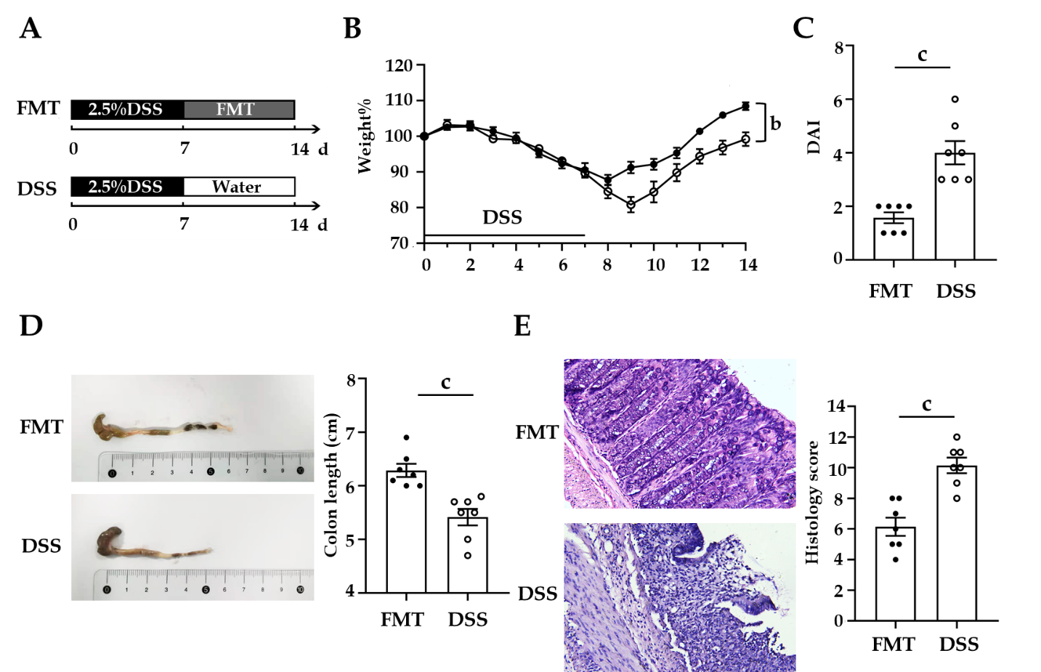
Figure 1 Therapeutic fecal microbiota transplantation ameliorates dextran sodium sulphate-induced inflammation. A: Schematic representation of fecal microbiota transplantation treatment in the dextran sodium sulphate colitis model (n = 7 per group); B: Daily changes of bodyweight of each group during the disease process; C: Disease activity index scores of each group were evaluated after sacrifice; D: Macroscopic view of colon was observed, colon length from each group was measured; E: Serial sections of colon tissues were stained with hematoxylin and eosin, original magnification 200 ×, Histological scores of each group were determined. Values of ªP < 0.05, ^{b}P < 0.01 and ^{c}P < 0.001 were considered as statistically significant. DSS: Dextran sodium sulphate; FMT: Fecal microbiota transplantation.
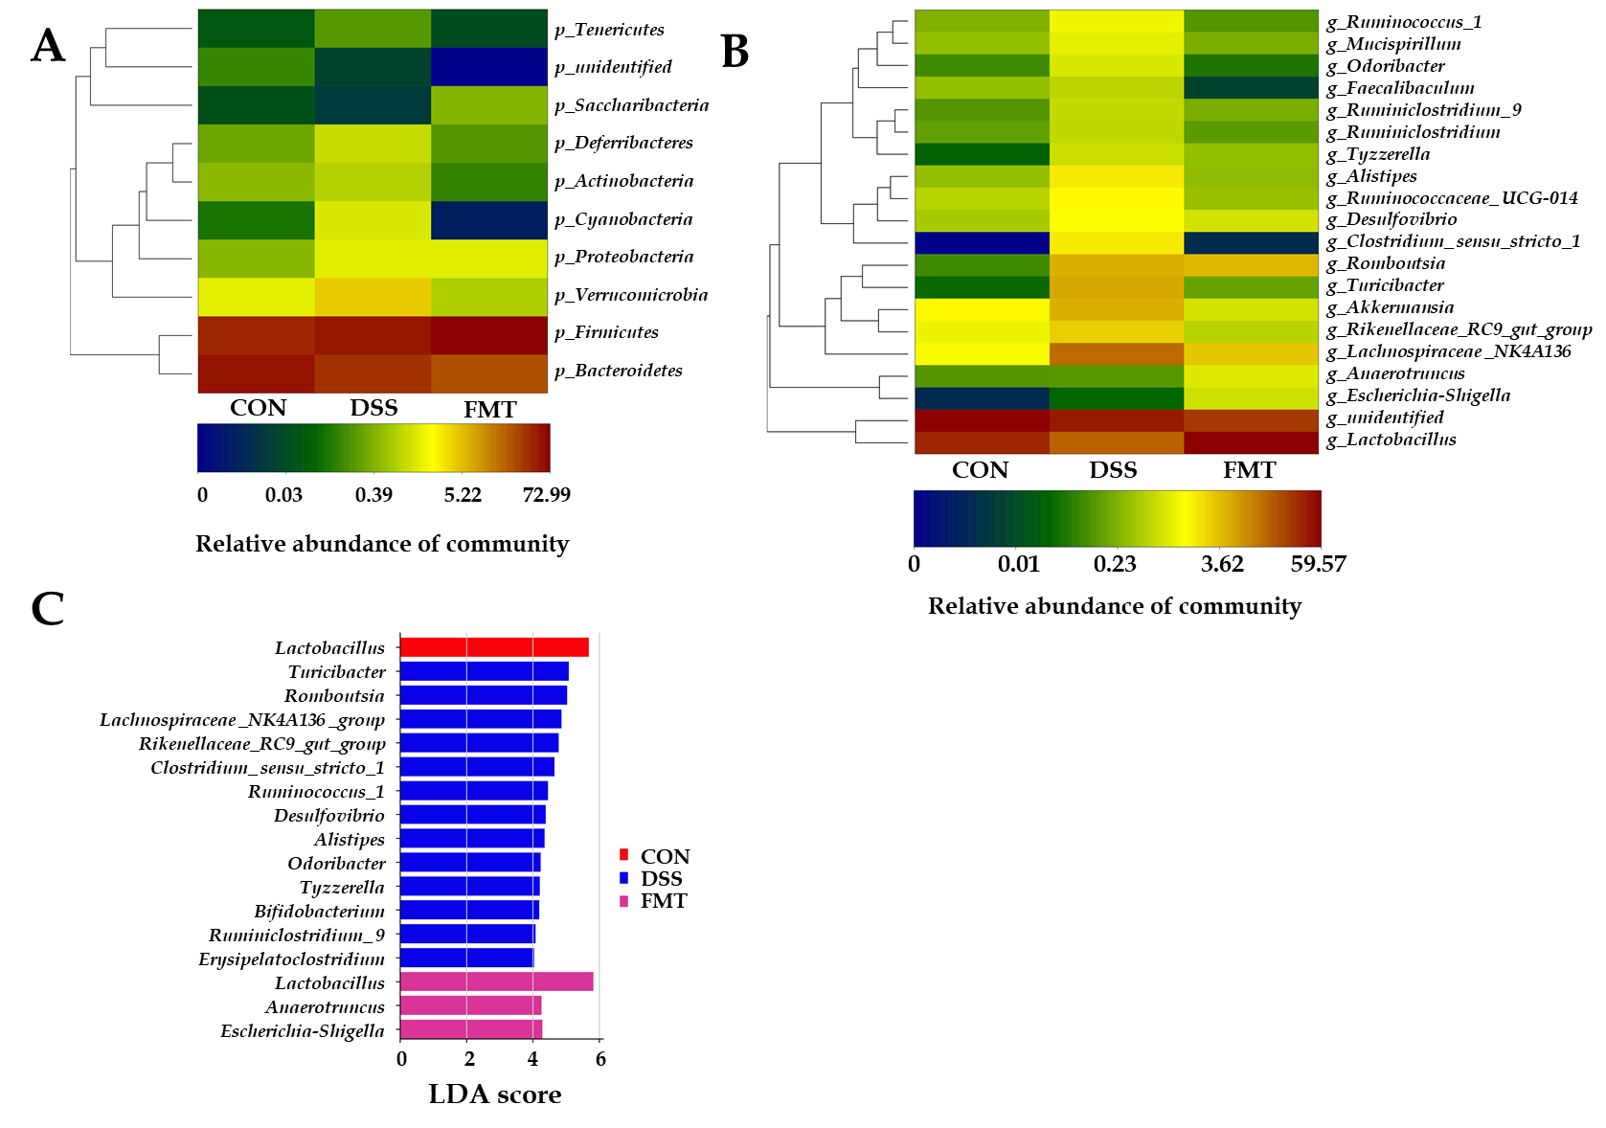
Figure 2 Fecal microbiota transplantation modulated the overall structure of gut microbiota. A and B: Heatmap of the relative abundance at the level of phylum and genus; C: The linear discriminant analysis effect size analysis at the level of genus in groups. CON: Control; DSS: Dextran sodium sulphate; FMT: Fecal microbiota transplantation.
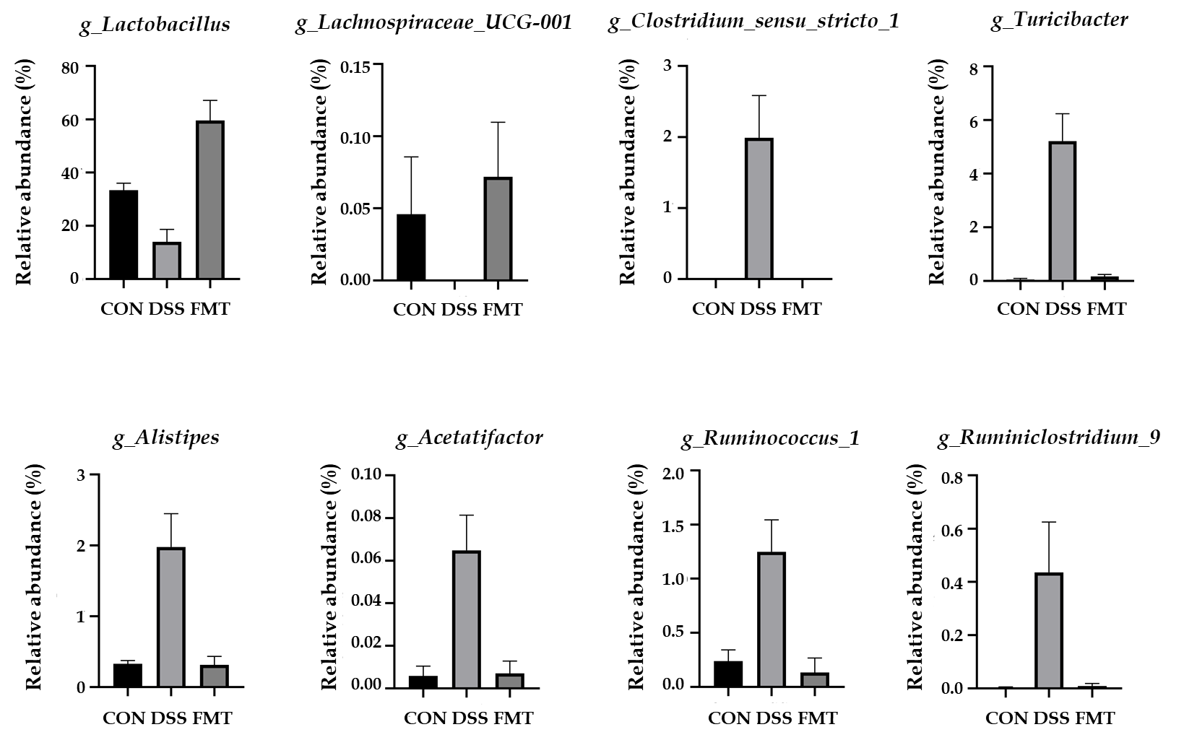
Figure 3 Fecal microbiota transplantation significantly regulated the relative abundance of eight genera compared with dextran sodium sulphate group. Lactobacillus [^{c}P < 0.001, one-way analysis of variance (ANOVA)]; Lachnospiraceae_UCG-001 (ªP < 0.05, one-way ANOVA); Clostridium_sensu_stricto_1 (^{c}P = 0.001, one-way ANOVA); Turicibacter (^{c}P < 0.001, one-way ANOVA); Alistipes (^{c}P = 0.001, one-way ANOVA); Acetatifactor (^{c}P = 0.001, one-way ANOVA); Ruminococcus_1 (^{b}P < 0.01, one-way ANOVA); Ruminiclostridium_6 (ªP < 0.05, one-way ANOVA). CON: Control; DSS: Dextran sodium sulphate; FMT: Fecal microbiota transplantation.
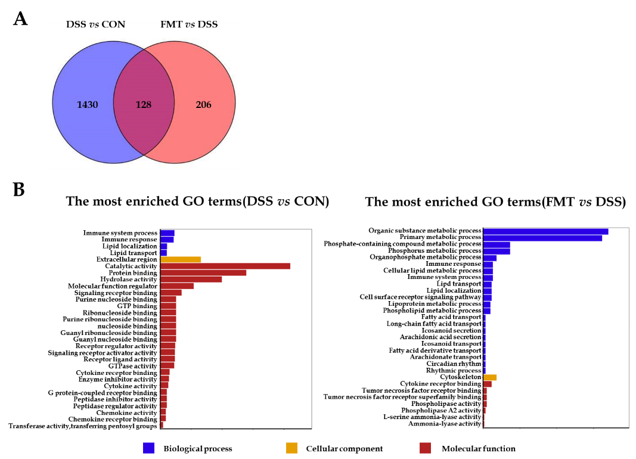
Figure 4 Effect of fecal microbiota transplantation on colonic transcriptome in colitis mice. A: Venn diagram with genes regulated between dextran sodium sulphate (DSS) and fecal microbiota transplantation (FMT) or shared between the two sections; B: The top 30 gene ontology terms with the most significant enrichment between DSS group and control (CON) group (left), FMT group and DSS group (right). After DSS treatment (left), the differentially expressed genes in mice colon were mainly associated with immune system process, while after FMT (right), the differentially expressed genes were mainly related to metabolic process and immune response. GO: Gene ontology.
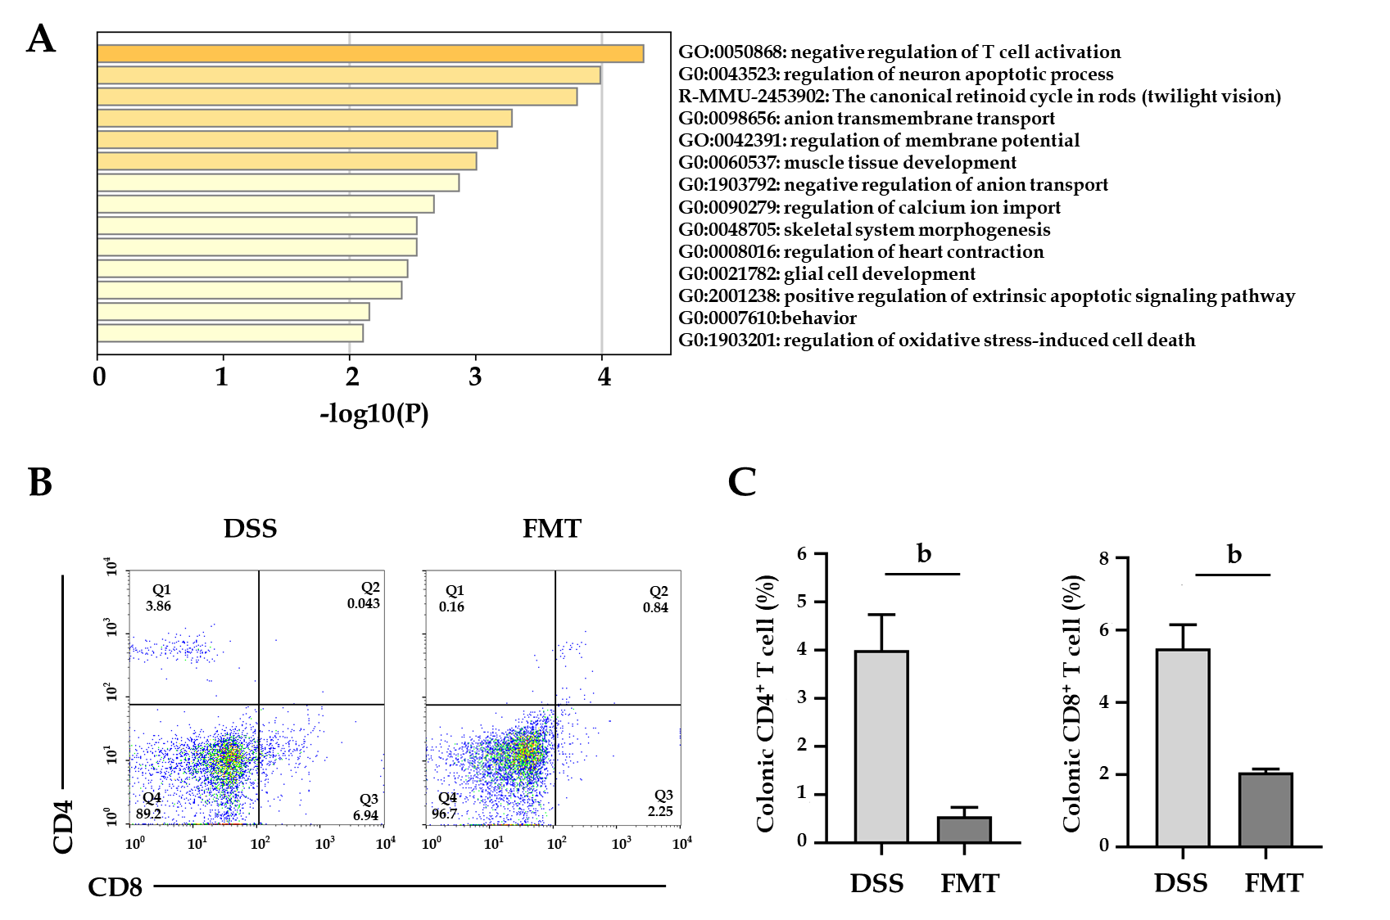
Figure 5 Therapeutic fecal microbiota transplantation modulates T cell phenotypes. A: Differentially expressed genes between control, dextran sodium sulphate (DSS) and fecal microbiota transplantation (FMT) group analyzed in Metascape; B: Colonic CD4⁺ and CD8⁺ T cells in DSS and FMT group; n = 4 mice per group; C: Bar charts of the percentage of T cells (^{b}P < 0.01). CON: Control.
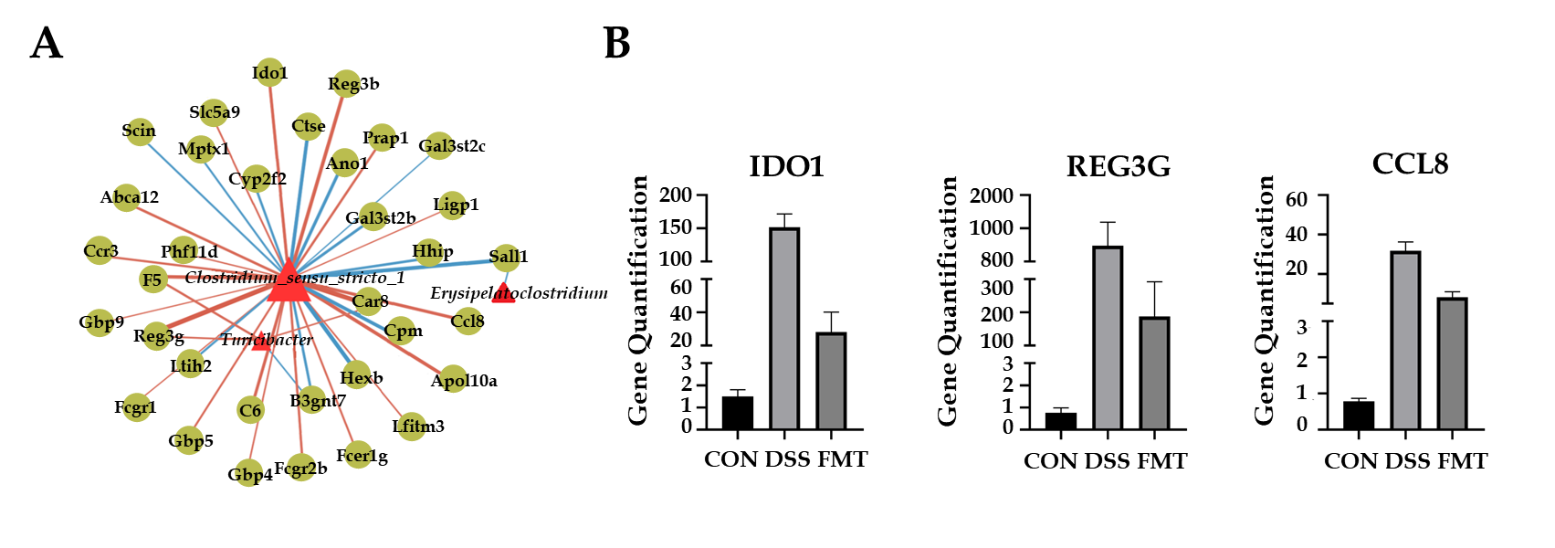
Figure 6 Network analysis of fecal microbiota transplantation in colitis mice. A: Network visualizing significant gene-microbe correlations (r > 0.8, P < 0.05). B: Relative quantification of transcript level of indoleamine 2,3-dioxygenase 1 (IDO1), antimicrobial C-type lectin regenerating islet-derived 3 gamma (REG3G) and monocyte chemoattractant protein 2 (CCL8) in groups (all the P < 0.001, one-way analysis of variance). CON: Control; DSS: Dextran sodium sulphate; FMT: Fecal microbiota transplantation.
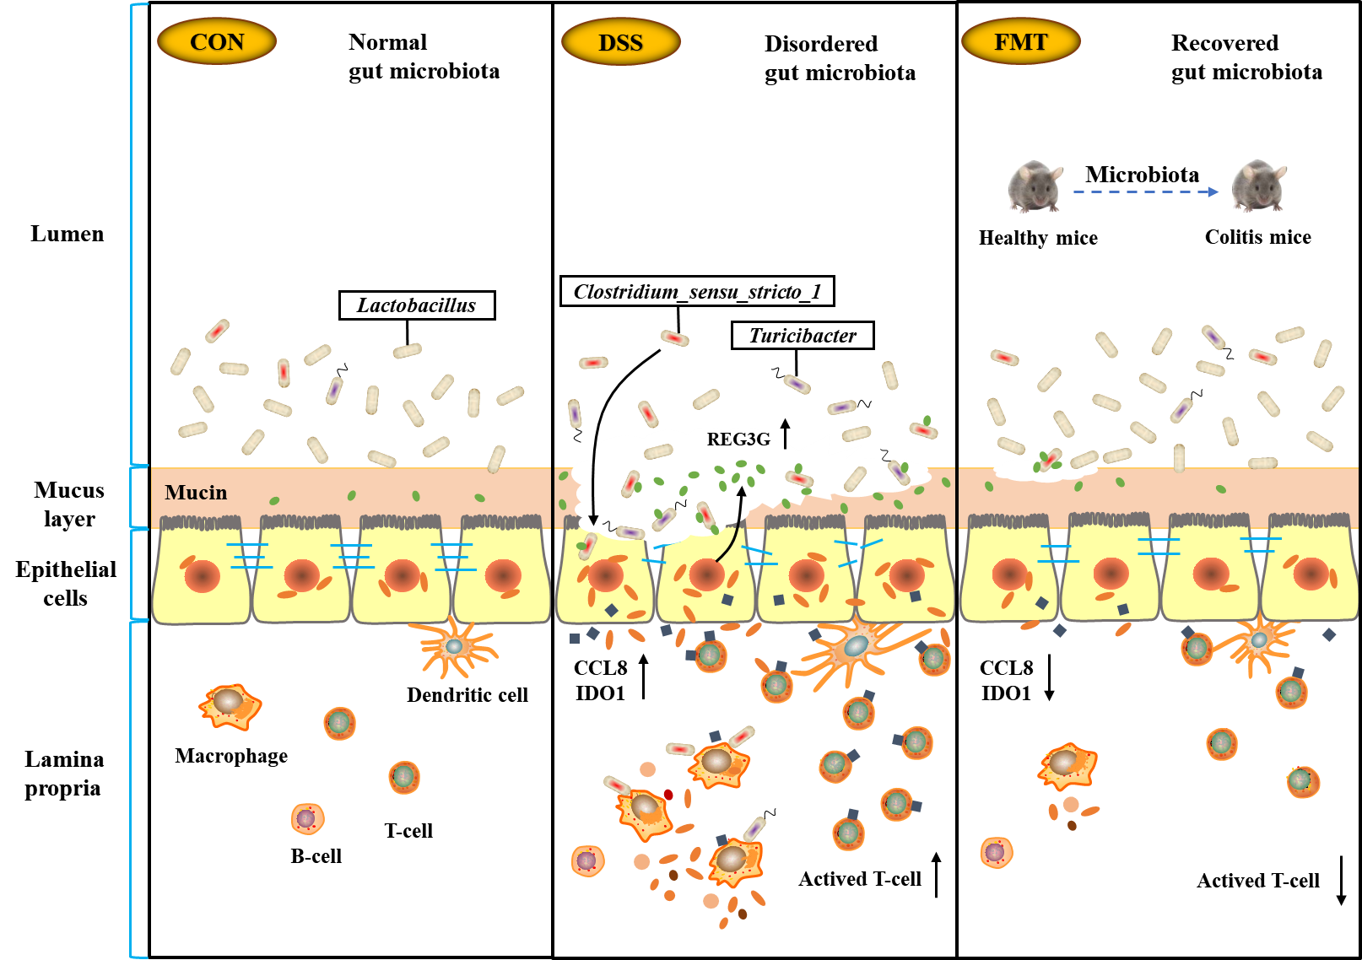
Figure 7 Summary scheme of the mechanisms underlying the therapeutic effect of fecal microbiota transplantation on experimental colitis. CCL8: Monocyte chemoattractant protein 2; CON: Control; DSS: Dextran sodium sulphate; FMT: Fecal microbiota transplantation; IDO1: Indoleamine 2,3-dioxygenase 1; REG3G: Antimicrobial C-type lectin regenerating islet-derived 3 gamma.
Table 1 Correlation between gut microbiota and transcriptome
Number | Gene name | Target microbiota | r value | P value
1 | Ccl8 | Clostridium_sensu_stricto_1 | 0.87 | < 0.001
2 | C6 | Clostridium_sensu_stricto_1 | 0.87 | < 0.001
3 | Ido1 | Clostridium_sensu_stricto_1 | 0.87 | < 0.001
4 | Abca12 | Clostridium_sensu_stricto_1 | 0.85 | < 0.001
5 | Fcgr2b | Clostridium_sensu_stricto_1 | 0.84 | < 0.001
6 | Prap1 | Clostridium_sensu_stricto_1 | 0.84 | < 0.001
7 | F5 | Turicibacter | 0.84 | < 0.001
8 | Ccr3 | Clostridium_sensu_stricto_1 | 0.84 | < 0.001
9 | Fcer1g | Clostridium_sensu_stricto_1 | 0.83 | < 0.001
10 | Gbp5 | Clostridium_sensu_stricto_1 | 0.83 | < 0.001
11 | Slc5a9 | Clostridium_sensu_stricto_1 | 0.82 | = 0.001
12 | Reg3g | Turicibacter | 0.82 | = 0.001
13 | Gbp4 | Clostridium_sensu_stricto_1 | 0.82 | = 0.001
14 | Ifitm3 | Clostridium_sensu_stricto_1 | 0.82 | = 0.001
15 | Car8 | Turicibacter | 0.81 | = 0.001
16 | Phf11d | Clostridium_sensu_stricto_1 | 0.81 | = 0.001
17 | Fcgr1 | Clostridium_sensu_stricto_1 | 0.8 | = 0.002
18 | Gbp9 | Clostridium_sensu_stricto_1 | 0.8 | = 0.002
19 | Iigp1 | Clostridium_sensu_stricto_1 | 0.8 | = 0.002
20 | Gal3st2c | Clostridium_sensu_stricto_1 | -0.8 | = 0.002
21 | Sall1 | Erysipelatoclostridium | -0.81 | = 0.001
22 | B3gnt7 | Turicibacter | -0.81 | = 0.001
23 | Mptx1 | Clostridium_sensu_stricto_1 | -0.83 | < 0.001
24 | Scin | Clostridium_sensu_stricto_1 | -0.83 | < 0.001
25 | Itih2 | Clostridium_sensu_stricto_1 | -0.84 | < 0.001
26 | Cyp2f2 | Clostridium_sensu_stricto_1 | -0.84 | < 0.001
27 | B3gnt7 | Clostridium_sensu_stricto_1 | -0.85 | < 0.001
28 | Hhip | Clostridium_sensu_stricto_1 | -0.85 | < 0.001
29 | Gal3st2b | Clostridium_sensu_stricto_1 | -0.86 | < 0.001
30 | Ano1 | Clostridium_sensu_stricto_1 | -0.87 | < 0.001

