Name of Journal: World Journal of Hepatology
Manuscript NO: 79672
Manuscript Type: ORIGINAL ARTICLE

Basic Study
Immunological classification of hepatitis B virus-positive hepatocellular carcinoma by transcriptome analysis

Li SW et al. Classification of HBV+ hepatocellular carcinoma

Sheng-Wei Li, Li-Fan Han, Yin He, Xiao-Sheng Wang

Sheng-Wei Li, Li-Fan Han, Yin He, Xiao-Sheng Wang, Basic Medicine and Clinical Pharmacy, China Pharmaceutical University, Nanjing 211198, Jiangsu Province, China

Author contributions: Li SW contributed to software, validation, formal analysis, investigation, data curation, visualization, writing - review & editing; Han LF contributed to software, formal analysis, data curation; He Y contributed to data curation; Wang XS contributed to conceptualization, methodology, resources, investigation, writing - original draft, supervision, project administration, funding acquisition.

Corresponding author: Xiao-Sheng Wang, PhD, Associate Professor, Basic Medicine and Clinical Pharmacy, China Pharmaceutical University, No. 639 Longmian Avenue, Jiangning District, Nanjing 211198, Jiangsu Province, China. xiaosheng.wang@cpu.edu.cn

Received: September 5, 2022
Revised: October 12, 2022
Accepted: November 22, 2022
Published online: December 27, 2022

Abstract
BACKGROUND
Hepatitis B virus (HBV) infection is a major factor responsible for HBV+ hepatocellular carcinoma (HCC).

AIM
An immunological classification of HBV+ HCC may provide both biological insights and clinical implications for this disease.

METHODS
Based on the enrichment of 23 immune signatures, we identified two immune-specific subtypes (Imm-H and Imm-L) of HBV+ HCC by unsupervised clustering. We showed that this subtyping method was reproducible and predictable by analyzing three different datasets.

RESULTS
Compared to Imm-L, Imm-H displayed stronger immunity, more stromal components, lower tumor purity, lower stemness and intratumor heterogeneity, lower-level copy number alterations, higher global methylation level, and better overall and disease-free survival prognosis. Besides immune-related pathways, stromal pathways (ECM receptor interaction, focal adhesion, and regulation of actin cytoskeleton) and neuro-related pathways (neuroactive ligand-receptor interaction, and prion diseases) were more highly enriched in Imm-H than in Imm-L. We identified nine proteins differentially expressed between Imm-H and Imm-L, of which MYH11, PDCD4, Dvl3, and Syk were upregulated in Imm-H, while PCNA, Acetyl-a-Tubulin-Lys40, ER-α_pS118, Cyclin E2, and β-Catenin were upregulated in Imm-L.

CONCLUSION
Our data suggest that “hot” tumors have a better prognosis than “cold” tumors in HBV+ HCC and that “hot” tumors respond better to immunotherapy.

Key Words: Hepatitis B virus; Hepatocellular carcinoma; Immunological classification; Transcriptomics; Tumor immunity; Cancer immunotherapy

©The Author(s) 2022. Published by Baishideng Publishing Group Inc. All rights reserved.

Citation: Li SW, Han LF, He Y, Wang XS. Immunological classification of hepatitis B virus-positive hepatocellular carcinoma by transcriptome analysis. World J Hepatol 2022; 14(12): 1997-2011
URL: https://www.wjgnet.com/1948-5182/full/v14/i12/1997.htm
DOI: https://dx.doi.org/10.4254/wjh.v14.i12.1997

Core Tip: First, for the first time, we identified immune-specific subtypes of hepatitis B virus (HBV) + hepatocellular carcinoma (HCC) based on immune signature scores and demonstrated that this new subtyping method was reproducible in three different datasets. Second, our subtyping method captures the comprehensive heterogeneity of HBV+ HCC in the tumor microenvironment, genomic integrity, protein expression profiles, DNA methylation profiles, tumor stemness, intratumor heterogeneity, and clinical outcomes. Third, our data suggest that it is copy number alterations but not tumor mutations responsible for the different immunity between the “hot” and “cold” tumor subtypes in HBV+ HCC. Finally, our identification of the immune-specific subtypes of HBV+ HCC may provide new insights into the tumor biology and identify the HBV+ HCC patients beneficial from immunotherapy.

INTRODUCTION
Hepatocellular carcinoma (HCC) is a major cancer of the liver that constitutes around 90% of liver cancer cases^{[1]}. Although traditional therapeutic approaches, including surgery, chemotherapy, radiotherapy, and targeted therapy, are effective in improving the survival of HCC patients, the overall survival prognosis of HCC patients is generally unfavorable^{[2]}. More recently, immunotherapy, such as immune checkpoint blockade (ICB), has shown success in the treatment of various cancers, including HCC^{[3]}. However, only a small proportion of cancer patients respond well to immunotherapies to date^{[4]}. To this end, certain predictive markers for cancer immunotherapy responses have been uncovered, e.g., PD-L1 expression^{[5]}, tumor mutation burden (TMB)^{[6]}, and mismatch repair deficiency^{[7]}. In addition, the tumor immune microenvironment (TIME) plays an important role in immunotherapy responses^{[8]}. Overall, the “hot” tumors infiltrated by a substantial number of tumor-infiltrating lymphocytes (TILs) are more responsive to immunotherapies, compared to the “cold” tumors lacking TILs^{[9]}. Hence, an investigation of the TIME in HCC would aid in the prediction of immunotherapy responses.
With the recent emergence of large-scale cancer genomics data, such as the Cancer Genome Atlas (TCGA) (https://portal.gdc.cancer.gov/) and International Cancer Genome Consortium (ICGC) (https://dcc.icgc.org/), many studies have investigated the TIME in HCC based on these data^{[10-12]}. For example, Gao et al^{[10]} identified four immune-relevant subtypes of HCC based on the enrichment of 13 signatures and revealed significantly different molecular and clinical characteristics among these subtypes. Sia et al^{[11]} uncovered an immune subclass of HCC representing nearly 25% of HCC cases, based on gene expression profiles in tumor, stromal, and immune cells. Based on the enrichment of immune cell subpopulations, Farha et al^{[12]} identified two immune clusters of HCC, and found that the cluster enriched with M0 macrophages had a worse prognosis.
Despite these previous studies^{[10-12]}, the discovery of immune-specific subtypes of hepatitis B virus-positive (HBV+) HCC is worth investigating, considering that HBV infection is a major cause of HCC^{[13]}. In this study, to characterize the immunological landscape of HBV+ HCC, we identified its immune-specific subtypes by the unsupervised machine learning in transcriptomic data. Furthermore, we comprehensively compared the clinical and molecular features of these subtypes. Our analysis would provide new insights into the HBV+ HCC immunity and its associated clinical and molecular features, as well as potential clinical implications for the management of this disease.

MATERIALS AND METHODS
Datasets
We obtained the TCGA Hepatocellular Carcinoma (TCGA-LIHC) dataset, including transcriptomes (RSEM-normalized RNA-Seq gene expression profiles), somatic mutations (“maf” file), somatic copy number alterations (SCNAs) (“SNP6” files), normalized protein expression profiles by Reverse Phase Protein Array (RPPA), and clinical data, from the Genomic Data Commons (GDC) Data Portal (https://portal.gdc.cancer.gov/). We obtained other two HCC transcriptomic datasets (GSE14520 and GSE121248) from the Gene Expression Omnibus (GEO) (https://www.ncbi.nlm.nih.gov/geo/). A description of these datasets is provided in Supplementary Table 1.

Single-sample gene set enrichment analysis
We evaluated the enrichment of an immune signature or pathway in a tumor by the single-sample gene-set enrichment analysis (ssGSEA)^{[14]}. This method extends the GSEA method^{[15]} to obtain the enrichment scores of input gene sets in specimens with input of gene expression matrices and marker or pathway gene sets. The marker or pathway gene sets of immune signatures or pathways are presented in Supplementary Table 2.

Identification of immune-specific subtypes of HBV+ HCC
By hierarchical clustering, we identified immune-specific subtypes of HBV+ HCC based on the enrichment scores of 23 immune signatures. The 23 immune cell types included Pro-inflammatory cytokines, APC co-inhibition, APC co-stimulation, Cytolytic activity, Immune cell infiltrate, Inflammation-promoting, Interferon, M1 macrophage, MHC Class I, Myeloid-derived suppressor cell, T cell co-inhibition, T cell exhaustion, Th1 cell, Th2 cell, TILs, activated dendritic cell, Eosinophil, Immature dendritic cell, Macrophage, Monocyte, Natural killer cell, Plasmacytoid dendritic cell, activated B cell. Before clustering, we performed the Z-score normalization of the ssGSEA scores and converted them into distance matrices using the R function “dist” with the following parameter: Method = “euclidean.” We performed the hierarchical clustering using the function “hclust()” in the R package “Stats” with the following parameters: method = “ward.D2” and members = NULL.

Class prediction
We conducted classification with the random forest (RF) algorithm. In the RF, the size of trees was 500, and the features were the 23 immune signatures. The prediction performance, namely the accuracy and weighted F-score, were reported. We performed this procedure using the R package "randomForest".

Survival analysis
We compared overall survival (OS) and disease-free survival (DFS) rates between two classes of samples with the Kaplan-Meier (K-M) method^{[16]}. K-M curves were used to show the differences in survival rates, and log-rank tests were utilized to evaluate their significance.

Calculation of TMB, SCNAs, Stemness scores, intratumor heterogeneity scores, immune scores, and tumor purity in tumors
A tumor’s TMB was defined as its total count of somatic mutations. We used GISTIC2^{[17]} to calculate SCNA frequencies and amplitudes in the immune-specific subtypes of HBV+ HCC with the input of “SNP6” files. A tumor’s stemness score was its ssGSEA score of the stemness marker genes, as shown in Supplementary Table 1. We measured intratumor heterogeneity (ITH) levels with the DEPTH algorithm^{[18]}, which evaluates ITH levels based on gene expression profiles. We assessed immune scores and tumor purity of bulk tumors using ESTIMATE^{[19]}. The immune scores indicate the levels of tumor immune infiltration, and tumor purity represents the fraction of tumor cells within a tumor bulk.

Pathway and gene ontology enrichment analysis
To identify pathways that are more enriched in one group compared to another group, we first uncovered the genes significantly upregulated in the group versus another group by Student's t tests using thresholds of false discovery rate (FDR) < 0.05 and mean gene expression levels’ fold change (FC) > 2. We then input the upregulated genes into the GSEA web tool^{[15]} to obtain the Kyoto Encyclopedia of Genes and Genomes (KEGG)^{[20]} pathways using a threshold of FDR < 0.05, which were more enriched in that group versus another class. Besides, we used the weighted gene co-expression network analysis (WGCNA)^{[21]} to identify the gene modules of co-expressed genes. Based on the expression correlations between the hub genes in gene modules, we identified the gene ontology (GO) terms showing significant correlations with specific traits. The WGCNA analysis was performed with the R package “WGCNA” (version 1.68).

Statistical analysis
In comparisons of two classes of normally distributed data, including gene expression levels, protein expression levels, and the ratios of immune-stimulatory to immune-inhibitory signatures, we used two-tailed Student’s t tests. In comparisons of two classes of data that were not normally distributed, including immune scores, stemness scores, ITH scores, TMB, and global methylation levels, we performed one-tailed Mann–Whitney U tests. We utilized the Spearman method to calculate correlations between immune scores and protein expression levels or pathways’ enrichment scores, and reported correlation coefficients (ρ) and P values. We employed the Benjamini–Hochberg method^{[22]} to calculate FDR for adjusting for multiple tests. We performed all statistical analyses in the R programming environment (version 4.1.3).

RESULTS
Clustering analysis identifies two immune-specific subtypes of HBV+ HCC
This analysis identified two subtypes of HBV+ HCC according to the enrichment scores of 23 immune signatures by hierarchical clustering, consistently in three transcriptomic datasets (TCGA-LIHC, GSE14520, and GSE121248) (Figure 1A). We termed the subtypes Imm-H and Imm-L, respectively, which showed high and low immune signature enrichment, respectively (Figure 1A). To explore whether this classification is predictable, we took one of the three datasets as the training set and the rest as test sets, in turn, to predict the subtypes by RF based on the attribute values (ssGSEA scores of the 23 immune signatures). The 10-fold CV accuracies and weighted F-scores in the training sets were all above 90%. The prediction accuracies and weighted F-scores in test sets with TCGA-LIHC or GSE121248 as the training set were not less than 90% (Figure 1B). These results demonstrate that the subtyping is predictable.
We further compared the expression levels of 25 genes encoding human leukocyte antigens between the subtypes. Of note, in TCGA-LIHC, all 25 genes were expressed at significantly higher levels in Imm-H than in Imm-L (FDR < 0.01; FC > 1.5) (Figure 2A). The immune scores were significantly higher in Imm-H than in Imm-L, consistently in the three datasets (P < 0.001) (Figure 2B). Furthermore, PD-L1, an antitumor immunosuppressive signature, was more highly expressed in Imm-H than in Imm-L (P < 0.01) (Figure 2C). Nevertheless, the ratios of immunostimulatory to immunosuppressive signatures (CD8+/CD4+ regulatory T cells), the base-2 Log-transformed values of the geometric mean expression levels of all marker genes of CD8+ T cells divided by those of CD4+ regulatory T cells, were significantly higher in Imm-H than in Imm-L (P < 0.05) (Figure 2D). Taken together, these results support that Imm-H has stronger anti-tumor immunity compared to Imm-L.

The immune-specific subtypes of HBV+ HCC have different clinical and phenotypic features
We compared 5-year OS and DFS prognosis between the immune-specific subtypes of HBV+ HCC in TCGA-LIHC, which had survival-related data available. Notably, Imm-H displayed significantly higher OS and DFS rates than Imm-L (P < 0.05) (Figure 3A). It supports the positive association between antitumor immune responses and survival prognosis in HBV+ HCC. We further compared several tumor progression-associated phenotypic features, including tumor stemness and ITH. We found that both stemness and ITH scores were markedly higher in Imm-L than in Imm-H in two of the three datasets (TCGA-LIHC and GSE121248) (P < 0.05) (Figure 3B). As expected, tumor purity was consistently higher in Imm-L than in Imm-H in the three datasets (Figure 3C). Altogether, these results indicate more favorable clinical outcomes in Imm-H than in Imm-L.

Comparisons of genomic and epigenomic features between the immune-specific subtypes of HBV+ HCC
Tumor aneuploidy, also known as copy number alteration (CNA), is a typical genomic feature in tumors^{[23]}. We found that Imm-L had higher frequencies of arm-level copy number amplification and deletion across chromosomes (Figure 4A). Moreover, Imm-L likely had higher amplitudes of copy number amplification and deletion across chromosomes as compared to Imm-H (Figure 4B). It suggested a higher level of genomic instability in Imm-L vs Imm-H, supporting a negative correlation between tumor aneuploidy and antitumor immunity^{[24]}. Nevertheless, TMB showed no significant difference between Imm-H and Imm-L (Mann–Whitney U test, P = 0.86). Furthermore, we found that Imm-H had significantly higher global methylation levels^{[25]} than Imm-L (P = 0.006) (Figure 4C). It conforms to a previous study showing that reduced DNA methylation levels promote antitumor immunosuppression^{[25]}.

Pathways and GO enriched in the immune-specific subtypes of HBV+ HCC
Based on the DEGs between Imm-H and Imm-L, we identified the KEGG pathways enriched in Imm-H and Imm-L common across the three datasets. Because there were no pathways enriched in Imm-L overlapping among the three datasets, we only attained the pathways enriched in Imm-H. We identified a total of 39 pathways highly enriched in Imm-H common in the three datasets. As expected, many immune-related pathways were on the list, including allograft rejection, antigen processing and presentation, apoptosis, asthma, autoimmune thyroid disease, B cell receptor signaling, cell adhesion molecules, chemokine signaling, complement and coagulation cascades, cytokine-cytokine receptor interaction, cytosolic DNA sensing, Fc epsilon RI signaling, Fc gamma R-mediated phagocytosis, graft vs host disease, hematopoietic cell lineage, intestinal immune network for IgA production, Jak-STAT signaling, leishmania infection, leukocyte transendothelial migration, natural killer cell-mediated cytotoxicity, NOD-like receptor signaling, primary immunodeficiency, T cell receptor signaling, systemic lupus erythematosus, Toll-like receptor signaling, and viral myocarditis (Figure 5A). Besides, several stromal pathways were included in the list, such as ECM receptor interaction, focal adhesion, and regulation of actin cytoskeleton. Interestingly, we found two neuro-associated pathways included in the pathway list: neuroactive ligand-receptor interaction, and prion diseases. It indicates that the activities of these neuro-associated pathways are positively correlated with antitumor immunity. Indeed, the enrichment scores of these pathways correlated positively with immune scores in these datasets (Spearman correlation, P < 0.05) (Figure 5B).
WGCNA^{[21]} identified nine gene modules significantly differentiating HBV+ HCC by the immune-specific subtypes, OS, and/or DFS (Figure 5C). The gene modules upregulated in Imm-H while downregulated in Imm-L included the green module (with the representative GO term of immune response) and the yellow module (with the representative GO term of extracellular matrix) (P < 0.001). It is consistent with the results from the prior pathway analysis showing more highly enriched immune and stromal pathways in Imm-H versus Imm-L. Moreover, both modules were positively correlated with the OS prognosis (P < 0.05), consistent with the better OS in Imm-H relative to Imm-L. Besides, the blue module (with the GO term of homophilic cell adhesion via plasma membrane adhesion molecules) was significantly and positively correlated with the OS prognosis (P = 0.02), although it showed no significant enrichment difference between Imm-H versus Imm-L. It is reasonable that the positive association between the blue module and OS since reduced homophilic cell adhesion can promote tumor progression^{[26]}. In contrast, the brown module had significant negative correlations with both OS and DFS time. The representative GO term for this module was cell cycle. It is justified since elevated cell cycle activity suggests tumor progression.

Proteins enriched in the immune-specific subtypes of HBV+ HCC
We compared the expression levels of 219 proteins between the immune-specific subtypes of HBV+ HCC in TCGA-LIHC. We identified nine proteins differentially expressed between Imm-H and Imm-L (P < 0.05) (Figure 6A). Among them, MYH11, PDCD4, Dvl3, and Syk were more highly expressed in Imm-H, while PCNA, Acetyl-a-Tubulin-Lys40, ER-α_pS118, Cyclin E2, and β-Catenin were more highly expressed in Imm-L. As expected, the proteins more enriched in Imm-H showed significantly positive expression correlations with immune scores in HBV+ HCC, and the proteins more enriched in Imm-L showed negative expression correlations with them (Spearman correlation, P < 0.05) (Figure 6B). Previous studies have shown that most of these proteins have associations with tumor immune regulation. For example, MYH11 is a smooth muscle myosin of the myosin heavy chain family, whose expression has been associated with antitumor immune infiltration in cancer^{[27]}. PDCD4 is a tumor suppressor, whose expression in the tumor microenvironment is correlated with increased immune infiltration^{[28,29]}. Syk is also a tumor suppressor and has a role in tumor immune regulation^{[30]}. PCNA is involved in the DNA repair pathway in response to DNA damage, whose upregulation may promote tumor immune evasion^{[31,32]}. This is consistent with its upregulation in Imm-L versus Imm-H. ER-α has been shown to induce antitumor immunosuppression^{[33]}, supporting our finding. Cyclin E2 is a positive regulator of cell cycle, which may inhibit antitumor immune responses and immunotherapy responses^{[34]}. Again, this is consistent with our result. β-Catenin is an activator of the Wnt/β-catenin signaling pathway, whose overexpression suppresses antitumor immune responses^{[35]}, in line with our findings.

DISCUSSION
This study identified two immune-specific subtypes (Imm-H and Imm-L) of HBV+ HCC based on the enrichment of 23 immune signatures by unsupervised clustering. We showed that this subtyping method was reproducible as well as predictable by analyzing three different datasets. Furthermore, we demonstrated that both subtypes had significantly different clinical and molecular features. Compared to Imm-L, Imm-H displayed stronger immunity, more stromal components, lower tumor purity, lower stemness and ITH, lower-level CNAs, higher global methylation level, and better overall and disease-free survival prognosis (Figure 7). Our data support that “hot” tumors have a better prognosis than “cold” tumors in HBV+ HCC for their stronger antitumor immune responses. Similar findings were also observed in other cancers^{[36-38]}. Intriguingly, although continual inflammatory responses in the liver caused by HBV infection is a major etiology for HBV+ HCC^{[39]}, higher immune/inflammatory responses are associated with a better prognosis in HBV+ HCC patients, as demonstrated by this analysis. It indicates that the relationship between immune/inflammatory responses and clinical outcomes in cancer is complex. Indeed, in some cancer types, such as glioma^{[40]} and prostate cancer^{[41]}, the relationship between immune/inflammatory responses and clinical outcomes is negative. Thus, the relationship between immune responses and clinical outcomes in cancers is dependent on their tissue or cellular origins, the tumor microenvironment, the ratio of immunostimulatory over immunosuppressive signatures, as well as whether the immune response is the tumor progression-promoting inflammation or immune cell-mediated elimination of tumor cells.
Prior studies have shown that TMB and CNAs have a positive and negative association with antitumor immune responses, respectively^{[24]}. However, our analysis suggests that TMB has no a significant association with antitumor immunity in HBV+ HCC, although CNAs have a negative association with antitumor immune responses. It suggests that it is CNAs but not TMB responsible for the significantly different immunity between the “hot” and “cold” tumor subtypes in HBV+ HCC. Furthermore, the significantly lower stemness and ITH of Imm-H compared to Imm-L suggest that stemness and ITH may lead to antitumor immunosuppression, consistent with previous findings^{[18,42,43]}.
Pathway analysis showed that two neuro-associated pathways (neuroactive ligand receptor interaction, and prion diseases) had higher enrichment in Imm-H than in Imm-L and that their upregulation was associated with increased tumor immune infiltration levels. The positive association between neuro-related pathways and antitumor immunity has been revealed in prior studies^{[44]}. Interestingly, many studies have demonstrated the inverse relationship between cancer and Alzheimer’s disease (AD)^{[45]}. AD is known as a progressive neurodegenerative disease as well as neuroinflammation disease^{[46]}. A recent study has proposed that AD is an autoimmune disorder of innate immunity^{[47]}. The present and prior data stimulate our imagination that the immune and inflammation could bridge the relationship between cancer and AD, such as hyperactivation of the immune system in AD patients reducing the risk of cancer.
Interestingly, besides the antitumor immune signatures, the immunosuppressive signature PD-L1, was also upregulated in Imm-H vs Imm-L. Because both PD-L1 expression^{[48]} and ample TILs^{[9]} are positive predictors of the response to ICB, Imm-H would respond better to immunotherapy than Imm-L. Thus, our subtyping method may stratify HBV+ HCC patients for immunotherapy. That is, immunotherapy may yield more propitious efficacy for Imm-H than for Imm-L HBV+ HCC patients.

CONCLUSION
HBV+ HCCs can be classified into two immune-specific subtypes in terms of their immune signature enrichment. Both subtypes have significantly different immunity, stromal contents, tumor purity, stemness, ITH, CNAs, methylation profiles, and survival prognosis. The immune-specific subtyping of HBV+ HCC may provide new biological insights as well as clinical implications for the management of this disease.

ARTICLE HIGHLIGHTS
Research background
Hepatocellular carcinoma (HCC) is a major cancer of the liver that constitutes around 90% of liver cancer cases. Although traditional therapeutic approaches, including surgery, chemotherapy, radiotherapy, and targeted therapy, are effective in improving the survival of HCC patients, the overall survival prognosis of HCC patients is generally unfavorable. More recently, immunotherapy, such as immune checkpoint blockade, has achieved success in the treatment of various cancers, including HCC. However, only a small proportion of cancer patients respond well to immunotherapies to date.

Research motivation
Certain predictive markers for cancer immunotherapy responses have been uncovered, e.g., PD-L1 expression, tumor mutation burden (TMB), and mismatch repair deficiency. In addition, the tumor immune microenvironment (TIME) plays an important role in immunotherapy responses. Overall, the “hot” tumors infiltrated by a substantial number of tumor-infiltrating lymphocytes (TILs) are more responsive to immunotherapies, compared to the “cold” tumors lacking TILs. Hence, an investigation of the TIME in HCC would aid in the prediction of immunotherapy responses.

Research objectives
Despite these previous studies, the discovery of immune-specific subtypes of hepatitis B virus-positive (HBV+) HCC is worth investigating, considering that HBV infection is a major cause of HCC.

Research methods
In this study, to characterize the immunological landscape of HBV+ HCC, we identified its immune-specific subtypes by the unsupervised machine learning in transcriptomic data. Furthermore, we comprehensively compared the clinical and molecular features of these subtypes.

Research results
Compared to Imm-L, Imm-H displayed stronger immunity, more stromal components, lower tumor purity, lower stemness and intratumor heterogeneity, lower-level copy number alterations, higher global methylation level, and better overall and disease-free survival prognosis.

Research conclusions
Our immune-specific subtyping of HBV+ HCC may provide new biological insights as well as clinical implications for the management of this disease.

Research perspectives
This study is interesting for several reasons. First, for the first time, we identified immune-specific subtypes of HBV+ HCC based on immune signature scores and demonstrated that this new subtyping method was reproducible in three different datasets. Second, our subtyping method captures the comprehensive heterogeneity of HBV+ HCC in the tumor microenvironment, genomic integrity, protein expression profiles, DNA methylation profiles, tumor stemness, intratumor heterogeneity, and clinical outcomes. Third, our data suggest that it is copy number alterations but not tumor mutations responsible for the different immunity between the “hot” and “cold” tumor subtypes in HBV+ HCC. Finally, our identification of the immune-specific subtypes of HBV+ HCC may provide new insights into the tumor biology and identify the HBV+ HCC patients beneficial from immunotherapy.

REFERENCES
1 Villanueva A. Hepatocellular Carcinoma. N Engl J Med 2019; 380: 1450-1462 [PMID: 30970190 DOI: 10.1056/NEJMra1713263]
2 Llovet JM, Kelley RK, Villanueva A, Singal AG, Pikarsky E, Roayaie S, Lencioni R, Koike K, Zucman-Rossi J, Finn RS. Hepatocellular carcinoma. Nat Rev Dis Primers 2021; 7: 6 [PMID: 33479224 DOI: 10.1038/s41572-020-00240-3]
3 Yau T, Kang YK, Kim TY, El-Khoueiry AB, Santoro A, Sangro B, Melero I, Kudo M, Hou MM, Matilla A, Tovoli F, Knox JJ, Ruth He A, El-Rayes BF, Acosta-Rivera M, Lim HY, Neely J, Shen Y, Wisniewski T, Anderson J, Hsu C. Efficacy and Safety of Nivolumab Plus Ipilimumab in Patients With Advanced Hepatocellular Carcinoma Previously Treated With Sorafenib: The CheckMate 040 Randomized Clinical Trial. JAMA Oncol 2020; 6: e204564 [PMID: 33001135 DOI: 10.1001/jamaoncol.2020.4564]
4 Braun DA, Burke KP, Van Allen EM. Genomic Approaches to Understanding Response and Resistance to Immunotherapy. Clin Cancer Res 2016; 22: 5642-5650 [PMID: 27698000 DOI: 10.1158/1078-0432.CCR-16-0066]
5 Taube JM, Klein A, Brahmer JR, Xu H, Pan X, Kim JH, Chen L, Pardoll DM, Topalian SL, Anders RA. Association of PD-1, PD-1 ligands, and other features of the tumor immune microenvironment with response to anti-PD-1 therapy. Clin Cancer Res 2014; 20: 5064-5074 [PMID: 24714771 DOI: 10.1158/1078-0432.CCR-13-3271]
6 Goodman AM, Kato S, Bazhenova L, Patel SP, Frampton GM, Miller V, Stephens PJ, Daniels GA, Kurzrock R. Tumor Mutational Burden as an Independent Predictor of Response to Immunotherapy in Diverse Cancers. Mol Cancer Ther 2017; 16: 2598-2608 [PMID: 28835386 DOI: 10.1158/1535-7163.MCT-17-0386]
7 Le DT, Uram JN, Wang H, Bartlett BR, Kemberling H, Eyring AD, Skora AD, Luber BS, Azad NS, Laheru D, Biedrzycki B, Donehower RC, Zaheer A, Fisher GA, Crocenzi TS, Lee JJ, Duffy SM, Goldberg RM, de la Chapelle A, Koshiji M, Bhaijee F, Huebner T, Hruban RH, Wood LD, Cuka N, Pardoll DM, Papadopoulos N, Kinzler KW, Zhou S, Cornish TC, Taube JM, Anders RA, Eshleman JR, Vogelstein B, Diaz LA Jr. PD-1 Blockade in Tumors with Mismatch-Repair Deficiency. N Engl J Med 2015; 372: 2509-2520 [PMID: 26028255 DOI: 10.1056/NEJMoa1500596]
8 Murciano-Goroff YR, Warner AB, Wolchok JD. The future of cancer immunotherapy: microenvironment-targeting combinations. Cell Res 2020; 30: 507-519 [PMID: 32467593 DOI: 10.1038/s41422-020-0337-2]
9 Haanen JBAG. Converting Cold into Hot Tumors by Combining Immunotherapies. Cell 2017; 170: 1055-1056 [PMID: 28886376 DOI: 10.1016/j.cell.2017.08.031]
10 Gao X, Huang H, Wang Y, Pan C, Yin S, Zhou L, Zheng S. Tumor Immune Microenvironment Characterization in Hepatocellular Carcinoma Identifies Four Prognostic and Immunotherapeutically Relevant Subclasses. Front Oncol 2020; 10: 610513 [PMID: 33680932 DOI: 10.3389/fonc.2020.610513]
11 Sia D, Jiao Y, Martinez-Quetglas I, Kuchuk O, Villacorta-Martin C, Castro de Moura M, Putra J, Camprecios G, Bassaganyas L, Akers N, Losic B, Waxman S, Thung SN, Mazzaferro V, Esteller M, Friedman SL, Schwartz M, Villanueva A, Llovet JM. Identification of an Immune-specific Class of Hepatocellular Carcinoma, Based on Molecular Features. Gastroenterology 2017; 153: 812-826 [PMID: 28624577 DOI: 10.1053/j.gastro.2017.06.007]
12 Farha M, Jairath NK, Lawrence TS, El Naqa I. Characterization of the Tumor Immune Microenvironment Identifies M0 Macrophage-Enriched Cluster as a Poor Prognostic Factor in Hepatocellular Carcinoma. JCO Clin Cancer Inform 2020; 4: 1002-1013 [PMID: 33136432 DOI: 10.1200/CCI.20.00077]
13 Zamor PJ, deLemos AS, Russo MW. Viral hepatitis and hepatocellular carcinoma: etiology and management. J Gastrointest Oncol 2017; 8: 229-242 [PMID: 28480063 DOI: 10.21037/jgo.2017.03.14]
14 Hänzelmann S, Castelo R, Guinney J. GSVA: gene set variation analysis for microarray and RNA-seq data. BMC Bioinformatics 2013; 14: 7 [PMID: 23323831 DOI: 10.1186/1471-2105-14-7]
15 Subramanian A, Tamayo P, Mootha VK, Mukherjee S, Ebert BL, Gillette MA, Paulovich A, Pomeroy SL, Golub TR, Lander ES, Mesirov JP. Gene set enrichment analysis: a knowledge-based approach for interpreting genome-wide expression profiles. Proc Natl Acad Sci U S A 2005; 102: 15545-15550 [PMID: 16199517 DOI: 10.1073/pnas.0506580102]
16 Bland JM, Altman DG. Survival probabilities (the Kaplan-Meier method). BMJ 1998; 317: 1572 [PMID: 9836663 DOI: 10.1136/bmj.317.7172.1572]
17 Mermel CH, Schumacher SE, Hill B, Meyerson ML, Beroukhim R, Getz G. GISTIC2.0 facilitates sensitive and confident localization of the targets of focal somatic copy-number alteration in human cancers. Genome Biol 2011; 12: R41 [PMID: 21527027 DOI: 10.1186/gb-2011-12-4-r41]
18 Li M, Zhang Z, Li L, Wang X. An algorithm to quantify intratumor heterogeneity based on alterations of gene expression profiles. Commun Biol 2020; 3: 505 [PMID: 32917965 DOI: 10.1038/s42003-020-01230-7]
19 Yoshihara K, Shahmoradgoli M, Martínez E, Vegesna R, Kim H, Torres-Garcia W, Treviño V, Shen H, Laird PW, Levine DA, Carter SL, Getz G, Stemke-Hale K, Mills GB, Verhaak RG. Inferring tumour purity and stromal and immune cell admixture from expression data. Nat Commun 2013; 4: 2612 [PMID: 24113773 DOI: 10.1038/ncomms3612]
20 Kanehisa M, Furumichi M, Tanabe M, Sato Y, Morishima K. KEGG: new perspectives on genomes, pathways, diseases and drugs. Nucleic Acids Res 2017; 45: D353-D361 [PMID: 27899662 DOI: 10.1093/nar/gkw1092]
21 Langfelder P, Horvath S. WGCNA: an R package for weighted correlation network analysis. BMC Bioinformatics 2008; 9: 559 [PMID: 19114008 DOI: 10.1186/1471-2105-9-559]
22 Benjamini Y, Hochberg Y. Controlling the false discovery rate: a practical and powerful approach to multiple testing. Journal of the Royal Statistical Society B, 1995; 57: 289-300 [DOI: 10.1111/J.2517-6161.1995.TB02031.X]
23 Knijnenburg TA, Wang L, Zimmermann MT, Chambwe N, Gao GF, Cherniack AD, Fan H, Shen H, Way GP, Greene CS, Liu Y, Akbani R, Feng B, Donehower LA, Miller C, Shen Y, Karimi M, Chen H, Kim P, Jia P, Shinbrot E, Zhang S, Liu J, Hu H, Bailey MH, Yau C, Wolf D, Zhao Z, Weinstein JN, Li L, Ding L, Mills GB, Laird PW, Wheeler DA, Shmulevich I; Cancer Genome Atlas Research Network, Monnat RJ Jr, Xiao Y, Wang C. Genomic and Molecular Landscape of DNA Damage Repair Deficiency across The Cancer Genome Atlas. Cell Rep 2018; 23: 239-254.e6 [PMID: 29617664 DOI: 10.1016/j.celrep.2018.03.076]
24 Davoli T, Uno H, Wooten EC, Elledge SJ. Tumor aneuploidy correlates with markers of immune evasion and with reduced response to immunotherapy. Science 2017; 355 [PMID: 28104840 DOI: 10.1126/science.aaf8399]
25 Jung H, Kim HS, Kim JY, Sun JM, Ahn JS, Ahn MJ, Park K, Esteller M, Lee SH, Choi JK. DNA methylation loss promotes immune evasion of tumours with high mutation and copy number load. Nat Commun 2019; 10: 4278 [PMID: 31537801 DOI: 10.1038/s41467-019-12159-9]
26 Craig SE, Brady-Kalnay SM. Cancer cells cut homophilic cell adhesion molecules and run. Cancer Res 2011; 71: 303-309 [PMID: 21084269 DOI: 10.1158/0008-5472.CAN-10-2301]
27 Wu SZ, Swarbrick A. Single-cell advances in stromal-leukocyte interactions in cancer. Immunol Rev 2021; 302: 286-298 [PMID: 34033129 DOI: 10.1111/imr.12976]
28 Tran TT, Rane CK, Zito CR, Weiss SA, Jessel S, Lucca L, Lu BY, Oria VO, Adeniran A, Chiang VL, Omay SB, Hafler DA, Kluger HM, Jilaveanu LB. Clinical Significance of PDCD4 in Melanoma by Subcellular Expression and in Tumor-Associated Immune Cells. Cancers (Basel) 2021; 13 [PMID: 33801444 DOI: 10.3390/cancers13051049]
29 Pin G, Huanting L, Chengzhan Z, Xinjuan K, Yugong F, Wei L, Shifang L, Zhaojian L, Kun H, Weicheng Y, Yingying L, Yongming Q, Yanan Y. Down-Regulation of PDCD4 Promotes Proliferation, Angiogenesis and Tumorigenesis in Glioma Cells. Front Cell Dev Biol 2020; 8: 593685 [PMID: 33304903 DOI: 10.3389/fcell.2020.593685]
30 Krisenko MO, Geahlen RL. Calling in SYK: SYK's dual role as a tumor promoter and tumor suppressor in cancer. Biochim Biophys Acta 2015; 1853: 254-263 [PMID: 25447675 DOI: 10.1016/j.bbamcr.2014.10.022]
31 Wang YL, Lee CC, Shen YC, Lin PL, Wu WR, Lin YZ, Cheng WC, Chang H, Hung Y, Cho YC, Liu LC, Xia WY, Ji JH, Liang JA, Chiang SF, Liu CG, Yao J, Hung MC, Wang SC. Evading immune surveillance via tyrosine phosphorylation of nuclear PCNA. Cell Rep 2021; 36: 109537 [PMID: 34433039 DOI: 10.1016/j.celrep.2021.109537]
32 Rosental B, Hadad U, Brusilovsky M, Campbell KS, Porgador A. A novel mechanism for cancer cells to evade immune attack by NK cells: The interaction between NKp44 and proliferating cell nuclear antigen. Oncoimmunology 2012; 1: 572-574 [PMID: 22754791 DOI: 10.4161/onci.19366]
33 Liu Z, Jiang Z, Gao Y, Wang L, Chen C, Wang X. TP53 Mutations Promote Immunogenic Activity in Breast Cancer. J Oncol 2019; 2019: 5952836 [PMID: 31275382 DOI: 10.1155/2019/5952836]
34 Goel S, DeCristo MJ, Watt AC, BrinJones H, Sceneay J, Li BB, Khan N, Ubellacker JM, Xie S, Metzger-Filho O, Hoog J, Ellis MJ, Ma CX, Ramm S, Krop IE, Winer EP, Roberts TM, Kim HJ, McAllister SS, Zhao JJ. CDK4/6 inhibition triggers anti-tumour immunity. Nature 2017; 548: 471-475 [PMID: 28813415 DOI: 10.1038/nature23465]
35 Wang C, Yan J, Yin P, Gui L, Ji L, Ma B, Gao WQ. β-Catenin inhibition shapes tumor immunity and synergizes with immunotherapy in colorectal cancer. Oncoimmunology 2020; 9: 1809947 [PMID: 32939327 DOI: 10.1080/2162402X.2020.1809947]
36 Lyu H, Li M, Jiang Z, Liu Z, Wang X. Correlate the TP53 Mutation and the HRAS Mutation with Immune Signatures in Head and Neck Squamous Cell Cancer. Comput Struct Biotechnol J 2019; 17: 1020-1030 [PMID: 31428295 DOI: 10.1016/j.csbj.2019.07.009]
37 He Y, Jiang Z, Chen C, Wang X. Classification of triple-negative breast cancers based on Immunogenomic profiling. J Exp Clin Cancer Res 2018; 37: 327 [PMID: 30594216 DOI: 10.1186/s13046-018-1002-1]
38 Jiang Z, Liu Z, Li M, Chen C, Wang X. Immunogenomics Analysis Reveals that TP53 Mutations Inhibit Tumor Immunity in Gastric Cancer. Transl Oncol 2018; 11: 1171-1187 [PMID: 30059832 DOI: 10.1016/j.tranon.2018.07.012]
39 Yang YM, Kim SY, Seki E. Inflammation and Liver Cancer: Molecular Mechanisms and Therapeutic Targets. Semin Liver Dis 2019; 39: 26-42 [PMID: 30809789 DOI: 10.1055/s-0038-1676806]
40 Pombo Antunes AR, Scheyltjens I, Duerinck J, Neyns B, Movahedi K, Van Ginderachter JA. Understanding the glioblastoma immune microenvironment as basis for the development of new immunotherapeutic strategies. Elife 2020; 9 [PMID: 32014107 DOI: 10.7554/eLife.52176]
41 Thorsson V, Gibbs DL, Brown SD, Wolf D, Bortone DS, Ou Yang TH, Porta-Pardo E, Gao GF, Plaisier CL, Eddy JA, Ziv E, Culhane AC, Paull EO, Sivakumar IKA, Gentles AJ, Malhotra R, Farshidfar F, Colaprico A, Parker JS, Mose LE, Vo NS, Liu J, Liu Y, Rader J, Dhankani V, Reynolds SM, Bowlby R, Califano A, Cherniack AD, Anastassiou D, Bedognetti D, Mokrab Y, Newman AM, Rao A, Chen K, Krasnitz A, Hu H, Malta TM, Noushmehr H, Pedamallu CS, Bullman S, Ojesina AI, Lamb A, Zhou W, Shen H, Choueiri TK, Weinstein JN, Guinney J, Saltz J, Holt RA, Rabkin CS; Cancer Genome Atlas Research Network, Lazar AJ, Serody JS, Demicco EG, Disis ML, Vincent BG, Shmulevich I. The Immune Landscape of Cancer. Immunity 2018; 48: 812-830.e14 [PMID: 29628290 DOI: 10.1016/j.immuni.2018.03.023]
42 Li L, Chen C, Wang X. DITHER: an algorithm for Defining IntraTumor Heterogeneity based on EntRopy. Brief Bioinform 2021; 22 [PMID: 34096997 DOI: 10.1093/bib/bbab202]
43 Miranda A, Hamilton PT, Zhang AW, Pattnaik S, Becht E, Mezheyeuski A, Bruun J, Micke P, de Reynies A, Nelson BH. Cancer stemness, intratumoral heterogeneity, and immune response across cancers. Proc Natl Acad Sci U S A 2019; 116: 9020-9029 [PMID: 30996127 DOI: 10.1073/pnas.1818210116]
44 Feng Q, Song D, Wang X. Pan-cancer analysis reveals that neurotrophin signaling correlates positively with anti-tumor immunity, clinical outcomes, and response to targeted therapies and immunotherapies in cancer. Life Sci 2021; 282: 119848 [PMID: 34293398 DOI: 10.1016/j.lfs.2021.119848]
45 Karanth SD, Katsumata Y, Nelson PT, Fardo DW, McDowell JK, Schmitt FA, Kryscio RJ, Browning SR, Braithwaite D, Arnold SM, Abner EL. Cancer diagnosis is associated with a lower burden of dementia and less Alzheimer's-type neuropathology. Brain 2022; 145: 2518-2527 [PMID: 35094057 DOI: 10.1093/brain/awac035]
46 Kinney JW, Bemiller SM, Murtishaw AS, Leisgang AM, Salazar AM, Lamb BT. Inflammation as a central mechanism in Alzheimer's disease. Alzheimers Dement (N Y) 2018; 4: 575-590 [PMID: 30406177 DOI: 10.1016/j.trci.2018.06.014]
47 Meier-Stephenson FS, Meier-Stephenson VC, Carter MD, Meek AR, Wang Y, Pan L, Chen Q, Jacobo S, Wu F, Lu E, Simms GA, Fisher L, McGrath AJ, Fermo V, Barden CJ, Clair HDS, Galloway TN, Yadav A, Campágna-Slater V, Hadden M, Reed M, Taylor M, Kelly B, Diez-Cecilia E, Kolaj I, Santos C, Liyanage I, Sweeting B, Stafford P, Boudreau R, Reid GA, Noyce RS, Stevens L, Staniszewski A, Zhang H, Murty MRVS, Lemaire P, Chardonnet S, Richardson CD, Gabelica V, DePauw E, Brown R, Darvesh S, Arancio O, Weaver DF. Alzheimer's disease as an autoimmune disorder of innate immunity endogenously modulated by tryptophan metabolites. Alzheimers Dement (N Y) 2022; 8: e12283 [PMID: 35415204 DOI: 10.1002/trc2.12283]
48 Patel SP, Kurzrock R. PD-L1 Expression as a Predictive Biomarker in Cancer Immunotherapy. Mol Cancer Ther 2015; 14: 847-856 [PMID: 25695955 DOI: 10.1158/1535-7163.MCT-14-0983]

Footnotes
Institutional review board statement: Because we did not perform any human/animal experiments in this research, we could not provide the following file: Institutional review board approval form or document.

Institutional animal care and use committee statement: Because we did not perform any animal experiments in this research, we could not provide the file.

Conflict-of-interest statement: All the authors declare that they have no known competing financial interests or personal relationships that could have appeared to influence the work reported in this paper.

Data sharing statement: No additional data are available.

ARRIVE guidelines statement: The authors have read the ARRIVE guidelines, and the manuscript was prepared and revised according to the ARRIVE guidelines.

Open-Access: This article is an open-access article that was selected by an in-house editor and fully peer-reviewed by external reviewers. It is distributed in accordance with the Creative Commons Attribution NonCommercial (CC BY-NC 4.0) license, which permits others to distribute, remix, adapt, build upon this work non-commercially, and license their derivative works on different terms, provided the original work is properly cited and the use is non-commercial. See: https://creativecommons.org/Licenses/by-nc/4.0/

Provenance and peer review: Invited article; Externally peer reviewed.
Peer-review model: Single blind

Peer-review started: September 5, 2022
First decision: September 30, 2022
Article in press: November 22, 2022

Specialty type: Oncology
Country/Territory of origin: China
Peer-review report’s scientific quality classification
Grade A (Excellent): 0
Grade B (Very good): B, B
Grade C (Good): 0
Grade D (Fair): 0
Grade E (Poor): 0

P-Reviewer: Aynalem A, Ethiopia; Elpek GO, Turkey S-Editor: Liu JH L-Editor: A P-Editor: Liu JH

Figure Legends
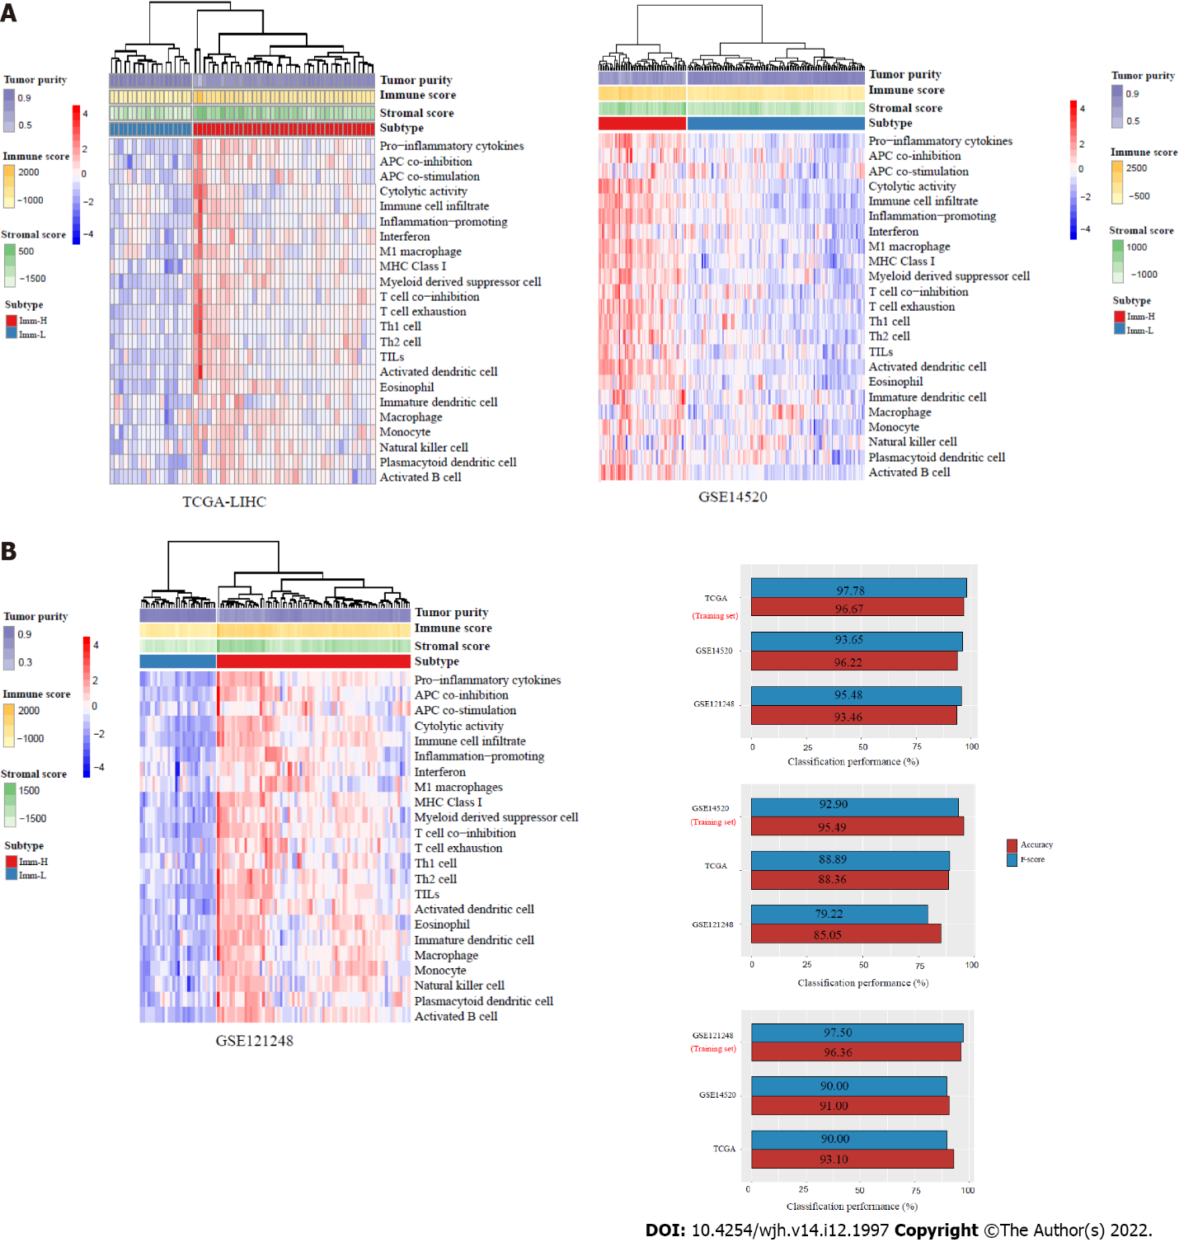
Figure 1 Identification of immune-specific subtypes of hepatitis B virus + hepatocellular carcinoma by clustering analysis. A: Based on the enrichment scores of 23 immune signatures, hierarchical clustering identifies two immune-specific subtypes of hepatitis B virus (HBV) + hepatocellular carcinoma (HCC): Imm-H and Imm-L, with high and low immunity, respectively, consistently in three datasets; B: Prediction of the immune-specific subtypes of HBV+ HCC by the Random Forest algorithm using the 23 immune signatures as attributes. The 10-fold cross-validation results in the training set and classification results in test sets are shown.
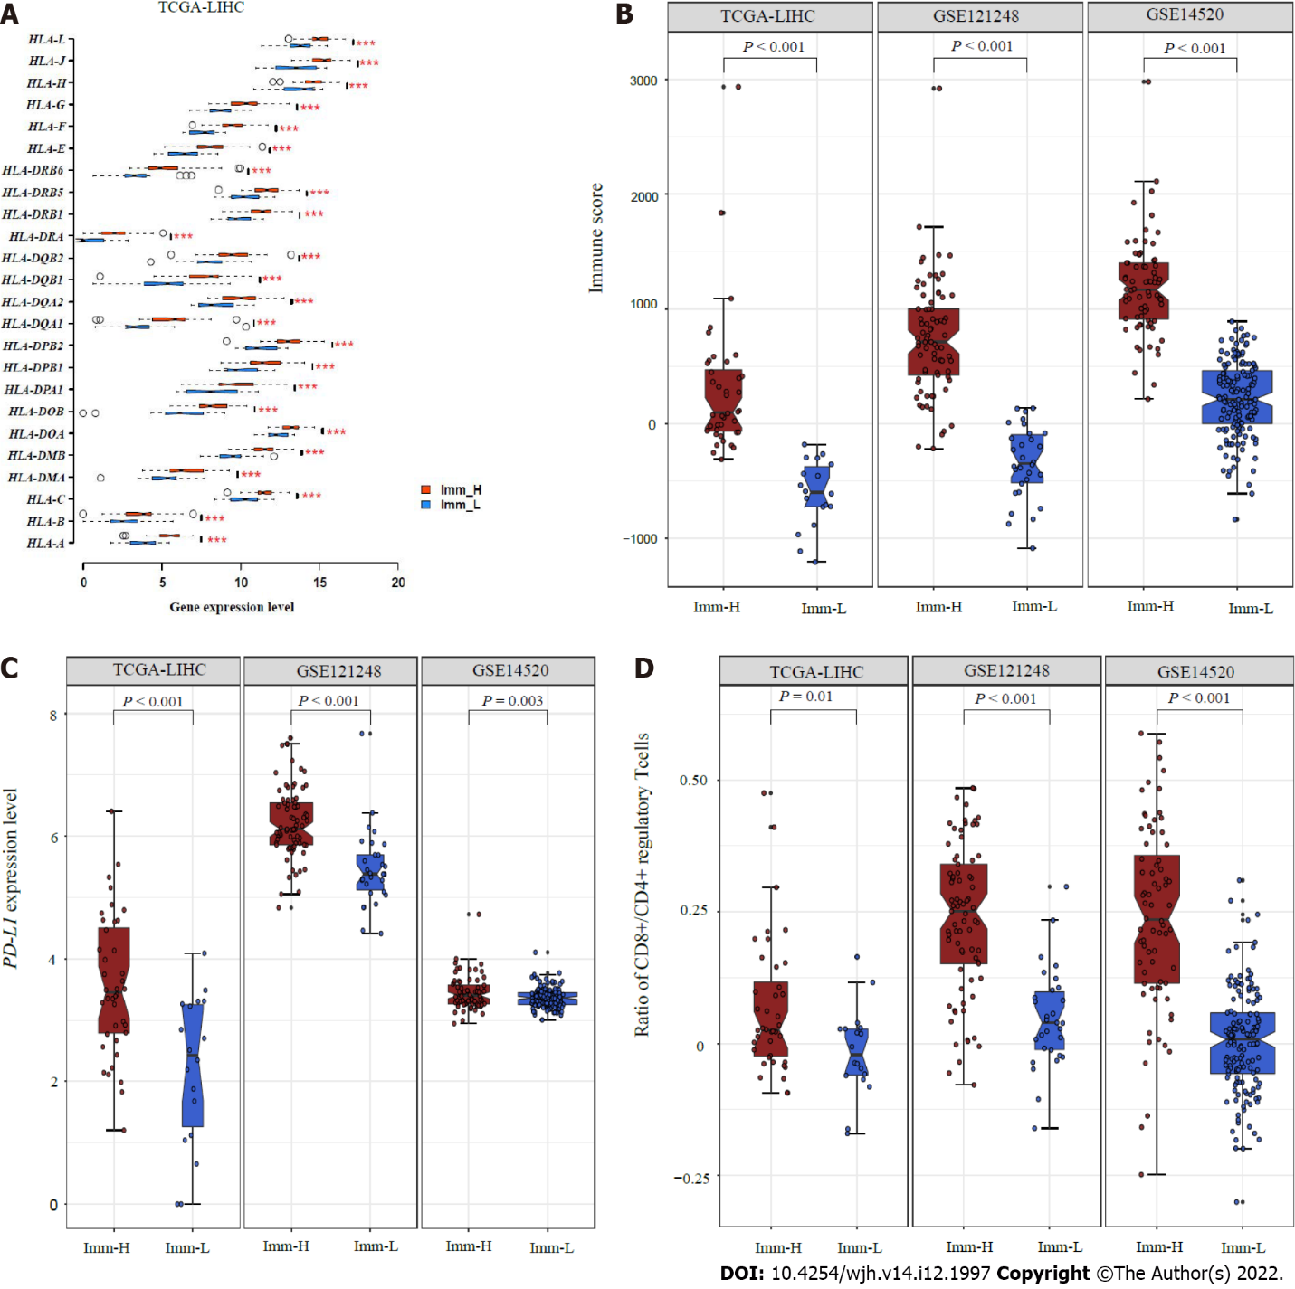
Figure 2 Comparisons of immune features between the immune-specific subtypes of hepatitis B virus + hepatocellular carcinoma. A: Imm-H shows significantly higher expression levels of HLA genes; B: Immune scores; C: PD-L1 expression levels; D: Ratios of immunostimulatory to immunosuppressive signatures (CD8+/CD4+ regulatory T cells) than Imm-L. The two-tailed Student’s t test P values are shown in (A, C, D), and the one-tailed Mann–Whitney U test P values are shown in (B).

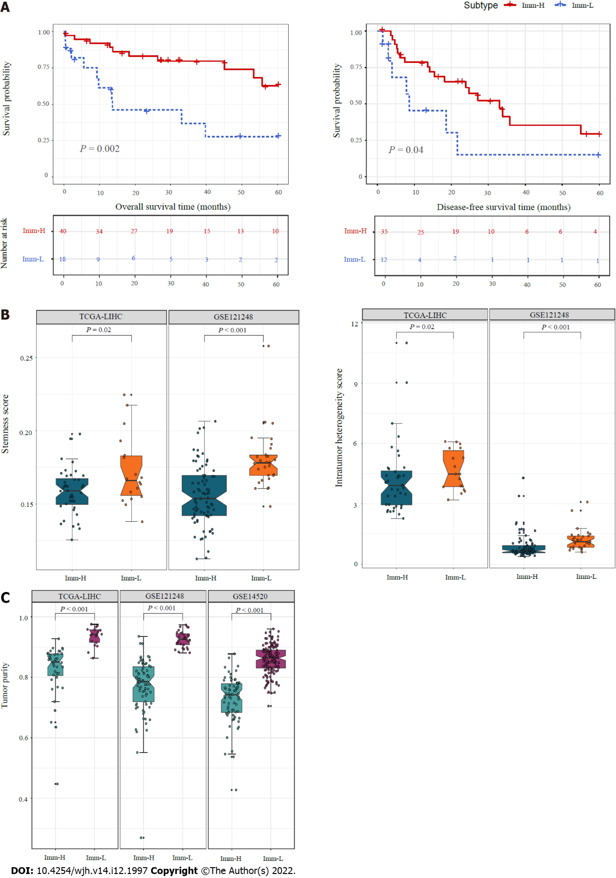
Figure 3 Comparisons of clinical and phenotypic features between the immune-specific subtypes of hepatitis B virus + hepatocellular carcinoma. A: K–M curves showing that Imm-H has significantly higher 5-year overall survival and disease-free survival rates than Imm-L. The log-rank test P values are shown; B: Imm-H has significantly lower stemness and intratumor heterogeneity than Imm-L; C: Imm-H has significantly lower tumor purity than Imm-L. The one-tailed Mann–Whitney U test P values are shown in (B, C).
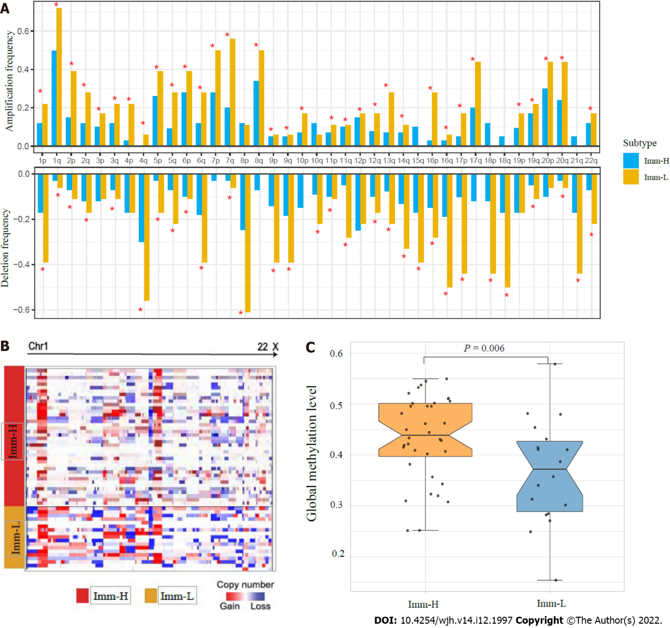
Figure 4 Comparisons of genomic and epigenomic features between the immune-specific subtypes of hepatitis B virus + hepatocellular carcinoma in TCGA-LIHC. A: Comparison of the arm-level SCNAs between Imm-H and Imm-L. The red asterisks indicate the chromosome arms in which Imm-L has higher amplification or deletion frequency than Imm-H; B: Heatmap showing that Imm-L likely has higher amplitudes of copy number amplification and deletion across chromosomes than Imm-H; C: Imm-H has significantly higher global methylation levels than Imm-L. The one-tailed Mann–Whitney U test P values are shown.

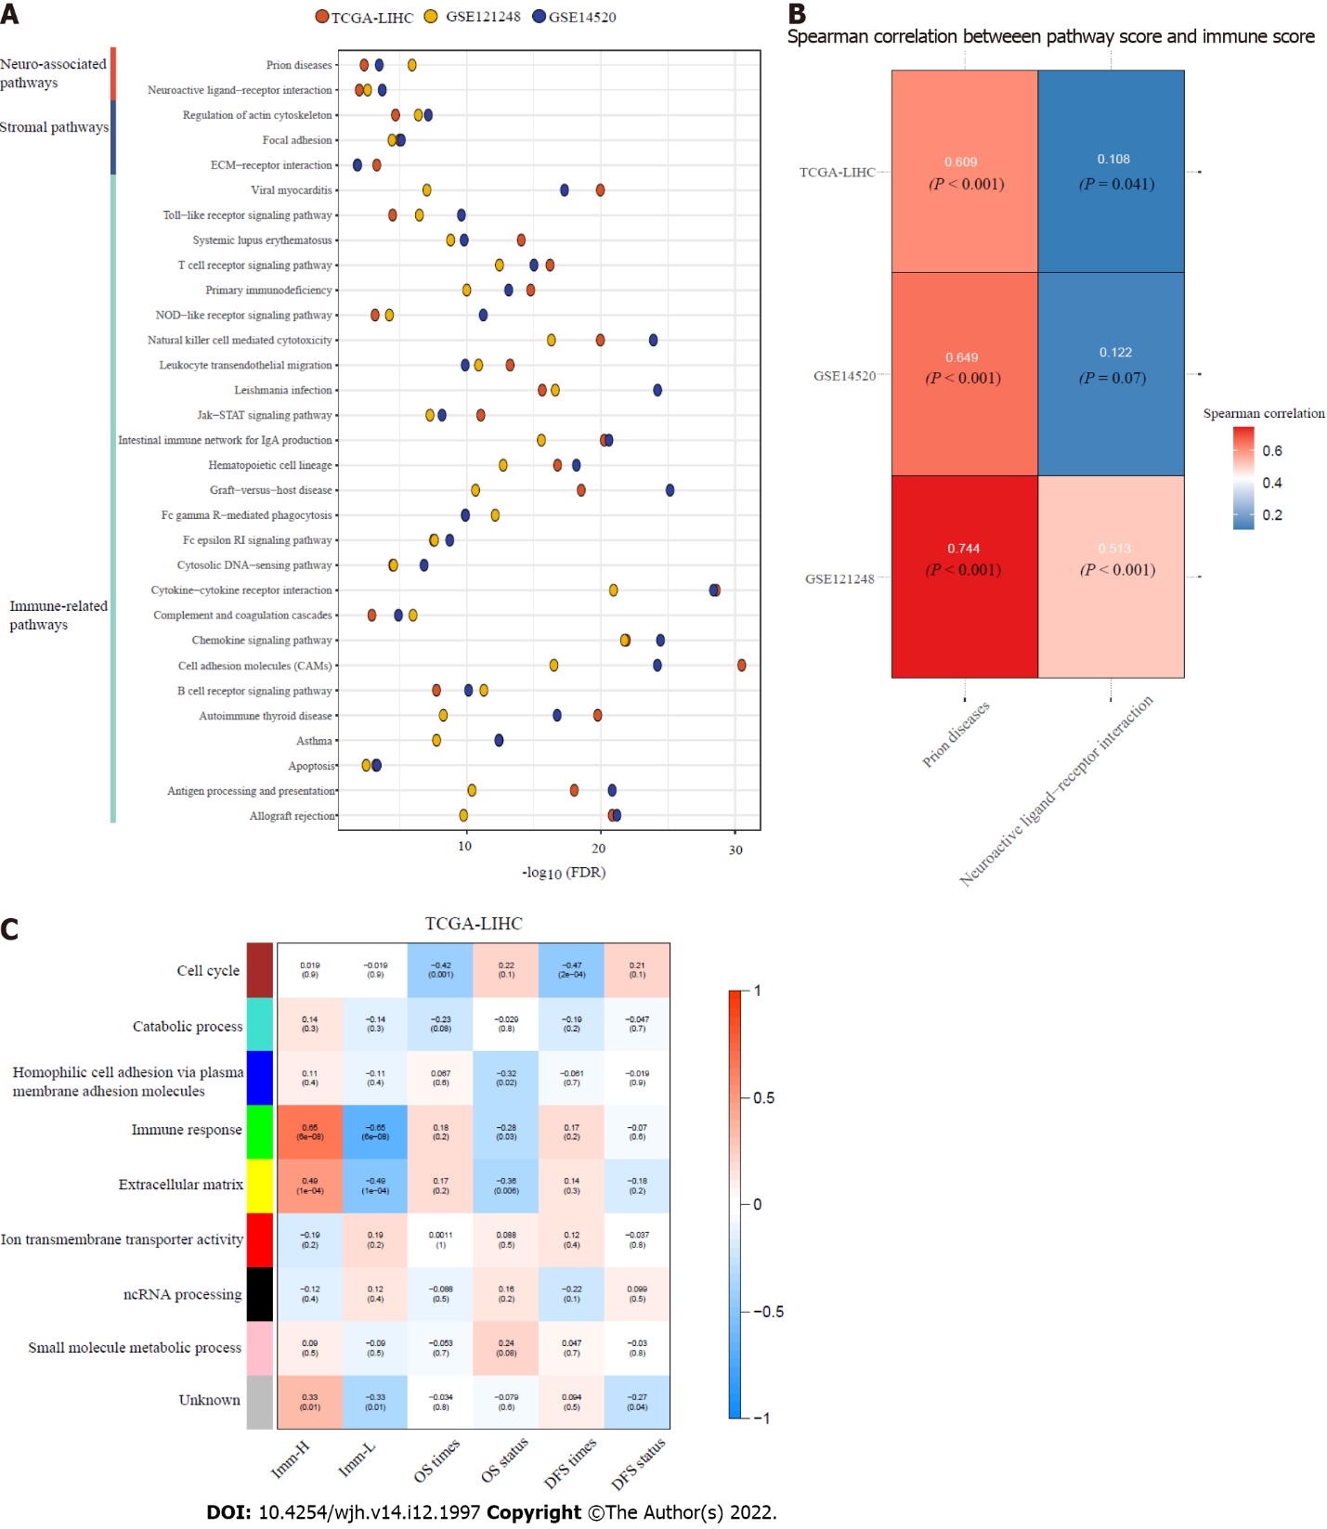
Figure 5 Pathways and gene ontology enriched in the immune-specific subtypes of hepatitis B virus + hepatocellular carcinoma. A: The immune, stroma, and neuro-associated pathways more highly enriched in Imm-H versus Imm-L (false discovery rate < 0.05); B: Spearman correlations between the enrichment scores of the two neuro-associated pathways upregulated in Imm-H and immune scores in hepatitis B virus (HBV) + hepatocellular carcinoma (HCC); C: The gene modules and their representative gene ontology terms significantly differentiating HBV+ HCC by the immune-specific subtypes, overall survival, and/or disease-free survival. The correlation coefficients and P values (in parenthesis) are shown.
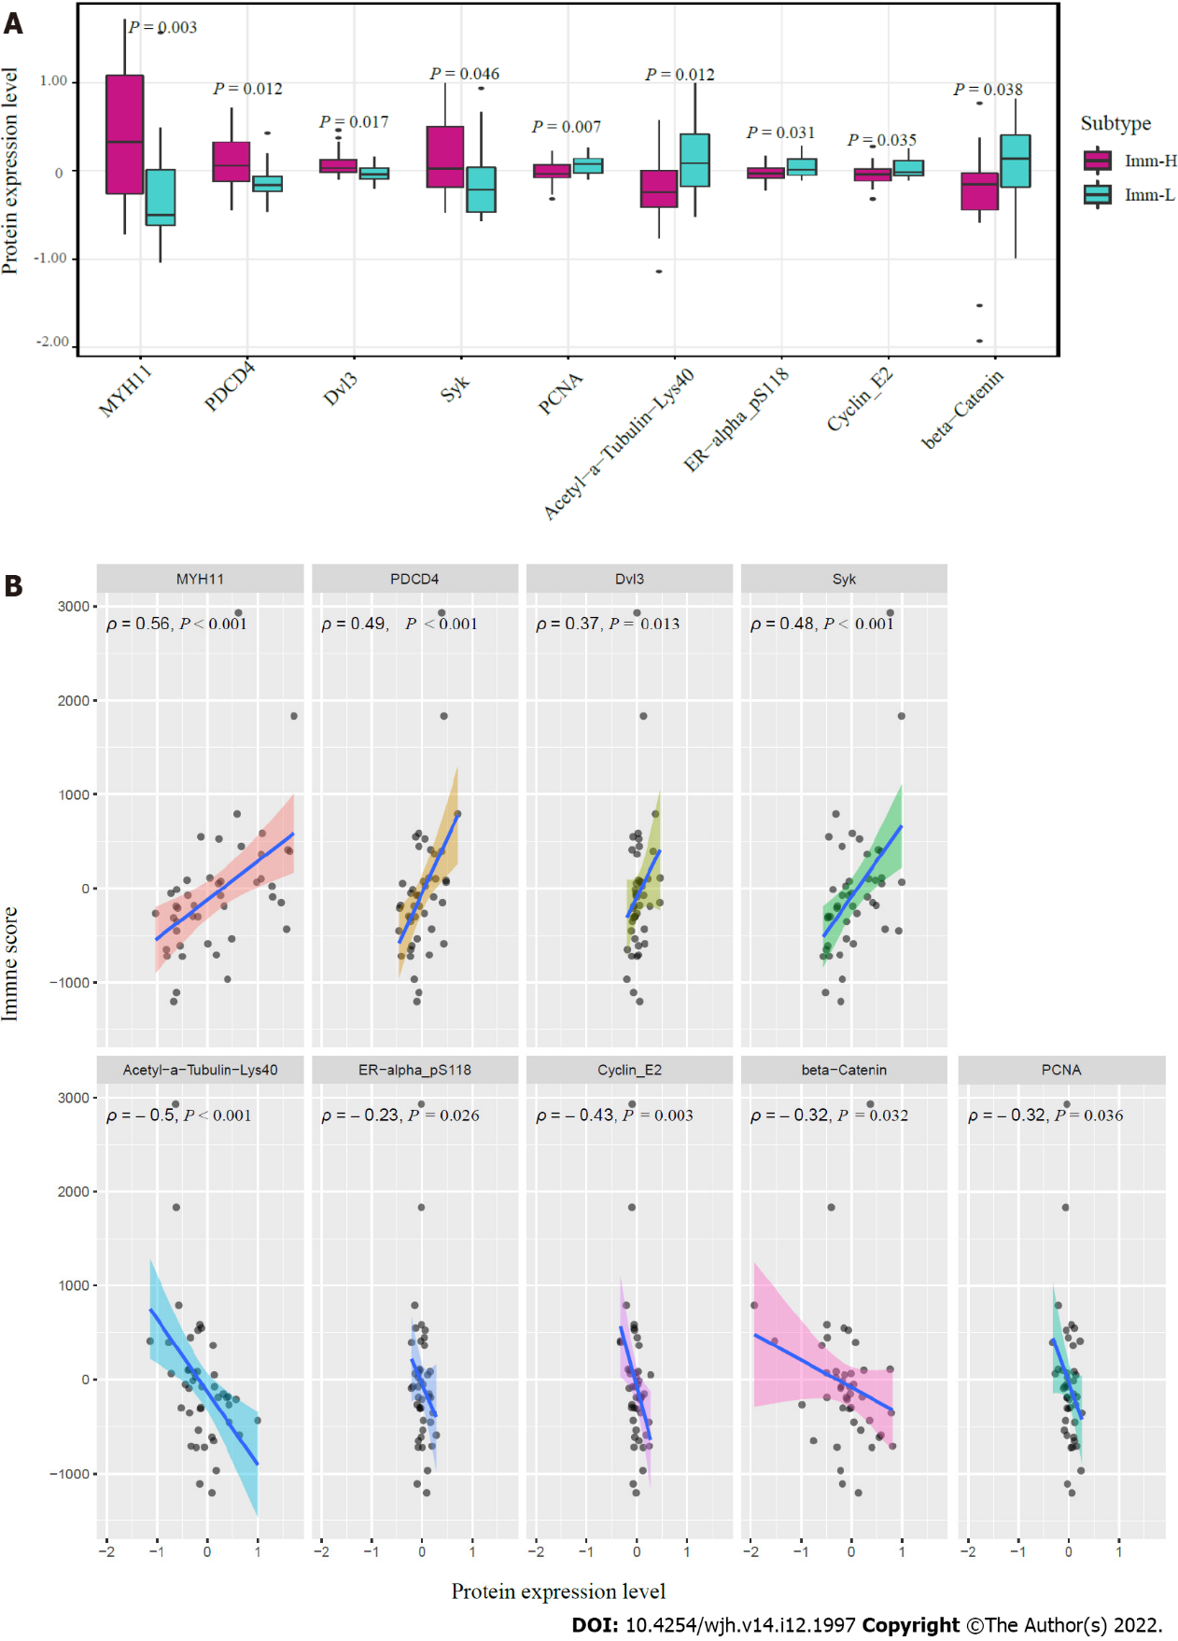
Figure 6 Proteins enriched in the immune-specific subtypes of hepatitis B virus + hepatocellular carcinoma in TCGA-LIHC. A: Nine proteins having significantly different expression levels between Imm-H and Imm-L. The two-tailed Student’s t test P values are shown; B: Spearman correlations between the expression levels of the nine proteins and immune scores in hepatitis B virus + hepatocellular carcinoma. The Spearman correlation coefficients (ρ) and P values are shown.

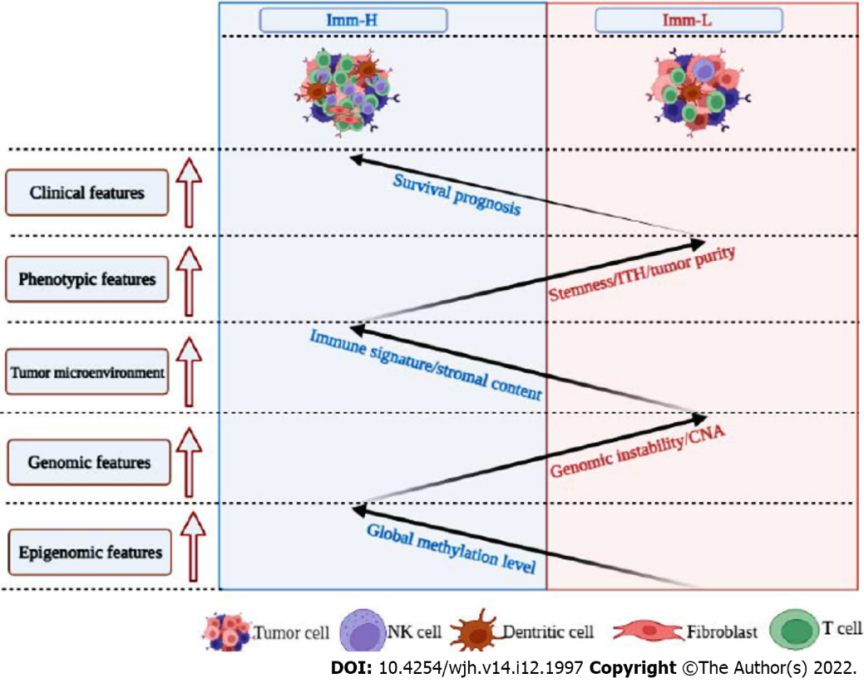
Figure 7 Schematic comparisons of clinical and molecular features between the immune-specific subtypes of hepatitis B virus + hepatocellular carcinoma. The figure was created with BioRender.com.

Published by Baishideng Publishing Group Inc
7041 Koll Center Parkway, Suite 160, Pleasanton, CA 94566, USA
Telephone: +1-925-3991568
E-mail: bpgoffice@wjgnet.com
Help Desk: https://www.f6publishing.com/helpdesk
https://www.wjgnet.com

© 2022 Baishideng Publishing Group Inc. All rights reserved.

