Name of journal: World Journal of Gastroenterology
ESPS Manuscript NO: 23012
Manuscript Type: ORIGINAL ARTICLE

Retrospective Cohort Study
Prognostic factors and long-term outcomes of hilar cholangiocarcinoma: A single-institution experience in China

Hu HJ et al. Prognostic factors of HCCA

Hai-Jie Hu, Hui Mao , Anuj Shrestha, Yong-Qiong Tan, Wen-Jie Ma, Qin Yang, Jun-Ke Wang, Nan-Sheng Cheng, Fu-Yu Li

Hai-Jie Hu, Yong-Qiong Tan, Anuj Shrestha, Wen-Jie Ma , Qin Yang, Jun-Ke Wang, Nan-Sheng Cheng, Fu-Yu Li, Department of Biliary Surgery, West China Hospital of Sichuan University, Chengdu 610041, Sichuan Province, China

Hui Mao, Department of Respiratory Medicine, West China Hospital of Sichuan University, Chengdu 610041, Sichuan Province, China

Anuj Shrestha, Department of General Surgery, Gandaki Medical College, Pokhara 33700, Nepal

Author contributions: Hu HJ contributed to the data acquisition and analysis and drafted the manuscript; Ma WJ, Yang Q and Wang JK contributed to data acquisition and analysis of the manuscript; Shrestha A helped draft and revise the manuscript; Cheng NS and Tan YQ were involved in the revision of the manuscript; Li FY and Mao H contributed to the study design and revision of the manuscript. All authors read and approved the final manuscript.
Supported by the National Nature Science of China, No. 3080111 and No. 30972923; and Science and Technology Support Project of Sichuan Province, No. 2014SZ0002-10.

Institutional review board statement: The study was reviewed and supported by the West China Hospital of Sichuan University Institutional Review Board.

Informed consent statement: All involved patients gave their informed consent statement prior to the study inclusion.

Conflict-of-interest statement: We declare that we have no conflict of interest.

Data sharing statement: No additional unpublished data are available.

Open-Access: This article is an open-access article which was selected by an in-house editor and fully peer-reviewed by external reviewers. It is distributed in accordance with the Creative Commons Attribution Non Commercial (CC BY-NC 4.0) license, which permits others to distribute, remix, adapt, build upon this work non-commercially, and license their derivative works on different terms, provided the original work is properly cited and the use is non-commercial. See: http://creativecommons.org/licenses/by-nc/4.0/

Correspondence to: Fu-Yu Li, MD, PhD, Department of Biliary Surgery, West China Hospital of Sichuan University, 37 Guoxue Xiang, Wuhou District, Chengdu 610041, Sichuan Province, China. lfy_74 @hotmail.com
Telephone: + 86-28-85422465
Fax: +86-28-85422465

Received: October 13, 2015
Peer-review started: October 14, 2015
First decision: November 5, 2015
Revised: November 18, 2015
Accepted: December 8, 2015
Article in press:
Published online:

Abstract
AIM: To evaluate the prognostic factors of hilar cholangiocarcinoma in a large series of patients in a single institution.

METHODS: Eight hundred and fourteen patients with a diagnosis of hilar cholangiocarcinoma, evaluated and treated between 1990 and 2014 were included, of which 381 patients underwent curative surgery. Potential factors associated with overall survival (OS) and disease free survival (DFS) were evaluated by univariate and multivariate analysis.

RESULTS: Curative surgery provided the best long-term survival with a median OS of 26.3 mo. The median DFS was 18.1 mo. Multivariate analysis showed that patients with tumor size > 3 cm (HR = 1.482, 95%CI: 1.127-1.949, P = 0.005), positive nodal disease (HR = 1.701, 95%CI 1.346-2.149, P < 0.001), poor differentiation (HR = 2.535, 95%CI: 1.839-3.493, P < 0.001), vascular invasion (HR = 1.542, 95%CI: 1.082-2.197, P = 0.017) and positive margins (HR = 1.798, 95%CI: 1.314-2.461, P < 0.001) had poor OS outcome. The independent factors for DFS were positive nodal disease (HR = 3.383, 95%CI: 2.633-4.348, P < 0.001), poor differentiation (HR = 2.774, 95%CI: 2.012-3.823, P < 0.001) vascular invasion (HR = 2.136, 95%CI: 1.658-3.236, P < 0.001) and positive margins (HR = 1.835, 95%CI: 1.256-2.679, P < 0.001). Multiple logistic regression analysis showed that caudate lobectomy (OR = 9.771, P < 0.001, 95%CI: 4.672-20.433), tumor diameter (OR = 3.772, P < 0.001, 95%CI: 1.914–7.434), surgical procedures (OR = 10.236, P < 0.001, 95%CI: 4.738–22.116), AJCC T stage (OR = 2.010, P = 0.037, 95%CI: 1.043–3.870) and vascular invasion (OR = 2.278, P = 0.051, 95%CI: 0.997–5.207) were independently associated with tumor-free margin, and surgical procedures could indirectly affect survival outcome by influencing the tumor resection margin.

CONCLUSION: Tumor margin, tumor differentiation, vascular invasion and lymph node status were independent factors for OS and DFS. Surgical procedures can indirectly affect survival outcome by influencing the tumor resection margin and was the most important factor that play a role in affecting tumor-free margin.

Key words: Hilar cholangiocarcinoma; Surgical outcome; Tumor-free margin; Survival; Prognosis

© The Author(s) 2015. Published by Baishideng Publishing Group Inc. All rights reserved.

Core tip: Hilar cholangiocarcinoma remains among the most difficult management problems faced by surgeons. Curative surgery is significant in prolonging the survival time of patients diagnosed with hilar cholangiocarcinoma. Due to the difference in study methods and small patient numbers in some studies, it may cause potential biases or even contradictory outcomes. Furthermore, some large cases of multi-center reports may induce biases due to the heterogeneity of clinical methods and surgical strategies. Thus, we retrospectively analyzed the prognostic factors of hilar cholangiocarcinoma and factors associated with tumor free margin in a large sample of hilar cholangiocarcinoma cases in a single institution.

Hu HJ, Mao H, Shrestha A, Tan YQ, Ma WJ, Yang Q, Wang JK, Cheng NS, Li FY. Prognostic factors and Long-term outcomes of hilar cholangiocarcinoma: A single-institution experience in China. World J Gastroenterol 2015; In press

INTRODUCTION
Hilar cholangiocarcinoma (HC) is a rare, devastating, and highly malignant disease of the bile duct^{[1-4]}. On the basis of the Bismuth classification, hilar cholangiocarcinoma can be divided into 4 types: type I represents for tumors affecting the common hepatic duct, type II represents for tumors affecting the hilus, type III A/B represents for tumors invading the right or left hepatic duct, type IV with tumors infiltration of both right and left hepatic ducts and the sub-segments^{[1]}. A variety of established risk factors are reported to increase the odds of hilar cholangiocarcinomas, which include the primary sclerosing cholangitis, the biliary duct cysts, the oriental cholangiohepatitis, the hepatolithiasis, the biliary parasitic disease and the toxins exposure, the specific etiology is still unclear^{[5,6]}. HC is reported to be a slow-growing and late-metastasizing malignant disease^{[7-9]}, but it situated at a cabinet and pivotal space, encircled by the portal vein, hepatic artery, liver parenchyma and the bile duct, thus, having a strong tendency to extensively invade the portal vein, hepatic artery, perineural tissue and the surrounding liver parenchyma, including the caudate lobe^{[10-15]}. Moreover, the caudate lobe lies in a deep and complex location and has an intimate relationship with the major vascular structures^{[16, 17]}, resulting in high operative risks and increased postoperative complications^{[18,19]}. In addition, hilar cholangiocarcinoma always lies in the core part of the biliary system, causing malignant biliary obstruction and cholestatic hepatitis. Thus, major hepatic resection tends to associate with increased risk of postoperative hepatic insufficiency and postoperative hepatic failure is reported to be the most frequent cause of in-hospital death following major hepatectomy^{[14,20]}. This is the reason why hilar cholangiocarcinoma is still recognized as the most difficult surgeries besides liver transplantation in hepatobiliary surgery. Nevertheless, surgical resection with extended hepatectomy, caudate lobectomy, lymphadenectomy, vascular resection and reconstruction remains the cornerstone of the treatment and represents the only potentially radical therapeutic modality to prolong the survival of patients with hilar cholangiocarcinoma^{[21-26]}.
Uni- and multivariate analysis have identified various prognostic factors for OS and DFS of hilar cholangiocarcinoma^{[7,27-29]}. But only large-volume patient cases can provide more confidence to guide the treatment. Thus, the current study was planned to protrude the following points: (1) estimate prognostic factors associated with OS and DFS after successful resection of hilar cholangiocarcinoma in a large, single-center study; (2) evaluate which factors could contribute to the obtaining of R0 resection to help future surgical decision making; and (3) compare various surgical procedures in treating and prolonging the lifespan of hilar cholangiocarcinoma (HCCA) patients to guide the treatment of HCCA and forecast the postoperative prognosis.

MATERIALS AND METHODS
Patients
All patients with a diagnosis of hilar cholangiocarcinoma evaluated and treated at our institution since 1990 were identified from a hepatobiliary database. Patients were divided into 3 groups: patients who underwent curative surgery (381), those who only take palliative surgery (330) and those who did not take any surgery (103). Patients with intrahepatic bile duct carcinoma infringing the hilum, patients with gallbladder carcinomas, patients underwent liver transplantation were excluded. Clinical, radiologic, histopathologic, therapy and survival data were obtained and evaluated.

Assessment of resectability
Resectability was assessed both with preoperative imaging studies and intraoperative evaluation. Patients with any of the following were considered to be unresectable: poor conditions, Child-Pugh C, advanced biliary invasion that excludes complete tumor resection, encasement of major vessel structures that eliminate vascular reconstruction, lymph nodes metastases beyond the hepatoduodenal ligament, metastatic disease (lung and peritoneum metastases)^{[30,31]}. Biliary drainage was performed in most of patients with obstructive jaundice. In patients with cholangitis, resection was performed after alleviation of inflammation. As for the patients who were considered to have potentially resectable tumors, portal vein embolization was performed when the future remnant liver volume (25%–30%) was deemed insufficient (53 patients). Surgical procedures were selected according to the preoperative and intraoperative evaluation.

Follow-up protocol
After treatment, patients were regularly followed-up at outpatient clinic with clinical examination, CA 19-9 serum level, liver function tests and hepatic ultrasonography. If recurrence was suspected in some specific patients, further assessments such as abdominal CT or MRCP were used to make a definitive diagnosis. The median follow-up period for resected patients was 21.7 mo (range, 3–85 mo) with a follow-up rate of 95.6%.

Statistical analysis
Data analysis was performed using SPSS version16.0 (SPSS Inc., Chicago, IL, United States). Frequency and descriptive analysis were used to depict patient characteristics. Parametric statistical analysis was conducted using Student t test, while nonparametric analysis was calculated using χ². Survival (calculated from the time of surgery) was estimated using Kaplan-Meier methods, differences in survival were reviewed using the log-rank test. Multivariate analysis was performed on all factors with a P value of less than 0.10 in univariate analysis. Univariate and bivariate analysis were used to check the association of several tumor variables with tumor resection margin. Multiple logistic regression analysis was used in the final analysis to adjust for independent variables for tumor-free margin. The hazard ratio and the 95%CI were estimated and a P value less than 0.05 were considered significant.

RESULTS
Patients and tumors
The clinical characteristics of the study population are summarized in Table 1. The specific surgical procedures for patients underwent curative and palliative surgery are presented in Table 2.

Morbidity and mortality
Curative intent surgery: The perioperative complication rate after major surgical treatment was 29.4% (n = 112), which includes, hemorrhage (15 cases), bile leakage (40 cases), peritoneal cavity infection (16 cases), lung infection (23 cases), sepsis (3 cases), acute cardiac failure (3 cases), hepatic failure (20 cases), renal failure (5 cases), stress ulcer (10 cases), wound dehiscence (4 cases) and hydrothorax or ascites (6 cases). Perioperative mortality rate was 3.8% (n = 10). And both postoperative morbidity and operative mortality were deemed as those occurring within 60 d of the major surgery, or occurred at any time of the postoperative hospital stay. Then we examined the relationship between postoperative complications and risk factors, we found that patients undergoing hepatectomy had more complications when compared with those who underwent bile duct resection alone (P < 0.001). In patients with postoperative hyperbilirubinemia, the incidence of postoperative complication rate was also higher (P = 0.004).

Palliative intent surgery: The perioperative complication rate after palliative treatment was 11.2% (n = 37), of which the most frequent was lung infection (16 cases), others include hemorrhage (4 cases), bile leakage (7 cases), peritoneal cavity infection (13 cases), sepsis (2 cases), wound infection (2 cases), hepatic failure (3 cases), renal failure (1 cases), wound dehiscence (1 cases), and others (3 cases). And the perioperative mortality rate was 4.5% (15 case), of which the most common cause was multiple organ failure because of liver failure (8 cases) followed by renal failure (3 case), infective complications (3 cases) and heart failure (1 cases).

Survival analysis of curative and palliative surgery
As expected, the radical resection provided the best opportunity of OS with a median survival time of 26.3 mo, and the 1-, 3-, 5-year survival rate was 80%, 43%, and 28% respectively. This contrasted to the patients who underwent palliative surgery with a median OS of about 7.3 months and the 1-, 3-, 5-year survival rate was 10%, 2%, and 0% (Figure 1, log-rank test, P < 0.001). As for patients who did not take any surgical treatment, the median OS and the 1-, 3-year survival rate was 2.6 mo and 1% and 0%, respectively (Figure 1, log-rank test, P < 0.001). The median DFS of radically resection group was 18.1 months, and the 1-, 3-, 5-year DFS was 78%, 18%, and 10% respectively. Furthermore, we compared the survival rate of those underwent surgical palliation and nonsurgical palliation, the former had a median survival time and 6-month survival rate of 7.4 mo and 27% respectively, while the latter had a median survival time of 5.5 mo and 6-mo survival rate of 9% respectively (P < 0.001).

Factors associated with OS and DFS after curative resection
As was shown in Table 3, OS was significantly longer in patients with no lymph node metastasis (P < 0.001), well histological differentiation (P < 0.001), negative resection margin (P < 0.001), tumor size ≤ 3 cm (P < 0.001), caudate lobectomy (P = 0.04), lower CA 19-9 level (P = 0.039) and no vascular invasion (P = 0.009). Hepatectomy and the lack of perineural infiltration were approaching statistical differences as positive prognostic factors for OS in univariate analysis (P = 0.072 and 0.084 respectively). Then we further examined factors associated with disease-free survival, it showed that resection margins (P < 0.001), tumor differentiation (P < 0.001), lymph nodes metastases (P < 0.001), tumor size (P < 0.001), caudate lobectomy (P < 0.001), CA 19-9 level (P = 0.018), T stage of AJCC (P = 0.028), and vascular invasion (P < 0.001) were associated with DFS (Table 3).
In multivariate analysis, tumor size > 3 cm (HR = 1.482, 95%CI: 1.127-1.949, P = 0.005), positive nodal disease (HR = 1.701, 95%CI 1.346-2.149, P < 0.001), poor differentiation (HR = 2.535, 95%CI: 1.839-3.493, P < 0.001) vascular invasion (HR = 1.542, 95%CI: 1.082-2.197, P = 0.017) and positive margins (HR = 1.798, 95%CI: 1.314-2.461, P < 0.001) remained associated with OS (Table 4). For DFS, positive nodal disease (HR = 3.383, 95%CI: 2.633-4.348, P < 0.001), poor differentiation (HR = 2.774, 95%CI: 2.012-3.823, P < 0.001), vascular invasion (HR = 2.136, 95%CI: 1.658-3.236, P < 0.001) and positive margins (HR = 1.835, 95%CI: 1.256-2.679, P < 0.001) were correlated with DFS in multivariate analysis (Table 4).

Factors associated R0 resection
Now that R0 resection was important as R0 resection conferred to a median survival time of 35.2 mo while patients with R1 and R2 resection had a median survival time of 12.4 mo, and the palliative surgery only granted a median survival time of 7.3 mo. Thus, further studies emphasized on the factors that could affect the tumor-free margin. Univariate analysis showed that tumor differentiation (P = 0.001), tumor diameter (P < 0.001), hepatectomy (P = 0.012), lymph node metastasis (P = 0.001), T stage (AJCC, P = 0.001) caudate lobectomy (P = 0.001), Bismuth-Corlette classification (P = 0.038), and vascular invasion (P = 0.01) were associated with tumor-free margin. Multiple logistic regression analysis (Table 5) showed that caudate lobectomy (OR = 9.771, P < 0.001, 95%CI: 4.672-20.433), tumor diameter (OR = 3.772, P < 0.001, 95%CI: 1.914–7.434), surgical procedures (OR = 10.236, P < 0.001, 95%CI: 4.738–22.116), AJCC T stage (OR = 2.010, P = 0.037, 95%CI: 1.043–3.870) and vascular invasion (OR = 2.278, P = 0.051, 95%CI: 0.997–5.207) were independently associated with tumor-free margin after adjusting for other factors.

DISCUSSION
Hilar cholangiocarcinoma remains among the most difficult management problems faced by surgeons. The accumulated outcomes from many institutions show firmly that only an excision with negative resection margin can be regarded as radically therapeutic and in this condition hepatic resection is often demanded^{[28,30]}. Many authorities have reported various prognostic factors of HCCA; however, due to the difference in study methods and small patient numbers in other studies, it may cause potential biases or even contradictory outcomes. Furthermore, some large cases of multi-center reports may induce biases due to the heterogeneity of clinical methods and surgical strategies. Thus a large number of HCCA cases of single center experience are urgently needed to standardize the prognostic factors and to supply better guidance and treatment for HCCA.
We reported a median OS of 26.3 months with the 1-, 3-, 5-year survival rate of about 80%, 43%, and 28%, which was comparable to some published articles from high-volume hepatobiliary centers that recorded a median OS between 16 and 40 mo and a 5-year survival rate of 11% to 40%^{[4, 32-34]}. We also reported a median DFS of 18.1 mo for radically resection group, which was commendably within the range from 12 to 20 mo covered by other literatures^{[1,4,31,35]}. The data in our series has also verified the common notion that curative surgery provided the best opportunity in increasing the median and long term survival rate of patients diagnosed as HCCA, as the failure of conducting curative surgery resulted in a sharp decrease in the overall survival (Figure 1; P < 0.001). And compared with patients who did not accept any treatment, palliative surgery resulted in a relatively better outcome, which might explained as follows: Palliative surgery can roughly remove the root of obstructive jaundice and adequately open biliary tract and then the liver function can be improved and relatively better survival outcomes can be expected to some extent. We also identified that intraoperative palliation conferred to a relatively longer survival than nonsurgical palliation when compared with nonsurgical palliation, intraoperative palliation can directly lessen the odds of bile duct obstruction by completely opening bile duct as much as possible, facilitating whole biliary decompression and finally enhancing liver function and survival outcomes. Therefore, we believe that intra-operative palliation is superior to nonsurgical palliation in patients who lost the chance of undergoing curative resection. However, further studies with more number of cases are needed in future to testify the reasonability of whether surgical palliation is superior to nonsurgical palliation. In the long run, compared with the curative surgery, we convincingly believe that curative surgery is the best way in prolonging the survival outcome.
Many clinical, surgical, and pathological factors have been shown to influence OS and DFS after major resection in recent literature^{[28, 29,31,36]}. In our retrospective study, multivariate analysis showed surgical margin, lymph node, tumor differentiation, vascular invasion were independent factors for OS and DFS. In addition, tumor size was also an independent factor for OS but not for DSF.
It is broadly recognized that among a large succession of prognostic factors of HCCA, tumor-free margin is the most powerful predictor for both OS and DFS^{[35,37,38]}. In our present study, R0 resection emerged as an independent prognostic factor for both disease-free (Figure 2A) and overall survival (Figure 3A), patients with negative margins had markedly better OS and DFS than those with positive ones. The fact that patients undergoing R1 or R2 resection have better outcomes than patients undergoing palliative surgery has also been reconfirmed in current research. And we further examined factors associated with R0 resection, finding that patients with smaller tumor size, concomitant hepatic resection, caudate lobectomy, T1 and T2 stage (AJCC) and the lack of vascular invasion had a higher tendency of obtaining tumor-free margin.
In our study, survival was hazarded by the existence of lymph node metastasis as testified by univariate and multivariate analysis, with a decrease in the median OS from 39.9 mo to 15.7 mo, and a decrease in the median DFS from 25.4 mo to 12.3 mo. This corresponded with those reported by other previous studies that lymph node metastasis is an important independent prognostic factor for both disease-free^{[31,39,40]} and overall^{[26,28,39,41,42]} survival. The prognostic significance of node status stressed the necessity for a radical lymphadenectomy. In this respect, thoroughly lymph nodes dissection may be significant and should be prospectively evaluated and studied in the future.
Tumor differentiation is a disputable factor in many retrospective studies, Hasegawa et al^{[42]} did not find a survival disadvantage in case of tumor differentiation, while Saxena et al^{[4]} have shown that tumor differentiation is a biological marker for measuring tumor invasion and metastasis and predicting long-term survival, which was comparable to our results, as the median OS decreased sharply from 54.1 mo to 13.5 mo when the patients had a poor differentiation. And the median DFS of well-differentiated patients was two folders greater as compared with poor-differentiated patients. Thus in view of the fact that histologic differentiation is an independent prognostic factor both in OS and DFS, we were tempted to conclude that poorly differentiated cancers have poor prognosis and higher recurrence rate.
Vascular invasion is no longer a contraindication for the excision of HCCA. With the reason that this procedure has high mortality and risk, we performed vascular resection and reconstruction only when the patients were clinical suspicious of vascular infiltration. Our report demonstrated that patients with vascular invasion were more likely to have a poor OS and DFS (Figures 2B and 3B); similarly, vascular invasion was also associated with a higher tendency of R1 and R2 status although it was only approaching statistical difference in the multivariate logistic regression (OR = 2.278, 95%CI: 0.997-5.207, P = 0.051). Thus in those highly suspected patients, vascular resection is recommended.
Perhaps more importantly, we found that tumor size was a significant prognostic parameter for OS and DFS in univariate analysis. It was also an independent factor that was associated with OS in multivariate analysis (Figure 2C). So far, no other reports have shown this association as clear as us in the current study. And our reports also confirmed the T stage of DeOliveira staging system was important in which the 3 cm cut-off was regarded as T3. Moreover, tumor size could influence R0 resection in multivariate logistic regression. Thus, from this point of view, this factor is needed to be taken into consideration when we evaluate the long term survival of HCCA patients.
Many studies have shown that caudate lobectomy appears to have a positive effect on tumor-free margin and survival after the resection of Klatskin tumors^{[26,43,44]}. In our study, caudate lobe was routinely removed, and it was not associated with postoperative complications, the OS and DFS were found to be significantly longer in patients with caudate lobectomy as compared with those without caudate lobectomy in the univariate analysis (median OS 35.7 : 21.4 mo, median DSF 21.3 : 15.0 mo; P = 0.04 and P < 0.001 respectively). At the same time, caudate lobectomy was approaching statistical significance as a positive prognostic factor for OS on multivariate analysis (HR = 1.257, 95%CI: 0.981-1.612, P = 0.071). Furthermore, it was also an independent factor for tumor-free margin in our current series (OR = 10.236, 95%CI: 4.738-22.116, P < 0.001). Thus, we firmly believe that this procedure should be considered as a part of the standard surgical resection.
In contrast to previous researches, our study did not find a survival advantage in case of hepatectomy. We only found curative surgery accompanied with hepatectomy could easily achieve more complete tumor-free margins, this was consistent with many previous studies^{[27,29,43,45]}. Tumor- free margin in turn could promote the overall survival outcome and is the powerful predictor of survival both reported in our series and in other literature. In our research, hepatectomy was the most important factor that could affect the tumor-free margin. Thus hepatectomy is an indirect prognostic factor that can promote the overall survival, it can indirectly affect survival outcome by influencing the tumor resection margin.
In conclusion, radical surgical resection is the best treatment option for HCCA. R0 resection along with negative lymph nodes metastases, well-differentiation and lack of vascular invasion indicate better OS and DFS. Smaller tumor size also predicts better OS but not DFS. Multivariate logistic regression analysis shows that hepatectomy, tumor diameter, T stage, caudate lobectomy and vascular invasion are independently associated with tumor-free margin. Hepatectomy can help achieve more tumor-free resection margins and then indirectly affect OS; it is an indirect prognostic factor on survival.

COMMENTS
Background
Many authorities have reported various prognostic factors of hilar cholangiocarcinoma (HCCA); however, due to the difference in study methods and small patient numbers in other studies, it might cause potential biases or even contradictory outcomes. Furthermore, some large cases of multi-center reports might induce biases due to the heterogeneity of clinical methods and surgical strategies.

Research frontiers
To estimate prognostic factors associated with overall survival (OS) and disease free survival (DFS) after successful resection of hilar cholangiocarcinoma in a large, single-center study and to evaluate which factors could contribute to the R0 resection to help future surgical decision making and then guide the treatment of HCCA.

Innovations and breakthroughs
Based on our study, R0 resection along with negative lymph nodes metastases, well-differentiation and lack of vascular invasion indicated better OS and DFS. Smaller tumor size also predicts better OS but not DFS. Hepatectomy, tumor diameter, T stage, caudate lobectomy and vascular invasion were independently associated with tumor-free margin. Hepatectomy can help achieve more tumor-free resection margins and then indirectly affect OS; it was an indirect prognostic factor on survival.

Applications
Hilar cholangiocarcinoma remains among the most difficult management problems faced by surgeons. Our results may help future surgical decision making and then better guide the treatment of HCCA.

Terminology
Curative resection is important for the prognosis of hilar cholagiocarcinoma, and R0 resection plays a significant role in prolonging the survival time of patients, R0 resection refers to those with microscopically negative tumor resection margin.

Peer-review
The authors examined the potential risk factors correlated with HCCA and factors that could affect tumor free margin in a large, single-center study. The study was well performed and its findings are interesting and informative.

REFERENCES
1 Baton O, Azoulay D, Adam DV, Castaing D. Major hepatectomy for hilar cholangiocarcinoma type 3 and 4: prognostic factors and longterm outcomes. J Am Coll Surg 2007; 204: 250-260 [PMID: 17254929 DOI: 10.1016/j.jamcollsurg.2006.10.028]
2 Xiong J, Nunes QM, Huang W, Wei A, Ke N, Mai G, Liu X, Hu W. Major hepatectomy in Bismuth types I and II hilar cholangiocarcinoma. J Surg Res 2015; 194: 194-201 [PMID: 25454973 DOI: 10.1016/j.jss.2014.10.029]
3 Figueras J, Codina-Barreras A, López-Ben S, Soriano J, Pardina B, Falgueras L, Castro E, Torres-Bahi S, Ortiz R, Diaz E, Maroto A, Canals E. Major hepatectomies are safe in patients with cholangiocarcinoma and jaundice. Cirugía Española (English Edition) 2009; 86: 296-302 [PMID: 19646686 DOI: 10.1016/s2173-5077(09)70100-0]
4 Saxena A, Chua TC, Chu FC, Morris DL. Improved outcomes after aggressive surgical resection of hilar cholangiocarcinoma: a critical analysis of recurrence and survival. Am J Surg 2011; 202: 310-320 [PMID: 21871986 DOI: 10.1016/j.amjsurg.2010.08.041]
5 D'Angelica MI, Jarnagin WR, Blumgart LH. Resectable hilar cholangiocarcinoma: surgical treatment and long-term outcome. Surg Today 2004; 34: 885-890 [PMID: 15526120 DOI: 10.1007/s00595-004-2832-3]
6 Khan SA, Toledano MB, Taylor-Robinson SD. Epidemiology, risk factors, and pathogenesis of cholangiocarcinoma. HPB (Oxford) 2008; 10: 77-82 [PMID: 18773060 DOI: 10.1080/13651820801992641]
7 Seyama Y, Kubota K, Sano K, Noie T, Takayama T, Kosuge T, Makuuchi M. Long-term outcome of extended hemihepatectomy for hilar bile duct cancer with no mortality and high survival rate. Ann Surg 2003; 238: 73-83 [PMID: 12832968 DOI: 10.1097/01.SLA.0000074960.55004.72]
8 Lillemoe KD, Cameron JL. Surgery for hilar cholangiocarcinoma: the Johns Hopkins approach. J Hepatobiliary Pancreat Surg 2000; 7: 115-121 [PMID: 10982602 DOI: 10.1007/s005340000070115.534]
9 Rea DJ, Munoz-Juarez M, Farnell MB, Donohue JH, Que FG, Crownhart B, Larson D, Nagorney DM. Major hepatic resection for hilar cholangiocarcinoma: analysis of 46 patients. Arch Surg 2004; 139: 514-23; discussion 523-5 [PMID: 15136352 DOI: 10.1001/archsurg.139.5.514]
10 Gerhards MF, van Gulik TM, Bosma A, ten Hoopen-Neumann H, Verbeek PC, Gonzalez Gonzalez D, de Wit LT, Gouma DJ. Long-term survival after resection of proximal bile duct carcinoma (Klatskin tumors). World J Surg 1999; 23: 91-96 [PMID: 9841770]
11 Lee SG, Lee YJ, Park KM, Hwang S, Min PC. One hundred and eleven liver resections for hilar bile duct cancer. J Hepatobiliary Pancreat Surg 2000; 7: 135-141 [PMID: 10982605 DOI: 10.1007/s005340000070135.534]
12 Tsao JI, Nimura Y, Kamiya J, Hayakawa N, Kondo S, Nagino M, Miyachi M, Kanai M, Uesaka K, Oda K, Rossi RL, Braasch JW, Dugan JM. Management of hilar cholangiocarcinoma: comparison of an American and a Japanese experience. Ann Surg 2000; 232: 166-174 [PMID: 10903592]
13 Gazzaniga GM, Filauro M, Bagarolo C, Mori L. Surgery for hilar cholangiocarcinoma: an Italian experience. J Hepatobiliary Pancreat Surg 2000; 7: 122-127 [PMID: 10982603 DOI: 10.1007/s005340000070122.534]
14 Yi B, Xu AM, Lai EC, Qu ZQ, Cheng QB, Liu C, Luo XJ, Yu Y, Qiu YH, Wang XY, Cheng HY, Zhang BH, Shen F, Lau WY, Wu MC, Jiang XQ. Preoperative portal vein embolization for hilar cholangiocarcinoma--a comparative study. Hepatogastroenterology 2010; 57: 1341-1346 [PMID: 21443082]
15 Burke EC, Jarnagin WR, Hochwald SN, Pisters PW, Fong Y, Blumgart LH. Hilar Cholangiocarcinoma: patterns of spread, the importance of hepatic resection for curative operation, and a presurgical clinical staging system. Ann Surg 1998; 228: 385-394 [PMID: 9742921]
16 Qiu ZQ, Tan WF, Yan PN, Luo XJ, Zhang BH, Wu MC, Jiang XQ, Lau WY.. Early control of short hepatic portal veins in isolated or combined hepatic caudate lobectomy. Hepatobiliary Pancreat Dis Int 2012; 11: 377-382 [PMID: 22893464 DOI: 10.1016/s1499-3872(12)60195-7]
17 Ahanatha Pillai S, Sathyanesan J, Perumal S, Ulagendra Perumal S, Lakshmanan A, Ramaswami S, Ramasamy R, Palaniappan R, Rajagopal S. Isolated caudate lobe resection: technical challenges. Ann Gastroenterol 2013; 26: 150-155 [PMID: 24714918]
18 Sakoda M, Ueno S, Kubo F, Hiwatashi K, Tateno T, Kurahara H, Mataki Y, Shinchi H, Natsugoe S. Surgery for hepatocellular carcinoma located in the caudate lobe. World J Surg 2009; 33: 1922-1926 [PMID: 19582505 DOI: 10.1007/s00268-009-0110-7]
19 Abdel Wahab M, Lawal AR, EL Hanafy E, Salah T, Hamdy E, Sultan AM. Caudate lobe resection: an Egyptian center experience. Langenbecks Arch Surg 2009; 394: 1057-1063 [PMID: 19763602 DOI: 10.1007/s00423-009-0554-0]
20 Hirano S, Kondo S, Tanaka E, Shichinohe T, Tsuchikawa T, Kato K, Matsumoto J, Kawasaki R. Outcome of surgical treatment of hilar cholangiocarcinoma: a special reference to postoperative morbidity and mortality. J Hepatobiliary Pancreat Sci 2010; 17: 455-462 [PMID: 19820891 DOI: 10.1007/s00534-009-0208-1]
21 Ramacciato G, Nigri G, Bellagamba R, Petrucciani N, Ravaioli M, Cescon M, Del Gaudio M, Ercolani G, Di Benedetto F, Cautero N, Quintini C, Cucchetti A, Lauro A, Miller C, Pinna AD. Univariate and multivariate analysis of prognostic factors in the surgical treatment of hilar cholangiocarcinoma. Am Surg 2010; 76: 1260-1268 [PMID: 21140696]
22 Neuhaus P, Jonas S, Settmacher U, Thelen A, Benckert C, Lopez-Hänninen E, Hintze RE. Surgical management of proximal bile duct cancer: extended right lobe resection increases resectability and radicality. Langenbecks Arch Surg 2003; 388: 194-200 [PMID: 12819970 DOI: 10.1007/s00423-003-0383-5]
23 Regimbeau JM, Fuks D, Pessaux P, Bachellier P, Chatelain D, Diouf M, Raventos A, Mantion G, Gigot JF, Chiche L, Pascal G, Azoulay D, Laurent A, Letoublon C, Boleslawski E, Rivoire M, Mabrut JY, Adham M, Le Treut YP, Delpero JR, Navarro F, Ayav A, Boudjema K, Nuzzo G, Scotte M, Farges O. Tumour size over 3 cm predicts poor short-term outcomes after major liver resection for hilar cholangiocarcinoma. By the HC-AFC-2009 group. HPB (Oxford) 2015; 17: 79-86 [PMID: 24992279 DOI: 10.1111/hpb.12296]
24 Miyazawa M, Toshimitsu Y, Torii T, Okada K, Koyama I. Extended right hepatectomy for hilar cholangiocarcinoma with resection of the left hepatic duct prior to hepatic resection. J Surg Oncol 2006; 93: 72-75 [PMID: 16353189 DOI: 10.1002/jso.20401]
25 Miyazaki M, Kimura F, Shimizu H, Yoshidome H, Ohtsuka M, Kato A, Yoshitomi H, Nozawa S, Furukawa K, Mitsuhashi N, Takeuchi D, Suda K, Yoshioka I. Recent advance in the treatment of hilar cholangiocarcinoma: hepatectomy with vascular resection. J Hepatobiliary Pancreat Surg 2007; 14: 463-468 [PMID: 17909714 DOI: 10.1007/s00534-006-1195-0]
26 Kow AW, Wook CD, Song SC, Kim WS, Kim MJ, Park HJ, Heo JS, Choi SH. Role of caudate lobectomy in type III A and III B hilar cholangiocarcinoma: a 15-year experience in a tertiary institution. World J Surg 2012; 36: 1112-1121 [PMID: 22374541 DOI: 10.1007/s00268-012-1497-0]
27 Klempnauer J, Ridder GJ, Werner M, Weimann A, Pichlmayr R. What constitutes long term survival after surgery for hilar cholangiocarcinoma? Cancer 1997; 79(1): 26-34 [PMID: WOS: A1997VZ23200005 DOI: 10.1002/(Sici)1097-0142(19970101)79]
28 Li H, Qin Y, Cui Y, Chen H, Hao X, Li Q. Analysis of the surgical outcome and prognostic factors for hilar cholangiocarcinoma: a Chinese experience. Dig Surg 2011; 28: 226-231 [PMID: 21540611 DOI: 10.1159/000327361]
29 Dumitrascu T, Chirita D, Ionescu M, Popescu I. Resection for hilar cholangiocarcinoma: analysis of prognostic factors and the impact of systemic inflammation on long-term outcome. J Gastrointest Surg 2013; 17: 913-924 [PMID: 23319395 DOI: 10.1007/s11605-013-2144-2]
30 Jarnagin WR, Fong Y, DeMatteo RP, Gonen M, Burke EC, Bodniewicz BS J, Youssef BA M, Klimstra D, Blumgart LH. Staging, resectability, and outcome in 225 patients with hilar cholangiocarcinoma. Ann Surg 2001; 234: 507-17; discussion 517-9 [PMID: 11573044]
31 Ito F, Agni R, Rettammel RJ, Been MJ, Cho CS, Mahvi DM, Rikkers LF, Weber SM. Resection of hilar cholangiocarcinoma: concomitant liver resection decreases hepatic recurrence. Ann Surg 2008; 248: 273-279 [PMID: 18650638 DOI: 10.1097/SLA.0b013e31817f2bfd]
32 Igami T, Nishio H, Ebata T, Yokoyama Y, Sugawara G, Nimura Y, Nagino M. Surgical treatment of hilar cholangiocarcinoma in the "new era": the Nagoya University experience. J Hepatobiliary Pancreat Sci 2010; 17: 449-454 [PMID: 19806294 DOI: 10.1007/s00534-009-0209-0]
33 Ercolani G, Zanello M, Grazi GL, Cescon M, Ravaioli M, Del Gaudio M, Vetrone G, Cucchetti A, Brandi G, Ramacciato G, Pinna AD. Changes in the surgical approach to hilar cholangiocarcinoma during an 18-year period in a Western single center. J Hepatobiliary Pancreat Sci 2010; 17: 329-337 [PMID: 20464563 DOI: 10.1007/s00534-009-0249-5]
34 Sano T, Shimada K, Sakamoto Y, Yamamoto J, Yamasaki S, Kosuge T. One hundred two consecutive hepatobiliary resections for perihilar cholangiocarcinoma with zero mortality. Ann Surg 2006; 244: 240-247 [PMID: 16858186 DOI: 10.1097/01.sla.0000217605.66519.38]
35 Matsuo K, Rocha FG, Ito K, D'Angelica MI, Allen PJ, Fong Y, Dematteo RP, Gonen M, Endo I, Jarnagin WR. The Blumgart preoperative staging system for hilar cholangiocarcinoma: analysis of resectability and outcomes in 380 patients. J Am Coll Surg 2012; 215: 343-355 [PMID: 22749003 DOI: 10.1016/j.jamcollsurg.2012.05.025]
36 Ruys AT, van Haelst S, Busch OR, Rauws EA, Gouma DJ, van Gulik TM. Long-term Survival in Hilar Cholangiocarcinoma also Possible in Unresectable Patients. World J Surg 2012; 36: 2179-2186 [PMID: 22569746 DOI: 10.1007/s00268-012-1638-5]
37 Ebata T, Nagino M, Kamiya J, Uesaka K, Nagasaka T, Nimura Y. Hepatectomy with portal vein resection for hilar cholangiocarcinoma: audit of 52 consecutive cases. Ann Surg 2003; 238: 720-727 [PMID: 14578735 DOI: 10.1097/01.sla.0000094437.68038.a3]
38 Lee SG, Song GW, Hwang S, Ha TY, Moon DB, Jung DH, Kim KH, Ahn CS, Kim MH, Lee SK, Sung KB, Ko GY. Surgical treatment of hilar cholangiocarcinoma in the new era: the Asan experience. J Hepatobiliary Pancreat Sci 2010; 17: 476-489 [PMID: 19851704 DOI: 10.1007/s00534-009-0204-5]
39 Nuzzo G, Giuliante F, Ardito F, Giovannini I, Aldrighetti L, Belli G, Bresadola F, Calise F, Dalla Valle R, D'Amico DF, Gennari L, Giulini SM, Guglielmi A, Jovine E, Pellicci R, Pernthaler H, Pinna AD, Puleo S, Torzilli G, Capussotti L, Cillo U, Ercolani G, Ferrucci M, Mastrangelo L, Portolani N, Pulitanò C, Ribero D, Ruzzenente A, Scuderi V, Federico B. Improvement in perioperative and long-term outcome after surgical treatment of hilar cholangiocarcinoma: results of an Italian multicenter analysis of 440 patients.Arch Surg 2012; 147: 26-34 [PMID: 22250108 DOI: 10.1001/archsurg.2011.771]
40 Kobayashi A, Miwa S, Nakata T, Miyagawa S. Disease recurrence patterns after R0 resection of hilar cholangiocarcinoma. Br J Surg 2010; 97: 56-64 [PMID: 19937985 DOI: 10.1002/bjs.6788]
41 DeOliveira ML, Cunningham SC, Cameron JL, Kamangar F, Winter JM, Lillemoe KD, Choti MA, Yeo CJ, Schulick RD. Cholangiocarcinoma: thirty-one-year experience with 564 patients at a single institution. Ann Surg 2007; 245: 755-762 [PMID: 17457168 DOI: 10.1097/01.sla.0000251366.62632.d3]
42 Hasegawa S, Ikai I, Fujii H, Hatano E, Shimahara Y. Surgical resection of hilar cholangiocarcinoma: analysis of survival and postoperative complications. World J Surg 2007; 31: 1256-1263 [PMID: 17453285 DOI: 10.1007/s00268-007-9001-y]
43 Dinant S, Gerhards MF, Rauws EA, Busch OR, Gouma DJ, van Gulik TM. Improved outcome of resection of hilar cholangiocarcinoma (Klatskin tumor). Ann Surg Oncol 2006; 13: 872-880 [PMID: 16614876 DOI: 10.1245/ASO.2006.05.053]
44 Cheng QB, Yi B, Wang JH, Jiang XQ, Luo XJ, Liu C, Ran RZ, Yan PN, Zhang BH. Resection with total caudate lobectomy confers survival benefit in hilar cholangiocarcinoma of Bismuth type III and IV. Eur J Surg Oncol 2012; 38: 1197-1203 [PMID: 22992326 DOI: 10.1016/j.ejso.2012.08.009]
45 Hemming AW, Reed AI, Fujita S, Foley DP, Howard RJ. Surgical Management of Hilar Cholangiocarcinoma. Ann Surg 2005; 241: 693-702 [PMID: 15849505 DOI: 10.1097/01.sla.0000160701.38945.82]

P-Reviewer: Balaban YH, Chetty R, Dang SS, Raoul JL, Sergi C S-Editor: Qi Y L-Editor: E-Editor:

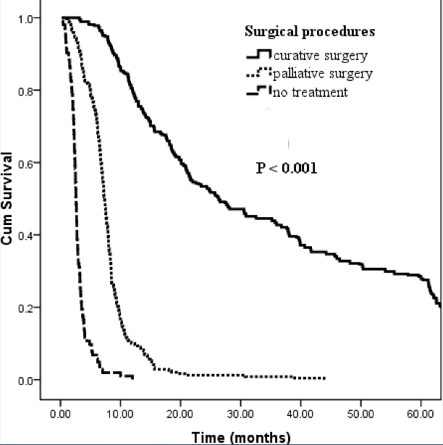
Figure 1 Comparing overall survival of patients who underwent curative intent surgery, palliative surgery and those who did not take any treatment for Hilar Cholangiocarcinoma (P < 0.001).

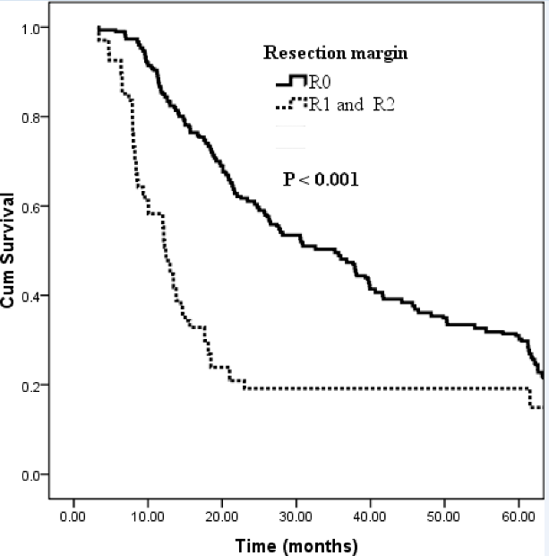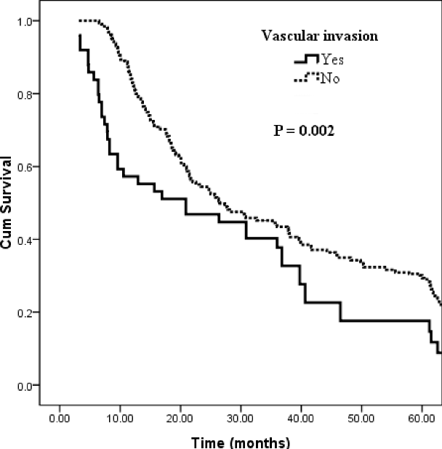
A B
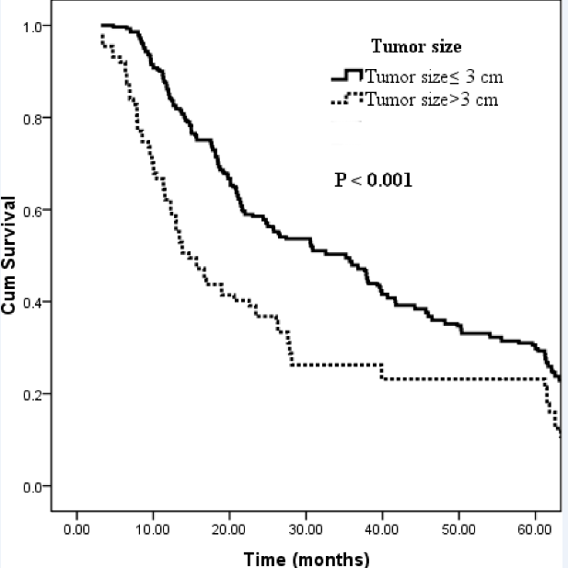
C
Figure 2 Overall survival of patients who underwent curative surgery for hilar Cholangiocarcinoma stratified by (A) resection margin, vascular invasion (B), tumor size (C).
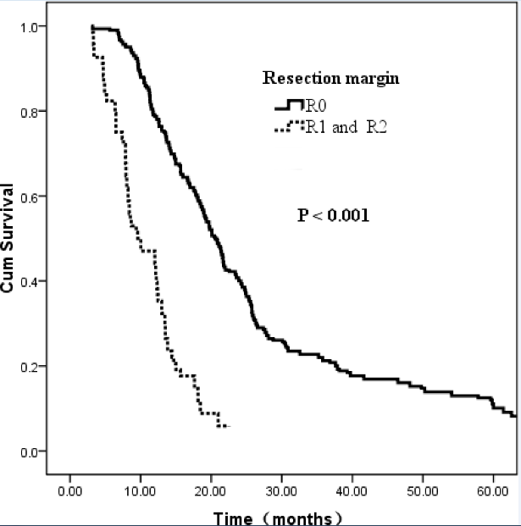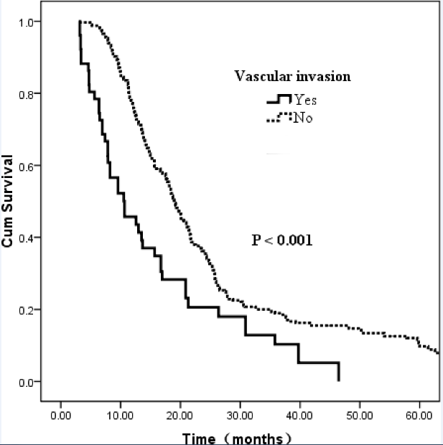
A B
Figure 3 Disease free survival of patients who underwent curative surgery for hilar Cholangiocarcinoma stratified by resection margin (A), vascular invasion (B).

Table 1 Patient characters: comparison between resected and palliative patients

 | Number (%) or median [range]
Variable | Curative surgery  (n = 381) | Palliative surgery  (n = 330)
Age (median [range]) | 60 [26-82] | 58 [19-80]
Gender, male (%) | 231 (60.6) | 178 (53.9)
Presenting symptoms, n (%)
Jaundice | 267 (70.1) | 240 (72.7)
Weight loss | 26 (6.8) | 22 (6.7)
Abdominal pain | 24 (6.3) | 28 (8.5)
Nausea and vomiting | 20 (5.2) | 17 (5.1)
General fatigue | 44 (11.6) | 23 (7.0)
Tumor markers (median [range])
Pre-operative CA 199 level, U/mL | 348 [0.6-1000] | 539.9 [0.6-3015.17]
Pre-operative CA 125 level, U/mL | 19.84 [1.23-257.7] | 33.94 [1.54-1598]
Pre-operative CEA level, ng/mL | 3.23 [0.2-65.51] | 4.44 [0.47-1000]
Liver functions (median [range])
Pre-operative TB level, mg/dL | 209.4 [7.1-586.3] | 239.65 [1.9-805.7]
Pre-operative ALT level, U/L | 95 [10-967] | 78.5 [6-1212]
Pre-operative AST level, U/L | 86 [14-1016] | 87 [11-927]
Pre-operative Albumin level, g/L | 36.7 [18.7-51.8] | 35.95 [21.3-72.5]
Preoperative hospital stay (median [range]) | 7 [2-44] | 7 [3-48]
Total hospital stay (median [range]) | 19 [9-113] | 16 [4-102]
Portal vein embolization, n (%) | 53 (13.9)
Biliary drainage, n (%) | 201 (52.8)
Estimated blood loss ( median [range]) | 600 [50-2000] | 348 [0.6-1000]
Bismuth-Corlette classification, n (%)
Type I | 95 (25.2) | 16 (4.8)
Type II | 92 (24.2) | 59 (17.9)
Type IIIa or IIIb | 102 (26.8) | 102 (30.9)
Type IV | 92 (24.2) | 153 (46.4)
CA-19-9: carbohydrate antigenic determinant 19-9; CA125: carbohydrate antigen 125; TB: total bilirubin; ALT: alanine aminotransferase; AST: aspartate transaminase; CEA: Carcino Embryonie Antigen.

Table 2 Type of surgical procedures

Surgical procedures | n (%)
Curative intent surgery | 381 (53.6)
Hilar bile duct resection alone | 50 (13.1)
Left hemihepatectomy | 142 (37.3)
Right hemihepatectomy | 101 (26.5)
Left trisegmentectomy | 46 (12.1)
Right trisegmentectomy | 20 (5.2)
Mesohepatetctomy | 22 (5.8)
Additional procedures
Caudate lobectomy | 300 (78.7)
Portal vein resection | 51 (13.4)
Pancreatoduodenectomy | 8 (2.1)
Palliative intent surgery | 330 (46.4)
Surgical palliation | 266 (80.6)
Nonsurgical palliation | 64 (19.4)
ERCP | 35 (10.6)
PTCD | 29 (8.8)
ERCP: Endoscopic retrograde cholangiopancreatography; PTCD: Percutaneous transhepaticcholangial drainage.

Table 3 Univariate analysis of prognostic factors on overall survival and disease free survival

Variables | Median OS (mo) | P value | Median DFS (mo) | P value
Tumor size
≤ 3 cm | 35.2 | < 0.001 | 19.8 | < 0.001
> 3 cm | 14.7 |  | 13.0
Surgical procedures
BDR | 20.8 | 0.072 | 15.0 | 0.065
BDR+hepatectomy | 27.6 |  | 18.7
Lymph node metastasis
N0 | 39.9 | < 0.001 | 25.4 | < 0.001
N1-2 | 15.7 |  | 12.3
Tumor differentiation
well | 54.1 | < 0.001 | 25.3 | < 0.001
moderate | 27.6 |  | 17.8
poor | 13.5 |  | 12.1
Resection margin
R0 | 35.2 | < 0.001 | 20.6 | < 0.001
R1 and R2 | 12.4 |  | 9.6
Presence of vascular invasion
No | 26.3 | 0.009 | 19 | < 0.001
Yes | 20.9 |  | 10.6
Caudate lobe resection
Yes | 35.7 | 0.04 | 21.3 |  | < 0.001
No | 21.4 |  | 15.0
CA 19-9 >100 U/L
No | 39.7 | 0.039 | 23.6 |  | 0.018
Yes | 23.0 |  | 16.7
Perineural infiltration
No | 27.3 | 0.084 | 22.7 |  | 0.09
Yes | 20.8 |  | 15.9
T stage (AJCC)
T1 and T2 | 27.6 | NS | 19.2 |  | 0.028
T3 and T4 | 25.7 |  | 16.9
Additional factors not significant in univariate analysis included age, gender, gross feature, operative time, total hospital stay, preoperative biliary drainage, Bismuth-Corlett classification et al. NS: Not significant; OS: Overall survival; DFS: Disease free survival; BDR: Hilar bile duct resection; CA-19-9: Carbohydrate antigenic determinant 19-9; AJCC: American Joint Committee On Cancer.

Table 4 Multivariate analysis of prognostic factors on overall survival and disease free survival

Variables | For OS |  |  | For DFS
 | Hazard ratio | 95% CI | P value | Hazard ratio | 95% CI | P value
Tumor size > 3 cm | 1.482 | 1.127-1.949 | 0.005 | - | - | -
Poor tumor differentiation | 2.535 | 1.839-3.493 | < 0.001 | 2.774 | 2.012-3.823 | < 0.001
Positive resection margin | 1.798 | 1.314-2.461 | < 0.001 | 1.835 | 1.256-2.679 | < 0.001
Positive nodal status | 1.701 | 1.346-2.149 | < 0.001 | 3.383 | 2.633-4.348 | < 0.001
Vascular invasion | 1.542 | 1.082-2.197 | 0.017 | 2.136 | 1.658-3.236 | < 0.001
OS: Overall survival; DFS: Disease free survival.

Table 5 Multivariate analysis of risk factors for tumor free resection margin

Variables | Hazard ratio | 95% CI | P value
Tumor size | 3.772 | 1.914–7.434 | < 0.001
AJCC T stage | 2.010 | 1.043–3.870 | 0.037
Surgical procedures | 10.236 | 4.738–22.116 | < 0.001
Caudate lobectomy | 9.771 | 4.672-20.433 | < 0.001
Vascular invasion | 2.278 | 0.997–5.207 | 0.051
AJCC: American Joint Committee on Cancer.

