Name of Journal: World Journal of Gastrointestinal Oncology
Manuscript NO: 66172
Manuscript Type: FRONTIER

Engineering nanotheranostic strategies for liver cancer

Cao L et al. Theranostics for liver cancer

Lei Cao, Yu-Qin Zhu, Zhi-Xian Wu, Gao-Xiong Wang, Hong-Wei Cheng

Lei Cao, Yu-Qin Zhu, Gao-Xiong Wang, Department of Pathology, Quanzhou Women's and Children's Hospital, Quanzhou 362000, Fujian Province, China

Zhi-Xian Wu, Department of Hepatobiliary Disease, The 900th Hospital of the People’s Liberation Army Joint Service Support Force, Fuzhou 350025, Fujian Province, China

Hong-Wei Cheng, School of Public Health, Xiamen University, Xiamen 361002, Fujian Province, China

Author contributions: Cao L and Zhu YQ conducted the literature manufacture and drafted the manuscript, and contributed equally to this study; Wu ZX provided technological support and contributed to the project discussion; Wang GX and Cheng HW had equal contributions to the conceptualization of this study and authentication of the validity of the reported results.

Supported by Science and Technology Innovation Joint Fund Project of Fujian Province, No. 2019Y9044; and Science and Technology Project of Quanzhou, No. 2018Z155.

Correspondence to: Hong-Wei Cheng, MD, Research Associate, School of Public Health, Xiamen University, Xiangan South Road, Xiangan District, Xiamen 361002, Fujian Province, China. hongwei1026@hotmail.com

Received: March 22, 2021
Revised: June 28, 2021
Accepted: August 12, 2021
Published online: October 15, 2021

Abstract
The incidence and mortality of hepatocellular carcinoma have continued to increase over the last few years, and the medicine-based outlook of patients is poor. Given great ideas from the development of nanotechnology in medicine, especially the advantages in the treatments of liver cancer. Some engineering nanoparticles with active targeting, ligand modification, and passive targeting capacity achieve efficient drug delivery to tumor cells. In addition, the behavior of drug release is also applied to the drug loading nanosystem based on the tumor microenvironment. Considering clinical use of local treatment of liver cancer, in situ drug delivery of nanogels is also fully studied in orthotopic chemotherapy, radiotherapy, and ablation therapy. Furthermore, novel therapies including gene therapy, phototherapy, and immunotherapy are also applied as combined therapy for liver cancer. Engineering nonviral polymers to function as gene delivery vectors with increased efficiency and specificity, and strategies of co-delivery of therapeutic genes and drugs show great therapeutic effect against liver tumors, including drug-resistant tumors. Phototherapy is also applied in surgical procedures, chemotherapy, and immunotherapy. Combination strategies significantly enhance therapeutic effects and decrease side effects. Overall, the application of nanotechnology could bring a revolutionary change to the current treatment of liver cancer.

Key Words: Liver cancer; Poor prognosis; Nanotheranostic; Drug delivery; Gene delivery; Combination therapy

©The Author(s) 2021. Published by Baishideng Publishing Group Inc. All rights reserved.

Citation: Cao L, Zhu YQ, Wu ZX, Wang GX, Cheng HW. Engineering nanotheranostic strategies for liver cancer. World J Gastrointest Oncol 2021; 13(10): 1213-1228
URL: https://www.wjgnet.com/1948-5204/full/v13/i10/1213.htm
DOI: https://dx.doi.org/10.4251/wjgo.v13.i10.1213

Core Tip: With the development of nanotheranostic strategies for liver cancer treatment, the efficacy of drug delivery is improved by smart nanoparticles with excellent targeting capacity. To overcome the complex tumor microenvironment, nanosystems with combined strategies of curative or palliative treatments have significant synergistic therapeutic effect against unfavorable clinical obstacles in the treatment of liver cancer.

INTRODUCTION
According to newly reported cancer statistics, the liver cancer death rate is much higher than the incidence, suggesting that the clinical treatments for liver cancer are unsatisfactory^{[1]}. With the development of nanotechnology in medicine, especially in the improvement of combined treatments, many studies have attempted to improve the therapeutic effect and decrease the side effects affecting normal organs^{[2,3]}. To fully understand the engineering nanotheranostic strategies for liver cancer, the dilemma of clinical liver cancer treatments should be described. Poor diagnosis and ineffective treatments are the general shortcomings of the clinical management of liver cancer. To overcome the poor therapeutic effect, this frontier demonstrates the potential engineering nanosystems based on curative or palliative treatments. Firstly, the expanding intersection of curative treatments and nanotheranostic strategy emphasizes surgical resection and tumor ablation, which improve the efficacy of therapeutic solutions to prevent tumor occurrence and metastasis. Moreover, improved nanotheranostic strategies are also presented based on palliative treatments, including chemotherapy, radiotherapy, embolization therapy, and novel therapies, such as gene therapy, phototherapy, and immunotherapy. Many smart nanomaterials are designed to act as effective drug delivery platforms to enhance the therapeutic effect against tumor cells, especially to combat drug resistance^{[4-6]}. In addition, strategies that combine chemotherapy, phototherapy, gene therapy, and immunotherapy increase the sensitivity tumor cells to treatment^{[7-10]}. To sum up, the engineering nanotheranostic strategy could revolutionize the current treatment of liver cancer and have great transformative value to ameliorate the prognosis of liver cancer patients.

DILEMMA OF CLINICAL LIVER CANCER TREATMENTS
General shortcomings in clinical liver cancer
According to worldwide cancer statistics, the estimated death rate of liver cancer is significantly higher than its estimated incidence^{[1,11,12]}, suggesting that the clinical practice for liver cancer is unsatisfactory. Many complex factors contribute to this dilemma. As Figure 1 shows, clinical shortcomings for liver cancer include four areas, diagnosis, curative treatments, palliative treatments, and prognostic evaluation^{[13,14]}.

Clinical diagnosis
The clinical diagnosis of liver cancer is poor, the early symptoms of liver cancer are inconspicuous, and most patients are diagnosed in the intermediate or advanced stages, and without a chance to employ curative treatments including tumor resection, liver transplantation, and ablation^{[15]}. Therefore, discovery of effective biomarkers has been extensively studied in recent years, with the expectation to overcome the shortcomings of low specificity and sensitivity of existing clinical markers, such as alpha-fetoprotein (AFP) and glypican 3 (GPC3)^{[15]}.

Curative treatments
Curative treatments for liver cancer are applicable to patients with very early stage or early stage disease, thus many patients cannot benefit from these strategies because of their strict indications^{[16,17]}. For tumor resection, the disease stages and complex physiological factors, including liver function, cirrhosis and surgery tolerance, limit its application for liver cancer patients^{[18,19]}. In recent years, advances in liver transplantation have resulted in promising prospects in improving the prognosis of liver cancer patients with early stage disease^{[20-22]}. However, because of the limitation of liver donors, few patients benefit from that treatment. Tumor ablation, including radiofrequency ablation (RFA), NanoKnife, and microwave ablation are available, but incomplete ablation is the main constraint in clinical practice^{[23-25]}.

Palliative treatments
Palliative treatments are available for most liver cancer patients, including chemotherapy, transarterial embolization, radiotherapy and immunotherapy. However, drug resistance is an important factor that deserves particular attention, because it significantly impairs treatment outcome. Immunotherapy is a novel, promising strategy in with potential benefits in some cancers. However, clinical trials of programmed death-1 (PD-1) monoclonal antibody therapy in patients with advanced hepatocellular carcinoma did not improve overall survival or progression-free survival of patients^{[26,27]}. Incomplete transarterial embolization leads to tumor metastasis and recurrence and limits its clinical outcome. Consequently, the improvement of palliative treatments is urgently needed to reduce the mortality of liver cancer.

EFFICIENT DRUG DELIVERY TO IMPROVE TREATMENT EFFICACY
Active targeting
Chemotherapy plays an indispensable role in the liver cancer clinic, but the outcome is unsatisfactory^{[28]}. Considering the underlying reasons, minimal drug bioavailability and side effects are the two main problems^{[29]}. The development of nanotechnology allows for the improvement of effectiveness of chemotherapy. First, the nanostructure design enhances the solubility of chemotherapeutics like paclitaxel (PTX) and sorafenib, which are poorly soluble^{[30]}. Improved biocompatibility can enhance the drug bioavailability. Second, the involvement of nanomaterials allows modification of drug behavior, and binding to the targeted ligand is an excellent solution to improve drug delivery and enhance the therapeutic effect of tumor inhibition. For example, Wu et al^{[31]} described PTX-loaded poly (3-hydroxybutyrate-co-3-hydroxyvalerate) PHBV nanoparticles coated with polydopamine (PDA-PHBV-PTX-NPs) and modified by hepatocellular carcinoma (HCC)-targeted arginine-glycine-aspartic acid (RGD-peptide). As shown in Figure 2A, integrin αvβ3 or αvβ5 are overexpressed in liver cancer cells, and RGD is a specific ligand of integrin αvβ3/αvβ5. The PTX-loaded nanoparticles actively target and enter liver tumor cells. Figure 2B shows the cellular uptake of fluorescently labeled RGD-modified nanoparticles was remarkably higher than other groups (Figure 2B), and in vivo results of fluorescence imaging confirmed that RGD active targeting nanoparticles significantly increased the drug concentration in tumor tissues (Figure 2C and D). The evidence suggests that active targeting of nanomaterials has remarkable advantages in the efficacy of drug delivery. In recent years, with advances in biomarker discovery for liver cancer, many nanomaterials with active targeting ability have improved drug delivery, especially of insoluble drugs, with targeted peptides or antibodies used to confer the active targeting ability and thus improve drug bioavailability and therapeutic effects^{[4,5,32]}.

Passive targeting
In recent studies, nanomaterials used as a drug delivery platform have made significant progress in cancer treatment. Active targeting medications are “the eyes” of nanomedicine, but the unique passive targeting capability of nanostructured materials is also a widely recognized uptake mechanism via enhanced permeability and retention (EPR)^{[33]}. In a previous study, Ebrahim et al^{[34]} designed galactose-conjugated nanoparticles to study the difference between ligand-active targeting and passive EPR targeting in liver cancer therapy. As in previous reports, collecting-3 was highly expressed in the liver tumor vessel endothelial cells, and galactose as the ligand of galectin-3 has been used as a functional fragment for targeted drug delivery to liver cancer. Furthermore, asialoglycoprotein with exposure to galactose residues can bind to asialoglycoprotein receptors (ASGPR), which are expressed in liver cancer cells. Interestingly, the expression of ASGPR in higher in normal hepatocytes cells than in liver hepatoma cells. Thus this novel nanoparticle strategy can help us understand the difference between active targeting and passive targeting in liver cancer drug delivery (Figure 3A). The result of the binding activity of galactose-conjugated nanoparticles for galectin-3 (Figure 3B) was higher than nanoparticles without galactose modification, and the specific HCC targeting capability was also evaluated in an orthotopic HCC tumor model. Bioluminescence shows the location of liver cancer cells, and the fluorescence shows the location of DiR-loaded nanoparticles with galactose or not, and the surprising results showed that galactose-conjugated nanoparticles were accumulated mostly in the hepatocytes, but not in liver tumors. However, the nanoparticles without galactose surface expression only depended on EPR passive-targeting capability, showing better accumulation in the liver tumors (Figure 3C). The dual strategy not only shows the advantage of ligand-active targeting in nanomedicine, but also confirms the indispensable role of EPR passive targeting in drug delivery. Even the efficiency of EPR-mediated passive targeting to cancer cells is still unclear, and particle size control is essential to the EPR effect of nanoparticles on tumor targeting, which provides a theoretical reference for the design of nanomedicines^{[35,36]}.

Tumor microenvironment-responsive drug release
Based on the design of ligand-active or EPR passive targeting, nanomaterials have substantial advance progress in drug delivery. The detailed drug release behavior of nanomedicine has also been reported in recent years, especially in the exploitation of the tumor microenvironment (e.g., hypoxia, low pH, high glutathione, immune-suppressive microenvironment, and so on^{[37,38]}. Therefore, while achieving higher drug delivery efficiency, the design of controllable drug release based on the tumor microenvironment has significant strengths in improving drug bioavailability, reducing toxic side effects, and improving therapeutic effects. Zhu et al^{[39]} reported a nanodrug with reduced side effects and pH-sensitive drug release behavior applied as targeted HCC therapy. A copolymer of monomethoxyl polyethylene glycol and poly N-(2-aminoethanethiol-co-2-aminoethyldiisopropylamine) aspartamide (mPEG-PAsp) or MEA & DIP was self-assembled with sorafenib and super-paramagnetic iron oxide nanoparticles (SPIONs) into nanoparticles, and then modified with anti-GPC3 antibody (Ab_{GPC3}) to construct a nanodrug system with active targeting of liver cancer cells (Figure 4). SPIONs provided magnetic resonance imaging (MRI) capability to monitor the delivery behavior of the nanodrug. Increased glutathione and the low pH of the liver tumor microenvironment promote dissociation of the sorafenib-loaded nanodrug with sorafenib release on demand. Precise drug release significantly increases drug concentration in the tumor cells that guarantees therapeutic dosage and prevents drug resistance^{[40]}. Furthermore, tumor microenvironment-responsive drug release decreases the toxicity to normal cells by drug blockade and nonspecific uptake by normal cells^{[3]}.

Enhanced therapeutic strategies of in situ treatment
Topical therapy is an important strategy in cancer treatment, and ablation and transcatheter artery embolization (TAE) are common topical treatments in the liver cancer clinic^{[41]}. Common embolism reagents contain lipiodol and microspheres. The advantage of liquid lipiodol is to embolize peripheral blood vessels of tumors, but it has little effect on the embolization of large blood vessels, which contributes to multiple procedures to prevent recanalization of blood vessels^{[2,42,43]}. Incomplete peripheral blood vessel embolization also limits the therapeutic effects of microspheres, and the higher cost also impairs patient willingness to accept treatment^{[44]}. Therefore, the construction of novel embolic reagents might be a promising solution to the obstacles to HCC artery embolization. Hydrogels are novel embolic reagents for HCC therapy. Hydrogels have the advantages of good biocompatibility, sustained drug release, high drug loading, and so on^{[45-47]}. The three-dimensional structure can improve the loading of insoluble drugs, which is essential for improved drug bioavailability^{[48]}. Zheng et al^{[7]} described a thermosensitive poly (D, L-lactic acid-co-glycolic acid)-b-poly (ethylene glycol) -b-poly (D,L-lactic acid-co-glycolic acid) (PLGA-PEG-PLGA)-based hydrogel nanosystem, composed of sorafenib, lipiodol and selenium nanoparticles (SeNPs). The hydrogel was injected into liver tumors and had long-term local anticancer effects. Combination with X-ray radiotherapy further enhanced the therapeutic effects (Figure 5). More important, the thermosensitive hydrogel system takes advantage of lipiodol in the embolization of peripheral blood vessels. The dual-functional design warrants future investigation of embolic materials.
Another critical aspect of local therapy is tumor ablation. Conventional ablation is temperature- or chemical-based. Temperature-based methods include radiofrequency ablation (RFA), microwave ablation, laser ablation, high-intensity focus ultrasound, cryoablation, and nonreversible electroporation (IRE, or NanoKnife)^{[49,50]}. Ethanol and ethanoic acid are the two main reagents used for chemical ablation. However, the evidence from clinical liver cancer practice indicates that incomplete ablation is an urgent problem that deserves more attention^{[51]}. To overcome these flaws, nanomaterial-enhanced strategies are widely studied. Considering the superior embolic effect of thermogels and the good heat ablation effect of gold nanoclusters, Yang et al^{[8]} described a composite system composed of poly (N-isopropylamide-co-acrylic acid) (PNAs) and dual-valent gold nanoclusters (dvGC) with a core-shell nanostructure. The incorporation of gold nanoclusters enhanced the heating effect of radiofrequency ablation and improved tumor inhibition^{[8]}. The application of nanomaterials in topical HCC therapy achieves a better therapeutic effect over systemic treatments, and the patients can benefit from nanomaterial application in embolization and ablation-combined treatment. With the development of interventional technology, the future of tumor regional therapy is encouraging.

GENE THERAPY IN LIVER CANCER
Gene delivery carrier construction
Gene therapy opens up prospects of innovative therapeutic schedules in HCC, and some therapeutic genes have been used to correct the genetic alterations. Genetic therapy includes the use of plasmid genes, small interfering RNA (siRNA), micro RNA (miRNA), or messenger RNA (mRNA)^{[52]}. In recent years, some plasmids coding tumor suppressor genes were delivered into tumor cells to prevent tumor progression. Some siRNAs or miRNAs against oncogenic genes have been used to prevent pro-oncogenic signaling pathways. Of note, mRNA delivery is also promising in antitumor immunity^{[53,54]}. At present, gene therapy-based chimeric antigen receptor T (CAR-T) therapy for HCC has been investigated in clinical trials. Introduction of CAR genes introduction is accomplished by viral gene delivery to guarantee efficient gene transfection ex vivo^{[55,56]}. Reviewing the potential risks of viral vectors in vivo, nonviral gene delivery vector has developed rapidly, especially in the development of nanostructured materials^{[57]}. Compared with viral vector gene delivery, nonviral delivery of nanomaterials has superior efficiency, specificity, biosafety, and multifunction design^{[58-60]} (Figure 6). Common nonviral gene delivery vectors include many cationic nanocarriers that were developed to adsorb nucleic acids by electrostatic interactions, such as cationic liposomes and polymers with positively charged blocks^{[61,62]}.

Co-delivery of genes and chemotherapeutics for drug-resistant liver cancer
Drug resistance is an essential influence of patient prognosis, especially in HCC. HCC is frequently diagnosed at an advanced stage, and chemotherapy is a standard treatment for patients without surgical options, but drug resistance often occurs. The combination of other novel treatments with chemotherapy might be beneficial for HCC patients. Gene therapy has potential value in chemosensitization. Many studies have reported that delivery of tumor suppressor genes or silencing RNA against oncogenes recovered the sensitivity of tumor cells to chemotherapy drugs. Some studies focused on midkine, which is a biomarker of diagnosis and prognosis of HCC patients, and is involved in the cell proliferation and metastasis^{[63,64]}. Downregulation of midkine to inhibit the progression of HCC has been confirmed in previous studies^{[65,66]}. Harashima et al^{[67]} developed small lipid nanoparticles that encapsulated midkine-siRNA and sorafenib. As shown in Figure 7A, midkine was overexpressed in sorafenib-resistant HepG2 cells, and knockdown of midkine significantly improved the inhibition of cell viability by sorafenib (Figure 7B). They also demonstrated that the silencing of midkine inhibited STAT-3 and NF-κB signaling pathways and promoted Caspase-3 antitumor activity (Figure 7C). The treatment outcome of co-delivery of sorafenib and siRNA against midkine was confirmed in a mouse model, showing significant tumor suppression (Figure 7D-F).
Pump-mediated drug efflux is a mediator of chemotherapy resistance, and P-glycoprotein (MDR1) is a principal regulator in drug efflux. Our team and other research groups have developed some delivery systems to overcome drug efflux-mediated resistance. We previously described thermo-responsive supramolecular polymers that enhanced the cellular uptake of chemotherapeutics by cells that overexpressed multidrug resistance (MDR)1^{[68,69]}. The co-delivery of chemotherapeutics and siRNA against MDR1 resulted in significant inhibition of drug efflux and improved treatment response^{[70,71]}. The findings show that engineered nanosystems with combined treatments have significant advantages to overcome drug efflux-pump resistance. However, non-pump-mediated drug resistance also restricts the therapeutic effect of chemotherapy. Bcl-2, a mitochondrial regulator, functions as an antiapoptotic mediator to interfere with Caspase family apoptotic signaling. Knockdown of Bcl-2 expression with inhibitors or siRNA is a classical strategy to strengthen tumor inhibition by chemotherapeutics^{[6,72]}. However, the stability of siRNA is a notable constraint. Interestingly, Wu et al^{[9,73-75]} developed a strategy to co-deliver Nur77△DBD gene plasmids and chemotherapeutic PTX simultaneously. The Nur77/△DBD interacted with Bcl-2 and changed Bcl-2 from tumor protector to tumor killer. Considering the advantage of DNA on stability over RNA, that strategy might increase the efficiency of gene delivery and enhance the cytotoxicity of chemotherapeutic PTX. The mitochondrial location of Nur77/△DBD promotes reversal of Bcl-2 function (Figure 8). In general, the co-delivery of genes and chemotherapeutic drugs can be applied in both drug efflux pump and non-pump drug resistance. The combination with gene therapy can significantly reverse pro-oncogenic pathways, and improve the performance of chemotherapeutic drugs.

PHOTO-ASSISTED THERAPIES IN LIVER CANCER
Imaging-guided surgical resection
To date, surgical resection is the first choice for HCC treatment, which can significantly prolong the survival of HCC patients. However, because of the difficulty to identify small lesions by the naked eye, incomplete tumor resection contributes to tumor recurrence or metastasis, which significantly affect the clinical outcome. In recent years, imaging-guided tumor resection has shown outstanding performance in HCC surgical treatment. Compared with some classical imaging options including computed tomography and MRI, photo-imaging has better clinical transformation value. Fluorescence imaging (FLI) and photo-acoustic imaging are the two representative solutions with improved efficiency in the detection of small lesions. Tian et al^{[76]} reported indocyanine green (ICG) as an FDA-approved near-infrared (NIR-Ⅱ) probe to guide tumor resection in HCC patients. They reported that intraoperative NIR-II fluorescence imaging had a higher tumor detection sensitivity and a better signal-to-noise ratio to distinguish HCC tumor and normal liver tissue (Figure 9A).
Considering the rapid clearance of ICG in vivo and the time demands of surgery, Liu et al^{[77]} developed a novel embolic formulation that combined an embolic lipiodol agent and ICG. This study was motivated by the clinical demand for TAE to treat HCC. Some insoluble chemotherapeutic drugs cannot fully disperse in lipiodol, which contributes to the instability of the drugs in the local tumor environment. To overcome the problem, a superstable homogeneous iodinated formulation technology (SHIFT) was used to improve the stability of ICG in lipiodol, and allow combined therapy of embolization with fluorescence-guided surgical resection, which is suitable for patients with advanced HCC (Figure 9B). Interestingly, the rabbit VX2 tumor model results showed remarkable fluorescence intensity in the tumor after 2 wk of embolization therapy (Figure 9C). Intravenous injection of free ICG 24 h before surgery resulted in no significant fluorescence intensity. The evidence shows that transcatheter embolization synergistic fluorescence imaging-assisted surgical resection can enhance tumor detection, and achievement of complete tumor resection to avoid tumor recurrence and metastasis. Additionally, precise fluorescence imaging can decrease the resection risk of normal tissues. In general, the strategy of imaging-guided surgical resection has clinical potential for HCC patients, even for those with progressive disease.

Phototherapy combined with chemotherapeutic therapy
Photothermal therapy (PTT) and photodynamic therapy (PDT) are the two main phototherapies. Simply, photosensitizers are exploited by PTT and PDT under laser irradiation, the heat or reactive oxygen species (ROS) that are produced kill tumors^{[78,79]}. Some studies have reported the potential application of PTT and PDT in HCC. Yu et al^{[80]} evaluated bovine serum albumin (BSA)-coated zinc phthalocyanine (ZnPc) and chemotherapeutic sorafenib (SFB) nanoparticles in an oil-in-water emulsion (Figure 10). Zinc phthalocyanine was added as photosensitizer to achieve PTT and PDT effect. Based on the advantages of nanoparticles for drug delivery, sorafenib significantly inhibited Raf/MEK/ERK signaling, which is essential for cell proliferation, angiogenesis, and metastasis. Efficient heat and ROS generation could remarkably induce tumor apoptosis, and enhance the sensitivity of tumor cells to sorafenib chemotherapy. The combination of phototherapy and chemotherapy is a potential strategy to address the shortcomings of chemotherapy, such as acquired drug tolerance.

Phototherapy combined with immunotherapy
Immunotherapy as a revolutionary cancer treatment that include immune checkpoint blockade, such as CTLA-4, PD-1 or PD-L1 and chimeric antigen receptor T cell (CAT-T)^{[81,82]}. However, off-target toxicity and low efficiency are the main shortcomings. Many studies have confirmed that immunotherapy slightly improves the survival of HCC patients^{[26,83]}. Considering the difficulties of immunotherapy in solid tumors, the potential value of nanomaterial-assisted efficient drug delivery, and synergistic treatment effects, many studies have investigated ways to increase the therapeutic effect of immunotherapy. Some synergistic strategies have achieved therapeutic effects^{[84,85]}. Tian’s group^{[10]} reported that SP94-coated Prussian blue nanoparticles effectively delivered sorafenib to liver tumor cells (Figure 11). The Prussian blue color showed that the nanoparticles mediated an efficient PTT effect under laser irradiation, and the complementary treatment with sorafenib induced immunogenic cell death, released tumor-associated antigen, and promoted dendritic cell (DC) maturation, which significantly enhanced the therapeutic response of anti-PD-L1 monoclonal antibody (mAb). Synergistic phototherapy and checkpoint blockade immunotherapy strategy can restructure tumor immunosuppression microenvironments, making HCC patients more sensitive to immunotherapy. Overall, synergistic strategy opens the door for immunotherapy of HCC.

CONCLUSION
In conclusion, this frontier focuses on the prominent problems in the clinical treatment of liver cancer, especially in the discussion of key factors that restrict the early diagnosis and create a poor prognosis of liver cancer, and further explores nanotechnology-based solutions. With smart nano-design, the efficacy of drug delivery is achieved by active or passive targeting strategies. Combined strategies with current curative or palliative treatments of liver cancer can strengthen the therapeutic effect of surgery, ablation, chemotherapy, gene therapy, and phototherapy. In clinical practice, combination therapy is commonly used for liver cancer to overcome the shortcomings of single treatment that are subject to acquired drug resistance and toxic side effects. The specific structure of many nanotheranostic strategies improves the performance of combination therapy, which significantly improves the prognosis of liver cancer patients and prolongs survival. Overall, development of the engineering nanotheranostic strategy could revolutionize the current treatment of liver cancer.

ACKNOWLEDGEMENTS
The authors thank the previous publisher or copyright holder for giving permission of figure to be re-published.

REFERENCES
1 Siegel RL, Miller KD, Fuchs HE, Jemal A. Cancer Statistics, 2021. CA Cancer J Clin 2021; 71: 7-33 [PMID: 33433946 DOI: 10.3322/caac.21654]
2 Li Z, Di C, Li S, Yang X, Nie G. Smart Nanotherapeutic Targeting of Tumor Vasculature. Acc Chem Res 2019; 52: 2703-2712 [PMID: 31433171 DOI: 10.1021/acs.accounts.9b00283]
3 Jiang X, Fan X, Xu W, Zhao C, Wu H, Zhang R, Wu G. Self-assembled peptide nanoparticles responsive to multiple tumor microenvironment triggers provide highly efficient targeted delivery and release of antitumor drug. J Control Release 2019; 316: 196-207 [PMID: 31682910 DOI: 10.1016/j.jconrel.2019.10.031]
4 Tang X, Chen L, Li A, Cai S, Zhang Y, Liu X, Jiang Z, Liu X, Liang Y, Ma D. Anti-GPC3 antibody-modified sorafenib-loaded nanoparticles significantly inhibited HepG2 hepatocellular carcinoma. Drug Deliv 2018; 25: 1484-1494 [PMID: 29916268 DOI: 10.1080/10717544.2018.1477859]
5 Shen J, Cai W, Ma Y, Xu R, Huo Z, Song L, Qiu X, Zhang Y, Li A, Cao W, Zhou S, Tang X. hGC33-Modified and Sorafenib-Loaded Nanoparticles have a Synergistic Anti-Hepatoma Effect by Inhibiting Wnt Signaling Pathway. Nanoscale Res Lett 2020; 15: 220 [PMID: 33242103 DOI: 10.1186/s11671-020-03451-5]
6 Kim J, Shim MK, Yang S, Moon Y, Song S, Choi J, Kim J, Kim K. Combination of cancer-specific prodrug nanoparticle with Bcl-2 inhibitor to overcome acquired drug resistance. J Control Release 2021; 330: 920-932 [PMID: 33152391 DOI: 10.1016/j.jconrel.2020.10.065]
7 Zheng L, Li C, Huang X, Lin X, Lin W, Yang F, Chen T. Thermosensitive hydrogels for sustained-release of sorafenib and selenium nanoparticles for localized synergistic chemoradiotherapy. Biomaterials 2019; 216: 119220 [PMID: 31200144 DOI: 10.1016/j.biomaterials.2019.05.031]
8 Li L, Guo X, Peng X, Zhang H, Liu Y, Li H, He X, Shi D, Xiong B, Zhao Y, Zheng C, Yang X. Radiofrequency-responsive dual-valent gold nanoclusters for enhancing synergistic therapy of tumor ablation and artery embolization. Nano Today 2020; 35: 100934 [DOI: 10.1016/j.nantod.2020.100934]
9 Li Z, Liu X, Chen X, Chua MX, Wu YL. Targeted delivery of Bcl-2 conversion gene by MPEG-PCL-PEI-FA cationic copolymer to combat therapeutic resistant cancer. Mater Sci Eng C Mater Biol Appl 2017; 76: 66-72 [PMID: 28482577 DOI: 10.1016/j.msec.2017.02.163]
10 Zhou T, Liang X, Wang P, Hu Y, Qi Y, Jin Y, Du Y, Fang C, Tian J. A Hepatocellular Carcinoma Targeting Nanostrategy with Hypoxia-Ameliorating and Photothermal Abilities that, Combined with Immunotherapy, Inhibits Metastasis and Recurrence. ACS Nano 2020; 14: 12679-12696 [PMID: 32909732 DOI: 10.1021/acsnano.0c01453]
11 Wu C, Li M, Meng H, Liu Y, Niu W, Zhou Y, Zhao R, Duan Y, Zeng Z, Li X, Li G, Xiong W, Zhou M. Analysis of status and countermeasures of cancer incidence and mortality in China. Sci China Life Sci 2019; 62: 640-647 [PMID: 30900169 DOI: 10.1007/s11427-018-9461-5]
12 Pilleron S, Sarfati D, Janssen-Heijnen M, Vignat J, Ferlay J, Bray F, Soerjomataram I. Global cancer incidence in older adults, 2012 and 2035: A population-based study. Int J Cancer 2019; 144: 49-58 [PMID: 29978474 DOI: 10.1002/ijc.31664]
13 Llovet JM, Villanueva A, Marrero JA, Schwartz M, Meyer T, Galle PR, Lencioni R, Greten TF, Kudo M, Mandrekar SJ, Zhu AX, Finn RS, Roberts LR; AASLD Panel of Experts on Trial Design in HCC. Trial Design and Endpoints in Hepatocellular Carcinoma: AASLD Consensus Conference. Hepatology 2021; 73 Suppl 1: 158-191 [PMID: 32430997 DOI: 10.1002/hep.31327]
14 Llovet JM, Montal R, Sia D, Finn RS. Molecular therapies and precision medicine for hepatocellular carcinoma. Nat Rev Clin Oncol 2018; 15: 599-616 [PMID: 30061739 DOI: 10.1038/s41571-018-0073-4]
15 Luo P, Yin P, Hua R, Tan Y, Li Z, Qiu G, Yin Z, Xie X, Wang X, Chen W, Zhou L, Wang X, Li Y, Chen H, Gao L, Lu X, Wu T, Wang H, Niu J, Xu G. A Large-scale, multicenter serum metabolite biomarker identification study for the early detection of hepatocellular carcinoma. Hepatology 2018; 67: 662-675 [PMID: 28960374 DOI: 10.1002/hep.29561]
16 Inchingolo R, Posa A, Mariappan M, Spiliopoulos S. Locoregional treatments for hepatocellular carcinoma: Current evidence and future directions. World J Gastroenterol 2019; 25: 4614-4628 [PMID: 31528090 DOI: 10.3748/wjg.v25.i32.4614]
17 Bruix J, Han KH, Gores G, Llovet JM, Mazzaferro V. Liver cancer: Approaching a personalized care. J Hepatol 2015; 62: S144-S156 [PMID: 25920083 DOI: 10.1016/j.jhep.2015.02.007]
18 Hackl C, Schlitt HJ, Renner P, Lang SA. Liver surgery in cirrhosis and portal hypertension. World J Gastroenterol 2016; 22: 2725-2735 [PMID: 26973411 DOI: 10.3748/wjg.v22.i9.2725]
19 Forner A, Reig M, Bruix J. Hepatocellular carcinoma. Lancet 2018; 391: 1301-1314 [PMID: 29307467 DOI: 10.1016/S0140-6736(18)30010-2]
20 Marroni CA, Fleck AM Jr, Fernandes SA, Galant LH, Mucenic M, de Mattos Meine MH, Mariante-Neto G, Brandão ABM. Liver transplantation and alcoholic liver disease: History, controversies, and considerations. World J Gastroenterol 2018; 24: 2785-2805 [PMID: 30018475 DOI: 10.3748/wjg.v24.i26.2785]
21 Line PD. Frontiers in liver transplantation. Br J Surg 2020; 107: 790-792 [PMID: 32463145 DOI: 10.1002/bjs.11714]
22 Thuluvath PJ, Thuluvath AJ, Hanish S, Savva Y. Liver transplantation in patients with multiple organ failures: Feasibility and outcomes. J Hepatol 2018; 69: 1047-1056 [PMID: 30071241 DOI: 10.1016/j.jhep.2018.07.007]
23 Hu J, Dong Y, Ding L, Mao F, Cao J, Sun Y, Wang W, Duan Y. Localized Chemotherapy Prevents Lung Metastasis After Incomplete Microwave Ablation of Hepatic VX2 Tumor. J Biomed Nanotechnol 2019; 15: 261-271 [PMID: 30596549 DOI: 10.1166/jbn.2019.2686]
24 Sparchez Z, Mocan T, Radu P, Mocan LP, Sparchez M, Leucuta DC, Al Hajjar N. Prognostic Factors after Percutaneous Radiofrequency Ablation in the Treatment of Hepatocellular Carcinoma. Impact of Incomplete Ablation on Recurrence and Overall Survival Rates. J Gastrointestin Liver Dis 2018; 27: 399-407 [PMID: 30574622 DOI: 10.15403/jgld.2014.1121.274.pro]
25 Niessen C, Thumann S, Beyer L, Pregler B, Kramer J, Lang S, Teufel A, Jung EM, Stroszczynski C, Wiggermann P. Percutaneous Irreversible Electroporation: Long-term survival analysis of 71 patients with inoperable malignant hepatic tumors. Sci Rep 2017; 7: 43687 [PMID: 28266600 DOI: 10.1038/srep43687]
26 Finn RS, Ryoo BY, Merle P, Kudo M, Bouattour M, Lim HY, Breder V, Edeline J, Chao Y, Ogasawara S, Yau T, Garrido M, Chan SL, Knox J, Daniele B, Ebbinghaus SW, Chen E, Siegel AB, Zhu AX, Cheng AL; KEYNOTE-240 investigators. Pembrolizumab As Second-Line Therapy in Patients With Advanced Hepatocellular Carcinoma in KEYNOTE-240: A Randomized, Double-Blind, Phase III Trial. J Clin Oncol 2020; 38: 193-202 [PMID: 31790344 DOI: 10.1200/JCO.19.01307]
27 Faivre S, Rimassa L, Finn RS. Molecular therapies for HCC: Looking outside the box. J Hepatol 2020; 72: 342-352 [PMID: 31954496 DOI: 10.1016/j.jhep.2019.09.010]
28 Chen X, Zhang X, Zhang L, Gao Y, Wang C, Hong W, Zhao G, Li L, Liu R, Wang C. Amphiphilic Janus nanoparticles for imaging-guided synergistic chemo-photothermal hepatocellular carcinoma therapy in the second near-infrared window. Nanoscale 2021; 13: 3974-3982 [PMID: 33595029 DOI: 10.1039/d0nr09017d]
29 Rimassa L, Danesi R, Pressiani T, Merle P. Management of adverse events associated with tyrosine kinase inhibitors: Improving outcomes for patients with hepatocellular carcinoma. Cancer Treat Rev 2019; 77: 20-28 [PMID: 31195212 DOI: 10.1016/j.ctrv.2019.05.004]
30 Zhang J, Wang T, Mu S, Olerile LD, Yu X, Zhang N. Biomacromolecule/Lipid hybrid nanoparticles for controlled delivery of sorafenib in targeting hepatocellular carcinoma therapy. Nanomedicine (Lond) 2017; 12: 911-925 [PMID: 28339312 DOI: 10.2217/nnm-2016-0402]
31 Wu M, Zhong C, Zhang Q, Wang L, Wang L, Liu Y, Zhang X, Zhao X. pH-responsive delivery vehicle based on RGD-modified polydopamine-paclitaxel-loaded poly (3-hydroxybutyrate-co-3-hydroxyvalerate) nanoparticles for targeted therapy in hepatocellular carcinoma. J Nanobiotechnology 2021; 19: 39 [PMID: 33549107 DOI: 10.1186/s12951-021-00783-x]
32 Fu Y, Urban DJ, Nani RR, Zhang YF, Li N, Fu H, Shah H, Gorka AP, Guha R, Chen L, Hall MD, Schnermann MJ, Ho M. Glypican-3-Specific Antibody Drug Conjugates Targeting Hepatocellular Carcinoma. Hepatology 2019; 70: 563-576 [PMID: 30353932 DOI: 10.1002/hep.30326]
33 Kalyane D, Raval N, Maheshwari R, Tambe V, Kalia K, Tekade RK. Employment of enhanced permeability and retention effect (EPR): Nanoparticle-based precision tools for targeting of therapeutic and diagnostic agent in cancer. Mater Sci Eng C Mater Biol Appl 2019; 98: 1252-1276 [PMID: 30813007 DOI: 10.1016/j.msec.2019.01.066]
34 Ebrahim Attia AB, Oh P, Yang C, Tan JP, Rao N, Hedrick JL, Yang YY, Ge R. Insights into EPR effect vs lectin-mediated targeted delivery: biodegradable polycarbonate micellar nanoparticles with and without galactose surface decoration. Small 2014; 10: 4281-4286 [PMID: 25091699 DOI: 10.1002/smll.201401295]
35 Kang H, Rho S, Stiles WR, Hu S, Baek Y, Hwang DW, Kashiwagi S, Kim MS, Choi HS. Size-Dependent EPR Effect of Polymeric Nanoparticles on Tumor Targeting. Adv Healthc Mater 2020; 9: e1901223 [PMID: 31794153 DOI: 10.1002/adhm.201901223]
36 Tong X, Wang Z, Sun X, Song J, Jacobson O, Niu G, Kiesewetter DO, Chen X. Size Dependent Kinetics of Gold Nanorods in EPR Mediated Tumor Delivery. Theranostics 2016; 6: 2039-2051 [PMID: 27698939 DOI: 10.7150/thno.17098]
37 Zhou Y, Chen X, Cao J, Gao H. Overcoming the biological barriers in the tumor microenvironment for improving drug delivery and efficacy. J Mater Chem B 2020; 8: 6765-6781 [PMID: 32315375 DOI: 10.1039/d0tb00649a]
38 Piñeiro Fernández J, Luddy KA, Harmon C, O'Farrelly C. Hepatic Tumor Microenvironments and Effects on NK Cell Phenotype and Function. Int J Mol Sci 2019; 20 [PMID: 31450598 DOI: 10.3390/ijms20174131]
39 Cai M, Li B, Lin L, Huang J, An Y, Huang W, Zhou Z, Wang Y, Shuai X, Zhu K. A reduction and pH dual-sensitive nanodrug for targeted theranostics in hepatocellular carcinoma. Biomater Sci 2020; 8: 3485-3499 [PMID: 32432234 DOI: 10.1039/d0bm00295j]
40 Zhang M, Guo X, Wang M, Liu K. Tumor microenvironment-induced structure changing drug/gene delivery system for overcoming delivery-associated challenges. J Control Release 2020; 323: 203-224 [PMID: 32320817 DOI: 10.1016/j.jconrel.2020.04.026]
41 Sonbol MB, Riaz IB, Naqvi SAA, Almquist DR, Mina S, Almasri J, Shah S, Almader-Douglas D, Uson Junior PLS, Mahipal A, Ma WW, Jin Z, Mody K, Starr J, Borad MJ, Ahn DH, Murad MH, Bekaii-Saab T. Systemic Therapy and Sequencing Options in Advanced Hepatocellular Carcinoma: A Systematic Review and Network Meta-analysis. JAMA Oncol 2020; 6: e204930 [PMID: 33090186 DOI: 10.1001/jamaoncol.2020.4930]
42 Qian K, Ma Y, Wan J, Geng S, Li H, Fu Q, Peng X, Kan X, Zhou G, Liu W, Xiong B, Zhao Y, Zheng C, Yang X, Xu H. The studies about doxorubicin-loaded p(N-isopropyl-acrylamide-co-butyl methylacrylate) temperature-sensitive nanogel dispersions on the application in TACE therapies for rabbit VX2 Liver tumor. J Control Release 2015; 212: 41-49 [PMID: 26079186 DOI: 10.1016/j.jconrel.2015.06.013]
43 Li L, Liu Y, Li H, Guo X, He X, Geng S, Zhao H, Peng X, Shi D, Xiong B, Zhou G, Zhao Y, Zheng C, Yang X. Rational design of temperature-sensitive blood-vessel-embolic nanogels for improving hypoxic tumor microenvironment after transcatheter arterial embolization. Theranostics 2018; 8: 6291-6306 [PMID: 30613298 DOI: 10.7150/thno.28845]
44 Facciorusso A. Drug-eluting beads transarterial chemoembolization for hepatocellular carcinoma: Current state of the art. World J Gastroenterol 2018; 24: 161-169 [PMID: 29375202 DOI: 10.3748/wjg.v24.i2.161]
45 Chan BQY, Cheng H, Liow SS, Dou Q, Wu YL, Loh XJ, Li Z. Poly(carbonate urethane)-Based Thermogels with Enhanced Drug Release Efficacy for Chemotherapeutic Applications. Polymers (Basel) 2018; 10 [PMID: 30966125 DOI: 10.3390/polym10010089]
46 Hu B, Owh C, Chee PL, Leow WR, Liu X, Wu YL, Guo P, Loh XJ, Chen X. Supramolecular hydrogels for antimicrobial therapy. Chem Soc Rev 2018; 47: 6917-6929 [PMID: 29697128 DOI: 10.1039/c8cs00128f]
47 Liu X, Li Z, Loh XJ, Chen K, Li Z, Wu YL. Targeted and Sustained Corelease of Chemotherapeutics and Gene by Injectable Supramolecular Hydrogel for Drug-Resistant Cancer Therapy. Macromol Rapid Commun 2019; 40: e1800117 [PMID: 29992700 DOI: 10.1002/marc.201800117]
48 Ning P, Lü S, Bai X, Wu X, Gao C, Wen N, Liu M. High encapsulation and localized delivery of curcumin from an injectable hydrogel. Mater Sci Eng C Mater Biol Appl 2018; 83: 121-129 [PMID: 29208269 DOI: 10.1016/j.msec.2017.11.022]
49 Habibollahi P, Sheth RA, Cressman ENK. Histological Correlation for Radiofrequency and Microwave Ablation in the Local Control of Hepatocellular Carcinoma (HCC) before Liver Transplantation: A Comprehensive Review. Cancers (Basel) 2020; 13 [PMID: 33396289 DOI: 10.3390/cancers13010104]
50 Luo W, Zhang Y, He G, Yu M, Zheng M, Liu L, Zhou X. Effects of radiofrequency ablation vs other ablating techniques on hepatocellular carcinomas: a systematic review and meta-analysis. World J Surg Oncol 2017; 15: 126 [PMID: 28693505 DOI: 10.1186/s12957-017-1196-2]
51 Kurokohchi K, Watanabe S, Masaki T, Hosomi N, Miyauchi Y, Himoto T, Kimura Y, Nakai S, Deguchi A, Yoneyama H, Yoshida S, Kuriyama S. Comparison between combination therapy of percutaneous ethanol injection and radiofrequency ablation and radiofrequency ablation alone for patients with hepatocellular carcinoma. World J Gastroenterol 2005; 11: 1426-1432 [PMID: 15770716 DOI: 10.3748/wjg.v11.i10.1426]
52 Reghupaty SC, Sarkar D. Current Status of Gene Therapy in Hepatocellular Carcinoma. Cancers (Basel) 2019; 11 [PMID: 31466358 DOI: 10.3390/cancers11091265]
53 Huang KW, Hsu FF, Qiu JT, Chern GJ, Lee YA, Chang CC, Huang YT, Sung YC, Chiang CC, Huang RL, Lin CC, Dinh TK, Huang HC, Shih YC, Alson D, Lin CY, Lin YC, Chang PC, Lin SY, Chen Y. Highly efficient and tumor-selective nanoparticles for dual-targeted immunogene therapy against cancer. Sci Adv 2020; 6: eaax5032 [PMID: 31998834 DOI: 10.1126/sciadv.aax5032]
54 Huang KW, Lai YT, Chern GJ, Huang SF, Tsai CL, Sung YC, Chiang CC, Hwang PB, Ho TL, Huang RL, Shiue TY, Chen Y, Wang SK. Galactose Derivative-Modified Nanoparticles for Efficient siRNA Delivery to Hepatocellular Carcinoma. Biomacromolecules 2018; 19: 2330-2339 [PMID: 29808997 DOI: 10.1021/acs.biomac.8b00358]
55 Wang Y, Chen M, Wu Z, Tong C, Dai H, Guo Y, Liu Y, Huang J, Lv H, Luo C, Feng KC, Yang QM, Li XL, Han W. CD133-directed CAR T cells for advanced metastasis malignancies: A phase I trial. Oncoimmunology 2018; 7: e1440169 [PMID: 29900044 DOI: 10.1080/2162402X.2018.1440169]
56 Li D, Li N, Zhang YF, Fu H, Feng M, Schneider D, Su L, Wu X, Zhou J, Mackay S, Kramer J, Duan Z, Yang H, Kolluri A, Hummer AM, Torres MB, Zhu H, Hall MD, Luo X, Chen J, Wang Q, Abate-Daga D, Dropulic B, Hewitt SM, Orentas RJ, Greten TF, Ho M. Persistent Polyfunctional Chimeric Antigen Receptor T Cells That Target Glypican 3 Eliminate Orthotopic Hepatocellular Carcinomas in Mice. Gastroenterology 2020; 158: 2250-2265.e20 [PMID: 32060001 DOI: 10.1053/j.gastro.2020.02.011]
57 Olden BR, Cheng Y, Yu JL, Pun SH. Cationic polymers for non-viral gene delivery to human T cells. J Control Release 2018; 282: 140-147 [PMID: 29518467 DOI: 10.1016/j.jconrel.2018.02.043]
58 Kauffman KJ, Webber MJ, Anderson DG. Materials for non-viral intracellular delivery of messenger RNA therapeutics. J Control Release 2016; 240: 227-234 [PMID: 26718856 DOI: 10.1016/j.jconrel.2015.12.032]
59 Van Bruggen C, Hexum JK, Tan Z, Dalal RJ, Reineke TM. Nonviral Gene Delivery with Cationic Glycopolymers. Acc Chem Res 2019; 52: 1347-1358 [PMID: 30993967 DOI: 10.1021/acs.accounts.8b00665]
60 Kargaard A, Sluijter JPG, Klumperman B. Polymeric siRNA gene delivery - transfection efficiency vs cytotoxicity. J Control Release 2019; 316: 263-291 [PMID: 31689462 DOI: 10.1016/j.jconrel.2019.10.046]
61 Wu Y, Xiong Y, Wang L, Zhou Q, Li L, Levkin PA, Davidson G, Gao L, Deng W. Development of new self-assembled cationic amino liposomes for efficient gene delivery. Biomater Sci 2020; 8: 3021-3025 [PMID: 32322846 DOI: 10.1039/d0bm00331j]
62 Chountoulesi M, Pippa N, Chrysostomou V, Pispas S, Chrysina ED, Forys A, Otulakowski L, Trzebicka B, Demetzos C. Stimuli-Responsive Lyotropic Liquid Crystalline Nanosystems with Incorporated Poly(2-Dimethylamino Ethyl Methacrylate)-b-Poly(Lauryl Methacrylate) Amphiphilic Block Copolymer. Polymers (Basel) 2019; 11 [PMID: 31454966 DOI: 10.3390/polym11091400]
63 Tsuchiya N, Sawada Y, Endo I, Saito K, Uemura Y, Nakatsura T. Biomarkers for the early diagnosis of hepatocellular carcinoma. World J Gastroenterol 2015; 21: 10573-10583 [PMID: 26457017 DOI: 10.3748/wjg.v21.i37.10573]
64 Omran MM, Farid K, Omar MA, Emran TM, El-Taweel FM, Tabll AA. A combination of α-fetoprotein, midkine, thioredoxin and a metabolite for predicting hepatocellular carcinoma. Ann Hepatol 2020; 19: 179-185 [PMID: 31648804 DOI: 10.1016/j.aohep.2019.09.002]
65 Dai LC, Wang X, Yao X, Lu YL, Ping JL, He JF. Enhanced therapeutic effects of combined chemotherapeutic drugs and midkine antisense oligonucleotides for hepatocellular carcinoma. World J Gastroenterol 2007; 13: 1989-1994 [PMID: 17461503 DOI: 10.3748/wjg.v13.i13.1989]
66 Younis MA, Khalil IA, Abd Elwakil MM, Harashima H. A Multifunctional Lipid-Based Nanodevice for the Highly Specific Codelivery of Sorafenib and Midkine siRNA to Hepatic Cancer Cells. Mol Pharm 2019; 16: 4031-4044 [PMID: 31403802 DOI: 10.1021/acs.molpharmaceut.9b00738]
67 Younis MA, Khalil IA, Elewa YHA, Kon Y, Harashima H. Ultra-small lipid nanoparticles encapsulating sorafenib and midkine-siRNA selectively-eradicate sorafenib-resistant hepatocellular carcinoma in vivo. J Control Release 2021; 331: 335-349 [PMID: 33484779 DOI: 10.1016/j.jconrel.2021.01.021]
68 Fan X, Cheng H, Wang X, Ye E, Loh XJ, Wu YL, Li Z. Thermoresponsive Supramolecular Chemotherapy by "V"-Shaped Armed β-Cyclodextrin Star Polymer to Overcome Drug Resistance. Adv Healthc Mater 2018; 7: e1701143 [PMID: 29280358 DOI: 10.1002/adhm.201701143]
69 Cheng H, Fan X, Wang X, Ye E, Loh XJ, Li Z, Wu YL. Hierarchically Self-Assembled Supramolecular Host-Guest Delivery System for Drug Resistant Cancer Therapy. Biomacromolecules 2018; 19: 1926-1938 [PMID: 29350902 DOI: 10.1021/acs.biomac.7b01693]
70 Wang C, Guan W, Peng J, Chen Y, Xu G, Dou H. Gene/paclitaxel co-delivering nanocarriers prepared by framework-induced self-assembly for the inhibition of highly drug-resistant tumors. Acta Biomater 2020; 103: 247-258 [PMID: 31846802 DOI: 10.1016/j.actbio.2019.12.015]
71 Gao Y, Jia L, Wang Q, Hu H, Zhao X, Chen D, Qiao M. pH/Redox Dual-Responsive Polyplex with Effective Endosomal Escape for Codelivery of siRNA and Doxorubicin against Drug-Resistant Cancer Cells. ACS Appl Mater Interfaces 2019; 11: 16296-16310 [PMID: 30997984 DOI: 10.1021/acsami.9b02016]
72 Ghaffari M, Dehghan G, Baradaran B, Zarebkohan A, Mansoori B, Soleymani J, Ezzati Nazhad Dolatabadi J, Hamblin MR. Co-delivery of curcumin and Bcl-2 siRNA by PAMAM dendrimers for enhancement of the therapeutic efficacy in HeLa cancer cells. Colloids Surf B Biointerfaces 2020; 188: 110762 [PMID: 31911391 DOI: 10.1016/j.colsurfb.2019.110762]
73 Cheng H, Wu Z, Wu C, Wang X, Liow SS, Li Z, Wu YL. Overcoming STC2 mediated drug resistance through drug and gene co-delivery by PHB-PDMAEMA cationic polyester in liver cancer cells. Mater Sci Eng C Mater Biol Appl 2018; 83: 210-217 [PMID: 29208281 DOI: 10.1016/j.msec.2017.08.075]
74 Wang X, Liow SS, Wu Q, Li C, Owh C, Li Z, Loh XJ, Wu YL. Codelivery for Paclitaxel and Bcl-2 Conversion Gene by PHB-PDMAEMA Amphiphilic Cationic Copolymer for Effective Drug Resistant Cancer Therapy. Macromol Biosci 2017; 17 [PMID: 28714224 DOI: 10.1002/mabi.201700186]
75 Liu X, Chen X, Chua MX, Li Z, Loh XJ, Wu YL. Injectable Supramolecular Hydrogels as Delivery Agents of Bcl-2 Conversion Gene for the Effective Shrinkage of Therapeutic Resistance Tumors. Adv Healthc Mater 2017; 6 [PMID: 28481473 DOI: 10.1002/adhm.201700159]
76 Hu Z, Fang C, Li B, Zhang Z, Cao C, Cai M, Su S, Sun X, Shi X, Li C, Zhou T, Zhang Y, Chi C, He P, Xia X, Chen Y, Gambhir SS, Cheng Z, Tian J. First-in-human liver-tumour surgery guided by multispectral fluorescence imaging in the visible and near-infrared-I/II windows. Nat Biomed Eng 2020; 4: 259-271 [PMID: 31873212 DOI: 10.1038/s41551-019-0494-0]
77 Chen H, Cheng H, Dai Q, Cheng Y, Zhang Y, Li D, Sun Y, Mao J, Ren K, Chu C, Liu G. A superstable homogeneous lipiodol-ICG formulation for locoregional hepatocellular carcinoma treatment. J Control Release 2020; 323: 635-643 [PMID: 32302761 DOI: 10.1016/j.jconrel.2020.04.021]
78 Denkova AG, de Kruijff RM, Serra-Crespo P. Nanocarrier-Mediated Photochemotherapy and Photoradiotherapy. Adv Healthc Mater 2018; 7: e1701211 [PMID: 29282903 DOI: 10.1002/adhm.201701211]
79 Moole H, Tathireddy H, Dharmapuri S, Moole V, Boddireddy R, Yedama P, Dharmapuri S, Uppu A, Bondalapati N, Duvvuri A. Success of photodynamic therapy in palliating patients with nonresectable cholangiocarcinoma: A systematic review and meta-analysis. World J Gastroenterol 2017; 23: 1278-1288 [PMID: 28275308 DOI: 10.3748/wjg.v23.i7.1278]
80 Yu XN, Deng Y, Zhang GC, Liu J, Liu TT, Dong L, Zhu CF, Shen XZ, Li YH, Zhu JM. Sorafenib-Conjugated Zinc Phthalocyanine Based Nanocapsule for Trimodal Therapy in an Orthotopic Hepatocellular Carcinoma Xenograft Mouse Model. ACS Appl Mater Interfaces 2020; 12: 17193-17206 [PMID: 32207914 DOI: 10.1021/acsami.0c00375]
81 Johnston MP, Khakoo SI. Immunotherapy for hepatocellular carcinoma: Current and future. World J Gastroenterol 2019; 25: 2977-2989 [PMID: 31293335 DOI: 10.3748/wjg.v25.i24.2977]
82 Jiang Y, Han QJ, Zhang J. Hepatocellular carcinoma: Mechanisms of progression and immunotherapy. World J Gastroenterol 2019; 25: 3151-3167 [PMID: 31333308 DOI: 10.3748/wjg.v25.i25.3151]
83 Ruiz de Galarreta M, Bresnahan E, Molina-Sánchez P, Lindblad KE, Maier B, Sia D, Puigvehi M, Miguela V, Casanova-Acebes M, Dhainaut M, Villacorta-Martin C, Singhi AD, Moghe A, von Felden J, Tal Grinspan L, Wang S, Kamphorst AO, Monga SP, Brown BD, Villanueva A, Llovet JM, Merad M, Lujambio A. β-Catenin Activation Promotes Immune Escape and Resistance to Anti-PD-1 Therapy in Hepatocellular Carcinoma. Cancer Discov 2019; 9: 1124-1141 [PMID: 31186238 DOI: 10.1158/2159-8290.CD-19-0074]
84 Da Silva CG, Camps MGM, Li TMWY, Zerrillo L, Löwik CW, Ossendorp F, Cruz LJ. Effective chemoimmunotherapy by co-delivery of doxorubicin and immune adjuvants in biodegradable nanoparticles. Theranostics 2019; 9: 6485-6500 [PMID: 31588231 DOI: 10.7150/thno.34429]
85 Goldberg MS. Improving cancer immunotherapy through nanotechnology. Nat Rev Cancer 2019; 19: 587-602 [PMID: 31492927 DOI: 10.1038/s41568-019-0186-9]

Footnotes
Conflict-of-interest statement: The authors declare that they have no conflicting interests.

Open-Access: This article is an open-access article that was selected by an in-house editor and fully peer-reviewed by external reviewers. It is distributed in accordance with the Creative Commons Attribution NonCommercial (CC BY-NC 4.0) license, which permits others to distribute, remix, adapt, build upon this work non-commercially, and license their derivative works on different terms, provided the original work is properly cited and the use is non-commercial. See: http://creativecommons.org/Licenses/by-nc/4.0/

Manuscript source: Invited manuscript

Corresponding Author's Membership in Professional Societies: China Anticancer Association, No. M160205336A.

Peer-review started: March 22, 2021
First decision: June 14, 2021
Article in press: August 12, 2021

Specialty type: Oncology
Country/Territory of origin: China
Peer-review report’s scientific quality classification
Grade A (Excellent): 0
Grade B (Very good): B
Grade C (Good): 0
Grade D (Fair): 0
Grade E (Poor): 0

P-Reviewer: Chen S S-Editor: Ma YJ L-Editor: Filipodia P-Editor: Xing YX
Figure Legends
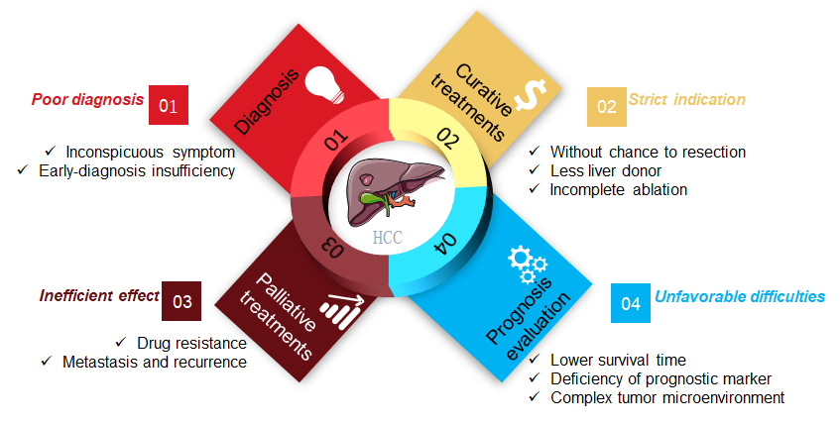
Figure 1 The dilemma of clinical hepatocellular carcinoma treatment.
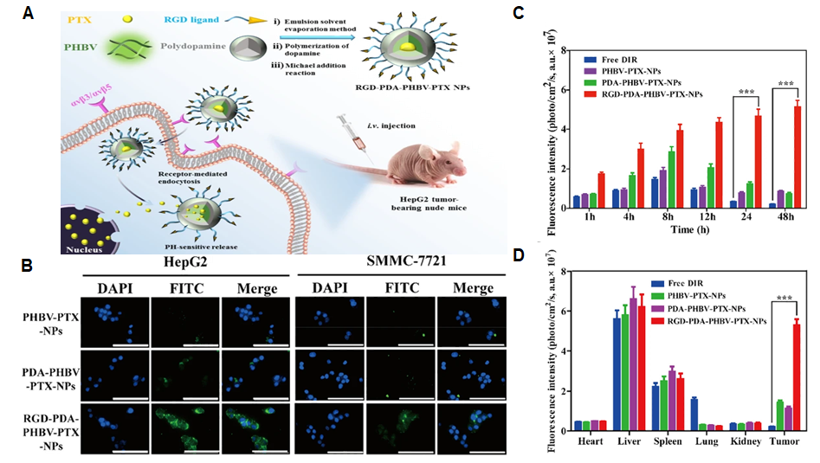
Figure 2 RGD-modified nanoparticles for targeted hepatocellular carcinoma therapy. A: Illustration of RGD-PDA-PHBV-PTX-NPs and targeted therapy; B: Specific targeting of RGD-modified PDA-PHBV-PTX-NPs for liver cancer cells; C: Distribution of various NPs in tumors in a HepG2 xenograft tumor model; D: Bio-distribution of NPs in major organs. Citation: Wu M, Zhong C, Zhang Q, Wang L, Wang L, Liu Y, Zhang X, Zhao X. pH-responsive delivery vehicle based on RGD-modified polydopamine-paclitaxel-loaded poly (3-hydroxybutyrate-co-3-hydroxyvalerate) nanoparticles for targeted therapy in hepatocellular carcinoma. J Nanobiotechnology 2021; 19: 39. Copyright © The Authors 2021. Published by BioMed Central Ltd.
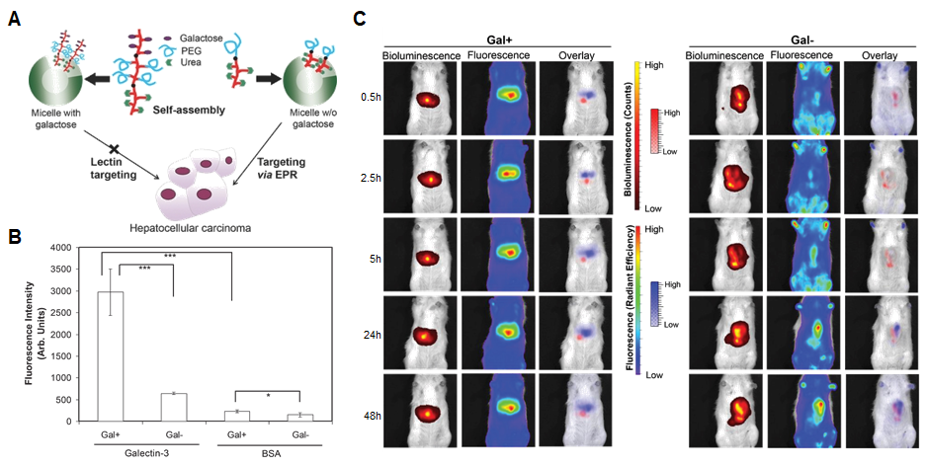
Figure 3 enhanced permeability and retention effect favors polymeric micelles as an ideal drug delivery platform. A: Illustration of polymeric micelles with or without galactose for hepatocellular carcinoma (HCC) targeting; B: Galactose-functionalized micelles bind to galectin-3; C: Specific HCC targeting powered by enhanced permeability and retention. Citation: Ebrahim Attia AB, Oh P, Yang C, Tan JP, Rao N, Hedrick JL, Yang YY, Ge R. Insights into EPR effect vs lectin-mediated targeted delivery: biodegradable polycarbonate micellar nanoparticles with and without galactose surface decoration. Small 2014; 10: 4281-4286. Copyright © The Authors 2014. Published by John Wiley & Sons, Inc.
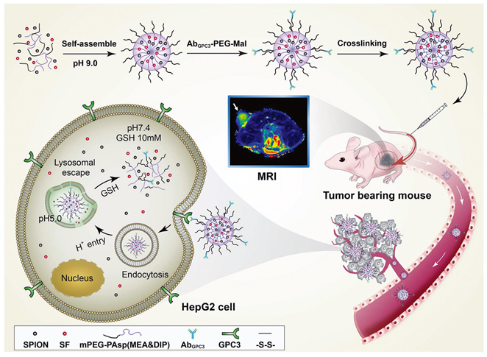
Figure 4 Dual-sensitive nanodrug delivery for treatment of hepatocellular carcinoma. Based on the tumor microenvironment, a copolymer system was designed to rapidly release sorafenib in response to high cytoplasmic glutathione and low pH. Citation: Cai M, Li B, Lin L, Huang J, An Y, Huang W, Zhou Z, Wang Y, Shuai X, Zhu K. A reduction and pH dual-sensitive nanodrug for targeted theranostics in hepatocellular carcinoma. Biomater Sci 2020; 8: 3485-3499. Copyright © The Authors 2020. Published by Royal Society of Chemistry.
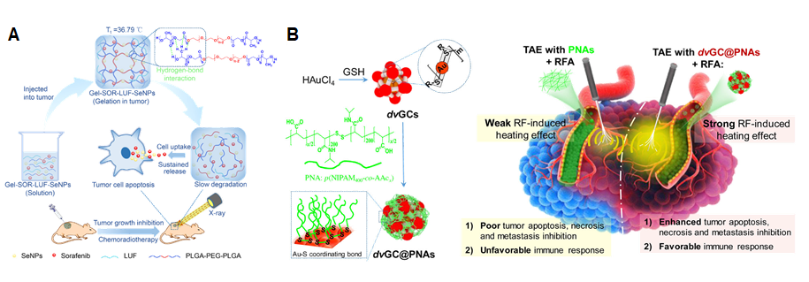
Figure 5 Enhanced therapeutic strategies of in situ treatment. A: Temperature-sensitive hydrogel with sustained drug release capacity for orthotopic hepatocellular carcinoma therapy. Citation: Zheng L, Li C, Huang X, Lin X, Lin W, Yang F, Chen T. Thermosensitive hydrogels for sustained-release of sorafenib and selenium nanoparticles for localized synergistic chemoradiotherapy. Biomaterials 2019; 216: 119220. Copyright © The Authors 2019. Published by Elsevier; B: Gold nanoclusters in thermosensitive hydrogel for radiofrequency ablation and transcatheter artery embolization. Citation: Li L, Guo X, Peng X, Zhang H, Liu Y, Li H, He X, Shi D, Xiong B, Zhao Y, Zheng C, Yang X. Radiofrequency-responsive dual-valent gold nanoclusters for enhancing synergistic therapy of tumor ablation and artery embolization. Nano Today 2020; 35: 100934. Copyright © The Authors 2020. Published by Elsevier.
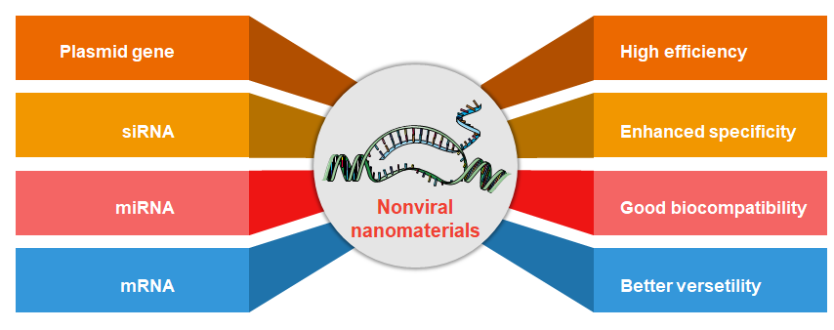
Figure 6 Advantages of nonviral nanomaterials for gene delivery.
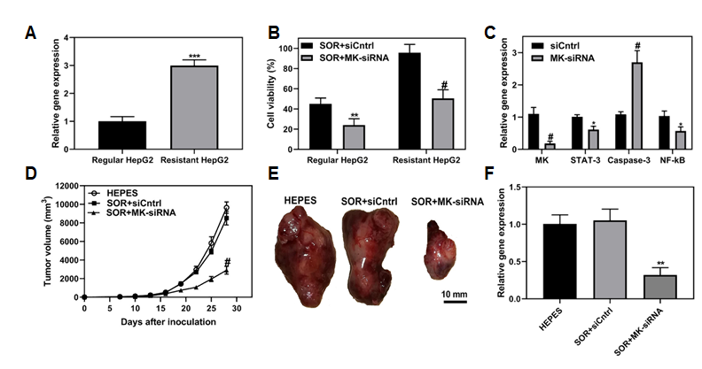
Figure 7 Co-delivery of siRNA and chemotherapeutic sorafenib by ultra-small lipid nanoparticles to overcome drug resistance of hepatocellular carcinoma. A: MK gene expression was evaluated in HepG2 and sorafenib-resistant HepG2 cells; B: HepG2 and resistant HepG2 cells were treated with sorafenib and MK-siRNA or siCntrl, and subjected test for cell viability; C: Sorafenib-resistant HepG2 cells were treated usLNPs encapsulating MK-siRNA or control. STAT-3, Caspase-3 and NF-κB signaling were assayed; D-E: Sorafenib-resistant HCC tumors in mice were treated with sorafenib and MK-siRNA, and tumor volume and resected tumors were evaluated; F: After treatment, tumor tissue was collected and MK gene expression level was assayed. Citation: Younis MA, Khalil IA, Elewa YHA, Kon Y, Harashima H. Ultra-small lipid nanoparticles encapsulating sorafenib and midkine-siRNA selectively-eradicate sorafenib-resistant hepatocellular carcinoma in vivo. J Control Release 2021; 331: 335-349. Copyright © The Authors 2021. Published by Elsevier.
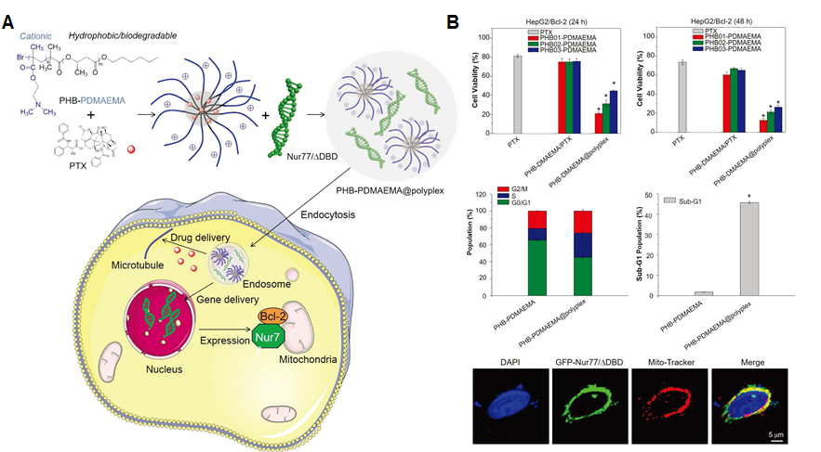
Figure 8 Co-delivery of Bcl-2 conversion gene and chemotherapeutic agents for non-pump drug resistance. A: The diagram shows the PHB-PDMAEMA@polyplex with chemotherapeutic PTX and Nur77/△DBD to inhibit Bcl-2-mediated drug resistance through the reversal of Bcl-2 from protector to killer in liver tumor cells; B: Significant tumor inhibition of the PHB-PDMAEMA@polyplex of cell viability and cell cycle in Bcl-2-related drug-resistant tumor cells. Citation: Wang X, Liow SS, Wu Q, Li C, Owh C, Li Z, Loh XJ, Wu YL. Co-delivery for Paclitaxel and Bcl-2 Conversion Gene by PHB-PDMAEMA Amphiphilic Cationic Copolymer for Effective Drug Resistant Cancer Therapy. Macromol Biosci 2017; 17. Copyright © The Authors 2017. Published by Wiley.
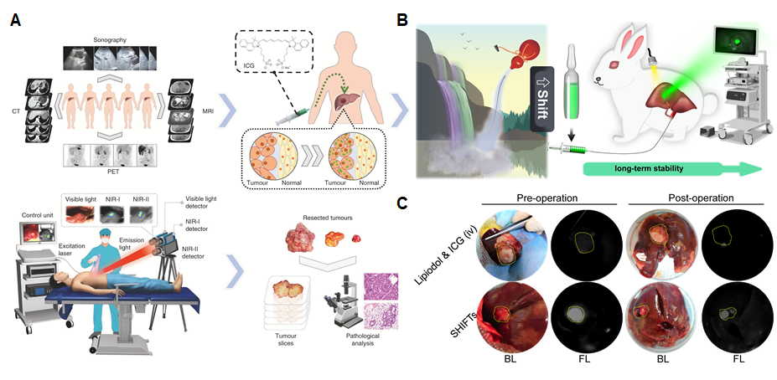
Figure 9 Imaging-guided tumor surgery. A: ICG fluorescence imaging-guided tumor resection in hepatoma patients; B: Illustration of a superstable homogeneous lipiodol-ICG formulation for HCC therapy; C: Long-term stability of ICG fluorescence in tumors through a combination of transcatheter arterial embolization. Citation: Hu Z, Fang C, Li B, Zhang Z, Cao C, Cai M, Su S, Sun X, Shi X, Li C, Zhou T, Zhang Y, Chi C, He P, Xia X, Chen Y, Gambhir SS, Cheng Z, Tian J. First-in-human liver-tumour surgery guided by multispectral fluorescence imaging in the visible and near-infrared-I/II windows. Nat Biomed Eng 2020; 4: 259-271. Copyright © The Authors 2020. Published by Springer Nature Limited. Citation: Chen H, Cheng H, Dai Q, Cheng Y, Zhang Y, Li D, Sun Y, Mao J, Ren K, Chu C, Liu G. A superstable homogeneous lipiodol-ICG formulation for locoregional hepatocellular carcinoma treatment. J Control Release 2020; 323: 635-643. Copyright © The Authors 2020. Published by Elsevier.
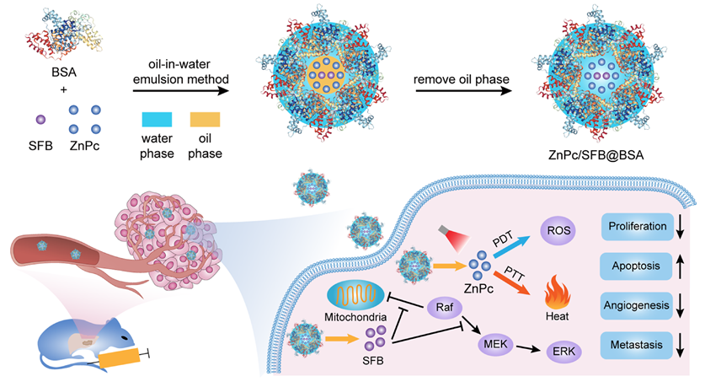
Figure 10 Trimodal therapy of ZnPc/SFB@BSA for orthotopic hepatocellular carcinoma. Bovine serum albumen (BSA)-coated zinc phthalocyanine and sorafenib (ZnPc/SFB@BSA) nanoparticles for photodynamic therapy (PDT), photothermal therapy (PTT) and chemotherapy with 730 nm light irradiation. Citation: Yu XN, Deng Y, Zhang GC, Liu J, Liu TT, Dong L, Zhu CF, Shen XZ, Li YH, Zhu JM. Sorafenib-Conjugated Zinc Phthalocyanine Based Nanocapsule for Trimodal Therapy in an Orthotopic Hepatocellular Carcinoma Xenograft Mouse Model. ACS Appl Mater Interfaces 2020; 12: 17193-17206. Copyright © The Authors 2020. Published by American Chemical Society.
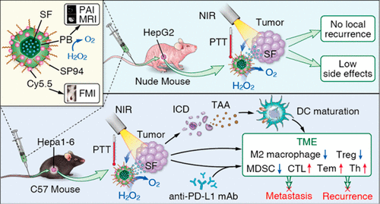
Figure 11 Phototherapy combined with immunotherapy to inhibit hepatocellular carcinoma metastasis and recurrence. Multifunctional Prussian blue nanoparticles loading sorafenib are conjugated with hepatocellular carcinoma-specific targeting peptide SP94 and Cy5.5. The photothermal treatment induces immunogenic cell death, activating the systemic immune response, and enhance the treatment of anti-PD-L1 therapy. Citation: Zhou T, Liang X, Wang P, Hu Y, Qi Y, Jin Y, Du Y, Fang C, Tian J. A Hepatocellular Carcinoma Targeting Nanostrategy with Hypoxia-Ameliorating and Photothermal Abilities that, Combined with Immunotherapy, Inhibits Metastasis and Recurrence. ACS Nano 2020; 14: 12679-12696. Copyright © The Authors 2020. Published by American Chemical Society.

Published by Baishideng Publishing Group Inc
7041 Koll Center Parkway, Suite 160, Pleasanton, CA 94566, USA
Telephone: +1-925-3991568
E-mail: bpgoffice@wjgnet.com
Help Desk: https://www.f6publishing.com/helpdesk
https://www.wjgnet.com

© 2021 Baishideng Publishing Group Inc. All rights reserved.

