Name of Journal: World Journal of Gastroenterology
ESPS Manuscript NO: 29152
Manuscript Type: REVIEW

Protocol for laparoscopic cholecystectomy: Is it rocket science?

Hori T et al. How to dismantle open cholecystectomy?

Tomohide Hori, Fumitaka Oike, Hiroaki Furuyama, Takafumi Machimoto, Yoshio Kadokawa, Toshiyuki Hata, Shigeru Kato, Daiki Yasukawa, Yuki Aisu, Maho Sasaki, Yusuke Kimura, Yuichiro Takamatsu, Masato Naito, Masaya Nakauchi, Takahiro Tanaka, Daigo Gunji, Kiyokuni Nakamura, Kiyoko Sato, Masahiro Mizuno, Taku Iida, Shintaro Yagi, Shinji Uemoto, Tsunehiro Yoshimura

Tomohide Hori, Hiroaki Furuyama, Takafumi Machimoto, Yoshio Kadokawa, Toshiyuki Hata, Shigeru Kato, Daiki Yasukawa, Maho Sasaki, Yuki Aisu, Yusuke Kimura, Yuichiro Takamatsu, Tsunehiro Yoshimura, Department of Gastrointestinal and General Surgery, Tenriyorodusoudanjyo Hospital, Tenri 632-8552, Japan

Fumitaka Oike, Masato Naito, Masaya Nakauchi, Takahiro Tanaka, Daigo Gunji, Kiyokuni Nakamura, Department of Gastrointestinal Surgery, Mitsubishi Kyoto Hospital, Kyoto 615-8087, Japan

Kiyoko Sato, Department of Anesthesiology, Mitsubishi Kyoto Hospital, Kyoto 615-8087, Japan

Masahiro Mizuno, Department of Gastroenterology and Hepatology, Mitsubishi Kyoto Hospital, Kyoto 615-8087, Japan

Taku Iida, Shintaro Yagi, Shinji Uemoto, Department of Hepatobiliary Pancreatic Surgery, Kyoto University Hospital, Kyoto 606-8507, Japan

Author contributions: Hori T and Oike F created the initial protocol for laparoscopic cholecystectomy, and both authors thereafter further revised the protocol; Hori T drew all illustrations and schemas, collected the data, performed the statistical analyses, and wrote the review; Furuyama H, Machimoto T, Kadokawa Y, Hata T, Kato S, Yasukawa D, Sasaki M, Aisu Y, Kimura Y, Takamatsu Y, Naito M, Nakauchi M, Tanaka T, Gunji D, Nakamura K, Sato K, Mizuno M, Iida T and Yagi S provided academic opinions on the review and helped to assess important papers; Oike F, Yoshimura T and Uemoto S supervised this review.

Conflict-of-interest statement: Neither author has a potential conflict of interest.

Open-Access: This article is an open-access article which was selected by an in-house editor and fully peer-reviewed by external reviewers. It is distributed in accordance with the Creative Commons Attribution Non Commercial (CC BY-NC 4.0) license, which permits others to distribute, remix, adapt, build upon this work non-commercially, and license their derivative works on different terms, provided the original work is properly cited and the use is non-commercial. See: http://creativecommons.org/licenses/by-nc/4.0/

Manuscript source: Invited manuscript

Correspondence to: Tomohide Hori, PhD, MD, FACS, Department of Gastrointestinal and General Surgery, Tenriyorodusoudanjyo Hospital, 200 Mishima-cho, Tenri, Nara 632-8552, Japan. horitomo@tenriyorozu.jp
Telephone: +81-743-635611
Fax: +81-743-631530

Received: July 30, 2016
Peer-review started: August 2, 2016
First decision: September 28, 2016
Revised: October 16, 2016
Accepted: November 23, 2016
Article in press:
Published online:

Abstract
Laparoscopic cholecystectomy (LC) does not require advanced techniques, and its performance has therefore rapidly spread worldwide. However, the rate of biliary injuries has not decreased. The concept of the critical view of safety (CVS) was first documented two decades ago. Unexpected injuries are principally due to misidentification of human factors. The surgeon’s assumption is a major cause of misidentification, and a high level of experience alone is not sufficient for successful LC. We herein describe tips and pitfalls of LC in detail and discuss various technical considerations. Finally, based on a review of important papers and our own experience, we summarize the following mandatory protocol for safe LC: (1) consideration that a high level of experience alone is not enough; (2) recognition of the plateau involving the common hepatic duct and hepatic hilum; (3) blunt dissection until CVS exposure; (4) Calot’s triangle clearance in the overhead view; (5) Calot’s triangle clearance in the view from underneath; (6) dissection of the posterior right side of Calot’s triangle; (7) removal of the gallbladder body; and (8) positive CVS exposure. We believe that adherence to this protocol will ensure successful and beneficial LC worldwide, even in patients with inflammatory changes and rare anatomies.

Key words: laparoscopic cholecystectomy; gallbladder; critical view of safety; biliary injury; protocol

© The Author(s) 2016. Published by Baishideng Publishing Group Inc. All rights reserved.

Core tip: In 1995, the concept of the critical view of safety was clearly established. In 2006, it was revolutionarily suggested that a high level of experience alone is not sufficient for successful laparoscopic cholecystectomy (LC). In 2016, we described a protocol for successful LC, even in patients with inflammatory changes and rare anatomies. Thus, the mandatory protocol for LC seems to have undergone stepwise development in every decade. Although all surgeons are at risk of making errors based on their own assumptions during LC, we believe that adherence to the herein-described protocol preserves the benefits of LC for patients worldwide.

Hori T, Oike F, Furuyama H, Machimoto T, Kadokawa Y, Hata T, Kato S, Yasukawa D, Aisu Y, Sasaki M, Kimura Y, Takamatsu Y, Naito M, Nakauchi M, Tanaka T, Gunji D, Nakamura K, Sato K, Mizuno M, Iida T, Yagi S, Uemoto S, Yoshimura T. Protocol for laparoscopic cholecystectomy: Is it rocket science? World J Gastroenterol 2016; In press

INTRODUCTION
Pure laparoscopic surgery (PLS) has been adopted in various fields. Compared with open surgery (OS), PLS has substantial advantages in terms of less blood loss, less pain, a lower morbidity rate, a shorter time to a postoperative diet, and a shorter hospital stay^{[1]}. Unfortunately, especially in the field of hepatobiliary and pancreatic (HBP) surgery, PLS has developed relatively slowly due to technical difficulties and a protracted learning curve^{[1]}.
Laparoscopic cholecystectomy (LC) is an exception in the field of HBP surgery^{[2,3]}. LC does not require advanced techniques involving reconstructions and/or anastomoses, and it embodies a rapid learning curve^{[4]}. The documented conversion rate to OS is 5%^{[5]}. The validated advantages of LC include lower morbidity and mortality rates, a shorter time to a postoperative diet, a shorter hospital stay, earlier social reintegration, and a modest cost advantage^{[4,6,7]}. Since the first report of LC in 1989^{[8]}, this procedure has become globally widespread.
The surgical indications for gallbladder (GB) diseases are well described in textbooks^{[9,10]}. Major textbooks in the fields of general surgery^{[11]} and HBP surgery^{[10]} have devoted much space to LC.
The basic skills required for PLS and OS are distinct. Notably, a high level of experience alone is not adequate to ensure successful performance of LC^{[12]}. We herein summarize various tips and pitfalls of LC in detail and discuss the technical considerations of this procedure. Finally, we summarize the intraoperative principles for safe performance of LC based on a review of important papers and our own experience.

IMPORTANT ANATOMY
The anatomy of the biliary system is shown in Figure 1A. Hartmann’s pouch and the GB infundibulum are located in different portions of the biliary system. The GB infundibulum and cystic duct (CD) meet to form the infundibulum–CD (IC) junction, and the CD contains Heister’s valves (spiral folds). The common hepatic duct (CHD), CD, and common bile duct (CBD) comprise the biliary confluence, and biliary drainage is regulated by motility of Oddi’s sphincter.

CRITICAL VIEW OF SAFETY
The concept of the critical view of safety (CVS) was originated by Strasberg et al^{[13]} in 1995 (Figure 1B). The CD and cystic artery (CA) should not be clipped or cut until positively identified. Calot’s triangle must be dissected free of fatty, fibrous, and areolar tissues. The lower end of the GB is dissected off of the liver bed (LB), and the bottom of the liver should be visible. It is not necessary to directly confirm the CHD and CBD. Hence, only two structures should be seen to enter the GB.
Positive identification of the CD and CA as they join the GB infundibulum is required before these structures can be divided^{[12]}. This theory advocates use of the CVS^{[13]}, intraoperative cholangiography^{[14-18]}, and infundibular technique^{[19]}. However, a simple question arises. How can this reliably be achieved? The clear answer is employment of the technical concept of CVS; i.e., tentative but positive division of cystic structures in Calot’s triangle followed by removal of the GB off of the LB^{[12]}.

DETAILED PROCEDURES FOR ELECTIVE CASES WITHOUT INFLAMMATION
The patient is placed in a combination of an open-leg supine position and lithotomy position using a knee-crutch-type leg holder system (Figure 1C). A negative-pressure holding fixture (Magic bed; Matsuyoshi & Co., Tokyo, Japan) is useful. A three-dimensional (3D) laparoscopic system is not required; instead, a flexible laparoscope with an adequate luminous source is usually used. Our laparoscope is 5 mm in diameter (Endoeye Flex; Olympus, Tokyo, Japan). Based on our experience, a flexible laparoscope is better from the viewpoint of excellent vision. The camera port is placed at the umbilicus without injury. Pneumoperitoneum of 12 mmHg is created by carbon dioxide gas with the patient lying in the left arm reclining and head-up position. Pneumoperitoneum pressure induced by marked infiltration of carbon dioxide gas helps to create a dissectible/cuttable layer. The smallest necessary stab wounds are made; an additional incision may be required for later GB excision. If an umbilical incision of >10 mm appears to be required to extract the GB, a 10-mm flexible laparoscope is chosen as the luminous source. Based on our experience, a 10-mm laparoscope is better from the viewpoint of enough luminous source.
Surgeons should be cooperative during LC. A separate laparoscopist is employed to participate if possible. As noted above, the smallest possible stab wounds are made, and four ports are placed (two 5-mm and two approximately 3-mm ports) (Figure 1D). Port placement should avoid injury to the vessels of the abdominal wall and intraperitoneal organs (Figure 1E). The intraperitoneal length of the port should be adjusted. The lateral port is placed, and the GB fundus is superiorly and cranially lifted by the assistant. In a word, the fundus is retracted cranially and towards right shoulder. Thereafter, the operator’s lateral port is placed with the forceps tip placed at an adequate degree around Calot’s triangle (approximately 45º-60°) (Figure 1D and F). Avoidance of an excessively sharp or wide degree is important. Thinner trocars (3.5-mm trocar sleeve and blunt type of trocar pin, AdTec mini; Aesculap, Tokyo, Japan) and instruments (grasping forceps, Maryland dissector, and Metzenbaum scissors, 3.5-mm, AdTec mini; Aesculap) work well. Stretching of the hepatoduodenal ligament is important to ensure a clear surgical field, and colored gauze without halation is placed at the hepatorenal fossa (i.e., Morison’s pouch) if needed (Figure 1G). Based on our experience, this gauze placement is useful.
The GB fundus is lifted superiorly and cranially by the assistant’s forceps, and the liver is then retracted. An articulated fan-shaped retractor with a delta-shaped piece of gauze can allow for adequate liver retraction without any slippage, although a 5-mm port is required. The liver retraction is performed superiorly and cranially, and a working space is obtained. The hepatorenal fossa is widely dilated, and Rouviere’s sulcus and Hartmann’s pouch are confirmed (Figure 1G).
The CVS is established using the many-angled views of the flexible laparoscope. The GB is then removed from the LB without injury. This is an important goal during LC. We recognize that a flexible scope is not readily available at all institutions around the world. However, from this viewpoint, a flexible laparoscope is better.
The medial and lateral segments are visibly bound by the left sagittal fissure and round ligament. A fatty fissure is traced in a U shape from the round ligament of the liver to the left side of the GB (Figure 1H) because the bottom plateau of this U-shaped line necessarily involves the CHD and hepatic hilum. Recognition of the plateau involving the CHD and hepatic hilum is very important for subsequent isolation of the CD.
Initial recognition of Rouviere’s sulcus is also important (Figure 1G). Even in patients with an aberrant right hepatic duct (RHD) or a biliary branch of segment 6 (B6), which runs into the CHD separately, the fatty fissure of Rouviere’s sulcus always involves the RHD, aberrant RHD, and a solitary B6. Notably, the right hepatic artery (RHA) should never be used as a visual marker.
A flexible laparoscope can provide an excellent view in any direction. Calot’s triangle must be dissected from both its dorsal and ventral aspects^{[12-14,20]}. In particular, a combination of blunt dissection (Figure 2A-C) and an L-hook electrocautery technique has broad utility (Figure 2D and E)^{[12]}.
Hartmann’s pouch should be pulled laterally and inferiorly to open the anterior left side of Calot’s triangle and create a wider angle between the CD and CHD^{[12,13,20]} (Figure 2F); this avoids biliary injury due to the parallel junction of the CD with the CHD^{[12]}. The overhead view is useful during this procedure. A dissectable and cuttable layer should be intensively traced as close to the GB and CD as possible^{[13]}. A partial penetration window is made to identify the dorsal side (Figure 2G). The anterior left side of Calot’s triangle is then exposed and dissected (Figure 2F and G). The GB should be followed down to the presumed point of the IC junction^{[12]} (Figure 2G). The lymph node of the CD (LN# 12c) should be preserved.
Next, the posterior right side of Calot’s triangle is exposed and dissected while applying superior and medial traction to the GB infundibulum or Hartmann’s pouch^{[13,21]} (Figure 2H). The GB should never be pushed directly to the liver. The flexible laparoscope provides an excellent view from underneath during this procedure. Intentional confirmation of the S-like curve on Hartmann’s pouch, infundibulum, IC junction, and CD is very important (Figure 3A). The IC junction may be recognized by the whiter color change of the CD. Note that the IC junction will be confirmed as an inverted V shape because of the superior and medial traction of the GB (Figure 3B).
The cutline of the membrane is made to the GB body at a point adequately distant from Rouviere’s sulcus (Figure 3C). The dissectable tissue around the GB should never be followed into Rouviere’s sulcus because biliary injury may occur (Figure 3D). Establishment of a rightward and upward view under superior and medial traction of the GB infundibulum or Hartmann’s pouch is key to dissection of the posterior right side of Calot’s triangle^{[13,21]} (Figure 3D). First, however, a dissectable and cuttable layer is traced to the GB body as close to the GB as possible by L-hook electrocautery. Uncoupling of the GB wall and fatty fissure of Rouviere’s sulcus is important to avoid biliary injury to the RHD, aberrant RHD, or a solitary B6 (Figure 3D).
Approximately two-thirds or half of the GB body is removed from the LB at the time of CVS exposure (Figure 3E and F), even in patients with a floating GB. Thereafter, structures entering the GB (i.e., the CA and CD) are skeletonized with effort. Hence, the CVS is positively established (Figure 3G and H). Notably, no sealing devices should be used until the CVS has been established.
The structures entering the GB are cut (the CA followed by the CD). The CA is cut with scissors after bilateral clipping; alternatively, it can be cut directly with laparoscopic coagulating shears (LCS) or stronger sealing devices. The CD is then cut with scissors after bilateral and dual clipping. To avoid residual placement of foreign material, the remnant sides of the CA and CD are ligated by absorbable sutures.
Finally, the GB is removed from the LB and placed in a bag. The umbilical wound is extended as little as possible, and the bag is extracted. Lavage is not necessarily required. Hemostasis, stumps, and port sites are carefully checked. After GB removal, release of the retraction and the weight of the liver itself often stops most bleeding. Adequate compression using gauze also works well to stop bleeding at the LB (Figure 4A). To avoid biliary injury, hemostasis by thermal spread should not be used, especially at the LB of the GB neck, Rouviere’s sulcus, and CD stump (Figure 4B). Only ≥ 5-mm stab wounds are closed with absorbable sutures (PDS Plus; Ethicon, Tokyo, Japan). If the umbilical wound is extended, the fascia and skin are closed separately to prevent postoperative hernia formation.

PROTOCOL FOR RELIABLE LC
Our protocol for reliable LC comprises eight items: (1) Perform LC under the consideration that a high level of experience alone is not enough. Unexpected injuries may be caused by misidentification, and the surgeon’s assumption is a major cause of misidentification; (2) Recognize the U-like line of the medial segment. This bottom plateau necessarily involves the CHD and hepatic hilum; (3) Mainly employ blunt dissection until CVS exposure. The dissectable/cuttable layer should be traced as close to the GB and CD as possible. Tissue dissection and membrane cutting should be extended from the apparent side, not from the unknown side. No sealing devices should be used until the CVS has been exposed; (4) Expose and dissect the anterior left side of Calot’s triangle in the overhead view. Hartmann’s pouch is pulled laterally and inferiorly to open the anterior left side of Calot’s triangle. A wider angle between the CD and CHD is created to avoid a biliary injury due to the parallel junction of the CD and CHD; (5) Expose and dissect Calot’s triangle in the view from underneath. Superior and medial traction of the GB infundibulum or Hartmann’s pouch is performed. The S-like curve on Hartmann’s pouch, GB infundibulum, IC junction, and CD is confirmed. The IC junction may be confirmed as an inverted V shape; (6) Expose and dissect the posterior right side of Calot’s triangle in the rightward and upward view. Recognize Rouviere’s sulcus. The cutline of the membrane is made to the GB body at an adequately far distance from Rouviere’s sulcus, and the GB wall and fatty fissure of Rouviere’s sulcus are then uncoupled. Dissectable tissue around the GB should never be followed into Rouviere’s sulcus because unexpected biliary injuries may occur; (7) Remove half to two-thirds of the GB body from the LB; and (8) Positively complete exposure of the CVS. Only two cystic structures should be seen entering the GB. The details of this protocol are summarized in Table 1.

PROCEDURES FOR PATIENTS WITH CHOLECYSTITIS
The indications for and timing of surgery for acute cholecystitis are described in textbooks of general surgery^{[9]} and HBP surgery^{[22]}. In Japan, surgical guidelines and clinical decisions are documented for acute cholecystitis^{[23]}. The GB neck and Hartmann’s pouch often extend into the dorsal space due to inflammatory changes and/or healing contracture, and unexpected excursions of important ducts and vessels may occur (Figure 4C). This phenomenon is related to so-called “Hidden CD syndrome”^{[19]}. Disease severity is an important risk factor^{[19,24-26]}. Extrinsic compression of the CHD/CBD, including Mirizzi syndrome, technically make LC more difficult. Inflammatory impacts on the CHD, confluence, and CBD as well as the presence of any biliary fistulas should be detected by image studies and recognized beforehand. Surgeons should take patients with acute or chronic inflammation seriously, and they should not hesitate to perform preoperative detailed imaging studies (Figure 4D) or employ a 3D laparoscopic system during LC. We suggest that compliance with the above-described protocol for LC make LC safe even in patients with inflammation.
The flexibility of the laparoscopic view, an adequately luminous source, and use of grasping forceps with an increased grip force are even more important in patients with cholecystitis who are not undergoing elective treatment. The grasping force of thin forceps is not high enough to grasp a swollen GB body/fundus and edematous Hartmann’s pouch. We routinely use a 10-mm flexible laparoscope to obtain a sufficient light intensity and 5-mm forceps to ensure enough grasping ability. The size and number of stab wounds for the ports should never be easily reduced; this will ensure safe and successful LC. We usually place two 10-mm ports at the umbilicus and upper midline and two 5-mm ports at the right lateral abdomen. The surgeon should never hesitate to add the ports during LC if needed. Additional stab wounds are never invasive.
Although GB aspiration to prevent GB rupture during LC is unnecessary during elective LC^{[27]}, we have a clear impression that GB aspiration is effective for LC in patients with cholecystitis. When the presence of severe GB swelling makes it difficult to grasp the wall and there is a possibility of compressing small stones into the CBD during the surgical procedure, GB decompression by aspiration of infected bile is effective. In our institution, the GB is decompressed at the fundus by aspiration without spillage (Figure 4E and F), and the aspiration hole is then promptly closed by extracorporeal ligation (Figure 4G and H). The suction tip is securely placed in the GB to prevent spilled stones and/or infected bile^{[28]}. We usually choose extracorporeal ligation (Monocryl 3-0, 90 cm, violet, SH Plus, Y242H; Ethicon) because of faster closure than with intracorporeal ligation. After GB decompression by aspiration, the GB neck and/or Hartmann’s pouch can be pulled from the dorsal space (Figure 5A), and unexpected excursions of important ducts and vessels are resolved.
LC for acute or chronic inflammation is accompanied by technical difficulties in adamant dissection of a dense scar, an obstructed surgical field by bleeding, and hard fat around the portal vein^{[12]}. However, until exposure of the CVS is ensured, sealing devices should not be used because they can safely cut everything under misidentification. Even in patients with cholecystitis, safe LC is guaranteed when the surgeon strictly adheres to the principles of meticulous dissection and only positive identification of structures is performed before divisions^{[12]}.
Vessels of the GB wall are well developed due to inflammation, and even a subtle retraction of the GB will cause easy bleeding. During GB removal from the LB, hemostasis should be ensured by cauterizing or sealing any developed vessels. If oozing is severe due to inflammatory change, a button-shaped electrode with suction used in conjunction with a soft-coagulation system (VIO; Erbe, Tübingen, Germany) is an effective tool for secure hemostasis (Figure 5B).
Lavage and drain placement are usually required, although intraoperative decisions are dependent upon the individual physician. Wound closure is performed in the same manner as in an elective case except that the fascia of ≥10-mm wounds is closed separately to prevent the development of a postoperative hernia.

PATIENTS WITH RARE ANATOMY
When a rare anomaly and/or unfamiliar anatomy is suspected upon examination of preoperative images, the clinician should not hesitate to perform more detailed studies. The CD rarely runs into the RHD, and a left-sided GB (a portal malformation) has also been documented^{[29]}. In the postoperative period after an upper abdominal surgery such as distal gastrectomy with Billroth I reconstruction, important ducts and vessels are easily shifted. Drip-infusion cholangiography and 3D imaging studies may be performed if needed.
An aberrant RHD has been described^{[13]} and reportedly occurs at a frequency of 2%^{[12]}. An aberrant RHD has also been highlighted in several biliary injury reports^{[12]}, and this duct seems especially vulnerable during LC^{[13]}. Thus, because the RHD has some variations, recognition of Rouviere’s sulcus is very important. The surgeon should not hesitate to perform intraoperative cholangiography. The 10% detection rate of a type A biliary injury during LC will improve when the procedure is combined with a contrast agent and dye. Usage of a contrast agent and dye may not give an intrahepatic cholangiography. Identification of Hjortsjo’s curve is an informative way to detect the RHD.

UNEXPECTED THERMAL DAMAGE
Cautery-induced injury results in necrotizing loss of ductal and/or perivascular tissues^{[12]}. Cautery, LCS, and stronger devices may cause thermal necrosis of adjacent structures^{[12,30]}. Moreover, cautery and LCS may cause delayed thermal injury^{[31]}. Stronger sealing devices, such as the Thunderbeat (Olympus) and EnSeal (Ethicon), may easily cause thermal spreading and more delayed biliary complications than after cautery or LCS.
In our institution, LC for whole-layer removal of the GB with sampling of LN #12c is performed as an intraoperative biopsy in patients suspected to have GB malignancy. Severe oozing/bleeding at the LB may occur during and/or after whole-layer removal. To ensure hemostasis at the LB without injury to the vessels and/or ducts, it is helpful to use a button-shaped electrode with suction in conjunction with a soft-coagulation system or a self-irrigating monopolar electrode (IO advanced; Erbe).

BILIARY INJURY DURING LC
A small diameter should never be used as the reason for failure to recognize the CBD or CHD, although a large-diameter duct with visible vessels on the surface is possibly the CHD or CBD^{[13]}. Routine operative cholangiography may be useful to avoid biliary injury^{[14-18]}, although no clear evidence yet exists^{[13]}. Intraoperative cholangiography is the best method with which to detect misidentification of the CHD or CBD as the CD^{[12]}; notably, however, these structures are frequently misinterpreted in the presence of injury^{[12]}. We employ intraoperative cholangiography with atoxic dye if needed; this use of dye may increase the detection rate of biliary injury by cholangiography during LC. Unexpected findings, such as visualization of only the lower part of the CBD without filling of the CHD, may necessitate conversion to OS^{[13]}.
Intraoperative recognition of “the second CD” or “accessory duct,” which is actually the CHD, strongly indicates inherent misidentification of the CD^{[12]}. The RHA may also be injured if this misidentification occurs^{[12]}. Hepatic arterial injury results in a higher mortality rate^{[32]}, and brisk bleeding is an indication for conversion to OS^{[12]}.
When injuries of the CHD/CBD are detected during LC, transcystic C-tube placement is performed if CHD/CBD drainage has a positive effect. In our institution, an elastic thread is never ligated to avoid overtightening of the C-tube, and clips are placed at an angular separation to avoid slippage of the clips (Figure 5C and D). We perform an initial cholangiography at postoperative day 4, and the C-tube is thereafter removed based on the cholangiographic findings and necessity of biliary drainage. Management of C-tube drainage is simple, although Kehr’s T-tube drainage requires drain placement over a 3-wk period^{[33,34]}.
A flexible laparoscope provides an excellent overhead view for anastomotic procedures involving application of interrupted sutures to the CHD/CBD or the performance of cholangiojejunostomy by absorbable sutures (6-0 PDS II, violet; Ethicon). Skillful surgeons consider that the persistence of PLS even with additional ports is suitable for these biliary repairs or reconstructions, if required during LC.

DISCUSSION
Surgeons should be proficient in a variety of dissection techniques, such as pulling techniques, gentle spreading with forceps, hook cautery, blunt dissection with a nonactivated spatula cautery tip or suction tube, temporal fixation by anchored pledgets, and reliable hemostasis by rubbing a bleeding point using a button-type pole with suction. Current laparoscopic instruments are well developed, but each instrument should be used in the correct manner^{[35]}. Various devices are available, and surgeons should follow the manufacturers’ instructions to avoid any malfunctions. Surgeons must also continuously update their knowledge of how to use these devices^{[35]}. To avoid technical error, a clip should be applied with the tip extending beyond the duct or vessels^{[12]} (Figure 5E); it should never be manipulated in the subsequent dissection^{[12]}. If the CD is too thick, loop ligation or a laparoscopic stapler can be chosen^{[12]} (Figure 5F). Additionally, to avoid technical error, bleeding should never be controlled by blind application of clips and cautery^{[12]}.
Cautery can be carefully used to dissect Calot’s triangle^{[12]}. Some surgeons suggest not using it at all, although some use it preferentially^{[12]}. We usually use L-hook electrocautery; LCS and stronger devices are never used until exposure of the CVS. L-hook electrocautery has the advantage of simultaneously cutting and pulling the tissue from only one port using a safety area in front of the cut tissue (L-hook electrocautery technique). To ensure effective performance of the L-hook electrocautery technique, it is important to insinuate the hook through limited amounts of tissue, lift that tissue off the underlying structures with precise vision, and deploy a suitable current^{[12]}. The CD should be cut sharply with scissors because cautery will lead to thermal necrosis of the stump of the CD or adjacent bile duct^{[12,30]}. In patients with cirrhosis, LCS has some advantages over electrocautery^{[36]}.
Complete clearance of Calot’s triangle requires dissection of Calot’s triangle from both its dorsal and ventral aspects^{[12-14,20]}. A combination of blunt dissection and the L-hook electrocautery technique has broad utility in this approach^{[12]}. In the overhead view, Hartmann’s pouch should be pulled laterally and inferiorly to open the anterior left side of Calot’s triangle and create a wider angle between the CD and CHD^{[12,13,20]}; this is because minimization of alignment of the CD and CHD is important to prevent a tenting injury due to a parallel junction of the CD with the CHD^{[12]}. The posterior right side of Calot’s triangle is exposed and dissected while applying superior and medial traction to the GB infundibulum or Hartmann’s pouch^{[13,21]}. For this approach, the laparoscope view from underneath is important. The GB should be traced down to the presumed point of the IC junction, and dissection begins from this point, not from the middle of the CD^{[13]}.
LC involves retrograde dissection of the GB from the surrounding tissues; thus, misidentification may be catastrophic. The dissection plane should always be traced on the GB or CD^{[13,14]}. Tissue dissection and membrane cutting should be extended from the apparent side of the correct layer and not from the unknown side.
We consider that drains should be automatically placed in patients with inflammation, although intraoperative decisions are based on the individual physician. A drain pathway through the abdominal wall is remade from the same skin incision to prevent postoperative dislocation (Figure 5G). Very short-term placement of a closed drain from a stab wound is not invasive and does not place the patient at risk for retrograde infection.
Unfortunately, the rate of biliary injury has not decreased^{[37]}, and the annual hospital volume does not affect the risk^{[38]}. Biliary injuries occur at a rate of about 1 in 200 patients^{[39,40]}. Perioperative complications are frequent, and nearly all can be managed nonoperatively^{[41]}. However, about 1 in 500 patients requires surgical biliary reconstruction^{[42]}. Disease severity and the presence of a rare anatomy are very important risk factors^{[19,24-26]}. In particular, biliary injuries accompanied by hilar duct injuries, vessel injuries, and peritonitis result in poor outcomes^{[32,43,44]}.
Many surgeons have focused the cause, prevention, and treatment of biliary injuries such as ductal laceration, bile leakage, and aberrant duct injury during LC^{[6,12,13,45]} because a slightly higher incidence of biliary injury during LC has been documented^{[6]}. Surprisingly, biliary injuries occur for surgeons who have gone beyond the learning curve^{[12]}. From the viewpoint of human factors, biliary injuries are principally caused by misperception and not by lack of skill, inadequate knowledge, or misjudgment^{[46]}. Moreover, ample rest with relaxation reduces biliary complications^{[47]}. Successful repair of biliary injuries can be achieved in specialized HBP units^{[41,43,48]}.
Strasberg et al^{[49]} created a detailed classification of biliary injuries based on traditional major injuries. Injuries that do not involve major ducts are the least serious^{[12]}. Such injuries are categorized as type A in Strasberg’s classification system and occur at a frequency of 5% of all injuries^{[13]}. Injuries of vessels and/or ducts in the LB occur when unavoidable dissection is too deep due to the presence of inflammatory change or an intrahepatic GB^{[12]}. Cautery-induced and/or thermal surficial injuries of segment 4/5 may easily occur, especially during hemostasis of the LB. Hemostasis by thermal spread at the LB will cause type A biliary injury (5%)^{[12]}. Approximately 10% of type A injuries are identified during LC^{[12]}, although most biliary injuries are diagnosed during the first week after LC^{[13]}. Delayed detection of biliary injuries is associated with greater severity of such injuries^{[24]}. For successful management of postoperatively detected biliary complications, invasive or operative therapies should be avoided as much as possible^{[13,48,50,51]}.
Misidentification is the result of failure to conclusively identify the cystic structures before clipping^{[13]}, and potentially disastrous errors will occur during LC based on an assumption. Intraoperative cholangiography and exposure of the biliary confluence are not essentially important to avoid biliary injury^{[13]}, although performance of intraoperative cholangiography and adequate rest of surgeons may decrease the injury rate^{[14,15]}.
Classic biliary injury usually involves misidentification of the CHD/CBD as the CD^{[19]}. Strasberg’s “infundibular technique” might be a contributing factor in the development of this injury^{[19]}. The CD may be hidden in some patients, especially in the presence of inflammation^{[19]}. Hidden CD syndrome may lead to the deceptive appearance of a false infundibulum that misleads the surgeon into identifying the CHD/CBD as the CD^{[19]}. Biliary injury is more likely when CD identification relies solely on the appearance of the IC junction, and Strasberg’s “infundibular technique” should be abandoned^{[19]}. This technique identifies the CD as the funnel-like junction of the GB and CD^{[12]}. This technique is now falling out of favor and should be used only in combination with confirmatory cholangiography^{[12]} because of the difficulty in retracting the GB or large stones^{[12]}.
Biliary injury may be accompanied by vascular injuries. Hepatic arterial injuries may involve the RHA or proper hepatic artery, resulting in a higher mortality rate^{[12,32]}. Portal injury and thrombosis are rare, although portal venous complications may result in disastrous adverse events^{[12]}. Vascular injury can cause hepatic necrosis with biliary leakage and may require salvage liver resection and even liver transplantation^{[12]}. Biliary injuries of the CHD or hilar duct, vascular injuries, and biliary peritonitis are associated with a higher mortality rate and result in poor outcomes^{[12,32,43,44]}. If informed consent is thoughtlessly obtained, patients undergoing LC and their family will assume that LC is easy and lacks complications. Insufficient patient education becomes a genesis of complaints. Iatrogenic biliary injury during LC is associated with major morbidity and high rates of litigation claims^{[48]}. The quality of life in patients who undergo biliary reconstruction for iatrogenic injuries during LC is fair to good^{[52]}, and the detrimental effect of iatrogenic biliary injury on survival can be prevented if a multidisciplinary team comprising gastroenterologists, radiologists, and skillful HBP surgeons treats this injury together^{[41,48]}.
Although LC usually requires no epidural anesthesia, local anesthesia at the stab wound sites may be effective^{[53]}. Because deep venous thrombosis may readily develop during the perioperative period of laparoscopic surgery^{[54]}, optimal thromboprophylaxis in surgical patients must consider the risks of deep venous thrombosis and bleeding complications^{[55]}. According to the risk assessment performed in each case^{[55]}, prophylaxis for deep venous thrombosis is routinely performed not with unfractionated heparin but with low-molecular-weight heparin, such as enoxaparin sodium (Clexane; Kaken Pharmaceutical, Tokyo, Japan)^{[56]}.
The surgeon’s assumption is a major cause of misidentification, and operators may affect and mislead each other. The casual viewpoint of a detached observer may be an actual solution, and this bystander surgeon can monitor and advise the primary surgeons during all procedures (Figure 5H). Will an intra-operative cholangiography prevent biliary injury during LC? This point is discussed, enough, already^{[57-62]}.
Although single-incision laparoscopic surgery has been introduced for LC^{[63,64]}, we consider that this surgery increases the risk to the patient^{[65]}. On the other hand, robotic-assisted surgery for cholecystectomy has been documented^{[66,67]}. Scarless surgery (i.e., natural-orifice translumenal endoscopic surgery^{[68]}) has also been reported, and the GB is extracted by the transvaginal^{[69]}, transgastric^{[70]}, and transcolonic^{[71]} routes. Each country has its own health insurance system. The Japanese government employs a universal health insurance system. Therefore, novel surgical procedures in Japan are not authorized until they receive a listing in the health insurance system by the governmental council. However, these advanced surgeries seem to have some potential benefits.
We have no cases with OS conversion or with biliary injury, if this protocol was followed. In the present study, we only evaluated patients undergoing emergency treatment for acute cholecystitis without extended necrosis, liver cirrhosis, or other diseases. We investigated four factors in these patients: (1) operative time; (2) intraoperative blood loss; (3) time to adequate postoperative meal intake and ambulation; and (4) postoperative hospital stay. The LC and OS groups comprised 30 patients each. There were significant differences between the LC and OS groups not in blood loss (54.7 ± 82.5 mL vs 77.2 ± 82.0 mL, respectively, P = 0.2924), but in operative time (80.3 ± 31.9 min vs 113.5 ± 34.8 min, respectively, P = 0.0003), time to adequate postoperative meal intake and ambulation (1.6 ± 0.8 d vs 3.1 ± 1.6 d, respectively, P < 0.0001), and postoperative hospital stay (4.5 ± 2.1 d vs 10.0 ± 4.1 d, respectively, P < 0.0001) (Figure 6). Disease severity and the presence of a rare anatomy are documented risk factors for unsuccessful LC^{[19,24-26]}. However, even in emergency cases involving patients with acute cholecystitis, our own data clearly demonstrate that LC is advantageous for patients who should undergo cholecystectomy. In order to shorten postoperative durations to enough meal intake and sufficient ambulation, intensive intervention even from preoperative period by both rehab counselors and physical therapists are so crucial^{[72-74]}.

CONCLUSION
The nightmare episode of the television drama Grey’s Anatomy features a relatively confident surgeon who injures the CBD and hepatic artery, and this may alarm viewers. However, the story in this television episode is realistic from the viewpoint of all real surgeons, because every surgeon may make potentially disastrous errors based on their own assumptions during LC. We believe that compliance with the herein-described protocol for LC can greatly increase the chance of successful LC. When performing cholecystectomy, surgeons should not choose OS as the first-line procedure and should thoughtfully consider LC. Safe LC comes first even in difficult cases. We hope that our LC protocol realizes the benefits to which all patients are entitled.
REFERENCES
1 Park JI, Kim KH, Lee SG. Laparoscopic living donor hepatectomy: a review of current status. J Hepatobiliary Pancreat Sci 2015; 22: 779-788 [PMID: 26449392 DOI: 10.1002/jhbp.288]
2 Ingraham AM, Cohen ME, Ko CY, Hall BL. A current profile and assessment of north american cholecystectomy: results from the american college of surgeons national surgical quality improvement program. J Am Coll Surg 2010; 211: 176-186 [PMID: 20670855 DOI: 10.1016/j.jamcollsurg.2010.04.003]
3 Mallon P, White J, McMenamin M, Das N, Hughes D, Gilliland R. Increased cholecystectomy rate in the laparoscopic era: a study of the potential causative factors. Surg Endosc 2006; 20: 883-886 [PMID: 16738975 DOI: 10.1007/s00464-005-0598-3]
4 Peters JH, Ellison EC, Innes JT, Liss JL, Nichols KE, Lomano JM, Roby SR, Front ME, Carey LC. Safety and efficacy of laparoscopic cholecystectomy. A prospective analysis of 100 initial patients. Ann Surg 1991; 213: 3-12 [PMID: 1824674]
5 Ballal M, David G, Willmott S, Corless DJ, Deakin M, Slavin JP. Conversion after laparoscopic cholecystectomy in England. Surg Endosc 2009; 23: 2338-2344 [PMID: 19266237 DOI: 10.1007/s00464-009-0338-1]
6 A prospective analysis of 1518 laparoscopic cholecystectomies. The Southern Surgeons Club. N Engl J Med 1991; 324: 1073-1078 [PMID: 1826143 DOI: 10.1056/NEJM199104183241601]
7 Keus F, de Jong JA, Gooszen HG, van Laarhoven CJ. Laparoscopic versus open cholecystectomy for patients with symptomatic cholecystolithiasis. Cochrane Database Syst Rev 2006; (4): CD006231 [PMID: 17054285 DOI: 10.1002/14651858.CD006231]
8 Dubois F, Berthelot G, Levard H. [Cholecystectomy by coelioscopy]. Presse Med 1989; 18: 980-982 [PMID: 2525724]
9 Elsey JK, Schmidt DR. Acute cholecyctitis. In: Cameron JL, Cameron AM. Current surgical therapy. Philadelphia: Elsevier, 2014: 387-391
10 Nagle A, Soper NJ. Laparpscopic cholecyctectomy and choledocholithotomy. In: Jarnagin WR, Belghiti J, Büchler MW, Chapman WC, D'Angelica MI, DeMatteo RP, Hann LE, Blumgart LH. Blumgart's surgery of the liver, biliary tract, and pancreas. 1. Philadelphia: Elsevier, 2012: 511-531
11 Blrunt LM. Laparoscopic cholecyctectomy. In: Cameron JL, Cameron AM. Current surgical therapy. Philadelphia: Elsevier, 2014: 1305-1311
12 Callery MP. Avoiding biliary injury during laparoscopic cholecystectomy: technical considerations. Surg Endosc 2006; 20: 1654-1658 [PMID: 17063288 DOI: 10.1007/s00464-006-0488-3]
13 Strasberg SM, Hertl M, Soper NJ. An analysis of the problem of biliary injury during laparoscopic cholecystectomy. J Am Coll Surg 1995; 180: 101-125 [PMID: 8000648]
14 Asbun HJ, Rossi RL, Lowell JA, Munson JL. Bile duct injury during laparoscopic cholecystectomy: mechanism of injury, prevention, and management. World J Surg 1993; 17: 547-551; 551-552 [PMID: 8362534]
15 Way LW. Bile duct injury during laparoscopic cholecystectomy. Ann Surg 1992; 215: 195 [PMID: 1531912]
16 Fletcher DR, Hobbs MS, Tan P, Valinsky LJ, Hockey RL, Pikora TJ, Knuiman MW, Sheiner HJ, Edis A. Complications of cholecystectomy: risks of the laparoscopic approach and protective effects of operative cholangiography: a population-based study. Ann Surg 1999; 229: 449-457 [PMID: 10203075]
17 Flum DR, Dellinger EP, Cheadle A, Chan L, Koepsell T. Intraoperative cholangiography and risk of common bile duct injury during cholecystectomy. JAMA 2003; 289: 1639-1644 [PMID: 12672731 DOI: 10.1001/jama.289.13.1639]
18 Hobbs MS, Mai Q, Knuiman MW, Fletcher DR, Ridout SC. Surgeon experience and trends in intraoperative complications in laparoscopic cholecystectomy. Br J Surg 2006; 93: 844-853 [PMID: 16671070 DOI: 10.1002/bjs.5333]
19 Strasberg SM, Eagon CJ, Drebin JA. The "hidden cystic duct" syndrome and the infundibular technique of laparoscopic cholecystectomy--the danger of the false infundibulum. J Am Coll Surg 2000; 191: 661-667 [PMID: 11129816]
20 Ferguson CM, Rattner DW, Warshaw AL. Bile duct injury in laparoscopic cholecystectomy. Surg Laparosc Endosc 1992; 2: 1-7 [PMID: 1341493]
21 Soper NJ. Laparoscopic cholecystectomy. Curr Probl Surg 1991; 28: 581-655 [PMID: 1831416]
22 Kelly K, Weber S. Cholecyctitis. In: Jarnagin WR, Belghiti J, Büchler MW, Chapman WC, D'Angelica MI, DeMatteo RP, Hann LE, Blumgart LH. Blumgart's surgery of the liver, biliary tract, and pancreas. 1. Philadelphia: Elsevier, 2012: 487-493
23 Yamashita Y, Takada T, Strasberg SM, Pitt HA, Gouma DJ, Garden OJ, Büchler MW, Gomi H, Dervenis C, Windsor JA, Kim SW, de Santibanes E, Padbury R, Chen XP, Chan AC, Fan ST, Jagannath P, Mayumi T, Yoshida M, Miura F, Tsuyuguchi T, Itoi T, Supe AN. TG13 surgical management of acute cholecystitis. J Hepatobiliary Pancreat Sci 2013; 20: 89-96 [PMID: 23307007 DOI: 10.1007/s00534-012-0567-x]
24 Schol FP, Go PM, Gouma DJ. Risk factors for bile duct injury in laparoscopic cholecystectomy: analysis of 49 cases. Br J Surg 1994; 81: 1786-1788 [PMID: 7827940]
25 Kum CK, Eypasch E, Lefering R, Paul A, Neugebauer E, Troidl H. Laparoscopic cholecystectomy for acute cholecystitis: is it really safe? World J Surg 1996; 20: 43-8; discussion 48-9 [PMID: 8588411]
26 Georgiades CP, Mavromatis TN, Kourlaba GC, Kapiris SA, Bairamides EG, Spyrou AM, Kokkinos CN, Spyratou CS, Ieronymou MI, Diamantopoulos GI. Is inflammation a significant predictor of bile duct injury during laparoscopic cholecystectomy? Surg Endosc 2008; 22: 1959-1964 [PMID: 18443865 DOI: 10.1007/s00464-008-9943-7]
27 Ezer A, Nursal TZ, Colakoglu T, Noyan T, Moray G, Haberal M. The impact of gallbladder aspiration during elective laparoscopic cholecystectomy: a prospective randomized study. Am J Surg 2008; 196: 456-459 [PMID: 18519128 DOI: 10.1016/j.amjsurg.2008.02.006]
28 Jabbari Nooghabi A, Hassanpour M, Jangjoo A. Consequences of Lost Gallstones During Laparoscopic Cholecystectomy: A Review Article. Surg Laparosc Endosc Percutan Tech 2016; 26: 183-192 [PMID: 27258908 DOI: 10.1097/SLE.0000000000000274]
29 Velimezis G, Vassos N, Kapogiannatos G, Koronakis D, Salpiggidis C, Perrakis E, Perrakis A. Left-sided Gallbladder in the Era of Laparoscopic Cholecystectomy: A Single-center Experience. Am Surg 2015; 81: 1249-1252 [PMID: 26736163]
30 Park YH, Oskanian Z. Obstructive jaundice after laparoscopic cholecystectomy with electrocautery. Am Surg 1992; 58: 321-323 [PMID: 1535764]
31 Humes DJ, Ahmed I, Lobo DN. The pedicle effect and direct coupling: delayed thermal injuries to the bile duct after laparoscopic cholecystectomy. Arch Surg 2010; 145: 96-98 [PMID: 20083761 DOI: 10.1001/archsurg.2009.236]
32 Li J, Frilling A, Nadalin S, Paul A, Malagò M, Broelsch CE. Management of concomitant hepatic artery injury in patients with iatrogenic major bile duct injury after laparoscopic cholecystectomy. Br J Surg 2008; 95: 460-465 [PMID: 18161898 DOI: 10.1002/bjs.6022]
33 Maghsoudi H, Garadaghi A, Jafary GA. Biliary peritonitis requiring reoperation after removal of T-tubes from the common bile duct. Am J Surg 2005; 190: 430-433 [PMID: 16105531 DOI: 10.1016/j.amjsurg.2005.04.015]
34 Kitano S, Bandoh T, Yoshida T, Shuto K. Transcystic C-tube Drainage Following Laparoscopic Common Bile Duct Exploration. Surg Technol Int 1994; 3: 181-186 [PMID: 21319087]
35 Hori T, Masui T, Kaido T, Ogawa K, Yasuchika K, Yagi S, Seo S, Takaori K, Mizumoto M, Iida T, Fujimoto Y, Uemoto S. Laparoscopic Distal Pancreatectomy with or without Preservation of the Spleen for Solid Pseudopapillary Neoplasm. Case Rep Surg 2015; 2015: 487639 [PMID: 26587305 DOI: 10.1155/2015/487639]
36 El Nakeeb A, Askar W, El Lithy R, Farid M. Clipless laparoscopic cholecystectomy using the Harmonic scalpel for cirrhotic patients: a prospective randomized study. Surg Endosc 2010; 24: 2536-2541 [PMID: 20376490 DOI: 10.1007/s00464-010-0999-9]
37 Gentileschi P, Di Paola M, Catarci M, Santoro E, Montemurro L, Carlini M, Nanni E, Alessandroni L, Angeloni R, Benini B, Cristini F, Dalla Torre A, De Stefano C, Gatto A, Gossetti F, Manfroni S, Mascagni P, Masoni L, Montalto G, Polito D, Puce E, Silecchia G, Terenzi A, Valle M, Vita S, Zanarini T. Bile duct injuries during laparoscopic cholecystectomy: a 1994-2001 audit on 13,718 operations in the area of Rome. Surg Endosc 2004; 18: 232-236 [PMID: 14691705 DOI: 10.1007/s00464-003-8815-4]
38 Waage A, Nilsson M. Iatrogenic bile duct injury: a population-based study of 152 776 cholecystectomies in the Swedish Inpatient Registry. Arch Surg 2006; 141: 1207-1213 [PMID: 17178963 DOI: 10.1001/archsurg.141.12.1207]
39 Karvonen J, Gullichsen R, Laine S, Salminen P, Grönroos JM. Bile duct injuries during laparoscopic cholecystectomy: primary and long-term results from a single institution. Surg Endosc 2007; 21: 1069-1073 [PMID: 17514397 DOI: 10.1007/s00464-007-9316-7]
40 Tantia O, Jain M, Khanna S, Sen B. Iatrogenic biliary injury: 13,305 cholecystectomies experienced by a single surgical team over more than 13 years. Surg Endosc 2008; 22: 1077-1086 [PMID: 18210186 DOI: 10.1007/s00464-007-9740-8]
41 Sicklick JK, Camp MS, Lillemoe KD, Melton GB, Yeo CJ, Campbell KA, Talamini MA, Pitt HA, Coleman J, Sauter PA, Cameron JL. Surgical management of bile duct injuries sustained during laparoscopic cholecystectomy: perioperative results in 200 patients. Ann Surg 2005; 241: 786-792; discussion 793-795 [PMID: 15849514]
42 Dolan JP, Diggs BS, Sheppard BC, Hunter JG. Ten-year trend in the national volume of bile duct injuries requiring operative repair. Surg Endosc 2005; 19: 967-973 [PMID: 15920680 DOI: 10.1007/s00464-004-8942-6]
43 Schmidt SC, Langrehr JM, Hintze RE, Neuhaus P. Long-term results and risk factors influencing outcome of major bile duct injuries following cholecystectomy. Br J Surg 2005; 92: 76-82 [PMID: 15521078 DOI: 10.1002/bjs.4775]
44 Schmidt SC, Settmacher U, Langrehr JM, Neuhaus P. Management and outcome of patients with combined bile duct and hepatic arterial injuries after laparoscopic cholecystectomy. Surgery 2004; 135: 613-618 [PMID: 15179367 DOI: 10.1016/j.surg.2003.11.018]
45 Rauws EA, Gouma DJ. Endoscopic and surgical management of bile duct injury after laparoscopic cholecystectomy. Best Pract Res Clin Gastroenterol 2004; 18: 829-846 [PMID: 15494281 DOI: 10.1016/j.bpg.2004.05.003]
46 Way LW, Stewart L, Gantert W, Liu K, Lee CM, Whang K, Hunter JG. Causes and prevention of laparoscopic bile duct injuries: analysis of 252 cases from a human factors and cognitive psychology perspective. Ann Surg 2003; 237: 460-469 [PMID: 12677139 DOI: 10.1097/01.SLA.0000060680.92690.E9]
47 Yaghoubian A, Saltmarsh G, Rosing DK, Lewis RJ, Stabile BE, de Virgilio C. Decreased bile duct injury rate during laparoscopic cholecystectomy in the era of the 80-hour resident workweek. Arch Surg 2008; 143: 847-851; discussion 851 [PMID: 18794421 DOI: 10.1001/archsurg.143.9.847]
48 de Reuver PR, Rauws EA, Bruno MJ, Lameris JS, Busch OR, van Gulik TM, Gouma DJ. Survival in bile duct injury patients after laparoscopic cholecystectomy: a multidisciplinary approach of gastroenterologists, radiologists, and surgeons. Surgery 2007; 142: 1-9 [PMID: 17629994 DOI: 10.1016/j.surg.2007.03.004]
49 Bismuth H. Postoperative strictures of the bile ducts. In: Blumgart LH. The Biliary Tract V. New York: Churchill Livingstone, 1982: 209–218
50 Kuroda Y, Tsuyuguchi T, Sakai Y, K C S, Ishihara T, Yamaguchi T, Saisho H, Yokosuka O. Long-term follow-up evaluation for more than 10 years after endoscopic treatment for postoperative bile duct strictures. Surg Endosc 2010; 24: 834-840 [PMID: 19730951 DOI: 10.1007/s00464-009-0673-2]
51 Fatima J, Barton JG, Grotz TE, Geng Z, Harmsen WS, Huebner M, Baron TH, Kendrick ML, Donohue JH, Que FG, Nagorney DM, Farnell MB. Is there a role for endoscopic therapy as a definitive treatment for post-laparoscopic bile duct injuries? J Am Coll Surg 2010; 211: 495-502 [PMID: 20801692 DOI: 10.1016/j.jamcollsurg.2010.06.013]
52 Hogan AM, Hoti E, Winter DC, Ridgway PF, Maguire D, Geoghegan JG, Traynor O. Quality of life after iatrogenic bile duct injury: a case control study. Ann Surg 2009; 249: 292-295 [PMID: 19212184 DOI: 10.1097/SLA.0b013e318195c50c]
53 Louizos AA, Hadzilia SJ, Leandros E, Kouroukli IK, Georgiou LG, Bramis JP. Postoperative pain relief after laparoscopic cholecystectomy: a placebo-controlled double-blind randomized trial of preincisional infiltration and intraperitoneal instillation of levobupivacaine 0.25%. Surg Endosc 2005; 19: 1503-1506 [PMID: 16328673 DOI: 10.1007/s00464-005-3002-4]
54 Milic DJ, Pejcic VD, Zivic SS, Jovanovic SZ, Stanojkovic ZA, Jankovic RJ, Pecic VM, Nestorovic MD, Jankovic ID. Coagulation status and the presence of postoperative deep vein thrombosis in patients undergoing laparoscopic cholecystectomy. Surg Endosc 2007; 21: 1588-1592 [PMID: 17332962 DOI: 10.1007/s00464-006-9179-3]
55 Gould MK, Garcia DA, Wren SM, Karanicolas PJ, Arcelus JI, Heit JA, Samama CM. Prevention of VTE in nonorthopedic surgical patients: Antithrombotic Therapy and Prevention of Thrombosis, 9th ed: American College of Chest Physicians Evidence-Based Clinical Practice Guidelines. Chest 2012; 141: e227S-e277S [PMID: 22315263 DOI: 10.1378/chest.11-2297]
56 Goto M, Yoshizato T, Tatsumura M, Takashima T, Ogawa M, Nakahara H, Satoh S, Sanui A, Eguchi F, Miyamoto S. Safety and efficacy of thromboprophylaxis using enoxaparin sodium after cesarean section: A multi-center study in Japan. Taiwan J Obstet Gynecol 2015; 54: 248-252 [PMID: 26166335 DOI: 10.1016/j.tjog.2014.09.008]
57 Wysocki AP. Population-Based Studies Should not be Used to Justify a Policy of Routine Cholangiography to Prevent Major Bile Duct Injury During Laparoscopic Cholecystectomy. World J Surg 2016; Epub ahead of print [PMID: 27468742 DOI: 10.1007/s00268-016-3665-0]
58 Pesce A, Piccolo G, La Greca G, Puleo S. Utility of fluorescent cholangiography during laparoscopic cholecystectomy: A systematic review. World J Gastroenterol 2015; 21: 7877-7883 [PMID: 26167088 DOI: 10.3748/wjg.v21.i25.7877]
59 March B, Burnett D, Gani J. Single-stage laparoscopic cholecystectomy and intraoperative endoscopic retrograde cholangiopancreatography: is this strategy feasible in Australia? ANZ J Surg 2016; 86: 874-877 [PMID: 27445110 DOI: 10.1111/ans.13676]
60 Sun SX, Kulaylat AN, Hollenbeak CS, Soybel DI. Cost-effective Decisions in Detecting Silent Common Bile Duct Gallstones During Laparoscopic Cholecystectomy. Ann Surg 2016; 263: 1164-1172 [PMID: 26575281 DOI: 10.1097/SLA.0000000000001348]
61 Zroback C, Chow G, Meneghetti A, Warnock G, Meloche M, Chiu CJ, Panton ON. Fluorescent cholangiography in laparoscopic cholecystectomy: the initial Canadian experience. Am J Surg 2016; 211: 933-937 [PMID: 27151917 DOI: 10.1016/j.amjsurg]
62 Halawani HM, Tamim H, Khalifeh F, Mailhac A, Jamali FR. Impact of intraoperative cholangiography on postoperative morbidity and readmission: analysis of the NSQIP database. Surg Endosc 2016; Epub ahead of print [PMID: 27105616 DOI: 10.1007/s00464-016-4896-8]
63 Philipp SR, Miedema BW, Thaler K. Single-incision laparoscopic cholecystectomy using conventional instruments: early experience in comparison with the gold standard. J Am Coll Surg 2009; 209: 632-637 [PMID: 19854405 DOI: 10.1016/j.jamcollsurg.2009.07.020]
64 Elsey JK, Feliciano DV. Initial experience with single-incision laparoscopic cholecystectomy. J Am Coll Surg 2010; 210: 620-624, 624-626 [PMID: 20421017 DOI: 10.1016/j.jamcollsurg.2009.12.030]
65 Hori T, Okada N, Nakauchi M, Hiramoto S, Kikuchi-Mizota A, Kyogoku M, Oike F, Sugimoto H, Tanaka J, Morikami Y, Shigemoto K, Ota T, Kaneko M, Nakatsuji M, Okae S, Tanaka T, Gunji D, Yoshioka A. Hematogenous umbilical metastasis from colon cancer treated by palliative single-incision laparoscopic surgery. World J Gastrointest Surg 2013; 5: 272-277 [PMID: 24179626 DOI: 10.4240/wjgs.v5.i10.272]
66 Breitenstein S, Nocito A, Puhan M, Held U, Weber M, Clavien PA. Robotic-assisted versus laparoscopic cholecystectomy: outcome and cost analyses of a case-matched control study. Ann Surg 2008; 247: 987-993 [PMID: 18520226 DOI: 10.1097/SLA.0b013e318172501f]
67 Maeso S, Reza M, Mayol JA, Blasco JA, Guerra M, Andradas E, Plana MN. Efficacy of the Da Vinci surgical system in abdominal surgery compared with that of laparoscopy: a systematic review and meta-analysis. Ann Surg 2010; 252: 254-262 [PMID: 20622659 DOI: 10.1097/SLA.0b013e3181e6239e]
68 Flora ED, Wilson TG, Martin IJ, O'Rourke NA, Maddern GJ. A review of natural orifice translumenal endoscopic surgery (NOTES) for intra-abdominal surgery: experimental models, techniques, and applicability to the clinical setting. Ann Surg 2008; 247: 583-602 [PMID: 18362621 DOI: 10.1097/SLA.0b013e3181656ce9]
69 Jacobsen GR, Barajas-Gamboa JS, Coker AM, Cheverie J, Macias CA, Sandler BJ, Talamini MA, Horgan S. Transvaginal organ extraction: potential for broad clinical application. Surg Endosc 2014; 28: 484-491 [PMID: 24149847 DOI: 10.1007/s00464-013-3227-6]
70 Dallemagne B, Perretta S, Allemann P, Asakuma M, Marescaux J. Transgastric hybrid cholecystectomy. Br J Surg 2009; 96: 1162-1166 [PMID: 19787764 DOI: 10.1002/bjs.6704]
71 Auyang ED, Hungness ES, Vaziri K, Martin JA, Soper NJ. Natural orifice translumenal endoscopic surgery (NOTES): dissection for the critical view of safety during transcolonic cholecystectomy. Surg Endosc 2009; 23: 1117-1118 [PMID: 19263107 DOI: 10.1007/s00464-009-0407-5]
72 Kho ME, Martin RA, Toonstra AL, Zanni JM, Mantheiy EC, Nelliot A, Needham DM. Feasibility and safety of in-bed cycling for physical rehabilitation in the intensive care unit. J Crit Care 2015; 30: 1419.e1-1419.e5 [PMID: 26318234 DOI: 10.1016/j.jcrc.2015.07.025]
73 Amalakuhan B, Adams SG. Improving outcomes in chronic obstructive pulmonary disease: the role of the interprofessional approach. Int J Chron Obstruct Pulmon Dis 2015; 10: 1225-1232 [PMID: 26170651 DOI: 10.2147/COPD.S71450]
74 Hansen N, Hardin E, Bates C, Bellatorre N, Eisenberg D. Preoperative change in 6-minute walk distance correlates with early weight loss after sleeve gastrectomy. JSLS 2014; 18: [PMID: 25392673 DOI: 10.4293/JSLS.2014.00383]
P-Reviewer: Hu H, Lam V, Mazeh H, Reddy VSK S-Editor: Gong ZM
L-Editor: E-Editor:
Specialty type: Gastroenterology and hepatology
Country of origin: Japan
Peer-review report classification
Grade A (Excellent): 0
Grade B (Very good): B, B
Grade C (Good): C
Grade D (Fair): D
Grade E (Poor): 0

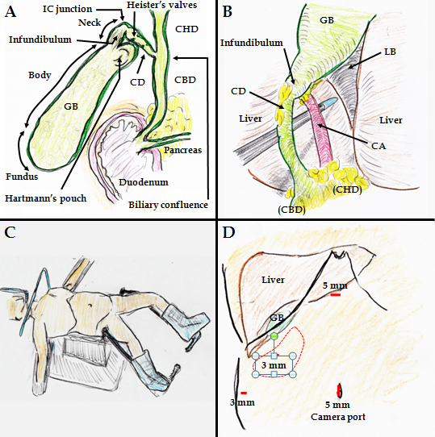
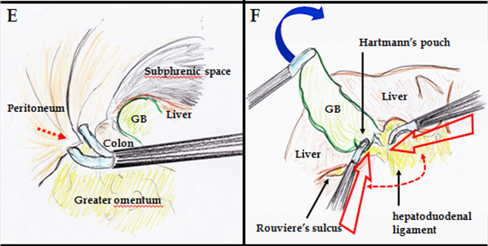
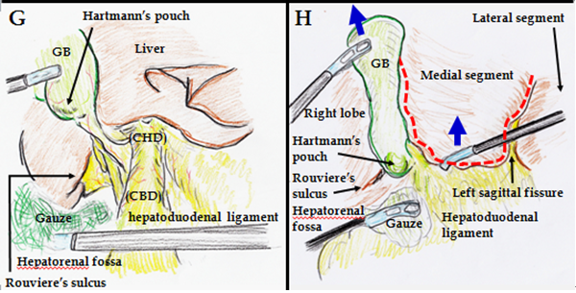
Figure 1 Tips and pitfalls of laparoscopic cholecystectomy. A: Anatomy is important when performing LC. B: Strasberg’s CVS is shown. C: The patient is placed in a combination of an open-leg supine position and lithotomy position. D: Four ports are placed. The operator’s lateral port should be adequately placed (red circle). E: Port placement (red arrow) should be performed without any injuries. F: The GB fundus is superiorly and cranially lifted (blue arrow). The operator’s ports should then be placed with the forceps tip positioned at an adequate degree around Calot’s triangle (dotted arrow). G: Gauze is placed to dilate the hepatorenal fossa. The hepatoduodenal ligament is stretched. Rouviere’s sulcus and Hartmann’s pouch are confirmed. H: The left sagittal fissure is confirmed. A U-shaped line (dotted line) is visually traced from the round ligament of the liver to the left side of the GB. The bottom plateau of this U-shaped line necessarily involves the CHD and hepatic hilum. Adequate retractions are performed (blue arrows). CD: cystic duct; CHD: common hepatic duct; CVS: critical view of safety; GB: gallbladder; IC: infundibulum-cystic duct; LB, liver bed; LC: laparoscopic cholecystectomy.

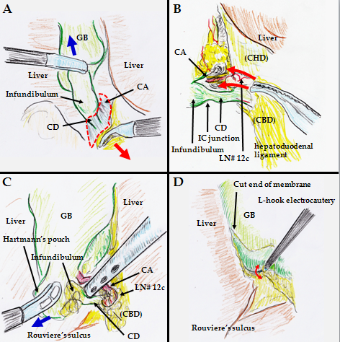
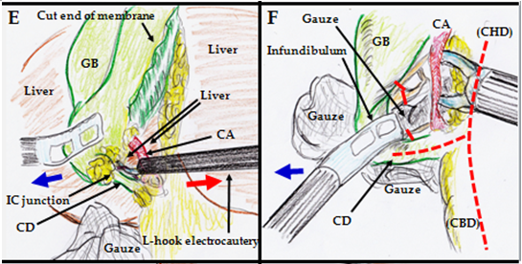
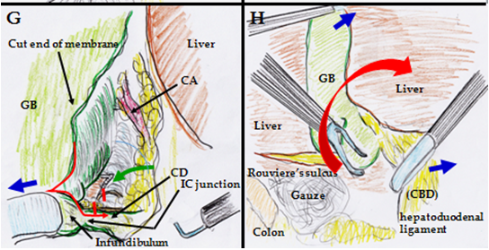
Figure 2 Tips and pitfalls of laparoscopic cholecystectomy. A: Countertraction by grasping tissue (red arrow) is a useful dissection, and a dissectable/cuttable layer (dotted circle) is made under coordinated retraction (blue arrow). B: Blunt dissection in the overhead view is useful around Calot’s triangle (red arrows). C: Blunt dissection by suction in the overhead view is also useful under adequate retraction (blue arrow). D: A dissectible/cuttable layer is created and should be intentionally traced as close to the GB as possible. The width of the dissectable/cuttable layer is confirmed with a reciprocating L-hook (red arrow). E: A safe field is routinely made to the foreground. Tension is created with an L-hook (red arrow), and the tissue is then cut by energization. Adequate traction is performed (blue arrow). F: Hartmann’s pouch should be pulled laterally and inferiorly (blue arrow) to open the anterior left side of Calot’s triangle and create a wider angle between the CD and CHD (dotted line). A parallel junction of the CD with the CHD should be avoided. Nerves around the GB neck and CD are cut nearly at the GB (red lines). G: Hartmann’s pouch should be pulled laterally and inferiorly (blue arrow). The GB should be followed down to the presumed point of the IC junction, as close to the GB side as possible (red arrow). Nerves around the GB neck and the CD are cut (red lines). A partial penetration window is made to confirm the dorsal side (green arrow). The anterior left side of Calot’s triangle is adequately exposed in the overhead view. H: The posterior right side of Calot’s triangle is exposed and dissected while applying superior and medial traction of the GB infundibulum or Hartmann’s pouch (red arrow). The GB should never be pushed directly to the liver side. Supportive tractions are performed (blue arrows). CD: cystic duct; CHD: common hepatic duct; CVS: critical view of safety; GB: gallbladder; IC: infundibulum-cystic duct; LB, liver bed; LC: laparoscopic cholecystectomy.

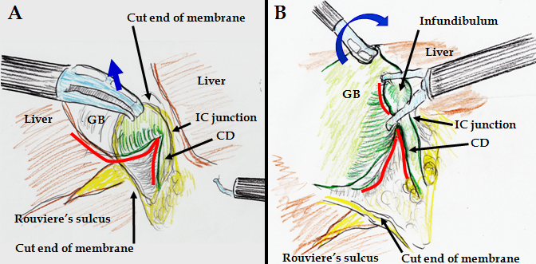
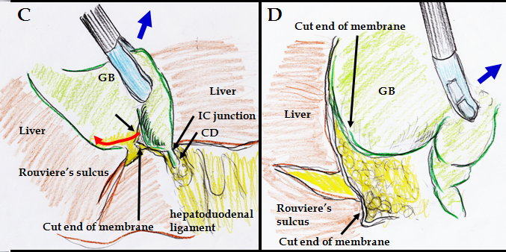
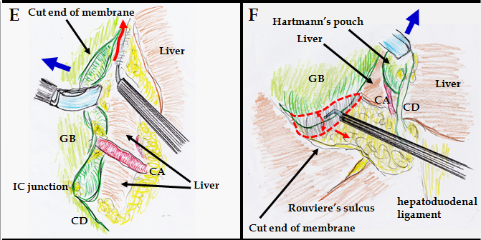
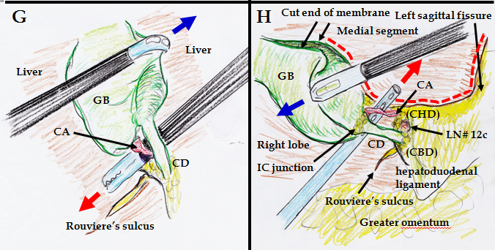
Figure 3 Tips and pitfalls of laparoscopic cholecystectomy. A: Adequate retraction is performed for the laparoscopic view from underneath (blue arrow). Confirmation of the S-like curve on Hartmann’s pouch, infundibulum, IC junction, and CD is important (red line). B: The IC junction is confirmed as an inverted V shape (red line) because of the superior and medial traction of the GB (blue arrow). C: The cutline of the membrane is made to the GB body at a safe distance from Rouviere’s sulcus (red arrow). Adequate retraction is performed (blue arrow). D: Dissectable tissue around the GB should never be followed into Rouviere’s sulcus. Uncoupling of the GB wall and fatty fissure of Rouviere’s sulcus is important to avoid any biliary injuries. Adequate retraction is performed (blue arrow). E: Approximately two-thirds or half of the GB body is removed from the LB in the overhead view. A dissectable/cuttable layer is cut by L-hook electrocautery (red arrow) under adequate retraction (blue arrow), as close to the GB as possible. F: Approximately two-thirds or half of the GB body is removed from the LB in the view from underneath with adequate retraction (blue arrow). The dissectable/cuttable layer (dotted circle) is cut as close to the GB as possible using the L-hook electrocautery technique (red arrows). G: The CVS is ventrally confirmed (red arrow) under counter-retraction (blue arrow). Approximately two-thirds or half of the GB body is removed from the LB. Rouviere’s sulcus is far from the CD and GB. H: The CVS is dorsally confirmed (red arrow) under counter-retraction (blue arrow). Approximately two-thirds or half of the GB body is removed from the LB. Rouviere’s sulcus is located far from the CD and GB. The U-like line from the round ligament of the liver to the left side of the GB is visually traced (dotted line). CD: cystic duct; CHD: common hepatic duct; CVS: critical view of safety; GB: gallbladder; IC: infundibulum-cystic duct; LB, liver bed; LC: laparoscopic cholecystectomy.

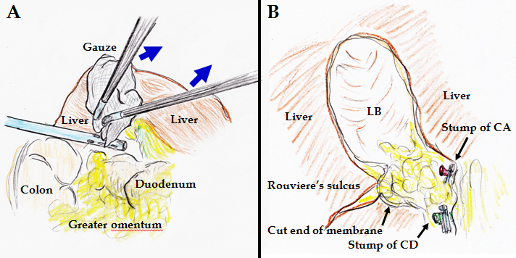
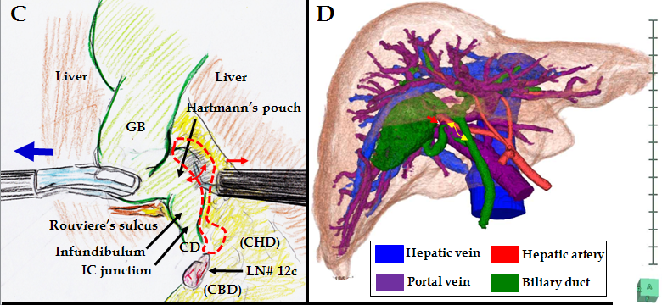
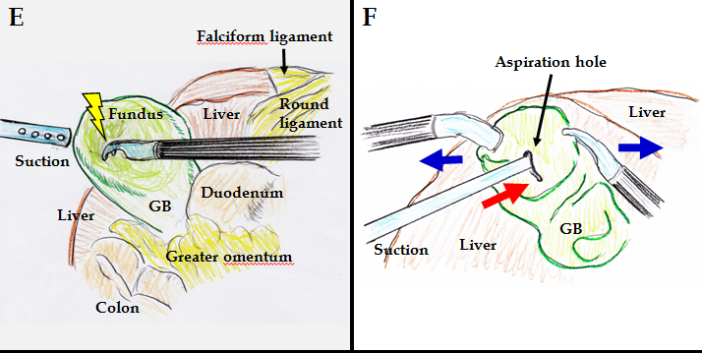
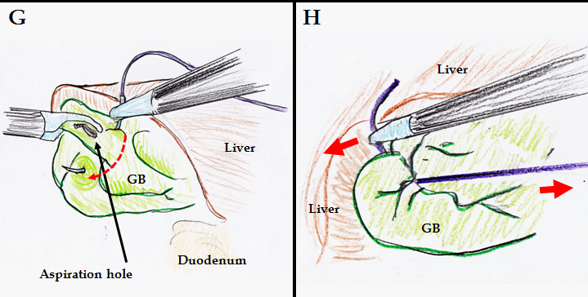
Figure 4 Tips and pitfalls of laparoscopic cholecystectomy. A: Adequate compression using gauze (blue arrows) works well to stop bleeding at the LB. B: Hemostasis by thermal spread should be never used, nearly at the LB of the GB neck, Rouviere’s sulcus, and CD stump. C: The GB neck and Hartmann’s pouch often extend into the dorsal space due to inflammatory change and/or healing contracture, and unexpected excursions of important ducts and vessels may occur (dotted area). The dissectable/cuttable layer is cut under adequate retraction (blue arrow) as close to the GB as possible using the L-hook electrocautery technique (red arrows). D: Surgeons should not hesitate to perform preoperative detailed imaging studies in complicated cases. The CD (yellow arrow) and CA (red arrow) can be clearly detected on the 3D image. E: The GB is decompressed at the fundus by a dissector with energization. F: Under GB fixation (blue arrows), aspiration is surely performed (red arrow). G: A couple of sutures are placed to close an aspiration hole (dotted arrow). H: The aspiration hole is promptly closed by an extracorporeal ligation (red arrows). CD: cystic duct; CHD: common hepatic duct; CVS: critical view of safety; GB: gallbladder; IC: infundibulum-cystic duct; LB, liver bed; LC: laparoscopic cholecystectomy.

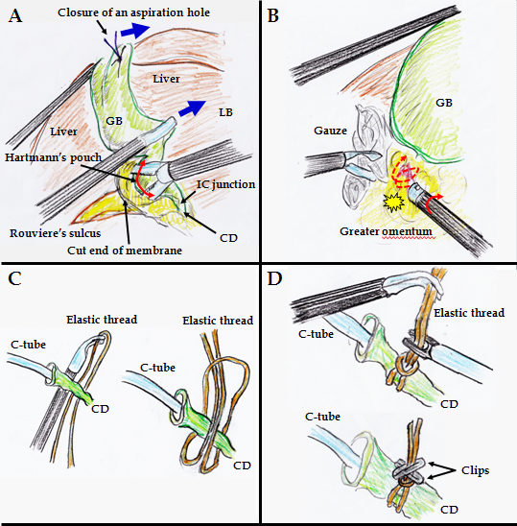
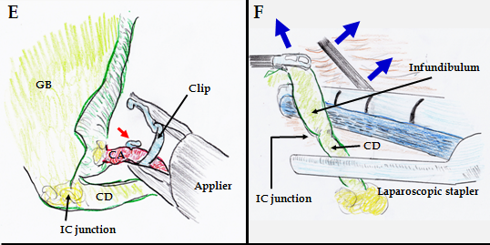

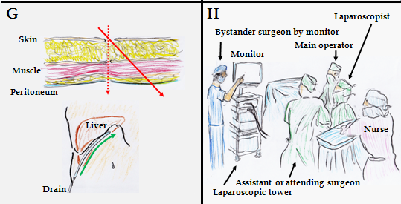
Figure 5 Tips and pitfalls of laparoscopic cholecystectomy. A: After GB decompression by aspiration, the GB neck and/or Hartmann’s pouch can be pulled from the dorsal space. Hence, dissection can be performed as close to the GB as possible (red arrow) under adequate retractions (blue arrow). B: The rubbing of a bleeding vessel or oozing tissue (dotted arrow) by a button-shaped electrode with suction with a soft-coagulation system is a key technique for reliable hemostasis. During this hemostasis, subtle rotation of the electrode is important (red arrow). C: An elastic thread is never ligated directly. D: Clips are positioned to establish angular separation. E: A clip should be applied with the tip extending beyond the duct or vessels (red arrow). F: If the CD is too thick, loop ligation or a laparoscopic stapler can be chosen, under adequate retractions (blue arrows). G: Laparoscopic port penetrates abdominal wall at right angle (dotted arrow). A drain pathway through the abdominal wall is remade from the same skin incision (red arrow), to make the best drain placement (green arrow). H: A detached observer may be an actual solution for prevention of misidentification during LC. CD: cystic duct; GB: gallbladder; IC: infundibulum-cystic duct; LC: laparoscopic cholecystectomy.

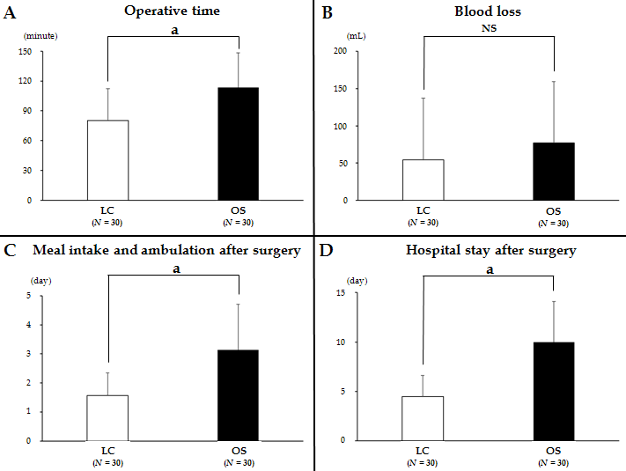
Figure 6 Tips and pitfalls of laparoscopic cholecystectomy. A: Operative time; B: Intraoperative blood loss; C: Postoperative time to adequate meal intake and ambulation; D: postoperative hospital stay after surgery were compared between LC and OS among patients undergoing emergency treatment for acute cholecystitis. There were significant differences not in blood loss but in operative time, postoperative duration until adequate meal intake and ambulation, and postoperative hospital stay (ªP < 0.05). NS: not significant; LC: laparoscopic cholecystectomy.

Table 1 Mandatory protocol to avoid unexpected injuries during laparoscopic cholecystectomy
Consideration that a high level of experience alone is not adequate for successful laparoscopic cholecystectomy
Biliary injuries are principally caused by misperception, not from insufficient skill, lack of knowledge, or misjudgment.
Misidentification is the result of failure to conclusively identify the cystic structures and is secondary to the surgeons’ assumptions during LC.
Recognition of the plateau involving the CHD and hepatic hilum
Stretch the hepatoduodenal ligament and confirm the left sagittal fissure.
A U-shaped line is visually traced from the round ligament of the liver to the left side of the GB.
The bottom plateau of this U-shaped line necessarily involves the CHD and hepatic hilum.
Blunt dissection until CVS exposure
During clearance of Calot’s triangle, the dissectable/cuttable layer should be traced as close to the GB and CD as possible.
Tissue dissection and membrane cutting should be extended from the apparent side, not from the unknown side.
Never use any sealing devices until CVS exposure.
Calot’s triangle clearance in the overhead view
Hartmann’s pouch should be pulled laterally and inferiorly to open the anterior left side of Calot’s triangle.
A wider angle between the CD and CHD is created.
The anterior left side of Calot’s triangle is exposed and dissected.
Calot’s triangle clearance in the view from underneath
The hepatorenal fossa is widely dilated, and Hartmann’s pouch is confirmed.
Superior and medial traction of the GB infundibulum or Hartmann’s pouch is performed.
The S-like curve on Hartmann’s pouch, GB infundibulum, IC junction, and CD is confirmed.
The IC junction is confirmed as an inverted V shape due to superior and medial traction of the GB.
Dissection of posterior right side of Calot’s triangle in the rightward and upward view
Cutline of membrane is made to the GB body at a point adequately distant from Rouviere’s sulcus.
The posterior right side of Calot’s triangle is exposed and dissected.
The GB wall and fatty fissure of Rouviere’s sulcus should be uncoupled.
Dissectable tissue around the GB should never be followed into Rouviere’s sulcus.
Removal of half to two-thirds of GB body from the LB
Half to approximately two-thirds of the GB body is removed from the LB at the CVS exposure.
Positive accomplishment of the CVS exposure
Only two cystic structures should be seen entering the GB.
CD: cystic duct; CHD: common hepatic duct; CVS: critical view of safety; GB: gallbladder; IC: infundibulum-cystic duct; LB, liver bed; LC: laparoscopic cholecystectomy.

