Name of Journal: World Journal of Clinical Cases
Manuscript NO: 62820
Manuscript Type: CASE REPORT

Coronary sinus endocarditis in a hemodialysis patient: A case report and review of literature

Hwang HJ et al. Coronary sinus endocarditis

Hui-Jeong Hwang, Sung-Wook Kang

Hui-Jeong Hwang, Department of Cardiology, Kyung Hee University Hospital at Gangdong, Kyung Hee University College of Medicine, Seoul 05278, South Korea

Sung-Wook Kang, Department of Pulmonary, Allergy and Critical Care Medicine, Kyung Hee University Hospital at Gangdong, Seoul 05278, South Korea

Author contributions: Hwang HJ drafted the manuscript and reviewed the literature; Kang SW was the patient’s medical doctor and contributed to interpret clinical findings of the patient; all authors issued final approval for the version to be submitted.

Corresponding author: Hui-Jeong Hwang, MD, PhD, Associate Professor, Department of Cardiology, Kyung Hee University Hospital at Gangdong, Kyung Hee University College of Medicine, 892 Dongnam-ro, Gangdong-gu, Seoul 05278, South Korea. neonic7749@khu.ac.kr

Received: January 20, 2021
Revised: February 23, 2021
Accepted: April 12, 2021
Published online:

Abstract
BACKGROUND
Infective endocarditis is more common in hemodialysis patients than in the general population and is sometimes difficult to diagnose. Isolated coronary sinus (CS) vegetation is extremely rare and has a good prognosis, but complicated CS vegetation may have a poorer clinical course. We report a case of CS vegetation accidentally found via echocardiography in a hemodialysis patient with undifferentiated shock. The CS vegetation may have been caused by endocardial denudation due to tricuspid regurgitant jet and subsequent bacteremia.

CASE SUMMARY
A 91-year-old man with dyspnea and hypotension was transferred from a nursing hospital. He was on regular hemodialysis and had a history of severe grade of tricuspid regurgitation. There was no leukocytosis or fever upon admission. Repetitive and sequential blood cultures revealed absence of microorganism growth. Chest computed tomography showed lung consolidation and a large pleural effusion. A mobile band-like mass on the CS, suggestive of vegetation, was observed on echocardiography. We diagnosed him with infective endocarditis involving the CS, pneumonia, and septic shock based on echocardiographic, radiographic, and clinical findings. Infusion of broad-spectrum antibiotics, fluid resuscitation, inotropic support, and ventilator care were performed. However, the patient died from uncontrolled infection and septic shock.

CONCLUSION
CS vegetation can be fatal in hemodialysis patients with impaired immune systems, especially when it delays the diagnosis.

Key Words: Coronary sinus; Endocarditis; Renal dialysis; Echocardiography; Diagnosis, differential; Case report

Hwang HJ, Kang SW. Coronary sinus endocarditis in a hemodialysis patient: A case report and review of literature. World J Clin Cases 2021; In press

Core Tip: Coronary sinus vegetation is rarely observed. It might also be confused with a coronary sinus thrombosis and inappropriately managed. We present a case of coronary sinus vegetation with typical echocardiographic findings and review clinical challenges, including differential diagnoses and therapeutic options, associated with treating hemodialysis patients suspected to have coronary sinus endocarditis.

INTRODUCTION
Infective endocarditis in hemodialysis patients is more common and has higher morbidity and mortality than that in the general population^{[1,2]}. Although infective endocarditis in hemodialysis patients occurs due to vascular access-related infection during dialysis, it mainly involves left-sided heart structures, while right-sided structures are rarely affected^{[2]}. Right-sided infective endocarditis (RIE) accounts for 5%-10% of all cases of infective endocarditis and frequently affects intravenous drug users or patients with central venous catheters or intracardiac devices^{[3]}. RIE usually involves the tricuspid or pulmonary valves and often leads to secondary right heart failure^{[3]}. This report shows an elderly hemodialysis patient with coronary sinus (CS) endocarditis who presented with septic shock. CS endocarditis has rarely been reported and usually has a good prognosis^{[4]}, but it was fatal in our case. We review the clinical challenges that caused a poor clinical outcome in our case, including differential diagnosis and therapeutic options in hemodialysis patients with endocarditis.

CASE PRESENTATION
Chief complaints
A 91-year-old male patient admitted to a nursing hospital was transferred to our hospital with dyspnea, cough, and a confused mental state.

History of present illness
Prior to patient transfer, a single dose of moxifloxacin was administered at the nursing hospital without blood culture tests. Oxygen was administered via a nasal cannula during the transfer.

History of past illness
The patient has undergone regular hemodialysis for one year. He had a medical history of atrial fibrillation, severe grade of tricuspid and mitral regurgitation, and chronic obstructive pulmonary disease. He also had a stroke 5 years previously.

Physical examination
At the time of admission in our institution, blood pressure, heart rate, respiratory rate, and body temperature of the patient were 85/40 mmHg, 110 /min, 20 /min, and 36.5 °C, respectively.

Laboratory examinations
Laboratory tests revealed a white blood cell count of 8780 /μL (neutrophils: 78%), C-reactive protein level of 1.6 mg/dL (normal range < 0.5 mg/dL), procalcitonin level of 0.571 μg/L (normal range < 0.046 μg/L), creatinine level of 5.6 mg/dL (glomerular filtration rate by the modification of diet in renal disease study equation = 10 mL/min/1.73 m²), and brain natriuretic peptide level of 124 ng/L (normal range < 100 ng/L). Arterial blood gas analysis during oxygen supply revealed severe acidosis with a pH of 7.173, partial pressure of carbon dioxide of 66 mmHg, partial pressure of oxygen of 100 mmHg, and bicarbonate of 24 mEq/L.

Imaging examinations
Chest radiography revealed a large right pleural effusion and pulmonary edema (Figure 1A). Chest computed tomography showed consolidation in the right upper and middle lobes and total atelectasis of the right lower lobe (Figure 1B). The pleural effusion was a transudate, according to the following Light’s criteria^{[5]}: Pleural fluid protein-to-serum protein ratio of 0.4; pleural fluid lactate dehydrogenase (LDH) -to-serum LDH of 0.6; and pleural fluid LDH to the upper normal limit for serum of 0.6. There was no growth of microorganisms on pleural fluid culture. Transthoracic echocardiography showed a moderate grade of eccentric tricuspid regurgitant jet flow directed towards the CS and a mobile band-like echogenic mass (longitudinal dimension of approximately 8 cm) attached to the ostium of the CS and posterolateral wall of the right atrium, suggesting the presence of vegetation (Figure 2 and Supplementary Videos 1-3, which demonstrate a vegetation on echocardiography). He also had a moderate grade of pulmonary hypertension (estimated systolic pulmonary arterial pressure = 61 mmHg) and right atrial enlargement (30 cm²). Other cardiac structures, including the valves, were unaffected, and the left ventricular ejection fraction was normal. There was no radiographic evidence of pulmonary thromboembolism or deep vein thrombosis. Sequential blood culture results were negative.

FINAL DIAGNOSIS
The patient was diagnosed with septic shock due to CS endocarditis and pneumonia. Respiratory acidosis with metabolic decompensation was accompanied by severe infection, acute exacerbation of chronic obstructive pulmonary disease, hypoventilation, and a large pleural effusion.

TREATMENT
Broad-spectrum antibiotics, including teicoplanin and meropenem, were administered. A chest tube was inserted at the site of pleural effusion. A mechanical ventilator and continuous renal replacement therapy were administered. Fluid resuscitation and inotropic support were provided to maintain blood pressure.

OUTCOME AND FOLLOW-UP
Hypercapnia and respiratory acidosis were improved to some extent after insertion of the chest tube and application of the mechanical ventilator (pH = 7.347, partial pressure of carbon dioxide = 41 mmHg, partial pressure of oxygen = 97 mmHg, and bicarbonate = 22 mEq/L on arterial blood gas analysis). Follow-up echocardiography after one week showed remnants of vegetation (Figure 3), suggesting migration of the cardiac vegetation into the lung. There was no abrupt hypoxic event that could lead to deterioration. However, leukocytosis and metabolic and respiratory acidosis worsened over time [white blood cell count, 33830 /μL (neutrophils, 90%); pH = 7.160, partial pressure of carbon dioxide = 52 mmHg, partial pressure of oxygen = 73 mmHg, bicarbonate 18 mEq/L, lactic acid = 3.6 mmol/L on arterial blood gas analysis]. Septic shock persisted despite medical support and he eventually died.

DISCUSSION
The CS is a structure that receives approximately 60% of the total cardiac venous supply and drains into the right atrium^{[6]}. It is mainly injured during right cardiac procedures, including insertion of central venous catheter, cannulation of the CS during heart surgery, electrophysiologic study, and placement of intracardiac devices^{[6]}. Unlike traumatic injury, spontaneous endothelial injury of the CS has been reported in some conditions causing accelerating or turbulent jet flow in the CS, such as coronary arteriovenous fistula between the left circumferential artery and CS and eccentric tricuspid regurgitation towards the CS^{[4,7-9]}. In our case, the substantial tricuspid regurgitant jet flow directed towards the CS and posterolateral right atrial surface might have caused endothelial denudation; subsequently, bacteremia during hemodialysis or sepsis due to pneumonia probably led to the formation of vegetation at that location.
Vegetation of the CS resembles thrombosis in appearance. However, both need to be distinguished because they require different treatments. CS vegetation, including infective endocarditis or septic thrombophlebitis, has been reported in 13 cases, including our case (Table 1)^{[4,7-17]}. According to these cases, patients with CS vegetation mainly had symptoms and signs of infection, such as fever and leukocytosis, and had typical imaging or pathologic findings involving the CS. In rare cases^{[7,14]}, blood culture results were negative; however, pathogens were identified on tissue culture. The major pathogen was Staphylococcus aureus (four in infective endocarditis cases and three in septic thrombophlebitis) which is associated with complicated clinical courses, including huge vegetation, destructive abscess and fistulation, and septic embolization^{[3]}. Indeed, five (71%) of the seven cases with Staphylococcus aureus infection underwent surgery or died suddenly. Patients with complex CS vegetation, including septic embolism and tissue destruction leading to heart failure, underwent surgery or died before treatment, while patients with isolated CS vegetation without complications recovered with only antibiotics. Septic thrombophlebitis has both characteristics of thrombosis and infection of the CS. It was fatal when there was acute mechanical obstruction of the CS^{[14,15]}. Similar to CS vegetation, spontaneous CS thrombosis without iatrogenic injury has been reported in less than 15 cases. CS thrombosis mostly occurred in conditions leading to a static status of the right atrium, including atrial fibrillation^{[18-21]}, right heart failure with severe pulmonary hypertension^{[18,19,22,23]}, or hypercoagulable conditions such as severe inflammation/infection^{[20,24-26]} and malignancy^{[27]}; this presentation is similar to that of thrombosis at other sites. Patients with CS thrombosis primarily have symptoms and signs associated with partial or complete obstruction of the CS, but no symptoms and signs of infection. For example, chest pain, ST-segment elevation^{[28]}, or hemodynamic collapse and subsequent sudden death^{[22,24,25,27]} have been reported. CS thrombosis with complete obstruction required emergency surgery^{[19,26]}; however, thrombosis without obstructive signs responded to anti-coagulation therapy^{[18,20]}.
Although vegetation or thrombosis of the CS is confirmed based on histopathological findings, echocardiography is the best imaging technique for screening. However, minor structures of the right heart, such as the CS and Chiari network, are sometimes overlooked during echocardiography. This might be one of the reasons why cases were rarely reported. In our case, infective endocarditis was not suspected before echocardiography because typical microorganisms did not grow in blood cultures, and only non-specific hypotension and mild elevation of C-reactive protein and procalcitonin levels were observed without typical infection signs. In fact, echocardiography was performed to screen for cardiogenic shock, and CS vegetation was incidentally observed. We immediately started broad-spectrum antibiotics for infective endocarditis and found no vegetation on the follow-up echocardiography. If the echogenic mass had continued to increase, it might have caused other clinical problems due to mechanical obstruction or destruction of structures adjacent to the CS. Although immediate treatment with antibiotics did not alter the prognosis of this patient, early detection of CS vegetation is essential for appropriate management.
The mortality rate of RIE including CS endocarditis^{[4]} is considered to be lower than that of left-sided infective endocarditis (LIE)^{[3]}. However, a high proportion (60%-80%) of intravenous drug users, who generally display a benign clinical course, might account for the good prognosis of RIE in previous studies^{[29,30]}. Indeed, recent studies that enrolled patients with no history of intravenous drug use or with cardiac devices showed similar in-hospital mortality rates between RIE and LIE^{[31,32]}. Furthermore, hemodialysis patients with inherently impaired immune systems are highly susceptible to bacteremia and septic shock. In our case, the patient died because his immune systems were impaired due to old age, chronic renal impairment, fragility, and severe infection. Moreover, the diagnosis of infective endocarditis was delayed due to atypical symptoms. His negative blood culture results might also be associated with poor outcome because it made antibiotic selection difficult.
The diagnosis and treatment of infective endocarditis in hemodialysis patients is challenging. Clinical manifestations, including fever and leukocytosis, may be atypical because of impaired cellular host defense; thus, diagnosis or management of infective endocarditis may be delayed^{[2]}. Indwelling intravascular catheters may be a primary source of pathogens; however, removal of the catheter is not always possible or necessary^{[2]}. Infective endocarditis caused by methicillin-resistant Staphylococcus aureus is a common clinical entity. However, empirical use of vancomycin before the isolation of microorganisms should be determined carefully because vancomycin has a slower bactericidal effect on methicillin-susceptible Staphylococcus aureus compared to beta-lactam antibiotics^{[2,33]}.

CONCLUSION
Infective endocarditis is more common and has a poorer prognosis in hemodialysis patients than it does in the general population. Thus, echocardiography should be thoroughly investigated in hemodialysis patients suspected of having sepsis or shock. In addition, CS vegetation is easy to be misdiagnosed when the clinician is not cautious or inexperienced. The treatment of infective endocarditis in hemodialysis patients is more challenging when blood cultures are negative. More careful consideration and a team-based approach involving cardiologists, nephrologists, and infectious disease specialists, is needed for the treatment of infectious diseases in hemodialysis patients.

REFERENCES
1 Maraj S, Jacobs LE, Kung SC, Raja R, Krishnasamy P, Maraj R, Braitman LE, Kotler MN. Epidemiology and outcome of infective endocarditis in hemodialysis patients. Am J Med Sci 2002; 324: 254-260 [PMID: 12449446 DOI: 10.1097/00000441-200211000-00004]
2 Nucifora G, Badano LP, Viale P, Gianfagna P, Allocca G, Montanaro D, Livi U, Fioretti PM. Infective endocarditis in chronic haemodialysis patients: an increasing clinical challenge. Eur Heart J 2007; 28: 2307-2312 [PMID: 17656347 DOI: 10.1093/eurheartj/ehm²78]
3 Habib G, Lancellotti P, Antunes MJ, Bongiorni MG, Casalta JP, Del Zotti F, Dulgheru R, El Khoury G, Erba PA, Iung B, Miro JM, Mulder BJ, Plonska-Gosciniak E, Price S, Roos-Hesselink J, Snygg-Martin U, Thuny F, Tornos Mas P, Vilacosta I, Zamorano JL; ESC Scientific Document Group . 2015 ESC Guidelines for the management of infective endocarditis: The Task Force for the Management of Infective Endocarditis of the European Society of Cardiology (ESC). Endorsed by: European Association for Cardio-Thoracic Surgery (EACTS), the European Association of Nuclear Medicine (EANM). Eur Heart J 2015; 36: 3075-3128 [PMID: 26320109 DOI: 10.1093/eurheartj/ehv319]
4 Song G, Zhang J, Zhang X, Yang H, Huang W, Du M, Zhou K, Ren W. Right-sided infective endocarditis with coronary sinus vegetation. BMC Cardiovasc Disord 2018; 18: 111 [PMID: 29866073 DOI: 10.1186/s12872-018-0845-x]
5 Light RW, Macgregor MI, Luchsinger PC, Ball WC Jr. Pleural effusions: the diagnostic separation of transudates and exudates. Ann Intern Med 1972; 77: 507-513 [PMID: 4642731 DOI: 10.7326/0003-4819-77-4-507]
6 Masood W, Sitammagari KK. Coronary Sinus Thrombosis. FL: StatPearls, 2021 [PMID: 29939583]
7 Takashima A, Yagi S, Yamaguchi K, Takagi E, Kanbara T, Ogawa H, Ise T, Kusunose K, Tobiume T, Yamada H, Soeki T, Wakatsuki T, Kitagawa T, Sata M. Vegetation in the coronary sinus that concealed the presence of a coronary arteriovenous fistula in a patient with infectious endocarditis. Int J Cardiol 2016; 207: 266-268 [PMID: 26808990 DOI: 10.1016/j.ijcard.2016.01.057]
8 Kasravi B, Reid CL, Allen BJ. Coronary artery fistula presenting as bacterial endocarditis. J Am Soc Echocardiogr 2004; 17: 1315-1316 [PMID: 15562274 DOI: 10.1016/j.echo.2004.06.028]
9 Theodoropoulos KC, Papachristidis A, Walker N, Dworakowski R, Monaghan MJ. Coronary sinus endocarditis due to tricuspid regurgitation jet lesion. Eur Heart J Cardiovasc Imaging 2017; 18: 382 [PMID: 28025260 DOI: 10.1093/ehjci/jew300]
10 Kumar KR, Haider S, Sood A, Mahmoud KA, Mostafa A, Afonso LC, Kottam AR. Right-sided endocarditis: eustachian valve and coronary sinus involvement. Echocardiography 2017; 34: 143-144 [PMID: 27550778 DOI: 10.1111/echo.13345]
11 Machado MN, Nakazone MA, Takakura IT, Silva CM, Maia LN. Spontaneous Bacterial Pericarditis and Coronary Sinus Endocarditis Caused by Oxacillin-Susceptible Staphylococcus aureus. Case Rep Med 2010; 2010: 984562 [PMID: 20585370 DOI: 10.1155/2010/984562]
12 Gill DS, Yong QW, Wong TW, Tan LK, Ng KS. Vegetation and bilateral congenital coronary artery fistulas. J Am Soc Echocardiogr 2005; 18: 492-493 [PMID: 15891763 DOI: 10.1016/j.echo.2005.01.033]
13 Kwan C, Chen O, Radionova S, Sadiq A, Moskovits M. Echocardiography: a case of coronary sinus endocarditis. Echocardiography 2014; 31: E287-E288 [PMID: 24976149 DOI: 10.1111/echo.12665]
14 Ross EM, Macher AM, Roberts WC. Aspergillus fumigatus thrombi causing total occlusion of both coronary arterial ostia, all four major epicardial coronary arteries and coronary sinus and associated with purulent pericarditis. Am J Cardiol 1985; 56: 499-500 [PMID: 3898801 DOI: 10.1016/0002-9149(85)90904-x]
15 Dryer R, Goldman D, Nelson R. Letter: Septic thrombophlebitis of the coronary sinus in aucte bacterial endocarditis. Lancet 1976; 2: 369 [PMID: 60601 DOI: 10.1016/s0140-6736(76)92626-x]
16 Jones D, Amsterdam E, Young JN. Septic thrombophlebitis of the coronary sinus with complete recovery after surgical intervention. Cardiol Rev 2004; 12: 325-326 [PMID: 15476571 DOI: 10.1097/01.crd.0000128237.44935.98]
17 Fournet M, Behaghel A, Pavy C, Flecher E, Thebault C. Spontaneous bacterial coronary sinus septic thrombophlebitis treated successfully medically. Echocardiography 2014; 31: E92-E93 [PMID: 24749166 DOI: 10.1111/echo.12430]
18 Floria M, Negru D, Antohe I. Coronary sinus thrombus without spontaneous contrast. J Thromb Thrombolysis 2016; 42: 421-422 [PMID: 27116357 DOI: 10.1007/s11239-016-1369-9]
19 Neri E, Tripodi A, Tucci E, Capannini G, Sassi C. Dramatic improvement of LV function after coronary sinus thromboembolectomy. Ann Thorac Surg 2000; 70: 961-963 [PMID: 11016343 DOI: 10.1016/s0003-4975(00)01639-8]
20 Hart MA, Simegn MA. Pylephlebitis presenting as spontaneous coronary sinus thrombosis: a case report. J Med Case Rep 2017; 11: 309 [PMID: 29092714 DOI: 10.1186/s13256-017-1479-9]
21 Moey MYY, Ebin E, Marcu CB. Venous varices of the heart: a case report of spontaneous coronary sinus thrombosis with persistent left superior vena cava. Eur Heart J Case Rep 2018; 2: yty092 [PMID: 31020169 DOI: 10.1093/ehjcr/yty092]
22 Ramsaran EK, Sadigh M, Miller D. Sudden cardiac death due to primary coronary sinus thrombosis. South Med J 1996; 89: 531-533 [PMID: 8638186 DOI: 10.1097/00007611-199605000-00019]
23 Kachalia A, Sideras P, Javaid M, Muralidharan S, Stevens-Cohen P. Extreme clinical presentations of venous stasis: coronary sinus thrombosis. J Assoc Physicians India 2013; 61: 841-843 [PMID: 24974504]
24 Parmar RC, Kulkarni S, Nayar S, Shivaraman A. Coronary sinus thrombosis. J Postgrad Med 2002; 48: 312-313 [PMID: 12571393]
25 Martin J, Nair V, Edgecombe A. Fatal coronary sinus thrombosis due to hypercoagulability in Crohn's disease. Cardiovasc Pathol 2017; 26: 1-3 [PMID: 27776257 DOI: 10.1016/j.carpath.2016.09.008]
26 Frogel JK, Weiss SJ, Kohl BA. Transesophageal echocardiography diagnosis of coronary sinus thrombosis. Anesth Analg 2009; 108: 441-442 [PMID: 19151269 DOI: 10.1213/ane.0b013e31818f61e3]
27 Kitazawa S, Kitazawa R, Kondo T, Mori K, Matsui T, Watanabe H, Watanabe M. Fatal cardiac tamponade due to coronary sinus thrombosis in acute lymphoblastic leukaemia: a case report. Cases J 2009; 2: 9095 [PMID: 20062732 DOI: 10.1186/1757-1626-2-9095]
28 Al-Turki MA, Patton D, Crean AM, Horlick E, Dhillon R, Johri AM. Spontaneous Thrombosis of a Left Circumflex Artery Fistula Draining Into the Coronary Sinus. World J Pediatr Congenit Heart Surg 2015; 6: 640-642 [PMID: 26467878 DOI: 10.1177/2150135115577432]
29 Thalme A, Westling K, Julander I. In-hospital and long-term mortality in infective endocarditis in injecting drug users compared to non-drug users: a retrospective study of 192 episodes. Scand J Infect Dis 2007; 39: 197-204 [PMID: 17366047 DOI: 10.1080/00365540600978856]
30 Moss R, Munt B. Injection drug use and right sided endocarditis. Heart 2003; 89: 577-581 [PMID: 12695478 DOI: 10.1136/heart.89.5.577]
31 Lee MR, Chang SA, Choi SH, Lee GY, Kim EK, Peck KR, Park SW. Clinical features of right-sided infective endocarditis occurring in non-drug users. J Korean Med Sci 2014; 29: 776-781 [PMID: 24932077 DOI: 10.3346/jkms.2014.29.6.776]
32 Ortiz C, López J, García H, Sevilla T, Revilla A, Vilacosta I, Sarriá C, Olmos C, Ferrera C, García PE, Sáez C, Gómez I, San Román JA. Clinical classification and prognosis of isolated right-sided infective endocarditis. Medicine (Baltimore) 2014; 93: e137 [PMID: 25501052 DOI: 10.1097/MD.0000000000000137]
33 Hoen B. Infective endocarditis: a frequent disease in dialysis patients. Nephrol Dial Transplant 2004; 19: 1360-1362 [PMID: 15004259 DOI: 10.1093/ndt/gfh149]

Footnotes
Informed consent statement: Informed written consent was obtained from the patient’s legal guardian for publication of this report and any accompanying image.

Conflict-of-interest statement: The authors declare that they have no conflict of interest.

CARE Checklist (2016) statement: The authors have read the CARE Checklist (2016), and the manuscript was prepared according to the CARE Checklist (2016).

Open-Access: This article is an open-access article that was selected by an in-house editor and fully peer-reviewed by external reviewers. It is distributed in accordance with the Creative Commons Attribution NonCommercial (CC BY-NC 4.0) license, which permits others to distribute, remix, adapt, build upon this work non-commercially, and license their derivative works on different terms, provided the original work is properly cited and the use is non-commercial. See: http://creativecommons.org/Licenses/by-nc/4.0/

Manuscript source: Unsolicited manuscript

Peer-review started: January 20, 2021
First decision: February 11, 2021
Article in press:

Specialty type: Cardiac and cardiovascular systems
Country/Territory of origin: South Korea
Peer-review report’s scientific quality classification
Grade A (Excellent): 0
Grade B (Very good): B
Grade C (Good): 0
Grade D (Fair): D
Grade E (Poor): 0

P-Reviewer: Shuang WB, Zhu F S-Editor: Liu M L-Editor: P-Editor:
Figure Legends
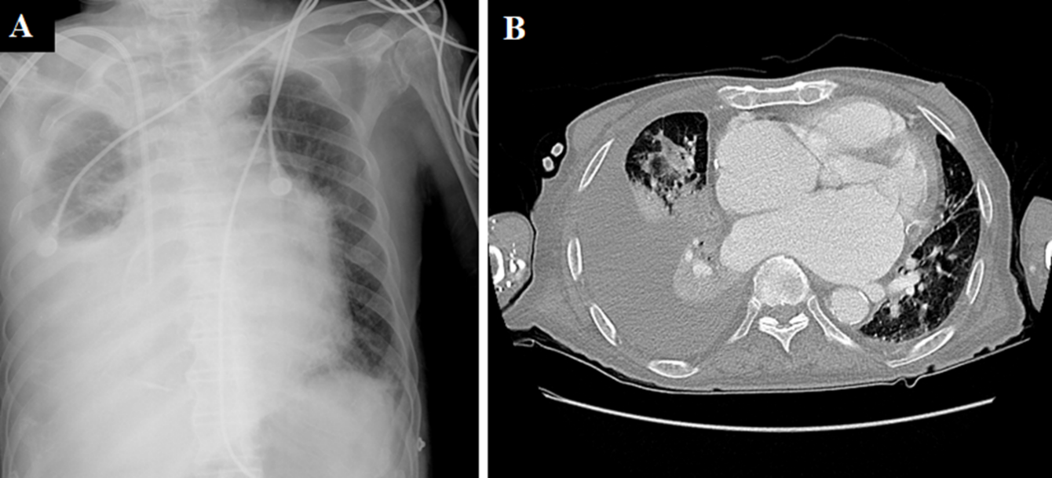

Figure 1 Radiographic imaging. A: Chest radiograph showing a large right pleural effusion and pulmonary edema; B: Chest computed tomography showing consolidation of the right middle lobe, total atelectasis of the right lower lobe, and a large right pleural effusion.

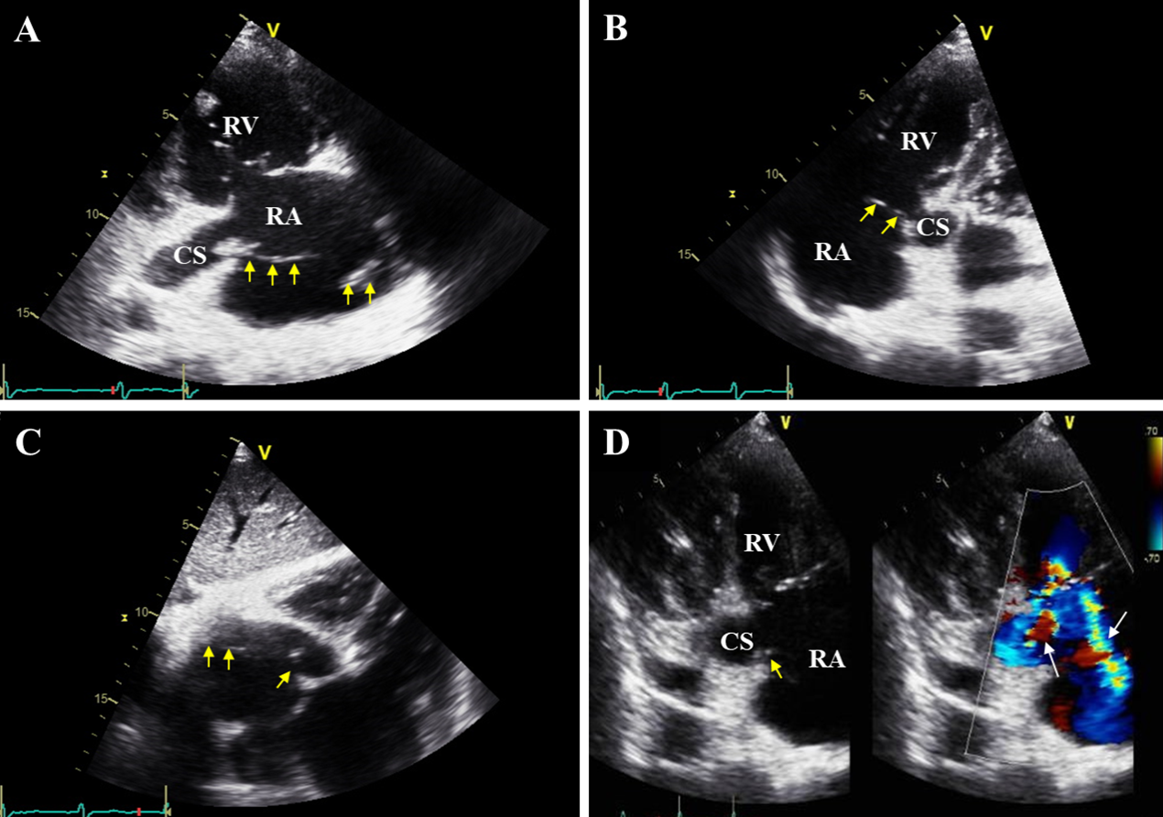

Figure 2 Echocardiographic imaging. A: Right ventricular inflow view showing a mobile band-like vegetation, approximately 8 cm in size, attached to the coronary sinus ostium and the posterolateral wall of the right atrium; B: Modified apical four-chamber view showing a vegetation attached to the ostium of the coronary sinus; C: Subcostal view showing a vegetation; D: Right ventricular inflow view showing eccentric tricuspid regurgitant jet flow directed towards the coronary sinus and concentric tricuspid regurgitant jet flow directed towards the posterolateral wall of the right atrium, observed through color Doppler imaging, and an attached vegetation at the site, observed via two-dimensional imaging. Yellow arrow indicates vegetation; White arrow indicates directed tricuspid regurgitant jet flow. RA: Right atrium; RV: Right ventricle; CS: Coronary sinus.

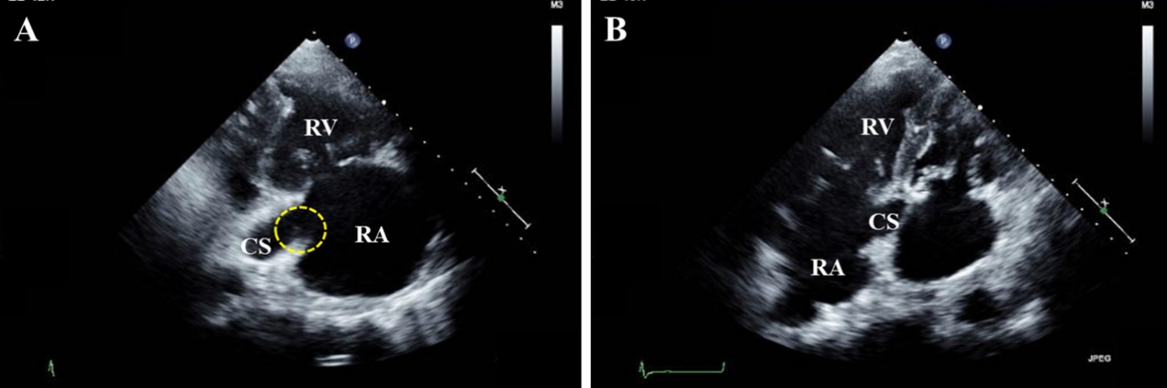
Figure 3 Follow-up echocardiographic imaging. A: Right ventricular inflow; B: Modified apical four-chamber views showing a remnant vegetation at the coronary sinus ostium (dotted circle). RA: Right atrium; RV: Right ventricle; CS: Coronary sinus.
Table 1 Cases of infective endocarditis and septal thrombophlebitis involving the coronary sinus reported in the literature
Ref. | Age/sex | Symptoms | Characteristics of vegetation in the CS | Associated pathology | Pathogen | Therapy | Events
Cases of infective endocarditis
Takashima et al^{[7]}, 2016 | 64/M | Fever, fatigue | A sessile mass with mobile multi-lobules on the CS lumen | CAVF, vegetation on the MV and AV with moderate regurgitation, acute HF | Negative results in BC, Corynebacterium species in TC | Surgery | Multi-organ failure, DIC, died
Kasravi et al^{[8]}, 2004 | 31/M | Fever, pleuritic chest pain | A mobile and multi-lobulated mass protruding from the CS to the RA | CAVF | MSSA in BC | Surgery | SE (lung) and DIC, recovered
Song et al^{[4]}, 2018 | 71/M | Fever, chest pain, hemoptysis | A banded mobile mass in the CS | ASD, PLSVC, severe eccentric TR jet to the CS, RV dysfunction with RAE, moderate PHT | MSSA in BC | Surgery | SE (lung), recovered
Kumar et al^{[10]}, 2016 | 27/F | Septic shock | A pedunculated mobile mass 1 cm proximal from the CS orifice to the Eustachian valve | IVDU | MSSA in BC | Antibiotics | SE (lung, viscera), recovered
Machado et al^{[11]}, 2010 | 44/M | Fever, dyspnea | A mobile mass originating in the CS orifice, extending to the RA | Purulent pericardial effusion | MSSA in BC | Surgery | Recovered
Gill et al^{[12]}, 2005 | 37/M | Fever, weight loss | A mobile mass in the CS and CAVF | CAVF | Streptococcus mitis in BC | Antibiotics | Recovered
Theodoropoulos et al^{[9]}, 2016 | 28/F | Fever, hemoptysis | Two mobile masses towards the CS orifice and in the CS lumen | IVDU, eccentric moderate TR jet to the CS | Group C Streptococcus in BC | Antibiotics | Recovered
Kwan et al^{[13]}, 2014 | 23/F | Fever | A mobile round mass protruding from the CS orifice | HD | Acinetobacter baumanii in BC | Antibiotics | Recovered
Our case | 91/M | Septic shock | A mobile band-like mass protruding from the CS orifice | HD, eccentric moderate TR jet to the CS | Negative results in BC | Antibiotics | Died
Cases of septic thrombophlebitis
Ross et al^{[14]}, 1985 | 31/M | Fever, dyspnea | Occlusion of the CS orifice by fungal thrombi (in necropsy) | Lymphoma, occlusion of the LCA by fungal thrombi (in necropsy) | Negative results in fungal culture, Aspergillus fumigatus in the lung, LCA and CS | Antibiotics | Died
Dryer et al^{[15]}, 1976 | 20/M | Fever, disturbed mental state | Occlusion of the CS orifice by septic thrombophlebitis (in necropsy) | IVDU, vegetation on the MV, multi-organ embolic infarction (in necropsy) | MSSA in BC | Antibiotics | SE (muti-organs), died
Jones et al^{[16]}, 2004 | 50/M | Fever | A mass protruding from the CS orifice to the RA, and extending to the posterior interventricular vein | Previous pericardiectomy due to purulent pericarditis, recurrent furunculosis | MSSA in BC | Surgery | SE (lung), recovered
Fournet et al^{[17]}, 2014 | 38/F | Fever, chest pain, | A mobile mass originating from the CS ostium with heterogeneous solid material | Purulent pericardial effusion | MSSA in BC | Antibiotics | SE (lung), recovered
CS: Coronary sinus; M: Male; F: Female; CAVF: Coronary arteriovenous fistula between left circumferential artery and coronary sinus; MV: Mitral valve; AV: Aortic valve; HF: Heart failure; BC: Blood culture; TC: Tissue culture; DIC: Disseminated intravascular coagulation; RA: Right atrium; MSSA: Methicillin-sensitive Staphylococcus aureus; SE: Septic embolism; ASD: Atrial septal defect; PLSVC: Persistent left superior vena cava; TR: Tricuspid regurgitation; RV: Right ventricle; RAE: Right atrial enlargement; PHT: Pulmonary hypertension; IVDU: Intravenous drug user; HD: Hemodialysis; LCA: Left coronary arteries including left anterior descending and left circumflex arteries.

