Name of Journal: World Journal of Gastroenterology
Manuscript NO: 81613
Manuscript Type: SCIENTOMETRICS

Global trend and future landscape of intestinal microcirculation research from 2000 to 2021: A scientometric study

Fu SJ et al. 22 years of intestinal microcirculation

Sun-Jing Fu, Meng-Ting Xu, Bing Wang, Bing-Wei Li, Hao Ling, Yuan Li, Qin Wang, Xue-Ting Liu, Xiao-Yan Zhang, Ai-Ling Li, Ming-Ming Liu

Sun-Jing Fu, Meng-Ting Xu, Bing Wang, Bing-Wei Li, Yuan Li, Qin Wang, Xue-Ting Liu, Xiao-Yan Zhang, Ai-Ling Li, Ming-Ming Liu, Institute of Microcirculation, Key Laboratory of Microcirculation, Ministry of Health, Chinese Academy of Medical Sciences & Peking Union Medical College, Beijing 100005, China

Hao Ling, Department of Radiology, The Affiliated Changsha Central Hospital, Hengyang Medical School, University of South China, Changsha 410004, Hunan Province, China

Ming-Ming Liu, Diabetes Research Center, Chinese Academy of Medical Sciences & Peking Union Medical College, Beijing 100005, China

Author contributions: Liu MM designed the scientometric analysis strategy; Fu SJ, Xu MT, Wang B, Li BW, Ling H, Wang Q, Liu XT, Zhang XY, and Li AL downloaded and analyzed the data; Fu SJ and Liu MM wrote the manuscript; Liu MM made critical revisions to the article for important intellectual content; All authors discussed the results and approved the final version of the manuscript.

Supported by the Beijing Municipal Natural Science Foundation, No. 7212068; and the National Natural Science Foundation of China, No. 81900747.

Corresponding author: Ming-Ming Liu, PhD, Research Scientist, Institute of Microcirculation, Key Laboratory of Microcirculation, Ministry of Health, Chinese Academy of Medical Sciences & Peking Union Medical College, No. 5 Dong Dan Third Alley, Dongcheng District, Beijing 100005, China. mingmingliu@imc.pumc.edu.cn

Received: November 18, 2022
Revised: February 1, 2023
Accepted: February 24, 2023
Published online: March 7, 2023

Abstract
BACKGROUND
The intestinal microcirculation functions in food absorption and metabolic substance exchanges. Accumulating evidence indicates that intestinal microcirculatory dysfunction is a significant source of multiple gastrointestinal diseases. To date, there has not been a scientometric analysis of intestinal microcirculatory research.

AIM
To investigate the current status, development trends, and frontiers of intestinal microcirculatory research based on bibliometric analysis.

METHODS
VOSviewer and CiteSpace 6.1.R2 were used to identify the overall characteristics and knowledge map of intestinal microcirculatory research based on the core literature published from 2000 to 2021 in the Web of Science database. The characteristics of each article, country of origin, institution, journal, cocitations, and other information were analyzed and visualized.

RESULTS
There were 1364 publications enrolled in the bibliometric analysis, exhibiting an upward trend from 2000 to 2021 with increased participation worldwide. The United States and Dalhousie University took the lead among countries and institutions, respectively. Shock was the most prolific journal, and Nature Reviews Microbiology Clinical had the most citations. The topical hotspots and frontiers in intestinal microcirculatory research were centered on the pathological processes of functional impairment of intestinal microvessels, diverse intestinal illnesses, and clinical treatment.

CONCLUSION
Our study highlights insights into trends of the published research on the intestinal microcirculation and offers serviceable guidance to researchers by summarizing the prolific areas in intestinal disease research to date.

Key Words: Intestinal microcirculation; Bibliometric analysis; CiteSpace; VOSviewer; Visualization

©The Author(s) 2023. Published by Baishideng Publishing Group Inc. All rights reserved.

Citation: Fu SJ, Xu MT, Wang B, Li BW, Ling H, Li Y, Wang Q, Liu XT, Zhang XY, Li AL, Liu MM. Global trend and future landscape of intestinal microcirculation research from 2000 to 2021: A scientometric study. World J Gastroenterol 2023; 29(9): 1523-1535
URL: https://www.wjgnet.com/1007-9327/full/v29/i9/1523.htm
DOI: https://dx.doi.org/10.3748/wjg.v29.i9.1523

Core Tip: This bibliometric analysis of the research directions and important literature related to the intestinal microcirculation over the last 22 years documents the current status, development trends, and frontiers of intestinal microcirculatory research and provides information that may guide future research efforts.
INTRODUCTION
The intestines function in food absorption and metabolic substance exchange. Approximately 20%-25% of cardiac output is directed toward the digestive tract under physiological conditions. Among them, about 60%-80% flow to the submucosal and mucosal layers^{[1]}, providing the highly metabolically active epithelial, immune with nutrients and oxygen. Intestinal microvessels and lymph capillaries serve as an integrated system (so-called intestinal microcirculation) providing multiple bidirectional transport processes while defending the lumen against the threat of chemicals and bacteria. The intestinal microcirculation regulates a variety of metabolic and physiological processes involved in diseases such as shock, sepsis^{[2,3]}, gastrointestinal diseases^{[4]}, and diabetes mellitus^{[5]}.
Recent studies have shown that intestinal microcirculatory dysfunction is characterized by nutritive perfusion failure, inflammatory cell responses, surges in proinflammatory mediators, and breakdown of epithelial barrier function, as well as bacterial translocation and the development of systemic inflammatory responses^{[6-8]}. Notably, there is widespread consensus that ischemic injury and severe microcirculatory dysfunction in the highly vascularized gut are significant sources of multiple organ dysfunction and even death^{[9,10]}. Moreover, the intestinal microcirculation behaves as an isolated area in patients with postoperative abdominal sepsis^{[11]}, suggesting that the intestinal microcirculation does not always correlate with systemic hemodynamic variables (for example, blood pressure)^{[12]} in gastrointestinal diseases. Therefore, it is rational to have a comprehensive scenario that depicting the functional status of intestinal microcirculation in discussing the specific issues. However, there have been few attempts to systematically assess the scientific findings and current networks in this field from a worldwide perspective.
Bibliometrics analyzes the quantitative relationships, distribution structure, and cocitation patterns of publications using mathematical and statistical methods, revealing the disciplinary development direction and research dynamics of related fields and illustrating the key paths and knowledge nodes of disciplinary field evolution^{[13]}. This study provided a bibliometric analysis of the research process and important literature related to the intestinal microcirculation over the last 22 years to provide information for future research on the intestinal microcirculation.

MATERIALS AND METHODS
Search strategies
The literature data for this study were retrieved from Clarivate Analytics’ Web of Science Core Collection (WOSCC). The key topic for retrieval was TS = (intestinal microcirculation) OR (intestinal microvascular*). The timespan was limited from January 1, 2000 to December 31, 2021. The data were obtained within one day to avoid any potential discrepancies due to daily updates of the database. Only English-language original articles and reviews were selected. Consequently, a total of 1364 publications, comprising 1192 articles and 172 reviews, were retrieved, and each literature record included relevant information such as title, author, keywords, abstract, year, organization, and citation. A summary of the search and selection methodology for the study can be found in Figure 1.

Data analysis and visualization
In this current study, CiteSpace 6.1.R2 (https://citespace.podia.com) was adopted to map cooperation networks (institutions) and document cocitation clustering, and keyword clustering. The set of parameters was as follows: The time slice was set to one year for articles published from 2000 to 2021, and the node types were “institution”, “reference”, and “keyword”, with a g-index k value of 25. Different parameters were set following different node types, and the visualization map was drawn.
VOSviewer (1.6.18) (www.vosviewer.com) was used to identify and illustrate the co-occurring countries/regions, cocitation analysis of journals and references, and analysis of keyword co-occurrence. The screening condition and thresholds were as follows: The counting method was set as “Full counting” with a minimum number of 5 and a maximum of 1000 items.

RESULTS
Characteristics and trends of publications
The annual publication trend reflects the development level of intestinal microcirculatory research^{[14]}. From 2000 to 2021, a total of 1364 intestinal microcirculation-related articles met the retrieval standard. Subsequently, we illustrated the article counts per year with a histogram. According to Figure 2, the annual number of relevant publications was rather consistent, with a mean of 65 publications, indicating sustained attention from 2000-2021. Although articles accounted for most of the literature, there was a considerable increase in reviews from 2019-2021, indicating a growing interest in the intestinal microcirculation.

Contributions by countries/regions and institutions
The number of papers published by research groups according to country/region and institution can reflect the distribution of research forces in the field of intestinal microcirculatory research. In Table 1, the top 10 countries and institutions were ranked based on the number of publications related to the intestinal microcirculation. With 420 publications accounting for 30.79% of the total, the United States was the top-producing nation, followed by Germany (231, 16.94%) and China (164, 12.02%). The co-occurrence map demonstrated that the United States attached great importance to cooperation and worked closely with Germany, England, Canada, and other European countries (Figure 3). In addition, colleges and universities were the major sources of intestinal microcirculatory research. Dalhousie University was identified as the most productive scientific institution, with the most papers (41), followed by the University of Szeged (35) and the University of Amsterdam (33). These findings highlighted useful information on prominent research teams and established collaborative ties.

Analysis of journals and cited journals
Table 2 lists the top 10 most prolific journals and most-cited journals. Shock (53) published the most papers about the intestinal microcirculation, followed by the Journal of Pathology (37), and the World Journal of Gastroenterology (36). Nature Reviews Microbiology had the highest number of local citations (2930 local citations) in the field, Clinical Microbiology Reviews was the second-cited journal (1533 local citations) and the Journal of Pathology (1520 local citations) was the third. Additionally, a dual-map overlay of journals with four colored pathways was established to reflect the disciplinary distribution of academic journals (Figure 4). Most clusters of citing and cited journals are located in medicine, clinical, molecular, biology, and immunology.

Analysis of co-cited references
The landmark literature and the rapid development of this field can be clarified through the cocitation analysis of relevant publications^{[15]}. We then established the co-cited reference network map (Figure 5A), and through cluster analysis, similar references were categorized into knowledge units (Figure 5B). Additionally, the modularity value (Q value) and the mean silhouette value (S value) were used to evaluate the effect of the literature cocitation mapping.
With more than 5000 references cited in the last 22 years, the top 10 most cited articles about the intestinal microcirculation are listed in Table 3. (Binion DG, 1997), which had a citation count of 65, was the top-ranked article. (Chiu CJ, 1970), with 62 citations, and (Ince C, 2005), with 49 citations, followed. Moreover, 9 clusters were identified for mitochondrial respiration, sepsis, tissue oxygen tension, ischemia-reperfusion injury, hemorrhagic shock, endothelium, adenosine 5-triphosphate, gut, and no-reflow. The Q value of the clustering map was 0.9342, and the S value was 0.9579, confirming that the structured network was well mapped and that the clustering results were effective and reliable.

Analysis of keywords
Keywords refer to a high-level overview and refinement of the study topic and article content^{[16]}. In terms of frequency, the top 10 keywords in the intestinal microcirculatory research from 2000 to 2021 were determined by creating a graphical map of keyword co-occurrence (Figure 6A and Table 4). The top keywords were “expression”, “nitric oxide”, “blood flow”, “rat”, “injury”, “microvascular endothelial cell”, “inflammatory bowel disease”, “microcirculation”, “sepsis” and “sepsis shock”. Clustering analysis was carried out based on the above results and the following 10 clusters were identified (Figure 6B), which represented the key research areas. Specifically, the clusters “nitric oxide”, “Shiga toxin” and “alkaline phosphatase” explored the mechanisms and pathological basis of damage to the intestinal microcirculation; the clusters “septic shock” and “inflammatory bowel disease” were diseases related to the intestinal microcirculation; the cluster “intravital microscopy” represented an effective measurement technique; and the clusters “cytokine therapy” and “negative pressure wound therapy” involve effective and reliable countermeasures for intestinal microcirculatory dysfunction.
Burst keywords also highlight hotspots and developing trends; hence, the detection of keywords with the fastest increase in citations (citation bursts) denotes the emerging focus in dynamic domains^{[17]}. Our analysis revealed the top 25 keywords for the strongest citation bursts from 2000 to 2021 (Figure 7). Among them, the highest burst strength (10.34) was found for “multiple organ failure” since 2000, and also the longest-lasting burst term was “endothelial growth factor” (2007-2019). From 2000 to 2005, the mechanism tended to be more actively researched based on the main keywords “neutrophil”, “adhesion”, “free radical”, and “platelet-activating factor”. Since 2006, researchers have begun to investigate the potential correlation between clinical gut illnesses and microcirculation, with the main keywords being “ulcerative colitis”, “Crohn's disease”, and “necrotizing enterocolitis”. In addition, the keyword for the most recent burst was “gut microbiota” (2019), suggesting it has been in the spotlight so far.

DISCUSSION
This study performed a scientometric analysis of publications on the intestinal microcirculation published from 2000 to 2021 using CiteSpace and VOSviewer. The findings provided insight into recent developments in global research collaborations, the most active journals, the core research areas, and emerging research areas.
In total, 1364 publications about the intestinal microcirculation were extracted from WOSCC. Although the trend of annual publications from 2000 to 2021 reflected the continued interest of scholars in intestinal microcirculatory research, in comparison to research on the microcirculation of other tissues and organs, the annual number of papers on the intestinal microcirculation is relatively low, which may be associated with the technical and clinical challenges involved in the research. The United States and Germany are thriving hubs of intestinal microcirculatory research due to increased collaborations and strengthened citation links between several European countries, suggesting that a strong level of collaboration promotes academic influence.
Notably, journals focusing on clinical practice and published reviews and articles on the crucial role of the intestinal microcirculation in the progression of gastrointestinal diseases. Additionally, a dual-map overlay of journals demonstrated that the research was focused on basic and clinical medicine, thus, multidisciplinary efforts are needed to support the development of the intestinal microcirculatory field. Co-cited references revealed that (Binion DG, 1997), with the highest frequency of citations, was a representative reference that laid the foundation for intestinal microcirculatory mechanisms in inflammatory bowel disease. Other landmark publications such as (Ince C, 2005) and (Daniel DB, 2002), outlined mechanisms of interaction between sepsis and microcirculation. In addition, (Daniel DB, 2007) reported the results of a roundtable organized in Amsterdam, reaching a formal consensus on the acquisition and analysis of microcirculatory images. These references provided a solid theoretical foundation for future research.
Based on the analysis of keywords, we sought to identify research interests and focus related to the intestinal microcirculation. Keywords revealed by the co-occurrence map were classified into two categories: Pathophysiology-related research and clinical disease-related research, which is also consistent with the clustering of the cocitation references. The keywords “expression”, “blood flow”, “microvascular endothelial cell” and “nitric oxide” were associated with the pathophysiology of the intestinal microcirculation. Endothelial cell activation, hemorheological alterations, and altered vasoreactivity were just a few examples of functional and structural modifications^{[18-20]}. Additionally, pathological situations significantly disrupted the nitric oxide (NO) system, which is essential to the autoregulatory control of microcirculatory patency and could result in pathological flow shunting. These conspicuous keywords indicated that further research on microcirculatory mechanisms is needed.
Previous research has revealed that intestinal microcirculatory dysfunction can occur early in patients with shock and sepsis^{[21]}. Necrotizing enterocolitis and inflammatory bowel disease are included as examples resulting from the pathologic changes in the intestinal microcirculation^{[22]}. Several studies have shown that microvascular remodeling and angiogenesis, vasodilatation microvascular dysfunction, and infiltration of immune cells play a role in the pathogenesis of inflammatory bowel disease and necrotizing enterocolitis^{[23-25]}. Additionally, the imbalance among vascular mediators such as NO, catecholamines, and endothelin regulates neonatal intestinal vascular resistance and may influence the pathophysiology of these gut diseases^{[26,27]}. Thus, the intestinal microcirculation as a new therapeutic target offers possibilities for treating these diseases.
Largely ignored throughout history, the intestinal microcirculation has recently been identified as the center of various pathophysiological processes. The determinants of oxygen delivery, tissue oxygen tension, blood flow regulation, and mitochondrial well-being have yet to be fully understood. The origin of intestinal microcirculatory failure in necrotizing enterocolitis and inflammatory bowel disease that is not responsive to therapy is represented by the dysfunction of the integrated intestinal microcirculation rather than systemic hemodynamic variables. Therefore, a new area of outcomes and the potential for discovering novel therapeutic targets has been made possible by introducing improved tools into clinical practice that permit the examination of integrated intestinal microcirculation. Small-molecule drugs (melatonin^{[28]}, L-citrulline^{[29]}, heparin^{[30]}, and potential vasoactive Chinese traditional medicines such as Weiqi decoction^{[31]}), as well as novel therapeutic approaches such as remote ischemic conditioning^{[32]} are recommended. Furthermore, research that determines whether these medicines are effective at enhancing the outcome of patients by ameliorating the intestinal microcirculation should be investigated in the future.
However, our study also has certain limitations. First, this analysis was restricted to English papers in the WOSCC database which may contain fewer established articles than other databases, future research may consider embedding expanded literature databases, such as Scopus. Second, non-English literature was not included in the database or analysis, possibly resulting in linguistic source bias. Finally, bibliometric data that change over time might lead to a different conclusion. In an updated analysis, it will be necessary to follow the most recent primary studies and non-English investigations dynamically.

CONCLUSION
The intestinal microcirculation has important academic value and clinical application prospects in health and diseases. We illustrated the global developing trends, influential articles, thematic keywords, and research frontiers from 2000 to 2021 in this field. In coauthorship analyses, the patterns of scientific cooperation were found across countries/regions, institutions, and journals. Moreover, the current state and potential future directions were detected by the reference cocitation analysis, burst references, and keyword identification. We now have a deeper grasp of the pathophysiologic mechanisms underlying the intestinal microcirculation, and optimal diagnosis, prognosis assessment, and clinical therapies are the features and trends of the field. Multidisciplinary collaborations will be critical to advancing intestinal microcirculatory research.

ARTICLE HIGHLIGHTS
Research background
The intestinal microcirculation plays an important role in food absorption and metabolic substance exchange. And it is beneficial to comprehensively describe the progress of intestinal microcirculation research and provide information that may guide future research efforts.

Research motivation
Few attempts have been made to systematically assess scientific findings and current networks in the field of intestinal microcirculation. It is difficult to identify potential research hotspots or emerging research frontiers.

Research objectives
To investigate the research status, development trend, and frontier dynamics of intestinal microcirculation in the past 22 years (2000-2021).

Research methods
Based on the core literature published in the Web of Science database from 2000-2021, VOSviewer and CiteSpace 6.1.R2 were used to analyze and visualize the overall characteristics, source countries, institutions, journals, and citation frequencies of intestinal microcirculatory research.

Research results
A total of 1364 publications were included in the bibliometric analysis, showing an upward trend from 2000 to 2021. The United States and Dalhousie University ranked first among all countries and institutions. Most of the publications were released in Shock, and the most cited journal was Nature Reviews Microbiology Clinical. The topical hotspots and frontiers of intestinal microcirculation focused on the pathological processes of functional impairment on intestinal micro-vessels, diverse intestinal illnesses, and clinical treatment.

Research conclusions
Our study reveals research trends in the field of intestinal microcirculation and offers serviceable guidance to researchers by providing the prolific areas for intestinal disease research to date.

Research perspectives
Our analysis systematically assesses the scientific findings and current networks in this study of intestinal microcirculation from a worldwide perspective. Optimization of diagnosis, prognostic assessment, and clinical treatment are features and trends in this field. Multidisciplinary collaboration is essential to facilitate intestinal microcirculation research.

REFERENCES
1 Hasibeder W. Gastrointestinal microcirculation: still a mystery? Br J Anaesth 2010; 105: 393-396 [PMID: 20837720 DOI: 10.1093/bja/aeq236]
2 Tang AL, Shen MJ, Zhang GQ. Intestinal microcirculation dysfunction in sepsis: pathophysiology, clinical monitoring, and therapeutic interventions. World J Emerg Med 2022; 13: 343-348 [PMID: 36119779 DOI: 10.5847/wjem.j.1920-8642.2022.031]
3 Assimakopoulos SF, Triantos C, Thomopoulos K, Fligou F, Maroulis I, Marangos M, Gogos CA. Gut-origin sepsis in the critically ill patient: pathophysiology and treatment. Infection 2018; 46: 751-760 [PMID: 30003491 DOI: 10.1007/s15010-018-1178-5]
4 Zhang HY, Wang F, Feng JX. Intestinal microcirculatory dysfunction and neonatal necrotizing enterocolitis. Chin Med J (Engl) 2013; 126: 1771-1778 [PMID: 23652066]
5 Nerup N, Ambrus R, Lindhe J, Achiam MP, Jeppesen PB, Svendsen LB. The effect of glucagon-like peptide-1 and glucagon-like peptide-2 on microcirculation: A systematic review. Microcirculation 2019; 26: e12367 [PMID: 28266749 DOI: 10.1111/micc.12367]
6 Thorburn T, Aali M, Lehmann C. Immune response to systemic inflammation in the intestinal microcirculation. Front Biosci (Landmark Ed) 2018; 23: 782-795 [PMID: 28930572 DOI: 10.2741/4616]
7 Han JY, Li Q, Ma ZZ, Fan JY. Effects and mechanisms of compound Chinese medicine and major ingredients on microcirculatory dysfunction and organ injury induced by ischemia/reperfusion. Pharmacol Ther 2017; 177: 146-173 [PMID: 28322971 DOI: 10.1016/j.pharmthera.2017.03.005]
8 Fan CN, Yang SJ, Shih PY, Wang MJ, Fan SZ, Tsai JC, Sun WZ, Liu CM, Yeh YC. Comparing effects of intraoperative fluid and vasopressor infusion on intestinal microcirculation. Sci Rep 2020; 10: 19856 [PMID: 33199828 DOI: 10.1038/s41598-020-76983-6]
9 Czabanka M, Peter C, Martin E, Walther A. Microcirculatory endothelial dysfunction during endotoxemia--insights into pathophysiology, pathologic mechanisms and clinical relevance. Curr Vasc Pharmacol 2007; 5: 266-275 [PMID: 17979793 DOI: 10.2174/157016107782023389]
10 Haussner F, Chakraborty S, Halbgebauer R, Huber-Lang M. Challenge to the Intestinal Mucosa During Sepsis. Front Immunol 2019; 10: 891 [PMID: 31114571 DOI: 10.3389/fimmu.2019.00891]
11 Edul VS, Ince C, Navarro N, Previgliano L, Risso-Vazquez A, Rubatto PN, Dubin A. Dissociation between sublingual and gut microcirculation in the response to a fluid challenge in postoperative patients with abdominal sepsis. Ann Intensive Care 2014; 4: 39 [PMID: 25625013 DOI: 10.1186/s13613-014-0039-3]
12 Tavy AL, de Bruin AF, Boerma EC, Ince C, Hilty MP, Noordzij PG, Boerma D, van Iterson M. Association between serosal intestinal microcirculation and blood pressure during major abdominal surgery. J Intensive Med 2021; 1: 59-64 [PMID: 36789277 DOI: 10.1016/j.jointm.2021.03.003]
13 Cooper ID. Bibliometrics basics. J Med Libr Assoc 2015; 103: 217-218 [PMID: 26512226 DOI: 10.3163/1536-5050.103.4.013]
14 Qin Y, Zhang Q, Liu Y. Analysis of knowledge bases and research focuses of cerebral ischemia-reperfusion from the perspective of mapping knowledge domain. Brain Res Bull 2020; 156: 15-24 [PMID: 31843561 DOI: 10.1016/j.brainresbull.2019.12.004]
15 Zhang X, Zhou Y, Wei N, Shou X, Fan S, You Y, Li Y, Hu Y. A Bibliometric Analysis of Heart Failure with Preserved Ejection Fraction From 2000 to 2021. Curr Probl Cardiol 2022; 47: 101243 [PMID: 35545178 DOI: 10.1016/j.cpcardiol.2022.101243]
16 Liang YD, Li Y, Zhao J, Wang XY, Zhu HZ, Chen XH. Study of acupuncture for low back pain in recent 20 years: a bibliometric analysis via CiteSpace. J Pain Res 2017; 10: 951-964 [PMID: 28479858 DOI: 10.2147/JPR.S132808]
17 Luo H, Cai Z, Huang Y, Song J, Ma Q, Yang X, Song Y. Study on Pain Catastrophizing From 2010 to 2020: A Bibliometric Analysis via CiteSpace. Front Psychol 2021; 12: 759347 [PMID: 34975649 DOI: 10.3389/fpsyg.2021.759347]
18 Chen Y, Pu W, Maswikiti EP, Tao P, Li X, Wang D, Gu B, Yu Y, Gao L, Zhao C, Chen H. Intestinal congestion and reperfusion injury: damage caused to the intestinal tract and distal organs. Biosci Rep 2021; 41 [PMID: 34369557 DOI: 10.1042/BSR20211560]
19 Dickson K, Malitan H, Lehmann C. Imaging of the Intestinal Microcirculation during Acute and Chronic Inflammation. Biology (Basel) 2020; 9 [PMID: 33255906 DOI: 10.3390/biology9120418]
20 Colbert JF, Schmidt EP. Endothelial and Microcirculatory Function and Dysfunction in Sepsis. Clin Chest Med 2016; 37: 263-275 [PMID: 27229643 DOI: 10.1016/j.ccm.2016.01.009]
21 Hiltebrand LB, Krejci V, tenHoevel ME, Banic A, Sigurdsson GH. Redistribution of microcirculatory blood flow within the intestinal wall during sepsis and general anesthesia. Anesthesiology 2003; 98: 658-669 [PMID: 12606910 DOI: 10.1097/00000542-200303000-00014]
22 Hatoum OA, Heidemann J, Binion DG. The intestinal microvasculature as a therapeutic target in inflammatory bowel disease. Ann N Y Acad Sci 2006; 1072: 78-97 [PMID: 17057192 DOI: 10.1196/annals.1326.003]
23 Deban L, Correale C, Vetrano S, Malesci A, Danese S. Multiple pathogenic roles of microvasculature in inflammatory bowel disease: a Jack of all trades. Am J Pathol 2008; 172: 1457-1466 [PMID: 18458096 DOI: 10.2353/ajpath.2008.070593]
24 Alkim C, Alkim H, Koksal AR, Boga S, Sen I. Angiogenesis in Inflammatory Bowel Disease. Int J Inflam 2015; 2015: 970890 [PMID: 26839731 DOI: 10.1155/2015/970890]
25 Bowker RM, Yan X, De Plaen IG. Intestinal microcirculation and necrotizing enterocolitis: The vascular endothelial growth factor system. Semin Fetal Neonatal Med 2018; 23: 411-415 [PMID: 30213591 DOI: 10.1016/j.siny.2018.08.008]
26 Watkins DJ, Besner GE. The role of the intestinal microcirculation in necrotizing enterocolitis. Semin Pediatr Surg 2013; 22: 83-87 [PMID: 23611611 DOI: 10.1053/j.sempedsurg.2013.01.004]
27 Nair J, Lakshminrusimha S. Role of NO and other vascular mediators in the etiopathogenesis of necrotizing enterocolitis. Front Biosci (Schol Ed) 2019; 11: 9-28 [PMID: 30844734 DOI: 10.2741/S524]
28 Lansink MO, Patyk V, de Groot H, Effenberger-Neidnicht K. Melatonin reduces changes to small intestinal microvasculature during systemic inflammation. J Surg Res 2017; 211: 114-125 [PMID: 28501107 DOI: 10.1016/j.jss.2016.11.055]
29 Wijnands KA, Vink H, Briedé JJ, van Faassen EE, Lamers WH, Buurman WA, Poeze M. Citrulline a more suitable substrate than arginine to restore NO production and the microcirculation during endotoxemia. PLoS One 2012; 7: e37439 [PMID: 22666356 DOI: 10.1371/journal.pone.0037439]
30 Zhu C, Liang Y, Liu Y, Shu W, Luan Z, Ma X. Unfractionated Heparin Protects Microcirculation in Endotoxemic Rats by Antagonizing Histones. J Surg Res 2023; 282: 84-92 [PMID: 36257167 DOI: 10.1016/j.jss.2022.09.019]
31 Yin J, Yi J, Yang C, Xu B, Lin J, Hu H, Wu X, Shi H, Fei X. Weiqi Decoction Attenuated Chronic Atrophic Gastritis with Precancerous Lesion through Regulating Microcirculation Disturbance and HIF-1α Signaling Pathway. Evid Based Complement Alternat Med 2019; 2019: 2651037 [PMID: 31320912 DOI: 10.1155/2019/2651037]
32 Koike Y, Li B, Ganji N, Zhu H, Miyake H, Chen Y, Lee C, Janssen Lok M, Zozaya C, Lau E, Lee D, Chusilp S, Zhang Z, Yamoto M, Wu RY, Inoue M, Uchida K, Kusunoki M, Delgado-Olguin P, Mertens L, Daneman A, Eaton S, Sherman PM, Pierro A. Remote ischemic conditioning counteracts the intestinal damage of necrotizing enterocolitis by improving intestinal microcirculation. Nat Commun 2020; 11: 4950 [PMID: 33009377 DOI: 10.1038/s41467-020-18750-9]

Footnotes
Conflict-of-interest statement: All the authors report no relevant conflicts of interest for this article.

PRISMA 2009 Checklist statement: The authors have read the PRISMA 2009 Checklist, and the manuscript was prepared and revised according to the PRISMA 2009 Checklist.

Open-Access: This article is an open-access article that was selected by an in-house editor and fully peer-reviewed by external reviewers. It is distributed in accordance with the Creative Commons Attribution NonCommercial (CC BY-NC 4.0) license, which permits others to distribute, remix, adapt, build upon this work non-commercially, and license their derivative works on different terms, provided the original work is properly cited and the use is non-commercial. See: https://creativecommons.org/Licenses/by-nc/4.0/

Provenance and peer review: Unsolicited article; Externally peer reviewed.
Peer-review model: Single blind

Peer-review started: November 18, 2022
First decision: January 23, 2023
Article in press: February 24, 2023

Specialty type: Gastroenterology and hepatology
Country/Territory of origin: China
Peer-review report’s scientific quality classification
Grade A (Excellent): 0
Grade B (Very good): 0
Grade C (Good): C, C
Grade D (Fair): 0
Grade E (Poor): 0

P-Reviewer: Huan C, United States; Tai X, China S-Editor: Zhang H L-Editor: A P-Editor: Yuan YY

Figure Legends
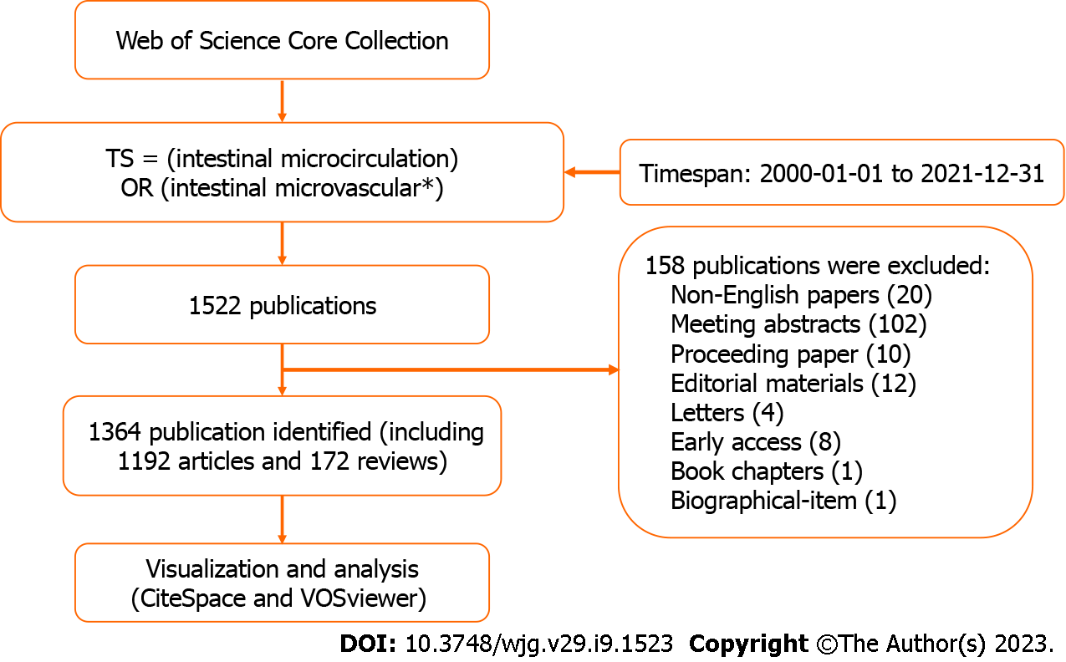
Figure 1 The flow chart for the search and selection strategy of the study.
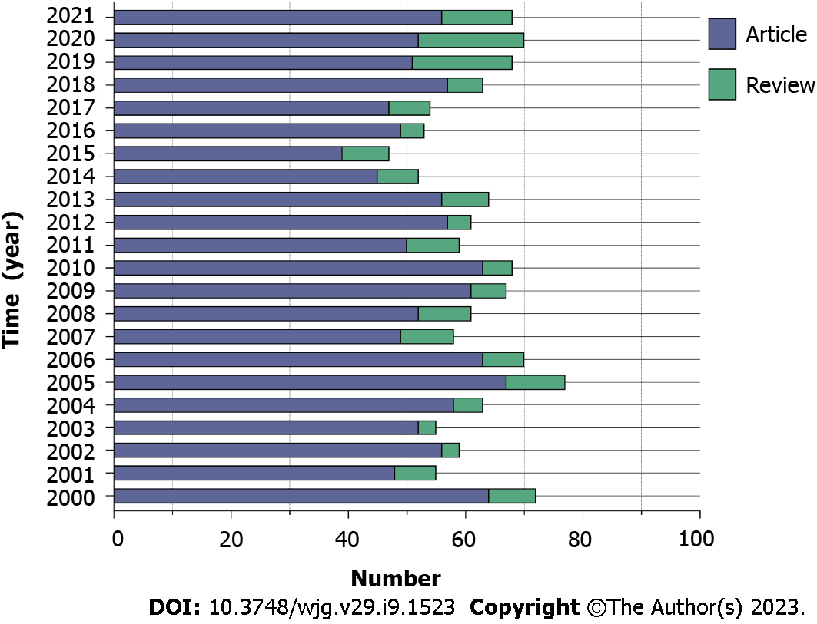
Figure 2 Distribution of articles published in the intestinal microcirculatory research from 2000 to 2021. The chart showed trends in annual publishing during the previous 22 years. Purple bars represent the number of articles related to intestinal microcirculation per year, while green bars represent the number of reviews.
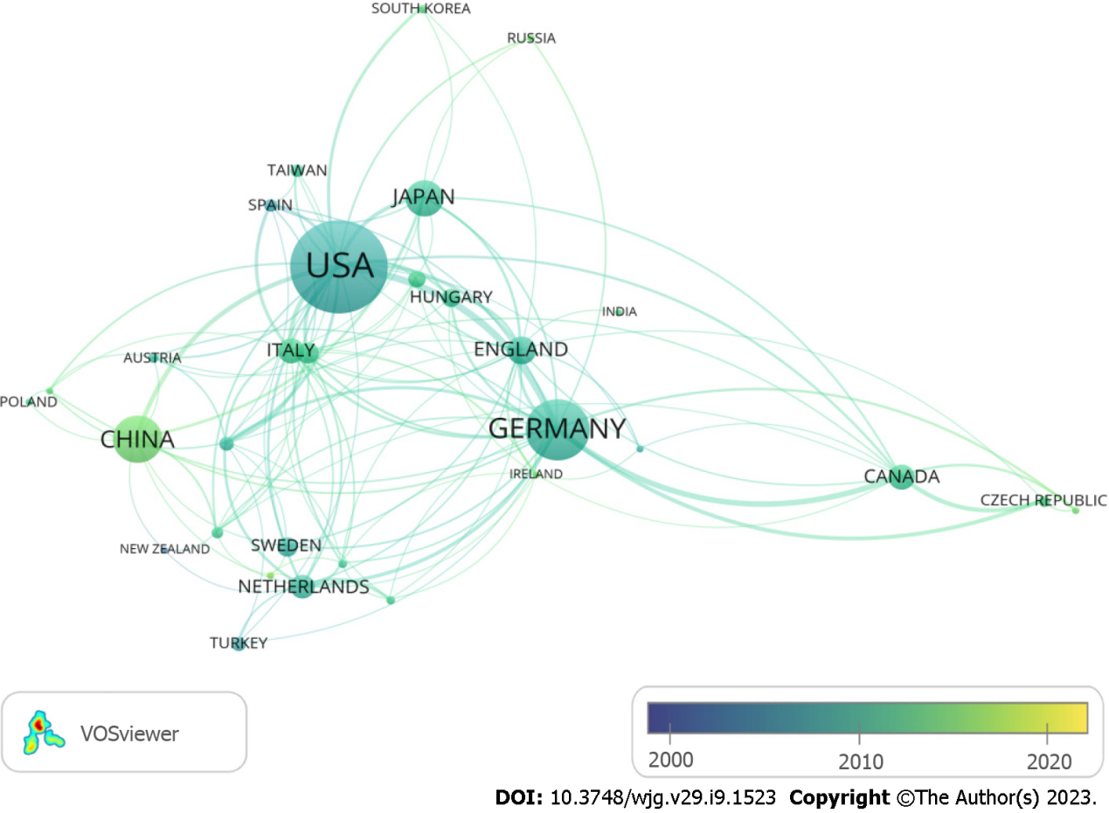
Figure 3 The network of countries/regions engaged in the intestinal microcirculatory research. The collaborations were generated after a minimum of five publications per country. Of the 62 countries active in this field, 32 countries meet this criterion. The size of the node represents the number of posts, and the links between the nodes represent the connection or cooperation between the countries. The transition from blue to yellow in the color bar depicts the years 2000 to 2021.
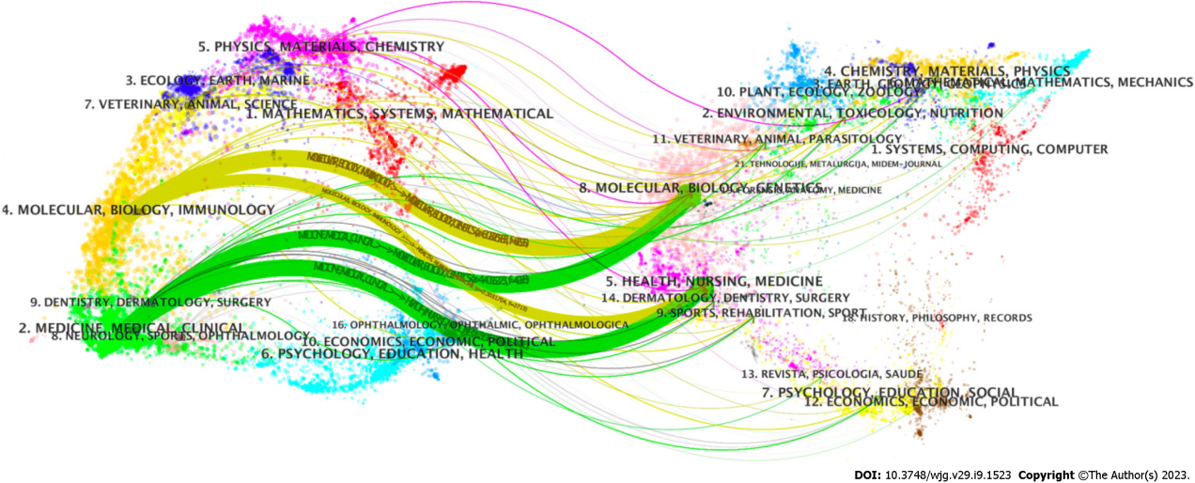
Figure 4 The dual-map overlay of journals in the intestinal microcirculatory research. The left panel shows the map of citing journals while the right panel represents the map of the cited journals. The labels represent the scientific subject covered by the journals. Colored paths indicate the citation relationships, with the thicker lines representing the main pathways.
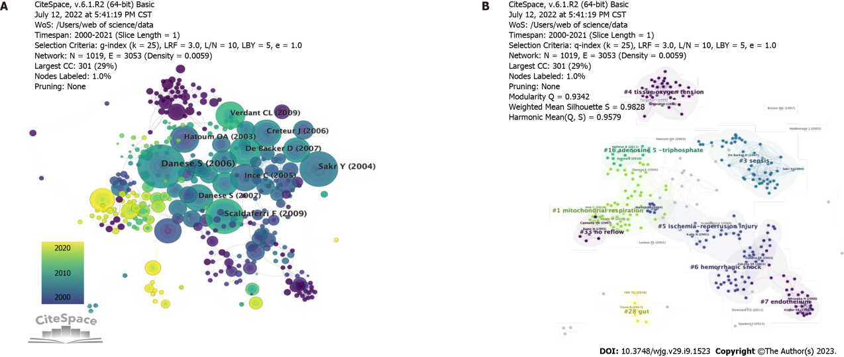
Figure 5 The network map of co-cited references in the intestinal microcirculatory research. A: The network map of co-cited references. Nodes in the visualized network represent co-cited references and lines between nodes represent co-cited links; B: The network map of co-cited clusters. 9 clusters with diversified research themes were formed and illustrated in different colors. Silhouette = 0.9828. Modularity Q = 0.9342.
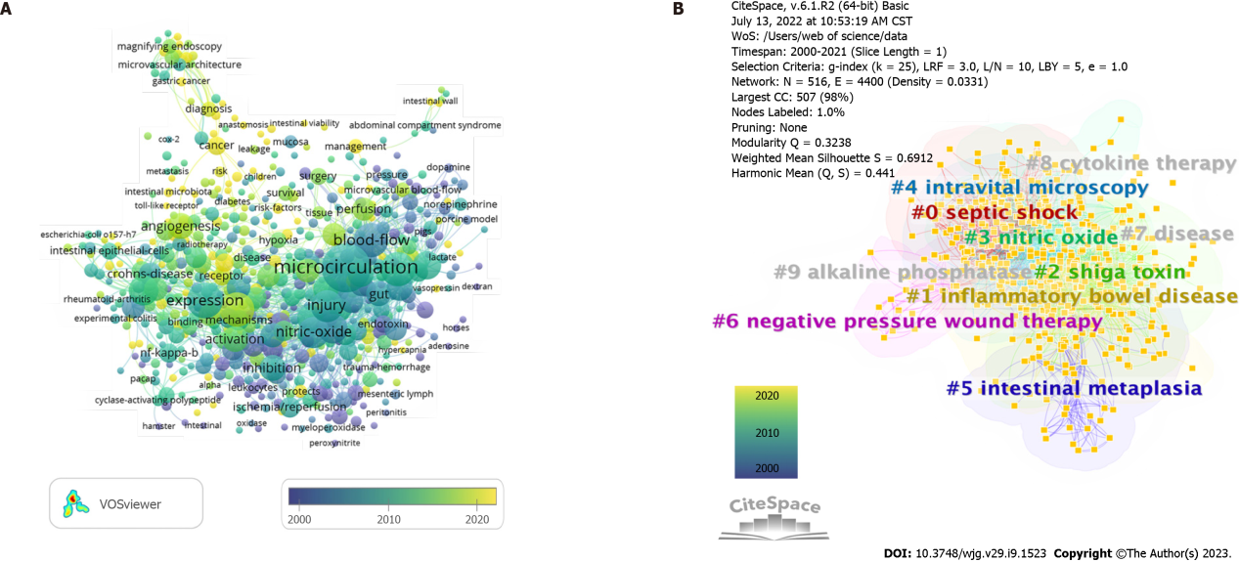
Figure 6 The network map of keywords in the intestinal microcirculatory research. A: The co-occurrence map of keywords in the intestinal microcirculatory research. The graphical mapping of terms was created when setting the minimum number of keyword occurrences to 5. Of the 6607 keywords in the field, 572 reached this threshold. Each node represents a keyword, and the sizes of the node denote the number of occurrences of the keywords map. The transition from blue to yellow in the color bar depicts the years 2000 to 2021; B: The clustering map of keywords in the intestinal microcirculatory research. 10 clusters with diversified themes were formed and illustrated in different colors. Colors represent clusters of the close-working network. Silhouette = 0.3238. Modularity Q = 0.6912.
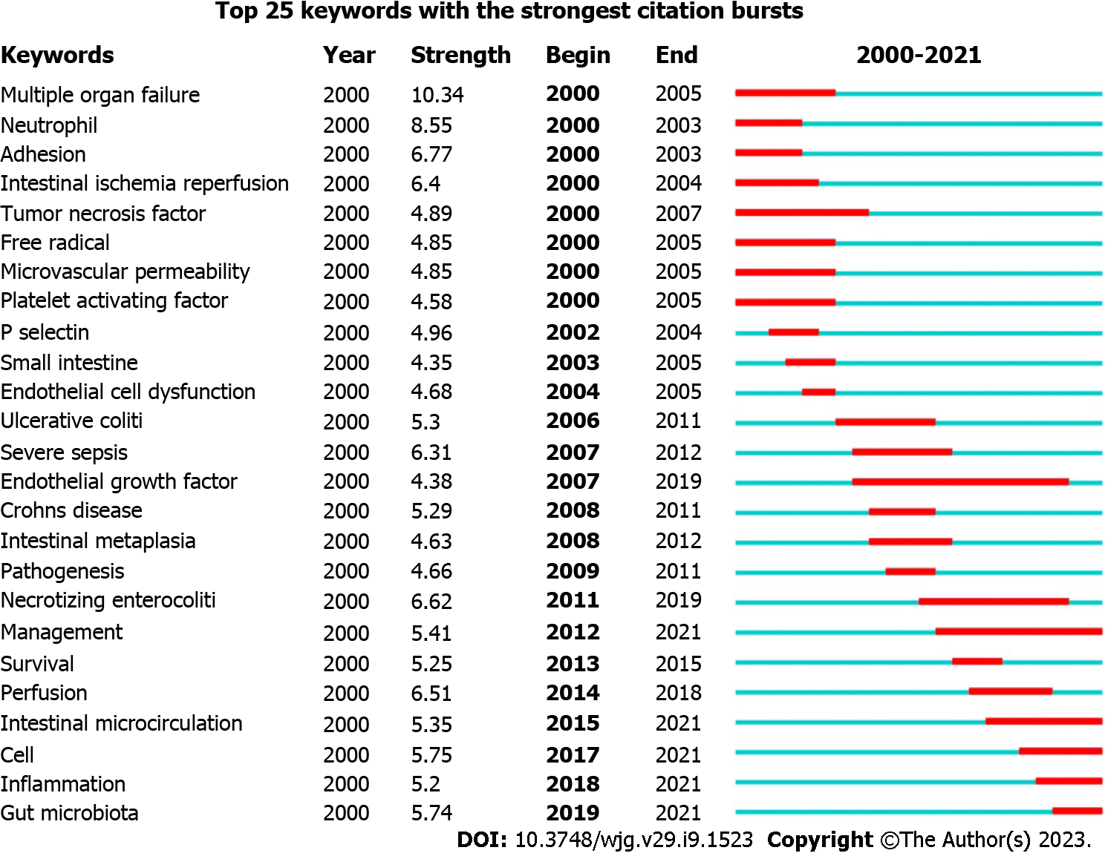
Figure 7 Top 25 keywords with the strongest citation bursts. Keywords bursts identify as indicators of emerging trends in the intestinal microcirculatory field to a published article. In the burst detection, “begin” represented the year the reference began to have a citation burst, and “end” represented the year ended the citation burst. The red line is the time of duration and the “strength” is the intensity of the citation burst.
Table 1 The top 10 countries and institutions contributed to publications on intestinal microcirculation
Rank | Country | Count | Institution | Count
1 | United States | 420 | Dalhousie Univ | 41
2 | Germany | 231 | Univ Szeged | 35
3 | China | 164 | Univ Amsterdam | 33
4 | Japan | 113 | Louisiana State Univ | 31
5 | England | 77 | Med Coll Wisconsin | 29
6 | Canada | 69 | Univ Louisville | 29
7 | Italy | 67 | Univ Munster | 23
8 | Netherlands | 63 | Univ Sao Paulo | 23
9 | France | 51 | China Agr Univ | 20
10 | Sweden | 47 | Lund Univ | 20

Table 2 The top 10 journals and cited journals of intestinal microcirculation research
Rank | Journal | Count | Cited-journal | Count
1 | Shock | 53 | Nature Reviews Microbiology | 2930
2 | Journal of Surgical Research | 37 | Clinical Microbiology Reviews | 1533
3 | World Journal of Gastroenterology | 36 | Journal of Pathology | 1520
4 | American Journal of Physiology-Gastrointestinal and Liver Physiology | 34 | Critical Care Medicine | 1499
5 | Critical Care Medicine | 34 | Gastroenterology | 1372
6 | Clinical Hemorheology and Microcirculation | 27 | American Journal of Physiology-Gastrointestinal and Liver Physiology | 1175
7 | Microcirculation | 20 | World Journal of Gastroenterology | 1126
8 | Microvascular Research | 95 | Science | 968
9 | Plos One | 73 | Shock | 965
10 | American Journal of Physiology-Heart and Circulatory Physiology | 70 | Journal of Immunology | 937
Table 3 Top 10 highly cited publications in intestinal microcirculation
Rank | Title | Citations | Journal | First author | Published year
1 | Enhanced Leukocyte Binding by Intestinal Microvascular Endothelial Cells in Inflammatory Bowel Disease | 65 | Gastroenterology | David G. Binion | 1997
2 | Intestinal mucosal lesion in low-flow states | 62 | Archives of Surgery | Chu-Jeng Chiu | 1970
3 | The microcirculation is the motor of sepsis | 49 | Critical care | Can Ince | 2005
4 | Microvascular Blood Flow Is Altered in Patients with Sepsis | 46 | American Journal of Respiratory and Critical Care Medicine | Daniel De Backer | 2002
5 | How to evaluate the microcirculation: report of a round table conference | 45 | Critical care | Daniel De Backer | 2007
6 | Preparation of rat intestinal muscle and mucosa for quantitative microcirculatory studies | 43 | Microcirculation research | H.Glenn Bohlen | 1976
7 | Persistent microcirculatory alterations are associated with organ failure and death in patients with septic shock | 42 | Critical care medicine | Yasser Sakr | 2004
8 | Microcirculatory oxygenation and shunting in sepsis and shock | 34 | Critical care medicine | Can Ince | 1999
9 | Angiogenesis as a Novel Component of Inflammatory Bowel Disease Pathogenesis | 32 | Gastroenterology | Silvio Danese | 2006
10 | Ischemia–Reperfusion Injury of the Intestine and Protective Strategies Against Injury | 32 | Digestive Diseases and Sciences | Ismail Hameed Mallick | 2004

Table 4 Top 10 keywords in terms of frequency
Rank | Frequency | Centrality | Keywords
1 | 136 | 0.05 | Expression
2 | 136 | 0.04 | Nitric oxide
3 | 134 | 0.06 | Blood flow
4 | 109 | 0.05 | Rat
5 | 106 | 0.03 | Injury
6 | 100 | 0.04 | Microvascular endothelial cell
7 | 100 | 0.08 | Inflammatory bowel disease
8 | 92 | 0.06 | Microcirculation
9 | 85 | 0.08 | Sepsis
10 | 85 | 0.05 | Septic shock

Published by Baishideng Publishing Group Inc
7041 Koll Center Parkway, Suite 160, Pleasanton, CA 94566, USA
Telephone: +1-925-3991568
E-mail: bpgoffice@wjgnet.com
Help Desk: https://www.f6publishing.com/helpdesk
https://www.wjgnet.com

© 2023 Baishideng Publishing Group Inc. All rights reserved.

