Name of Journal: World Journal of Clinical Cases
Manuscript NO: 86082
Manuscript Type: CASE REPORT

Single omental metastasis of renal cell carcinoma after radical nephrectomy: A case report

Chung JW et al. Single omental metastasis of RCC

Jae-Wook Chung, Jun-Koo Kang, Eun Hye Lee, So Young Chun, Yun-Sok Ha, Jun Nyung Lee, Tae-Hwan Kim, Tae Gyun Kwon, Ghil Suk Yoon

Jae-Wook Chung, Jun-Koo Kang, Yun-Sok Ha, Jun Nyung Lee, Tae-Hwan Kim, Tae Gyun Kwon, Department of Urology, Kyungpook National University Hospital, Daegu 41404, South Korea

Jae-Wook Chung, Yun-Sok Ha, Jun Nyung Lee, Tae-Hwan Kim, Tae Gyun Kwon, Department of Urology, School of Medicine, Kyungpook National University, Daegu 41404, South Korea

Jae-Wook Chung, Eun Hye Lee, So Young Chun, Yun-Sok Ha, Jun Nyung Lee, Tae-Hwan Kim, Tae Gyun Kwon, Biomedical Research Institute, Kyungpook National University, Daegu 41404, South Korea

Jae-Wook Chung, Yun-Sok Ha, Jun Nyung Lee, Tae-Hwan Kim, Tae Gyun Kwon, Joint Institute for Regenerative Medicine, Kyungpook National University, Daegu 41404, South Korea

Ghil Suk Yoon, Department of Pathology, Kyungpook National University Hospital, Daegu 41404, South Korea

Ghil Suk Yoon, Department of Pathology, School of Medicine, Kyungpook National University, Daegu 41404, South Korea

Author contributions: Chung JW, Kang JK, Kwon TG, and Yoon GS contributed to manuscript writing and editing and data collection; Lee EH, Chun SY, Ha YS, Lee JN, and Kim TH contributed to data analysis; Kwon TG and Yoon GS contributed to conceptualization and supervision; all authors have read and approved the final manuscript.

Corresponding author: Ghil Suk Yoon, MD, PhD, Professor, Department of Pathology, Kyungpook National University Hospital, Hakjeong-ro 561, Buk-gu, Daegu 41404, South Korea. gsyoon@knu.ac.kr

Received: May 31, 2023
Revised: July 28, 2023
Accepted: August 8, 2023
Published online:

Abstract
BACKGROUND
Renal cell carcinoma (RCC) is the third most common malignancy in the genitourinary tract. The lungs, bone, lymph nodes, liver, and brain are common metastatic sites of RCC. However, there is limited literature on single omental metastasis of RCC.

CASE SUMMARY
We present the case of a 44-year-old man with single omental metastasis of RCC after laparoscopic radical nephrectomy. Pathological diagnosis of the resected left kidney revealed pT3a clear cell RCC (Fuhrman grade III). At 6 mo postoperatively, abdominal computed tomography revealed a 12-mm enhancing nodule in the left lower peritoneum. At 7 mo after initial operation, laparoscopic removal of the left omental nodule was performed. The pathological results indicated metastatic clear cell RCC. Currently, the patient is being treated with adjuvant pembrolizumab.

CONCLUSION
Omental metastasis of RCC owing to laparoscopic radical nephrectomy is rare. Urologists should be aware of the diverse nature of RCC.

Key Words: Metastasis; Omentum; Renal cell carcinoma; Radical nephrectomy; Case report

Chung JW, Kang JK, Lee EH, Chun SY, Ha YS, Lee JN, Kim T, Kwon TG, Yoon GS. Single omental metastasis of renal cell carcinoma after radical nephrectomy: A case report. World J Clin Cases 2023; In press

Core Tip: The authors present the case of a 44-year-old man with single omental metastasis of renal cell carcinoma (RCC) after laparoscopic radical nephrectomy. Omental metastasis of RCC owing to laparoscopic radical nephrectomy is rare. Urologists should be aware of the diverse nature of RCC.

INTRODUCTION
Renal cell carcinoma (RCC) is the third most common malignancy in the genitourinary tract^{[1]}. In South Korea, the incidence of RCC has been rising, with 6952 new cases estimated in both sexes in 2022^{[2]}. The lungs, bone, lymph nodes, liver, and brain are common metastatic sites of RCC^{[1,3]}. However, literature on single omental metastasis of RCC is limited. We herein present the case of a 44-year-old man with single omental metastasis of RCC after laparoscopic radical nephrectomy.

CASE PRESENTATION
Chief complaints
A 44-year-old man with gross hematuria and left flank pain visited our emergency department on July 14, 2022.

History of present illness
The patient’s gross hematuria started 1 day before admission. In the morning of the day of visit, the hematuria became more severe and was accompanied with clots. Moreover, he experienced severe pain in the left flank.

History of past illness
The patient was healthy and had a history of appendectomy 10 years earlier.

Personal and family history
The patient denied any history of tobacco or alcohol consumption. He had no medication history. His family history was unremarkable.

Physical examination
At the emergency department, the patient’s initial vital signs were stable. His blood pressure level was 129/79 mmHg, pulse rate was 81 beats/min, and respiratory rate was 16 breaths/min. The patient’s body weight was 86 kg, and his height was 171.0 cm (body mass index = 29.4 kg/m²). There was no palpable mass around the left flank area. The patient showed left flank tenderness but no rebound tenderness.

Laboratory examinations
Laboratory serum tests were normal (hemoglobin level: 13.7 g/dL, creatinine level: 1.05 mg/dL, and calcium level: 9.1 mg/dL). Urinalysis revealed the presence of many red blood cells. Electrocardiogram indicated normal sinus rhythm.

Imaging examinations
Initial kidney dynamic computed tomography (CT) (three phases of intravenous contrast enhancement) revealed an 8.8 cm × 6.1 cm heterogeneously enhancing mass in the upper to mid pole of the left kidney abutting the left adrenal gland and pancreas (Figure 1). No metastatic lesions were detected in the enhanced brain and chest CT scans.
Follow-up CT 3 mo after radical nephrectomy showed no metastatic lesions. However, at 6 mo postoperatively, abdominal CT revealed a 12-mm enhancing nodule in the left lower peritoneum (Figure 2). 18F-fluorodeoxyglucose (FDG) positron emission tomography/CT (Figure 3) was performed immediately, and the results were the same (mildly hypermetabolic nodule in the left lower peritoneum).

FINAL DIAGNOSIS
Pathological diagnosis of the resected specimen from initial radical nephrectomy revealed pT3a clear cell RCC (Fuhrman grade III). Tumor capsular invasion was absent, but lymphovascular invasion and tumor cell necrosis were present (10%). No tumor was observed in the left adrenal gland.
The pathological results of the second laparoscopic removal of the left omental nodule revealed metastatic clear cell RCC (Figure 4).

TREATMENT
At the time of the patient’s visit to emergency department, he experienced severe flank pain and gross hematuria; therefore, we decided to perform emergency surgery rather than elective surgery. Laparoscopic radical nephrectomy and adrenalectomy were performed on the same day. We inserted a 12-mm camera port near the umbilicus. Mild adhesion was observed between the renal mass and pancreas, but pancreatic injury did not occur. No tumor spillage was found during radical nephrectomy. We further opened the 12-mm camera port to remove the specimen from the abdominal cavity using endobag (Lapbag®, SEJONG Medical).
On February 3, 2023, laparoscopic removal of the left omental nodule was performed. The patient underwent the second surgery in the supine position. A 12-mm port was inserted just above the umbilicus, and other 12- and 5-mm ports were inserted in the anterior axillary line at the level of the umbilicus and 2 cm below the xiphoid process. Fortunately, the nodule was visible immediately after entering the abdominal cavity, and the urologist could remove the nodule without any help from a general surgeon.

OUTCOME AND FOLLOW-UP
No metastatic lesion was observed in the most recent CT scan. The most recent brain, chest, and abdomen CT was performed on July 5, 2023. In other words, the interval between the primary surgery and the most recent CT was 12 mo.
Currently, the patient is being treated with adjuvant pembrolizumab. However, adjuvant pembrolizumab is not covered by Korean health insurance. Therefore, immediately after radical nephrectomy, he refused adjuvant pembrolizumab owing to its high cost but agreed to administer it after the second operation.
At our hospital, immunotherapy or targeted therapy for RCC is entirely established by urologists, not medical oncologists. Therefore, JWC decided to initiate treatment with adjuvant pembrolizumab. The duration/scheme of pembrolizumab application is intravenous injection every 3 wk, with at least ten administrations^{[4]}.
Thyroid function tests revealed minor abnormalities, but no recent side effects have been reported.

DISCUSSION
Kidney cancers are the third most common genitourinary malignancy, accounting for over 431288 new cancer diagnoses and over 179368 deaths worldwide annually^{[5]}. CT and magnetic resonance imaging have increased the diagnosis of early RCC in many patients. The 5-year survival rate for early RCC is approximately 93%; however, the 5-year survival rate of RCC patients with metastases is only 12%^{[6]}.
RCC commonly metastasizes to the lung parenchyma (45.2%), bone (29.5%), lymph nodes (20.8%), liver (20.3%), adrenal glands (8.9%), and brain (8.1%)^{[1]}. Metastases into the pancreas are rare and found mostly in asymptomatic patients^{[7]}. Other atypical RCC metastases in the omentum, thyroid, and mediastinum are extremely rare. In particular, port-site metastasis or peritoneal metastasis after a laparoscopic procedure for urological malignancies is a rare event, accounting for approximately 0.09 % and 0.03 % of total cases, respectively^{[8,9]}. RCC is the least common urological malignancy that leads to port-site metastasis or peritoneal metastasis, with only rare cases being reported in the literature^{[10]}.
In 2013, Ploumidis et al^{[9]} presented a case report concerning tumor seeding in the omentum found in a 75-year-old female patient after a previous transperitoneal robot-assisted radical nephrectomy for papillary RCC. Two years after the initial surgery, the patient was diagnosed with cervical cancer, leading to radical hysterectomy with lymphadenectomy and omentectomy. Incidentally, a neoplastic omental nodule was discovered during the surgery. Pathological outcome and immunohistochemistry result confirmed the presence of features consistent with papillary RCC. In 2016, Acar et al^{[3]} also presented a case report of a 62-year-old male patient who, 13 years after having undergone open extraperitoneal partial nephrectomy for pT1 clear cell RCC, developed an omental metastatic lesion.
Similarly, we present the case of a 44-year-old man with single omental metastasis of RCC after laparoscopic radical nephrectomy. We reviewed the recorded video of the surgery again and did not find intraoperative tumor spillage. We can conjecture that despite the absence of macroscopic surgically induced tumor spillage, there is a possibility that certain tumorigenic yet nonmetastasizing neoplastic cells, which typically do not survive the metastatic cascade under normal circumstances, could have been transferred and aided in establishing a novel neoplastic colony.

CONCLUSION
In summary, omental metastasis of RCC because of laparoscopic radical nephrectomy is rare. Urologists should be aware of the diverse nature of RCC. Various therapeutic approaches should be considered, such as morphological and functional imaging studies together with histopathological assessment of metastatic lesions, and a fundamental treatment for the causative disease should be applied.

REFERENCES
1 Bruckschen F, Gerharz CD, Sagir A. Renal cell carcinoma with unusual metachronous metastasis up to 22 years after nephrectomy: two case reports. J Med Case Rep 2021; 15: 490 [PMID: 34607612 DOI: 10.1186/s13256-021-03098-5]
2 Jung KW, Won YJ, Hong S, Kong HJ, Lee ES. Prediction of Cancer Incidence and Mortality in Korea, 2020. Cancer Res Treat 2020; 52: 351-358 [PMID: 32178488 DOI: 10.4143/crt.2020.203]
3 Acar Ö, Mut T, Sağlıcan Y, Sag AA, Falay O, Selcukbiricik F, Tabak L, Esen T. Isolated omental metastasis of renal cell carcinoma after extraperitoneal open partial nephrectomy: A case report. Int J Surg Case Rep 2016; 21: 6-11 [PMID: 26874583 DOI: 10.1016/j.ijscr.2016.02.008]
4 Choueiri TK, Tomczak P, Park SH, Venugopal B, Ferguson T, Chang YH, Hajek J, Symeonides SN, Lee JL, Sarwar N, Thiery-Vuillemin A, Gross-Goupil M, Mahave M, Haas NB, Sawrycki P, Gurney H, Chevreau C, Melichar B, Kopyltsov E, Alva A, Burke JM, Doshi G, Topart D, Oudard S, Hammers H, Kitamura H, Bedke J, Perini RF, Zhang P, Imai K, Willemann-Rogerio J, Quinn DI, Powles T; KEYNOTE-564 Investigators. Adjuvant Pembrolizumab after Nephrectomy in Renal-Cell Carcinoma. N Engl J Med 2021; 385: 683-694 [PMID: 34407342 DOI: 10.1056/NEJMoa2106391]
5 Saad AM, Gad MM, Al-Husseini MJ, Ruhban IA, Sonbol MB, Ho TH. Trends in Renal-Cell Carcinoma Incidence and Mortality in the United States in the Last 2 Decades: A SEER-Based Study. Clin Genitourin Cancer 2019; 17: 46-57.e5 [PMID: 30391138 DOI: 10.1016/j.clgc.2018.10.002]
6 Kumar S, Singh V, Singh MK, Sankhwar SN. Management of Metastatic Renal Cell Carcinoma in a Tertiary Care Hospital. Cureus 2023; e35623 [DOI: 10.7759/cureus.35623]
7 Tosoian JJ, Cameron JL, Allaf ME, Hruban RH, Nahime CB, Pawlik TM, Pierorazio PM, Reddy S, Wolfgang CL. Resection of isolated renal cell carcinoma metastases of the pancreas: outcomes from the Johns Hopkins Hospital. J Gastrointest Surg 2014; 18: 542-548 [PMID: 24163138 DOI: 10.1007/s11605-013-2278-2]
8 Tanaka K, Hara I, Takenaka A, Kawabata G, Fujisawa M. Incidence of local and port site recurrence of urologic cancer after laparoscopic surgery. Urology 2008; 71: 728-734 [PMID: 18279936 DOI: 10.1016/j.urology.2007.10.054]
9 Ploumidis A, Panoskaltsis T, Gavresea T, Yiannou P, Yiannakou N, Pavlakis K. Tumor seeding incidentally found two years after robotic-Assisted radical nephrectomy for papillary renal cell carcinoma. A case report and review of the literature. Int J Surg Case Rep 2013; 4: 561-564 [PMID: 23632074 DOI: 10.1016/j.ijscr.2013.03.031]
10 Castillo OA, Vitagliano G. Port site metastasis and tumor seeding in oncologic laparoscopic urology. Urology 2008; 71: 372-378 [PMID: 18342166 DOI: 10.1016/j.urology.2007.10.064]

Footnotes
Informed consent statement: The present study was approved by the Ethics Committee (IRB Number: KNUCH 2023-03-009) and performed in accordance with the ethical standards laid down in the 1964 Declaration of Helsinki and its later amendments. The need for informed consent was waived by the aforementioned IRB due to the retrospective nature and single case report of the study.

Conflict-of-interest statement: All the authors declare that they have no conflict of interest to disclose.

CARE Checklist (2016) statement: The authors have read the CARE Checklist (2016), and the manuscript was prepared and revised according to the CARE Checklist (2016).

Open-Access: This article is an open-access article that was selected by an in-house editor and fully peer-reviewed by external reviewers. It is distributed in accordance with the Creative Commons Attribution NonCommercial (CC BY-NC 4.0) license, which permits others to distribute, remix, adapt, build upon this work non-commercially, and license their derivative works on different terms, provided the original work is properly cited and the use is non-commercial. See: https://creativecommons.org/Licenses/by-nc/4.0/

Provenance and peer review: Unsolicited article; Externally peer reviewed.
Peer-review model: Single blind

Peer-review started: May 31, 2023
First decision: July 19, 2023
Article in press:

Specialty type: Urology and Nephrology
Country/Territory of origin: South Korea
Peer-review report’s scientific quality classification
Grade A (Excellent): 0
Grade B (Very good): 0
Grade C (Good): C
Grade D (Fair): D
Grade E (Poor): 0

P-Reviewer: Sawazaki H, Japan; Taskovska M, Slovenia S-Editor: Liu JH L-Editor: Wang TQ P-Editor: Liu JH
Figure Legends
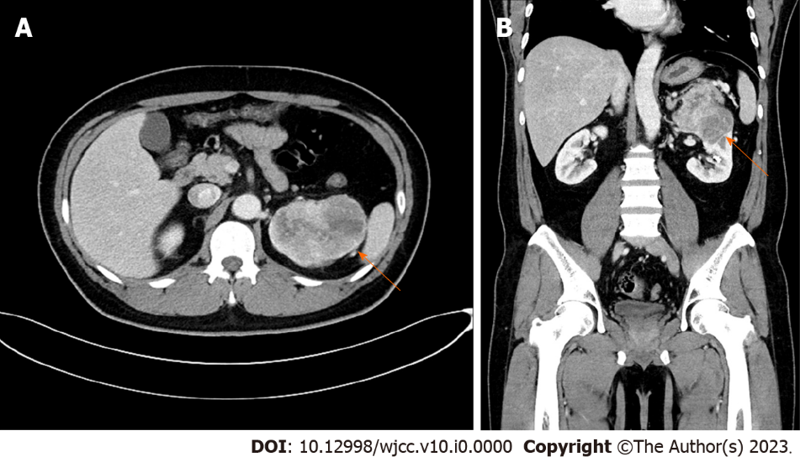
Figure 1 Kidney dynamic computed tomography. A: Axial view; B: Coronal view. Initial kidney dynamic computed tomography showing an 8.8 cm × 6.1 cm heterogeneously enhancing mass in the upper to mid pole of the left kidney abutting onto the left adrenal gland and pancreas (arrows).

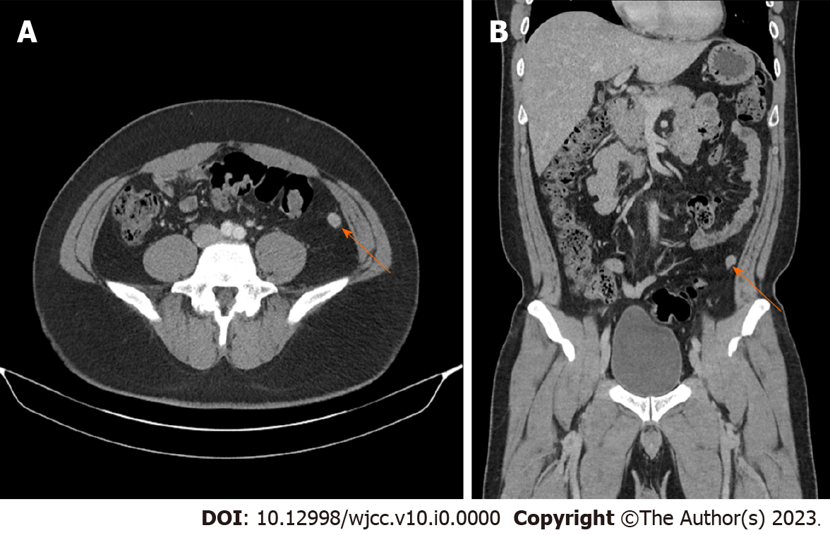
Figure 2 Abdominal computed tomography. A: Axial view; B: Coronal view. Abdominal computed tomography at 6 mo postoperatively showed a 12 mm enhancing nodule at the left lower peritoneum (arrows).

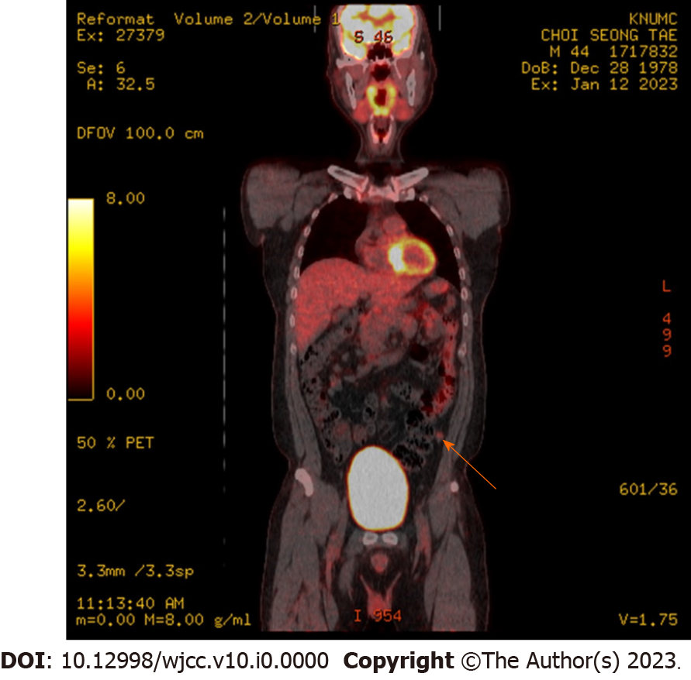
Figure 3 18F-fluorodeoxyglucose positron emission tomography/computed tomography. F-fluorodeoxyglucose positron emission tomography/computed tomography at 6 mo postoperatively showed a hypermetabolic nodule in the left lower peritoneum (arrow).

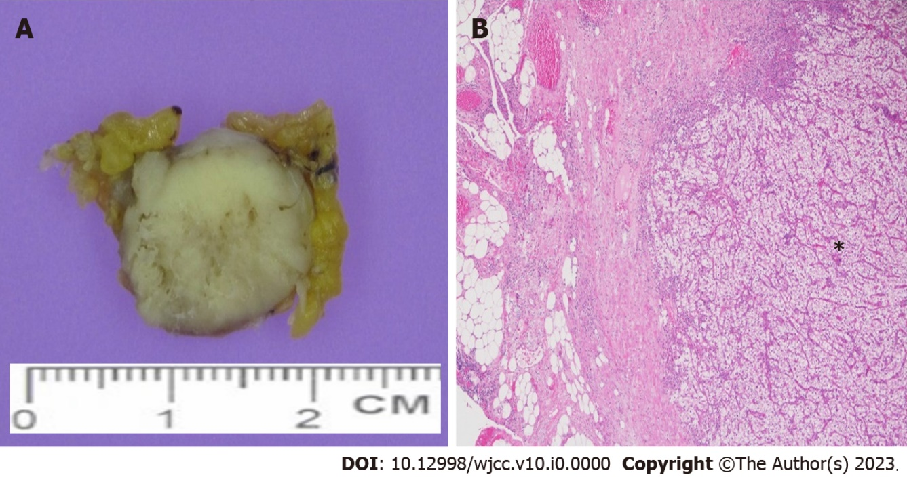
Figure 4 Histologic outcomes. Gross and microscopic features in this case: A: Gross examination; B: Hematoxylin and eosin (H&E) staining (magnification, × 400). A: Gross finding shows a well-defined pale yellow solid mass in fibroadipose tissue of the abdominal wall; B: Histological finding shows a metastatic clear cell renal cell carcinoma consisting of atypical clear cell nests in fibroadipose tissue (*).

