Name of Journal: World Journal of Clinical Cases
Manuscript NO: 67694
Manuscript Type: CASE REPORT

Perfect pair, scopes unite—laparoscopic-assisted transumbilical gastroscopy for gallbladder-preserving polypectomy: A case report

Zheng Q et al. Minimally invasive: Endoscopic gallbladder-preserving polypectomy

Quan Zheng, Gang Zhang, Xiao-Huan Yu, Zhen-Feng Zhao, Lu Lu, Jing Han, Jin-Zhuo Zhang, Jin-Ku Zhang, Ying Xiong

Quan Zheng, Xiao-Huan Yu, Jing Han, Jin-Zhuo Zhang, Ying Xiong, Department of Gastroenterology, Baoding No. 1 Central Hospital, Baoding 071000, Hebei Province, China

Gang Zhang, Department of General Surgery, Baoding No. 1 Central Hospital, Baoding 071000, Hebei Province, China

Zhen-Feng Zhao, Lu Lu, Endoscopic Treatment Center, Baoding No. 1 Central Hospital, Baoding 071000, Hebei Province, China

Jin-Ku Zhang, Key Laboratory of Molecular Pathology ang Early Diagnosis of Tumor in Hebei Province, Baoding No. 1 Central Hospital, Baoding 071000, Hebei Province, China

Author contributions: Zheng Q performed all the procedures and drafted, edited and approved the final manuscript; Xiong Y and Zhang G drafted, edited and approved the final manuscript; all authors read and approved the final manuscript.

Corresponding author: Ying Xiong, MD, Professor, Department of Gastroenterology, Baoding No. 1 Central Hospital, No. 320 Changcheng North Street, Lianchi District, Baoding 071000, Hebei Province, China. xy_spring@163.com

Received: June 21, 2021
Revised: July 27, 2021
Accepted: September 19, 2021
Published online:

Abstract
BACKGROUND
Gallbladder polyps are one indication for cholecystectomy, but this procedure carries some disadvantages, including the potential for severe injury and high risk of post-operative complications. Laparoscopy combined with endoscopic surgery is a minimally invasive treatment option. We herein report a young patient with a gallbladder polyp who was successfully discharged from the hospital after laparoscopic-assisted endoscopy. This procedure may offer an alternative in the management of such lesions.

CASE SUMMARY
A 24-year-old female patient was hospitalized primarily for a gallbladder polyp. Due to the surgical risk associated with cholecystectomy and the low post-operative quality of life, the woman underwent laparoscopic-assisted transumbilical gastroscopy for gallbladder-preserving polypectomy under endotracheal intubation and general anaesthesia. The operation went smoothly.

CONCLUSION
We conclude laparoscopic-assisted transumbilical gastroscopy for gallbladder-preserving polypectomy is a safe and effective technique for the treatment of gallbladder polyps.

Key Words: Endoscopy; Laparoscopy; Gallbladder polyp; Alternative; Safe; Case report

Zheng Q, Zhang G, Yu XH, Zhao ZF, Lu L, Han J, Zhang JZ, Zhang JK, Xiong Y. Perfect pair, scopes unite—laparoscopic-assisted transumbilical gastroscopy for gallbladder-preserving polypectomy: A case report. World J Clin Cases 2021; In press

Core Tip: Cholecystectomy is currently the standard of care for gallbladder polyps. However, resection techniques not only cause great injury and carry high risk but may also lead to various postoperative complications. We present a successful case of radical resection after laparoscopic-assisted transumbilical gastroscopy for gallbladder-preserving polypectomy without severe postoperative complications.

INTRODUCTION
Laparoscopic-assisted endoscopy has been increasingly used in clinical settings. It results in relatively little trauma to surrounding tissues, is low risk and offers a quick recovery^{[1-5]}.
Laparoscopic-assisted transumbilical gastroscopy for gallbladder-preserving polypectomy was used in place of traditional laparoscopic cholecystectomy to remove a gallbladder polyp safely, effectively and with minimal invasiveness from the gallbladder of this young patient. This method provides a new option for the treatment of gallbladder polyps. We report a case of laparoscopic-assisted endoscopic excision of a gallbladder polyp and evaluate the safety and efficacy of this approach.

CASE PRESENTATION
Chief complaints
A 24-year-old woman presented in this case with a gallbladder polyp requiring treatment.

History of present illness
The patient was hospitalized for a gallbladder polyp discovered more than 3 years prior. The patient’s gallbladder polyp, approximately 0.7 cm × 0.6 cm in size, was found by physical examination 3 years ago, and it was not treated at that time.

History of past illness
She had no specific past illness.

Personal and family history
The patient didn’t have a history of smoking or drinking alcohol. And she has no remarkable family medical history.

Physical examination
No significant abnormalities on physical examination. Her temperature was 36.5°C, pulse rate was 72 beats/min, and blood pressure was 124/86 mmHg.

Laboratory examinations
Blood analysis showed a normal complete blood count, liver function and C-reactive protein.

Imaging examinations
Colour ultrasound examination of the upper abdomen showed a medium-strong echo intensity on the capsule wall, with a size of approximately 1.3 cm × 0.9 cm. There was no obvious sound or shadow behind it, and it did not move with a change in posture (Figure 1).

FINAL DIAGNOSIS
The patient was diagnosed with gallbladder polyp with no dysplasia.

TREATMENT
Laparoscopic-assisted transumbilical gastroscopy for gallbladder-preserving polypectomy was performed (Figure 2). The patient was placed in the supine position under general anaesthesia. Pneumoperitoneum was established using direct trocar insertion in an umbilical location. A right subcostal 12-mm port was then placed. The gastroscope entered the abdominal cavity through the umbilical trocar. The gallbladder was located with the assistance of laparoscopy, and an approximately 2-cm incision in the gallbladder wall was made longitudinally at the bottom of the gallbladder (Figure 2A and B). The procedure was smooth, and no significant bleeding was observed. Endoscopy entering the gallbladder showed a pedicled polyp with a grape cluster appearance (Figure 2C). The lesion was resected by high-frequency electroresection; active bleeding could be seen at the base, and haemostasis was achieved by electrocoagulation with haemostatic forceps (Figure 2D). The specimen was removed and fixed for pathological examination. The gastroscope was withdrawn from the abdominal cavity, and laparoscopic suture of the gallbladder incision was performed, followed by full flushing of the abdominal pelvic cavity and suture of the abdominal incision (Figure 2E). The specimen was found to be a cholesterol polyp. The total operative time was 96 min, and the blood loss was 10 mL.

OUTCOME AND FOLLOW-UP
The patient was cured after the operation, and the specimen was found to be a cholesterol polyp (Figure 2F). Her vital signs were stable, and no obvious abnormality was found in cardiopulmonary or abdominal specialist examinations.

DISCUSSION
The patient was a 24-year-old woman. Routine cholecystectomy to remove the gallbladder not only causes great injury and carries high risk but may also lead to various postoperative complications. Recently reported complications have mainly included postoperative bleeding, bile leakage, biliary peritonitis, subhepatic effusion or subphrenic abscess, postoperative jaundice, postoperative pancreatitis, and gastrointestinal fistula. Long-term complications include bile duct stricture, recurrent choledocholithiasis, biliary bleeding, post-cholecystectomy syndrome, cystic duct residual syndrome, and an increased incidence of colon cancer, among others. These complications can greatly impact the future quality of life of these patients^{[6,7]}. Under this premise, gallbladder-preserving polypectomy was the most minimally invasive and safest treatment for this patient, which also reflects that surgery today needs to consider the concept of minimally invasive and humanized polypectomy.
Laparoscopic-assisted transumbilical gastroscopy for gallbladder-preserving polypectomy gives full play to the respective advantages of laparoscopy and gastroscopy. The advantages of laparoscopy are as follows: (1) It can directly monitor the location of abdominal organs and can provide an intraoperative visual field for endoscopy; and (2) Laparoscopy can be used to suture the gallbladder after the operation and reduce the incidence of biliary fistula and removes the need for metal clips to remain in the body. The advantages of the gastroscope are as follows: (1) It is a “soft lens” with a good degree of freedom. Gastroscopy can remove polyps under direct vision of the gallbladder and can locate small polyps that cannot be detected by ultrasound and other simultaneous auxiliary examinations; and (2) Tissue staining combined with electronic endoscopy (NBI, BLI, etc.) can improve the diagnosis rate of early cancer. Therefore, the complementary advantages of gastroscopy and laparoscopy provide the best solution for gallbladder-preserving polypectomy.
Laparoscopic-assisted endoscopic techniques are increasingly being used^{[8]}, including laparoscopic-assisted endoscopic retrograde cholangiopancreatography (LA-ERCP) and laparoscopic-assisted endoscopic ultrasound (LA-EUS)^{[9,10]}. In a dual-centre study reported by Bowman et al^{[11]} these surgical approaches were used for patients who underwent Roux-en-Y gastric bypass and developed pancreatobiliary issues after surgery. Bowman et al^{[11]} argued in this study that LA-ERCP and combined LA-EUS plus LA-ERCP are safe and highly successful diagnostic and therapeutic modalities for patients. The advantages of laparoscopic-assisted transumbilical gastroscopy for gallbladder-preserving polypectomy over these laparoscopic-assisted peroral gastroscopy procedures are as follows: The gastroscope does not enter the abdominal cavity through a window in the stomach wall through the oral cavity but through the umbilicus, a natural cavity, which is clearly safer and minimally invasive, as the stomach incision does not need to be sutured when removing the scope. By minimizing the operation of the laparoscope during surgery, the laparoscope is only responsible for observing the position of the gallbladder and suturing the gallbladder incision, which shortens the operative time and reduces the risk associated with surgery.
This operation reflects the organic combination of laparoscopy and endoscopy, giving full play to their respective advantages. With the concept of minimally invasive therapy deeply rooted in the hearts of people and the continuously increasing demand for improvements in post-surgical aesthetics, the combination of laparoscopy and endoscopy is bound to become the direction of development for minimally invasive therapy^{[12,13]}. This combination meets not only the aesthetic requirement of “no scar” surgery but also the inevitable trend toward more accurate and minimally invasive medical surgery in the 21st century.

CONCLUSION
To our knowledge, this is the first report of laparoscopic-assisted transumbilical gastroscopy for gallbladder-preserving polypectomy. We encountered no complications in the case. Our results suggest that this new method is safe and effective in the treatment of gallbladder polyps when cholecystectomy is not possible or available.

REFERENCES
1 Ceppa FA, Gagné DJ, Papasavas PK, Caushaj PF. Laparoscopic transgastric endoscopy after Roux-en-Y gastric bypass. Surg Obes Relat Dis 2007; 3: 21-24 [PMID: 17116423 DOI: 10.1016/j.soard.2006.08.018]
2 Nguyen NT, Hinojosa MW, Slone J, Lee J, Khiatani V, Wilson SE. Laparoscopic transgastric access to the biliary tree after Roux-en-Y gastric bypass. Obes Surg 2007; 17: 416-419 [PMID: 17546853 DOI: 10.1007/s11695-007-9051-0]
3 Martinez J, Guerrero L, Byers P, Lopez P, Scagnelli T, Azuaje R, Dunkin B. Endoscopic retrograde cholangiopancreatography and gastroduodenoscopy after Roux-en-Y gastric bypass. Surg Endosc 2006; 20: 1548-1550 [PMID: 16897292 DOI: 10.1007/s00464-005-0267-6]
4 Pimentel RR, Mehran A, Szomstein S, Rosenthal R. Laparoscopy-assisted transgastrostomy ERCP after bariatric surgery: case report of a novel approach. Gastrointest Endosc 2004; 59: 325-328 [PMID: 14745421 DOI: 10.1016/s0016-5107(03)02549-5]
5 Roberts KE, Duffy AJ, Bell RL. Laparoscopic transgastric repair of a gastrogastric fistula after gastric bypass: a novel technique. Surg Innov 2007; 14: 18-23 [PMID: 17442875 DOI: 10.1177/1553350606298966]
6 Strasberg SM. Laparoscopic biliary surgery. Gastroenterol Clin North Am 1999; 28: 117-132, vii [PMID: 10198781 DOI: 10.1016/s0889-8553(05)70046-7]
7 Maydeo A, Dhir V. The gallbladder polyp conundrum: a riddler on the wall. Gastrointest Endosc 2013; 78: 494-495 [PMID: 23948197 DOI: 10.1016/j.gie.2013.04.175]
8 Roberts KE, Panait L, Duffy AJ, Jamidar PA, Bell RL. Laparoscopic-assisted transgastric endoscopy: current indications and future implications. JSLS 2008; 12: 30-36 [PMID: 18402736]
9 Lopes TL, Clements RH, Wilcox CM. Laparoscopy-assisted ERCP: experience of a high-volume bariatric surgery center (with video). Gastrointest Endosc 2009; 70: 1254-1259 [PMID: 19846085 DOI: 10.1016/j.gie.2009.07.035]
10 Bertin PM, Singh K, Arregui ME. Laparoscopic transgastric endoscopic retrograde cholangiopancreatography (ERCP) after gastric bypass: case series and a description of technique. Surg Endosc 2011; 25: 2592-2596 [PMID: 21416184 DOI: 10.1007/s00464-011-1593-5]
11 Bowman E, Greenberg J, Garren M, Guda N, Rajca B, Benson M, Pfau P, Soni A, Walker A, Gopal D. Laparoscopic-assisted ERCP and EUS in patients with prior Roux-en-Y gastric bypass surgery: a dual-center case series experience. Surg Endosc 2016; 30: 4647-4652 [PMID: 26823057 DOI: 10.1007/s00464-016-4746-8]
12 Cho WY, Kim YJ, Cho JY, Bok GH, Jin SY, Lee TH, Kim HG, Kim JO, Lee JS. Hybrid natural orifice transluminal endoscopic surgery: endoscopic full-thickness resection of early gastric cancer and laparoscopic regional lymph node dissection--14 human cases. Endoscopy 2011; 43: 134-139 [PMID: 21108175 DOI: 10.1055/s-0030-1255955]
13 Hammad H, Esmadi M, Ahmad D, Reicks M, Rawlings A. Laparoscopic and hand-assisted deep enteroscopy with polypectomy in Peutz-Jeghers syndrome. Gastrointest Endosc 2014; 79: 26 [PMID: 24064371 DOI: 10.1016/j.gie.2013.07.044]

Footnotes
Informed consent statement: Informed written consent was obtained from the patient for publication of this report and any accompanying images.

Conflict-of-interest statement: The authors have no conflict of interest to report.

CARE Checklist (2016) statement: The authors have read the CARE Checklist (2016), and the manuscript was prepared and revised according to the CARE Checklist (2016).

Open-Access: This article is an open-access article that was selected by an in-house editor and fully peer-reviewed by external reviewers. It is distributed in accordance with the Creative Commons Attribution NonCommercial (CC BY-NC 4.0) license, which permits others to distribute, remix, adapt, build upon this work non-commercially, and license their derivative works on different terms, provided the original work is properly cited and the use is non-commercial. See: http://creativecommons.org/Licenses/by-nc/4.0/

Manuscript source: Unsolicited manuscript

Peer-review started: June 21, 2021
First decision: July 14, 2021
Article in press:

Specialty type: Gastroenterology and Hepatology
Country/Territory of origin: China
Peer-review report’s scientific quality classification
Grade A (Excellent): 0
Grade B (Very good): B
Grade C (Good): 0
Grade D (Fair): 0
Grade E (Poor): 0

P-Reviewer: Saraiva MM S-Editor: Chang KL L-Editor: A P-Editor:

Figure Legends
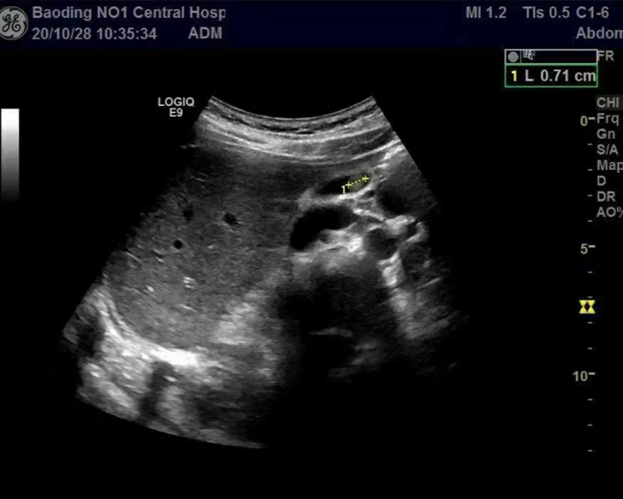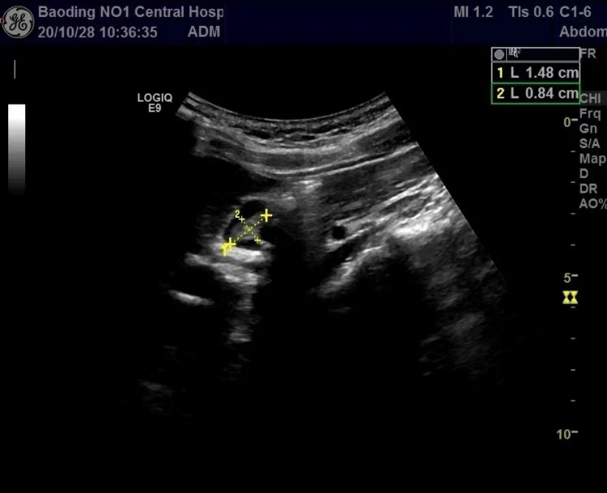
Figure 1 The polyp in the gallbladder shows a medium-strong echo intensity.

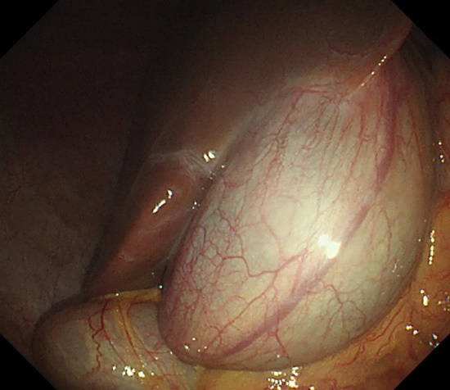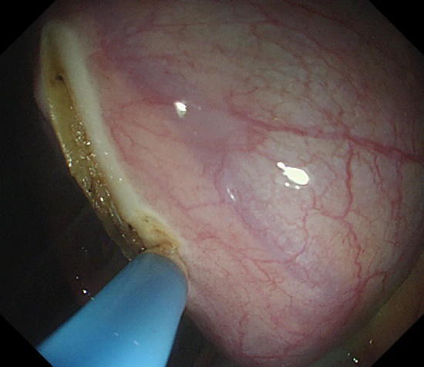
A B
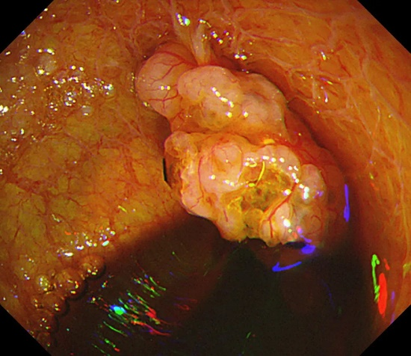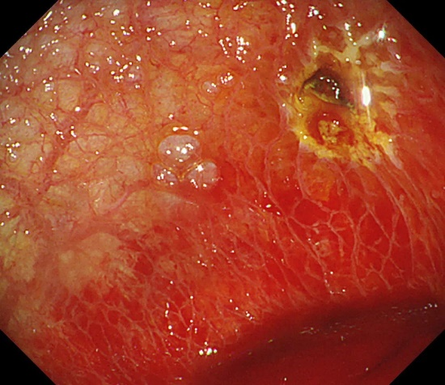
C D
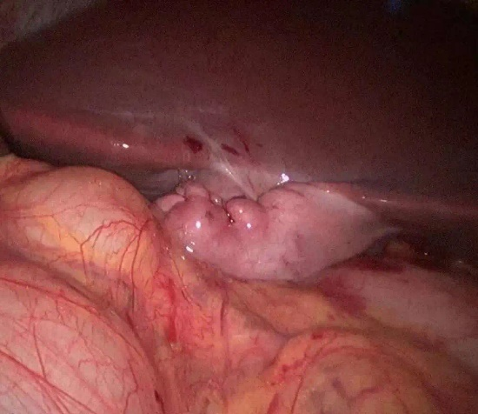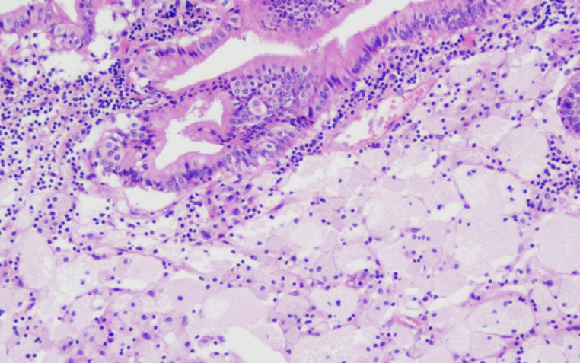
E F
Figure 2 Laparoscopic-assisted transumbilical gastroscopy for gallbladder-preserving polypectomy. A and B: The gastroscope entered the abdominal cavity through the umbilical trocar. The gallbladder was located with the assistance of laparoscopy, and an approximately 2-cm incision in the gallbladder wall was made longitudinally at the bottom of the gallbladder; C and D: Endoscopy entering the gallbladder showed a pedicled polyp with the appearance of a grape cluster. The lesion was resected by high-frequency electroresection; active bleeding could be seen at the base, and haemostasis was achieved by electrocoagulation with haemostatic forceps. The specimen was removed and fixed for pathological examination; E: The gastroscope was withdrawn from the abdominal cavity. Laparoscopic suture of the gallbladder incision was performed, followed by full flushing of the abdominal pelvic cavity and suture of the abdominal incision; F: The specimen was found to be a cholesterol polyp (Original magnification 200 ×).

