Name of journal: World Journal of Orthopedics
ESPS Manuscript NO: 9686
Columns: Topic Highlight

WJO 5th Anniversary Special Issues (2): Arthroscopic

Utility of arthroscopic guided synovial biopsy in understanding synovial tissue pathology in health and disease states

Wechalekar MD et al. Synovial pathology in health and disease

Mihir D Wechalekar, Malcolm D Smith

Mihir D Wechalekar, Malcolm D Smith, Rheumatology Research Unit, Repatriation General Hospital, Daw Park SA 5041, Australia

Author contributions: Both the authors contributed equally to this work.

Supported by A National Health and Medical Research Council Medical and Dental Postgraduate Research Scholarship to Dr. Mihir D Wechalekar, No. APP1018009

Correspondence to: Malcolm D Smith, BSc (Hons), MBBS, FRACP, PhD, Professor of Medicine, Director of Rheumatology, Southern Adelaide Local Health Network, Rheumatology Research Unit, Repatriation General Hospital, Daws Road, Daw Park SA 5041, South Australia, Australia. malcolm.smith@health.sa.gov.au

Telephone: +61-8-82751819 Fax: +61-8-83744276

Received: February 23, 2014 Revised: April 30, 2014
Accepted: July 12, 2014

Published online:

Abstract
The synovium is the soft tissue lining diarthodial joints, tendon sheaths and bursae and is composed of intimal and subintimal layers. The intimal layer is composed of type A cells (macrophages) and type B cells (fibroblasts); in health, the subintima has few inflammatory cells. The synovium performs several homeostatic functions and is the primary target in several inflammatory arthritides. Inflammatory states are characterised by thickening of the synovial lining, macrophage recruitment and fibroblast proliferation, and an influx of inflammatory cells including lymphocytes, monocytes and plasma cells. Of the various methods employed to perform synovial biospies arthroscopic techniques are considered the “gold standard”, and have an established safety record. Synovial biopsy has been of critical importance in understanding disease pathogenesis and has provided insight into mechanisms of action of targeted therapies by way of direct evidence about events in the synovial tissue in various arthritides. It has been very useful as a research tool for proof of concept studies to assess efficacy and mechanisms of new therapies, provide tissue for in-vitro studies, proteomics and microarrays and allow evaluation for biomarkers that may help predict response to therapy and identify new targets for drug development. It also has diagnostic value in the evaluation of neoplastic or granulomatous disease or infection when synovial fluid analysis is non-contributory.

© 2014 Baishideng Publishing Group Inc. All rights reserved.

Key words: Synovium; Synovial biopsy; Arthroscopy; Inflammatory arthritis; Synovial pathology

Core tip: The synovium is the soft tissue lining diarthodial joints, tendon sheaths and bursae. Arthroscopic synovial biopsy techniques have an established safety record. Synovial biopsy has been of critical importance in understanding disease pathogenesis and mechanisms of action of targeted therapies; it has been invaluable as a research tool in proof of concept studies to assess mechanisms and efficacy of new therapies. It also has diagnostic value when synovial fluid analysis is non-contributory.

Wechalekar MD, Smith MD. Utility of arthroscopic guided synovial biopsy in understanding synovial tissue pathology in health and disease states. World J Orthop 2014; In press

INTRODUCTION
The synovium is the soft tissue lining diarthrodial joints, tendon sheaths and bursae. The normal synovium has intimal and subintimal layers and performs the critical homeostatic functions of non-adherence, control of synovial fluid volume and composition and contributes to chondrocyte nutrition. The synovial membrane is involved in several rheumatic diseases including rheumatoid arthritis (RA), osteoarthritis (OA), the spondyloarthritides and the crystal induced arthropathies; and is the primary target of inflammation in RA. Analyses of the synovial membrane have been central to our current understanding of the pathogenetic mechanisms in the inflammatory arthritides in addition to having provided insight into mechanisms of action of targeted therapies.

METHODS OF SYNOVIAL BIOPSY
The synovium is amenable to biopsy by arthroscopy or by using blind needle or ultrasound directed techniques^{[1]}. Blind needle techniques have been established for decades and have a good safety and feasibility record^{[2]}. They can be undertaken in an office setting, are relatively low-cost, and do not require special facilities. The major concerns of blind biopsy techniques lie in failure to obtain satisfactory samples, especially if the joint is clinically quiescent because of failure to visualize involved areas; in addition the joints that are amenable to biopsy by this technique are limited^{[2]}. In one series with more than 800 Parker-Pearson biopsy procedures, sufficient tissue was obtained in about 85% of patients for histological examination; the authors found that the procedure failed especially in joints that were not swollen. There were no haemarthroses or infections reported in this series^{[3]}. This failure rate, however would not be acceptable within the context of “proof of concept” phase IB or II RCTs in which arthroscopic synovial biopsy would be more acceptable ^{[2]}.
Arthroscopic synovial biopsy (usually done with a small-bore arthroscope) is the “gold standard”^{[2]}; it has the advantage of macroscopic examination, visually directed biopsies with better sampling from areas of interest, its major disadvantages being the need for a “learning curve” and the requirement of a sterile area and operation theatre facilities^{[2]}. In addition arthroscopic biopsy techniques allow biopsies from sites adjacent to cartilage (the “cartilage-pannus junction”), an area that differs quantitatively and qualitatively from the synovium as opposed to needle biopsies in which this area is difficult if not impossible to access^{[1]}. Complications with arthroscopies performed by rheumatologists are similar to those reported in the orthopaedic literature: in a study evaluating 16532 arthroscopies in which 50.5% and 49.5% of the arthroscopies had a clinical and research indication respectively revealed a complication rate of joint infection in 0.1%, wound infection in 0.1%, haemarthrosis in 0.9%, deep venous thrombosis in 0.2% and neurological damage, thrombophlebitis and other complications in 0.02%, 0.08% and 0.06% respectively. Irrigation volume correlated with wound infection rate and centres that performed cartilage biopsy had a higher rate of haemarthrosis^{[4]}. Further information on details of arthroscopic synovial biopsy performed as a day procedure has been reviewed elsewhere^{[5]}.
Ultrasound guided synovial biopsy is a relatively recent technique which combines the advantage of being minimally invasive, enables sampling under guidance, and may be of particular utility in synovial biopsy of small joints^{[6, 7]}.

MACROSCOPIC APPEARANCE OF THE SYNOVIUM
Macroscopically, the normal synovium (Figure 1) looks bland and devoid of villi, granularity or increased vascularity. In contrast, synovium in RA (Figure 2) has a distinct vascularity pattern with straight vessels as opposed to tortuous vessels or a mixed pattern seen in spondyloarthritides (SpA), reactive arthritis and psoriatic arthritis (Figure 3). The macroscopic appearance may predict histological changes (albeit with only a very moderate correlation) and clinical parameters with the straight pattern portending a worse outcome. However there is no widely accepted scoring system or well-validated method of description of macroscopic changes, and no reliable method to predict microscopic features, especially in an individual patient^{[1, 6, 8]}.

THE UNDERLYING DISEASE PROCESS AND REPRESENTATIVENESS OF SYNOVIAL TISSUE
A single study^{[9]} has examined arthroscopic synovial biopsies from the knee joint and wrists or metacarpophalangeal joints in a small number of patients and found that the numerous biopsy specimens correlated well with regards to qualitative and quantitative markers of cellular infiltrate.
Various studies have also looked at whether there was significant variability of synovial tissue within regions of the same joint; this distinction is particularly relevant in the context of inflammatory arthritis such as RA where the cartilage-pannus (which is the inflamed tongue of abnormal synovium at the junction of the cartilage and bone and is thought to be central in causing bone destruction known as erosions; see Figure 4) junction may have a different cellular and cytokine profile as compared to synovium elsewhere. While some differences in certain cellular populations can be recognised, in general the features of inflammation and expression of mediators of inflammation and destruction are thought to be largely similar, though cellular markers responsible for bone destruction may be one notable exception^{[2,10,11]}.
To minimise intra-joint variability and to maximise reliability it has been demonstrated that a minimum of six synovial biopsy specimens are necessary^{[2]}.
HANDLING OF SYNOVIAL TISSUE
The handling and processing of synovial tissue is largely dictated by the indication for the synovial biopsy. For routine histopathology by light microscopy, synovial biopsy samples should be fixed in 4% formalin and then embedded in paraffin. If infection is suspected, the tissue should be transported in suitable culture media. For detection of bacterial DNA using the polymerase chain reaction (PCR), it is critical to avoid contamination of the samples by foreign DNA and the samples should be snap frozen in liquid nitrogen^{[6]}. The latter method is also preferred for synovial sample processing and storage in the research setting, and enables immunohistochemical staining to be performed without the need for antigen retrieval. For detection of crystals, synovial tissue needs to be sent in absolute alcohol (as crystals dissolve in most other fixatives)^{[6]}.

METHODS OF QUANTIFICATION OF CELLULAR, CYTOKINE, CHEMOKINE AND RECEPTOR EXPRESSION IN SYNOVIAL BIOPSIES
The histological assessment of synovium in RA includes intimal thickness and density and composition of the cellular infiltrate^{[1]}. The preferred method to analyse cellular infiltrate, cell phenotype, cell surface receptor expression and cellular adhesion molecule expression is by immunohistochemical techniques. Quantification can be performed using either manual counting (reliable but time consuming), semiquantitative scoring (the fastest of all techniques with proven intra- and inter-observer reliability) or digital image analysis (expensive and time consuming but has been validated with regards to inter- and intra-observer reliability for the widest range of biological variables including cytokines, metalloproteinases, vascular markers, adhesion molecules and chemokines) ^{[2]}. The synovium can also be subject to analyses, by real time quantitative polymerase chain reaction (PCR) for gene expression profiling, and to potentially analyse all genes, expression microarrays can be used; the latter method has revealed considerable heterogeneity and identified molecularly distinct forms of RA^{[12,13]}.

THE NORMAL SYNOVIUM
The normal synovium has an intimal layer, which is 20 to 40 μm thick in cross section, and an areolar subintima, which can be up to 5 mm in thickness; considerable variability in this pattern exists and three main types of synovia have been described on the basis of their subintima: fibrous, areolar and adipose^{[14]}. Of these, areolar synovium (Figure 5) is the most specialized form. Often crimped into folds, the lining consists of 2-3 layers of cells. Beneath this layer are capillaries and further down a network of arterioles, venules and lymphatic vessels. Nerve fibres are present in association with blood vessels. The supporting tissue matrix is rich in type I collagen which forms the physical membrane. Still deeper is a loose layer that enables the synovial membrane to move freely^{[15-18]}. The adipose synovium occurs as fat pads and within villi; the deeper tissue is fat, there is a superficial net of capillaries and a complete intimal layer. Fibrous synovium can be difficult to accurately define and consists of fibrous tissue such as ligament or tendon on which lies an intimal layer of cells.
The synovium is devoid of a true basement membrane. Most of the soluble components and proteins in synovial fluid exit the synovial microcirculation through pores or fenestration in the vascular endothelium, traverse the interstitium and then enter the joint space. A rich microvascular network lies beneath the synovial surface with the larger venules, arterioles and lymphatics forming an anastomosing quadrilateral array^{[15,17,18]}. The subintima in health, is generally devoid of inflammatory cells apart from a few macrophages and mast cells.
Recent evidence^{[19]} from an animal model suggests that cadherin-11 (cadherins are cell-cell adhesion molecules controlling animal morphogenesis) on synovial fibroblasts may be critical in the development of a recognisable synovial lining by facilitation of cellular organization, compaction, and matrix development and may be critical for normal synovial tissue development.
Synovial intimal cells are of two types: type A cells (macrophages) and type B cells (fibroblasts). Evidence suggests that synovial macrophages are true macrophages derived from bone marrow derived precursors in contrast to synovial fibroblasts which are locally derived. In health, synovial fibroblasts are the dominant population (in disease states, macrophages may constitute as much as 80% of the intimal cells) ^{[20-24]}. Synovial fibroblasts are adapted to hyaluronan production and demonstrate high activity of the enzyme uridine diphosphoglucose dehydrogenase (UDPGD) which is essential for synthesis of hyaluronan^{[25]}. Synovial intimal fibroblasts express CD55; this feature distinguishes them from CD68 positive (but CD55 negative) intimal macrophages.

THE SYNOVIUM IN DISEASE STATES
RA
Microvascular changes occur very early in the course of the disease. As noted above, synovial blood vessels in RA are relatively straight in contrast to tortuous and bushy appearance in early psoriatic arthritis and SpA^{[26]}.
As early as four to six weeks following the onset of symptoms of RA, synovial lining layer thickening of up to 10 cells is noted along with vascular proliferation and diffuse subintimal inflammatory infiltrate consisting of macrophages, lymphocytes, neutrophils, mast cells and dendritic cells (DCs)^{[27]}. Synovial fibroblast proliferation and macrophage recruitment are both thought to be contributors to the lining layer thickening^{[28]} and are of particular importance as they are both implicated in engendering joint damage^{[29-31]}. Importantly, cellular changes in joints are well evident and established before the clinical onset of disease^{[32]} and asymptomatic joints also show cellular changes mainly in the form of lining layer hyperplasia, though to a lesser degree than in clinically involved joints^{[33]}. While most of the cellular subtypes (including monocytes, macrophages, lymphocytes and plasma cells thought to be more typical of established disease) are similar in early and late disease (including the degree of lymphocytic, plasma cell and neutrophil infiltration), lymphoid follicles (Figure 6) are generally a feature of established RA as compared to early disease^{[26,34,35]}. Of note, “early” arthritis is a clinical and not a histological definition and changes at the synovial level precede clinical symptoms by an undetermined period of time^{[36]}.
In general, there is no definite evidence to suggest a distinct histopathological pattern in early as opposed to late disease; the differences observed may relate not to disease duration but how active the disease was at the time of sampling: this was illustrated in a well-designed study^{[37]} that included 16 patients with early RA (and similar numbers with late RA, early SpA and OA). In this study except for maximal synovial lining thickness, no difference was found between early and late RA, though differences were found between RA and SpA/ OA.

The spondyloarthritides including psoriatic arthritis
In the study alluded to above^{[37]}, patients with SpA showed similar degree of synovial villous hypertrophy in RA vs SpA, with a clear difference in vascular pattern. The mean synovial intimal layer thickness was similar. On microscopy vascularity was increased and few had lymphoid follicles. Another study^{[38]} confirmed the increased vascularity of the psoriatic arthritic synovium as compared to RA and found less intimal layer hyperplasia, fewer macrophages but similar numbers of B cells, T cells and T cell subsets. There has been increasing interest recently in the Th-17 T cell pathway and related cytokines in the spondyloarthitides; despite therapeutic success of drugs targeting this pathway^{[39]} and demonstration of increased frequency of IL-23 positive cells in facet joints of ankylosing spondylitis^{[40]}, this pathway probably has diverse roles in the pathogenesis of psoriatic SpA, with little or no expression of IL-22 in the psoriatic synovium^{[41]}.

The synovium as an immunologic target; synovial response to therapy in the inflammatory arthritides and targeted therapy
Despite the fact that the synovium is the primary target of many inflammatory arthritides, synovial tissue specific antigens that may elicit an immune response per se are virtually unknown; when the rheumatic diseases are associated with autoantibodies, the antigens involved are ubiquitous. One of the most important reasons in undertaking a study of the synovium in health and disease is to gain insight into immunopathologic processes that may suggest a therapeutic target in the inflammatory arthritides and identify biomarkers to predict outcomes in individual patients. Several studies have used serial synovial biopsies to attempt to identify biomarkers; these studies have evaluated responses to corticosteroids, gold, methotrexate, leflunomide, tumour necrosis factor (TNF) inhibitors and rituximab, among others^{[42-46]}. It is now well established that the inflammatory arthritides are very heterogeneous; indeed RA is now considered to be an umbrella term encompassing multiple disease subtypes with different phenotypes correlating to different genotypes. This heterogeneity^{[13,47]} perhaps explains the variable response to therapy. It remains unexplained why some patients with RA fail to respond to standard and biologic disease modifying therapy; in addition, a proportion of patients initially respond only to lose response later. The exact reasons for this remain elusive. Studies in our laboratory (Figure 7) show that at the level of the synovial cellular infiltrate, the dominance of infiltrate is markedly heterogeneous and therapeutic selections that are not individualised may be one explanation for primary or secondary non-response to therapy.

Synovial proliferative conditions
Pigmented villonodular synovitis (PVNS) is a nodular and villous thickening of the synovial membrane that affects males and females equally with the knee being the most commonly involved joint^{[48]}. Microscopy reveals synovial intimal cells overlying a lobular and sheet-like arrangement of mononuclear rounded (containing large haemosiderin granules) and epitheloid cells, multinucleated osteoclast-like giant cells, and lipid rich cells; an extra-articular analogue of PVNS is the giant cell tumour of the tendon sheath. Haemosiderotic synovitis (which usually happens as a complication of chronic intra-articular haemorrhage in haemophiliacs) differs from PVNS; the synovium lacks the thickened fronds and nodules of PVNS and becomes thickened and opaque due to repeated scarring^{[48]}.
Synovial chondromatosis is characterised by multiple nodules of metaplastic hyaline cartilage that are present in the synovial sublining and often have foci of calcification or endochondral ossification^{[48]}.

Crystal induced synovial disease: Gout and Calcium pyrophosphate dehydrate deposition disease (Pseudogout)
Monosodium urate crystal deposits in the synovium appear as creamy white tophi (which demonstrate needle shaped crystals that are strongly negatively birefringent on polarised light microscopy) and lead to membrane opacification and papillary thickening; histological examination of the synovial membrane in acute gout shows lining layer hyperplasia and intense infiltration with neutrophils, mononuclear cells and lymphocytes^{[48-50]}. Synovial sections can also be stained with the DeGolantal stain for urate to identify gouty synovitis^{[6]}. Calcium pyrophosphate dehydrate (CPPD) disease, in contrast also involves cartilage; CPPD crystals are rhomboid shaped and positively birefringent on polarised light microscopy. Synovial deposits are usually smaller than gout, are associated with foci of metaplastic cartilage and usually elicit a histiocytic reaction^{[48]}.

Infectious and granulomatous, infiltrating and other deposition diseases
Synovial biospies can assist in diagnosing bacterial species when blood and synovial cultures are negative especially when antibiotic treatment has been initiated^{[51]} before culturing synovial fluid and with fastidious and difficult to grow bacteria^{[52]}. Synovial biospies may also help in diagnosis of granulomatous, infiltrating and deposition diseases including amyloidosis, sarcoidosis, arthritis caused by foreign body material and Erdheim-Chester disease ^{[6]}.

CONCLUSION
Synovial biopsy is a safe and generally well-tolerated procedure; of the several methods used to obtain synovial biopsies, arthroscopic techniques, though more complicated, allow macroscopic examination and have a consistent and higher yield especially after effective therapy when synovial tissue volume has reduced.
Analyses of the synovial membrane provides useful insight into the aetiopathogenesis of and direct evidence about events in the synovial tissue in various arthritides; in particular, evaluation of serial biopsy specimens has been very useful in understanding the effects of targeted therapies. In addition, synovial biopsies have a role in the diagnostic evaluation of neoplastic or granulomatous disease or infection when synovial fluid analysis is non-contributory. Finally, synovial biopsies are invaluable as a research tool for proof of concept studies to assess efficacy and mechanisms of new therapies, provide tissue for in-vitro studies, proteomics and microarrays and allow evaluation for biomarkers that may help predict response to therapy and identify new targets for drug development.

REFERENCES
1 Vordenbäumen S, Joosten LA, Friemann J, Schneider M, Ostendorf B. Utility of synovial biopsy. Arthritis Res Ther 2009; 11: 256 [PMID: 19951395 DOI: 10.1186/ar2847]
2 Smith MD, Baeten D, Ulfgren AK, McInnes IB, Fitzgerald O, Bresnihan B, Tak PP, Veale D. Standardisation of synovial tissue infiltrate analysis: how far have we come? How much further do we need to go? Ann Rheum Dis 2006; 65: 93-100 [PMID: 15975970 DOI: 10.1136/ard.2005.036905]
3 Gerlag D, Tak PP. Synovial biopsy. Best Pract Res Clin Rheumatol 2005; 19: 387-400 [PMID: 15939365 DOI: 10.1016/j.berh.2005.01.005]
4 Kane D, Veale DJ, FitzGerald O, Reece R. Survey of arthroscopy performed by rheumatologists. Rheumatology (Oxford) 2002; 41: 210-215 [PMID: 11886972]
5 Smith MD, Chandran G, Youssef PP, Darby T, Ahern MJ. Day case knee arthroscopy under regional anaesthesia, performed by rheumatologists. Aust N Z J Med 1996; 26: 108-109 [PMID: 8775537]
6 Gerlag DM, Tak PP. How to perform and analyse synovial biopsies. Best Pract Res Clin Rheumatol 2013; 27: 195-207 [PMID: 23731931 DOI: 10.1016/j.berh.2009.01.006]
7 Scire CA, Epis O, Codullo V, Humby F, Morbini P, Manzo A, Caporali R, Pitzalis C, Montecucco C. Immunohistological assessment of the synovial tissue in small joints in rheumatoid arthritis: Validation of a minimally invasive ultrasound-guided synovial biopsy procedure. Arthritis Res Ther 2007; 9: R101 [DOI: 10.1186/ar2302]
8 Reece RJ, Canete JD, Parsons WJ, Emery P, Veale DJ. Distinct vascular patterns of early synovitis in psoriatic, reactive, and rheumatoid arthritis. Arthritis Rheum 1999; 42: 1481-1484 [DOI: 10.1002/1529-0131(199907)42: 7<1481: : aid-anr23>3.0.co; 2-e]
9 Kraan MC, Reece RJ, Smeets TJ, Veale DJ, Emery P, Tak PP. Comparison of synovial tissues from the knee joints and the small joints of rheumatoid arthritis patients: Implications for pathogenesis and evaluation of treatment. Arthritis Rheum 2002; 46: 2034-2038 [PMID: 12209505 DOI: 10.1002/art.10556]
10 Kane D, Jensen LE, Grehan S, Whitehead AS, Bresnihan B, Fitzgerald O. Quantitation of metalloproteinase gene expression in rheumatoid and psoriatic arthritis synovial tissue distal and proximal to the cartilage-pannus junction. J Rheumatol 2004; 31: 1274-1280 [PMID: 15229943]
11 Crotti TN, Ahern MJ, Lange K, Weedon H, Coleman M, Roberts-Thomson PJ, Haynes DR, Smith MD. Variability of RANKL and osteoprotegerin staining in synovial tissue from patients with active rheumatoid arthritis: quantification using color video image analysis. J Rheumatol 2003; 30: 2319-2324 [PMID: 14677171]
12 van der Pouw Kraan TC, van Gaalen FA, Huizinga TW, Pieterman E, Breedveld FC, Verweij CL. Discovery of distinctive gene expression profiles in rheumatoid synovium using cDNA microarray technology: evidence for the existence of multiple pathways of tissue destruction and repair. Genes Immun 2003; 4: 187-196 [PMID: 12700593 DOI: 10.1038/sj.gene.6363975]
13 van der Pouw Kraan TC, van Gaalen FA, Kasperkovitz PV, Verbeet NL, Smeets TJ, Kraan MC, Fero M, Tak PP, Huizinga TW, Pieterman E, Breedveld FC, Alizadeh AA, Verweij CL. Rheumatoid arthritis is a heterogeneous disease: evidence for differences in the activation of the STAT-1 pathway between rheumatoid tissues. Arthritis Rheum 2003; 48: 2132-2145 [PMID: 12905466]
14 Key JA. The synovial membrane of joints and bursae. Special cytology. New York: PB Hoeber, 1932: 1055-1076
15 DAVIES DV. The structure and functions of the synovial membrane. Br Med J 1950; 1: 92-95 [PMID: 15404164]
16 Smith MD, Barg E, Weedon H, Papengelis V, Smeets T, Tak PP, Kraan M, Coleman M, Ahern MJ. Microarchitecture and protective mechanisms in synovial tissue from clinically and arthroscopically normal knee joints. Ann Rheum Dis 2003; 62: 303-307 [PMID: 12634226]
17 Wilkinson LS, Edwards JC. Microvascular distribution in normal human synovium. J Anat 1989; 167: 129-136 [PMID: 2630527]
18 Xu H, Edwards J, Banerji S, Prevo R, Jackson DG, Athanasou NA. Distribution of lymphatic vessels in normal and arthritic human synovial tissues. Ann Rheum Dis 2003; 62: 1227-1229 [PMID: 14644866]
19 Lee DM, Kiener HP, Agarwal SK, Noss EH, Watts GF, Chisaka O, Takeichi M, Brenner MB. Cadherin-11 in synovial lining formation and pathology in arthritis. Science 2007; 315: 1006-1010 [PMID: 17255475 DOI: 10.1126/science.1137306]
20 Edwards JC. The nature and origins of synovium: experimental approaches to the study of synoviocyte differentiation. J Anat 1994; 184 (Pt 3): 493-501 [PMID: 7928638]
21 Edwards JC, Willoughby DA. Demonstration of bone marrow derived cells in synovial lining by means of giant intracellular granules as genetic markers. Ann Rheum Dis 1982; 41: 177-182 [PMID: 7041832]
22 Edwards JCW, Wilkinson LS. Immunohistochemistry of synovium. In: Henderson B, Edwards JCW and Pettifer ER Mechanisms and models in rheumatoid arthritis. New York: Academic Press, 1995: 133-150 [DOI: 10.1016/B978-012340440-4/50039-8]
23 Ghadially FN. Fine structure of joints. In: Sokoloff L The joints and synovial fluid. New York: Academic Press, 1978: 105-176
24 Henderson B, Revell PA, Edwards JC. Synovial lining cell hyperplasia in rheumatoid arthritis: dogma and fact. Ann Rheum Dis 1988; 47: 348-349 [PMID: 3284489]
25 Wilkinson LS, Pitsillides AA, Worrall JG, Edwards JC. Light microscopic characterization of the fibroblast-like synovial intimal cell (synoviocyte). Arthritis Rheum 1992; 35: 1179-1184 [PMID: 1329776]
26 Hitchon CA, el-Gabalawy HS. The histopathology of early synovitis. Clin Exp Rheumatol 2003; 21: S28-S36 [PMID: 14969047]
27 Katrib A, McNeil HP, Youssef PP. What can we learn from the synovium in early rheumatoid arthritis? Inflamm Res 2002; 51: 170-175 [PMID: 12058953]
28 Henderson B. The synovial lining cell and synovitis. Scand J Rheumatol Suppl 1988; 76: 33-38 [PMID: 3075086]
29 Bartok B, Firestein GS. Fibroblast-like synoviocytes: key effector cells in rheumatoid arthritis. Immunol Rev 2010; 233: 233-255 [PMID: 20193003 DOI: 10.1111/j.0105-2896.2009.00859.x]
30 Mulherin D, Fitzgerald O, Bresnihan B. Synovial tissue macrophage populations and articular damage in rheumatoid arthritis. Arthritis Rheum 1996; 39: 115-124 [PMID: 8546720]
31 Yanni G, Whelan A, Feighery C, Bresnihan B. Synovial tissue macrophages and joint erosion in rheumatoid arthritis. Ann Rheum Dis 1994; 53: 39-44 [PMID: 8311554]
32 Kraan MC, Versendaal H, Jonker M, Bresnihan B, Post WJ, t Hart BA, Breedveld FC, Tak PP. Asymptomatic synovitis precedes clinically manifest arthritis. Arthritis Rheum 1998; 41: 1481-1488 [PMID: 9704648 DOI: 10.1002/1529-0131(199808)41: 8<1481: : AID-ART19>3.0.CO; 2-O]
33 Soden M, Rooney M, Cullen A, Whelan A, Feighery C, Bresnihan B. Immunohistological features in the synovium obtained from clinically uninvolved knee joints of patients with rheumatoid arthritis. Br J Rheumatol 1989; 28: 287-292 [PMID: 2787183]
34 Smeets TJ, Dolhain RJEM AM, de Kuiper R, Breedveld FC, Tak PP. Poor expression of T cell-derived cytokines and activation and proliferation markers in early rheumatoid synovial tissue. Clin Immunol Immunopathol 1998; 88: 84-90 [PMID: 9683554 DOI: 10.1006/clin.1998.4525]
35 Tak PP, Smeets TJ, Daha MR, Kluin PM, Meijers KA, Brand R, Meinders AE, Breedveld FC. Analysis of the synovial cell infiltrate in early rheumatoid synovial tissue in relation to local disease activity. Arthritis Rheum 1997; 40: 217-225 [PMID: 9041933]
36 Tarner IH, Härle P, Müller-Ladner U, Gay RE, Gay S. The different stages of synovitis: acute vs chronic, early vs late and non-erosive vs erosive. Best Pract Res Clin Rheumatol 2005; 19: 19-35 [PMID: 15588969 DOI: 10.1016/j.berh.2004.08.002]
37 Baeten D, Demetter P, Cuvelier C, Van Den Bosch F, Kruithof E, Van Damme N, Verbruggen G, Mielants H, Veys EM, De Keyser F. Comparative study of the synovial histology in rheumatoid arthritis, spondyloarthropathy, and osteoarthritis: influence of disease duration and activity. Ann Rheum Dis 2000; 59: 945-953 [PMID: 11087697 DOI: 10.1136/ard.59.12.945]
38 Veale D, Yanni G, Rogers S, Barnes L, Bresnihan B, Fitzgerald O. Reduced synovial membrane macrophage numbers, ELAM-1 expression, and lining layer hyperplasia in psoriatic arthritis as compared with rheumatoid arthritis. Arthritis Rheum 1993; 36: 893-900 [PMID: 7686370 DOI: 10.1002/art.1780360705]
39 Zaghi D, Krueger GG, Callis Duffin K. Ustekinumab: a review in the treatment of plaque psoriasis and psoriatic arthritis. J Drugs Dermatol 2012; 11: 160-167 [PMID: 22270196]
40 Appel H, Maier R, Bleil J, Hempfing A, Loddenkemper C, Schlichting U, Syrbe U, Sieper J. In situ analysis of interleukin-23- and interleukin-12-positive cells in the spine of patients with ankylosing spondylitis. Arthritis Rheum 2013; 65: 1522-1529 [PMID: 23508523 DOI: 10.1002/art.37937]
41 Benham H, Norris P, Goodall J, Wechalekar MD, FitzGerald O, Szentpetery A, Smith M, Thomas R, Gaston H. Th17 and Th22 cells in psoriatic arthritis and psoriasis. Arthritis Res Ther 2013; 15: R136 [PMID: 24286492]
42 Gerlag DM, Haringman JJ, Smeets TJ, Zwinderman AH, Kraan MC, Laud PJ, Morgan S, Nash AF, Tak PP. Effects of oral prednisolone on biomarkers in synovial tissue and clinical improvement in rheumatoid arthritis. Arthritis Rheum 2004; 50: 3783-3791 [PMID: 15593225 DOI: 10.1002/art.20664]
43 Haringman JJ, Gerlag DM, Zwinderman AH, Smeets TJ, Kraan MC, Baeten D, McInnes IB, Bresnihan B, Tak PP. Synovial tissue macrophages: a sensitive biomarker for response to treatment in patients with rheumatoid arthritis. Ann Rheum Dis 2005; 64: 834-838 [PMID: 15576415 DOI: 10.1136/ard.2004.029751]
44 Thurlings RM, Vos K, Wijbrandts CA, Zwinderman AH, Gerlag DM, Tak PP. Synovial tissue response to rituximab: mechanism of action and identification of biomarkers of response. Ann Rheum Dis 2008; 67: 917-925 [PMID: 17965121]
45 van Kuijk AW, Gerlag DM, Vos K, Wolbink G, de Groot M, de Rie MA, Zwinderman AH, Dijkmans BA, Tak PP. A prospective, randomised, placebo-controlled study to identify biomarkers associated with active treatment in psoriatic arthritis: Effects of adalimumab treatment on synovial tissue. Ann Rheum Dis 2009; 68: 1303-1309 [DOI: 10.1136/ard.2008.091389 doi: 10.1136/ard.2008.091389
46 Wijbrandts CA, Vergunst CE, Haringman JJ, Gerlag DM, Smeets TJ, Tak PP. Absence of changes in the number of synovial sublining macrophages after ineffective treatment for rheumatoid arthritis: Implications for use of synovial sublining macrophages as a biomarker. Arthritis Rheum 2007; 56: 3869-3871 [PMID: 17968928 DOI: 10.1002/art.22964]
47 Weyand CM, Klimiuk PA, Goronzy JJ. Heterogeneity of rheumatoid arthritis: from phenotypes to genotypes. Springer Semin Immunopathol 1998; 20: 5-22 [PMID: 9836366]
48 O'Connell JX. Pathology of the synovium. AM J Clin Pathol 2000; 114: 773-784 [DOI: 10.1309/lww3-5xk0-fkg9-hdrk]
49 Dalbeth N, Haskard DO. Mechanisms of inflammation in gout. Rheumatology (Oxford) 2005; 44: 1090-1096 [PMID: 15956094 DOI: 10.1093/rheumatology/keh640]
50 Schumacher HR. Pathology of crystal deposition diseases. Rheum Dis Clin North Am 1988; 14: 269-288 [PMID: 3051152]
51 van der Heijden IM, Wilbrink B, Vije AE, Schouls LM, Breedveld FC, Tak PP. Detection of bacterial DNA in serial synovial samples obtained during antibiotic treatment from patients with septic arthritis. Arthritis Rheum 1999; 42: 2198-2203 [PMID: 10524694 DOI: 10.1002/1529-0131(199910)42: 10<2198: : aid-anr23>3.0.co; 2-n]
52 Jaulhac B, Chary-Valckenaere I, Sibilia J, Javier RM, Piémont Y, Kuntz JL, Monteil H, Pourel J. Detection of Borrelia burgdorferi by DNA amplification in synovial tissue samples from patients with Lyme arthritis. Arthritis Rheum 1996; 39: 736-745 [PMID: 8639170 DOI: 10.1002/art.1780390505]

P-Reviewers: Fenichel I, Malik MHA S-Editor: Song XX L-Editor: E-Editor:

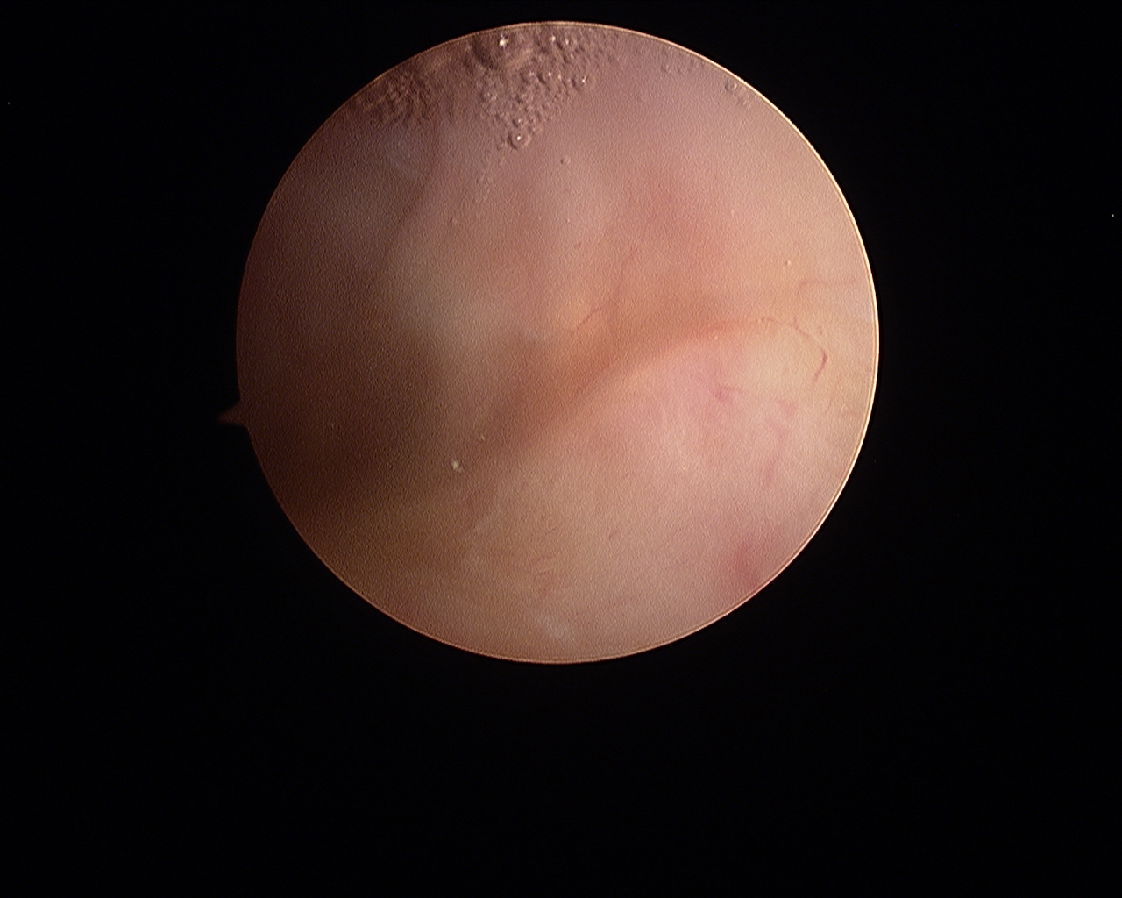
Figure 1 The normal synovium.

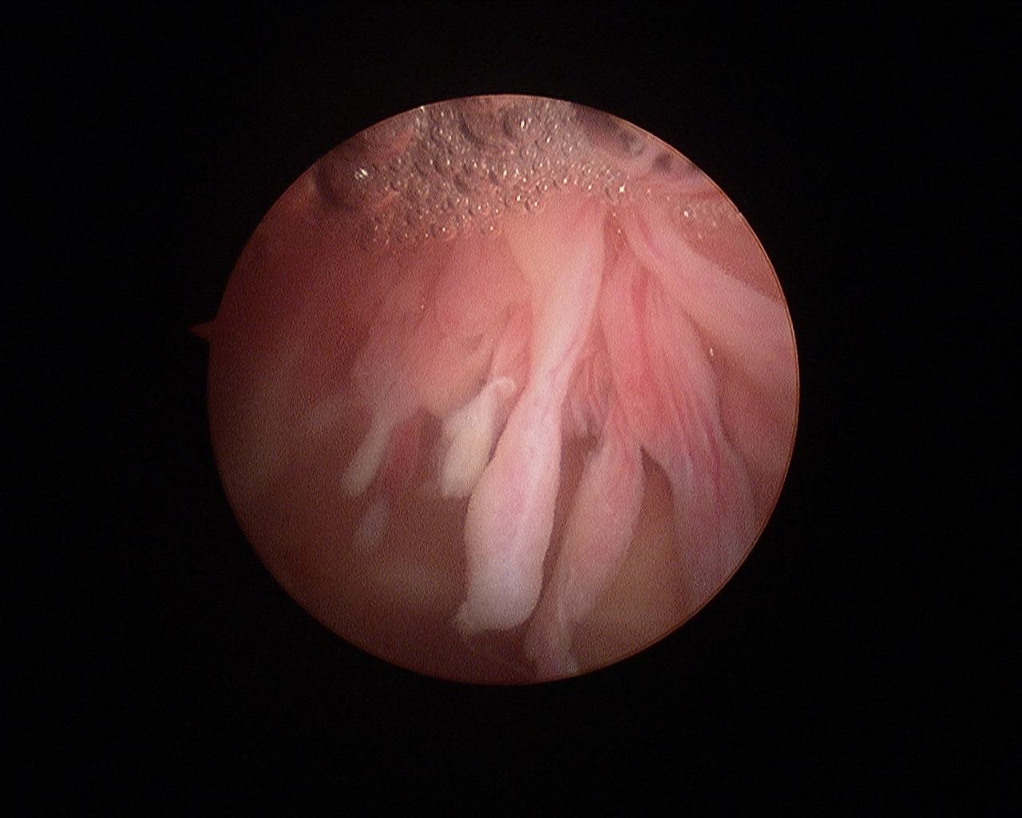
Figure 2 The synovium in rheumatoid arthritis. Note the villous appearance and straight vessels.

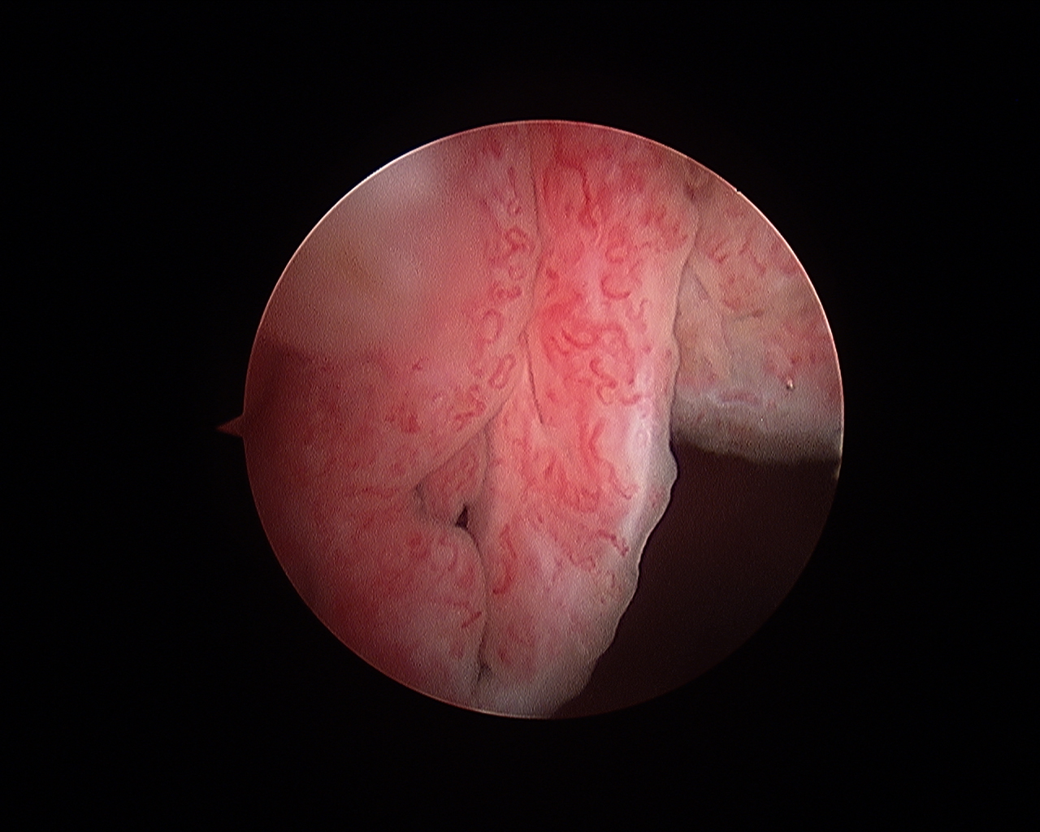
Figure 3 The synovium in psoriatic arthritis. Note the hypervascular villous hypertrophy and tortuous vessels.

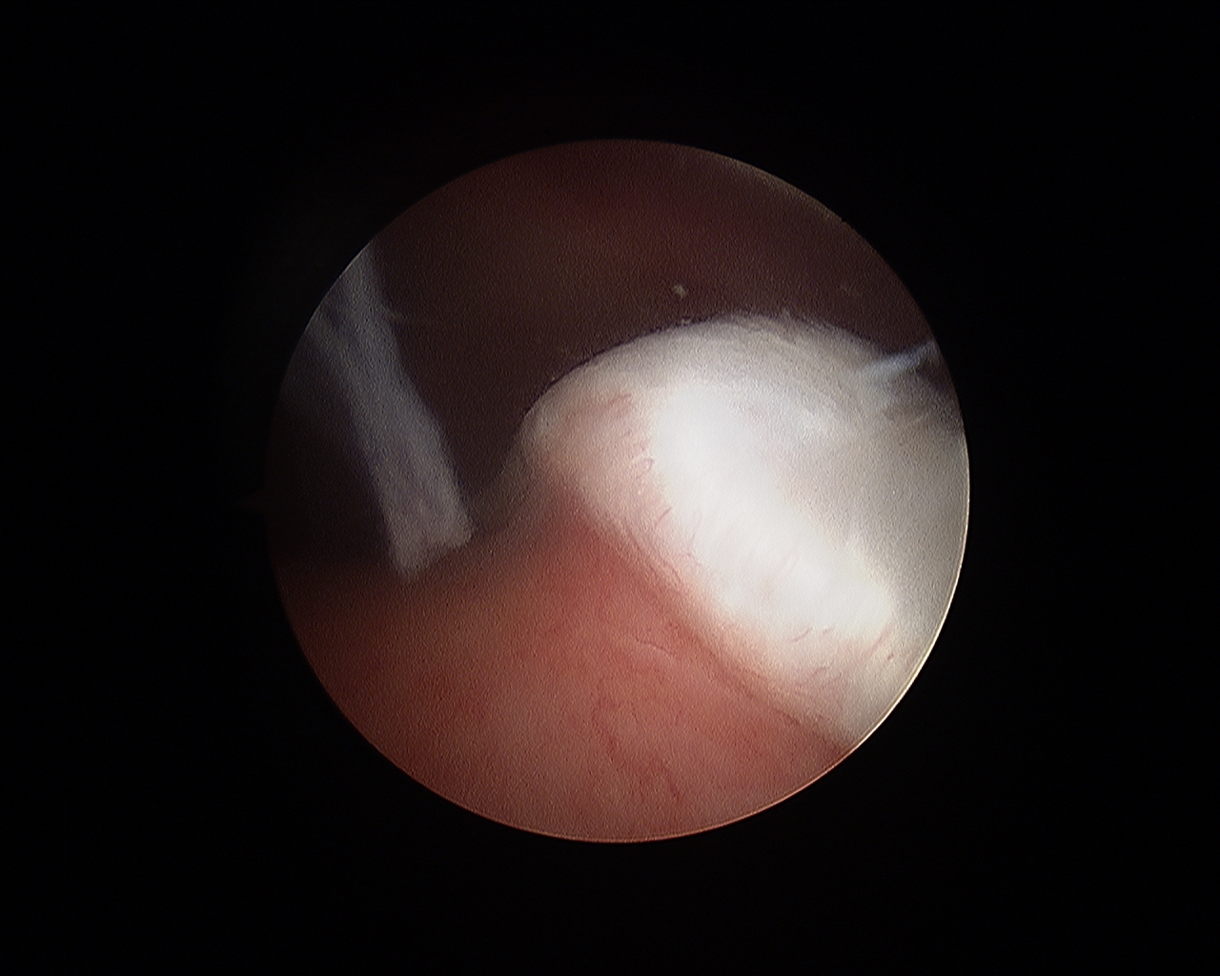
Figure 4 The cartilage-pannus junction.

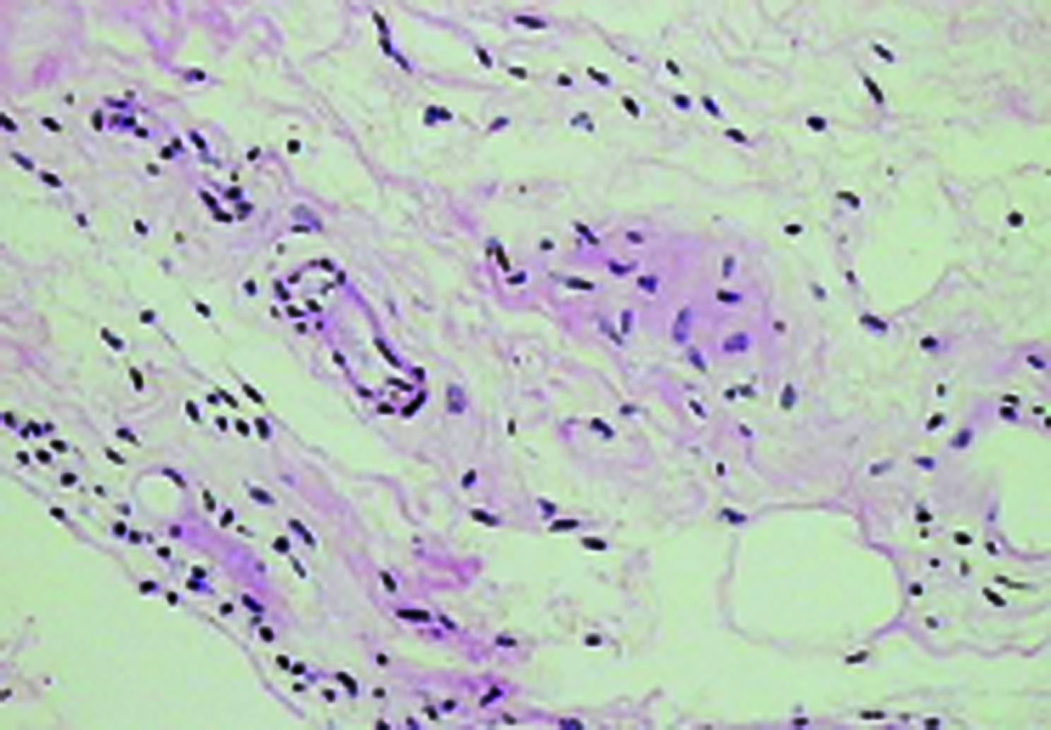
Figure 5 The normal (areolar) synovium.

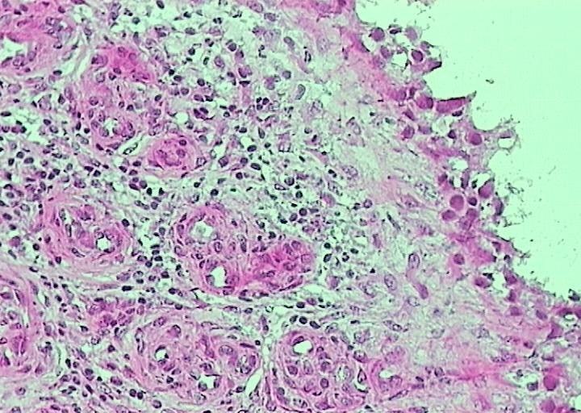
Figure 6 Lymphoid follicles in rheumatoid arthritis.

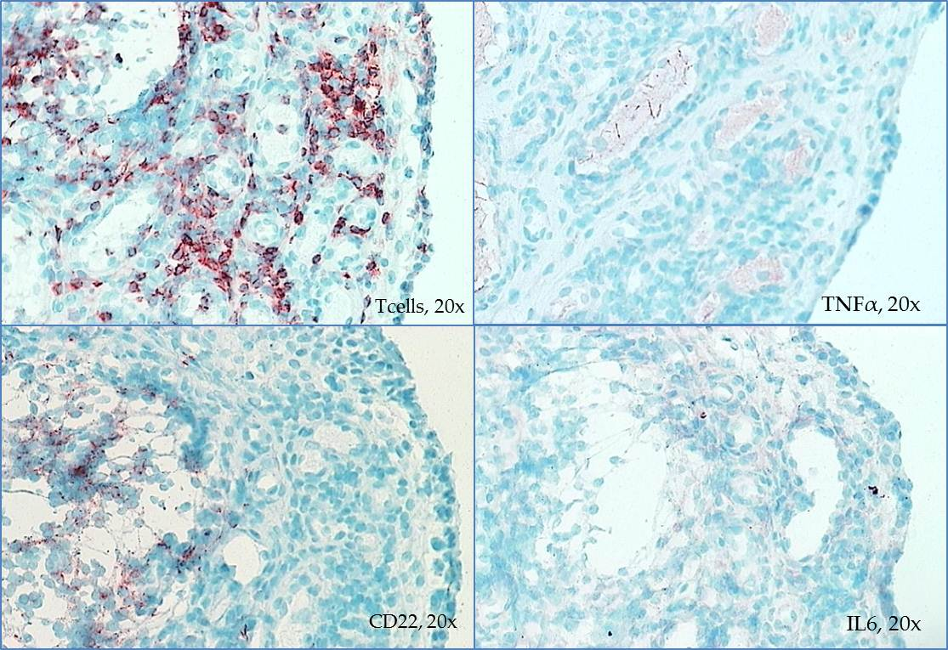
Figure 7 Differential staining of synovial biopsy for T cells, tumour necrosis factor, B cells (CD22), and interleukin-6 in a patient with active rheumatoid arthritis prior to disease-modifying therapy. TNF: Tumour necrosis factor; IL: Interleukin.

