Name of Journal: World Journal of Meta-Analysis
Manuscript NO: 70742
Manuscript Type: META-ANALYSIS

Different methods of acupuncture for relief of pain due to liver cancer: A network meta-analysis

Mou HY et al. Acupuncture for liver cancer pain: A meta-analysis

Hong-Yuan Mou, Jing Chen, Zuo-Yun Chen, Hong Du

Hong-Yuan Mou, Jing Chen, Zuo-Yun Chen, Department of Traditional Chinese Medicine, People’s Hospital of Lichuan, Lichuan 445400, Hubei Province, China

Hong Du, Preventive Treatment Center, Central Hospital of Enshi Prefecture, Enshi 445000, Hubei Province, China

Author contributions: Mou HY and Chen ZY contributed to the conception and design of the study, acquisition, analysis, and interpretation of the data, and drafting the article; Chen J and Du H interpreted the data and revised the article; All authors read and issued final approval of the submitted version.

Corresponding author: Zuo-Yun Chen, BM BCh, Chief Doctor, Department of Traditional Chinese Medicine, People’s Hospital of Lichuan, No. 12 Longchuan Road, Lichuan 445400, Hubei Province, China. 1513588676@qq.com

Received: August 12, 2021
Revised: October 15, 2021
Accepted: March 5, 2022
Published online:

Abstract
BACKGROUND
Pain in the liver is a common symptom of liver cancer in late stages, and the pain incidence rate exceeds 50%. In serious cancer pain, morphine and other major analgesics have been commonly administrated for clinical treatments, and their effects are accurate, but with a high incidence of side effects, such as nausea, vomiting, constipation, and other conditions. Acupuncture is a traditional Chinese medicine therapy. There have been many randomized controlled trials addressing the safety and usefulness of different methods of acupuncture in alleviating liver cancer pain. However, which of these methods is the most effective method is still unclear.

AIM
To compare the effectiveness of different acupuncture methods for alleviating pain due to liver cancer.

METHODS
Eligible studies were retrieved from eight databases (the Cochrane Library, PubMed, Embase, Medline, CNKI, CBM, Chongqing VIP, and Wan Fang Database) up to March 31, 2021 and screened based on the established inclusion and exclusion criteria. The quality of the include studies was evaluated. Stata software was applied for statistical analyses. Publication bias of the included studies was also determined. Finally, the network meta-analysis was carried out to evaluate the efficacy of acupuncture methods for relief of pain due to liver cancer.

RESULTS
A total of eight randomized controlled trials were included in the network meta-analysis. Eight trials (covering 5 treatments and 734 patients) provided data suitable for analysis. Most trials focused on short-term effects and many were classed as being of poor quality with a high risk of bias, commonly associated with lack of blinding (which was sometimes impossible to achieve). End of treatment results showed that four interventions, including wrist-ankle acupuncture, triple puncture and remaining needle acupuncture, Tian Yuan acupuncture, and block acupuncture, produced a statistically significant reduction in pain when compared with the three-step analgesic ladder therapy. The surface under the cumulative ranking sorting results showed that triple puncture and remaining needle acupuncture had a relatively high effective rate.

CONCLUSION
The network meta-analysis results indicate that the overall effectiveness of triple puncture and remaining needle acupuncture is better than the other therapies.

Key Words: Pain; Liver cancer; Acupuncture; Network meta-analysis; Effectiveness; Three-step analgesic ladder

Mou HY, Chen J, Chen ZY, Du H. Different methods of acupuncture for relief of pain due to liver cancer: A network meta-analysis. World J Meta-Anal 2022; In press

Core Tip: Seventy-five percent of patients with liver cancer suffer varying degrees of pain. Pain is widely perceived as the fifth vital sign in cancer patients, which seriously affects the quality of their life and threatens their survival. Acupuncture, part of traditional Chinese medicine, involves the application of needles, heat, pressure, and other treatments at specific sites of the body known as acupoints to affect the physical functions of the body. Numerous studies have concluded that acupuncture may be efficacious in relieving cancer-related pain. However, there is still no direct evidence on which method of acupuncture is more effective. The present study aimed to identify the best method of acupuncture for liver cancer-related pain.

INTRODUCTION
According to the GLOBOCAN 2012, primary liver cancer is the fifth most common cancer and the third most common cause of cancer mortality worldwide^{[2]}. More than 1 million individuals are diagnosed with this disease each year, and over 250000 patients die annually due to disease progression^{[3,4]}. In China, primary liver cancer is the second most common malignancy, with 360000 incident cases and 350000 deaths a year currently reported^{[5]}. With people’s growing emphasis on health and advances in medical technology, the early screening and treatment of liver cancer have extended the lives of many patients. However, cancer pain brings physical suffering to patients and makes them anxious, desperate, and depressed. In addition, this further aggravates the cancer pain, resulting in a vicious circle. The current clinical treatment for cancer pain is mainly in accordance with the World Health Organization (WHO) recommended three-step analgesic ladder, under which 70%-90% of cancer pain can be relieved^{[6]}. Nevertheless, anesthetic adverse effects, drug resistance, addiction, and other issues associated with the use of opioid analgesics have limited their clinical use. Thus, the identification of an effective treatment for relief of cancer pain with fewer toxic or adverse effects will radically improve quality of life and benefit most patients with cancer pain. Acupuncture analgesia is a traditional Chinese medicine therapy that has the advantages of safety, effectiveness, and no adverse effects and plays an important role in the treatment of cancer pain. Current clinical research shows that acupuncture combined with other therapies can effectively relieve the pain, reduce the adverse effects of Western medicine, and improve the quality of life of patients with primary liver cancer. By using network meta-analysis (NMA), both direct and indirect randomized data can be analyzed, and recommended rankings of different treatments can be provided^{[7,8]}. Therefore, we conducted an NMA to analyze both direct and indirect comparisons of different methods of acupuncture for the relief of pain due to liver cancer. Based on the current evidence, we sorted and explored the advantages and disadvantages of different methods of acupuncture. Compared with traditional meta-analysis, the results of this study may provide a higher quality basis and reference for acupuncture treatment of pain due to liver cancer.

MATERIALS AND METHODS
This NMA was based on the international guidelines for conducting and reporting systematic reviews, as applied to NMA^{[9,10]}.

Search strategy
PubMed, Embase, Cochrane Library, China National Knowledge Infrastructure, Wan Fang Database, Chongqing VIP, and Chinese Biomedical Databases were searched from inception to March31, 2021. Randomized controlled trials (RCTs) associated with pain due to liver cancer and cancer were retrieved. The specific search strategy, which adopted a combination of subject words and free words, was made based on the Cochrane Handbook for Systematic Review of Interventions (version 5.1.0)^{[11]}. (Liver Neoplasms, or Neoplasm or Liver Neoplasm or Hepatic neoplasm or Cancer of Liver or Hepatic Cancer or Liver Cancer or Hepatoma or Hepatocellular Carcinoma or HCC) and (Pain or Suffering or Ache) and (Acupuncture Therapy or Acupuncture or Acupuncture Points or Acupuncture Analgesia or Electro-acupuncture or Moxibustion or Acupotom or Electro-acupuncture or Electro-acupuncture or Needling or Acupoint) was used as the search strategy for Chinese and English databases.

Study selection
Two reviewers independently identified relevant studies based on titles and abstracts. In addition, full-text articles were scanned by these reviewers to identify eligible studies. All disagreements were resolved by consensus and adjudged by a third reviewer if necessary. In the case of duplicate citations, the most updated study was selected for data extraction.

Inclusion and exclusion criteria
The studies included in the review should met the following criteria: (1) The study design must be RCT; (2) Patients diagnosed with liver cancer irrespective of age and sex were enrolled; diagnostic criteria must be clear and inclusion and exclusion criteria were explicit; (3) All subjects had moderate to severe pain; (4) According to the cancer pain improvement standard of the WHO, the analgesic effects of the treatments were classified into four levels: Complete remission (CR; completely pain-free); partial remission (PR; substantial relief of pain and generally normal sleep); mild remission (MR; moderate relief of pain with residual pain and sleep disturbance); no remission (NR; no relief of pain). Usually, CR and NR are relatively easy to judge, whereas PR and MR are less well defined. CR and PR were considered effective; (5) Participants in the experimental group have received acupuncture treatments; and (6) English or Chinese language studies were included. The following studies were excluded: (1) Self-controlled and non-RCT studies; (2) Preclinical studies, systematic reviews, case reports, and meta-analyses; (3) Reports without sufficient or clear original data; and (4) Duplicate studies and studies reporting the same results.

Data collection and quality assessment
We used the risk of bias tool recommended by the Cochrane Handbook to evaluate the quality of included studies. The items considered were as follows: (1) Random sequence generation; (2) Allocation concealment; (3) Blinding of participants and personnel; (4) Blinding of outcome assessment; (5) Complete outcome data; (6) Selective reporting; and (7) Company funding. The possible answers to items 1–5 were ‘yes’ (representing low risk), ‘no’ (representing high risk), or ‘unclear’ (representing unclear risk). For item 6, ‘yes’ represented high risk, ‘no’ represented low risk, and ‘unclear’ represented unclear risk. Furthermore, grading of recommendation assessment, development, and evaluation (GRADE), which included five aspects (study limitation, indirectness, inconsistency, imprecision, and publication bias), was used to evaluate the quality of evidence contributing to each comparison and the overall ranking of treatment.

Statistical analysis
Stata16.0 software was used to create the network evidence graph that displays the basic information of interventions under each type of outcome indicators. Each node represents an intervention, the size of the node represents the sample size of the intervention, and the connection between the nodes represents the number of included studies under the intervention. As the outcome index of this study was a binary variable, the comparison results are expressed as relative risk. According to the ranking probability of each intervention, the best intervention could be identified.

RESULTS
Literature retrieval
A total of 5889 related studies were searched initially, and 2002 duplicate publications were excluded using Endnote X7 software. Three hundred and sixty-nine studies were initially screened out by scanning the title and abstract. Thereafter, 49 studies that may have met the criteria were read in detail. Finally, eight RCTs with a total of 734 patients, including four studies on wrist–ankle acupuncture, one on triple puncture and remaining needle acupuncture, one on Tian Yuan acupuncture, and three on block acupuncture, were selected (Figure 1).

Basic characteristics and quality evaluation of the included studies
Of the eight articles selected, all provided statistical analysis of the age and gender of the patients, and five reported the visual analog scale scores. All studies mentioned the random grouping method, and there were no incomplete reporting data or selective reporting results, but the allocation hiding and blind methods were not described in detail. Therefore, the overall quality of the literature was fair (Table 1, Figure 2)

Network meta-analysis results of pain treatment in patients with liver cancer under different measures
The NMA of the response rate under different measures of treatment was tested for consistency, and the results showed that P > 0.05, so the consistency model analysis was used. The results of the NMA showed that the response rate to triple puncture and remaining needle acupuncture in treating pain in patients with liver cancer was higher than that to three-step analgesic ladder therapy, wrist-ankle acupuncture, and block acupuncture, and the differences were statistically significant (P < 0.05); the response rate to Tianyuan acupoint acupuncture in treating pain in patients with liver cancer was significantly higher than that of three-step analgesic ladder therapy and wrist-ankle acupuncture (P < 0.05); the other pairwise comparisons between the interventions showed no statistical significance. The result of ranking the probability that one intervention is the best treatment is as follows: Triple puncture and remaining needle acupuncture (88.8%) > Tianyuan acupoint acupuncture (84.8%) > block acupuncture (45.0%) > wrist-ankle acupuncture (17.7%) > three-step analgesic ladder therapy (14.1%), suggesting that triple puncture and remaining needle acupuncture may be the most effective measure for the treatment of pain in patients with liver cancer (Figures 3-5, Tables 2 and 3).

Nodal analysis
There were no results of nodal analysis and ring inconsistency testing as the network evidence graph does not form a closed ring.

Publication bias and small-sample effect assessment
A funnel plot of treatment response rate is drawn, and each point on the funnel plot is scattered and not completely symmetrical, suggesting that there may be a small publication bias. The funnel plot of the response rate has scatter points distributed at the bottom of the funnel, suggesting the presence of a small sample effect (Figure 6).

DISCUSSION
The aim of this study was to identify the effectiveness or different methods of acupuncture for relief of pain due to liver cancer. In this NMA, the association of each acupuncture and related therapies with relief of pain due to liver cancer was compared using the combination of direct and indirect evidence from eight RCTs with 734 patients. An NMA provides a basis for synthesizing all the available evidence in a consistent framework, obviating the need to make decisions by subjective inferences from disparate data. However, our analysis represents the use of the most practical methods currently available to compare a large number of different types of treatment, thus enabling us to compare different methods of acupuncture with each other. In this study, we found that triple puncture and remaining needle acupuncture had the highest effectiveness.
Acupuncture may be useful in controlling the pain experienced by many cancer patients. It is a complementary and conservative therapy that balances the flow of vital energy, and in turn helps to relieve pain. It is an analgesic adjunctive method for cancer patients that is worthy of additional high quality studies^{[12-14]}.
Danxixinfa holds that meridians blocked by qi stagnation and phlegm are involved in the pathogenesis of cancer pain. Xuezhenglun attaches significance to cancer pain attributed to blood stagnation. Professor Zhong-Ying Zhou, a master of traditional Chinese medicine, proposed the cancer virus theory^{[15]}, and pointed out that under the action of internal and external factors, cold and heat stagnation is produced in the body, and then produces ‘poison’, and over time cancer develops. Pain due to liver cancer can be divided into excess pain and deficiency pain. Excess pain means that external pathogens invade the body and compete in the body or accumulate in the liver meridians, resulting in disorder of qi movement; furthermore, impairment of blood circulation occurs, and finally blood stasis blocks meridians, and stagnation leads to pain. Deficiency pain is caused by a prolonged illness, in other words, the deep presence of pathogenic qi impairs the healthy qi, then the deficiency of qi and blood makes meridians and viscera lose nourishment, that is, loss of nourishment leads to pain^{[16]}.
The main mechanisms of acupuncture in alleviating cancer pain are as follows. First, acupuncture has the function of regulating qi and blood as well as dredging channels and collaterals; hence, pain is relieved with improved blood circulation. Second, it can effectively adjust the body’s immune function to achieve the effects of strengthening body resistance and eliminating pathogenic factors, tonifying deficiency, and purging excess^{[17]}. Western medicine theory holds that the benign stimulation of acupuncture can act on the sympathetic and sensory nerves, and on the relevant autonomic nerve center through the segmental axon reflex of the nerve, thus effectively adjusting the visceral sensory function. In addition, the effective stimulation of acupuncture on acupoints can release endogenous opioid peptides through neurohumoral or meridian conduction, thus achieving acupuncture analgesia^{[18,19]}.
From our NMA, we found that triple puncture and remaining needle acupuncture had the highest effectiveness in treating moderate to severe liver cancer pain. Tianyuan acupoint acupuncture mainly uses the exterior and interior acupoint selection method, 12-meridian hedge acupoint selection method, Sanyin Sanyang Guanheshu acupoint selection method, and twirling reinforcing-reducing method in the Guidelines of Acupuncture Meridians to relieve cancer pain. The exterior and interior acupoint selection method selects acupoints according to the relationship between exterior and interior deficiency of meridians, superficial acupoint is selected for interior disease, and deep acupoint is selected for exterior disease. Because liver cancer is an internal disease, the liver Beishu and Ganshu acupoints on the liver surface, as well as Ququan acupoint, were selected to tonify the liver meridian deficiency syndrome, dredge the qi and blood of the liver meridian meridians, and prevent the conduction of pathogenic factors. The 12-meridian hedge acupoint selection method is proposed according to the hedge relationship of the 12 earthly branches, that is, Zi and Wu hedge, Yin and Shen hedge, Chen and Wu hedge, etc. There is a corresponding relationship between the 12 meridians of the human body and the 12 earthly branches, and there is also a hedge relationship across the 12 meridians of the human body; that is, the hedge between Taiyin Lung Meridian and the Foot-Taiyang Bladder Meridian, the hedge between the Foot-Yangming Stomach Meridian and the Hand-Jueyin Pericardium Meridian, the hedge between the Hand-Shaoyin Heart Meridian and the Foot-Shaoyang Gallbladder Meridian, etc. According to the theory of Sanyin and Sanyang Guanheshu and the tendency of pathogenic conduction of meridians, as for the method of acupoint selection of Sanyin and Sanyang Guanshu, the Shu or He acupoint is selected for the disease at Guan acupoint, Guan or Shu is selected for the disease at He acupoint, and Guan or He is selected for the disease at Shu acupoint. The typical acupoints that can be used are Xinyuand Dazhui. Those acupoints are selected for tranquilizing, soothing the liver, relieving depression, activating blood circulation, and relieving pain. Tianyuan acupoint acupuncture uses rotational tonifying and reducing manipulation with a small amount of stimulation, while the Tianyuan acupoint selection method selects acupoints carefully, so the effect is good^{[20,21]}. Wrist–ankle acupuncture is a method of acupuncture at specific parts of the wrist or ankle to treat systemic diseases. It is gradually formed and developed under the inspiration of the mid-dermal theory in meridian doctrine. It was officially applied in clinical practice in the early 1970s. Because of its single-acupoint selection, easy operation, and minimal damage to the body, this method is safe without needle sensation^{[19]}. Ququan point is selected for blocking acupuncture, which is the converging point of liver meridian, where the liver meridian qi is full, and acupuncture can soothe the liver, regulate qi and meridians, and relieve pain. Dazhui is the point of the Du meridian, which is a good option for acupoint selection when treating shoulder and back pain and has the functions of activating blood circulation, dredging collaterals, and relieving pain. Liver cancer pain is caused by liver enlargement, tumor invasion of the diaphragm, and stimulation of diaphragmatic nerves into the cervical segment of the spinal cord, resulting in the right shoulder and liver pain, so acupuncture at this point can play a role in soothing the liver, activating blood circulation to relieve pain, and blocking the conduction of pathogenic factors. Acupuncture at Xinshu is used to tranquilize the mind, regulate qi and relieve depression, replenish qi and meridians, and treat cancer pain. Ganshu is the Beishu point of the liver meridian. Acupuncture can notify liver blood, and soothe liver and meridians to treat cancer pain, and the simultaneous treatment of principal and subordinate symptoms can be achieved^{[22]}. Triple puncture and remaining needle acupuncture, as recorded in LingShu, is called concerted needling. Concerted needling involves insertion directly into one point and then further insertion of two more needles directly beside the first to treat cold qi and is localized but slightly deep. The method of concerted needling and needle retaining for liver cancer pain can prolong the analgesic time. From the recorded description, concerted needling selects the appropriate needle, on the selected acupoints, as follows. First, the first needle is inserted straight down the needle tip in the center of the acupoint, and then 0.5 cun (1 cun is equal to 3.3333333 cm) next to the first needle (up and down or left and right); the needle tip is aligned with the direction of the first needle, and the other two needles are straightly (obliquely) inserted; one acupoint is simultaneously inserted into by three needles, and at the same time, lifting, inserting, and twisting of the needle are performed to achieve the arrival of qi. Three needles are used together, so the name of concerted needling is given, which is mainly suitable for arthralgia with limited lesions, as well as with deep location of lesions and pathogenic factors. According to clinical research reports, the three needles of the concerted needling method not only strengthen the local irritation volume of the acupoint where the acupuncture is located, but also expand the scope of action of the acupoint where the acupuncture is located. This method is conducive to rapidly stimulating the conduction of meridians and qi so that the induction of acupuncture can reach the disease site directly and the needle sensation spread from shallow to deep, from near to far around the acupoint, rapidly reaching the acupuncture requirements of qi to the disease site. The method also plays a role in relieving tendons through meridians, promoting blood circulation and dredging collaterals, and removing arthralgia and relieving pain. Thus, the purpose of acupuncture treatment based on the principle of “no obstruction, no pain” is achieved^{[23]}.
This study had several limitations. First, we failed to evaluate the safety of each acupuncture therapy due to limited data in the primary studies. Future trials should report adverse events clearly to improve the quality of study design. Second, unaddressed concerns still exist regarding the long-term effects of using acupuncture and acupuncture-related therapies for pain due to liver cancer in the clinical setting. Further clinical evaluation of acupuncture for pain due to liver cancer is required and longer follow-up appears warranted. Third, blinding of patients and research was not performed in the included studies that were mainly conducted in China, which may have led to publication bias. Fourth, the included studies in our NMA lacked comparisons on the effectiveness of different acupuncture therapies. Further confirmatory effectiveness trials should compare different types of acupuncture therapies. Finally, numerous studies that focused on other methods of acupuncture were not included in our study due to the type of design and outcome measures.

CONCLUSION
The evidence from our NMA, in which different methods of acupuncture for pain due to liver cancer were compared with each other within a coherent framework, suggests that the overall effectiveness of triple puncture and remaining needle acupuncture is better than that of other therapies. However, despite the evidence from this study, the methodological limitations associated with many of the trials indicate that high-quality trials of acupuncture treatments are still required.

ARTICLE HIGHLIGHTS
Research background
Seventy-five percent of patients with liver cancer suffer varying degrees of pain. Pain is widely perceived as the fifth vital sign in cancer patients, which seriously affects the quality of their life and threatens their survival. Acupuncture, part of traditional Chinese medicine, involves the application of needles, heat, pressure, and other treatments at specific sites of the body known as acupoints to affect the physical functions of the body. Numerous studies have concluded that acupuncture may be efficacious in relieving cancer-related pain. However, there is still no direct evidence on which method of acupuncture is more effective. The present study aimed to identify the best method of acupuncture for liver cancer-related pain. Further clinical evaluation of acupuncture for pain due to liver cancer is required and longer follow-up appears warranted. The comparisons of the effectiveness of different acupuncture therapies should be conducted.

Research motivation
The aim of our study was to compare the effectiveness of different acupuncture methods for alleviating pain due to liver cancer. In this study, we found that triple puncture and remaining needle acupuncture had the highest effectiveness. The finding of our study may provide evidence for directly comparing different methods of acupuncture for liver cancer related pain.

Research objectives
The present study aimed to identify the best method of acupuncture for liver cancer-related pain. The finding of our study may provide evidence for direct comparisons of different methods of acupuncture for liver cancer related pain.

Research methods
In this network meta-analysis (NMA), the association of each acupuncture and related therapies with relief of pain due to liver cancer was compared using the combination of direct and indirect evidence from eight RCTs with 734 patients. An NMA provides a basis for synthesizing all the available evidence in a consistent framework, obviating the need to make decisions by subjective inferences from disparate data. However, our analysis represents the use of the most practical methods currently available to compare a large number of different types of treatment, thus enabling us to compare different methods of acupuncture with each other.

Research results
We conducted an NMA to analyze both direct and indirect comparisons of different methods of acupuncture for the relief of pain due to liver cancer. Based on the current evidence, we sorted and explored the advantages and disadvantages of different methods of acupuncture. Compared with traditional meta-analysis, the results of this study may provide a higher quality basis and reference for acupuncture treatment of pain due to liver cancer.

Research conclusions
The evidence from our NMA, in which different methods of acupuncture for pain due to liver cancer were compared with each other within a coherent framework, suggests that the overall effectiveness of triple puncture and remaining needle acupuncture is better than that of other therapies. However, despite the evidence from this study, the methodological limitations associated with many of the trials indicate that high-quality trials of acupuncture treatments are still required.

Research perspectives
Further clinical evaluation of acupuncture for pain due to liver cancer is required and longer follow-up appears warranted. The comparisons of the effectiveness of different acupuncture therapies should be conducted.

ACKNOWLEDGEMENTS
The authors are grateful for the professional help from their colleagues of Lichuan People‘s Hospital and the Central Hospital of EnShi prefecture.

REFERENCES
1 Xu L, Wan Y, Huang J, Xu F. Clinical analysis of electroacupuncture and multiple acupoint stimulation in relieving cancer pain in patients with advanced hepatocellular carcinoma. J Cancer Res Ther 2018; 14: 99-102 [PMID: 29516968 DOI: 10.4103/jcrt.JCRT_736_17]
2 Ferlay J, Soerjomataram I, Ervik M. GLOBOCAN 2012 v1.0, Cancer incidence and mortality worldwide: IARC Cancer Base No. 11. Lyon: International Agency for Research on Cancer, 2013. [cited 15 May 2021]. Available from: http://globocan.iarc.fr
3 Massarweh NN, El-Serag HB. Epidemiology of Hepatocellular Carcinoma and Intrahepatic Cholangiocarcinoma. Cancer Control 2017; 24: 1073274817729245 [PMID: 28975830 DOI: 10.1177/1073274817729245]
4 Kulik L, El-Serag HB. Epidemiology and Management of Hepatocellular Carcinoma. Gastroenterology 2019; 156: 477-491.e1 [PMID: 30367835 DOI: 10.1053/j.gastro.2018.08.065]
5 Chen JG, Zhang SW. Liver cancer epidemic in China: past, present and future. Semin Cancer Biol 2011; 21: 59-69 [PMID: 21144900 DOI: 10.1016/j.semcancer.2010.11.002]
6 Swierzewski SJ. Treatment for Cancer Pain. [cited 10 January 2021]. Available from: http://www. Healthcommunities.com/cancer-pain/treatmentfor-cancer-pain.html
7 Chaimani A, Higgins JP, Mavridis D, Spyridonos P, Salanti G. Graphical tools for network meta-analysis in STATA. PLoS One 2013; 8: e76654 [PMID: 24098547 DOI: 10.1371/journal.pone.0076654]
8 Salanti G, Del Giovane C, Chaimani A, Caldwell DM, Higgins JP. Evaluating the quality of evidence from a network meta-analysis. PLoS One 2014; 9: e99682 [PMID: 24992266 DOI: 10.1371/journal.pone.0099682]
9 Hoaglin DC, Hawkins N, Jansen JP, Scott DA, Itzler R, Cappelleri JC, Boersma C, Thompson D, Larholt KM, Diaz M, Barrett A. Conducting indirect-treatment-comparison and network-meta-analysis studies: report of the ISPOR Task Force on Indirect Treatment Comparisons Good Research Practices: part 2. Value Health 2011; 14: 429-437 [PMID: 21669367 DOI: 10.1016/j.jval.2011.01.011]
10 Stewart LA, Clarke M, Rovers M, Riley RD, Simmonds M, Stewart G, Tierney JF; PRISMA-IPD Development Group. Preferred Reporting Items for Systematic Review and Meta-Analyses of individual participant data: the PRISMA-IPD Statement. JAMA 2015; 313: 1657-1665 [PMID: 25919529 DOI: 10.1001/jama.2015.3656]
11 Higgins JP, Green S. Cochrane handbook for systematic reviews of interventions. Cochrane Collaborate, 2012
12 Aung S. The clinical use of acupuncture in oncology: symptom control. Acupunct Med. 1994; 12: 37-40 [DOI:10.1136/aim.12.1.37]
13 Lee H, Schmidt K, Ernst E. Acupuncture for the relief of cancer-related pain--a systematic review. Eur J Pain 2005; 9: 437-444 [PMID: 15979024 DOI: 10.1016/j.ejpain.2004.10.004]
14 Johnstone PA, Polston GR, Niemtzow RC, Martin PJ. Integration of acupuncture into the oncology clinic. Palliat Med 2002; 16: 235-239 [PMID: 12047000 DOI: 10.1191/0269216302pm540oa]
15 Abstracts from the 3rd International Genomic Medicine Conference (3rd IGMC 2015) : Jeddah, Kingdom of Saudi Arabia. 30 November - 3 December 2015. BMC Genomics 2016; 17 Suppl 6: 487 [PMID: 27454254 DOI: 10.1186/s12864-016-2858-0]
16 Fu SL, Wang WH, Li XB, Ming Y, Wang WP. Analyses on Clinical Syndrome Types and Prescriptions of Cancer Pain. Shiyong Zhongyi Neike Zazhi 2012; 26: 1-4 [DOI: 10.3969/j.issn.1671-7813.2012.03.01]
17 Cai W, Shen WD. Clinical Review of Acupuncture Treatment on Primary Liver Cancer Pain. Zhenjiu Linchuang Zazhi 2017; 33: 76-79
18 Chen H, Liu TY, Kuai L, Zhu J, Wu CJ, Liu LM. Electroacupuncture treatment for pancreatic cancer pain: a randomized controlled trial. Pancreatology 2013; 13: 594-597 [PMID: 24280575 DOI: 10.1016/j.pan.2013.10.007]
19 Zeng K, Dong HJ, Chen HY, Chen Z, Li B, Zhou QH. Wrist-ankle acupuncture for pain after transcatheter arterial chemoembolization in patients with liver cancer: a randomized controlled trial. Am J Chin Med 2014; 42: 289-302 [PMID: 24707863 DOI: 10.1142/S0192415X14500190]
20 Li JY, Zhu Y, Lv H, Dong SJ, Liu SJ. 128 cases of Shoulder Periarthritis Treated by Tianyuan acupuncture. Renmin Junyi 2011; 54: 221
21 Li JY, Li JJ. Tian-yuan acupuncture. Renmin Junyi 2010; 38-43
22 Liu XY, Dong RP. 51 cases of liver cancer pain treated by Acupuncture and Acupoint Injection. ShanXi Zhongyiyao Zazhi 2008; 29: 347-348
23 Sun Y, Wang CT, Wang XY, Yang K, Ni SJ, Wang K. Observation on the Clinical Efficacy of Triple Acupuncture on Tinnitus. Liaoning Zhongyiyao Daxue Xuebao 2021; 23: 16-19 [DOI: 10.13194/j.issn.1673-842x.2021.02.005]

Footnotes
Conflict-of-interest statement: The authors have no conflict of interest to declare.

PRISMA 2009 Checklist statement: The authors have read the PRISMA 2009 Checklist, and the manuscript was prepared and revised according to the PRISMA 2009 Checklist.

Open-Access: This article is an open-access article that was selected by an in-house editor and fully peer-reviewed by external reviewers. It is distributed in accordance with the Creative Commons Attribution NonCommercial (CC BY-NC 4.0) license, which permits others to distribute, remix, adapt, build upon this work non-commercially, and license their derivative works on different terms, provided the original work is properly cited and the use is non-commercial. See: https://creativecommons.org/Licenses/by-nc/4.0/

Provenance and peer review: Unsolicited article; Externally peer reviewed.
Peer-review model: Single blind

Peer-review started: August 12, 2021
First decision: October 2, 2021
Article in press:

Specialty type: Gastroenterology and hepatology
Country/Territory of origin: China
Peer-review report’s scientific quality classification
Grade A (Excellent): 0
Grade B (Very good): B
Grade C (Good): C
Grade D (Fair): D
Grade E (Poor): E

P-Reviewer: Gong X, China; Yang M, United States; Yang H, China S-Editor: Liu M L-Editor: Wang TQ P-Editor: Liu M
Figure Legends
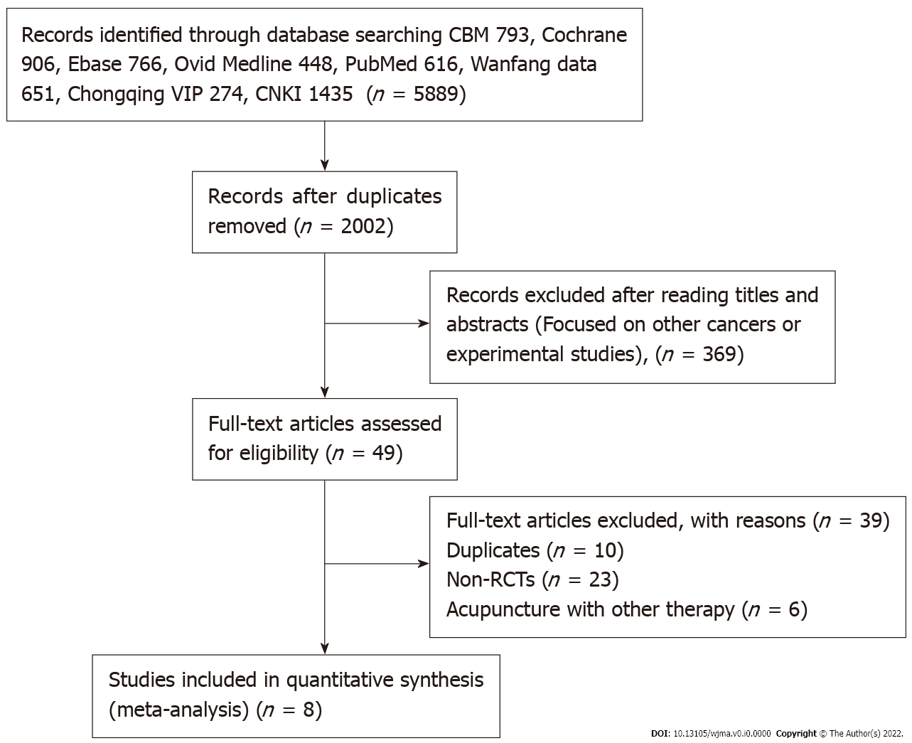
Figure 1 Flow chart of study inclusion.
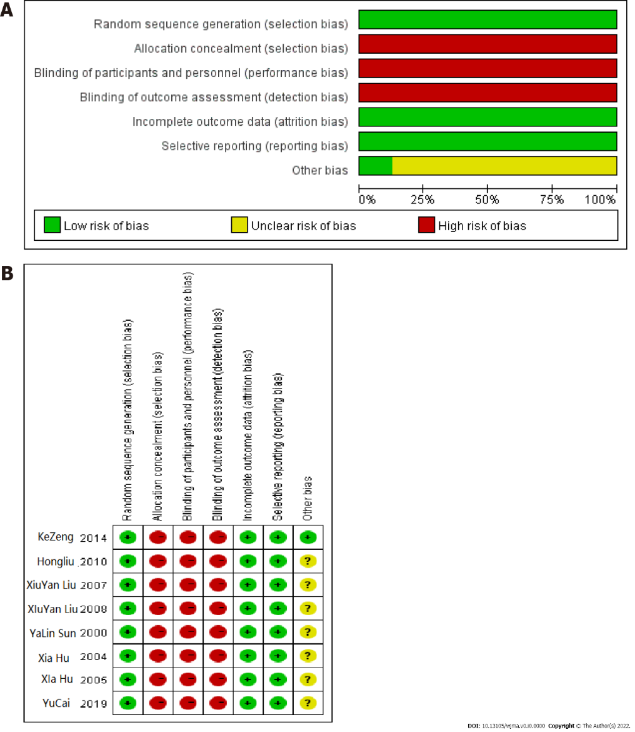
Figure 2 Assessment of quality of the literature. A: Percentile chart of literature risk bias; B: Risk of bias assessment.

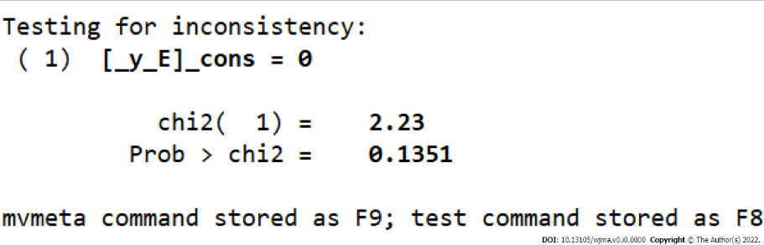
Figure 3 Test for inconsistency.

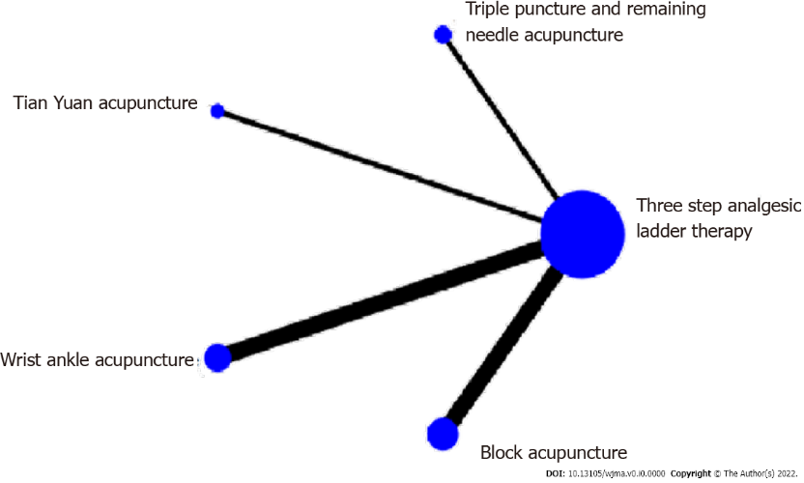
Figure 4 Network comparing the analgesic effect of different acupuncture methods.

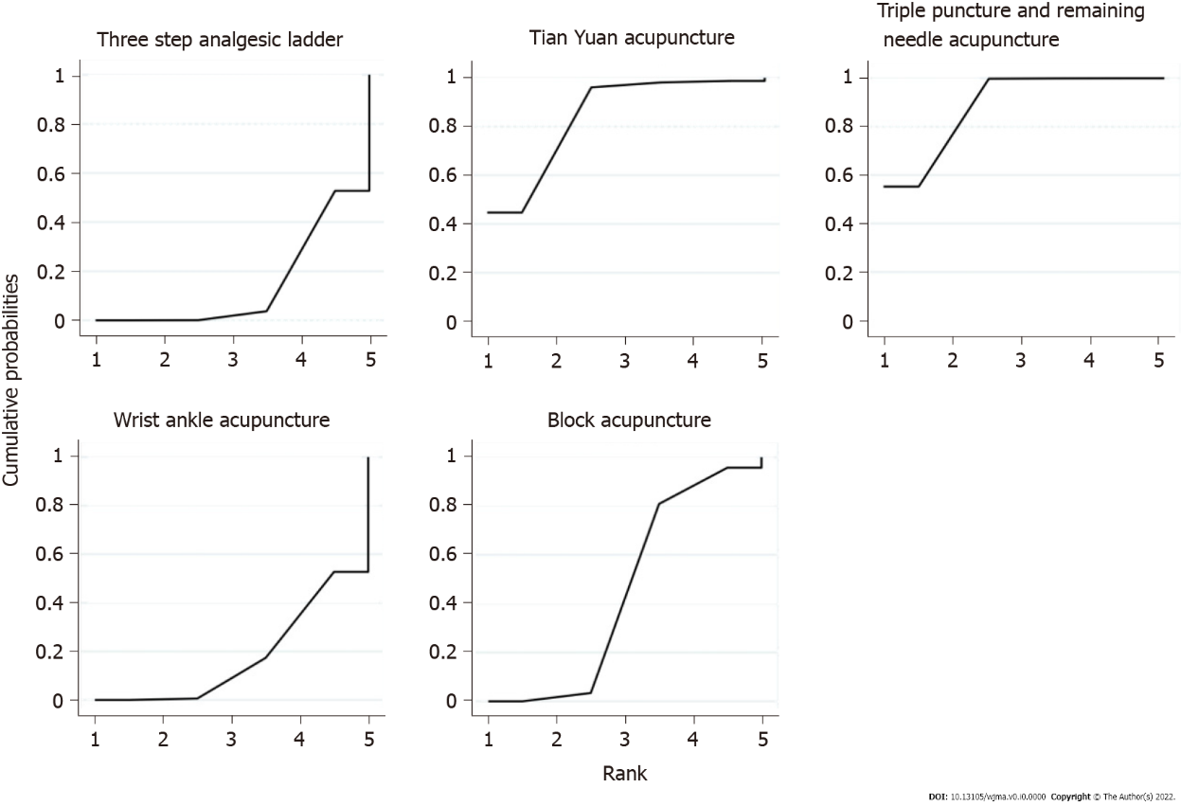
Figure 5 Probability ranking chart of treatment efficiency.

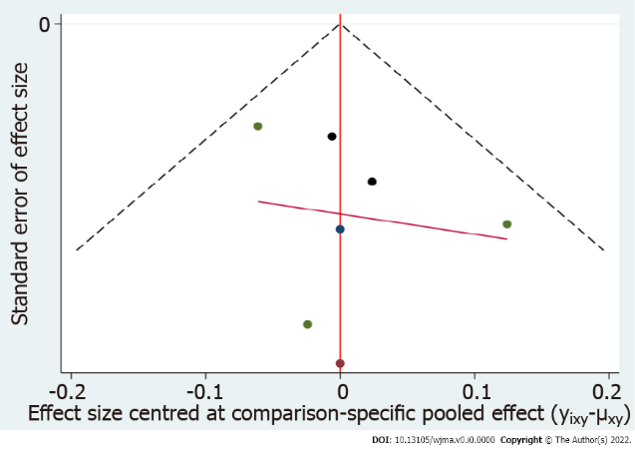
Figure 6 Efficient funnel chart.
Table 1 Main characteristics of the selected articles
Ref. |  | Cases (observation group/control group) | Treatment measures | Control measures | Evaluating indicator
Zeng et al^{[18]}, 2014 |  | 30/30 | Wrist ankle acupuncture | Three step analgesicladder therapy | Degree of pain relief
Liu et al^{[18]}, 2010 |  | 51/51 | Block acupuncture | Three step analgesicladder therapy | Degree of pain relief/VAS score
Liu et al^{[18]}, 2007 |  | 30/30 | Block acupuncture | Three step analgesicladder therapy | Degree of pain relief/VAS score
Liu et al^{[21]}, 2008 |  | 51/51 | Block acupuncture | Three step analgesicladder therapy | Degree of pain relief/VAS score
Sun et al^{[22]}, 2021 |  | 80/60 | Triple puncture and remaining needle acupuncture | Three step analgesicladder therapy | Degree of pain relief
Hu et al^{[22]}, 2004 | 36/50 |  | Wrist ankle acupuncture | Three step analgesicladder therapy | Degree of pain relief
Hu et al^{[22]}, 2005 | 36/40 |  | Wrist ankle acupuncture | Three step analgesicladder therapy | Degree of pain relief
Cai et al^{[22]}, 2009 | 54/54 |  | Tianyuam acupuncture | Three step analgesicladder therapy | Degree of pain relief/VAS score
Table 2 Analgesic effect of different acupuncture methods based on network meta-analysis
Three-step analgesic ladder
0.71 (0.59, 0.85) | Triple puncture and remaining needle acupuncture
0.72 (0.54, 0.97) | 1.02 (0.72, 1.44) | Tian Yuan acupuncture
1.00 (0.93, 1.08) | 1.41 (1.16, 1.71) | 1.38 (1.02, 1.87) | Wrist ankle acupuncture
0.95 (0.90, 1.01) | 1.34 (1.11, 1.62) | 1.32 (0.97, 1.78) | 0.95 (0.87, 1.05) | Block acupuncture

Table 3 Probability ranking of interventions in different outcome indicators (SUCRA)
Treatment | SUCRA | PrBest | MeanRank
Three-step analgesic ladder | 14.1 | 0.0 | 4.4
Triple puncture and remaining needle acupuncture | 88.8 | 55.3 | 1.4
Tian Yuan acupuncture | 84.4 | 44.7 | 1.6
Wrist ankle acupuncture | 17.7 | 0.0 | 4.3
Block acupuncture | 45.0 | 0.0 | 3.2

