Name of Journal: World Journal of Clinical Cases
Manuscript NO: 79385
Manuscript Type: STANDARD AND CONSENSUS

Baishideng’s Reference Citation Analysis database announces the first Article Influence Index of multidisciplinary scholars

Wang JL et al. RCA announces the 2022 AII of 632 scholars

Jin-Lei Wang, Yu-Jie Ma, Li Ma, Na Ma, Diao-Mei Guo, Lian-Sheng Ma

Jin-Lei Wang, Yu-Jie Ma, Li Ma, Na Ma, Diao-Mei Guo, Lian-Sheng Ma, Baishideng Publishing Group Inc, Pleasanton, CA 94566, United States

Author contributions: Wang JL analyzed the data and drafted the manuscript; Ma YJ participated in the data collection; Ma LS revised the manuscript for important intellectual content; and all authors participated in manuscript revision.

Corresponding author: Lian-Sheng Ma, Doctor, Founder and CEO, Baishideng Publishing Group Inc, 7041 Koll Center Parkway, Suite 160, Pleasanton, CA 94566, United States. l.s.ma@baishideng.com

Received: August 18, 2022
Revised: September 6, 2022
Accepted: September 21, 2022
Published online:

Abstract
After three rounds of rigorous evaluation of registered scholars conducted by the Reference Citation Analysis (RCA) editorial team of Baishideng Publishing Group (Baishideng), the RCA database of Baishideng officially released the 2022 Article Influence Index (2022 AII) of 632 scholars from 74 countries/territories in 98 research categories, for the first time. The list of 632 scholars can be found at: https://www.referencecitationanalysis.com/searchscholar. Among them, the highest 2022 AII is 348.211, the highest number of total citations is 42830, and the highest number of total articles is 901. The category with the largest number of RCA scholars is Gastroenterology & Hepatology, with a total of 100 (15.8%), and the second is Surgery, with a total of 46 (7.3%). This article summarizes the RCA scholars and describes the mission of RCA, the openness and transparency of RCA evaluation, the calculation method for the 2022 AII, and the evaluation process of RCA scholars. The RCA scholar list will effectively serve as a useful Find-a-Scholar tool. Any interested scholar is welcome to register and join this RCA scholar list.

Key Words: Reference Citation Analysis; Article Influence Index; Scholar list; Find a scholar; Announcement

Wang JL, Ma YJ, Ma L, Ma N, Guo DM, Ma LS. Baishideng’s Reference Citation Analysis database announces the first Article Influence Index of multidisciplinary scholars. World J Clin Cases 2022; In press

Core Tip: The Reference Citation Analysis (RCA) database of Baishideng Publishing Group officially released the 2022 Article Influence Index (2022 AII) of 632 scholars from 74 countries/territories in 98 research categories, for the first time. This article summarizes the RCA scholars and describes the mission of RCA, the openness and transparency of RCA evaluation, the calculation method for the 2022 AII, and the evaluation process of RCA scholars. The RCA scholar list will effectively serve as a useful Find-a-Scholar tool. Any interested scholar is welcome to register and join this RCA scholar list.

INTRODUCTION
We are very pleased to announce that the Reference Citation Analysis (RCA) database^{[1]} of Baishideng Publishing Group (Baishideng) has, for the first time, officially released the 2022 Article Influence Index (2022 AII) of 632 scholars from 74 countries/territories in 98 research categories, for the first time. The list of 632 scholars can be found at: https://www.referencecitationanalysis.com/searchscholar.
RCA is an AI technology-based open multidisciplinary citation analysis database. As such, RCA will lead the development of wisdom, knowledge innovation, and emerging disciplines. The functions of RCA include: Find an Article (55334324), Find a Category (254), Find a Journal (14077), Find a Scholar (632), and Find an Academic Assistant (18) (Data collection: August 15, 2022). RCA updates its list of journals daily, according to relevant data including total number of articles, total citations, and 2022 Journal Article Influence Index (2022 JAII). RCA acquires the newly released abstracts and references from Crossref and adds them to the RCA database weekly. RCA also acquires the abstracts and references released that year from Crossref and adds them to the RCA database monthly, and then updates the total number of articles, citations, and 2022 JAII^{[2]}. Herein, we summarize the RCA scholars, describe the mission of RCA and the openness and transparency of RCA evaluation, and introduce the calculation method for the 2022 AII and the evaluation process of RCA scholars.

SUMMARY OF RCA SCHOLARS
We sent invitation letters to scholars of various research categories around the world through the F6Publishing highly influential scientists database. As of August 15, 2022, a total of 1228 scholars have registered in the RCA. After three rounds of rigorous evaluation by the RCA editorial team, 632 (51.5%) scholars were approved for inclusion in the RCA scholar list. These 632 RCA scholars are from 74 countries/territories, and are distributed in 98 research categories, including 90 (14.2%) from China, 63 (10.0%) from Italy, 59 (9.3%) from India, 43 (6.8%) from Egypt, 32 (5.1%) from the United States, 30 (4.7%) from Turkey, and 25 (4.0%) from Spain (Figure 1). The category with the largest number of RCA scholars is Gastroenterology & Hepatology, with a total of 100 (15.8%) scholars, and the second is Surgery, with a total of 46 (7.3%) scholars, followed by Biochemistry & Molecular Biology with 31 (4.9%) scholars and Oncology with 31 (4.9%) scholars (Figure 2).

Top 3 RCA scholars ranked by total articles, total citations, and 2022 AII
Among the 632 RCA scholars, the scholar with the largest number of total articles is Giuseppe Biondi-Zoccai, Associate Professor (RCA ID: 00000973) from Italy, who has published a total of 901 articles (Table 1). The scholar with the largest number of total citations is Kamarul Imran Musa, Associate Professor (RCA ID: 00000942) from Malaysia, with 42830 citations (Table 2), and has the highest 2022 AII, which is 348.211 (Table 3).

Top 3 RCA scholars in the field of Gastroenterology & Hepatology ranked by total articles, total citations, and 2022 AII
Among the 100 RCA scholars in the field of Gastroenterology & Hepatology, the scholar with the largest number of total articles is Kamran B Lankarani, Professor (RCA ID: 00001172) from Iran, who has published a total of 392 articles (Table 4). The scholar with the largest number of total citations is Andrzej S Tarnawski, Professor (RCA ID: 00000002) from the United States, with 8764 citations (Table 5). The scholar with the highest 2022 AII is Paul Henderson, Senior Lecturer (RCA ID: 00000799) from the United Kingdom, and his 2022 AII is 89.661 (Table 6).

Top 3 RCA scholars in the field of Surgery ranked by total articles, total citations, and 2022 AII
Among the 46 RCA scholars in the field of Surgery, the scholar with the largest number of total articles is Bing Hu, Professor (RCA ID: 00000233) from China, who has published a total of 206 articles (Table 7). The scholar with the largest number of total citations is William C Dooley, Professor (RCA ID: 00000689) from the United States, with 3740 citations (Table 8), and has the highest 2022 AII, which is 45.060 (Table 9).

Top 3 RCA scholars in the field of Biochemistry & Molecular Biology ranked by total articles, total citations, and 2022 AII
Among the 31 RCA scholars in the field of Biochemistry & Molecular Biology, the scholar with the largest number of total articles is Giuseppe Maurizio Campo, Professor (RCA ID: 00000278) from Italy, who has published a total of 183 articles (Table 10). The scholar with the largest number of total citations is Yoshiro Saito, Professor (RCA ID: 00001051) from Japan, with 5886 citations (Table 11). The scholar with the highest 2022 AII is Manoj Kumar Kashyap, Associate Professor (RCA ID: 00000155) from India, and his 2022 AII is 75.521 (Table 12).

Top 3 RCA scholars in the field of Oncology ranked by total articles, total citations, and 2022 AII
Among the 31 RCA scholars in the field of Oncology, the scholar with the largest number of total articles is Jing He, Research Associate (RCA ID: 00000057) from China, who has published a total of 206 articles (Table 13). The scholar with the largest number of total citations is Reza Alizadeh-Navaei, Adjunct Associate Professor (RCA ID: 00000754) from Iran, with 23735 citations (Table 14), and has the highest 2022 AII, which is 168.333 (Table 15).

RCA’S MISSION
The mission of RCA is to provide a high-quality academic article evaluation service platform for various categories. At present, there are many evaluation methods for academic articles, but their calculation methods are complicated. RCA is a new generation method of evaluating the quality of academic articles, which allows academic evaluation of journals, scholars, institutions, drugs, medical devices, and publishers based on the JAII of each article in the citation analysis database, thus greatly enriching the academic evaluation systems across different disciplines and guiding healthy development of the academic community^{[2]}.

OPENNESS AND TRANSPARENCY OF RCA EVALUATION
RCA is unique in its objective, impartial, fair, and transparent release of citation analysis data of important academic journals to authors and readers, including evaluation data, evaluation indices, evaluation methods, and evaluation results, in order to ensure the reliability of academic evaluation^{[2]}.

CALCULATION METHOD FOR 2022 AII AND DATA UPDATE
The 2022 AII, calculated as Total citations/Total articles, is not a 2-year or 5-year average of citations, but is an average of citations for all articles of a scholar. Article types are not only limited to original articles and review articles, but for all types of articles. In this way, it is a more objective, fair, and transparent calculation of the academic influence index of a scholar. The RCA updates the article data of scholars weekly, including total number of articles, total citations, and 2022 AII^{[2]}.

EVALUATION PROCESS OF RCA SCHOLARS
The scholars included in the RCA core scholars list need to undergo three rounds of strict evaluation. The evaluation process is as follows^{[2]}:

First-round evaluation: The general information on the scholar is verified, including Name, Professional Designations(s), Job Title/Position, Research Domain, Research Keywords, Biography, Institution URL, Institution, Photo, Social Media URLs, and Academic Activity. Usually, RCA scholars must have an MD or PhD degree, and the job title/position must be at least Associate Professor, Associate Chief Physician or Associate Researcher, or above.

Second-round evaluation: The academic quality of the scholar’s published articles is verified according to the list of articles imported by the RCA registration user, including whether the imported articles are published by the scholars themselves and whether the author information in the articles is correct. Following the evaluation, scholars will be notified to verify the correctness of the information in the article.

Third-round evaluation: Based on the reliability of the scholar’s general information, the number of published articles by the scholar, the distribution of publications, the number of citations of articles, and AII, the RCA editorial team evaluates each scholar, makes the decision to accept or reject the scholar, and creates a list of core scholars by research category.

FUNCTION OF THE RCA SCHOLAR LIST
The function of the RCA scholar list is to: (1) Classify scholars according to categories and rank them according to various bibliometrics, including total view, AII, total citations, cited by in F6publishing, total articles, and number of years; and (2) Provide a website platform for each RCA scholar to display the scholar’s name, RCA ID, personal RCA site address, research domain, research keywords, biography, total view, total journal(s), total articles, total citations, cited by in F6publishing, AII, institution URL, institution, scholar’s citation analysis list, ranked by (impact index per article, cited by in Crossref, and cited by in F6publishing), results analysis (year published analysis, article type analysis, journal title analysis, category analysis, and citation analysis), year published, article type, journal title, and category^{[2]}.

CONCLUSION
RCA is a new impartial, fair, open, and transparent method for third-party quantitative and qualitative evaluation of the quality of academic articles by scholars based on the impact index of each article in the RCA database. The ultimate purpose of RCA is to provide scholars with a permanent RCA ID and personal network sharing website. The scholars’ personal RCA site provides them with a platform for academic exchange that integrates social media and network sharing, thus helping to expand the global academic influence of scholars’ articles and leading to the healthy development of the exchange of academic ideas.

REFERENCES
1 Baishideng Publishing Group Inc. Welcome to the Reference Citation Analysis. Available from: https://www.referencecitationanalysis.com
2 Baishideng Publishing Group Inc. Reference Citation Analysis’s evaluation process for inclusion of scholars. [cited 19 August 2022]. Available from: https://www.wjgnet.com/bpg/GerInfo/304

Footnotes
Conflict-of-interest statement: The authors are all employees of Baishideng Publishing Group Inc, and declare that they have no other real or potential conflicts of interest to disclose.

Open-Access: This article is an open-access article that was selected by an in-house editor and fully peer-reviewed by external reviewers. It is distributed in accordance with the Creative Commons Attribution NonCommercial (CC BY-NC 4.0) license, which permits others to distribute, remix, adapt, build upon this work non-commercially, and license their derivative works on different terms, provided the original work is properly cited and the use is non-commercial. See: https://creativecommons.org/Licenses/by-nc/4.0/

Provenance and peer review: Unsolicited article; Externally peer reviewed
Peer-review model: Single blind

Peer-review started: August 18, 2022
First decision: August 29, 2022
Article in press:

Specialty type: Medical laboratory technology
Country/Territory of origin: United States
Peer-review report’s scientific quality classification
Grade A (Excellent): 0
Grade B (Very good): B, B
Grade C (Good): 0
Grade D (Fair): 0
Grade E (Poor): 0

P-Reviewer: Exbrayat JM, France; Li XB, China S-Editor: Wang JJ L-Editor: Webster JR P-Editor:

Figure Legends
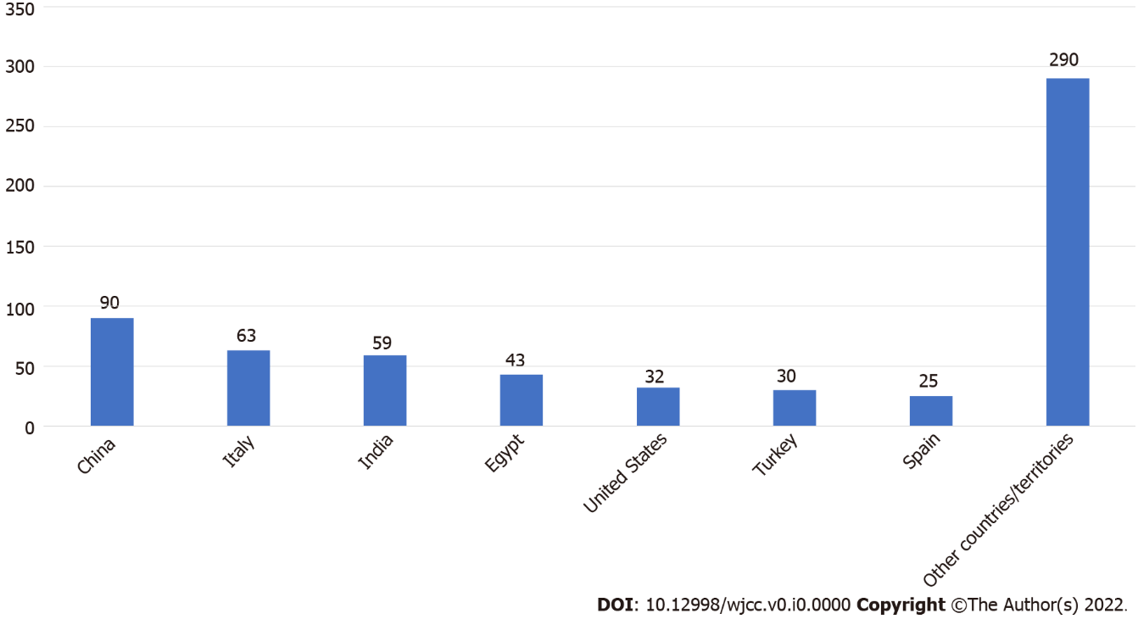
Figure 1 Country sources and number of Reference Citation Analysis scholars.

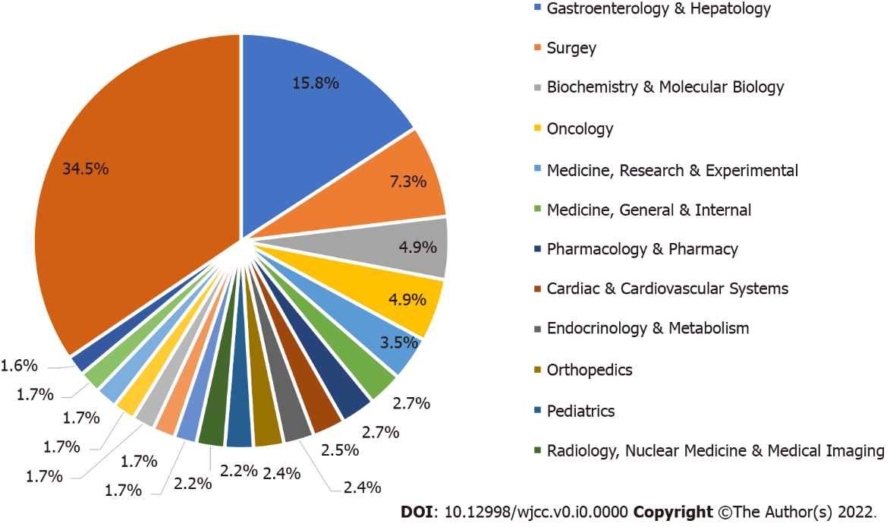
Figure 2 Category distribution of Reference Citation Analysis scholars.

Table 1 Top 3 Reference Citation Analysis scholars ranked by total articles
Rank | RCA ID | Name | Country | Total articles | Research category | Total citations | 2022 Article Influence Index
1 | 00000973 | Giuseppe Biondi-Zoccai | Italy | 901 | Cardiac & Cardiovascular Systems | 26476 | 29.385
2 | 00000223 | Michael Horowitz | Australia | 725 | Endocrinology & Metabolism | 29432 | 40.596
3 | 00000650 | Hafiz MN Iqbal | Mexico | 465 | Engineering, Environmental | 13495 | 29.022

Table 2 Top 3 Reference Citation Analysis scholars ranked by total citations
Rank | RCA ID | Name | Country | Total citations | Research category | Total articles | 2022 Article Influence Index
1 | 00000942 | Kamarul Imran Musa | Malaysia | 42830 | Public, Environmental & Occupational Health | 123 | 348.211
2 | 00000637 | Furio Pacini | Italy | 30373 | Endocrinology & Metabolism | 300 | 101.243
3 | 00000223 | Michael Horowitz | Australia | 29432 | Endocrinology & Metabolism | 725 | 40.596

Table 3 Top 3 Reference Citation Analysis scholars ranked by 2022 Article Influence Index
Rank | RCA ID | Name | Country | 2022 Article Influence Index | Research category | Total articles | Total citations
1 | 00000942 | Kamarul Imran Musa | Malaysia | 348.211 | Public, Environmental & Occupational Health | 123 | 42830
2 | 00000664 | Gani Bajraktari | Kosovo | 260.303 | Cardiac & Cardiovascular Systems | 99 | 25770
3 | 00000245 | Yasir Waheed | Pakistan | 198.624 | Infectious Diseases | 141 | 28004

Table 4 Top 3 Reference Citation Analysis scholars in the field of Gastroenterology & Hepatology ranked by total articles
Rank | RCA ID | Name | Country | Total articles | Total citations | 2022 Article Influence Index
1 | 00001172 | Kamran B Lankarani | Iran | 392 | 4100 | 10.459
2 | 00000002 | Andrzej S Tarnawski | United States | 365 | 8764 | 24.011
3 | 00000349 | Xing-Shun Qi | China | 311 | 4561 | 14.666

Table 5 Top 3 Reference Citation Analysis scholars in the field of Gastroenterology & Hepatology ranked by total citations
Rank | RCA ID | Name | Country | Total citations | Total articles | 2022 Article Influence Index
1 | 00000002 | Andrzej S Tarnawski | United States | 8764 | 365 | 24.011
2 | 00000598 | Bruno Annibale | Italy | 7695 | 286 | 26.906
3 | 00000248 | Francis Seow-Choen | Singapore | 6960 | 225 | 30.933

Table 6 Top 3 Reference Citation Analysis scholars in the field of Gastroenterology & Hepatology ranked by 2022 Article Influence Index
Rank | RCA ID | Name | Country | 2022 Article Influence Index | Total articles | Total citations
1 | 00000799 | Paul Henderson | United Kingdom | 89.661 | 62 | 5559
2 | 00001068 | Li Ma | United States | 51.500 | 8 | 412
3 | 00000239 | Dar-In Tai | Taiwan | 50.385 | 96 | 4837

Table 7 Top 3 Reference Citation Analysis scholars in the field of Surgery ranked by total articles
Rank | RCA ID | Name | Country | Total articles | Total citations | 2022 Article Influence Index
1 | 00000233 | Bing Hu | China | 206 | 1686 | 8.184
2 | 00000861 | Tsutomu Namikawa | Japan | 206 | 1559 | 7.568
3 | 00000889 | Rafael Denadai | Brazil | 198 | 1226 | 6.192

Table 8 Top 3 Reference Citation Analysis scholars in the field of Surgery ranked by total citations
Rank | RCA ID | Name | Country | Total citations | Total articles | 2022 Article Influence Index
1 | 00000689 | William C Dooley | United States | 3740 | 83 | 45.060
2 | 00000803 | Luca Morelli | Italy | 2619 | 158 | 16.576
3 | 00001229 | Trond Buanes | Norway | 2618 | 131 | 19.985

Table 9 Top 3 Reference Citation Analysis scholars in the field of Surgery ranked by 2022 Article Influence Index
Rank | RCA ID | Name | Country | 2022 Article Influence Index | Total articles | Total citations
1 | 00000689 | William C Dooley | United States | 45.060 | 83 | 3740
2 | 00001197 | Nicolò Fabbri | Italy | 33.229 | 35 | 1163
3 | 00001006 | Zaza Demetrashvili | Georgia | 30.373 | 59 | 1792

Table 10 Top 3 Reference Citation Analysis scholars in the field of Biochemistry & Molecular Biology ranked by total articles
Rank | RCA ID | Name | Country | Total articles | Total citations | 2022 Article Influence Index
1 | 00000278 | Giuseppe Maurizio Campo | Italy | 183 | 4479 | 24.475
2 | 00001051 | Yoshiro Saito | Japan | 117 | 5886 | 50.308
3 | 00000168 | Medine Cumhur Cüre | Turkey | 116 | 891 | 7.681

Table 11 Top 3 Reference Citation Analysis scholars in the field of Biochemistry & Molecular Biology ranked by total citations
Rank | RCA ID | Name | Country | Total citations | Total articles | 2022 Article Influence Index
1 | 00001051 | Yoshiro Saito | Japan | 5886 | 117 | 50.308
2 | 00000302 | Guoxun Chen | United States | 4576 | 71 | 64.451
2 | 00000278 | Giuseppe Maurizio Campo | Italy | 4479 | 183 | 24.475

Table 12 Top 3 Reference Citation Analysis scholars in the field of Biochemistry & Molecular Biology ranked by 2022 Article Influence Index
Rank | RCA ID | Name | Country | 2022 Article Influence Index | Total articles | Total citations
1 | 00000155 | Manoj Kumar Kashyap | India | 75.521 | 48 | 3625
 | 00000302 | Guo-Xun Chen | United States | 64.451 | 71 | 4576
2 | 00001051 | Yoshiro Saito | Japan | 50.308 | 117 | 5886

Table 13 Top 3 Reference Citation Analysis scholars in the field of Oncology ranked by total articles
Rank | RCA ID | Name | Country | Total articles | Total citations | 2022 Article Influence Index
1 | 00000057 | Jing He | China | 206 | 3489 | 16.937
2 | 00000659 | Dario de Biase | Italy | 161 | 2488 | 15.453
3 | 00000800 | Cosimo Sperti | Italy | 156 | 3467 | 22.224

Table 14 Top 3 Reference Citation Analysis scholars in the field of Oncology ranked by total citations
Rank | RCA ID | Name | Country | Total citations | Total articles | 2022 Article Influence Index
1 | 00000754 | Reza Alizadeh-Navaei | Iran | 23735 | 141 | 168.333
2 | 00000380 | José Carvalheira | Brazil | 6059 | 119 | 50.916
2 | 00000768 | Amit Dutt | India | 6026 | 67 | 89.940

Table 15 Top 3 Reference Citation Analysis scholars in the field of Oncology ranked by 2022 Article Influence Index
Rank | RCA ID | Name | Country | 2022 Article Influence Index | Total articles | Total citations
1 | 00000754 | Reza Alizadeh-Navaei | Iran | 168.333 | 141 | 23735
 | 00000768 | Amit Dutt | India | 89.940 | 67 | 6026
2 | 00000512 | Nuri Faruk Aykan | Turkey | 65.455 | 44 | 2880

