Name of journal: World Journal of Gastroenterology
Manuscript NO: 38018

Manuscript Type: ORIGINAL ARTICLE

Basic Study
Sodium chloride exacerbates dextran sulfate sodium-induced colitis by tuning pro-inflammatory and anti-inflammatory lamina propria mononuclear cells through p38/MAPK pathway in mice

Guo HX et al. Sodium chloride exacerbates DSS-induced colitis in mice

Hong-Xia Guo, Nan Ye, Ping Yan, Min-Yue Qiu, Ji Zhang, Zi-Gang Shen, Hai-Yang He, Zhi-Qiang Tian, Hong-Li Li, Jin-Tao Li

Hong-Xia Guo, Jin-Tao Li, Department of Microbiology, Third Military Medical University (Army Medical University), District Shapingba, Chongqing 400038, China

Hong-Xia Guo, Nan Ye, Min-Yue Qiu, Jin-Tao Li, Institute of Tropical Medicine, Third Military Medical University (Army Medical University), District Shapingba, Chongqing 400038, China

Ping Yan, Department of Obstetrics and Gynecology, Southwest Hospital, Third Military Medical University (Army Medical University), Chongqing 400038, China

Ji Zhang, Zi-Gang Shen, Hai-Yang He, Zhi-Qiang Tian, Institute of Immunology, Third Military Medical University (Army Medical University), District Shapingba, Chongqing 400038, China

Hong-li Li, Department of Histology and Embryology, College of Basic Medicine, Third Military Medical University (Army Medical University), Chongqing 400038, China

ORCID number: Hong-Xia Guo (0000-0003-4476-3141); Nan Ye (0000-0001-8929-7813); Ping Yan (0000-0001-7984-9880); Min-Yue Qiu (0000-0002-7718-3111); Ji Zhang (0000-0002-6444-3949); Zi-Gang Shen (0000-0001-5224-5315); Hai-Yang He (0000-0002-2862-3600); Zhi-Qiang Tian (0000-0003-4609-6637); Hong-Li Li (0000-0003-0851-2310); Jin-Tao Li (0000-0003-3637-2386).

Author contributions: Li JT designed the research. Guo HX, Ye N, Li HL and Qiu MY performed the research; Yan P, Zhang J, Shen ZG, He HY, Tian ZQ contributed reagents and analytic tools; Ye N contributed to statistical analysis; Guo HX and Li JT wrote the manuscript and carried out the critical revision of the manuscript; while all authors contributed to the final approval of the article.

Supported by National Natural Science Foundation of China, No. 81271813 and No. 81570497.

Institutional review board statement: This study was reviewed and approved by the Third Military Medical University (Army Medical University) Institutional Review Board.

Institutional animal care and use committee statement: All procedures involving the care and use of animals were approved by The Institutional Animal Care and Use Committee of the Third Military Medical University (Army Medical University).

Conflict-of-interest statement: All authors declared there were no conflicts of interests.

Data sharing statement: No additional data are available.

ARRIVE guidelines statement: The authors have read the ARRIVE guidelines, and the manuscript was prepared and revised according to the ARRIVE guidelines.

Open-Access: This article is an open-access article which was selected by an in-house editor and fully peer-reviewed by external reviewers. It is distributed in accordance with the Creative Commons Attribution Non Commercial (CC BY-NC 4.0) license, which permits others to distribute, remix, adapt, build upon this work non-commercially, and license their derivative works on different terms, provided the original work is properly cited and the use is non-commercial. See: http://creativecommons.org/licenses/by-nc/4.0/

Manuscript source: Unsolicited manuscript

Correspondence to: Jin-tao Li, PhD, Professor, Institute of Tropical Medicine, Third Military Medical University (Army Medical University), Gaotanyan Street 30, Chongqing 400038, China. ljtqms@tmmu.edu.cn
Telephone: +86-23-68752329
Fax: +86-23-68752329

Received: January 25, 2018
Peer-review started: January 26, 2018
First decision: February 24, 2018
Revised: March 11, 2018
Accepted: March 18, 2018
Article in press:
Published online:

Abstract
AIM
To investigate the influence of high salt on dextran sulfate sodium (DSS)-induced colitis in mice and explore the underlying mechanisms of this effect.

METHODS
DSS and NaCl were used to establish pro-inflammatory animal model. We evaluated the colitis severity. Flow cytometry was employed for detecting the frequencies of Th1, macrophages and Tregs in spleen, mesenteric lymph node and lamina propria (LP). The important role of macrophages in the promotion of DSS-induced colitis by NaCl was evaluated by depleting macrophages with MDP. Activated peritoneal macrophages and lamina propria mononuclear cells (LPMCs) were stimulated with NaCl, and proteins were detected by Western blot. Cytokines and inflammation genes were analyzed by ELISA and RT-PCR, respectively.

RESULTS
The study findings indicate that NaCl up-regulates the frequencies of CD11b⁺ macrophages and CD4⁺IFN-γ⁺IL-17⁺ T cells in LP in DSS-treated mice. CD3⁺CD4⁺CD25⁺Foxp3⁺ cells which can secrete high levels of IL-10 and TGF-β increase through feedback in NaCl and DSS treated mice. Furthermore, MDP pretreatment significantly alleviated DSS-induced colitis indicating that macrophages play a vital role in NaCl pro-inflammatory activity. NaCl aggravates peritoneal macrophage inflammation by promoting the expressions of interleukin (IL)-1, IL-6 and iNOS. Specifically, high NaCl concentrations promote p38 phosphorylation in LPS and IFN-γ activated LPMCs mediated by SGK1.

CONCLUSION
Pro-inflammatory macrophages may play an essential role in the onset and development of NaCl-promoted inflammation in DSS-induced colitis. The underlining mechanism involves on the up-regulation of the p38/MAPK axis.

Key words: NaCl; inflammatory bowel disease; macrophage; CD4⁺IFN-γ⁺IL-17⁺ T cell; p38/MAPK

© The Author(s) 2018. Published by Baishideng Publishing Group Inc. All rights reserved.

Core tip: NaCl, as an indispensable environmental factor, evokes both innate and adaptive immune pro-inflammation cell activation in mice affected by dextran sulfate sodium (DSS)-induced colitis. Pro-inflammatory CD4⁺ cells in DSS- and NaCl-treated mice are mainly double-positive IL-17⁺IFN-γ⁺ T cells. Macrophage depletion significantly alleviates DSS-induced colitis. M1 macrophages play an important role in the pro-inflammatory effect of NaCl in the gut of mice. NaCl promotes M1 pro-inflammatory gene expression in LPS-activated peritoneal macrophage. The mechanism by which NaCl promotes DSS-induced colitis involves the up-regulation of the p38/MAPK axis.

Guo HX, Ye N, Yan P, Qiu MY, Zhang J, Shen ZG, He HY, Tian ZQ, Li HL, Li JT. Sodium chloride exacerbates dextran sulfate sodium-induced colitis by tuning pro-inflammatory and anti-inflammatory lamina propria mononuclear cells through p38/MAPK pathway in mice. World J Gastroenterol 2018; In press

INTRODUCTION
Inflammatory bowel disease (IBD), is a chronic and recurrent disease, usually manifested as ulcerative colitis (UC) and Crohn’s disease (CD)^{[1]}. IBD is a high risk factor for colorectal cancer and it is a serious threat to the human health globally. Although its etiology is presently unclear, findings yielded by extant studies indicate that IBD is a complex process involving heredity, environment and immunity^{[2-5]}.
Innate and adaptive immune cells play different roles in IBD pathogenesis. Results obtained in a large number of studies have shown that Th17, Th1, regulatory T cells (Tregs) and macrophages play important roles in IBD pathogenesis. For instance, the number of Th17 cells increases significantly in mucosa lamina propria (LP) of colitis patients, whereby IL-17 is produced, resulting in mucosal damage and enhancing disease activity^{[6,7]}. Th1 polarization is related to colonic inflammation by inducing IFN-γ and TNF-α production, whereas the differential propensity to develop colitis is linked to the inherent tendency of immune system to give rise to Th1 or Th17/Treg response^{[8]}. Tregs, which are very important regulatory T cells, highly express IL-10 and inhibit inflammation in IBD^{[9]}. Macrophages in intestinal mucosa of colitis patients could secrete cytokines TNF-α, IL-1 and IL-6^{[10]}. Intestinal macrophages are the major population of antigen presenting cells in intestinal mucosa and they shape the types of T cell response to luminal antigens^{[11]}.
Sodium chloride mediates the inflammatory effects of immune cells that are very important to IBD. NaCl exacerbates EAE in mice by promoting Th17 cell differentiation^{[12]}. High salt content strengthens the LPS induced macrophage activation by activating signaling pathways of p38 and ERK1 to induce the production of pro-inflammatory factors^{[13]}. Extant studies have shown that the high salt diet promotes Th17 cell activation in LP and exacerbates experimental colitis in mice^{[14,15]}. However, high salt diet on other immune cells such as Th1, Tregs and macrophages, which are also associated with pathopoiesis in IBD, is still unclear. Macrophage activation plays a pivotal role in inﬂammation initiation and progression in diverse pathological conditions. Findings obtained in our previous research indicate that, in mice treated with clodronate liposomes (MDP), gut macrophages were successfully depleted. Macrophage depletion could protect mice against colitis induced by dextran sulfate sodium (DSS), suggesting that the macrophage play an important role in colitis pathogenesis.
In the present study, we hypothesized that NaCl promotes the onset and course of DSS-induced colitis, as well as sustains the disease. The promotion effect may be due to monocyte-macrophages shifting the T cell response toward Th17, Th1 and Treg cells. We tested this hypothesis in a DSS-induced colitis mouse model, which shares many characteristics with human UC^{[16,17]}. We found that NaCl promoted both macrophages and CD4⁺ pro-inflammatory cell immune response, whereby CD4⁺ pro-inflammatory cells were mainly CD4⁺IFN-γ⁺IL-17⁺ T cells. NaCl enhanced the pro-inflammatory gene expression and cytokine secretion in the colons of mice affected by colitis. Depletion of gut macrophages significantly alleviated DSS-induced colitis suggesting macrophages play a vital role in the NaCl pro-inflammation process. High NaCl enhanced M1 pro-inflammation gene expression in LPS-activated peritoneal macrophages. Therefore, colitis promoted by high NaCl levels may be a result of M1 macrophage polarization. M1 polarization shifts T cell response toward pro-inflammatory CD4⁺IFN-γ⁺IL-17⁺ T cells. High NaCl pro-inflammation in LPS and IFN-γ activated LPMC relies on the up-regulation of the p38 mitogen-activated protein kinase (p38/MAPK) axis.

MATERIALS AND METHODS
Animal treatment
For this study, 8- to 10- wk-old female C57BL/6J mice were purchased from the Animal Center of Third Military Medical University (Army Medical University). Mice were housed at 24 ℃ under light-controlled cycle (12 h) with free access to standard laboratory water and food. All processes were supported by the Committee on Use and Care of Laboratory Animals at Third Military Medical University (Army Medical University).

Establishment of animal model with DSS and NaCl
Mice purchased from the Animal Center were allowed at least seven days to adapt to the environment before being randomly divided into four groups. They received water containing 2% NaCl (Sinopharm Chemical Reagent, China) and/or water containing 2.5% DSS (MP biomedicals160110, United States) for 10 d. The intestinal macrophages were depleted using MDP (van Rooijen and van Kesteren-Hendrikx, 2003, clodronateliposomes.org, Holland)^{[18]}. Briefly, 200μl MDP was injected i.p. into mice four days prior to the onset of inflammation and on day -1, 1, 3 and 5 during 2.5% DSS and 2%NaCl treatment. The disease activity index (DAI)-which was used for the clinical scoring of stool consistency, bleeding and weight loss-served as the measure of colitis severity. The criteria for grading the DAI were adopted from elsewhere^{[19]}.

Cell isolation
Spleen (SP) and mesenteric lymph node (MLN) cells from each mouse in all groups were separated by grinding on filters. SP red blood cells were lysed using red blood cell lysis buffer (Beyotime C3702, China). Single cell suspensions of SPs and MLNs were obtained through filters. Cells were washed twice with PBS (Zhongshanjinqiao, Beijin, China) containing 2% fetal calf serum (2%FBS/PBS, Gibco, Life Technologies, United States) through centrifugation. Cell pellets were resuspended in 2%FBS/PBS and were kept on ice for later use. Intestinal lamina propria mononuclear cells (LPMCs) were isolated in accordance with the Lamina Propria Dissociation kit instructions (Miltenyi Biotec 130-097-410, Germany). Cell pellets were resuspended in 40% percoll (Ruitaibio, Beijing, China) and added slowly to the upper part of centrifuge tubes which were added 5ml 80% percoll at the bottoms. LPMCs were obtained by washing twice with 2%FBS/PBS after density gradient centrifuging at 420 g for 20 min.

Flow analysis
The isolated cells from SPs, MLNs and LPs from each experimental group were cultured in 96-well U plate in 0.2ml 1640 medium containing 1% penicillin-streptomycin (Beyotime C0222, China) and 10% FBS with ionomycin (I) (1 μg/ml, Beyotime S1672, China), phorbol 12-myristate 13-acetate (PMA) (25 ng/ml, Beyotime S1819, China) and Brefeldin A (BFA) (10 ug/ml, BD Bioscience 51-2092KZ, United States) for 6 hours. The cells were collected and pre-blocked by Fc receptors for 20 minutes. Cell-surface staining was performed using PE-, FITC-, APC- or percp-conjugated anti-CD4, CD3, CD25 or CD11b (eBioscience, CA, United States). Intracellular staining was performed using the FITC-conjugated anti-mouse IFN-γ, PE-conjugated anti-mouse IL-17 or Foxp3 (eBioscience, CA, United States). The intracellular or nuclear staining for IFN-γ, IL-17 and Foxp3 analysis was performed according to the BD Bioscience protocol.

LPMCs stimulation
Isolated LPMCs were cultured at a concentration of 5 × 10⁶ cells/ml for 24 h, after which the culture supernatants were collected and cytokine levels were analyzed by ELISA or were stimulated using different NaCl concentrations (5, 10, 20, 40, 60, 80 mmol/L) in the presence of 100 ng/ml LPS (Sigma, United States) and 20 ng/ml IFN-γ (Sigma, United States) with SB20358 (p38 inhibitor) or DMSO (Beyotime ST038, China) for 24 h. The cells were detected by Western blot (WB) or real time-PCR (RT-PCR).

Mouse peritoneal macrophage preparation
Mice were injected intraperitoneally with 2 mL of 4% sterile thioglycollate medium (Becton Dickinson, United States)^{[20]}. Peritoneal macrophages were obtained by washing the peritoneal cavity with 8ml PBS containing 1% penicillin-streptomycin per mouse. Peritoneal macrophages were centrifuged and resuspended in DMEM (Gibco, Thermo Fisher Scientific, United States) containing 10%FBS and 1% penicillin- streptomycin. Next, peritoneal macrophages were seeded in 24-well plates (Corning, United States) and non adherent cells were removed 4 h after seeding by washing with medium^{[21]}. Once adhered to the culture plates, cells were stimulated with NaCl (10, 20, 40, 60, 80 mmol/L) and 100 ng/ml LPS for 24 h. Finally, cells were collected for gene expression evaluation.

Colon culture
Colon tissues were cultured as previously described^{[22,23]}. Briefly, after cut longitudinally, colon tissues were washed with PBS for removing intestinal contents and were cut into 1-cm segments. These pieces were cultured in 24-well plates in 2ml RPMI1640 medium (Gibco, Life Technology, Shanghai, China) containing 1% penicillin-streptomycin for 24 h. Supernatant was obtained by centrifuging at 10000 g at 4 °C for 10 min and was immediately stored at -80 °C until required for further ELISA detection.

RNA isolation and RT-PCR
RNAs of cells and tissues were extracted by trizol (Ambion, Life Technology, USA). RNA was transcribed into cDNA using reverse transcription kits (TAKARA, RR047A, Japan). Quantitative real time PCR was performed using BIORAD in duplicates using SYBR Green (TAKARA, RR820A, Japan) to measure the products. Gene expression was analyzed using the comparative Ct method and was normalized to GAPDH which served as internal control. The primer sequences are shown in Table 1.

ELISA
Cytokine content was expressed in pg/ml. Abs, including purified and biotinylated rat anti-mouse, and related reagents were purchased from eBioscience (CA, United States). Briefly, 2 μg/ml capture antibody diluted with coat buffering was incubated at 4 ℃ overnight in 96 well plates(Corning, United States) and was blocked with 5% bovine serum albumin (BSA) (Sigma, United States) at 37 ℃ for 2 h. Samples were incubated at 37 ℃ for 2 h after being washed three times with PBS containing 0.05% tween-20 (PBST). Biotinylated antibodies were incubated at 37 ℃ for 1 h after being washed with PBST three times. HRP-conjugated antibody was incubated at 37 ℃ for 30 min after being washed with PBST five times. The reaction of detection reagent at 37 ℃ required needed 15 min after the unbounded antibody was removed by washing with PBST five times. The plate was analyzed at 450nm wavelength after terminating the reaction with the stop solution.

Histology and immunohistochemistry
Colon tissues were fixed with 4% paraformaldehyde before being embedded in paraffin. To assess inflammation, colon tissue cross sections were stained with hematoxylin and eosin (HE). Sections were incubated with rabbit anti- mouse iNOS antibody labeled with FITC (Biorbyt, orb14179, United Kingdom) and rabbit anti- mouse F4/80 antibody labeled with PE (Biolegend 123109, United States). All immunofluorescence images were taken by a fluorescence microscope (Leica, Germany) under the same exposure and intensity settings.

Western blotting
Proteins were extracted by RIPA lysis buffer containing protease inhibitor cocktail. The protein concentration was detected using the Protein Concentration Kits (Beyotime P0012, China) and the samples were boiled for 5 min at 98 ℃. Then, 30 μg of protein for each sample was separated with SDS-PAGE. Next, proteins were electro transferred onto a nitrocellulose membrane (GE Healthcare, Sweden) and were blocked with 5%BSA in TBS-0.05% Tween 20 (TBST) at room temperature for 2 h. The membrane was subsequently incubated with GAPDH (1:1000, Santa Cruz, United States), p38 or phosphorylated p38 (1:250, Abcam, United States) at 4 ℃ for 16 h. The membrane was washed with TBST before being incubated at room temperature for 1 h with antibody conjugated with HRP (1:2000, Zhongshanjinqiao, Beijing, China). Antibody binding was detected with the ECL substrate (BIORAD170-5060, United States) after washing with TBST. The optical density of bands was analyzed using Image J 1.42 software (United States).

Statistical analysis
All data were expressed as mean ± SD. GraphPad software (GraphPad Prism 5.00 for Windows, United States) was used for data analysis. Statistical results were evaluated using unpaired Student’s t-test or ANOVA, and P < 0.05 was considered statistically signiﬁcant.

RESULTS
NaCl aggravates DSS-induced colitis in mice
To determine the influence of NaCl on enteritis, mice were given 2.5% DSS and/or 2% NaCl. Mice that received both NaCl and DSS started losing weight from Day 5 and subsequently exhibited greater weight loss compared to the DSS group (Figure 1A). Moreover, the death rate in the DSS + NaCl group was markedly higher than in the DSS group (Figure 1B). Compared to other groups, colons of mice in the DSS + NaCl group became shorter (Figure 1C). H＆E staining displayed obvious inflammatory cells infiltration in both groups, but the DSS + NaCl group exhibited more inflammatory cell infiltration in colon tissues compared to the DSS group (Figure 1D). These findings suggest that NaCl aggravated inflammation in DSS-induced colitis.

NaCl up-regulates the frequency of CD4⁺IFN-γ⁺IL17⁺ T cells and promotes the secretion of inflammatory cytokines in mice with DSS-induced colitis
Increasing evidence indicates that CD4⁺ T cells play a crucial role in the pathogenesis of chronic intestinal inflammation, and related cytokines-such as IFN-γ, IL-6, IL-17A and TNF -are highly expressed in the inflamed mucosa of IBD patients^{[24,25]}. To explore the influence of NaCl on CD4⁺ T cells in colitis-affected mice, the CD4⁺IFN-γ⁺IL-17⁺ T cell subsets were detected. Compared to the DSS group, the flow cytometry analysis indicated that frequencies of CD4⁺IL-17⁺ and CD4⁺IFN-γ⁺ T cell subsets were markedly up-regulated in the DSS + NaCl group (Figure 2A). NaCl promotion of the DSS-induced colitis development is associated with both CD4⁺IL-17⁺ and CD4⁺IFN-γ⁺ T cells in LPs, MLNs and SPs. In addition, the frequencies of inflammatory CD4⁺ T cells (IL-17⁺ and IFN-γ⁺ single positive T cells and IFN-γ⁺IL-17⁺ double positive T cells) in DSS + NaCl group were higher than in the DSS group. It is also noteworthy that the frequency of CD4⁺IFN-γ⁺ T cells was up-regulated the most (Figure 2B). These findings suggest that CD4⁺IFN-γ⁺IL-17⁺ T cells are crucial in the inflammation promotion by NaCl in DSS-treated mice.
Cytokines IFN-γ, IL-17α, IL-1α, IL-6 and TNF-α secreted by colon tissues were detected by ELISA and the gene expression of colon tissues from the animal model was measured by RT-PCR. Compared to the DSS group, IFN-γ, IL-17α, IL-1α, IL-1β, IL-6 and TNF-α were all higher in the DSS + NaCl group (Figure 2C and D). Therefore, high NaCl levels up-regulate inflammation gene expression and promote the secretion of multiple pro-inflammatory cytokines in mice affected by DSS-induced colitis.

NaCl up-regulates macrophage frequency in DSS-treated mice
Macrophages play a crucial role in the Th1 and Th17 responses, and are also important regulators of salt homeostasis^{[26]}. To determine the effect of NaCl on macrophages in mice affected by colitis, we detected the frequency of CD11b⁺ macrophages in mice that received DSS and/or NaCl by flow cytometry. We observed that the macrophages increased significantly in the LP, MLN and SP in DSS + NaCl group compared to the DSS group (Figure 3A). The increased CD11b⁺ macrophages were mainly located in intestinal LP and MLN (Figure 3B). These findings indicate that the macrophages also participate in the NaCl pro-inflammation activities in DSS-induced colitis.

Tregs increase through feedback in the development of NaCl aggravating inflammation associated with DSS-induced colitis
Tregs play an important role in the maintenance of intestinal mucosal homeostasis by suppressing abnormal immune response against dietary antigens or commensal flora^{[8]}. To explore the changes in Tregs in the mice that received DSS and NaCl, we detected CD3⁺CD4⁺CD25⁺Forp3⁺ T cells by flow cytometry and observed that their levels were higher in DSS+NaCl group than in the DSS group (Figure 4A). The increased Tregs were mainly distributed in the LP and MLN, while their prevalence in SP did not change significantly (Figure 4B). To explore the influence of NaCl on Tregs in DSS-induced colitis, we evaluated cytokine levels in culture supernatants of LPMCs by ELISA. The results yielded by the analyses indicate that NaCl induces LPMCs to secrete TNF-α, IL-1α, IL-6 and IL-17, which are critical Th17 cell-related cytokines. Moreover, NaCl promotes the secretion of TGF-β and IL-10, which are significant anti-inflammatory cytokines secreted by Tregs (Figure 4C). These findings show that Tregs levels also increase as a result of inflammation promotion by NaCl in mice with DSS-induced colitis.

Macrophages play a critical role in NaCl aggravating DSS-induced colitis
Extant studies have shown that MDP can deplete macrophages in mice^{[27]}. We used MDP to deplete the macrophages in mice during the DSS and NaCl treatment to determine their role in the promotion of DSS- induced colitis by NaCl (Figure 5A). We observed that macrophage depletion by MDP could prevent colon shortening in the mice treated with NaCl and DSS (Figure 5B).The DAI also showed that macrophage depletion alleviated inflammation in NaCl pro-inflammatory processes (Figure 5C). The levels of inflammation cytokines IFN-γ, TNF-α, IL-1β, IL-17A, IL-6, MCP1 and MIP2 secreted by colon tissues from MDP treated mice were reduced (Figure 5D). The colon tissues from the DSS + NaCl group contained a greater number of F4/80⁺iNOS⁺ macrophages compared to the DSS group. In addition, the MDP-treated mice had fewer F4/80⁺iNOS⁺ macrophages compared to the DSS + NaCl group (Figure 6). Thus, we posit that macrophage depletion can reduce colitis severity in mice.

High NaCl promotes M1 macrophage polarization in vitro
Macrophages in both peritoneal cavity and gastrointestinal tract are linked to IBD^{[28]}. Different NaCl concentrations (10, 20, 40, 60, 80 mmol/L) were used to stimulate the macrophages from the abdominal cavity and the gene expression was detected by RT-PCR. Our findings indicate that IL-1β, IL-6 and iNOS, which usually exhibit pro-inflammatory roles, gradually increased as the NaCl concentration increased (Figure 7A-C). It is worth noting that IL-10 and Arg1, which are M2 macrophage markers, increased modestly at low NaCl concentrations, whereas their expression markedly increased at 40mM and above (Figure 7D and E). These results display that high NaCl levels promote LPS-activated peritoneal macrophages toward to M1 polarization.

NaCl promotes inflammation response in LPs, whereas LPS and IFN-γ activated LPMCs rely on p38/MAPK
P38/MAPK is related to both IBD and hyperosmotic stress^{[29,30]}. Western blot analysis revealed that high NaCl levels significantly up-regulated phosphorylated-p38 of LPMCs stimulated with LPS and IFN-γ for different time periods (1 h, 6 h, 12 h, 24 h), however, they did not affect the total level of p38, and p38 phosphorylation reached the highest level after 12 h (Figure 8A). LPMCs were treated with NaCl at different concentrations (5, 10, 20, 40, 60, 80 mmol/L) in the presence of LPS and IFN-γ for 24 h. The WB revealed that p38 phosphorylation increased in a dose dependent manner (Figure 8B). Serum glucocorticoid regulated kinase 1 (SGK1) increased in LPMCs activated by LPS and IFN-γ due to NaCl stimulation (Figure 8C). The results further indicated that p38 inhibitor can decrease high-NaCl-promoted p38 phosphorylation in LPMCs (Figure 8D). These findings confirmed that NaCl promotes an inflammatory response in the LPS and IFN-γ activated LPMCs and the pro-inflammation effect depends on p38/MAPK phosphorylation mediated by SGK1.

DISCUSSION
NaCl has been shown to exert pro-inflammatory effect in many diseases including experimental colitis, EAE, and cardiovascular disease^{[31-33]}. In the present study, we observed that macrophages played an important role in the promotion of DSS-induced colitis by NaCl. Macrophages, as antigen -presenting cells, are important in regulating innate and adaptive immune responses and have a crucial role in resolving tissue injury and promoting tissue repair in IBD^{[34,35]}. Even though the cause of IBD remains unclear, mice with lymphocyte deficiency developed more severe inflammation, suggesting that innate immune cells are capable of triggering the onset and development of disease^{[36]}. Activation of innate immune system is regarded as the most direct cause of IBD because it can recruit cells of the adaptive immune system to the inflammatory site, thus resulting in inflammation^{[37]}.
Findings yielded by the present study further indicated that NaCl promoted the increase in the CD4⁺ T cell count, especially the IFN-γ⁺IL-17⁺ double positive T cells in DSS-treated mice. Extant research indicates that highsalt diet promotes the differentiation of CD4⁺ T cells into Th17 as well as Th1^{[32]}. However, Wei et al. showed that, in TNBS-induced colitis, NaCl promoted Th17 polarization, but not Th1 polarization^{[15]}. DSS and TNBS may cause different pathogenic mechanisms. Wei et al used TNBS to induce colitis, which mainly simulated CD. However, we used DSS to induce colitis which mainly simulated UC^{[38]}. In both CD and UC patients, activation and mucosal infiltration of CD4⁺ T lymphocytes has been reported^{[39]}. Extant studies have revealed that blocking CD4⁺ T cell activation was capable of limiting the development of mucosal inflammation in experimental colitis models^{[40]}. CD4⁺ IFN-γ⁺IL-17⁺ T cells, as an intermediate form between Th17 and Th1, are an easily observable crossover subset promoted by IL-12 signaling beyond IL-17^{[41,42]}. Th17 cells play an important role in colitis pathogenesis by directly giving rise to Th1-like cells response^{[43]}. Empirical evidence indicates that IBD is characterized by Th1 cell activation and subsequent over expression of cytokines such as TNF-α, IL-6 and IL-1β^{[44,45]}. In addition, findings yielded by extant research suggest that Th1 cytokines are important promoters of continuous mucosal inflammation in DSS-induced colitis^{[46,47]}. The results obtained in the present work confirmed the important role of CD4⁺IFN-γ⁺IL-17⁺ T cells in the promotion of inflammation by NaCl in DSS-treated mice. High NaCl content up-regulates inflammation gene expression and promotes the secretion of multiple pro-inflammatory cytokines for promoting intestinal inflammation in mice affected by DSS-induced colitis.
IL-6 and IL-17 are critical Th17 cell-related cytokines that are involved in inflammatory responses during IBD development^{[7,48]}. In contrast, anti-inflammatory TGF-β and IL-10, are mainly produced by Tregs^{[49]}. Wei and colleagues demonstrated that, while high-salt diet did not change Tregs percentage, it did inhibit the secretion of IL-10 and the suppressive function of Tregs in TNBS-induced colitis^{[15]}. In our study, NaCl promoted an increase in Tregs frequency in MLNs and LPs, as well as enhanced IL-10 and TGF-β expression, in DSS-induced colitis. Tregs, as an immune suppressing cell, is essential in maintaining intestinal homeostasis^{[50]}. In DSS-treated beta7-deficient mice, in which colonic Tregs were depleted, excessive macrophage infiltration in colons occurred by up-regulation of colonic epithelial intercellular ICAM1, which promoted pro-inflammatory cytokine expression, aggravating DSS-induced colitis^{[51]}. Disruption in balance may allow T cells to proliferate in an increased fashion, thereby promoting chronic intestinal inflammatory development^{[52]}. Therefore, continuous Tregs differentiation and trafficking in the gut is required to dampen immune responses to dietary antigens and commensal bacteria^{[53]}.
We also found that NaCl promoted an increase in CD11b⁺ cells in the LP and MLN from mice treated with DSS. Denning et al^{[54]} have shown that CD11b⁺F4/80⁺CD11c⁻ macrophages in LP could induce Foxp3⁺ regulatory T cell differentiation, while CD11b⁺ dendritic cells in LP elicited responses of IL-17-producing T cells^{[54]}. Empirical evidence indicates that the intake of high dietary salt could boost Th17 response through activating the caspase-1 in macrophages^{[15,55]}. Moreover, in reaction to NaCl, macrophages with enhanced expression of immune-stimulatory molecules, promote pro-inflammatory cytokine production and T cell proliferation^{[10,56]}. Human monocyte-derived GM-Mφ exhibit potent Ag-presenting functions, produce IL-12p40 and IL-23p19, and promote development of Th1 immunity^{[57,58]}. In our study, inflammation was relieved when the intestinal macrophages were depleted by MDP, which indicated that the activation of Th17 and Th1 cells required macrophage participation.
Peritoneal macrophages from mice are among the best-studied macrophage populations and their role in the regulation of inflammatory responses and mucosal immunity is well understood^{[59,60]}. Macrophages in peritoneal cavity, which are crucial in the regulation of inflammatory pathologies, are also related to IBD^{[28,61]}. In the present study, we have shown that high NaCl content enhanced the expression of pro-inflammation gene IL-1β, IL-6 and iNOS and anti-inflammation gene Arg1 and IL-10 in macrophages from abdominal cavity of mice. Macrophages can be polarized to either classically activated (M1) or alternatively activated (M2) macrophages^{[62]}. M1 macrophages are pro- inflammatory cells dur to their high capacityfor producing pro-inflammatory cytokines, such as IL-23, IL-12, IL-1β, TNF-α and iNOS^{[63,64]}. M2 macrophages highly express IL-10 and Arg1, which are involved in anti-inflammatory, anti-microbial response^{[62,65]}. These cytokines promote the activation of the adaptive immune and T cell response^{[66]}. In this research, high NaCl content boosted M1 polarization and up-regulated expression of pro-inflammatory genes to promote inflammation. Under low NaCl concentrations, IL-1, IL-6 and iNOS mainly produced by M1 macrophages were up-regulated, while the negative adjustment factor expressions were low. When the NaCl concentration rised to a certain dose, high levels of pro-inflammatory factors IL - 1, IL - 6 and iNOS induced the cell protective response through feedback, and caused the up-regulation of negative adjustment factor IL-10 and Arg1. Thus, when the inflammation continues to worsen, the M2 macrophages will respond to balance inflammation with protective immunity, and inhibit the expression of pro-inflammatory factor.
We explored the influence of NaCl on LPS and IFN-γ activated LPMCs and demonstrated that high NaCl enhanced phosphorylation of p38, as inflammation and salt intake are both linked to p38/MAPK. The p38/MAPK signaling pathway is important in IBD and the inhibition of p38/MAPK can effectively suppress the production of inflammatory mediators^{[29]}. Available evidence indicates that p38/MAPK mediates intestinal inflammation gene expression, such as TNF-α, IL-1 and IL-6, and this up-regulation occurs in multiple types of cells, especially monocytes and macrophages^{[67]}. In addition, p38/MAPK can regulate the SGK1 activation^{[30]}. High NaCl concentration promotes p38/MAPK phosphorylation and activates the SGK1^{[32]}. SGK1 has been shown to control Na(+) transport and NaCl homeostasis in cells, and could trigger Th17 responses and promote tissue inflammation^{[12]}. Human LPMCs exposed to high NaCl concentrations highly express IL-17A, IL-23R and TNF-α, and pharmacological inhibition of p38/MAPK has been shown to abrogate the effect of NaCl on LPMC-derived cytokines^{[14]}. In the present study, high NaCl content was shown to promote inflammation in LPS and IFN-γ activated LPMCs. However, this process relies on the up-regulation of p38/MAPK and SGK1.
In summary, the study findings reported in this work indicate that NaCl induces alterations to both the innate and acquired immune system in mice with DSS-induced colitis. NaCl promotes M1 macrophage polarization, and M1 polarization may shift T cell response toward the pro-inflammatory CD4⁺IFN-γ⁺IL-17⁺ T cells aggravating colitis. The mechanism by which high NaCl concentrations promote inflammation relies on the up-regulation of p38/MAPK and SGK1. Although results obtained in the present study indicate that excessive NaCl intake can promote the inflammation in mice with the DSS-induced colitis, the causality of high salt diet and IBD still needs to be confirmed by further investigations. More clinical and experimental studies are required to fully clarify the role of salt in IBD.

Article Highlights
Research background
At present, most diets are characterized by high salt content. Extant studies have shown that high salt intake contributes to inflammatory bowel disease (IBD) incidence and pathogenesis. However, the mechanism underlining these effects remains unclear.

Research motivation
NaCl mediates the inflammatory effects of immune cells. Both innate and adaptive immune pro-inflammation cells play important roles in IBD. Studies have shown the high salt intake promotes the activation of Th17 cells in lamina propria (LP) and exacerbates experimental colitis in mice. However, the influence of high salt content in diet on other immune cells is still unclear. The present study explored the influence of high NaCl concentration on immune cell subsets and the underlining mechanisms.

Research objectives
The aim of the present study was to determine the impact of high NaCl concentration on DSS-induced colitis in mice and explore its influence on other immune cells, such as Th1, Tregs and macrophages, while attempting to elucidate the mechanism underlying this effect.

Research methods
DSS and NaCl were used to establish pro-inflammatory animal model. The immune cell subsets were detected by flow cytometry in order to determine the target cells of NaCl. Cytokines secreted by intestinal tissue were detected. In the present study, MDP was used to deplete macrophages to further delineate their vital role in the promotion of DSS-induced colitis in mice by NaCl. In cell experiments, NaCl at different concentrations acted directly on LPMCs and macrophages. mRNA levels of inflammation genes and p38/MAPK proteins were determined by RT-PCR and WB, respectively.

Research results
High NaCl concentration exacerbated the DSS-induced colitis. Intestinal CD4⁺IFN-γ⁺IL-17⁺ T cells and macrophages both play crucial roles in the promotion of inflammation by NaCl in mice with colitis. NaCl promotes M1 pro-inflammatory gene expression in LPS-activated peritoneal macrophages. High NaCl concentrations promote the up-regulation of the p38/MAPK axis in the LPS and IFN-γactivated LPMCs.

Research conclusions
NaCl evokes both innate and adaptive immune pro-inflammation cell activation in mice affected by colitis. Colitis may be promoted by high NaCl levels, by NaCl initially by acting on macrophages toward to M1 polarization. Then, M1 polarization shifts T cell response toward pro-inflammatory CD4⁺IFN-γ⁺IL-17⁺ T cells. Inflammation promotion by NaCl in LPS and IFN-γ activated LPMCs relies on the up-regulation of the p38/MAPK axis.

Research perspectives
Although results in this study indicate that high NaCl intake can promote the inflammation in mice with the DSS-induced colitis, the causality of high salt diet and IBD still needs to be confirmed by further investigations. More clinical and experimental studies are inspired to fully clarify the role of salt in IBD.

REFERENCEs
1 Vasovic M, Gajovic N, Brajkovic D, Jovanovic M, Zdravkovaic N, Kanjevac T. The relationship between the immune system and oral manifestations of inflammatory bowel disease: a review. Cent Eur J Immunol 2016; 41: 302-310 [PMID: 27833449 DOI: 10.5114/ceji.2016.63131]
2 Boedeker EC. Gut microbes, the innate immune system and inflammatory bowel disease: location, location, location. Curr Opin Gastroenterol 2007; 23: 1-3 [PMID: 17133076 DOI: 10.1097/MOG.0b013e328011b837]
3 Van Limbergen J, Russell RK, Nimmo ER, Ho GT, Arnott ID, Wilson DC, Satsangi J. Genetics of the innate immune response in inflammatory bowel disease. Inflamm Bowel Dis 2007; 13: 338-355 [PMID: 17206667 DOI: 10.1002/ibd.20096]
4 Reinisch W. Fecal Microbiota Transplantation in Inflammatory Bowel Disease. Dig Dis 2017; 35: 123-126 [PMID: 28147375 DOI: 10.1159/000449092]
5 Dutta AK, Chacko A. Influence of environmental factors on the onset and course of inflammatory bowel disease. World J Gastroenterol 2016; 22: 1088-1100 [PMID: 26811649 DOI: 10.3748/wjg.v22.i3.1088]
6 Jiang W, Su J, Zhang X, Cheng X, Zhou J, Shi R, Zhang H. Elevated levels of Th17 cells and Th17-related cytokines are associated with disease activity in patients with inflammatory bowel disease. Inflamm Res 2014; 63: 943-950 [PMID: 25129403 DOI: 10.1007/s00011-014-0768-7]
7 Hundorfean G, Neurath MF, Mudter J. Functional relevance of T helper 17 (Th17) cells and the IL-17 cytokine family in inflammatory bowel disease. Inflamm Bowel Dis 2012; 18: 180-186 [PMID: 21381156 DOI: 10.1002/ibd.21677]
8 Yang F, Wang D, Li Y, Sang L, Zhu J, Wang J, Wei B, Lu C, Sun X. Th1/Th2 Balance and Th17/Treg-Mediated Immunity in relation to Murine Resistance to Dextran Sulfate-Induced Colitis. J Immunol Res 2017; 2017: 7047201 [PMID: 28584821 DOI: 10.1155/2017/7047201]
9 Groux H, O'Garra A, Bigler M, Rouleau M, Antonenko S, de Vries JE, Roncarolo MG. A CD4+ T-cell subset inhibits antigen-specific T-cell responses and prevents colitis. Nature 1997; 389: 737-742 [PMID: 9338786 DOI: 10.1038/39614]
10 Kamada N, Hisamatsu T, Okamoto S, Chinen H, Kobayashi T, Sato T, Sakuraba A, Kitazume MT, Sugita A, Koganei K, Akagawa KS, Hibi T. Unique CD14 intestinal macrophages contribute to the pathogenesis of Crohn disease via IL-23/IFN-gamma axis. J Clin Invest 2008; 118: 2269-2280 [PMID: 18497880 DOI: 10.1172/JCI34610]
11 Mahida YR. The key role of macrophages in the immunopathogenesis of inflammatory bowel disease. Inflamm Bowel Dis 2000; 6: 21-33 [PMID: 10701146]
12 Wu C, Yosef N, Thalhamer T, Zhu C, Xiao S, Kishi Y, Regev A, Kuchroo VK. Induction of pathogenic TH17 cells by inducible salt-sensing kinase SGK1. Nature 2013; 496: 513-517 [PMID: 23467085 DOI: 10.1038/nature11984]
13 Zhang WC, Zheng XJ, Du LJ, Sun JY, Shen ZX, Shi C, Sun S, Zhang Z, Chen XQ, Qin M, Liu X, Tao J, Jia L, Fan HY, Zhou B, Yu Y, Ying H, Hui L, Liu X, Yi X, Liu X, Zhang L, Duan SZ. High salt primes a specific activation state of macrophages, M(Na). Cell Res 2015; 25: 893-910 [PMID: 26206316 DOI: 10.1038/cr.2015.87]
14 Monteleone I, Marafini I, Dinallo V, Di Fusco D, Troncone E, Zorzi F, Laudisi F, Monteleone G. Sodium chloride-enriched Diet Enhanced Inflammatory Cytokine Production and Exacerbated Experimental Colitis in Mice. J Crohns Colitis 2017; 11: 237-245 [PMID: 27473029 DOI: 10.1093/ecco-jcc/jjw139]
15 Wei Y, Lu C, Chen J, Cui G, Wang L, Yu T, Yang Y, Wu W, Ding Y, Li L, Uede T, Chen Z, Diao H. High salt diet stimulates gut Th17 response and exacerbates TNBS-induced colitis in mice. Oncotarget 2017; 8: 70-82 [PMID: 27926535 DOI: 10.18632/oncotarget.13783]
16 Ko JK, Auyeung KK. Inflammatory bowel disease: etiology, pathogenesis and current therapy. Curr Pharm Des 2014; 20: 1082-1096 [PMID: 23782147]
17 Li K, Wang B, Sui H, Liu S, Yao S, Guo L, Mao D. Polymorphisms of the macrophage inflammatory protein 1 alpha and ApoE genes are associated with ulcerative colitis. Int J Colorectal Dis 2009; 24: 13-17 [PMID: 18762952 DOI: 10.1007/s00384-008-0575-0]
18 Weisser SB, van Rooijen N, Sly LM. Depletion and reconstitution of macrophages in mice. J Vis Exp 2012; : 4105 [PMID: 22871793 DOI: 10.3791/4105]
19 Li YH, Xiao HT, Hu DD, Fatima S, Lin CY, Mu HX, Lee NP, Bian ZX. Berberine ameliorates chronic relapsing dextran sulfate sodium-induced colitis in C57BL/6 mice by suppressing Th17 responses. Pharmacol Res 2016; 110: 227-239 [PMID: 26969793 DOI: 10.1016/j.phrs.2016.02.010]
20 Nam TG, Lim TG, Lee BH, Lim S, Kang H, Eom SH, Yoo M, Jang HW, Kim DO. Comparison of Anti-Inflammatory Effects of Flavonoid-Rich Common and Tartary Buckwheat Sprout Extracts in Lipopolysaccharide-Stimulated RAW 264.7 and Peritoneal Macrophages. Oxid Med Cell Longev 2017; 2017: 9658030 [PMID: 28928906 DOI: 10.1155/2017/9658030]
21 He G, Zhang X, Chen Y, Chen J, Li L, Xie Y. Isoalantolactone inhibits LPS-induced inflammation via NF-κB inactivation in peritoneal macrophages and improves survival in sepsis. Biomed Pharmacother 2017; 90: 598-607 [PMID: 28407580 DOI: 10.1016/j.biopha.2017.03.095]
22 Rakoff-Nahoum S, Paglino J, Eslami-Varzaneh F, Edberg S, Medzhitov R. Recognition of commensal microflora by toll-like receptors is required for intestinal homeostasis. Cell 2004; 118: 229-241 [PMID: 15260992 DOI: 10.1016/j.cell.2004.07.002]
23 Siegmund B, Lehr HA, Fantuzzi G, Dinarello CA. IL-1 beta -converting enzyme (caspase-1) in intestinal inflammation. Proc Natl Acad Sci U S A 2001; 98: 13249-13254 [PMID: 11606779 DOI: 10.1073/pnas.231473998]
24 Zhou R, Chang Y, Liu J, Chen M, Wang H, Huang M, Liu S, Wang X, Zhao Q. JNK Pathway-Associated Phosphatase/DUSP22 Suppresses CD4<sup>+</sup> T-Cell Activation and Th1/Th17-Cell Differentiation and Negatively Correlates with Clinical Activity in Inflammatory Bowel Disease. Front Immunol 2017; 8: 781 [PMID: 28725226 DOI: 10.3389/fimmu.2017.00781]
25 Strober W, Fuss IJ. Proinflammatory cytokines in the pathogenesis of inflammatory bowel diseases. Gastroenterology 2011; 140: 1756-1767 [PMID: 21530742 DOI: 10.1053/j.gastro.2011.02.016]
26 Machnik A, Neuhofer W, Jantsch J, Dahlmann A, Tammela T, Machura K, Park JK, Beck FX, Müller DN, Derer W, Goss J, Ziomber A, Dietsch P, Wagner H, van Rooijen N, Kurtz A, Hilgers KF, Alitalo K, Eckardt KU, Luft FC, Kerjaschki D, Titze J. Macrophages regulate salt-dependent volume and blood pressure by a vascular endothelial growth factor-C-dependent buffering mechanism. Nat Med 2009; 15: 545-552 [PMID: 19412173 DOI: 10.1038/nm.1960]
27 Zhao A, Urban JF Jr, Anthony RM, Sun R, Stiltz J, van Rooijen N, Wynn TA, Gause WC, Shea-Donohue T. Th2 cytokine-induced alterations in intestinal smooth muscle function depend on alternatively activated macrophages. Gastroenterology 2008; 135: 217-225.e1 [PMID: 18471439 DOI: 10.1053/j.gastro.2008.03.077]
28 Gross M, Salame TM, Jung S. Guardians of the Gut - Murine Intestinal Macrophages and Dendritic Cells. Front Immunol 2015; 6: 254 [PMID: 26082775 DOI: 10.3389/fimmu.2015.00254]
29 Feng YJ, Li YY. The role of p38 mitogen-activated protein kinase in the pathogenesis of inflammatory bowel disease. J Dig Dis 2011; 12: 327-332 [PMID: 21955425 DOI: 10.1111/j.1751-2980.2011.00525.x]
30 Bell LM, Leong ML, Kim B, Wang E, Park J, Hemmings BA, Firestone GL. Hyperosmotic stress stimulates promoter activity and regulates cellular utilization of the serum- and glucocorticoid-inducible protein kinase (Sgk) by a p38 MAPK-dependent pathway. J Biol Chem 2000; 275: 25262-25272 [PMID: 10842172 DOI: 10.1074/jbc.M002076200]
31 Tubbs AL, Liu B, Rogers TD, Sartor RB, Miao EA. Dietary Salt Exacerbates Experimental Colitis. J Immunol 2017; 199: 1051-1059 [PMID: 28637899 DOI: 10.4049/jimmunol.1700356]
32 Kleinewietfeld M, Manzel A, Titze J, Kvakan H, Yosef N, Linker RA, Muller DN, Hafler DA. Sodium chloride drives autoimmune disease by the induction of pathogenic TH17 cells. Nature 2013; 496: 518-522 [PMID: 23467095 DOI: 10.1038/nature11868]
33 Zidek W. [High salt consumption increases cardiovascular risk in hypertonic patients]. Dtsch Med Wochenschr 2016; 141: 1524 [PMID: 27750335 DOI: 10.1055/s-0042-117074]
34 Gren ST, Grip O. Role of Monocytes and Intestinal Macrophages in Crohn's Disease and Ulcerative Colitis. Inflamm Bowel Dis 2016; 22: 1992-1998 [PMID: 27243595 DOI: 10.1097/MIB.0000000000000824]
35 Steinbach EC, Plevy SE. The role of macrophages and dendritic cells in the initiation of inflammation in IBD. Inflamm Bowel Dis 2014; 20: 166-175 [PMID: 23974993 DOI: 10.1097/MIB.0b013e3182a69dca]
36 Kim TW, Seo JN, Suh YH, Park HJ, Kim JH, Kim JY, Oh KI. Involvement of lymphocytes in dextran sulfate sodium-induced experimental colitis. World J Gastroenterol 2006; 12: 302-305 [PMID: 16482634]
37 Katakura K, Watanabe H, Ohira H. Innate immunity and inflammatory bowel disease: a review of clinical evidence and future application. Clin J Gastroenterol 2013; 6: 415-419 [PMID: 26182129 DOI: 10.1007/s12328-013-0436-4]
38 Alex P, Zachos NC, Nguyen T, Gonzales L, Chen TE, Conklin LS, Centola M, Li X. Distinct cytokine patterns identified from multiplex profiles of murine DSS and TNBS-induced colitis. Inflamm Bowel Dis 2009; 15: 341-352 [PMID: 18942757 DOI: 10.1002/ibd.20753]
39 Fantini MC, Monteleone G, Macdonald TT. New players in the cytokine orchestra of inflammatory bowel disease. Inflamm Bowel Dis 2007; 13: 1419-1423 [PMID: 17712836 DOI: 10.1002/ibd.20212]
40 Elson CO, Cong Y, Brandwein S, Weaver CT, McCabe RP, Mähler M, Sundberg JP, Leiter EH. Experimental models to study molecular mechanisms underlying intestinal inflammation. Ann N Y Acad Sci 1998; 859: 85-95 [PMID: 9928372]
41 Annunziato F, Romagnani S. Do studies in humans better depict Th17 cells? Blood 2009; 114: 2213-2219 [PMID: 19494349 DOI: 10.1182/blood-2009-03-209189]
42 Li J, Ueno A, Iacucci M, Fort Gasia M, Jijon HB, Panaccione R, Kaplan GG, Beck PL, Luider J, Barkema HW, Qian J, Gui X, Ghosh S. Crossover Subsets of CD4<sup>+</sup> T Lymphocytes in the Intestinal Lamina Propria of Patients with Crohn's Disease and Ulcerative Colitis. Dig Dis Sci 2017; 62: 2357-2368 [PMID: 28573508 DOI: 10.1007/s10620-017-4596-9]
43 Harbour SN, Maynard CL, Zindl CL, Schoeb TR, Weaver CT. Th17 cells give rise to Th1 cells that are required for the pathogenesis of colitis. Proc Natl Acad Sci U S A 2015; 112: 7061-7066 [PMID: 26038559 DOI: 10.1073/pnas.1415675112]
44 Fuss IJ, Neurath M, Boirivant M, Klein JS, de la Motte C, Strong SA, Fiocchi C, Strober W. Disparate CD4+ lamina propria (LP) lymphokine secretion profiles in inflammatory bowel disease. Crohn's disease LP cells manifest increased secretion of IFN-gamma, whereas ulcerative colitis LP cells manifest increased secretion of IL-5. J Immunol 1996; 157: 1261-1270 [PMID: 8757634]
45 Yamamoto M, Yoshizaki K, Kishimoto T, Ito H. IL-6 is required for the development of Th1 cell-mediated murine colitis. J Immunol 2000; 164: 4878-4882 [PMID: 10779797]
46 Fichtner-Feigl S, Fuss IJ, Preiss JC, Strober W, Kitani A. Treatment of murine Th1- and Th2-mediated inflammatory bowel disease with NF-kappa B decoy oligonucleotides. J Clin Invest 2005; 115: 3057-3071 [PMID: 16239967 DOI: 10.1172/JCI24792]
47 Dieleman LA, Palmen MJ, Akol H, Bloemena E, Peña AS, Meuwissen SG, Van Rees EP. Chronic experimental colitis induced by dextran sulphate sodium (DSS) is characterized by Th1 and Th2 cytokines. Clin Exp Immunol 1998; 114: 385-391 [PMID: 9844047]
48 Li L, Shi QG, Lin F, Liang YG, Sun LJ, Mu JS, Wang YG, Su HB, Xu B, Ji CC, Huang HH, Li K, Wang HF. Cytokine IL-6 is required in Citrobacter rodentium infection-induced intestinal Th17 responses and promotes IL-22 expression in inflammatory bowel disease. Mol Med Rep 2014; 9: 831-836 [PMID: 24430732 DOI: 10.3892/mmr.2014.1898]
49 Ma L, Liang Y, Fang M, Guan Y, Si Y, Jiang F, Wang F. The cytokines (IFN-gamma, IL-2, IL-4, IL-10, IL-17) and Treg cytokine (TGF-beta1) levels in adults with immune thrombocytopenia. Pharmazie 2014; 69: 694-697 [PMID: 25272942]
50 Geng X, Xue J. Expression of Treg/Th17 cells as well as related cytokines in patients with inflammatory bowel disease. Pak J Med Sci 2016; 32: 1164-1168 [PMID: 27882014 DOI: 10.12669/pjms.325.10902]
51 Zhang HL, Zheng YJ, Pan YD, Xie C, Sun H, Zhang YH, Yuan MY, Song BL, Chen JF. Regulatory T-cell depletion in the gut caused by integrin β7 deficiency exacerbates DSS colitis by evoking aberrant innate immunity. Mucosal Immunol 2016; 9: 391-400 [PMID: 26220167 DOI: 10.1038/mi.2015.68]
52 Gibson DJ, Ryan EJ, Doherty GA. Keeping the bowel regular: the emerging role of Treg as a therapeutic target in inflammatory bowel disease. Inflamm Bowel Dis 2013; 19: 2716-2724 [PMID: 23899545 DOI: 10.1097/MIB.0b013e31829ed7df]
53 Curotto de Lafaille MA, Lafaille JJ. Natural and adaptive foxp3+ regulatory T cells: more of the same or a division of labor? Immunity 2009; 30: 626-635 [PMID: 19464985 DOI: 10.1016/j.immuni.2009.05.002]
54 Denning TL, Wang YC, Patel SR, Williams IR, Pulendran B. Lamina propria macrophages and dendritic cells differentially induce regulatory and interleukin 17-producing T cell responses. Nat Immunol 2007; 8: 1086-1094 [PMID: 17873879 DOI: 10.1038/ni1511]
55 Ip WK, Medzhitov R. Macrophages monitor tissue osmolarity and induce inflammatory response through NLRP3 and NLRC4 inflammasome activation. Nat Commun 2015; 6: 6931 [PMID: 25959047 DOI: 10.1038/ncomms7931]
56 Hausmann M, Kiessling S, Mestermann S, Webb G, Spöttl T, Andus T, Schölmerich J, Herfarth H, Ray K, Falk W, Rogler G. Toll-like receptors 2 and 4 are up-regulated during intestinal inflammation. Gastroenterology 2002; 122: 1987-2000 [PMID: 12055604]
57 Akagawa KS. Functional heterogeneity of colony-stimulating factor-induced human monocyte-derived macrophages. Int J Hematol 2002; 76: 27-34 [PMID: 12138892]
58 Verreck FA, de Boer T, Langenberg DM, Hoeve MA, Kramer M, Vaisberg E, Kastelein R, Kolk A, de Waal-Malefyt R, Ottenhoff TH. Human IL-23-producing type 1 macrophages promote but IL-10-producing type 2 macrophages subvert immunity to (myco)bacteria. Proc Natl Acad Sci U S A 2004; 101: 4560-4565 [PMID: 15070757 DOI: 10.1073/pnas.0400983101]
59 Ghosn EE, Cassado AA, Govoni GR, Fukuhara T, Yang Y, Monack DM, Bortoluci KR, Almeida SR, Herzenberg LA, Herzenberg LA. Two physically, functionally, and developmentally distinct peritoneal macrophage subsets. Proc Natl Acad Sci U S A 2010; 107: 2568-2573 [PMID: 20133793 DOI: 10.1073/pnas.0915000107]
60 Wynn TA, Chawla A, Pollard JW. Macrophage biology in development, homeostasis and disease. Nature 2013; 496: 445-455 [PMID: 23619691 DOI: 10.1038/nature12034]
61 Asano K, Takahashi N, Ushiki M, Monya M, Aihara F, Kuboki E, Moriyama S, Iida M, Kitamura H, Qiu CH, Watanabe T, Tanaka M. Intestinal CD169(+) macrophages initiate mucosal inflammation by secreting CCL8 that recruits inflammatory monocytes. Nat Commun 2015; 6: 7802 [PMID: 26193821 DOI: 10.1038/ncomms8802]
62 Lawrence T, Natoli G. Transcriptional regulation of macrophage polarization: enabling diversity with identity. Nat Rev Immunol 2011; 11: 750-761 [PMID: 22025054 DOI: 10.1038/nri3088]
63 Mosser DM, Edwards JP. Exploring the full spectrum of macrophage activation. Nat Rev Immunol 2008; 8: 958-969 [PMID: 19029990 DOI: 10.1038/nri2448]
64 Cibiček N, Roubalová L, Vrba J, Zatloukalová M, Ehrmann J, Zapletalová J, Večeřa R, Křen V, Ulrichová J. Protective effect of isoquercitrin against acute dextran sulfate sodium-induced rat colitis depends on the severity of tissue damage. Pharmacol Rep 2016; 68: 1197-1204 [PMID: 27657482 DOI: 10.1016/j.pharep.2016.07.007]
65 Mills CD, Kincaid K, Alt JM, Heilman MJ, Hill AM. M-1/M-2 macrophages and the Th1/Th2 paradigm. J Immunol 2000; 164: 6166-6173 [PMID: 10843666]
66 Cassado Ados A, D'Império Lima MR, Bortoluci KR. Revisiting mouse peritoneal macrophages: heterogeneity, development, and function. Front Immunol 2015; 6: 225 [PMID: 26042120 DOI: 10.3389/fimmu.2015.00225]
67 Scaldaferri F, Correale C, Gasbarrini A, Danese S. Molecular signaling blockade as a new approach to inhibit leukocyte-endothelial interactions for inflammatory bowel disease treatment. Cell Adh Migr 2009; 3: 296-299 [PMID: 19571660]
P-Reviewer: Chiba T, Day AS, De Ponti F, Triantafillidis JK
S-Editor: Gong ZM L-Editor: E-Editor:
Specialty type: Gastroenterology and hepatology
Country of origin: China
Peer-review report classification
Grade A (Excellent): 0
Grade B (Very good): B, B
Grade C (Good): C, C
Grade D (Fair): 0
Grade E (Poor): 0

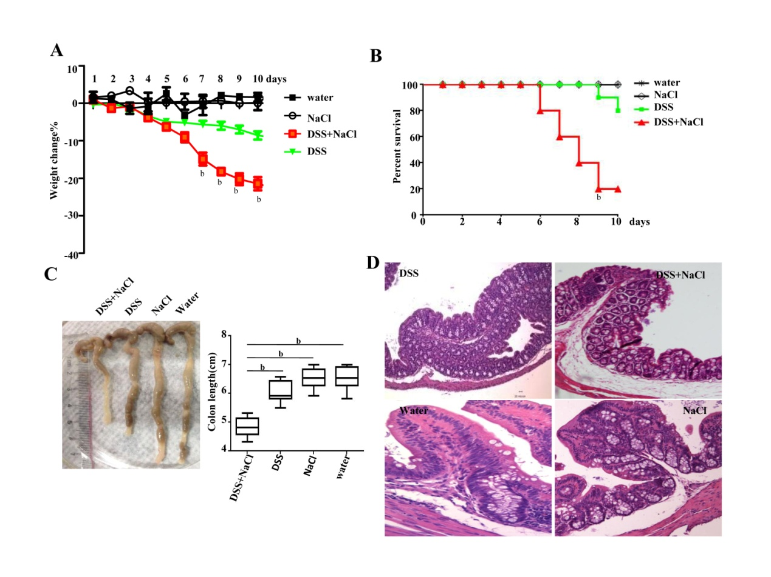
Figure 1 Mice treated with dextran sulfate sodium and NaCl develop more severe colitis. A: Mice were given DSS and/or NaCl and were weighed daily . B: The death status were recorded daily. C: Colonic tissues were collected from four groups of mice and Colonic length was measured. D: Histological analyses show sections of the colon stained with HE for DSS or NaCl treated mice. In all the panels, data indicate three separate experiments, whereby 10 mice per group were used in each experiment. ªP < 0.05; ^{b}P < 0.01; ^{c}P < 0.001. DSS: dextran sulfate sodium.
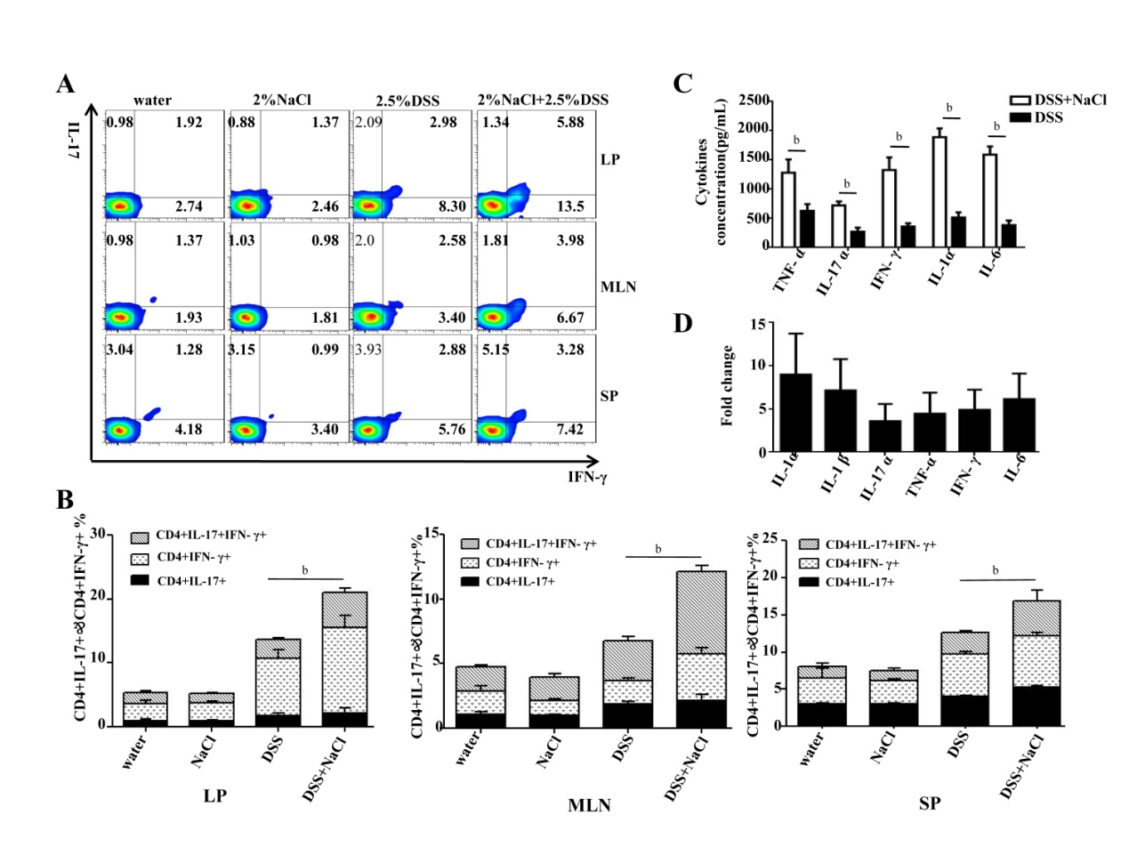
Figure 2 NaCl promotes CD4⁺IFN-γ⁺IL-17⁺ T cell increase and inflammatory cytokine secretion in dextran sulfate sodium treated mice. A: The CD4+IFN-γ+IL-17+ T cells in LPs, MLNs and SPs from mice treated with NaCl and/or DSS were detected by flow cytometry. B: Combined the flow cytometry, the analysis of CD4⁺IL-17⁺, CD4⁺IFN-γ⁺ and CD4⁺IFN-γ⁺IL-17⁺ T cell subset distribution in LPs, MLNs and SPs. C: Colon tissues collected from mice treated with DSS or DSS + NaCl which were washed with PBS and cultured for 24 h, and the supernatant were collected and detected by ELISA. D: The colon tissues collected from mice treated with NaCl and DSS (or only DSS) were detected by RT-PCR. The relative fold change in DSS + NaCl-treated mice vs DSS-treated mice. In all the panels, data indicate three separate experiments, whereby three mice per group were used in each experiment. ªP < 0.05; ^{b}P < 0.01; ^{c}P < 0.001. DSS: dextran sulfate sodium; LP: lamina propria; MLN: mesenteric lymph node; SP: Spleen.

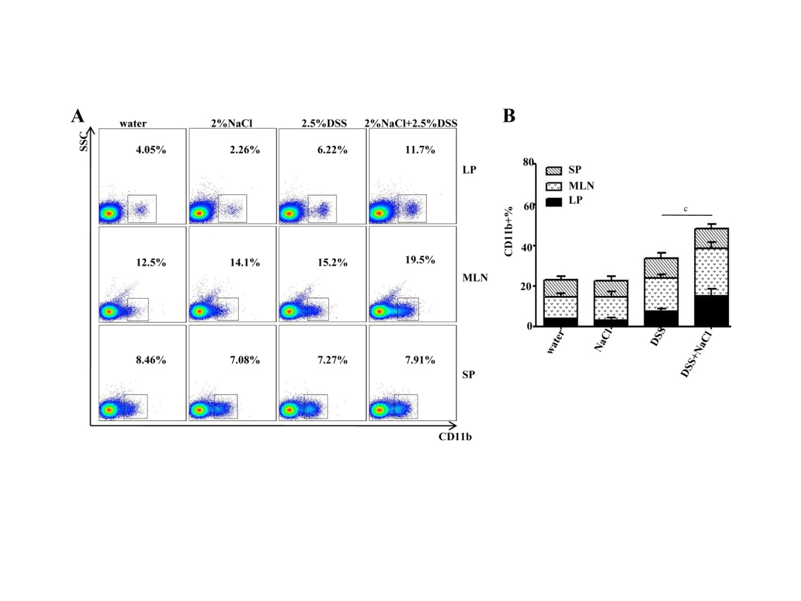
Figure 3 CD11b⁺ macrophages increase in dextran sulfate sodium and NaCl treated mice. A: The CD11b⁺ cells in LPs, MLNs and SPs from the four groups were detected by flow cytometry. B: Quantification of the flow cytometry data indicates the CD11b⁺ cell distribution in LPs, MLNs and SPs. In the panels, data indicate three separate experiments, whereby three mice per group were used in each experiment. ªP < 0.05; ^{b}P < 0.01; ^{c}P < 0.001. LP: lamina propria; MLN: mesenteric lymph node; SP: Spleen.

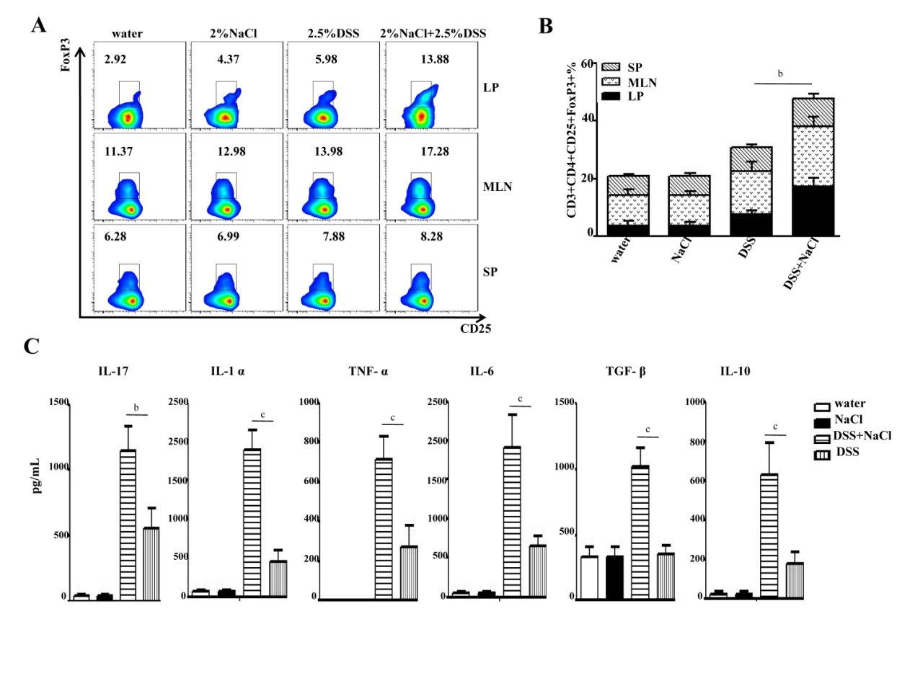
Figure 4 CD3⁺CD4⁺CD25⁺Foxp3⁺ T cells increase in mice treated with dextran sulfate sodium and NaCl. A: CD3⁺CD4⁺CD25⁺Foxp3⁺ T cells in LPs, MLNs and SPs from animal models were detected by flow cytometry. B: A summary of the percentages of CD3⁺CD4⁺CD25⁺Foxp3⁺ T cell distribution in LPs, MLNs and SPs. C: LPMCs from the four groups were isolated and cultured for 24 h, and the levels of cytokines in the culture supernatants were collected and analyzed by ELISA. In all the panels, data indicate three separate experiments, whereby three mice per group were used in each experiment. ªP < 0.05; ^{b}P < 0.01; ^{c}P < 0.001 vs the DSS group. DSS: dextran sulfate sodium; LP: lamina propria; MLN: mesenteric lymph node; SP: Spleen.

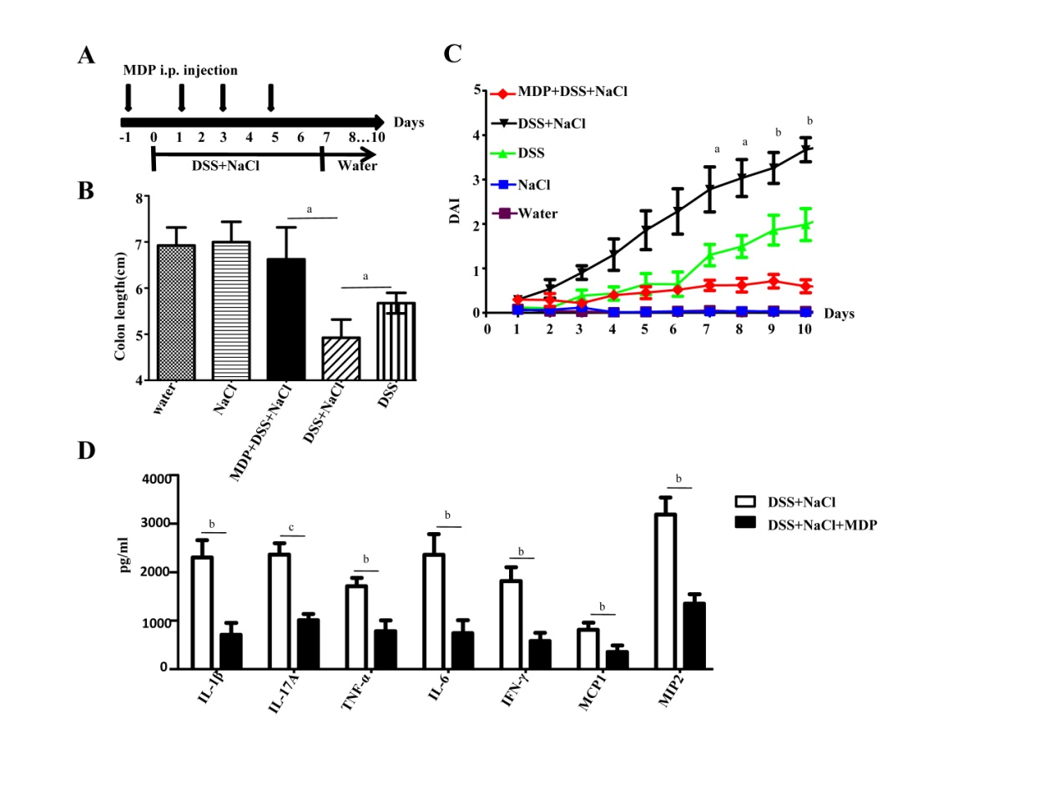
Figure 5 The depletion of macrophages reduces the severity of DSS-induced colitis promoted by NaCl. A: Clodronate-liposomes (MDP) or control PBS-liposomes (PBS) were administrated intravenously to all mice, as schematic protocol indicated during DSS and NaCl treatment. B: DAI were monitored daily. C: Colon length was measured in each group mice (n = 10). Colon explants were cultured for 24 h and the inflammatory cytokines in supernatants were detected by ELISA (n = 3) (D). ªP < 0.05; ^{b}P < 0.01; ^{c}P < 0.001 (MDP + DSS + NaCl vs DSS + NaCl). DSS: dextran sulfate sodium.

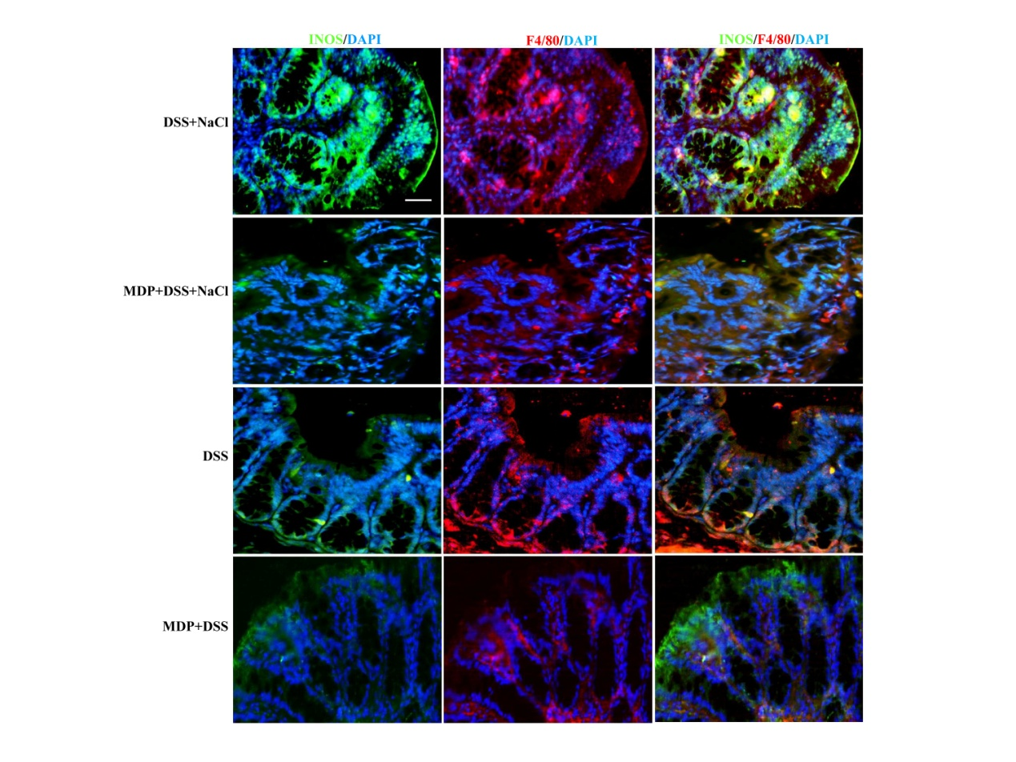
Figure 6 INOS⁺F4/80⁺ macrophages increase in the colon of dextran sulfate sodium and NaCl treated mice. Macrophages in colon tissue obtained from mice injected i.p. with PBS-containing liposomes (PBS), or clodronate-liposomes (MDP) during the NaCl and DSS treatment were analyzed. The sections were stained with antibodies of anti-F4/80 (red) and anti-iNOS (green). Nuclei were stained with DAPI (blue). Laser Co-focal Microscopy was used to detect fluorescence. (Scale bar = 50 μm).

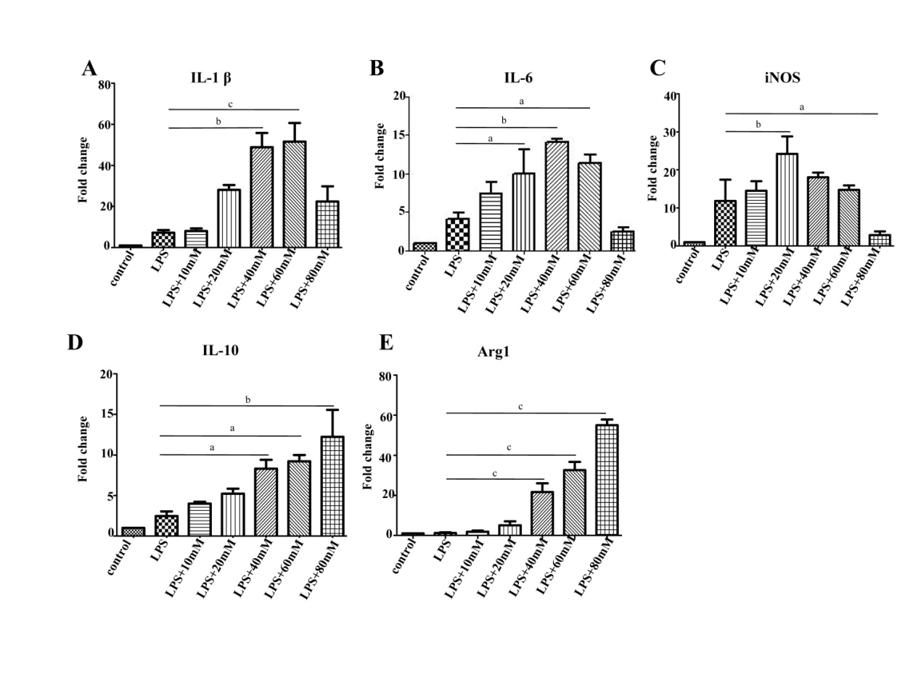
Figure 7 High NaCl levels enhance pro-inflammatory gene expression in LPS-activated peritoneal macrophage. A-E: Peritoneal macrophages were stimulated with different NaCl concentrations (10-80 mmol/L) in the presence of LPS for 24 h. mRNA expression was measured by RT-PCR for the indicated genes. In all the panels, data indicate three separate experiments. ªP < 0.05; ^{b}P < 0.01; ^{c}P < 0.001.

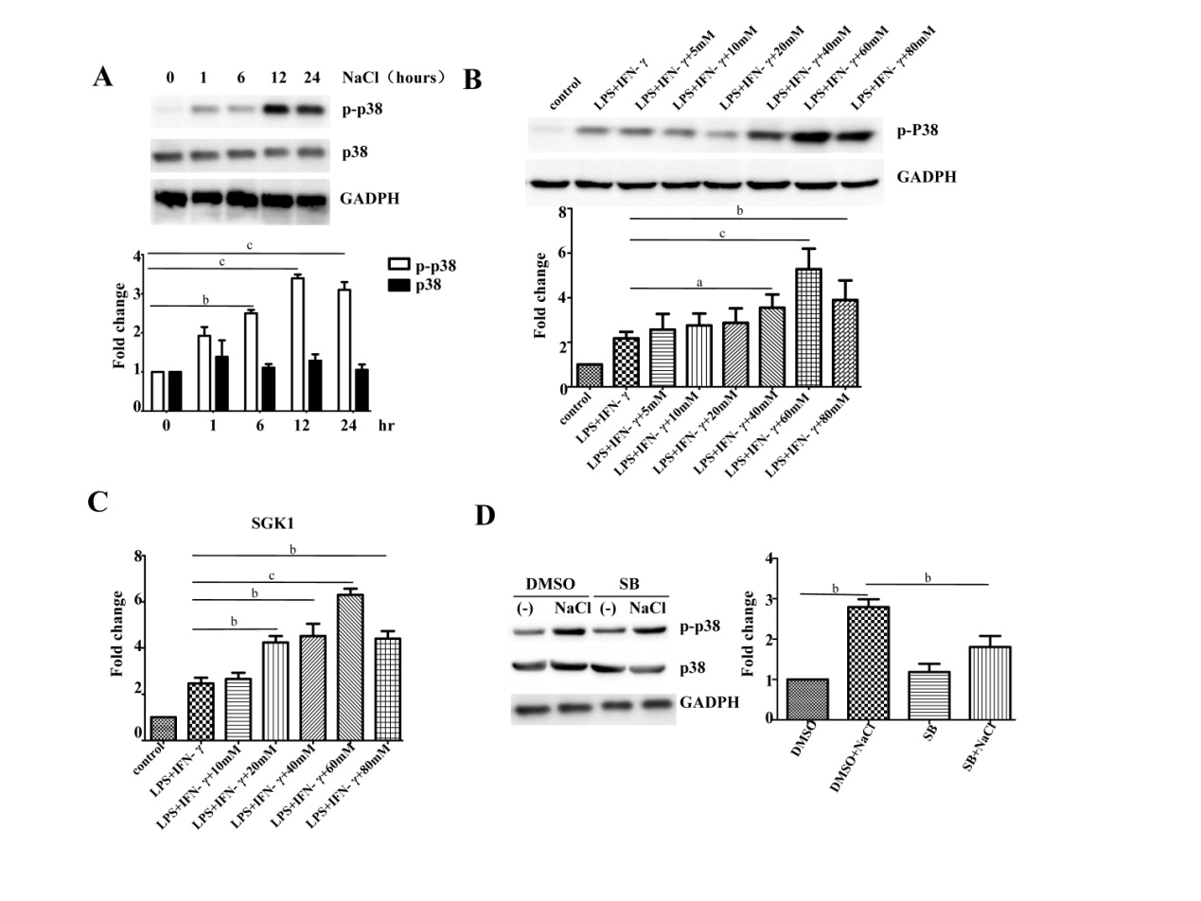
Figure 8 NaCl promotion of inflammation relies on the P38/MAPK. A: LPMCs were stimulated with 60 mmol/L NaCl in the presence of 100 ng/ml LPS and 20 ng/ml IFN-γ for 1 h, 6 h, 12 h and 24 h and the p38 and phosphorylated p38 protein were detected by WB. B: LPMCs were stimulated with different NaCl concentrations in the presence of 100 ng/ml LPS and 20 ng/ml IFN-γ for 24 h and phosphorylated p38 protein was detected by WB. C: LPMCs were stimulated with different NaCl concentrations in the presence of LPS and IFN-γ, and the mRNA expression of SGK1 was measured by RT-PCR. D: LPMCs were pretreated with 10 µmol/L SB20358 (SB) or DMSO for 2 h and were subsequently stimulated with 60 mmol/L NaCl along with 100 ng/ml LPS and 20 ng/ml IFN-γ in the presence of DMSO or 10 µmol/L SB for 24 h and the protein of p38 and phosphorylated p38 were detected by WB. In all the panels, data indicate three separate experiments. ªP < 0.05; ^{b}P < 0.01; ^{c}P < 0.001. DSS: dextran sulfate sodium; LP: lamina propria; MLN: mesenteric lymph node; SP: Spleen.

Table 1 Primers used in the real time-PCR
Gene name |  | Primer sequences (5’-3’)
GAPDH | Sence | 5'- AGGTCGGTGTGAACGGATT -3'
 | Anti-sense | 5'- AATCTCCACTTTGCCACTGC -3'
IL-1β | Sence | 5'- TGGTGTGTGACGTTCCCATTA -3'
 | Anti-sense | 5'- CAGCACGAGGCTTTTTTGTTG -3'
IL-1α | Sence | 5′-CGCCAATGACTCAGAGGAAGA-3′
 | Anti-sense | 5′-GGCGTCATTCAGGATGAATTC-3′
IL-6 | Sence | 5'- ACAACCACGGCCTTCCCTACTT -3'
 | Anti-sense | 5'- CACGATTTCCCAGAGAACATGTG -3'
IFN-γ | Sence | 5’-CTGCTGATGGGAGGAGATGT-3’
 | Anti-sense | 5’-ATTTGTCATTCGGGTGTAGTCA-3’
Arg1 | Sence | 5’-CTCCAAGCCAAAGTCCTTAGAG-3’
 | Anti-sense | 5’-GGAGCTGTCATTAGGGACATCA-3’
iNOS | Sence | 5’-ACATCGACCCGTCCACAGTAT-3’
 | Anti-sense | 5’-CAGAGGGGTAGGCTTGTCTC-3’
IL-10 | Sence | 5’-GCTCTTACTGACTGGCATGAG-3’
 | Anti-sense | 5’-CGCAGCTCTAGGAGCATGTG-3’
TNF-α | Sence | 5’-CTGAACTTCGGGGTGATCGG-3’
 | Anti-sense | 5’-GGCTTGTCACTCGAATTTTGAGA-3’
IL-17α | Sence | 5′-TGTGAAGGTCAACCTCAAAGTCT-3’
 | Anti-sense | 5′-GAGGGATATCTATCAGGGTCTTCAT-3′
SGK1 | Sence | 5′-CTGCTCGAAGCACCCTTACC-3′
 | Anti-sense | 5′-TCCTGAGGATGGGACATTTTCA -3′

