Name of Journal: World Journal of Gastrointestinal Endoscopy
ESPS Manuscript NO: 19280
Manuscript Type: Therapeutics Advances

Cutting edge of endoscopic full-thickness resection for gastric tumor

Maehata T et al. Cutting edge of endoscopic full-thickness resection

Tadateru Maehata, Osamu Goto, Hiroya Takeuchi, Yuko Kitagawa, Naohisa Yahagi

Tadateru Maehata, Osamu Goto, Naohisa Yahagi, Division of Research and Development for Minimally Invasive Treatment, Cancer Center, Keio University, School of Medicine, Tokyo 160-8582, Japan

Hiroya Takeuchi, Yuko Kitagawa, Department of Surgery, Keio University, School of Medicine, Tokyo 160-8582, Japan

Author contributions: Maehata T wrote this article; Takeuchi H, Kitagawa Y and Yahagi N provided advice for this article; Goto O critically revised this article.

Conflict-of interest statement: There is no conflict of interest regarding this article.

Open-Access: This article is an open-access article which was selected by an in-house editor and fully peer-reviewed by external reviewers. It is distributed in accordance with the Creative Commons Attribution Non Commercial (CC BY-NC 4.0) license, which permits others to distribute, remix, adapt, build upon this work non-commercially, and license their derivative works on different terms, provided the original work is properly cited and the use is non-commercial. See: http://creativecommons.org/licenses/by-nc/4.0/

Correspondence to: Osamu Goto, MD, PhD, Division of Research and Development for Minimally Invasive Treatment, Cancer Center, Keio University, School of Medicine, 35, Shinanomachi, Shinjuku-ku, Tokyo 160-8582, Japan. ogotou-gi@keio.jp
Telephone: +81-3-53633437
Fax: +81-3-53633895

Received: May 2, 2015
Peer-review started: May 9, 2015
First decision: July 17, 2015
Revised: August 18, 2015
Accepted: September 29, 2015
Article in press:
Published online:

Abstract
Recently, several studies have reported local full-thickness resection techniques using flexible endoscopy for gastric tumors, such as gastrointestinal stromal tumors, gastric carcinoid tumors, and early gastric cancer (EGC). These techniques have the advantage of allowing precise resection lines to be determined using intraluminal endoscopy. Thus, it is possible to minimize the resection area and subsequent deformity. Some of these methods include: (1) classical laparoscopic and endoscopic cooperative surgery (LECS); (2) inverted LECS; (3) combination of laparoscopic and endoscopic approaches to neoplasia with non-exposure technique; and (4) non-exposed endoscopic wall-inversion surgery. Furthermore, a recent prospective multicenter trial of the sentinel node navigation surgery (SNNS) for EGC has shown acceptable results in terms of sentinel node detection rate and the accuracy of nodal metastasis. Endoscopic full-thickness resection with SNNS is expected to become a treatment option that bridges the gap between endoscopic submucosal dissection and standard surgery for EGC. In the future, the indications for these procedures for gastric tumors could be expanded.

Key words: Gastrointestinal stromal tumor; Early gastric cancer; Full-thickness resection; Laparoscopic and endoscopic cooperative surgery; Sentinel node navigation surgery

© The Author(s) 2015. Published by Baishideng Publishing Group Inc. All rights reserved.

Core tip: Several studies have investigated local full-thickness resection techniques using flexible endoscopy for gastric tumors. These techniques are advantageous because a resection line can be determined more precisely using intraluminal endoscopy. Thus, it is possible to minimize the resection area and subsequent deformity, and better secure the surgical margins. In the near future, endoscopic full-thickness resection is expected to become a treatment option that bridges the gap between endoscopic submucosal dissection and standard surgery for gastric tumors.

Maehata T, Goto O, Takeuchi H, Kitagawa Y, Yahagi N. Cutting edge of endoscopic full-thickness resection for gastric tumor. World J Gastrointest Endosc 2015; In press

INTRODUCTION
Laparoscopic wedge resection (LWR) has been accepted as a minimally invasive surgical technique for gastric tumors such as gastrointestinal stromal tumor (GIST)^{[1]}, early gastric cancer (EGC) without the risk of lymph node metastasis^{[2,3]}. However, patients frequently experience severe deformity and gastric stasis as a result of excessive gastric resection. This occurs because identification of the proper incision line is complicated. From this point of view, several studies have reported that endoscopic submucosal dissection (ESD) and endoscopic submucosal enucleation are feasible for the resection of gastric tumors in the muscularis propria^{[4,5]}. Furthermore, ESD has performed for the diagnosis of suspected submucosal EGC. However, some tumors are resected incompletely because they have positive surgical margins; thus, the risk of recurrence exists^{[6]}. Therefore, a full-thickness resection would be more appropriate to secure the surgical margins. This suggests the need for function-preserving or reductive surgeries that bridge the gap between ESD and standard surgery. Recently, some publications have described local resection techniques using peroral flexible endoscopy. Endoscopic full-thickness resection (EFTR) of the gastric wall using a snaring technique has been applied for gastric subepithelial tumors^{[7-9]}. In addition, Hiki et al^{[10]} reported that classical laparoscopic and endoscopic cooperative surgery (classical LECS) provides an alternative gastric wedge resection. However, these procedures (EFTR and classical LECS) have inherent risks of peritoneal infection and cancer cell seeding because intentional perforation of the gastric lumen is required during the procedures. As a result, some procedures [e.g., inverted LECS^{[11]}, a combination of laparoscopic and endoscopic approaches to neoplasia with non-exposure technique (CLEAN-NET)^{[12]} and non-exposed endoscopic wall-inversion surgery (NEWS)^{[13]}] have been developed to mitigate these risks. These techniques are advantageous because a more precise resection area can be determined using intraluminal endoscopy, thus minimizing the resection area. This will result in less deformity and better surgical margins.
In the current review, recent developments related to full-thickness resection using flexible endoscopy for gastric tumors are presented and discussed.

EFTR WITHOUT LAPAROSCOPIC ASSISTANCE
Endoscopic full-thickness resection of the gastric wall using a snaring technique has been applied for gastric subepithelial tumors^{[7]}. Nevertheless, this technique has limitations from the perspective of the localization and size of the lesion. Ikeda et al^{[14]}. reported EFTR using an ESD technique with a sewing method and have shown that it is possible to resect larger specimens. In addition, Zhou et al^{[8]} and Feng et al^{[15]} reported successful resection of gastric subepithelial tumors originating from the muscularis propria layer^{[8,15]} (Table 1).
After the periphery of the lesion is marked endoscopically, a solution is injected into the submucosal layer circumferentially. A circumferential incision is then made to the depth of the muscularis propria around the lesion using ESD devices and techniques. Next, the serosal layer around the lesion is incised using ESD devices to create an intentional perforation. The tumor, including the surrounding muscularis propria and serosa, is subsequently removed using the snare. Finally, the gastric wall defect is closed with several metallic clips (Figure 1).
There are difficulties associated with these techniques. For example, it is unknown whether a large iatrogenic perforation can be successfully closed using the endoscopic technique. Guo et al^{[9]} have reported the safety and feasibility of the over-the-scope clip system for the closure of gastric defects following EFTR. After all, EFTR is expected to prevent the severe complications can occur due to iatrogenic perforation. Although EFTR seems to be an effective and minimally invasive treatment for patients with gastric subepithelial tumors, it is necessary to demonstrate the efficacy and safety of EFTR in a large number of cases.

CLASSICAL LECS
Hiki et al^{[10]} reported that the LECS technique provides an alternative gastric wedge resection for the removal of GISTs, and combines gastrointestinal endoscopy and laparoscopy. The advantage of this technique is that it avoids excessive resection of the gastric wall because a resection line can be determined more precisely using intraluminal endoscopy.
The periphery of the lesion is first marked endoscopically, and after a submucosal injection around the lesion, a circumferential incision is made using ESD devices and techniques. Then, an artificial perforation is performed from the inside of the stomach and a seromuscular incision is performed, as much as possible, with laparoscopic assistance. Next, a laparoscopic incision of the remaining seromuscular layer is performed. Finally, the defect closure of the gastric wall is performed by laparoscopic linear staplers or a laparoscopic hand sewn suture technique^{[16,17]} (Figure 2).
Some pilot studies have reported the feasibility of LECS for GISTs, and have presented favorable results^{[18-20]}. This procedure is also feasible for lesions that cannot be treated with LWR^{[1,21]} [e.g., the esophagogastric junction (EGJ)]^{[22]}. However, there is a major limitation associated with classical LECS. This technique requires opening the gastric wall, and the gastric lumen is opened to the abdominal cavity. As a result, gastric contents (e.g., bacteria and tumor cells) flow into and contaminate the clean peritoneal cavity, increasing the risk of bacterial contamination and dissemination of peritoneal tumor cells.

INVERTED LECS
As described above, there are several drawbacks associated with classical LECS especially for gastric cancer. Therefore, a modified LECS procedure, referred to as inverted LECS, was developed to prevent the implanting of tumor cells^{[11]}.
The procedure, from placing the markings to performing the artificial perforation, is similar to the classical LECS. To prevent contact between the tumor and the visceral tissue, the gastric wall is pulled up circumferentially to the incision line as a crown using some stitches. Then, the seromuscular layer is dissected using ESD or laparoscopic devices around the incision line of the submucosal layer. The tumor is then resected into the abdominal cavity and the specimen is retrieved perorally. Finally, the gastric wall defect is closed by laparoscopic linear staplers.
This procedure was developed to prevent stomach contents from spilling into the clean abdominal cavity. However, since the gastric lumen is opened to the peritoneal cavity, there is still a risk of gastric content contamination. Furthermore, there is a risk of cancer recurrence caused by instrument contact.

CLEAN-NET
CLEAN-NET is another promising non-exposure method^{[12]}. After mucosal markings are made endoscopically around the tumor, the mucosal layer is fixed to the seromuscular layer with four full-layer stay sutures, and a sub-mucosal cushion is created circumferentially using an endoscopic injection. The seromuscular layer is then dissected laparoscopically around the four stay sutures. Consequently, the full-layer specimen and the mucosal layer that surrounds it are lifted by the stay sutures. Finally, the specimen is resected using a linear stapler (Figure 3). The CLEAN-NET is useful as a non-exposure technique for full-thickness resection.

NEWS
NEWS was developed as a novel, full-thickness resection technique, without intentional perforation^{[13,23,24]}. With this procedure, markings are made around the tumor on the mucosa while serosal markings are made laparoscopically. The serosal markings are made by pressing on the gastric wall, on the side opposite the mucosal markings. A sodium hyaluronate solution, that includes a small amount of indigo carmine dye, is endoscopically injected into the submucosal layer circumferentially. A circumferential seromuscular incision is performed laparoscopically around the serosal markings. After a flap is created by cutting the submucosa deeper toward the outside, the seromuscular layers are linearly sutured with the lesion inverted toward the inside of the stomach. Prior to the suturing, a laparoscopic surgical sponge is inserted as a spacer between the serosal layer of the inverted lesion and the suture layer. This is done to provide counter-traction to the mucosa and prevent cutting of the suture. Finally, the circumferential mucosal incision and the subsequent incision of the remnant submucosal tissue are made a few millimeters outside of the mucosal markings around the inverted lesion using ESD techniques. The resected specimen and the spacer are retrieved perorally and the mucosal edges are closed with several endoscopic clips (Figures 4 and 5).
The NEWS technique has been developed as a full-thickness resection method without transluminal communication and is similar to the CLEAN-NET. It is a non-exposure technique. However, there are several differences between the two procedures. First, the seromuscular hand suturing and circumferential mucosal incision can be skipped in CLEAN-NET, which results in a shorter procedural time than that for NEWS. Secondly, the incision line is determined from the serosal side; as a result, proper mucosal incision could be complicated to determine resulting in a relatively large resection area. However, due to the lower risk of peritoneal cavity infection and the seeding of tumor cells, NEWS has already been clinically introduced for gastric subepithelial tumors as well as gastric cancers at selected hospitals^{[24]}. This procedure is technically feasible and, theoretically, safe.

APPLICATION TO GASTRIC CANCER
ESD is widely accepted as a minimally invasive curative treatment for early stage gastrointestinal cancer^{[25-27]} that enables the preservation of function and maintains the patients’ quality of life. However, ESD still requires a skilled and experienced surgeon for large lesions located at the greater curvature of the upper gastric body and fornix, and for lesions with severe ulcerative changes. In these situations, ESD has a higher incidence rate of complications such as perforation and bleeding. Furthermore, ESD may be associated with longer operation times^{[28]}; therefore, LECS may be an alternative treatment option especially for lesions difficult to resect by ESD^{[11]}.
In contrast, EGC with possible lymph node metastasis should be treated with gastrectomy with wide resection of the regional lymph nodes because the presence and site of lymph node metastasis are unclear. Approximately 10–20% of patients with EGC, especially those with deep submucosal invasion, have lymph node metastasis^{[29]}. In other words, the incidence of node-negative gastric cancer accounts for at least 80% of all EGCs and therefore, most of the patients with EGC have undergone an unnecessarily wide gastrectomy with lymphadenectomy. If node-negative gastric cancer is confirmed, local resection (e.g., full-thickness resection) might be the best option.
Sentinel node navigation surgery (SNNS) is expected to be able to diagnose lymph node metastasis intraoperatively, and this could result in minimally invasive and function-preserving gastrectomy with selective lymphadenectomy^{[30]}. Theoretically, the sentinel node (SN) is the first lymph node or group of nodes capable of draining cancer cells and is considered the first site of metastasis along the route of lymphatic drainage. However, it remains controversial whether the SN concept is feasible in EGC. In response, the Japan Society of Sentinel Node Navigation Surgery conducted a prospective multicenter trial to confirm the SN concept. It reported that patients with clinical T1N0 (≤ 4 cm) gastric cancer can undergo sentinel node mapping and biopsy without limitation of tumor location^{[31]}. Currently, surgical treatment of cT1N0 gastric cancer, of ≤ 4 cm, can be individualized on the basis of the SN concept. Furthermore, some studies have reported that in the absence of metastasis to the SNs, a surgery that combines ESD and SNNS^{[32]} may be adequate. However, ESD cannot guarantee secure vertical margins or accurate preoperative diagnosis of tumor invasion. Hence, for submucosal EGC, a full-thickness resection would be more appropriate to secure the vertical margins and identify intramural cancer cells. Abe et al^{[33]} first reported EFTR for EGC under laparoscopic guidance, combined with lymphadenectomy. Similarly, Hur et al^{[34]} reported laparoscopy-assisted endoscopic full-thickness resection with sentinel node navigation surgery. However, as previously mentioned, these procedures require opening of the gastric wall, thus opening the gastric lumen to the peritoneal cavity. As a result, cancer cells may spill into the peritoneal cavity. Consequently, peritoneal dissemination of cancer cells as well as bacterial contamination during the procedure might occur. Therefore, it is desirable to use a non-exposure technique to prevent bacterial contamination and peritoneal dissemination of tumor cells. Hence, full-thickness resection such as NEWS and CLEAN-NET, in combination with sentinel node basin dissection, may be an ideal treatment that bridges the gap between ESD and standard surgery with respect to the invasiveness of the treatment^{[35,36]} (Table 2).

CONCLUSION
The endoscopic full-thickness resection for upper gastrointestinal subepithelial tumors and EGC has been developed as a novel and minimally invasive surgery. In particular, NEWS with sentinel node basin dissection may be an ideal, minimally invasive, and function-preserving gastrectomy with selective lymphadenectomy for EGC. However, reports of these procedures are limited to case reports. Pilot studies need to be performed, and the long-term efficacy of these procedures need to be clarified. Therefore, further studies such as prospective clinical trials with a large number of patients are required to show the feasibility of these treatment methods, especially with regard to safe and complete resection. In the near future, the concept of endoscopic full-thickness resection is expected to become a treatment option that bridges the gap between ESD and standard surgery for subepithelial tumors and EGC.

REFERENCES
1 Choi SM, Kim MC, Jung GJ, Kim HH, Kwon HC, Choi SR, Jang JS, Jeong JS. Laparoscopic wedge resection for gastric GIST: long-term follow-up results. Eur J Surg Oncol 2007; 33: 444-447 [PMID: 17174060 DOI: 10.1016/j.ejso.2006.11.003]
2 Nozaki I, Kubo Y, Kurita A, Tanada M, Yokoyama N, Takiyama W, Takashima S. Long-term outcome after laparoscopic wedge resection for early gastric cancer. Surg Endosc 2008; 22: 2665-2669 [PMID: 18363067 DOI: 10.1007/s00464-008-9795-1]
3 Koeda K, Nishizuka S, Wakabayashi G. Minimally invasive surgery for gastric cancer: the future standard of care. World J Surg 2011; 35: 1469-1477 [PMID: 21476116 DOI: 10.1007/s00268-011-1051-5]
4 Liu BR, Song JT, Qu B, Wen JF, Yin JB, Liu W. Endoscopic muscularis dissection for upper gastrointestinal subepithelial tumors originating from the muscularis propria. Surg Endosc 2012; 26: 3141-3148 [PMID: 22580875 DOI: 10.1007/s00464-012-2305-5]
5 Jeong ID, Jung SW, Bang SJ, Shin JW, Park NH, Kim do H. Endoscopic enucleation for gastric subepithelial tumors originating in the muscularis propria layer. Surg Endosc 2011; 25: 468-474 [PMID: 20589510 DOI: 10.1007/s00464-010-1195-7]
6 Nagano H, Ohyama S, Fukunaga T, Seto Y, Fujisaki J, Yamaguchi T, Yamamoto N, Kato Y, Yamaguchi A. Indications for gastrectomy after incomplete EMR for early gastric cancer. Gastric Cancer 2005; 8: 149-154 [PMID: 16086117 DOI: 10.1007/s10120-005-0328-5]
7 Suzuki H, Ikeda K. Endoscopic mucosal resection and full thickness resection with complete defect closure for early gastrointestinal malignancies. Endoscopy 2001; 33: 437-439 [PMID: 11396763 DOI: 10.1055/s-2001-14269]
8 Zhou PH, Yao LQ, Qin XY, Cai MY, Xu MD, Zhong YS, Chen WF, Zhang YQ, Qin WZ, Hu JW, Liu JZ. Endoscopic full-thickness resection without laparoscopic assistance for gastric submucosal tumors originated from the muscularis propria. Surg Endosc 2011; 25: 2926-2931 [PMID: 21424195 DOI: 10.1007/s00464-011-1644-y]
9 Guo J, Liu Z, Sun S, Liu X, Wang S, Ge N, Wang G, Qi Y. Endoscopic full-thickness resection with defect closure using an over-the-scope clip for gastric subepithelial tumors originating from the muscularis propria. Surg Endosc 2015 Feb 21; Epub ahead of print [PMID: 25701060 DOI: 10.1007/s00464-015-4076-2]
10 Hiki N, Yamamoto Y, Fukunaga T, Yamaguchi T, Nunobe S, Tokunaga M, Miki A, Ohyama S, Seto Y. Laparoscopic and endoscopic cooperative surgery for gastrointestinal stromal tumor dissection. Surg Endosc 2008; 22: 1729-1735 [PMID: 18074180 DOI: 10.1007/s00464-007-9696-8]
11 Nunobe S, Hiki N, Gotoda T, Murao T, Haruma K, Matsumoto H, Hirai T, Tanimura S, Sano T, Yamaguchi T. Successful application of laparoscopic and endoscopic cooperative surgery (LECS) for a lateral-spreading mucosal gastric cancer. Gastric Cancer 2012; 15: 338-342 [PMID: 22350555 DOI: 10.1007/s10120-012-0146-5]
12 Inoue H, Ikeda H, Hosoya T, Yoshida A, Onimaru M, Suzuki M, Kudo SE. Endoscopic mucosal resection, endoscopic submucosal dissection, and beyond: full-layer resection for gastric cancer with nonexposure technique (CLEAN-NET). Surg Oncol Clin N Am 2012; 21: 129-140 [PMID: 22098836 DOI: 10.1016/j.soc.2011.09.012]
13 Goto O, Mitsui T, Fujishiro M, Wada I, Shimizu N, Seto Y, Koike K. New method of endoscopic full-thickness resection: a pilot study of non-exposed endoscopic wall-inversion surgery in an ex vivo porcine model. Gastric Cancer 2011; 14: 183-187 [PMID: 21394421 DOI: 10.1007/s10120-011-0014-8]
14 Ikeda K, Mosse CA, Park PO, Fritscher-Ravens A, Bergström M, Mills T, Tajiri H, Swain CP. Endoscopic full-thickness resection: circumferential cutting method. Gastrointest Endosc 2006; 64: 82-89 [PMID: 16813808 DOI: 10.1016/j.gie.2005.12.039]
15 Feng Y, Yu L, Yang S, Li X, Ding J, Chen L, Xu Y, Shi R. Endolumenal endoscopic full-thickness resection of muscularis propria-originating gastric submucosal tumors. J Laparoendosc Adv Surg Tech A 2014; 24: 171-176 [PMID: 24555874 DOI: 10.1089/lap.2013.0370]
16 Huang LY, Cui J, Lin SJ, Zhang B, Wu CR. Endoscopic full-thickness resection for gastric submucosal tumors arising from the muscularis propria layer. World J Gastroenterol 2014; 20: 13981-13986 [PMID: 25320536 DOI: 10.3748/wjg.v20.i38.13981]
17 Schmidt A, Bauder M, Riecken B, von Renteln D, Muehleisen H, Caca K. Endoscopic full-thickness resection of gastric subepithelial tumors: a single-center series. Endoscopy 2015; 47: 154-158 [PMID: 25380509 DOI: 10.1055/s-0034-1390786]
18 Tsujimoto H, Yaguchi Y, Kumano I, Takahata R, Ono S, Hase K. Successful gastric submucosal tumor resection using laparoscopic and endoscopic cooperative surgery. World J Surg 2012; 36: 327-330 [PMID: 22187132 DOI: 10.1007/s00268-011-1387-x]
19 Qiu WQ, Zhuang J, Wang M, Liu H, Shen ZY, Xue HB, Shen L, Ge ZZ, Cao H. Minimally invasive treatment of laparoscopic and endoscopic cooperative surgery for patients with gastric gastrointestinal stromal tumors. J Dig Dis 2013; 14: 469-473 [PMID: 23701957 DOI: 10.1111/1751-2980.12076]
20 Kawahira H, Hayashi H, Natsume T, Akai T, Uesato M, Horibe D, Mori M, Hanari N, Aoyama H, Nabeya Y, Shuto K, Matsubara H. Surgical advantages of gastric SMTs by laparoscopy and endoscopy cooperative surgery. Hepatogastroenterology 2012; 59: 415-417 [PMID: 21940370 DOI: 10.5754/hge11456]
21 Hwang SH, Park do J, Kim YH, Lee KH, Lee HS, Kim HH, Lee HJ, Yang HK, Lee KU. Laparoscopic surgery for submucosal tumors located at the esophagogastric junction and the prepylorus. Surg Endosc 2009; 23: 1980-1987 [PMID: 18470554 DOI: 10.1007/s00464-008-9955-3]
22 Hoteya S, Haruta S, Shinohara H, Yamada A, Furuhata T, Yamashita S, Kikuchi D, Mitani T, Ogawa O, Matsui A, Iizuka T, Udagawa H, Kaise M. Feasibility and safety of laparoscopic and endoscopic cooperative surgery for gastric submucosal tumors, including esophagogastric junction tumors. Dig Endosc 2014; 26: 538-544 [PMID: 24355070 DOI: 10.1111/den.12215]
23 Mitsui T, Goto O, Shimizu N, Hatao F, Wada I, Niimi K, Asada-Hirayama I, Fujishiro M, Koike K, Seto Y. Novel technique for full-thickness resection of gastric malignancy: feasibility of nonexposed endoscopic wall-inversion surgery (news) in porcine models. Surg Laparosc Endosc Percutan Tech 2013; 23: e217-e221 [PMID: 24300935 DOI: 10.097/SLE.0b013e31828e3f94]
24 Mitsui T, Niimi K, Yamashita H, Goto O, Aikou S, Hatao F, Wada I, Shimizu N, Fujishiro M, Koike K, Seto Y. Non-exposed endoscopic wall-inversion surgery as a novel partial gastrectomy technique. Gastric Cancer 2014; 17: 594-599 [PMID: 23974429 DOI: 10.1007/s10120-013-0291-5]
25 Gotoda T, Iwasaki M, Kusano C, Seewald S, Oda I. Endoscopic resection of early gastric cancer treated by guideline and expanded National Cancer Centre criteria. Br J Surg 2010; 97: 868-871 [PMID: 20301163 DOI: 10.1002/bjs.7033]
26 Goto O, Fujishiro M, Kodashima S, Ono S, Omata M. Outcomes of endoscopic submucosal dissection for early gastric cancer with special reference to validation for curability criteria. Endoscopy 2009; 41: 118-122 [PMID: 19214889 DOI: 10.1055/s-0028-1119452]
27 Ono H, Hasuike N, Inui T, Takizawa K, Ikehara H, Yamaguchi Y, Otake Y, Matsubayashi H. Usefulness of a novel electrosurgical knife, the insulation-tipped diathermic knife-2, for endoscopic submucosal dissection of early gastric cancer. Gastric Cancer 2008; 11: 47-52 [PMID: 18373177 DOI: 10.1007/s10120-008-0452-0]
28 Oda I, Gotoda T, Hamanaka H, Eguchi T, Saito Y, Matsuda T, Bhandan P, Emura F, Saito D, Ono H. Endoscopic submucosal dissection for early gastric cancer: technical feasibility, operation time and complications from a large consecutive series. Dig Endosc 2005; 17: 54-58 [DOI: 10.1111/j.1443-1661.2005.00459.x]
29 Sano T, Kobori O, Muto T. Lymph node metastasis from early gastric cancer: endoscopic resection of tumour. Br J Surg 1992; 79: 241-244 [PMID: 1313325 DOI: 10.1002/bjs.1800790319]
30 Takeuchi H, Kitagawa Y. New sentinel node mapping technologies for early gastric cancer. Ann Surg Oncol 2013; 20: 522-532 [PMID: 22941161 DOI: 10.1245/s10434-012-2602-1]
31 Kitagawa Y, Takeuchi H, Takagi Y, Natsugoe S, Terashima M, Murakami N, Fujimura T, Tsujimoto H, Hayashi H, Yoshimizu N, Takagane A, Mohri Y, Nabeshima K, Uenosono Y, Kinami S, Sakamoto J, Morita S, Aikou T, Miwa K, Kitajima M. Sentinel node mapping for gastric cancer: a prospective multicenter trial in Japan. J Clin Oncol 2013; 31: 3704-3710 [PMID: 24019550 DOI: 10.1200/JCO.2013.50.3789]
32 Bok GH, Kim YJ, Jin SY, Chun CG, Lee TH, Kim HG, Jeon SR, Cho JY. Endoscopic submucosal dissection with sentinel node navigation surgery for early gastric cancer. Endoscopy 2012; 44: 953-956 [PMID: 22987216 DOI: 10.1055/s-0032-1310162]
33 Abe N, Mori T, Takeuchi H, Ueki H, Yanagida O, Masaki T, Sugiyama M, Atomi Y. Successful treatment of early stage gastric cancer by laparoscopy-assisted endoscopic full-thickness resection with lymphadenectomy. Gastrointest Endosc 2008; 68: 1220-1224 [PMID: 18547568 DOI: 10.1016/j.gie.2008.02.077]
34 Hur H, Lim SG, Byun C, Kang JK, Shin SJ, Lee KM, Kim JH, Cho YK, Han SU. Laparoscopy-assisted endoscopic full-thickness resection with basin lymphadenectomy based on sentinel lymph nodes for early gastric cancer. J Am Coll Surg 2014; 219: e29-e37 [PMID: 25026878 DOI: 10.1016/j.jamcollsurg.2014.05.016]
35 Goto O, Takeuchi H, Kawakubo H, Matsuda S, Kato F, Sasaki M, Fujimoto A, Ochiai Y, Horii J, Uraoka T, Kitagawa Y, Yahagi N. Feasibility of non-exposed endoscopic wall-inversion surgery with sentinel node basin dissection as a new surgical method for early gastric cancer: a porcine survival study. Gastric Cancer 2015; 18: 440-445 [PMID: 24619187 DOI: 10.1007/s10120-014-0358-y]
36 Goto O, Takeuchi H, Kawakubo H, Sasaki M, Matsuda T, Matsuda S, Kigasawa Y, Kadota Y, Fujimoto A, Ochiai Y, Horii J, Uraoka T, Kitagawa Y, Yahagi N. First case of non-exposed endoscopic wall-inversion surgery with sentinel node basin dissection for early gastric cancer. Gastric Cancer 2015; 18: 434-439 [PMID: 25087058 DOI: 10.1007/s10120-014-0406-7]
P-Reviewer: Habic A, Tan KY S-Editor: Tian YL
L-Editor: E-Editor:

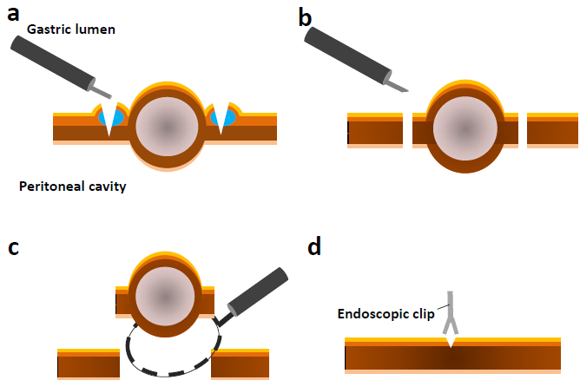
Figure 1 Illustration of the procedure for endoscopic full-thickness resection without laparoscopic assistance. A: A circumferential incision is made to the depth of the muscularis propria around the lesion using ESD devices and techniques; B: After intentional perforation, the serosal layer around the lesion is incised using ESD devices; C: The tumor, including the surrounding muscularis propria and serosa, is removed using the snare; D: The gastric wall defect is closed with several metallic clips.

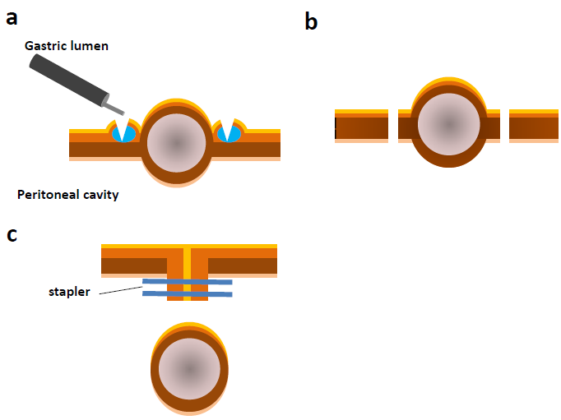

Figure 2 Illustration of the procedure for classical laparoscopic and endoscopic cooperative surgery. A: A circumferential incision is made using ESD devices and techniques; B: An artificial perforation is performed from the inside of the stomach and a seromuscular incision is performed along the incision line with laparoscopic assistance. A laparoscopic incision of the remaining seromuscular layer is performed; C: The defect closure of the gastric wall is performed by laparoscopic linear staplers.

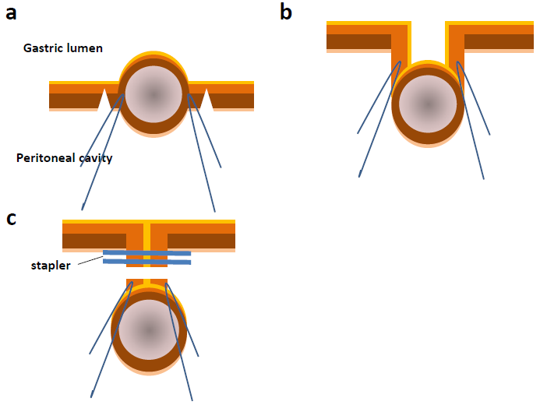

Figure 3 Illustration of the procedure for a combination of laparoscopic and endoscopic approaches to neoplasia with non-exposure technique. A: Seromuscular layer is dissected using a laparoscopic electrocautery knife; B: Full-layer specimen is lifted by the stay sutures; C: Full-layer specimen is resected using a linear stapler.

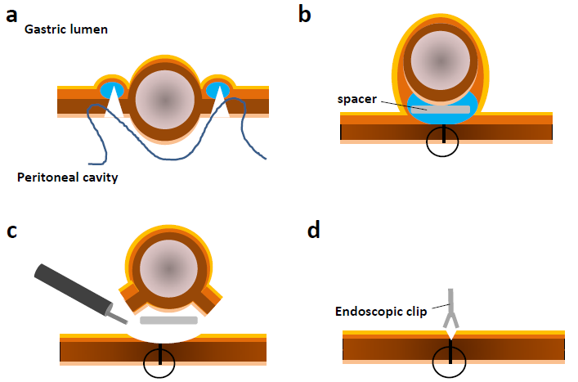
Figure 4 Illustration of the procedure for non-exposed endoscopic wall-inversion surgery. A: circumferential seromuscular incision is performed laparoscopically outside the serosal markings after endoscopic submucosal injection; B: seromuscular layers are linearly sutured with the lesion inverted toward the inside of the stomach. A surgical sponge as a spacer is inserted between the serosal layer of the inverted lesion and the suture layer; C: Circumferential mucosal incision and the remnant submucosal incisions are made using ESD devices and techniques; D: Defect is closed with several metallic clips.

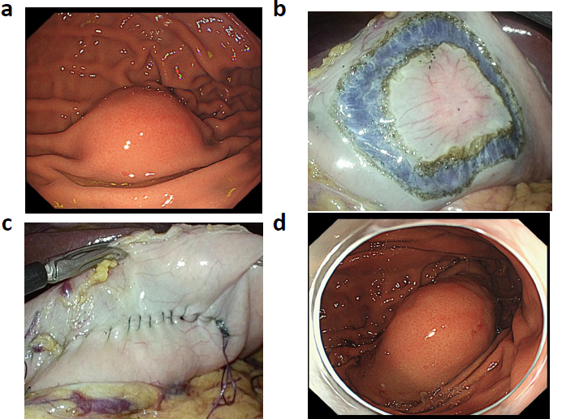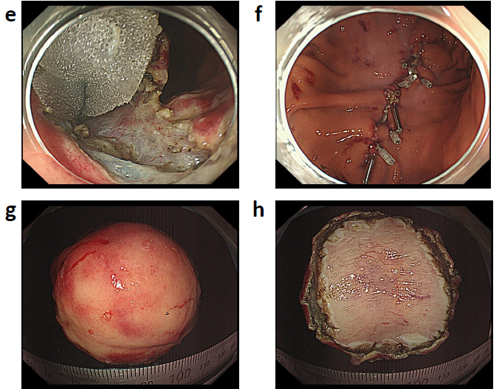
Figure 5 Procedures of non-exposed endoscopic wall-inversion surgery. A: Protruding submucosal lesion is seen at the greater curvature of the middle gastric body; B: Circumferential seromuscular incision is made outside the serosal markings after endoscopic submucosal injection; C: Lesion is inverted with a surgical sponge used as a spacer; D: Massive protrusion of the inverted tissue; E: Surgical sponge as a spacer and a suturing line during endoscopic mucosal incision; F: Mucosal clipping after the resection; G: Resected specimen: mucosal side; H: Resected specimen: serosal side.

Ref. | n | Mean operation | Mean tumor | Complete resection | Complication
 |  | time (min) | diameter (mm) | rate (%) | rate (%)
Zhou et al^{[8]} | 26 | 105 | 28 | 100 | 0
Feng et al^{[15]} | 48 | 60 | 16 | 100 | 0
Huang et al^{[19]} | 35 | 90 | 28 | 100 | 0
Schmidt et al^{[17]} | 31 | 60 | 20.5 | 90.3 | 9.7 (perforation)
Guo et al^{[9]} | 23 | 40.5 | 12.1 | 100 | 0
Table 1 Representative publications reporting endoscopic full-thickness resection for upper gastrointestinal tumors

Table 2 Comparison of each procedure
 | Instruments | Indication for | Retrieval route | Intentional gastric | Advantage | Limitation
 |  | EGC |  | perforation
EFTR | Endoscopy only | No | Transroral | Required | Simple methods using intraluminal endoscopy only | Risk of contamination,
 |  |  |  |  |  | Endoscopic skills required
Classical LECS | Endoscopy = Laparoscopy | No | Transabdominal | Required | Accurate to determine the resection line, | Risk of contamination
 |  |  |  |  | laparoscopic assistance | Risk of contact to tumor surface
Inverted LECS | Endoscopy = Laparoscopy | Indefinite | Transoral | Required | Accurate to determine the  resection line, | Risk of contact to cancer surface,
 |  |  |  |  | laparoscopic assistance | Tumor size
CLEAN-NET | Endoscopy < Laparoscopy | Yes | Transabdominal | Not required | No transluminal communication | Excessive resection of the mucosa,
 |  |  |  |  |  | Difficult to determine the resection line
NEWS | Endoscopy = Laparoscopy | Yes | Transoral | Not required | Accurate to determine the resection line, | Tumor size,
 |  |  |  |  | laparoscopic assistance, | Experience required,
 |  |  |  |  | no transluminal communication | Time-consuming
EFTR: Endoscopic full-thickness resection; LECS: Laparoscopic and endoscopic cooperative surgery; CLEAN-NET: Combination of laparoscopic and endoscopic approaches to neoplasia with a nonexposure technique; NEWS: Nonexposed endoscopic wall-inversion surgery; EGC: Early gastric cancer.

