Name of Journal: World Journal of Diabetes
Manuscript NO: 89473
Manuscript Type: ORIGINAL ARTICLE

Retrospective Study
Myosteatosis is associated with coronary artery calcification in patients with type 2 diabetes

Liu FP et al. Myosteatosis and CAC

Fu-Peng Liu, Mu-Jie Guo, Qing Yang, Yan-Ying Li, Yan-Gang Wang, Mei Zhang

Fu-Peng Liu, The Affiliated Hospital of Medical College Qingdao University, Qingdao University, Qingdao 266071, Shandong Province, China

Fu-Peng Liu, Yan-Ying Li, Mei Zhang, Department of Endocrinology, The Affiliated Hospital of Jining Medical University, Jining 272029, Shandong Province, China

Mu-Jie Guo, Department of Medical Imaging, The Affiliated Hospital of Jining Medical University, Jining 272029, Shandong Province, China

Qing Yang, Department of Clinical Nutrition, The Affiliated Hospital of Jining Medical University, Jining 272029, Shandong Province, China

Yan-Gang Wang, Department of Endocrinology, The Affiliated Hospital of Qingdao University, Qingdao 266003, Shandong Province, China

Co-corresponding authors: Yan-Gang Wang and Mei Zhang.

Author contributions: Zhang M and Wang YG designed research; Zhang M, Wang YG and Liu FP contributed to study protocols and analysis plans; Liu FP, Guo MJ, Yang Q, and Li YY interpreted the data; Liu FP and Yang Q drafted the manuscript; Liu FP, Yang Q, and Guo MJ were the guarantors of this work, thereby having full access to all the data in the study and taking responsibility for the data’s integrity and accuracy of the analysis; all authors were involved in the critical review of the results and have contributed to, read, and approved the final manuscript. Zhang M and Wang YG were designated as co-corresponding authors. First, the research was performed as a collaborative effort, and the designation of co-corresponding authors accurately reflected the distribution of responsibilities and efforts involved in completing the study and the resulting paper. Second, the research team encompassed authors with a variety of expertise and skills from different fields, making the designation of co-corresponding authors the most suitable choice to reflect this diversity. Third, Zhang M and Wang YG made substantial and equal contributions throughout the research process. Selecting these researchers as co-corresponding authors acknowledged and respected their equal contributions while recognizing the spirit of teamwork and collaboration in this study. In summary, we believe that designating Zhang M and Wang YG as co-corresponding authors is appropriate for our manuscript as it accurately reflects our team's collaborative spirit, equal contributions, and diversity.

Supported by Research Fund for Lin He’s Academician Workstation of New Medicine and Clinical Translation in Jining Medical University, No. JYHL2021FMS11; and Jining Key Research and Development Projects, No. 2022YXNS009.

Corresponding author: Mei Zhang, MD, Doctor, Department of Endocrinology, The Affiliated Hospital of Jining Medical University, No. 89 Guhuai Road, Jining 272029, Shandong Province, China. zhangmeijn@163.com

Received: November 2, 2023
Revised: December 19, 2023
Accepted: February 20, 2024
Published online:

Abstract
BACKGROUND
Myosteatosis, rather than low muscle mass, is the primary etiologic factor of sarcopenia in patients with type 2 diabetes mellitus (T2DM). Myosteatosis may lead to a series of metabolic dysfunctions, such as insulin resistance, systematic inflammation, and oxidative stress, and all these dysfunctions are closely associated with the acceleration of T2DM and atherosclerosis.

AIM
To investigate the association between myosteatosis and coronary artery calcification (CAC) in patients with T2DM.

METHODS
Patients with T2DM, who had not experienced major cardiovascular events and had undergone both abdominal and thoracic computed tomography (CT) scans, were included. The mean skeletal muscle attenuation was assessed using abdominal CT images at the L3 level. The CAC score was determined from thoracic CT images using the Agatston scoring method. Myosteatosis was diagnosed according to Martin’s criteria. Severe CAC (SCAC) was defined when the CAC score exceeded 300. Logistic regression and decision tree analyses were performed.

RESULTS
A total of 652 patients with T2DM were enrolled. Among them, 167 (25.6%) patients had SCAC. Logistic regression analysis demonstrated that myosteatosis, age, duration of diabetes, cigarette smoking, and alcohol consumption were independent risk factors of SCAC. Myosteatosis was significantly associated with an increased risk of SCAC (OR = 2.381, P = 0.003). The association between myosteatosis and SCAC was significant in the younger patients (OR = 2.672, 95%CI: 1.477-4.834, P = 0.002), but not the older patients (OR = 1.456, 95%CI: 0.863-2.455, P = 0.188), and was more prominent in the population with lower risks of atherosclerosis. The decision tree analyses prioritized older age as the primary variable for SCAC. In older patients, cigarette smoking was the main contributing factor for SCAC, while in younger patients, it was myosteatosis.

CONCLUSION
Myosteatosis is a novel risk factor for atherosclerosis in patients with T2DM, especially in the population with younger ages and fewer traditional risk factors.

Key Words: Type 2 diabetes; Myosteatosis; Muscle quality; Coronary artery calcification; Atherosclerosis; Cardiovascular diseases

Liu FP, Guo MJ, Yang Q, Li YY, Wang YG, Zhang M. Myosteatosis is associated with coronary artery calcification in patients with type 2 diabetes. World J Diabetes 2024; In press

Core Tip: Myosteatosis, rather than low muscle mass, is the primary etiologic factor of sarcopenia in patients with type 2 diabetes mellitus (T2DM). Myosteatosis may lead to a series of metabolic dysfunctions that are closely associated with the acceleration of T2DM and atherosclerosis. This study demonstrated that myosteatosis was a novel risk factor for atherosclerosis in patients with T2DM, especially in the population with younger ages and fewer traditional risk factors. Therefore, this indicates the potential benefit of initiating muscle-strengthening exercises and improving muscle quality at a younger age.

INTRODUCTION
The prevalence of diabetes, especially type 2 diabetes mellitus (T2DM), has been dramatically increasing in China, from 10.9% in 2013 to 12.4% in 2018, and atherosclerotic cardiovascular disease is the leading cause of mortality in these patients^{[1,2]}. Myosteatosis, a marker of muscle quality, has been proposed as a novel risk factor for atherosclerotic cardiovascular diseases, independent of muscle mass^{[3-6]}. Myosteatosis may lead to a series of metabolic dysfunctions, such as insulin resistance, systematic inflammation, and oxidative stress, and all these dysfunctions are closely associated with the acceleration of T2DM and atherosclerosis (Supplementary Figure 1)^{[3,7,8]}.
Computed tomography (CT) is considered the gold standard for myosteatosis measurement, and lower muscle radiodensity indicates higher fat infiltration (i.e., myosteatosis)^{[9]}. Recently, a large-sample study involving 20986 participants indicated that the patients with T2DM had significantly higher values of muscle mass but significantly lower values of muscle quality^{[10,11]}. Therefore, low muscle quality rather than low muscle mass is the major characteristic change of skeletal muscle in patients with T2DM. Patients with T2DM have high risks of myosteatosis and atherosclerosis. However, the association between myosteatosis and coronary artery calcification (CAC) in this population has not been reported yet.
CAC score (CACS), which can be calculated with the Agatston scoring method, is considered a useful tool for identifying coronary atherosclerosis. The risk of coronary events in patients with CACS > 300 across various ethnic groups has a nearly 10-fold increase^{[12-14]}. In Australia, CACS is used to help define the risk in the primary prevention of cardiovascular diseases^{[15]}. The long-term (> 10 years) prognostic value of CACS in cardiovascular diseases has also been validated in patients with T2DM^{[16]}.
Herein, we performed this cross-sectional study to analyze the association of myosteatosis with CAC in patients with T2DM. The myosteatosis and CACS were evaluated with abdominal and thoracic CT, respectively.

MATERIALS AND METHODS
Study population
Patients with T2DM who were hospitalized in the Department of Endocrinology, Affiliated Hospital of Jining Medical University between January 2017 and December 2021 were included in this study. They all underwent abdominal and thoracic CT scans. The exclusion criteria included: (1) Patients with age < 30 or > 80 years old; (2) patients with a history of major cardiovascular events (i.e., myocardial infarction, congestive heart failure, coronary stent implantation, and cerebrovascular accidents); and (3) patients with consumptive or critical diseases (i.e., malignant tumors, abnormal thyroid function, and stage V diabetic nephropathy). At admission, all patients were informed that their medical records may be used for research purposes unless they indicate their opposition. For the present study, no patient indicated opposition. This study was approved by the Ethics Committee of the Affiliated Hospital of Jining Medical University (No. 2021-08-C001).

Laboratory measurements and assessment of diabetic complications
All biochemical and immune indexes were measured in the laboratory of our hospital. Fasting glucose and C-peptide were measured for calculating homeostasis model assessment 2 of insulin resistance and homeostasis model assessment 2 of beta-cell function (HOMA2-β).

Measurement of body composition and CAC
Both abdominal and thoracic CT scans were performed using a Dual-Source Flash CT scanner (Siemens, Erlangen, Germany). The body composition was assessed using abdominal axial CT images at the L3 level and the Slice-O-Matic software (V.5.0, TomoVision, Montreal, Quebec, Canada), as described in our previous study^{[17]}. The CT attenuation thresholds were from -29 to 150 Hounsfield Unit (HU) for skeletal muscle, from -150 to -30 HU for visceral adipose tissue, and from -190 to -30 HU for intramuscular and subcutaneous adipose tissue^{[18]}. The mean skeletal muscle attenuation (MMA), which was automatically calculated by the software, was shown as the mean radiation attenuation of skeletal muscle in HU. Myosteatosis was diagnosed according to Martin’s criteria, i.e. MMA < 33 HU with body mass index (BMI) ≥ 25 kg/m² or MMA < 41 HU with BMI < 25 kg/m^{2[19]}. The skeletal muscle index (SMI) (cm²/m²) was calculated by normalizing the L3 cross-sectional skeletal muscle area in cm² to height in m^{2[20]}. The fat mass index (kg/m²), which is proposed by VanItallie et al^{[21]} and is an indicator of nutritional status, was calculated by normalizing fat mass in kg to height in m^{2[21,22]}. The fat mass was calculated with the following formula: fat mass (kg) = 0.042 × (total adipose area at L3 in cm²) + 11.2^{[22]}. The CACS was calculated based on the thoracic CT images by the automated software of syngo via and with the Agatston method. Severe CAC (SCAC) was defined when the CACS was > 300^{[14]}.

Definitions and diagnosis
Coronary heart disease (CHD) was defined as a suspected history of CHD confirmed through CT coronary angiography. Hypertension was defined as systolic blood pressure ≥ 140 mmHg, diastolic blood pressure ≥ 90 mmHg, and/or use of antihypertensive medications. Dyslipidemia was defined as disorders of lipoprotein metabolism and/or the use of lipid medications. Alcohol consumption was defined as consuming at least 30 g of alcohol per week for at least a year. Cigarette smoking was defined as smoking at least 100 cigarettes in a lifetime^{[23]}. Diabetic complications were assessed systematically according to the guidelines for the prevention and control of T2DM in China^{[24]}. Diabetic nephropathy was diagnosed when there was elevated urinary albumin excretion and reduced estimated glomerular filtration rate in the absence of other primary causes of kidney damage. Diabetic peripheral neuropathy referred to the symptoms or signs of peripheral nerve dysfunction in diabetic patients that cannot be attributed to other causes. Asymptomatic patients must be diagnosed by physical examination or neuro-electrophysiological examination. Diabetic retinopathy was diagnosed by an ophthalmologist who specialized in diabetic retinopathy, according to the international clinical grading standard for diabetic retinopathy. Lower-extremity arterial disease was diagnosed if the patients had a resting ankle-brachial index (ABI) ≤ 0.90. For patients who experienced discomfort upon moving and had a resting ABI ≥ 0.90, lower-extremity arterial disease was also diagnosed if the ABI decreased by 15%-20% after a treadmill test.

Statistical analysis
Continuous variables with normal distribution are presented as mean ± standard deviation, whereas those with non-normal distribution are presented as median and interquartile range. Categorical variables are described by the number and percentage. The characteristics of the study population were compared using independent samples t-test, Mann-Whitney U test, or χ² test, as appropriate. The variables with statistical significance between the two groups were enrolled in the logistic regression analysis to identify independent factors for SCAC. Receiver operating characteristic (ROC) curves were plotted and the area under the curve (AUC) of independent factors for SCAC was compared using the z-test. The Youden index was calculated to determine the cut-off points of age in distinguishing SCAC. Subgroups were stratified based on the risk factors of atherosclerosis. The Chi-squared Automatic Interaction Detection (CHAID) decision tree analysis was further performed based on the identified independent factors. The minimum parent and child nodes were determined as 100 and 50, respectively. Statistical analysis was performed using SPSS software (V.26.0). The two-sided P value less than 0.05 was considered statistically significant.

RESULTS
Characteristics of the study population
A total of 652 patients with T2DM were enrolled in this study. The characteristics of the study population are presented in Table 1. There were 425 (65.2%) males and 227 (34.8%) females. Among the 652 patients, 167 (25.6%) had SCAC and were classified into the T2DM + SCAC group. The remaining patients were classified into the T2DM group. Patients in the T2DM + SCAC group had higher values of age, diabetes duration, fasting glucose, creatinine, blood urea nitrogen, and cystatin C; had higher percentages of myosteatosis, CHD, cigarette smoking, alcohol consumption, aspirin usage, hypertension, diabetic nephropathy, and diabetic retinopathy; and received more types of antidiabetics, lipid-lowering, and antihypertensive drugs. However, they had lower values of hemoglobin, alanine transaminase, low-density lipoprotein, free triiodothyronine, and SMI. The comparison of clinical characteristics of patients with and without myosteatosis is presented in the Supplementary Table 1.

Role of myosteatosis in predicting SCAC
The patients with myosteatosis exhibited significantly higher percentages of SCAC compared with those without myosteatosis (35.6% vs 16.6%). Logistic regression analysis revealed that myosteatosis, age, duration of diabetes, cigarette smoking, and alcohol consumption were independent risk factors for SCAC (Figure 1). Patients with myosteatosis showed an increased risk of SCAC (OR = 2.381, 95%CI: 1.347-4.207, P = 0.003) after adjustment for age, diabetes duration, cigarette smoking, and alcohol consumption.
The predictive abilities of the aforementioned five factors for SCAC were evaluated using ROC curve analysis (Figure 2). Age had the highest AUC, followed by duration of diabetes, myosteatosis, cigarette smoking, and drinking. The combined model of the five independent risk factors yielded a higher AUC than age alone (0.794 vs 0.734, P = 0.034).

Subgroup analysis
Given the variation in age-specific risk of cardiovascular disease by gender, ROC curve analyses were conducted to determine the cut-off points of age in predicting SCAC. The cut-off points for older age were identified as age > 56.5 years in males and age > 63.5 years in females (Figure 3). Patients in the older age group exhibited significantly higher percentages of SCAC compared to those in the younger age group (47.3% vs 13.2% in males and 38.7% vs 13.4% in females).
Subgroup stratification based on sex, age, BMI, cigarette smoking, alcohol consumption, dyslipidemia, and hypertension was performed (Figure 4). The association between myosteatosis and SCAC was found to be significant in younger patients (OR = 2.672, 95%CI: 1.477-4.834, P = 0.002) rather than in older patients (OR = 1.456, 95%CI: 0.863-2.455, P = 0.188), and was more prominent in patients with a lower risk of atherosclerosis, such as BMI < 25 kg/m², without cigarette smoking, alcohol consumption, dyslipidemia, and hypertension.

Construction of CHAID decision tree
CHAID decision tree analysis was conducted using the older age, myosteatosis, and other significantly different factors between the T2DM + SCAC and T2DM groups. Older age, myosteatosis, and cigarette smoking were determined as critical variables and were included in the construction of the CHAID decision tree (Figure 5). The primary variable for SCAC was older age (OR = 5.186, 95%CI: 3.543-7.590, P < 0.001). Among patients of older age, the primary factor was cigarette smoking (OR = 2.459, 95%CI: 1.486-4.069, P < 0.001), while among younger patients, the primary factor was myosteatosis (OR = 2.672, 95%CI: 1.477-4.834, P = 0.001).

DISCUSSION
To the best of our knowledge, this is the first study to investigate the relationship of myosteatosis with CAC in patients with T2DM. Logistic regression and CHAID decision tree analyses confirmed that myosteatosis, age, cigarette smoking, and alcohol consumption were independent factors of SCAC. Moreover, the association between myosteatosis and CAC might be more prominent in the younger population.
Two large-sample cross-sectional studies have investigated the relationship of muscle quality with CAC in populations other than T2DM^{[25]}. The Coronary Artery Risk Development in Young Adults study enrolled 3051 participants aged 43 to 55 years and defined CAC with CACS > 0^{[25]}. Compared with those with the lowest quartile, the young adults with the upper quartile of abdominal intermuscular adipose tissue volume had a higher risk of CAC [OR 1.6 (1.2-2.1)] after adjusting for cardiovascular disease risk factors^{[25]}. In another study by Lee et al^{[4]}, a total of 4068 subjects without cardiovascular diseases were included and significant CAC was defined if CACS was > 100. They found that the higher ratio of the muscle area with normal attenuation to the total abdominal muscle area was strongly associated with a lower prevalence of significant CAC after adjustment^{[4]}. Different from these two studies, our study focused on patients with T2DM, and this population is associated with high risks of both myosteatosis and CAC. We demonstrated that myosteatosis was significantly associated with SCAC in patients with T2DM, independent of traditional cardiovascular disease risk factors.
In our study, we found that in addition to myosteatosis, factors such as age, duration of diabetes, smoking, and drinking^{[26-28]} were identified as independent risk factors for SCAC. It is worth noting that the age-specific risk of cardiovascular disease varies by gender, being significantly lower in women before menopause^{[29,30]}. We determined the cut-off age values for predicting SCAC to be > 56.5 years in males and > 63.5 years in females. This finding aligns with a previous study, which revealed that the prevalence of CACS > 0 exceeded 25% in young males with at least one risk factor by the age of 40, and in young females with at least one traditional risk factor by the age of 50^{[31]}.
Muscle mass has been regarded as a predictor for coronary atherosclerosis in previous studies^{[32,33]}. However, these studies are limited by the use of dual-energy X-ray absorptiometry or bioelectrical impedance analysis, which are not allowed to be used to evaluate muscle quality. In our study, both logistic regression and CHAID decision tree analyses showed no significant association between SMI and SCAC, even when SMI was transferred into a binary variable according to the diagnostic criteria of low muscle mass (data not shown)^{[9]}. This result is consistent with the study by Lee et al^{[4]}, which assessed the association between muscle quality and CAC in the general population. Therefore, myosteatosis might play a more important role than low muscle mass in the development of CAC, especially in the population with T2DM.
CHAID algorithm for decision tree analysis was used to visualize the relationship between SCAC and related factors in an easy-to-interpret tree image. Myosteatosis was a primary factor for SCAC in younger patients and was associated with a more than two-fold increased risk of SCAC. Therefore, the occurrence of severe atherosclerosis in certain younger individuals might be attributed to myosteatosis. It is important to note that while myosteatosis was not included in the CHAID decision tree analysis for the older age subgroup, the quality of muscle in elderly patients remains significant. Our study revealed that approximately 65.8% of older patients were diagnosed with myosteatosis (data not shown), and therefore, myosteatosis cannot truly reflect the difference in their muscle quality. Thus, large epidemiological studies are needed to establish an improved criterion for myosteatosis based on age, especially for myosteatosis in elderly individuals.
In addition to CAC, we also assessed the associations of myosteatosis with diabetes complications, hormonal status, and medication usage. Although no difference was found in the risk of diabetes complications, patients with myosteatosis exhibited a higher risk of CHD. This finding supports our conclusion regarding the association between myosteatosis with SCAC. Hormonal status plays a crucial role in maintaining muscle health. In this cross-sectional study, patients with myosteatosis showed no significant differences in the levels of thyroid hormones. Further research is necessary to evaluate the association of myosteatosis with other hormones, including growth hormone, estrogen, testosterone, and adrenal hormones. Patients with myosteatosis had a higher prevalence of insulin, statins, and aspirin usage. However, this does not imply that these medications induce myosteatosis, as patients with myosteatosis require these medications due to their elevated risk of CHD and lower levels of HOMA2-β.
Our study has several limitations. First, the characteristics of the cross-sectional study limited the further exploration of the causal inference and the clarification of the underlying pathophysiological mechanism between myosteatosis and coronary atherosclerosis. Second, we did not assess the muscle function (e.g., handgrip strength and gait speed), which is highly associated with muscle quality^{[34]}. Third, some information that may be associated with CAC, such as the family history of premature cardiovascular disease and the physical activity of patients, was missing. Fourth, our study did not analyze the association of myosteatosis with the features of plaque vulnerability, such as volume and density, which may have opposite relationships with cardiovascular events^{[35]}. Lastly, because our study was conducted in Chinese adults with T2DM, the findings may not be readily generalizable to other populations or ethnicities.
However, our study also has several strengths. First, this study included a large sample of 652 individuals and used CT-derived measures of both myosteatosis and SCAC. Second, our study focused on patients with T2DM and this population has a high prevalence of both myosteatosis and atherosclerotic cardiovascular diseases. Third, most of the important biochemical variables were available and all the diabetic complications were assessed by professional clinicians. Fourth, the CHAID decision tree analysis highlighted that the association between myosteatosis and SCAC might be more prominent in individuals with younger ages and lower risks of atherosclerosis. This is a novel finding of our study.

CONCLUSION
In conclusion, myosteatosis was a novel risk factor for atherosclerosis in patients with T2DM, especially in the population with younger ages or fewer traditional risk factors. This suggests the potential benefit of initiating muscle-strengthening exercises and improving muscle quality at a younger age. Further follow-up studies are warranted to validate the role of myosteatosis in cardiovascular events or mortality in patients with T2DM.

ARTICLE HIGHLIGHTS
Research background
Myosteatosis rather than low muscle mass is the major etiologic factor of sarcopenia in patients with type 2 diabetes mellitus (T2DM). Myosteatosis may lead to a series of metabolic dysfunctions which are closely associated with acceleration of T2DM and atherosclerosis.

Research motivation
The association between myosteatosis and coronary atherosclerosis in patients with T2DM has not been reported yet.

Research objectives
To investigate the association between myosteatosis and coronary artery calcification (CAC) in patients with T2DM.

Research methods
Severe CAC (SCAC) was defined when the CAC score was > 300. Logistic regression and decision tree analyses were performed to assess the association between myosteatosis and SCAC.

Research results
Myosteatosis was significantly associated with increased risk of SCAC. The association between myosteatosis and SCAC was significant in the younger, rather than older patients, and was more prominent in the population with lower risks of atherosclerosis.
In the patients with older age, the main factor for SCAC was cigarette smoking, while in the patients with younger age, the main factor was myosteatosis.

Research conclusions
Myosteatosis was a novel risk factor of atherosclerosis in patients with T2DM, especially in the population with younger age or lower traditional risk factors.

Research perspectives
Follow-up studies are warranted to confirm the role of myosteatosis in cardiovascular events or mortality in patients with T2DM.

REFERENCES
1 Wang L, Peng W, Zhao Z, Zhang M, Shi Z, Song Z, Zhang X, Li C, Huang Z, Sun X, Wang L, Zhou M, Wu J, Wang Y. Prevalence and Treatment of Diabetes in China, 2013-2018. JAMA 2021; 326: 2498-2506 [PMID: 34962526 DOI: 10.1001/jama.2021.22208]
2 Strain WD, Paldánius PM. Diabetes, cardiovascular disease and the microcirculation. Cardiovasc Diabetol 2018; 17: 57 [PMID: 29669543 DOI: 10.1186/s12933-018-0703-2]
3 Miljkovic I, Kuipers AL, Cauley JA, Prasad T, Lee CG, Ensrud KE, Cawthon PM, Hoffman AR, Dam TT, Gordon CL, Zmuda JM; Osteoporotic Fractures in Men Study Group. Greater Skeletal Muscle Fat Infiltration Is Associated With Higher All-Cause and Cardiovascular Mortality in Older Men. J Gerontol A Biol Sci Med Sci 2015; 70: 1133-1140 [PMID: 25838547 DOI: 10.1093/gerona/glv027]
4 Lee MJ, Kim HK, Kim EH, Bae SJ, Kim KW, Kim MJ, Choe J. Association Between Muscle Quality Measured by Abdominal Computed Tomography and Subclinical Coronary Atherosclerosis. Arterioscler Thromb Vasc Biol 2021; 41: e128-e140 [PMID: 33356388 DOI: 10.1161/ATVBAHA.120.315054]
5 Keddar M, Muylle T, Carrie E, Trefois P, Nachit M, Crott R, Christiaens C, Bammens B, Jadoul M, Goffin E, Morelle J. Non-invasive Quantification of Fat Deposits in Skeletal Muscle Predicts Cardiovascular Outcome in Kidney Failure. Front Physiol 2020; 11: 130 [PMID: 32161551 DOI: 10.3389/fphys.2020.00130]
6 Morel A, Ouamri Y, Canouï-Poitrine F, Mulé S, Champy CM, Ingels A, Audard V, Luciani A, Grimbert P, Matignon M, Pigneur F, Stehlé T. Myosteatosis as an independent risk factor for mortality after kidney allograft transplantation: a retrospective cohort study. J Cachexia Sarcopenia Muscle 2022; 13: 386-396 [PMID: 34738343 DOI: 10.1002/jcsm.12853]
7 Petersen MC, Shulman GI. Mechanisms of Insulin Action and Insulin Resistance. Physiol Rev 2018; 98: 2133-2223 [PMID: 30067154 DOI: 10.1152/physrev.00063.2017]
8 Neeland IJ, Poirier P, Després JP. Cardiovascular and Metabolic Heterogeneity of Obesity: Clinical Challenges and Implications for Management. Circulation 2018; 137: 1391-1406 [PMID: 29581366 DOI: 10.1161/CIRCULATIONAHA.117.029617]
9 Amini B, Boyle SP, Boutin RD, Lenchik L. Approaches to Assessment of Muscle Mass and Myosteatosis on Computed Tomography: A Systematic Review. J Gerontol A Biol Sci Med Sci 2019; 74: 1671-1678 [PMID: 30726878 DOI: 10.1093/gerona/glz034]
10 Kim EH, Kim HK, Lee MJ, Bae SJ, Kim KW, Choe J. Association between type 2 diabetes and skeletal muscle quality assessed by abdominal computed tomography scan. Diabetes Metab Res Rev 2022; 38: e3513 [PMID: 34799961 DOI: 10.1002/dmrr.3513]
11 Kim HK, Kim CH. Quality Matters as Much as Quantity of Skeletal Muscle: Clinical Implications of Myosteatosis in Cardiometabolic Health. Endocrinol Metab (Seoul) 2021; 36: 1161-1174 [PMID: 34986299 DOI: 10.3803/EnM.2021.1348]
12 Agatston AS, Janowitz WR, Hildner FJ, Zusmer NR, Viamonte M Jr, Detrano R. Quantification of coronary artery calcium using ultrafast computed tomography. J Am Coll Cardiol 1990; 15: 827-832 [PMID: 2407762 DOI: 10.1016/0735-1097(90)90282-t]
13 Arnett DK, Blumenthal RS, Albert MA, Buroker AB, Goldberger ZD, Hahn EJ, Himmelfarb CD, Khera A, Lloyd-Jones D, McEvoy JW, Michos ED, Miedema MD, Muñoz D, Smith SC Jr, Virani SS, Williams KA Sr, Yeboah J, Ziaeian B. 2019 ACC/AHA Guideline on the Primary Prevention of Cardiovascular Disease: A Report of the American College of Cardiology/American Heart Association Task Force on Clinical Practice Guidelines. Circulation 2019; 140: e596-e646 [PMID: 30879355 DOI: 10.1161/CIR.0000000000000678]
14 Detrano R, Guerci AD, Carr JJ, Bild DE, Burke G, Folsom AR, Liu K, Shea S, Szklo M, Bluemke DA, O'Leary DH, Tracy R, Watson K, Wong ND, Kronmal RA. Coronary calcium as a predictor of coronary events in four racial or ethnic groups. N Engl J Med 2008; 358: 1336-1345 [PMID: 18367736 DOI: 10.1056/NEJMoa072100]
15 Jennings GL, Audehm R, Bishop W, Chow CK, Liaw ST, Liew D, Linton SM. National Heart Foundation of Australia: position statement on coronary artery calcium scoring for the primary prevention of cardiovascular disease in Australia. Med J Aust 2021; 214: 434-439 [PMID: 33960402 DOI: 10.5694/mja2.51039]
16 Malik S, Zhao Y, Budoff M, Nasir K, Blumenthal RS, Bertoni AG, Wong ND. Coronary Artery Calcium Score for Long-term Risk Classification in Individuals With Type 2 Diabetes and Metabolic Syndrome From the Multi-Ethnic Study of Atherosclerosis. JAMA Cardiol 2017; 2: 1332-1340 [PMID: 29117273 DOI: 10.1001/jamacardio.2017.4191]
17 Yang Q, Zhang M, Sun P, Li Y, Xu H, Wang K, Shen H, Ban B, Liu F. Cre/CysC ratio may predict muscle composition and is associated with glucose disposal ability and macrovascular disease in patients with type 2 diabetes. BMJ Open Diabetes Res Care 2021; 9 [PMID: 34732398 DOI: 10.1136/bmjdrc-2021-002430]
18 Albersheim J, Sathianathen NJ, Zabell J, Renier J, Bailey T, Hanna P, Konety BR, Weight CJ. Skeletal Muscle and Fat Mass Indexes Predict Discharge Disposition after Radical Cystectomy. J Urol 2019; 202: 1143-1149 [PMID: 31483713 DOI: 10.1097/JU.0000000000000450]
19 Martin L, Birdsell L, Macdonald N, Reiman T, Clandinin MT, McCargar LJ, Murphy R, Ghosh S, Sawyer MB, Baracos VE. Cancer cachexia in the age of obesity: skeletal muscle depletion is a powerful prognostic factor, independent of body mass index. J Clin Oncol 2013; 31: 1539-1547 [PMID: 23530101 DOI: 10.1200/JCO.2012.45.2722]
20 Loosen SH, Schulze-Hagen M, Püngel T, Bündgens L, Wirtz T, Kather JN, Vucur M, Paffenholz P, Demir M, Bruners P, Kuhl C, Trautwein C, Tacke F, Luedde T, Koch A, Roderburg C. Skeletal Muscle Composition Predicts Outcome in Critically Ill Patients. Crit Care Explor 2020; 2: e0171 [PMID: 32832910 DOI: 10.1097/CCE.0000000000000171]
21 VanItallie TB, Yang MU, Heymsfield SB, Funk RC, Boileau RA. Height-normalized indices of the body's fat-free mass and fat mass: potentially useful indicators of nutritional status. Am J Clin Nutr 1990; 52: 953-959 [PMID: 2239792 DOI: 10.1093/ajcn/52.6.953]
22 Mourtzakis M, Prado CM, Lieffers JR, Reiman T, McCargar LJ, Baracos VE. A practical and precise approach to quantification of body composition in cancer patients using computed tomography images acquired during routine care. Appl Physiol Nutr Metab 2008; 33: 997-1006 [PMID: 18923576 DOI: 10.1139/H08-075]
23 Xu S, Ming J, Jia A, Yu X, Cai J, Jing C, Liu C, Ji Q. Normal weight obesity and the risk of diabetes in Chinese people: a 9-year population-based cohort study. Sci Rep 2021; 11: 6090 [PMID: 33731778 DOI: 10.1038/s41598-021-85573-z]
24 Weng J, Ji L, Jia W, Lu J, Zhou Z, Zou D, Zhu D, Chen L, Chen L, Guo L, Guo X, Ji Q, Li Q, Li X, Liu J, Ran X, Shan Z, Shi L, Song G, Yang L, Yang Y, Yang W; Chinese Diabetes Society. Standards of care for type 2 diabetes in China. Diabetes Metab Res Rev 2016; 32: 442-458 [PMID: 27464265 DOI: 10.1002/dmrr.2827]
25 Terry JG, Shay CM, Schreiner PJ, Jacobs DR Jr, Sanchez OA, Reis JP, Goff DC Jr, Gidding SS, Steffen LM, Carr JJ. Intermuscular Adipose Tissue and Subclinical Coronary Artery Calcification in Midlife: The CARDIA Study (Coronary Artery Risk Development in Young Adults). Arterioscler Thromb Vasc Biol 2017; 37: 2370-2378 [PMID: 29025708 DOI: 10.1161/ATVBAHA.117.309633]
26 Malakar AK, Choudhury D, Halder B, Paul P, Uddin A, Chakraborty S. A review on coronary artery disease, its risk factors, and therapeutics. J Cell Physiol 2019; 234: 16812-16823 [PMID: 30790284 DOI: 10.1002/jcp.28350]
27 Buse JB, Ginsberg HN, Bakris GL, Clark NG, Costa F, Eckel R, Fonseca V, Gerstein HC, Grundy S, Nesto RW, Pignone MP, Plutzky J, Porte D, Redberg R, Stitzel KF, Stone NJ; American Heart Association; American Diabetes Association. Primary prevention of cardiovascular diseases in people with diabetes mellitus: a scientific statement from the American Heart Association and the American Diabetes Association. Diabetes Care 2007; 30: 162-172 [PMID: 17192355 DOI: 10.2337/dc07-9917]
28 Wong ND. Epidemiological studies of CHD and the evolution of preventive cardiology. Nat Rev Cardiol 2014; 11: 276-289 [PMID: 24663092 DOI: 10.1038/nrcardio.2014.26]
29 Gao Z, Chen Z, Sun A, Deng X. Gender differences in cardiovascular disease. Med Nov Technol Devices 2019; 4: 100025 [DOI: 10.1016/j.medntd.2019.100025]
30 Kane AE, Howlett SE. Differences in Cardiovascular Aging in Men and Women. Adv Exp Med Biol 2018; 1065: 389-411 [PMID: 30051398 DOI: 10.1007/978-3-319-77932-4_25]
31 Dzaye O, Razavi AC, Dardari ZA, Shaw LJ, Berman DS, Budoff MJ, Miedema MD, Nasir K, Rozanski A, Rumberger JA, Orringer CE, Smith SC Jr, Blankstein R, Whelton SP, Mortensen MB, Blaha MJ. Modeling the Recommended Age for Initiating Coronary Artery Calcium Testing Among At-Risk Young Adults. J Am Coll Cardiol 2021; 78: 1573-1583 [PMID: 34649694 DOI: 10.1016/j.jacc.2021.08.019]
32 Jun JE, Kang M, Jin SM, Kim K, Hwang YC, Jeong IK, Kim JH. Additive effect of low skeletal muscle mass and abdominal obesity on coronary artery calcification. Eur J Endocrinol 2021; 184: 867-877 [PMID: 33852417 DOI: 10.1530/EJE-20-0885]
33 Knowles R, Carter J, Jebb SA, Bennett D, Lewington S, Piernas C. Associations of Skeletal Muscle Mass and Fat Mass With Incident Cardiovascular Disease and All-Cause Mortality: A Prospective Cohort Study of UK Biobank Participants. J Am Heart Assoc 2021; 10: e019337 [PMID: 33870707 DOI: 10.1161/JAHA.120.019337]
34 Cruz-Jentoft AJ, Bahat G, Bauer J, Boirie Y, Bruyère O, Cederholm T, Cooper C, Landi F, Rolland Y, Sayer AA, Schneider SM, Sieber CC, Topinkova E, Vandewoude M, Visser M, Zamboni M; Writing Group for the European Working Group on Sarcopenia in Older People 2 (EWGSOP2), and the Extended Group for EWGSOP2. Sarcopenia: revised European consensus on definition and diagnosis. Age Ageing 2019; 48: 16-31 [PMID: 30312372 DOI: 10.1093/ageing/afy169]
35 Criqui MH, Denenberg JO, Ix JH, McClelland RL, Wassel CL, Rifkin DE, Carr JJ, Budoff MJ, Allison MA. Calcium density of coronary artery plaque and risk of incident cardiovascular events. JAMA 2014; 311: 271-278 [PMID: 24247483 DOI: 10.1001/jama.2013.282535]

Footnotes
Institutional review board statement: This study was reviewed and approved by the Ethics Committee of Jining Medical University Institutional Review Board.

Informed consent statement: As the study used anonymous and pre-existing data, the requirement for the informed consent from patients was waived.

Conflict-of-interest statement: We have no financial relationships to disclose.

Data sharing statement: All data generated or analyzed during this study are included in this published article. Further inquiries can be directed to the corresponding authors.

Open-Access: This article is an open-access article that was selected by an in-house editor and fully peer-reviewed by external reviewers. It is distributed in accordance with the Creative Commons Attribution NonCommercial (CC BY-NC 4.0) license, which permits others to distribute, remix, adapt, build upon this work non-commercially, and license their derivative works on different terms, provided the original work is properly cited and the use is non-commercial. See: https://creativecommons.org/Licenses/by-nc/4.0/

Provenance and peer review: Invited article; Externally peer reviewed.

Peer-review model: Single blind

Peer-review started: November 2, 2023
First decision: December 6, 2023
Article in press:

Specialty type: Endocrinology and metabolism
Country/Territory of origin: China
Peer-review report’s scientific quality classification
Grade A (Excellent): 0
Grade B (Very good): B, B, B
Grade C (Good): C
Grade D (Fair): 0
Grade E (Poor): 0

P-Reviewer: Cai L, United States; Kotlyarov S, Russia; Wu QN, China S-Editor: Qu XL L-Editor: A P-Editor:
Figure Legends
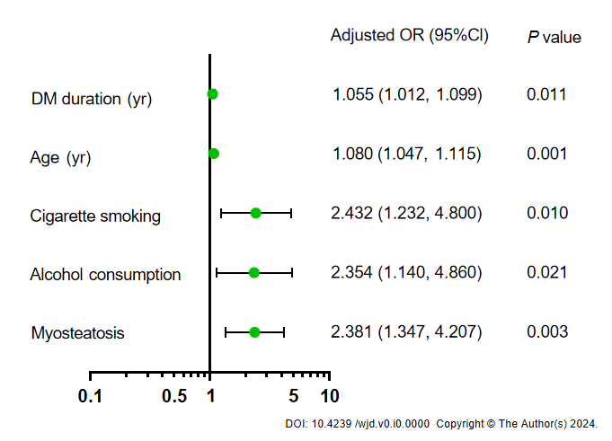
Figure 1 Forest plot of independent factors identified from logistic linear regression for severe coronary artery calcification. DM: Diabetes mellitus.
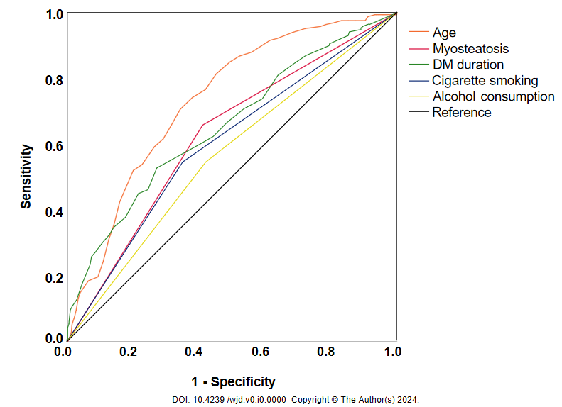
Figure 2 Receiver operating characteristic curve analysis of risk factors for severe coronary artery calcification alone or in combination. DM: Diabetes mellitus.

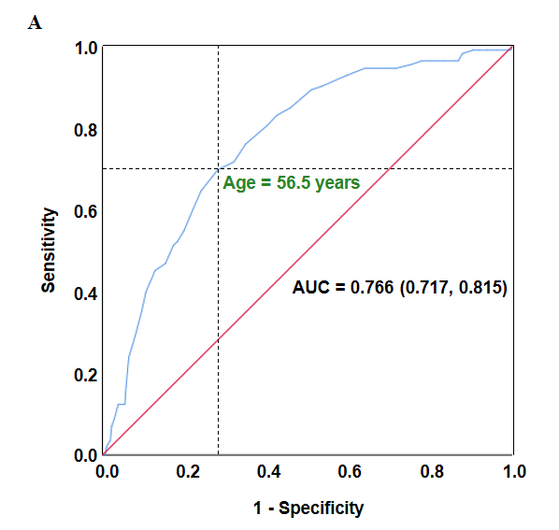
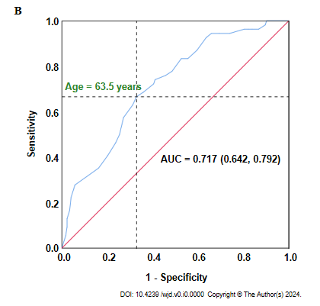
Figure 3 Cut-off points of age for severe coronary artery calcification. A. Subgroup of males; B. Subgroup of females. AUC: Area under the curve.
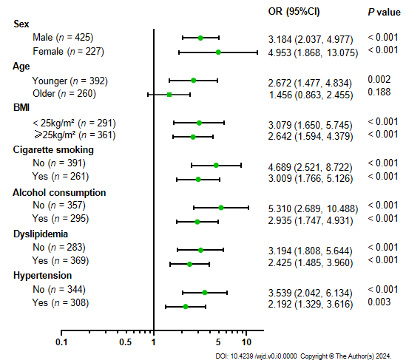
Figure 4 Subgroup analyses of myosteatosis in predicting severe coronary artery calcification. BMI: Body mass index.
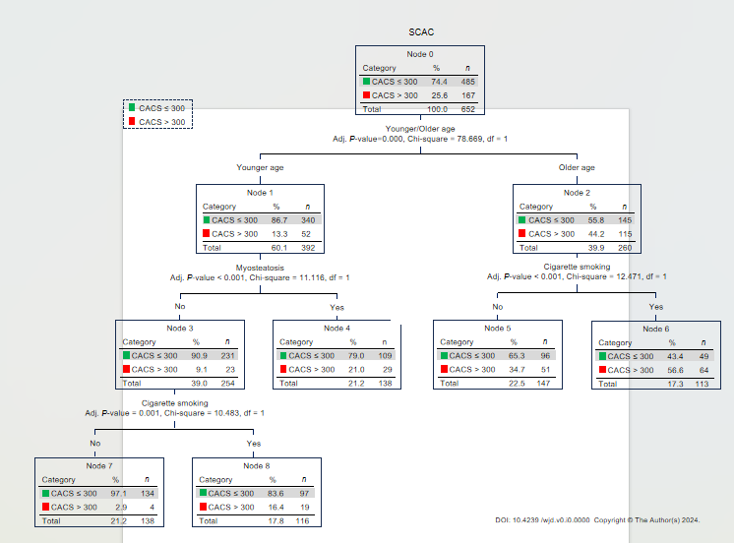
Figure 5 Chi-squared automatic interaction detection decision tree analysis. SCAC: severe coronary artery calcification; CACS: Severe coronary artery calcification score.
Table 1 Characteristics of the study population
Variables | All patients  (n = 652) | T2DM group  (n = 485) | T2DM + SCAC group  (n = 167) | P value
Male (%) | 425 (65.2) | 312 (64.3) | 113 (67.7) | 0.453
Age (yr) | 55.95 ± 10.87 | 53.75 ± 10.62 | 62.34 ± 8.94 | < 0.001
Diabetes duration (yr) | 8.97 ± 7.13 | 7.87 ± 6.36 | 12.15 ± 8.22 | < 0.001
Body mass index (kg/m²) | 25.79 ± 3.66 | 25.87 ± 3.61 | 25.56 ± 3.79 | 0.358
Fasting glucose (mmol/L) | 7.67 ± 2.23 | 7.53 ± 2.19 | 8.09 ± 2.31 | 0.018
Fasting C peptide (ng/mL) | 2.27 ± 1.06 | 2.25 ± 0.97 | 2.32 ± 1.30 | 0.581
Hemoglobin A1c (%) | 8.71 ± 2.19 | 8.76 ± 2.23 | 8.59 ± 2.06 | 0.384
HOMA2-β | 166.51 ± 93.75 | 169.89 ± 92.31 | 155.97 ± 97.78 | 0.170
HOMA2-IR | 5.62 ± 2.67 | 5.55 ± 2.48 | 5.84 ± 3.20 | 0.314
Hemoglobin (g/L) | 138.69 ± 21.98 | 139.77 ± 22.44 | 135.52 ± 20.30 | 0.032
Albumin (g/L) | 43.14 ± 4.51 | 43.34 ± 4.31 | 42.55 ± 5.01 | 0.071
Alanine transaminase (U/L) | 18.20 (13.30, 27.80) | 19.35 (13.93, 28.90) | 15.90 (12.20, 21.90) | < 0.001
Creatinine (mg/L) | 61.38 ± 16.65 | 60.30 ± 15.78 | 64.49 ± 18.66 | 0.010
Blood urea nitrogen (mg/dL) | 5.65 ± 1.59 | 5.52 ± 1.45 | 6.04 ± 1.90 | < 0.001
Cystatin C (mg/L) | 1.00 ± 0.29 | 0.97 ± 0.25 | 1.11 ± 0.35 | < 0.001
Triglycerides (mmol/L) | 1.44 (0.98, 2.24) | 1.44 (0.98, 2.32) | 1.39 (0.95, 1.99) | 0.199
Total cholesterol (mmol/L) | 4.63 ± 1.56 | 4.70 ± 1.33 | 4.44 ± 2.09 | 0.059
HDL (mmol/L) | 1.18 ± 0.38 | 1.18 ± 0.40 | 1.16 ± 0.33 | 0.506
LDL (mmol/L) | 2.77 ± 1.18 | 2.86 ± 1.22 | 2.53 ± 1.05 | 0.002
FT3 (pmol/L) | 4.53 ± 1.40 | 4.61 ± 1.57 | 4.30 ± 0.71 | 0.016
FT4 (pmol/L) | 16.58 ± 3.04 | 16.57 ± 3.08 | 16.59 ± 2.91 | 0.943
TSH (pmol/L) | 2.25 ± 1.41 | 2.24 ± 1.37 | 2.30 ± 1.54 | 0.597
SBP (mmHg) | 136.23 ± 19.06 | 136.10 ± 19.82 | 136.63 ± 16.72 | 0.736
DBP (mmHg) | 81.13 ± 13.00 | 81.19 ± 13.43 | 80.95 ± 11.68 | 0.840
MMA (HU) | 36.41 ± 7.29 | 37.24 ± 7.23 | 34.02 ± 6.95 | < 0.001
Myosteatosis (%) | 309 (47.4) | 199 (41.0) | 110 (65.9) | < 0.001
CHD (%) | 166 (25.5) | 96 (19.8) | 70 (41.9) | < 0.001
SMI (cm²/m²) | 46.71 ± 9.31 | 47.18 ± 9.30 | 45.34 ± 9.23 | 0.027
FMI (kg/m²) | 8.56 ± 1.79 | 8.51 ± 1.79 | 8.68 ± 1.79 | 0.290
Cigarette smoking (%) | 261 (40.0) | 170 (35.1) | 91 (54.5) | < 0.001
Alcohol intake (%) | 295 (45.2) | 204 (42.1) | 91 (54.5) | 0.007
Dyslipidemia (%) | 369 (56.6) | 282 (58.1) | 87 (52.1) | 0.176
Hypertension (%) | 308 (47.2) | 215 (44.3) | 93 (55.7) | 0.012
Diabetic complications (%) | 564 (86.5) | 410 (84.5) | 154 (92.2) | 0.012
DN (%) | 247 (37.9) | 169 (34.8) | 78 (46.7) | 0.007
DPN (%) | 498 (76.4) | 362 (74.6) | 136 (81.4) | 0.091
LEAD (%) | 105 (16.1) | 73 (15.1) | 32 (19.2) | 0.223
DR (%) | 185 (28.4) | 118 (24.3) | 67 (40.1) | < 0.001
Antidiabetics (%) | 569 (87.3) | 411 (84.7) | 158 (94.6) | 0.001
Insulin (%) | 249 (38.2) | 172 (35.5) | 77 (46.1) | 0.016
Metformin (%) | 434 (66.6) | 310 (63.9) | 124 (74.3) | 0.017
Sulphonylureas (%) | 312 (47.9) | 230 (47.7) | 82 (49.1) | 0.720
Acarbose (%) | 257 (39.4) | 180 (37.1) | 77 (46.1) | 0.044
Others (%) | 167 (25.6) | 120 (24.7) | 47 (28.1) | 0.411
Lipid-lowering drugs (%) | 140 (21.5) | 84 (17.3) | 56 (33.5) | < 0.001
Statins (%) | 131 (20.1) | 75 (15.5) | 56 (33.5) | < 0.001
Fibrates (%) | 9 (1.4) | 9 (1.9) | 0 (0.0) | 0.121
Antihypertensive drugs (%) | 237 (36.3) | 158 (32.6) | 79 (47.3) | 0.001
ACE inhibitors (%) | 33 (5.1) | 20 (4.1) | 13 (7.8) | 0.068
ARBs (%) | 105 (16.1) | 71 (14.6) | 34 (20.4) | 0.088
Calcium antagonists (%) | 134 (20.6) | 89 (18.4) | 45 (26.9) | 0.020
β-Blockers (%) | 64 (9.8) | 36 (7.4) | 28 (16.8) | 0.001
Diuretics (%) | 32 (4.9) | 22 (4.5) | 10 (6.0) | 0.533
Aspirin (%) | 145 (22.2) | 84 (17.3) | 61 (36.5) | < 0.001
T2DM: Type 2 diabetes mellitus; SCAC: Severe coronary artery calcification; HOMA2-β: Homeostasis model assessment 2 of beta-cell function; HOMA2-IR: Homeostasis model assessment 2 of insulin resistance; HDL: High-density lipoproteins; LDL: Low-density lipoproteins; FT3: Free triiodothyronine; FT4: Free thyroxine; TSH: Thyroid-stimulating hormone; SBP: Systolic blood pressure; DBP: Diastolic blood pressure; CHD: Coronary heart disease; SMI: Skeletal muscle index; MMA: Mean skeletal muscle attenuation; FMI: Fat mass index; DN: Diabetic nephropathy; DPN: Diabetic peripheral neuropathy; LEAD: Lower extremity arterial disease; DR: Diabetic retinopathy; ACE: Angiotensin-converting enzyme; ARB: Angiotensin II receptor blocker.

