Name of Journal: World Journal of Clinical Oncology
Manuscript NO: 82834
Manuscript Type: ORIGINAL ARTICLE

Basic Study
Thymoquinone enhances the antioxidant and anticancer activity of Lebanese propolis

AlDreini S et al. Antioxidant and anticancer activity of TQ and propolis combination

Sima AlDreini, Zaynab Fatfat, Najwa Abou Ibrahim, Maamoun Fatfat, Hala Gali-Muhtasib, Hala Khalife

Sima AlDreini, Najwa Abou Ibrahim, Hala Khalife, Rammal Rammal Laboratory (ATAC Group), Faculty of Sciences I, Hadath 1003, Lebanon

Zaynab Fatfat, Maamoun Fatfat, Hala Gali-Muhtasib, Department of Biology, American University of Beirut, Beirut 1107-2020, Lebanon

Hala Khalife, Lebanon and Applied Biochemistry Laboratory, School of Pharmacy, Camerino University, Camerino 62032, Italy

Author contributions: AlDreini S carried out lab work as part of her MSc thesis, performed analysis and interpretation of data; Fatfat Z drafted the manuscript; Abou Ibrahim N provided propolis, and contributed intellectually to the study; Fatfat M supervised the experimental work; Khalife H reviewed the manuscript and contributed in the critical appraisal of data; Gali-Muhtasib H conceived the project, supervised the work, and edited the manuscript draft; All authors have read and approved the final manuscript.

Supported by the Lebanese University and the Undergraduate Research Experience funds at the American University of Beirut.

Corresponding author: Hala Khalife, PhD, Professor, Rammal Rammal Laboratory (ATAC Group), Faculty of Sciences I, Rafic Hariri University Campus, Lebanon and Applied Biochemistry Laboratory, School of Pharmacy, Camerino University, Camerino 62032, Italy. hala-khalifeh@hotmail.com

Received: December 28, 2022
Revised: March 24, 2023
Accepted: April 12, 2023
Published online:

Abstract
BACKGROUND
Reactive oxygen species (ROS) are produced by multiple cellular processes and are maintained at optimal levels in normal cells by endogenous antioxidants. In recent years, the search for potential exogenous antioxidants from dietary sources has gained considerable attention to eliminate excess ROS that is associated with oxidative stress related diseases including cancer. Propolis, a resinous honeybee product, has been shown to have protective effects against oxidative stress and anticancer effects against several types of neoplasms.

AIM
To investigate the antioxidant and anticancer potential of Lebanese propolis when applied alone or in combination with the promising anticancer compound Thymoquinone (TQ) the main constituent of Nigella sativa essential oil.

METHODS
Crude extracts of Lebanese propolis collected from two locations, Rashaya and Akkar-Danniyeh, were prepared in methanol and the total phenolic content was determined by Folin–Ciocalteu method. The antioxidant activity was assessed by the ability to scavenge 2,2-diphenyl-1-picrylhydrazyl (DPPH) free radical and to inhibit H₂O₂-induced oxidative hemolysis of human erythrocytes. The anticancer activity was evaluated by [3-(4,5-dimethylthiazol-2-yl)-2,5 diphenyl tetrazolium bromide] MTT assay against HCT-116 human colorectal cancer cells and MDA-MB-231 human breast cancer cells.

RESULTS
The total phenolic content of propolis extract from Rashaya and Akkar-Danniyeh were 56.81 µg and 83.503 µg of gallic acid equivalent /mg of propolis, respectively. Both natural agents exhibited strong antioxidant activities as evidenced by their ability to scavenge DPPH free radical and to protect erythrocytes against H₂O₂-induced hemolysis. They also dose-dependently decreased the viability of both cancer cell lines. The IC₅₀ value of each of propolis extract from Rashaya and Akkar-Danniyeh or TQ was 22.3, 61.7, 40.44 µg/mL for breast cancer cells at 72 h and 33.3, 50.9, 33.5 µg/mL for colorectal cancer cells at the same time point, respectively. Importantly, the inhibitory effects of propolis on DPPH radicals and cancer cell viability were achieved at half its concentration when combined with TQ.

CONCLUSION
Our results indicate that Lebanese propolis extract has antioxidant and anticancer potential and its combination with TQ could possibly prevent ROS- mediated diseases.

Key Words: Lebanese propolis; Thymoquinone; Combination; Antioxidant activity; Anticancer activity; Phenolic compounds

AlDreini S, Fatfat Z, Abou Ibrahim N, Fatfat M, Gali-Muhtasib H, Khalife H. Thymoquinone enhances the antioxidant and anticancer activity of Lebanese propolis. World J Clin Oncol 2023; In press

Core Tip: Combining Thymoquinone with Lebanese propolis enhanced its antioxidant activity and its anticancer effects against breast and colorectal cancer cells. The combination of these natural products could have potential health benefits and could possibly prevent oxidative stress mediated diseases including cancer.

INTRODUCTION
Oxidative stress refers to the imbalance between the generation of reactive oxygen species (ROS) and their neutralization by endogenous antioxidant systems resulting in an excess of ROS which has detrimental effects on key cellular components^{[1,2]}. There are two types of ROS: Free radicals and nonradicals. Free radicals are highly reactive molecules because they have at least one unpaired electron in their structure and react with different biological macromolecules^{[3]}. Although nonradical species are less reactive than free radicals, they can easily cause free radical reactions in living organisms^{[3,4]}. The accumulation of ROS causes the peroxidation of cell membrane lipids and cell membrane disintegration, alters the configuration of proteins resulting in loss of biochemical functionality in addition to inducing DNA mutations and replication errors^{[2]}. Ample evidence shows that ROS-mediated oxidative stress is associated with the pathogenesis of various diseases including cancer, cardiovascular diseases, neurodegenerative disorders, and diabetes^{[5]}.
Removing excessive ROS by exogenous antioxidants supplementation has long been considered a potential strategy to prevent diseases. Over the last decade, there has been considerable interest in the intake of natural antioxidants from food and diets to strengthen cell antioxidant defense in humans. A recent pilot study demonstrated that a healthy mixed diet rich in antioxidant micronutrients reduced the concentration of ROS in the blood of healthy subjects^{[6]}. Another study showed that regular consumption of an antioxidant-rich juice increased plasma antioxidant capacity and reduced plasma lipid oxidation in healthy individuals^{[7]}. In addition, several clinical trials showed that intake of foods rich in antioxidants can potentiate plasma antioxidant capacity and reduce oxidative stress markers in subjects with diabetes, obesity, and dyslipidemia^{[8]}. Interestingly, the combination of several antioxidants has been suggested to be more potent than the application of single antioxidants given the diverse chemistry and biochemistry of ROS, and the interactions that could arise from antioxidants that have different modes of action^{[9]}.
Propolis is a glue-like resinous material produced by honeybees from various plant sources and used in the construction and maintenance of their hives^{[10,11]}. Propolis possesses numerous health-promoting potentials including anti-inflammatory^{[12]}, antioxidant^{[13]}, anticancer^{[14]} and antidiabetic effects^{[15]}. The chemical composition and therefore the biological effects of propolis vary depending on several factors such as the geographical region, botanical source, and the bee species^{[16]}. The bioactive compounds of propolis were reported to effectively scavenge free radicals^{[17]}. Different in vivo studies reported the protective effects of propolis against the oxidative stress induced by several exogenous oxidants such as cisplatin^{[18]}, isoproterenol^{[19]}, nicotine^{[20]} ,UV^{[21]}, and carbon tetrachloride^{[22]}. In addition, propolis was demonstrated to reduce the blood pressure and suppress oxidative stress in heart, liver, and renal tissues in animal models of hypertension^{[23-25]}.
Thymoquinone (TQ), the major bioactive constituent of Nigella sativa (black seed) essential oil, was extensively studied for its diverse therapeutic benefits including antioxidant, anti-inflammatory, anticancer, antibacterial, antifungal and anticonvulsant activity^{[26]}. TQ was reported as a strong scavenger of different ROS and was found to inhibit non-enzymatic lipid peroxidation^{[27]}. TQ was demonstrated to have a protective effect against oxidative stress induced in rats by different agents such as radiation^{[28]}, lead^{[29]} and acrylamide^{[30]}. In addition, it reduced the oxidative stress in rat models of myocardial infarction^{[31]}, diabetes mellitus^{[32]}, lung injury^{[33]} and dopaminergic neurodegeneration^{[34]}.
Although the antioxidant potential of propolis and TQ has been well investigated in previous studies, there are no studies that have evaluated the antioxidant and anticancer effects of the combination of both natural agents. Thus, we aimed to test the antioxidant and anticancer activities of combining TQ and propolis that was collected from two locations in Lebanon (Rashaya and Akkar-Danniyeh). We evaluated the total phenolic content of both propolis extract and determined the antihemolytic and antioxidant activity of propolis and TQ in addition to their anticancer effects against HCT-116 human colorectal cancer cells and MDA-MB-231 human breast cancer cells.

MATERIALS AND METHODS
Preparation of thymoquinone
Fresh stocks of the purified synthetic compound TQ (Sigma-Aldrich) were prepared in methanol directly before use.

Preparation of methanol extracts of propolis
Two samples of raw propolis material were collected, the first from Rashaya district in the Beqaa governorate of Lebanon and the second from Akkar-Danniyeh in the north of the country. A mass of 10 g of raw propolis from each sample was chopped into small pieces and extracted with 100 mL distilled water. The extraction was carried at 80ºC for 3 h and the obtained solution was subsequently filtered through a Buchner funnel. Residues were then extracted with 100 mL methanol. The extraction was carried at room temperature for 4 h then at 50ºC for 15 min. The propolis extracts were subsequently filtered three times by Buchner funnel. The obtained filtrate was evaporated by nitrogen gas to obtain the methanol propolis extract (MPE). MPE-R denotes MPE from Rashaya and MPE-D denotes MPE from Akkar-Danniyeh.

Total phenolic content
The relative content in phenols was determined according to the Folin Ciocalteu method. Briefly, 100 µL of MPE-R or MPE-D (1 mg/mL of methanol) from each sample were mixed with 500 μL of Folin Ciocalteu's phenol reagent 10%. After 5 min, 1.5 mL of 2% sodium bicarbonate were added to the solution. The mixture was maintained at room temperature in the dark for 30 min after which the absorbance was recorded at 760 nm using a spectrophotometer. The total phenolic content was calculated using the calibration curve generated from standard solutions of gallic acid ranging from 0 to 50 μg/mL (y = 0.2811x - 0.3266; R² = 0.956). Total phenolic content was expressed as the average of 3 independent experiments performed in triplicates and as µg of gallic acid equivalents (GAE)/mg of propolis.

DPPH assay
Free radical-scavenger activity was determined by the 2,2-diphenyl-1-picrylhydrazyl (DPPH) assay. Briefly, 1 mL of MPE-R or MPE-D (10-100 µg/mL) were mixed with 1 mL of DPPH (0.052 mg/mL methanol). The reaction mixtures were homogenized and incubated in the dark at room temperature for 30 min and the absorbance (Abs) was measured at 515 nm by a Gene Quant 1300 UV-Vis spectrophotometer. The ascorbic acid was used as a reference antioxidant and a mixture of 1 mL DPPH with 1 mL methanol was used as a control. For combination treatments, TQ (12.5-100 µg/mL) was combined with MPE-R or MPE-D (10- 50 µg/mL) and the experiment was carried as described above. The DPPH scavenging ability of the different agents was calculated using the following equation: % DPPH inhibition = [(Abs control − Abs sample)]/ (Abs control)] × 100.

H₂O₂- induced hemolysis
Fresh human blood was washed three times with 1X phosphate-buffered saline (PBS). With every wash, the sample was centrifuged for 12 min at 4ºC and 2500 rpm, the supernatant was discarded, and the pellet was resuspended in PBS. Then, the pellet was resuspended in Dulbecco's PBS and 1 mL of the cell suspension was mixed with 100 μL of each of MPE-R, MPE-D or TQ at 10, 50, and 100 μg/mL. After 5 min, 1 mL of 10% H₂O₂ was added, and the mixture was incubated at 37°C for 90 min and shaken every 30 min. This was followed by centrifugation at 4°C and 2500 rpm for 10 min and measurement of the absorbance of the supernatant at 540 nm. The positive control consisted of a mixture of blood with 10% H₂O₂. The results were expressed as percentage of inhibition of hemolysis. % inhibition of hemolysis= [(Abs control − Abs sample)]/ (Abs control)] × 100

Hemolytic activity
Fresh human blood was washed three times with 1X PBS. With every wash, the sample was centrifuged at 4ºC and 2500 rpm for 12 min, the supernatant was discarded, and the pellet was resuspended in PBS. The washed blood was mixed with each of MPE-R or MPE-D (10, 100, 200 µg/mL), TQ (20, 50, 100 µg/mL) or their combinations. The mixture was kept at 37ºC for 90 min and was shaken every 30 min. The samples were then centrifuged at 4ºC, 2500 rpm, for 10 min after which the absorbance of the supernatant was recorded at 540 nm. The positive control consisted of a mixture of blood with 1% SDS which is known to cause hemolysis. The results were expressed as the percentage of hemolysis. % hemolysis= [Abs sample/ Abs control] × 100

Cell culture conditions
HCT-116 human colorectal cancer cells and MDA-MB-231 human breast cancer cells were maintained in RPMI 1640 (Lonza; Cat.N: BE12-115F) supplemented with 10% fetal bovine serum (Sigma F9665) and 1% penicillin/ streptomycin (Sigma, P4333) in a humidified atmosphere at 37ºC in 5% CO₂.

MTT cell viability assay
HCT-116 and MDA-MB-231 cells were seeded overnight in 96-well microtiter plates at a density of 10⁴ cells/well. After 24 h, cells were treated with MPE-R, MPE-D or TQ at a concentration ranging from 1-15 μg/mL or with the combination of MPE-R or MPE-D (0.5-7.5 μg/mL) with TQ (0.5-7.5 μg/mL). After 24, 48 and 72 h of treatment, cells in each well were incubated with 20 μL of [3-(4, 5-dimethylthiazolyl-2)-2, 5-diphenyltetrazolium bromide] MTT for 3 to 4 h, then with 100 µL of DMSO for about 1 h. The MTT optical density (O.D.) was then measured by a microplate spectrophotometer at 515 nm. The results are expressed as percentage of viable cells with respect to the untreated control using this formula: % viability = [mean O.D. treatment/mean O.D. control] × 100.

Statistical analysis
Data are presented as means ± SD. Two tailed Student’s t-test was performed to evaluate the statistical significance of the difference between the groups using GraphPad Prism V.9.5.0 software. Statistical significance was set with a 95% confidence interval at P < 0.05, P < 0.01 and P < 0.0001.

RESULTS
Total phenolic content of propolis varies depending on location
The total phenolic content of propolis extracts was determined by Folin Ciocalteu method and is reported as gallic acid equivalents by reference to a standard curve (y = 0.2811x - 0.3266; R² = 0.956). The phenolic content was variable depending on location such that the total phenolic content of MPE- D in 1 mg of propolis was 47% higher than that of MPE-R (Table1).

TQ enhanced the antioxidant activity of propolis
We then evaluated the ability of propolis extracts to scavenge free radicals using DPPH radical scavenging assay. Both propolis extract exhibited a dose-dependent DPPH inhibition efficiency suggesting antioxidant potential. MPE-D had higher antioxidant activity than MPE-R as reflected by the higher percentages of inhibition recorded at all the concentrations ranging from 20-100 µg/mL. MPE-R showed maximum inhibition of DPPH of 56.5% at 100 µg/mL, while inhibition by MPE-D reached 89% at 75 and 100 µg/mL (Figure 1A).
To determine whether the antioxidant effects of propolis extracts could be potentiated by TQ, we combined each of MPE-R or MPE-D (10-50 µg/mL) with TQ (12.5-100 µg/mL) and evaluated their antioxidant activity in comparison to single treatments. Results showed that the combination with TQ enhanced the antioxidant activity of propolis extracts. While a dose of 100 µg/mL of MPE-R induced 56.5% inhibition of DPPH, the combination of 50 µg/mL of MPE-R with 100 µg/mL TQ caused 85.7% inhibition. MPE-D alone showed maximal inhibitory effects of 89% at 75-100 µg/mL, while combination with 50-100 µg/mL TQ resulted in 84% inhibition at lower concentrations of 25-50 µg/mL (Figure 1B).

Propolis extracts and TQ protected human red blood cells against oxidative hemolysis
We then evaluated the biological relevance of the antioxidant activity of propolis extracts and of TQ by testing the protective effects of single treatments against oxidative hemolysis induced by H₂O₂ in human red blood cells. Treatment with MPE-R, MPE-D or TQ exhibited good antihemolytic potential against H₂O₂-induced hemolysis. A dose of 10 µg/mL of each of MPE-R, MPE-D and TQ induced 46, 49 and 51% decrease in hemolysis, respectively (Figure 2).

The combination of propolis extracts with TQ had no hemolytic activity at low concentrations
To investigate if propolis extracts or TQ are toxic to human red blood cells, we evaluated their hemolytic potential at concentrations ranging from 10- 200 µg/mL and 20- 100 µg/mL, respectively. Both MPE-R and MPE-D produced less than 5% hemolysis at 10 µg/mL, suggesting that these extracts are not toxic to red blood cells at this concentration. Increasing concentrations of MPE-D up to 100 or 200 µg/mL also showed low hemolytic activity of 7.8%. Similarly, hemolysis by TQ was less than 5% at all the tested concentrations. However, MPE-R induced higher hemolytic response that reached 20% at 200 µg/mL (Figure 3A).
Combining 5 µg/mL MPE-R or MPE-D with 10 µg/mL TQ produced less than 5% hemolysis suggesting that combinations at these low doses have low hemolytic effects. However, increasing concentrations to 50 µg/mL MPE-R and 25 µg/mL TQ or 100 µg/mL MPE-R and 50 µg/mL TQ produced 12.7% and 21.9% hemolysis, respectively. Similar concentrations of MPE-D and TQ produced 7.3% and 13.7% hemolysis, respectively (Figure 3B), suggesting that MPE-R had higher hemolytic effects when combined with TQ at higher doses.

TQ potentiated the inhibitory effects of propolis extracts on cancer cell viability
Next, we tested the anticancer activity of propolis extracts when applied alone or in combination with TQ. MDA-MB-231 human breast cancer cells and HCT-116 human colorectal cancer cells were treated with different concentrations of the natural products for 24, 48 and 72 h after which cell viability was assessed by MTT assay. Single treatments with MPE-R or MPE-D (1-15 µg/mL) reduced the viability of both cell lines in a dose dependent manner to almost similar levels. Treatment of MDA-MB 231 cells with 15 µg/mL of MPE-R, MPE-D or TQ for 72 h caused 34.6%, 18.5% and 24.52% reduction in cell viability, respectively. The IC₅₀ value of each of MPE-R, MPE-D or TQ at 72 h was 22.3, 61.7, 40.44 µg/mL, respectively. Combining lower doses of 7.5 µg/mL MPE-R or MPE-D with 7.5 µg/mL TQ decreased cell viability by 48.9% and 39.3%, respectively (Figure 4A and B), suggesting enhanced efficacy by combination treatment.
Treatment of HCT-116 cells for 72 h with 15 µg/mL of MPE-R, MPE-D or TQ decreased cell viability by 18.6, 14.3 and 26%, respectively. The IC₅₀ value of each of MPE-R, MPE-D or TQ at 72 h was 33.3, 50.9, 33.5 µg/mL, respectively. Interestingly, the combination of half doses of MPE-R or MPE-D (7.5 µg/mL) with 7.5 µg/mL TQ caused a respective decrease in viability of 40.9% and 34.4% at 72 h (Figure 5A and B). Thus, combining propolis extracts with TQ enhanced their anticancer activities against breast and colorectal cancer cells.

DISCUSSION
The intake of dietary antioxidants is known to support the endogenous antioxidant system and prevent oxidative stress-mediated diseases^{[35]}. Studies have shown that combining dietary antioxidants from different sources produces more potent antioxidant effects and possibly more effective therapeutic potential than single agents. Combining Nigella sativa oil with honey was shown to augment its antioxidant capacity^{[36]}. In addition, the combination of Nigella sativa seeds and honey exhibited antioxidant effects and decreased the viability of ovarian cancer cells^{[37]}. Interestingly, oral intake of honey potentiated the protective effect of Nigella sativa grains against methylnitrosourea-induced oxidative stress and carcinogenesis in Sprague Dawely rats^{[38]}. Here, we evaluated the antioxidant and the anticancer potential of combining propolis, the third most important component of bee products^{[39]}, with TQ as the major bioactive constituent of Nigella sativa essential oil. The key finding of the present study is that combining TQ with Lebanese propolis at half its concentration resulted in an enhanced antioxidant and anticancer effects in comparison to propolis alone as demonstrated by the improved DPPH radical scavenging activity and inhibitory effects against breast and colorectal cancer cell lines.
First, we assessed the total phenolic content of propolis collected from two different Lebanese regions Rashaya and Akkar- Danniyeh. The phenolic content is the most widely investigated among all the components of propolis because it was reported to be mainly responsible for its biological activity^{[40]}. According to the results reported by El-Ali et al^{[41]}, the total phenolic content of ethanol extract of propolis collected from the two Lebanese regions Debaal and Wadi Faara were similar to our study’s finding. On the other hand, higher phenolic content values were recorded in the ethanol extract of propolis collected from the Lebanese regions Fakeha and Berqayel and the citrus groves of the Lebanese coast^{[41,42]}. This variation in total phenolic content of propolis collected from different Lebanese regions could be attributed to several factors including the botanical origin of the raw material, mode of collection, collecting season, or the solvent used in the extraction method^{[40]}.
Next, we assessed the antioxidant activity of MPE-R and MPE-D alone or in combination with TQ using DPPH free radical scavenging test. DPPH is a stable nitrogen-centered free radical which color changes from violet to yellow when it receives a hydrogen- or electron- from an antioxidant^{[43]}. MPE-R and MPE-D exhibited significant DPPH scavenging efficacy reflecting the presence of antioxidants within their constituents. Numerous studies reported a positive correlation between antioxidant activity of propolis extracts and their contents of phenolic compounds suggesting that they are responsible of the antioxidant activity of the extracts^{[41,44,45]}. Phenolics are known to have a hydroxyl group attached to their aromatic ring which can donate electron to free radicals and therefore stabilize them^{[46]}. As for TQ which is a non-phenolic compound, a recent computational study reported that it attacks free radical preferentially at its 3CH position and preferably via hydrogen atom transfer^{[47]}.
After demonstrating the antioxidant efficacy of each of MPE-R, MPE-D and TQ, we assessed their potential to protect red blood cells from oxidative damage and hemolysis induced by H₂O₂. Red blood cells are highly prone to oxidative damage due to its high membrane concentration of polyunsaturated fatty acids^{[48]}. When the membrane lipids of red blood cells are subjected to ROS attack, they lose a hydrogen atom from an unsaturated fatty acyl chain. This initiates lipid peroxidation that propagates as a chain reaction and lead to membrane damage and consequently hemolysis^{[49,50]}. Our findings are in the same line with previous research that has shown the anti-hemolytic activity of propolis or TQ under oxidative stress conditions^{[40,51]}. The antihemolytic activity of MPE-R and MPE-D could be associated with their phenolic content. Phenolic compounds are supposed to donate electrons to hydrogen peroxide, neutralize it to water and prevent it to induce hemolysis^{[52]}.
The assessment of hemolytic activity of blood-contacting compounds is of high importance for their future application in vivo^{[53]}. Our results are in agreement with those reported by Shubharani et al^{[54]} who showed that low concentrations of ethanolic extract of Indian propolis did not have hemolytic activity. Although high concentrations of Lebanese propolis showed low to moderate hemolysis, same concentrations of Polish or Brazilian propolis extract did not cause hemolysis^{[40,55]}.
Cancer cells exhibit elevated levels of ROS which promote cell cycle progression and lead to an increase in cell proliferation^{[56]}. By-products of oxidative damage such as 8-hydroxy-2-deoxyguanosine, malondialdehyde, 4-hydroxy-2-nonenal, and carbonylated proteins were speculated to play a mutagenic role^{[57]}. In addition, oxidative stress was found to be responsible for inactivation of several key proteins such as caspases, phosphatases, and phosphatase and tensin homologue, and inhibits p53 binding to gene promoters which reduce apoptosis and increase cell survival^{[58]}. Dietary antioxidants have been demonstrated to have chemopreventive and anticancer effects in vitro and in vivo^{[59]}. Numerous studies demonstrated the anticancer effect of each of TQ, propolis and its phenolic compounds in different types of cancer^{[60,61]}. To our knowledge, this is the first study that demonstrates the promising anticancer effect of the combination of these agents. Only one study demonstrated the anticancer effect of Lebanese propolis collected from the south of the country on leukemic T cells^{[10]}. Although MPE-D had higher antioxidant activity than MPE-R, the inhibitory effect of both extracts on the cell viability of cancer cell lines was almost the same. This result suggests that phenolic compounds may not be responsible for this inhibitory effect of the extracts.

CONCLUSION
In summary, the Lebanese propolis from Rashaya and Akkar-Danniyeh exhibited promising therapeutic potential as reflected by their potent DPPH radical scavenging activity, protective effects against H₂O₂ induced hemolysis and inhibitory effects against breast and colorectal cancer cell lines. The combination of TQ with propolis resulted in enhanced antioxidant and anticancer activities in comparison to single treatments. Thus, this combination could have potential health benefits and holds promise for the prevention of oxidative stress related diseases. Further studies should be conducted to analyze the chemical composition of propolis, decipher the antioxidant and anticancer mechanism of its combination with TQ in addition to evaluating the effects of TQ and propolis in animal models of oxidative stress.

ARTICLE HIGHLIGHTS
Research background
Oxidative stress is implicated in the pathogenesis of numerous diseases including cancer. Propolis, the third most important component of bee products, and Thymoquinone (TQ), the main constituent of Nigella sativa essential oil, were extensively reported to have antioxidant and anticancer effects. However, the antioxidant potential of the combination of these natural products as well as their anticancer activity against breast and colorectal cancer cells have not been investigated yet.

Research motivation
To establish a new therapeutic approach for oxidative stress induced cancers using a combination of natural agents from food and diets.

Research objectives
To investigate the antioxidant and anticancer potential of Lebanese propolis and TQ alone and in combination.

Research methods
Folin–Ciocalteu method was used to determine the total phenolic content of the methanolic extract of propolis. The 2,2-diphenyl-1-picrylhydrazyl (DPPH) free radical assay and the H₂O₂-induced oxidative hemolysis of human erythrocytes in vitro assay were employed to assess the antioxidant activity of TQ and Lebanese propolis. The MTT assay was used to evaluate the anticancer activity of these natural agents in single and dual treatment against HCT-116 human colorectal cancer cells and MDA-MB-231 human breast cancer cells in vitro.

Research results
Combination of TQ with Lebanese propolis at half its concentration improved the antioxidant and anticancer activity of propolis as reflected by the enhanced DPPH radical scavenging activity and inhibitory effects against breast and colorectal cancer cells.

Research conclusions
Our results suggest the use of a combination of TQ and Lebanese propolis as potential therapy for the management of oxidative stress and treatment of breast and colorectal cancer. This is the first study to report the promising enhancement in Lebanese propolis antioxidant and anticancer activity when combined with TQ.

Research perspectives
Further research on the antioxidant and anticancer mechanisms of the combination of these natural agents and its therapeutic effects in animal models of oxidative stress should be performed in the future.

REFERENCES
1 Zhu L, Yuan C, Zhang D, Ma Y, Ding X, Zhu G. BHV-1 induced oxidative stress contributes to mitochondrial dysfunction in MDBK cells. Vet Res 2016; 47: 47 [PMID: 27000063 DOI: 10.1186/s13567-016-0332-2]
2 Pisoschi AM, Pop A, Iordache F, Stanca L, Predoi G, Serban AI. Oxidative stress mitigation by antioxidants - An overview on their chemistry and influences on health status. Eur J Med Chem 2021; 209: 112891 [PMID: 33032084 DOI: 10.1016/j.ejmech.2020.112891]
3 Phaniendra A, Jestadi DB, Periyasamy L. Free radicals: properties, sources, targets, and their implication in various diseases. Indian J Clin Biochem 2015; 30: 11-26 [PMID: 25646037 DOI: 10.1007/s12291-014-0446-0]
4 Ali AT, Al-Swayeh OA, Al-Rashed RS, Al-Mofleh IA, Al-Dohayan AD, Al-Tuwaijri AS. Role of oxygen-derived free radicals on gastric mucosal injury induced by ischemia-reperfusion. Saudi J Gastroenterol 1996; 2: 19-28 [PMID: 19864838]
5 Sharifi-Rad M, Anil Kumar NV, Zucca P, Varoni EM, Dini L, Panzarini E, Rajkovic J, Tsouh Fokou PV, Azzini E, Peluso I, Prakash Mishra A, Nigam M, El Rayess Y, Beyrouthy ME, Polito L, Iriti M, Martins N, Martorell M, Docea AO, Setzer WN, Calina D, Cho WC, Sharifi-Rad J. Lifestyle, Oxidative Stress, and Antioxidants: Back and Forth in the Pathophysiology of Chronic Diseases. Front Physiol 2020; 11: 694 [PMID: 32714204 DOI: 10.3389/fphys.2020.00694]
6 Zeng Z, Zdzieblik D, Centner C, Brauchle C, Gollhofer A, König D. Changing dietary habits increases the intake of antioxidant vitamins and reduces the concentration of reactive oxygen species in blood: A pilot study. Int J Food Prop 2020; 23: 1337-1346 [DOI: 10.1080/10942912.2020.1800727]
7 Díaz-Rubio ME, Pérez-Jiménez J, Martínez-Bartolomé MÁ, Álvarez I, Saura-Calixto F. Regular consumption of an antioxidant-rich juice improves oxidative status and causes metabolome changes in healthy adults. Plant Foods Hum Nutr 2015; 70: 9-14 [PMID: 25481643 DOI: 10.1007/s11130-014-0455-4]
8 Ávila-Escalante ML, Coop-Gamas F, Cervantes-Rodríguez M, Méndez-Iturbide D, Aranda-González II. The effect of diet on oxidative stress and metabolic diseases-Clinically controlled trials. J Food Biochem 2020; 44: e13191 [PMID: 32160647 DOI: 10.1111/jfbc.13191]
9 Bai H, Liu R, Chen HL, Zhang W, Wang X, Zhang XD, Li WL, Hai CX. Enhanced antioxidant effect of caffeic acid phenethyl ester and Trolox in combination against radiation induced-oxidative stress. Chem Biol Interact 2014; 207: 7-15 [PMID: 24211618 DOI: 10.1016/j.cbi.2013.10.022]
10 Noureddine H, Hage-Sleiman R, Wehbi B, Fayyad-Kazan H, Hayar S, Traboulssi M, Alyamani OA, Faour WH, ElMakhour Y. Chemical characterization and cytotoxic activity evaluation of Lebanese propolis. Biomed Pharmacother 2017; 95: 298-307 [PMID: 28850929 DOI: 10.1016/j.biopha.2017.08.067]
11 Braakhuis A. Evidence on the Health Benefits of Supplemental Propolis. Nutrients 2019; 11 [PMID: 31717277 DOI: 10.3390/nu11112705]
12 Inui S, Hosoya T, Yoshizumi K, Sato H, Kumazawa S. Phytochemical and anti-inflammatory properties of Senegalese propolis and isolated compounds. Fitoterapia 2021; 151: 104861 [PMID: 33631223 DOI: 10.1016/j.fitote.2021.104861]
13 Kocot J, Kiełczykowska M, Luchowska-Kocot D, Kurzepa J, Musik I. Antioxidant Potential of Propolis, Bee Pollen, and Royal Jelly: Possible Medical Application. Oxid Med Cell Longev 2018; 2018: 7074209 [PMID: 29854089 DOI: 10.1155/2018/7074209]
14 Forma E, Bryś M. Anticancer Activity of Propolis and Its Compounds. Nutrients 2021; 13 [PMID: 34444754 DOI: 10.3390/nu13082594]
15 El Adaouia Taleb R, Djebli N, Chenini H, Sahin H, Kolayli S. In vivo and in vitro anti-diabetic activity of ethanolic propolis extract. J Food Biochem 2020; 44: e13267 [PMID: 32378224 DOI: 10.1111/jfbc.13267]
16 El Menyiy N, Bakour M, El Ghouizi A, El Guendouz S, Lyoussi B. Influence of Geographic Origin and Plant Source on Physicochemical Properties, Mineral Content, and Antioxidant and Antibacterial Activities of Moroccan Propolis. Int J Food Sci 2021; 2021: 5570224 [PMID: 33791359 DOI: 10.1155/2021/5570224]
17 Syed Salleh SNA, Mohd Hanapiah NA, Ahmad H, Wan Johari WL, Osman NH, Mamat MR. Determination of Total Phenolics, Flavonoids, and Antioxidant Activity and GC-MS Analysis of Malaysian Stingless Bee Propolis Water Extracts. Scientifica (Cairo) 2021; 2021: 3789351 [PMID: 34721923 DOI: 10.1155/2021/3789351]
18 Yuluğ E, Türedi S, Yıldırım Ö, Yenilmez E, Aliyazıcıoğlu Y, Demir S, Özer-Yaman S, Menteşe A. Biochemical and morphological evaluation of the effects of propolis on cisplatin induced kidney damage in rats. Biotech Histochem 2019; 94: 204-213 [PMID: 30512970 DOI: 10.1080/10520295.2018.1543895]
19 Ahmed R, Tanvir EM, Hossen MS, Afroz R, Ahmmed I, Rumpa NE, Paul S, Gan SH, Sulaiman SA, Khalil MI. Antioxidant Properties and Cardioprotective Mechanism of Malaysian Propolis in Rats. Evid Based Complement Alternat Med 2017; 2017: 5370545 [PMID: 28261310 DOI: 10.1155/2017/5370545]
20 Khaled S, Makled MN, Nader MA. Protective effects of propolis extract against nicotine-evoked pulmonary and hepatic damage. Environ Sci Pollut Res Int 2022; 29: 5812-5826 [PMID: 34431048 DOI: 10.1007/s11356-021-16093-6]
21 Fonseca YM, Marquele-Oliveira F, Vicentini FT, Furtado NA, Sousa JP, Lucisano-Valim YM, Fonseca MJ. Evaluation of the Potential of Brazilian Propolis against UV-Induced Oxidative Stress. Evid Based Complement Alternat Med 2011; 2011 [PMID: 20953396 DOI: 10.1155/2011/863917]
22 Badr G, Sayed EA, Waly H, Hassan KA, Mahmoud MH, Selamoglu Z. The Therapeutic Mechanisms of Propolis Against CCl(4) -Mediated Liver Injury by Mediating Apoptosis of Activated Hepatic Stellate Cells and Improving the Hepatic Architecture through PI3K/AKT/mTOR, TGF-β/Smad2, Bcl2/BAX/P53 and iNOS Signaling Pathways. Cell Physiol Biochem 2019; 53: 301-322 [PMID: 31343125 DOI: 10.33594/000000140]
23 Ozdemir B, Gulhan MF, Sahna E, Selamoglu Z. The investigation of antioxidant and anti-inflammatory potentials of apitherapeutic agents on heart tissues in nitric oxide synthase inhibited rats via Nω-nitro-L-arginine methyl ester. Clin Exp Hypertens 2021; 43: 69-76 [PMID: 32799699 DOI: 10.1080/10641963.2020.1806294]
24 Selamoglu ZS, Ozdemir I, Ciftci O, Gulhan MF, Savci A. Antioxidant Effect of Ethanolic Extract of Propolis in Liver of L-NAME Treated Rats. Adv Clin Exp Med 2015; 24: 227-232 [PMID: 25931353 DOI: 10.17219/acem/40461]
25 Salmas RE, Gulhan MF, Durdagi S, Sahna E, Abdullah HI, Selamoglu Z. Effects of propolis, caffeic acid phenethyl ester, and pollen on renal injury in hypertensive rat: An experimental and theoretical approach. Cell Biochem Funct 2017; 35: 304-314 [PMID: 28833317 DOI: 10.1002/cbf.3277]
26 Badary OA, Hamza MS, Tikamdas R. Thymoquinone: A Promising Natural Compound with Potential Benefits for COVID-19 Prevention and Cure. Drug Des Devel Ther 2021; 15: 1819-1833 [PMID: 33976534 DOI: 10.2147/DDDT.S308863]
27 Cobourne-Duval MK, Taka E, Mendonca P, Bauer D, Soliman KF. The Antioxidant Effects of Thymoquinone in Activated BV-2 Murine Microglial Cells. Neurochem Res 2016; 41: 3227-3238 [PMID: 27585756 DOI: 10.1007/s11064-016-2047-1]
28 Demir E, Taysi S, Ulusal H, Kaplan DS, Cinar K, Tarakcioglu M. Nigella sativa oil and thymoquinone reduce oxidative stress in the brain tissue of rats exposed to total head irradiation. Int J Radiat Biol 2020; 96: 228-235 [PMID: 31638880 DOI: 10.1080/09553002.2020.1683636]
29 Mabrouk A. Protective effect of thymoquinone against lead-induced antioxidant defense system alteration in rat liver. Acta Biol Hung 2017; 68: 248-254 [PMID: 28901799 DOI: 10.1556/018.68.2017.3.2]
30 Abdel-Daim MM, Abo El-Ela FI, Alshahrani FK, Bin-Jumah M, Al-Zharani M, Almutairi B, Alyousif MS, Bungau S, Aleya L, Alkahtani S. Protective effects of thymoquinone against acrylamide-induced liver, kidney and brain oxidative damage in rats. Environ Sci Pollut Res Int 2020; 27: 37709-37717 [PMID: 32608003 DOI: 10.1007/s11356-020-09516-3]
31 Khalifa AA, Rashad RM, El-Hadidy WF. Thymoquinone protects against cardiac mitochondrial DNA loss, oxidative stress, inflammation and apoptosis in isoproterenol-induced myocardial infarction in rats. Heliyon 2021; 7: e07561 [PMID: 34355083 DOI: 10.1016/j.heliyon.2021.e07561]
32 Faisal Lutfi M, Abdel-Moneim AH, Alsharidah AS, Mobark MA, Abdellatif AAH, Saleem IY, Al Rugaie O, Mohany KM, Alsharidah M. Thymoquinone Lowers Blood Glucose and Reduces Oxidative Stress in a Rat Model of Diabetes. Molecules 2021; 26 [PMID: 33920728 DOI: 10.3390/molecules26082348]
33 Alzohairy MA, Khan AA, Alsahli MA, Almatroodi SA, Rahmani AH. Protective Effects of Thymoquinone, an Active Compound of Nigella sativa, on Rats with Benzo(a)pyrene-Induced Lung Injury through Regulation of Oxidative Stress and Inflammation. Molecules 2021; 26 [PMID: 34072086 DOI: 10.3390/molecules26113218]
34 Dong J, Zhang X, Wang S, Xu C, Gao M, Liu S, Li X, Cheng N, Han Y, Wang X, Han Y. Thymoquinone Prevents Dopaminergic Neurodegeneration by Attenuating Oxidative Stress Via the Nrf2/ARE Pathway. Front Pharmacol 2020; 11: 615598 [PMID: 33519481 DOI: 10.3389/fphar.2020.615598]
35 Hegazy AM, El-Sayed EM, Ibrahim KS, Abdel-Azeem AS. Dietary antioxidant for disease prevention corroborated by the Nrf2 pathway. J Complement Integr Med 2019; 16 [PMID: 30726190 DOI: 10.1515/jcim-2018-0161]
36 Briga M, Odobasic A, Sestan I, Begic S. Black seed oil as an additive to honey. Eur Food Res Technol 2019; 7: 15-25
37 Rathi B, Devanesan S, AlSalhi MS, Ranjith Singh AJ. In-vitro free radical scavenging effect and cytotoxic analysis of Black Cummins and Honey formulation. Saudi J Biol Sci 2021; 28: 1576-1581 [PMID: 33732043 DOI: 10.1016/j.sjbs.2020.12.051]
38 Mabrouk GM, Moselhy SS, Zohny SF, Ali EM, Helal TE, Amin AA, Khalifa AA. Inhibition of methylnitrosourea (MNU) induced oxidative stress and carcinogenesis by orally administered bee honey and Nigella grains in Sprague Dawely rats. J Exp Clin Cancer Res 2002; 21: 341-346 [PMID: 12385575]
39 Pasupuleti VR, Sammugam L, Ramesh N, Gan SH. Honey, Propolis, and Royal Jelly: A Comprehensive Review of Their Biological Actions and Health Benefits. Oxid Med Cell Longev 2017; 2017: 1259510 [PMID: 28814983 DOI: 10.1155/2017/1259510]
40 Woźniak M, Mrówczyńska L, Kwaśniewska-Sip P, Waśkiewicz A, Nowak P, Ratajczak I. Effect of the Solvent on Propolis Phenolic Profile and its Antifungal, Antioxidant, and In Vitro Cytoprotective Activity in Human Erythrocytes Under Oxidative Stress. Molecules 2020; 25 [PMID: 32957629 DOI: 10.3390/molecules25184266]
41 El-Ali M, Jaber A, Dorra Z, El Riachi M, Ibrahim G, Cheble E. Chemical Analysis and Antioxidant Activity of Four Propolis Samples Collected from Different Regions of Lebanon. Journal of Apitherapy and Nature 2021; 4: 1-21 [DOI: 10.35206/jan.828140]
42 Zeitoun R, Hayar S, JanbeiH Z, Elmakhour Y. Analysis of the chemical composition of Lebanese propolis. Asian J Appl Sci Technol 2018; 9: 8735-8742 Available from: http://mail.journalajst.com/analysis-chemical-composition-lebanese-propolis
43 Alinezhad H, Azimi R, Zare M, Ebrahimzadeh MA, Eslami S, Nabavi SF, Nabavi SM. Antioxidant and antihemolytic activities of ethanolic extract of flowers, leaves, and stems of hyssopus officinalis L. var. angustifolius. Int J Food Prop 2013; 16: 1169-1178 [DOI: 10.1080/10942912.2011.578319]
44 Nina N, Quispe C, Jiménez-Aspee F, Theoduloz C, Giménez A, Schmeda-Hirschmann G. Chemical profiling and antioxidant activity of Bolivian propolis. J Sci Food Agric 2016; 96: 2142-2153 [PMID: 26138367 DOI: 10.1002/jsfa.7330]
45 Asem N, Abdul Gapar NA, Abd Hapit NH, Omar EA. Correlation between total phenolic and flavonoid contents with antioxidant activity of malaysian stingless bee propolis extract. J Apic Res 2020; 59: 437-442 [DOI: 10.1080/00218839.2019.1684050]
46 Afsar T, Razak S, Khan MR, Mawash S, Almajwal A, Shabir M, Haq IU. Evaluation of antioxidant, anti-hemolytic and anticancer activity of various solvent extracts of Acacia hydaspica R. Parker aerial parts. BMC Complement Altern Med 2016; 16: 258 [PMID: 27473625 DOI: 10.1186/s12906-016-1240-8]
47 Hossen J, Ali MA, Reza S. Theoretical investigations on the antioxidant potential of a non-phenolic compound thymoquinone: a DFT approach. J Mol Model 2021; 27: 173 [PMID: 34014420 DOI: 10.1007/s00894-021-04795-0]
48 Pichai N, Durairaj B. Antiplatelet and antihemolytic activities of hydroethanolic extract of Annona muricata leavesa. Int J Pharm Sci Res 2020; 11: 5125-5128 [DOI: 10.13040/IJPSR.0975-8232.11(10).5125-28]
49 Mendes L, de Freitas V, Baptista P, Carvalho M. Comparative antihemolytic and radical scavenging activities of strawberry tree (Arbutus unedo L.) leaf and fruit. Food Chem Toxicol 2011; 49: 2285-2291 [PMID: 21703325 DOI: 10.1016/j.fct.2011.06.028]
50 Zhao H, Zhang H, Yang S. Phenolic compounds and its antioxidant activities in ethanolic extracts from seven cultivars of chinese jujube. Food Sci Hum Wellness 2014; 3: 183-190 [DOI: 10.1016/j.fshw.2014.12.005]
51 Aman S, Moin S. Antioxidant Activity of Thymoquinone and its Protective Effect Against Oxidative Hemolysis. Int J Sci Res 2012; 2: 28-30 [DOI: 10.15373/22778179/APR2013/108]
52 Ebrahimzadeh MA, Nabavi SF, Nabavi SM, Eslami B. Antihemolytic and antioxidant activities of allium paradoxum. Cent Eur J Biol 2010; 5: 338-345 [DOI: 10.2478/s11535-010-0013-5]
53 Weber M, Steinle H, Golombek S, Hann L, Schlensak C, Wendel HP, Avci-Adali M. Blood-Contacting Biomaterials: In Vitro Evaluation of the Hemocompatibility. Front Bioeng Biotechnol 2018; 6: 99 [PMID: 30062094 DOI: 10.3389/fbioe.2018.00099]
54 Shubharani R, Sivaram V, Kishore BR. In-vitro cytotoxicity of indian bee propolis on cancer cell lines. Int J Pharma Bio Sci 2014; 5: 698-706
55 Campos JF, Dos Santos UP, da Rocha Pdos S, Damião MJ, Balestieri JB, Cardoso CA, Paredes-Gamero EJ, Estevinho LM, de Picoli Souza K, Dos Santos EL. Antimicrobial, Antioxidant, Anti-Inflammatory, and Cytotoxic Activities of Propolis from the Stingless Bee Tetragonisca fiebrigi (Jataí). Evid Based Complement Alternat Med 2015; 2015: 296186 [PMID: 26185516 DOI: 10.1155/2015/296186]
56 Liou GY, Storz P. Reactive oxygen species in cancer. Free Radic Res 2010; 44: 479-496 [PMID: 20370557 DOI: 10.3109/10715761003667554]
57 Zahra KF, Lefter R, Ali A, Abdellah EC, Trus C, Ciobica A, Timofte D. The Involvement of the Oxidative Stress Status in Cancer Pathology: A Double View on the Role of the Antioxidants. Oxid Med Cell Longev 2021; 2021: 9965916 [PMID: 34394838 DOI: 10.1155/2021/9965916]
58 Shan W, Zhong W, Swanlund J, Oberley TD. Oxidative stress in prostate cancer. In: Spitz DR, Dornfeld KJ, Krishnan K, Gius D. Oxidative stress in cancer biology and therapy. Humana Press, 2012: 301-331 [DOI: 10.1007/978-1-61779-397-4_15]
59 Merlin JPJ, Rupasinghe HPV, Dellaire G, Murphy K. Role of Dietary Antioxidants in p53-Mediated Cancer Chemoprevention and Tumor Suppression. Oxid Med Cell Longev 2021; 2021: 9924328 [PMID: 34257824 DOI: 10.1155/2021/9924328]
60 Valente MJ, Baltazar AF, Henrique R, Estevinho L, Carvalho M. Biological activities of Portuguese propolis: protection against free radical-induced erythrocyte damage and inhibition of human renal cancer cell growth in vitro. Food Chem Toxicol 2011; 49: 86-92 [PMID: 20934479 DOI: 10.1016/j.fct.2010.10.001]
61 Gomathinayagam R, Ha JH, Jayaraman M, Song YS, Isidoro C, Dhanasekaran DN. Chemopreventive and Anticancer Effects of Thymoquinone: Cellular and Molecular Targets. J Cancer Prev 2020; 25: 136-151 [PMID: 33033708 DOI: 10.15430/JCP.2020.25.3.136]

Footnotes
Institutional review board statement: There was no need to provide an Institutional Review Board Approval Form or Document since no human or animal subjects were involved in this study.

Conflict-of-interest statement: All the authors declare no conflicts of interest.

Data sharing statement: No additional data are available.

ARRIVE guidelines statement: The authors have read the ARRIVE guidelines, and the manuscript was prepared and revised according to the ARRIVE guidelines.

Open-Access: This article is an open-access article that was selected by an in-house editor and fully peer-reviewed by external reviewers. It is distributed in accordance with the Creative Commons Attribution NonCommercial (CC BY-NC 4.0) license, which permits others to distribute, remix, adapt, build upon this work non-commercially, and license their derivative works on different terms, provided the original work is properly cited and the use is non-commercial. See: https://creativecommons.org/Licenses/by-nc/4.0/

Provenance and peer review: Unsolicited article; Externally peer reviewed.
Peer-review model: Single blind

Peer-review started: December 28, 2022
First decision: March 15, 2023
Article in press:

Specialty type: Oncology
Country/Territory of origin: Lebanon
Peer-review report’s scientific quality classification
Grade A (Excellent): 0
Grade B (Very good): B
Grade C (Good): 0
Grade D (Fair): D
Grade E (Poor): 0

P-Reviewer: Chen BH, Taiwan; Selamoglu Z, Turkey S-Editor: Liu JH L-Editor: A P-Editor:
Figure Legends
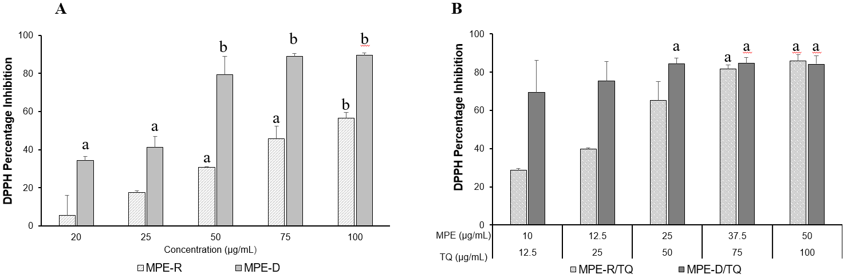
Figure 1 2,2-diphenyl-1-picrylhydrazyl free radical scavenging activity of methanol propolis extract alone or in combination with Thymoquinone. A: 2,2-diphenyl-1-picrylhydrazyl (DPPH) free radical scavenging activity of each of methanol propolis extract from Rashaya (MPE-R) and from Akkar-Danniyeh (MPE-D; 20-100 µg/mL) alone; B: DPPH free radical scavenging activity of each of MPE-R and MPE-D (10-50 µg/mL) in combination with Thymoquinone (TQ; 12.5-100 µg/mL). The samples were mixed with DPPH and the absorbance of the mixture was measured after 30 min. The values are expressed as percentage of DPPH percentage inhibition relative to the control. Each value represents the mean ± SD of n = 2 experiments. ªP < 0.05 and ^{b}P < 0.01 are significantly different from control using two-tailed Student's t-test.
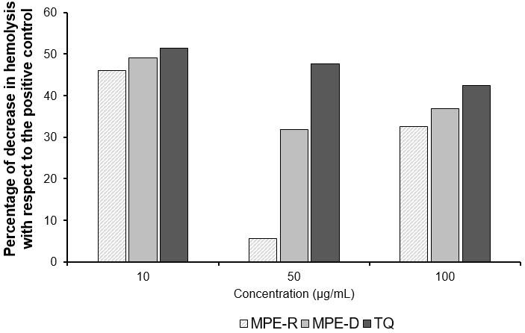
Figure 2 In vitro antihemolytic/cytoprotective activity of each of Thymoquinone and methanol propolis extract from Rashaya and Akkar-Danniyeh against H₂O₂- induced oxidative hemolysis. Human red blood cells suspension was preincubated with methanol propolis extract from Rashaya (MPE-R), methanol propolis extract from Akkar-Danniyeh (MPE-D), or Thymoquinone (TQ; 10-100 µg/mL) for 5 min. The cell suspension was then incubated with 10% H₂O₂ for 90 min at 37°C. The samples were then centrifuged, and the absorbance of the supernatant was measured. The values are expressed as percentage of decrease in hemolysis with respect to the positive control (10 % H₂O₂). Each value is obtained from n = 1 experiment performed in monoplicate.
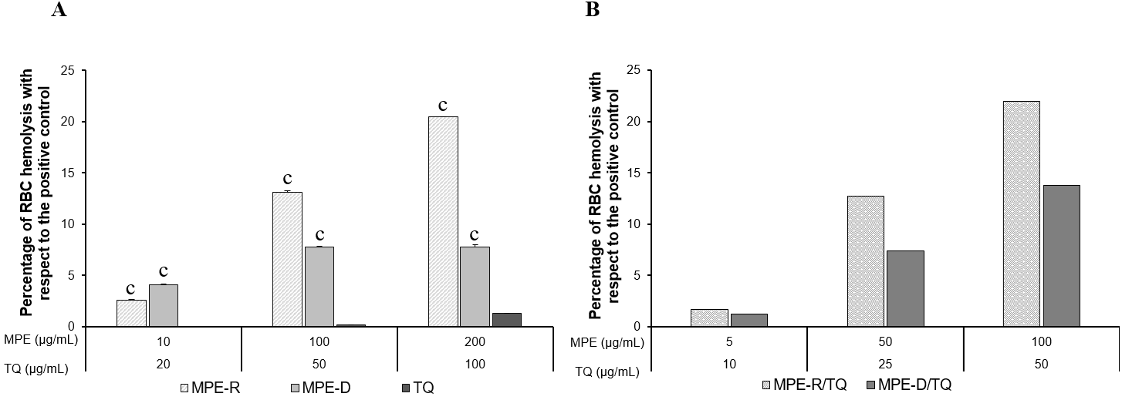
Figure 3 In vitro hemolytic activity of each of methanol propolis extract from Rashaya and Akkar-Danniyeh alone or in combination with Thymoquinone. A: Hemolytic activity of each of methanol propolis extract from Rashaya (MPE-R) and methanol propolis extract from Akkar-Danniyeh (MPE-D; 10-200 µg/mL) and Thymoquinone (TQ; 20-100 µg/mL); B: hemolytic activity of the combination of MPE- R or- D (5-100 µg/mL) and TQ (10-50 µg/mL). Washed fresh human blood was incubated with the natural products for 90 min. The samples were then centrifuged, and the absorbance of the supernatant was measured. The values are expressed as percentages of red blood cells hemolysis with respect to the positive control (SDS 1%). Each value represents the mean ± SD of n = 3 experiments for MPE-R and MPE-D single treatments and n = 1 for TQ single treatment and combination treatments. ^{c}P < 0.0001 is significantly different from positive control using two-tailed Student's t-test.
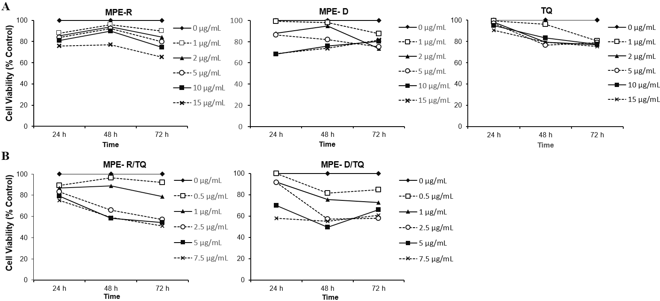
Figure 4 Anticancer activity of Thymoquinone and methanol propolis extract from Rashaya and Akkar-Danniyeh against MDA-MB-231 human breast cancer cells. A: Cells were treated with each of methanol propolis extract from Rashaya (MPE-R), methanol propolis extract from Akkar-Danniyeh (MPE-D) and Thymoquinone (TQ; 0-15 µg/mL) alone for 24, 48 and 72 h; B: Cells were treated with the combination of each of MPEs (0-7.5 µg/mL) with TQ (0-7.5 µg/mL) for the same time point. Cell viability was then determined using MTT assay. The values are expressed as percentage of viable cells relative to untreated control. Each value represents the mean ± SD of n = 1 experiment performed in duplicates.
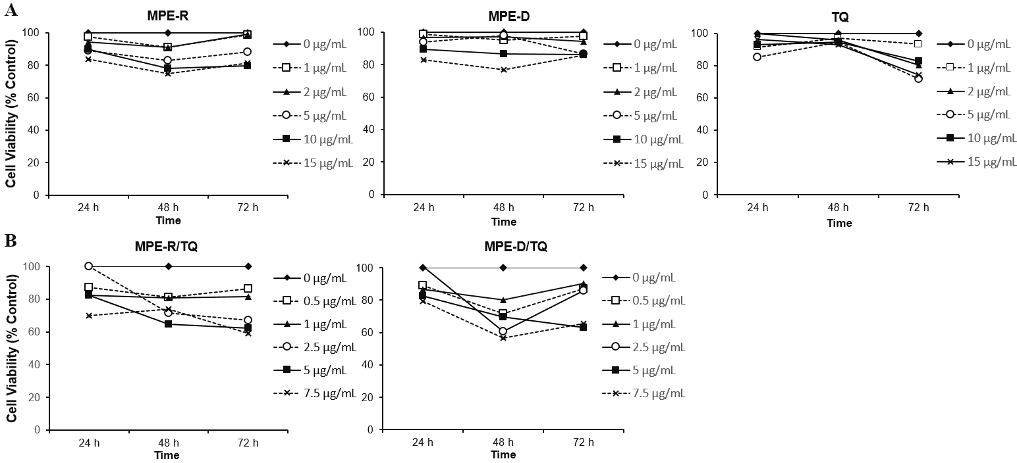
Figure 5 Anticancer activity of Thymoquinone and methanol propolis extract from Rashaya and Akkar-Danniyeh against HCT-116 human colorectal cancer cells. A: Cells were treated with each of methanol propolis extract from Rashaya (MPE–R), methanol propolis extract from Akkar-Danniyeh (MPE-D) and Thymoquinone (TQ; 0-15 µg/mL) alone for 24, 48 and 72 h; B: Cells were treated with the combination of each of MPEs (0-7.5 µg/mL) with TQ (0-7.5 µg/mL) for the same time point. Cell viability was then determined using MTT assay. The values are expressed as percentage of viable cells relative to untreated control. Each value represents the mean ± SD of n = 1 experiment performed in duplicates.
Table 1 Total phenolic content of methanol propolis extract from Rashaya and Akkar-Danniyeh in µg of gallic acid equivalents/mg of propolis and µg/mL of methanol propolis extract
 | TPC (µg GAE/mg) | TPC (µg GAE/mL of MPE)
MPE-R | 56.81 | 2.3
MPE-D | 83.503 | 3.997
TPC: Total phenolic content; MPE: Methanol propolis extract; MPE-R: Methanol propolis extract from Rashaya; MPE-D: Methanol propolis extract from Akkar-Danniyeh; GAE: Gallic acid equivalents.

