Name of Journal: World Journal of Critical Care Medicine
Manuscript NO: 75942
Manuscript Type: ORIGINAL ARTICLE

Observational Study
Development and pilot implementation of a patient-oriented discharge summary for critically Ill patients

Shahid A et al. ICU discharge summary for patients

Anmol Shahid, Bonnie Sept, Shelly Kupsch, Rebecca Brundin-Mather, Danijela Piskulic, Andrea Soo, Christopher Grant, Jeanna Parsons Leigh, Kirsten M Fiest, Henry T Stelfox

Anmol Shahid, Bonnie Sept, Shelly Kupsch, Rebecca Brundin-Mather, Andrea Soo, Christopher Grant, Jeanna Parsons Leigh, Kirsten M Fiest, Henry T Stelfox, Department of Critical Care Medicine, University of Calgary, Calgary T2N 4Z6, Alberta, Canada

Danijela Piskulic, Department of Psychiatry, Hotchkiss Brain Institute, Calgary T2N 4Z6, Alberta, Canada

Jeanna Parsons Leigh, School of Health Administration, Dalhousie University, Halifax B3H 4R2, Nova Scotia, Canada

Author contributions: Shahid A drafted the manuscript; all authors have contributed to the conception, design of this study, critically revised the manuscript and approved of the final submitted version.

Corresponding author: Anmol Shahid, BSc, PhD, Postdoctoral Fellow, Department of Critical Care Medicine, University of Calgary, McCaig Tower, Ground Floor, 3260 Hospital Drive NW, Calgary T2N 4Z6, Alberta, Canada. anmol.shahid1@ucalgary.ca

Received: March 1, 2022
Revised: May 6, 2022
Accepted: June 18, 2022
Published online:

Abstract
BACKGROUND
Patients leaving the intensive care unit (ICU) often experience gaps in care due to deficiencies in discharge communication, leaving them vulnerable to increased stress, adverse events, readmission to ICU, and death. To facilitate discharge communication, written summaries have been implemented to provide patients and their families with information on medications, activity and diet restrictions, follow-up appointments, symptoms to expect, and who to call if there are questions. While written discharge summaries for patients and their families are utilized frequently in surgical, rehabilitation, and pediatric settings, few have been utilized in ICU settings.

AIM
To develop an ICU specific patient-oriented discharge summary tool (PODS-ICU), and pilot test the tool to determine acceptability and feasibility.

METHODS
Patient-partners (i.e., individuals with lived experience as an ICU patient or family member of an ICU patient), ICU clinicians (i.e., physicians, nurses), and researchers met to discuss ICU patients’ specific informational needs and design the PODS-ICU through several cycles of discussion and iterative revisions. Research team nurses piloted the PODS-ICU with patient and family participants in two ICUs in Calgary, Canada. Follow-up surveys on the PODS-ICU and its impact on discharge were administered to patients, family participants, and ICU nurses.

RESULTS
Most participants felt that their discharge from the ICU was good or better (n = 13; 87.0%), and some (n = 9; 60.0%) participants reported a good understanding of why the patient was in ICU. Most participants (n = 12; 80.0%) reported that they understood ICU events and impacts on the patient’s health. While many patients and family participants indicated the PODS-ICU was informative and useful, ICU nurses reported that the PODS-ICU was “not reasonable” in their daily clinical workflow due to “time constraint”.

CONCLUSION
The PODS-ICU tool provides patients and their families with essential information as they discharge from the ICU. This tool has the potential to engage and empower patients and their families in ensuring continuity of care beyond ICU discharge. However, the PODS-ICU requires pairing with earlier discharge practices and integration with electronic clinical information systems to fit better into the clinical workflow for ICU nurses. Further refinement and testing of the PODS-ICU tool in diverse critical care settings is needed to better assess its feasibility and its effects on patient health outcomes.

Key Words: Discharge tool; Patient discharge summary; Patient communication; Family communication; Transitions in care; Intensive care unit

Shahid A, Sept B, Kupsch S, Brundin-Mather R, Piskulic D, Soo A, Grant C, Leigh JP, Fiest KM, Stelfox HT. Development and pilot implementation of a patient-oriented discharge summary for critically Ill patients. World J Crit Care Med 2022; In press

Core Tip: Critically ill patients face a difficult transition when moving home from an intensive care unit. In order to ease this transition, we developed and pilot tested a patient-oriented discharge summary tool that included information about medications, activity and diet restrictions, follow-up appointments, symptoms to expect, and who to call if there are questions. We found that critically ill patients and their families found the tool to be very informative. However, nurse practitioners found the discharge tool to be time consuming to complete and a poor fit into their clinical workflow. Further revision and testing of the tool is needed to better assess it’s feasibility and determine any impact it may have on patient health outcomes.

INTRODUCTION
The discharge of patients from the intensive care unit (ICU) is a challenging transition period that leaves patients particularly vulnerable to heightened stress and increases their chances of experiencing adverse events, being readmitted to ICU, and dying^{[1-4]}. Many patients who report experiencing gaps in care during their transition from the ICU are dissatisfied with the quality of care they received^{[5]}. They cite confusion due to poor communication with their healthcare team as a major contributing factor to their dissatisfaction^{[6,7]}. Failures to effectively communicate information such as diagnoses, tests, treatments, and goals of care to patients and their family-caregivers result in poorly executed transitions in care, and impede continuity of care^{[8-10]}. Deficiencies in communication can be further worsened by any combination of patient factors such as lack of understanding of medical terms, limited fluency in English, difficulty retaining verbal instructions, or inability to absorb critical information due to stress^{[11-16]}. While patient-centered summary tools to communicate critical information to patients and family-caregivers (i.e., family members or close friends of the patient) at discharge have been implemented, many of these tools vary in their applicability to diverse care settings and are not standardized across healthcare systems^{[17]}.
There have been a number of initiatives to improve patient and family-caregiver communication during transitions in care using written communications that facilitate and support the exchange of information from clinicians to patients and their families^{[18-20]}. Among these are patient- and caregiver-centered discharge summaries that include information on medications, activity and diet restrictions, follow-up appointments, symptoms to expect, and who to call if there are questions^{[21,22]}. Most patient-and caregiver-centered discharge summary tools use evidence-based techniques such as plain language, large fonts, pictograms, and teach-back components to ensure patients are engaged and develop a strong understanding of their health^{[23-27]}. While written patient-centered discharge tools have become commonplace in surgical, rehabilitation, and pediatric settings, few have been employed in critical care settings^{[28-31]}.
To address the need for a standardized, written, patient-centered discharge tool suitable for use in the ICU, our team of patient partners (i.e., previous patients and family-caregivers who now represent patients’ interest in research), clinicians, and researchers aimed to incorporate ICU-specific elements into the patient-oriented discharge summary tool (PODS) co-developed by patients, the Toronto Central Local Health Integration Network, and OpenLab (Toronto, Canada). Specifically, our objectives were to: (1) Adapt the content of the PODS to the ICU context based on input from key stakeholder groups including patient partners, clinicians, and researchers (PODS-ICU); (2) Pilot test the adapted PODS-ICU in the ICU to determine its acceptability and feasibility; and (3) Gather patient, family-caregiver, and clinician perspectives on the usability of the tool and quality (e.g., comprehensiveness) of information provided to patients and family-caregivers during a discharge from the ICU.

MATERIALS AND METHODS
Setting
We conducted this study in two ICUs in Calgary, Alberta, Canada. ICU A, Foothills Medical Centre, is a 28-bed medical-surgical ICU in a tertiary level academic hospital and ICU B, South Health Campus, is a 10-bed medical-surgical ICU in a community-based hospital (collective catchment population 1.4 million). Both hospitals use the same patient information systems which house ICU patients’ demographics along with key clinical, healthcare service, and health outcome data^{[32]}.

Design
We designed our study as a collaborative quality improvement research project that adhered to the internationally recognized Revised Standards for Quality Improvement Reporting Excellence (SQUIRE) 2.0 guidelines for reporting new knowledge on improving healthcare^{[33]}. We executed the study in two distinct phases: Development of the PODS-ICU and Pilot testing of the PODS-ICU in two ICUs (ICU A and ICU B).

Development of the PODS-ICU
To create a workable PODS-ICU tool and a standardized implementation process, we formed a working group of stakeholders with diverse backgrounds and extensive critical care experience. The working group included two patient partners (1 patient, 1 family-caregiver), four bedside registered nurses (RNs), two nurse practitioners (NPs), one physician, one clinical nurse specialist, a quality improvement lead, and a researcher. The working group was tasked with producing a printable (i.e., not handwritten) PODS-ICU template for patients who were being discharged from the ICU to a hospital ward or directly into community settings (i.e., their home). The working group met monthly to discuss and reach consensus on the content and the format for the PODS-ICU (i.e., electronic vs paper-based templates) and to complete iterative revisions of the tool. After each meeting, minutes were circulated by email to working group members. The researcher incorporated feedback into the tool, circulating documents that mapped out the revised content areas back to the group by email. This process led to agenda building for the next working group meeting and was repeated until a consensus was reached on the PODS-ICU. In order to maximize efficient completion of the PODS-ICU, the working group decided to make the tool easily accessible to clinicians, and to permit editing of its content until it was deemed ready for pilot testing. The group agreed that the PODS-ICU should be paired with effective education methods such as teach-back, which has been shown to optimize communication between clinicians, patients, and family-caregivers^{[34]}.

Pilot test of the PODS-ICU tool
Sample and recruitment: Between August 12th and November 5th, 2019, we recruited a sample of patients and family-caregivers transitioning from the ICU to the hospital ward from ICU A. Between January 5th and March 1st, 2020 we recruited a sample of patients and family-caregivers transitioning from ICU to home from ICU B. Trained team members (RNs and NPs) were tasked with piloting the PODS-ICU in the participating sites.
We used eCritical MetaVision Alberta to identify patients who were expected to leave the study ICUs within the next 24-48 h. A patient partner and a research assistant from our study team approached patients if they were: (1) Cleared for discharge; (2) Over 18 years of age; (3) Able to provide written informed consent; and (4) able to communicate in English. Family-caregivers, defined as any individuals providing physical or emotional support to a patient (e.g., a relative, friend or a formal caregiver) who had knowledge of the patient before the ICU admission, were also approached to participate in the study. Family-caregivers were eligible to participate if they were: (1) Over 18 years of age; (2) Able to provide informed consent; and (3) Able to communicate in English. A recruitment script [Supplementary material] was used to ensure patients and family-caregivers (i.e., collectively referred to as participants) were provided adequate information about the study, and understood the role of study participants. Written informed consent was collected from all participants. Participants were enrolled as dyads (i.e., a patient and a family-caregiver) for this study.

PODS-ICU implementation: Patient partners informed select RNs/NPs (ICU nurses who had agreed to administer the PODS-ICU to participants) when a patient and family-caregiver had been enrolled. RN/NPs then completed the PODS-ICU tool and conducted a teach-back education session with the recruited participant (s) (i.e., patient and/or family-caregiver) prior to the patient’s discharge from the ICU. The RN/NP then completed a brief online questionnaire (via Qualtrics, Provo, Utah) [Supplementary material] to provide feedback on their experience completing the PODS-ICU (e.g., ease of access, ease of use, time required to review the tool with a patient or family-caregiver) and its perceived impact on their workflow.

Participant questionnaires: The patient partner followed up with study participants, regardless of whether the PODS-ICU was successfully delivered, within one week after patient discharge from ICU to administer questionnaires assessing the quality of the discharge process. Patients and family-caregivers received separate versions of the feedback questionnaire. The follow-up was done in person for patients still present in the hospital, and over the phone for those patients who had left the hospital. Participants were administered questionnaires that inquired about how well they understood their (or the patient’s) care trajectory as they were discharged from the ICU [Supplementary material]. Participants who did not respond were contacted by the patient partner up to two additional times.

PODS-ICU acceptability and feasibility: We measured the acceptability of the PODS-ICU by calculating the proportion of eligible patients and family-caregivers who consented to participate in the study. The feasibility was assessed by calculating the proportion of consented participants who received the PODS-ICU prior to discharge.

Statistical analysis
We conducted data analysis as per the standard recommendations for design and analysis of pilot studies^{[35]} in Microsoft Excel v16.0 (Microsoft Corporation, Redmond USA. Given that our study did not involve hypothesis testing, no power analysis was conducted, and no inferential statistics were calculated. We used descriptive statistics (mean, median) to summarize participant characteristics and questionnaire data (from patients, family-caregivers, and clinicians).

RESULTS
Development of PODS-ICU
The working group held 7 meetings between December 2018 and July 2019. After drafting an initial PODS-ICU template, the working group determined that patients discharged from the ICU to another inpatient care unit differed clinically (i.e., were sicker) from patients discharged from the ICU directly to the community. Hence, the two patient groups required different post-discharge information. As such, the working group developed two different versions of the PODS-ICU. Following two rounds of major revisions and multiple rounds of minor revisions, the working group standardized written content where possible to improve efficiencies in completing the PODS-ICU, while still allowing for tailoring of patient-specific information. The working group first developed the PODS-ICU tool as a Microsoft Word (2019, Redmond, USA) template accessible through the hospitals’ internal Website. The final template was subsequently developed alongside an in-house collaborator and embedded into a locally developed customized software program that could be run off an encrypted USB or a desktop local drive. A side-by-side comparison of the PODS-ICU Word versions for patients being discharged from the ICU to another care unit, and PODS-ICU for patients being discharged from ICU directly home in the community is shown in Figure 1.

Pilot test of the PODS-ICU tool
Participant enrolment: During the study period, 319 patients were discharged alive from the two study ICUs. Of these, 42 patients were potentially eligible for the study. Participant recruitment and reasons for exclusion are shown in Figure 2. The most common reasons for patient exclusion were ICU stays less than 24 h in duration (n = 181 patients) and discharges on weekends when the study team (i.e., patient partners) was unavailable to approach patients (n = 57). A number (n = 39) of patients were excluded based on recommendations of the clinical team to not approach for clinical or psychosocial reasons (i.e., stress, family not available). Forty-two patients were approached for participation into the study, of which 10 were excluded due to inability to communicate in English and/or provide consent, and 1 for being enrolled in another study. Of the 31 eligible patients, 28 (90.3%) consented to be part of the study. Patients who declined to participate in the study indicated that they felt too overwhelmed to participate (n = 2; 9.70%) or that their family was not present at the time they were approached (n = 1; 6.70%). Nine (32.1%) of the consented patients were administered PODS-ICU by the ICU research team nurses, while 19 (68.0%) patients did not receive PODS-ICU because there was either no research team nurse available to administer the tool (n = 11; 40.0%), or there was insufficient time for the research team nurse to complete the PODS-ICU (n = 8; 28.6%) prior to discharge. Twenty-one (75.0%) family-caregivers for the 28 participating patients consented to participate in the study.
The nine patients who received the PODS-ICU were primarily female (n = 6; 66.7%) with a mean age of 63 years with at least some post-secondary education (n = 6; 66.7%). Family-caregivers were primarily women (n = 55.6%) with a mean age of 62 years, and most had some post-secondary education (n = 55.6). Of the 21 family-caregivers that consented to participate in the study, 6 caregivers (66.7%) for the 9 patients who were administered the PODS-ICU received information about the patient’s transition from the ICU. Once enrolled, no patients or family-caregivers withdrew from the study. Demographic characteristics of participating patients and family-caregivers are listed in Table 1.

Participants’ reported experiences: Of the 15 participants (9 patients and 6 family-caregivers) who received the PODS-ICU, 13 felt that their discharge from the ICU was good (n = 4; 30.1%), very good (n = 5; 38.5%), or excellent (n = 4; 31.0%)) (Figure 3A). Over half of participants (n = 9; 60.0%) felt they were moderately, very, or completely engaged in thinking about the ICU transition process (Figure 3B). Most participants stated they had a good or better understanding of the medical condition that brought the patient to the ICU (n = 11; 73.3%) and that they understood the events that happened in the ICU and the impact of the ICU stay on the patient’s health (n = 11; 73.3%) (Figure 3C). When asked about the ICU discharge, most participants (n = 12; 80.0%) said they had a conversation with the ICU team to discuss the transition and next steps (Figure 3D).

Clinician reported experiences: Participating nurses completed the feedback questionnaire for 10 (66.7%) of the 15 patients who had a PODS-ICU completed. It took the study nurses an estimated 45 min on average to complete the PODS-ICU tool (median 25 min) and an additional 30 min on average to review it with the patient and/or family-caregiver (median 15 min). Key data from the survey (which included closed and open-ended questions) are displayed in Table 2.
Participating RNs and NPs reported, that: (1) Patients and family-caregivers appreciated the information the tool provided; (2) Discharge timing often did not allow for an opportunity to complete and teach-back the PODS-ICU, or to do it well; and (3) The process of filling out the PODS-ICU was too time-consuming and did not fit well into the clinical workflow. Select comments received from research team RNs/NPs are shown here: “As I am the provider and tasked with not only putting together the PODS, but contacting community physicians, arranging for outpatient follow up, writing Rx, faxing pharmacies, collaborating with multi-disciplinary teams (like PT/OT/Transitions) reviewing with both patient and family, then returning back to discuss in addition to caring for up to 10 other ICU patients, I have to say a big NO to reasonable in my current work flow. I have come in often on my days off to facilitate patient discharges. Ideas to optimize: once patient is flagged for ICU-Home discharge then start the process at least 24-48 h prior to d/c home”; “Family was very appreciative, the patient's wife seemed to find it more difficult to retain information covered, patient's daughter was taking notes to refer back to and was able to follow along better. Wife expressed she was overwhelmed with everything and was glad to be getting a written summary”; “Time constraint was the most problematic on my part, felt like teach back was rushed”.

DISCUSSION
We designed and pilot tested the PODS-ICU, a patient- and family-caregiver- focused written discharge summary tool to provide critically ill patients and their family-caregivers with key information on the patient’s stay in ICU, transition (i.e., discharge) from the ICU, and what to expect post-ICU. Our pilot study showed that the PODS-ICU was well accepted and participants viewed their discharge from the ICU positively when it was used. However, the pilot study also showed that while the tool had high acceptability, it was not feasible to administer in the ICU settings as: (1) The time to discharge varies for each patient and current clinical practices did not allow for the tool to be consistently delivered; and (2) Clinicians found the PODS-ICU to be time consuming and fit poorly within their clinical workflow.
The practice of providing written information to patients and/or their family-caregivers at the point of discharge from the ICU remains uncommon, with very few existing tools to aid in that process^{[31,36]}. Previous evaluations of written discharge communications for patients and family-caregivers in ICU have shown that these tools can improve family-caregiver satisfaction with care in the ICU, decrease family-caregiver ‘transfer’ anxiety around transitions from the ICU, help patients and families understand and accept ICU events, help ‘fill in the gaps’ for patients with memory lapses, and improve longer term patient outcomes^{[37-44]}. In developing the PODS-ICU tool, we relied on the pre-existing OpenLab PODS tool and input from patient-partners to ensure the tool addressed specific informational needs of patients in the ICU (e.g., summary of ICU events, medications, upcoming tests and appointments, what to expect during recovery, resources for help)^{[21,27,45]}. This allowed the PODS-ICU to support reliable delivery of essential information from clinicians to patients and family-caregivers at discharge from the ICU, whether the patient was being transferred to a ward in the hospital or directly home. In our study, clinicians reported the PODS-ICU tool to generate comprehensive and beneficial summaries. Interestingly, previous evaluations of summary tools have reported similar challenges to those we observed in implementing the PODS-ICU, such as varying clinician motivation to complete the tool due to lack of time, competing priorities, and/or negative perceptions of the tool’s utility^{[40]}. Due to these limitations, clinicians in our study struggled with the feasibility of incorporating this tool into their workflow.
Outside of ICU settings, patient-centered discharge communications (both written and oral) have shown benefit in cardiovascular, maternity and neonatal, and surgical settings. Like the PODS-ICU, discharge communications in other settings have aimed to convey information on next steps (e.g., what to expect), identification and management of risk factors and complications (e.g., when to seek care, pain management), and medications from healthcare providers to patients and their families^{[46-57]}. Similarly to the PODS-ICU, many discharge communications from various acute care settings have been reported as time consuming and adding to healthcare provider workload^{[40,45,57,58]}. However, they have also been reported to reduce hospital readmissions, improve treatment adherence, and enhance patient satisfaction and can be considered important to successful transitions in care^{[40,57,58]}. This suggests a high value to improving upon ICU discharge tools (like the PODS-ICU), which could be expected to have cost-savings comparable to discharge communications between hospital and community-based healthcare providers^{[59]}.
Pilot implementation of the PODS-ICU highlights important opportunities to improve clinician-patient communication during a discharge from the ICU. These include: 1) earlier discharge planning (i.e., preparation for discharge begins as soon as a patient is admitted), 2) integration of discharge communication with electronic clinical information systems, and 3) regular incorporation of teach-back into clinician-patient communications. At a practical level, earlier discharge planning could prompt clinicians to begin completing parts of the discharge summary as soon as a patient is admitted, perhaps fitting better into their workflow. Electronic clinical information systems provide the potential to partially automate the population of patient data into discharge summaries, a time-consuming aspect of the PODS-ICU. Pre-population of discharge summaries with patient data can increase efficiency and potentially reduce the risk of human transcription error^{[60,61]}. Finally, incorporating the teach-back method into clinician-patient and clinician-family-caregiver communications, an important aspect of the PODS-ICU and recommended by the Agency for Healthcare Research and Quality (AHRQ), has been shown to improve patients’ understanding of their health information^{[62,63]}. This could foster better connections between patients and clinicians^{[34]}, further benefitting communication efforts. Apart from the above discussed methods to increase time efficiency of completing the PODS-ICU (i.e., earlier discharge planning, integration with electronic clinical information systems), further engaging patients and families to modify the PODS-ICU to only include information important to patients may be a valuable refinement to the tool.
There are a number of limitations to consider when interpreting the results of our pilot study. First, only a small number of participants (n = 9 patients and n = 6 family-caregivers) received the PODS-ICU tool. Although we were able to ascertain some reasons for the low delivery of PODS-ICU (i.e., availability of research team nurses and time required to complete the tool), an assessment by more patients, family-caregivers and clinicians could provide more insights into the usability of the tool. Second, we pilot tested the PODS-ICU in two study ICUs in a single city (Calgary) in Canada. We recognize that ICU populations differ in type and severity of illness and some ICU staff may have more capacity to implement the PODS-ICU. As the OpenLab’s PODS has shown the potential to improve patient outcomes in various care settings^{[21,45]}, the PODS-ICU may be more successful in settings where it is better integrated into clinician work flow^{[45]}.

CONCLUSION
We developed a written discharge summary tool (PODS-ICU) that provides patients and their family-caregivers with the essential information they need as they transition out of the ICU. While the PODS-ICU may require pairing with earlier discharge practices and integration with electronic clinical information systems to fit better into the clinical workflow, the tool has the potential to engage and empower patients and family-caregivers in ensuring continuity of care. Further refinement and testing of the PODS-ICU tool in diverse ICUs is needed to determine its broader feasibility and the effects on patient health outcomes as well as patient-centered care.

ARTICLE HIGHLIGHTS
Research background
Gaps in discharge communication can leave critically ill patients vulnerable to stress, poor health outcomes, and death. There are no standard written discharge summaries available for critically ill patients and their families.

Research motivation
Written discharge summaries can provide patients and their families with important information (e.g., medications, activity and diet restrictions, follow-up appointments, symptoms to expect, who to call if there are questions).

Research objectives
To develop and pilot test a patient-oriented discharge summary tool for critically ill patients and their families.

Research methods
We worked alongside former critically ill patients and their families, clinicians, and researchers to discuss patient needs and develop a written discharge summary tool. Intensive care unit nurses piloted the tool in two intensive care units in Calgary, Canada. Research team members administered follow-up surveys to patients, family participants, and ICU nurses on the impact of the summary tool on discharge.

Research results
Most participants felt the discharge summary tool was useful and informative. Most participants reported that they understood intensive care unit events and impacts on the patient’s health. Participating intensive care unit nurses reported time constraint in completing the discharge summary tool and encouraged refinement of the tool.

Research conclusions
The patient-oriented discharge summary tool could benefit from further refinement and testing in diverse critical care settings to better assess its feasibility and its effects on patient health outcomes.

Research perspectives
Written discharge communication provides patients and their families with essential information as they discharge from the intensive care unit. Future directions for a written patient-oriented discharge summary tool for critically ill patients include pairing the tool with earlier discharge practices and integrating the tool with electronic clinical information systems to fit better into the clinical workflow for ICU nurses.

ACKNOWLEDGEMENTS
We would like to thank the working group for their role in developing the patient-oriented discharge summary tool (PODS-ICU), the individuals involved in PODS-ICU testing, and the patient partners involved in participant recruitment for all their hard work on this project.

REFERENCES
1 Whittaker J, Ball C. Discharge from intensive care: a view from the ward. Intensive Crit Care Nurs 2000; 16: 135-143 [PMID: 10859622 DOI: 10.1054/iccn.2000.1488]
2 Forster AJ, Murff HJ, Peterson JF, Gandhi TK, Bates DW. The incidence and severity of adverse events affecting patients after discharge from the hospital. Ann Intern Med 2003; 138: 161-167 [PMID: 12558354 DOI: 10.7326/0003-4819-138-3-200302040-00007]
3 Niven DJ, Bastos JF, Stelfox HT. Critical care transition programs and the risk of readmission or death after discharge from an ICU: a systematic review and meta-analysis. Crit Care Med 2014; 42: 179-187 [PMID: 23989177 DOI: 10.1097/CCM.0b013e3182a272c0]
4 Kramer AA, Higgins TL, Zimmerman JE. The association between ICU readmission rate and patient outcomes. Crit Care Med 2013; 41: 24-33 [PMID: 23128381 DOI: 10.1097/CCM.0b013e3182657b8a]
5 Naylor M, Brooten D, Jones R, Lavizzo-Mourey R, Mezey M, Pauly M. Comprehensive discharge planning for the hospitalized elderly. A randomized clinical trial. Ann Intern Med 1994; 120: 999-1006 [PMID: 8185149 DOI: 10.7326/0003-4819-120-12-199406150-00005]
6 Hunziker S, McHugh W, Sarnoff-Lee B, Cannistraro S, Ngo L, Marcantonio E, Howell MD. Predictors and correlates of dissatisfaction with intensive care. Crit Care Med 2012; 40: 1554-1561 [PMID: 22511136 DOI: 10.1097/CCM.0b013e3182451c70]
7 de Grood C, Leigh JP, Bagshaw SM, Dodek PM, Fowler RA, Forster AJ, Boyd JM, Stelfox HT. Patient, family and provider experiences with transfers from intensive care unit to hospital ward: a multicentre qualitative study. CMAJ 2018; 190: E669-E676 [PMID: 29866892 DOI: 10.1503/cmaj.170588]
8 Coleman EA, Berenson RA. Lost in transition: challenges and opportunities for improving the quality of transitional care. Ann Intern Med 2004; 141: 533-536 [PMID: 15466770 DOI: 10.7326/0003-4819-141-7-200410050-00009]
9 Arora V, Johnson J, Lovinger D, Humphrey HJ, Meltzer DO. Communication failures in patient sign-out and suggestions for improvement: a critical incident analysis. Qual Saf Health Care 2005; 14: 401-407 [PMID: 16326783 DOI: 10.1136/qshc.2005.015107]
10 Kattel S, Manning DM, Erwin PJ, Wood H, Kashiwagi DT, Murad MH. Information Transfer at Hospital Discharge: A Systematic Review. J Pat Safety 2020; 16 [DOI: 10.1097/pts.0000000000000248]
11 Engel KG, Buckley BA, Forth VE, McCarthy DM, Ellison EP, Schmidt MJ, Adams JG. Patient understanding of emergency department discharge instructions: where are knowledge deficits greatest? Acad Emerg Med 2012; 19: E1035-E1044 [PMID: 22978730 DOI: 10.1111/j.1553-2712.2012.01425.x]
12 Samuels-Kalow ME, Stack AM, Porter SC. Effective discharge communication in the emergency department. Ann Emerg Med 2012; 60: 152-159 [PMID: 22221840 DOI: 10.1016/j.annemergmed.2011.10.023]
13 Miquel-Verges F, Donohue PK, Boss RD. Discharge of infants from NICU to Latino families with limited English proficiency. J Immigr Minor Health 2011; 13: 309-314 [PMID: 20490681 DOI: 10.1007/s10903-010-9355-3]
14 Marcus C. Strategies for improving the quality of verbal patient and family education: a review of the literature and creation of the EDUCATE model. Health Psychol Behav Med 2014; 2: 482-495 [PMID: 25750796 DOI: 10.1080/21642850.2014.900450]
15 Mistraletti G, Mezzetti A, Anania S, Ionescu Maddalena A, Del Negro S, Giusti GD, Gili A, Iacobone E, Pulitanò SM, Conti G, Bocci MG. Improving communication toward ICU families to facilitate understanding and reduce stress. Protocol for a multicenter randomized and controlled Italian study. Contemp Clin Trials 2019; 86: 105847 [PMID: 31525488 DOI: 10.1016/j.cct.2019.105847]
16 Makaryus AN, Friedman EA. Patients' understanding of their treatment plans and diagnosis at discharge. Mayo Clin Proc 2005; 80: 991-994 [PMID: 16092576 DOI: 10.4065/80.8.991]
17 Harel Z, Wald R, Perl J, Schwartz D, Bell CM. Evaluation of deficiencies in current discharge summaries for dialysis patients in Canada. J Multidiscip Healthc 2012; 5: 77-84 [DOI: 10.2147/jmdh.s27572]
18 D VN, Rajavelu P, Rajagopalan A. Pre-formatted written discharge summary-a step towards quality assurance in the emergency department. Int J Emerg Med 2008; 1: 321-325 [DOI: 10.1007/s12245-008-0077-4]
19 Reid DB, Parsons SR, Gill SD, Hughes AJ. Discharge communication from inpatient care: an audit of written medical discharge summary procedure against the new National Health Service Standard for clinical handover. Aust Health Rev 2015; 39: 197-201 [PMID: 25494034 DOI: 10.1071/AH14095]
20 Bench SD, Day TL, Griffiths P. Developing user centred critical care discharge information to support early critical illness rehabilitation using the Medical Research Council's complex interventions framework. Intensive Crit Care Nurs 2012; 28: 123-131 [PMID: 22386848 DOI: 10.1016/j.iccn.2012.02.002]
21 Hahn-Goldberg S, Okrainec K, Damba C, Huynh T, Lau D, Maxwell J, McGuire R, Yang L, Abrams HB. Implementing Patient-Oriented Discharge Summaries (PODS): A Multisite Pilot Across Early Adopter Hospitals. Healthc Q 2016; 19: 42-48 [PMID: 27133607 DOI: 10.12927/hcq.2016.24610]
22 Wimsett J, Harper A, Jones P. Review article: Components of a good quality discharge summary: a systematic review. Emerg Med Australas 2014; 26: 430-438 [PMID: 25186466 DOI: 10.1111/1742-6723.12285]
23 Nomura M, Tronbacke B. Guidelines for easy-to-read materials: revision. Hague: International Federation of Library Associations and Institutions, 2010 [DOI: 10.1515/9783111356662-002]
24 van Beusekom MM, Grootens-Wiegers P, Bos MJ, Guchelaar HJ, van den Broek JM. Low literacy and written drug information: information-seeking, leaflet evaluation and preferences, and roles for images. Int J Clin Pharm 2016; 38: 1372-1379 [PMID: 27655308 DOI: 10.1007/s11096-016-0376-4]
25 Hong YR, Huo J, Jo A, Cardel M, Mainous AG, 3rd. Association of Patient-Provider Teach-Back Communication with Diabetic Outcomes: A Cohort Study. J Am Board Fam Med 2020; 33: 903-912 [DOI: 10.3122/jabfm.2020.06.200217]
26 Ha Dinh TT, Bonner A, Clark R, Ramsbotham J, Hines S. The effectiveness of the teach-back method on adherence and self-management in health education for people with chronic disease: a systematic review. JBI Database System Rev Implement Rep 2016; 14: 210-247 [PMID: 26878928 DOI: 10.11124/jbisrir-2016-2296]
27 Hahn-Goldberg S, Okrainec K, Huynh T, Zahr N, Abrams H. Co-creating patient-oriented discharge instructions with patients, caregivers, and healthcare providers. J Hosp Med 2015; 10: 804-807 [PMID: 26406116 DOI: 10.1002/jhm.2444]
28 Lumpkin S, Kratzke I, Duke M, Chaumont N. Twelve Tips for Preparing a Surgical Discharge Summary: Enabling a Safe Discharge. MedEdPublish 2019; 8 [DOI: 10.15694/mep.2019.000039.1]
29 Gandara E, Moniz TT, Ungar J, Lee J, Chan-Macrae M, O'Malley T, Schnipper JL. Deficits in discharge documentation in patients transferred to rehabilitation facilities on anticoagulation: results of a systemwide evaluation. Jt Comm J Qual Patient Saf 2008; 34: 460-463 [PMID: 18714747 DOI: 10.1016/s1553-7250 (08)34057-4]
30 Lakhaney D, Banker SL. An Evaluation of the Content of Pediatric Discharge Summaries. Hosp Pediatr 2020; 10: 949-954 [PMID: 33097565 DOI: 10.1542/hpeds.2020-0148]
31 Stelfox HT, Lane D, Boyd JM, Taylor S, Perrier L, Straus S, Zygun D, Zuege DJ. A scoping review of patient discharge from intensive care: opportunities and tools to improve care. Chest 2015; 147: 317-327 [PMID: 25210942 DOI: 10.1378/chest.13-2965]
32 Brundin-Mather R, Soo A, Zuege DJ, Niven DJ, Fiest K, Doig CJ, Zygun D, Boyd JM, Parsons Leigh J, Bagshaw SM, Stelfox HT. Secondary EMR data for quality improvement and research: A comparison of manual and electronic data collection from an integrated critical care electronic medical record system. J Crit Care 2018; 47: 295-301 [PMID: 30099330 DOI: 10.1016/j.jcrc.2018.07.021]
33 Ogrinc G MS, Estrada C. Revised Standards for Quality Improvement Reporting Excellence SQUIRE 2.0. [cited 20 January 2022]. Available from: http://squire-statement.org/index.cfm?fuseaction = Page.ViewPage&PageID=471
34 Yen PH, Leasure AR. Use and Effectiveness of the Teach-Back Method in Patient Education and Health Outcomes. Fed Pract 2019; 36: 284-289 [PMID: 31258322]
35 Lancaster GA, Dodd S, Williamson PR. Design and analysis of pilot studies: recommendations for good practice. J Eval Clin Pract 2004; 10: 307-312 [PMID: 15189396 DOI: 10.1111/j..2002.384.doc.x]
36 Wong D, Wickham A. A survey of intensive care unit discharge communication practices in the UK. J Intensive C Society 2013; 14: 330-333 [DOI: 10.1177/175114371301400411]
37 Mitchell ML, Courtney M. An intervention study to improve the transfer of ICU patients to the ward- evaluation by family members. Australian Critical Care 2005; 18: 61-69 [DOI: 10.1016/s1036-7314 (05)80004-9]
38 Bouve LR, Rozmus CL, Giordano P. Preparing parents for their child's transfer from the PICU to the pediatric floor. Appl Nurs Res 1999; 12: 114-120 [DOI: 10.1016/s0897-1897 (99)80012-3]
39 Linton S, Grant C, Pellegrini J. Supporting families through discharge from PICU to the ward: the development and evaluation of a discharge information brochure for families. Intensive Crit Care Nurs 2008; 24: 329-337 [DOI: 10.1016/j.iccn.2008.06.002]
40 Bench SD, Heelas K, White C, Griffiths P. Providing critical care patients with a personalised discharge summary: a questionnaire survey and retrospective analysis exploring feasibility and effectiveness. Intensive Crit Care Nurs 2014; 30: 69-76 [PMID: 24211048 DOI: 10.1016/j.iccn.2013.08.007]
41 Van Waning NR, Kleiber C, Freyenberger B. Development and implementation of a protocol for transfers out of the pediatric intensive care unit. Crit Care Nurse 2005; 25: 50-55 [PMID: 15946928]
42 Löf L, Berggren L, Ahlström G. ICU patients' recall of emotional reactions in the trajectory from falling critically ill to hospital discharge: follow-ups after 3 and 12 mo. Intensive Crit Care Nurs 2008; 24: 108-121 [PMID: 17897829 DOI: 10.1016/j.iccn.2007.08.001]
43 Gourley GR. Shwachman Award remarks for Emeritus Professor Gerard B. Odell, M.D., annual meeting of NASPGN/ESPGAN, Westin Galleria Hotel, Houston, Texas, October 10, 1994. J Pediatr Gastroenterol Nutr 1995; 20: 245-247 [PMID: 7608820 DOI: 10.1097/00005176-199504000-00001]
44 Bench S, Day T, Griffiths P. Effectiveness of critical care discharge information in supporting early recovery from critical illness. Crit Care Nurse 2013; 33: 41-52 [PMID: 23727851 DOI: 10.4037/ccn2013134]
45 Hahn-Goldberg S, Huynh T, Chaput A, Krahn M, Rac V, Tomlinson G, Matelski J, Abrams H, Bell C, Madho C, Ferguson C, Turcotte A, Free C, Hogan S, Nicholas B, Oldershaw B, Okrainec K. Implementation, spread and impact of the Patient Oriented Discharge Summary (PODS) across Ontario hospitals: a mixed methods evaluation. BMC Health Serv Res 2021; 21: 361 [PMID: 33865385 DOI: 10.1186/s12913-021-06374-8]
46 Gwadry-Sridhar FH, Arnold JM, Zhang Y, Brown JE, Marchiori G, Guyatt G. Pilot study to determine the impact of a multidisciplinary educational intervention in patients hospitalized with heart failure. Am Heart J 2005; 150: 982 [PMID: 16290975 DOI: 10.1016/j.ahj.2005.08.016]
47 Haerem JW, Rønning EJ, Leidal R. Home access to hospital discharge information on audiotape reduces sick leave and readmissions in patients with first-time myocardial infarction. Scand Cardiovasc J 2000; 34: 219-222 [PMID: 10872714 DOI: 10.1080/14017430050142297]
48 Eshah NF. Predischarge education improves adherence to a healthy lifestyle among Jordanian patients with acute coronary syndrome. Nurs Health Sci 2013; 15: 273-279 [PMID: 23302042 DOI: 10.1111/nhs.12018]
49 Ho SM, Heh SS, Jevitt CM, Huang LH, Fu YY, Wang LL. Effectiveness of a discharge education program in reducing the severity of postpartum depression: a randomized controlled evaluation study. Patient Educ Couns 2009; 77: 68-71 [PMID: 19376677 DOI: 10.1016/j.pec.2009.01.009]
50 Shieh SJ, Chen HL, Liu FC, Liou CC, Lin YI, Tseng HI, Wang RH. The effectiveness of structured discharge education on maternal confidence, caring knowledge and growth of premature newborns. J Clin Nurs 2010; 19: 3307-3313 [PMID: 20946444 DOI: 10.1111/j.1365-2702.2010.03382.x]
51 Whitby M, McLaws ML, Doidge S, Collopy B. Post-discharge surgical site surveillance: does patient education improve reliability of diagnosis? J Hosp Infect 2007; 66: 237-242 [PMID: 17582652 DOI: 10.1016/j.jhin.2007.04.014]
52 Moore SM. The effects of a discharge information intervention on recovery outcomes following coronary artery bypass surgery. Int J Nurs Stud 1996; 33: 181-189 [PMID: 8675378 DOI: 10.1016/0020-7489 (95)00054-2]
53 Reynolds MA. Postoperative pain management discharge teaching in a rural population. Pain Manag Nurs 2009; 10: 76-84 [DOI: 10.1016/j.pmn.2008.07.003]
54 Morice AH, Wrench C. The role of the asthma nurse in treatment compliance and self-management following hospital admission. Respir Med 2001; 95: 851-856 [PMID: 11716197 DOI: 10.1053/rmed.2001.1166]
55 Marušić S, Meliš P, Lucijanić M, Grgurević I, Turčić P, Neto PRO, Bilić-Ćurčić I. Impact of pharmacotherapeutic education on medication adherence and adverse outcomes in patients with type 2 diabetes mellitus: a prospective, randomized study. Croat Med J 2018; 59: 290-297 [PMID: 30610771]
56 Marusic S, Gojo-Tomic N, Erdeljic V, Bacic-Vrca V, Franic M, Kirin M, Bozikov V. The effect of pharmacotherapeutic counseling on readmissions and emergency department visits. Int J Clin Pharm 2013; 35: 37-44 [PMID: 23007693 DOI: 10.1007/s11096-012-9700-9]
57 Christoph Becker SZ, Katharina Beck, Alessia Vincent, Nina Loretz, Jonas Müller,, Simon Amacher RS, Sabina Hunziker. Interventions to Improve Communication at Hospital Discharge and Rates of Readmission. Jama Net Open 2021; 4 [DOI: 10.1001/jamanetworkopen.2021.19346]
58 Okrainec K, Lau D, Abrams HB, Hahn-Goldberg S, Brahmbhatt R, Huynh T, Lam K, Bell CM. Impact of patient-centered discharge tools: A systematic review. J Hosp Med 2017; 12: 110-117 [PMID: 28182809 DOI: 10.12788/jhm.2692]
59 Sevick LK, Esmail R, Tang K, Lorenzetti DL, Ronksley P, James M, Santana M, Ghali WA, Clement F. A systematic review of the cost and cost-effectiveness of electronic discharge communications. BMJ Open 2017; 7: e014722 [PMID: 28674136 DOI: 10.1136/bmjopen-2016-014722]
60 Motamedi SM, Posadas-Calleja J, Straus S, Bates DW, Lorenzetti DL, Baylis B, Gilmour J, Kimpton S, Ghali WA. The efficacy of computer-enabled discharge communication interventions: a systematic review. BMJ Qual Saf 2011; 20: 403-415 [PMID: 21262793 DOI: 10.1136/bmjqs.2009.034587]
61 Parsons Leigh J, Brundin-Mather R, Zjadewicz K, Soo A, Stelfox HT. Improving transitions in care from intensive care units: Development and pilot testing of an electronic communication tool for healthcare providers. J Crit Care 2020; 56: 265-272 [PMID: 31986370 DOI: 10.1016/j.jcrc.2020.01.019]
62 Quality AfHRa. Use the Teach-Back Method: Tool #5. In: Second edition, 2020: 18-20 [DOI: 10.17918/00000016]
63 Griffey RT, Shin N, Jones S, Aginam N, Gross M, Kinsella Y, Williams JA, Carpenter CR, Goodman M, Kaphingst KA. The impact of teach-back on comprehension of discharge instructions and satisfaction among emergency patients with limited health literacy: A randomized, controlled study. J Commun Healthc 2015; 8: 10-21 [PMID: 26617669 DOI: 10.1179/1753807615Y.0000000001]

Footnotes
Institutional review board statement: The study was conducted in accordance with the Declaration of Helsinki (1983). All methods were performed in accordance with the relevant guidelines and regulations by the University of Calgary Health Research Ethics Board, which granted institutional ethics approval for this study (18-1770). We also established a research agreement with the primary health custodian, Alberta Health Services (AHS) to permit us to conduct this study in the two identified ICUs and to access participant data via AHS health information systems.

Informed consent statement: Written informed consent was collected from all participants prior to the study enrollment.

Conflict-of-interest statement: There are no conflicts-of-interest to declare.

Data sharing statement: The dataset is available from the corresponding author at tstelfox@ucalgary.ca.

STROBE statement: The authors have read the STROBE Statement—checklist of items, and the manuscript was prepared and revised according to the STROBE Statement—checklist of items.

Open-Access: This article is an open-access article that was selected by an in-house editor and fully peer-reviewed by external reviewers. It is distributed in accordance with the Creative Commons Attribution NonCommercial (CC BY-NC 4.0) license, which permits others to distribute, remix, adapt, build upon this work non-commercially, and license their derivative works on different terms, provided the original work is properly cited and the use is non-commercial. See: https://creativecommons.org/Licenses/by-nc/4.0/

Provenance and peer review: Unsolicited article; Externally peer reviewed.
Peer-review model: Single blind

Peer-review started: March 1, 2022
First decision: April 13, 2022
Article in press:

Specialty type: Critical care medicine
Country/Territory of origin: Canada
Peer-review report’s scientific quality classification
Grade A (Excellent): 0
Grade B (Very good): B, B
Grade C (Good): C
Grade D (Fair): 0
Grade E (Poor): 0

P-Reviewer: Karim HMR, India; Saaiq M, Pakistan; Surani S, United States S-Editor: Wang LL L-Editor: A P-Editor: Wang LL

Figure Legends
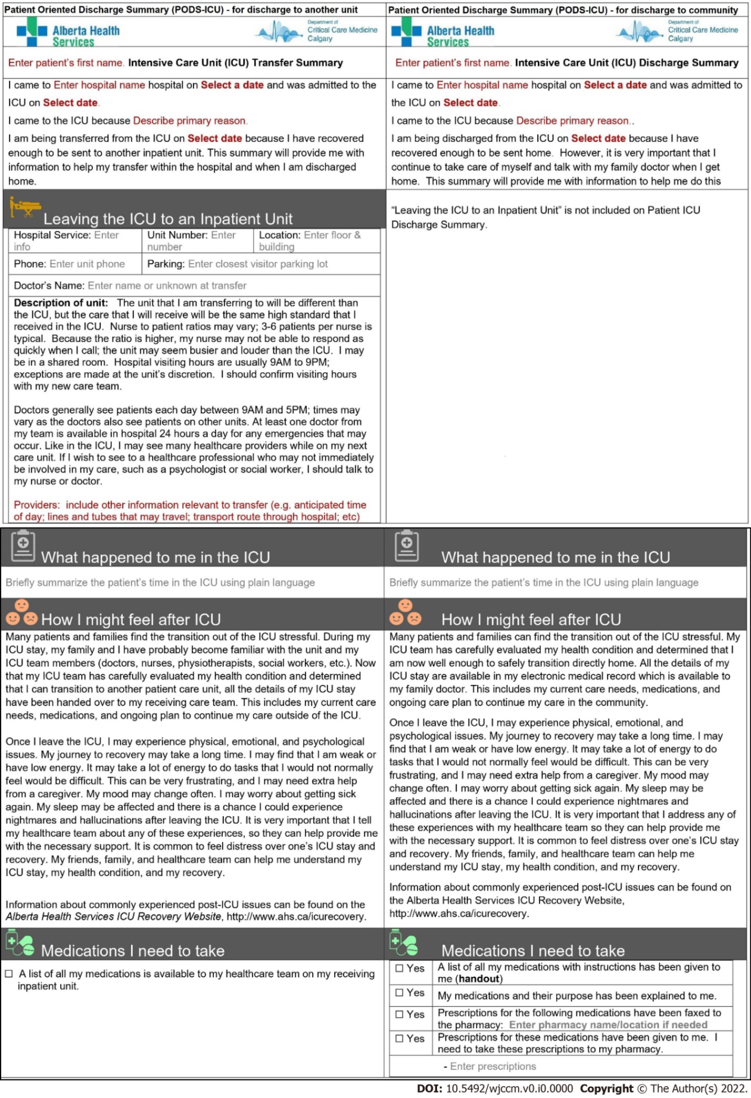
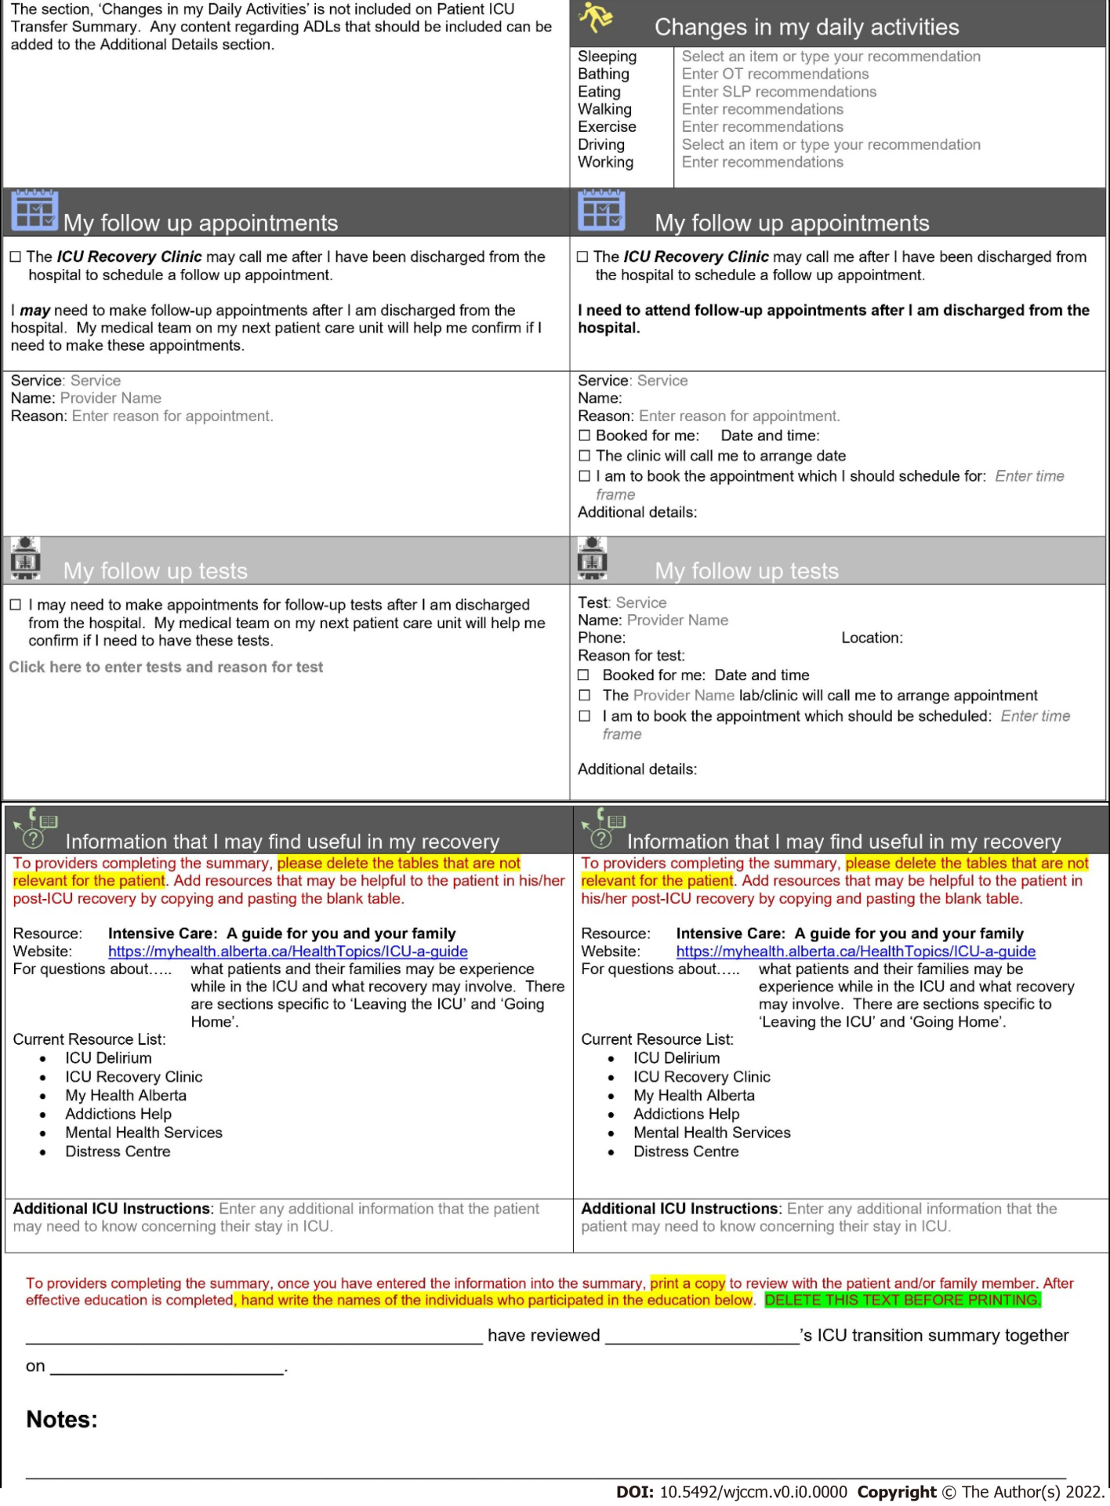
Figure 1 A side-by-side comparison of the patient-oriented discharge summary intended for patients being discharged from the intensive care unit to another care unit (left) and the patient-oriented discharge summary intended for patients being discharged from intensive care unit to a community care setting, including their home (right).

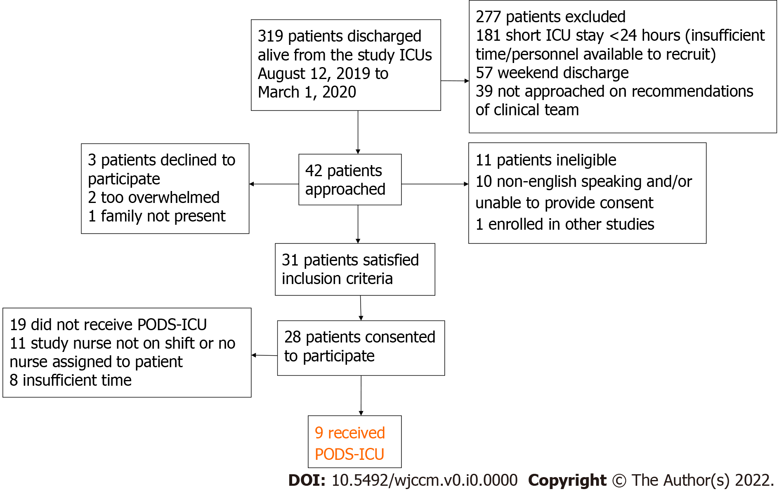
Figure 2 Patient recruitment and reasons for exclusion of certain patients. ICU: Intensive care unit; PODS-ICU: Patient-oriented discharge summary tool.

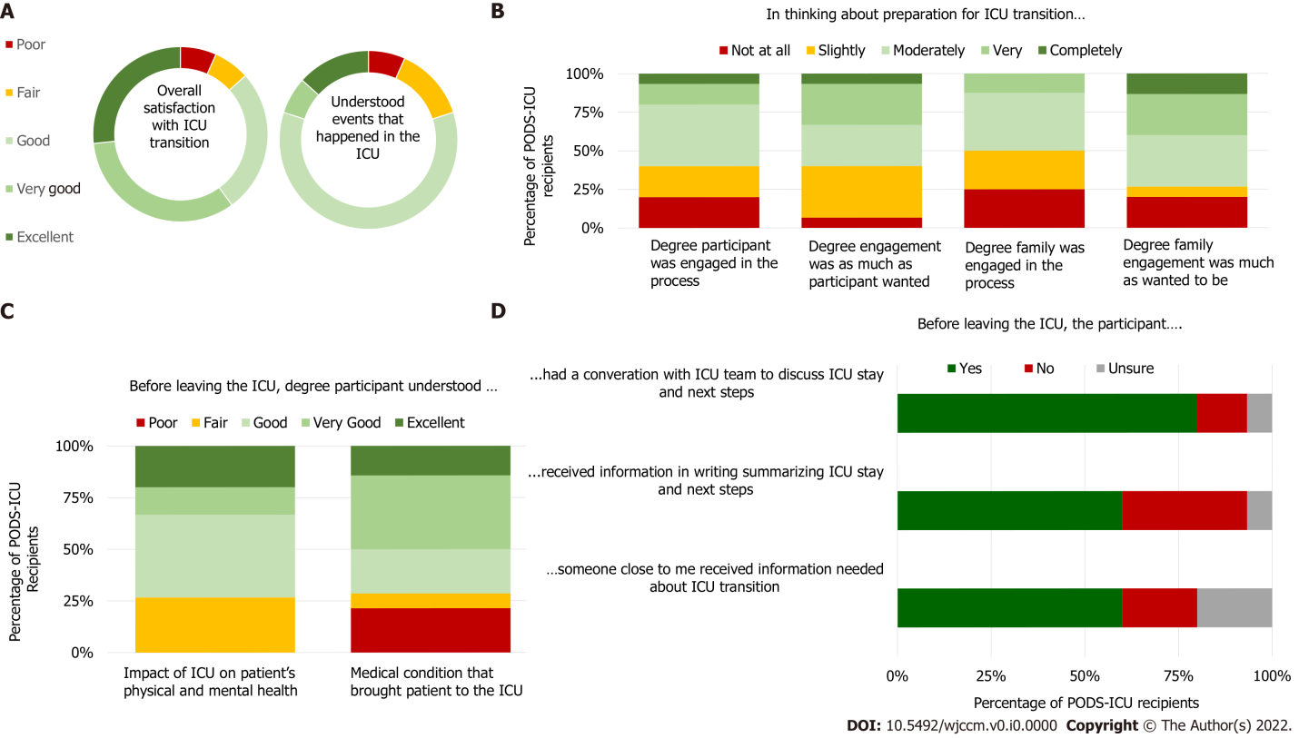
Figure 3 Data display of key questions from the follow-up surveys administered to patients and family-caregivers to collect their feedback on transitioning from the intensive care unit. Data is displayed in percentages. ICU: Intensive care unit; PODS: Patient-oriented discharge summary.

Table 1 Demographic characteristics of participating patients and family-caregivers who received the patient-oriented discharge summary and completed the follow-up survey
 |  | Number of participants (n)
 |  | Patients total n = 9 | Family caregivers total n = 6
Age, mean (range) |  | 63 (54-69) | 62 (40-70)
Female |  | 6 (66.7%) | 5 (83.3%)
Education | High school or less | 3 (33.3%) | 1 (16.7%)
 | Some post-secondary | 2 (22.2.%) | 3 (50.0%)
 | Post-secondary | 4 (44.4%) | 2 (33.3%)

Table 2 Clinician semi-structured survey quantitative results (n = 10)
 |  | Total responses, n = 10
Respondents | Nurse practitioner | 3 (30.0%)
 | Registered nurse | 4 (40.0%)
 | Unknown/response missing | 3 (30.0%)
Role in PODS-ICU implementation | Completed and delivered¹ | 9 (90.0%)
 | Completed only | 1 (10.0%)
Main PODS-ICU delivery recipient | Patient only | 4 (40.0%)
 | Friend/family only | 2 (20.0%)
 | Patient and family/friend | 4 (40.0%)
Time taken to complete PODS-ICU | 0-15 min | 3 (30.0%)
 | 16-30 min | 3 (30.0%)
 | 31-45 min | 1 (10.0%)
 | 46-60 min | 0 (0.00%)
 | 61+ min | 2 (20.0%)
 | Unknown/response missing | 1 (10.0%)
Time spent discussing PODS-ICU with recipient | 0-15 min | 6 (60.0%)
 | 16-30 min | 0 (0.00%)
 | 31-45 min | 1 (10.0%)
 | 46-60 min | 1 (10.0%)
 | 61+ min | 0 (0.00%)
 | Unknown/response missing | 2 (20.0%)
¹Delivered (in role in patient-oriented discharge summary (PODS-ICU) refers to whether a teach-back session was conducted or whether the ICU nurse only completed the PODS-ICU). PODS: Patient-oriented discharge summary; ICU: Intensive care unit.

