Name of journal: World Journal of Gastroenterology
ESPS Manuscript NO: 22376
Manuscript Type: ORIGINAL ARTICLE
Basic Study
Hepatitis B and C virus-induced hepatitis: Apoptosis, autophagy, and unfolded protein response

Yeganeh B et al. Cell fate in hepatocytes after HBV and HCV infection

Behzad Yeganeh, Adel Rezaei Moghadam, Javad Alizadeh, Emilia Wiechec, Seyed Moayed Alavian, Mohammad Hashemi, Bita Geramizadeh, Afshin Samali, Kamaran Bagheri Lankarani, Martin Post, Payam Peymani, Kevin M Coombs, Saeid Ghavami

Behzad Yeganeh, Martin Post, Department of Physiology and Experimental Medicine, Hospital for Sick Children Research Institute, University of Toronto, Toronto M5G 0A4, Canada

Adel Rezaei Moghadam, Department of Clinical Biochemistry, Islamic Azad University, Ardabi l56131-56491, Iran

Javad Alizadeh, Saeid Ghavami, Department of Human Anatomy and Cell Science, College of Medicine, Faculty of Health Sciences, University of Manitoba, Winnipeg R3E 0J9, Canada

Javad Alizadeh, Saeid Ghavami, The Children Hospital Research Institute of Manitoba, University of Manitoba, Winnipeg R3E 0J9, Canada

Emilia Wiechec, Department of Clinical and Experimental Medicine, Division of Cell Biology and Integrative Regenerative Medicine Center (IGEN), Linköping University, 581-85 Linköping, Sweden

Seyed Moayed Alavian, Department of Virology, School of Public Health, Tehran University of Medical Sciences, Tehran 1417-613151, Iran

Mohammad Hashemi, Department of Clinical Biochemistry, School of Medicine, Zahedan University of Medical Sciences, Zahedan 43181-98167, Iran

Bita Geramizadeh, Department of Pathology and Organ Transplant Research Center, Shiraz University of Medical Sciences, Shiraz 71348, Iran

Afshin Samali, Department of Biochemistry, National University of Ireland Galway, 000 Galway, Ireland

Kamaran Bagheri Lankarani, Payam Peymani, Saeid Ghavami, Health Policy Research Centre, Shiraz University of Medical Sciences, Shiraz 7134, Iran

Kevin M Coombs, Manitoba Center for Proteomics and Systems Biology, University of Manitoba, Winnipeg R3E 0J9, Canada

Kevin M Coombs, Department of Medical Microbiology and Infectious Diseases, University of Manitoba, Winnipeg R3E 0J9, Canada

Author Contributions: Yeganeh B and Post M performed fluorescence immunohistochemistry, tissue array; Yeganeh B interpreted the data, drafted the whole primary version of manuscript; Rezaei Moghadam A and Alizadeh J analyzed the fluorescence immunohistochemistry results, participated in preparing the apoptosis and autophagy parts of manuscript, respectively; Wiechec E analyzed the fluorescence immunohistochemistry and tissue array results, drafted of the autophagy and apoptosis part of manuscript; Alavian SM diagnosed and got liver biopsy of HBV patients; Hashemi M contributed PCR or samples for HBV and HCV virus titer, and analyzed the fluorescence immunohistochemistry results; Geramizadeh B contributed pathology diagnosis, scoring, and graded of HBV and HCV biopsies; Samali A contributed unfolded protein response, and proof final versions of the manuscript; Bagheri Lankarani K diagnosed and got liver biopsy of HCV patients; Peymani P prepared liver biopsy sample, biochemical liver function, statistical analysis; Coombs KM and Ghavami S designed the project, and proofed final versions of the manuscript; Ghavami S prepared primary draft of UPR part of manuscript; Peymani P, Coombs KM and Ghavami S had equal senior authorship.

Supported by University of Manitoba Start-up funds and an award from the Manitoba Medical Service Foundation to Ghavami S; University of Manitoba Start-up Funds to Alizadeh J.

Institutional review board statement: This retrospective study was approved by local research ethics committee of Health policy research Center (Protocol number HP-101-91). All patients were informed about the study and gave verbal informed consent prior to enrollment.

Conflict-of-interest statement: All authors do not have any conflict of interest.

Data sharing statement: This is an open access work and the researcher can use the data for any further investigations.

Open-Access: This article is an open-access article which was selected by an in-house editor and fully peer-reviewed by external reviewers. It is distributed in accordance with the Creative Commons Attribution Non Commercial (CC BY-NC 4.0) license, which permits others to distribute, remix, adapt, build upon this work non-commercially, and license their derivative works on different terms, provided the original work is properly cited and the use is non-commercial. See: http://creativecommons.org/licenses/by-nc/4.0/

Correspondence to: Saeid Ghavami, PhD, Assistant Professor, Room 104, Department of Human Anatomy and Cell Science, College of Medicine, Faculty of Health Sciences, University of Manitoba, Winnipeg R3E 0J9, Canada. saeid.ghavami@umanitoba.ca
Telephone: +1-204-2723061
Fax: +1-204-7893920

Received: August 29, 2015
Peer-review started: August 30, 2015
First decision: September 29, 2015
Revised: October 14, 2015
Accepted: November 13, 2015
Article in press:
Published online:

Abstract
Aim: To investigate the co-incidence of apoptosis, autophagy, and unfolded protein response (UPR) in hepatitis B (HBV) and C (HCV) infected hepatocytes.

Methods: We performed immunofluorescence (IF) confocal microscopy on 10 liver biopsies from HBV and HCV patients and tissue microarrays of HBV positive liver samples. We used specific antibodies for LC3β, cleaved caspase-3, BIP (GRP78), and XBP1 to detect autophagy, apoptosis and UPR, respectively. Anti-HCV NS3 and anti-HBs antibodies were also used to confirm infection. We performed triple blind counting of events to determine the co-incidence of autophagy (LC3β punctuate), apoptosis (cleaved caspase-3), and unfolded protein response (GRP78) with HBV and HCV infection in hepatocytes. All statistical analyses were performed using SPSS software for Windows (Version 16 SPSS Inc, Chicago, IL, United States). P-values < 0.05 were considered statistically significant. Statistical analyses were performed with Mann-Whitney test to compare incidence rates for autophagy, apoptosis, and UPR in HBV- and HCV-infected cells and adjacent non-infected cells.

Results: Our results showed that infection of hepatocytes with both HBV and HCV induces significant increase (P < 0.001) in apoptosis (cleavage of caspase-3), autophagy (LC3β punctuate), and UPR (increase in GRP78 expression) in the HCV- and HBV-infected cells, as compared to non-infected cells of the same biopsy sections. Our tissue microarray immunohistochemical expression analysis of LC3β in HBV^{Neg} and HBV^{Pos} revealed that majority of HBV-infected hepatocytes display strong positive staining for LC3β. Interestingly, although XBP splicing in HBV-infected cells was significantly higher (P < 0.05), our analyses shows a slightly increase of XBP splicing was in HCV-infected cells (P > 0.05). Furthermore, our evaluation of patients with HBV and HCV infection based on stage and grade of the liver diseases revealed no correlation between these pathological findings and induction of apoptosis, autophagy, and UPR.

Conclusion: The results of this study indicate that HCV and HBV infection activates apoptosis, autophagy and UPR, but slightly differently by each virus. Further studies are warranted to elucidate the interconnections between these pathways in relation to pathology of HCV and HBV in the liver tissue.

Key words: Cell fate; Cell death; Hepatocyte; Viral infection; Endoplasmic reticulum stress

© The Author(s) 2015. Published by Baishideng Publishing Group Inc. All rights reserved.

Core tip: For the first time, the current study has addressed the co-incidence of apoptosis, autophagy, and unfolded protein response in the liver tissue of hepatitis B and hepatitis C (HBV, and HCV) infected patients. The results showed that all of these events are activated at the same time by HBV and HCV infection in the liver. All of these pathways probably are involved in replication and pathogenesis of HBV and HCV infection therefore their modulation would probably be beneficial for new therapeutic approaches in these diseases.

Yeganeh B, Rezaei Moghadam A, Alizadeh J, Wiechec E, Alavian SM, Hashemi M, Geramizadeh B, Samali A, Bagheri Lankarani K, Post M, Peymani P, Coombs KM, Ghavami S. Hepatitis B and C virus-induced hepatitis: Apoptosis, autophagy, and unfolded protein response. World J Gastroenterol 2015; In press

Introduction
The liver is the primary organ infected by, and in which both hepatitis B virus (HBV) and hepatitis C virus (HCV) replicate. HBV and HCV are structurally unrelated and responsible for infection of huge numbers of individuals in the world.
It has been reported that around 2 billion people are infected with HBV, and more than 350 million are chronic carriers according to clinical definitions that identify individuals who have continuous viral and subviral particles in their blood for more than six months^{[1,2]}. Several studies have determined that HBV infection in adulthood might lead to a carrier stage in about 5%–10% of infected individuals. In addition, in up to 30% of these individuals hepatitis, fibrosis, cirrhosis, and finally hepatocellular carcinoma (HCC) can develop and it is usually considered a progressive chronic liver disease (CLD)^{[3]}. Several groups have investigated the risk of HCC development in different populations and shown that HCC development can be increased up to 100-fold in carrier infected individuals compared with uninfected individuals, which depends on the population and different markers. The risk of developing HCC among carriers with CLD ranges from 10-fold to 100-fold greater compared to uninfected people^{[2,4]}. Approximately 85% of acute HCV infection leads to a chronic situation and 50% of individuals who suffer from HCV chronic infections (about 170 million worldwide) can develop CLD. Approximately 5%–20% of this population can progress to liver cirrhosis in 5–20 years after their infection, and 1%–2% of these patients will probably develop HCC per year^{[3]}. It is strongly believed that this can be considered one of the closest relationships between an environmental agent and a cancer that has so far been identified^{[3]}.
Autophagy is a tightly regulated catabolic process, which is essential in many cellular events including development, differentiation, survival, and homeostasis^{[5-7]}. In the past few years, many investigators have focused on the involvement of autophagy in different human diseases and many aspects of this relationship have been described^{[8-10]}. Autophagy is usually considered a very important step for numerous virus life cycles^{[11]}, including HBV and HCV^{[12]}.
Apoptosis is a programmed cell death initiated via two different pathways (1) extrinsic which is activated by ligation of death receptors, and (2) intrinsic which is activated by mitochondrial death related proteins. These two distinct pathways crosstalk and potentiate each other to ultimately activate caspase cascade and facilitate controlled proteolysis of cellular components^{[13-15]}.
Synthesized and secretory proteins are correctly folded and assembled in the endoplasmic reticulum (ER)^{[16]}. During cellular stress, the ER loses its capacity to correct protein folding which results in the accumulation of unfolded and misfolded proteins. Following this, the unfolded protein response (UPR) targets the degradation of the accumulated proteins in the ER, inhibits global protein translation and also activates the transcription of genes that increase the protein folding capacity of the ER including lectins, chaperones, and calcium pumps^{[17]}. Three ER membrane sensors mediate signals from the ER upon activation of the UPR including activating transcription factor 6 (ATF6), inositol-requiring enzyme 1α (IRE1α), and protein kinase RNA (PKR)-like ER-localized kinase (PERK)^{[16]}. Each of these molecules activates independently distinct signaling pathways to provide an integrated response to ER stress^{[18]}. Unfolded and misfolded proteins in ER disrupt binding of the binding immunoglobulin protein (BIP)/glucose-regulated protein 78 (GRP78) with ER stress sensors, leading to their activation. PERK phosphorylates eukaryotic initiation factor 2α (eIF2α) which results in a decrease in mRNA translation with concurrent translation increase of several mRNAs like activating transcription factor 4 (ATF4) and the CCAAT-enhancer-binding protein homologous protein (CHOP) (ATF4 downstream target)^{[16]}.
Several previous investigations have shown that HBV^{[19-24]} and HCV^{[25-27]} infection can modulate apoptosis, autophagy, and UPR in different in vitro and non-human in vivo models. However, most of these studies did not use human samples and also have not simultaneously investigated apoptosis, autophagy, and UPR in the same infected tissue or organ. To address these gaps, we used tissue microarray, and fluorescence immunohistochemistry (IHC)in the present study to evaluate apoptosis, autophagy and UPR in human biopsy samples from patients who were infected with HBV or HCV. This study, for the first time, provides an evaluation of these events at the same time in HBV and HCV liver biopsies of infected patients.

Materials and Methods
Materials and antibodies
The following antibodies were used in this study for immunoflourescence (IF) or IHC, or both: LC3β antibody was obtained from Proteintech (18725-1-AP, Chicago, IL, United States). Antibody for hepatitis B surface antigen (HBsAg) was obtained from Novus Biologicals (NBP1-22568, Littleton, Co, United States). Cleaved caspase-3 (Asp175) antibody was purchased from Cell Signaling Technology (#9661, MA, United States). Anti-Hepatitis C virus NS3 (ab49486), anti-BIP (GRP78) (ab21685) and anti-XBP1 (ab37152) antibodies were purchased from Abcam (Cambridge, MA, United States). Biotin conjugated secondary antibodies were purchased from Jackson Immunoresearch Laboratories, Inc. (West Grove, PA, United States). VECTASTAIN Peroxidase ABC kit was purchased from Vector Laboratories (Vector Laboratories, Burlingame, CA, United States). Fluorescent-conjugated (Alexa Fluor 488 and 546) secondary antibodies were purchased from Molecular Probes (Eugene, OR, United States). Type B hepatitis and normal liver tissue array (IC03001) was purchased from United States BioMax (Rockville, MD, United States).

Ethical Protocol
This retrospective study was approved by local research ethics committee of Health policy research Center (Protocol number HP-101-91). All patients were informed about the study and gave verbal informed consent prior to enrollment.

Selection criteria for HBV and HCV patients
HBV- and HCV-infected individuals (10 in each group) were diagnosed and selected based on the following criteria from the patients who had been referred to Namazi Hospital (Shiraz, Iran): (1) HBV-infected patients: Hepatitis virus surface antigen positive and HBV DNA > 2000 IU/ml in the serum. And (2) HCV-infected patients: HCV antibody positive, which was confirmed by detecting HCV RNA in the serum.
All cases had abnormal levels of liver enzymes including alanine transaminase (ALT); 2 × the upper limit of normal range (Normal Range is 7-56 IU/L) in two measurements that were performed three months apart. In all cases other diagnoses were ruled out with appropriate work up and no case had mixed cause of liver function abnormality in this series. DNA was extracted using Qiagen kit (Qiagen, Hiden, Germany), as per manufacturer’s instructions. HBV and HCV genome copy numbers were measured using Qiagen kit (Germany). Patients with other causes of chronic liver disease such as Wilson's hemochromatosis, drug induced liver disease, alpha-1 antitryspin deficiency, or alcoholic liver diseases were excluded. Patients were also excluded if pregnant, or if presented with comorbid conditions including diabetes mellitus, congestive heart failure, or chronic kidney disease.

Liver biopsy and sample preparation
Biopsy of the liver was performed by the radiologist under the guide of ultrasound or computerized tomography (CT) scan using Tru-cut® needles (standard biopsy needle). Biopsies were fixed in formalin, and then processed as routine pathology specimens.

Histology and immunohistochemistry
Paraffin-embedded liver tissues were used for histology and IHC. Briefly, paraffin sections of 4 μm thickness were prepared, deparaffinized, rehydrated and used for staining. Following unmasking of antigens using Heat-Induced Epitope Retrieval (HIER) and citrate buffer (0.1 mol/L citric acid, 0.1 mol/L sodium citrate, pH 6.0) in a Coplin Jar for 30 min, IHC was performed by means of detecting antigens with corresponding primary antibodies followed by biotinylated secondary antibodies (Jackson ImmunoResearch Labs) and an avidin-biotin peroxidase complex technique using ABC kit. The slides were then counterstained with Mayer’s hematoxylin (Sigma, H9627), dehydrated and mounted with Permount (Thermo Fisher Scientific, Ottawa, ON, Canada). For Immunofluorescence staining, after primary antibody incubation, sections were covered with fluorescent-conjugated (Alexa Fluor 488 and 546) secondary antibodies followed by nuclear staining using ProLong® Gold Antifade Mountant with 4′,6-diamidino-2-phenylindole DAPI (Molecular Probes, Eugene, OR, United States).
As a negative control, sections were processed as above but addition of primary antibody was omitted. Images were captured using a Leica CTRMIC 6000 confocal microscope equipped with a Hamamatsu C910013 spinning disc camera (Leica Microsystems, Inc., Concord, ON, Canada). Laser intensity and detector sensitivity settings remained constant for all image acquisitions within each experiment. Images were later analyzed with Volocity software (Perkin-Elmer, Woodbridge, ON, Canada).

Liver tissue microarray and scoring
IHC analysis was performed on commercially available tissue microarray (TMA) (cat. No. IC03001; Biomax Inc., Rockville, MD, United States) consisting of 30 cases of normal liver tissue and 10 cases of HBV-induced hepatitis. For evaluation of IHC staining, semi-quantitative scoring (H-scores) was used to assess positive staining for LC3β protein expression in TMAs according to the method described previously^{[28]}. The H-score was calculated by a semi-quantitative assessment of both staining intensity (scale 0–3) and the percentage of positive cells (0%–100%), which, when multiplied, generated a score ranging from 0 to 300. The intensity score was made on the basis of the average intensity of staining where 0 = negative, 1 = weak, 2 = intermediate and 3 = strong. Statistical analysis was carried out on the H-score data obtained. Scoring of the sections was performed blindly by three independent individuals.

Classification of HBV and HCV patients based on the liver disease stage and grade
HBV and HCV patient liver biopsies were carefully assessed by two pathologists and the stage and grade of their liver disease were classified based on the following definitions:
Grade (necroinflammation grade): 0 = none, 1-6 = mild, 7-12 = moderate, 13-18 = severe; Stage (Ishak Fibrosis Score): 0 = No fibrosis, 1-2 = Fibrous expansion of some and most portal areas (+/-) short fibrous septa, 3-4 = Fibrous expansion of most portal areas with occasional portal to portal (P-P) bridging and Fibrous expansion of portal areas with marked bridging (P-P) as well as portal to central (P-C), 5-6 = Marked bridging (P-P and/or P-C), with occasional nodules (incomplete cirrhosis), and Cirrhosis, probable or definite. The results of HBV and HCV patient classifications are shown in Table 1 (stage) and Table 2 (grade).

Statistical analysis
All statistical analyses were performed using SPSS software for Windows (Version 16 SPSS Inc, Chicago, IL, United States). P-values < 0.05 were considered statistically significant. Statistical analyses were performed with Mann-Whitney test for comparing autophagy marker (punctate LC3β), apoptosis marker (cleaved caspase-3), and UPR marker (BIP) between HBV- and HCV-infected cells and adjacent non-infected cells. Statistical analyses were performed with Kruskal-Wallis test for relation of stage (ordinal variable) and grade (ordinal variable) liver biopsies of HBV and HCV patients with autophagy marker (punctate LC3β), apoptosis marker (cleaved caspase-3), and UPR marker (BIP) . According to our small sample size, we obligate to use non-parametric test, so we selected Kruskal-Wallis test. It is noteworthy to mention that Kruskal-Wallis test is equivalent nonparametric test of “one-way analysis of variance (ANOVA)”.

Results
HBV and HCV infection induces autophagy in human liver tissue
Immunohistochemistry (IHC) analyses confirmed HBV and HCV infection in different liver tissue samples (Figure 1A and B). LC3β expression was later investigated in different HBV- and HCV-infected liver tissues and LC3β expression was confirmed in all samples (Figure 1C and D). It has been previously shown that lipidated LC3β serves as a reliable marker of autophagy in ICC and IHC^{[5,29-31]}. Because the previous immunochemistry analyses were meant to primarily confirm infection status and globally explore LC3β expression, we also used fluorescent IHC to directly identify autophagy in the liver biopsy cells from HBV and HCV positive patients (Figure 2A and B). Our results show accumulation of autophagosomes in HBV- (Figure 2A) and HCV- (Figure 2B) infected hepatocytes as determined by significantly higher number of LC3β-positive puncta in both HBV- (Figure 2C) and HCV- (Figure 2D) infected cells compared to adjacent non-infected hepatocytes (P < 0.001) .

Tissue microarray immunohistochemical profile of LC3β in HBV^{Neg} and HBV^{Pos} hepatocytes
Immunostaining for LC3β was performed on the commercially available TMA slide (see Materials and Methods). A total of 40 samples were analyzed. Ten of the samples were type B hepatitis and 30 were normal liver tissue. Normal liver cells, as well as adjacent non-infected cells in the HBV-infected samples, displayed weak LC3β staining (Figure 3A). However, the majority of HBV-infected liver cells exhibit strong positive staining of LC3β (Figure 3B). Evaluation of LC3β protein expression by IHC using H-score showed a significant (p < 0.001) cytoplasmic staining of LC3β compared with the normal liver samples (Figure 3C).

HBV and HCV infection induces apoptosis in human liver tissue
Previous reports have shown that caspase-3 cleavage is one of the most important hallmarks of apoptosis activation in different models^{[6,32,33]}. The results of immunofluorescence staining showed that both HBV and HCV infection induces caspase-3 cleavage in infected hepatocytes (Figure 4A and B). In addition, caspase-3 cleavage was significantly higher in HBV- and HCV-infected cells compared to non-infected adjacent cells (Figure 4C and D) (P < 0.001).

HBV and HCV infection induces UPR in human liver tissue
UPR induces expression of genes encoding proteins, such as BIP, to restore ER homeostasis^{[29,34]}. Therefore higher expression of BIP is the major biochemical marker of the activation of UPR. Analysis of IHC staining showed significantly higher expression of BIP in HBV (Figure 5A and C) and HCV (Figure 5B and D) infected hepatocytes compared to non-infected adjacent cells (P < 0.001).

HBV infection induces XBP1 splicing in human liver tissue
IRE1α is bifunctional enzyme which possesses kinase and RNase activity. One of the primary targets of RNase activity of IRE1α is XBP1, leading to production of spliced XBP1 (sXBP1) during the UPR^{[13,34]}. In our present investigation, we showed that both HBV and HCV infection induced XBP1 expression in infected hepatocytes (Figure 6A and B). Interestingly, HBV infection significantly induced XBP1 splicing (nuclear localized XBP1) compared to adjacent non-infected hepatocytes (Figure 6C) (P < 0.001) while HCV infection increased XBP splicing which is not statistically different compared to non-infected adjacent cells (Figure 6D) (P > 0.05).

Autophagy, apoptosis, and UPR do not correlate with the stage and the grade of liver disease in HBV and HCV patients
Our statistical analysis showed that autophagy, apoptosis, and UPR do not significantly correlate with the stage and the grade of the liver disease in both HBV and HCV patient groups (Tables 1 and 2) (P > 0.05).

Discussion
In the current study we showed that HBV or HCV infection can significantly induce apoptosis, autophagy, and UPR in infected human patient hepatocytes compared to non-infected adjacent cells. This study importantly represents real clinical sample evaluation of these events in the context of authentic HBV and HCV infection.
HCV infection has a striking tendency towards chronicity, often of significant liver diseases like chronic hepatitis, cirrhosis, and hepatocellular carcinoma^{[35]}. Apoptosis (programmed cell death) is a cellular process in which cells systematically kill themselves through activating intracellular death pathways in response to different kinds of stimuli^{[36]}. Although apoptosis has been observed as a crucial mechanism in viral clearance^{[37]}, the exact mechanisms of HCV pathogenesis have not yet been fully delineated. There is an accumulating body of evidence that highlights the significant role of hepatocyte apoptosis regulation in HCV pathogenesis^{[38]} and a variety of apoptotic pathways were proposed that might be involved in this mechanism^{[39]}. The HCV core protein alone can greatly affect cellular functions. It can either induce or inhibit the apoptosis process. Apoptosis promotion by the core protein may be the reason for occurrence of hepatitis and liver damage and apoptosis inhibition. On the other hand, core might provide conditions for HCV to establish persistent infection^{[40]}.
HBV is also a causative agent of chronic hepatitis and represents one of the major risk factors for development of HCC^{[41-43]}. The hepatitis B virus X protein (HBx) has recently garnered much attention regarding its effect on cellular functions, especially apoptosis during HBV infection. Being the smallest protein encoded by HBV genome, HBx is expressed in 70% of patients with HBV-related HCC^{[44,45]}, highly conserved in mammalian hepadnaviruses and essential for infection in mammals^{[46]}. HBx has various functions that may participate in HBV pathogenesis^{[47]} and different studies have investigated the role of HBx in multifaceted aspects of apoptosis process. One of the main mechanisms of HBx protein during HBV infection and that contributes to HCC development is its influence on apoptosis. Since the pro-apoptotic functions of HBx were first described^{[47]}, a wide range of different studies have evaluated the effect of HBx expression on apoptotic pathway regulation; however, results of such studies are variable. According to studies in multiple cellular contexts, HBx might induce^{[19, 20, 47-53]}, inhibit^{[54-57]} or have no effect^{[58]} on apoptosis.
As previously mentioned, autophagy is often defined as an evolutionarily conserved process that catabolizes intracellular components by delivering them into lysosomes^{[59-61]}. It has been shown that some viruses utilize and induce autophagy in favor of their own replication and survival using their proteins^{[62-64]}. To contribute different steps of its life cycle like replication, translation, assembly, and lipo-viro-particle release, HCV takes advantage of the autophagic process. However, these effects are partially indirect^{[65]}. Similarly, several studies have been performed aimed at clarifying the involvement of autophagy in establishment of chronic HCV infection^{[26,66,67]} and findings from these studies suggest that autophagy is involved in HCV infection. A subgenomic replicon, corresponding to the HCV NS3-NS5B coding region of HCV genotype 1b, can trigger autophagy^{[68]} which implies autophagy induction via viral nonstructural proteins. In addition, siRNA-targeting ATGs, that inhibit autophagy, abrogates HCV replication^{[69]}. Moreover, HCV infection activates various pattern recognition receptors^{[70]}, being able to trigger autophagy^{[71]}. Nevertheless, their exact roles in autophagy induction during HCV infection remains poorly understood.
Some recent studies investigated the interaction between HBV chronic infection and autophagy^{[72,73]}. Autophagy is involved in different stages of HBV development and infection; however, its exact impacts are not fully known. Presumably, autophagy can either increase the replication of HBV DNA or contribute to HBV envelopment^{[22,74]}. Results from electron microscopy, confocal microscopy, and biochemical assays have demonstrated that HBV can enhance autophagy during infection in cell cultures and mouse liver^{[72]}. There is compelling evidence that HBV acts on the early step of phagosome formation and that the degradation rate of autophagic protein is not increased while HBV triggers the formation of early phagosomes^{[74,75]}. Different HBV proteins are involved in the autophagy process. HBx not only is involved in apoptosis induction^{[19]} but also in autophagy process in the course of HBV infection^{[73]}. HBV usurps cellular activities such as autophagy and proliferation in favor of virus replication^{[22]}. Nevertheless, the involved mechanisms for the induction of autophagy and the step of HBV replication affected by autophagy are not completely understood and open to interpretation^{[72,74]}.
The UPR has recently been identified as a novel mechanism involved in a wide range of human diseases including viral infections^{[76,77]}. In fact, it has been revealed that a number of viruses utilize UPR to help attenuate anti-viral responses and establishment of infection^{[78-82]}. HCV uses the membranous compartment of the ER as the biogenesis site for its envelope protein and particle assembly^{[83]}. Therefore, there is general agreement on the induction of ER stress by HCV infection which can interfere with the ER function in host cells and upon sensing ER stress, cells activate the UPR signaling pathway^{[18]}. Moreover, there are some well documented data that HCV induces ER stress and UPR in both in vitro and in vivo experimental models^{[27,84-86]}. Virus-induced UPR is demonstrated to trigger apoptosis of the infected hepatocytes and also overwhelming evidence indicates the crucial role of UPR in the HCV replication^{[68,84,85]} and life cycle^{[27, 85-92]}. HCV infection apparently activates all three UPR sensors^{[27,60,84,93]}. It was observed in a cell culture system that HCV-induced UPR plays a positive role in RNA replication and efficient propagation of HCV as HCV replication was suppressed when one of three UPR pathways was significantly abrogated^{[68]}. A study by Li et al^{[90]} showed that HCV NS4B can activate UPR by induction of XBP1 mRNA splicing and ATF6 cleavage. Our finding shows that there is no significant difference in XBP splicing between HCV-infected and non-infected cells which does not correlate with previous reports that highlighted the role of XBP splicing in HCV infection in hepatocytes. We assume that this difference could be the result of the difference in genetic background of the population study or the lack of enough samples in our study.
Different studies have shown that HBx protein of HBV can trigger UPR. Meanwhile, a major drawback that has prevented us from broadening our in-depth knowledge in a natural infection system has been the lack of a strong and efficient in vitro infectivity model^{[94]}. Cho et al^{[24]} observed that HBx downregulates the cellular ATP level and mitochondrial membrane potential; then ATP reduction induces ER stress. In addition, ATF4, which is a UPR marker, was demonstrated to up-regulate COX2 expression. This kind of UPR induction by HBx might trigger the development of HCC as well as liver inflammation^{[24]}. Moreover, HBx and S proteins both can activate the IRE1/XBP1 branch of the UPR. Li and colleagues demonstrated that the transiently-expressed HBx protein in Hep3B and HepG2 cells caused a high increase (up to 7-fold) in XBP1 promoter activity and also ATF6 cleavage in a dose-dependent manner^{[23]}. This mechanism of HBx in inducing UPR was determined as a potential mechanism, contributing to the replication of HBV in liver cells^{[23]}. Similarly, in another study conducted by Li et al^{[74]}, they over-expressed the S protein in the Huh7 hepatoma cells and observed the presence of the XBP1 mRNA (both precursor and spliced forms) which suggests the ability of S protein to trigger UPR by the IRE1/XBP1 pathway. XBP1, as a crucial sensor of UPR pathway, is a key protein in the growth and differentiation of hepatocytes as shown by XBP1 knockout mice^{[95]}. It is supposed that HBx might act as a kinase activator that increases the phosphorylation level of the ER stress sensor IRE1, thereby activating the IRE1-XBP1 pathway. On the other hand, HBx is able to interact with the bZIP class of transcription factors and both ATF6 and XBP1 belong to this family so that HBx can activate or co-activate them to enhance trans-activating activities ^{[95]}. Furthermore, HBx might be involved in the expression and persistence of HBV since the ATF6 pathway associates with ER chaperone expression and helps the unfolded proteins to refold^{[91,96]}. It should be noted that studies on the UPR at early stages of HBV infection have not yet been addressed and this may be due to the difficulty in investigating HBV infection^{[97]}.
In conclusion, our studies confirm previous in vivo and in vitro studies which showed HBV and HCV infection is associated with the induction of apoptosis, autophagy, and UPR in hepatocytes. In the present study, we showed, for the first time, simultaneous induction of apoptosis, autophagy, and UPR after HBV or HCV infection in human liver tissue. Our study highlights the co-incidence of all of these events in the human liver after natural HBV or HCV infection. As apoptosis, autophagy, and UPR are linked together via different regulatory proteins, it will be very important to address which events (apoptosis, autophagy, or UPR) are induced first after HBV or HCV induction. This understanding would be beneficial to design new strategies to control these pathways after HBV or HCV infection to ameliorate the process of liver injury after viral infection. As our study has been done in human samples, these results have great potential impact in HBV- and HCV-infection-initiated liver diseases. Further long term and follow up studies are in process to highlight the effect of these events in the progression of liver diseases.

Acknowledgements
This study is a complementary and Side Project of the PhD thesis of Dr. Payam Peymani (Thesis Number: 92-6907).

COMMENTS
Background
Hepatitis caused by hepatitis B virus (HBV) and hepatitis C virus (HCV) infection has emerged as a major public health problem throughout the world. Dysregulation of apoptosis, autophagy and the unfolded protein response (UPR) has been implicated in a wide spectrum of human diseases including viral infection. These pathways are tightly interconnected and their crosstalk is a key factor for cell-fate determination in response to different stimuli. However, their interplay during HBV and HCV infection remains unclear. In this study we investigated induction of autophagy, UPR, and apoptosis in HBV- and HCV–infected human liver tissues to examine the importance of these pathways in HBV- and HCV-induced liver damage. In addition, these studies will pave the way for the development and application of therapeutics that modulate these pathways to affect HBV and HCV replication and the progress of liver damage in patients.

Research frontiers
The authors investigates the importance of apoptosis, autophagy, and UPR in health and diseases. they modulate these pathways to provide new approaches in treatment of different diseases.

Innovations and breakthrough
The current research showed the co-incidence of apoptosis, autophagy, and UPR in HBV and HCV infected hepatocytes.

Applications
The next step of this research would be to target the modulation of apoptosis, autophagy, UPR in the hepatocytes of HBV/HCV infected patients to prevent the progress of liver damage in these patients.

Peer-review
This is an interesting manuscript about cell fate in hepatocytes after hepatitis B and C virus infection. Also, the manuscript was clearly written and organized.

References
1 El-Serag HB, Rudolph KL. Hepatocellular carcinoma: epidemiology and molecular carcinogenesis. Gastroenterology 2007; 132: 2557-2576 [PMID: 17570226 DOI: 10.1053/j.gastro.2007.04.061]
2 Beasley RP, Hwang LY, Lin CC, Chien CS. Hepatocellular carcinoma and hepatitis B virus. A prospective study of 22 707 men in Taiwan. Lancet 1981; 2: 1129-1133 [PMID: 6118576]
3 Arzumanyan A, Reis HM, Feitelson MA. Pathogenic mechanisms in HBV- and HCV-associated hepatocellular carcinoma. Nat Rev Cancer 2013; 13: 123-135 [PMID: 23344543 DOI: 10.1038/nrc3449]
4 Nguyen VT, Law MG, Dore GJ. Hepatitis B-related hepatocellular carcinoma: epidemiological characteristics and disease burden. J Viral Hepat 2009; 16: 453-463 [PMID: 19302335 DOI: 10.1111/j.1365-2893.2009.01117.x]
5 Ghavami S, Cunnington RH, Gupta S, Yeganeh B, Filomeno KL, Freed DH, Chen S, Klonisch T, Halayko AJ, Ambrose E, Singal R, Dixon IM. Autophagy is a regulator of TGF-β1-induced fibrogenesis in primary human atrial myofibroblasts. Cell Death Dis 2015; 6: e1696 [PMID: 25789971 DOI: 10.1038/cddis.2015.36]
6 Marzban H, Del Bigio MR, Alizadeh J, Ghavami S, Zachariah RM, Rastegar M. Cellular commitment in the developing cerebellum. Front Cell Neurosci 2014; 8: 450 [PMID: 25628535 DOI: 10.3389/fncel.2014.00450]
7 Gutierrez MG, Master SS, Singh SB, Taylor GA, Colombo MI, Deretic V. Autophagy is a defense mechanism inhibiting BCG and Mycobacterium tuberculosis survival in infected macrophages. Cell 2004; 119: 753-766 [PMID: 15607973 DOI: 10.1016/j.cell.2004.11.038]
8 Wasik AM, Grabarek J, Pantovic A, Cieślar-Pobuda A, Asgari HR, Bundgaard-Nielsen C, Rafat M, Dixon IM, Ghavami S, Łos MJ. Reprogramming and carcinogenesis--parallels and distinctions. Int Rev Cell Mol Biol 2014; 308: 167-203 [PMID: 24411172 DOI: 10.1016/B978-0-12-800097-7.00005-1]
9 Hara T, Nakamura K, Matsui M, Yamamoto A, Nakahara Y, Suzuki-Migishima R, Yokoyama M, Mishima K, Saito I, Okano H, Mizushima N. Suppression of basal autophagy in neural cells causes neurodegenerative disease in mice. Nature 2006; 441: 885-889 [PMID: 16625204 DOI: 10.1038/nature04724]
10 Komatsu M, Waguri S, Chiba T, Murata S, Iwata J, Tanida I, Ueno T, Koike M, Uchiyama Y, Kominami E, Tanaka K. Loss of autophagy in the central nervous system causes neurodegeneration in mice. Nature 2006; 441: 880-884 [PMID: 16625205 DOI: 10.1038/nature04723]
11 Tanida I, Fukasawa M, Ueno T, Kominami E, Wakita T, Hanada K. Knockdown of autophagy-related gene decreases the production of infectious hepatitis C virus particles. Autophagy 2009; 5: 937-945 [PMID: 19625776]
12 Alavian SM, Ande SR, Coombs KM, Yeganeh B, Davoodpour P, Hashemi M, Los M, Ghavami S. Virus-triggered autophagy in viral hepatitis - possible novel strategies for drug development. J Viral Hepat 2011; 18: 821-830 [PMID: 22093031 DOI: 10.1111/j.1365-2893.2011.01530.x]
13 Ghavami S, Yeganeh B, Stelmack GL, Kashani HH, Sharma P, Cunnington R, Rattan S, Bathe K, Klonisch T, Dixon IM, Freed DH, Halayko AJ. Apoptosis, autophagy and ER stress in mevalonate cascade inhibition-induced cell death of human atrial fibroblasts. Cell Death Dis 2012; 3: e330 [PMID: 22717585 DOI: 10.1038/cddis.2012.61]
14 Ghavami S, Cunnington RH, Yeganeh B, Davies JJ, Rattan SG, Bathe K, Kavosh M, Los MJ, Freed DH, Klonisch T, Pierce GN, Halayko AJ, Dixon IM. Autophagy regulates trans fatty acid-mediated apoptosis in primary cardiac myofibroblasts. Biochim Biophys Acta 2012; 1823: 2274-2286 [PMID: 23026405 DOI: 10.1016/j.bbamcr.2012.09.008]
15 Qu X, Zou Z, Sun Q, Luby-Phelps K, Cheng P, Hogan RN, Gilpin C, Levine B. Autophagy gene-dependent clearance of apoptotic cells during embryonic development. Cell 2007; 128: 931-946 [PMID: 17350577 DOI: 10.1016/j.cell.2006.12.044]
16 Malhi H, Kaufman RJ. Endoplasmic reticulum stress in liver disease. J Hepatol 2011; 54: 795-809 [PMID: 21145844 DOI: 10.1016/j.jhep.2010.11.005]
17 Ogata M, Hino S, Saito A, Morikawa K, Kondo S, Kanemoto S, Murakami T, Taniguchi M, Tanii I, Yoshinaga K, Shiosaka S, Hammarback JA, Urano F, Imaizumi K. Autophagy is activated for cell survival after endoplasmic reticulum stress. Mol Cell Biol 2006; 26: 9220-9231 [PMID: 17030611DOI: 10.1128/MCB.01453-06]
18 Ron D, Walter P. Signal integration in the endoplasmic reticulum unfolded protein response. Nat Rev Mol Cell Biol 2007; 8: 519-529 [PMID: 17565364 DOI: 10.1038/nrm2199]
19 Chami M, Ferrari D, Nicotera P, Paterlini-Bréchot P, Rizzuto R. Caspase-dependent alterations of Ca2+ signaling in the induction of apoptosis by hepatitis B virus X protein. J Biol Chem 2003; 278: 31745-31755 [PMID: 12799372 DOI: 10.1074/jbc.M304202200]
20 Liang X, Liu Y, Zhang Q, Gao L, Han L, Ma C, Zhang L, Chen YH, Sun W. Hepatitis B virus sensitizes hepatocytes to TRAIL-induced apoptosis through Bax. J Immunol 2007; 178: 503-510 [PMID: 17182590 DOI: 10.4049/jimmunol.178.1.503]
21 Sir D, Kuo CF, Tian Y, Liu HM, Huang EJ, Jung JU, Machida K, Ou JH. Replication of hepatitis C virus RNA on autophagosomal membranes. J Biol Chem 2012; 287: 18036-18043 [PMID: 22496373 DOI: 10.1074/jbc.M111.320085]
22 Tang SW, Ducroux A, Jeang KT, Neuveut C. Impact of cellular autophagy on viruses: Insights from hepatitis B virus and human retroviruses. J Biomed Sci 2012; 19: 92 [PMID: 23110561 DOI: 10.1186/1423-0127-19-92]
23 Li B, Gao B, Ye L, Han X, Wang W, Kong L, Fang X, Zeng Y, Zheng H, Li S, Wu Z, Ye L. Hepatitis B virus X protein (HBx) activates ATF6 and IRE1-XBP1 pathways of unfolded protein response. Virus Res 2007; 124: 44-49 [PMID: 17092596 DOI: 10.1016/j.virusres.2006.09.011]
24 Cho HK, Cheong KJ, Kim HY, Cheong J. Endoplasmic reticulum stress induced by hepatitis B virus X protein enhances cyclo-oxygenase 2 expression via activating transcription factor 4. Biochem J 2011; 435: 431-439 [PMID: 21244365 DOI: 10.1042/BJ20102071]
25 Honda M, Kaneko S, Shimazaki T, Matsushita E, Kobayashi K, Ping LH, Zhang HC, Lemon SM. Hepatitis C virus core protein induces apoptosis and impairs cell-cycle regulation in stably transformed Chinese hamster ovary cells. Hepatology 2000; 31: 1351-1359 [PMID: 10827163]
26 Mack HI, Munger K. Modulation of autophagy-like processes by tumor viruses. Cells 2012; 1: 204-247 [PMID: 24710474 DOI: 10.3390/cells1030204]
27 Merquiol E, Uzi D, Mueller T, Goldenberg D, Nahmias Y, Xavier RJ, Tirosh B, Shibolet O. HCV causes chronic endoplasmic reticulum stress leading to adaptation and interference with the unfolded protein response. PLoS One 2011; 6: e24660 [PMID: 21949742 DOI: 10.1371/journal.pone.0024660]
28 Yeganeh B. Characterization of lung adenocarcinoma in transgenic mice overexpressing calreticulin under control of the Tie-2 promoter 2010, PhD Thesis, University of Manitoba. Available from: URL: http://hdl.handle.net/1993/4239
29 Ghavami S, Sharma P, Yeganeh B, Ojo OO, Jha A, Mutawe MM, Kashani HH, Los MJ, Klonisch T, Unruh H, Halayko AJ. Airway mesenchymal cell death by mevalonate cascade inhibition: integration of autophagy, unfolded protein response and apoptosis focusing on Bcl2 family proteins. Biochim Biophys Acta 2014; 1843: 1259-1271 [PMID: 24637330 DOI: 10.1016/j.bbamcr.2014.03.006]
30 Jangamreddy JR, Ghavami S, Grabarek J, Kratz G, Wiechec E, Fredriksson BA, Rao Pariti RK, Cieślar-Pobuda A, Panigrahi S, Łos MJ. Salinomycin induces activation of autophagy, mitophagy and affects mitochondrial polarity: differences between primary and cancer cells. Biochim Biophys Acta 2013; 1833: 2057-2069 [PMID: 23639289 DOI: 10.1016/j.bbamcr.2013.04.011]
31 Ghavami S, Mutawe MM, Schaafsma D, Yeganeh B, Unruh H, Klonisch T, Halayko AJ. Geranylgeranyl transferase 1 modulates autophagy and apoptosis in human airway smooth muscle. Am J Physiol Lung Cell Mol Physiol 2012; 302: L420-L428 [PMID: 22160308 DOI: 10.1152/ajplung.00312.2011]
32 Ghavami S, Hashemi M, Ande SR, Yeganeh B, Xiao W, Eshraghi M, Bus CJ, Kadkhoda K, Wiechec E, Halayko AJ, Los M. Apoptosis and cancer: mutations within caspase genes. J Med Genet 2009; 46: 497-510 [PMID: 19505876 DOI: 10.1136/jmg.2009.066944]
33 Chaabane W, Cieślar-Pobuda A, El-Gazzah M, Jain MV, Rzeszowska-Wolny J, Rafat M, Stetefeld J, Ghavami S, Los MJ. Human-gyrovirus-Apoptin triggers mitochondrial death pathway--Nur77 is required for apoptosis triggering. Neoplasia 2014; 16: 679-693 [PMID: 25246270 DOI: 10.1016/j.neo.2014.08.001]
34 Chevet E, Hetz C, Samali A. Endoplasmic reticulum stress-activated cell reprogramming in oncogenesis. Cancer Discov 2015; 5: 586-597 [PMID: 25977222 DOI: 10.1158/2159-8290.CD-14-1490]
35 Villano SA, Vlahov D, Nelson KE, Cohn S, Thomas DL. Persistence of viremia and the importance of long-term follow-up after acute hepatitis C infection. Hepatology 1999; 29: 908-914 [PMID: 10051497 DOI: 10.1002/hep.510290311]
36 Schuchmann M, Galle PR. Apoptosis in liver disease. Eur J Gastroenterol Hepatol 2001; 13: 785-790 [PMID: 11474307 DOI: 10.1097/00042737-200107000-00005]
37 Zekri AR, Bahnassy AA, Hafez MM, Hassan ZK, Kamel M, Loutfy SA, Sherif GM, El-Zayadi AR, Daoud SS. Characterization of chronic HCV infection-induced apoptosis. Comp Hepatol 2011; 10: 4 [PMID: 21781333 DOI: 10.1186/1476-5926-10-4 DOI: 10.1186/1476-5926-10-4]
38 Mankouri J, Dallas ML, Hughes ME, Griffin SD, Macdonald A, Peers C, Harris M. Suppression of a pro-apoptotic K+ channel as a mechanism for hepatitis C virus persistence. Proc Natl Acad Sci U S A 2009; 106: 15903-15908 [PMID: 19717445 DOI: 10.1073/pnas.0906798106]
39 Otsuka M, Kato N, Taniguchi H, Yoshida H, Goto T, Shiratori Y, Omata M. Hepatitis C virus core protein inhibits apoptosis via enhanced Bcl-xL expression. Virology 2002; 296: 84-93 [PMID: 12036320 DOI: 10.1006/viro.2002.1371]
40 Bantel H, Schulze-Osthoff K. Apoptosis in hepatitis C virus infection. Cell Death Differ 2003; 10 Suppl 1: S48-S58 [PMID: 12655346 DOI: 10.1038/sj.cdd.4401119]
41 Cougot D, Neuveut C, Buendia MA. HBV induced carcinogenesis. J Clin Virol 2005; 34 Suppl 1: S75-S78 [PMID: 16461228 DOI: 10.1016/S1386-6532(05)80014-9]
42 Waghray A, Murali AR, Menon KN. Hepatocellular carcinoma: From diagnosis to treatment. World J Hepatol 2015; 7: 1020-1029 [PMID: 26052391 DOI: 10.4254/wjh.v7.i8.1020]
43 Chan HLY, Sung JJY. Hepatocellular carcinoma and hepatitis B virus. Proceedings of the Seminars in liver disease; 2006. Copyright© 2006 by Thieme Medical Publishers, Inc., 333 Seventh Avenue, New York, NY 10001, USA: 153-161
44 Fung J, Lai CL, Yuen MF. Hepatitis B and C virus-related carcinogenesis. Clin Microbiol Infect 2009; 15: 964-970 [PMID: 19874379 DOI: 10.1111/j.1469-0691.2009.03035.x]
45 Kanda T, Yokosuka O, Imazeki F, Yamada Y, Imamura T, Fukai K, Nagao K, Saisho H. Hepatitis B virus X protein (HBx)-induced apoptosis in HuH-7 cells: influence of HBV genotype and basal core promoter mutations. Scand J Gastroenterol 2004; 39: 478-485 [PMID: 15180187 DOI: 10.1080/00365520310008719]
46 Chen HS, Kaneko S, Girones R, Anderson RW, Hornbuckle WE, Tennant BC, Cote PJ, Gerin JL, Purcell RH, Miller RH. The woodchuck hepatitis virus X gene is important for establishment of virus infection in woodchucks. J Virol 1993; 67: 1218-1226 [PMID: 8437213]
47 Su F, Schneider RJ. Hepatitis B virus HBx protein sensitizes cells to apoptotic killing by tumor necrosis factor alpha. Proc Natl Acad Sci USA 1997; 94: 8744-8749 [PMID: 9238048 DOI: 10.1073/pnas.94.16.8744]
48 Chirillo P, Pagano S, Natoli G, Puri PL, Burgio VL, Balsano C, Levrero M. The hepatitis B virus X gene induces p53-mediated programmed cell death. Proc Natl Acad Sci USA 1997; 94: 8162-8167 [PMID: 9223332 DOI: 10.1073/pnas.94.15.8162]
49 Kim HJ, Kim SY, Kim J, Lee H, Choi M, Kim JK, Ahn JK. Hepatitis B virus X protein induces apoptosis by enhancing translocation of Bax to mitochondria. IUBMB Life 2008; 60: 473-480 [PMID: 18481805 DOI: 10.1002/iub.68]
50 Lee YI, Hwang JM, Im JH, Lee YI, Kim NS, Kim DG, Yu DY, Moon HB, Park SK. Human hepatitis B virus-X protein alters mitochondrial function and physiology in human liver cells. J Biol Chem 2004; 279: 15460-15471 [PMID: 14724286 DOI: 10.1074/jbc.M309280200]
51 Terradillos O, Pollicino T, Lecoeur H, Tripodi M, Gougeon ML, Tiollais P, Buendia MA. p53-independent apoptotic effects of the hepatitis B virus HBx protein in vivo and in vitro. Oncogene 1998; 17: 2115-2123 [PMID: 9798683 DOI: 10.1038/sj.onc.1202432]
52 Kim KH, Seong BL. Pro-apoptotic function of HBV X protein is mediated by interaction with c-FLIP and enhancement of death-inducing signal. EMBO J 2003; 22: 2104-2116 [PMID: 12727877 DOI: 10.1093/emboj/cdg210]
53 Wang WH, Grégori G, Hullinger RL, Andrisani OM. Sustained activation of p38 mitogen-activated protein kinase and c-Jun N-terminal kinase pathways by hepatitis B virus X protein mediates apoptosis via induction of Fas/FasL and tumor necrosis factor (TNF) receptor 1/TNF-alpha expression. Mol Cell Biol 2004; 24: 10352-10365 [PMID: 15542843 DOI: 10.1128/MCB.24.23.10352-10365.2004]
54 Marusawa H, Matsuzawa S, Welsh K, Zou H, Armstrong R, Tamm I, Reed JC. HBXIP functions as a cofactor of survivin in apoptosis suppression. EMBO J 2003; 22: 2729-2740 [PMID: 12773388 DOI: 10.1093/emboj/cdg263]
55 Elmore LW, Hancock AR, Chang SF, Wang XW, Chang S, Callahan CP, Geller DA, Will H, Harris CC. Hepatitis B virus X protein and p53 tumor suppressor interactions in the modulation of apoptosis. Proc Natl Acad Sci U S A 1997; 94: 14707-14712 [PMID: 9405677 DOI: 10.1073/pnas.94.26.14707]
56 Clippinger AJ, Gearhart TL, Bouchard MJ. Hepatitis B virus X protein modulates apoptosis in primary rat hepatocytes by regulating both NF-kappaB and the mitochondrial permeability transition pore. J Virol 2009; 83: 4718-4731 [PMID: 19279112 DOI: 10.1128/JVI.02590-08]
57 Diao J, Khine AA, Sarangi F, Hsu E, Iorio C, Tibbles LA, Woodgett JR, Penninger J, Richardson CD. X protein of hepatitis B virus inhibits Fas-mediated apoptosis and is associated with up-regulation of the SAPK/JNK pathway. J Biol Chem 2001; 276: 8328-8340 [PMID: 11099494 DOI: 10.1074/jbc.M006026200]
58 Yun C, Um HR, Jin YH, Wang JH, Lee MO, Park S, Lee JH, Cho H. NF-kappaB activation by hepatitis B virus X (HBx) protein shifts the cellular fate toward survival. Cancer Lett 2002; 184: 97-104 [PMID: 12104053 DOI: 10.1016/S0304-3835(02)00187-8]
59 Degenhardt K, Mathew R, Beaudoin B, Bray K, Anderson D, Chen G, Mukherjee C, Shi Y, Gélinas C, Fan Y, Nelson DA, Jin S, White E. Autophagy promotes tumor cell survival and restricts necrosis, inflammation, and tumorigenesis. Cancer Cell 2006; 10: 51-64 [PMID: 16843265 DOI: 10.1016/j.ccr.2006.06.001]
60 Ke PY, Chen SS. Autophagy: a novel guardian of HCV against innate immune response. Autophagy 2011; 7: 533-535 [PMID: 21242722 DOI: 10.4161/auto.7.5.14732]
61 Mizushima N, Yoshimori T, Ohsumi Y. The role of Atg proteins in autophagosome formation. Annu Rev Cell Dev Biol 2011; 27: 107-132 [PMID: 21801009 DOI: 10.1146/annurev-cellbio-092910-154005]
62 Lee HK, Iwasaki A. Autophagy and antiviral immunity. Curr Opin Immunol 2008; 20: 23-29 [PMID: 18262399 DOI: 10.1016/j.coi.2008.01.001]
63 Lin LT, Dawson PW, Richardson CD. Viral interactions with macroautophagy: a double-edged sword. Virology 2010; 402: 1-10 [PMID: 20413139 DOI: 10.1016/j.virol.2010.03.026]
64 Kudchodkar SB, Levine B. Viruses and autophagy. Rev Med Virol 2009; 19: 359-378 [PMID: 19750559 DOI: 10.1002/rmv.630]
65 Vescovo T, Refolo G, Romagnoli A, Ciccosanti F, Corazzari M, Alonzi T, Fimia GM. Autophagy in HCV infection: keeping fat and inflammation at bay. Biomed Res Int 2014; 2014: 265353 [PMID: 25162004 DOI: 10.1155/2014/265353]
66 Chiramel AI, Brady NR, Bartenschlager R. Divergent roles of autophagy in virus infection. Cells 2013; 2: 83-104 [PMID: 24709646 DOI: 10.3390/cells2010083]
67 Dreux M, Chisari FV. Impact of the autophagy machinery on hepatitis C virus infection. Viruses 2011; 3: 1342-1357 [PMID: 21994783 DOI: 10.3390/v3081342]
68 Sir D, Chen WL, Choi J, Wakita T, Yen TS, Ou JH. Induction of incomplete autophagic response by hepatitis C virus via the unfolded protein response. Hepatology 2008; 48: 1054-1061 [PMID: 18688877 DOI: 10.1002/hep.22464]
69 Dreux M, Gastaminza P, Wieland SF, Chisari FV. The autophagy machinery is required to initiate hepatitis C virus replication. Proc Natl Acad Sci USA 2009; 106: 14046-14051 [PMID: 19666601DOI: 10.1073/pnas.0907344106]
70 Imran M, Waheed Y, Manzoor S, Bilal M, Ashraf W, Ali M, Ashraf M. Interaction of Hepatitis C virus proteins with pattern recognition receptors. Virol J 2012; 9: 126 [PMID: 22726246 DOI: 10.1186/1743-422X-9-126]
71 Deretic V, Saitoh T, Akira S. Autophagy in infection, inflammation and immunity. Nat Rev Immunol 2013; 13: 722-737 [PMID: 24064518 DOI: 10.1038/nri3532]
72 Sir D, Tian Y, Chen WL, Ann DK, Yen TS, Ou JH. The early autophagic pathway is activated by hepatitis B virus and required for viral DNA replication. Proc Natl Acad Sci U S A 2010; 107: 4383-4388 [PMID: 20142477 DOI: 10.1073/pnas.0911373107]
73 Tang H, Da L, Mao Y, Li Y, Li D, Xu Z, Li F, Wang Y, Tiollais P, Li T, Zhao M. Hepatitis B virus X protein sensitizes cells to starvation-induced autophagy via up-regulation of beclin 1 expression. Hepatology 2009; 49: 60-71 [PMID: 19065679 DOI: 10.1002/hep.22581]
74 Li J, Liu Y, Wang Z, Liu K, Wang Y, Liu J, Ding H, Yuan Z. Subversion of cellular autophagy machinery by hepatitis B virus for viral envelopment. J Virol 2011; 85: 6319-6333 [PMID: 21507968]
75 Tian Y, Sir D, Kuo CF, Ann DK, Ou JH. Autophagy required for hepatitis B virus replication in transgenic mice. J Virol 2011; 85: 13453-13456 [PMID: 21957292]
76 Favreau DJ, Desforges M, St-Jean JR, Talbot PJ. A human coronavirus OC43 variant harboring persistence-associated mutations in the S glycoprotein differentially induces the unfolded protein response in human neurons as compared to wild-type virus. Virology 2009; 395: 255-267 [PMid:19846189 DOI: 10.1016/j.virol.2009.09.026]
77 Wang S, Kaufman RJ. The impact of the unfolded protein response on human disease. J Cell Biol 2012; 197: 857-867 [PMID: 22733998 DOI: 10.1083/jcb.201110131]
78 Galindo I, Hernáez B, Muñoz-Moreno R, Cuesta-Geijo MA, Dalmau-Mena I, Alonso C. The ATF6 branch of unfolded protein response and apoptosis are activated to promote African swine fever virus infection. Cell Death Dis 2012; 3: e341 [PMID: 22764100 DOI: 10.1038/cddis.2012.81]
79 Jheng JR, Lau KS, Tang WF, Wu MS, Horng JT. Endoplasmic reticulum stress is induced and modulated by enterovirus 71. Cell Microbiol 2010; 12: 796-813 [PMID: 20070307 DOI: 10.1111/j.1462-5822.2010.01434.x]
80 Qian Z, Xuan B, Chapa TJ, Gualberto N, Yu D. Murine cytomegalovirus targets transcription factor ATF4 to exploit the unfolded-protein response. J Virol 2012; 86: 6712-6723 [PMID: 22496230 DOI: 10.1128/jvi.00200-12 DOI: 10.1186/1743-422X-10-36]
81 Rathore AP, Ng ML, Vasudevan SG. Differential unfolded protein response during Chikungunya and Sindbis virus infection: CHIKV nsP4 suppresses eIF2α phosphorylation. Virol J 2013; 10: 36 [PMID: 23356742]
82 Stahl S, Burkhart JM, Hinte F, Tirosh B, Mohr H, Zahedi RP, Sickmann A, Ruzsics Z, Budt M, Brune W. Cytomegalovirus downregulates IRE1 to repress the unfolded protein response. PLoS Pathog 2013; 9: e1003544 [PMID: 23950715 DOI: 10.1371/journal.ppat.1003544]
83 Jones DM, McLauchlan J. Hepatitis C virus: assembly and release of virus particles. J Biol Chem 2010; 285: 22733-22739 [PMID: 20457608 DOI: 10.1074/jbc.R110.133017]
84 Ke PY, Chen SS. Activation of the unfolded protein response and autophagy after hepatitis C virus infection suppresses innate antiviral immunity in vitro. J Clin Invest 2011; 121: 37-56 [PMID: 21135505 DOI: 10.1172/JCI41474]
85 Joyce MA, Walters KA, Lamb SE, Yeh MM, Zhu LF, Kneteman N, Doyle JS, Katze MG, Tyrrell DL. HCV induces oxidative and ER stress, and sensitizes infected cells to apoptosis in SCID/Alb-uPA mice. PLoS Pathog 2009; 5: e1000291 [PMID: 19242562 DOI: 10.1371/journal.ppat.1000291]
86 Tardif KD, Mori K, Siddiqui A. Hepatitis C virus subgenomic replicons induce endoplasmic reticulum stress activating an intracellular signaling pathway. J Virol 2002; 76: 7453-7459 [PMID: 12097557 DOI: 10.1128/JVI.76.15.7453-7459.2002]
87 Chan SW, Egan PA. Hepatitis C virus envelope proteins regulate CHOP via induction of the unfolded protein response. FASEB J 2005; 19: 1510-1512 [PMID: 16006626 DOI: 10.1096/fj.04-3455fje]
88 Ciccaglione AR, Costantino A, Tritarelli E, Marcantonio C, Equestre M, Marziliano N, Rapicetta M. Activation of endoplasmic reticulum stress response by hepatitis C virus proteins. Arch Virol 2005; 150: 1339-1356 [PMID: 15770357 DOI: 10.1007/s00705-004-0487-4]
89 Ciccaglione AR, Marcantonio C, Tritarelli E, Equestre M, Vendittelli F, Costantino A, Geraci A, Rapicetta M. Activation of the ER stress gene gadd153 by hepatitis C virus sensitizes cells to oxidant injury. Virus Res 2007; 126: 128-138 [PMID: 17368854 DOI: 10.1016/j.virusres.2007.02.006]
90 Top D, Barry C, Racine T, Ellis CL, Duncan R. Enhanced fusion pore expansion mediated by the trans-acting Endodomain of the reovirus FAST proteins. PLoS Pathog 2009; 5: e1000331 [PMID: 19266079 DOI: 10.1371/journal.ppat.1000331]
91 Tardif KD, Mori K, Kaufman RJ, Siddiqui A. Hepatitis C virus suppresses the IRE1-XBP1 pathway of the unfolded protein response. J Biol Chem 2004; 279: 17158-17164 [PMID: 14960590 DOI: 10.1074/jbc.M312144200]
92 Zheng Y, Gao B, Ye L, Kong L, Jing W, Yang X, Wu Z, Ye L. Hepatitis C virus non-structural protein NS4B can modulate an unfolded protein response. J Microbiol 2005; 43: 529-536 [PMID: 16410770]
93 Kroemer G, Mariño G, Levine B. Autophagy and the integrated stress response. Mol Cell 2010; 40: 280-293 [PMID: 20965422 DOI: 10.1016/j.molcel.2010.09.023]
94 Gripon P, Rumin S, Urban S, Le Seyec J, Glaise D, Cannie I, Guyomard C, Lucas J, Trepo C, Guguen-Guillouzo C. Infection of a human hepatoma cell line by hepatitis B virus. Proc Natl Acad Sci U S A 2002; 99: 15655-15660 [PMID: 12432097 DOI: 10.1073/pnas.232137699]
95 Reimold AM, Etkin A, Clauss I, Perkins A, Friend DS, Zhang J, Horton HF, Scott A, Orkin SH, Byrne MC, Grusby MJ, Glimcher LH. An essential role in liver development for transcription factor XBP-1. Genes Dev 2000; 14: 152-157 [PMID: 10652269]
96 Isler JA, Skalet AH, Alwine JC. Human cytomegalovirus infection activates and regulates the unfolded protein response. J Virol 2005; 79: 6890-6899 [PMID: 15890928 DOI: 10.1128/JVI.79.11.6890-6899.2005]
97 Lazar C, Uta M, Branza-Nichita N. Modulation of the unfolded protein response by the human hepatitis B virus. Front Microbiol 2014; 5: 433 [PMID: 25191311 DOI: 10.3389/fmicb.2014.00433]
P-Reviewer: Kanda T S-Editor: Gong ZM
L-Editor: E-Editor:

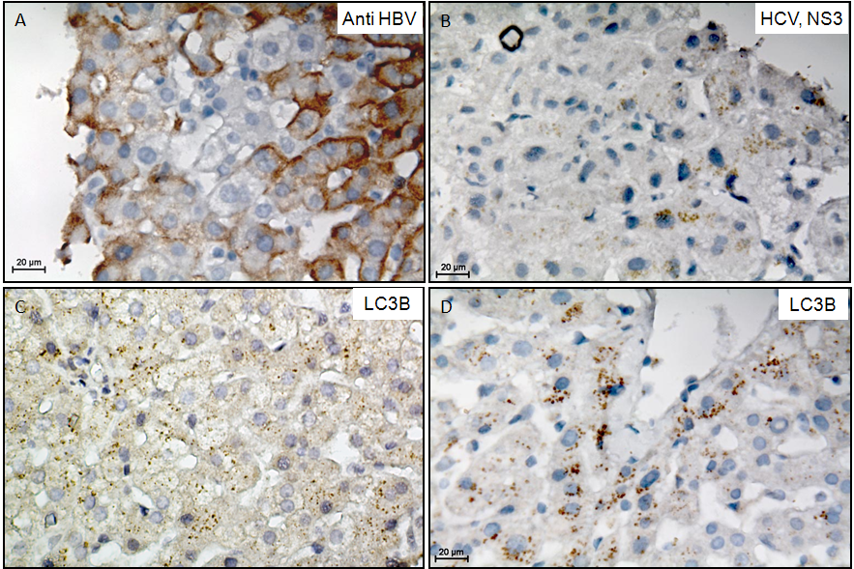
Figure 1 Confirmation of hepatitis B and C virus infection and LC3β expression in liver tissues. A: Immunohistochemistry (IHC) confirms hepatitis B virus (HBV) infection in the liver tissue; the image is representative of IHC for HBV infection in all patients; B: IHC confirms hepatitis C virus (HCV) infection (Anti NS3 HCV) in the liver tissue; the image is representative of IHC for HCV infection in all patients; C: IHC confirms LC3β expression in HBV infected liver tissue; the image is representative of IHC for all patients; D: IHC confirms LC3β expression in HCV infected liver tissue; the image is representative of IHC for all patients. HBV: hepatitis B virus; HCV: hepatitis C virus; IHC: immunohistochemistry.

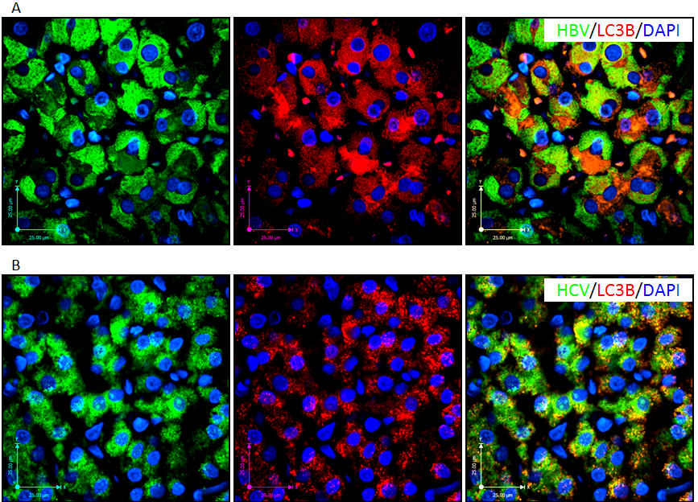
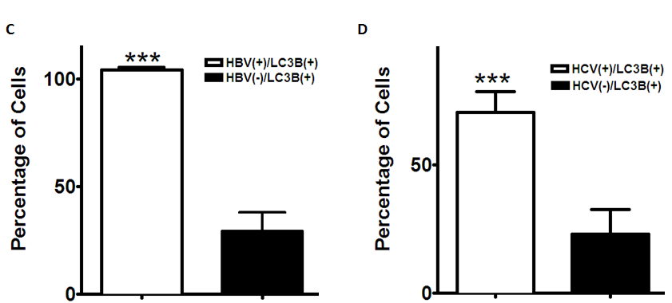
a
a
Figure 2 hepatitis B and C virus infection induces autophagy in liver tissues. A: Fluorescent immunohistochemistry (IHC) confirms co-localization of hepatitis B virus (HBV) and punctate LC3β in the HBV-infected liver tissue; the image is representative of fluorescence IHC for all patients; B: Fluorescencent IHC confirms co-localization of hepatitis C virus (HCV) and punctate LC3β in the HCV infected liver tissue; the image is representative of fluorescence IHC for all patients; C: HBV infection significantly (ªP < 0.001 vs HBV⁻) induces autophagy in the infected hepatocytes compared to non-infected adjacent cells. The graph shows results of the event (HBV infection and punctuated LC3β) in at least 50 cells counted in four different microscopic fields of view from each patient’s sample. D: HCV infection significantly (ªP < 0.001 vs HCV⁻) induces autophagy in the infected hepatocytes compared to non-infected adjacent cells. The graph shows results of the event (HCV infection and punctuated LC3β) in at least 50 cells counted in four different microscopic fields of view from each patient’s sample. HBV: hepatitis B virus; HCV: hepatitis C virus; IHC: immunohistochemistry.

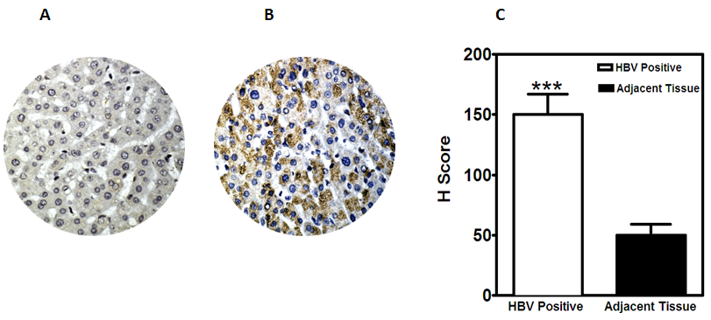
a
Figure 3 Comparison of LC3β expression, determined by immunohistochemistry in HBV^{Pos} and HBV^{Neg} liver tissue microarrays. immunohistochemistry was performed as described in Materials and Methods. H-scores were derived from semi-quantitative assessments of both staining intensity (scale 0–3) and the percentage of positive cells (0%–100%) and, when multiplied, generate a score ranging from 0 to 300. A: Representative image of tissue core from HBV^{Neg} liver showing low expression of LC3β (H-score of 50); B: HBV^{Pos} liver tissue showing higher expression of LC3β (H-score of 150); C: The bar graphs show expression levels (H-score) of LC3β in HBV^{Pos} and HBV^{Neg} liver tissue microarrays. The bars represent the mean ± SEM. ªp < 0.001 vs the normal HBV^{Neg}. HBV: hepatitis B virus; HCV: hepatitis C virus; IHC: immunohistochemistry.

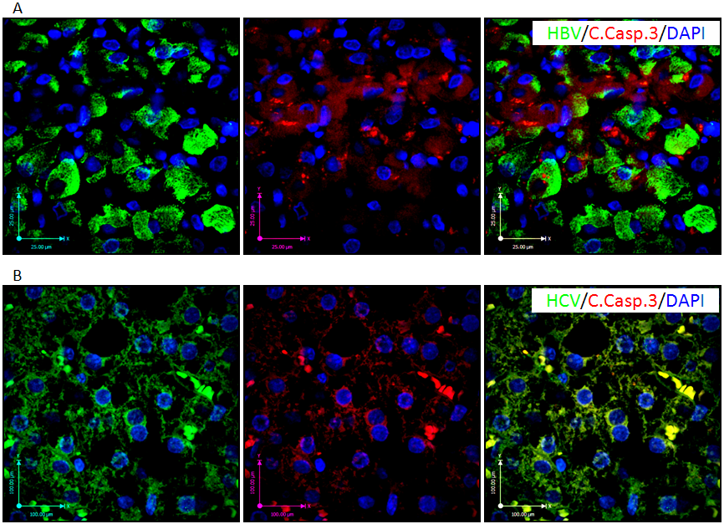
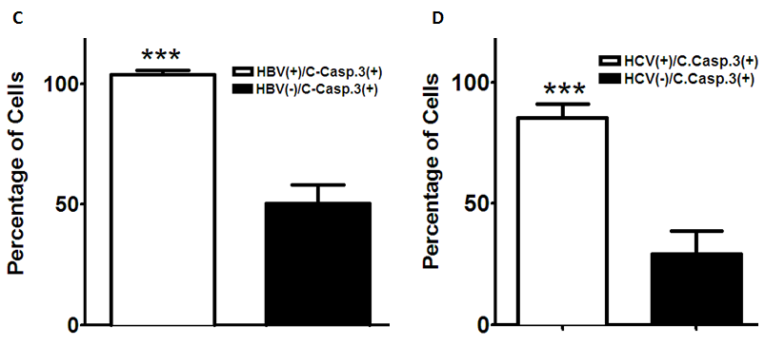
a
a
Figure 4 hepatitis B and C virus infection induces apoptosis in the infected liver tissue. A: Immunofluorescence double-labeling shows co-localization of hepatitis B virus (HBV) and cleaved caspase-3 in the HBV infected liver tissue; the image is representative of fluorescence immunohistochemistry (IHC) for all patients; B: Immunofluorescence double-staining shows co-localization of hepatitis C virus (HCV) and cleaved caspase-3 in the HCV infected liver tissue; the image is representative of fluorescence IHC for all patients; C: HBV infection significantly (ªP < 0.001 vs HBV⁻) induces apoptosis in the infected hepatocytes compared to non-infected adjacent cells. The graph shows results of the event (HBV infection and cleaved caspase-3) in at least 50 cells counted in four different microscopic fields from each patient’s sample; D: HCV infection significantly (ªP < 0.001 vs HCV⁻) induces apoptosis in the infected hepatocytes compared to non-infected adjacent cells. The graph shows results of the event (HCV infection and cleaved caspase-3) in at least 50 cells counted in four different microscopic fields from each patient’s sample. HBV: hepatitis B virus; HCV: hepatitis C virus.

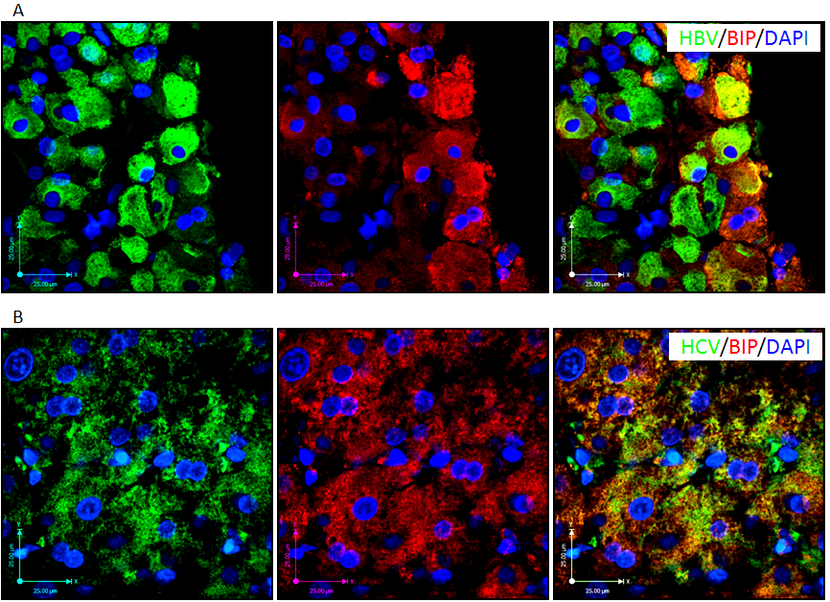
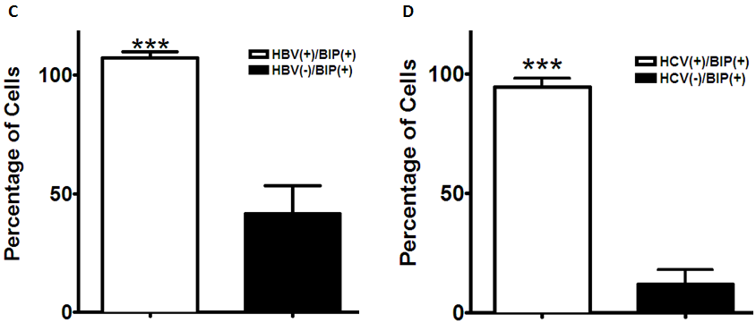
a
a
Figure 5 hepatitis B and C virus infection induces unfolded protein response in the infected liver tissue. A: Fluorescence immunohistochemistry (IHC) confirms co-localization of hepatitis B virus (HBV) and BIP (GRP78) expression in the HBV-infected liver tissue; the image is representative of fluorescence IHC for all patients; B: Fluorescence IHC confirms co-localization of hepatitis C virus (HCV) and BIP (GRP78) expression in the HCV-infected liver tissue; the image is representative of fluorescence IHC for all patients; C: HBV infection significantly (ªP < 0.001 vs HBV⁻) induces UPR in the infected hepatocytes compared to non-infected adjacent cells. The graph shows results of the event,HBV infection and BIP (GRP78) expression in at least 50 cells counted in four different views of fluorescence IHC in each patient’s sample; D: HCV infection significantly (ªP < 0.001 vs HCV⁻) induces UPR in the infected hepatocytes compared to non-infected adjacent cells. The graph shows results of the event (HCV infection and BIP (GRP78) expression) in at least 50 cells counted in four different views of fluorescence IHC in each patient’s sample. HBV: hepatitis B virus; HCV: hepatitis C virus; IHC: immunohistochemistry; UPR: unfolded protein response.

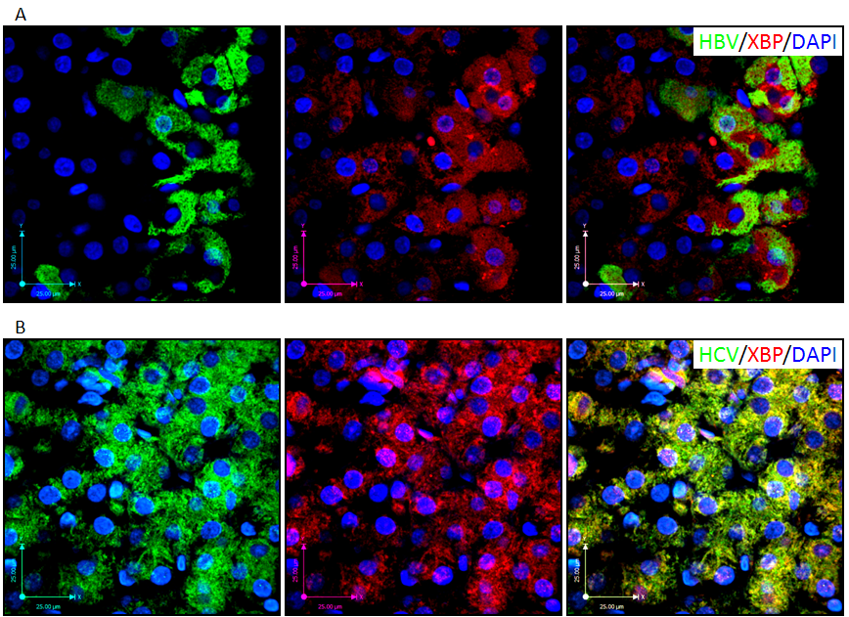
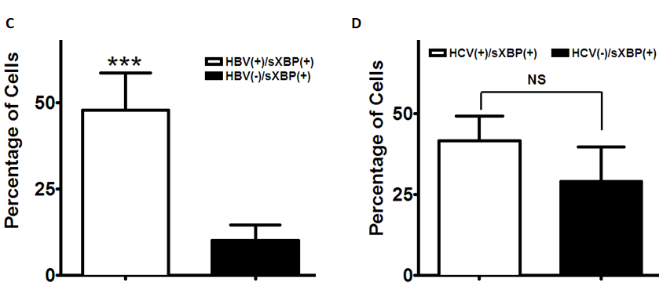
a
Figure 6 hepatitis B virus infection induces XBP splicing in the infected liver tissue while hepatitis C virus infection does not induce XBP splicing. A: Fluorescence immunohistochemistry (IHC) confirms co-localization of hepatitis B virus (HBV) and spliced XBP (sXBP) (spliced XBP localized in the nucleus) in the HBV-infected liver tissue; the image is representative of fluorescence IHC for all patients; B: Fluorescence IHC shows that co-localization of hepatitis C virus (HCV) and spliced XBP (sXBP) (spliced XBP localized in the nucleus) is not a dominant event in the HCV-infected liver tissue; the image is representative of fluorescence IHC for all patients; C: HBV infection significantly (ªP < 0.001 vs HBV⁻) induces XBP splicing (spliced XBP localized in the nucleus) in the infected hepatocytes compared to non-infected adjacent cells. The graph shows results of the event [HBV infection and spliced XBP (sXBP) (spliced XBP localized in the nucleus)] in at least 50 cells counted in four different views of fluorescence IHC in each patient’s sample; D: HCV infection does not significantly (P > 0.05) induce XBP splicing in the infected hepatocytes compared to non-infected adjacent cells. The graph shows results of the event [HCV infection and spliced XBP (sXBP) (spliced XBP localized in the nucleus)] in at least 50 cells counted in four different views of fluorescence IHC in each patient’s sample. HBV: hepatitis B virus; HCV: hepatitis C virus; IHC: immunohistochemistry.

Table 1 The stage of liver disease in hepatitis B and C virus infected patients
Stage | None | Mild | Moderate | Severe
HBV (n) | 5 | 5 | 0 | 0
HCV (n) | 3 | 5 | 1 | 1

HBV: hepatitis B virus; HCV: hepatitis C virus.
Table 2 The grade of liver disease in hepatitis B and C virus infected patients
Grade | None | Mild | Moderate | Severe
HBV (n) | 4 | 3 | 3 | 0
HCV (n) | 4 | 2 | 1 | 3

HBV: hepatitis B virus; HCV: hepatitis C virus.

