June 20th, 2022

The authors have read the STROBE Statement-checklist of items, and the manuscript was prepared and revised according to the STROBE Statement-checklist of items.

All the best,

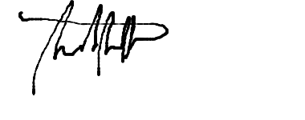
Saad Saffo, MD
Yale School of Medicine

