Name of Journal: World Journal of Clinical Cases
Manuscript NO: 46050
Manuscript Type: CASE REPORT

Gastric adenocarcinoma of fundic gland type after Helicobacter pylori eradication: A case report

Yu YN et al. GA-FG after H. pylori eradication

Ya-Nan Yu, Xiao-Yan Yin, Qi Sun, Hua Liu, Qi Zhang, Yun-Qing Chen, Qing-Xi Zhao, Zi-Bin Tian

Ya-Nan Yu, Xiao-Yan Yin, Hua Liu, Qi Zhang, Qing-Xi Zhao, Zi-Bin Tian, Department of Gastroenterology, the Affiliated Hospital of Qingdao University, Qingdao 266003, Shandong Province, China

Qi Sun, Department of Pathology, the Affiliated Drum Tower Hospital of Nanjing University Medical School, Nanjing 210008, Jiangsu Province, China

Yun-Qing Chen, Department of Pathology, the Affiliated Hospital of Qingdao University, Qingdao 266003, Shandong Province, China

ORCID number: Ya-Nan Yu (0000-0002-7530-1647); Xiao-Yan Yin (0000-0002-8643-0786); Qi Sun (0000-0001-8276-4327); Hua Liu (0000-0002-0621-5358); Qi Zhang (0000-0002-8529-4823); Yun-Qing Chen (0000-0001-9964-2537); Qing-Xi Zhao (0000-0001-5044-373x); Zi-Bin Tian (0000-0002-3211-2934).

Author contributions: Yu YN and Yin XY wrote the manuscript; Sun Q and Chen YQ contributed to the immunohistochemistry and pathology; Liu H and Zhang Q contributed to the manuscript discussion; Zhao QX, Tian ZB, and Yin XY reviewed the manuscript.

Supported by the National Natural Science Foundation of China, No. 81502025; and China Postdoctoral Science Foundation, No. 2018M632631.

Informed consent statement: Written informed consent from the patient was obtained.

Conflict-of-interest statement: Authors have no conflict of interest relevant to this article.

CARE Checklist (2016) statement: The authors have read the CARE Checklist (2016), and the manuscript was prepared and revised according to the CARE Checklist (2016).

Open-Access: This article is an open-access article that was selected by an in-house editor and fully peer-reviewed by external reviewers. It is distributed in accordance with the Creative Commons Attribution Non Commercial (CC BY-NC 4.0) license, which permits others to distribute, remix, adapt, build upon this work non-commercially, and license their derivative works on different terms, provided the original work is properly cited and the use is non-commercial. See: http://creativecommons.org/licenses/by-nc/4.0/

Manuscript source: Unsolicited manuscript

Corresponding author: Xiao-Yan Yin, MD, PhD, Chief Doctor, Department of Gastroenterology, the Affiliated Hospital of Qingdao University, 16 Jiangsu Road, Qingdao 266003, Shandong Province, China. yxy4503@163.com
Telephone: +86-532-82911303
Fax: +86-532-82911302

Received: March 25, 2019
Peer-review started: March 25, 2019
First decision: April 11, 2019
Revised: April 29, 2019
Accepted: May 10, 2019
Article in press:
Published online:
Abstract
BACKGROUND
Gastric adenocarcinoma of fundic gland type (GA-FG) has recently been proposed as a novel histological type of gastric cancer.

CASE SUMMARY
We report a case of GA-FG in a 77-year-old Chinese woman with epigastric distention who was referred to endoscopy for the management of an incidentally found submucosal tumor-like elevated lesion in the lower part of the gastric body. The tumor occurred after Helicobacter pylori (H. pylori) eradication therapy without long-term use of proton pump inhibitors. Complete and curable removal of the tumor was performed by endoscopic submucosal dissection. Histopathological findings showed numerous cells with basophilic cytoplasm and mildly atypical nuclei-like chief cells of the fundic gland. The tumor was observed to have the so-called “endless glands” pattern of the well-differentiated mixed phenotype. A safe resection margin without lymphatic and venous invasion was observed. As the tumor occurred after H. pylori eradication therapy, it is unknown whether there was a relationship with H. pylori eradication. The patient will be followed up by periodic gastroscopic observation.

CONCLUSION
In conclusion, we report a case of GA-FG after H. pylori eradication therapy without long-term proton pump inhibitors use. Further analysis of similar cases will reveal the clinical behavior of GA-FG.

Key words: Gastric adenocarcinoma; Fundic gland; Helicobacter pylori; Eradication; Case report

© The Author(s) 2019. Published by Baishideng Publishing Group Inc. All rights reserved.

Core tip: Gastric adenocarcinoma of fundic gland type (GA-FG) remains a rare disease despite a recent uptick in diagnoses. Here, we report a case of GA-FG with submucosal tumor-like appearance, located in the lower part of the gastric body. This case report discusses the probability-of-occurrence after Helicobacter pylori eradication therapy without long-term usage of proton pump inhibitors. Complete and curable removal of endoscopic submucosal dissection was performed. Further analysis of similar cases will reveal the clinical behavior of GA-FG.

Yu YN, Yin XY, Sun Q, Liu H, Zhang Q, Chen YQ, Zhao QX, Tian ZB. Gastric adenocarcinoma of fundic gland type after Helicobacter pylori eradication: A case report. World J Clin Cases 2019; In press
INTRODUCTION
Traditionally, gastric carcinoma has been categorized into intestinal and diffuse types using the Lauren classification^{[1]}. However, with progress made in histochemical techniques, it has been shown that gastric adenocarcinoma of the intestinal type comprises the gastric phenotype^{[2]}. It was demonstrated that gastric phenotypes included the foveolar type, pyloric gland type, and fundic gland type. Of these phenotypes, gastric adenocarcinoma of fundic gland type (GA-FG) is a novel histological type of gastric cancer first proposed by Tsukamoto et al^{[3]} in 2007. Based on their composition, the differentiation of characteristic oxyntic glands can be divided into chief cell predominant, parietal cell predominant, and mixed phenotype. Following a report in 2010 that included 10 cases of gastric adenocarcinoma showing chief cell differentiation, the concept of GA-FG was proposed^{[4]}, which has since been gradually recognized. However, the demographics, predisposing factors, prognosis, and how GA-FGs differ from conventional carcinomas are unclear. To date, only information on the early stages of GA-FG are available.
We report a patient with GA-FG who was treated with endoscopic submucosal dissection (ESD). This case report discusses the probability-of-occurrence after Helicobacter pylori (H. pylori) eradication without long-term use of proton pump inhibitors (PPIs).

CASE PRESENTATION
Chief complaints
A 77-year-old Chinese woman visited our hospital with epigastric discomfort for more than 4 years and worsened for 1 mo=.

History of present illness
Her medical history was notable for chronic atrophic gastritis.

History of past illness
She had a longstanding history of chronic atrophic gastritis in January 2014 with gastroscopy. According to the Kimura/Takemoto classification^{[5]}, atrophy of the gastric mucosa was classified as C-2. She had received recommended dose of H. pylori eradication therapy twice, once 7 d for omeprazole + amoxicillin + clarithromycin and once 14 d for pantoprazole + bismuthate + tetracycline + metronidazole. She was followed up with annual gastroscopy and had not taken any PPIs since then. In addition, she had a history of myoma of uterus for more than 40 years, without operation.

Physical examination upon admission
On physical examination upon admission, she was 1.54 meters in height and 60 kilogram in weight. She had a blood pressure of 117/68 mmHg with pulse rate of 65 beats per minute. Her jugular venous pressure was not elevated. She had clear lungs and normal heart sounds with no murmurs or gallops on auscultation. There were no other pathognomonic signs during physical examination, except for slight tenderness in the upper abdomen.

Laboratory examinations
After admission, the patient was thoroughly evaluated with routine blood tests, routine urine tests, routine fecal tests and occult blood test, blood biochemistry, and infection indexes. No significant abnormal laboratory results were recorded in this patient.

Imaging examinations
Gastroscopy revealed a 6 mm submucosal tumor (SMT)-like slightly elevated lesion in the anterior wall of the lower part of the gastric body, which had faint yellow discoloration (Figure 1A and B). Atrophy of the gastric mucosa was classified as C-2, yet the local background mucosa of the lesion showed no apparent atrophy, after eradication of H. pylori. No fundus gland polyp (FGP) was found in other sections of the stomach.
A biopsy of the SMT-like lesion was obtained, and histopathological findings showed numerous cells with basophilic cytoplasm and mildly atypical nuclei-like chief cells of the fundic gland, which were arranged in irregular branching and anastomosing tubules in a layer of the lamina propria mucosae (Figure 2A-C).

FINAL DIAGNOSIS
Based on endoscopic performance and histopathologic characteristics, GA-FG was diagnosed.

TREATMENT
The patient underwent ESD subsequently. To observe the microstructure of the lesion, narrowband imaging with magnifying endoscopy was carried out. It showed an enlarged microvascular pattern and a mildly disordered microsurface pattern especially prominent in the upper part of the SMT-like elevated lesion, with an expected biopsy scar in the lower part (Figure 1C). On assessment of the ESD specimen, a slightly elevated tumor measuring 5 mm × 6 mm was identified in the submucosal layer (Figure 1D).
Similar to the histological characteristics, neoplastic glands infiltrating the submucosal layer were observed (Figure 2D-F). On immunohistochemical (IHC) examination, the tumor was strongly and diffusely reactive for pepsinogen-I and mucin 6, with scattered expression of H+/K+-ATPase but negative for MUC5AC (Figure 3), and the Ki-67 labeling index was 4% (Figure 4). The IHC staining results were consistent with the diagnosis of GA-FG with predominantly chief cell differentiation. Resection margin was safe without lymphatic and venous invasion, resulting in curative resection. No atrophic changes or intestinal metaplasia in the background mucosa of the ESD specimen were observed.

OUTCOME AND FOLLOW-UP
Complete and curable removal by ESD was performed. The patient has required regular clinic and gastroscopy follow up. She has remained stable.

DISCUSSION
GA-FG has been characterized as a new histological type of gastric cancer in recent years. Since Tsukamoto et al^{[3]} first described a case of GA-FG in 2007, multiple cases of this disease have been reported. Most of these cases have been reported in Japan, with only a few reported in Western countries, suggesting that GA-FG is uncommon or there is a lack of awareness of this tumor. The carcinogenesis of GA-FG is still unclear. Benedict et al^{[6]} reported 111 cases of GA-FG to highlight the key features and controversies associated with this uncommon neoplasm. The overwhelming majority of GA-FGs (approximately 80%) have occurred in the upper third of the stomach, followed by the middle third (18%), and only one tumor has been found in the lower third of the stomach (1%)^{[7-25]}. In our patient, the GA-FG was localized in the lower part of the gastric body (i.e. the middle third of the stomach).
Of the 111 cases of GA-FG published, 40% cases were H. pylori positive from only 39% available data^{[6]}. So, the presence or not of H. pylori does not seem to be relevant. Although GA-FG is generally thought related to non-atrophic mucosa and H. pylori negative, it has been reported to occur with a history of H. pylori eradication^{[9]}. Our patient had a history of H. pylori eradication therapy twice, which supported this viewpoint. In addition, the background mucosa of GA-FG after eradication was endoscopically and pathologically free of atrophy or intestinal metaplasia. In a series of 12 cases reported, 7 of the 8 cases with available history of medication had used acid suppressive therapy (six PPI and one H2 blocker)^{[11]}. However, our patient had no history of long-term medication of any PPIs and had no FGP in other sections of her stomach. It is unclear whether there was a relationship with PPIs use.
GA-FGs are often small, with an average size of 10 mm^{[7]}. They can be elevated, flat, depressed, SMT-like or mimic a gastric FGP, and tend to be white or yellow in color, with branching dilated mucosal vessels in the non-atrophic adjacent mucosa^{[8,9,26]}. The use of narrowband imaging enhances visualization of the irregular pattern of mucosal vessels, suggestive of the heterogeneity of the microvessels in GA-FG. Diagnosis is dependent on biopsy and pathology. Differential diagnosis is also important with other conditions such as neuroendocrine tumors, gastric SMT, and FGPs.
The histologic appearance of GA-FG is often a well-differentiated neoplasm, arising directly from the gastric mucosa, with resemblance to the fundic glands. The following three subcategories have been identified: chief cell predominant pattern, parietal cell predominant pattern, or a mixture of both cell types. The lesion invariably shows the so-called “endless glands” pattern, which is the principal pathological feature of GA-FG. Most GA-FGs have mild cytologic atypia and slightly enlarged nuclei. The Ki-67 index is usually lower than 5%^{[8]}. Typically, the adjacent mucosa is normal without atrophy or intestinal metaplasia^{[10]}. When a pathologist is aware of this tumor, recognition of the so-called “endless glands” pattern in the well-differentiated mixed phenotypes is easy following hematoxylin and eosin staining. Some IHC markers can be helpful in identifying lineage differentiation, including pepsinogen-I, MIST1, H+/K+-ATPase, and mucin 6. To date, a lack of awareness of GA-FG in the pathology community and few available markers have resulted in diagnostic difficulties.
GA-FG is a less aggressive and slow-growing neoplasm with a favorable prognosis because of their low cell proliferation and cellular atypia. These tumors tend to invade the submucosa, lymphovascular invasion is infrequent, and follow a benign course. Tumors with superficial submucosal invasion can be treated with endoscopic mucosal resection, ESD, or limited gastric resection^{[6]}. For deeply invasive tumors or suspected nodal metastasis, extended gastrectomy with lymph node dissection should be performed.
In our patient, the SMT-like lesion was located in the lower part of the gastric body. She was previously H. pylori positive and had received eradication therapy twice. In addition, she was followed up with annual gastroscopy and had not taken PPIs for 4 years. The background mucosa of the tumor was H. pylori negative without atrophy or intestinal metaplasia. As the tumor occurred after H. pylori eradication therapy, it is unclear whether there was a relationship with H. pylori eradication. Complete and curable removal by ESD was performed in this patient. According to the current understanding and a comprehensive literature analysis, the patient will be followed up with periodic gastroscopic observation.

CONCLUSION
GA-FG remains a rare disease despite a recent uptick in diagnoses owing to increased physician suspicion and improved endoscopic techniques. Here, we report a case of GA-FG with SMT-like appearance, located in the lower part of the gastric body. This case report discusses the probability-of-occurrence of GA-FG after H. pylori eradication therapy without long-term usage of PPIs. Treatment consisted of ESD only. Further analysis of similar cases will reveal the clinical behavior of GA-FG.

REFERENCES
1 Lauren P. The two histological main types of gastric carcinoma: diffuse and so-called intestinal-type carcinoma. an attempt at a histo-clinical classification. Acta Pathol Microbiol Scand 1965; 64: 31-49 [PMID: 14320675 DOI: 10.1111/apm.1965.64.1.31]
2 Kabashima A, Yao T, Sugimachi K, Tsuneyoshi M. Gastric or intestinal phenotypic expression in the carcinomas and background mucosa of multiple early gastric carcinomas. Histopathology 2000; 37: 513-522 [PMID: 11122433 DOI: 10.1046/j.1365-2559.2000.01008.x]
3 Tsukamoto T, Yokoi T, Maruta S, Kitamura M, Yamamoto T, Ban H, Tatematsu M. Gastric adenocarcinoma with chief cell differentiation. Pathol Int 2007; 57: 517-522 [PMID: 17610477 DOI: 10.1111/j.1440-1827.2007.02134.x]
4 Ueyama H, Yao T, Nakashima Y, Hirakawa K, Oshiro Y, Hirahashi M, Iwashita A, Watanabe S. Gastric adenocarcinoma of fundic gland type (chief cell predominant type): proposal for a new entity of gastric adenocarcinoma. Am J Surg Pathol 2010; 34: 609-619 [PMID: 20410811 DOI: 10.1097/PAS.0b013e3181d94d53]
5 Kimura K, Takemoto T. An endoscopic recognition of the atrophic border and its significance in chronic gastritis. Endoscopy 1969; 1: 87-97 [DOI: 10.1055/s-0028-1098086]
6 Benedict MA, Lauwers GY, Jain D. Gastric Adenocarcinoma of the Fundic Gland Type: Update and Literature Review. Am J Clin Pathol 2018; 149: 461-473 [PMID: 29648578 DOI: 10.1093/ajcp/aqy019]
7 Nomura R, Saito T, Mitomi H, Hidaka Y, Lee SY, Watanabe S, Yao T. GNAS mutation as an alternative mechanism of activation of the Wnt/β-catenin signaling pathway in gastric adenocarcinoma of the fundic gland type. Hum Pathol 2014; 45: 2488-2496 [PMID: 25288233 DOI: 10.1016/j.humpath.2014.08.016]
8 Tohda G, Osawa T, Asada Y, Dochin M, Terahata S. Gastric adenocarcinoma of fundic gland type: Endoscopic and clinicopathological features. World J Gastrointest Endosc 2016; 8: 244-251 [PMID: 26962407 DOI: 10.4253/wjge.v8.i4.244]
9 Chiba T, Kato K, Masuda T, Ohara S, Iwama N, Shimada T, Shibuya D. Clinicopathological features of gastric adenocarcinoma of the fundic gland (chief cell predominant type) by retrospective and prospective analyses of endoscopic findings. Dig Endosc 2016; 28: 722-730 [PMID: 27129734 DOI: 10.1111/den.12676]
10 Ueyama H, Matsumoto K, Nagahara A, Hayashi T, Yao T, Watanabe S. Gastric adenocarcinoma of the fundic gland type (chief cell predominant type). Endoscopy 2014; 46: 153-157 [PMID: 24338239 DOI: 10.1055/s-0033-1359042]
11 Chan K, Brown IS, Kyle T, Lauwers GY, Kumarasinghe MP. Chief cell-predominant gastric polyps: a series of 12 cases with literature review. Histopathology 2016; 68: 825-833 [PMID: 26335020 DOI: 10.1111/his.12859]
12 Fukatsu H, Miyoshi H, Ishiki K, Tamura M, Yao T. Gastric adenocarcinoma of fundic gland type (chief cell predominant type) treated with endoscopic aspiration mucosectomy. Dig Endosc 2011; 23: 244-246 [PMID: 21699569 DOI: 10.1111/j.1443-1661.2011.01125.x]
13 Sato Y, Fujino T, Kasagawa A, Morita R, Ozawa SI, Matsuo Y, Maehata T, Yasuda H, Takagi M, Itoh F. Twelve-year natural history of a gastric adenocarcinoma of fundic gland type. Clin J Gastroenterol 2016; 9: 345-351 [PMID: 27624750 DOI: 10.1007/s12328-016-0680-5]
14 Takeda S, Mitoro A, Namisaki T, Yoshida M, Sawai M, Yamao J, Yoshiji H, Uejima M, Moriya K, Douhara A, Seki K, Ishida K, Morita K, Noguchi R, Kitade M, Kawaratani H, Okura Y, Takaya H, Fukui H. Gastric adenocarcinoma of fundic gland type (chief cell predominant type) with unique endoscopic appearance curatively treated by endoscopic submucosal resection. Acta Gastroenterol Belg 2015; 78: 340-343 [PMID: 26448418]
15 Miyazawa M, Matsuda M, Yano M, Hara Y, Arihara F, Horita Y, Matsuda K, Sakai A, Noda Y. Gastric adenocarcinoma of fundic gland type: Five cases treated with endoscopic resection. World J Gastroenterol 2015; 21: 8208-8214 [PMID: 26185396 DOI: 10.3748/wjg.v21.i26.8208]
16 Kushima R, Sekine S, Matsubara A, Taniguchi H, Ikegami M, Tsuda H. Gastric adenocarcinoma of the fundic gland type shares common genetic and phenotypic features with pyloric gland adenoma. Pathol Int 2013; 63: 318-325 [PMID: 23782334 DOI: 10.1111/pin.12070]
17 Ueo T, Yonemasu H, Ishida T. Gastric adenocarcinoma of fundic gland type with unusual behavior. Dig Endosc 2014; 26: 293-294 [PMID: 24321002 DOI: 10.1111/den.12212]
18 Terada T. Well differentiated adenocarcinoma of the stomach composed of chief cell-like cells and parietal cells (Gastric adenocarcinoma of fundic gland type). Int J Clin Exp Pathol 2011; 4: 797-798 [PMID: 22135729 DOI: 10.1002/ijc.25536]
19 Singhi AD, Lazenby AJ, Montgomery EA. Gastric adenocarcinoma with chief cell differentiation: a proposal for reclassification as oxyntic gland polyp/adenoma. Am J Surg Pathol 2012; 36: 1030-1035 [PMID: 22472957 DOI: 10.1097/PAS.0b013e31825033e7]
20 Parikh ND, Gibson J, Aslanian H. Gastric Fundic Gland Adenocarcinoma With Chief Cell Differentiation. Clin Gastroenterol Hepatol 2015; 13: A17-A18 [PMID: 26215839 DOI: 10.1016/j.cgh.2015.07.023]
21 Cha HJ, Kim K, Kim M, Choi H, Kim YM, Suh JH. Concurrent Gastric Adenocarcinoma of Fundic Gland Type and Carcinoma with Lymphoid Stroma: A Rare Case Report. Case Rep Gastroenterol 2016; 10: 292-301 [PMID: 27462199 DOI: 10.1159/000444277]
22 Kato M, Uraoka T, Isobe Y, Abe K, Hirata T, Takada Y, Wada M, Takatori Y, Takabayashi K, Fujiyama Y, Sekiya K, Kawaguchi Y, Sukeda A, Shiraishi J. A case of gastric adenocarcinoma of fundic gland type resected by combination of laparoscopic and endoscopic approaches to neoplasia with non-exposure technique (CLEAN-NET). Clin J Gastroenterol 2015; 8: 393-399 [PMID: 26615600 DOI: 10.1007/s12328-015-0619-2]
23 Abe T, Nagai T, Fukunaga J, Okawara H, Nakashima H, Syutou M, Kajimoto N, Wake R, Oyama T, Yao T. Long-term follow-up of gastric adenocarcinoma with chief cell differentiation using upper gastrointestinal tract endoscopy. Intern Med 2013; 52: 1585-1588 [PMID: 23857090 DOI: 10.2169/internalmedicine.52.0361]
24 Chen WC, Rodriguez-Waitkus PM, Barroso A, Balsaver A, McKechnie JC. A Rare Case of Gastric Fundic Gland Adenocarcinoma (Chief Cell Predominant Type). J Gastrointest Cancer 2012; 43 Suppl 1: S262-S265 [PMID: 22791069 DOI: 10.1007/s12029-012-9416-z]
25 Fujisawa T, Takata M, Ouchi S, Ueyama S, Nakajima T, Mitsutsuji M, Kawamura T, Toyoda M, Okamura A. Intra-abdominal plexiform neurofibromatosis including periportal, mesentery, and gastrointestinal tract involvement in neurofibromatosis type 1: case report and review of the literature. Clin J Gastroenterol 2011; 4: 292-297 [PMID: 26189627 DOI: 10.1007/s12328-011-0241-x]
26 Miyazawa M, Matsuda M, Yano M, Hara Y, Arihara F, Horita Y, Matsuda K, Sakai A, Noda Y. Gastric adenocarcinoma of the fundic gland (chief cell-predominant type): A review of endoscopic and clinicopathological features. World J Gastroenterol 2016; 22: 10523-10531 [PMID: 28082804 DOI: 10.3748/wjg.v22.i48.10523]

P-Reviewer: Koseoglu RD, Kopljar M, Lobo MDT, Park WS, Slomiany BL, Viola LA S-Editor: Ji FF L-Editor: Filipodia E-Editor:

Specialty type: Medicine, research and experimental
Country of origin: China
Peer-review report classification
Grade A (Excellent): 0
Grade B (Very good): B
Grade C (Good): C, C, C
Grade D (Fair): D, D
Grade E (Poor): 0

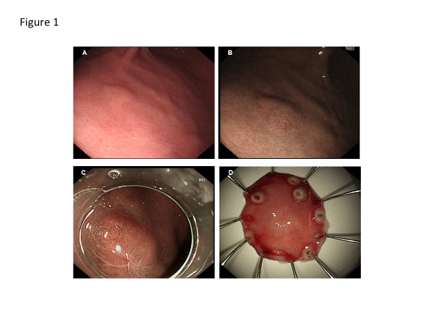
Figure 1 Endoscopic findings. A, B: A yellowish submucosal tumor-like elevated lesion is observed with white light endoscopy (A) and narrowband imaging (B) in the anterior wall of the lower third of the gastric body; C: It showed an enlarged microvascular pattern and a mildly disordered microsurface pattern especially prominent in the upper part of the lesion; D: On assessment of the endoscopic submucosal dissection specimen, a tumor measuring 5 mm × 6 mm was identified in the submucosal layer.

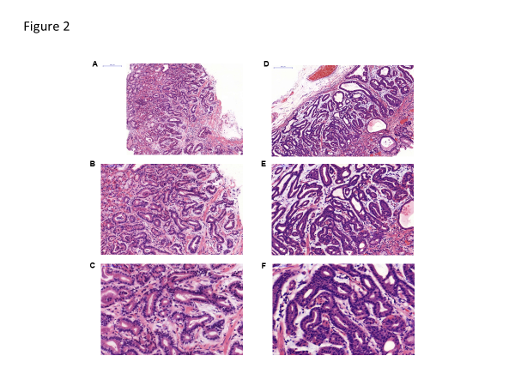
Figure 2 Histopathological findings (hematoxylin and eosin staining). A-F: Well-differentiated adenocarcinoma with numerous fundic gland-like cells were observed in the biopsy (A, B, and C) and endoscopic submucosal dissection specimen (D, E and F), which were crowded and disordered in a layer of the lamina propria mucosae, and formed the so-called “endless glands” pattern. Magnification: A and D: 100 ×; B and E: 200 ×; C and F: 400 ×.

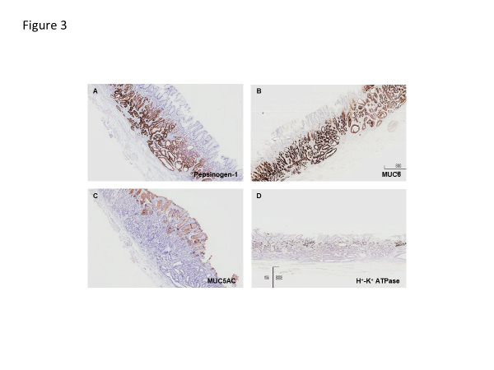
Figure 3 Immunohistochemical findings. Magnification of all photographs is 40 ×. A-D: The tumor cells of gastric adenocarcinoma of fundic gland type were strongly and diffusely reactive for pepsinogen-I (A) and MUC6 (B), negative for MUC5AC (C) and H+/K+-ATPase (D). MUC6: Mucin 6.

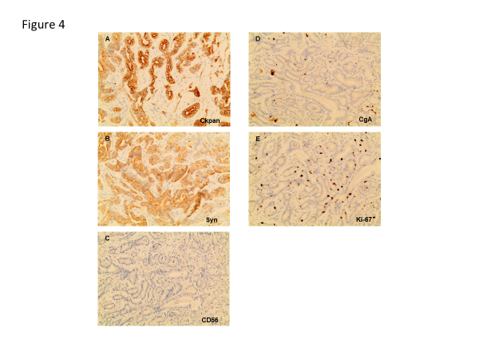
Figure 4 Immunohistochemical findings. A, B: Magnification of all photographs is 200 ×. The tumor was strongly positive for Ckpan (A), scattered positivity for Syn (B); C, D, E: Staining for CgA (C) and CD56 was negative (D), and the Ki-67 labeling index was 4% (E).

