Name of journal: World Journal of Gastroenterology
ESPS Manuscript NO: 14210
Columns: META-ANALYSIS

Infliximab is superior to the other biological agents for the treatment of active ulcerative colitis: A meta-analysis

Mei WQ et al. Meta-analysis of biological agents in UC

Wei-Qun Mei, Hui-Zhen Hu, Ying Liu, Zhi-Chen Li, Wei-Guo Wang

Wei-Qun Mei, Hui-Zhen Hu, Wei-Guo Wang, Department of Gastroenterology, No. 117 Hospital of PLA, Hangzhou 310021, Zhejiang Province, China

Ying Liu, Zhi-Chen Li, Department of Endocrinology, No. 117 Hospital of PLA, Hangzhou 310021, Zhejiang Province, China

Author contributions: Wang WG designed the study; Mei WQ and Hu HZ screened the citations; Mei WQ and Liu Y did the data analyses; Li ZC wrote the paper.

Conflict-of-interest: The authors declare that there is no conflict of interest.

Data sharing: No additional data are availabe.

Open-Access: This article is an open-access article which selected by an in-house editor and fully peer-reviewed by external reviewers. It distributed in accordance with the Creative Commons Attribution Non Commercial (CC BY-NC 4.0) license, which permits others to distribute, remix, adapt, build upon this work non-commercially, and license their derivative works on different terms, provided the original work is properly cited and the use is non-commercial. See: http://creativecommons.org/licenses/by-nc/4.0/

Correspondence to: Dr. Wei-Guo Wang, Department of Gastroenterology, No. 117 Hospital of PLA, 14 Lingyin Road, Hangzhou 310021, Zhejiang Province, China. wangweiguo117@126.com
Telephone: 86-571-87340801 Fax: 86-571-87340811

Received: September 24, 2014
Peer-review started: September 25, 2014
First decision: October 29, 2014
Revised: November 25, 2014
Accepted: December 14, 2014

Article in press:
Published online:

Abstract
AIM: To compare the efficacy and safety of biological agents for the treatment of active ulcerative colitis (UC).

METHODS: Literatures were searched in PubMed, MEDLINE, EMBASE and the Cochrane library to screen citations from January 1996 to August 2014 in this study. The mixed treatment comparison meta-analysis within a Bayesian framework was performed by WinBUGS14 software. The proportions of patients reaching clinical response, clinical remission and mucosal healingin induction and maintenance phases were analyzed as efficacy indicators. Serious adverse events in maintenance phase were analyzed as safety indicator.

RESULTS: The meta-analysis results showed that biological agents achieved more clinical response, clinical remission and mucosal healing than placebo. Indirect comparison indicated that in induction phase, infliximab was more effective than adalimumab in inducing clinical response (OR = 0.41, 95%CI: 0.29-0.57), clinical remission (OR = 0.33, 95%CI: 0.19-0.56) and mucosal healing (OR = 0.33, 95%CI: 0.19-0.56), and golimumab in inducing clinical response (OR = 0.66, 95%CI: 0.39-2.33) and mucosal healing (OR = 2.15, 95%CI: 1.18-4.22). No significant difference was found between placebo and biological agents regarding their safety.

Conclusion: All biological agents were superior to placebo for UC treatment in both induction and maintenance phases with a similar safety, and infliximab had a better clinical effect than the other biological agents.

© The Author(s) 2015. Published by Baishideng Publishing Group Inc. All rights reserved.

Key words: Biological agents; Efficacy; Meta-analysis; Safety; Ulcerative colitis

Core tip: Currently the option of biological agents in ulcerative colitis (UC) therapy was still controversial. We performed this meta-analysis to compare the efficacy and safety of biological agents for the treatment of active UC, and finally found all biological agents were superior to placebo for UC treatment in both induction and maintenance phases with a similar safety, and infliximab had a better clinical effect than the other biological agents.

Mei WQ, Hu HZ, Liu Y, Li ZC, Wang WG. Infliximab is superior to the other biological agents for the treatment of active ulcerative colitis: A meta-analysis. World J Gastroenterol 2015; In press

INTRODUCTION
Ulcerative colitis (UC) is a chronic inflammatory bowel disease (IBD) of colon characterized by recurrent rectal bleeding, increased stool frequency and urgency, abdominal cramps and pain, and systemic symptoms (such as fever, anemia and weight loss)^{[1,2]}. It is reported that the incidence of UC is 1.2-20.3 per 100000 person-years and its prevalence is 7.6-246.0 per 100000 persons^{[3]}. Current options of treatment includeaminosalicylates, corticosteroids, immunosuppressive medications such as azathioprine, 6-mercaptopurine and biological agents including antitumor necrosis factor α (TNFα) antibodies and integrin antagonists.
5-aminosalicylic acid (5-ASA) is the first line medication used to induce and maintain remission in patients with mild-to-moderate active ulcerative colitis^{[4]}. Patients who do not have adequate response to 5-ASA are recommended to receive corticosteroids treatments^{[5]}. Moreover, traditional immunosuppressive azathioprine (AZA) and 6-mercaptopurine are suggested to treat patients with moderate active ulcerative colitis who are not responsive to oral corticosteroids^{[6]}. However, conventional treatments often lead to a series of adverse events and have a limited effect in long time disease control.
Anti-TNFα agents including infliximab, adalimumab and golimumab have been approved by United States Food and Drug Administration for the treatment of moderate-to-severe ulcerative colitis. All the 3 anti-TNFα agents are demonstrated to be effective for the induction and maintenance of remission in moderate or severe UC. In addition, these agents can also induce mucosal healing and reduce glucocorticoid dependence^{[7]}. Vedolizumab is a humanized immunoglobulin G1 monoclonal antibody to α4β7 integrin^{[8]}. A phase 3 study investigating the efficacy and safety of vedolizumab in patients with moderate to severe active UC indicated that vedolizumab was significantly more effective on clinical response and remission compared to placebo in both induction and maintenance phases^{[9]}.
Currently, the option of biological agents in UC therapy was still controversial. Traditional methods cannot be applied for the comparison for lack of head-to-head studies comparing different biological agents. Therefore we used a mixed treatment comparison (MTC) to compare the efficacy of biological agents, as MTC was available for indirect comparisons between drugs with different comparators^{[10,11]}.

MATERIALS AND METHODS
Search strategy and inclusion criteria
Four databases (PubMed, EMBASE, MEDLINE and the Cochrane library) were screened to obtain citations from January 1996 to August 2014 for inclusion in this study. The key words Ulcerative Colitis and (infliximabor adalimumab or golimumab orvedolizumab) were used to search relevant citations. We included those studies meeting the two criteria: (1) the study evaluated the efficacy of biological treatments by a random case-control design; and (2) trials had to be placebo controlled.

Data extraction and quality assessment
The following information was extracted from each study: the first author name; the year of publication; the number of patients; the number of patients achieving clinical response; the number of patients achieving clinical remission; the number of patients achieving mucosal healing; the outcome of serious adverse events; endpoints and study duration. The Jadad score was used to assess the quality of included studies. Different doses of the same biological agent were regarded as different separate interventions. Odds rates were used to measure the outcome of clinical response, clinical remission, mucosal healing and serious adverse events in induction and maintenance phases. Sanborn et al^{[12,13]}study and Feagan et al^{[9,14]} study presented induction phase results at week 6, and their studies were analyzed with trials presenting results at week 8. Sanborn et al^{[12,13]} presented maintenance phase results at week 54, and this study was analyzed with trials presenting results at week 52.

Statistical analysis
To evaluate the relative effectiveness of each biologics, a mixed treatment comparison (MTC) meta-analysis within a Bayesian framework was performed. For all Bayesian analyses, Markov-chain-Monte-Carlo methods were used^{[15]}. A random effect model was used to estimate the odds ratios (OR) as the measurement of relative treatment effect. We carried out 60000 iterations. The first 10000 iterations were discarded after the burn-in period and estimates were based on the subsequent 50000 ones. Heterogeneity between studies was assessed by Cochrane Q statistics and I² test. A significant level of no less than 50% for I² test was considered as evidence of heterogeneity. Fix effect model was used when there was no evidence of heterogeneity, otherwise random effect model was chosen. Data analysis was performed by WinBUGS version 1.4.3 (MRC Biostatistics Unit, Cambridge, United Kingdom) and STATA12 (Stata Corp, College Station, Texas, United States). The statistical methods of this study were reviewed by Shanghai 2med Biotechnology Co., Ltd (Shanghai, China).

RESULTS
Search results and characteristics
A total of 209 citations were obtained via database searches; ten met the inclusion criteria for this study (Figure 1). A total of 4237 patients with moderate-to-severe active UC have been involved. Among the UC patients, 484 patients were treated with infliximab; 685 patients were treated with adalimumab; 970 patients were treated with golimumab; 746 patients were treated with vedolizumab; 1352 patients were treated with placebo. The information in these citations was summarized in Table 1.

Heterogeneity analysis
Before performing MTC meta-analysis, we analyzed effect of single biological agent on response, remission, mucosal healing and serious adverse events compared to placebo.No heterogeneity was found between studies (Table 2).

Clinical response
Clinical response was defined as a decrease from baseline in the total Mayo score of at least 3 points and at least 30 percent, with an accompanying decrease in the subscore for rectal bleeding of at least 1 point or an absolutesubscore for rectal bleeding of 0 or 1. All biological agents were superior to placebo in both induction and maintenance phases (Figure 2). The results of MTC meta-analysis showed that in induction phase infliximab was more effective than adalimumab (OR = 0.41, 95%CI: 0.29-0.57) and golimumab (OR = 0.66, 95%CI: 0.44-0.97), while golimumab had a better effect than adalimumab (OR = 1.62, 95%CI: 1.13-2.33). In maintenance phase, vedolizumab was more effective than adalimumab (OR = 1.94, 95%CI: 1.11-3.44) and golimumab (OR = 1.85, 95%CI: 1.08-3.2). Forest plots were summarized in supplementary Figure 3.

Clinical remission
Clinical remission was defined as a total Mayo score of 2 points or lower, with no individual subscore exceeding 1 point. All biological agents were better than placebo for clinical remission in induction and maintenance phases (Figure 4). In induction phase, adalimumab was less effective than infliximab (OR = 0.33, 95%CI: 0.19-0.56), golimumab (OR = 2.15, 95%CI: 1.18-4.22) and vedolizumab (OR = 2.49, 95%CI: 0.99-6.64). However, there was no significant difference between the biological agents in maintenance phase. Forest plots were summarized in supplementary Figure 5.

Mucosal healing
Mucosal healing was defined as absolute subscore for endoscopy of 0 or 1. Biological agents were better than placebo for mucosal healing in induction and maintenance phases (Figure 6). In induction phase, infliximab was more effective than adalimumab (OR = 0.41, 95%CI: 0.29-0.57) and golimumab (OR = 0.6, 95%CI: 0.41-0.87), while golimumab had a better effect than adalimumab (OR = 1.45, 95%CI: 1.02-2.09). However, no significant difference was found between the biological agents in maintenance phase. Forest plots were summarized in supplementary Figure 7.

Safety
This analysis used random trials data on serious adverse events from maintenance phase. The MTC meta-analysis results showed that biological agents had a similar safety with placebo (Figure 8). Forest plots were summarized in supplementary Figure 9.

DISCUSSION
The appearance of biological agents dramatically changed the treatment landscape for UC. Biological agents were used for the treatment of moderate to severe UC patients failing conventional treatment. Previous randomized controlled trials (RCTs) proved that biological agents were effective and safe for the treatment of UC in both induction and maintenance phases. Danese et al. compared the biological agents by performing a multiple-treatment meta-analysis. They illustrated that infliximab is more effective to induce clinical response and mucosal healing than adalimumab in induction phase^{[3]}. However, there was still lack of head to head RCTs to compare the different treatment options for long time efficacy and safety.
This meta-analysis assessing biological agents for the treatment of moderate to severe active ulcerative colitis included 9 RCTs, all of which were placebo controlled trials. No heterogeneity was found when assessing the effect of single biological agent. Meta-analysis showed that all biological agents were effective for UC treatment in induction and maintenance phases. Indirect comparisons of induction studies indicated that infliximab had a favorable clinical outcome than golimumab, vedolizumaband adalimumab, while adalimumabwas less effective than the others. However, at maintenance phase, all biological agents had a similar effect without statistical difference. The occurrence of serious adverse events was not different between the biological agents and placebo.
However, it should be noted that there are some limitations in our study. Firstly, a potential weakness of this meta-analysis was caused by the fact that the included trials were likely different in study design. For example, Sanborn et al^{[12,13]} study and Feagan et al^{[9,14]} study reported effect and safety results at week 6 while the others at week 8. Patient characteristics such as previous treatments also varied slightly across studies. Secondly, the small sample size and lack of head-to-head trials may increase the uncertainty of the results. Thirdly, we could not assess the publication bias. Despite these limitations, we believed that our analysis could contribute to the evaluation of biological agents that might support clinical decision making.
In conclusion, the results of our meta-analysis suggested that all biological agents were superior to placebo for clinical effect in both induction and maintenance phases. It was also showed that infliximab had a better clinical effect than the other biological agents. By analyzing incidence of serious adverse events, biological agents had a similar safety with placebo. However, head-to-head comparisons, continuous data collection and benefit-risk assessment are needed to indentify our findings.

COMMENTS
Background
Ulcerative colitis (UC) is a chronic inflammatory bowel disease (IBD) of colon characterized by recurrent rectal bleeding, increased stool frequency and urgency, abdominal cramps and pain, and systemic symptoms (such as fever, anemia and weight loss). Current options of treatment include aminosalicylates, corticosteroids, immunosuppressive medications and biological agents. However, conventional treatments often lead to a series of adverse events and have a limited effect in long time disease control.

Research frontiers
Biological agents include antitumor necrosis factor α (TNFα) antibodies and integrin antagonists. Anti-TNFα agents including infliximab, adalimumab and golimumabhave been approved by United States Food and Drug Administration for the treatment of moderate-to-severe UC. All the 3 anti-TNFα agents are demonstrated to be effective for the induction and maintenance of remission in moderate or severe UC. In addition, these agents can also induce mucosal healing and reduce glucocorticoid dependence. Vedolizumab is a humanized immunoglobulin G1 monoclonal antibody to α4β7 integrin. A phase 3 study investigating the efficacy and safety of vedolizumab in patients with moderate to severe active UC indicated that vedolizumab was significantly more effective on clinical response and remission compared to placebo in both induction and maintenance phases.

Innovations and breakthroughs
Previous studies have shown that biological agents were effective in treatment of UC. However, the option of biological agents in UC therapy was still controversial. Traditional methods cannot be applied for the comparison for lack of head-to-head studies comparing different biological agents. Therefore we used a mixed treatment comparison (MTC) to compare the efficacy of biological agents, as MTC was available for indirect comparisons between drugs with different comparators.

Applications
The study results suggest that all biological agents were superior to placebo for UC treatment in both induction and maintenance phases with a similar safety, and infliximab had a better clinical effect than the other biological agents.

Terminology
UC is a chronic IBD of colon characterized by recurrent rectal bleeding, increased stool frequency and urgency, abdominal cramps and pain, and systemic symptoms. Anti-TNFα agents including infliximab, adalimumab and golimumab are monoclonal antibodies that bind to TNF-α with high affinity and specificity. Vedolizumab, a representative for integrin antagonists, is a humanized immunoglobulin G1 monoclonal antibody to α4β7 integrin.

Peer review
This manuscript is very interesting article.

REFERENCES
1 Ochsenkühn T, D'Haens G. Current misunderstandings in the management of ulcerative colitis. Gut 2011; 60: 1294-1299 [PMID: 21504997 DOI: 10.1136/gut.2010.218180]
2 Stange EF, Travis SP, Vermeire S, Reinisch W, Geboes K, Barakauskiene A, Feakins R, Fléjou JF, Herfarth H, Hommes DW, Kupcinskas L, Lakatos PL, Mantzaris GJ, Schreiber S, Villanacci V, Warren BF. European evidence-based Consensus on the diagnosis and management of ulcerative colitis: Definitions and diagnosis. J Crohns Colitis 2008; 2: 1-23 [PMID: 21172194 DOI: 10.1016/j.crohns.2007.11.001]
3 Danese S, Fiorino G, Peyrin-Biroulet L, Lucenteforte E, Virgili G, Moja L, Bonovas S. Biological agents for moderately to severely active ulcerative colitis: a systematic review and network meta-analysis. Ann Intern Med 2014; 160: 704-711 [PMID: 24842416 DOI: 10.7326/M13-2403]
4 Sonu I, Lin MV, Blonski W, Lichtenstein GR. Clinical pharmacology of 5-ASA compounds in inflammatory bowel disease. Gastroenterol Clin North Am 2010; 39: 559-599 [PMID: 20951918 DOI: 10.1016/j.gtc.2010.08.011]
5 Eugène C. Ulcerative colitis practice guidelines in adults. Clin Res Hepatol Gastroenterol 2012; 36: 107-109 [PMID: 22236738 DOI: 10.1016/j.clinre.2011.12.005]
6 Lichtenstein GR, Abreu MT, Cohen R, Tremaine W. American Gastroenterological Association Institute medical position statement on corticosteroids, immunomodulators, and infliximab in inflammatory bowel disease. Gastroenterology 2006; 130: 935-939 [PMID: 16530531 DOI: 10.1053/j.gastro.2006.01.047]
7 Samaan MA, Bagi P, Vande Casteele N, D'Haens GR, Levesque BG. An update on anti-TNF agents in ulcerative colitis. Gastroenterol Clin North Am 2014; 43: 479-494 [PMID: 25110254 DOI: 10.1016/j.gtc.2014.05.006]
8 Gilroy L, Allen PB. Is there a role for vedolizumab in the treatment of ulcerative colitis and Crohn's disease? Clin Exp Gastroenterol 2014; 7: 163-172 [PMID: 24899819 DOI: 10.2147/CEG.S45261]
9 Induction and maintenance therapy with vedolizumab, a novel biologic therapy for ulcerative colitis. Gastroenterol Hepatol (N Y) 2014; 10: 64-66 [PMID: 24799843]
10 Mills EJ, Thorlund K, Ioannidis JP. Demystifying trial networks and network meta-analysis. BMJ 2013; 346: f2914 [PMID: 23674332 DOI: 10.1136/bmj.f2914]
11 Salanti G, Higgins JP, Ades AE, Ioannidis JP. Evaluation of networks of randomized trials. Stat Methods Med Res 2008; 17: 279-301 [PMID: 17925316 DOI: 10.1177/0962280207080643]
12 Sandborn WJ, Feagan BG, Marano C, Zhang H, Strauss R, Johanns J, Adedokun OJ, Guzzo C, Colombel JF, Reinisch W, Gibson PR, Collins J, Järnerot G, Hibi T, Rutgeerts P. Subcutaneous golimumab induces clinical response and remission in patients with moderate-to-severe ulcerative colitis. Gastroenterology 2014; 146: 85-95; quiz e14-15 [PMID: 23735746 DOI: 10.1053/j.gastro.2013.05.048]
13 Sandborn WJ, Feagan BG, Marano C, Zhang H, Strauss R, Johanns J, Adedokun OJ, Guzzo C, Colombel JF, Reinisch W, Gibson PR, Collins J, Järnerot G, Rutgeerts P. Subcutaneous golimumab maintains clinical response in patients with moderate-to-severe ulcerative colitis. Gastroenterology 2014; 146: 96-109.e1 [PMID: 23770005 DOI: 10.1053/j.gastro.2013.06.010]
14 Feagan BG, Rutgeerts P, Sands BE, Hanauer S, Colombel JF, Sandborn WJ, Van Assche G, Axler J, Kim HJ, Danese S, Fox I, Milch C, Sankoh S, Wyant T, Xu J, Parikh A. Vedolizumab as induction and maintenance therapy for ulcerative colitis. N Engl J Med 2013; 369: 699-710 [PMID: 23964932 DOI: 10.1056/NEJMoa1215734]
15 Callhoff J, Sieper J, Weiß A, Zink A, Listing J.Efficacy of TNFα blockers in patients with ankylosing spondylitis and non-radiographic axial spondyloarthritis: a meta-analysis. Ann Rheum Dis 2014; [PMID: 24718959 DOI: 10.1136/annrheumdis-2014-205322]
16 Rutgeerts P, Sandborn WJ, Feagan BG, Reinisch W, Olson A, Johanns J, Travers S, Rachmilewitz D, Hanauer SB, Lichtenstein GR, de Villiers WJ, Present D, Sands BE, Colombel JF. Infliximab for induction and maintenance therapy for ulcerative colitis. N Engl J Med 2005; 353: 2462-2476 [PMID: 16339095 DOI: 10.1056/NEJMoa050516]
17 Feagan BG, Reinisch W, Rutgeerts P, Sandborn WJ, Yan S, Eisenberg D, Bala M, Johanns J, Olson A, Hanauer SB. The effects of infliximab therapy on health-related quality of life in ulcerative colitis patients. Am J Gastroenterol 2007; 102: 794-802 [PMID: 17324131 DOI: 10.1111/j.1572-0241.2007.01094.x]
18 Sandborn WJ, Rutgeerts P, Feagan BG, Reinisch W, Olson A, Johanns J, Lu J, Horgan K, Rachmilewitz D, Hanauer SB, Lichtenstein GR, de Villiers WJ, Present D, Sands BE, Colombel JF. Colectomy rate comparison after treatment of ulcerative colitis with placebo or infliximab. Gastroenterology 2009; 137: 1250-160; quiz 1520 [PMID: 19596014 DOI: 10.1053/j.gastro.2009.06.061]
19 Suzuki Y, Motoya S, Hanai H, Matsumoto T, Hibi T, Robinson AM, Mostafa NM, Chao J, Arora V, Camez A, Thakkar RB, Watanabe M. Efficacy and safety of adalimumab in Japanese patients with moderately to severely active ulcerative colitis. J Gastroenterol 2014; 49: 283-294 [PMID: 24363029 DOI: 10.1007/s00535-013-0922-y]
20 Sandborn WJ, van Assche G, Reinisch W, Colombel JF, D'Haens G, Wolf DC, Kron M, Tighe MB, Lazar A, Thakkar RB. Adalimumab induces and maintains clinical remission in patients with moderate-to-severe ulcerative colitis. Gastroenterology 2012; 142: 257-65.e1-3 [PMID: 22062358 DOI: 10.1053/j.gastro.2011.10.032]
21 Reinisch W, Sandborn WJ, Hommes DW, D'Haens G, Hanauer S, Schreiber S, Panaccione R, Fedorak RN, Tighe MB, Huang B, Kampman W, Lazar A, Thakkar R. Adalimumab for induction of clinical remission in moderately to severely active ulcerative colitis: results of a randomised controlled trial. Gut 2011; 60: 780-787 [PMID: 21209123 DOI: 10.1136/gut.2010.221127]
P-Reviewer: Kawalec P S-Editor: Qi Y L-Editor: E-Editor:

Table 1 Baseline characteristics of the included studies
Study | Age (yr) | Durg and dose | Case | Patients | treatment | Duration(week)
ACT 1  (Rutgeerts et al^{[16]}, Feagan et al^{[17]}, Sandborn et al^{[18]} ) | 41.4 ± 13.7  42.4 ± 14.3  41.8 ± 14.9 | Placebo  Infliximab 5 mg/kg  Infliximab 10 mg/kg | 121  121  122 | Moderate to-severe active UC | Intravenous infusions at weeks 0, 2 and 6 and then every eight weeks or matching placebo. | 54
ACT 2  (Rutgeerts et al^{[16]},Feagan et al^{[17]}, Sandborn et al^{[18]} ) | 39.3 ± 13.5  40.5 ± 13.1  40.3 ± 13.3 | Placebo  Infliximab 5 mg/kg  Infliximab 10 mg/kg | 123  121  120 | moderate-to-severe active UC | Intravenous infusions at weeks 0, 2 and 6 and then every eight weeks or matching placebo. | 30
Suzuki et al^{[19]} | 41.3 ± 13.6  44.4 ± 15.0  42.5 ± 14.6 | Placebo  Adalimumab 80/40mg  Adalimumab 160/80mg | 96  87  90 | moderate-to-severe active UC | Subcutaneous injections 160/80 mg at wk 0, 80/40 mg at week 2 and then 40 mg beginning at week 4 every other week or match placebo. | 52
ULTRA 2  (Sandborn et al^{[20]} ) | 41.3 ± 13.2  39.6 ± 12.5 | Placebo  Adalimumab | 246  248 | moderate-to-severe active UC | Subcutaneous injections 160 mg at week 0, 80 mg at week 2 and then 40 mg beginning at week 4 every other week or matching placebo. | 52
Reinisch et al^{[21]} | 37 ± 9  40 ± 9.5  36.5 ± 9.5 | Placebo  Adalimumab 80/40mg  Adalimumab 160/80mg | 130  130  130 | moderate-to-severe active UC | Subcutaneous injections 160/80 mg at week 0, 80/40 mg at week 2 and then 40 mg beginning at week 4 every other week or matching placebo. | 8
PURSUIT-SC  (Sandborn et al^{[12]}) | 39.0 ± 13.0  40.0 ± 13.5  40.7 ± 13.7 | Placebo  Golimumab 200/100mg  Golimumab 400/200mg | 331  331  331 | moderate-to-severe active UC | Subcutaneous injections 400/200 mg at week 0 and 200/100 at week 2 or matching placebo. | 6
PURSUIT-M  (Sandborn et al^{[13]}) | 40.2 ± 14.1  41.4 ± 13.8  39.1 ± 13.1 | Placebo  Golimumab 50 mg  Golimumab 100 mg | 156  154  154 | moderate-to-severe active UC | Subcutaneous injections 100/50 mg every 4 wk or matching placebo. | 54
GEMINI 1  (Feagan et al^{[14]}, et al^{[9]}) | 41.2 ± 12.5  40.1 ± 13.2 | Placebo  Vedolizumab 300mg | 149  746 | moderate-to-severe active UC | Intravenous infusions every 4 wk or every 8 wk or matching placebo. | 52

Table 2 Heterogeneity analysis of the biological agents compared to placebo
 | Response  induction maintenance |  | Remission  induction maintenance |  | Mucosal healing  induction maintenance |  | Serious adverse  maintenance
Infliximab | 0 | 0 | 47.4% | 0 | 0 | 0 | 0
Adalimumab | 0 | 0 | 0 | 0 | 0 | 0 | 0
Golimumab | 0 | 0 | 0 | 0 | 0 | 0 | 0
Vedolizumab | - | 0 | - | 0 | - | 0 | -

Figure 1 Flow diagram of the studies identified.
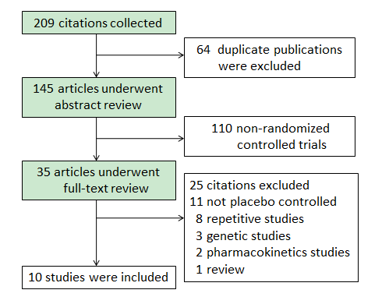

Figure 2 Comparative clinical response of biological agents therapy for moderate to severe active ulcerative colitis.
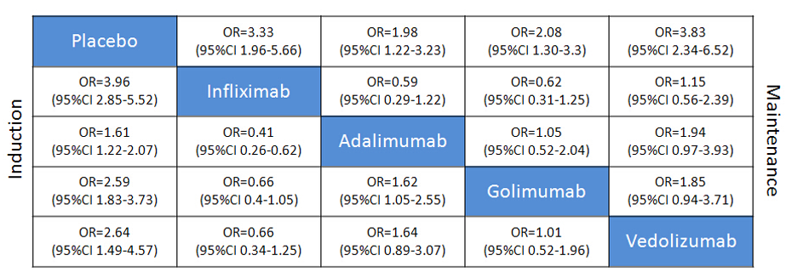

Figure 3 Forest plots of biological agents therapy clinical reponse for moderate to severe active ulcerative colitis.
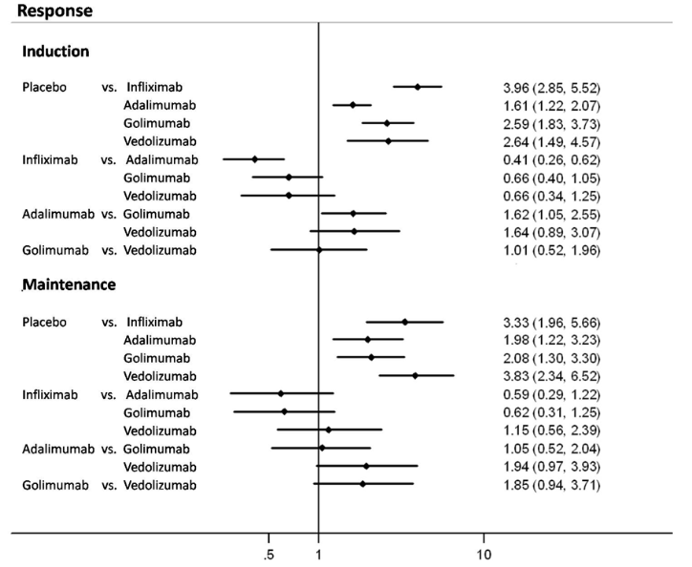

Figure 4 Comparative clinical remission of biological agents therapy for moderate to severe active ulcerative colitis.
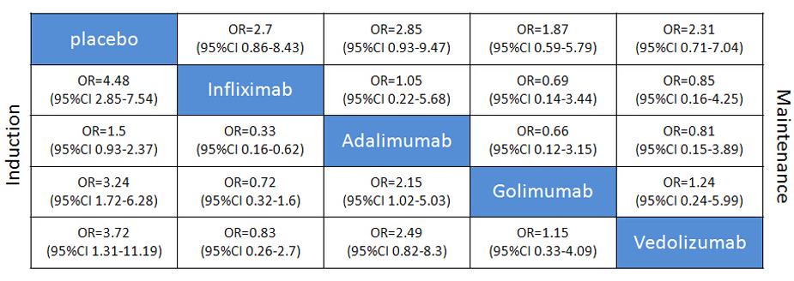

Figure 5 Forest plots of biological agents therapy clinical remission for moderate to severe active ulcerative colitis.
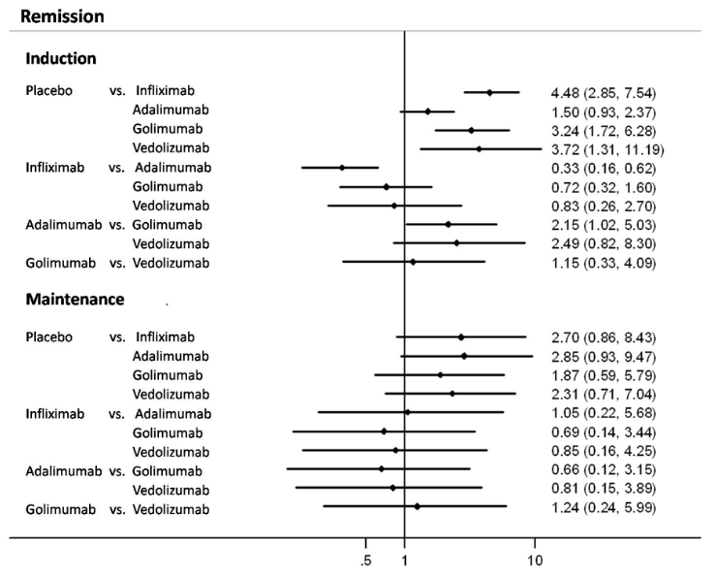

Figure 6 Comparativemucosal healing of biological agents therapy for moderate to severe active ulcerative colitis.
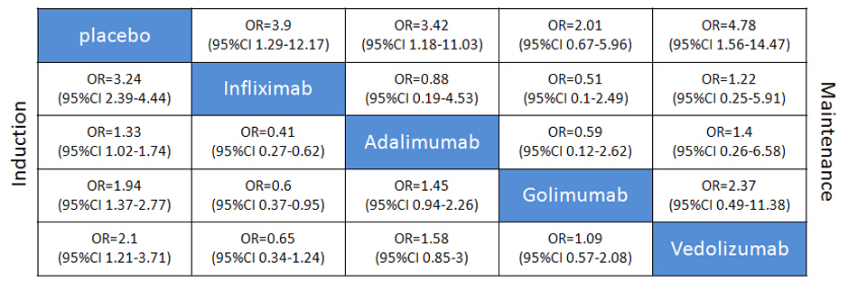

Figure 7 Forest plots of biological agents therapy mucosal healing for moderate to severe active ulcerative colitis.
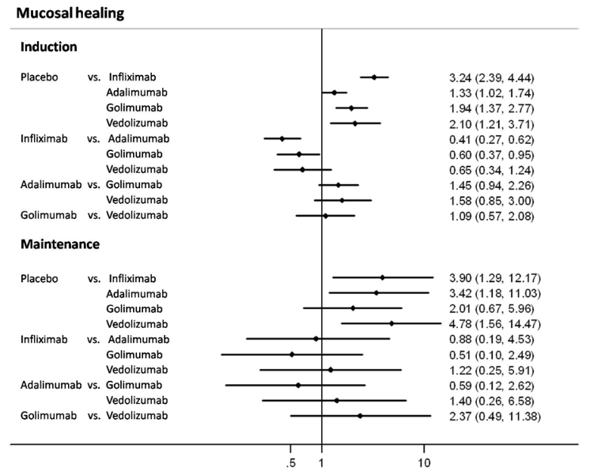

Figure 8 Comparative serious adverse events of biological agents therapy for moderate to severe active ulcerative colitis.
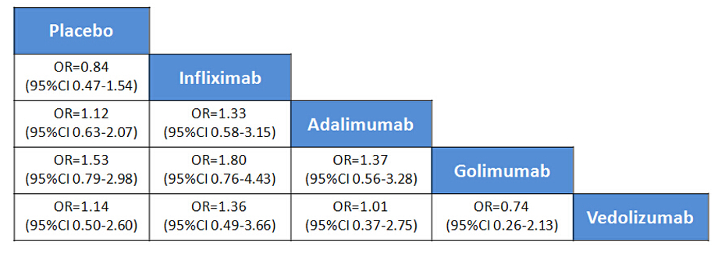

Figure 9 Forest plots of biological agents therapy serious adverse events for moderate to severe active ulcerative colitis.
