Name of journal: World Journal of Gastroenterology
ESPS Manuscript NO: 32
Columns: BRIEF ARTICLES

Dual probiotic strains suppress high fructose-induced metabolic syndrome

Park DY et al. L.curvatus and L.plantarum suppress metabolic syndrome

Do-Young Park, Young-Tae Ahn, Chul-Sung Huh, Robin A McGregor, Myung-Sook Choi

Do-Young Park, Young-Tae Ahn, Chul-Sung Huh, Korea Yakult Co., Ltd., Yongin, Gyeonggi 449-901, South Korea

Robin A McGregor, Myung-Sook Choi, Department of Food Science and Nutrition, Center for Food and Nutritional Genomics, Kyungpook National University, Daegu 702-701, South Korea

Author contributions: Park DY, Ahn YT, Huh CS and Choi MS contributed to the conception, design and acquisition of data; Park DY and McGregor RA contributed to the analysis and interpretation of data; Park DY, McGregor RA and Choi MS contributed to drafting the article or revising it critically for important intellectual content; all authors gave final approval of the version to be published.

Supported by the Basic Science Research Program, Center for Food and Nutritional Genomics, the National Research Foundation (NRF) of Korea funded by the Ministry of Education, Science and Technology and Korea Yakult Co., Ltd., No. 2011-0000912

Correspondence to: Myung-Sook Choi, PhD, Professor of Food and Nutrition, Department of Food Science and Nutrition, Kyungpook National University, 1370 Sankyuk Dong, Buk-gu, Daegu 702-701, South Korea. mschoi@knu.ac.kr

Telephone: +82-53-9506232 Fax: +82-53-9506229
Received: July 7, 2012 Revised: September 16, 2012
Accepted: November 14, 2012
Published online:

Abstract

AIM: To investigate the effect of novel probiotics on the clinical characteristics of high-fructose induced metabolic syndrome.

METHODS: Male Wistar rats aged 4 wk were fed a 70% w/w high-fructose diet (n = 27) or chow diet (n = 9) for 3 wk to induce metabolic syndrome, then randomised into groups and administered probiotic [Lactobacillus curvatus (L. curvatus) HY7601 and Lactobacillus plantarum (L. plantarum) KY1032] at 10⁹ cfu/d or 10¹⁰ cfu/d or placebo by oral gavage for 3 wk. Food intake and body weight were measured once a week. After 6 wk, rats were fasted for 12 h, then anesthetized with diethyl ether and sacrificed. Blood samples were taken from the inferior vena cava for plasma analysis of glucose, insulin, C-peptide, total-cholesterol, triglycerides and thiobarbituric acid-reacting substances. Real-time polymerase chain reaction was performed using mouse-specific Taqman probe sets to assess genes related to fatty acid β-oxidation, lipogenesis and cholesterol metabolism in liver. Target gene expression was normalized to the housekeeping gene glyceraldehyde-3-phosphate dehydrogenase.

RESULTS: Rodents fed a high-fructose diet developed clinical characteristics of the metabolic syndrome including increased plasma glucose, insulin, triglycerides, total cholesterol and oxidative stress levels, as well as increased liver mass and liver lipids compared to chow fed controls. Probiotic treatment (L. curvatus HY7601 and L. plantarum KY1032) at high (10¹⁰ cfu/d) or low dosage (10⁹ cfu/d) lowered plasma glucose, insulin, triglycerides and oxidative stress levels. Only high-dose probiotic treatment reduced liver mass and liver cholesterol. Probiotic treatment reduced lipogenesis via down-regulation of SREBP1, FAS and SCD1 mRNA levels and increased β-oxidation via up-regulation of PPARα and CPT2 mRNA levels.

CONCLUSION: Probiotic L. curvatus HY7601 and L. plantarum KY1032 combined suppressed clinical characteristics of high-fructose induced metabolic syndrome therefore may provide a natural alternative for the treatment of diet-induced metabolic syndrome.

© 2012 Baishideng. All rights reserved.

Key words: Dyslipidemia; Fasting glucose; Gut microbiota; High-Fructose diet; Inflammation; Insulin resistance; Lactobacillus; Metabolic syndrome; Oxidative stress; Probiotic

Park DY, Ahn YT, Huh CS, McGregor RA, Choi MS. Dose-dependent effects of two probiotic strains combined on high fructose-induced metabolic syndrome. World J Gastroenterol
Available from: URL: http://www.wjgnet.com/
DOI: http://dx.doi.org/

INTRODUCTION
Metabolic syndrome is a rapidly growing worldwide pandemic, which is associated with greater risk of multiple chronic pathologies including cardiovascular disease and Type 2 diabetes. Metabolic syndrome is characterised by a cluster of metabolic abnormalities including insulin resistance, elevated fasting glucose, elevated plasma triglycerides, elevated blood pressure, low-grade inflammation, abdominal obesity and reduced high-density lipoprotein (HDL)-cholesterol^{[1,2]}. There is no universal cause of metabolic syndrome, although major underlying risk factors include abdominal obesity, physical inactivity or diabetogenic diets^{[1]}.
Diabetogenic diets with high fructose content have been strongly implicated in the development of metabolic syndrome, cardiovascular disease and Type 2 diabetes^{[3]}. Food manufacturers are increasingly using fructose corn syrup to increase sweetness, as well as the palatability of food and beverages. However, there is growing experimental evidence that excessive fructose intake can lead to metabolic abnormalities, including insulin resistance, dyslipidemia as well as abdominal adiposity in both animals and humans^{[4]}. Animals fed a high-fructose diet develop clinical characteristics of metabolic syndrome, therefore high-fructose fed animals are particularly useful to assess potential therapeutic interventions against metabolic syndrome^{[5]}. Excess dietary fructose can be converted to triglycerides through de novo lipogenesis, resulting in increased lipid accumulation in the liver and elevated blood lipid levels. Over-time prolonged high intracellular and systemic lipid levels can cause increased oxidative stress and inflammation, both of which can trigger insulin resistance, leading to increased blood glucose levels. Due to the lack of effective drugs to treat metabolic syndrome, there is growing interest in natural therapeutics to prevent or manage metabolic syndrome.
Over the past five years, probiotics have rapidly emerged as natural therapeutics with potential to target key risk factors associated with metabolic syndrome^{[6,7]}. Probiotics consist of single or multiple live bacterial species, which may directly or indirectly modulate gut microbial activity and improve host health. The human gut harbours between 10¹⁴ bacterial species collectively forming the gut microbiota^{[8]}. Gut microbial communities are proposed to provide the host with the ability to harvest otherwise inaccessible energy from the diet^{[9-11]} and also modulate host genes associated with energy storage in adipose tissue^{[2,12]}. Probiotics have been widely assessed in-vivo in diet-induced obesity models^{[13-17]}, however different probiotic species even from the same family can exert variable effects on lipid accumulation and obesity^{[18]}, therefore it remains essential to assess the effectiveness of probiotic strains in different animal disease models in-vivo. Probiotic yogurt containing multiple lactobacillus strains has been reported to alleviate fasting blood glucose, plasma insulin and triglyceride in high-fructose fed rats^{[19]}. However, few other studies have considered the impact of probiotics on high-fructose diet induced metabolic syndrome. To our knowledge, the dose dependent and metabolic effects of probiotic treatment in high-fructose induced metabolic syndrome remain to be established.
The aim of this study was to assess the dose dependent effects of a probiotic consisting of Lactobacillus curvatus (L. curvatus) HY7601 and lactobacillus plantarum (L. plantarum) KY1032 on hyperlipidemia, hyperglycaemia, insulin resistance, oxidative stress and hepatic metabolism related gene expression in high-fructose fed rats with metabolic syndrome. We hypothesized probiotic treatment may protect against dysregulated metabolism induced by a high-fructose diet in a dose-dependent manner.

MATERIALS AND METHODS
Animals, diets and experimental design
Male Wistar rats (n = 36) aged 4 wk were purchased from Jackson Laboratories (Bar Harbor, United States). All rats were individually housed under a constant temperature and humidity (22 ± 1 ºC, 55% ± 10%) with 12 h light/12 h dark cycle. The experimental design consisted of a pretreatment phase (0-3 wk) and a treatment phase (3-6 wk). During the pretreatment phase male Wistar rats were fed a 70% w/w high-fructose diet (n = 27) to induce metabolic abnormalities or a chow diet (n = 9) for 3 wk. The composition of the high-fructose diet was formulated according to Table 1. During the treatment phase, the placebo (HF) group (n = 9), low dose probiotic (LP) group (n = 9) and high dose probiotic (HP) group (n = 9) were fed the same high-fructose diet with placebo, 10⁹ cfu probiotics or 10¹⁰ cfu probiotics administered orally each day for a further 3 wk. The chow control group was fed the same chow diet with placebo administered orally each day for a further 3 wk. Freeze-dried Lactobacillus strains were produced by Culture Systems Inc. (United States), and packed with lactose according to Table 2. Each pack was resuspended in 500 μL distilled water prior to administration. Food intake and body weight were measured once a week. Before sacrifice, rats were fasted for 12 h and anesthetized with diethyl ether. Blood samples were taken from the inferior vena cava for plasma analysis. Epididymal adipose tissue and liver tissue were removed, rinsed with phosphate buffered saline, weighed and immediately frozen at -70 °C. The experimental design was approved by the Ethics Committee of Korea Yakult Company Limited Rand D center.

Blood analysis
Plasma glucose, insulin and C-peptide concentrations were determined using the glucose assay kit (Cayman, United States), insulin enzyme-linked immunosorbent assay (ELISA) kit (Millipore, United States) and rat C-peptide ELISA kit (EIAab, China) according to the manufacturer’s instructions. Insulin resistance was assessed based on homeostasis model assessment of insulin resistance (HOMA-IR), calculated as the product of fasting plasma glucose (FPG) and insulin (FPI), divided by a constant^{[20]}. The equation was [FPG (mg/dL) × FPI (μU/mL)]/2430. Plasma total-cholesterol and triglyceride concentrations were determined using commercial kits (AsanPharm, South Korea). Plasma thiobarbituric acid-reacting substances (TBARS) were measured to assess oxidative stress as described previously^{[21]}.

Hepatic lipid profile analysis

Hepatic lipids were extracted as previously reported^{[22]}. The dried lipid residues were dissolved in 1 mL of isopropanol for the triglyceride and cholesterol assays. Hepatic triglyceride and cholesterol concentrations were measured using the same commercial kits (AsanPharm, South Korea) used for the plasma analysis.

RT-qPCR

Total RNA was extracted from liver (15 mg) tissue using an RNAqueous kit (Ambion, United States). DNA was removed with a Turbo DNA-free kit (Ambion, United States). RNA integrity was verified and RNA quantified using a GeneQuant Pro spectrophotometer (GE Healthcare, United States). Total RNA (2 µg) was reverse-transcribed into cDNA with a high-capacity RNA-to-cDNA kit (Applied Biosystems Inc., United States). Then cDNA was amplified on a 7500 Real Time PCR System (Applied Biosystems Inc., United States) using mouse-specific Taqman probe sets (Table 3) under the following conditions: 95 °C for 10 min, followed by 40 cycles at 95°C for 15 s, and 60 °C for 1 min. Target gene expression was normalized to the housekeeping gene glyceraldehyde-3-phosphate dehydrogenase (catalog number Rn01775763_g1). Data was analyzed using the ABI 7500 System Sequence Detection software (Applied Biosystems Inc., United States) and presented as mean ± SE.

Statistical analysis

All data were presented as mean ± SE. Statistical analysis was performed using SPSS software (SPSS Inc., United States). Data were analyzed by one way analysis of variance, and the differences between experimental groups were evaluated using Duncan’s multiple range test at the P < 0.05 level. Significant differences between C-P and HF-P groups were determined using unpaired Student’s t-test. Significant differences between week 3 and week 6 in each parameter were determined using paired Student’s t-test, and the values were considered statistically significant when P < 0.05.

RESULTS
Effects of probiotic treatment on food intake, body weight and tissue mass
Metabolic syndrome was induced in rodents by feeding them a high-fructose diet over 3 wk, while a control group was fed a chow diet. Rodents with metabolic syndrome were then randomized into three treatment groups and fed a high-fructose diet for 3 wk more, with daily treatment of either probiotic (HP) at a dose of 1 x 10¹⁰ cfu/d, probiotic (LP) at a dose of 1 x 10⁹ cfu/d or placebo administered by oral gavage. The chow control group were fed the same diet for the same period and administered placebo by oral gavage. Average food intake was suppressed in the high-fructose diet fed rodents compared to the chow fed controls (Figure 1A). However, low or high dose probiotic treatment had no significant effect on food intake (Figure 1A). Body weight gain and epididymal fat mass were not significantly affected by high-fructose feeding or probiotic treatment regardless of dosage (Figure 1B and C). Importantly, average liver mass, which was significantly increased by high-fructose diet, was significantly lower following HP treatment by 10% (P < 0.01) compared to high-fructose fed controls (Figure 1D).

Effects of probiotic treatment on dyslipidaemia
Hypertriglyceridemia was effectively induced by a high-fructose diet within 3 wk (163.91 ± 6.50 mg/dL vs 49.26 ± 3.99 mg/dL, HF and chow group, respectively). However, subsequently 3-wk of probiotic treatment significantly reduced average plasma triglyceride levels by 46% compared to placebo treatment in the high-fructose fed rodents (Figure 2A). The probiotic treatment had no influence on either total cholesterol or HDL cholesterol levels, which were increased by high-fructose diet intake (Figure 2B and C).

Effects of probiotic treatment on hyperglycaemia, insulin resistance and oxidative stress
The average plasma glucose levels of the high-fructose fed rats were significantly higher than that of the chow fed controls at week 6, but effectively reduced following LP and HP treatment by 24% (P < 0.05) and 14% (P < 0.05) respectively (Figure 3A). The average plasma insulin levels of the high-fructose fed rats were significantly higher at both weeks 3 and 6 compared to the chow fed controls. However, after HP treatment plasma insulin levels were substantially lower (31%, P < 0.05) compared to the high-fructose fed rats. Moreover, the plasma insulin levels following LP and HP treatment were 33% (P < 0.01) and 29% (P < 0.05) reduced compared to before treatment (Figure 3B). The HOMA-IR, a representative index of insulin resistance, was significantly higher in the high-fructose fed rats compared to the chow fed controls at week 6, but significantly reduced by LP (35%) and HP (34%) treatment (Figure 3C). Furthermore, HOMA-IR following LP treatment was 25% (P < 0.05) lower compared to before treatment (Figure 3C). The plasma C-peptide is another biomarker associated with insulin resistance. The plasma C-peptide level was 24% (P < 0.05) lower following HP treatment compared to placebo treatment in high-fructose fed rats (Figure 3D). Moreover, the plasma C-peptide levels after HP treatment were 28% (P < 0.05) lower compared to before treatment (Figure 3D). In addition, probiotic treatment of either LP or HP decreased plasma TBARS levels by 37% (P < 0.01) and 50% (P < 0.001), respectively (Figure 3E).

Effects of probiotic treatment on hepatic lipid content and gene expression
Both hepatic triglyceride and cholesterol levels in the high-fructose fed rats were significantly higher than the chow fed controls. Probiotic treatment with either LP or HP tended to reduce hepatic triglyceride levels (Figure 4A), and HP significantly reduced (27%, P < 0.05) hepatic cholesterol levels compared to the high-fructose fed controls (Figure 4B).
In order to determine the mechanisms underlying the probiotic effect on hepatic lipid homeostasis, we examined the mRNA levels of hepatic genes associated with lipid metabolism (Figure 5A-C). High-fructose diet intake altered gene expression compared to chow diet intake. The gene expression changes in the high-fructose group indicated decreases in fatty acid β-oxidation (PPARα, CPT1, CPT2 and ACOX1), cholesterol uptake (LDLR) and bile acid synthesis (CYP7A1), and increases in fatty acid synthesis (SREBP1, FAS, SCD1). Importantly, HP treatment significantly reversed high-fructose induced gene expression changes including up-regulation of PPARα (+76%), CPT2 (+66%) and CYP7A1 (+71%), and down-regulation of SREBP1 (-30%), FAS (-54%) and SCD1 (-23%), although LP treatment did not cause any significant changes in hepatic lipid metabolism gene expression.

DISCUSSION
Recent studies indicate the gut microbiota plays an important role in host lipid and glucose metabolism. Therefore, therapeutic probiotics which can manipulate the gut microbiota may also prevent some of the risk factors underlying the development of metabolic syndrome including dyslipidemia, elevated fasting glucose levels and insulin resistance^{[23]}. In the present study, we used a novel probiotic consisting of L. curvatus HY7601 and L. plantarum KY1302 isolated from Korean fermented cabbage. We show probiotic administered to high-fructose fed mice reverses risk factors underlying the metabolic syndrome. Previous evidence from high-fructose diet-fed rat studies indicated a probiotic-cultured yogurt called Dahi can also improve metabolic abnormalities^{[19,24]}. Importantly, here we established the dose-dependent effects of a novel combination of probiotic strains on metabolic syndrome.
High-fructose intake is reported to promote lipogenesis and suppress glucose intake^{[25-27]}. Consistent with other studies of high-fructose fed animals hepatic gene expression analysis indicated lipogenesis was increased via upregulation of SREBP1, FAS and SCD1, conversely β-oxidation was decreased via downregulation of PPARα and PPARα-regulated CPT1, CPT2 and ACOX1 expression^{[25-27]}. Increased lipogenesis and decreased β-oxidation lead to excess accumulation of cellular lipids, evident by the liver enlargement and hypertriglyceridemia in the high-fructose fed rats in the present study. Hypertriglyceridemia is known to be an important predictor of cardiovascular disease mortality in subjects with diabetes or impaired glucose tolerance^{[28]}, therefore reducing plasma triglycerides levels may improve long-term health.
Past studies show probiotics can alter the gut microbiota^{[29]}, and direct gut microbiota manipulations in germ-free mice significantly affect host lipid metabolism^{[2,12]}. Here we showed 10¹⁰ cfu/d probiotic treatment led to upregulated PPARα and CPT2 expression reflecting activation of β-oxidation, and downregulated SREBP1, FAS and SCD1 expression reflecting suppression of lipogenesis. Moreover, these probiotic induced transcriptional changes resulted in a significant reduction in liver mass and plasma triglyceride levels. These findings are consistent with previous a previous report which showed L. plantarum KY1032 inhibits lipid droplet accumulation during adipocyte differentiation. In contrast to plasma triglyceride levels, hepatic triglyceride levels were only slightly reduced by probiotic treatment. We hypothesized that the probiotic induced increase in hepatic β-oxidation related gene expression was partly to clear excess hepatic triglycerides generated through high-fructose induced de novo lipogenesis.
Contrary to hepatic triglyceride levels, cholesterol levels were significantly reduced by probiotic treatment whereas plasma cholesterol levels were unchanged. We assessed whether the reduction in hepatic cholesterol following probiotic treatment was due to altered hepatic cholesterol metabolism related gene expression. High-fructose diet suppressed CYP7A1 expression, which encodes cholesterol 7 alpha-hydroxylase, the rate-limiting enzyme involved in the formation of bile from cholesterol. However, 10¹⁰ cfu/d probiotic treatment upregulated CYP7A1 expression indicating increased bile synthesis activity. Some probiotics are also reported to increase bile salt hydrolase activity^{[30]}. Hepatic LDLR expression remained unchanged, suggesting probiotic treatment did not enhance uptake of plasma cholesterol into the liver, which is consistent with the absence of changes in plasma cholesterol levels. However, the effect of probiotics on liver cholesterol metabolism may be party dependent on the diet regime used, because in high-fat or high-cholesterol diet fed animals, probiotics are reported to decrease plasma and hepatic cholesterol levels together.
The probiotic effect on host lipid levels may also contribute to the observed improvement in glucose homeostasis. Excess intracellular lipids can inhibit insulin signalling, hence reduce insulin-stimulated glucose uptake leading to hyperglycemia and hyperinsulinemia as shown in this study. We observed probiotic treatment at 10⁹ or 10¹⁰ cfu/d significantly lowered plasma glucose, insulin and C-peptide concentrations, as well as reducing insulin resistance indicated by the reduced HOMA-IR index^{[20,31]}. Excess fructose intake is also reported to promote lipid peroxidation and oxidative stress is implicated in the pathogenesis of insulin resistance^{[32,33]}. In the present study, probiotic treatment at 10⁹ or 10¹⁰ cfu/d significantly reversed the oxidative stress present in the high-fructose fed rats with metabolic syndrome, indicated by lower plasma TBARS levels. Some Lactobacillus strains are also reported to possess anti-oxidative activity. For example, probiotics have been reported to reduce exercise-induced oxidative stress, via increases in anti-oxidative activity, which helps neutralise reactive oxygen species ^{[34]}. Furthermore, studies in human Type 2 diabetes show probiotic supplementation can increase superoxide dismutase and glutathione peroxidase activities ^{[35]}, which are anti-oxidants that help protect against oxidative stress.
While evidence is growing on the effects of probiotic treatment on many chronic pathologies, some issues remain to be addressed. Probiotics are widely assumed to modulate the gut microbiota, and exert health benefits via direct modification of gut microbial communities^{[8]}. Studies on diet-induced mice indicate probiotics alter the gut microbiota^{[29]}, similar to our recent experience with the same probiotic used in this study (unpublished observations). Although in another study using germ-free mice transplanted with a small artificial gut microbial community, a multi-species probiotics failed to change the gut microbiota^{[36]}. Whether multi-species probiotics are more effective than single-species probiotics is not clear, because few studies make this comparison. We used a two species probiotic in the present study, based on our preliminary data that suggests combined species are more effective than either species alone. Finally, whether probiotics exert dose-dependent effects against metabolic syndrome has not been evaluated, nor the minimum amount of live bacteria that is necessary for functional health benefits. Evidence from the present study indicates probiotics containing 10¹⁰ cfu/d showed the greatest effectiveness against high-fructose induced metabolic syndrome, over a relatively short-term period without any adverse effects. In contrast, probiotic treatment at 10⁹ cfu/d exerted minimal effects on hypertriglyceridemia, but effectively improved hyperglycaemia and insulin resistance. In the case of hepatic gene expression, 10⁹ cfu/d probiotic treatment had no modulatory effect on any of the genes tested, but probiotic treatment at 10¹⁰ cfu/d modulated lipogenesis and β-oxidation related genes.
In conclusion, probiotic L. curvatus HY7601 and L. plantarum KY1032 combined can suppress clinical characteristics of high-fructose induced metabolic syndrome therefore may provide a natural alternative for the treatment of diet-induced metabolic syndrome.

ACKNOWLEDGMENTS
Choi MS and McGregor RA declare no conflicts of interest. Park DY, Ahn YT and Huh CS are current or past employees of Korea YaKult Co., Ltd.

COMMENTS
Background
Metabolic syndrome is a growing health problem characterised by elevated blood sugar and blood lipid levels, insulin resistance, high blood pressure and abdominal obesity. Poor diet consisting of high sugar or high fat content is a major risk factor for metabolic syndrome. There is no universal treatment for metabolic syndrome. Probiotics found in fermented foods have emerged as a natural way to protect against metabolic syndrome, but many probiotic strains exist with varying metabolic effects. Therefore, a major challenge for scientists is discovering probiotic strains, which may help protect against metabolic syndrome.

Research frontiers
Probiotic strains identified in kimchi, a traditional Korean fermented cabbage consumed regularly in South Asian countries, are reported to have various beneficial properties. Current research aims to determine whether these probiotic strains are effective in different animal models of disease including metabolic syndrome, Type 2 diabetes and obesity.

Innovations and breakthroughs
We show two probiotic strains called Lactobacillus curvatus (L. curvatus) HY7601 and Lactobacillus plantarum (L. plantarum) KY1032 can suppress metabolic abnormalities such as hypertriglyceridemia, hyperglycaemia and insulin resistance in high-fructose induced metabolic syndrome. These probiotic health benefits were associated with decreased lipogenesis and increased β-oxidation related gene expression in the liver.

Applications
Probiotic with L. curvatus HY7601 and L. plantarum KY1032 may provide a natural supplement for the management of the underlying risk factors of metabolic syndrome.

Terminology
Probiotics consist of live micro-organisms which confer beneficial effects on host health. Hypertriglyceridemia is the prolonged elevated triglyceride levels in blood. Hyperglycaemia is the prolonged elevated glucose levels in the blood. Insulin resistance is the inability of insulin to stimulate glucose uptake pathways in fat, skeletal muscle and the liver.

Peer review
This paper investigated the effect of novel probiotics on the clinical characteristics of high-fructose induced metabolic syndrome. The authors were suggesting a mechanism. One novel thing of this paper is that no one has looked at these specific microbes in this combination. It is well written.

REFERENCES
- Grundy SM, Cleeman JI, Daniels SR, Donato KA, Eckel RH, Franklin BA, Gordon DJ, Krauss RM, Savage PJ, Smith SC, Spertus JA. Diagnosis and management of the metabolic syndrome: an American Heart Association/National Heart, Lung, and Blood Institute scientific statement: Executive Summary. Crit Pathw Cardiol 2005; 4: 198-203 [PMID: 18340209]
- Bäckhed F, Ding H, Wang T, Hooper LV, Koh GY, Nagy A, Semenkovich CF, Gordon JI. The gut microbiota as an environmental factor that regulates fat storage. Proc Natl Acad Sci USA 2004; 101: 15718-15723 [PMID: 15505215]
- Malik VS, Popkin BM, Bray GA, Després JP, Hu FB. Sugar-sweetened beverages, obesity, type 2 diabetes mellitus, and cardiovascular disease risk. Circulation 2010; 121: 1356-1364 [PMID: 20308626]
- Stanhope KL, Schwarz JM, Keim NL, Griffen SC, Bremer AA, Graham JL, Hatcher B, Cox CL, Dyachenko A, Zhang W, McGahan JP, Seibert A, Krauss RM, Chiu S, Schaefer EJ, Ai M, Otokozawa S, Nakajima K, Nakano T, Beysen C, Hellerstein MK, Berglund L, Havel PJ. Consuming fructose-sweetened, not glucose-sweetened, beverages increases visceral adiposity and lipids and decreases insulin sensitivity in overweight/obese humans. J Clin Invest 2009; 119: 1322-1334 [PMID: 19381015]
- de Moura RF, Ribeiro C, de Oliveira JA, Stevanato E, de Mello MA. Metabolic syndrome signs in Wistar rats submitted to different high-fructose ingestion protocols. Br J Nutr 2009; 101: 1178-1184 [PMID: 19007450]
- Everard A, Lazarevic V, Derrien M, Girard M, Muccioli GG, Neyrinck AM, Possemiers S, Van Holle A, François P, de Vos WM, Delzenne NM, Schrenzel J, Cani PD. Responses of gut microbiota and glucose and lipid metabolism to prebiotics in genetic obese and diet-induced leptin-resistant mice. Diabetes 2011; 60: 2775-2786 [PMID: 21933985]
- Cani PD, Amar J, Iglesias MA, Poggi M, Knauf C, Bastelica D, Neyrinck AM, Fava F, Tuohy KM, Chabo C, Waget A, Delmée E, Cousin B, Sulpice T, Chamontin B, Ferrières J, Tanti JF, Gibson GR, Casteilla L, Delzenne NM, Alessi MC, Burcelin R. Metabolic endotoxemia initiates obesity and insulin resistance. Diabetes 2007; 56: 1761-1772 [PMID: 17456850]
- Sekirov I, Russell SL, Antunes LC, Finlay BB. Gut microbiota in health and disease. Physiol Rev 2010; 90: 859-904 [PMID: 20664075]
- Turnbaugh PJ, Hamady M, Yatsunenko T, Cantarel BL, Duncan A, Ley RE, Sogin ML, Jones WJ, Roe BA, Affourtit JP, Egholm M, Henrissat B, Heath AC, Knight R, Gordon JI. A core gut microbiome in obese and lean twins. Nature 2009; 457: 480-484 [PMID: 19043404]
- Turnbaugh PJ, Ley RE, Mahowald MA, Magrini V, Mardis ER, Gordon JI. An obesity-associated gut microbiome with increased capacity for energy harvest. Nature 2006; 444: 1027-1031 [PMID: 17183312]
- Bird AR, Brown IL, Topping DL. Starches, resistant starches, the gut microflora and human health. Curr Issues Intest Microbiol 2000; 1: 25-37 [PMID: 11709851]
- Bäckhed F, Manchester JK, Semenkovich CF, Gordon JI. Mechanisms underlying the resistance to diet-induced obesity in germ-free mice. Proc Natl Acad Sci USA 2007; 104: 979-984 [PMID: 17210919]
- Lee K, Paek K, Lee HY, Park JH, Lee Y. Antiobesity effect of trans-10,cis-12-conjugated linoleic acid-producing Lactobacillus plantarum PL62 on diet-induced obese mice. J Appl Microbiol 2007; 103: 1140-1146 [PMID: 17897219 DOI: 10.1111/j.1365-2672.2007.03336.x]
- Lee HY, Park JH, Seok SH, Baek MW, Kim DJ, Lee KE, Paek KS, Lee Y, Park JH. Human originated bacteria, Lactobacillus rhamnosus PL60, produce conjugated linoleic acid and show anti-obesity effects in diet-induced obese mice. Biochim Biophys Acta 2006; 1761: 736-744 [PMID: 16807088 DOI: 10.1016/j.bbalip.2006.05.007]
- Kondo S, Xiao JZ, Satoh T, Odamaki T, Takahashi S, Sugahara H, Yaeshima T, Iwatsuki K, Kamei A, Abe K. Antiobesity effects of Bifidobacterium breve strain B-3 supplementation in a mouse model with high-fat diet-induced obesity. Biosci Biotechnol Biochem 2010; 74: 1656-1661 [PMID: 20699581]
- Kang JH, Yun SI, Park HO. Effects of Lactobacillus gasseri BNR17 on body weight and adipose tissue mass in diet-induced overweight rats. J Microbiol 2010; 48: 712-714 [PMID: 21046354 DOI: 10.1007/s12275-010-0363-8]
- Chen JJ, Wang R, Li XF, Wang RL. Bifidobacterium longum supplementation improved high-fat-fed-induced metabolic syndrome and promoted intestinal Reg I gene expression. Exp Biol Med (Maywood) 2011; 236: 823-831 [PMID: 21685239 DOI: 10.1258/ebm.2011.010399]
- Yin YN, Yu QF, Fu N, Liu XW, Lu FG. Effects of four Bifidobacteria on obesity in high-fat diet induced rats. World J Gastroenterol 2010; 16: 3394-3401 [PMID: 20632441]
- Yadav H, Jain S, Sinha PR. Antidiabetic effect of probiotic dahi containing Lactobacillus acidophilus and Lactobacillus casei in high fructose fed rats. Nutrition 2007; 23: 62-68 [PMID: 17084593]
- Cacho J, Sevillano J, de Castro J, Herrera E, Ramos MP. Validation of simple indexes to assess insulin sensitivity during pregnancy in Wistar and Sprague-Dawley rats. Am J Physiol Endocrinol Metab 2008; 295: E1269-E1276 [PMID: 18796548]
- Do GM, Oh HY, Kwon EY, Cho YY, Shin SK, Park HJ, Jeon SM, Kim E, Hur CG, Park TS, Sung MK, McGregor RA, Choi MS. Long-term adaptation of global transcription and metabolism in the liver of high-fat diet-fed C57BL/6J mice. Mol Nutr Food Res 2011; 55 Suppl 2: S173-S185 [PMID: 21618427 DOI: 10.1002/mnfr.201100064]
- Park DY, Ahn YT, Huh CS, Jeon SM, Choi MS. The inhibitory effect of Lactobacillus plantarum KY1032 cell extract on the adipogenesis of 3T3-L1 Cells. J Med Food 2011; 14: 670-675 [PMID: 21554138 DOI: 10.1089/jmf.2010.1355]
- Kootte RS, Vrieze A, Holleman F, Dallinga-Thie GM, Zoetendal EG, de Vos WM, Groen AK, Hoekstra JB, Stroes ES, Nieuwdorp M. The therapeutic potential of manipulating gut microbiota in obesity and type 2 diabetes mellitus. Diabetes Obes Metab 2012; 14: 112-120 [PMID: 21812894]
- Yadav H, Jain S, Sinha PR. Effect of skim milk and dahi (yogurt) on blood glucose, insulin, and lipid profile in rats fed with high fructose diet. J Med Food 2006; 9: 328-335 [PMID: 17004894]
- Basciano H, Federico L, Adeli K. Fructose, insulin resistance, and metabolic dyslipidemia. Nutr Metab (Lond) 2005; 2: 5 [PMID: 15723702]
- Miyazaki M, Dobrzyn A, Man WC, Chu K, Sampath H, Kim HJ, Ntambi JM. Stearoyl-CoA desaturase 1 gene expression is necessary for fructose-mediated induction of lipogenic gene expression by sterol regulatory element-binding protein-1c-dependent and -independent mechanisms. J Biol Chem 2004; 279: 25164-25171 [PMID: 15066988]
- Nagai Y, Nishio Y, Nakamura T, Maegawa H, Kikkawa R, Kashiwagi A. Amelioration of high fructose-induced metabolic derangements by activation of PPARalpha. Am J Physiol Endocrinol Metab 2002; 282: E1180-E1190 [PMID: 11934685]
- Fontbonne A, Eschwège E, Cambien F, Richard JL, Ducimetière P, Thibult N, Warnet JM, Claude JR, Rosselin GE. Hypertriglyceridaemia as a risk factor of coronary heart disease mortality in subjects with impaired glucose tolerance or diabetes. Results from the 11-year follow-up of the Paris Prospective Study. Diabetologia 1989; 32: 300-304 [PMID: 2666216]
- Divergent metabolic outcomes arising from targeted manipulation of the gut microbiota in diet-induced obesity. Gut 2012 Aug 9 [Epub ahead of print] [PMID: 22345653 DOI: 10.1136/gutjnl-2011-300705]
- Begley M, Hill C, Gahan CG. Bile salt hydrolase activity in probiotics. Appl Environ Microbiol 2006; 72: 1729-1738 [PMID: 16517616]
- Wu T, Giovannucci E, Pischon T, Hankinson SE, Ma J, Rifai N, Rimm EB. Fructose, glycemic load, and quantity and quality of carbohydrate in relation to plasma C-peptide concentrations in US women. Am J Clin Nutr 2004; 80: 1043-1049 [PMID: 15447918]
- Kelley GL, Allan G, Azhar S. High dietary fructose induces a hepatic stress response resulting in cholesterol and lipid dysregulation. Endocrinology 2004; 145: 548-555 [PMID: 14576175]
- Busserolles J, Rock E, Gueux E, Mazur A, Grolier P, Rayssiguier Y. Short-term consumption of a high-sucrose diet has a pro-oxidant effect in rats. Br J Nutr 2002; 87: 337-342 [PMID: 12064343]
- Martarelli D, Verdenelli MC, Scuri S, Cocchioni M, Silvi S, Cecchini C, Pompei P. Effect of a probiotic intake on oxidant and antioxidant parameters in plasma of athletes during intense exercise training. Curr Microbiol 2011; 62: 1689-1696 [PMID: 21400082]
- Ejtahed HS, Mohtadi-Nia J, Homayouni-Rad A, Niafar M, Asghari-Jafarabadi M, Mofid V. Probiotic yogurt improves antioxidant status in type 2 diabetic patients. Nutrition 2012; 28: 539-543 [PMID: 22129852]
- McNulty NP, Yatsunenko T, Hsiao A, Faith JJ, Muegge BD, Goodman AL, Henrissat B, Oozeer R, Cools-Portier S, Gobert G, Chervaux C, Knights D, Lozupone CA, Knight R, Duncan AE, Bain JR, Muehlbauer MJ, Newgard CB, Heath AC, Gordon JI. The impact of a consortium of fermented milk strains on the gut microbiome of gnotobiotic mice and monozygotic twins. Sci Transl Med 2011; 3: 106ra106 [PMID: 22030749]

P-Reviewer Gibson DL S-Editor Xiong L L-Editor E-Editor

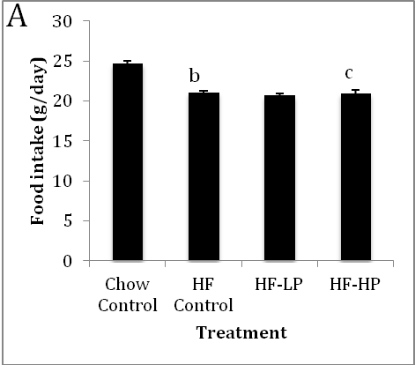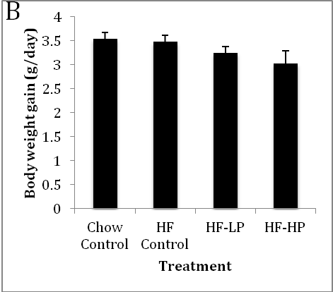
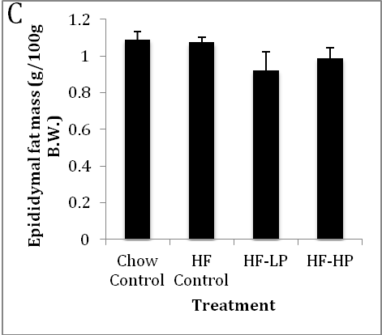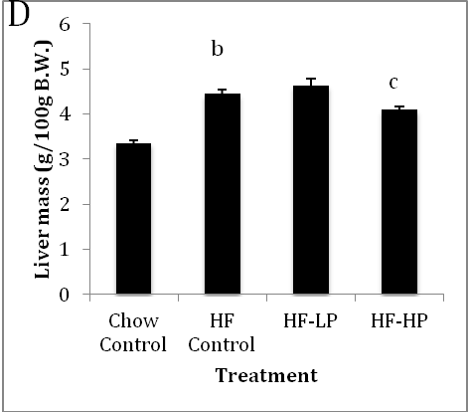
Figure 1 Effects of probiotic treatment on food intake(A), body weight gain (B), epididymal fat mass (C) and liver mass (D) in high-fructose diet-fed rats. Results are expressed as mean ± SE. ^{b}P < 0.01 vs chow control by unpaired Student’s t-test; ^{c}P < 0.05 vs HF control and HF-low dose probiotic (LP) by Duncan’s multiple range tests. HP: High dose probiotic.

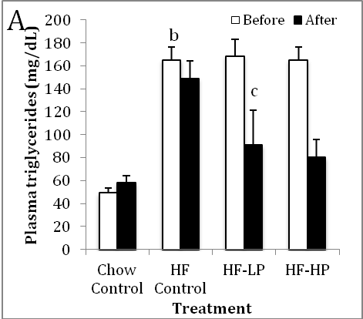

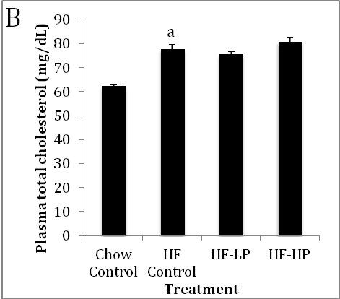

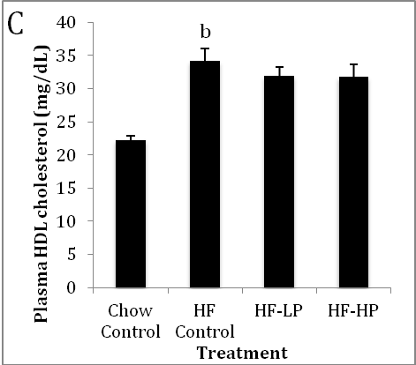
Figure 2 Effects of probiotic treatment on plasma triglyceride (A), plasma total cholesterol (B) and plasma high-density lipoprotein cholesterol (C) in high-fructose diet-fed rats. Results are expressed as mean ± SE. ªP < 0.05 and ^{b}P < 0.01 vs chow control by unpaired Student’s t-test; ^{c}P < 0.05 vs HF control by Duncan’s multiple range tests. GP: High dose probiotic; LP: Low dose probiotic.
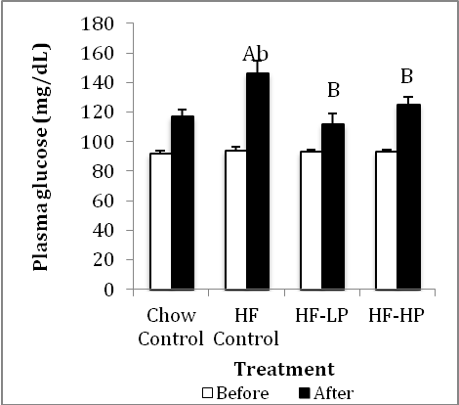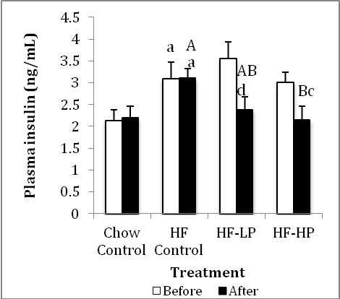
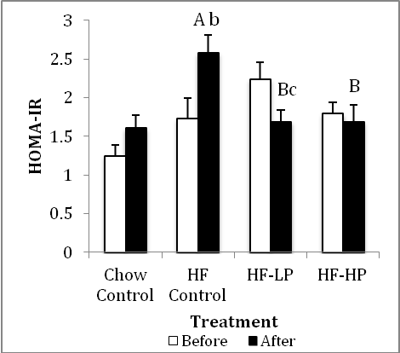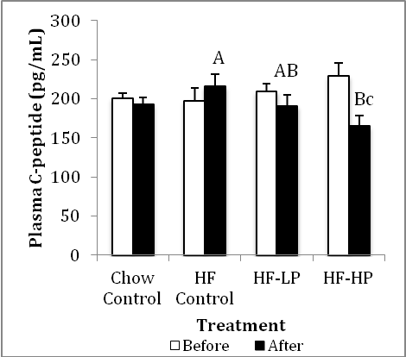
Figure 3 Effects of probiotic treatment on plasma glucose, plasma insulin, insulin resistance, plasma C-peptide and plasma thiobarbituric acid-reacting substances in high-fructose diet-fed rats. Results are expressed as mean ± SE. ªP < 0.05 and ^{b}P < 0.01 high dose probiotic (HP) control vs chow control by unpaired Student’s t-test; ^{c}P < 0.05 and ^{d}P < 0.01 week 6 vs week 3 by paired Student’s t-test; ^{AB}Bars with different capital letters are significantly different at P < 0.05 by Duncan’s multiple range tests. LP: Low dose probiotic.

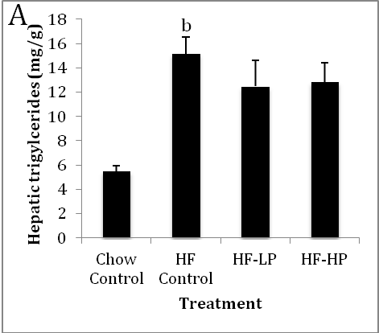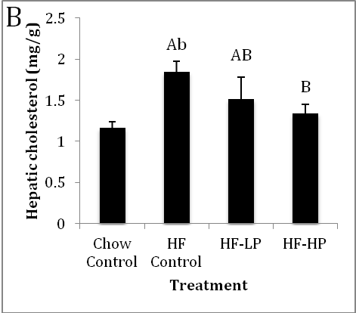
Figure 4 Effects of probiotic treatment on hepatic triglyceride and hepatic total cholesterol in high-fructose diet-fed rats. Results are expressed as mean ± SE. ^{b}P < 0.01 HF control vs chow control by unpaired Student’s t-test; ^{AB}Bars with different capital letters are significantly different at P < 0.05 by Duncan’s multiple range tests. LP: Low dose probiotic; HP: High dose probiotic.

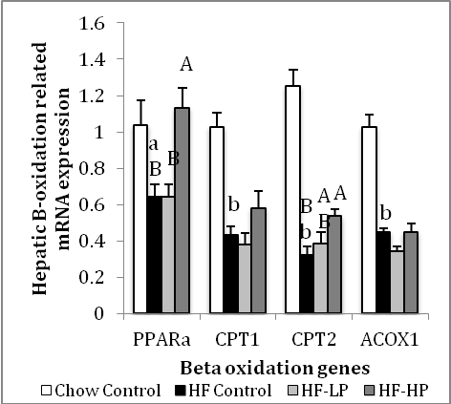
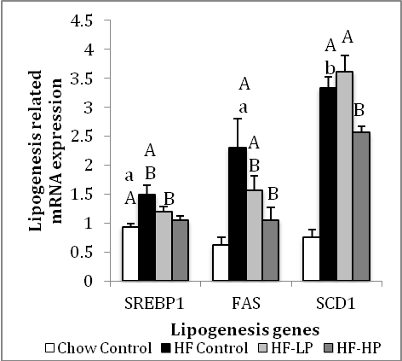
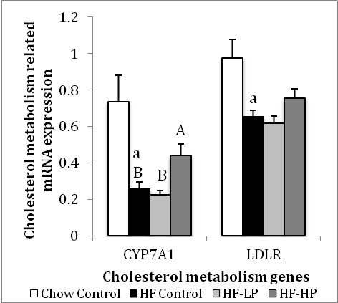

Figure 5 Effects of probiotic treatment on hepatic B-oxidation, lipogenesis and cholesterol metabolism related gene expression in high-fructose diet-fed rats. Results are expressed as mean ± SE. ªP < 0.05 and ^{b}P < 0.01 HF control vs chow control by unpaired Student’s t-test; ^{AB}Bars with different capital letters are significantly different at P < 0.05 by Duncan’s multiple range tests. FAS: Fatty acid synthase; SREBP1: Sterol regulatory element-binding protein-1; PPARα: Peroxisome proliferator-activated receptor alpha; CPT: Carnitine palmitoyltransferase; ACOX: Acyl-coenzyme A oxidase; SCD: Steaoryl-CoA desaturase; CYP7A1: Cholesterol 7alpha-hydroxylase gene; LDLR: Low-density lipoprotein receptor.

Table 1 Composition of high fructose diet
Ingredient | High fructose diet (g)
Casein | 200.0
L-cystine | 3.0
Fructose | 700.0
Cellulose powder | 50.0
Corn oil | 25.0
Lard | 20.0
Mineral Mix S10026 | 10.0
DiCalcium Phosphate | 13.0
Calcium Carbonate | 5.5
Potassium Citrate | 16.5
Vitamin Mix V10001 | 10.0
Choline Bitartrate | 2.0
Total | 1000.0
Table 2 The composition of each supplement pack
 | Placebo (mg) | 10⁹ probiotics (mg) | 10¹⁰ probiotics (mg)
Lactobacillus curvatus HY7601 | - | 5.0 (5 × 10⁸) | 50.0 (5 × 10⁹)
Lactobacillus plantarum KY1032 | - | 2.5 (5 × 10⁸) | 25.0 (5 × 10⁹)
Lactose | 100.0 | 92.5 | 25.0
Total | 100.0 | 100.0 | 100.0
Freeze-dried Lactobacillus curvatus HY7601 and Lactobacillus plantarum KY1032 concentration was 1 × 10⁸ and 2 × 10⁸ cfu/mg, respectively.
Table 3 Catalog numbers of Taqman probes
Taqman probe | Catalog number
Peroxisome proliferative activated receptor α | Rn00566193_m1
Carnitine palmitoyl transferase 1 | Rn00580702_m1
Carnitine palmitoyl transferase 2 | Rn00563995_m1
Acyl-CoA oxidase 1 | Rn01460628_m1
Sterol regulatory element binding protein-1 | Rn01495769_m1
Fatty acid synthase | Rn00569117_m1
Stearoyl-CoA desaturase 1 | Rn00594894_g1
Cholesterol 7 alpha-hydroxylase | Rn00564065_m1
Low density lipoprotein receptor | Rn00598442_m1

