Name of Journal: World Journal of Clinical Cases
Manuscript NO: 62413
Manuscript Type: CASE REPORT

Idiopathic basal ganglia calcification associated with new MYORG mutation site: A case report

Fei BN et al. IBGC with new MYORG mutation site

Bei-Ni Fei, Hui-Zhen Su, Xiang-Ping Yao, Jing Ding, Xin Wang

Bei-Ni Fei, Jing Ding, Xin Wang, Department of Neurology, Zhongshan Hospital, Fudan University, Shanghai 200032, China

Hui-Zhen Su, Xiang-Ping Yao, Department of Neurology and Institute of Neurology, First Affiliated Hospital, Fujian Medical University, Fuzhou 350108, Fujian Province, China

Jing Ding, Xin Wang, CAS Center for Excellence in Brain Science and Intelligence Technology, Shanghai 200032, China

Author contributions: Fei BN collected the clinical data and was the major contributor in writing the manuscript; Su HZ and Yao XP performed the genetic analysis; all authors read and approved the final manuscript; Ding J and Wang X were the patient's attending physicians and directed the writing of the article.

Supported by National Key R&D Program of China, No. 2018YFC1312900.

Corresponding author: Jing Ding, MD, Doctor, Department of Neurology, Zhongshan Hospital, Fudan University, No. 180 Fenglin Road, Shanghai 200032, China. ding.jing@zs-hospital.sh.cn

Received: January 11, 2021
Revised: May 1, 2021
Accepted: July 5, 2021
Published online: August 26, 2021

Abstract
BACKGROUND
Idiopathic basal ganglia calcification (IBGC) is a neurodegenerative disease characterized by symmetrical calcification of basal ganglia and other brain region, also known as Fahr’s disease. It can be sporadic or familial, and there is no definite etiology at present. With the development of neuroimaging, the number of reports of IBGC has increased in recent years. However, due to its hidden onset, diverse clinical manifestations, and low incidence, it is likely to be misdiagnosed or ignored by potential patients and their family.

CASE SUMMARY
We report a case of a 61-year-old man who presented with symptoms of dysphagia and alalia. His computed tomography scan of the brain revealed bilateral symmetric calcifications of basal ganglia, cerebellum, thalamus, and periventricular area. The genetic test showed a new mutation sites of MYORG, c.1438T>G mutation and c.1271_1272 TGGTGCGC insertion mutation. He was finally diagnosed with IBGC.

CONCLUSION
It is important to detect MYORG mutation when IBGC is suspected, especially in those without an obvious family history, for better understanding of the underlying mechanism and identifying potential treatments.

Key Words: Idiopathic basal ganglia calcification; Fahr’s disease; Gene; Point mutation; Inheritance; Case report

©The Author(s) 2021. Published by Baishideng Publishing Group Inc. All rights reserved.

Citation: Fei BN, Su HZ, Yao XP, Ding J, Wang X. Idiopathic basal ganglia calcification associated with new MYORG mutation site: A case report. World J Clin Cases 2021; 9(24): 7169-7174
URL: https://www.wjgnet.com/2307-8960/full/v9/i24/7169.htm
DOI: https://dx.doi.org/10.12998/wjcc.v9.i24.7169

Core Tip: Idiopathic basal ganglia calcification (IBGC) is characterized by calcification of basal ganglia and other regions of the brain. IBGC is clinically heterogeneous and usually exhibits an autosomal dominant pattern of inheritance. We report a case of a 61-year-old man who presented with symptoms of dysphagia and alalia. His computed tomography scan of the brain revealed bilateral symmetric calcifications of basal ganglia, cerebellum, thalamus, and periventricular area. The genetic test showed a new mutation site of MYORG.

INTRODUCTION
Idiopathic basal ganglia calcification (IBGC) is characterized by calcification of basal ganglia and other regions of the brain, commonly known as Fahr’s disease^{[1]}. IBGC is clinically heterogeneous and usually exhibits an autosomal dominant pattern of inheritance. Wang et al^{[2]} discovered the first pathogenic gene of IBGC: SLC20A2 in 2012. Three other IBGC pathogenic genes (PDGFRB^{[3]}, PDGFB^{[4]}, and XPR1^{[5]}) were subsequently identified. In 2018, Yao et al^{[6]} first reported that MYORG is a new pathogenic gene for IBGC with an autosomal-recessive trait. Here, we report a family with novel mutation sites of MYORG.

CASE PRESENTATION
Chief complaints
The patient is a 61-year-old man with the complaint of progressive severe dysphagia and alalia.

History of present illness
Patient’s symptoms started 4 years ago and were getting worse. He denied any headache, seizures, and psychiatric symptoms.

History of past illness
Patient has hypertension for more than 10 years.

Personal and family history
Patient’s parents passed away in their sixties with unknown reason. He had an old brother and three old sisters, three of them died of unknown reason. The surviving sister is clinically asymptomatic but has calcifications on computed tomography (CT) scan (Figure 1A), and total calcification^{[7]} score was 10. His three daughters were also asymptomatic and with normal CT scan. The pedigree chart is shown in Figure 2.

Physical examination
The neurological examination was normal.

Laboratory examinations
Laboratory tests, including serum calcium, phosphorus, and parathyroid hormone levels, were within normal limits (calcium 2.22 mmol/L, phosphorus 0.84 mmol/L, parathyroid hormone 37.5 ng/L).

Imaging examinations
Patient’s CT scan revealed multiple symmetric calcifications of bilateral basal ganglia, cerebellum, thalamus, and periventricular area (Figure 1B). Total calcification score was 54.

Genetic tests
Genetic tests were done for the patient and his family. Excluding the dead and unreachable individuals, 7 people over two generations of the patient’s family were investigated. The patient’s genetic test showed c.1438T >G mutation and c.1271_1272 TGGTGCGC insertion mutation in exon 2 of MYORG gene. Besides the patient, his sister and two of his daughter have MYORG c.1438T>G mutation, while one daughter has MYORG c.1271_1272 TGGTGCGC insertion mutation (Table 1 and Figure 3).

FINAL DIAGNOSIS
According to these laboratory tests and neuroimaging, he was diagnosed with IBGC.

TREATMENT
Oxiracetam and nicergoline were given for neurotrophic treatments and improving cerebrovascular circulation.

OUTCOME AND FOLLOW-UP
The symptoms were not approved with these agents.

DISCUSSION
IBGC is a hereditary disease of the nervous system. With the wide application of CT, the detection rate of IBGC becomes higher and higher. Most patients were healthy in the adolescent period. Even if characteristic calcification lesions had appeared in the head CT examination, there might not be obvious abnormal symptoms of the nervous system. Neuropsychiatric and motor disorders would gradually present in the middle-aged and elderly patients with progressive parkinsonism and spasticity.
In this pedigree, the patient had compound heterozygous mutations, one point mutation and one insertion mutation. His sister and daughters only had one mutation site, and they did not present with any symptoms. Some research found that homozygotes have more serious brain calcification, whereas with the heterozygous mutation, only punctated calcification was found in the globus pallidus. The clinical symptoms in homozygotes are various neurological symptoms, while heterozygotes are usually clinically asymptomatic^{[8]}. Although the patient’s sister and daughters are asymptomatic, they had the MYORG mutation. We suggested to them annual cranial CT scans, because with age the disease may progress and clinical symptoms may appear.
Previous studies reported that IBGC is inherited as an autosomal dominant disease^{[9,10]} and identified SLC20A2 coding for the phosphate transporter PiT2, PDGFRB³ coding for the platelet derived growth factor receptor, as a cause of IBGC. However, SLC20A2, PDGFRB, PDGFB, and XPR1 mutations were only detected in 16.8% of familial brain calcification. The underlying reason of IBGC remains unclear, especially in those without a prominent family history. In 2018, Yao et al^{[6]} identified MYORG as the new recessive causal gene for IBGC, and reported 10 different mutation sites. Our patient and his family have MYORG novel mutation sites, c.1438T>G mutation and c.1271_1272 TGGTGCGC insertion mutation, which have not been reported previously.
MYORG, also known as KIAA1161 or NET37, is located on chromosome 9p13.3. It encodes a protein containing 714 amino acids, which is a member of the glycosylase 31 family. MYORG gene was specifically expressed in S100b positive astrocytes. Bilateral symmetrical nodules of cerebral calcification were observed in MYORG knockout mice. The main components of calcium nodules were calcium and phosphorus, which were highly similar to the elements of brain calcification in clinical patients, which proved that MYORG autosomal recessive function deletion mutation was an important pathogenic gene of IBGC. The mutation of this gene causes dysfunction of astrocytes, which may affect the combination of astrocytes and pericytes, interfere with the normal function of neurovascular unit, and finally may lead to the calcification of the brain. According to the clinical manifestations, Chen et al^{[11]} found that 76.5% patients with MYORG mutation were symptomatic, and the most recurrent symptom was movement disorder. Our patient’s manifestation was progressive dysphagia and alalia.

CONCLUSION
Since many patients will exhibit a progressive neurological disorder with no known treatment, it is important to detect MYORG mutation, especially in those without obvious family history, for better understanding the underlying mechanism and identifying potential treatments.

REFERENCES
1 Manyam BV. What is and what is not 'Fahr's disease'. Parkinsonism Relat Disord 2005; 11: 73-80 [PMID: 15734663 DOI: 10.1016/j.parkreldis.2004.12.001]
2 Wang C, Li Y, Shi L, Ren J, Patti M, Wang T, de Oliveira JR, Sobrido MJ, Quintáns B, Baquero M, Cui X, Zhang XY, Wang L, Xu H, Wang J, Yao J, Dai X, Liu J, Zhang L, Ma H, Gao Y, Ma X, Feng S, Liu M, Wang QK, Forster IC, Zhang X, Liu JY. Mutations in SLC20A2 link familial idiopathic basal ganglia calcification with phosphate homeostasis. Nat Genet 2012; 44: 254-256 [PMID: 22327515 DOI: 10.1038/ng.1077]
3 Nicolas G, Pottier C, Maltête D, Coutant S, Rovelet-Lecrux A, Legallic S, Rousseau S, Vaschalde Y, Guyant-Maréchal L, Augustin J, Martinaud O, Defebvre L, Krystkowiak P, Pariente J, Clanet M, Labauge P, Ayrignac X, Lefaucheur R, Le Ber I, Frébourg T, Hannequin D, Campion D. Mutation of the PDGFRB gene as a cause of idiopathic basal ganglia calcification. Neurology 2013; 80: 181-187 [PMID: 23255827 DOI: 10.1212/WNL.0b013e31827ccf34]
4 Keller A, Westenberger A, Sobrido MJ, García-Murias M, Domingo A, Sears RL, Lemos RR, Ordoñez-Ugalde A, Nicolas G, da Cunha JE, Rushing EJ, Hugelshofer M, Wurnig MC, Kaech A, Reimann R, Lohmann K, Dobričić V, Carracedo A, Petrović I, Miyasaki JM, Abakumova I, Mäe MA, Raschperger E, Zatz M, Zschiedrich K, Klepper J, Spiteri E, Prieto JM, Navas I, Preuss M, Dering C, Janković M, Paucar M, Svenningsson P, Saliminejad K, Khorshid HR, Novaković I, Aguzzi A, Boss A, Le Ber I, Defer G, Hannequin D, Kostić VS, Campion D, Geschwind DH, Coppola G, Betsholtz C, Klein C, Oliveira JR. Mutations in the gene encoding PDGF-B cause brain calcifications in humans and mice. Nat Genet 2013; 45: 1077-1082 [PMID: 23913003 DOI: 10.1038/ng.2723]
5 Legati A, Giovannini D, Nicolas G, López-Sánchez U, Quintáns B, Oliveira JR, Sears RL, Ramos EM, Spiteri E, Sobrido MJ, Carracedo Á, Castro-Fernández C, Cubizolle S, Fogel BL, Goizet C, Jen JC, Kirdlarp S, Lang AE, Miedzybrodzka Z, Mitarnun W, Paucar M, Paulson H, Pariente J, Richard AC, Salins NS, Simpson SA, Striano P, Svenningsson P, Tison F, Unni VK, Vanakker O, Wessels MW, Wetchaphanphesat S, Yang M, Boller F, Campion D, Hannequin D, Sitbon M, Geschwind DH, Battini JL, Coppola G. Mutations in XPR1 cause primary familial brain calcification associated with altered phosphate export. Nat Genet 2015; 47: 579-581 [PMID: 25938945 DOI: 10.1038/ng.3289]
6 Yao XP, Cheng X, Wang C, Zhao M, Guo XX, Su HZ, Lai LL, Zou XH, Chen XJ, Zhao Y, Dong EL, Lu YQ, Wu S, Li X, Fan G, Yu H, Xu J, Wang N, Xiong ZQ, Chen WJ. Biallelic Mutations in MYORG Cause Autosomal Recessive Primary Familial Brain Calcification. Neuron 2018; 98: 1116-1123.e5 [PMID: 29910000 DOI: 10.1016/j.neuron.2018.05.037]
7 Nicolas G, Pottier C, Charbonnier C, Guyant-Maréchal L, Le Ber I, Pariente J, Labauge P, Ayrignac X, Defebvre L, Maltête D, Martinaud O, Lefaucheur R, Guillin O, Wallon D, Chaumette B, Rondepierre P, Derache N, Fromager G, Schaeffer S, Krystkowiak P, Verny C, Jurici S, Sauvée M, Vérin M, Lebouvier T, Rouaud O, Thauvin-Robinet C, Rousseau S, Rovelet-Lecrux A, Frebourg T, Campion D, Hannequin D; French IBGC Study Group. Phenotypic spectrum of probable and genetically-confirmed idiopathic basal ganglia calcification. Brain 2013; 136: 3395-3407 [PMID: 24065723 DOI: 10.1093/brain/awt255]
8 Bauer M, Rahat D, Zisman E, Tabach Y, Lossos A, Meiner V, Arkadir D. MYORG Mutations: a Major Cause of Recessive Primary Familial Brain Calcification. Curr Neurol Neurosci Rep 2019; 19: 70 [PMID: 31440850 DOI: 10.1007/s11910-019-0986-z]
9 Volpato CB, De Grandi A, Buffone E, Facheris M, Gebert U, Schifferle G, Schönhuber R, Hicks A, Pramstaller PP. 2q37 as a susceptibility locus for idiopathic basal ganglia calcification (IBGC) in a large South Tyrolean family. J Mol Neurosci 2009; 39: 346-353 [PMID: 19757205 DOI: 10.1007/s12031-009-9287-3]
10 Dai X, Gao Y, Xu Z, Cui X, Liu J, Li Y, Xu H, Liu M, Wang QK, Liu JY. Identification of a novel genetic locus on chromosome 8p21.1-q11.23 for idiopathic basal ganglia calcification. Am J Med Genet B Neuropsychiatr Genet 2010; 153B: 1305-1310 [PMID: 20552677 DOI: 10.1002/ajmg.b.31102]
11 Chen Y, Fu F, Chen S, Cen Z, Tang H, Huang J, Xie F, Zheng X, Yang D, Wang H, Huang X, Zhang Y, Zhou Y, Liu JY, Luo W. Evaluation of MYORG mutations as a novel cause of primary familial brain calcification. Mov Disord 2019; 34: 291-297 [PMID: 30589467 DOI: 10.1002/mds.27582]

Footnotes
Informed consent statement: Written informed consent was obtained from the patient for the publication of any potentially identifiable images or data included in this article.

Conflict-of-interest statement: We declare that we have no competing interests.

CARE Checklist (2016) statement: The authors have read the CARE Checklist (2016), and the manuscript was prepared and revised according to the CARE Checklist (2016).

Open-Access: This article is an open-access article that was selected by an in-house editor and fully peer-reviewed by external reviewers. It is distributed in accordance with the Creative Commons Attribution NonCommercial (CC BY-NC 4.0) license, which permits others to distribute, remix, adapt, build upon this work non-commercially, and license their derivative works on different terms, provided the original work is properly cited and the use is non-commercial. See: http://creativecommons.org/Licenses/by-nc/4.0/

Manuscript source: Unsolicited manuscript

Peer-review started: January 11, 2021
First decision: April 25, 2021
Article in press: July 5, 2021

Specialty type: Medicine, research and experimental
Country/Territory of origin: China
Peer-review report’s scientific quality classification
Grade A (Excellent): 0
Grade B (Very good): B, B
Grade C (Good): 0
Grade D (Fair): 0
Grade E (Poor): 0

P-Reviewer: Tamune H S-Editor: Fan JR L-Editor: Filipodia P-Editor: Wang LYT
Figure Legends
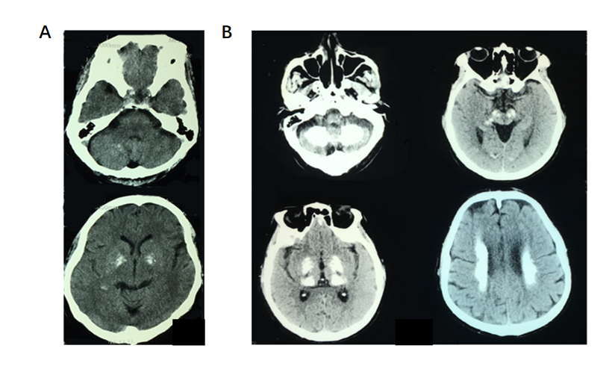
Figure 1 Computed tomography. A: Basal ganglia and cerebellum calcification of patient’s sister; B: Patient’s symmetric calcifications of bilateral basal ganglia, cerebellum, thalamus, and periventricular area.
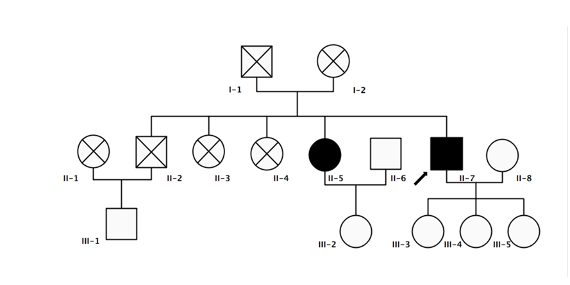
Figure 2 Pedigree. The patients with idiopathic basal ganglia calcification are represented in black, unaffected individuals in white. The index patient is indicated by an arrow.
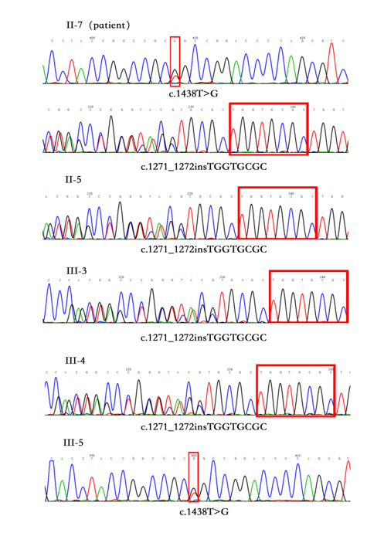
Figure 3 Gene sequencing. II-7 (patient) has c.1438T>G mutation and c.1271_1272 TGGTGCGC insertion mutation. II-5, III-,3 and III-4 has c.1271_1272 TGGTGCGC insertion mutation. III-5 has c.1438T>G mutation.

Table 1 Clinical characteristics of pedigree
 | II-5 | II-7 | II-8 | III-1 | III-3 | III-4 | III-5
Age at evaluation | 66 | 61 | 61 | 51 | 36 | 34 | 32
Education level | II | II | II | III | IV | IV | IV
MMSE (/30) | 27 | 26 | 28 | 29 | 30 | 30 | 30
MoCA (/30) | 26 | 19 | 27 | 28 | 30 | 29 | 29
Clinic symptom | - | + | - | - | - | - | -
Calcifications on CT | + | + | - | - | - | - | -
Total calcification score | 54 | 10 | 0 | 0 | 0 | 0 | 0
MYORG mutation | + | + | - | - | + | + | +
c.1438T>G mutation | - | + | - | - | - | - | +
c.1271_1272 TGGTGCGC insertion mutation | + | + | - | - | + | + | -
CT: Computed tomography; MMSE: Mini-mental state examination; MoCA: Montreal Cognitive Assessment.

Published by Baishideng Publishing Group Inc
7041 Koll Center Parkway, Suite 160, Pleasanton, CA 94566, USA
Telephone: +1-925-3991568
E-mail: bpgoffice@wjgnet.com
Help Desk: https://www.f6publishing.com/helpdesk
https://www.wjgnet.com

© 2021 Baishideng Publishing Group Inc. All rights reserved.

