Name of Journal: World Journal of Gastrointestinal Oncology
Manuscript NO: 46541
Manuscript Type: CASE REPORT

Inflammatory pseudotumor-like follicular dendritic cell sarcoma: A brief report of two cases

Zhang BX et al. Inflammatory pseudotumor-like follicular dendritic cell sarcoma

Bi-Xi Zhang, Zhi-Hong Chen, Yu Liu, Yuan-Jun Zeng, Yan-Chun Li

Bi-Xi Zhang, Zhi-Hong Chen, Yu Liu, Yuan-Jun Zeng, Yan-Chun Li, Department of Pathology, People’s Hospital of Hunan Province, Changsha 410005, Hunan Province, China

ORCID number: Bi-Xi Zhang (0000-0001-7443-5072); Zhi-Hong Chen (0000-0002-8994-5187); Yu Liu (0000-0001-6734-3241); Yuan-Jun Zeng (000-0002-3898-3992); Yan-Chun Li (0000-0001-6462-5868).

Author contributions: All authors contributed to the study; Zhang BX wrote the manuscript; Chen ZH, Liu Y, Zeng YJ, and Li YC collected and analysed the data and contributed to the follow-up results; all authors read and approved the final manuscript.

Informed consent statement: All study participants, or their legal guardian, provided written informed consent prior to the study.

Conflict-of-interest statement: The authors declare that they have no conflict of interest.

CARE Checklist (2016) statement: The manuscript was prepared and revised according to the CARE Checklist (2016).

Open-Access: This article is an open-access article which was selected by an in-house editor and fully peer-reviewed by external reviewers. It is distributed in accordance with the Creative Commons Attribution Non Commercial (CC BY-NC 4.0) license, which permits others to distribute, remix, adapt, build upon this work non-commercially, and license their derivative works on different terms, provided the original work is properly cited and the use is non-commercial. See: http://creativecommons.org/licenses/by-nc/4.0/

Manuscript source: Unsolicited manuscript

Corresponding author: Yan-Chun Li, PhD, Doctor, Department of Pathology, People’s Hospital of Hunan Province, No. 61, Jiefang West Road, Changsha 410005, Hunan Province, China. lychglx@163.com
Telephone: +86-731-83929288

Received: February 20, 2019
Peer-review started: February 22, 2019
First decision: June 4, 2019
Revised: September 1, 2019
Accepted: September 26, 2019
Article in press:
Published online:

Abstract
Background
Follicular dendritic cell (FDC) sarcoma/tumor is a rare malignant tumor of follicular dendritic cells, which is considered a low-grade sarcoma that can involve lymph nodes or extranodal sites. Conventional FDC sarcomas are negative for Epstein-Barr virus (EBV), whereas the inflammatory pseudotumor-like variant consistently shows EBV in the neoplastic cells.

CASE SUMMARY
We report two cases of inflammatory pseudotumor-like FDC sarcoma in the liver that received 3D laparoscopic right hepatectomy and open right hepatectomy separately.

CONCLUSION
EBV probe-based in situ hybridization and detection of immunohistochemical markers of FDC play an important role in the diagnosis and differential diagnosis of inflammatory pseudotumor-like FDC sarcoma. Complete surgical excision combined with regional lymphadenectomy may be effective in reducing the postoperative recurrence and metastasis and improving long-term survival rates.

Key words: Inflammatory pseudotumor-like follicular dendritic cell sarcoma; Epstein-Barr virus; Liver; Spleen; Case report

© The Author(s) 2019. Published by Baishideng Publishing Group Inc. All rights reserved.

Core tip: There have been 48 previously reported cases of inflammatory pseudotumor-like follicular dendritic cell (FDC) sarcoma, which occurs almost exclusively in the liver and spleen. Here we report two cases of inflammatory pseudotumor-like FDC sarcoma in the liver that were treated by 3D laparoscopic right hepatectomy and open right hepatectomy separately.

Zhang BX, Chen ZH, Liu Y, Zeng YJ, Li YC. Inflammatory pseudotumor-like follicular dendritic cell sarcoma: A brief report of two cases. World J Gastrointest Oncol 2019; In press

Introduction
Follicular dendritic cell (FDC) sarcoma/tumor is a rare malignant tumor of follicular dendritic cells, which are mesenchymal cells in the lymphoid follicles with antigen presenting ability. It is considered a low-grade sarcoma that can involve lymph nodes or extranodal sites^{[1-5]}. In 1996, Shek et al^{[6]} reported the first case of primary FDC sarcoma in the liver. The histology was similar to an inflammatory pseudotumor and it was related to Epstein-Barr virus (EBV)-related clonal proliferation^{[6]}. Inflammatory pseudotumor-like FDC sarcoma was first described as a distinctive variant of FDC sarcoma and associated with EBV in 2001^{[7]}. There have been 48 previously reported cases of inflammatory pseudotumor-like FDC sarcoma, which occurs almost exclusively in the liver and spleen (Table 1). Ancillary tests, including detection of immunohistochemical markers of FDC such as CD21, CD23, or CD35 and EBV probe-based in situ hybridization, are required for this diagnosis. Here we report two cases of inflammatory pseudotumor-like FDC sarcoma in the liver that were treated by 3D laparoscopic right hepatectomy and open right hepatectomy separately.

CASE PRESENTATION
Chief complaints
Case 1: A 31-year-old woman was admitted to hospital for evaluation of a four-week history of anorexia.

Case 2: A 48-year-old man stumbled across a liver mass through a routine ultrasound examination.

History of present illness
Unremarkable.

History of past illness
Case 1: Her past medical history was chronic hepatitis B for more than 10 years without antiviral treatment.

Case 2: Unremarkable.

Personal and family history
Unremarkable.

Physical examination upon admission
Case 1: Physical examination revealed mild tenderness to palpation in the right upper quadrant.

Case 2: Physical examination was unremarkable.

Laboratory examinations
Case 1: Laboratory tests showed seropositivity for HBsAg, HBeAb, and HBcAb. Furthermore, serum level of hepatitis B virus-DNA was lower than detection limit.

Case 2: Laboratory tests were unremarkable.

Imaging examinations

Case 1: Abdominal magnetic resonance imaging revealed two well-circumscribed masses in the right posterior lobe of the liver (Figure 1).

Case 2: An abdominal computed tomography examination revealed an ill-defined 10 cm mass in the right lobe of the liver accompanied with enlargement of hepatic portal lymph nodes (Figure 3).

FINAL DIAGNOSIS
Case 1
EBV-positive inflammatory pseudotumor-like FDC sarcoma in the liver (Figure 2A-G).

Case 2
EBV-positive inflammatory pseudotumor-like FDC sarcoma in the liver with hepatoduodenal ligament lymph node involvement (Figure 4A-H).

TREATMENT
Case 1
3D laparoscopic right hepatectomy.

Case 2
Open right hepatectomy combined with regional lymphadenectomy

OUTCOME AND FOLLOW-UP
Case 1
Follow-up for 10 mo showed no recurrence or metastasis.

Case 2
Follow-up for 2 mo showed no recurrence or metastasis.

DISCUSSION
FDC sarcoma is a neoplastic proliferation of spindled to ovoid cells exhibiting morphological and immunophenotypic features of FDCs. Histologically, FDC sarcomas are classified into two types: (A) Conventional FDC sarcoma consisting of spindled to ovoid cells forming fascicles, storiform arrays, whorls, diffuse sheets, or vague nodules with an array of small lymphocytes; and (B) inflammatory pseudotumor-like FDC sarcoma composed of neoplastic spindled cells that are dispersed within a prominent lymphoplasmacytic infiltrate^{[3]}. To date, 48 cases of inflammatory pseudotumor-like FDC sarcoma have been reported in the English-language literature, located in the liver (16/48), spleen (32/48), colon (1/48), and peri-pancreas (1/48), respectively. These cases included 19 males and 29 females (male/female ratio of 1: 1.5), with a mean age of 55 years (range, 19-79 years). Clinical manifestations include abdominal pain, abdominal bloating, abdominal mass, weight loss, fever, fatigue, and anorexia, but most cases are asymptomatic (Table 1).
The origin of FDC sarcoma remains controversial. Phenotypic marker studies and in vitro experiments with fibroblast-like cell lines have developed FDCs from fibroblast-like cells^{[8]}. The neoplastic cells are often positive for FDC markers, such as CD21, CD23, and CD35, with the staining ranging from extensive to very local. FDCs appear to be closely related to bone marrow stromal progenitors, with several myofibroblast features^{[9]}. Two studies examining the transcriptional profile of FDC sarcoma have revealed: (A) A peculiar immunological microenvironment enriched in follicular helper T cells and Treg populations, with special relevance to the inhibitory immune receptor programmed cell death protein 1 and its ligands, programmed cell death-Ligand 1 and programmed cell death-Ligand 2; and (B) the highly specific expression of the genes encoding for FDC secreted peptide and serglycin^{[10-11]}.
Conventional FDC sarcomas are negative for EBV, whereas the inflammatory pseudotumor-like variant consistently shows EBV in the neoplastic cells^{[7]}. EBV-encoded small RNA was detected in both of the present cases by in situ hybridization. EBV-encoded latent membrane protein 1, which has been found to have an oncogenic role, has been identified in 74% (26/35) cases of inflammatory pseudotumor-like FDC sarcomas by immunohistochemical staining^{[7,17,19-21,25]}. Recently, Takeuchi et al^{[12]} reported increased numbers of EBV-infected cells in IgG4-related lymphadenopathy, compared with other reactive lymphadenopathy or extranodal IgG4-related disease, which suggests that there may be a relationship between IgG4-related disease and EBV^{[12]}. Interestingly, Choe et al^{[17]} reported that significant numbers of IgG4-positive plasma cells were found in six cases of EBV-positive inflammatory pseudotumor-like FDC sarcoma of the spleen, suggesting that EBV plays a critical role in inflammatory pseudotumor-like FDC sarcoma and IgG4-related sclerosing disease^{[17]}. Generally, the pathogenic mechanism of EBV in inflammatory pseudotumor-like FDC sarcoma remains unclear and further investigation is required.
FDC sarcoma is usually treated by complete surgical excision, with or without adjuvant radiotherapy or chemotherapy. A pooled analysis of the literature revealed local recurrence and distant metastasis rates of 28% and 27%, respectively. Large tumor size (≥6 cm), coagulative necrosis, high mitotic count (≥5 mitoses per 10 high-power fields), and significant cytological atypia are associated with a worse prognosis^{[2,5]}. Regarding the prognosis of patients with inflammatory pseudotumor-like FDC sarcoma, based on the literature reports of inflammatory pseudotumor-like FDC sarcoma with a median follow-up period of 17 mo, 35 patients had no evidence of disease. Five patients exhibited distant metastasis and two had local recurrence, with traits similar to large tumors and multiple masses. One of the current cases presented with liver and hepatoduodenal ligament lymph node involvement, suggesting that inflammatory pseudotumor-like FDC sarcoma presents an increased risk of lymph node metastasis. Complete surgical excision combined with regional lymphadenectomy may be effective in reducing the postoperative recurrence and metastasis and improving the long-term survival rates.

CONCLUSION
In conclusion, there is little specificity in the clinical manifestations of inflammatory pseudotumor-like FDC sarcoma. EBV probe-based in situ hybridization and detection of immunohistochemical markers of FDC play important roles in the diagnosis and differential diagnosis of inflammatory pseudotumor-like FDC sarcoma. Radical surgical resection is the main therapeutic intervention for inflammatory pseudotumor-like FDC sarcoma, especially for cases with lymph node involvement, and patients require long-term post-surgical follow-up.

References
1 Monda L, Warnke R, Rosai J. A primary lymph node malignancy with features suggestive of dendritic reticulum cell differentiation. A report of 4 cases. Am J Pathol 1986; 122: 562-572 [PMID: 2420185]
2 Chan JK, Fletcher CD, Nayler SJ, Cooper K. Follicular dendritic cell sarcoma. Clinicopathologic analysis of 17 cases suggesting a malignant potential higher than currently recognized. Cancer 1997; 79: 294-313 [PMID: 9010103 DOI: 10.1002/(sici)1097-0142(19970115)79:2<294::aid-cncr13>3.0.co;2-w]
3 Steven HS, Elias C, Nancy LH, Elaine SJ, Stefano AP, Harald S, Jurgen T, Daniel AA, Robert PH, Michelle MLB, Attilio O, Reiner S. WHO classification of tumours of haematopoietic and lymphoid tissues. Lyon: IARC press 2017: 476-479.
4 Duan GJ, Wu F, Zhu J, Guo DY, Zhang R, Shen LL, Wang SH, Li Q, Xiao HL, Mou JH, Yan XC. Extranodal follicular dendritic cell sarcoma of the pharyngeal region: a potential diagnostic pitfall, with literature review. Am J Clin Pathol 2010; 133: 49-58 [PMID: 20023258 DOI: 10.1309/AJCP7U8YISBUAVNW]
5 Saygin C, Uzunaslan D, Ozguroglu M, Senocak M, Tuzuner N. Dendritic cell sarcoma: a pooled analysis including 462 cases with presentation of our case series. Crit Rev Oncol Hematol 2013; 88: 253-271 [PMID: 23755890 DOI: 10.1016/j.critrevonc.2013.05.006]
6 Shek TW, Ho FC, Ng IO, Chan AC, Ma L, Srivastava G. Follicular dendritic cell tumor of the liver. Evidence for an Epstein-Barr virus-related clonal proliferation of follicular dendritic cells. Am J Surg Pathol 1996; 20: 313-324 [PMID: 8772785 DOI: 10.1097/00000478-199603000-00008]
7 Cheuk W, Chan JK, Shek TW, Chang JH, Tsou MH, Yuen NW, Ng WF, Chan AC, Prat J. Inflammatory pseudotumor-like follicular dendritic cell tumor: a distinctive low-grade malignant intra-abdominal neoplasm with consistent Epstein-Barr virus association. Am J Surg Pathol 2001; 25: 721-731 [PMID: 11395549 DOI: 10.1097/00000478-200106000-00003]
8 van Nierop K, de Groot C. Human follicular dendritic cells: function, origin and development. Semin Immunol 2002; 14: 251-257 [PMID: 12163300 DOI: 10.1016/s1044-5323(02)00057-x]
9 Muñoz-Fernández R, Blanco FJ, Frecha C, Martín F, Kimatrai M, Abadía-Molina AC, García-Pacheco JM, Olivares EG. Follicular dendritic cells are related to bone marrow stromal cell progenitors and to myofibroblasts. J Immunol 2006; 177: 280-289 [PMID: 16785523 DOI: 10.4049/jimmunol.177.1.280]
10 Hu ZQ, Zhao WH. Critical role of PD-1/PD-L1 pathway in generation and function of follicular regulatory T cells. Cell Mol Immunol 2013; 10: 286-288 [PMID: 23624877 DOI: 10.1038/cmi.2013.15]
11 Lorenzi L, Döring C, Rausch T, Benes V, Lonardi S, Bugatti M, Campo E, Cabeçadas J, Simonitsch-Klupp I, Borges A, Mehta J, Agostinelli C, Pileri SA, Facchetti F, Hansmann ML, Hartmann S. Identification of novel follicular dendritic cell sarcoma markers, FDCSP and SRGN, by whole transcriptome sequencing. Oncotarget 2017; 8: 16463-16472 [PMID: 28145886 DOI: 10.18632/oncotarget.14864]
12 Takeuchi M, Sato Y, Yasui H, Ozawa H, Ohno K, Takata K, Gion Y, Orita Y, Tachibana T, Itoh T, Asano N, Nakamura S, Swerdlow SH, Yoshino T. Epstein-Barr virus-infected cells in IgG4-related lymphadenopathy with comparison with extranodal IgG4-related disease. Am J Surg Pathol 2014; 38: 946-955 [PMID: 24705309 DOI: 10.1097/PAS.0000000000000206]
13 Li X, Shi Z, You R, Li Y, Cao D, Lin R, Huang X. Inflammatory Pseudotumor-Like Follicular Dendritic Cell Sarcoma of the Spleen: Computed Tomography Imaging Characteristics in 5 Patients. J Comput Assist Tomogr 2018; 42: 399-404 [PMID: 29287022 DOI: 10.1097/RCT.0000000000000700]
14 Hang JF, Wang LC, Lai CR. Cytological features of inflammatory pseudotumor-like follicular dendritic cell sarcoma of spleen: A case report. Diagn Cytopathol 2017; 45: 230-234 [PMID: 27775241 DOI: 10.1002/dc.23626]
15 Ge R, Liu C, Yin X, Chen J, Zhou X, Huang C, Yu W, Shen X. Clinicopathologic characteristics of inflammatory pseudotumor-like follicular dendritic cell sarcoma. Int J Clin Exp Pathol 2014; 7: 2421-2429 [PMID: 24966952]
16 Pan ST, Cheng CY, Lee NS, Liang PI, Chuang SS. Follicular Dendritic Cell Sarcoma of the Inflammatory Pseudotumor-like Variant Presenting as a Colonic Polyp. Korean J Pathol 2014; 48: 140-145 [PMID: 24868227 DOI: 10.4132/KoreanJPathol.2014.48.2.140]
17 Choe JY, Go H, Jeon YK, Yun JY, Kim YA, Kim HJ, Huh J, Lee H, Shin DH, Kim JE. Inflammatory pseudotumor-like follicular dendritic cell sarcoma of the spleen: a report of six cases with increased IgG4-positive plasma cells. Pathol Int 2013; 63: 245-251 [PMID: 23714251 DOI: 10.1111/pin.12057]
18 Granados R, Aramburu JA, Rodríguez JM, Nieto MA. Cytopathology of a primary follicular dendritic cell sarcoma of the liver of the inflammatory pseudotumor-like type. Diagn Cytopathol 2008; 36: 42-46 [PMID: 18064686 DOI: 10.1002/dc.20744]
19 Li XQ, Cheuk W, Lam PW, Wang Z, Loong F, Yeong ML, Browett P, McCall J, Chan JK. Inflammatory pseudotumor-like follicular dendritic cell tumor of liver and spleen: granulomatous and eosinophil-rich variants mimicking inflammatory or infective lesions. Am J Surg Pathol 2014; 38: 646-653 [PMID: 24503752 DOI: 10.1097/PAS.0000000000000170]
20 Chen Y, Shi H, Li H, Zhen T, Han A. Clinicopathological features of inflammatory pseudotumour-like follicular dendritic cell tumour of the abdomen. Histopathology 2016; 68: 858-865 [PMID: 26332157 DOI: 10.1111/his.12851]
21 Kitamura Y, Takayama Y, Nishie A, Asayama Y, Ushijima Y, Fujita N, Morita K, Baba S, Kubo Y, Shirabe K, Honda H. Inflammatory Pseudotumor-like Follicular Dendritic Cell Tumor of the Spleen: Case Report and Review of the Literature. Magn Reson Med Sci 2015; 14: 347-354 [PMID: 25740238 DOI: 10.2463/mrms.2014-0052]
22 Bui PL, Vicens RA, Westin JR, Jensen CT. Multimodality imaging of Epstein-Barr virus-associated inflammatory pseudotumor-like follicular dendritic cell tumor of the spleen: case report and literature review. Clin Imaging 2015; 39: 525-528 [PMID: 25725946 DOI: 10.1016/j.clinimag.2014.12.021]
23 Vardas K, Manganas D, Papadimitriou G, Kalatzis V, Kyriakopoulos G, Chantziara M, Exarhos D, Drakopoulos S. Splenic inflammatory pseudotumor-like follicular dendritic cell tumor. Case Rep Oncol 2014; 7: 410-416 [PMID: 25076893 DOI: 10.1159/000365000]
24 Kim HJ, Kim JE, Kang GH, Kim JY, Park K. Inflammatory Pseudotumor-like Follicular Dendritic Cell Tumor of the Spleen with Extensive Histiocytic Granulomas and Necrosis: A Case Report and Literature Review. Korean J Pathol 2013; 47: 599-602 [PMID: 24421858 DOI: 10.4132/KoreanJPathol.2013.47.6.599]
25 Horiguchi H, Matsui-Horiguchi M, Sakata H, Ichinose M, Yamamoto T, Fujiwara M, Ohse H. Inflammatory pseudotumor-like follicular dendritic cell tumor of the spleen. Pathol Int 2004; 54: 124-131 [PMID: 14720144 DOI: 10.1111/j.1440-1827.2004.01589.x]
P-Reviewer: Ebrahimifar M, Grizzi F, Pandey A, Souto Nacif L
S-Editor: Zhang L L-Editor: Wang TQ E-Editor:

Specialty type: Oncology
Country of origin: China
Peer-review report classification
Grade A (Excellent): A
Grade B (Very good): B, B, B
Grade C (Good): 0
Grade D (Fair): 0
Grade E (Poor): 0

Table 1 Review of inflammatory pseudotumor-like follicular dendritic cell tumor/sarcoma
Ref. | Sex/age | Location | Maximum diameter (cm) | Symptom | Treatment | Follow-up  (mo) | Outcome
Li^{[13]} | F/64 | Spleen | 7.2 | Upper abdominal pain | Laparoscopic splenectomy | 8 | NED
 | M/61 | Spleen | 6.2 | Asymptomatic | Laparoscopic splenectomy | 16 | NED
 | F/42 | Spleen | 4 | Left-sided flank pain | Laparoscopic splenectomy | 9 | NED
 | F/57 | Spleen | 13.3 | Upper abdominal pain | Laparoscopic splenectomy | 4 | LWD, pulmonary metastasis
 | M/52 | Spleen | 2 masses: 3.7, 2.9 | Back pain | Laparoscopic splenectomy | 5 | LWD, bone metastasis
Hang^{[14]} | M/57 | Spleen | 2.7 | Asymptomatic | Laparoscopic partial splenectomy | 9 | NED
Ge^{[15]} | F/54 | Spleen | 3.5 | Left-sided flank pain | Splenectomy | 10 | NED
 | M/79 | Spleen | 6 | Asymptomatic | Splenectomy | 18 | NED
Pan^{[16]} | F/78 | Colon | 3.9 | Abdominal discomfort, bloody stool | Polypectomy | 5 | NED
Choe^{[17]} | F/64 | Spleen | 5.5 | Asymptomatic | Splenectomy | 78 | NED
 | F/72 | Spleen | 7.2 | Asymptomatic | Splenectomy | 18 | NED
 | F/53 | Spleen | 3.2 | Asymptomatic | Splenectomy | 13 | NED
 | M/76 | Spleen | 3.2 | Asymptomatic | Splenectomy | 8 | NED
 | M/72 | Spleen | 6 | Asymptomatic | Splenectomy | 18 | NED
 | M/75 | Spleen | 3.5 | Abdominal pain | Splenectomy | 30 | NED
Granados^{[18]} | F/57 | Liver | 13 | Abdominal pain, vomiting | Partial hepatectomy | 24 | NED
Cheuk^{[7]} | F/19 | Liver | 12 | Right upper quadrant pain, abdominal mass, weight loss | Partial hepatectomy | 40 | NED
 | F/56 | Liver | 15 | Abdominal discomfort | Partial hepatectomy | 56 | LWD, recurrence in liver
 | F/40 | Liver | 12.5 | Upper abdominal pain, weight loss | Partial hepatectomy | 108 | LWD, intraabdominal recurrence
 | F/49 | Liver | 4.2 | Asymptomatic | Partial hepatectomy | 9 | NED
 | M/37 | Liver | 15 | Abdominal mass, weight loss | Partial hepatectomy | 42 | NED
 | F/35 | Liver | 20 | Abdominal discomfort, fever, weight loss | Partial hepatectomy | 95 | DOD, disseminated in liver and peritoneum
 | F/31 | Liver | 15 | Abdominal distension, weight loss | Partial hepatectomy | 60 | NED
 | F/58 | Spleen | 22 | Abdominal mass | Splenectomy | 4 | NED
 | F/39 | Spleen | 7.5 | Weight loss, fever | Splenectomy | 2 | LWD, persistent fever
 | F/61 | Spleen | 3.5 | Asymptomatic | Splenectomy | NA | NA
 | F/49 | Peri-pancreas | 15 | Abdominal distension | Whipple’s operation | NA | NA
Li^{[19]} | F/49 | Spleen | 4.7 | Asymptomatic | Splenectomy | NA | NA
 | F/56 | Spleen | 8 | Abdominal pain | Splenectomy | 17 | NED
 | M/38 | Liver | 8.5 | Anorexia | Partial hepatectomy | 11 | NED
 | F/42 | Liver | 2 masses: 2, 1.7 | Abdominal pain | Partial hepatectomy | 36 | NED
 | M/50 | Spleen and liver | Spleen: 10 Liver: 3 | Abdominal bloating | Splenectomy and partial hepatectomy | 17 | NED
 | F/39 | Liver | 9 | Asymptomatic | Partial hepatectomy | 84 | NED
Chen^{[20]} | F/28 | Liver | 6 | Abdominal pain, fatigue, anorexia | Partial hepatectomy | 48 | LWD, recurrence in liver
 | M/39 | Spleen | 7.4 | Asymptomatic | Splenectomy | 40 | NED
 | M/48 | Liver | 23.3 | Abdominal pain, fever, fatigue | Partial hepatectomy | 23 | NED
 | M/65 | Spleen and liver | Spleen: 22.3  Liver: 5.8 (multi masses) | Abdominal pain, fever, fatigue, anorexia, weight loss | Splenectomy | 2 | DOD
 | M/51 | Spleen | 8.5 | Weight loss | Splenectomy | 19 | NED
 | M/68 | Spleen | 2.3 | Asymptomatic | Splenectomy | 6 | NED
 | F/51 | Spleen | 5.3 | Abdominal discomfort | Splenectomy | 5 | NED
 | M/67 | Spleen | 7.5 | Asymptomatic | Splenectomy | 5 | NED
 | M/60 | Liver | 3 | Asymptomatic | Partial hepatectomy | 3 | NED
 | F/52 | Spleen | 0.9 | Asymptomatic | Splenectomy | 12 | NED
Kitamura ^{[21]} | F/74 | Spleen | 3.6 | Asymptomatic | Splenectomy | 24 | NED
Bui ^{[22]} | F/50 | Spleen | 6 | Abdominal pain | Splenectomy | NA | NA
Vardas^{[23]} | M/61 | Spleen | 10 | Abdominal pain | Splenectomy | 12 | NED
Kim^{[24]} | M/76 | Spleen | 3.2 | Asymptomatic | Splenectomy | NA | NA
Horiguchi^{[25]} | F/77 | Spleen | 8.5 | Abdominal pain | Splenectomy | 36 | NED
Present case | F/31 | Liver | 2 masses: 3.5, 2.5 | Anorexia | 3D laparoscopic right hepatectomy | 10 | NED
 | M/48 | Liver and hepatoduodenal ligament lymph node | Liver: 10  Lymph node: 3.5 | Asymptomatic | Open right hepatectomy, lymph node excision | 2 | NED
M: Male; F: Female; NED: No evidence of disease; DOD: Dead of disease; LWD: Live with disease; NA: Not available.

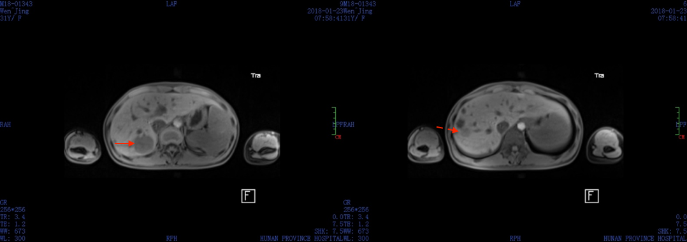
Figure 1 Magnetic resonance imaging. Two well-circumscribed lesions with long T1 and long or equal T2 signal (arrows). The multiple lesions with long T1 and long T2 signal are hepatic cysts verified by pathological examination later.

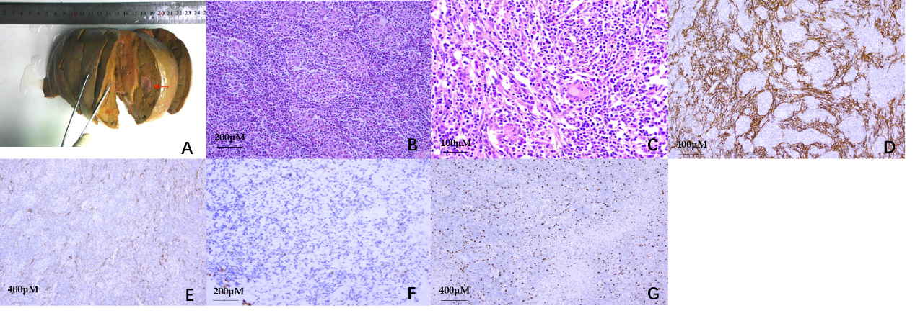
Figure 2 Epstein-Barr virus-positive inflammatory pseudotumor-like follicular dendritic cell sarcoma in the liver. a: Gross picture of an inflammatory pseudotumor-like follicular dendritic cell sarcoma of the liver. A well-circumscribed solid nodule was found in the liver. Note the grayish-white colored and soft cut surface with focal hemorrhage (arrow); b: Haematoxylin and eosin stained image showing that the tumor tissue had a meshwork-like architecture (×200); c: On high-power field, the tumor was composed of oval to spindle cells with vesicular chromatin and distinct nucleoli. There was less degree of atypia. The background showed abundant lymphocytes and plasma cells (×400); D: CD21 was detected on the membrane of almost all of tumor cells by immunohistochemistry (×100); E: Smooth muscle actin was detected in the cytoplasm of a part of tumor cells by immunohistochemistry (×100); F: Epstein-Barr virus-encoded small RNA-based in situ hybridization demonstrated positive nuclei of the neoplastic dendritic cells (×200); G: Ki-67 was detected in the nuclei of almost all of tumor cells by immunohistochemistry (30%; ×100).

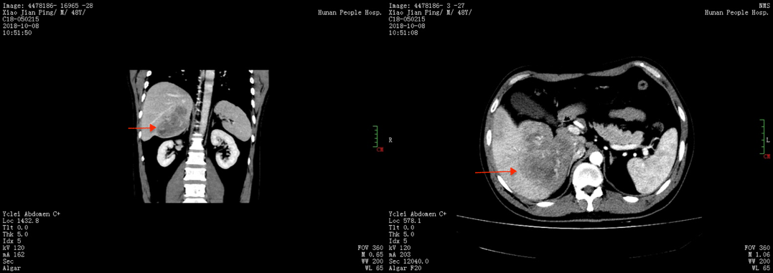
Figure 3 Abdominal computed tomography examination. The images show an ill-defined and low-density 10 cm mass (arrows) in the right lobe of the liver, accompanied with enlargement of hepatic portal lymph nodes.

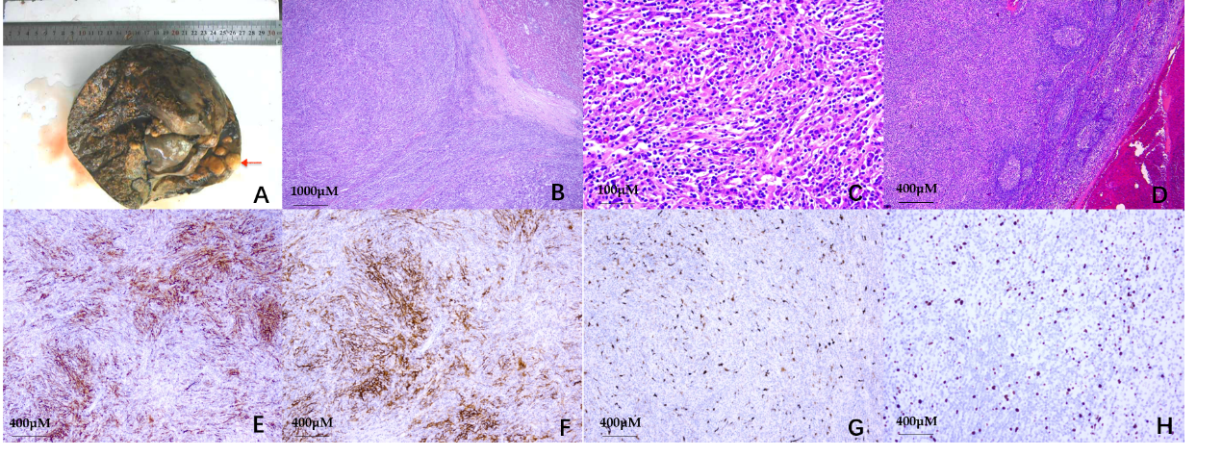
Figure 4 Epstein-Barr virus positive inflammatory pseudotumor-like follicular dendritic cell sarcoma in the liver with hepatoduodenal ligament lymph node involvement. a: Gross picture of an inflammatory pseudotumor-like follicular dendritic cell sarcoma of the liver. A large and multinodular confluent tumor was found in the liver (arrow); B: Histologic sections of follicular dendritic cell sarcoma showing an unencapsulated tumor (left) with a sharp margin from the adjacent liver parenchyma (right). The tumor tissue was arranged in whorls (×40); C: On high-power field, the tumor was composed of oval to spindle cells with vesicular chromatin and distinct nucleoli. There was less degree of atypia. The background showed abundant lymphocytes and plasma cells (×400); D: In the hepatoduodenal ligament lymph node, lymphoid follicles were pushed aside by tumor tissue (×100); E: CD21 was detected on the membrane of almost all of tumor cells by immunohistochemistry (×100); F: S100 was detected in the membrance and cytoplasm of almost all of tumor cells by immunohistochemistry (×100); G: Epstein-Barr virus-encoded small RNA in situ hybridization demonstrated positive nuclei of the neoplastic dendritic cells (×100); H: Ki-67 was detected in the nuclei of almost all of tumor cells (20%; ×100).

