Name of Journal: World Journal of Gastroenterology
Manuscript NO: 50187
Manuscript Type: CASE REPORT

Long-term growth of intrahepatic papillary neoplasms: A case report

Hasebe T et al. Long-term growth of intrahepatic papillary neoplasms

Takumu Hasebe, Koji Sawada, Hidemi Hayashi, Shunsuke Nakajima, Hiroyuki Takahashi, Masahiro Hagiwara, Koji Imai, Sayaka Yuzawa, Mikihiro Fujiya, Hiroyuki Furukawa, Toshikatsu Okumura

Takumu Hasebe, Koji Sawada, Hidemi Hayashi, Shunsuke Nakajima, Mikihiro Fujiya, Toshikatsu Okumura, Department of Medicine, Division of Gastroenterology and Hematology/Oncology, Asahikawa Medical University, Asahikawa 0788510, Hokkaido, Japan

Hiroyuki Takahashi, Masahiro Hagiwara, Koji Imai, Hiroyuki Furukawa, Department of Surgery, Division of Gastroenterological and General Surgery, Asahikawa Medical University, Asahikawa 0788510, Hokkaido, Japan

Sayaka Yuzawa, Department of Diagnostic Pathology, Asahikawa Medical University Hospital, Asahikawa 0788510, Hokkaido, Japan

ORCID number: Takumu Hasebe (0000-0002-4333-4428); Koji Sawada (0000-0002-9708-4786); Hidemi Hayashi (0000-0002-8421-7586); Shunsuke Nakajima (0000-0003-3060-2785); Hiroyuki Takahashi (0000-0003-2876-5964); Masahiro Hagiwara (0000-0002-2589-3955); Koji Imai (0000-0001-9318-1450); Hiroyuki Furukawa (0000-0003-3559-4155); Sayaka Yuzawa (0000-0002-2337-4000); Mikihiro Fujiya (0000-0002-4321-7774); Toshikatsu Okumura (0000-0003-1810-007X).

Author contributions: Hasebe T, Sawada K, Hayashi H and Nakajima S performed the preoperative evaluation and diagnosis; Takahashi H, Hagiwara M, Imai K and Furukawa H performed surgical resection of the tumor; Yuzawa S pathologically diagnosed the tissue; Hasebe T, Sawada K, Fujiya M and Okumura T reviewed the literature and contributed to drafting the manuscript; and all authors issued final approval for the submitted version.

Informed consent statement: Informed written consent was obtained from the patient for publication of this report and any accompanying images.

Conflict-of-interest statement: The authors declare that they have no conflicts of interest.

CARE Checklist (2016) statement: The authors have read the CARE Checklist (2016), and the manuscript was prepared according to the CARE Checklist (2016).

Open-Access: This is an open-access article that was selected by an in-house editor and fully peer-reviewed by external reviewers. It is distributed in accordance with the Creative Commons Attribution Non Commercial (CC BY-NC 4.0) license, which permits others to distribute, remix, adapt, build upon this work non-commercially, and license their derivative works on different terms, provided the original work is properly cited and the use is non-commercial. See: http://creativecommons.org/licenses/by-nc/4.0/

Manuscript source: Unsolicited manuscript

Corresponding author: Takumu Hasebe, MD, PhD, Doctor, Department of Medicine, Division of Gastroenterology and Hematology/Oncology, Asahikawa Medical University, 2-1-1-1 Midorigaoka Higashi, Asahikawa 0788510, Hokkaido, Japan. taku-has@asahikawa-med.ac.jp
Telephone: +81-166-682462
Fax: +81-166-682469

Received: July 17, 2019
Peer-review started: July 17, 2019
First decision: August 18, 2019
Revised: August 29, 2019
Accepted: September 11, 2019
Article in press: September 11, 2019
Published online: September 28,2019

Abstract
BACKGROUND
Intraductal papillary neoplasm of the bile duct (IPNB) is a type of tumor that presents in the intra- or extrahepatic bile ducts. Cystic-type intrahepatic IPNB often mimics simple liver cysts, making the diagnosis difficult. Because the growth of IPNB is slow, careful follow-up and timely therapeutic intervention is recommended. There are few reports with a follow-up period longer than a decade; thus, we report the case of a patient with an IPNB that grew for over 13 years.

CASE SUMMARY
A 65-year-old man was diagnosed, 13 years prior with a cystic hepatic tumor with abnormal imaging findings. The targeted tumor biopsy results showed no malignancy. Biannual follow-up examinations were performed because of the potential for malignancy. The cystic lesions showed gradual enlargement over 11 years and a 4 mm papillary proliferation appeared on the cyst wall, which is compatible with IPNB. The tumor was observed for another 2 years because of the patient’s wishes. The imaging findings showed enlargement to 8 mm and a new 9 mm papillary proliferation of the cystic tumor. Contrast-enhanced ultrasonography showed hyperenhancement during the arterial phase in both cyst walls, indicating intraductal tumor progression in both tumors. Thus, liver segment 8 subsegmentectomy was performed. The pathological findings indicated that the tumors contained mucin, and high-grade atypia was observed in the papillary lesions, showing IPNB.

CONCLUSION
The development of IPNB should be monitored in patients with cystic lesions and ultrasonography are useful tool for the evaluation.

Key words: Bile duct neoplasm; Mucin; Disease progression; Ultrasonography; Perfluorobutane; Case report

© The Author(s) 2019. Published by Baishideng Publishing Group Inc. All rights reserved.

Core tip: Cystic lesions in the liver, such as intraductal papillary neoplasms of the bile duct, rarely yield malignant tumors; additionally, the development of a tumor over a decade is hardly ever observed. Here, we present the case of a patient with an intrahepatic intraductal papillary neoplasm of the bile duct that developed over 13 years from a cystic tumor of the liver. The tumor was diagnosed by contrast-enhanced ultrasonography with perfluorobutane and was completely surgically resected. Notably, the intracystic spread of the tumor was well represented by contrast-enhanced ultrasonography.

Hasebe T, Sawada K, Hayashi H, Nakajima S, Takahashi H, Hagiwara M, Imai K, Yuzawa S, Fujiya M, Furukawa H, Okumura T. Long-term growth of intrahepatic papillary neoplasms: A case report. World J Gastroenterol 2019; 25(36): 5569-5577

URL: https://www.wjgnet.com/1007-9327/full/v25/i36/5569.htm
DOI: https://dx.doi.org/10.3748/wjg.v25.i36. 5569

INTRODUCTION
Intraductal papillary neoplasm of the bile duct (IPNB) is a type of tumor that presents in the common or intrahepatic bile duct and occasionally accompanies mucus production^{[1]}. IPNB shares common characteristics in common with intrapancreatic mucinous neoplasms (IPMNs), which are sometimes malignant^{[2]}. Although the development of IPMNs from pancreatic cysts is well documented because of the high prevalence rate of these neoplasms, there are only a few reports about IPNB development from hepatic cysts. Careful follow-up for IPNB is recommended because complete and timely surgical resection is required if malignancy is suspected^{[3]}. However, little is known about the natural course of IPNB over a long-term period.
The clinical diagnosis of the IPNB is often made by computed tomography (CT) or magnetic resonance imaging (MRI), however, few studies have reported that contrast-enhanced ultrasonography (CEUS) is useful for diagnosing the tumor. Here, we report a case of IPNB that developed in a normal liver over 13 years with follow-up imaging of hepatic cystic hepatic tumors. We could clearly detect papillary lesions and tumor progressions by CEUS and performed successful resection.

CASE PRESENTATION
Chief complaints
A 65-year-old Japanese man was admitted for growing cystic tumors in his liver. Liver cysts were originally found 13 years prior.

History of present illness
Two cystic lesions, located in the right hepatic lobe with diameters of 6 (anterior tumor: tumor-Ant) and 18 (posterior tumor: tumor-Post) mm, were detected by primary imaging performed in 2004. Magnetic resonance imaging (MRI) demonstrated simple liver cysts; however, tumor-Post partially contained abnormal lesions (Figure 1). Because ultrasonography of tumor-Post demonstrated hyperechoic lesions, leading to the suspicion of solid tumors, ultrasound-guided histological puncture of tumor-Post was performed, and the result showed normal liver tissue with no malignancy (Supplementary Figure 1). Biannual follow-up examinations were performed, because there is a possibility that the biopsy missed the target and the complex morphology of the cystic tumor had the potential for malignancy.
In 2015, eleven years after the initial clinical visit, MRI demonstrated a 4 mm papillary lesion on the anterior surface of tumor-Ant for the first time. Tumor-Ant and tumor-Post had enlarged to 14 and 30 mm, respectively. From these findings, we diagnosed the tumor as IPNB and recommended surgical resection to the patient. Although the tumor had a potential for malignancy, the patient hoped to wait and see if the papillary tumor grew. Two years later, in 2017, tumor-Ant had enlarged to 33 mm, and new papillary lesions were present, so the patient underwent a detailed examination. The timeline of tumor proliferation is shown in Figure 2.

History of past illness
The patient had no previous noteworthy medical history.

Personal and family history
The patient did not smoke tobacco or consume alcohol. There was no noteworthy family medical history, such as cancer or liver diseases.

Physical examination
The patient’s height and weight were 162 cm and 59 kg, respectively. The patient exhibited a clear sensorium, with a body temperature of 37.0 °C, blood pressure of 120/52 mmHg, and pulse rate of 58 beats/min. The abdomen was soft and flat, with no spontaneous pain or tenderness.

Laboratory examinations
There were no abnormal laboratory data findings, including tumor marker results.

Imaging examinations
The papillary lesion had grown to 8 mm with another new 9 mm papillary lesion on the posterior surface of tumor-Ant (Figure 3). No significant papillary hyperenhancement was detected through dynamic CT or MRI studies.
CEUS using perfluorobutane (Sonazoid™; Daiichi-Sankyo, Japan) demonstrated papillary hyperenhancement and marginal hyperenhancement of tumor-Ant during the arterial phase. Moreover, marginal hyperenhancement of tumor-Post was demonstrated on CEUS, which indicated IPNB extension to tumor-Post (Figure 4). Although cystic-type IPNB usually has a connection between bile ducts, we could not detect a connection by magnetic resonance cholangiopancreatography or drip infusion cholecystocholangiography CT. Endoscopic retrograde cholangiopancreatography was not performed because we could not obtain patient agreement for the procedure.

TREATMENT
Because the papillary proliferation had grown, which indicated tumor malignancy, liver segment 8 subsegmentectomy was performed after the patient provided informed consent. The surgery procedure resulted in complete tumor resection. Cholangiography during the surgical procedure showed cystic pooling of the contrast media, demonstrating the connection between the bile ducts and cystic tumors (Figure 5) and suggesting that the cystic lesions should be considered IPNB but not mucinous cystic neoplasms.

Pathological findings
Macroscopically, tumor-Ant contained a mixture of mucin and bile, and tumor-Post contained solidified bile (Figure 6A). Microscopically, papillary proliferation of the gastric epithelium with high-grade nuclear atypia was observed at the posterior surface of tumor-Ant. Both tumor-Ant and tumor-Post showed proliferation of the tumor cells with high-grade dysplasia, which represented an IPNB extension on tumor-Post (Figure 6B). Thick band-like proliferation of the glandular epithelium of the papillary structure was observed on the posterior surface of tumor-Post, which corresponded to the hyperenhancement observed on CEUS (Figure 6C). No stromal invasion was detected. Immunohistochemical analysis demonstrated mucin core protein 5AC (MUC5AC) and MUC6 positivity in most cells. MUC2 was positive in less than 5% of the tumor cells, whereas MUC1 was negative (Figure 6D-G), suggesting that the tumor is gastric type neoplasm.

FINAL DIAGNOSIS
The final diagnosis of the presented neoplasm was cystic type IPNB with no invasion.

OUTCOME AND FOLLOW-UP
The patient was followed up for 25 mo after surgical resection, and there was no recurrence. Biannual follow-up examinations with several imaging modalities, including CT, MRI, and CEUS, are scheduled to be performed.

DISCUSSION
Papillary growth of the liver neoplastic epithelium was first reported by Chen et al^{[4]}. IPNB was described as a papillary neoplastic lesion of the biliary tract in the 2010 World Health Organization classification^{[5]}. Both intra- and extrahepatic bile ducts can be a source of IPNB^{[6]}. Intrahepatic IPNB is characterized into 3 types: ductectatic-type, cystic-type, and diffuse-type neoplasms^{[7,8]}. Cystic-type IPNB often shares similar imaging features with cystic hepatic tumors, which may be misdiagnosed as mucinous cystic neoplasms, complicated hepatic cysts, cystic hemangiomas, lymphangiomas, hepatic foregut cysts, mesenchymal hematomas or teratomas^{[9–11]}. Thus, careful follow-up and appropriate inspection of cystic hepatic tumors are necessary.
The diagnosis of a cystic hepatic tumor requires a comprehensive assessment by multiple imaging modalities. Kim et al^{[12]} reported the CT criteria differentiating IPNB from simple hepatic cysts. The criteria included 4 CT findings: coexistence of fewer than 3 other cysts; transient hepatic attenuation differences; upstream bile duct dilatation; and lesion located in the left lobe. In the present case, only the number of cysts met the criteria, indicating that the present IPNB is atypical.
Ultrasonography is a more powerful imaging modality than CT or MRI for evaluating cystic hepatic lesions^{[13,14]}. Hyperenhancement of the cystic wall or nodules on CEUS is an important finding for evaluating the potential for malignancy^{[15]}. Liu et al^{[16]} investigated the imaging features of IPNB, and observed hyperenhancement during the arterial phase of CEUS in 60% of IPNB patients^{[16]}. Tominaga et al^{[17]} demonstrated that the hyperenhancement detected on CEUS corresponds with malignant tissue. Because the present case demonstrates that hyperenhancement observed on CEUS corresponds with microscopically extended dysplastic epithelia, hyperenhancement during the arterial phase of CEUS is an effective imaging feature for analyzing IPNB extension.
Pathological findings, especially regarding mucus secretion and the immunohistochemistry of mucin core proteins, have been well-studied in the previous literature. Although most IPMNs have mucus hypersecretion, only 35% of IPNBs have a mucus hypersecretion phenotype^{[18]}. The immunohistochemical results of mucin in IPNB are described as follows: MUC2 expression is common in the intestinal type, MUC6 is common in the gastric type, and MUC5AC is expressed in both of the phenotypes. As the presented case shows gastric epithelium, the MUC staining results are consistent with the phenotype. MUC1 is positive only in malignant IPNBs, such as pancreato-biliary and oncocytic type neoplasms^{[7,11]}. The lack of mucus secretion corresponds with MUC1 positivity and the malignant potential^{[19]}. Downregulation of MUC1 protein expression decreases the metastatic potential of adenocarcinoma^{[20]}. These previous findings support the clinical course of the present case, which progressed slowly and was not highly malignant.
Distinguishing cystic-type IPNB that develops on the small bile ducts from simple hepatic cysts is often difficult because the imaging features of these two neoplasms are similar^{[21]}. We searched the English-language literature published after 2010 for IPNBs developed from cystic hepatic tumors that were followed up for more than one year before treatment. Five cases, including the present case, were treated by surgical resection (Table 1)^{[9,22–24]}. The follow-up period ranged from 2.5 to 13 years, and 4 patients showed gradual enlargement of the cystic tumor, initially without any clinical symptoms. Two patients developed clinical symptoms, but the other 3 did not, which indicates that most IPNBs show slow, asymptomatic progression. All patients were from East Asia: 4 were from Japan, and 1 was from South Korea. Tan et al^{[11]} reviewed previous studies of 354 IPNB patients, among whom, 52.8% were from Japan, and 19.5% were from Eastern countries, including China, South Korea and Taiwan, which indicates that IPNBs occur more commonly in the East Asian population than in other populations. There was no previous literature which could detect the tumor progression from the main lesion to other cysts or bile ducts using CEUS. The present case shows that even if the tumor is followed for over a decade, periodic imaging surveillance is necessary. CEUS is an effective imaging method which can detect the detailed features of IPNB.

CONCLUSION
We encountered a patient with an IPNB that developed over 13 years, who had no recurrence for 25 mo after the complete surgical resection. The present case suggests that IPNB slowly and asymptomatically develops for a long time. Thus, periodical imaging surveillance is needed for cystic hepatic tumors even if the tumor seems benign. CEUS is a useful inspection tool for evaluating the tumor progression of cystic lesions.

REFERENCES
1 Nakanuma Y, Sato Y, Harada K, Sasaki M, Xu J, Ikeda H. Pathological classification of intrahepatic cholangiocarcinoma based on a new concept. World J Hepatol 2010; 2: 419-427 [PMID: 21191517 DOI: 10.4254/wjh.v2.i12.419]
2 Nakanuma Y, Zen Y, Harada K, Ikeda H, Sato Y, Uehara T, Sasaki M. Tumorigenesis and phenotypic characteristics of mucin-producing bile duct tumors: an immunohistochemical approach. J Hepatobiliary Pancreat Sci 2010; 17: 211-222 [PMID: 19680592 DOI: 10.1007/s00534-009-0158-7]
3 Rocha FG, Lee H, Katabi N, DeMatteo RP, Fong Y, D'Angelica MI, Allen PJ, Klimstra DS, Jarnagin WR. Intraductal papillary neoplasm of the bile duct: a biliary equivalent to intraductal papillary mucinous neoplasm of the pancreas? Hepatology 2012; 56: 1352-1360 [PMID: 22504729 DOI: 10.1002/hep.25786]
4 Chen TC, Nakanuma Y, Zen Y, Chen MF, Jan YY, Yeh TS, Chiu CT, Kuo TT, Kamiya J, Oda K, Hamaguchi M, Ohno Y, Hsieh LL, Nimura Y. Intraductal papillary neoplasia of the liver associated with hepatolithiasis. Hepatology 2001; 34: 651-658 [PMID: 11584359 DOI: 10.1053/jhep.2001.28199]
5 Nakanuma Y, Curado M-P, Franceschi S, Gores G, Paradis V, Sripa B, Tsui WMS, Wee A. Intrahepatic colangiocarcinoma. In: Bosman FT, Carneiro F, Hruban RH, Theise ND. World Health Organization Classification of Tumours of the Digestive System. Lyon: International Agency for Research on Cancer, 2010: 217–224
6 Nakanuma Y. A novel approach to biliary tract pathology based on similarities to pancreatic counterparts: is the biliary tract an incomplete pancreas? Pathol Int 2010; 60: 419-429 [PMID: 20518896 DOI: 10.1111/j.1440-1827.2010.02543.x]
7 Naito Y, Kusano H, Nakashima O, Sadashima E, Hattori S, Taira T, Kawahara A, Okabe Y, Shimamatsu K, Taguchi J, Momosaki S, Irie K, Yamaguchi R, Yokomizo H, Nagamine M, Fukuda S, Sugiyama S, Nishida N, Higaki K, Yoshitomi M, Yasunaga M, Okuda K, Kinoshita H, Nakayama M, Yasumoto M, Akiba J, Kage M, Yano H. Intraductal neoplasm of the intrahepatic bile duct: clinicopathological study of 24 cases. World J Gastroenterol 2012; 18: 3673-3680 [PMID: 22851859 DOI: 10.3748/wjg.v18.i28.3673]
8 Kim JR, Lee KB, Kwon W, Kim E, Kim SW, Jang JY. Comparison of the Clinicopathologic Characteristics of Intraductal Papillary Neoplasm of the Bile Duct according to Morphological and Anatomical Classifications. J Korean Med Sci 2018; 33: e266 [PMID: 30310366 DOI: 10.3346/jkms.2018.33.e266]
9 Yamada S, Kato Y, Hada M, Kotake M, Oyama K, Hara T. A case of a mucin-producing bile duct tumor diagnosed over the course of 6 years. Clin J Gastroenterol 2017; 10: 530-534 [PMID: 28913716 DOI: 10.1007/s12328-017-0775-7]
10 Kubota K, Nakanuma Y, Kondo F, Hachiya H, Miyazaki M, Nagino M, Yamamoto M, Isayama H, Tabata M, Kinoshita H, Kamisawa T, Inui K. Clinicopathological features and prognosis of mucin-producing bile duct tumor and mucinous cystic tumor of the liver: a multi-institutional study by the Japan Biliary Association. J Hepatobiliary Pancreat Sci 2014; 21: 176-185 [PMID: 23908126 DOI: 10.1002/jhbp.23]
11 Tan Y, Milikowski C, Toribio Y, Singer A, Rojas CP, Garcia-Buitrago MT. Intraductal papillary neoplasm of the bile ducts: A case report and literature review. World J Gastroenterol 2015; 21: 12498-12504 [PMID: 26604656 DOI: 10.3748/wjg.v21.i43.12498]
12 Kim JY, Kim SH, Eun HW, Lee MW, Lee JY, Han JK, Choi BI. Differentiation between biliary cystic neoplasms and simple cysts of the liver: accuracy of CT. AJR Am J Roentgenol 2010; 195: 1142-1148 [PMID: 20966320 DOI: 10.2214/AJR.09.4026]
13 Borhani AA, Wiant A, Heller MT. Cystic hepatic lesions: a review and an algorithmic approach. AJR Am J Roentgenol 2014; 203: 1192-1204 [PMID: 25415696 DOI: 10.2214/AJR.13.12386]
14 Arnaoutakis DJ, Kim Y, Pulitano C, Zaydfudim V, Squires MH, Kooby D, Groeschl R, Alexandrescu S, Bauer TW, Bloomston M, Soares K, Marques H, Gamblin TC, Popescu I, Adams R, Nagorney D, Barroso E, Maithel SK, Crawford M, Sandroussi C, Marsh W, Pawlik TM. Management of biliary cystic tumors: a multi-institutional analysis of a rare liver tumor. Ann Surg 2015; 261: 361-367 [PMID: 24509187 DOI: 10.1097/SLA.0000000000000543]
15 Wang C, Miao R, Liu H, Du X, Liu L, Lu X, Zhao H. Intrahepatic biliary cystadenoma and cystadenocarcinoma: an experience of 30 cases. Dig Liver Dis 2012; 44: 426-431 [PMID: 22169273 DOI: 10.1016/j.dld.2011.11.007]
16 Liu LN, Xu HX, Zheng SG, Sun LP, Guo LH, Zhang YF, Xu JM, Liu C, Xu XH. Ultrasound Findings of Intraductal Papillary Neoplasm in Bile Duct and the Added Value of Contrast-Enhanced Ultrasound. Ultraschall Med 2015; 36: 594-602 [PMID: 25188491 DOI: 10.1055/s-0034-1366672]
17 Tominaga K, Kamimura K, Sakamaki A, Terai S. Intraductal papillary neoplasm of the bile duct: A rare liver tumor complicated by malignancy. Hepatology 2017; 66: 1695-1697 [PMID: 28520182 DOI: 10.1002/hep.29266]
18 Nakanuma Y, Sato Y, Ojima H, Kanai Y, Aishima S, Yamamoto M, Ariizumi S, Furukawa T, Hayashi H, Unno M, Ohta T; Hepatolithiasis Subdivision of Intractable Hepatobiliary Diseases Study Group of Japan (Chairman, Hirohito Tsubouchi). Clinicopathological characterization of so-called “cholangiocarcinoma with intraductal papillary growth” with respect to “intraductal papillary neoplasm of bile duct (IPNB)”. Int J Clin Exp Pathol 2014; 7: 3112-3122 [PMID: 25031730]
19 Ohtsuka M, Kimura F, Shimizu H, Yoshidome H, Kato A, Yoshitomi H, Furukawa K, Takeuchi D, Takayashiki T, Suda K, Takano S, Kondo Y, Miyazaki M. Similarities and differences between intraductal papillary tumors of the bile duct with and without macroscopically visible mucin secretion. Am J Surg Pathol 2011; 35: 512-521 [PMID: 21412069 DOI: 10.1097/PAS.0b013e3182103f36]
20 Tsutsumida H, Swanson BJ, Singh PK, Caffrey TC, Kitajima S, Goto M, Yonezawa S, Hollingsworth MA. RNA interference suppression of MUC1 reduces the growth rate and metastatic phenotype of human pancreatic cancer cells. Clin Cancer Res 2006; 12: 2976-2987 [PMID: 16707592 DOI: 10.1158/1078-0432.CCR-05-1197]
21 Zen Y, Pedica F, Patcha VR, Capelli P, Zamboni G, Casaril A, Quaglia A, Nakanuma Y, Heaton N, Portmann B. Mucinous cystic neoplasms of the liver: a clinicopathological study and comparison with intraductal papillary neoplasms of the bile duct. Mod Pathol 2011; 24: 1079-1089 [PMID: 21516077 DOI: 10.1038/modpathol.2011.71]
22 Fujita M, Wakui N, Yamauchi Y, Takeda Y, Sato T, Ueki N, Otsuka T, Oba N, Nishinakagawa S, Minagawa M, Takeda Y, Shiono S, Kojima T. A case of branch duct type intraductal papillary neoplasm of the bile duct treated by open surgery after 11 years of follow-up. Mol Clin Oncol 2013; 1: 965-969 [PMID: 24649278 DOI: 10.3892/mco.2013.160]
23 Miki H, Tsunemi K, Toyoda M, Senzaki H, Tsubara A. A case of intraductal papillary neoplasm of the bile duct initially diagnosed 8 years earlier as a solitary hepatic cyst. J Japan Surg Assoc 2011; 72: 456–460 [DOI: 10.3919/jjsa.72.456]
24 Kim SW, Kim HC, Yang DM, Won KY, Kim BS. Cystic intraductal papillary adenocarcinoma of the bile duct of the caudate lobe initially manifesting as a simple cyst on CT. Jpn J Radiol 2014; 32: 371-374 [PMID: 24682931 DOI: 10.1007/s11604-014-0309-x]
P-Reviewer: Aktekin A, Ali FEM, Köksal AŞ, Sergi C, Sun WB, Yuan YS
S-Editor: Ma RY L-Editor: A E-Editor: Zhang YL
Specialty type: Gastroenterology and hepatology
Country of origin: Japan
Peer-review report classification
Grade A (Excellent): 0
Grade B (Very good): B, B, B, B
Grade C (Good): C, C
Grade D (Fair): 0
Grade E (Poor): 0

Table 1 Case reports of intraductal papillary neoplasm of the bile ducts followed up for more than one year before treatment
Case | Age  (yr) | Sex | Initial tumor size | Follow-up  duration | Treated tumor size | Clinical symptom | Intervention
1^{[9]} | 64 | M | 30 mm | 6 years | 50 mm | None | Left lateral hepatectomy
2^{[22]} | 70 | F | 50 mm | 11 years | 50 mm | Obstructive jaundice | Left hepatic lobectomy
3^{[23]} | 61 | F | 20 mm | 8 years | 40 mm | Abdominal distension | Segment 3 subsegmentectomy
4^{[24]} | 56 | M | 30 mm | 2.5 years | 43 mm | None | Caudate lobectomy
Present | 65 | M | 18 mm | 13 years | 33 mm | None | Segment 8 subsegmentectomy
M: Male; F: Female.

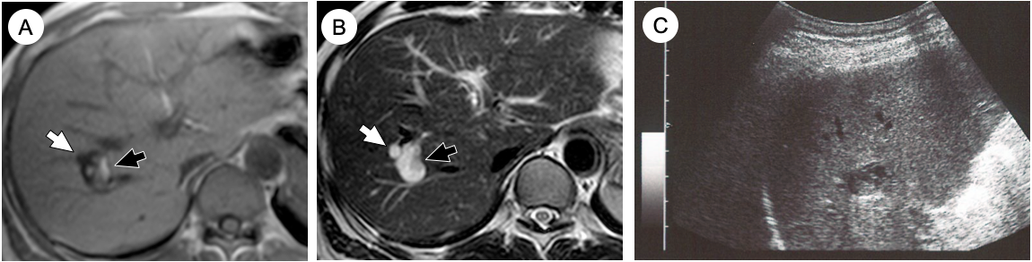
Figure 1 Magnetic resonance imaging and ultrasonography were performed during the initial visit. A and B: Magnetic resonance imaging shows 2 tumors in the right lobe. Anterior tumor is 6 mm, with low intensity on the T1-weighted image (A) and high intensity on the T2-weighted image (B; white arrow), which is consistent with simple liver cysts. Posterior tumor is 18 mm with mostly T1 low- and T2 high-intensity areas but has partial T1 high- and T2 low-intensity areas (black arrow). C: B-mode ultrasonography of the posterior tumor shows low-echoic cystic lesions with high-echoic areas inside.

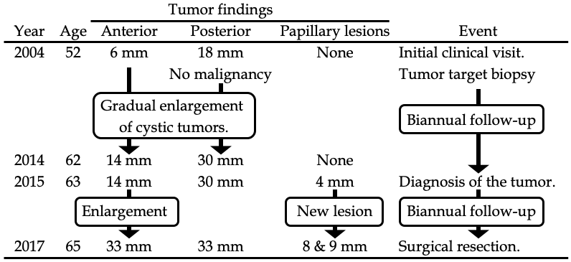
Figure 2 Timeline of tumor proliferation.

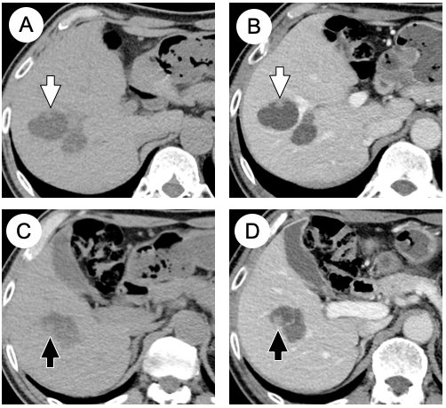
Figure 3 Computed tomography performed 13 years after the initial clinical visit. A and C: Plain computed tomography (CT) shows the 33 mm anterior tumor and the 32 mm posterior tumor. Two papillary proliferations are observed on the surface of the anterior tumor [8 mm on the anterior surface (A; white arrow) and 9 mm on the posterior surface (C; black arrow)]. B and D: Portal-phase CT shows slight hyperenhancement of the tumor surface and the papillary proliferation. CT: Computed tomography.

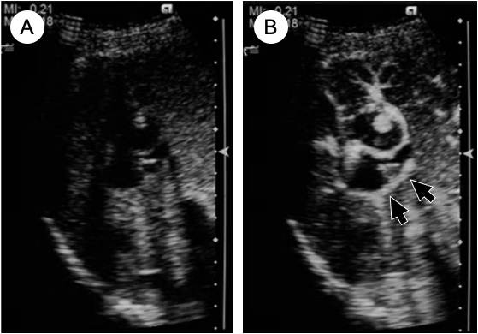
Figure 4 Ultrasonography performed 13 years after the initial clinical visit. Contrast-enhanced ultrasonography shows a 7 mm hyperechoic papillary proliferation (A: pre-enhancement; B: arterial phase). Marginal hyperenhancement of the anterior tumor and early enhancement of the papillary proliferation were detected. Marginal enhancement of the posterior tumor (black arrows) was also detected, which suggests tumor spread to the posterior tumor.

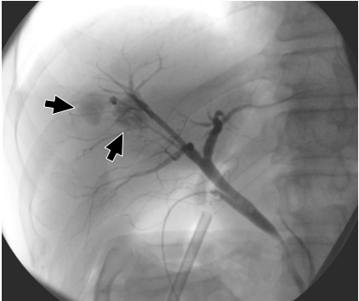
Figure 5 Cholangiography during the surgical procedure. Cholangiography showed cystic tumor enhancement (black arrows), which represents ductal communication between the cystic lesions and bile ducts.

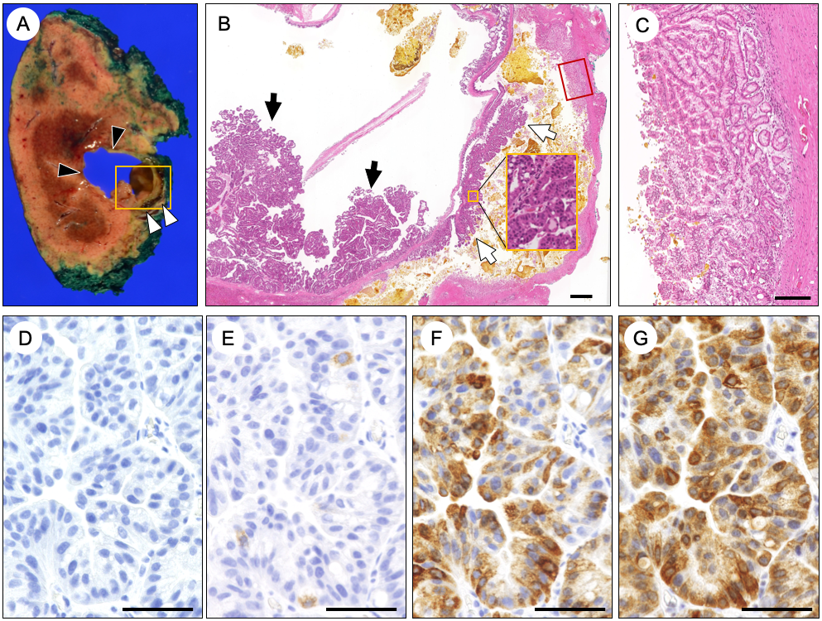Figure 6 Pathological findings of the surgical specimens. A: Macroscopic findings show 2 cystic lesions with a maximum diameter of 3 cm. The anterior tumor (black arrowhead) contained mucin and bile with papillary proliferation, while the posterior tumor (white arrowhead) contained solidified bile. B: Microscopic findings of the tumor (yellow square in A). Dysplastic epithelium proliferated on both anterior tumor (black arrow) and posterior tumor (white arrow). Higher magnification of the papillary proliferation of the posterior tumor (yellow square in B) shows dysplastic epithelium. C: Thick glandular epithelium was observed on the posterior tumor (red square in B), which corresponds to the hyperenhancement seen on the contrast-enhanced ultrasonography. D-G: Immunohistochemical findings of the papillary tumor show MUC1 negativity (D), MUC2 positivity in less than 5% of the cells (E), MUC5AC positivity (F), and MUC6 positivity (G). The black bar in B represents 1000 µm, C represents 200 µm, and D-G represents 50 µm. MUC: Mucin core protein.

