Name of Journal: World Journal of Gastroenterology
ESPS Manuscript NO: 25858
Manuscript Type: Review

Transanal surgery for obstructed defecation syndrome: literature review and a single-center experience

Liu WC et al. Transanal surgery for obstructed defecation syndrome

Wei-Cheng Liu, Song-Lin Wan, SM Yaseen, Xiang-Hai Ren, Cui-Ping Tian, Zhao Ding, Ken-Yan Zheng, Yun-Hua Wu, Cong-Qing Jiang, Qun Qian

Wei-Cheng Liu, Song-Lin Wan, SM Yaseen, Xiang-Ha Ren, Cui-Ping Tian, Zhao Ding, Ken-Yan Zheng, Yun-Hua Wu, Cong-Qing Jiang, Qun Qian, Department of Colorectal and Anal Surgery of Zhongnan Hospital of Wuhan University, Key Laboratory of Intestinal and Colorectal Diseases of Hubei Province, Quality Control Center of Colorectal and Anal Surgery of Health and Family Planning Commission of Hubei Province, Clinical Center of Intestinal and Colorectal Diseases of Hubei Province, Wuhan 430071, Hubei Province, China

Author contributions: Liu WC substantially contributed to design of the study, the literature review, the completion of the initial manuscript and drafted the article; Wan SL contributed to the literature review, the completion of the initial manuscript and drafted the article; Yaseen SM contributed to the article drafting; Ren XH contributed to the analysis and interpretation of data; Tian CP contributed to the completion of the initial manuscript and drafting the article; Ding Z, Zheng KY and Wu YH contributed to the acquisition of data; Jiang CQ and Qian Q contributed to the conception and design of the study; All authors made critical revisions related to important intellectual content of the manuscript and gave final approval of the version of the article to be published.

Supported by the National Natural Science Foundation of China, No. 81500505 and No. 81570492; and Natural Science Foundation of Hubei Province of China, No. 2015CFB636.

Conflict-of-interest statement: Authors declare no conflict of interests in this article.

Open-Access: This article is an open-access article which was selected by an in-house editor and fully peer-reviewed by external reviewers. It is distributed in accordance with the Creative Commons Attribution Non Commercial (CC BY-NC 4.0) license, which permits others to distribute, remix, adapt, build upon this work non-commercially, and license their derivative works on different terms, provided the original work is properly cited and the use is non-commercial. See: http://creativecommons.org/licenses/by-nc/4.0/

Manuscript source: Invited manuscript

Correspondence to: Qun Qian, MD, PhD, Professor, Chief, Department of Colorectal and Anal Surgery of Zhongnan Hospital of Wuhan University, Key Laboratory of Intestinal and Colorectal Diseases of Hubei Province, Quality Control Center of Colorectal and Anal Surgery of Health and Family Planning Commission of HuBei Province, Clinical Center of Intestinal and Colorectal Diseases of Hubei Province, Wuhan 430071, Hubei Province, China. qunqian2007@163.com
Telephone: +86-27-67812778
Fax: +86-27-67812778

Received: March 24, 2016
Peer-review started: March 25, 2016
First decision: May 12, 2016
Revised: June 23, 2016
Accepted: August 1, 2016
Article in press:
Published online:

Abstract
Obstructed defecation syndrome (ODS) is a functional disorder commonly encountered by colorectal surgeons and gastroenterologists, and greatly affects the quality of life of patients from both societal and psychological aspects. The underlying anatomical and pathophysiological changes of ODS are complex. However, intra-rectal intussusception and rectocele are frequently found in patients with ODS and both are thought to have played an important role in pathogenesis of ODS. At present, with the development of evaluation methods in anorectal physiology laboratories and radiology studies, a great variety of new operative procedures, especially transanal procedures, have been invented to treat ODS. However, no procedure has been proved to be superior to others at present. Each operation has its own merits and defects. Thus, choosing appropriate transanal surgical procedures for the treatment of ODS remains a challenge for all surgeons. This review provides an introduction of the current problems and options for treatment of ODS and a detailed summary of the essential assessments needed for patient evaluation before carrying out transanal surgery. Besides, an overview of the benefits and problems of current transanal surgical procedures for treatment of ODS is summarized by this review. And a report of clinical experience of some transanal surgical techniques used in the authors’ center is also presented.

Key words: Obstructive defecation syndrome; Transanal surgery; Medical assessment; Transanal manual technique; Transanal stapling procedure; Clinical outcome; Clinical experience

© The Author(s) 2016. Published by Baishideng Publishing Group Inc. All rights reserved.

Core tip: Transanal surgery for obstructed defecation syndrome (ODS) remains a challenge for colorectal surgeons. Possible reasons are that reported clinical outcomes of current transanal surgical procedures are controversial and the patient selection criteria for different procedures are usually deficiently described in current literatures. This article reviews literatures regarding present transanal surgery, introduces current problems and options for treatment of ODS and summarizes essential assessments needed for patient evaluation and the benefits and problems of each procedure. The aim of this article is to improve the understanding of selective strategies of transanal operations and increase patient satisfaction.

Liu WC, Wan SL, Yaseen SM, Ren XH, Tian CP, Ding Z, Zheng KY, Wu YH, Jiang CQ, Qian Q. Transanal surgery for obstructed defecation syndrome: literature review and a single-center experience. World J Gastroenterol 2016; In press

INTRODUCTIONS
Obstructed defecation syndrome (ODS) is defined as paradoxical contraction or inappropriate relaxation of the pelvic floor muscles during attempted defecation with symptoms such as excessive straining, incomplete or fragmented evacuation, and/or inappropriate pulsive forces during attempted defecation with symptoms such as need for perineal or digital facilitation of defecation, and tenesmus, urgency and pelvic heaviness with the normal desire to defecate^{[1-3]}.
Rectocele and internal rectal intussusception are anatomic disorders that have frequently been associated with ODS^{[4-8]}. To date, there have been various surgical methods used for the treatment of symptomatic ODS through transanal approaches^{[9-13]}. However, these transanal surgeries for ODS are challenges for all colorectal surgeons. One reason may be ODS should be described as an “iceberg syndrome” characterized by “emerging rocks”, such as internal rectal intussusception and rectocele that may benefit from operation, and also by “underwater rocks” or occult diseases such as rectal hyposensation that may affect the postoperative result of transanal operation^{[14,15]}. Another reason is that few standards of selection criteria of transanal surgical procedures for treatment of ODS have been made yet^{[4,5,7,8]}. Besides, anatomical and physiological disturbances underlying ODS are complex and remain incompletely understood.
These reasons may also explain why reported clinical outcomes of different transanal surgical procedures for treatment of ODS are controversial and remain debatable. None of these procedures has shown superior advantages and each technique has its benefits and disadvantages^{[16-20]}. This article will review literatures regarding current transanal operative procedures for ODS to summarize the problems and alternatives for treatment of ODS and to conclude essential assessments needed for patient evaluation before carrying out transanal surgery for ODS patients. The benefits and disadvantages of each transanal surgical procedure and some experiences of transanal surgery for ODS in a single clinical center will also be presented.

CURRENT OPTIONS FOR ODS TREATMENT
Medical treatments
The basic medical treatments for patients with ODS may be a change of lifestyle, such as drinking plenty of water and eating a fiber diet every day^{[16,21]}. And a short period of using retrograde rectal irrigation or large bowel irrigation with warm normal saline can also be alternative basic medical treatment for patients with ODS^{[22-24]}.
For patients with ODS induced by anismus may firstly be given botulinum toxin A treatment through trananal injection of 50 units of botulinum toxin A into the puborectalis muscle^{[25]}. Such patients may also benefit from yoga exercises. Patients are trained to relax themselves and control the pelvic floor muscles, which may change the activity of the pelvic floor muscles during incompleted defecation^{[26,27]}. For patients with ODS induced by anismus and rectal hyposensation, biofeedback therapy should be advised^{[16,28]}. If symptoms of the patient are related to pudendal neuropathy and rectal hyposensation, an alternative therapy might be transanal electrostimulation, which carried out by inserting a small probe connected with a portable electrostimulator into the anus^{[7]}.
Psychological counselling plays an important role on the treatment of patients with severe psychological pressure, such as depression and anxiety^{[29]}. Besides, simple relaxation exercises of abdominal and pelvic floor muscle may also be helpful for these patients^{[30]}. Furthermore, the latest psycho-echo- biofeedback therapy combined ultrasound-guided biofeedback with guided imagery and relaxation techniques. It might be a good option for ODS patients with both anismus and server psychological pressure^{[31]}. Another new technology called biofeedback therapy plus transanal electrostimulation might also be an alternative for medical treatment of ODS^{[32,33]}.

Alternative transanal surgical methods
The clinical outcomes of non-surgical treatment for anismus induced ODS were conflicting, and the effects are not significant. That may be the reason why partial division of the puborectalis procedure was proposed^{[34]}. And this transanal manual procedure was thought to be effective in treating anismus induced ODS through partially dividing the puborectalis to relax the tension of hypertrophic puborectalis muscle^{[34-38]}.
As a most commonly used transanal manual procedure, internal Delorme‘s transanal excision was supposed to be a relatively cheap and pathophysiologically appropriate procedure for many patients with ODS^{[39]}.
Based on the stapled hemorrhoidopexy procedure, Longo et al^{[40]} introduced an alternative minimally invasive transanal stapling procedure for patients with rectocele and internal intussusception induced ODS. This novel technique could restore the anatomical abnormality (rectocele and rectal intussusception) in the rectum through stapled transanal rectal resection (STARR) by sequentially using double circular stapling devices for the procedure for prolapse and hemorrhoids (PPH). That’s why it was named as PPH-STARR procedure. By resecting a full-thickness part of the rectum and subsequently strengthening the recto-vaginal septum and resecting redundant rectum, this procedure may provide promising results for ODS treatment.
PPH-STARR technique was confined to treat patients with large internal rectal intussusception and/or rectocele due to its limitation of resection of a large volume of prolapsed tissue and difficulties in visualizing the procedure. Patients with large internal rectal intussusception and/or rectocele may be treated by using a curved headed stapler device called the Contour-Transtar procedure^{[41]}. For patients with larger prolapses of more than 5.0 cm, PPH-STARR has the disadvantage of resecting bands of rectal mucosal prolapses with a maximal width of approximately 4.5 cm, a better choice might be the “transanal repair of rectocele and rectal mucosectomy with a single circular stapler (TRREMS)” or tissue selecting therapy-stapled transanal rectal resection (TST-STARR) procedure^{[11,42-44]}. When treating patients with rectocele and rectocele with relatively minor rectal intussusception (depth of rectocele more than 4.5 cm) induced ODS, the Bresler procedure or improved linear stapling procedure combined with a Bioabsorbable Seamguard (BSG) should be a smart choice^{[9,45]}. For patients with ODS induced by symptomatic very high take-off internal rectal intussusception which are limited to reach the apex of the prolapse by above procedures, a transanal procedure called the TransAnal Endoscopic (internal) Rectal Prolapse” (TERP) may be advised^{[46]}.

ESSENTIAL ASSESSMENTS NEEDED BEFORE TRANSANAL SURGERY FOR ODS
Clinical questionnaires
After hospitalized, all patients should be evaluated with standardized questionnaires-the Cleveland Clinic Florida constipation score (Wexner score) for the assessment of constipation. And the fecal incontinence score questionnaire including St. Marks incontinence score and Cleveland Clinic incontinence score should also be carried out. Moreover, quality of life questionnaire should be assessed for all patients through the use of the gastrointestinal quality of life index and the Italian version of the Short-Form 12^{[11,12,34,37,39]}.

Clinical examination
All candidates should have prior screening with diagnostic examinations before the transanal operation as follows: (1) Gastrointestinal transit time (GITT) assay with 20 radiopaque markers, and repeatedly performing abdominal X-Ray tests on days 1, 3 and 5; (2) defecography or simultaneous pelvicography and colpocystodefecography (PCCD), including defecography, voiding cystography, vaginal opacification and pelvicography; (3) Colonoscopy; (4) Endorectal and endoanal ultraosonography; (5) Anorectal manometry test; and (6) Measurement of pudendal nerve terminal motor latency, anal surface electromyography and balloon expulsion^{[9,46-49]}.

Clinical test
Before surgery, all routine inspections should be completed, including a routine blood test, liver and kidney tests, the chest radiographs, and electrocardiogram^{[10,36,47-49]}.

Inclusion criteria and exclusion criteria for transanal surgery
Inclusion criteria (ODS Induced by rectocele and/or rectal intussusception)
Symptoms of patients: Patients^{[3,9,11,50,51]} should fulfill at least 2 of the following symptoms for past 3 mo, with these symptoms appeared at least 6 mo prior to diagnosis: (1) A felling of attempted defecation during ≥ 25% of defecations; (2) Frequent feeling to defecate with failed attempts and a feeling of anorectal obstruction–blockage with long periods of time during ≥ 25% of defecations; (3) Hard or lumpy stools during ≥ 25% of defecations; (4) Facilitate ≥ 25% of defecations only by using at least one method as follows: digital assistance, perineal support, enema and odd posture; (5) Excessive straining and prolonged painful effort during ≥ 25% of defecations; and (6) defecation ≤ 3 times per week. What’s more, patients should satisfy these conditions including: (1) loose stools seldom appear without using of laxatives and deficient standards for diagnosis of irritable bowel syndrome; and (2) Impaired defecation proved by using balloon expulsion test or anorectal manometry test.

Clinical history of patients: (1) Unresponsiveness to current intensive and appropriate medical treatment for at least 6 mo, such as basic medical therapy (drinking ≥ 1.5 L water and taking 10 g lactulose per day and eating high-fiber diet), stimulants, osmotic laxatives and enemas; and (2) the absence of severe psychiatric diseases^{[45,46,52-54]}.

Radiological findings and cleveland clinic florida constipation score: (1) The depth of rectocele ≥ 3 cm and/or rectal intussusception into the anal canal ≥ 1 cm on straining or defecography after defecation; and (2) a Cleveland Clinic Florida constipation score (Wexner score) ≥ 12^{[11,39,41,55,56]}.

Inclusion criteria (ODS Induced by anismus)
The inclusion criteria^{[3,34,37,38,57]} were: (1) Patients with the following symptoms for past 3 mo, with these symptoms appeared at least 6 mo before diagnosis; (2) Proof of appropriate pulsive forces during defecation (rectal pressure > 45 mmHg); (3) Evidence for loss to rest the pelvic floor muscles or improper contraction through medical examination of the pelvic floor muscles during evacuation combined with defecography, anorectal manometry test, electromyography and balloon expulsion; and (4) a permanent need of digital assistance, enema and laxatives to facilitate evacuation.

Exclusion criteria (ODS Induced by rectocele and/or rectal intussusception)
(1) Patients with cystocele or genital prolapse need transvaginal surgery; (2) Patients with fecal incontinence or ODS induced by anismus or pelvic floor dyssynergia; (3) Patients with anastomotic stoma or foreign material or chronic inflammatory lesions in the rectum or the anal canal; (4) Patients with colonic inertia, neoplasia or anorectal stenosis; and (5) Patients with mental disorders or patients refuse to accept surgery^{[3,9,11,50,51]}.

Exclusion Criteria (ODS induced by anismus)
(1) Patients with colonic inertia or sphincter defect; (2) Patients with not only anismus but also other defecographic abnormalities; and (3) with former pelvic operation^{[3,34,37,38,57]}.

ALTERNATIVE TRANSANAL SURGICAL PROCEDURES FOR ODS
There have been a great variety of transanal surgical techniques to treat patients with ODS and all techniques have its benefits and problems. And the tabular format of the diverse transanal operative procedures highlighting the pros and cons of each technique is summarized in Table 1 (pros) and Table 2 (cons).

Partial division of puborectalis
As Wasserman et al^{[36]} and Wallace et al^{[35]} reported, patients had good responses after partial division of the puborectalis muscle. Moreover, a comparative study investigated by Faried et al^{[37]} showed that partial division of puborectalis was more effective than non-surgical treatment such as biofeedback retraining with a BTX-A injection. However, there some studies reported that the outcome of treatment for patients with anismus through lateral or posterior midline division of the puborectalis muscle was disappointing^{[34,38,57]}. And it was failed to improve the ODS symptoms among the majority of patients through division of the puborectalis muscle, but might increase the risk of subsequent incontinence after surgery^{[34,38,57]}.

Internal delorme’s procedure
Irwin et al^{[50]} demonstrated that 21 patients who had undergone this procedure obtained a satisfaction rate of 71% at the 3-year follow-up without any major complications. Ganio et al^{[53]} found that 45.7% of the incontinent patients had normal fecal continence after undergoing the internal Delorme’s procedure. Tsunoda et al^{[58]} and Liberman et al^{[59]} also proved that internal Delorme’s procedure had a reasonably low recurrence rate and a low morbidity. And this procedure did not lead to constipation post operation. However, this procedure also has limitations such as not being suitable for patients with diarrhea. Additionally, postoperative complications, including fissure-in-ano, suture-line dehiscence and anastomotic stoma stenosis were observed^{[53]}. As Ohazuruike et al^{[39]} reported, 8.6% of patients in their study had felt transient incontinence to gas and fluids respectively. And for ODS patient with severe fecal incontinence, this procedure should combine with sphincteroplasty to improve postoperative anal continence^{[60]}. However, Ohazuruike et al^{[39]} thought there were no statistically significant differences between internal Delorme’s procedure and PPH-STARR procedure on treatment ODS induced by rectocele and rectal intussusceptions. Roman et al^{[61]} also reported that the long-term outcome of it was less encouraging with a high recurrence rate. Besides, Mahmoud et al^{[55]} demonstrated this manual procedure had disadvantages of longer operative time and hospital stay and more complications, including constipation and fecal incontinence compared with stapling procedures, especially on treatment of rectocele in ODS.

PPH-STARR procedure
As described by Boccasanta et al^{[62]}, there was nearly 88% overall satisfaction for a period of 20 months of postoperative follow-up after transananl surgery performed with PPH-STARR procedure. Similarly, in another study by Gagliardi et al^{[63]}, 65% satisfaction was achieved in patients suffering from rectocele and rectal intussusception. Another study also reported that the frequency of defecatory urgency decreased dramatically from 10% at the 3rd month to 2% by the end of 12th months of postoperative follow-up^{[56]}. Additionally, radiological and clinical modification of the intussusception and rectocele was observed in 94.6% of patients during the follow-up investigated by Arroyo et al^{[52]}. And similar results were also reported by Ding et al^{[64]} and Naldini et al^{[65]}. Because a CAD was introduced into the anus to provide a better view for surgeons, possible damage to anal sphincters due to the introduction of the CAD was considered by some investigators. For this reason, Boccasanta et al^{[47]} suggested in their study that if the stapler was correctly used, there would not be any direct damage to the anal sphincters.
However, the procedure has the advantages of being simple, easy and fast. It requires extensive experience to avoid further postoperative complications and to carefully resect the rectocele and prolapsed tissue. Besides, it may not be suitable for patients with previous pelvic floor surgery^{[66]}. And there were some controversial points of view regarding the complication and poor postoperative outcome of this procedure^{[67,68]}. For instance, the primary and most common perioperative and postoperative complication is “bleeding”, which should be repaired intraoperatively by a few anastomotic sutures with absorbable thread^{[41,63]}. Another complication found in several studies was puborectalis dyssynergia^{[41,69,70]}. However, van Dam et al^{[71]} demonstrated that the clinical outcome of transanal surgery for ODS was not influenced by the presence of puborectalis dyssynergia. Persistent pain in anus was another complication appeared frequently after transanal surgery with PPH-STARR. This symptom might result from the staple line rupturing induced by postoperative sphincter spasm in anus, extreme tension on the anoderm and excessive resection of smooth muscle^{[72-74]}. Postoperative fecal urgency and fecal incontinence were also reported as postoperative complications of PPH-STARR procedure, which may be improved by sacral nerve stimulation or other medical treatments after surgery^{[75,76]}. Besides, Pescatori et al^{[77]} and Pescatori et al^{[78]} summarized complications of PPH-STARR, including recurrent ODS, severe proctalgia, fecal incontinence and rectovaginal fistula. Furthermore, Asteria et al^{[79]} stated that they had observed transient fecal urgency in 18% of cases and urinary retention in 12% of patients. And in a long follow-up investigated by Zhang et al^{[80]}, 14.7% of patients were reported to have similar complications related to the stapled granuloma of anastomotic stoma. Early postoperative urgency might result from traumatic inflammation at the staple line, but it couldn’t explain why it last so long after surgery. In addition, rare complications such as rectal diverticulum and sigmoid volvulus were also reported^{[81,82]}. However, minor postoperative complications have been mentioned in several studies, while neither major morbidity nor threatening mortality has been observed with PPH STARR procedure^{[83-86]}.

Contour-transtar procedure
As demonstrated by Renzi et al^{[87]}, 87% of cases with a prolonged history of constipation had symptom-free defecation after operation. This surgical procedure with a curved head was shown to be good and have a great effect on the development of symptoms in patients suffering from ODS. However, a percentage of patients may obtain anal stenosis and may have a risk of spiraling due to the longitudinal and circumferential resection of the prolapsed tissue. On account of these complications, Antonio Brescia et al^{[88]} modified the technique using an electric scalpel instead of a linear endoscopic stapler for initial longitudinal resection and stated that it could reduce the risk of spiraling. However, with resection of a large circumferential volume of the rectal wall, this new technique was considered to cause potentially severe complications such as recto-vaginal fistula, recto-enteric fistula, fecal urgency and fecal incontinence, which affected the quality of life of patients after surgery^{[89,90]}. Nonetheless, further investigation indicated that clinical outcome using this technique was good if the surgeons carefully resected the anterior rectal wall prolapse without the posterior vaginal wall and corrected the defect using a recto-vaginal flap between the recto-vaginal septum^{[91,92]}. As showed by Martellucci et al^{[91]}, only 1.5% of patients who underwent Contour-Transtar required further surgery because of anal pain caused by retained staples, and only 1 patient had rectal perforation rectified by colostomy and closed after 6 mo. They demonstrated that the early complication rate of this procedure was low and this new procedure had superiority over PPH-STARR procedure. What’s more, some following studies reported similar results^{[93-96]}. But, there were also some opposing views. Wadhawan et al^{[97]} and Naldini et al^{[65]} indicated that there were no statistically significant differences in postoperative clinical outcome, early complications, postoperative pain and hospital stay between PPH-STARR procedure and Contour-Transtar procedure. Similarly, Boccasanta et al^{[98]} demonstrated that no improvements in symptoms and defecographic parameters were observed postoperatively in patients underwent operation using Contour-Transtar procedure compared with PPH-STARR procedure. But the cost of the stapler device used in Contour-Transtar procedure was higher.

Bresler procedure
As showed by Ayav et al^{[45]}, at least 90% of patients were satisfied and had no symptoms postoperatively in the 3 years of follow-up. And 76% of symptom-free cases were observed after a median term follow up. Another study investigated by Jiang et al^{[99]} found that the mean constipation score improved significantly from 13.56 preoperatively to 5.07 postoperatively without severe complications as recto-vaginal fistula and peritoneal perforation. Moreover, Zhang et al^{[100]} proved that the efficacy of this procedure can be highly appreciable with 72% of patients cured clinically. In addition, a study conducted by Avolio et al^{[48]} indicated that defecography post operation proved complete correction of the anterior rectal wall defect in all 15 cases, and only a few cases had minor bleeding after surgery.

TRREMS procedure
As described by Regadas et al^{[42]}, all 8 patients with ODS caused by rectocele had a good clinical outcome after TRREMS procedure. Additionally, a complete correction of the rectocele was demonstrated by anal-vaginal digitation and postoperative defecography. Cruz et al^{[43]} investigated the outcomes of 75 patients with anorectocele related to rectal intussusception or mucosal prolapse in a prospective multicenter study. Mean Cleveland Clinic Florida constipation score (Wexner score) of these patients decreased meaningfully after the TRREMS procedure, which indicated that this operation is effective and safe. Besides, Leal et al^{[101]} showed that TRREMS procedure could significantly reduce the mean constipation and obstructed defecation scores with lowered costs, even in treatment of grade II and III rectocele. What’s more, as reported by Regadas et al^{[44]}, all 45 patients who underwent a modified TRREMS procedure had complete disappearance of rectal intussusception observed by imaging examination after surgery. Only 13.3% of the cases had a small residual mucosal prolapse.

TST-STARR procedure
Naldini et al^{[11]} reported that only 3 patients had anastomotic bleeding with only 1 patient needed surgical intervention in the 76 patients who underwent TST-STARR Plus procedure. And only 7.6% patients with fecal urgency were observed in their 14.5-mo follow-up.

Transanal rectocele repair using liner stapler and bioabsobable stapler line reinforcement material
As described by Portilla et al^{[9]}, a remarkable reduction in rectocele size on defecography and a significant improvement of symptoms as vaginal prolapse during evacuation, rectorrhagia, vaginal prolapse or digitation with bulge/mass, pruritus ani, pain and tenesmus were observed after surgery. No patient exhibited severe complications during the follow-up period and only 2 cases exhibited fecal urgency.

TERP procedure
As described by Bloemendaal et al^{[46]}, 2 of 3 patients had a significant improvement of ODS symptoms after surgery. Whereas another patient had a left hemicolectomy 1 year after the operation due to an anterior recurrence of internal rectal prolapse with a redundant loop of transverse colon near anastomotic stoma and an ulcer on anterior wall of the rectum.

OUR EXPERIENCE
Forty-three female patients with ODS induced by rectocele and/or minor rectal intussusception underwent transanal operation through Bresler procedure in three Chinese hospitals led by our center from November, 2008 to December, 2010. The surgical procedure (Figure 1 and Video 1) is similar to Ayav et al^{[45]}’s procedure. There were not any severe postoperative complications. Moreover, the mean constipation score improved significantly post operation. In addition, postoperative defecography also showed a great improvement with complete disappearance of the rectocele in 15 of 28 patients^{[99]}.
And our center registered a retrospective study in the Chinese Clinical Trial Registry (No. ChiCTR-ORN-16007696) to compare the clinical outcome between PPH-STARR and Bresler procedures on the treatment of ODS induced by rectocele and rectocele (depth of rectocele < 4.5 cm) with relatively minor rectal intussusception. Our PPH-STARR procedure (Figure 2 and Video 2) is similar to the traditional PPH-STARR procedure^{[40]}. And we investigated 30 female ODS patients who underwent Bresler surgery combined with 30 female ODS patients who underwent STARR surgery at our center from October, 2011 to November, 2012. However, there were no statistically significant differences (P > 0.05) between the two surgical procedures on mean operative time, blood loss and mean postoperative hospital stay (Table 3). Additionally, there were no statistically significant differences (P > 0.05) between the two surgical procedures in the incidence of postoperative complications (STARR procedure group vs Bresler procedure group = 26.7% vs 30%, Table 4). Moreover, evaluation of patient satisfaction in STARR procedure group was excellent (50%), good (16.7%), fair (10%) and poor (23.3%). The same assessment was excellent (46.7%), good (20%), fair (6.7%) and poor (26.6%) in Bresler procedure group. Moreover, the short-term follow-up of postoperative satisfaction rate (patients who felt excellent or good after surgery) of the two surgical procedures was same with 66.7% (Figure 3).
From April, 2013 to September, 2014, 50 patients (43 females and 7 males) with ODS were treated with TST-STARR procedure at our center. Our surgical procedure (Figure 4 and Video 3) was the same with Naldini et al^{[11]} ’s procedure. The average time of surgery was 21 ± 4 min (range: 12–35 min), blood loss was 12 ± 2 ml (range: 6–16 ml) and the average hospital stay was 5 d (range: 4–8 d). What’s more, there were a few postoperative complications with only 1 patient with transient fecal urgency and only 1 patient suffering anastomotic bleeding. Besides, there was only 1 patient with fecal incontinence and 1 patient of rectal anastomotic stenosis observed. What’s more, the postoperative Wexner constipation score improved significantly, and the overall satisfaction rates were approximately 84%, 84% and 82% at 3, 6, 12 mo respectively.
From January, 2015 to December, 2015, 45 patients (16 females and 29 males) with anismus induced ODS through transanal partial excision of puborectalis in our center. The surgical procedure was shown in Figure 5. And a retrospective study of postoperative outcome through transanal partial excision of puborectalis for treatment of anismus induced ODS had been registered in the Chinese Clinical Trial Registry with No. ChiCTR-ORB- 16007695. Part of the short-time follow-up showed a satisfactory outcome, and the full collection of clinical data and long-term follow-up was in progress. To date, none of these patients had complications such as fecal incontinence after surgery, and only 20% of patients had the recurrent ODS symptom.

DISSCUSSION
Although plenty of researches about the transanal surgical management of ODS have been published. Treatment strategies for ODS remain poorly understood. This may be because of the lacking of strict patient selection criteria for ODS operation, which is essential for the surgeons to define and evaluate the roles of each operative procedure. Additionally, randomized controlled trials and controlled clinical trials with long-term follow-up and review articles based upon these investigations are not enough for the surgeons to evaluate and compare the clinical applications and outcomes of these transanal surgical procedures for the treatment of ODS.
Internal Delorme’s procedure was supposed to be an appropriate operation for patients with ODS and internal prolapse with severe symptoms. However, this manual procedure had disadvantages of longer operative time and hospital stay. It also had more complications such as higher postoperative recurrence rate, constipation and recto-vaginal fistula compared with transanal stapling procedures, especially on the treatment of ODS induced by rectocele. Thus, the internal Delorme’s procedure should be considered as an alternative for patients with ODS induced by intra-rectal intussusception or internal rectal prolapse with relatively minor rectocele, and with supposed postoperative risk of fecal incontinence due to sphincter weakness. A partial division of puborectalis and partial excision of the puborectalis might be alternative to treat patients with anismus induced ODS. However, more long-term clinical controlled trials should be carried out to further investigate the effect of these manual procedures for the treatment of ODS.
PPH-STARR procedure contributed tremendously to treat patients with intra-rectal intussusception and rectocele induced ODS. However, it also has some postoperative complications, including bleeding, recurrence of ODS, fecal incontinence and so on. In addition, surgeons have a long learning curve to master this technique compared with other stapling procedures. What’s more, it remains limited to patients with large intra-rectal intussusception with a length more than 4.5 cm and rectocele with depth more than 4.5cm. Therefore, it should be advised to apply by surgeons with extensive maintenance experience for the treatment of patients with ODS induced by internal rectal prolapse (length of prolapse < 4.5 cm) and/or rectocele (depth of rectocele < 4.5 cm). The Contour Transtar procedure is technically demanding for treatment of ODS induced by large internal rectal prolapse and/or rectocele and its functional results may be as good as the PPH-STARR. However, its cost is relatively high and it may cause severe complications such as recto-vaginal fistula, fecal urgency, fecal incontinence and anorectal pain after surgery. Furthermore, the surgical procedure is relatively complicated. So, it also needs a long learning curve and should be advised to be carried out by surgeons with abundant experience for the treatment of patients with ODS induced by large intra-rectal intussusception and/or rectocele. When treating patients with large rectocele (depth of rectocele more than > 4.5 cm) and large rectocele with relatively minor rectal intussusception induced ODS, the Bresler technique and a combination of the Bresler technique with bioabsorbable seamguard may be simple and effective choices. Both procedures remove the rectocele completely, but they should be selectively applied to rectocele and rectocele with relatively minor rectal intussusception on account of their limited effect on rectal intussusception. Moreover, all the above transanal stapling procedure should not be advised to be carried out on treatment of patients with ODS and supposed postoperative risk of fecal incontinence due to sphincter weakness.
For patients with large internal rectal intussusception (more than 5.0 cm) and/or rectocele induced ODS, a better choice might be the TRREMS or TST-STARR procedure. Both techniques have advantages such as a shorter learning curve, fewer complications, more space to accommodate the resected tissue and a large volume of tissue resected. Moreover, TST-STARR procedure also provides surgeons with direct visualization during surgery. These two techniques are also suitable for treatment of ODS induced by internal rectal intussusception (less than 5.0 cm) and/or rectocele. Nonetheless, the TRREMS procedure should not be used on rectocele with a depth of more than > 4.5 cm due to its limited effect on severe rectocele. Furthermore, both the TRREMS and TST-STARR procedures should not be considered as an alternative for treatment of patients with ODS and sphincter weakness. And for patients with ODS induced by symptomatic very high take-off internal rectal prolapse, which is limited to reach the apex by other transanal procedures, TERP procedure should be an alternative choice. However, as a result of the small scale of patients who underwent the above three latest techniques, their clinical outcomes need further investigation and multicenter and randomized controlled trials with large-scale patient and long-term follow-up should be carried out.

CONCLUSION
Although transanal surgery for ODS has been presented as a relatively simple, effective and safe treatment in short-term follow-up, the clinical outcomes in long-term follow-up are controversial and remain debatable. Possible reasons are still in need of further investigation. First of all, essential assessments before transanal surgery for ODS, especially the inclusion criteria and exclusion criteria and objective validated measurements for selection of patients, were deficiently described and summarized in most published articles. Additionally, there are few well designed randomized controlled trials comparing outcomes among different transanal surgical procedures for the treatment of ODS. Third, patients may not be strictly selected adhering to the current inclusion and exclusion criteria of these transanal procedures. What’s more, the “underwater rocks” or occult diseases such as the psychosomatic component of ODS might be neglected by some colorectal surgeons. Last but not the least, supplementary therapies such as a high-fiber diet, conservative treatment with drugs and even a movement promoting defecation may be considered unnecessary to introduce to patients after surgery by some surgeons. From our experience, to get better clinical outcomes and patient satisfaction, the priority is to strictly select of proper transanal surgical procedure for each patient according to the inclusion and exclusion criteria for each transanal procedure and the actual situation of the patient. In addition, surgeons should not only pay attention to surgery itself but also conservative treatments such as a change of lifestyle, psychotherapy, pelvic floor and abdominal muscle relaxation exercises and so on in order to improve patient satisfaction. Unquestionably, more large-scale, long-term prospective, multicentric and randomized controlled trials are needed to validate these preliminary findings and provide us with a better understanding of transanal surgery and stricter selection criteria for choosing proper transanal surgical procedure for each ODS patient in the future.

REFERENCES
1 Bharucha AE, Wald A, Enck P, Rao S. Functional anorectal disorders. Gastroenterology 2006; 130: 1510-1518 [PMID: 16678564 DOI: 10.1053/j.gastro.2005.11.064]
2 Drossman DA. Functional Gastrointestinal Disorders: History, Pathophysiology, Clinical Features and Rome IV. Gastroenterology 2016; Epub ahead of print [PMID: 27144617 DOI: 10.1053/j.gastro.2016.02.032]
3 Rao SS, Bharucha AE, Chiarioni G, Felt-Bersma R, Knowles C, Malcolm A, Wald A. Functional Anorectal Disorders. Gastroenterology 2016; Epub ahead of print [PMID: 27144630 DOI: 10.1053/j.gastro.2016.02.009]
4 Ellis CN. Treatment of obstructed defecation. Clin Colon Rectal Surg 2005; 18: 85-95 [PMID: 20011347 DOI: 10.1055/s-2005-870889]
5 Ellis CN, Essani R. Treatment of obstructed defecation. Clin Colon Rectal Surg 2012; 25: 24-33 [PMID: 23449341 DOI: 10.1055/s-0032-1301756]
6 Khaikin M, Wexner SD. Treatment strategies in obstructed defecation and fecal incontinence. World J Gastroenterol 2006; 12: 3168-3173 [PMID: 16718835 DOI: 10.3748/wjg.v12.i20.3168]
7 Podzemny V, Pescatori LC, Pescatori M. Management of obstructed defecation. World J Gastroenterol 2015; 21: 1053-1060 [PMID: 25632177 DOI: 10.3748/wjg.v21.i4.1053]
8 Riss S, Stift A. Surgery for obstructed defecation syndrome - is there an ideal technique. World J Gastroenterol 2015; 21: 1-5 [PMID: 25574075 DOI: 10.3748/wjg.v21.i1.1]
9 de la Portilla F, Rada R, Vega J, Segovia-González MM, Caro F, Cisneros N, Maldonado VH. Transanal rectocele repair using linear stapler and bioabsorbable staple line reinforcement material: short-term results of a prospective study. Dis Colon Rectum 2010; 53: 88-92 [PMID: 20010357 DOI: 10.1007/DCR.0b013e3181baec51]
10 Lenisa L, Schwandner O, Stuto A, Jayne D, Pigot F, Tuech JJ, Scherer R, Nugent K, Corbisier F, Espin-Basany E, Hetzer FH. STARR with Contour Transtar: prospective multicentre European study. Colorectal Dis 2009; 11: 821-827 [PMID: 19175625 DOI: 10.1111/j.1463-1318.2008.01714.x]
11 Naldini G, Martellucci J, Rea R, Lucchini S, Schiano di Visconte M, Caviglia A, Menconi C, Ren D, He P, Mascagni D. Tailored prolapse surgery for the treatment of haemorrhoids and obstructed defecation syndrome with a new dedicated device: TST STARR Plus. Int J Colorectal Dis 2014; 29: 623-629 [PMID: 24569943 DOI: 10.1007/s00384-014-1845-7]
12 Reboa G, Gipponi M, Caviglia A, Matos J, Gallo M, Ferrari D. Technological improvements for the treatment of obstructed defecation syndrome. In Vivo 2015; 29: 45-50 [PMID: 25600529]
13 Reboa G, Gipponi M, Testa T, Lantieri F. Technological improvements in the treatment of haemorrhoids and obstructed defaecation syndrome. In Vivo 2011; 25: 129-135 [PMID: 21282746]
14 Pescatori M, Spyrou M, Pulvirenti d'Urso A. A prospective evaluation of occult disorders in obstructed defecation using the 'iceberg diagram'. Colorectal Dis 2006; 8: 785-789 [PMID: 17032326 DOI: 10.1111/j.1463-1318.2006.01138.x]
15 Pescatori M, Spyrou M, Pulvirenti d'Urso A. A prospective evaluation of occult disorders in obstructed defecation using the 'iceberg diagram'. Colorectal Dis 2007; 9: 452-456 [PMID: 17504343 DOI: 10.1111/j.1463-1318.2006.01094.x]
16 Bove A, Bellini M, Battaglia E, Bocchini R, Gambaccini D, Bove V, Pucciani F, Altomare DF, Dodi G, Sciaudone G, Falletto E, Piloni V. Consensus statement AIGO/SICCR diagnosis and treatment of chronic constipation and obstructed defecation (part II: treatment). World J Gastroenterol 2012; 18: 4994-5013 [PMID: 23049207 DOI: 10.3748/wjg.v]
17 Brusciano L, Limongelli P, Tolone S, del Genio GM, Martellucci J, Docimo G, Lucido F, Docimo L. Technical Aspect of Stapled Transanal Rectal Resection. From PPH-01 to Contour to Both: An Optional Combined Approach to Treat Obstructed Defecation? Dis Colon Rectum 2015; 58: 817-820 [PMID: 26163963 DOI: 10.1097/dcr.0000000000000381]
18 Köhler K, Stelzner S, Hellmich G, Lehmann D, Jackisch T, Fankhänel B, Witzigmann H. Results in the long-term course after stapled transanal rectal resection (STARR). Langenbecks Arch Surg 2012; 397: 771-778 [PMID: 22350643 DOI: 10.1007/s00423-012-0920-1]
19 Pescatori LC, Villanacci V, Pescatori M. Failed stapled rectal resection in a constipated patient with rectal aganglionosis. World J Gastroenterol 2014; 20: 4462-4466 [PMID: 24764689 DOI: 10.3748/wjg.v20.i15.4462]
20 Van Geluwe B, Stuto A, Da Pozzo F, Fieuws S, Meurette G, Lehur PA, D'Hoore A. Relief of obstructed defecation syndrome after stapled transanal rectal resection (STARR): a meta-analysis. Acta Chir Belg 2014; 114: 189-197 [PMID: 25102709 DOI: 10.1080/00015458.2014.11681007]
21 Murad-Regadas SM, Regadas FS, Bezerra CC, de Oliveira MT, Regadas Filho FS, Rodrigues LV, Almeida SS, da Silva Fernandes GO. Use of Biofeedback Combined With Diet for Treatment of Obstructed Defecation Associated With Paradoxical Puborectalis Contraction (Anismus): Predictive Factors and Short-term Outcome. Dis Colon Rectum 2016; 59: 115-121 [PMID: 26734969 DOI: 10.1097/dcr.0000000000000519]
22 Christensen P, Krogh K, Buntzen S, Payandeh F, Laurberg S. Long-term outcome and safety of transanal irrigation for constipation and fecal incontinence. Dis Colon Rectum 2009; 52: 286-292 [PMID: 19279425 DOI: 10.1007/DCR.0b013e3181979341]
23 Pizzetti D, Annibali R, Bufo A, Pescatori M. Colonic hydrotherapy for obstructed defecation. Colorectal Dis 2005; 7: 107-108 [PMID: 15606600 DOI: 10.1111/j.1463-1318.2004.00758.x]
24 Taffinder NJ, Tan E, Webb IG, McDonald PJ. Retrograde commercial colonic hydrotherapy. Colorectal Dis 2004; 6: 258-260 [PMID: 15206969 DOI: 10.1111/j.1463-1318.2004.00573.x]
25 Maria G, Sganga G, Civello IM, Brisinda G. Botulinum neurotoxin and other treatments for fissure-in-ano and pelvic floor disorders. Br J Surg 2002; 89: 950-961 [PMID: 12153619 DOI: 10.1046/j.1365-2168.2002.02121.x]
26 Dolk A, Holmström B, Johansson C, Frostell C, Nilsson BY. The effect of yoga on puborectalis paradox. Int J Colorectal Dis 1991; 6: 139-142 [PMID: 1744484 DOI: 10.1007/BF00341233]
27 Fucini C, Ronchi O, Elbetti C. Electromyography of the pelvic floor musculature in the assessment of obstructed defecation symptoms. Dis Colon Rectum 2001; 44: 1168-1175 [PMID: 11535858 DOI: 10.1007/BF02234640]
28 Pucciani F, Reggioli M, Ringressi MN. Obstructed defaecation: what is the role of rehabilitation? Colorectal Dis 2012; 14: 474-479 [PMID: 21689326 DOI: 10.1111/j.1463-1318.2011.02644.x]
29 Miliacca C, Gagliardi G, Pescatori M. The 'Draw-the-Family Test' in the preoperative assessment of patients with anorectal diseases and psychological distress: a prospective controlled study. Colorectal Dis 2010; 12: 792-798 [PMID: 19570066 DOI: 10.1111/j.1463-1318.2009.01985.x]
30 Norton C, Cody JD. Biofeedback and/or sphincter exercises for the treatment of faecal incontinence in adults. Cochrane Database Syst Rev 2012; (7): CD002111 [PMID: 22786479 DOI: 10.1002/14651858.CD002111.pub3]
31 Del Popolo F, Cioli VM, Plevi T, Pescatori M. Psycho-echo-biofeedback: a novel treatment for anismus--results of a prospective controlled study. Tech Coloproctol 2014; 18: 895-900 [PMID: 24858578 DOI: 10.1007/s10151-014-11]
32 Cadeddu F, Salis F, De Luca E, Ciangola I, Milito G. Efficacy of biofeedback plus transanal stimulation in the management of pelvic floor dyssynergia: a randomized trial. Tech Coloproctol 2015; 19: 333-338 [PMID: 25744688 DOI: 10.1007/s10151-015-1292-7]
33 Ratto C, Ganio E, Naldini G. Long-term results following sacral nerve stimulation for chronic constipation. Colorectal Dis 2015; 17: 320-328 [PMID: 25476039 DOI: 10.1111/codi.12857]
34 Kamm MA, Hawley PR, Lennard-Jones JE. Lateral division of the puborectalis muscle in the management of severe constipation. Br J Surg 1988; 75: 661-663 [PMID: 3416122 DOI: 10.1002/bjs.1800750713]
35 Wallace WC, Madden WM. Experience with partial resection of the puborectalis muscle. Dis Colon Rectum 1969; 12: 196-200 [PMID: 5767850 DOI: 10.1007/BF02617812]
36 Wasserman IF. Puborectalis Syndrome (Rectal Stenosis Due To Anorectal Spasm). Dis Colon Rectum 1964; 7: 87-98 [PMID: 14128302 DOI: 10.1007/BF02616902]
37 Faried M, El Nakeeb A, Youssef M, Omar W, El Monem HA. Comparative study between surgical and non-surgical treatment of anismus in patients with symptoms of obstructed defecation: a prospective randomized study. J Gastrointest Surg 2010; 14: 1235-1243 [PMID: 20499203 DOI: 10.1007/s11605-010-1229-4]
38 Keighley MR, Shouler P. Outlet syndrome: is there a surgical option? J R Soc Med 1984; 77: 559-563 [PMID: 6747979]
39 Ohazuruike NL, Martellucci J, Menconi C, Panicucci S, Toniolo G, Naldini G. Short-term results after STARR versus internal Delorme for obstructed defecation: a non-randomized prospective study. Updates Surg 2014; 66: 151-156 [PMID: 24430441 DOI: 10.1007/s13304-014-0247-2]
40 Corman ML, Carriero A, Hager T, Herold A, Jayne DG, Lehur PA, Lomanto D, Longo A, Mellgren AF, Nicholls J, Nyström PO, Senagore AJ, Stuto A, Wexner SD. Consensus conference on the stapled transanal rectal resection (STARR) for disordered defaecation. Colorectal Dis 2006; 8: 98-101 [PMID: 16412068 DOI: 10.1111/j.1463-1318.2005.00941.x]
41 Renzi A, Talento P, Giardiello C, Angelone G, Izzo D, Di Sarno G. Stapled trans-anal rectal resection (STARR) by a new dedicated device for the surgical treatment of obstructed defaecation syndrome caused by rectal intussusception and rectocele: early results of a multicenter prospective study. Int J Colorectal Dis 2008; 23: 999-1005 [PMID: 18654789 DOI: 10.1007/s00384-008-0522-0]
42 Regadas FS, Regadas SM, Rodrigues LV, Misici R, Silva FR, Regadas Filho FS. Transanal repair of rectocele and full rectal mucosectomy with one circular stapler: a novel surgical technique. Tech Coloproctol 2005; 9: 63-66 [PMID: 15868504 DOI: 10.1007/s10151-005-0197-2]
43 Cruz JV, Regadas FS, Murad-Regadas SM, Rodrigues LV, Benicio F, Leal R, Carvalho CG, Fernandes M, Roche LM, Miranda AC, Câmara L, Pereira JC, Parra AM, Leal VM. TRREMS procedure (transanal repair of rectocele and rectal mucosectomy with one circular stapler): a prospective multicenter trial. Arq Gastroenterol 2011; 48: 3-7 [PMID: 21537534 DOI: 10.1590/S0004-28032011000100002]
44 Regadas FS, Abedrapo M, Cruz JV, Murad Regadas SM, Regadas Filho FS. Apex technique in the treatment of obstructed defecation syndrome associated with rectal intussusception and full rectal mucosa prolapse. Dis Colon Rectum 2014; 57: 1324-1328 [PMID: 25285701 DOI: 10.1097/dcr.0000000000000229]
45 Ayav A, Bresler L, Brunaud L, Boissel P. Long-term results of transanal repair of rectocele using linear stapler. Dis Colon Rectum 2004; 47: 889-894 [PMID: 15085442 DOI: 10.1007/s10350-004-0527-x]
46 Bloemendaal AL, De Schepper M, Mishra A, Hompes R, Jones OM, Lindsey I, Cunningham C. Trans-anal endoscopic microsurgery for internal rectal prolapse. Tech Coloproctol 2016; 20: 129-133 [PMID: 26690927 DOI: 10.1007/s10151-015-1412-4]
47 Boccasanta P, Venturi M, Stuto A, Bottini C, Caviglia A, Carriero A, Mascagni D, Mauri R, Sofo L, Landolfi V. Stapled transanal rectal resection for outlet obstruction: a prospective, multicenter trial. Dis Colon Rectum 2004; 47: 1285-196; discussion 1285-196; [PMID: 15484341]
48 D'Avolio M, Ferrara A, Chimenti C. Transanal rectocele repair using EndoGIA: short-term results of a prospective study. Tech Coloproctol 2005; 9: 108-114 [PMID: 16007365 DOI: 10.1007/s10151-005-0207-4]
49 Schulte T, Bokelmann F, Jongen J, Peleikis HG, Fändrich F, Kahlke V. Mediastinal and retro-/intraperitoneal emphysema after stapled transanal rectal resection (STARR-operation) using the Contour Transtar stapler in obstructive defecation syndrome. Int J Colorectal Dis 2008; 23: 1019-1020 [PMID: 18594838 DOI: 10.1007/s00384-008-0516-y]
50 Berman IR, Harris MS, Rabeler MB. Delorme's transrectal excision for internal rectal prolapse. Patient selection, technique, and three-year follow-up. Dis Colon Rectum 1990; 33: 573-580 [PMID: 2193784 DOI: 10.1007/BF02052209]
51 Isbert C, Reibetanz J, Jayne DG, Kim M, Germer CT, Boenicke L. Comparative study of Contour Transtar and STARR procedure for the treatment of obstructed defecation syndrome (ODS)--feasibility, morbidity and early functional results. Colorectal Dis 2010; 12: 901-908 [PMID: 19438882 DOI: 10.1111/j.1463-1318.2009.01932.x]
52 Arroyo A, Pérez-Vicente F, Serrano P, Sánchez A, Miranda E, Navarro JM, Candela F, Calpena R. Evaluation of the stapled transanal rectal resection technique with two staplers in the treatment of obstructive defecation syndrome. J Am Coll Surg 2007; 204: 56-63 [PMID: 17189113 DOI: 10.1016/j.jamcollsurg.2006.09.017]
53 Ganio E, Martina S, Novelli E, Sandru R, Clerico G, Realis Luc A, Trompetto M. Internal Delorme's procedure for rectal outlet obstruction. Colorectal Dis 2013; 15: e144-e150 [PMID: 23216880 DOI: 10.1111/codi.12092]
54 Lang RA, Buhmann S, Lautenschlager C, Müller MH, Lienemann A, Jauch KW, Kreis ME. Stapled transanal rectal resection for symptomatic intussusception: morphological and functional outcome. Surg Endosc 2010; 24: 1969-1975 [PMID: 20135173 DOI: 10.1007/s00464-010-0889-1]
55 Mahmoud SA, Omar W, Farid M. Transanal repair for treatment of rectocele in obstructed defaecation: manual or stapled. Colorectal Dis 2012; 14: 104-110 [PMID: 21070566 DOI: 10.1111/j.1463-1318.2010.02502.x]
56 Zhang B, Ding JH, Yin SH, Zhang M, Zhao K. Stapled transanal rectal resection for obstructed defecation syndrome associated with rectocele and rectal intussusception. World J Gastroenterol 2010; 16: 2542-2548 [PMID: 20503455 DOI: 10.3748/wjg.v16.i20.2542]
57 Barnes PR, Hawley PR, Preston DM, Lennard-Jones JE. Experience of posterior division of the puborectalis muscle in the management of chronic constipation. Br J Surg 1985; 72: 475-477 [PMID: 4016517 DOI: 10.1002/bjs.1800720623]
58 Tsunoda A, Yasuda N, Yokoyama N, Kamiyama G, Kusano M. Delorme's procedure for rectal prolapse: clinical and physiological analysis. Dis Colon Rectum 2003; 46: 1260-1265 [PMID: 12972972 DOI: 10.1097/01.dcr.000008]
59 Liberman H, Hughes C, Dippolito A. Evaluation and outcome of the delorme procedure in the treatment of rectal outlet obstruction. Dis Colon Rectum 2000; 43: 188-192 [PMID: 10696892 DOI: 10.1007/BF02236980]
60 Pescatori M, Interisano A, Stolfi VM, Zoffoli M. Delorme's operation and sphincteroplasty for rectal prolapse and fecal incontinence. Int J Colorectal Dis 1998; 13: 223-227 [PMID: 9870165 DOI: 10.1007/s003840050165]
61 Roman H, Michot F. Long-term outcomes of transanal rectocele repair. Dis Colon Rectum 2005; 48: 510-517 [PMID: 15875294 DOI: 10.1007/s10350-004-0800-z]
62 Boccasanta P, Venturi M, Salamina G, Cesana BM, Bernasconi F, Roviaro G. New trends in the surgical treatment of outlet obstruction: clinical and functional results of two novel transanal stapled techniques from a randomised controlled trial. Int J Colorectal Dis 2004; 19: 359-369 [PMID: 15024596 DOI: 10.1007/s00384-003-0572-2]
63 Gagliardi G, Pescatori M, Altomare DF, Binda GA, Bottini C, Dodi G, Filingeri V, Milito G, Rinaldi M, Romano G, Spazzafumo L, Trompetto M. Results, outcome predictors, and complications after stapled transanal rectal resection for obstructed defecation. Dis Colon Rectum 2008; 51: 186-95; discussion 195 [PMID: 18157718 DOI: 10.1007/s10350-007-9096-0]
64 Ding JH, Zhang B, Bi LX, Yin SH, Zhao K. Functional and morphologic outcome after stapled transanal rectal resection for obstructed defecation syndrome. Dis Colon Rectum 2011; 54: 418-424 [PMID: 21383561 DOI: 10.1007/DCR.0b013e3182061c81]
65 Naldini G, Cerullo G, Menconi C, Martellucci J, Orlandi S, Romano N, Rossi M. Resected specimen evaluation, anorectal manometry, endoanal ultrasonography and clinical follow-up after STARR procedures. World J Gastroenterol 2011; 17: 2411-2416 [PMID: 21633641 DOI: 10.3748/wjg.v17.i1]
66 Adams K, Papagrigoriadis S. Stapled transanal rectal resection (STARR) for obstructive defaecation syndrome: patients with previous pelvic floor surgery have poorer long-term outcome. Colorectal Dis 2013; 15: 477-480 [PMID: 23057812 DOI: 10.1111/codi.12054]
67 Boenicke L, Reibetanz J, Kim M, Schlegel N, Germer CT, Isbert C. Predictive factors for postoperative constipation and continence after stapled transanal rectal resection. Br J Surg 2012; 99: 416-422 [PMID: 22237693 DOI: 10.1002/bjs.7837]
68 Pescatori M, Gagliardi G. Postoperative complications after procedure for prolapsed hemorrhoids (PPH) and stapled transanal rectal resection (STARR) procedures. Tech Coloproctol 2008; 12: 7-19 [PMID: 18512007 DOI: 10.1007/s10]
69 Dodi G, Pietroletti R, Milito G, Binda G, Pescatori M. Bleeding, incontinence, pain and constipation after STARR transanal double stapling rectotomy for obstructed defecation. Tech Coloproctol 2003; 7: 148-153 [PMID: 14628157 DOI: 10.1007/s10151-003-0026-4]
70 Schwandner T, Hecker A, Hirschburger M, Hecker M, Kierer W, Padberg W. Does the STARR procedure change the pelvic floor: a preoperative and postoperative study with dynamic pelvic floor MRI. Dis Colon Rectum 2011; 54: 412-417 [PMID: 21383560 DOI: 10.1007/DCR.0b013e318205ddda]
71 van Dam JH, Schouten WR, Ginai AZ, Huisman WM, Hop WC. The impact of anismus on the clinical outcome of rectocele repair. Int J Colorectal Dis 1996; 11: 238-242 [PMID: 8951514 DOI: 10.1007/s003840050053]
72 Jayne DG, Schwandner O, Stuto A. Stapled transanal rectal resection for obstructed defecation syndrome: one-year results of the European STARR Registry. Dis Colon Rectum 2009; 52: 1205-112; discussion 1205-112; [PMID: 19571694 DOI: 10.100]
73 Naldini G. Serious unconventional complications of surgery with stapler for haemorrhoidal prolapse and obstructed defaecation because of rectocoele and rectal intussusception. Colorectal Dis 2011; 13: 323-327 [PMID: 20002689 DOI: 10.1111/j.1463-1318.2009.02160.x]
74 Song KH, Lee DS, Shin JK, Lee SJ, Lee JB, Yook EG, Lee DH, Kim DS. Clinical outcomes of stapled transanal rectal resection (STARR) for obstructed defecation syndrome (ODS): a single institution experience in South Korea. Int J Colorectal Dis 2011; 26: 693-698 [PMID: 21311891 DOI: 10.1007/s00384-011-1147-2]
75 Goede AC, Glancy D, Carter H, Mills A, Mabey K, Dixon AR. Medium-term results of stapled transanal rectal resection (STARR) for obstructed defecation and symptomatic rectal-anal intussusception. Colorectal Dis 2011; 13: 1052-1057 [PMID: 20813023 DOI: 10.1111/j.1463-1318.2010.02405.x]
76 Boenicke L, Kim M, Reibetanz J, Germer CT, Isbert C. Stapled transanal rectal resection and sacral nerve stimulation - impact on faecal incontinence and quality of life. Colorectal Dis 2012; 14: 480-489 [PMID: 21689328 DOI: 10.1111/j.1463-1318.2011.02648.x]
77 Pescatori M, Zbar AP. Reinterventions after complicated or failed STARR procedure. Int J Colorectal Dis 2009; 24: 87-95 [PMID: 18696087 DOI: 10.1007/s00384-008-0556-3]
78 Pescatori M, Dodi G, Salafia C, Zbar AP. Rectovaginal fistula after double-stapled transanal rectotomy (STARR) for obstructed defaecation. Int J Colorectal Dis 2005; 20: 83-85 [PMID: 15349740 DOI: 10.1007/s00384-004-0658-5]
79 Asteria CR, Bellarosa S, Chiarioni G, Mazzola F, Bruni O, Villanacci V, Bassotti G. Long-term follow-up of after STARR for obstructed defecation. Tech Coloproctol 2014; 18: 213-214 [PMID: 23192707 DOI: 10.1007/s10151-012-0955-x]
80 Zhang B, Ding JH, Zhao YJ, Zhang M, Yin SH, Feng YY, Zhao K. Midterm outcome of stapled transanal rectal resection for obstructed defecation syndrome: a single-institution experience in China. World J Gastroenterol 2013; 19: 6472-6478 [PMID: 24151367 DOI: 10.3748/wjg.v19.i38.6472]
81 Sciaudone G, Di Stazio C, Guadagni I, Selvaggi F. Rectal diverticulum: a new complication of STARR procedure for obstructed defecation. Tech Coloproctol 2008; 12: 61-63 [PMID: 18512015 DOI: 10.1007/s10151-008-0389-z]
82 Resta G, Scagliarini L, Bandi M, Vedana L, Marzetti A, Ferrocci G, Santini M, Anania G, Cavallesco G, Baccarini M. Sigmoid volvulus: is it a possible complication after stapled transanal rectal resection (STARR)? G Chir 2013; 34: 224-226 [PMID: 24091179]
83 Hasan HM, Hasan HM. Stapled transanal rectal resection for the surgical treatment of obstructed defecation syndrome associated with rectocele and rectal intussusception. ISRN Surg 2012; 2012: 652345 [PMID: 22577584 DOI: 10.5402/2012/652345]
84 Leardi S, De Santis G, Lancione L, Sista F, Schietroma M, Pietroletti R. Quality of life after treatment of rectal intussusception or rectocele by means of STARR. Ann Ital Chir 2014; 85: 347-351 [PMID: 25263168]
85 Schwandner O, Fürst A. Assessing the safety, effectiveness, and quality of life after the STARR procedure for obstructed defecation: results of the German STARR registry. Langenbecks Arch Surg 2010; 395: 505-513 [PMID: 20549229 DOI: 10.1007/s00423-009-0591-8]
86 Titu LV, Riyad K, Carter H, Dixon AR. Stapled transanal rectal resection for obstructed defecation: a cautionary tale. Dis Colon Rectum 2009; 52: 1716-1722 [PMID: 19966603 DOI: 10.1007/DCR.0b013e3181b550bf]
87 Renzi A, Brillantino A, Di Sarno G, Izzo D, D'Aniello F, Falato A. Improved clinical outcomes with a new contour-curved stapler in the surgical treatment of obstructed defecation syndrome: a mid-term randomized controlled trial. Dis Colon Rectum 2011; 54: 736-742 [PMID: 21552059 DOI: 10.1007/DCR.0b013e31820ded31]
88 Brescia A, Gasparrini M, Cosenza UM, Laracca G, Milillo A, Pancaldi A, Vitale V, Mari FS. Modified technique for performing STARR with Contour Transtar™. Surgeon 2013; 11 Suppl 1: S19-S22 [PMID: 23182657 DOI: 10.1016/j.surge.2012.09.007]
89 Bock S, Wolff K, Marti L, Schmied BM, Hetzer FH. Long-term outcome after transanal rectal resection in patients with obstructed defecation syndrome. Dis Colon Rectum 2013; 56: 246-252 [PMID: 23303154 DOI: 10.1097/DCR.0b013e31827619aa]
90 Masoni L, Mari FS, Favi F, Gasparrini M, Cosenza UM, Pindozzi F, Pancaldi A, Brescia A. Stapled transanal rectal resection with contour transtar for obstructed defecation syndrome: lessons learned after more than 3 years of single-center activity. Dis Colon Rectum 2013; 56: 113-119 [PMID: 23222288 DOI: 10.1097/DCR.0b013e31826bda94]
91 Martellucci J, Talento P, Carriero A. Early complications after stapled transanal rectal resection performed using the Contour® Transtar™ device. Colorectal Dis 2011; 13: 1428-1431 [PMID: 20969712 DOI: 10.1111/j.1463-1318.2010.02466.x]
92 Wolff K, Marti L, Beutner U, Steffen T, Lange J, Hetzer FH. Functional outcome and quality of life after stapled transanal rectal resection for obstructed defecation syndrome. Dis Colon Rectum 2010; 53: 881-888 [PMID: 20485001 DOI: 10.1007/DCR.0b013e3181cdb445]
93 Mari FS, Gasparrini M, Cosenza UM, Nigri G, Dall'Oglio A, Pindozzi F, Berardi G, Pancaldi A, Brescia A. Feasibility and safety study of day-case Transtar™ procedure. Surgeon 2013; 11 Suppl 1: S6-S9 [PMID: 23122210 DOI: 10.1016/j.surge.2012.09.004]
94 Mirabi N, Fazlani M, Raisee R. Comparing the outcomes of stapled transanal rectal resection, delorme operation and electrotherapy methods used for the treatment of obstructive defecation syndrome. Iran J Med Sci 2014; 39: 440-445 [PMID: 25242842]
95 Ribaric G, D'Hoore A, Schiffhorst G, Hempel E. STARR with CONTOUR® TRANSTAR™ device for obstructed defecation syndrome: one-year real-world outcomes of the European TRANSTAR registry. Int J Colorectal Dis 2014; 29: 611-622 [PMID: 24554148 DOI: 10.1007/s00384-014-1836-8]
96 Ribas Y, Hotouras A, Muñoz-Duyos A. Comment on Ribaric et al: STARR with CONTOUR® TRANSTAR™ device for obstructed defecation syndrome: one-year real-world outcomes of the European TRANSTAR registry. Int J Colorectal Dis 2014; 29: 1583-1584 [PMID: 25024042 DOI: 10.1007/s00384-014-1952-5]
97 Wadhawan H, Shorthouse AJ, Brown SR. Surgery for obstructed defaecation: does the use of the Contour device (Trans-STARR) improve results? Colorectal Dis 2010; 12: 885-890 [PMID: 19486089 DOI: 10.1111/j.1463-1318.2009.01876.x]
98 Boccasanta P, Venturi M, Roviaro G. What is the benefit of a new stapler device in the surgical treatment of obstructed defecation? Three-year outcomes from a randomized controlled trial. Dis Colon Rectum 2011; 54: 77-84 [PMID: 21160317 DOI: 10.1007/DCR.0b013e3181e8aa73]
99 Jiang C, Ding Z, Wang M, Yang G, Situ G, Wu Y, Zheng K, Tang S, Liu Z, Qian Q. A transanal procedure using an endoscopic linear stapler for obstructed defecation syndrome: the first Chinese experience. Tech Coloproctol 2012; 16: 21-27 [PMID: 22116398 DOI: 10.1007/s10151-011-0789-y]
100 Zhang ZG, Yang G, Pan D, Liang CH. Efficacy of endoscopic stapled transanal rectal resection for the treatment of rectocele. Eur Rev Med Pharmacol Sci 2014; 18: 3921-3926 [PMID: 25555885]
101 Leal VM, Regadas FS, Regadas SM, Veras LR. Clinical and functional evaluation of patients with rectocele and mucosal prolapse treated with transanal repair of rectocele and rectal mucosectomy with a single circular stapler (TRREMS). Tech Coloproctol 2010; 14: 329-335 [PMID: 20957403 DOI: 10.1007/s10151-010-0649-1]

P-Reviewer: Elpek GO, Lee SC, Sebastian S, Suarez J S-Editor: Ma YJ L-Editor: E-Editor:

Specialty Type: Surgery
Country of Origin: China
Peer-Review Report Classification
Grade A (Excellent): 0
Grade B (Very good): 0
Grade C (Good): C, C, C
Grade D (Fair): D
Grade E (Poor): 0

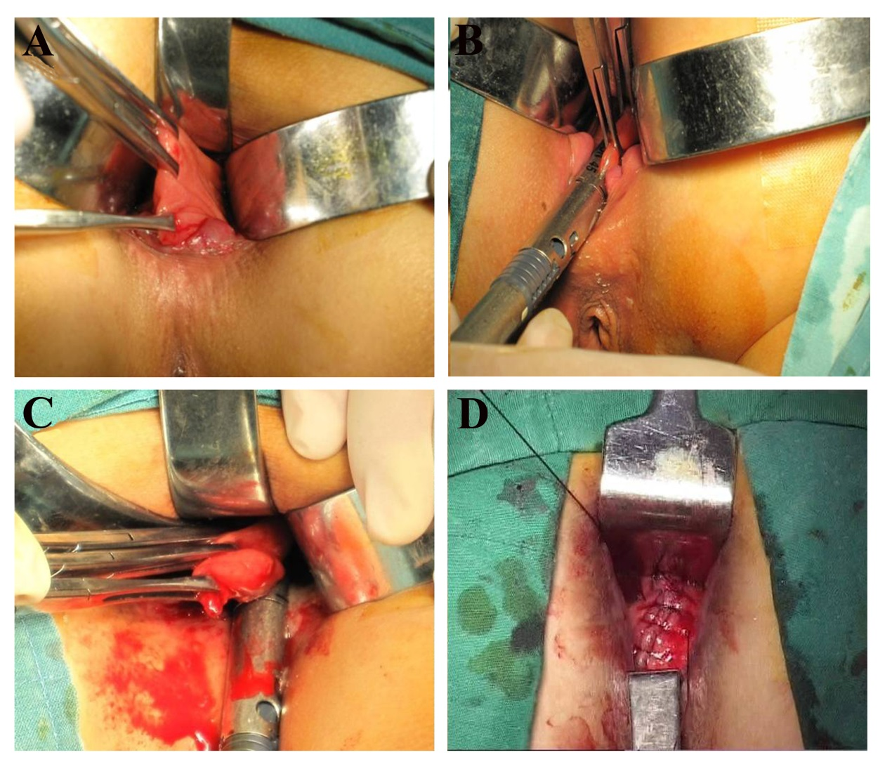
Figure 1 surgical technique of Bresler procedure. A: The anterior wall of the defect in the rectum should be raised with 2 or 3 Allis clamps, and it should be ensured every time that it does not involve the posterior wall of the vagina to avoid further complications; B, C: A single use, reloadable endoscopic linear cutter is introduced, and 1 or 2 firings might be necessary depending on the extent of prolapse seen in the rectocele; D: A longitudinal locked running suture, including rectal mucosa, submucosa, and muscle, was made with 2–0 absorbable vicryl along the staple line for the plication of the repaired anterior rectal wall to strengthen the stapled region.

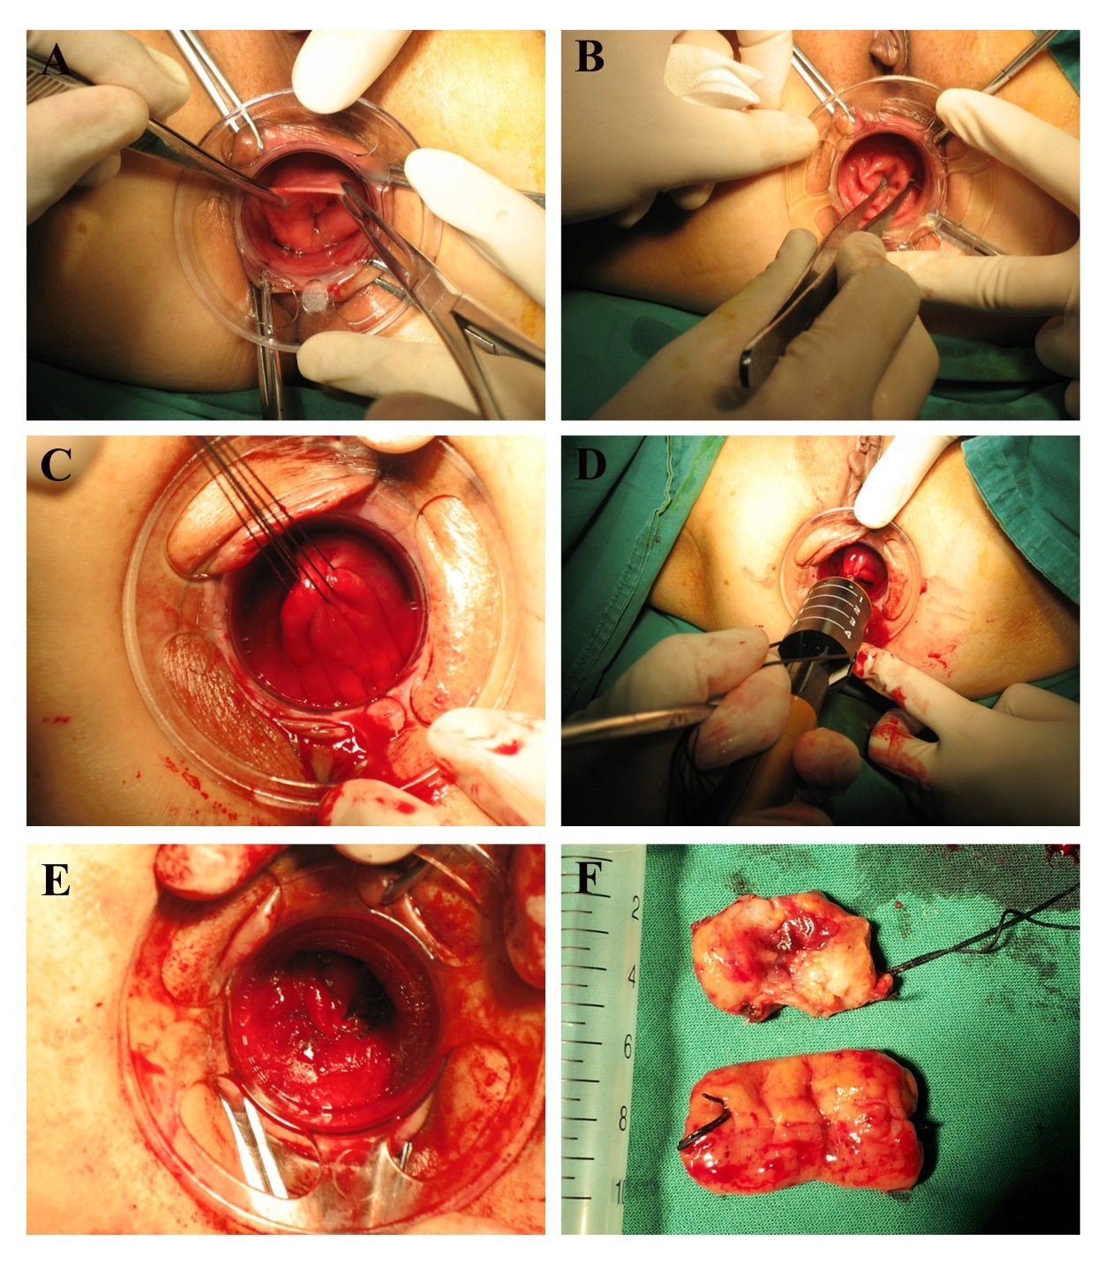
Figure 2 Surgical technique of prolapse and hemorrhoids-stapled transanal rectal resection procedure. A, B: A CAD was introduced into the anal canal, and a sterile betadine gauze hold with a pincer should be used to draw the prolapsed tissue inside the dilator; C: Three purse-string sutures in all of the layers of the rectum were made at 1 cm intervals using Prolene 2–0 in the anterior area of the rectum at 4 cm above the dentate line and from the 9 o’clock direction to the 3 o’clock direction including the apex of the anterior rectocele; D: A PPH device was inserted into the anal canal and closed and fired to perform the rectal anastomosis, and the staple line was reinforced using a 3-0 absorbable vicryl suture; E: The same procedure was repeated on the posterior rectal wall; F: The resected sample. PPH: Procedure for prolapse and hemorrhoids; STARR: Stapled transanal rectal resection; CAD: Circular anal dilator.
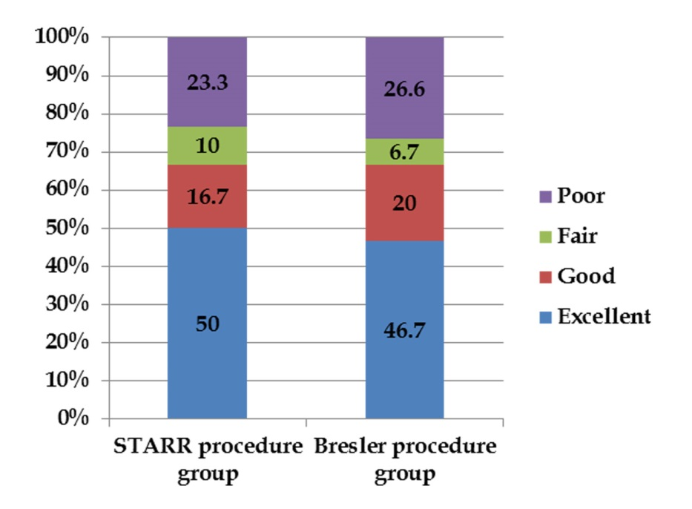
Figure 3 Short-term follow-up of postoperative satisfaction grade of both prolapse and hemorrhoids-stapled transanal rectal resection procedure and Bresler procedures. In 30 patients who underwent PPH-STARR procedure, there were 15 persons (50%) who felt excellent and 5 persons (16.7%) who felt good post operation. And there were 3 persons (10%) who just said fair and 7 persons (23.3%) complaint about poor outcome after operation. In 30 patients who underwent Bresler procedure, there were 14 persons (46.7%) who felt excellent and 6 persons (20%) who felt good post operation. And there were 2 persons (6.7%) who just said fair and 8 persons (26.6%) complaint about poor outcome after operation. PPH: Procedure for prolapse and hemorrhoids; STARR: Stapled transanal rectal resection.

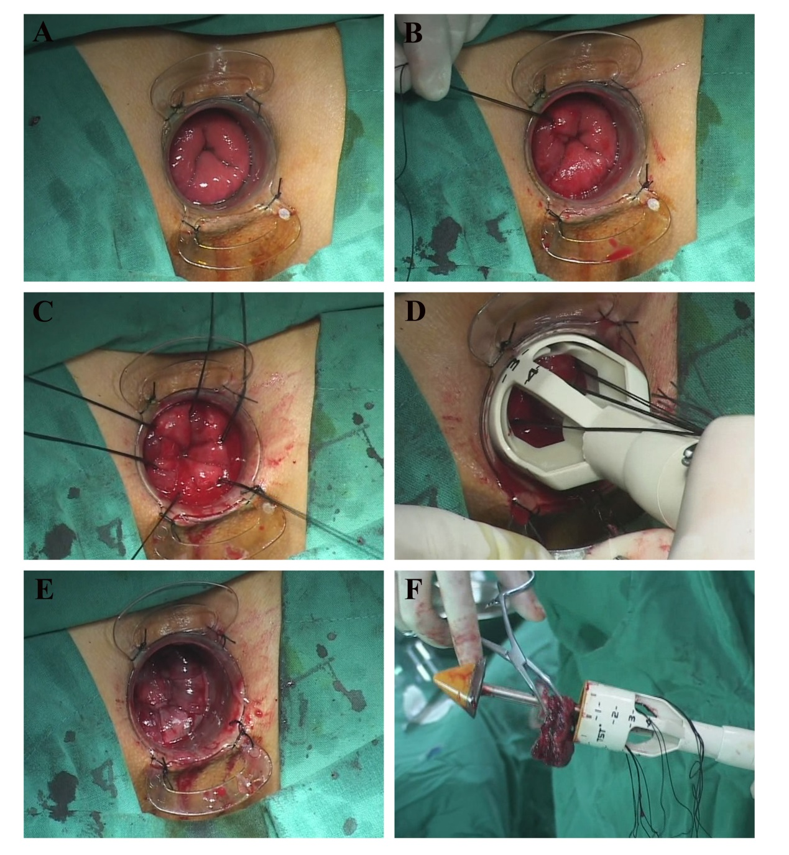
Figure 4 Surgical technique of tissue selecting therapy-stapled transanal rectal resection procedure. A: A CAD was gently introduced and fixed to the perianal skin after digital anal dilatation to assess the scope and degree of prolapse and rectocele; B, C: The parachute technique with 6 figure-eight sutures was used to pull out the rectocele and prolapsed tissues, and the depth of each suture should reach the rectal muscular layer; D: A 36-mm TST stapler was placed through the CAD, and all traction lines were pulled out through the mega windows; E: The stapler was closed and fired to perform the rectal anastomosis, and the staple line was reinforced using a 3-0 absorbable vicryl suture; F: The resected sample. TST: Tissue selecting therapy; STARR: Stapled transanal rectal resection; CAD: Circular anal dilator.

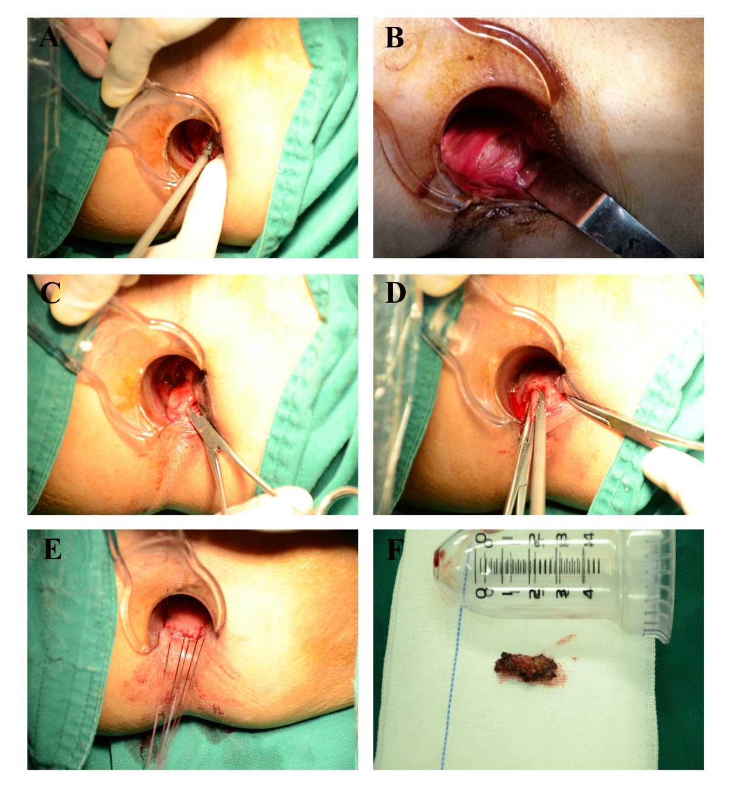
Figure 5 Technique of transanal partial excision of the puborectalis. A: Making a lateral incision of approximately 3 cm located 1 cm up on the dentate line on the rectal mucosa from the 3 o’clock direction to the 5 o’clock direction using an ultrasound knife; B: The rectal postero-lateral wall was dissected to the puborectalis; C, D: The puborectalis muscle was lifted up and approximately 2 cm was removed with an ultrasound knife; E: A full-thickness suture of the rectal wall was carried out; F: The resected sample.

Table 1 Overview and summary of pros of each transanal operative procedure
Procedure | Pros | Ref.
Partial Division of Puborectalis | Good short term follow up | [35-37]
 | More effective compared with common non-surgical procedures | [35]
Internal Delorme Procedure | Good long term follow up with advantages as low recurrence rate and without complications as postoperative constipation | [50,53,58,59]
 | Suitable for patients with ODS and postoperative risk of fecal incontinence | [50,53]
PPH-STARR Procedure | Overall satisfaction from postoperative long term follow up | [52,56,62-65,83-86]
 | Without damage to the anal sphincters | [47]
Contour-Transtar Procedure | High percent of patient satisfaction from long term follow up with advantages such as visualizing the procedure and suitable for resection of a large volume of prolapsed tissue and without severe complications as recto-vaginal fistula and fecal incontinence | [41,87,88,91-96]
 | With superiority over PPH-STARR procedure | [91]
Bresler Procedure and Liner Stapler and Bioabsobable Stapler Line Reinforcement Material | High percent of patient satisfaction from long term follow up with advantages such as suitable for rection of a large rectocele with depth more than 4.5 cm and simple procedure and without severe complications as recto-vaginal fistula and peritoneal perforation | [9,45,48,99,100]
TRREMS Procedure | High percent of patient satisfaction from long term follow up with advantages such as suitable for larger prolapses of more than 5.0 cm, a short learning curve and without severe complications | [42-44,101]
TST-STARR Procedure | High percent of patient satisfaction from long term follow up with advantages such as suitable for larger prolapses of more than 5.0 cm, a short learning curve,direct visualization during surgery and without severe complications | [11]
TERP Procedure | Good short term follow up | [46]
TRREMS: transanal repair of rectocele and rectal mucosectomy with a single circular stapler; TST: Tissue selecting therapy; PPH: Procedure for prolapse and hemorrhoids; STARR: Stapled transanal rectal resection.

Table 2 Overview and summary of cons of each transanal operative procedure
Procedure | Cons | Ref.
Partial Division of Puborectalis | Disappointing short term follow up | [34,38,57]
 | Increase the risk of postoperative fecal incontinence | [34,38,57]
Internal Delorme’s Procedure | Unsatisfactory long term follow up with disadvantages such as high recurrence rate and long operative time and complications as constipation, fissure-in-ano, and transient incontinence | [39,53,55,60,61]
 | Unsuitable for patients with ODS and diarrhea | [53]
 | Need additional sphincteroplasty for patients with ODS and severe fecal incontinence | [60]
 | Without superior to stapling procedures on treatment of rectocele induced ODS | [39,55]
PPH-STARR Procedure | Disappointing long term follow up with disadvantages as long learning curve and complications as bleeding, puborectalis dyssynergia, urinary retention, granuloma of anastomotic stoma and recurrent ODS | [41,63,67-70,79,80]
 | With some severe postoperative complications such as severe proctalgia, , fecal incontinence rectovaginal fistula | [75-78]
 | With rare complications as rectal diverticulum and sigmoid volvulus | [81,82]
 | Unsuitable for patients with previous pelvic floor surgery or sphincter weakness | [66,68-70,76-80]
 | limitation of resection of a large volume of prolapsed tissue and difficulties in visualizing the procedure | [41]
Contour-Transtar Procedure | Disappointing long term follow up with disadvantages as long learning curve , relatively complicated procedure and high cost and complications as bleeding, puborectalis dyssynergia, urinary retention, granuloma of anastomotic stoma and recurrent ODS | [65,87,89,90,97]
 | With some severe complications such as recto-vaginal fistula, fecal urgency, fecal incontinence and anorectal pain | [87,89,90]
 | Unsuitable for patients with previous pelvic floor surgery or sphincter weakness | [65,87,89,90,97]
 | Without superiority over PPH-STARR procedure | [65,97]
Bresler Procedure and Liner Stapler and Bioabsobable Stapler Line Reinforcement Material | limited effect on rectal intussusception and unsuitable for patients with sphincter weakness | [45,48,99,100]
TRREMS Procedure | limited effect on severe rectocele | [44]
 | Unsuitable for patients with sphincter weakness | [42-44,101]
TST-STARR procedure | Unsuitable for patients with sphincter weakness | [11]
TRREMS: transanal repair of rectocele and rectal mucosectomy with a single circular stapler; TST: Tissue selecting therapy; PPH: Procedure for prolapse and hemorrhoids; STARR: Stapled transanal rectal resection.

Table 3 Comparison of mean operative time, blood loss and mean postoperative hospital stay between the procedure for prolapse and hemorrhoids-stapled transanal rectal resection and Bresler procedures
 | STARR procedure | Bresler procedure | P-value
Mean operative time (min) | 21.5 ± 4.5 | 21.0 ± 4.0 | 0.26
Blood loss (ml) | 10.0 ± 2.5 | 9.0 ± 2.0 | 0.35
Mean postoperative hospital stay (d) | 5 | 5 | 0.19
STARR: Stapled transanal rectal resection.

Table 4 Comparison of the incidence of postoperative complications between the procedure for prolapse and hemorrhoids-stapled transanal rectal resection and Bresler procedures
 | Pain | Fecal incontinence | Bleeding | Total number | Incidence (%) | P-value
STARR procedure | 2 | 5 | 1 | 30 | 26.7 | 0.774
Bresler procedure | 3 | 4 | 2 | 30 | 30
STARR: Stapled transanal rectal resection.

