Name of Journal: World Journal of Hepatology
Manuscript NO: 80909
Manuscript Type: LETTER TO THE EDITOR

Prognostic role of ring finger and WD repeat domain 3 and immune cell infiltration in hepatocellular carcinoma

Miao YD et al. RFWD3 in HCC

Yan-Dong Miao, Wu-Xia Quan, Jiang-Tao Wang, Jian Gan, Xin Dong, Fang Zhang

Yan-Dong Miao, Fang Zhang, Cancer Center, Yantai Affiliated Hospital of Binzhou Medical University, Yantai 264000, Shandong Province, China

Wu-Xia Quan, Department of Electrocardiogram, Yantai Affiliated Hospital of Binzhou Medical University, Yantai 264100, Shandong Province, China

Jiang-Tao Wang, Department of Thyroid and Breast Surgery, Yantai Affiliated Hospital of Binzhou Medical University, Yantai 264000, Shandong Province, China

Jian Gan, Department of Gastroenterology, Yantai Affiliated Hospital of Binzhou Medical University, Yantai 264000, Shandong Province, China

Xin Dong, Second Department of Oncology, Yantai Affiliated Hospital of Binzhou Medical University, Yantai 264000, Shandong Province, China

Author contributions: Miao YD and Zhang F designed the research; Miao YD wrote this paper; Quan WX and Wang JT performed data analysis, Gan J and Dong X prepared tables and figures; Zhang F and Miao YD reviewed this manuscript; Miao YD and Quan WX contributed equally to this article; all authors approved the final manuscript.

Corresponding author: Fang Zhang, MD, Chief Doctor, Professor, Cancer Center, Yantai Affiliated Hospital of Binzhou Medical University, No. 717 Jinbu Street, Muping District, Yantai 264000, Shandong Province, China. zhangfang820127@163.com

Received: October 17, 2022
Revised: October 29, 2022
Accepted: December 23, 2022
Published online:

Abstract
The expression of ring finger and WD repeat domain 3 (RFWD3) is significantly higher in unpaired and paired hepatocellular carcinoma (HCC) tissues than in normal tissues. The expression of RFWD3 has a significant correlation with the infiltration level of 14 immune cells. There is a prominent difference in overall survival, disease-specific survival, and progression-free interval between the high and low RFWD3 expression subgroups. Besides, univariate cyclooxygenase analysis indicated that RFWD3 is an independent prognostic element for HCC. RFWD3 has an ability to accurately predict the prognosis in HCC (area under curve value = 0.863). Furthermore, nomogram can predict the probabilities of 1-, 3- and 5-year osteosarcoma via integrating the age, pathologic stage, AFP, and RFWD3 expression in HCC.

Key Words: Hepatocellular carcinoma; Ring finger and WD repeat domain 3; Immune cell infiltration; Bioinformatics

Miao YD, Quan WX, Wang JT, Gan J, Dong X, Zhang F. Prognostic role of ring finger and WD repeat domain 3 and immune cell infiltration in hepatocellular carcinoma. World J Hepatol 2022; In press

Core Tip: We discovered that ring finger and WD repeat domain 3 (RFWD3) expression is remarkable higher in tumor group than in the corresponding normal group, whether in unpaired or paired hepatocellular carcinoma (HCC) tissues. RFWD3 expression has a significant correlation with the infiltration level of 14 immune cells. Besides, univariate cyclooxygenase regression analysis indicated that RFWD3 is an independent prognostic element in HCC. RFWD3 has the ability to accurately predict the prognosis in HCC.

TO THE EDITOR
We studied with an interesting paper by Liang et al^{[1]}. They assessed ring finger and WD repeat domain 3 (RFWD3) expression levels in hepatocellular carcinoma (HCC) patients. Furthermore, they found RFWD3 affects the prognosis, proliferation, invasion, and metastasis of HCC via regulating the Wnt/β-catenin signal pathway. We appreciate the authors' unique view in probing into the prognostic implication of RFWD3 in HCC. We also discovered the expression of RFWD3 was prominently higher in both unpaired and paired HCC tissues than in the corresponding normal tissues (Figure 1A and B). According to the current research, cancer cells, endothelial cells, stromal cells, immune cells, and cancer-associated fibroblasts cells all exist in the tumor microenvironment (TME)^{[3,4]}. TME is also an crucial part in the development, invasion and metastasis of HCC, however, immune escape of HCC has become a hard conundrum in cancer treatment^{[5]}. Due to the limitations of chemotherapy in the liver cancer therapy, many immunotherapy for liver cancer arises at the historic moment. Immunotherapy mainly uses immune cells inside and outside TME to specific target and attack cancer cells, which has an advantage of high specificity and low side-effect^{[6]}. Different types of immune-related cells act diverse roles, containing inhibiting/promoting HCC and varying types that are controversial^{[7]}. Liang et al^{[1]} found RFWD3 affects the prognosis of HCC. Therefore, we tested a hypothesis that the expression of RFWD3 maybe associate with the immune cells infiltration in HCC. Detailed information are shown in Table 1.
To confirm the hypothesis, in this research, we explored the correlation between RFWD3 expression and infiltration level of 24 immune cells by spearman's analysis using ssGSEA algorithm^{[8]}. We found that RFWD3 expression has a remarkable correlation with the infiltration level of 14 immune cells (Figure 2A), among them, RFWD3 expression is positively associated with the infiltration level of Th2 cells, T helper cells, T follicular helper (TFH) cells, T central memory (Tcm) cells, activated dendritic cell (DC), NK CD56 bright cells, Eosinophils cells (Figure 2B-H, all P < 0.05); and negatively associated with cytotoxic cells, DC, plasmacytoid DC (pDC), Neutrophils cells, T gamma delta cells (Tgd), Treg cells, Th17 cells (Figure 2I-O, all P < 0.05). These finding might encourage further detection the effection of RFWD3 in HCC immunotherapy. Detailed information is manifested in Table 2.
We agree with Liang et al^{[1]}, who found that higher RFWD3 expression show a worse OS in HCC. Our study found that OS, DSS, and PFI are prominently shorter in the high RFWD3 subgroup than in the low RFWD3 subgroup (Figure 3A-C, all P < 0.05). Besides, univariate cyclooxygenase analysis demonstrated that RFWD3 is an independent prognostic element for HCC patients (Table 3). Receiver operating characteristic curve showed that RFWD3 has the ability to accurately predict the prognosis in HCC (area under curve = 0.863). Furthermore, we utilized the nomogram to predict the probabilities of 1-, 3- and 5-year osteosarcoma via integrating age, pathologic stage, AFP, and RFWD3 expression. Each element was assigned a score in ratio to its contribution to the survival risk (Figure 3E). Conversely, the above fingding indicated that the research performed through Liang et al^{[1]} is worthy of attention and that our discover may be provide supplementary information to their study, which can make the study more significant.

REFERENCES
1 Liang RP, Zhang XX, Zhao J, Lu QW, Zhu RT, Wang WJ, Li J, Bo K, Zhang CX, Sun YL. RING finger and WD repeat domain 3 regulates proliferation and metastasis through the Wnt/β-catenin signalling pathways in hepatocellular carcinoma. World J Gastroenterol 2022; 28: 3435-3454 [PMID: 36158256 DOI: 10.3748/wjg.v28.i27.3435]
2 Vivian J, Rao AA, Nothaft FA, Ketchum C, Armstrong J, Novak A, Pfeil J, Narkizian J, Deran AD, Musselman-Brown A, Schmidt H, Amstutz P, Craft B, Goldman M, Rosenbloom K, Cline M, O'Connor B, Hanna M, Birger C, Kent WJ, Patterson DA, Joseph AD, Zhu J, Zaranek S, Getz G, Haussler D, Paten B. Toil enables reproducible, open source, big biomedical data analyses. Nat Biotechnol 2017; 35: 314-316 [PMID: 28398314 DOI: 10.1038/nbt.3772]
3 Hanahan D. Hallmarks of Cancer: New Dimensions. Cancer Discov 2022; 12: 31-46 [PMID: 35022204 DOI: 10.1158/2159-8290.CD-21-1059]
4 Hanahan D, Weinberg RA. Hallmarks of cancer: the next generation. Cell 2011; 144: 646-674 [PMID: 21376230 DOI: 10.1016/j.cell.2011.02.013]
5 Wu Q, Zhou L, Lv D, Zhu X, Tang H. Exosome-mediated communication in the tumor microenvironment contributes to hepatocellular carcinoma development and progression. J Hematol Oncol 2019; 12: 53 [PMID: 31142326 DOI: 10.1186/s13045-019-0739-0]
6 Yost KE, Satpathy AT, Wells DK, Qi Y, Wang C, Kageyama R, McNamara KL, Granja JM, Sarin KY, Brown RA, Gupta RK, Curtis C, Bucktrout SL, Davis MM, Chang ALS, Chang HY. Clonal replacement of tumor-specific T cells following PD-1 blockade. Nat Med 2019; 25: 1251-1259 [PMID: 31359002 DOI: 10.1038/s41591-019-0522-3]
7 Hao X, Sun G, Zhang Y, Kong X, Rong D, Song J, Tang W, Wang X. Targeting Immune Cells in the Tumor Microenvironment of HCC: New Opportunities and Challenges. Front Cell Dev Biol 2021; 9: 775462 [PMID: 34869376 DOI: 10.3389/fcell.2021.775462]
8 Hänzelmann S, Castelo R, Guinney J. GSVA: gene set variation analysis for microarray and RNA-seq data. BMC Bioinformatics 2013; 14: 7 [PMID: 23323831 DOI: 10.1186/1471-2105-14-7]
9 Miao Y, Wang J, Li Q, Quan W, Wang Y, Li C, Wu J, Mi D. Prognostic value and immunological role of PDCD1 gene in pan-cancer. Int Immunopharmacol 2020; 89: 107080 [PMID: 33069926 DOI: 10.1016/j.intimp.2020.107080]
10 Walter W, Sánchez-Cabo F, Ricote M. GOplot: an R package for visually combining expression data with functional analysis. Bioinformatics 2015; 31: 2912-2914 [PMID: 25964631 DOI: 10.1093/bioinformatics/btv300]

Footnotes
Conflict-of-interest statement: All the authors report no relevant conflicts of interest for this article.

Open-Access: This article is an open-access article that was selected by an in-house editor and fully peer-reviewed by external reviewers. It is distributed in accordance with the Creative Commons Attribution NonCommercial (CC BY-NC 4.0) license, which permits others to distribute, remix, adapt, build upon this work non-commercially, and license their derivative works on different terms, provided the original work is properly cited and the use is non-commercial. See: https://creativecommons.org/Licenses/by-nc/4.0/

Provenance and peer review: Unsolicited article; Externally peer reviewed.
Peer-review model: Single blind

Peer-review started: October 17, 2022
First decision: November 15, 2022
Article in press:

Specialty type: Oncology
Country/Territory of origin: China
Peer-review report’s scientific quality classification
Grade A (Excellent): A
Grade B (Very good): 0
Grade C (Good): 0
Grade D (Fair): D
Grade E (Poor): 0

P-Reviewer: Ding Y, China; Papadopoulos N, Greece S-Editor: Xing YX L-Editor: A P-Editor: Xing YX
Figure Legends
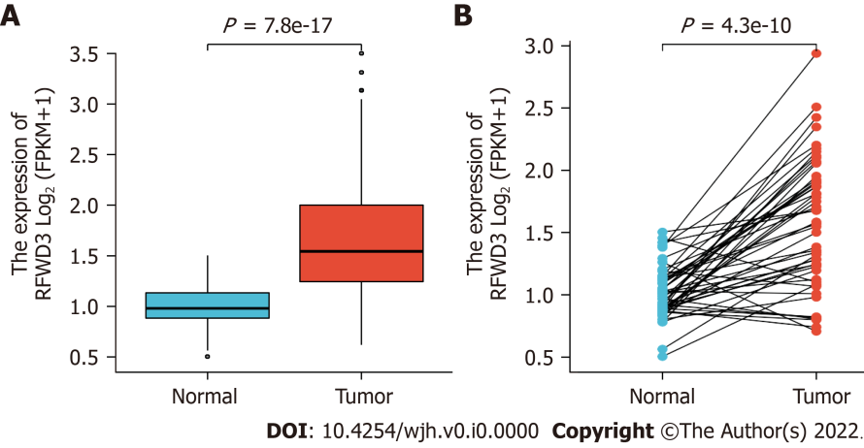
Figure 1 The differential expression level of ring finger and WD repeat domain 3 in hepatocellular carcinoma and normal tissues. A: Non-paired hepatocellular carcinoma (HCC) and normal samples; B: Paired HCC and normal samples. Data source: mRNA seq data of tetraphenylmethane format for GTEx and Cancer Genome Atlas processed consistently through the Toil process in the UCSC XENA database.
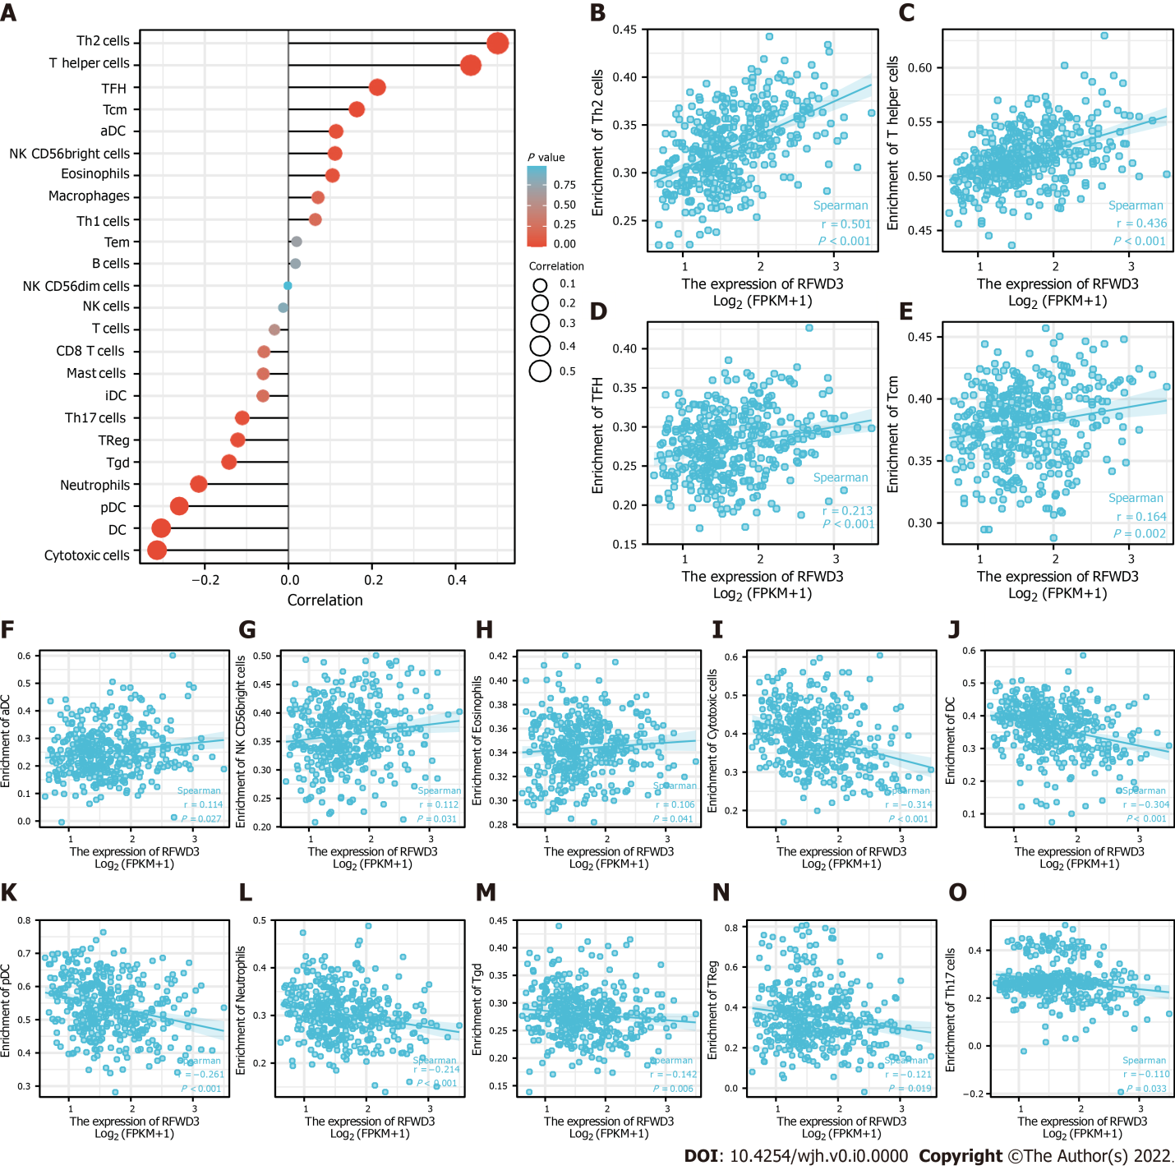
Figure 2 Correlation analysis of ring finger and WD repeat domain 3 expression and immune cell infiltration in hepatocellular carcinoma. A: Lollipop plot manifesting the correlation between ring finger and WD repeat domain 3 (RFWD3) expression and the infiltration level of 24 immune cells; B-H: Seven immune cell infiltration levels have significant positive correlation with RFWD3 expression; B: Th2 cells; C: T helper cells; D: T follicular helper cells; E: T central memory cells; F: Activated dendritic cell; G: Natural killer CD56 bright cells; H: Eosinophils cells; I-O: Seven immune cell infiltration levels have significant negative correlation with RFWD3 expression; I: Cytotoxic cells; J: Dendritic cell; K: Plasmacytoid dendritic cell; L: Neutrophils cells; M: T gamma delta; N: Treg cells; O: Th17 cells. aDC: Activated dendritic cell; DC: Dendritic cell; iDC: Immature dendritic cell; NK: Natural killer; pDC: Plasmacytoid dendritic cell; Tcm: T central memory; Tem: T effector memory; Tfh: T follicular helper; Tgd: T gamma delta.
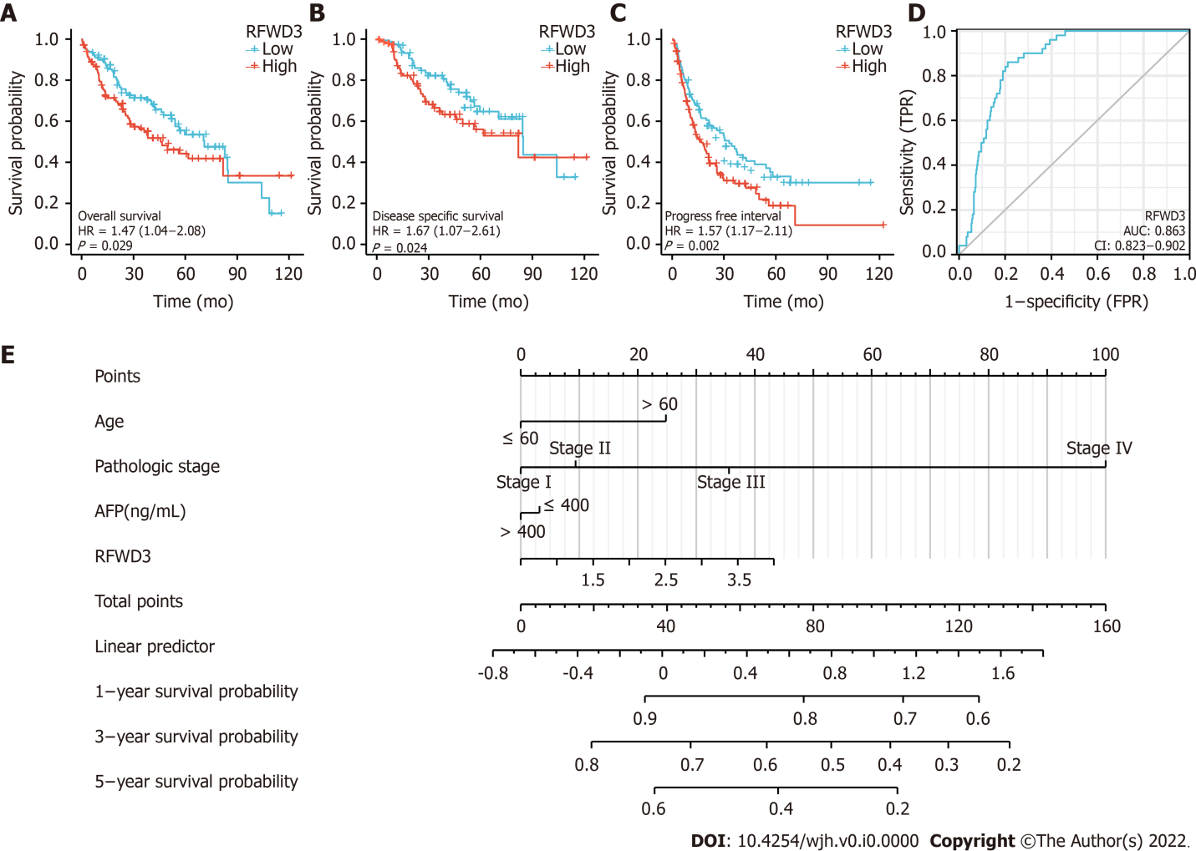
Figure 3 Survival analysis of ring finger and WD repeat domain 3 in hepatocellular carcinoma and the nomogram. Ring finger and WD repeat domain 3 (RFWD3) expression is related to A: Overall survival; B: Disease-specific survival; and C: progression-free interval in the Cancer Genome Atlas-hepatocellular carcinoma (HCC); D: Receiver operating characteristic curves of RFWD3 gene predicting prognosis. Nomogram can predict 1-, 3-, and 5-year osteosarcoma of HCC based on clinicopathological features and the expression of RFWD3.
Table 1 Detailed statistical results of differential expression of ring finger and WD repeat domain 3 in hepatocellular carcinoma
Gene | Group | Number | Minimum | Maximum | Median | IQR | Lower quartile | Upper quartile | Mean | SD | SE
RFWD3 | Normal | 50 | 0.504 | 1.504 | 0.98 | 0.251 | 0.883 | 1.133 | 1.013 | 0.208 | 0.029
RFWD3 | Tumor | 374 | 0.62 | 3.5 | 1.544 | 0.755 | 1.245 | 2 | 1.647 | 0.559 | 0.029
RFWD3 | Normal | 50 | 0.504 | 1.504 | 0.98 | 0.251 | 0.883 | 1.133 | 1.013 | 0.208 | 0.029
RFWD3 | Tumor | 50 | 0.707 | 2.939 | 1.577 | 0.716 | 1.204 | 1.92 | 1.578 | 0.521 | 0.074
RFWD3: Ring finger and WD repeat domain 3; IQR: Interquartile distance; SD: Standard deviation; SE: Standard error.

Table 2 Detailed information on the correlation between ring finger and WD repeat domain 3 expression and immune cell infiltration
Gene | Cell | Correlation coefficient (Pearson) | P value  (Pearson) | Correlation coefficient (Spearman) | P value  (Spearman)
RFWD3 | Th2 cells | 0.499 | < 0.001 | 0.501 | < 0.001
 | T helper cells | 0.434 | < 0.001 | 0.436 | < 0.001
 | Cytotoxic cells | -0.304 | < 0.001 | -0.314 | < 0.001
 | DC | -0.281 | < 0.001 | -0.304 | < 0.001
 | pDC | -0.261 | < 0.001 | -0.261 | < 0.001
 | Neutrophils | -0.210 | < 0.001 | -0.214 | < 0.001
 | TFH | 0.226 | < 0.001 | 0.213 | < 0.001
 | Tcm | 0.187 | < 0.001 | 0.164 | 0.002
 | Tgd | -0.105 | 0.043 | -0.142 | 0.006
 | TReg | -0.155 | 0.003 | -0.121 | 0.019
 | aDC | 0.141 | 0.006 | 0.114 | 0.027
 | NK CD56bright cells | 0.128 | 0.013 | 0.112 | 0.031
 | Th17 cells | -0.170 | < 0.001 | -0.110 | 0.033
 | Eosinophils | 0.077 | 0.135 | 0.106 | 0.041
 | Macrophages | 0.096 | 0.063 | 0.071 | 0.171
 | Th1 cells | 0.090 | 0.081 | 0.064 | 0.214
 | iDC | -0.034 | 0.507 | -0.061 | 0.241
 | Mast cells | -0.053 | 0.309 | -0.060 | 0.247
 | CD8 T cells | -0.047 | 0.368 | -0.058 | 0.260
 | T cells | -0.013 | 0.796 | -0.033 | 0.522
 | Tem | 0.085 | 0.100 | 0.020 | 0.704
 | B cells | 0.033 | 0.525 | 0.017 | 0.744
 | NK cells | 0.035 | 0.494 | -0.012 | 0.810
 | NK CD56dim cells | 0.020 | 0.699 | -0.001 | 0.979
RFWD3: Ring finger and WD repeat domain 3; a DC: Activated dendritic cell; DC: Dendritic cell; i DC: Immature dendritic cell; NK: Natural killer; p DC: Plasmacytoid dendritic cell; Tcm: T central memory; Tem: T effector memory; Tfh: T follicular helper; Tgd: T gamma delta.

Table 3 Univariate cyclooxygenase regression analysis in hepatocellular carcinoma
Characteristics | Total (n) | Univariate analysis
 |  | Hazard ratio (95%CI) | P value
Pathologic stage | 349
Stage I | 173
Stage II | 86 | 1.417 (0.868-2.312) | 0.164
Stage III | 85 | 2.734 (1.792-4.172) | < 0.001
Stage IV | 5 | 5.597 (1.726-18.148) | 0.004
Child-Pugh grade | 240
A | 218
B | 21 | 1.595 (0.757-3.361) | 0.219
C | 1 | 2.138 (0.294-15.544) | 0.453
Fibrosis ishak score | 214
0 | 75
1/2 | 31 | 0.935 (0.437-2.002) | 0.864
3/4 | 28 | 0.698 (0.288-1.695) | 0.428
5/6 | 80 | 0.737 (0.410-1.325) | 0.308
Histologic grade | 368
G1 | 55
G2 | 178 | 1.162 (0.686-1.969) | 0.576
G3 | 123 | 1.185 (0.683-2.057) | 0.545
G4 | 12 | 1.681 (0.621-4.549) | 0.307
RFWD3 | 373 | 1.557 (1.148-2.110) | 0.004

