Name of Journal: World Journal of Clinical Cases
Manuscript NO: 68946
Manuscript Type: CASE REPORT

Hemolymphangioma with multiple hemangiomas in liver of elderly woman with history of gynecological malignancy: A case report

Wang M et al. Hepatic hemolymphangioma with multiple hemangiomas

Min Wang, Hai-Feng Liu, Yan-Zhen-Zi Zhang, Zhi-Qing Zou, Zhou-Quan Wu

Min Wang, Zhi-Qing Zou, Zhou-Quan Wu, Department of Anesthesiology, The Affiliated Changzhou No. 2 People’s Hospital of Nanjing Medical University, Changzhou 213003, Jiangsu Province, China

Hai-Feng Liu, Department of Radiology, Third Affiliated Hospital of Soochow University, Changzhou 213003, Jiangsu Province, China

Yan-Zhen-Zi Zhang, Department of Pathology, Third Affiliated Hospital of Soochow University and Changzhou First People’s Hospital, Changzhou 213003, Jiangsu Province, China

Author contributions: Wang M and Wu ZQ contributed to the design, analysis, and drafting of the manuscript; Wang M and Liu HF contributed to the analysis, and critically revised the manuscript; Zhang YZZ explained the microscopic and immumohistochemical staining; Wu ZQ and Zou ZQ critically revised the manuscript; and all authors read and approved the final manuscript.

Supported by The Scientific Research Project of Jiangsu Provincial Health Commission, No. H2018047; Youth Project of Changzhou City Health Commission, No. QN2020022; and Young Talent Development Plan of Changzhou Health Commission, No. CZQM2021005.

Corresponding author: Zhou-Quan Wu, PhD, Chief Doctor, Department of Anesthesiology, The Affiliated Changzhou No. 2 People's Hospital of Nanjing Medical University, No. 188 Gehu Middle Road, Wujin District, Changzhou 213003, Jiangsu Province, China. wuzhouquan2005@126.com

Received: June 12, 2021
Revised: July 2, 2021
Accepted: September 8, 2021
Published online:

ABSTRACT
BACKGROUND
Hepatic hemolymphangioma is an extremely rare benign congenital malformation composed of cystically dilated lymphatic and blood vessels, and they have nonspecific clinical symptoms and laboratory results. In this study, hepatic hemolymphangioma with multiple hemangiomas in an elderly woman was initially reported and analyzed.

CASE SUMMARY
A 61-year-old female patient, with a history of hysterectomy and bilateral adnexectomy, was referred to the hepatobiliary surgery department with the complaint of multiple hepatic hemangiomas that had been diagnosed 2 years prior in a preoperative contrast-enhanced computed tomography (CECT) examination. Upon entering our hospital, no abnormal physical examination and laboratory data were found. The latest CECT revealed a new 7.0 cm × 6.2 cm cystic-solid lesion with multiple internal divisions in segment II of the liver, with delayed CECT enhancement characteristics that presented as solid parts with internal division. On the positron emission tomography (PET)/CT, no significant uptake of ¹⁸F-fluorodeoxyglucse was observed. Finally, hepatic hemolymphangioma was confirmed based on the pathological and immunohistochemical results after surgery. At 1-year follow-up, her posthepatectomy evaluation was uneventful, and she had recovered full activity. In addition, no postoperative recurrent or residual lesion was found on CECT imaging.

CONCLUSION
Hepatic hemolymphangioma with multiple hemangiomas was reported and observed by CECT and PET/CT imaging.

Key words: Hepatic hemolymphangioma; Hemangiomas; Contrast-enhanced computed tomography; Positron emission tomography/computed tomography; Case report

Wang M, Liu HF, Zhang YZZ, Zou ZQ, Wu ZQ. Hemolymphangioma with multiple hemangiomas in liver of elderly woman with history of gynecological malignancy: A case report. World J Clin Cases 2021; In press

Core tip: To the best of our knowledge, this is the first report of hepatic hemolymphangioma with multiple hemangiomas and the associated features observed by contrast-enhanced computed tomography (CECT) and ¹⁸F-fluorodeoxyglucose positron emission tomography/computed tomography. In addition, this case was beneficial for confirming the pathogenesis of hepatic hemolymphangioma caused by surgery. Finally, posthepatectomy evaluation was uneventful, and no postoperative recurrent or residual lesion was found on CECT imaging, presenting a good prognosis.

INTRODUCTION
Hemolymphangioma, also known as angioma lymphaticum, is an extremely rare vascular malformation that is characterized by blood vessels and cystic dilated lymphatics, which can occur at any age^{[1,2]}, with an estimated incidence from 1.2 to 2.8 per 1000 newborn infants^{[3]}, and both sexes are equally affected. Hemolymphangioma is considered to be a benign and noninvasive disorder, which is most commonly found in the cervical region^{[4]}, seldomly in the pancreas and spleen^{[5]}, and even more rarely in the liver. In a review of PubMed, only three hepatic hemolymphangiomas have been reported in the literature thus far^{[6-8]}. In this study, we present for the first time, a hepatic hemolymphangioma with multiple hemangiomas after hysterectomy and bilateral adnexectomy, in the hope of improving our understanding of hemolymphangioma. Moreover, the imaging features of hepatic hemolymphangiomas observed by contrast-enhanced computed tomography (CECT) and positron emission tomography/computed tomography (PET/CT) were also analyzed.

CASE PRESENTATION
Chief complaints
A 61-year-old female patient was referred to the hepatobiliary surgery department, with the complaint of multiple hepatic hemangiomas that had been diagnosed 2 years prior.

History of present illness
The patient was receiving maintenance chemotherapy after surgery for ovarian cancer.

History of past illness
The patient had a 2-year history of hysterectomy and bilateral adnexectomy owing to ovarian cancer. At her preoperative CECT examination, multiple uniform hypointensity lesions within the liver were found, which were preliminarily diagnosed as multiple hepatic hemangiomas, with the largest lesion measuring 3.6 cm × 2.2 cm, presenting with the enhancement feature of fast-in and slow-out (Figure 1A–C). Based on recommendations from the clinician, the patient was willing to receive regular follow-up.

Personal and family history
The patient had no specific personal or family history.

Physical examination
Physical examination revealed that the abdomen was soft without tenderness or an enlarged liver, and no abnormal temperature or heart pressure was noted. The risk factors for history of hepatitis, nausea and vomiting, yellowish discoloration of the skin and weight loss were initially absent 3 years ago and at this presentation.

Laboratory examinations
The laboratory data concerning liver function were normal: alanine transaminase, 11 (7–40) μ/L; aspartate transaminase, 20 (13–35) μ/L; albumin, 42.4 (35.0–53.0) g/L; and direct bilirubin, 4.8 (0.1–5.8) μmol/L. In addition, tumor biomarkers, such as α-fetoprotein, carcinoembryonic antigen, carbohydrate antigen (CA)-199, and CA-125, were all negative.

Imaging examinations
Upon entering our hospital on this occasion, the latest CECT was performed and revealed multiple hepatic hemangiomas with the same size and density as the previous CECT (3 years ago). However, a new 7.0 cm × 6.2 cm cystic-solid lesion with multiple internal divisions was found in segment II of the liver. The delayed CECT enhancement characteristics presented as solid parts with internal division (Figure 1D–F), which was considered by a radiologist to be a cystoma or cystadenocarcinoma of the liver. There were no CECT manifestations of enlarged lymph nodes or other abdominal organ metastases. On the PET/CT scan, no significant uptake of ¹⁸F-fluorodeoxyglucose was observed (Figure 1G).

Further diagnostic work-up
Postoperative pathology demonstrated that the lesion was soft with a honeycomb shape. Microscopically, enlarged lymphatics and capillaries of varying sizes were seen mixed with a few lymphocytes and red blood cells (Figure 2A, B). For immunohistochemical staining (Figure 2C, D), D2-40 (+), vimentin (+), CD31 (+), CD34 (+), cytokeratin (−), S-100 (−), and smooth muscle actin (−) were used.

FINAL DIAGNOSIS
Hepatic hemolymphangioma was confirmed based on the pathological and immunohistochemical results.

TREATMENT
The patient underwent partial hepatectomy under general anesthesia. A 5.4 cm × 3.2 cm well-defined and dark-red lesion with a false capsule was present in the left lobe and protruding from the liver surface. After the operation, neither radiotherapy nor immunotherapy was conducted, and no surgical complications or symptoms occurred.

OUTCOME AND FOLLOW-UP
At 1-year follow-up, posthepatectomy evaluation was uneventful, and the patient had recovered full activity. In addition, no postoperative recurrent or residual lesion was found on CECT imaging (Figure 1I).

DISCUSSION
Hemolymphangioma can be divided into congenital and acquired forms based on its pathogenesis. For congenital hemolymphangioma, the pathogenesis is mainly associated with obstruction of venous–lymphatic communication between the systemic circulation and dysembryoplastic vascular tissues^{[9]}. However, lymphatic vessel injury caused by surgery or trauma with inadequate lymph fluid drainage can contribute to acquired hemolymphangioma^{[10]}. In the present patient, acquired hemolymphangioma was more likely to be the diagnosis, not only because of the 2-year history of gynecological malignancy, but also because no suspicious hepatic hemolymphangioma was found on preoperative CECT examination. Therefore, this study indicated that surgery may contribute to the pathogenesis of hepatic hemolymphangioma, which was consistent with the previous conclusion reported by Mao et al^{[11]}.
The majority of patients with hepatic hemolymphangioma are asymptomatic for a long period of time, and a few patients may present with primary clinical symptoms of nonspecific epigastric discomfort or pain that originates from the tumor as it grows^{[12]}. In addition, the laboratory data of liver function and tumor biomarkers are often negative, which was also demonstrated in the present case. Abdominal imaging is valuable in evaluating the morphology and invasion of the tumor and guiding surgical treatment. Based on the literature review, hepatic hemolymphangioma usually demonstrates a well-demarcated cystic-solid tumor that has a small solid part and multiloculated cyst. The small solid part may be caused by residual and compressed vascular tissue, while a multiloculated cyst may represent rupture and fusion of the vascular cavity^{[13]}. In this case, hepatic hemolymphangioma appeared as gradual delayed enhancement of the internal division and cystic wall, suggesting minimal blood supply by the portal vein in the lesion. However, multilocular cysts with internal division in hepatic lesions are a common but atypical imaging feature. Thus, cystadenomas, cystadenocarcinomas, and intrahepatic hematomas pose a challenge to reaching a definitive diagnosis before surgery^{[14]}.
Hepatic hemolymphangioma is commonly considered as a benign disorder, but the recurrence and invasion of adjacent organs have been reported^{[5]}. Complete hepatectomy is the most effective therapy, with the aim to remove the entire tumor; however, careful performance is required to avoid possible hemorrhage, not only because of the vascular component of hemolymphangioma, but also the rich blood supply from the portal vein and hepatic artery. Angiography and embolization can also be performed in cases of acute bleeding. The majority of cases in the literature had successful postoperative treatment, and remained asymptomatic during postoperative follow-up, as did our case. However, the recurrence rates vary depending on the adequacy of the excision. Lesions that have been completely excised present 10%–27% recurrence, while those being partially resected may recur in 50%–100% of cases^{[15,16]}. Therefore, postoperative follow-up is necessary due to the potential recurrence of the tumor.

CONCLUSION
We described a patient diagnosed with hepatic hemolymphangioma with multiple hemangiomas in an elderly woman with a history of hysterectomy and bilateral adnexectomy and analyzed the features observed by CECT and PET/CT imaging, which is useful to improve our understanding of hepatic hemolymphangioma. In addition, this study was beneficial for proving the pathogenesis of hepatic hemolymphangioma caused by surgery.

REFERENCES
1 Mei Y, Peng CJ, Chen L, Li XX, Li WN, Shu DJ, Xie WT. Hemolymphangioma of the spleen: A report of a rare case. World J Gastroenterol 2015; 21: 5442-5444 [PMID: 25954120 DOI: 10.3748/wjg.v21.i17.5442]
2 Li Y, Zhang X, Pang X, Yang L, Peng B. Occipitocervical Hemolymphangioma in an Adult with Neck Pain and Stiffness: Case Report and Literature Review. Case Rep Med 2017; 2017: 7317289 [PMID: 29362566 DOI: 10.1155/2017/7317289]
3 Pan X, Dong Y, Yuan T, Yan Y, Tong D. Two cases of hemolymphangioma in the thoracic spinal canal and spinal epidural space on MRI: The first report in the literature. Medicine (Baltimore) 2017; 96: e9524 [PMID: 29384961 DOI: 10.1097/MD.0000000000009524]
4 Teng Y, Wang J, Xi Q. Jejunal hemolymphangioma: A case report. Medicine (Baltimore) 2020; 99: e18863 [PMID: 31977886 DOI: 10.1097/MD.0000000000018863]
5 Zhang Z, Ke Q, Xia W, Zhang X, Shen Y, Zheng S. An Invasive Hemolymphangioma of the Pancreas in a Young Woman. Comb Chem High Throughput Screen 2018; 21: 798-800 [PMID: 30605051 DOI: 10.2174/1386207322666190103110747]
6 Damascelli B, Spagnoli I, Garbagnati F, Ceglia E, Milella M, Masciadri N. Massive lymphorrhoea after fine needle biopsy of the cystic haemolymphangioma of the liver. Eur J Radiol 1984; 4: 107-109 [PMID: 6734606]
7 Daudet M. [Reflections apropos of a case of hepatic hemolymphangioma of the infant. Operation recovery]. Pediatrie 1965; 20: 445-451 [PMID: 5843368]
8 Hu HJ, Jing QY, Li FY. Hepatic Hemolymphangioma Manifesting as Severe Anemia. J Gastrointest Surg 2018; 22: 548-549 [PMID: 29043577 DOI: 10.1007/s11605-017-3577-9]
9 Figueroa RM, Lopez GJ, Servin TE, Esquinca MH, Gómez-Pedraza A. Pancreatic hemolymphangioma. JOP 2014; 15: 399-402 [PMID: 25076353 DOI: 10.6092/1590-8577/2649]
10 Chen G, Cui W, Ji XQ, Du JF. Diffuse hemolymphangioma of the rectum: a report of a rare case. World J Gastroenterol 2013; 19: 1494-1497 [PMID: 23538679 DOI: 10.3748/wjg.v19.i9.1494]
11 Mao CP, Jin YF, Yang QX, Zhang QJ, Li XH. Radiographic findings of hemolymphangioma in four patients: A case report. Oncol Lett 2018; 15: 69-74 [PMID: 29285187 DOI: 10.3892/ol.2017.7268]
12 Ohsawa M, Kohashi T, Hihara J, Mukaida H, Kaneko M, Hirabayashi N. A rare case of retroperitoneal hemolymphangioma. Int J Surg Case Rep 2018; 51: 107-111 [PMID: 30149326 DOI: 10.1016/j.ijscr.2018.08.030]
13 Pan L, Jian-Bo G, Javier PTG. CT findings and clinical features of pancreatic hemolymphangioma: a case report and review of the literature. Medicine (Baltimore) 2015; 94: e437 [PMID: 25621699 DOI: 10.1097/MD.0000000000000437]
14 Qian LJ, Zhu J, Zhuang ZG, Xia Q, Liu Q, Xu JR. Spectrum of multilocular cystic hepatic lesions: CT and MR imaging findings with pathologic correlation. Radiographics 2013; 33: 1419-1433 [PMID: 24025933 DOI: 10.1148/rg.335125063]
15 Kosmidis I, Vlachou M, Koutroufinis A, Filiopoulos K. Hemolymphangioma of the lower extremities in children: two case reports. J Orthop Surg Res 2010; 5: 56 [PMID: 20704732 DOI: 10.1186/1749-799X-5-56]
16 Zhang DY, Lu Z, Ma X, Wang QY, Sun WL, Wu W, Cui PY. Multiple Hemolymphangioma of the Visceral Organs: A Case Report and Review of the Literature. Medicine (Baltimore) 2015; 94: e1126 [PMID: 26166115 DOI: 10.1097/MD.0000000000001126]

Footnotes
Informed consent statement: Informed written consent was obtained from the patient and his parents for publication of this report and the accompanying images.

Conflict-of-interest statement: The authors declare that they have no conflict of interest.

CARE Checklist (2016) statement: This study was conducted based on Care Checklist (2016) statement.

Open-Access: This article is an open-access article that was selected by an in-house editor and fully peer-reviewed by external reviewers. It is distributed in accordance with the Creative Commons Attribution NonCommercial (CC BY-NC 4.0) license, which permits others to distribute, remix, adapt, build upon this work non-commercially, and license their derivative works on different terms, provided the original work is properly cited and the use is non-commercial. See: http://creativecommons.org/Licenses/by-nc/4.0/

Manuscript source: Unsolicited manuscript

Peer-review started: June 12, 2021
First decision: June 25, 2021
Article in press:

Specialty type: Gastroenterology and Hepatology
Country/Territory of origin: China
Peer-review report’s scientific quality classification
Grade A (Excellent): 0
Grade B (Very good): 0
Grade C (Good): C, C, C
Grade D (Fair): 0
Grade E (Poor): 0

P-Reviewer: Elpek GO, Liakina V, Marickar F S-Editor: Wang JL L-Editor: Kerr C P-Editor:

Figure Legends

Figure 1 Contrast-enhanced computed tomography (CECT) and positron emission tomography/computed tomography (PET/CT) features of hepatic hemolymphangioma. A–C: CECT images from 3 years ago revealing multiple hepatic hemangiomas (black arrow) with hypointensity (A) and fast-in and slow-out enhancement patterns (B,C); D–F: CECT before partial hepatectomy presented a new cystic-solid lesion (white arrow) with multiple internal divisions located in segment II of the liver (D), with delayed CECT enhancement characteristics (E, F); G: PET/CT scan found no significant uptake of ¹⁸F-fluorodeoxyglucose; H: At 1-year follow up, no obvious recurrent or residual lesion was identified by CT imaging.

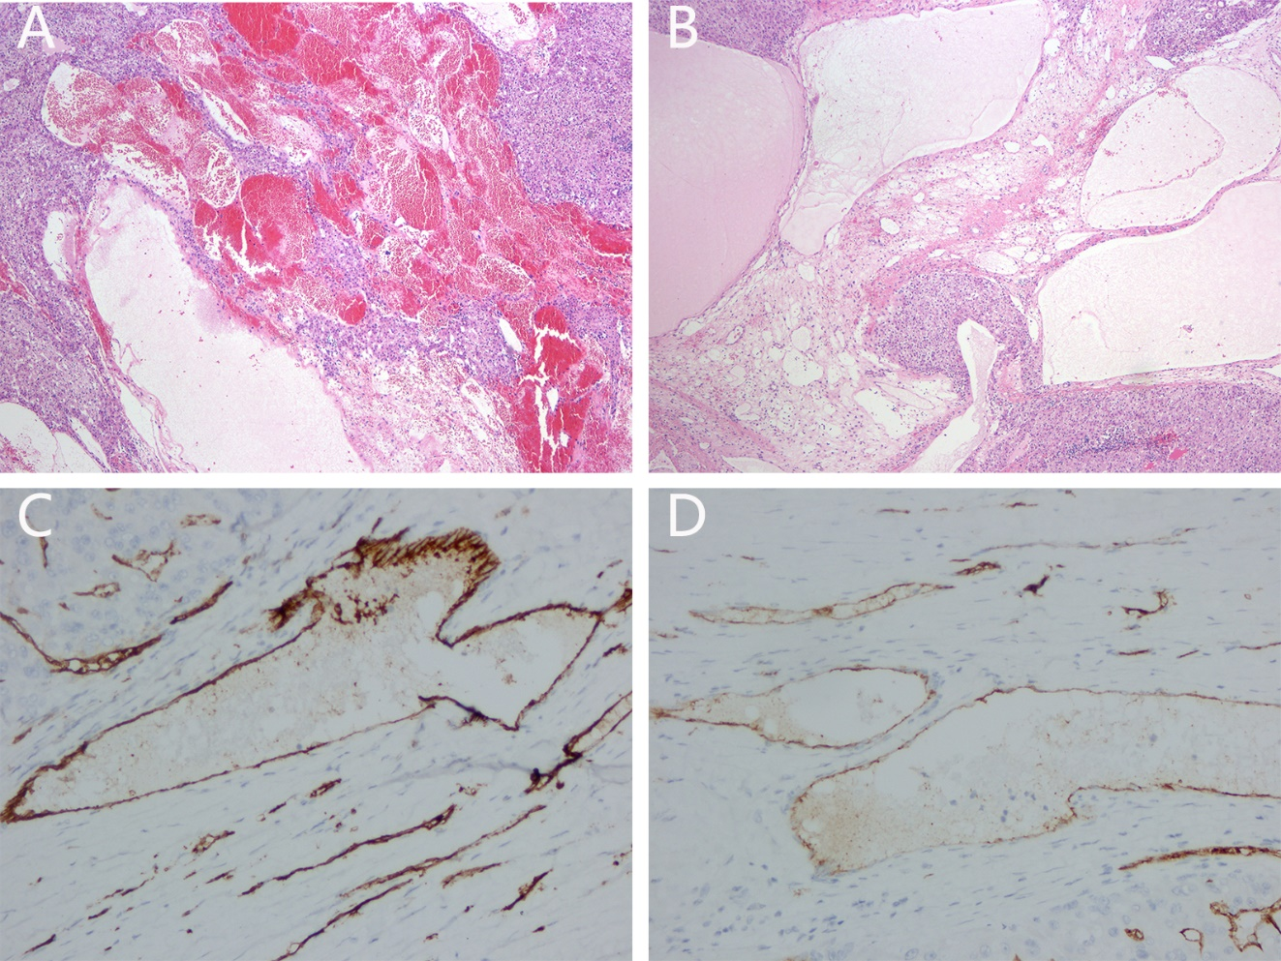
Figure 2 Pathological results of hepatic hemolymphangioma. A, B: Microscopically, the tumor was mainly composed of lymphatic and blood vessels (40×); C, D: Immunohistochemical staining showed that CD34 and CD31 were positive (400×).

