Name of Journal: World Journal of Psychiatry
Manuscript NO: 70978
Manuscript Type: ORIGINAL ARTICLE

Observational Study
Worldwide suicide mortality trends (2000-2019): A joinpoint regression analysis

Ilic M et al. Worldwide suicide mortality trends

Milena Ilic, Irena Ilic

Milena Ilic, Department of Epidemiology, Faculty of Medical Sciences, University of Kragujevac, Kragujevac 34000, Serbia

Irena Ilic, Faculty of Medicine, University of Belgrade, Belgrade 11000, Serbia

Author contributions: All authors equally contributed to this paper with conception and design of the study, data acquisition and analysis, and drafting, critical revision, editing, and approval of the final version.

Supported by the Ministry of Education, Science and Technological development, Republic of Serbia, 2011–2020, No. 175042.

Corresponding author: Milena Ilic, MD, PhD, Professor, Department of Epidemiology, Faculty of Medical Sciences, University of Kragujevac, S. Markovica 69, Kragujevac 34000, Serbia. drmilenailic@gmail.com

Received: August 22, 2021
Revised: November 16, 2021
Accepted: July 8, 2022
Published online: August 19, 2022

Abstract
BACKGROUND
Studies exploring suicide mortality on a global scale are sparse, and most evaluations were limited to certain populations.

AIM
To assess global, regional and national trends of suicide mortality.

METHODS
Suicide mortality data for the period 2000-2019 were obtained from the mortality database of the World Health Organization and the Global Burden of Disease Study. Age-standardized rates (ASRs; expressed per 100000) were presented. To assess trends of suicide mortality, joinpoint regression analysis was used: The average annual percent change (AAPC) with the corresponding 95% confidence interval (95%CI) was calculated.

RESULTS
A total of 759028 (523883 male and 235145 female) suicide deaths were reported worldwide in 2019. The global ASR of mortality of suicide was 9.0/100000 population in both sexes (12.6 in males vs 5.4 in females). In both sexes, the highest rates were found in the region of Africa (ASR = 11.2), while the lowest rates were reported in Eastern Mediterranean (ASR = 6.4). Globally, from 2000 to 2019, ASRs of mortality of suicide had a decreasing tendency in both sexes together [AAPC = -2.4% per year; 95%CI: (-2.6)-(-2.3)]. The region of the Americas experienced a significant increase in suicide mortality over 2000-2019 unlike other regions that had a declining trend. Out of all 133 countries with a decline in suicide mortality, Barbados (AAPC = -10.0%), Grenada (AAPC = -8.5%), Serbia (AAPC = -7.6%), and Venezuela (AAPC = -6.2%) showed the most marked reduction in mortality rates. Out of all 26 countries with a rise in suicide mortality, Lesotho (AAPC = +6.0%), Cyprus (AAPC = +5.1%), Paraguay (AAPC = +3.0%), Saudi Arabia (AAPC = +2.8%), Brunei (AAPC = +2.6%), Greece (AAPC = +2.6%), Georgia (AAPC = +2.1%), and Mexico (AAPC = +2.0%), are among those with the highest increase in mortality.

CONCLUSION
Decreasing trends in suicide mortality were observed in most countries across the world. Unfortunately, the mortality of suicide showed an increasing trend in a number of populations. Further research should explore the reasons for these unfavorable trends, in order to consider and recommend more efforts for suicide prevention in these countries.

Key Words: Suicide rates; Mortality; Trends; Average annual percent change; Joinpoint analysis

©The Author(s) 2022. Published by Baishideng Publishing Group Inc. All rights reserved.

Citation: Ilic M, Ilic I. Worldwide suicide mortality trends (2000-2019): A joinpoint regression analysis. World J Psychiatry 2022; 12(8): 1044-1060
URL: https://www.wjgnet.com/2220-3206/full/v12/i8/1044.htm
DOI: https://dx.doi.org/10.5498/wjp.v12.i8.1044

Core Tip: Despite a decline in mortality during the last decades, suicides are one of the main health challenges worldwide. About 750000 suicide deaths were recorded in 2019 across the world. Globally, the rate of suicide mortality in 2019 was 9.0/100000 for both sexes together (12.6 in males vs 5.4 in females). Despite the decreasing trends recorded in both sexes in most countries in the world, the mortality of suicide showed an increasing trend in certain populations. Further research should clarify the reasons for these unfavorable trends, in order to provide more effective measures for suicide prevention.

INTRODUCTION
Suicides present a significant burden for societies around the world^{[1-3]}. According to the 2019 estimates from the World Health Organization (WHO), suicides caused over 700000 deaths worldwide (representing about 1.3% of all deaths globally), making it the 17th leading cause of death in 2019^{[4]}. In 2016, suicide was among the top 10 leading causes of death in Eastern Europe, Central Europe, Western Europe, Central Asia, Australasia, Southern Latin America, and in high-income areas of North America^{[3]}. In the United States of America in 2019, and consistently over the past years, suicides were the 10th leading cause of death in both sexes^{[5]} and 8th leading cause of death in males^{[6]}.
Globally, for both sexes, suicide was the 4th leading cause of death in young people aged 15-29 years in 2019^{[1]}. In 2019, in several countries (such as Australia, Belarus, Canada, Finland, Germany, Japan, Kazakhstan, Mongolia, Montenegro, Netherlands, Norway, Republic of Korea, Russian Federation, Singapore, Sweden, Switzerland, and the United Kingdom), self-harm was the 1st leading cause of death in people aged 15-34 years for both sexes^{[6]}. The estimates from the Global Burden of Disease (GBD) Study 2019 ranked self-harm as third among the top causes of disability-adjusted life years in adolescents aged 10-24 years^{[7]}.
The majority of suicide deaths (77%) occurred in low- and middle-income countries in 2019^{[4]}. Age-standardized rate (ASR, per 100000) of suicide mortality was 27.5 in Eastern Europe, in high- income Asia Pacific 18.7, in Australasia 10.6, and in Central Europe 13.0 and high- income North America 12.7 in 2016^{[3]}. For both sexes in 2016, the lowest suicide death rates were found in countries in North Africa and the Middle East (4.8/100000). In men in 2016, countries in Eastern Europe recorded the highest suicide mortality rate (50.0/100000), while in women the highest suicide mortality rate was observed in South Asia (12.5/100000)^{[3]}.
During the last decades of the 20th century, declining suicide mortality trends were observed in Eastern Europe, the European Union, the United States of America, and in Japan, while suicide mortality increased sharply in the Russian Federation^{[8]}. Since the 2000s, mortality trends from suicide in 28 selected countries across Europe, the Americas, and Australasia showed downward trends in several areas, while in some countries suicide rates increased (in the United Kingdom, Brazil, Mexico, the United States of America, Republic of Korea, and Australia)^{[9]}.
WHO and the United Nations Sustainable Development Goals aim to reduce suicide mortality by one third by 2030^{[10]}. Reducing the global suicide mortality rate by a third is both an indicator and a target (the only one for mental health) in the United Nations (UN)-mandated Sustainable Development Goals (SDGs). How the coronavirus disease 2019 pandemic is affecting the burden of suicide is not clear yet, considering the lockdown, increased mental stress, possible delays in mental and other illness diagnoses, etc^{[11]}. Nevertheless, there is a scarcity of studies that explored the mortality of suicide in different areas, as most evaluations are limited to certain populations^{[8,9]}. The aim of this study was to estimate the recent global, regional and national trends of suicide mortality.

MATERIALS AND METHODS
Study design
For this descriptive epidemiological study, annual underlying cause of death data was used to describe trends in mortality from suicide for the period 2000-2019. We also cited high-quality articles in Reference Citation Analysis (https://www.referencecitationanalysis.com).

Data sources
Figures of suicide mortality were extracted from the WHO database^{[4]} and from the GBD Study^{[12]}. Mortality estimates of suicide covered site codes X60–X84 and Y87.0, based on the 10th revision of the International Classification of Diseases and Related Health Problems to classify death, injury and cause of death^{[13]}. The WHO and GBD databases provide a comprehensive and comparable assessment of mortality of suicide^{[4,12]}. These databases provide high-quality death statistics by national vital registries worldwide, which were derived from death certificates. According to the WHO guidelines, the definition of the underlying cause of death includes a disease or injury that has started a series of diseases or an injury that has triggered a series of disease states that directly led to death. Mortality was recorded at a local civil registry with information on the cause of death. The information was collected by the health authority and reported to the WHO annually. Only mortality cases that were medically certified were reported. The WHO estimates only comprised national mortality data series that meet the minimal inclusion criteria according to the WHO-defined medium data quality level, based on the degree of population coverage, completeness and accuracy^{[14]}. The WHO and GBD estimates have been documented following the Guidelines for Accurate and Transparent Health Estimates Reporting^{[15]}.
This manuscript presents data for 183 WHO Member States, i.e., only members/countries with a population of 90000 or greater in 2019^{[16]}. We extracted data for suicide in men and women for 183 countries worldwide, over the period 2000-2019. Also, suicide mortality was presented within six WHO regions: Africa, the Americas, South-East Asia, Europe, Eastern Mediterranean, and Western Pacific. For this purpose, ASRs (per 100000) calculated by direct method of standardization by age and sex, using the world standard population, were used^{[17]}. Also, specific (age- and sex-specific) mortality rates (expressed per 100000 persons) were presented.

Statistical analysis
The magnitude and direction of temporal trends for suicide mortality were assessed using the joinpoint regression analysis (Joinpoint regression software, Version 4.5.0.1 - June 2017, available through the Surveillance Research Program of the United States National Cancer Institute), proposed by Kim et al^{[18]}. The joinpoint regression analysis detected point(s), the so-called “joinpoints”, where the statistically significant changes of suicide mortality rates occurred (increase or decrease), and determined the trends between joinpoints^{[18]}. The analysis starts with a minimum of zero joinpoints (i.e., a straight line) and tests whether a change in the trend was statistically significant by testing more joinpoints up to the maximum of four joinpoints (five segments). The annual percentage change (APC) for each of the identified trends of suicide rates using the calendar year as a regression variable was determined. For countries worldwide (including the global and regional level), the average APC (AAPC) over the entire considered period was calculated; for each AAPC estimate, the corresponding 95% confidence interval (CI) was determined^{[19]}. In this manuscript, trend of suicide mortality of each country was presented with a straight line in the whole period, even if there were changes in trends in the observed period^{[18]}.
The terms “significant increase” or “significant decrease” were used in describing the direction of temporal trends, in order to signify that the slope of the trend was statistically significant (P < 0.05, on the basis of the statistical significance of the AAPC compared to zero). For non-statistically significant trends (P > 0.05, while AAPC with a 95%CI including zero), the terms “non-statistically significant increase” (for AAPC > 0.5%), and “non-statistically significant decrease” (for AAPC < -0.5%) were used, while the term “stable” was used for AAPC between -0.5% and 0.5%. Disparities in suicide mortality trends according to age and sex were tested by using a comparability test^{[20]}. The objective of the comparability test was to determine whether the two regression mean functions were identical (test of coincidence) or parallel (test of parallelism). A P-value < 0.05 was considered statistically significant.

Ethics statement
This study was approved by the Ethics Committee of the Faculty of Medical Sciences, University of Kragujevac (No. 01-14321).

RESULTS
A total of 759028 (523883 male and 235145 female) suicide deaths were reported worldwide in 2019 (Figure 1). Per annum, the number of suicides ranged from 839548 in 2000 to 742962 in 2015. During the observed period, there were 15.7 million deaths from suicide in the world (10.6 million men and 5.1 million women). Figure 2 shows the global distribution of suicide deaths in 2019 by WHO regions and by sex. In both sexes, most suicide deaths (230453; 31% of the total) were recorded in the South-East Asia region, followed by the region of the Western Pacific (184918; 24%). Almost one fifth of suicide deaths (137266) occurred in the European region. Compared to the distribution for both sexes, the differences in suicide deaths by regions in males are less obvious. In contrast, in females the dominant participation of suicides is evident in the region of South-East Asia (93552; 40% of the total). The female participation in suicide deaths in the European region was twice as low (29008; 12%) compared to men (108268; 21%).
The global ASR of mortality from suicide was 9.0/100000 population in both sexes (Figure 3). The highest rates were found in the region of Africa (11.2/100000), followed by Europe (10.5), South-East Asia (10.2), the Americas (9.0) and Western Pacific (7.2), while the lowest rates were reported in the Eastern Mediterranean (6.4). The global ASR of suicide mortality in 2019 was more than a two-fold higher in males than in females (12.6 in men vs 5.4 in women). Suicide mortality in men was the highest in Africa (18.0) and Europe (17.1). The region of South-East Asia (with a rate of 8.1) tended to predominate in the suicide mortality of women across the world. In 2019, the lowest suicide mortality rates in both sexes in 2019 were noted in the Eastern Mediterranean region (9.2 and 3.5, respectively).
There were significant international variations in suicide mortality by sex in 2019 (Figure 4). In men, the suicide mortality rate was the highest in Lesotho (146.9/100000), followed by populations in Eswatini, Guyana, Kiribati (with rates of 78.7, 65.0 and 53.6, respectively), whereas the lowest mortality rates (1.0 or less per 100000 people) were registered in Barbados, Grenada, Antiqua and Barbuda (Figure 4A). Also, there was a great variation in suicide mortality in women across countries: The highest mortality rate was in Lesotho (34.6), followed by populations in Guyana (17.0), and then Zimbabwe, Republic of Korea, Federal States of Micronesia (equally about 13.0/100000 people), while the lowest mortality rate (0.2/100000 people) was observed in Barbados (Figure 4B).
Globally, from 2000 to 2019, ASRs of mortality of suicide had a decreasing tendency in both sexes together [AAPC = -2.4% per year; 95%CI: (-2.6)-(-2.3)] (Figure 5A). Overall suicide mortality rates peaked at 14.0/100000 in 2000, and declined thereafter to 9.0/100000 in 2019. Joinpoint analysis identified two joinpoints, in 2009 and 2016, with three consequent trends. The first and second period showed significantly decreasing trends, with APC of -2.2% [95%CI: (-2.5)-(-2.0)] and -3.0% [95%CI: (-3.4)-(-2.5)], respectively. The trend since 2016 was stable, with APC of -0.5% [95%CI: (-1.9)-0.9]. Suicide mortality rates in males decreased from 18.9/100000 in 2000 to 12.6/100000 in the last year observed; AAPC = -2.2%, 95%CI: (-2.3)-(-2.1) (Figure 5B). Joinpoint analyses of suicide mortality in males identified two joinpoints in the year 2005 and 2016, with three trends. The first and second period showed significantly decreasing trends, with APC of -1.4% [95%CI: (-2.0)-(-0.9)] and -2.5% [95%CI: (-2.7)-(-2.3)], respectively. The trend since 2016 was characterized by a non-significant decrease, with APC of -1.3% [95%CI: (-2.6)-0.0]. In females, suicide mortality rates decreased from 9.5/100000 in 2000 to 5.4/100000 in the last year observed; AAPC = -3.0%, 95%CI: (-3.2)-(-2.8). Also, joinpoint analyses of suicide mortality in females identified two joinpoints in the year 2011 and 2016, with three trends. The first and second period showed significantly decreasing trends, with APC of -3.0% [95%CI: (-3.3)-(-2.7)] and -3.8% [95%CI: (-5.2)-(-2.4)], respectively. The trend since 2016 was stable, with APC of -0.2% [95%CI: (-2.5)-2.2]. The trends in suicide mortality in men and women were not parallel and not coincident according to the comparability test (P < 0.05).
When the suicide mortality trend was analyzed by six WHO regions, in males (Figure 6A) significantly decreasing trends were observed in five regions: In Africa (AAPC = -1.5%), South-East Asia (-2.1%), Europe (-3.4%), Eastern Mediterranean (-0.6%), and Western Pacific (-2.9%); the only exception was the region of the Americas, with a significantly increasing suicide mortality trend (+0.6%). Also, significantly decreasing trends were noted in women in five regions: In Africa (-2.3%), South-East Asia (-2.4%), Europe (-2.3%), Eastern Mediterranean (-1.7%), and Western Pacific (-5.1%); the only exception was the region of the Americas, with an unfavorable suicide mortality trend (+1.2%) (Figure 6B).
In comparison to males, suicide mortality rates were lower in females in countries across the world in 2019: The only exception was for females in Grenada and Antigua and Barbuda in whom suicide mortality rates higher than in men were recorded (Table 1). In both sexes together, a total of 133 of 183 countries showed a significantly decreasing trend in suicide mortality. Among the 133 countries where a decline in mortality of suicide was observed, Barbados (AAPC = -10.0%), Grenada (AAPC = -8.5%), Serbia (AAPC = -7.6%), and Venezuela (AAPC = -6.2%) had the most marked reductions. In total, 26 countries had a significant increase in mortality of suicide and 24 countries reported stable trends. Out of all 26 countries with a rise in suicide mortality, Lesotho (AAPC = +6.0%), Cyprus (AAPC = +5.1%), Paraguay (AAPC = +3.0%), Saudi Arabia (AAPC = +2.8%), Brunei (AAPC = +2.6%), Greece (AAPC = +2.6%), Georgia (AAPC = +2.1%), and Mexico (AAPC = +2.0%), were among those with the highest increase in mortality. Other countries with an increasing trend were (in alphabetical order) Bahamas, Brazil, Dominican Republic, Guinea, Guyana, Jamaica, Micronesia, Mozambique, Netherlands, Niger, Papua New Guinea, Philippines, Syria, Tajikistan, United States of America, Uruguay, Viet Nam and Zimbabwe.
Trends in suicide mortality were increasing significantly in both sexes in several countries - Brazil, Dominican Republic, Greece, Guinea, Jamaica, Lesotho, Mexico, Micronesia, the Netherlands, Papua New Guinea, Paraguay, Philippines, Saudi Arabia, Solomon Islands, Tajikistan, and United States of America. Some countries have shown a significant increase in suicide mortality trends only in females - Australia, Canada, Equatorial Guinea, Nepal, Portugal, and Sierra Leone. On the other hand, several countries showed a significant increase in suicide mortality trends only among men - in Bahamas, Cyprus, Georgia, Haiti, Iraq, Lebanon, Mozambique, Niger, and Syria.
Suicide death rates increased with age both in males and females (Table 2). In both sexes, suicide mortality rates were almost three times higher in people aged 70 or older than in people under 70. Age-specific suicide mortality rates in males were two to three times higher than rates in females in all age groups, with only one exception for males and females in younger age groups of 10-19 years. Suicide mortality rates were decreasing significantly in all age groups in both men and women from 2000 to 2019. The trends in suicide mortality by age were not parallel and not coincident according to comparability test (P < 0.05) in either sex.

DISCUSSION
This study presents global, regional and national trends in suicide mortality in 183 countries worldwide over the last two decades. Although a decrease in suicide mortality trends was seen in both sexes and in all age groups in most of the areas, increasing suicide mortality trends were reported in 26 countries. Worldwide, an estimated 759028 deaths from suicide occurred in 2019, with an ASR of 9.0/100000 people. Globally, compared to 2000, in 2019 there were approximately 80000 fewer deaths from suicides (less by about 18000 cases in males and about 62000 cases in females). In males, the decrease in number of total suicide deaths can be primarily attributed to the decrease in suicide deaths among men in the European region (from 153973 cases, i.e., with a share of 28.4% in the total number of suicides among men in 2000 to 108258 deaths - 20.7% in 2019). In females, the decrease in number of total suicide deaths can be primarily attributed to the decrease in suicide deaths among women in the Western Pacific region (with 112377 cases, i.e., with a share of 37.8% in the total number of suicides among women in 2000 to 64932 deaths by suicide - 27.6% in 2019).
Mortality rates from suicide were approximately 2.5 times higher in men than in women in 2019 (12.5/100000 men and 5.4/100000 women). In males in 2019, the regions of Africa (18.0/100000), Europe (17.1) and Americas (14.2) had suicide mortality rates which were higher than the global average. In females in 2019, only the South-East Asia region (8.1/100000) had suicide rates which were higher than the global average. For both men and women, the countries of the African region were ranked in the 3 leading places among the countries with the highest suicide rate in the world in 2019. These findings are consistent with previous research^{[3,8,9,21-25]}: Men had higher rates of suicide at all time points, for all age groups. Divergence in male and female suicide rates could be due to the changes in availability and lethality of commonly used methods of suicide: Domestic gas poisoning was the most commonly used method of suicide in males, while in females drug overdose dominated as the method for suicide (an explanation of this trend could be replacement of barbiturates by the less toxic benzodiazepines which usually result in lower lethality, etc)^{[23,24]}. In Canada^{[21]} and in 16 countries participating in the European Alliance Against Depression^{[26]}, hanging was the most prevalent method of suicide in both males (followed by firearms and poisoning by drugs) and females (followed by poisoning by drugs and jumping from a high place). In the Republic of Korea, from 1991 to 2015, with a traditionally high rate of pesticide suicide, female suicide victims were significantly more often of a lower educational level, unmarried/divorced/widowed and unemployed compared to males^{[27]}. By contrast, studies in South Korea and Japan suggested that female suicide rates were less affected by the economic crisis than rates in males^{[28,29]}.
Globally, a substantial decrease in suicide mortality trends was observed both in males and females. But, the region of the Americas experienced a significant increase in suicide mortality in both sexes over 2000-2019, unlike other WHO regions that had a declining trend. Also, a total of 26 countries had an increase in suicide mortality: Although they were mostly less developed countries, there were also several more developed countries such as the United States, Mexico, Brazil, and the Netherlands. The reasons for substantial international differences in suicide mortality rates and trends since 2000 are not completely elucidated. Epidemiological studies suggested an association between suicide and socio-economic instability, particularly poverty, unemployment, limited educational achievement, homelessness, divorce rate, birth rate, female labor force participation, alcohol consumption and general practitioners per 100000 people^{[9,29,30]}, although these findings were inconsistent^{[29,31,32]}. Also, according to the WHO mortality data, suicide methods between countries and world regions vary considerably: Pesticide poisoning was common in many countries in Asia and Latin America, firearm suicide dominated in the United States, poisoning by drugs was common in both Nordic countries and the United Kingdom, hanging was a common method of suicide in Eastern Europe and China, jumping from a high place in Hong Kong, and suicide by charcoal burning in some East/Southeast Asian countries^{[33]}. Although the importance of suicide methods is not well understood yet, it is considered that suicide method is linked to occupation, mental illness, chronic physical illness accompanied by pain, lower educational level, gun laws, and type of medication prescription.
Significant geographic differences in suicide mortality could be explained by different prevalence of the main risk factors (such as mental and behavioral disorders, chronic pain, alcohol and drug abuse), variations in suicide prevention, medical and other resources and management in health expenditure^{[34,35]}. Studies on suicide by recently discharged mental health patients have reported a high frequency of affective disorder (bipolar disorder and depression), personality disorder, schizophrenia and other delusional disorders, and other primary diagnosis (anxiety disorders, dementia, eating disorders)^{[34,35]}. Alcohol abuse is among the reasons explaining the very high suicide rates in Russia and the former Russian states; but the 2006 alcohol regulation decreased spirits consumption by 33% in the Russian Federation, and this was reflected in decline in suicides^{[36]}.
The implementation of national guidelines for suicide prevention only in some countries might, at least in part, explain the observed international differences in suicide mortality rates and trends^{[37]}. Additionally, variations in suicide mortality within some countries described among certain indigenous groups (such as high death rates in the Aboriginal population in Australia and the Inuit in Canada) can help in better understanding of the epidemiology of suicides^{[38]}. Besides, it is always a question whether the differences in suicide mortality are real or partially mirror differences in quality of data worldwide, in the registering causes of death process or under-reporting^{[14,16,17]}.
With the aging and growing population, the increasing prevalence of many risk factors (disorders considering mental health, alcohol abuse or non-communicable diseases), and with the fact that suicide prevention strategies have been implemented in only a few countries so far, it would be difficult to expect the UN-SDG’s goal of reducing suicide mortality by one-third by 2030 to be achieved^{[1,4,6,37]}. The differences between the regional and national rates and trends of suicide mortality indicate further opportunities to reduce mortality from suicide and also point to the necessity of improving the public health approach to suicide prevention worldwide. Therefore, the preventive strategies need to be tailored by different countries according to the burden of suicides, available medical and other resources, as legal, religious, and political circumstances.

Strengths and limitations
This study reported comprehensive global, regional and national trends of suicide mortality in the last two decades. This study analyzed suicide mortality data for 183 WHO member countries. Therefore, the results of this study could be generalized to the entire world. The presented trends could be essential for monitoring and assessing the epidemiological characteristics of suicides around the world, as well as for assessing the effects of preventive measures. The international variations in rates and trends in mortality from suicides underline the necessity of improving the public health approach to suicide prevention around the world.
Still, this study had some limitations. First, a possibility of under-reporting of suicide, particularly in developing countries, could introduce bias in the assessment of suicide mortality. Also, the quality of mortality statistics (considering coverage, accuracy, and completeness of data) varies substantially across the countries, which may introduce bias in comparison of suicide mortality rates between countries. Further, the validity of death certification for suicide is a major issue in some countries, due to a share of suicides classified as undetermined intent or accident or violent deaths. Finally, the WHO and GBD estimates partly resulted from adjustments of mortality data for countries without high-quality vital statistics (for example, for under-reporting of deaths, unknown age and sex, and ill-defined cause of death) and were computed using standard methods in order to provide cross-country comparability (using other data, e.g., household surveys, verbal autopsy, sample or sentinel registration systems, special studies, etc)^{[4,12]}. Besides, our analysis did not cover countries with a population of less than 90000 in 2019, i.e., it did not include 11 WHO members - Andorra, Cook Islands, Dominica, Marshall Islands, Monaco, Nauru, Niue, Palau, Saint Kitts and Nevis, San Marino, Tuvalu. Certainly, it is important to continue the efforts for improving the quality of mortality statistics of suicide across countries in the world.

CONCLUSION
Globally, suicide mortality rates are declining, but this has not been observed in all countries. A total of 26 out of 183 countries reported a significant increase in suicide mortality, while in 24 countries suicide mortality trends were stable. However, further epidemiological studies are necessary in order to better elucidate the disparities of suicide mortality worldwide.

ARTICLE HIGHLIGHTS
Research background
Suicides are an important public health problem in the world.

Research motivation
Studies exploring the mortality of suicide on a global scale are sparse, and most evaluations were limited to certain populations.

Research objectives
The objective of this manuscript was to evaluate global, regional and national patterns and temporal trends of suicide mortality between 2000 and 2019.

Research methods
Suicide mortality data were obtained from the World Health Organization and Global Burden of Disease mortality database. Age-standardized rates [(ASRs), expressed per 100000)] were presented. To assess trends of suicide mortality, joinpoint regression analysis was used: The average annual percent change (AAPC) with the corresponding 95% confidence interval (CI) was calculated.

Research results
A total of 759028 (523883 male and 235145 female) suicide deaths were reported worldwide in 2019. The global ASR of suicide mortality was 9.0/100000 population in both sexes (12.6 in males vs 5.4 in females). Globally, from 2000 to 2019, age-standardized suicide mortality rates had a decreasing tendency in both sexes together [AAPC = -2.4% per year; 95%CI: (-2.6)-(-2.3)]. Out of all 133 countries with a suicide mortality decline, Barbados (AAPC = -10.0%), Grenada (AAPC = -8.5%), Serbia (AAPC = -7.6%), and Venezuela (AAPC = -6.2%) had the most marked reductions. Out of all 26 countries with a rise in mortality from suicide, Lesotho (AAPC = +6.0%), Cyprus (AAPC = +5.1%), Paraguay (AAPC = +3.0%), Saudi Arabia (AAPC = +2.8%), Brunei (AAPC = +2.6%), Greece (AAPC = +2.6%), Georgia (AAPC = +2.1%), and Mexico (AAPC = 2.0%), are among those with the highest increase in mortality.

Research conclusions
Decreasing trends in suicide mortality were observed in most countries across the world. Unfortunately, the mortality of suicide showed an increasing trend in a number of populations.

Research perspectives
Further research should explore the reasons for these unfavorable trends, in order to consider and recommend more efforts for suicide prevention.

REFERENCES
1 World Health Organization. Suicide worldwide in 2019: Global Health Estimates. Geneva, Switzerland: World Health Organization, 2021
2 Fazel S, Runeson B. Suicide. N Engl J Med 2020; 382: 266-274 [PMID: 31940700 DOI: 10.1056/NEJMra1902944]
3 Naghavi M; Global Burden of Disease Self-Harm Collaborators. Global, regional, and national burden of suicide mortality 1990 to 2016: systematic analysis for the Global Burden of Disease Study 2016. BMJ 2019; 364: l94 [PMID: 31339847 DOI: 10.1136/bmj.l94]
4 World Health Organization. Mental Health and Substance Use. [cited 2 July 2021]. Available from: https://www.who.int/teams/mental-health-and-substance-use/data-research/suicide-data
5 Kochanek KD, Xu JQ, Arias E. Mortality in the United States, 2019. NCHS Data Brief. Hyattsville, MD: National Center for Health Statistics, 2020: 395
6 World Health Organization. Global Health Estimates: Life expectancy and leading causes of death and disability. [cited 2 July 2021]. Available from: https://www.who.int/data/gho/data/themes/mortality-and-global-health-estimates
7 GBD 2019 Diseases and Injuries Collaborators. Global burden of 369 diseases and injuries in 204 countries and territories, 1990-2019: a systematic analysis for the Global Burden of Disease Study 2019. Lancet 2020; 396: 1204-1222 [PMID: 33069326 DOI: 10.1016/S0140-6736(20)30925-9]
8 Levi F, La Vecchia C, Lucchini F, Negri E, Saxena S, Maulik PK, Saraceno B. Trends in mortality from suicide, 1965-99. Acta Psychiatr Scand 2003; 108: 341-349 [PMID: 14531754 DOI: 10.1034/j.1600-0447.2003.00147.x]
9 Alicandro G, Malvezzi M, Gallus S, La Vecchia C, Negri E, Bertuccio P. Worldwide trends in suicide mortality from 1990 to 2015 with a focus on the global recession time frame. Int J Public Health 2019; 64: 785-795 [PMID: 30847527 DOI: 10.1007/s00038-019-01219-y]
10 United Nations. Transforming our world: the 2030 Agenda for Sustainable Development. [cited 2, July 2021]. Available from https://sdgs.un.org/2030agenda
11 Reger MA, Stanley IH, Joiner TE. Suicide Mortality and Coronavirus Disease 2019-A Perfect Storm? JAMA Psychiatry 2020; 77: 1093-1094 [PMID: 32275300 DOI: 10.1001/jamapsychiatry.2020.1060]
12 Global Burden of Disease Collaborative Network. Global Burden of Disease Study 2019 (GBD 2019) Data Resources. [cited 2 July 2021]. Available from: https://ghdx.healthdata.org/gbd-2019
13 World Health Organization. ICD-10: international statistical classification of diseases and related health problems: tenth revision, 2nd ed. Geneva, Switzerland: World Health Organization, 2004
14 Mathers CD, Fat DM, Inoue M, Rao C, Lopez AD. Counting the dead and what they died from: an assessment of the global status of cause of death data. Bull World Health Organ 2005; 83: 171-177 [PMID: 15798840]
15 Stevens GA, Alkema L, Black RE, Boerma JT, Collins GS, Ezzati M, Grove JT, Hogan DR, Hogan MC, Horton R, Lawn JE, Marušić A, Mathers CD, Murray CJ, Rudan I, Salomon JA, Simpson PJ, Vos T, Welch V; (The GATHER Working Group). Guidelines for Accurate and Transparent Health Estimates Reporting: the GATHER statement. Lancet 2016; 388: e19-e23 [PMID: 27371184 DOI: 10.1016/S0140-6736(16)30388-9]
16 World Health Organization. WHO methods and data sources for country-level causes of death 2000-2019. [cited 2 July 2021]. Available from: https://www.who.int/docs/default-source/gho-documents/global-health-estimates/ghe2019_cod_methods.pdf?sfvrsn=37bcfacc_5
17 Ahmad OB, Boschi-Pinto C, Lopez AD, Murray CJL, Lozano R, Inoue M. Age standardization of rates: a new WHO standard. GPE Discussion Paper Series. Geneva, Switzerland: World Health Organization, 2001: 31
18 Kim HJ, Fay MP, Feuer EJ, Midthune DN. Permutation tests for joinpoint regression with applications to cancer rates. Stat Med 2000; 19: 335-351 [PMID: 10649300 DOI: 10.1002/(sici)1097-0258(20000215)19:3<335::aid-sim336>3.0.co;2-z]
19 Clegg LX, Hankey BF, Tiwari R, Feuer EJ, Edwards BK. Estimating average annual per cent change in trend analysis. Stat Med 2009; 28: 3670-3682 [PMID: 19856324 DOI: 10.1002/sim.3733]
20 Kim HJ, Fay MP, Yu B, Barrett MJ, Feuer EJ. Comparability of segmented line regression models. Biometrics 2004; 60: 1005-1014 [PMID: 15606421 DOI: 10.1111/j.0006-341X.2004.00256.x]
21 Liu L, Capaldi CA, Orpana HM, Kaplan MS, Tonmyr L. Changes over time in means of suicide in Canada: an analysis of mortality data from 1981 to 2018. CMAJ 2021; 193: E331-E338 [PMID: 33685950 DOI: 10.1503/cmaj.202378]
22 Fowler KA, Jack SPD, Lyons BH, Betz CJ, Petrosky E. Surveillance for Violent Deaths - National Violent Death Reporting System, 18 States, 2014. MMWR Surveill Summ 2018; 67: 1-36 [PMID: 29389917 DOI: 10.15585/mmwr.ss6702a1]
23 Ilic M, Ilic I. Suicide in Serbia. J Affect Disord 2016; 193: 187-193 [PMID: 26773920 DOI: 10.1016/j.jad.2015.12.063]
24 Gunnell D, Wehner H, Frankel S. Sex differences in suicide trends in England and Wales. Lancet 1999; 353: 556-557 [PMID: 10028988 DOI: 10.1016/S0140-6736(99)00408-0]
25 Biddle L, Brock A, Brookes ST, Gunnell D. Suicide rates in young men in England and Wales in the 21st century: time trend study. BMJ 2008; 336: 539-542 [PMID: 18276666 DOI: 10.1136/bmj.39475.603935.25]
26 Värnik A, Kõlves K, van der Feltz-Cornelis CM, Marusic A, Oskarsson H, Palmer A, Reisch T, Scheerder G, Arensman E, Aromaa E, Giupponi G, Gusmäo R, Maxwell M, Pull C, Szekely A, Sola VP, Hegerl U. Suicide methods in Europe: a gender-specific analysis of countries participating in the "European Alliance Against Depression". J Epidemiol Community Health 2008; 62: 545-551 [PMID: 18477754 DOI: 10.1136/jech.2007.065391]
27 Han DG, Kang SG, Cho SJ, Cho SE, Na KS. Suicide Methods According to Age and Sex: An Analysis of Data of 239,565 Suicide Victims in the Republic of Korea From 1991 to 2015. J Nerv Ment Dis 2018; 206: 770-775 [PMID: 30273273 DOI: 10.1097/NMD.0000000000000889]
28 Kim SY, Kim MH, Kawachi I, Cho Y. Comparative epidemiology of suicide in South Korea and Japan: effects of age, gender and suicide methods. Crisis 2011; 32: 5-14 [PMID: 21371965 DOI: 10.1027/0227-5910/a000046]
29 Chang SS, Stuckler D, Yip P, Gunnell D. Impact of 2008 global economic crisis on suicide: time trend study in 54 countries. BMJ 2013; 347: f5239 [PMID: 24046155 DOI: 10.1136/bmj.f5239]
30 Kõlves K, Milner A, Värnik P. Suicide rates and socioeconomic factors in Eastern European countries after the collapse of the Soviet Union: trends between 1990 and 2008. Sociol Health Illn 2013; 35: 956-970 [PMID: 23398609 DOI: 10.1111/1467-9566.12011]
31 Basta M, Vgontzas A, Kastanaki A, Michalodimitrakis M, Kanaki K, Koutra K, Anastasaki M, Simos P. 'Suicide rates in Crete, Greece during the economic crisis: the effect of age, gender, unemployment and mental health service provision'. BMC Psychiatry 2018; 18: 356 [PMID: 30384835 DOI: 10.1186/s12888-018-1931-4]
32 Dos Santos JP, Tavares M, Barros PP. More than just numbers: Suicide rates and the economic cycle in Portugal (1910-2013). SSM Popul Health 2016; 2: 14-23 [PMID: 29349124 DOI: 10.1016/j.ssmph.2015.11.004]
33 Ajdacic-Gross V, Weiss MG, Ring M, Hepp U, Bopp M, Gutzwiller F, Rössler W. Methods of suicide: international suicide patterns derived from the WHO mortality database. Bull World Health Organ 2008; 86: 726-732 [PMID: 18797649 DOI: 10.2471/blt.07.043489]
34 Bojanić L, Hunt IM, Baird A, Kapur N, Appleby L, Turnbull P. Early Post-Discharge Suicide in Mental Health Patients: Findings From a National Clinical Survey. Front Psychiatry 2020; 11: 502 [PMID: 32581877 DOI: 10.3389/fpsyt.2020.00502]
35 Hawton K, Casañas I Comabella C, Haw C, Saunders K. Risk factors for suicide in individuals with depression: a systematic review. J Affect Disord 2013; 147: 17-28 [PMID: 23411024 DOI: 10.1016/j.jad.2013.01.004]
36 Stickley A, Jukkala T, Norström T. Alcohol and suicide in Russia, 1870-1894 and 1956-2005: evidence for the continuation of a harmful drinking culture across time? J Stud Alcohol Drugs 2011; 72: 341-347 [PMID: 21388607 DOI: 10.15288/jsad.2011.72.341]
37 World Health Organization. Live life: an implementation guide for suicide prevention in countries. Geneva, Switzerland: World Health Organization, 2021
38 Pollock NJ, Naicker K, Loro A, Mulay S, Colman I. Global incidence of suicide among Indigenous peoples: a systematic review. BMC Med 2018; 16: 145 [PMID: 30122155 DOI: 10.1186/s12916-018-1115-6]

Footnotes
Institutional review board statement: This study is approved by the Ethics Committee of the Faculty of Medical Sciences, University of Kragujevac (No. 01-14321).

Informed consent statement: The study was conducted using publicly available data. No patient approvals were sought nor required for this study. The data used for inputs and analysis were derived from public sources (such as websites) and published literature. Our research question for estimating the trends of suicide mortality was based on the number of suicide mortality figures in the world from 2000 to 2019. However, as our model-based analysis used data from published sources such as publications, websites and modelling methods, patients were not involved in the design, or conduct, or reporting or dissemination plans of the research.

Conflict-of-interest statement: All the authors report no relevant conflicts of interest for this article.

Data sharing statement: No additional data are available.

STROBE statement: The authors have read the STROBE Statement - checklist of items, and the manuscript was prepared and revised according to the STROBE Statement - checklist of items.

Open-Access: This article is an open-access article that was selected by an in-house editor and fully peer-reviewed by external reviewers. It is distributed in accordance with the Creative Commons Attribution NonCommercial (CC BY-NC 4.0) license, which permits others to distribute, remix, adapt, build upon this work non-commercially, and license their derivative works on different terms, provided the original work is properly cited and the use is non-commercial. See: https://creativecommons.org/Licenses/by-nc/4.0/

Provenance and peer review: Invited article; Externally peer reviewed
Peer-review model: Single blind

Peer-review started: August 22, 2021
First decision: November 8, 2021
Article in press: July 8, 2022

Specialty type: Psychiatry
Country/Territory of origin: Serbia
Peer-review report’s scientific quality classification
Grade A (Excellent): 0
Grade B (Very good): B, B
Grade C (Good): 0
Grade D (Fair): 0
Grade E (Poor): 0

P-Reviewer: Azarbakhsh H, Iran; Stevovic LI, Montenegro S-Editor: Wang JJ L-Editor: Filipodia P-Editor: Wang JJ

Figure Legends
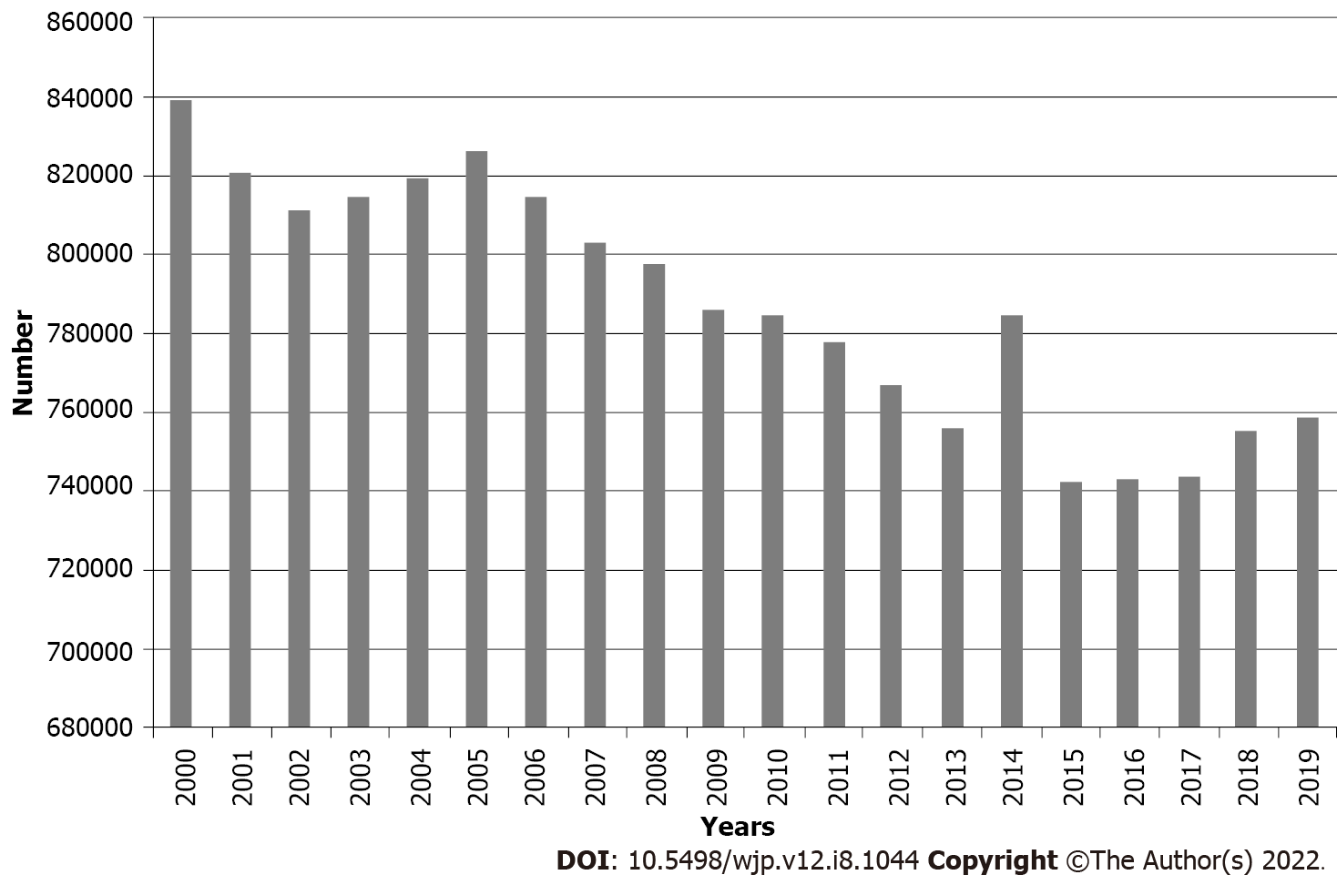
Figure 1 Global suicide deaths, 2000-2019. Source: World Health Organization^{[6]} and Global Burden of Disease estimates^{[7]}.
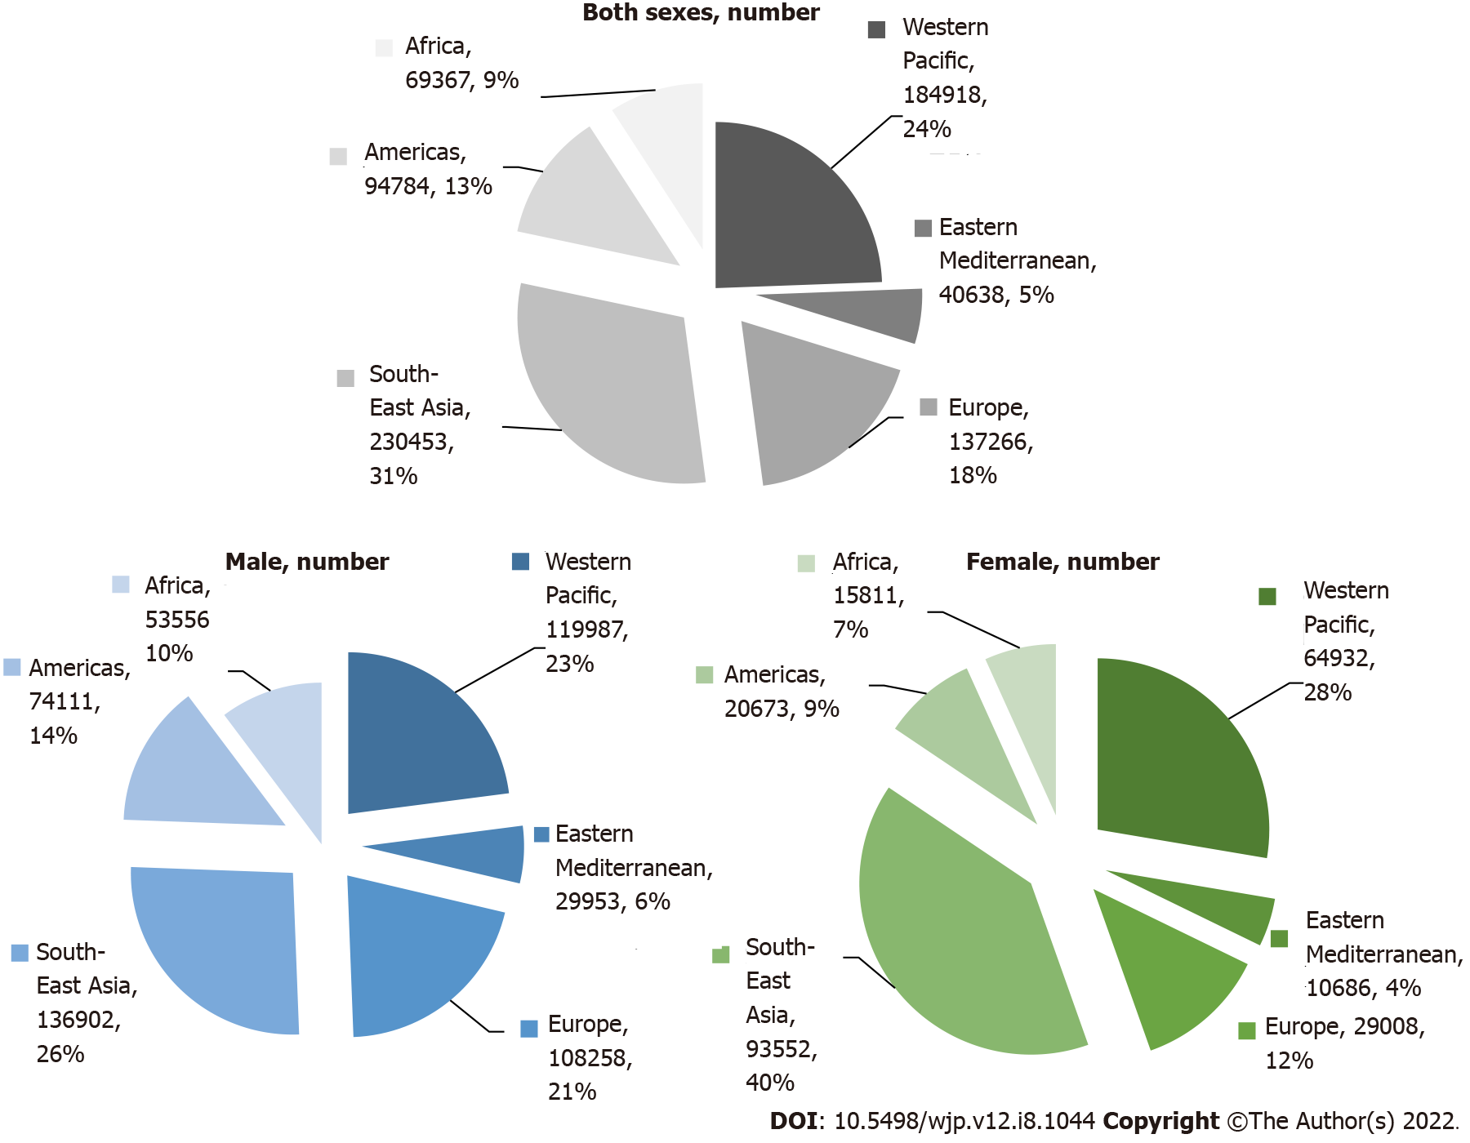
Figure 2 Number of suicide (global and by World Health Organization regions), by sex, 2019. Source: World Health Organization^{[6]} and Global Burden of Disease estimates^{[7]}.
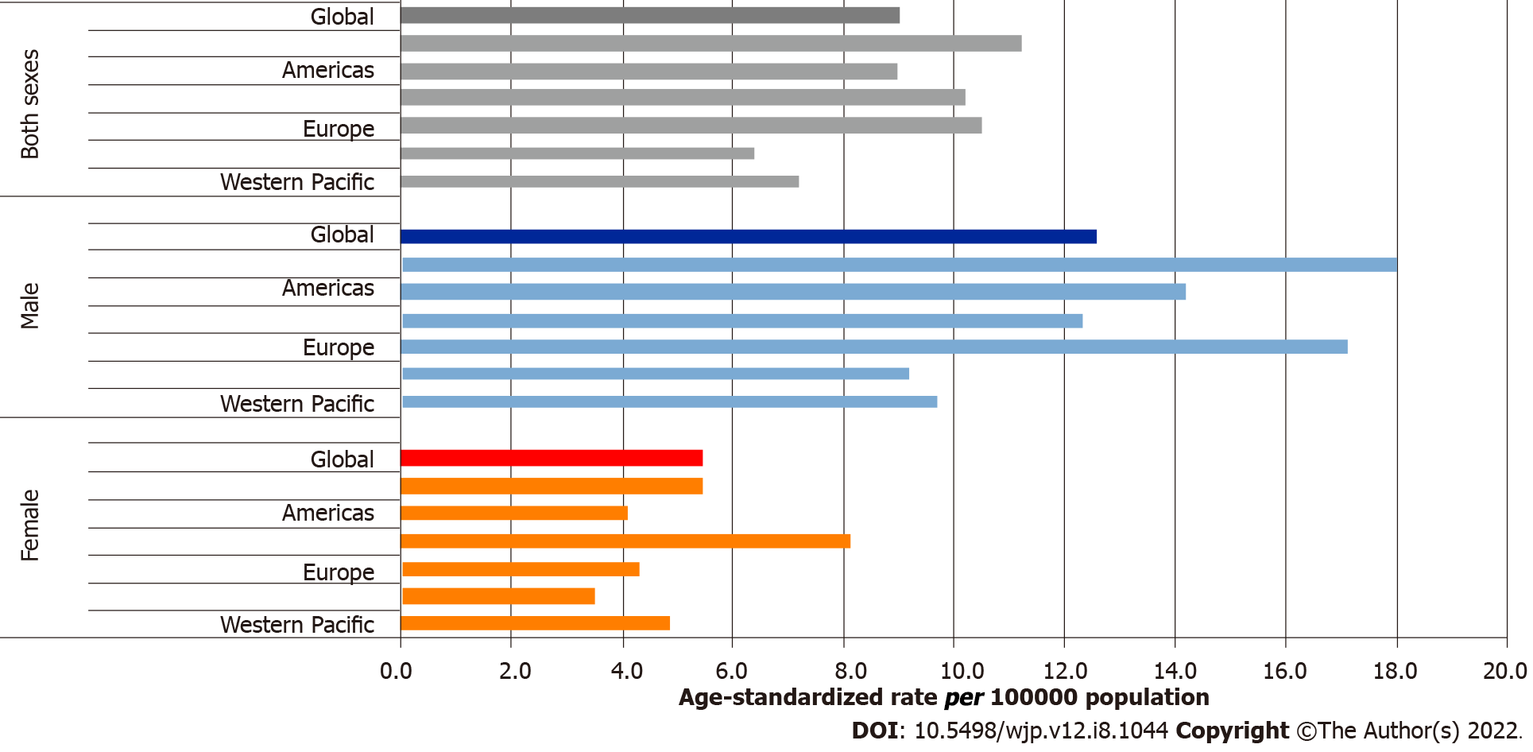
Figure 3 Age-standardized suicide mortality rates (global and by World Health Organization regions), by sex, 2019. Source: World Health Organization^{[6]} and Global Burden of Disease estimates^{[7]}.

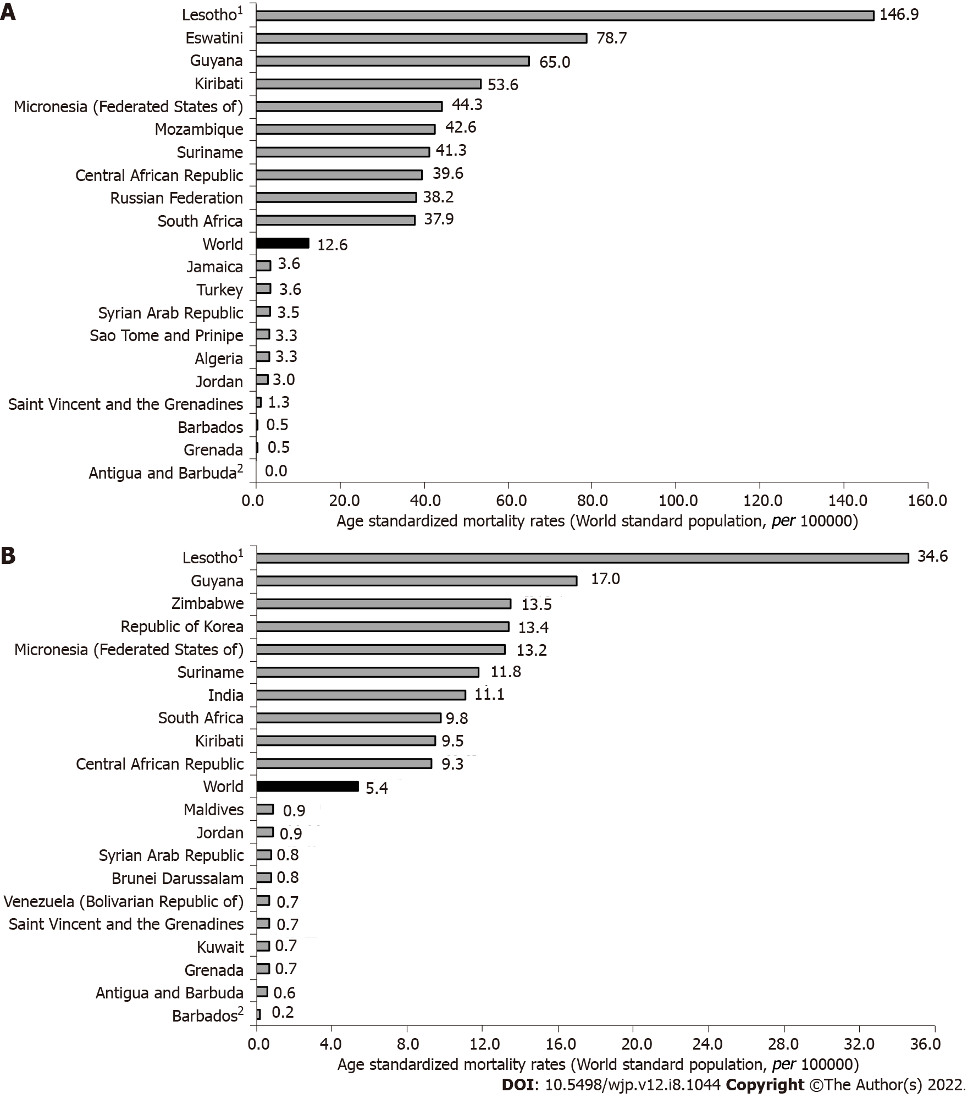
Figure 4 Suicide mortality, by countries, 2019. ¹Country with the highest rates; ²Country with the lowest rate. A: Men; B: Women. Source: World Health Organization^{[6]} and Global Burden of Disease estimates^{[7]}.
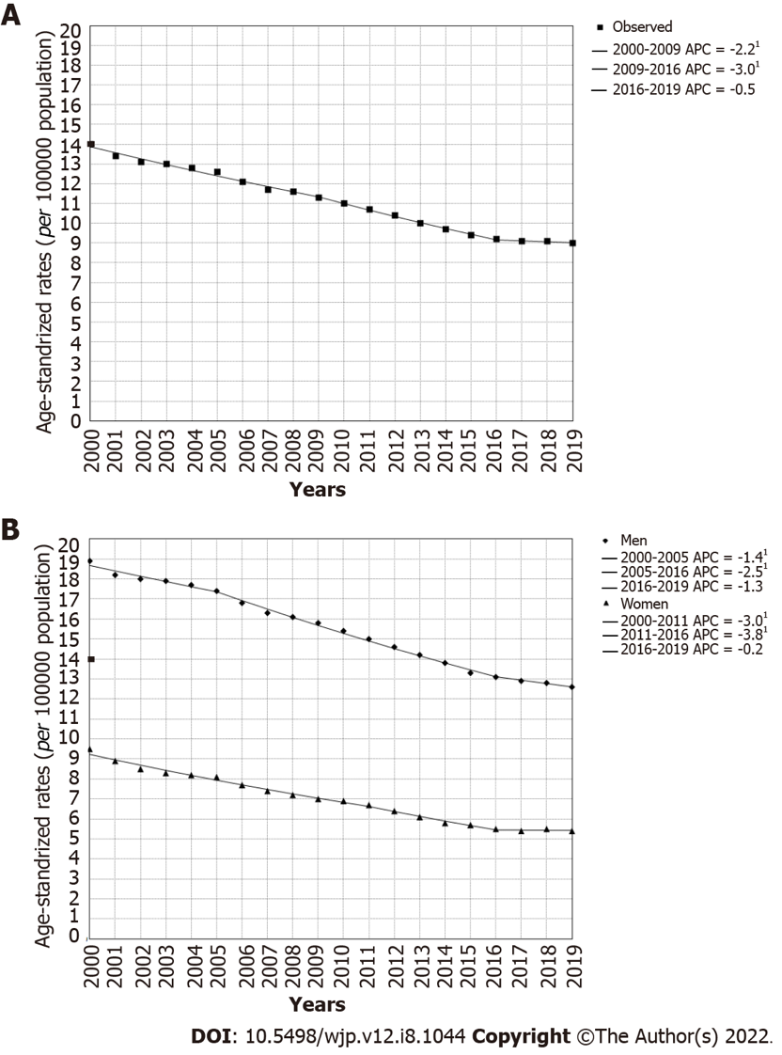
Figure 5 Joinpoint regression analysis of global suicide mortality. ¹Indicates that the Annual Percent Change is significantly different from zero at the alpha = 0.05 level. Final selected model: 2 joinpoints. A: Both sexes, 2019: 2 joinpoints; B: By sex, 2019: Men: 2 joinpoints vs women: 2 joinpoints. APC: Annual percent change. Source: World Health Organization^{[6]} and Global Burden of Disease estimates^{[7]}.
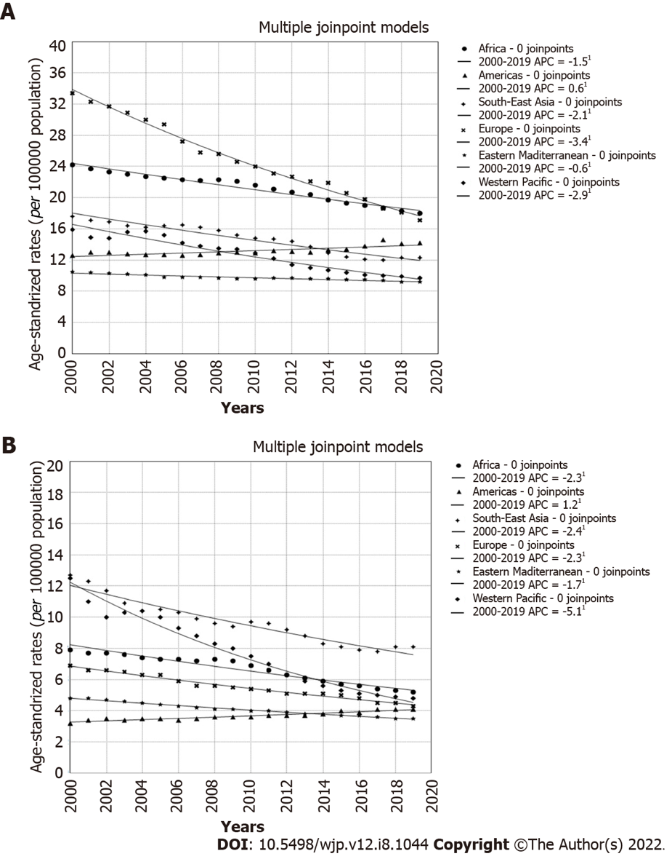
Figure 6 Suicide mortality trends (World Health Organization regions), 2000-2019; a joinpoint analysis. ¹Statistically significant trend. A: In males; B: In females. APC: Annual percent change. Source: World Health Organization^{[6]} and Global Burden of Disease estimates^{[7]}.

Table 1 Suicide mortality trends, by countries and sex, 2000-2019; a joinpoint analysis: Age-standardized rates (per 100000 population, world standard population)^{[6,7]}
Countries¹ | Both sexes |  |  | Male |  |  | Female
 | 2000 | 2019 | Trend² | 2000 | 2019 | Trend² | 2000 | 2019 | Trend²
Afghanistan | 7.7 | 6.0 | -1.8ª | 7.6 | 6.2 | -1.7ª | 7.8 | 5.7 | -2.1ª
Albania | 5.2 | 3.7 | -2.0 | 7.6 | 5.3 | -2.0ª | 2.9 | 2.2 | -2.0
Algeria | 4.7 | 2.6 | -3.4ª | 5.9 | 3.3 | -3.3ª | 3.5 | 1.9 | -3.4ª
Angola | 17.6 | 12.6 | -2.1ª | 30.0 | 21.7 | -2.0ª | 6.2 | 4.7 | -2.0ª
Antigua | 2.0 | 0.3 | - | 4.5 | 0.0 | - | 0.0 | 0.6 | -
Argentina | 9.2 | 8.1 | -0.7ª | 16.0 | 13.5 | -0.8ª | 3.4 | 3.3 | -0.6
Armenia | 3.3 | 2.7 | -0.3 | 5.5 | 4.9 | -0.2 | 1.7 | 1.0 | -0.3
Australia | 11.8 | 11.3 | +0.6 | 18.8 | 17.0 | +0.2 | 5.0 | 5.6 | +1.6ª
Austria | 15.8 | 10.4 | -1.8ª | 24.9 | 16.6 | -1.9ª | 7.9 | 4.6 | -2.1ª
Azerbaijan | 3.4 | 4.0 | -0.1 | 5.8 | 6.6 | -0.1 | 1.3 | 1.5 | -0.5
Bahamas | 2.5 | 3.4 | +1.5ª | 4.2 | 5.8 | +1.6ª | 1.1 | 1.2 | +0.1
Bahrain | 7.0 | 7.2 | -1.9ª | 10.2 | 9.9 | -2.1ª | 2.5 | 2.3 | -2.4ª
Bangladesh | 6.9 | 3.9 | -3.5ª | 10.0 | 6.0 | -3.1ª | 3.5 | 1.7 | -4.3ª
Barbados | 2.6 | 0.3 | -10.0ª | 4.9 | 0.5 | -8.7ª | 0.5 | 0.2 | -
Belarus | 37.3 | 16.5 | -4.7ª | 69.3 | 30.1 | -4.8ª | 9.5 | 5.3 | -3.5ª
Belgium | 18.3 | 13.9 | -1.3ª | 27.0 | 19.6 | -1.6ª | 10.1 | 8.4 | -0.6ª
Belize | 10.0 | 7.7 | -0.9ª | 17.2 | 13.6 | -0.7 | 2.9 | 1.8 | -2.6ª
Benin | 14.7 | 12.7 | -0.8ª | 23.6 | 20.3 | -0.8ª | 7.5 | 6.1 | -1.1ª
Bhutan | 6.9 | 5.1 | -1.6ª | 8.6 | 6.8 | -1.2ª | 5.0 | 3.1 | -2.6ª
Bolivia | 8.4 | 6.8 | -0.7ª | 11.8 | 9.6 | -0.8ª | 5.2 | 4.2 | -0.7ª
Bosnia and Herzegovina | 8.1 | 8.3 | -0.3 | 13.3 | 13.5 | -0.3 | 3.5 | 3.4 | -0.3ª
Botswana | 46.3 | 20.2 | -4.4ª | 76.2 | 35.5 | -4.0ª | 20.6 | 7.8 | -5.3ª
Brazil | 4.5 | 6.4 | +1.6ª | 7.4 | 10.3 | +1.5ª | 1.8 | 2.8 | +2.0ª
Brunei | 1.7 | 2.5 | +2.6ª | 3.0 | 4.2 | +1.9 | 0.4 | 0.8 | -
Bulgaria | 14.0 | 6.5 | -3.9ª | 21.8 | 10.6 | -3.7ª | 7.1 | 2.9 | -4.5ª
Burkina Faso | 16.9 | 14.4 | -0.5ª | 27.6 | 24.5 | -0.2ª | 9.2 | 6.5 | -1.6ª
Burundi | 23.4 | 12.1 | -3.3ª | 35.5 | 18.9 | -3.0ª | 13.6 | 6.4 | -4.1ª
Cabo Verde | 18.2 | 15.2 | -0.8ª | 33.3 | 27.4 | -1.1ª | 6.8 | 5.1 | -1.3ª
Cambodia | 6.8 | 5.5 | -1.2ª | 9.2 | 8.4 | -0.5ª | 5.0 | 3.1 | -2.7ª
Cameroon | 19.1 | 15.9 | -1.2ª | 29.8 | 25.2 | -1.1ª | 9.7 | 7.6 | -1.5ª
Canada | 10.7 | 10.3 | +0.1 | 16.6 | 15.3 | -0.1 | 5.0 | 5.4 | +0.8ª
Central African Republic | 32.5 | 23.0 | -1.2ª | 53.7 | 39.6 | -1.0ª | 14.6 | 9.3 | -2.1ª
Chad | 15.7 | 13.2 | -0.9ª | 24.8 | 20.2 | -1.1ª | 7.7 | 6.9 | -0.4ª
Chile | 10.5 | 8.0 | -1.1ª | 19.0 | 13.4 | -1.5ª | 2.9 | 3.0 | +0.4
China | 14.9 | 6.7 | -4.5ª | 15.5 | 8.6 | -3.4ª | 14.5 | 4.8 | -6.0ª
Colombia | 5.3 | 3.7 | -1.5ª | 8.4 | 6.0 | -1.3ª | 2.6 | 1.7 | -2.4ª
Comoros | 10.9 | 8.5 | -1.1ª | 14.5 | 11.3 | -1.0ª | 7.6 | 5.8 | -1.3ª
Congo | 24.7 | 11.6 | -3.4ª | 38.5 | 18.3 | -3.4ª | 14.1 | 6.1 | -3.7ª
Costa Rica | 6.9 | 7.6 | -0.4 | 12.3 | 13.3 | -0.6 | 1.6 | 1.9 | +0.4
Côte d’Ivoire | 24.0 | 15.7 | -1.9ª | 37.5 | 25.7 | -1.6ª | 8.4 | 5.0 | -2.3ª
Croatia | 16.3 | 11.0 | -2.0ª | 27.1 | 17.7 | -2.1ª | 6.9 | 5.1 | -1.7ª
Cuba | 15.6 | 10.2 | -1.5ª | 22.7 | 16.7 | -1.0ª | 8.9 | 4.1 | -3.3ª
Cyprus | 1.9 | 3.2 | +5.1ª | 2.6 | 5.3 | +6.3ª | 1.2 | 1.1 | +0.6
Czechia | 13.4 | 9.5 | -1.2ª | 22.6 | 15.4 | -1.5ª | 5.1 | 3.8 | -0.8ª
DPR Korea | 10.3 | 8.2 | -0.7ª | 12.3 | 10.6 | -0.2 | 8.9 | 6.3 | -1.4ª
DR Congo | 14.5 | 12.4 | -1.0ª | 24.9 | 20.7 | -1.1ª | 5.7 | 5.0 | -1.0ª
Denmark | 12.5 | 7.6 | -2.3ª | 18.9 | 11.1 | -2.3ª | 6.4 | 4.2 | -2.3ª
Djibouti | 12.1 | 11.9 | +0.1 | 17.1 | 16.3 | -0.2 | 7.5 | 7.6 | +0.2
Dominican Republic | 4.9 | 5.1 | +1.1ª | 8.3 | 8.5 | +1.1ª | 1.6 | 1.9 | +1.3ª
Ecuador | 6.8 | 7.7 | +0.2 | 9.6 | 11.9 | +0.8 | 4.2 | 3.6 | -1.3ª
Egypt | 3.6 | 3.4 | -0.3 | 4.7 | 4.7 | +0.2 | 2.7 | 2.2 | -1.1ª
El Salvador | 6.7 | 6.1 | -0.9 | 10.6 | 11.1 | -0.4 | 3.4 | 2.1 | -2.4ª
Equatorial Guinea | 19.4 | 13.5 | -0.9ª | 31.0 | 18.5 | -1.7ª | 7.8 | 8.8 | +1.3ª
Eritrea | 23.4 | 17.3 | -1.3ª | 38.4 | 27.2 | -1.5ª | 9.6 | 8.3 | -0.5ª
Estonia | 25.0 | 12.0 | -3.8ª | 43.1 | 20.2 | -4.0ª | 9.6 | 4.5 | -3.2ª
Eswatini | 40.6 | 40.5 | -0.8 | 65.5 | 78.7 | +0.4 | 20.9 | 6.4 | -7.5ª
Ethiopia | 18.4 | 9.5 | -3.8ª | 25.9 | 14.2 | -3.3ª | 11.2 | 5.2 | -4.6ª
Fiji | 11.7 | 9.5 | -0.6ª | 15.3 | 13.1 | -0.2 | 8.2 | 6.0 | -1.4ª
Finland | 21.7 | 13.4 | -2.5ª | 33.3 | 20.1 | -2.7ª | 10.4 | 6.8 | -2.1ª
France | 15.8 | 9.7 | -2.6ª | 24.2 | 15.2 | -2.3ª | 8.3 | 4.5 | -3.3ª
Gabon | 19.4 | 13.1 | -1.5ª | 33.2 | 23.3 | -1.2ª | 7.5 | 3.8 | -3.4ª
Gambia | 11.1 | 9.6 | -0.9ª | 15.3 | 13.3 | -1.0ª | 7.1 | 6.2 | -0.8ª
Georgia | 6.6 | 7.7 | +2.1ª | 11.9 | 14.0 | +2.3ª | 2.2 | 2.2 | +0.3
Germany | 11.2 | 8.3 | -1.4ª | 17.6 | 12.8 | -1.6ª | 5.3 | 3.9 | -1.3ª
Ghana | 9.8 | 10.5 | +0.3 | 17.2 | 20.0 | +0.7 | 2.9 | 1.8 | -3.0ª
Greece | 2.9 | 3.6 | +2.6ª | 4.6 | 5.9 | +2.5ª | 1.2 | 1.5 | +3.4ª
Grenada | 2.1 | 0.6 | -8.5a | 3.8 | 0.5 | - | 0.6 | 0.7 | -
Guatemala | 13.5 | 6.2 | -5.5ª | 24.0 | 10.3 | -6.0ª | 4.1 | 2.5 | -3.4ª
Guinea | 9.7 | 12.3 | +1.6ª | 13.7 | 18.4 | +1.9ª | 6.7 | 8.0 | +1.3ª
Guinea-Bissau | 17.5 | 12.4 | -1.6ª | 28.7 | 19.8 | -1.8ª | 8.8 | 6.7 | -1.3ª
Guyana | 35.8 | 40.9 | +0.5ª | 57.6 | 65.0 | +0.5 | 14.5 | 17 | +0.4
Haiti | 12.7 | 11.2 | -0.4ª | 14.7 | 14.9 | +0.5ª | 11.1 | 8.0 | -1.5ª
Honduras | 3.0 | 2.6 | +0.2 | 5.1 | 4.4 | +0.3 | 1.1 | 1.0 | -0.8ª
Hungary | 26.6 | 11.8 | -3.7ª | 44.7 | 19.1 | -3.9ª | 11.0 | 5.5 | -3.1ª
Iceland | 12.7 | 11.2 | -0.2 | 19.3 | 18.7 | +0.6 | 6.0 | 3.5 | -3.1ª
India | 19.1 | 12.9 | -2.3ª | 20.9 | 14.7 | -2.2ª | 17.4 | 11.1 | -2.4ª
Indonesia | 3.8 | 2.6 | -2.2ª | 5.5 | 4.0 | -2.0ª | 2.1 | 1.2 | -3.1ª
Iran | 8.0 | 5.1 | -1.5ª | 10.1 | 7.5 | -0.3 | 5.9 | 2.8 | -3.7ª
Iraq | 5.3 | 4.7 | +0.0 | 7.2 | 7.3 | +0.6ª | 3.4 | 2.4 | -1.3ª
Ireland | 12.1 | 8.9 | -1.4ª | 19.8 | 14.3 | -1.4ª | 4.4 | 3.6 | -1.1ª
Israel | 6.8 | 5.2 | -1.4ª | 11.0 | 8.3 | -1.5ª | 2.8 | 2.1 | -1.3ª
Italy | 5.5 | 4.3 | -0.8ª | 8.7 | 6.7 | -0.9ª | 2.7 | 2.1 | -0.9ª
Jamaica | 2.1 | 2.3 | +1.1ª | 3.3 | 3.6 | +1.0ª | 0.9 | 1.0 | +1.3ª
Japan | 18.1 | 12.2 | -1.9ª | 26.8 | 17.5 | -2.2ª | 9.6 | 6.9 | -1.4ª
Jordan | 3.5 | 2.0 | -3.4ª | 4.5 | 3.0 | -2.5ª | 2.4 | 0.9 | -6.0ª
Kazakhstan | 39.4 | 18.1 | -4.2ª | 71.7 | 30.9 | -4.5ª | 11.4 | 6.9 | -2.9ª
Kenya | 15.8 | 11.0 | -1.7ª | 24.8 | 18.1 | -1.5ª | 8.2 | 5.3 | -2.0ª
Kiribati | 35.6 | 30.6 | -0.6ª | 62.6 | 53.6 | -0.6ª | 11.1 | 9.5 | -0.6ª
Kuwait | 3.1 | 2.7 | -0.9ª | 4.1 | 3.8 | -0.3 | 1.5 | 0.7 | -4.5ª
Kyrgyzstan | 17.6 | 8.3 | -3.5ª | 30.7 | 13.5 | -3.8ª | 5.5 | 3.5 | -1.9ª
Lao PDR | 8.7 | 6.0 | -2.0ª | 11.0 | 8.6 | -1.3ª | 6.5 | 3.5 | -3.5ª
Latvia | 29.6 | 16.1 | -3.0ª | 54.3 | 29.0 | -3.0ª | 9.4 | 4.6 | -3.9ª
Lebanon | 3.0 | 2.8 | -0.2 | 3.7 | 3.9 | +0.6ª | 2.4 | 1.7 | -1.8ª
Lesotho | 42.6 | 87.5 | +6.0ª | 73.9 | 146.9 | +5.7ª | 16.0 | 34.6 | +6.1ª
Liberia | 8.8 | 7.4 | -0.7ª | 11.0 | 9.4 | -0.6ª | 6.7 | 5.5 | -0.7ª
Libya | 5.3 | 4.5 | +0.1 | 7.1 | 6.1 | +0.2 | 3.3 | 2.9 | +0.3
Lithuania | 45.8 | 20.2 | -3.4ª | 80.7 | 36.1 | -3.4ª | 15.3 | 6.2 | -3.4ª
Luxembourg | 13.4 | 8.6 | -2.8ª | 20.3 | 11.8 | -3.6ª | 7.1 | 5.4 | -1.2
Madagascar | 10.8 | 9.2 | -1.0ª | 15.5 | 13.3 | -0.9ª | 6.1 | 5.4 | -0.8ª
Malawi | 19.2 | 10.6 | -2.4ª | 31.8 | 20.0 | -1.8ª | 8.4 | 3.3 | -4.1ª
Malaysia | 6.1 | 5.8 | -0.5ª | 9.1 | 9.0 | -0.3 | 3.1 | 2.4 | -1.3ª
Maldives | 5.3 | 2.8 | -3.1ª | 8.1 | 4.1 | -3.4ª | 2.3 | 0.9 | -4.9ª
Mali | 8.8 | 8.0 | -0.4ª | 10.6 | 10.5 | +0.0 | 7.2 | 5.7 | -1.0ª
Malta | 6.0 | 5.3 | +0.2 | 9.8 | 8.4 | +0.5 | 2.4 | 2.3 | -0.6
Mauritania | 6.4 | 5.5 | -0.8ª | 8.2 | 7.4 | -0.6ª | 4.9 | 3.9 | -1.2ª
Mauritius | 11.5 | 8.8 | -0.8 | 18.4 | 15.0 | -0.5 | 4.9 | 2.5 | -2.1ª
Mexico | 3.9 | 5.3 | +2.0ª | 6.9 | 8.7 | +1.7ª | 1.1 | 2.2 | +3.6ª
Micronesia | 28.0 | 29.0 | +0.3ª | 43.4 | 44.3 | +0.2ª | 13.0 | 13.2 | +0.3ª
Mongolia | 23.6 | 18.0 | -1.5ª | 37.6 | 31.1 | -1.1ª | 10.2 | 5.6 | -2.8ª
Montenegro | 18.9 | 16.2 | -0.8ª | 28.9 | 25.4 | -0.7ª | 9.8 | 7.9 | -1.1ª
Morocco | 10.8 | 7.3 | -2.3ª | 13.9 | 10.1 | -2.0ª | 8.0 | 4.7 | -2.8ª
Mozambique | 20.9 | 23.2 | +0.9ª | 36.2 | 42.6 | +1.2ª | 8.8 | 8.9 | +0.6
Myanmar | 5.1 | 3.0 | -2.8ª | 8.1 | 5.1 | -2.2ª | 2.6 | 1.1 | -5.0ª
Namibia | 27.5 | 13.5 | -4.1ª | 47.5 | 24.9 | -3.9ª | 11.4 | 4.4 | -4.8ª
Nepal | 10.9 | 9.8 | -0.3 | 19.4 | 18.6 | +0.2 | 2.8 | 2.9 | +0.5ª
Netherlands | 8.1 | 9.3 | +1.1ª | 11.2 | 12.5 | +0.9ª | 5.2 | 6.1 | +1.3ª
New Zealand | 12.4 | 10.3 | -0.9ª | 20.8 | 15.4 | -1.2ª | 4.4 | 5.4 | +0.0
Nicaragua | 6.3 | 4.7 | -1.7ª | 9.3 | 7.8 | -1.5ª | 3.6 | 1.9 | -2.4ª
Niger | 9.5 | 10.1 | +0.3ª | 12.6 | 14.1 | +0.6ª | 6.7 | 6.4 | -0.2ª
Nigeria | 9.2 | 6.9 | -1.7ª | 13.7 | 10.1 | -1.7ª | 5.1 | 3.8 | -2.0ª
North Macedonia | 8.7 | 7.2 | -1.6ª | 12.5 | 11.0 | -1.5ª | 4.9 | 3.5 | -1.9ª
Norway | 13.0 | 9.9 | -1.0ª | 19.9 | 13.4 | -1.5ª | 6.1 | 6.3 | +0.1
Oman | 6.7 | 4.5 | -2.5ª | 10.1 | 6.4 | -2.9ª | 2.0 | 1.1 | -3.1ª
Pakistan | 11.1 | 9.8 | -0.8ª | 16.1 | 14.6 | -0.7ª | 5.7 | 4.8 | -1.2ª
Panama | 5.9 | 2.9 | -4.4ª | 10.4 | 4.8 | -4.5ª | 1.5 | 1.0 | -3.6ª
Papua New Guinea | 2.8 | 3.6 | +1.1ª | 4.4 | 5.2 | +0.9ª | 1.4 | 1.9 | +1.4ª
Paraguay | 3.6 | 6.2 | +3.0ª | 4.8 | 9.0 | +3.5ª | 2.5 | 3.3 | +1.5ª
Peru | 3.4 | 2.7 | -0.8ª | 4.6 | 4.1 | -0.2 | 2.4 | 1.4 | -2.3ª
Philippines | 2.3 | 2.5 | +1.4ª | 3.5 | 3.9 | +1.6ª | 1.1 | 1.3 | +1.5ª
Poland | 15.3 | 9.3 | -1.9ª | 26.8 | 16.5 | -1.8ª | 4.7 | 2.4 | -2.9ª
Portugal | 5.5 | 7.2 | +0.4 | 9.5 | 11.6 | +0.1 | 2.1 | 3.5 | +1.3ª
Qatar | 7.6 | 4.7 | -2.8ª | 10.0 | 5.7 | -3.3ª | 2.6 | 1.7 | -2.1ª
Republic of Korea | 13.9 | 21.2 | +1.1 | 20.4 | 29.7 | +1.0 | 8.2 | 13.4 | +1.0
Moldova | 16.3 | 12.2 | -1.9ª | 30.7 | 22.1 | -2.0ª | 4.2 | 3.3 | -2.0ª
Romania | 11.3 | 7.3 | -2.1ª | 19.4 | 12.6 | -2.1ª | 3.7 | 2.4 | -2.4ª
Russian Federation | 48.9 | 21.6 | -4.1ª | 88.8 | 38.2 | -4.3ª | 13.4 | 7.2 | -3.1ª
Rwanda | 25.6 | 9.5 | -4.9ª | 38.8 | 14.8 | -4.7ª | 14.0 | 5.0 | -5.2ª
Saint Lucia | 8.1 | 6.9 | -0.4 | 14.5 | 12.5 | -0.4 | 2.1 | 1.5 | -1.1ª
Saint Vincent | 6.5 | 1.0 | - | 12.6 | 1.3 | - | 0.5 | 0.7 | -
Samoa | 16.3 | 14.6 | -0.5ª | 24.1 | 20.9 | -0.7ª | 7.8 | 7.8 | +0.2
Sao Tome and Principe | 2.2 | 2.2 | -0.2 | 3.2 | 3.3 | -0.1 | 1.4 | 1.2 | -0.8ª
Saudi Arabia | 3.8 | 5.4 | +2.8a | 5.7 | 7.8 | +2.6ª | 1.4 | 1.9 | +3.2ª
Senegal | 14.4 | 11.0 | -1.3ª | 23.5 | 18.5 | -1.1ª | 6.8 | 5.2 | -1.2ª
Serbia | 18.9 | 7.9 | -7.6ª | 29.0 | 12.2 | -8.1ª | 10.1 | 3.9 | -6.9ª
Seychelles | 9.8 | 7.7 | -1.2ª | 18.4 | 14.0 | -1.5ª | 1.7 | 1.3 | -1.4ª
Sierra Leone | 10.1 | 11.3 | +0.2 | 14.4 | 14.8 | -0.2 | 6.5 | 8.2 | +0.9ª
Singapore | 11.4 | 9.7 | -2.0ª | 15.2 | 12.7 | -1.9ª | 7.8 | 6.4 | -2.7ª
Slovakia | 12.6 | 9.3 | -1.8ª | 21.9 | 16.7 | -1.7ª | 4.3 | 2.6 | -2.2ª
Slovenia | 25.6 | 14.0 | -3.4ª | 40.4 | 22.7 | -3.3ª | 12.6 | 5.5 | -4.2ª
Solomon Islands | 17.4 | 17.4 | +0.3 | 32.0 | 32.2 | +0.3ª | 2.1 | 2.4 | +1.3ª
Somalia | 16.8 | 14.7 | -0.8ª | 26.0 | 22.8 | -0.8ª | 7.9 | 7.1 | -0.5ª
South Africa | 26.6 | 23.5 | -0.8ª | 42.7 | 37.9 | -0.6ª | 11.6 | 9.8 | -1.5ª
South Sudan | 7.9 | 6.7 | -0.9ª | 12.4 | 10.4 | -1.0ª | 3.9 | 3.4 | -0.8ª
Spain | 6.6 | 5.3 | -0.8ª | 10.5 | 7.9 | -1.1ª | 3.0 | 2.8 | +0.0
Sri Lanka | 27.4 | 12.9 | -3.7ª | 41.5 | 20.9 | -3.3ª | 14 | 6.1 | -3.9ª
Sudan | 5.6 | 4.8 | -0.8ª | 7.2 | 6.3 | -0.7ª | 4.0 | 3.3 | -0.9ª
Suriname | 25.0 | 25.9 | -0.3ª | 38.8 | 41.3 | -0.2 | 11.8 | 11.8 | -0.1
Sweden | 12.2 | 12.4 | +0.1 | 17.1 | 16.9 | -0.1 | 7.5 | 7.7 | +0.4
Switzerland | 15.9 | 9.8 | -2.8ª | 23.7 | 14.2 | -2.7ª | 8.6 | 5.7 | -3.0ª
Syria | 2.0 | 2.1 | +0.5ª | 3.2 | 3.5 | +0.7ª | 0.9 | 0.8 | +0.1
Tajikistan | 5.1 | 5.3 | +0.7ª | 7.3 | 7.4 | +0.4ª | 2.9 | 3.4 | +1.5ª
Thailand | 11.6 | 8.0 | -2.1ª | 16.4 | 13.9 | -1.2ª | 7.1 | 2.3 | -5.4ª
Timor-Leste | 4.9 | 4.5 | -0.2 | 6.5 | 6.7 | +0.4 | 3.3 | 2.4 | -1.7ª
Togo | 17.3 | 14.8 | -1.0ª | 27.0 | 24.0 | -0.8ª | 8.6 | 6.5 | -1.7ª
Tonga | 5.1 | 4.4 | -0.2 | 6.7 | 5.9 | -0.1 | 3.6 | 2.9 | -0.5ª
Trinidad and Tobago | 16.2 | 8.3 | -3.2ª | 26.4 | 13.1 | -3.5ª | 6.3 | 3.7 | -1.8ª
Tunisia | 3.9 | 3.2 | -1.6ª | 5.2 | 4.6 | -1.1ª | 2.6 | 1.8 | -2.3ª
Turkey | 4.2 | 2.3 | -2.9ª | 6.7 | 3.6 | -3.2ª | 1.9 | 1.2 | -2.2ª
Turkmenistan | 13.8 | 6.1 | -5.9ª | 23.7 | 9.4 | -6.5ª | 4.6 | 2.9 | -3.6ª
Uganda | 21.7 | 10.4 | -4.5ª | 38.6 | 19.4 | -4.2ª | 8.6 | 3.7 | -5.4ª
Ukraine | 33.5 | 17.7 | -3.7ª | 62.7 | 32.7 | -3.8ª | 8.5 | 4.7 | -3.2ª
United Arab Emirates | 8.0 | 5.2 | -2.4ª | 9.3 | 6.3 | -2.3ª | 4.7 | 2.6 | -3.1ª
United Kingdom | 7.7 | 6.9 | +0.0 | 12.0 | 10.4 | -0.1 | 3.6 | 3.4 | +0.2
Tanzania | 15.6 | 8.2 | -3.1ª | 24.5 | 13.5 | -2.8ª | 8.1 | 3.7 | -3.7ª
United States of America | 10.0 | 14.5 | +1.9ª | 16.4 | 22.4 | +1.6ª | 4.0 | 6.8 | +2.7ª
Uruguay | 14.5 | 18.8 | +1.5ª | 25.7 | 31.1 | +1.4ª | 5.1 | 7.7 | +1.3ª
Uzbekistan | 12.0 | 8.3 | -1.5ª | 19.6 | 11.8 | -2.2ª | 4.8 | 4.9 | +0.7ª
Vanuatu | 23.2 | 21.0 | -0.4ª | 36.0 | 33.1 | -0.3ª | 10.1 | 9.0 | -0.6ª
Venezuela | 6.4 | 2.1 | -6.2ª | 11.3 | 3.7 | -6.2ª | 1.7 | 0.7 | -5.6ª
Viet Nam | 7.2 | 7.2 | +0.4ª | 9.4 | 10.6 | +1.1ª | 5.2 | 4.2 | -1.0ª
Yemen | 8.5 | 7.1 | -1.1ª | 10.5 | 9.0 | -1.0ª | 6.5 | 5.3 | -1.3ª
Zambia | 24.0 | 14.4 | -2.2ª | 35.9 | 25.7 | -1.4ª | 14.5 | 5.3 | -4.4ª
Zimbabwe | 20.0 | 23.6 | +1.9ª | 28.2 | 37.8 | +2.7ª | 14.2 | 13.5 | +0.8
ªStatistically significant trend (P < 0.05).
¹Joinpoint results are not shown for mortality in some countries, because no case of suicide occurred in at least 1 year in the observed period.
²For full period presented average annual percent change.

Table 2 Joinpoint regression analysis: global trends in age-specific suicide mortality rates (per 100000), by sex, 2000-2019
Age¹ | Males |  |  | Females
 | Age-specific rates² (2000) | Age-specific rates² (2019) | AAPC (95%CI) | Age-specific rates² (2000) | Age-specific rates² (2019) | AAPC (95%CI)
10-19 | 6.7 | 4.5 | -2.0ª [(-2.2)-(-1.8)] | 6.7 | 3.8 | -3.0ª [(-3.2)-(-2.7)]
20-29 | 21.4 | 15.7 | -1.8ª [(-1.9)-(-1.6)] | 14.9 | 7.9 | -3.3ª [(-3.8)-(-2.8)]
30-39 | 23.4 | 17.6 | -1.6ª [(-1.7)-(-1.5)] | 12.6 | 6.3 | -3.6ª [(-4.0)-(-3.2)]
40-49 | 27.6 | 17.8 | -2.6ª [(-2.8)-(-2.4)] | 11.0 | 6.4 | -2.7ª [(-2.9)-(-2.5)]
50-59 | 31.0 | 19.6 | -2.5ª [(-2.6)-(-2.4)] | 11.6 | 7.8 | -2.3ª [(-2.7)-(-2.0)]
60-69 | 33.7 | 21.8 | -2.5ª [(-2.6)-(-2.3)] | 13.7 | 9.2 | -2.3ª [(-2.6)-(-2.0)]
70-79 | 46.0 | 31.1 | -2.3ª [(-2.5)-(-2.1)] | 21.4 | 13.6 | -2.8ª [(-3.2)-(-2.4)]
80 + | 71.5 | 52.3 | -1.7ª [(-1.9)-(-1.6)] | 29.4 | 19.1 | -2.7ª [(-3.1)-(-2.3)]
ªStatistically significant trend.
¹Joinpoint results are not shown for the subgroups aged < 10 years for mortality, because fewer than 5 cases of suicide cases occurred in each of the decennium in any year.
²Average annual, per 100000 people. AAPC: Average annual percent change; CI: Confidence interval.

Published by Baishideng Publishing Group Inc
7041 Koll Center Parkway, Suite 160, Pleasanton, CA 94566, USA
Telephone: +19253991568
Email: bpgoffice@wjgnet.com
Help Desk: https://www.f6publishing.com/helpdesk
https://www.wjgnet.com

© 2022 Baishideng Publishing Group Inc. All rights reserved.

