Name of Journal: World Journal of Gastrointestinal Oncology

Manuscript NO: 35164

Manuscript Type: Case Report

Extrapancreatic solid pseudopapillary neoplasm followed by multiple metastases: Case report

Wu H et al. Extrapancreatic solid pseudopapillary neoplasm

Hao Wu, Yan-Fen Huang, Xiang-Hong Liu, Mei-Hua Xu

Hao Wu, Yan-Fen Huang, Xiang-Hong Liu, Mei-Hua Xu, Department of Gastroenterology, Xiangya Hospital of Central South University, Changsha 410008, Hunan Province, China

ORCID number: Hao Wu (0000-0002-8270-1307); Yan-Fen Huang (0000-0002-4496-830x); Xiang-Hong Liu (0000-0002-2140-9409); Mei-Hua Xu (0000-0003-3560-2645).

Author contributions: All authors contributed to the acquisition of data, writing, and revision of this manuscript.

Informed consent statement: Patients were not required to give informed consent to the study because the participant is deceased.

Conflict-of-interest statement: We have no pertinent financial relationships to disclose.

Open-Access: This article is an open-access article which was selected by an in-house editor and fully peer-reviewed by external reviewers. It is distributed in accordance with the Creative Commons Attribution Non Commercial (CC BY-NC 4.0) license, which permits others to distribute, remix, adapt, build upon this work non-commercially, and license their derivative works on different terms, provided the original work is properly cited and the use is non-commercial. See: http://creativecommons.org/licenses/by-nc/4.0/

Manuscript source: Unsolicited manuscript

Correspondence to: Mei-Hua Xu, MD, PhD, Doctor, Professor, Department of Gastroenterology, Xiangya Hospital of Central South University, No 87 Xiangya Road, Changsha 410008, Hunan Province, China. w339812016@csu.edu.cn
Telephone: +86-731-89753923

Received: June 24, 2017

Peer-review started: June 26, 2017

First decision: August 7, 2017
Revised: August 24, 2017

Accepted: November 3, 2017

Article in press:

Published online:

Abstract
Solid pseudopapillary neoplasm (SPN), also known as Gruber-Frantz tumor, is a rare form of neoplasm that almost exclusively occurs in the pancreas and in young females. While the potential of malignancy is low for SPN, these tumors can mimic other diseases and require a meticulous investigation and a standard treatment by total surgical resection. We present an unusual case of SPN arising in the mesentery of a 40-year-old man with subsequent multiple metastases. Histopathological examination showed similar properties of the mesenteric neoplasm to those of SPN in pancreas. Although the mass was surgically removed, the patient died of recurrent disease 4 years after the initial presentation. We speculate that SPN originates from pancreatic progenitor cells. Further histopathological analyses are required for the prediction of SPN recurrence after resection.

Key words: Solid pseudopapillary neoplasm; Mesentery; Metastasis

© The Author(s) 2017. Published by Baishideng Publishing Group Inc. All rights reserved.

Core tip: Solid pseudopapillary neoplasm (SPN) has been recognized by World Health Organization since 2010, and classified as a low malignant potential neoplasm. Such neoplasm is characterized by the presence of a mutation in the gene that encodes β-catenin. β-catenin is an important factor in the Wnt signaling pathway (β-catenin-dependent Wnt signaling). The identification of extrapancreatic SPN, especially in the mesentery, indicates a possible endoderm link between pancreatic progenitor cells and SPN cells.

Wu H, Huang YF, Liu XH, Xu MH. Extrapancreatic solid pseudopapillary neoplasm followed by multiple metastases: Case report. World J Gastrointest Oncol 2017; In press

INTRODUCTION
Solid pseudopapillary neoplasm (SPN) is a rare and indolent type of neoplasm that occurs in pancreas; SPN forms 0.3% to 2.7% of all pancreatic exocrine tumors. A large body of SPN indices are found in young female patients, and well-circumscribed. A margin negative surgical resection shows curative result in majority of cases^{[1-3]}; recurrence after surgical resection is reported in 2% to 10% of patients^{[4,5]}. Patients with unresectable SPN may have a long-term survival (5 years), and require complex chemo- and radio-therapy treatments; the efficacy of adjuvant therapies in the SPN treatment remains largely unknown and a clinical challenge. Thus, it is important to differentiate the risk of recurrence in SPN patients. An extrapancreatic development of SPN is a rare incident; only 16 cases of extrapancreatic SPN have been reported so far worldwide (Table 1). In the present article, we report a patient, in whom SPN was found in the mesentery; no invasion or attachments to adjacent organs was observed. To the best of our knowledge, this article is the first to report a SPN case in the mesentery.

CASE REPORT
A 40-year-old Chinese male came to hospital on November 15, 2012. His main complaint was abdominal distention that lasted over 6 mo. His physical examination revealed a 30 cm soft mass in the abdomen. An abdominal computed tomography (CT) scan exhibited solid and mixed cystic lesions, measuring > 28 cm diameter (Figure 1). Patient’s blood test results were unremarkable. On November 22, 2012, the patient underwent an exploratory laparotomy, and the tumor protruding from the mesentery was completely excised. At that time, no invasion or attachments to adjacent organs was observed. In addition, the postoperative course was uneventful. The resected specimen of the mesenteric tumor was 25 cm × 15 cm × 28 cm, and showed a multilobulated structure with rich microvasculature. Microscopic characterization of the tumor showed that the tumor formation was a mix of solid and pseudopapillary areas. There was no evidence of pancreatic tissue in the analyzed sample. Further, the specimen was positive for alpha-1-antitrypsin, vimentin, CD56 and β-catenin immunostaining, whereas negative for S-100, neuron-specific enolase, E-cadherin, calretinin, progesterone receptor, chromogranin, and pancytokeration (Figure 2). Such results led to the diagnosis of SPN in the mesentery. Following 3.5 years, the patient continued to complain about abdominal distention and occasional polypnea. An abdominal CT scan exhibited multiple tumors in peritoneum, greater omentum, and colonic wall (Figure 3). Meanwhile, cells in the pleural effusion were found positive for alpha-1-antitrypsin, vimentin, CD56 and β-catenin. It was clear that the patient was suffering from recurrence of the disease. Before the surgical operation to clean the recurrent tumors, the patient received the treatment of 60 mg cisplatin by hyperthermic intraperitoneal chemotherapy (HIPEC). Unfortunately, there was no response to the treatment, and the patient was transferred to the palliative care unit. Soon after the patient’s physical conditions worsened, we lost the patient on November 2016, 4 years after the initial surgery.

DISCUSSION
SPN has been recognized by the WHO classification as a low malignant potential neoplasm in 2010^{[3]}. It was first named as Gruber-Frantz tumor and after that it had been called the pancreatic solid papillary epithelial neoplasm, pancreatic papillary cystic neoplasm, pancreatic solid cystic tumor and solid pseudopapillary tumor. The differential diagnosis of SPN may include: pseudocyst, pancreatic mucinous neoplasms, well-differentiated ductal adenocarcinoma, pancreatic endocrine neoplasm, and acinic cell carcinoma. The pathogenesis of SPN remains unclear. Likewise, genetic events that contribute to the development of SPN are yet to be discovered. There are two basic proposals for the SPN origin: (1) genital ridge-related cells and (2) pancreatic progenitor cells^{[1,6]}. To note, an important proportion of SPN cases show mutations in the somatic β-catenin coding gene (CTNNB1)^{[7-9]}. Such mutations can affect Wnt signaling pathways as well as self-renewal capability of stem cells^{[10]}. SPN cells were reported to be positive for β-catenin, vimentin, alpha-1-anti-trypsin, CD10, CD56, and progesterone receptors by immunohistochemical analysis^{[11]}; however this staining pattern fails to reveal a clear phenotypic relationship between SPN and any of the defined cell lineages of the pancreas. Thereby, it can be speculated as SPN cells show multipotential differentiation. According to the study concerned with the embryonic development of the human pancreas, dorsal and ventral pancreatic buds were reported to proliferate from gut epithelium of endoderm during the 4th week of gestation. Dorsal pancreas fuses with ventral pancreas at the 7th week of gestation due to the rotation of the stomach and duodenum development^{[12]}. Identification of extrapancreatic SPN in the ovary, retroperitoneum and the omentum, as listed in Table 1, indicates a possible endoderm link, substantiated by the migration of pancreas during embryogenesis. We therefore believe that extrapancreatic SPN originates from pancreatic progenitor cells.
In SPN patients, tumor resection confers an 8-year survival rate in 85% of cases; nevertheless, local recurrence or distant metastases can occur in some patients^{[13]}. Histological and clinical parameters for prediction of disease recurrence after the initial surgical operation remain a challenge as there is still no consensus in the medical community. Many clinicians and researchers have been working to determine such criteria. For example, Kang et al^{[14]} listed: (1) a tumor size larger than 8 cm; (2) cellular atypia; (3) vascular invasion; (4) perineural invasion; (5) systemic metastasis; and (6) peritoneal seeding as significant prognostic factors for tumor recurrence in a multicenter study. A case series study conducted by Yang et al^{[15]} showed that vascular invasion, extra-pancreatic invasion, lymph node metastasis, and Ki-67 index ≥ 4% are associated with SPN recurrence. It is important to note that a rupture of the tumor or laparoscopic biopsy may seed the tumor cells into the peritoneal cavity, and could be an etiological factor responsible for the peritoneal recurrence^{[16]}. Nonetheless, a recurrence prediction scoring model require more investigation. Such model will help clinicians to distinguish a high-risk group from low-risk group. Likewise, there is still no consensus on the treatment strategy in patients with SPN recurrence. A previous report described a 35 years old woman relapsing 8 mo after the resection of an SPN, which ruptured preoperatively. The patient firstly underwent a complete cytoreductive surgery, but relapsed within 8 mo, and received another cytoreductive surgery combined with HIPEC (oxaliplatin and irinotecan). At 31 mo of follow-up, the patient showed no evidence of disease recurrence^{[17]}. Thus, a complete cytoreductive surgery combined with HIPEC stands as an important treatment solution for high-risk group of SPN. Further, another report concluded that SPN are radiosensitive, and can be successfully treated by using radiation therapy^{[18]}. Future clinical and molecular studies are required to provide more precise tools to predict the biological behavior of SPN.

ARTICLE HIGHLIGHTS

Case characteristics

Abdominal distension.

Clinical diagnosis

Abdominal mass.

Differential diagnosis

Pancreatic mucinous neoplasms.

Laboratory diagnosis

All labs were within normal limits.

Imaging diagnosis

Mesenchymal neoplasm.

Pathological diagnosis

Solid pseudopapillary neoplasm (SPN).

Treatment
Complete cytoreductive surgery combined with hyperthermic intraperitoneal chemotherapy.

Related reports

Grading and staging play an important role in treatment and prognosis.

Term explanation

SPN: Solid pseudopapillary neoplasm.

Experiences and lessons
Future clinical and molecular studies are required to provide more precise tools to predict the biological behavior of SPN.

REFERENCES
1 Mao C, Guvendi M, Domenico DR, Kim K, Thomford NR, Howard JM. Papillary cystic and solid tumors of the pancreas: a pancreatic embryonic tumor? Studies of three cases and cumulative review of the world's literature. Surgery 1995; 118: 821-828 [PMID: 7482268 DOI: 10.1016/s0039-6060(05)80271-5]
2 Yu PF, Hu ZH, Wang XB, Guo JM, Cheng XD, Zhang YL, Xu Q. Solid pseudopapillary tumor of the pancreas: a review of 553 cases in Chinese literature. World J Gastroenterol 2010; 16: 1209-1214 [PMID: 20222163 DOI: 10.3748/wjg.v16.i10.1209]
3 Bosman FT, World Health Organization, International Agency for Research on Cancer. WHO Classification of Tumors of the Digestive System. 4th edn. Lyon: International Agency for Research on Cancer, 2010
4 Lubezky N, Papoulas M, Lessing Y, Gitstein G, Brazowski E, Nachmany I, Lahat G, Goykhman Y, Ben-Yehuda A, Nakache R, Klausner JM. Solid pseudopapillary neoplasm of the pancreas: Management and long-term outcome. Eur J Surg Oncol 2017; 43: 1056-1060 [PMID: 28238521 DOI: 10.1016/j.ejso.2017.02.001]
5 Marchegiani G, Andrianello S, Massignani M, Malleo G, Maggino L, Paiella S, Ferrone CR, Luchini C, Scarpa A, Capelli P, Mino-Kenudson M, Lillemoe KD, Bassi C, Castillo CF, Salvia R. Solid pseudopapillary tumors of the pancreas: Specific pathological features predict the likelihood of postoperative recurrence. J Surg Oncol 2016; 114: 597-601 [PMID: 27471041 DOI: 10.1002/jso.24380]
6 Kosmahl M, Seada LS, Jänig U, Harms D, Klöppel G. Solid-pseudopapillary tumor of the pancreas: its origin revisited. Virchows Arch 2000; 436: 473-480 [PMID: 10881741 DOI: 10.1007/s004280050475]
7 Springer S, Wang Y, Dal Molin M, Masica DL, Jiao Y, Kinde I, Blackford A, Raman SP, Wolfgang CL, Tomita T, Niknafs N, Douville C, Ptak J, Dobbyn L, Allen PJ, Klimstra DS, Schattner MA, Schmidt CM, Yip-Schneider M, Cummings OW, Brand RE, Zeh HJ, Singhi AD, Scarpa A, Salvia R, Malleo G, Zamboni G, Falconi M, Jang JY, Kim SW, Kwon W, Hong SM, Song KB, Kim SC, Swan N, Murphy J, Geoghegan J, Brugge W, Fernandez-Del Castillo C, Mino-Kenudson M, Schulick R, Edil BH, Adsay V, Paulino J, van Hooft J, Yachida S, Nara S, Hiraoka N, Yamao K, Hijioka S, van der Merwe S, Goggins M, Canto MI, Ahuja N, Hirose K, Makary M, Weiss MJ, Cameron J, Pittman M, Eshleman JR, Diaz LA Jr, Papadopoulos N, Kinzler KW, Karchin R, Hruban RH, Vogelstein B, Lennon AM. A combination of molecular markers and clinical features improve the classification of pancreatic cysts. Gastroenterology 2015; 149: 1501-1510 [PMID: 26253305 DOI: 10.1053/j.gastro.2015.07.041]
8 Guo M, Luo G, Jin K, Long J, Cheng H, Lu Y, Wang Z, Yang C, Xu J, Ni Q, Yu X, Liu C. Somatic Genetic Variation in Solid Pseudopapillary Tumor of the Pancreas by Whole Exome Sequencing. Int J Mol Sci 2017; 18: pii: E81 [PMID: 28054945 DOI: 10.3390/ijms18010081]
9 Abraham SC, Klimstra DS, Wilentz RE, Yeo CJ, Conlon K, Brennan M, Cameron JL, Wu TT, Hruban RH. Solid-pseudopapillary tumors of the pancreas are genetically distinct from pancreatic ductal adenocarcinomas and almost always harbor beta-catenin mutations. Am J Pathol 2002; 160: 1361-1369 [PMID: 11943721 DOI: 10.1016/s0002-9440(10)62563-1]
10 Clevers H. Wnt/beta-catenin signaling in development and disease. Cell 2006; 127: 469-480 [PMID: 17081971 DOI: 10.1016/j.cell.2006.10.018]
11 Haque S, Dietz R, Perez MC. Recognizing the distinct cytomorphologic features of solid pseudopapillary neoplasm of the pancreas. J Gastrointest Oncol 2016; 7: E13-E16 [PMID: 27034801 DOI: 10.3978/j.issn.2078-6891.2015.121]
12 O'Rahilly R. The timing and sequence of events in the development of the human digestive system and associated structures during the embryonic period proper. Anat Embryol (Berl) 1978; 153: 123-136 [PMID: 677467 DOI: 10.1007/bf00343369]
13 Jutric Z, Rozenfeld Y, Grendar J, Hammill CW, Cassera MA, Newell PH, Hansen PD, Wolf RF. Analysis of 340 Patients with Solid Pseudopapillary Tumors of the Pancreas: A Closer Look at Patients with Metastatic Disease. Ann Surg Oncol 2017; 24: 2015-2022 [PMID: 28299507 DOI: 10.1245/s10434-017-5772-z]
14 Kang CM, Choi SH, Kim SC, Lee WJ, Choi DW, Kim SW; Korean Pancreatic Surgery Club. Predicting recurrence of pancreatic solid pseudopapillary tumors after surgical resection: a multicenter analysis in Korea. Ann Surg 2014; 260: 348-355 [PMID: 24743622 DOI: 10.1097/SLA.0000000000000583]
15 Yang F, Yu X, Bao Y, Du Z, Jin C, Fu D. Prognostic value of Ki-67 in solid pseudopapillary tumor of the pancreas: Huashan experience and systematic review of the literature. Surgery 2016; 159: 1023-1031 [PMID: 26619927 DOI: 10.1016/j.surg.2015.10.018]
16 Tajima Y, Kohara N, Maeda J, Inoue K, Kitasato A, Natsuda K, Irie J, Adachi T, Kuroki T, Eguchi S, Kanematsu T. Peritoneal and nodal recurrence 7 years after the excision of a ruptured solid pseudopapillary neoplasm of the pancreas: report of a case. Surg Today 2012; 42: 776-780 [PMID: 22706721 DOI: 10.1007/s00595-012-0208-7]
17 Honore C, Goere D, Dartigues P, Burtin P, Dumont F, Elias D. Peritoneal carcinomatosis from solid pseudopapillary neoplasm (Frantz's tumour) of the pancreas treated with HIPEC. Anticancer Res 2012; 32: 1069-1073 [PMID: 22399634]
18 Fried P, Cooper J, Balthazar E, Fazzini E, Newall J. A role for radiotherapy in the treatment of solid and papillary neoplasms of the pancreas. Cancer 1985; 56: 2783-2785 [PMID: 4052952 DOI: 10.1002/1097-0142(19851215)56:123.0.co;2-q]
19 Miyazaki Y, Miyajima A, Maeda T, Yuge K, Hasegawa M, Kosaka T, Kikuchi E, Kameyama K, Jinzaki M, Nakagawa K, Oya M. Extrapancreatic solid pseudopapillary tumor: case report and review of the literature. Int J Clin Oncol 2012; 17: 165-168 [PMID: 21656203 DOI: 10.1007/s10147-011-0261-z]
20 Hibi T, Ojima H, Sakamoto Y, Kosuge T, Shimada K, Sano T, Sakamoto M, Kitajima M, Yamasaki S. A solid pseudopapillary tumor arising from the greater omentum followed by multiple metastases with increasing malignant potential. J Gastroenterol 2006; 41: 276-281 [PMID: 16699862 DOI: 10.1007/s00535-005-1753-2]
21 Deshpande V, Oliva E, Young RH. Solid pseudopapillary neoplasm of the ovary: a report of 3 primary ovarian tumors resembling those of the pancreas. Am J Surg Pathol 2010; 34: 1514-1520 [PMID: 20871224 DOI: 10.1097/PAS.0b013e3181f133e9]
22 He S, Yang X, Zhou P, Cheng Y, Sun Q. Solid pseudopapillary tumor: an invasive case report of primary ovarian origin and review of the literature. Int J Clin Exp Pathol 2015; 8: 8645-8649 [PMID: 26339451]
23 Fukunaga M. Pseudopapillary solid cystic tumor arising from an extrapancreatic site. Arch Pathol Lab Med 2001; 125: 1368-1371 [PMID: 11570919 DOI: 10.1043/0003-9985(2001)1252.0.CO;2]
24 Ishikawa O, Ishiguro S, Ohhigashi H, Sasaki Y, Yasuda T, Imaoka S, Iwanaga T, Nakaizumi A, Fujita M, Wada A. Solid and papillary neoplasm arising from an ectopic pancreas in the mesocolon. Am J Gastroenterol 1990; 85: 597-601 [PMID: 2337064]
25 Guo X, Li N, Ren K, Wu L, Ma LI, Wu S, Xie F, Feng Z. Extrapancreatic solid pseudopapillary tumors: A clinicopathological analysis of two cases. Mol Clin Oncol 2016; 4: 845-850 [PMID: 27123293 DOI: 10.3892/mco.2016.802]
26 Junzu G, Yanbin S, Suxia W, Janjun D. A case of extrapancreatic solid pseudopapillary tumor in the retroperitoneum. Jpn J Radiol 2012; 30: 598-601 [PMID: 22528341 DOI: 10.1007/s11604-012-0084-5]
27 Zhu H, Xia D, Wang B, Meng H. Extrapancreatic solid pseudopapillary neoplasm: Report of a case of primary retroperitoneal origin and review of the literature. Oncol Lett 2013; 5: 1501-1504 [PMID: 23760027 DOI: 10.3892/ol.2013.1242]
28 Chen Q, Lu W, Lv W. Overlap of microcystic stromal tumor and primary solid pseudopapillary neoplasm of the ovary. Int J Clin Exp Pathol 2015; 8: 11792-11797 [PMID: 26617928]
29 Cheuk W, Beavon I, Chui DT, Chan JK. Extrapancreatic solid pseudopapillary neoplasm: report of a case of primary ovarian origin and review of the literature. Int J Gynecol Pathol 2011; 30: 539-543 [PMID: 21979589 DOI: 10.1097/PGP.0b013e31821724fb]
30 Walter T, Hommell-Fontaine J, Hervieu V, Adham M, Poncet G, Dumortier J, Lombard-Bohas C, Scoazec JY. Primary malignant solid pseudopapillary tumors of the gastroduodenal area. Clin Res Hepatol Gastroenterol 2011; 35: 227-233 [PMID: 21345760 DOI: 10.1016/j.clinre.2011.01.004]
31 Stoll LM, Parvataneni R, Johnson MW, Gui D, Dorigo O, Sullivan P. Solid pseudopapillary neoplasm, pancreas type, presenting as a primary ovarian neoplasm. Hum Pathol 2012; 43: 1339-1343 [PMID: 22534259 DOI: 10.1016/j.humpath.2011.12.018]

P-Reviewer: Ikura Y, Lin J, Ramia JM, Şendur MAN
S-Editor: Ji FF L-Editor: E-Editor:

Specialty type: Oncology

Country of origin: China

Peer-review report classification

Grade A (Excellent): 0
Grade B (Very good): 0
Grade C (Good): C, C, C
Grade D (Fair): D
Grade E (Poor): 0

Table 1 Review of extra-pancreatic solid pseudopapillary neoplasm
Ref. | Age | Sex | Location | Size (cm) | Procedure | Follow-up
Miyazaki et al^{[19]} | 22 | F | Retroperitoneum | 7 | Laparoscopy | 6 mo NED
Hibi et al^{[20]} | 45 | M | Omentum | 15 | Laparoscopy | 96 mo DOD
Deshpande et al^{[21]} | 17 | F | Left ovary | 25.5 | Open surgery | 72 mo NED
 | 57 | F | Right ovary | 3 | Open surgery | NA
 | 21 | F | Left ovary | 14 | Open surgery | NA
He et al^{[22]} | 39 | F | Right ovary | 6 | Laparoscopy | 36 mo NED
Fukunaga et al^{[23]} | 46 | F | Omentum | 5 | Laparoscopy | 3 mo NED
Ishikawa et al^{[24]} | 13 | F | Mesocolon | 4 | Open surgery | 36 mo NED
Guo et al^{[25]} | 47 | F | Retroperitoneum | 16 | Open surgery | 14 mo NED
Geng et al^{[26]} | 37 | F | Retroperitoneum | 8 | Open surgery | NA
Zhu et al^{[27]} | 22 | F | Retroperitoneum | 6 | Laparoscopy | 14 mo NED
Chen et al^{[28]} | 47 | F | Left ovary | 6 | Open surgery | 18 mo NED
Cheuk et al^{[29]} | 25 | F | Right ovary | 16.5 | Open surgery | 144 mo NED
Walter et al^{[30]} | 32 | F | Stomach | 10 | Open surgery | 24 mo LWD
 | 73 | M | Duodenum | 14 | Open surgery | 3 mo DOD
Stoll et al^{[31]} | 48 | F | Left ovary | 8 | Open surgery | 9 mo NED
Present case | 40 | M | Mesentery | 28 | Open surgery | 48 mo DOD

NED: No evidence of disease; DOD: Dead of disease; LWD: Live with disease; NA: Not available.

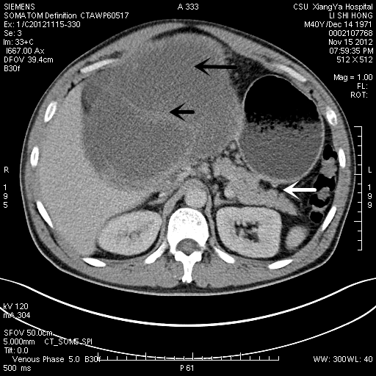
Figure 1 An abdominal computed tomography scan exhibited solid and mixed cystic lesions, measuring > 28 cm diameter (black arrow). The tumor was apart from the pancreas (white arrow).

A
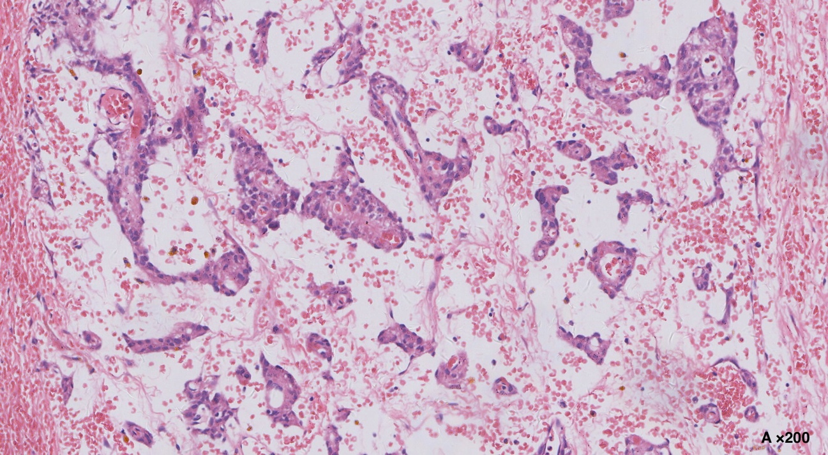
B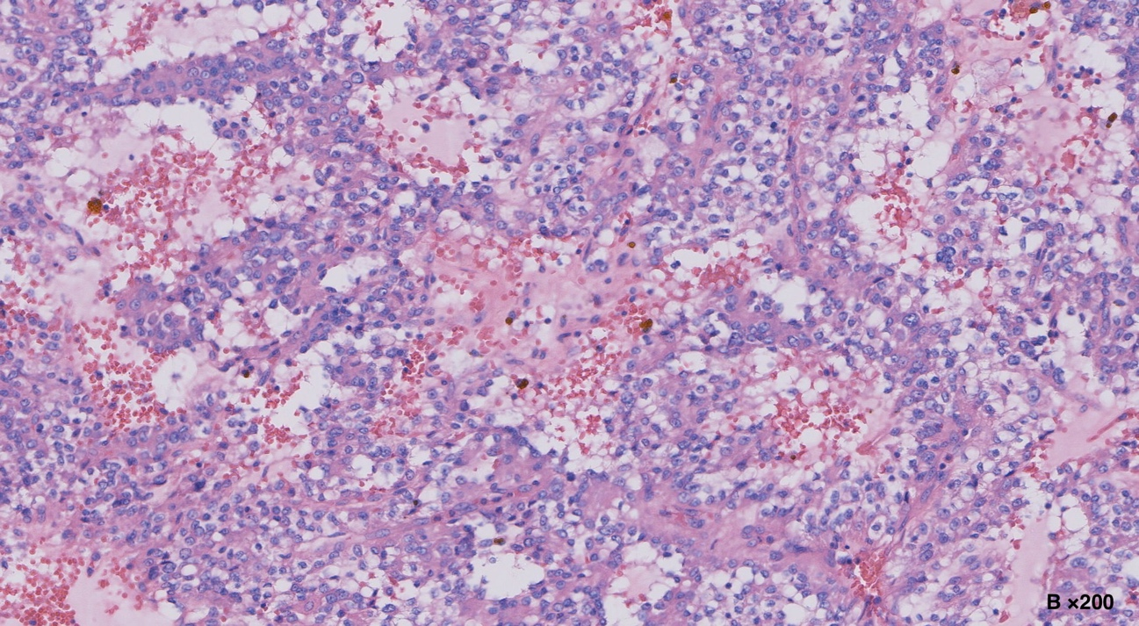
C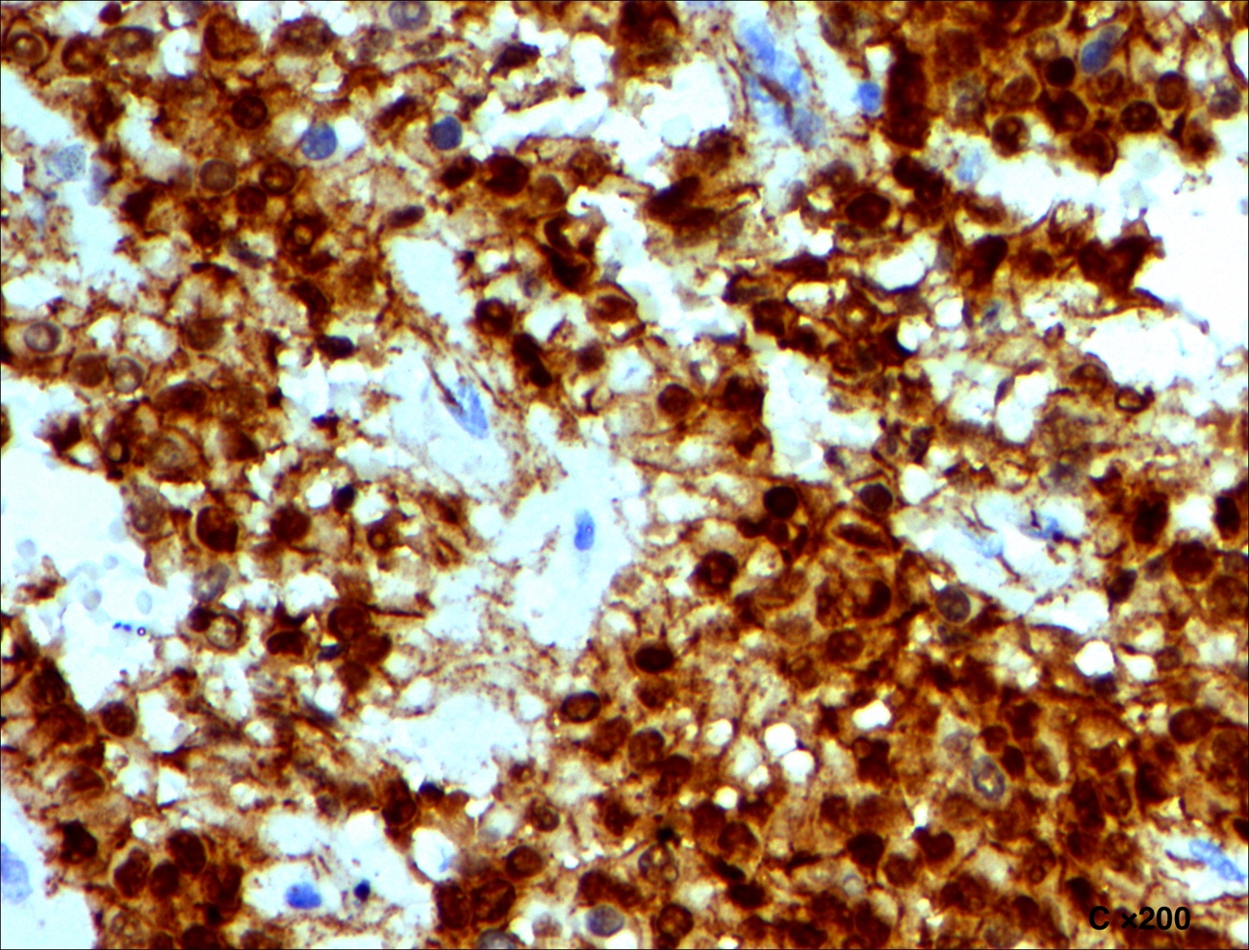D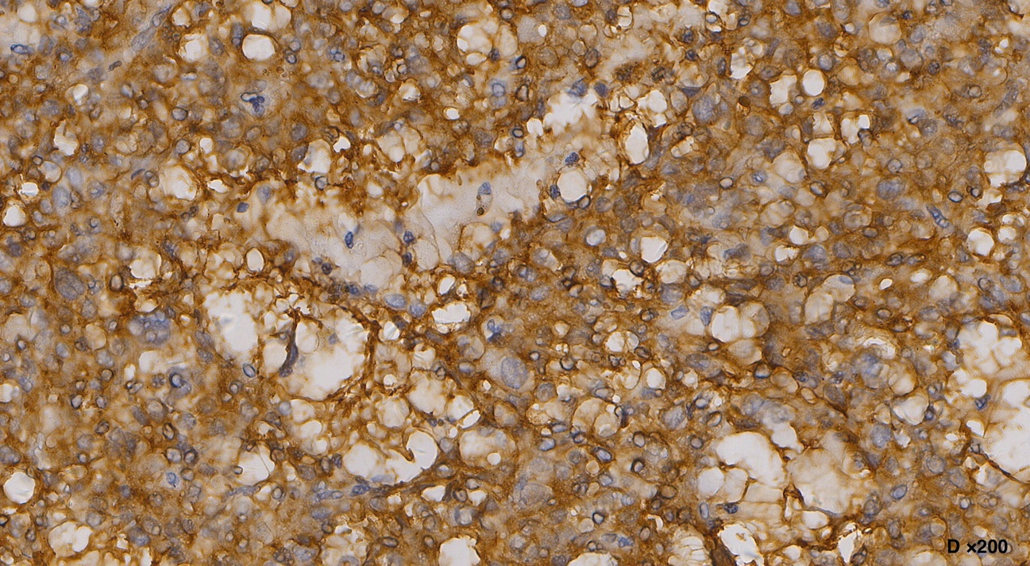

E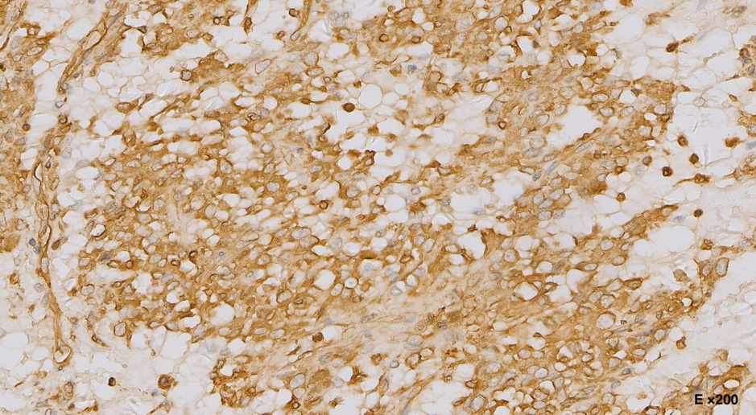

F
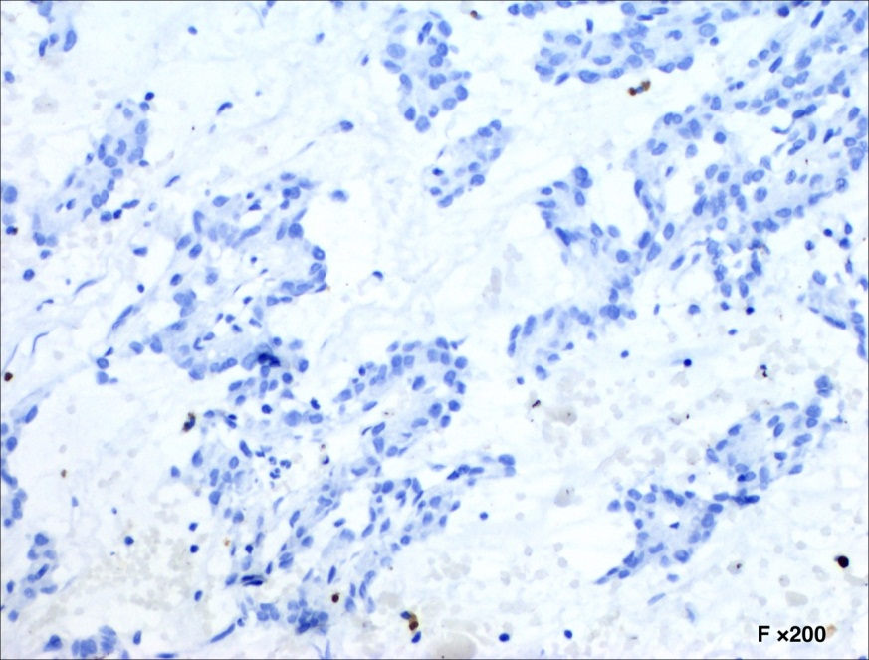
Figure 2 Histological and immunohistochemical findings of the tumor. The tumor cells are arranged in solid sheets, pseudopapillary and microcysts (A and B: Hematoxylin-eosin stain), and are immunohistochemically positive for alpha-1-antitrypsin (C), β-catenin (D: Cytoplasmic and nuclear staining), CD56 (E), whereas negative for chromogranin (F).
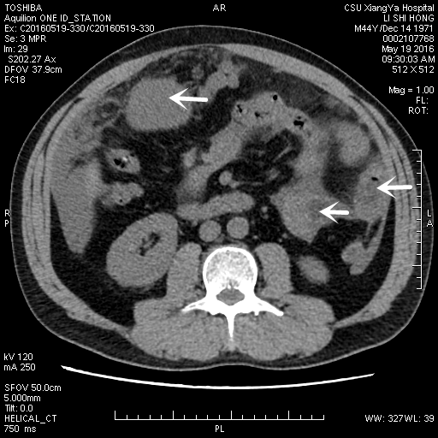
Figure 3 An abdominal computed tomography scan exhibited multiple tumors in peritoneum, greater omentum, and colonic wall (white arrow).

