Name of Journal: World Journal of Gastrointestinal Surgery
Manuscript NO: 48193
Manuscript Type: META-ANALYSIS

Pancreatogastrostomy vs pancreatojejunostomy after pancreaticoduodenectomy: An updated meta-analysis of RCTs and our experience

Yun J et al. Pancreatico-digestive tract anastomosis after pancreaticoduodenectomy

Yun Jin, Yang-Yang Feng, Xiao-Gang Qi, Geng Hao, Yuan-Quan Yu, Jiang-Tao Li, Shu-You Peng

Yun Jin, Yang-Yang Feng, Xiao-Gang Qi, Geng Hao, Yuan-Quan Yu, Jiang-Tao Li, Shu-You Peng, Department of General Surgery, the Second Affiliated Hospital, College of Medicine, Zhejiang University, Hangzhou 310009, Zhejiang Province, China

ORCID number: Yun Jin (0000-0002-3073-4043); Yang-Yang Feng (0000-0003-0598-8727); Xiao-Gang Qi (0000-0002-9040-5815); Geng Hao (0000-0001-7267-9540); Yuan-Quan Yu (0000-0002-1109-1652); Jiang-Tao Li (0000-0001-7538-2910); Shu-You Peng (0000-0003-3989-3056).

Author contributions: Li JT and Peng SY conceived and designed the study; Jin Y, Feng YY, and Hao G performed data extraction and statistical analysis; Jin Y, Feng YY, and Qi XG wrote the paper; Yu YQ, Li JT, and Peng SY reviewed and edited the manuscript; all authors read and approved the manuscript.

Supported by Training Project of Health High Level Talents in Zhejiang Province (2014).

Conflict-of-interest statement: We declare that we have no conflict of interest to this work.

PRISMA2009 Checklist statement: PRISMA2009 Checklist has been adopted.

Open-Access: This article is an open-access article which was selected by an in-house editor and fully peer-reviewed by external reviewers. It is distributed in accordance with the Creative Commons Attribution Non Commercial (CC BY-NC 4.0) license, which permits others to distribute, remix, adapt, build upon this work non-commercially, and license their derivative works on different terms, provided the original work is properly cited and the use is non-commercial. See: http://creativecommons.org/licenses/by-nc/4.0/

Manuscript source: Invited Manuscript

Corresponding author: Jiang-Tao Li, FACS, MD, Attending Doctor, Department of General Surgery, the Second Affiliated Hospital, College of Medicine, Zhejiang University, No. 88, Jiefang Road, Hangzhou 310009, Zhejiang Province, China. zrljt@zju.edu.cn
Telephone: +86-571-89713729

Received: April 16, 2019
Peer-review started: April 19, 2019
First decision: June 3, 2019
Revised: June 11, 2019
Accepted: June 20, 2019
Article in press:
Published online:

Abstract
BACKGROUND
Pancreatoduodenectomy (PD) is one of the most important operations in hepatobiliary and pancreatic surgery.

AIM
To evaluate the advantages and disadvantages of pancreaticojejunostomy (PJ) and pancreaticogastrostomy (PG).

METHODS
This meta-analysis was performed using Review Manager 5.3. All clinical randomized controlled trials, in which patients underwent PD with pancreatico-digestive tract reconstruction via PJ or PG, were included.

RESULTS
The search of PubMed, Wanfang Data, EMBASE, and the Cochrane Library provided 125 citations. After further analysis, 11 trials were included from nine counties. In all, 909 patients underwent PG and 856 underwent PJ. Meta-analysis showed that pancreatic fistula (PF) was a significantly lower morbidity in the PG group than in the PJ group (odds ratio [OR] = 0.67, 95% confidence interval [CI]: 0.53-0.86, P = 0.002); however, grades B and C PF was not significantly different between the two groups (OR = 0.61, 95%CI: 0.34-1.09, P = 0.09). Postoperative hemorrhage showed a significantly lower morbidity in the PJ group than in the PG group (OR = 1.47, 95%CI: 1.05-2.06, P = 0.03). Delayed gastric emptying was not significantly different between the two groups (OR = 1.09, 95%CI: 0.83-1.41, P = 0.54).

CONCLUSION
There is no difference in the incidence of grades B and C PF between the two groups. However, postoperative bleeding is significantly higher in PG than in PJ. Binding PJ or binding PG is a safe and secure technique according to our decades of experience.

Key words: Pancreaticojejunostomy; Pancreaticogastrostomy; Systematic review; Meta-analysis

© The Author(s) 2019. Published by Baishideng Publishing Group Inc. All rights reserved.

Core tip: Pancreatico-digestive tract anastomosis after pancreaticoduodenectomy is still controversial. This systematic review and meta-analysis aimed to further evaluate the role and importance of pancreaticojejunostomy and pancreaticogastrostomy. We compared the complications of these two surgical procedures, including pancreatic fistula, delayed gastric emptying, and hemorrhage.

Jin Y, Feng YY, Qi XG, Hao G, Yu YQ, Li JT, Peng SY. Pancreatogastrostomy vs pancreatojejunostomy after pancreaticoduodenectomy: An updated meta-analysis of RCTs and our experience. World J Gastrointest Surg 2019; In press

INTRODUCTION
Pancreatoduodenectomy (PD) is the main treatment procedure for benign and malignant tumors of the pancreatic head, lower common bile duct, and ampulla^{[1]}. The incidence of complications after PD is still high, with some large pancreatic centers reporting an incidence of approximately 10-45%^{[2-7]}. The incidence of pancreatic fistula (PF), delayed gastric emptying (DGE), and gastrointestinal or abdominal hemorrhage has been reported to be 3-45%^{[8]}, 5%-61%^{[9,10]}, and 1%-8%^{[11]}, respectively. Other complications include abdominal empyema, incision infection, and pulmonary infection^{[12]}.
Since the establishment of PD, pancreatico-digestive tract reconstruction has been a highly valued research area, which is considered to be closely related to the success/failure of the surgery^{[13]}. In general, pancreatico-digestive tract reconstruction includes pancreaticojejunostomy (PJ) and pancreaticogastrostomy (PG). Unlike gastrointestinal anastomosis, these two types of reconstruction after pancreatic surgery are diverse, with different results and evaluations. Therefore, there is still room for improvement in PJ and PG, and these procedures are still the focus of future research in PD.
This systematic review and meta-analysis aimed to further evaluate the role and importance of pancreatico-digestive tract anastomosis. Further, the advantages and disadvantages of PJ and PG were compared to provide a valuable reference for a more reasonable and safe choice of pancreatico-digestive tract reconstruction in the future.

MATERIALS AND METHODS
Eligibility criteria
All clinical randomized controlled trials, in which patients underwent PD with pancreatico-digestive tract reconstruction via PJ or PG, were included.

Information sources
Studies were identified by searching electronic databases and scanning reference lists of articles. No limits were applied for languages and foreign papers were translated to English. The search was applied to Medline, Wanfang Data, EMBASE, Science Citation Index Expanded, and the Cochrane Library. The last search was run on March 15, 2019.

Search
We used the following search terms to search all trial registers and databases: Pancreatoduodenectomy or Pancreatoduodenectomies or Duodenopancreatectomy or Duodenopancreatectomies or Pancreaticoduodenectomy or Whipple or PD or Whipple procedure or Pancreatoduodenal resection or Pancreaticoduodenal resection, Pancreaticojejunostomy or Pancreaticojejunostomies or Pancreatojejunostomy or Pancreatojejunostomies or Pancreaticoenteric anastomosis or Pancreatoenteric anastomosis or Pancreaticojejunal anastomosis or Pancreatojejunal anastomosis or PJ, or Pancreaticogastrostomy or PG.

Study selection
Eligibility assessment was performed independently in an unblinded standardized manner by two reviewers. Disagreements between reviewers were resolved by discussion.

Data collection process
One review author extracted the following data from the included studies and the second author checked the extracted data. Disagreements were resolved by discussion between the two review authors; if no agreement could be reached, a third author would take the decision.

Data items
Data were extracted from each included trial on: (1) characteristics of trial participants including age, disease, and number of patients; (2) intervention with PG vs PJ; (3) type of outcome measures including the definition and occurrence of PF, DGE, and other postoperative complications.

Risk of bias in individual studies
To ascertain the validity of eligible randomized trials, two independent reviewers with adequate reliability determined the adequacy of randomization, concealment of allocation, blinding of patients, healthcare providers, data collectors, and outcome assessors.

Statistical analysis
The meta-analysis was performed using Review Manager 5.3. The Chi-square test was used to test heterogeneity among studies. The heterogeneity level was judged according to I². Relative risk (RR), weighted mean difference (WMD), standardized mean difference (SMD), and 95%CI (confidence interval) were used.
For data with clinical heterogeneity, it is not easy to merge effect quantities. First, we tested heterogeneity among studies. Then subgroup analysis or meta-regression analysis was conducted according to heterogeneity. If data were insufficient or heterogeneity cannot be found, a random-effects model was used. The homogeneity of data was tested by the χ² test, and the homogeneity was quantitatively analyzed by the I² test. If there was no statistical heterogeneity, a fixed-effects model was used. When statistical analysis showed heterogeneity, a random-effects model was used. The significance level of the hypothesis test was set at P < 0.05.
To assess the risk of bias across studies, we plotted the effect by the inverse of its standard error for each trial. The symmetry was assessed both visually, and formally by the Egger's test.

RESULTS
A total of 11 studies involving 11 trials were identified for inclusion in the review^{[14-24]}. The search of PubMed, Wanfang Data, Embase, and the Cochrane Library provided 125 citations. Of the total 125 citations, 29 studies were discarded because they did not meet the inclusion criteria. Nine additional studies were discarded because full texts for these were not available. The full texts of the remaining 65 citations were examined in further detail. Following this, 51 studies were found not to meet the inclusion criteria as described, and three were repeat studies from the same institute at different time points (we chose the latest study in this case). Finally, 11 studies met the inclusion criteria and were included in the systematic review. Figure 1 shows the flow diagram of study selection (Figure 1).
From 1995 to 2016, 11 trials were included from nine counties. In all, 909 patients underwent PG and 856 underwent PJ. PF was defined and classified following the International Study Group on Pancreatic Fistula (ISGPF) consensus guidelines in seven trials^{[15,17-22]} (Table 1). The quality of these 11 trials is presented in Figure 2.
PF data were available for all 11 trials randomizing 1765 patients and reporting data for them. In the meta-analysis, there was no significant heterogeneity between these studies (I² = 20%); therefore, a fixed-effects model was applied. PF showed a significantly lower morbidity in the PG group than in the PJ group (odds ratio [OR] = 0.67, 95%CI: 0.53-0.86, P = 0.002) (Figure 3). Grade A PF did not affect the disease outcome; therefore, we further analyzed the incidence of grades B and C PF. Seven trials with 603 PG and 581 PJ patients were included. In the meta-analysis, there was a significant difference in heterogeneity between these studies (I² = 61%); accordingly, a random-effects model was applied. Grades B and C PF was not significantly different between the two groups (OR = 0.61, 95%CI: 0.34-1.09, P = 0.09) (Figure 4).
Nine trials with 788 PG and 734 PJ patients were included for analyzing postoperative hemorrhage. In the meta-analysis, there was no significant heterogeneity between these studies (I² = 0%); accordingly, a fixed-effects model was applied. Postoperative hemorrhage showed a significantly lower morbidity in the PJ group than in the PG group (OR = 1.47, 95%CI: 1.05-2.06, P = 0.03) (Figure 5).
Nine trials including 780 PG and 738 PJ patients were included for the analysis of DGE. In the meta-analysis, there was no significant heterogeneity between these studies (I² = 47%), and therefore a fixed-effects model was applied. DGE was not significantly different between the two groups (OR = 1.09, 95%CI: 0.83-1.41, P = 0.54) (Figure 6).

DISCUSSION
PF is one of the most common complications after PD. PF not only causes serious complications such as abdominal bleeding but also increases the length of hospital stay and cost for patients. Our study showed that PG anastomosis can reduce the incidence of all grades of PF than PJ anastomosis. In 2005, the ISGPF defined PF and divided it into three levels^{[25]}. In 2016, the group adjusted the classification of PF and defined grade A PF as a biochemical fistula^{[8]}. Therefore, in this study, we considered the incidence of grades B/C PF in subgroup analysis. We believe that this statistical analysis has more clinical value and significance. We found no statistical difference in grades B/C PF between the two groups (PJ and PG). However, our result showed that PG anastomosis may increase the incidence of bleeding compared with PJ anastomosis.
Our group has studied the anastomosis of the pancreas and digestive tract for more than 20 years, and has accumulated some experiences^{[7,26,27]}. In 1996, we established the binding pancreaticojejunostomy (BPJ). The main feature of this surgery is that the anastomosis between the jejunum and pancreas is mainly made with a binding line. It avoids the needle hole penetrating the intestinal cavity on the surface of the anastomotic site, thus preventing the leakage of pancreatic juice from the pinholes, to fundamentally eliminate the possibility of PF. At present, BPJ has been applied in more than a thousand of cases, which has a significant effect on the prevention of PF after surgery^{[7]}. In 2010, Buc, a French scholar, named BPJ procedure as Peng's PJ and reported that BPJ was a safe and secure technique^{[28]}. In 2008, Peng created the binding pancreaticogastrostomy (BPG), which simplified the operation steps of the previous pancreas-stomach anastomosis^{[29]}. After continuous improvement, only the bundled method was used in the posterior wall of the stomach, avoiding the suture of pancreas parenchyma and thus greatly shortening the surgical time and preventing anastomotic leakage. BPG not only solves the problem of excessive pancreatic stump but also reduces the harm of bile leakage because the biliary-enteric anastomosis is not in the same channel as PG anastomosis^{[27]}. The mid-term results of the randomized controlled study showed that the incidence of PF in BPG and BPJ was acceptable^{[17]}.
In recent years, with the continuous development of laparoscopic technology, laparoscopic PD has gradually become an alternative method, used as a routine treatment in some pancreatic surgeries^{[30-32]}. Thus, laparoscopic pancreaticogastrointestinal anastomosis has become a new focus for research. Owing to the limitation of the laparoscopic visual field, pancreatic duct to mucosa anastomosis is the first choice of procedure under laparoscopy^{[30]}.
The attempt of various methods makes the technique of PJ dazzling. However, the basic content cannot be separated from pancreas-jejunum (stomach) anastomosis or pancreatic duct-jejunum (stomach) anastomosis. The objective of evaluation should be as simple as possible. Moreover, the lower the incidence of pancreatic leakage compared with classical anastomosis, the better. As long as these principles are followed, sample enlargement and randomized controlled trials should be conducted to find the best method.

ARTICLE HIGHLIGHTS
Research background
Pancreatoduodenectomy (PD) is one of the most important operations in hepatobiliary and pancreatic surgery. Pancreatico-digestive tract reconstruction includes pancreaticojejunostomy (PJ) and pancreaticogastrostomy (PG). Unlike gastrointestinal anastomosis, these two types of reconstruction after pancreatic surgery are diverse, with different results and evaluations. Therefore, there is still room for improvement in PJ and PG, and these procedures are still the focus of future research in PD.

Research motivation and objectives
This systematic and meta-analysis aimed to evaluate the role and importance of pancreatico-digestive tract anastomosis. Advantages and disadvantages of PJ and PG were compared to provide a valuable reference and safe choice in the future.

Research methods
This search was applied to Medline, Wanfang Data, Embase, Science Citation Index Expanded, and the Cochrane Library. The last search was run on March 15, 2019. All clinical randomized controlled trials, in which patients underwent PD with pancreatico-digestive tract reconstruction via PJ or PG, were included. The Chi-square test was used to test heterogeneity among studies. The heterogeneity level was judged according to I². Relative risk (RR), weighted mean difference (WMD), standardized mean difference (SMD), and 95%CI were used.

Research results
In the meta-analysis of postoperative hemorrhage, there was no significant heterogeneity between these studies (I² = 0%); accordingly, a fixed-effect model was applied. Postoperative hemorrhage showed a significantly lower morbidity in the PJ group than in the PG group (OR = 1.47, 95%CI: 1.05-2.06, P = 0.03). In the meta-analysis of DGE, there was no significant heterogeneity between these studies (I² = 47%), and therefore a fixed-effects model was applied. DGE was not significantly different between the two groups (OR = 1.09, 95%CI: 0.83-1.41, P = 0.54).

Research conclusions
Our group has studied the anastomosis of the pancreas and digestive tract for more than 20 years, and has accumulated some experiences. We established the binding pancreaticojejunostomy (BPJ) and binding pancreaticogastrostomy (BPG). The mid-term results of the randomized controlled study showed that the incidence of PF in BPG and BPJ was acceptable.

Research perspectives
Laparoscopic pancreaticogastrointestinal anastomosis has become a new focus for research. The objective of evaluation should be as simple as possible. Moreover, the lower the incidence of pancreatic leakage compared with classical anastomosis, the better. As long as these principles are followed, sample enlargement and randomized controlled trials should be conducted to find the best method.

REFERENCES
1 Whipple AO, Parsons WB, Mullins CR. TREATMENT OF CARCINOMA OF THE AMPULLA OF VATER. Ann Surg 1935; 102: 763-779 [PMID: 17856666 DOI: 10.1097/00000658-193510000-00023]
2 Giuliano K, Ejaz A, He J. Technical aspects of pancreaticoduodenectomy and their outcomes. Chin Clin Oncol 2017; 6: 64 [PMID: 29156887 DOI: 10.21037/cco.2017.09.01]
3 McMillan MT, Allegrini V, Asbun HJ, Ball CG, Bassi C, Beane JD, Behrman SW, Berger AC, Bloomston M, Callery MP, Christein JD, Dickson E, Dixon E, Drebin JA, Fernandez-Del Castillo C, Fisher WE, Fong ZV, Haverick E, Hollis RH, House MG, Hughes SJ, Jamieson NB, Kent TS, Kowalsky SJ, Kunstman JW, Malleo G, McElhany AL, Salem RR, Soares KC, Sprys MH, Valero V 3rd, Watkins AA, Wolfgang CL, Zureikat AH, Vollmer CM Jr. Incorporation of Procedure-specific Risk Into the ACS-NSQIP Surgical Risk Calculator Improves the Prediction of Morbidity and Mortality After Pancreatoduodenectomy. Ann Surg 2017; 265: 978-986 [PMID: 27232260 DOI: 10.1097/sla.0000000000001796]
4 Reyna-Sepúlveda F, Muñoz-Maldonado G, Pérez-Rodríguez E, Hernández-Trejo F, Guevara-Charles A, Hernández-Guedea M. Prognostic factors for survival and surgical complications in Whipple's pancreatoduodenectomy during a 10-year experience. Cir Cir 2019; 87: 205-210 [PMID: 30768068 DOI: 10.24875/ciru.18000526]
5 Brown EG, Yang A, Canter RJ, Bold RJ. Outcomes of pancreaticoduodenectomy: where should we focus our efforts on improving outcomes? JAMA Surg 2014; 149: 694-699 [PMID: 24849180 DOI: 10.1001/jamasurg.2014.151]
6 Büchler MW, Wagner M, Schmied BM, Uhl W, Friess H, Z'graggen K. Changes in morbidity after pancreatic resection: toward the end of completion pancreatectomy. Arch Surg 2003; 138: 1310-4; discussion 1315 [PMID: 14662530 DOI: 10.1001/archsurg.138.12.1310]
7 Peng SY, Wang JW, Lau WY, Cai XJ, Mou YP, Liu YB, Li JT. Conventional versus binding pancreaticojejunostomy after pancreaticoduodenectomy: a prospective randomized trial. Ann Surg 2007; 245: 692-698 [PMID: 17457161 DOI: 10.1097/01.sla.0000255588.50964.5d]
8 Bassi C, Marchegiani G, Dervenis C, Sarr M, Abu Hilal M, Adham M, Allen P, Andersson R, Asbun HJ, Besselink MG, Conlon K, Del Chiaro M, Falconi M, Fernandez-Cruz L, Fernandez-Del Castillo C, Fingerhut A, Friess H, Gouma DJ, Hackert T, Izbicki J, Lillemoe KD, Neoptolemos JP, Olah A, Schulick R, Shrikhande SV, Takada T, Takaori K, Traverso W, Vollmer CR, Wolfgang CL, Yeo CJ, Salvia R, Buchler M; International Study Group on Pancreatic Surgery (ISGPS). The 2016 update of the International Study Group (ISGPS) definition and grading of postoperative pancreatic fistula: 11 Years After. Surgery 2017; 161: 584-591 [PMID: 28040257 DOI: 10.1016/j.surg.2016.11.014]
9 Eisenberg JD, Rosato EL, Lavu H, Yeo CJ, Winter JM. Delayed Gastric Emptying After Pancreaticoduodenectomy: an Analysis of Risk Factors and Cost. J Gastrointest Surg 2015; 19: 1572-1580 [PMID: 26170145 DOI: 10.1007/s11605-015-2865-5]
10 Wente MN, Bassi C, Dervenis C, Fingerhut A, Gouma DJ, Izbicki JR, Neoptolemos JP, Padbury RT, Sarr MG, Traverso LW, Yeo CJ, Büchler MW. Delayed gastric emptying (DGE) after pancreatic surgery: a suggested definition by the International Study Group of Pancreatic Surgery (ISGPS). Surgery 2007; 142: 761-768 [PMID: 17981197 DOI: 10.1016/j.surg.2007.05.005]
11 Wente MN, Veit JA, Bassi C, Dervenis C, Fingerhut A, Gouma DJ, Izbicki JR, Neoptolemos JP, Padbury RT, Sarr MG, Yeo CJ, Büchler MW. Postpancreatectomy hemorrhage (PPH): an International Study Group of Pancreatic Surgery (ISGPS) definition. Surgery 2007; 142: 20-25 [PMID: 17629996 DOI: 10.1016/j.surg.2007.02.001]
12 Lessing Y, Pencovich N, Nevo N, Lubezky N, Goykhman Y, Nakache R, Lahat G, Klausner JM, Nachmany I. Early reoperation following pancreaticoduodenectomy: impact on morbidity, mortality, and long-term survival. World J Surg Oncol 2019; 17: 26 [PMID: 30704497 DOI: 10.1186/s12957-019-1569-9]
13 Cameron JL, He J. Two thousand consecutive pancreaticoduodenectomies. J Am Coll Surg 2015; 220: 530-536 [PMID: 25724606 DOI: 10.1016/j.jamcollsurg.2014.12.031]
14 Yeo CJ, Cameron JL, Maher MM, Sauter PK, Zahurak ML, Talamini MA, Lillemoe KD, Pitt HA. A prospective randomized trial of pancreaticogastrostomy versus pancreaticojejunostomy after pancreaticoduodenectomy. Ann Surg 1995; 222: 580-588; discussion 588-592 [PMID: 7574936 DOI: 10.1097/00000658-199510000-00014]
15 Wellner UF, Sick O, Olschewski M, Adam U, Hopt UT, Keck T. Randomized controlled single-center trial comparing pancreatogastrostomy versus pancreaticojejunostomy after partial pancreatoduodenectomy. J Gastrointest Surg 2012; 16: 1686-1695 [PMID: 22744638 DOI: 10.1007/s11605-012-1940-4]
16 Bassi C, Falconi M, Molinari E, Salvia R, Butturini G, Sartori N, Mantovani W, Pederzoli P. Reconstruction by pancreaticojejunostomy versus pancreaticogastrostomy following pancreatectomy: results of a comparative study. Ann Surg 2005; 242: 767-771, discussion 771; 773 [PMID: 16327486 DOI: 10.1097/01.sla.0000189124.47589.6d]
17 Jian C. Comparsion of clinical effect between Binding Pancreaticojejunostomy and Binding Pancreaticogastrostomy-Multi-center Prospective Randomized Controlled Trial Study (Mid-term Data Analysis). Medical college of Zhejiang University, 2012
18 Topal B, Fieuws S, Aerts R, Weerts J, Feryn T, Roeyen G, Bertrand C, Hubert C, Janssens M, Closset J; Belgian Section of Hepatobiliary and Pancreatic Surgery. Pancreaticojejunostomy versus pancreaticogastrostomy reconstruction after pancreaticoduodenectomy for pancreatic or periampullary tumours: a multicentre randomised trial. Lancet Oncol 2013; 14: 655-662 [PMID: 23643139 DOI: 10.1016/s1470-2045(13)70126-8]
19 Keck T, Wellner UF, Bahra M, Klein F, Sick O, Niedergethmann M, Wilhelm TJ, Farkas SA, Börner T, Bruns C, Kleespies A, Kleeff J, Mihaljevic AL, Uhl W, Chromik A, Fendrich V, Heeger K, Padberg W, Hecker A, Neumann UP, Junge K, Kalff JC, Glowka TR, Werner J, Knebel P, Piso P, Mayr M, Izbicki J, Vashist Y, Bronsert P, Bruckner T, Limprecht R, Diener MK, Rossion I, Wegener I, Hopt UT. Pancreatogastrostomy Versus Pancreatojejunostomy for RECOnstruction After PANCreatoduodenectomy (RECOPANC, DRKS 00000767): Perioperative and Long-term Results of a Multicenter Randomized Controlled Trial. Ann Surg 2016; 263: 440-449 [PMID: 26135690 DOI: 10.1097/sla.0000000000001240]
20 El Nakeeb A, Hamdy E, Sultan AM, Salah T, Askr W, Ezzat H, Said M, Zeied MA, Abdallah T. Isolated Roux loop pancreaticojejunostomy versus pancreaticogastrostomy after pancreaticoduodenectomy: a prospective randomized study. HPB (Oxford) 2014; 16: 713-722 [PMID: 24467711 DOI: 10.1111/hpb.12210]
21 Fernández-Cruz L, Cosa R, Blanco L, López-Boado MA, Astudillo E. Pancreatogastrostomy with gastric partition after pylorus-preserving pancreatoduodenectomy versus conventional pancreatojejunostomy: a prospective randomized study. Ann Surg 2008; 248: 930-938 [PMID: 19092337 DOI: 10.1097/SLA.0b013e31818fefc7]
22 Figueras J, Sabater L, Planellas P, Muñoz-Forner E, Lopez-Ben S, Falgueras L, Sala-Palau C, Albiol M, Ortega-Serrano J, Castro-Gutierrez E. Randomized clinical trial of pancreaticogastrostomy versus pancreaticojejunostomy on the rate and severity of pancreatic fistula after pancreaticoduodenectomy. Br J Surg 2013; 100: 1597-1605 [PMID: 24264781 DOI: 10.1002/bjs.9252]
23 Duffas JP, Suc B, Msika S, Fourtanier G, Muscari F, Hay JM, Fingerhut A, Millat B, Radovanowic A, Fagniez PL; French Associations for Research in Surgery. A controlled randomized multicenter trial of pancreatogastrostomy or pancreatojejunostomy after pancreatoduodenectomy. Am J Surg 2005; 189: 720-729 [PMID: 15910726 DOI: 10.1016/j.amjsurg.2005.03.015]
24 Grendar J, Ouellet JF, Sutherland FR, Bathe OF, Ball CG, Dixon E. In search of the best reconstructive technique after pancreaticoduodenectomy: pancreaticojejunostomy versus pancreaticogastrostomy. Can J Surg 2015; 58: 154-159 [PMID: 25799130 DOI: 10.1503/cjs.010014]
25 Bassi C, Dervenis C, Butturini G, Fingerhut A, Yeo C, Izbicki J, Neoptolemos J, Sarr M, Traverso W, Buchler M; International Study Group on Pancreatic Fistula Definition. Postoperative pancreatic fistula: an international study group (ISGPF) definition. Surgery 2005; 138: 8-13 [PMID: 16003309 DOI: 10.1016/j.surg.2005.05.001]
26 Peng SY, Wang JW, Li JT, Mou YP, Liu YB, Cai XJ. Binding pancreaticojejunostomy--a safe and reliable anastomosis procedure. HPB (Oxford) 2004; 6: 154-160 [PMID: 18333069 DOI: 10.1080/13651820410016598]
27 Peng SY, Wang JW, Hong DF, Liu YB, Wang YF. Binding pancreaticoenteric anastomosis: from binding pancreaticojejunostomy to binding pancreaticogastrostomy. Updates Surg 2011; 63: 69-74 [PMID: 21442343 DOI: 10.1007/s13304-011-0067-6]
28 Buc E, Flamein R, Golffier C, Dubois A, Nagarajan G, Futier E, Pezet D. Peng's binding pancreaticojejunostomy after pancreaticoduodenectomy: a French prospective study. J Gastrointest Surg 2010; 14: 705-710 [PMID: 20054660 DOI: 10.1007/s11605-009-1125-y]
29 Peng SY, Hong DF, Liu YB, Tan ZJ, Li JT, Tao F. [Binding pancreaticogastrostomy]. Zhonghua Wai Ke Za Zhi 2009; 47: 139-142 [PMID: 19563012 DOI: 10.3760/cma.j.issn.0529-5815.2009.02.019PMID:]
30 Wang M, Peng B, Liu J, Yin X, Tan Z, Liu R, Hong D, Zhao W, Wu H, Chen R, Li D, Huang H, Miao Y, Liu Y, Liang T, Wang W, Cai Y, Xing Z, Cheng W, Zhong X, Zhao Z, Zhang J, Yang Z, Li G, Shao Y, Lin G, Jiang K, Wu P, Jia B, Ma T, Jiang C, Peng S, Qin R. Practice Patterns and Perioperative Outcomes of Laparoscopic Pancreaticoduodenectomy in China: A Retrospective Multicenter Analysis of 1029 Patients. Ann Surg 2019 [PMID: 30672792 DOI: 10.1097/sla.0000000000003190]
31 Palanivelu C, Jani K, Senthilnathan P, Parthasarathi R, Rajapandian S, Madhankumar MV. Laparoscopic pancreaticoduodenectomy: technique and outcomes. J Am Coll Surg 2007; 205: 222-230 [PMID: 17660068 DOI: 10.1016/j.jamcollsurg.2007.04.004]
32 Kendrick ML, van Hilst J, Boggi U, de Rooij T, Walsh RM, Zeh HJ, Hughes SJ, Nakamura Y, Vollmer CM, Kooby DA, Asbun HJ; Minimally Invasive Pancreatic Resection Organizing Committee. Minimally invasive pancreatoduodenectomy. HPB (Oxford) 2017; 19: 215-224 [PMID: 28317658 DOI: 10.1016/j.hpb.2017.01.023]

P-Reviewer: Aoki H, Bandyopadhyay SK, Uhlmann D
S-Editor: Cui LJ L-Editor: Wang TQ E-Editor:
Specialty type: Gastroenterology and hepatology
Country of origin: China
Peer-review report classification
Grade A (Excellent): 0
Grade B (Very good): B, B
Grade C (Good): 0
Grade D (Fair): D
Grade E (Poor): 0

Table 1 Characteristic of included trials
Author | Year | Country | Study type | Number of PG | Number of PJ | Definition of PF
Yeo et al^{[14]} | 1995 | United States | Single blind, controlled randomized, single center trial | 73 | 72 | PF was defined as drainage of greater than 50 mL of amylase-rid fluid on or after postoperative day 10
Duffas et al^{[23]} | 2005 | France | Single blind, controlled randomized, multicenter trial | 81 | 68 | Fluid obtained  through drains or percutaneous aspiration, containing at  least 4 times normal serum values of amylase for 3 day
Bassi et al^{[25]} | 2005 | Italy | Single blind, controlled randomized, single center trial | 69 | 82 | Any clinically significant output of fluid, rich  in amylase, confirmed by fistulography
Bassi et al^{[8]} | 2008 | Spain | Single blind, controlled randomized, single center trial | 53 | 55 | ISGPF definition
Wellner et al^{[15]} | 2012 | Germany | Single blind, controlled randomized, single center trial | 59 | 57 | ISGPF definition
Wang et al^{[30]} | 2012 | China | Single blind, controlled randomized, multicenter trial | 83 | 53 | ISGPF definition
El Nakeeb et al^{[20]} | 2013 | Egypt | Single blind, controlled randomized, single center trial | 45 | 45 | ISGPF definition
Topal et al^{[18]} | 2013 | Belgium | Single blind, controlled randomized, multicenter trial | 162 | 167 | ISGPF definition
Figueras et al^{[22]} | 2013 | Spain | Single blind, controlled randomized, multicenter trial | 65 | 58 | ISGPF definition
Grendar et al^{[24]} | 2015 | Canada | Single blind, controlled randomized, single center trial | 48 | 50 | Either radiologically proven anastomotic leak or continued drainage (via drain, enterocutaneous fistula, or wound) of lipase­rich ﬂuid on postoperative day 10
Keck et al^{[19]} | 2016 | Germany | Single blind, controlled randomized, multicenter trial | 171 | 149 | ISGPF definition
PG: Pancreaticogastrostomy; PJ: Pancreaticojejunostomy; PF: Postoperative pancreatic fistula.

91 records identified 34 records identified
through PubMed and through Embase and
Cochrane searching Wanfang searching

92 records excluded
3 no RCTs
2 repeat studies
5 having no comparison group
9 no full texts
7 reviews
37 meta-analyses
29 irrelevant records
22 duplicates removed

103 record
103 recordss screeneds

11 full-text articles
assessed for eligibility

11 studies included in
quantitative synthesis (meta-analysis)

11 studies included in
qualitative synthesis

Figure 1 Study flow diagram.

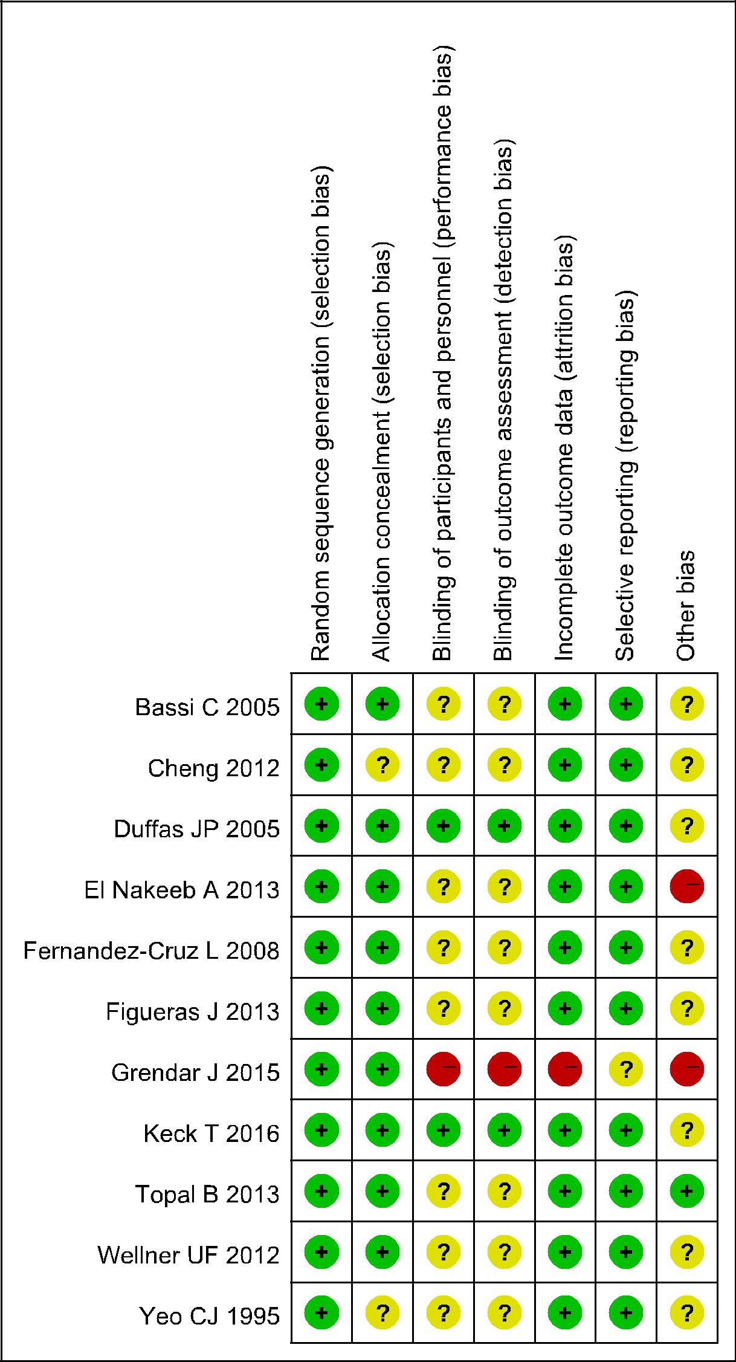
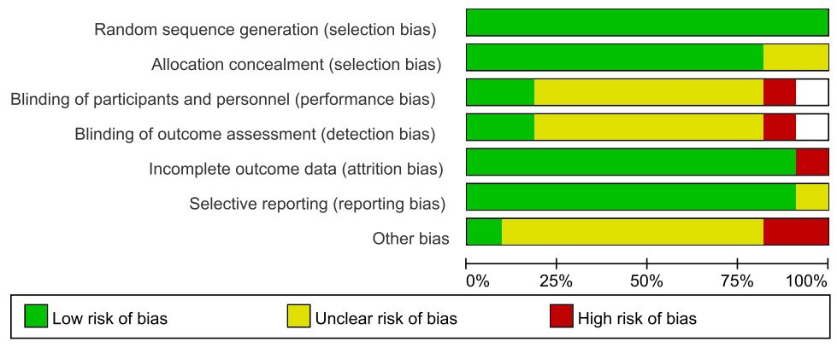

Figure 2 Quality of the included trials.

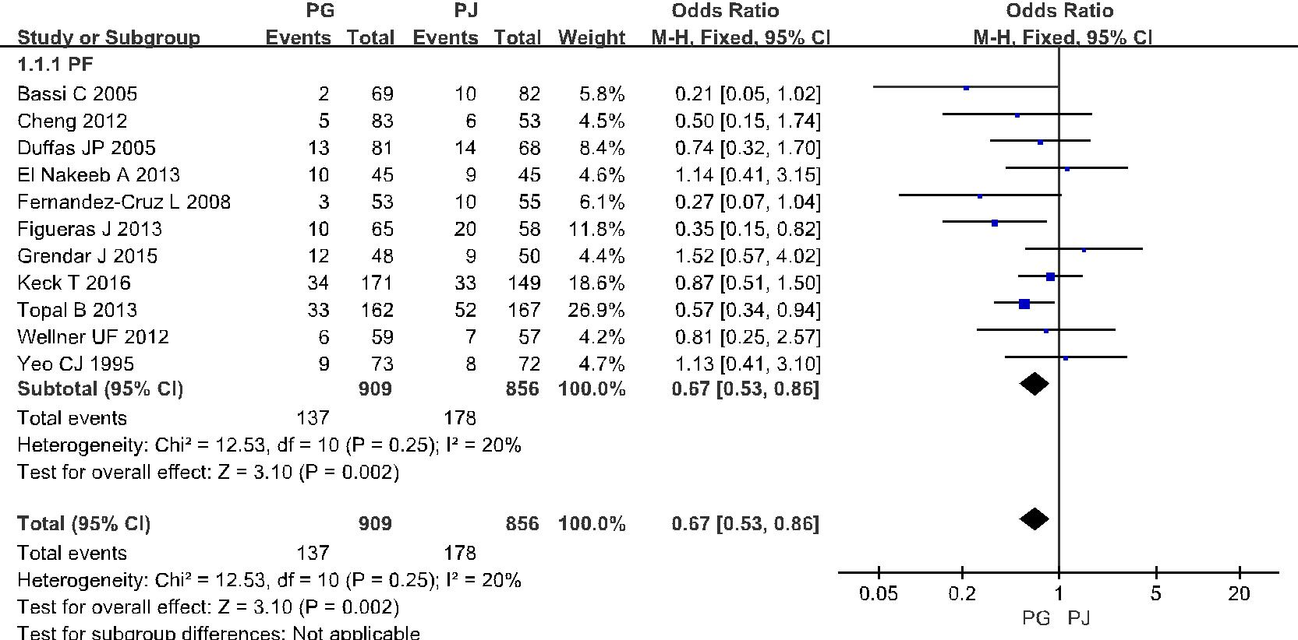

Figure 3 Forest plot of the incidence of all grades of postoperative pancreatic fistula. PG: Pancreaticogastrostomy; PJ: Pancreaticojejunostomy; PF: Postoperative pancreatic fistula.

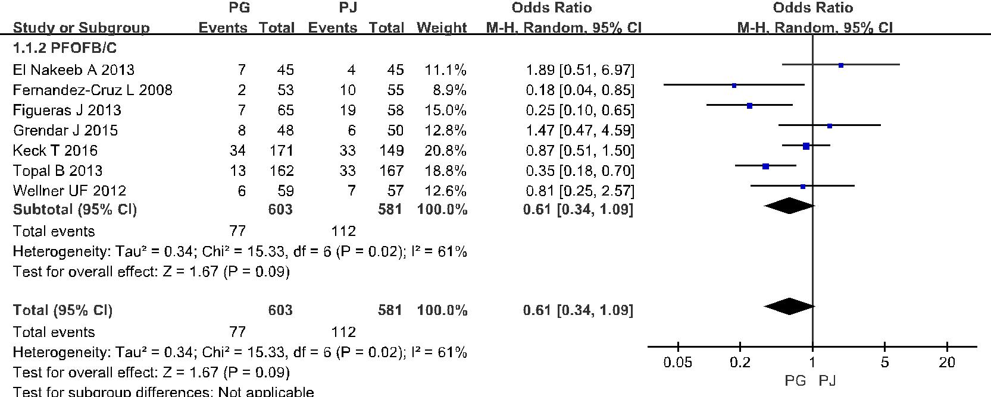

Figure 4 Forest plot of the incidence of grade B/C postoperative pancreatic fistula. PG: Pancreaticogastrostomy; PJ: Pancreaticojejunostomy; PF: Postoperative pancreatic fistula.

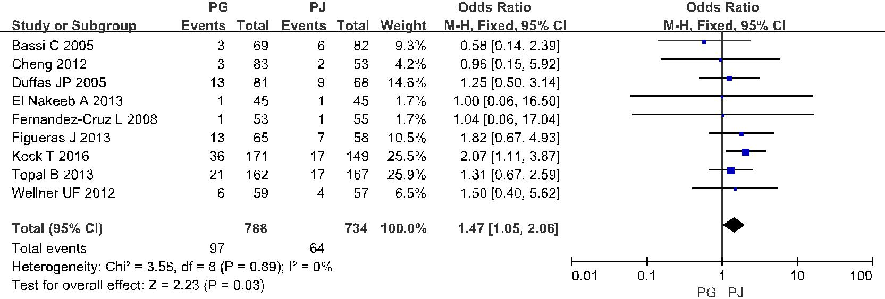

Figure 5 Forest plot of the incidence of postoperative hemorrhage. PG: Pancreaticogastrostomy; PJ: Pancreaticojejunostomy.

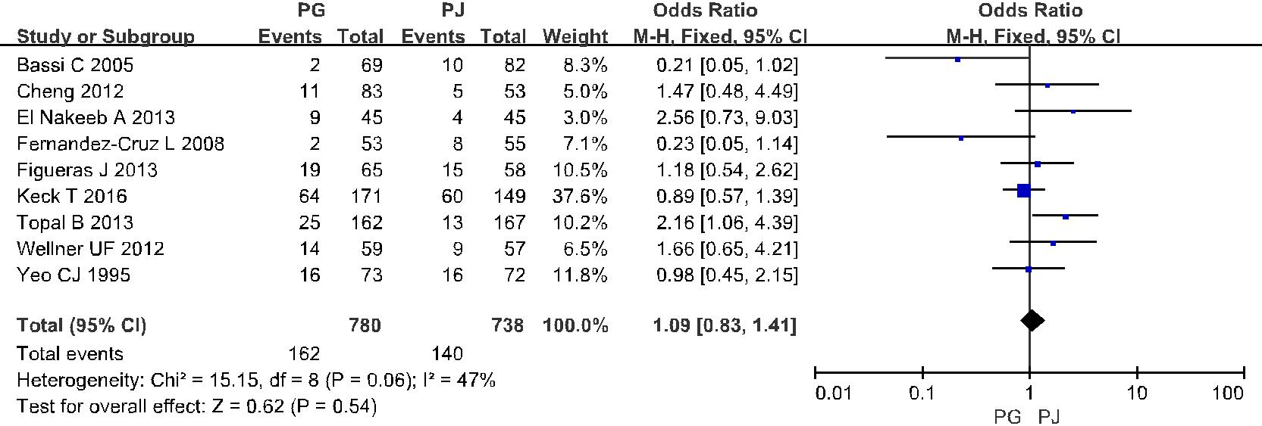

Figure 6 Forest plot of the incidence of delayed gastric emptying. PG: Pancreaticogastrostomy; PJ: Pancreaticojejunostomy; PF: Postoperative pancreatic fistula.

