Name of journal: World Journal of Gastrointestinal Endoscopy
ESPS Manuscript NO: 6675
Columns: CASE REPORT

Rare pancreas tumor mimicking adenocarcinoma: Extramedullary plasmacytoma

Akyuz F et al. Pancreatic mass and plasmacytoma

Filiz Akyuz, Davut Şahin , Umit Akyuz, Sezai Vatansever

Filiz Akyuz, Davut Şahin, Istanbul Faculty of Medicine, Department of Gastroenterology, Istanbul University, 34590 Capa, Istanbul, Turkey

Umit Akyuz, Department of Gastroenterology, Yeditepe University, 34752 Kozyatagi, Istanbul, Turkey

Sezai Vatansever, Istanbul Faculty of Medicine, Department of Pathology, Istanbul University, 34590 Capa, Istanbul, Turkey

Author contributions: Akyuz F and Akyuz U interpreted the results and wrote the manuscript; Şahin D reviewed the pathology specimen; Vatansever S performed data collection and interpretation.

Correspondence to: Filiz Akyuz, assistant Professor, Division of Gastroenterohepatology, Department of Internal Medicine, Istanbul Faculty of Medicine, Istanbul University, 34590 Capa, Istanbul, Turkey. filizakyuz@hotmail.com

Telephone: +90-21-24142000 Fax: +90-21-26319743
Received: October 26, 2013 Revised: November 9, 2013
Accepted: March 03, 2014
Published online:

Abstract
Neoplastic proliferation of plasma cells is called plasma cell dyscrasias, and these neoplasms can present as a solitary neoplasm or multiple myeloma. Extramedullary plasmacytoma, in particular pancreatic plasmacytoma, is a rare manifestation of multiple myeloma. Although computerized tomography is useful for the diagnosis of extramedullary plasmacytoma, there are no specific radiologic markers that distinguish it from adenocarcinoma. Histological confirmation by biopsy is necessary for accurate diagnosis and management of the tumor. Endosonography is the most sensitive method for the diagnosis of pancreatic tumors, and the use of fine needle aspiration by endosonography is associated with a lower risk for malignant seeding and complications. Here, we report a case of pancreatic plasmacytoma in newly identified multiple myeloma as diagnosed by endosonography. Endosonography is a reliable and rapid method for the diagnosis of extramedullary plasmacytoma. Therefore, endosonographic fine needle aspiration should be the first choice for histological evaluation when pancreatic plasmacytoma is suspected. Ideally, the pathology would be performed at the same site as endosonographic biopsy.

© 2014 Baishideng Publishing Group Co., Limited. All rights reserved.

Key words: Plasmacytoma; Endosonography; Pancreatic mass; Multiple myeloma; Fine needle aspiration

Core tip: The rare condition extramedullary plasmacytoma involves the gastrointestinal tract, usually liver, in approximately 10% of cases. A role for the pancreas is particularly rare. Pancreatic tumors can be identified radiologically, although it is impossible to discriminate between extramedullary plasmacytoma and adenocarcinoma. The use of endosonographic fine needle aspiration to acquire a histological sample from the pancreatic mass to confirm diagnosis is feasible and informative even in the presence of inoperable mass image.

Akyuz F, Şahin D, Akyuz U, Batansever S. Rare pancreas tumor mimicking adenocarcinoma: Extramedullary plasmacytoma.
Available from:
DOI:

INTRODUCTION
An uncommon manifestation of multiple myeloma is extramedullary plasmacytoma. It is generally localized to nasal fossa and rarely involves the pancreas. On imaging, such a pancreatic mass may mimic adenocarcinoma^{[1,2]}.

CASE REPORT
We present here a case of a 64-year-old man who was referred to our endoscopy unit for endosonographic (EUS) fine needle aspiration (FNA) for a pancreatic mass.

DISCUSSION
EUS (Fujinon, Tokyo, Japan) revealed a 3 cm heterogeneous focal mass in the head of the pancreas (Figure 1). Neoplasmic cells were detected by FNA (22 G; Cook Endoscopy, Winston-Salem, NC, United States), and plasmacytoma was diagnosed by the cytopathologist (Figure 2). Since plasmacytoma features are nonspecific on EUS and resemble other neoplasms including adenocarcinoma, plasmacytoma should be included in the differential diagnosis of a pancreatic mass, especially in advanced stage multiple myeloma patients. EUS-FNA is a fast and reliable technique for the diagnosis of plasmacytoma.

COMMENTS
Case characteristics
a 64-year-old man who was referred to our endoscopy unit.

Clinical diagnosis
endosonographic (EUS) fine needle aspiration (FNA) for a pancreatic mass.

Differential diagnosis
plasmacytoma features are nonspecific on EUS.

Imaging diagnosis
EUS revealed a 3 cm heterogeneous focal mass in the head of the pancreas. Neoplasmic cells were detected by FNA, and plasmacytoma was diagnosed by the cytopathologist.

Pathological diagnosis
Since plasmacytoma features are nonspecific on EUS and resemble other neoplasms including adenocarcinoma, plasmacytoma should be included in the differential diagnosis of a pancreatic mass, especially in advanced stage multiple myeloma patients.

Experiences and lessons
An uncommon manifestation of multiple myeloma is extramedullary plasmacytoma. It is generally localized to nasal fossa and rarely involves the pancreas.

Treatment
EUS-FNA is a fast and reliable technique for the diagnosis of plasmacytoma.

Peer review
As mentioned in this study, extramedullary plasmacytoma is a rare presentation of multiple myeloma. So it had innovative significance for this study to report a pancreatic plasmacytoma diagnosed by EUS-FNA.

REFERENCES
1 Lopes da Silva R. Pancreatic involvement by plasma cell neoplasms. J Gastrointest Cancer 2012; 43: 157-167 [PMID: 21845374 DOI: 10.1007/s12029-011-9314-9]
2 Miljkovic' M, Senadhi V. Use of endoscopic ultrasound in diagnosing plasmacytoma of the pancreas. JOP 2012; 13: 26-29 [PMID: 22233943 DOI: 10.6092/1590-8577/578]
P-Reviewers: Eysselein ve, Lin MS S-Editor: Ma YJ L-Editor: E-Editor:

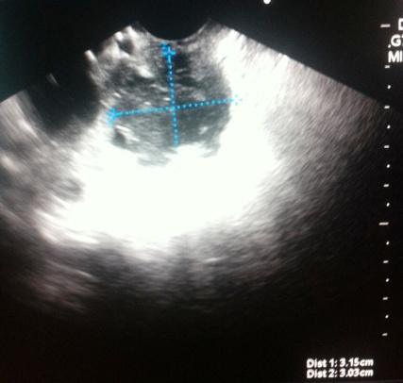
Figure 1 Endosonographic view of mass.

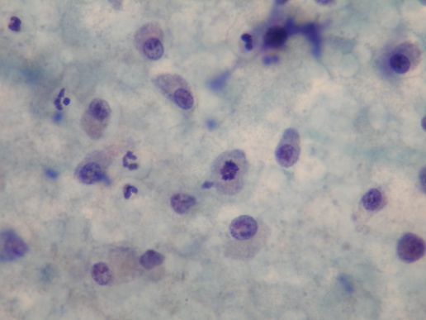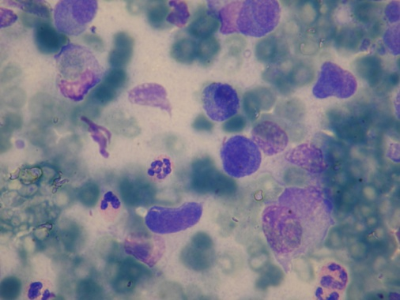
B
A
Figure 2 Cytopathologic findings of pancreatic mass obtained by endosonographic fine needle aspiration. A: Neoplasic plasmacytoid cells, mitose in the middle (× 100, Papa-nikolaou stain); B: Neoplasic plasmacytoid cells (× 100, May-Grunwald-Giemsa).

