Name of Journal: World Journal of Clinical Cases
Manuscript NO: 66587
Manuscript Type: CASE REPORT

Hemophagocytic lymphohistiocytosis secondary to composite lymphoma: Two case reports

Shen J et al. HLH secondary to composite lymphoma

Jing Shen, Jing-Shi Wang, Jian-Lan Xie, Lin Nong, Jia-Ning Chen, Zhao Wang

Jing Shen, Jing-Shi Wang, Zhao Wang, Department of Hematology, Capital Medical University Affiliated Beijing Friendship Hospital, Beijing 100000, China

Jian-Lan Xie, Department of Pathology, Capital Medical University Affiliated Beijing Friendship Hospital, Beijing 100050, China

Lin Nong, Department of Pathology, Peking University First Hospital, Beijing 100000, China

Jia-Ning Chen, Department of Clinical Laboratory, Capital Medical University Affiliated Beijing Friendship Hospital, Beijing 100000, China

Author contributions: Shen J and Wang JS conceived the topic, designed the study and revised the manuscript under the supervision of Wang Z; Shen J contributed to manuscript writing; Nong L contributed to data curation; Xie JL and Chen JN analyzed the data.

Corresponding author: Zhao Wang, MD, Professor, Department of Hematology, Capital Medical University Affiliated Beijing Friendship Hospital, No. 95 Yongan Road, Xicheng District, Beijing 100000, China. wangzhao@ccmu.edu.cn

Received: April 1, 2021
Revised: May 19, 2021
Accepted: July 2, 2021
Published online: October 26, 2021

Abstract
BACKGROUND
Hemophagocytic lymphohistiocytosis (HLH) is a rare and life-threatening disease caused by inherited pathogenic mutations and acquired dysregulations of the immune system. Composite lymphoma is defined as two or more morphologically and immunophenotypically distinct lymphomas that occur in a single patient. Here, we report two cases of HLH secondary to composite lymphoma with mixed lineage features of T- and B-cell marker expression both in the bone marrow and lymph nodes in adult patients.

CASE SUMMARY
Two patients were diagnosed with HLH based on the occurrence of fever, pancytopenia, lymphadenopathy, splenomegaly, hemophagocytosis and hyperferritinemia. Immunohistochemical staining of the axillary lymph node and bone marrow in case 1 showed typical features of combined B-cell and T-cell lymphoma. In addition, a lymph node gene study revealed rearrangement of the T-cell receptor chain and the immunoglobulin gene. Morphology and immunohistochemistry studies of a lymph node biopsy in case 2 showed typical features of T cell lymphoma, but immunophenotyping by flow cytometry analysis of a bone marrow aspirate showed B cell lymphoma involvement. The patients were treated with high-dose methylprednisolone combined with etoposide to control aggressive HLH progression. The patients also received immunochemotherapy with the R-CHOP (rituximab, cyclophosphamide, doxorubicin, vincristine, and prednisone) regimen immediately after diagnosis. Both patients presented with highly aggressive lymphoma, and died of severe infection or uncontrolled HLH.

CONCLUSION
We present two rare cases with overwhelming hemophagocytosis along with composite T- and B-cell lymphoma, which posed a diagnostic dilemma. HLH caused by composite lymphoma was characterized by poor clinical outcomes.

Key Words: Hemophagocytosis; Hemophagocytic lymphohistiocytosis; Composite lymphoma; T-cell; B-cell; Case report

©The Author(s) 2021. Published by Baishideng Publishing Group Inc. All rights reserved.

Citation: Shen J, Wang JS, Xie JL, Nong L, Chen JN, Wang Z. Hemophagocytic lymphohistiocytosis secondary to composite lymphoma: Two case reports. World J Clin Cases 2021; 9(30): 9159-9167
URL: https://www.wjgnet.com/2307-8960/full/v9/i30/9159.htm
DOI: https://dx.doi.org/10.12998/wjcc.v9.i30.9159

Core Tip: Lymphoma-associated hemophagocytic lymphohistiocytosis (HLH) is a rare and life-threatening clinical disorder. In particular, composite lymphoma with mixed lineage features of T- and B-cell marker expression is extremely rare. We report two cases of HLH secondary to bi-lineage composite lymphoma with lymphocyte infiltrations both in the bone marrow and lymph nodes in adult patients. Case 1 showed typical features of combined B-cell and T-cell lymphoma in axillary lymph node and bone marrow biopsies. Case 2 showed typical features of T cell lymphoma in lymph node biopsy, and B cell lymphoma in bone marrow biopsy. Both patients highlight the diagnostic dilemma, therapeutic challenges and poor prognosis of HLH secondary to composite lymphoma.
INTRODUCTION
Hemophagocytic lymphohistiocytosis (HLH) is a rare and life-threatening clinical disorder characterized by uncontrolled hyper-activation of inflammatory responses due to inherited pathogenic mutations and acquired dysregulations of the immune system^{[1,2]}. HLH can be classified into two subtypes: Primary and secondary. Secondary HLH can be triggered by underlying infection, autoimmune disease, or malignancy^{[3]}. Malignancy-associated HLH is more common in adults in certain hematologic malignancies compared to children, and the actual incidence of this disease is unclear^{[1]}. Lymphoma-associated HLH is comparatively common in T-cell or natural killer (NK)-cell lymphoma^{[4]}.
The term “composite lymphoma” (CL) was initially introduced as “the occurrence of more than one histological pattern of lymphoma in a single patient”^{[5]}. According to the review by Kim, CL accounts for 1%-4.7% of non-Hodgkin lymphoma (NHL), and can be associated with various combinations of T- and B-cell NHLs and Hodgkin lymphoma (HL)^{[5]}. However, CL presenting with simultaneous occurrence of both B-cell and T-cell lymphomas is extremely rare^{[6]}. Furthermore, only one case report of HLH secondary to CL of peripheral T-cell lymphoma (PTCL) and small B-cell lymphoma/chronic lymphocytic leukemia (SLL/CLL) has been described^{[7]}. It is worth mentioning that the presence of CL in this patient was confirmed at autopsy.
Here, we report two adult cases of HLH secondary to composite T- and B-cell lymphoma in both lymph nodes and bone marrow.

CASE PRESENTATION
Chief complaints
Case 1: A 50-year-old woman presented at our institution with lymphadenopathy in her bilateral armpits and groins and intermittent fever for 3 mo.

Case 2: A 65-year-old man was admitted to our hospital due to intermittent fever for 4 mo.

History of present illness
Case 1: Approximately 3 mo previously, this patient found an axillary lymph node mass and developed fever, she did not attend a hospital for diagnosis in April 2013. One month before, she was admitted to a local hospital due to fever, axillary and inguinal lymph node enlargement. Fever was not effectively improved with cephalosporin. She lost 10 kg in the previous 3 mo.

Case 2: Approximately 4 mo previously, this patient was admitted to a local hospital due to fever and respiratory infection in February 2013. He was treated with levofloxacin and carbapenem, and the infection was controlled. Three months before admission, the patient was treated at other hospital due to fever, abdominal pain and diarrhea. Positive cytomegalovirus (CMV)-DNA [3.60 × 10⁶ copies/mL (2.50 × 10² copies/ml)] in peripheral blood confirmed CMV infection. After 1-wk of antiviral treatment with ganciclovir, the patient developed pancytopenia and reexamination of CMV-DNA was negative. One month prior to admission, he underwent fine needle aspiration biopsy of his cervical mass. Subsequent histopathological examinations revealed the suspicion of T cell lymphoma. Following his admission to our department in June 2013, the patient had intermittent fever, pancytopenia and splenomegaly. No significant weight loss was reported over the previous few months.

History of past illness
Case 1: The patient had the history of colon cancer and received six cycles of chemotherapy with tegafur and oxaliplatin 5 years ago.

Case 2: The patient’s history of past illness was remarkable for pruritus and increased eosinophilia for 5 years.

Personal and family history
Both patients had no previous or family history of similar illnesses.

Physical examination
Case 1: After admission, the patient’s temperature was 39.0°C, heart rate was 120 bpm, respiratory rate was 20 breaths/min, and blood pressure was 110/70 mmHg. Physical examination revealed enlargement of multiple superficial lymph nodes and splenomegaly. Based on an abdominal ultrasound image, the long diameter of the spleen was 21.8 cm.

Case 2: The patient’s temperature was 36.0°C, heart rate was 72 bpm, respiratory rate was 18 breaths/min, and blood pressure was 110/75 mmHg. Physical examination revealed splenomegaly and superficial lymphadenopathy was not palpable.

Laboratory examinations
Case 1: Complete blood count revealed pancytopenia (white blood cells 1.4 × 10⁹/L; hemoglobin 5.8 g/dL; and platelets 18 × 10⁹/L), elevated levels of liver enzymes indicating possible liver injury, and an increased lactate dehydrogenase (LDH) level [522 IU/L (120-250 IU/L)] indicating the tumor load. Prothrombin time (PT) was 17.7 s (11-15 s), activated partial thromboplastin time (APTT) was normal and fibrinogen (FBG) level was 1.29 g/L (2-4 g/L). Increased ferritin level was 4760 ng/mL (11-306 ng/mL), and increased IL-2 receptor (SCD25) level was more than 44000 pg/mL (< 6500 pg/mL). A bone marrow biopsy revealed the occurrence of hemophagocytosis and lymphomatous infiltration (Figure 1A and B), along with atypical small or medium size neoplastic cell diffuse involvement with focal large irregular lymphocyte infiltration (Figure 1C). Immunohistochemical (IHC) analysis of bone marrow samples exhibited positive staining for large neoplastic cell markers CD20, PAX5, CD30, and granzyme B, and small neoplastic cells expressing CD2, CD3, and CD7 markers, and non-immunoreactivity for CD56, CD10 and CD21 expression (Figure 1D and E). In situ hybridization for Epstein-Barr virus (EBV) encoded nuclear RNA (EBER) in bone marrow biopsy was positive. The diagnosis was considered to be diffuse large B cell lymphoma (DLBCL) involving bone marrow, EBV infection, and suspected T-cell lymphoma involvement. Cytogenetic study of the bone marrow showed a normal karyotype.
Histopathological examination of the left axillary lymph node biopsy sample revealed invasion of atypical lymphocytes, indicating the occurrence of lymphoma (Figure 1F). IHC staining of tumor cells showed positive expression of CD2, CD3, CD5, CD7, CD20, CXCL-13, and BCL6 markers, and negative results for CD10 and CD21 markers (Figure 1G and H). Furthermore, Ki-67 showed a proliferation index of over 50%. We then performed a T-cell receptor (TCR) gene rearrangement study of the lymph node, using a previously published protocol^{[8]} to assess the clinical outcome and survival probability of the patient. Both clonal immunoglobulin heavy chain (IgH) gene and TCR γ chain rearrangements were detected in the same specimen by polymerase chain reaction (PCR) (Figure 2).

Case 2: Laboratory investigations of his blood sample revealed pancytopenia (white blood cells 2.0 × 10⁹/L; hemoglobin 9.6 g/dL; and platelets 37 × 10⁹/L). Further investigations of liver functions showed an increased level of LDH [389 IU/L (120-250 IU/L)], decreased albumin level [23.9 g/L (40-55 g/L)], an increased ferritin level [980 ng/mL (11-306 ng/mL)], and decreased FBG level [1.49 g/L (2-4 g/L)], suggesting liver dysfunction. Further, investigation revealed a high level of soluble CD25 [> 44000 pg/mL (< 6500 pg/mL)], and reduced NK cell activity [13.85% (31%-41%)].
A bone marrow aspirate smear showed 2% of scattered hemophagocytosis (Figure 3A) and medium-sized atypical cells comprising 45% of the total cell population (Figure 3B). These atypical cells showed positive expression of CD19, CD20, CD79b and lambda light chain markers but were negative for CD5, CD23, CD10, CD103, and CD25 markers as measured by flow cytometry. Cytogenetic analysis of bone marrow revealed an abnormal karyotype of 47, XY, + 5^{[22]}. Furthermore, the bone marrow biopsy revealed diffuse infiltration of medium-sized atypical lymphocytes (Figure 3C) with positive staining for PAX5 (Figure 3D), BCL6, CD20, lambda light chain, and negative for EBER. Similarly, Ki-67 scoring was more than 50%, indicating high cell proliferation. Based on the above-mentioned bone marrow histopathological features, a diagnosis of DLBCL was made. However, the immunophenotype of the left inguinal lymph node biopsy was not consistent with the diagnosis of DLBCL. The atypical lymphocytes were positive for CD3 expression and negative for CD 20, CD79a, CD30, and CD56 markers. Granzyme B and TIA-1 (T-cell intracellular antigen) staining was positive, and in situ hybridization for EBER was negative (Figure 3E-H). Pathological diagnosis of the lymph node was PTCL-NOS.

Imaging examinations
Case 1: Enhanced computed tomography (CT) imaging revealed multiple cervical, axillary, mediastinal, retroperitoneal, pelvic and inguinal lymphadenopathy as well as splenomegaly. There were many low-density lesions in the spleen and spleen infarction.

Case 2: Positron emission tomography-CT scanning revealed that the spleen was enlarged and ¹⁸F-fluorodeoxyglucose uptake was normal. Hypermetabolic lesions were also detected in the bone marrow, bilateral inguinal and bilateral lung hilar lymphadenopathy (Figure 4).

FINAL DIAGNOSIS
Case 1
The patient was diagnosed with secondary HLH, PTCL, not otherwise specified (PTCL-NOS) combined with DLBCL stage IV with B symptoms.

Case 2
The patient was diagnosed with HLH. HLH was secondary to stage IV composite PTCL-NOS and DLBCL lymphoma with B symptoms.

TREATMENT
Case 1
The patient was treated with a high dose of methylprednisolone (3 mg/kg) for 3 d and etoposide (100 mg/m²) one dose to control HLH. Three days later, the patient received combination chemotherapy with R-CHOP (rituximab, cyclophosphamide, doxorubicin, vincristine, and prednisone).

Case 2
To control HLH, high dose methylprednisolone (5 mg/kg for 3 d, tapering over 2 wk), and etoposide (100 mg/m²) weekly for 2 wk were administered. The patient had recurrent fever and diarrhea, and he received a cycle of chemotherapy with R-CHOP.

OUTCOME AND FOLLOW-UP
Case 1
After the first cycle of R-CHOP the patient presented with continued progression of lymphoma and eventually died of lymphoma 1 mo after diagnosis.

Case 2
After the first cycle of R-CHOP the patient died due to severe pneumonia as he was diagnosed with HLH for 2 mo.

DISCUSSION
To the best of our knowledge, this is the first report of the diagnostic dilemma in detecting underlying lymphoma in patients, which could complicate therapeutic decisions. HLH with CL is characterized by poor clinical outcomes. In the present study, we report an uncommon and difficult-to-diagnosis clinical scenario of CL of PTCL-NOS combined with DLBCL. Both patients presented with HLH, which is an aggressive and potentially fatal immune disease. CLs with variable combinations have been reported, however, HLH with CL is rare with only one case reported so far^{[7,9-11]}.
Clinically, HLH is characterized by excessive immune activation and cytokine release (cytokine storm) stimulating bone marrow macrophages to engulf hematopoietic cells, a pathological condition known as hemophagocytosis^{[12]}. When HLH develops in the secondary setting of malignancy, it is usually found to be associated with NK/T-cell lymphoma, which is a relatively severe trigger of HLH. Currently, HLH-94 or HLH-04 guidelines suggest standard therapeutic strategies for treating HLH^{[13]}. If HLH is secondary to CL with PTCL-NOS combined with DLBCL that would be difficult to control. In these two patients, we controlled HLH with high doses of methylprednisolone in combination with etoposide. When CL diagnosis was confirmed we treated the patients with R-CHOP, but the treatment response was poor. HLH with composite T- and B-cell lymphoma is aggressive, and the management is challenging. This makes treatment decisions more complicated, as the general therapeutic strategy is against both disease components. Traditional first-line treatment was not effective in these high-risk patients. Important advances have been made in lymphoma and the Bispecific antibodies (BsAbs) (Anti-CD19 -CD3) and immune checkpoint inhibitors should be considered as future treatment^{[14]}.
There are three possible reasons to explain the poor outcome of these two patients. First, both patients had intermittent fever for 3 mo before they were admitted to our hospital. It took time to clarify the diagnosis leading to exacerbation of HLH. Second, HLH in adults is life-threatening, and CL with bone marrow involvement may also be associated with a poor prognosis. Third, HLH in both patients highlighted the importance of immune dysregulation which was triggered by viral infection. EBER was positive in the case 1 and CMV-DNA was positive in case 2, which was associated with an immunosuppressive microenvironment.
In these patients, it was difficult for the hematopathologist to make the diagnosis when combinations of variable numbers of histocytes, B cells and T cells were present in the same tissue. The diagnosis of CL is quite challenging and is often neglected without comprehensive clonal tests. The incidence of CL has reportedly increased with the development of molecular genetics-based screening methods. The clinicopathological characteristics of CL have been well reviewed^{[5]}. CLs include combinations of HL and NHL or two distinct types of NHL; however, composite B-cell and T-cell lymphoma have rarely been reported. The exact etiology and mechanisms of CL are unknown. There are several mechanisms to explain the simultaneous occurrence of the two different clones. The involvement of both genetic predisposition and environmental risk factors could be the major explanation for the development of CL in two unrelated precursors (B-cell and T-cell lymphoma). Bi-directional differentiation of pluripotent cells may be a possible reason for the two lineages. An EBV-driven PTCL with uncontrolled expansion of B-cell clones has been reported^{[15]}.

CONCLUSION
In conclusion, these two case reports presented unique findings in that rare HLH secondary to bi-lineage CL with lymphocyte infiltrations in both the bone marrow and lymph nodes were observed. EBV or CMV infection also reflected immune dysfunction. We hypothesize that the presence of immune dysregulation was associated with CL in these two cases.

REFERENCES
1 Bhatt NS, Oshrine B, An Talano J. Hemophagocytic lymphohistiocytosis in adults. Leuk Lymphoma 2019; 60: 19-28 [PMID: 29966474 DOI: 10.1080/10428194.2018.1482543]
2 Esteban YM, de Jong JLO, Tesher MS. An Overview of Hemophagocytic Lymphohistiocytosis. Pediatr Ann 2017; 46: e309-e313 [PMID: 28806468 DOI: 10.3928/19382359-20170717-01]
3 Otrock ZK, Daver N, Kantarjian HM, Eby CS. Diagnostic Challenges of Hemophagocytic Lymphohistiocytosis. Clin Lymphoma Myeloma Leuk 2017; 17S: S105-S110 [PMID: 28760295 DOI: 10.1016/j.clml.2017.02.017]
4 Kim YR, Kim DY. Current status of the diagnosis and treatment of hemophagocytic lymphohistiocytosis in adults. Blood Res 2021; 56: S17-S25 [PMID: 33935031 DOI: 10.5045/br.2021.2020323]
5 Küppers R, Dührsen U, Hansmann ML. Pathogenesis, diagnosis, and treatment of composite lymphomas. Lancet Oncol 2014; 15: e435-e446 [PMID: 25186047 DOI: 10.1016/S1470-2045(14)70153-6]
6 Kim HK, Park CJ, Jang S, Cho YU, Park SH, Choi J, Park CS, Huh J, Chung YH, Lee JH. The first case report of composite bone marrow involvement by simultaneously developed peripheral T-cell lymphoma, not otherwise specified, and diffuse large B-cell lymphoma. Ann Lab Med 2015; 35: 152-154 [PMID: 25553299 DOI: 10.3343/alm.2015.35.1.152]
7 Alomari A, Hui P, Xu M. Composite peripheral T-cell lymphoma not otherwise specified, and B-cell small lymphocytic lymphoma presenting with hemophagocytic lymphohistiocytosis. Int J Surg Pathol 2013; 21: 303-308 [PMID: 23129836 DOI: 10.1177/1066896912464047]
8 van Dongen JJ, Langerak AW, Brüggemann M, Evans PA, Hummel M, Lavender FL, Delabesse E, Davi F, Schuuring E, García-Sanz R, van Krieken JH, Droese J, González D, Bastard C, White HE, Spaargaren M, González M, Parreira A, Smith JL, Morgan GJ, Kneba M, Macintyre EA. Design and standardization of PCR primers and protocols for detection of clonal immunoglobulin and T-cell receptor gene recombinations in suspect lymphoproliferations: report of the BIOMED-2 Concerted Action BMH4-CT98-3936. Leukemia 2003; 17: 2257-2317 [PMID: 14671650 DOI: 10.1038/sj.leu.2403202]
9 Wang E, Papavassiliou P, Wang AR, Louissaint A Jr, Wang J, Hutchinson CB, Huang Q, Reddi D, Wei Q, Sebastian S, Rehder C, Brynes R, Siddiqi I. Composite lymphoid neoplasm of B-cell and T-cell origins: a pathologic study of 14 cases. Hum Pathol 2014; 45: 768-784 [PMID: 24565206 DOI: 10.1016/j.humpath.2013.11.008]
10 Ibrahim F, Al Sabbagh A, Amer A, Soliman DS, Al Sabah H. Composite Chronic Lymphocytic Leukemia/Small Lymphocytic Lymphoma and Mantle Cell Lymphoma; Small Cell Variant: A Real Diagnostic Challenge. Case Presentation and Review of Literature. Am J Case Rep 2020; 21: e921131 [PMID: 32150530 DOI: 10.12659/AJCR.921131]
11 Aussedat G, Traverse-Glehen A, Stamatoullas A, Molina T, Safar V, Laurent C, Michot JM, Hirsch P, Nicolas-Virelizier E, Lamure S, Regny C, Picquenot JM, Ledoux-Pilon A, Tas P, Chassagne-Clément C, Manson G, Lemal R, Fontaine J, Le Cann M, Salles G, Ghesquières H, Copie-Bergman C, Sarkozy C. Composite and sequential lymphoma between classical Hodgkin lymphoma and primary mediastinal lymphoma/diffuse large B-cell lymphoma, a clinico-pathological series of 25 cases. Br J Haematol 2020; 189: 244-256 [PMID: 32030731 DOI: 10.1111/bjh.16331]
12 Wang Y, Wang Z. Treatment of hemophagocytic lymphohistiocytosis. Curr Opin Hematol 2017; 24: 54-58 [PMID: 27755125 DOI: 10.1097/MOH.0000000000000302]
13 Bubik RJ, Barth DM, Hook C, Wolf RC, Muth JM, Mara K, Patnaik MS, Pruthi RK, Marshall AL, Litzow MR, Elliott MA, Hogan WJ, Shah MV, Begna KH, Alkhateeb H, Pardanani A, Ashrani AA, Call TG, Rivera CE, Camoriano JK, Go RS, Wolanskyj-Spinner AP, Parikh SA. Clinical outcomes of adults with hemophagocytic lymphohistiocytosis treated with the HLH-04 protocol: a retrospective analysis. Leuk Lymphoma 2020; 61: 1592-1600 [PMID: 32157935 DOI: 10.1080/10428194.2020.1737684]
14 Lejeune M, Köse MC, Duray E, Einsele H, Beguin Y, Caers J. Bispecific, T-Cell-Recruiting Antibodies in B-Cell Malignancies. Front Immunol 2020; 11: 762 [PMID: 32457743 DOI: 10.3389/fimmu.2020.00762]
15 Hoffmann JC, Chisholm KM, Cherry A, Chen J, Arber DA, Natkunam Y, Warnke RA, Ohgami RS. An analysis of MYC and EBV in diffuse large B-cell lymphomas associated with angioimmunoblastic T-cell lymphoma and peripheral T-cell lymphoma not otherwise specified. Hum Pathol 2016; 48: 9-17 [PMID: 26772393 DOI: 10.1016/j.humpath.2015.09.033]

Footnotes
Informed consent statement: Consent was obtained from relatives of the patients for publication of this report and any accompanying images.

Conflict-of-interest statement: The authors declare that they have no conflicts of interest.

CARE Checklist (2016) statement: The authors have read the CARE Checklist (2016), and the manuscript was prepared and revised according to the CARE Checklist (2016).

Open-Access: This article is an open-access article that was selected by an in-house editor and fully peer-reviewed by external reviewers. It is distributed in accordance with the Creative Commons Attribution NonCommercial (CC BY-NC 4.0) license, which permits others to distribute, remix, adapt, build upon this work non-commercially, and license their derivative works on different terms, provided the original work is properly cited and the use is non-commercial. See: http://creativecommons.org/Licenses/by-nc/4.0/

Manuscript source: Unsolicited manuscript

Peer-review started: April 1, 2021
First decision: April 28, 2021
Article in press: July 2, 2021

Specialty type: Medicine, research and experimental
Country/Territory of origin: China
Peer-review report’s scientific quality classification
Grade A (Excellent): 0
Grade B (Very good): B
Grade C (Good): 0
Grade D (Fair): 0
Grade E (Poor): 0

P-Reviewer: Palacios Huatuco RM S-Editor: Gao CC L-Editor: Webster JR P-Editor: Li JH

Figure Legends
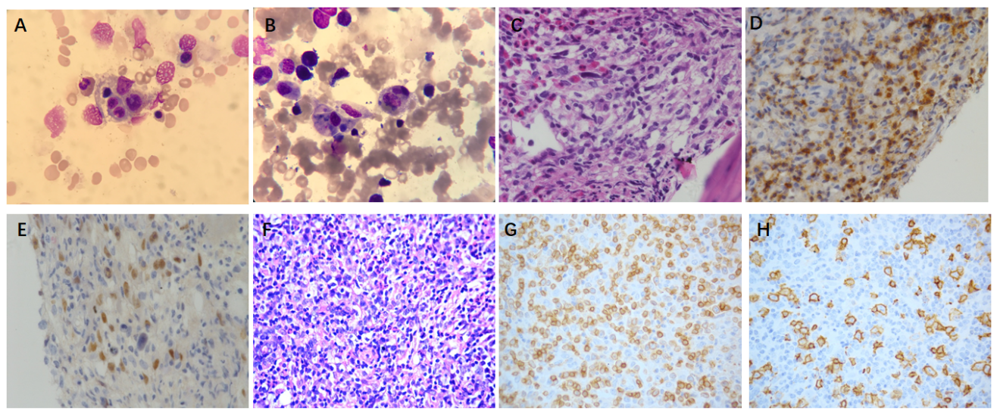
Figure 1 Morphology of bone marrow aspirate smear and biopsy in Case 1. A and B: Hemophagocytosis (A) and tumor cells (B) (Wright’s stain, × 1000); C: Diffuse small to medium-sized lymphocytes admixed scattered large atypical cells (hematoxylin-eosin stain, × 400); D and E: The tumor cells were positive for CD3 (D) and PAX-5 (E) (immunohistochemistry, IHC × 400); F: Lymph node biopsy sections showed a marked nodular aggregate of medium-sized lymphocytes with scattered large lymphocytes (hematoxylin-eosin stain, × 400); G and H: The tumor cells in lymph nodes were positive for CD3 (G) and CD20 (H) (IHC × 400).
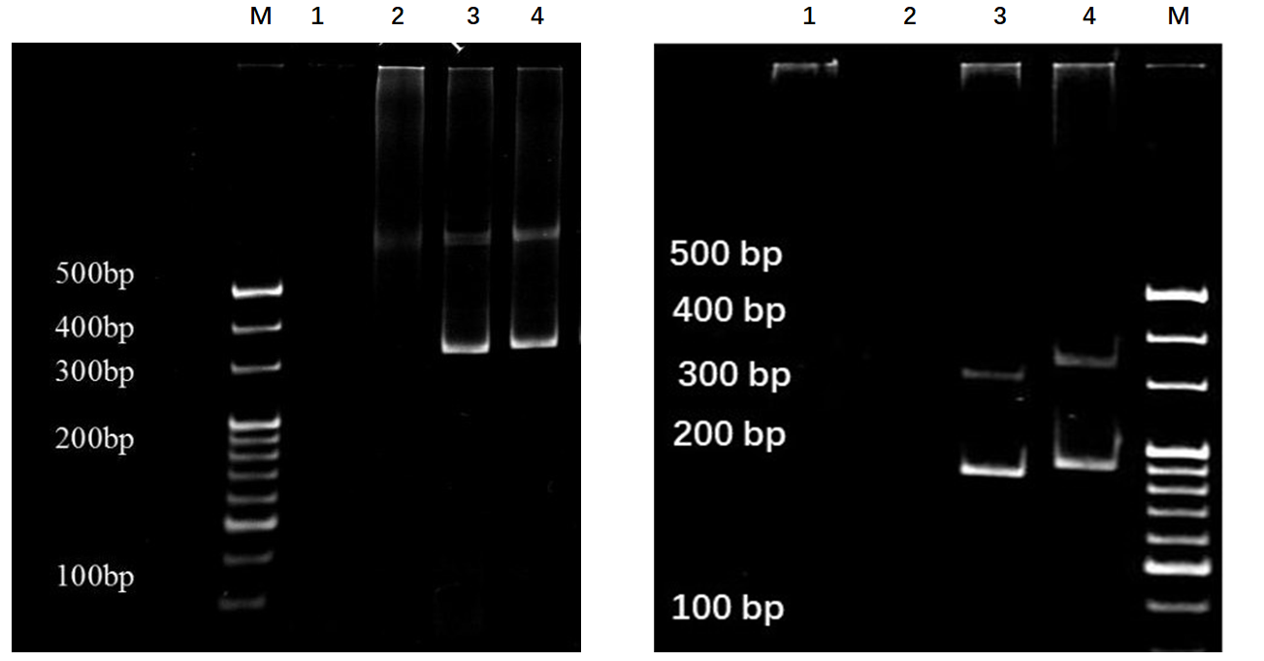
Figure 2 Monoclonal patterns of T-cell receptor and immunoglobulin H rearrangements detection in Case 1. DNA was extracted from the patient’s lymph node samples and amplified by polymerase chain reaction with primers for the framework 2 portion of the immunoglobulin VH region (left) and the T-cell receptor (TCR) γ chain (right). M: Marker; 1: Water; 2: Negative control; 3: Positive control; 4: Sample.
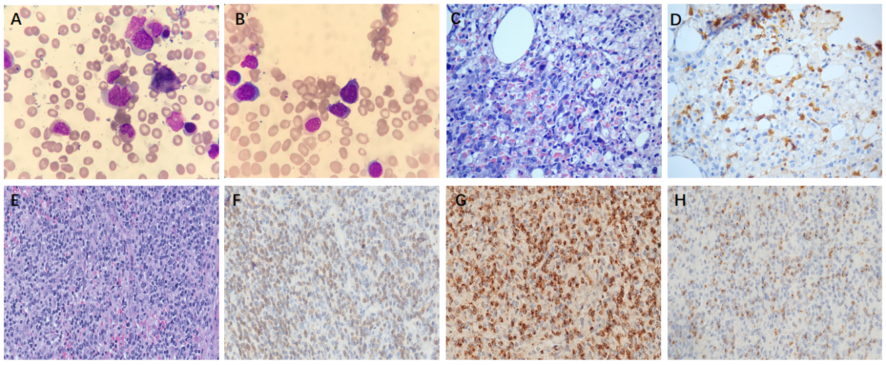
Figure 3 Morphology of bone marrow aspirate smear and biopsy in Case 2. A and B: Hemophagocytosis (A) and tumor cells (B) (Wright’s stain, × 1000); C: Diffuse medium-sized atypical lymphocytes infiltrated with the effacement of normal architecture (hematoxylin-eosin stain, × 400); D: The tumor cells were positive for PAX-5 (immunohistochemistry, IHC × 400); E: Lymph node biopsy sections showed that nodular tissue architecture was effaced by small- to intermediate-sized lymphocytes (hematoxylin-eosin stain, × 400); F-H: The tumor cells in lymph nodes were positive for CD3 (F), TIA-1 (G) and granzyme B (H) (IHC × 400).
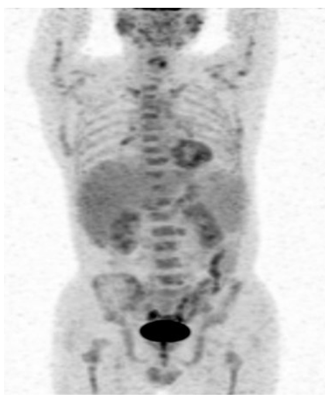
Figure 4 Positron emission tomography-computed tomography scanning in Case 2. The maximum intensity projection of ¹⁸F-fluorodeoxyglucose positron emission tomography-computed tomography revealed that the spleen was enlarged and ¹⁸F-fluorodeoxyglucose uptake was normal. Hypermetabolic lesions were detected in bone marrow, bilateral inguinal and bilateral lung hilar lymphadenopathy.

Published by Baishideng Publishing Group Inc
7041 Koll Center Parkway, Suite 160, Pleasanton, CA 94566, USA
Telephone: +1-925-3991568
E-mail: bpgoffice@wjgnet.com
Help Desk: https://www.f6publishing.com/helpdesk
https://www.wjgnet.com

© 2021 Baishideng Publishing Group Inc. All rights reserved.

