Name of Journal: World Journal of Gastrointestinal Oncology
Manuscript NO: 42247
Manuscript Type: CASE REPORT

Small intestinal hemangioma: Endoscopic or surgical intervention? A case report and review of literature

Hu PF et al. Small intestinal hemangioma

Ping-Fang Hu, Han Chen, Xiao-Hang Wang, Wei-Jun Wang, Ning Su, Bin Shi

Ping-Fang Hu, Xiao-Hang Wang, Bin Shi, Department of Gastroenterology, Changzheng Hospital, Second Military Medical University, Shanghai 200003, China

Han Chen, Department of General Surgery, Hongkou Branch of Changhai Hospital, Second Military Medical University, Shanghai 200081, China

Wei-Jun Wang, Ning Su, Department of General Surgery, Changzheng Hospital, Second Military Medical University, Shanghai 200003, China

ORCID number: Ping-Fang Hu (0000-0002-2790-9674); Han Chen (0000-0002-5912-3692); Xiao-Hang Wang (0000-0001-7598-9755); Wei-Jun Wang (0000-0002-8831-0665); Ning Su (0000-0002-8423-0975); Bin Shi (0000-0003-1775-4581).

Author contributions: Hu PF and Chen H reviewed the literature, designed the case report presentation and wrote the manuscript; Wang XH participated in manuscript preparation, revision, patient investigation and treatment; Wang WJ and Su N participated in patient investigation and treatment and provided the gross and pathology images; Shi B designed the case report presentation and revised the manuscript.

Informed consent statement: The study participant provided informed written consent prior to study enrollment.

Conflict of interest statement: The authors have no conflict of interest to declare.

CARE Checklist (2016) statement: The authors have read the CARE Checklist (2016), and the manuscript was prepared and revised according to the CARE Checklist (2016).

Open-Access: This article is an open-access article that was selected by an in-house editor and fully peer-reviewed by external reviewers. It is distributed in accordance with the Creative Commons Attribution Non Commercial (CC BY-NC 4.0) license, which permits others to distribute, remix, adapt, build upon this work non-commercially, and license their derivative works on different terms, provided the original work is properly cited and the use is non-commercial. See: http://creativecommons.org/licenses/by-nc/4.0/

Manuscript source: Unsolicited manuscript

Corresponding author: Bin Shi, MD, Professor, Department of Gastroenterology, Changzheng Hospital, Second Military Medical University, 415 Fengyang Road, Shanghai 200003, China. shibin7305@smmu.edu.cn
Telephone: +86-21-81885346
Fax: +86-21-81886924

Received: September 18, 2018
Peer-review started: September 18, 2018
First decision: October 15, 2018
Revised: October 24, 2018
Accepted: November 7, 2018
Article in press: November 7, 2018
Published online: December 15, 2018
Abstract
BACKGROUND
Hemangioma of the small intestine is a rare vascular malformation. Before the advent of capsule endoscopy (CE) and balloon-assisted enteroscopy (BAE), preoperative diagnosis of this disease was extremely difficult.

CASE SUMMARY
In this study, we report a 24-year-old female with a large transmural small bowel cavernous hemangioma, which was diagnosed with CE and BAE preoperatively and removed successfully using minimally invasive surgery. Meanwhile, we perform a literature review of the studies about intestinal hemangiomas published after 2000. Literature review revealed that 91.9% of the lesions were diagnosed preoperatively by CE and/or BAE and 45.9% of them were treated endoscopically, which is a marked improvement compared to before 2000. Therefore, CE and BAE are useful modalities for the preoperative diagnosis of hemangiomas in the small intestine.

CONCLUSION
Endoscopic treatment of intestinal hemangioma is generally prudent and might be suitable for multiple, relatively small lesions.

Key words: Hemangioma; Capsule endoscopy; Balloon-assisted enteroscopy; Endoscopic intervention; Surgery; Case report

© The Author(s) 2018. Published by Baishideng Publishing Group Inc. All rights reserved.

Core tip: Hemangioma of the small intestine is a rare disease and mostly presents as gastrointestinal bleeding. With the advent of capsule endoscopy and balloon-assisted enteroscopy, the preoperative diagnosis of this disease has been considerably improved. Surgical resection is the conventional treatment modality. With the improvement of endoscopic therapeutic interventions, less invasive procedures are becoming possible. However, potential risks of endoscopic treatment include bleeding and intestinal perforation. Since intestinal hemangiomas originate from the submucosal layer and some of them are transmural, endoscopic treatment might sometimes result in uncontrolled bleeding or perforation.

Citation: Hu PF, Chen H, Wang XH, Wang WJ, Su N, Shi B. Small intestinal hemangioma: endoscopic or surgical intervention? A case report and review of literature.
World J Gastrointest Oncol
2018; 10(12): 516-521
URL: https://www.wjgnet.com/1948-5204/full/v10/i12/516.htm
DOI: https://dx.doi.org/10.4251/wjgo.v10.i12.516
INTRODUCTION
Hemangioma of the small intestine is a rare disease, accounting for 7%-10% of all benign tumors of the small intestine^{[1,2]}. It may be solitary or multiple, with the jejunum being the most common site of involvement^{[3]}. The main presenting symptoms include hemorrhage, abdominal pain, obstruction, intussusceptions, or rarely, perforation^{[4,5]}. It originates from the submucosal vascular plexuses and may extend into the muscular layer or beyond^{[6]}. Histologically, hemangiomas are congenital benign vascular lesions that can be classified as capillary, cavernous, or mixed-type according to the size of the vascular channels^{[2]}. With the advent of capsule endoscopy (CE) and balloon-assisted enteroscopy (BAE), complete investigation of the small bowel is possible^{[7]}. The preoperative diagnosis of this disease has been considerably improved. Recent advances in endoscopic techniques have led to successful endoscopic intervention, but most large lesions have been treated surgically. Here, we present a case with solitary small bowel hemangioma, which was diagnosed preoperatively by CE and BAE and removed successfully using minimally invasive surgery.

CASE PRESENTATION
Chief complaints
A 24-year-old female suffered from recurrent melena and fatigue for 1 year.

History of present illness
Over the past year, the patient experienced repeated black stool, accompanied by fatigue, without hematemesis, hematochezia, abdominal pain or fever. The lowest level of hemoglobin was 42 g/L.

History of past illness
Past and family medical history was unremarkable.

Physical examination
Physical examination showed moderate anemia. Detailed dermatological evaluation did not show any cutaneous lesions.

Laboratory testing
Laboratory studies revealed moderated microcytic and hypochromic anemia (hemoglobin, 7.5 g/dL). Fecal occult blood test was positive.

Imaging examination
Gastroscopy and colonoscopy were normal. CE was performed, showing a prominent polypoid lesion in the ileum with no sign of active bleeding (Figure 1). Transanal double-balloon enteroscopy (DBE) revealed a reddish purple lesion in the ileum about 80 cm proximal to the ileocecal valve (Figure 2A). A titanium clip was used to mark the limit reached. Transoral DBE was performed to assess the remainder of small bowel, which revealed no additional lesions (Figure 2B).

MULTIDISCIPLINARY EXPERT CONSULTATION
Ping-Fang Hu, MD, Attending Doctor, Department of Gastroenterology
From the endoscopic appearance of the lesion, it was most likely a hemangioma. Considering that the lesion was large and diffuse, endoscopic interventions such as endoscopic mucosal resection (EMR) and endoscopic sclerotherapy might lead to uncontrolled bleeding or perforation. Therefore, laparoscopic surgery was deemed the best choice.

Bin Shi, MD, Professor, Department of Gastroenterology
The patient had repeated bleeding and a large amount of bleeding every time. Since the lesion was large and diffuse, surgery would be better for the patient.

Han Chen, MD, Attending Doctor, Department of Surgery
The patient suffered from recurrent melena in the past year. From the results of the CE and BAE, the cause is likely the small intestinal hemangioma. The surgical indication was explicit.

Ning Su, MD, Attending Doctor, Department of Surgery
The diagnosis is relatively clear. Since biopsy might lead to uncontrolled bleeding, we could not verify the diagnosis preoperatively.

Wei-Jun Wang, Professor, Department of Surgery
Imaging examination including ultrasound and CT scan did not find any abnormalities. From the endoscopic appearance of the lesion, it was most likely a hemangioma. The patient was a young female with a good health status. We could consider resecting the lesion laparoscopically.

FINAL DIAGNOSIS
Small bowel bleeding and small intestinal hemangioma.

TREATMENT
The patient was sent to laparoscopy, and a 5 cm × 3 cm × 3 cm purple-colored, raspberry-like lesion was found spreading diffusely along the serosal surface of the ileum (Figure 2C). The lesion was completely resected (Figure 2D). Hematoxylin-eosin staining (Figure 3A) and CD31 immunohistochemistry (Figure 3B) indicated a transmural cavernous hemangioma.

OUTCOME AND FOLLOW-UP
The patient recovered quickly and had no further episodes of bleeding since the operation. The hemoglobin value increased to normal (12.4 g/dL) and was stable.

DISCUSSION
Hemangioma accounts for only 0.05% of all gastrointestinal (GI) neoplasms. They mostly present with occult GI bleeding and iron deficiency anemia. Because of its rarity, it is not considered a common cause of GI bleeding. Previously, the preoperative diagnosis of this disease was difficult, and almost all cases were diagnosed during or after the operation^{[1]}. With the introduction of CE and BAE over the past decades, the small intestine has now become an area that can be targeted^{[8]}. We searched the PubMed database for studies about intestinal hemangiomas published after 2000 utilizing the following search terms: “hemangioma”, “vascular malformation”, “small intestine” and “small bowel”. A manual search was also performed using the references of eligible articles. The language was limited to English. A total of 37 cases (16 women, 21 men, mean age 39 years) were retrieved and reviewed (Table 1). The most common manifestation included GI bleeding and anemia. A total of 75.7% (28/37) of the cases were single, and the common location of the small intestine was the jejunum (60.9%). Thirty-four of the 37 lesions (91.9%) were diagnosed before operation by CE and/or BAE. Of these cases, 11 were detected with CE alone, and 22 were diagnosed with both CE and BAE. Compared with the cases reported before 2000, a markedly increased proportion of cases were preoperatively diagnosed^{[1]}. As in our case, CE was used to initially examine the GI tract, which was based on the algorithms for the diagnosis and treatment of obscure GI bleeding^{[7]}. Both transanal DBE and transoral DBE were then performed to complete total enteroscopy, which was useful to localize the lesion and rule out other lesions.
Surgical resection, which is relatively more invasive, is the conventional treatment modality for intestinal hemangiomas. With the improvement of endoscopic therapeutic interventions, less invasive procedures are becoming more widely employed. Of the 37 cases of intestinal hemangiomas published after 2000 (Table 1), 17 cases (45.9%) were treated endoscopically. Among them, 3 cases were removed by EMR, one case was treated by argon plasma coagulation, and 13 cases were subjected to sclerotherapy. Most of these lesions were multiple (14/17, 82.4%), and the lesions were relatively small. As suggested by the guideline on the management of small bowel bleeding, the patient should be managed with endoscopic therapy if a source of bleeding is found. Surgical treatment is generally regarded as a last resort^{[7]}. Compared with surgery, endoscopic treatments including sclerotherapy and EMR are less invasive. However, they increase the potential risks of GI bleeding and intestinal perforation. Since intestinal hemangiomas originate from the submucosal layer, endoscopic treatment such as EMR is dangerous because of the risk of perforation. Endoscopic treatment might lead to perforation because some intestinal hemangiomas were transmural, as in our case. Considering that the hemangioma was large in the current case, uncontrolled bleeding would probably occur after endoscopic intervention. After discussion with a multidisciplinary team, which included gastroenterologists, endoscopists and surgeons, we decided to remove the lesion by laparoscopy. It turned out that a laparoscopic approach was likely the best choice for our case, as the lesion was relatively large and most importantly, transmural. Thus, endoscopic treatment of intestinal hemangioma should be prudent. It is likely suitable for multiple, relatively small lesions.
In conclusion, we present a case of small bowel hemangioma that was preoperatively diagnosed by CE and BAE and treated by laparoscopy. We believe it is important for both the endoscopist and surgeons to recognize this somewhat unusual lesion. It is recommended that careful consideration of the indications for endoscopic treatment. As in our case, hemangiomas may sometimes involve the entire wall of the intestine. Endoscopic intervention may lead to uncontrolled bleeding or perforation. For the large and diffuse lesions, a laparoscopic excision might be a better approach.

EXPERIENCES AND LESSONS
Hemangioma of the small intestine is a rare disease, which mostly presented as occult GI bleeding and iron deficiency anemia. With the advent of CE and BAE, the diagnosis of lesions in the small intestine has been considerably improved. Endoscopic treatment of intestinal hemangioma should be prudent, and it might be suitable for multiple and relatively small lesions.

REFERENCES
1 Ramanujam PS, Venkatesh KS, Bettinger L, Hayashi JT, Rothman MC, Fietz MJ. Hemangioma of the small intestine: case report and literature review. Am J Gastroenterol 1995; 90: 2063-2064 [PMID: 7485031]
2 Kumar N, Adam SZ, Goodhartz LA, Hoff FL, Lo AA, Miller FH. Beyond hepatic hemangiomas: the diverse appearances of gastrointestinal and genitourinary hemangiomas. Abdom Imaging 2015; 40: 3313-3329 [PMID: 26239397 DOI: 10.1007/s00261-015-0515-8]
3 Quentin V, Lermite E, Lebigot J, Marinnes MZ, Arnaud JP, Boyer J. Small bowel cavernous hemangioma: wireless capsule endoscopy diagnosis of a surgical case. Gastrointest Endosc 2007; 65: 550-552 [PMID: 17321267 DOI: 10.1016/j.gie.2006.12.024]
4 Rao AB, Pence J, Mirkin DL. Diffuse infantile hemangiomatosis of the ileum presenting with multiple perforations: a case report and review of the literature. J Pediatr Surg 2010; 45: 1890-1892 [PMID: 20850639 DOI: 10.1016/j.jpedsurg.2010.05.019]
5 Ruiz AR Jr, Ginsberg AL. Giant mesenteric hemangioma with small intestinal involvement: an unusual cause of recurrent gastrointestinal bleed and review of gastrointestinal hemangiomas. Dig Dis Sci 1999; 44: 2545-2551 [PMID: 10630511 DOI: 10.1023/A:1026659710815]
6 Ersoy O, Akin E, Demirezer A, Koseoglu H, Balci S, Kiyak G. Cavernous haemangioma of small intestine mimicking gastrointestinal stromal tumour. Arab J Gastroenterol 2013; 14: 139-140 [PMID: 24206746 DOI: 10.1016/j.ajg.2013.08.008]
7 Gerson LB, Fidler JL, Cave DR, Leighton JA. ACG Clinical Guideline: Diagnosis and Management of Small Bowel Bleeding. Am J Gastroenterol 2015; 110: 1265-87; quiz 1288 [PMID: 26303132 DOI: 10.1038/ajg.2015.246]
8 Willert RP, Chong AK. Multiple cavernous hemangiomas with iron deficiency anemia successfully treated with double-balloon enteroscopy. Gastrointest Endosc 2008; 67: 765-767 [PMID: 18155208 DOI: 10.1016/j.gie.2007.07.044]
9 Easler JJ, Papachristou GI. A case of obscure gastrointestinal bleeding. Gastroenterology 2012; 142: 700, 1044 [PMID: 22370215 DOI: 10.1053/j.gastro.2011.09.009]
10 Ng EK, Cheung FK, Chiu PW. Blue rubber bleb nevus syndrome: treatment of multiple gastrointestinal hemangiomas with argon plasma coagulator. Dig Endosc 2009; 21: 40-42 [PMID: 19691801 DOI: 10.1111/j.1443-1661.2008.00817.x]
11 Wardi J, Shahmurov M, Czerniak A, Avni Y. Clinical challenges and images in GI. Capillary hemangioma of small intestine. Gastroenterology 2007; 132: 1656, 2084 [PMID: 17484862 DOI: 10.1053/j.gastro.2007.03.081]
12 Fernandes D, Dionísio I, Neves S, Duarte P. Cavernous hemangioma of small bowel: a rare cause of digestive hemorrhage. Rev Esp Enferm Dig 2014; 106: 214-215 [PMID: 25007019]
13 Law WL. Cavernous hemangioma: uncommon cause of obscure gastrointestinal bleeding. J Am Coll Surg 2007; 205: 511 [PMID: 17765169 DOI: 10.1016/j.jamcollsurg.2006.10.035]
14 Ning S, Zhang Y, Zu Z, Mao X, Mao G. Enteroscopic sclerotherapy in blue rubber bleb nevus syndrome. Pak J Med Sci 2015; 31: 226-228 [PMID: 25878650 DOI: 10.12669/pjms.311.5858]
15 Elias G, Toubia N. Hemangioma of the small intestine presenting with recurrent overt, obscure gastrointestinal bleeding. Clin Gastroenterol Hepatol 2010; 8: A18, A18.e1 [PMID: 19362610 DOI: 10.1016/j.cgh.2009.03.036]
16 Shibuya T, Osada T, Mitomi H, Takeda T, Nomura O, Nakayama H, Hidaka Y, Mori H, Beppu K, Sakamoto N, Nagahara A, Otaka M, Ogihara T, Yao T, Watanabe S. Jejunal capillary hemangioma treated by using double-balloon endoscopy (with video). Gastrointest Endosc 2010; 72: 660-661 [PMID: 20546731 DOI: 10.1016/j.gie.2009.12.051]
17 Igawa A, Oka S, Tanaka S, Kunihara S, Nakano M, Chayama K. Polidocanol injection therapy for small-bowel hemangioma by using double-balloon endoscopy. Gastrointest Endosc 2016; 84: 163-167 [PMID: 26907744 DOI: 10.1016/j.gie.2016.02.021]
18 Takase N, Fukui K, Tani T, Nishimura T, Tanaka T, Harada N, Ueno K, Takamatsu M, Nishizawa A, Okamura A, Kaneda K. Preoperative detection and localization of small bowel hemangioma: Two case reports. World J Gastroenterol 2017; 23: 3752-3757 [PMID: 28611528 DOI: 10.3748/wjg.v23.i20.3752]
19 Akazawa Y, Hiramatsu K, Nosaka T, Saito Y, Ozaki Y, Takahashi K, Naito T, Ofuji K, Matsuda H, Ohtani M, Nemoto T, Suto H, Yamaguchi A, Imamura Y, Nakamoto Y. Preoperative diagnosis of cavernous hemangioma presenting with melena using wireless capsule endoscopy of the small intestine. Endosc Int Open 2016; 4: E249-E251 [PMID: 27004239 DOI: 10.1055/s-0041-111321]
20 Chen CH, Jones J, McGowan P. Profound iron deficiency anemia caused by a small-intestinal cavernous hemangioma. Gastrointest Endosc 2009; 69: 1392-3; discussion 1393 [PMID: 19481664 DOI: 10.1016/j.gie.2009.01.049]
21 Dhumane P, Mutter D, D'Agostino J, Mavrogenis G, Leroy J, Marescaux J. Small bowel exploration and resection using single-port surgery: a safe and feasible approach. Colorectal Dis 2013; 15: 109-114 [PMID: 22672499 DOI: 10.1111/j.1463-1318.2012.03118.x]
22 Bae SJ, Hwang G, Kang HS, Song HJ, Chang WY, Maeng YH, Kang KS. Single Cavernous Hemangioma of the Small Bowel Diagnosed by Using Capsule Endoscopy in a Child with Chronic Iron-Deficiency Anemia. Clin Endosc 2015; 48: 340-344 [PMID: 26240811 DOI: 10.5946/ce.2015.48.4.340]
23 Huber A, Abdel Samie A, Kychenko D, Theilmann L. A rare cause of recurrent iron-deficiency anemia: cavernous hemangioma of the small intestine. J Gastrointestin Liver Dis 2012; 21: 343 [PMID: 23256111]
24 Khurana V, Dala R, Barkin JS. Small bowel cavernous hemangioma. Gastrointest Endosc 2004; 60: 96 [PMID: 15229433 DOI: 10.1016/S0016-5107(04)01292-1]
25 Pera M, Márquez L, Dedeu JM, Sánchez J, Garcia M, Ramón JM, Puigvehí M. Solitary cavernous hemangioma of the small intestine as the cause of long-standing iron deficiency anemia. J Gastrointest Surg 2012; 16: 2288-2290 [PMID: 22875598 DOI: 10.1007/s11605-012-1991-6]
26 Pinho R, Rodrigues A, Proença L, Silva AP, Fernandes S, Leite S, Amaral I, de Sousa P, Fraga J. Solitary hemangioma of the small bowel disclosed by wireless capsule endoscopy. Gastroenterol Clin Biol 2008; 32: 15-18 [PMID: 18405648 DOI: 10.1016/j.gcb.2007.11.004]
27 Magnano A, Privitera A, Calogero G, Nanfito' L, Basile G, Sanfilippo G. Solitary hemangioma of the small intestine: an unusual cause of bleeding diagnosed at capsule endoscopy. J Pediatr Surg 2005; 40: e25-e27 [PMID: 16226971 DOI: 10.1016/j.jpedsurg.2005.06.014]
28 Kuo LW, Chuang HW, Chen YC. Small bowel cavernous hemangioma complicated with intussusception: report of an extremely rare case and review of literature. Indian J Surg 2015; 77: 123-124 [PMID: 25972669 DOI: 10.1007/s12262-014-1194-3]
29 Guardiola A, Navajas J, Valle J, López-Pardo R, Rodríguez-Merlo R, Lombera Mdel M, Alcántara M. Small bowel giant cavernous hemangioma diagnosed by capsule endoscopy. Rev Esp Enferm Dig 2012; 104: 277-278 [PMID: 22662783 DOI: 10.4321/S1130-01082012000500011]
30 Purdy-Payne EK, Miner JF, Foles B, Tran TA. The "Endothelialized Muscularis Mucosae": A Case Report Describing a Large Cavernous Hemangioma at the Terminal Ileum and a New Histologic Clue for Preoperative Diagnosis from Endoscopic Biopsy. Case Rep Gastrointest Med 2015; 2015: 454836 [PMID: 26442160 DOI: 10.1155/2015/454836]

P-Reviewer: Cao ZF, Sawaki A, Yarema RR S-Editor: Ji FF L-Editor: Filipodia E-Editor:

Specialty type: Oncology
Country of origin: China
Peer-review report classification
Grade A (Excellent): 0
Grade B (Very good): 0
Grade C (Good): C, C, C
Grade D (Fair): 0
Grade E (Poor): 0

Table 1 Summary of hemangioma of small intestine reported after 2000
Ref. | Country | Case | Sex/age | Complaint | Diagnosis | Location | Single/multiple | Treatment | Pathology
Easler et al^{[9]} | United States | 1 | M/71 | Anemia, melena | BAE | Jejunum | Single | EMR | Cavernous
Ng et al^{[10]} | China | 1 | F/20 | Anemia | Small bowel enema | Terminal ileum | Multiple | APC | -
Wardi et al^{[11]} | Israel | 1 | M/77 | Anemia, melena | CE | Ileum | Single | Laparoscopy | Capillary
Ersoy et al^{[6]} | Turkey | 1 | F/50 | Melena, hematemesis | CE + BAE | Proximal jejunum | Single | Laparoscopy | Cavernous
Fernandes et al^{[12]} | Portugal | 1 | F/56 | Hematochezia, syncope | CE | Ileum | Single | Laparoscopy | Cavernous
Law^{[13]} | China | 1 | F/31 | Melena | CE + BAE | Jejunum | Single | Laparoscopy | Cavernous
Ning et al^{[14]} | China | 1 | M/10 | Melena | BAE | Jejunum/ileum | Multiple | Polidocanol injection | -
Elias et al^{[15]} | United States | 1 | M/30 | Anemia | CE + BAE | Jejunum | Multiple | Surgery | Cavernous
Shibuya et al^{[16]} | Japan | 1 | M/74 | Melena | CE + BAE | jejunum | Single | EMR | Capillary
Willert et al^{[8]} | Australia | 1 | M/19 | Anemia | CE + BAE | Jejunum/ileum | Multiple | EMR | Cavernous
Igawa et al^{[17]} | Japan | 12 | 6M/6F | Gastrointestinal bleeding | CE + BAE | Jejunum/ileum | 7 single/5 multiple | Polidocanol injection | -
Takase et al^{[18]} | Japan | 2 | F-62/M-52 | Melena | CE + BAE | Jejunum/ileum | Single | Laparoscopy | Cavernous/capillary
Akazawa et al^{[19]} | Japan | 1 | F/56 | Melena | CE + BAE | Jejunum | Single | Laparoscopy | Cavernous
Chen et al^{[20]} | United States | 1 | M/23 | Fatigue | CE | Ileum | Single | Laparoscopy | Cavernous
Dhumane et al^{[21]} | France | 1 | M/60 | Anemia | CE + BAE | Jejunum | Single | Laparoscopy | Cavernous
Bae et al^{[22]} | South Korea | 1 | M/13 | Dizziness, fatigue | CE | Jejunum | Single | Laparoscopy | Cavernous
Huber et al^{[23]} | Germany | 1 | M/23 | Weakness, dizziness | CE + BAE | Jejunum | Single | Laparoscopy | Cavernous
Quentin et al^{[3]} | France | 1 | F/32 | Hematochezia | CE | Jejunum | Single | Laparoscopy | Cavernous
Khurana et al^{[24]} | United States | 1 | M/62 | Melena | BAE | Jejunum | Single | Surgery | Cavernous
Pera et al^{[25]} | Spain | 1 | M/16 | Fatigue | CE | Jejunum | Single | Laparoscopy | -
Pinho et al^{[26]} | Portugal | 1 | F/9 | Melena, anemia | CE | Ileum | Single | Surgery | Cavernous
Magnano et al^{[27]} | Italy | 1 | M/13 | Fatigue, malaise | CE | Ileum | Single | Laparoscopy | Cavernous
Kuo et al^{[28]} | China | 1 | F/20 | Abdominal pain | - | Jejunum | Single | Laparoscopy | Cavernous
Guardiola et al^{[29]} | Spain | 1 | M/19 | Anemia | CE | Ileum | Single | Laparoscopy | Cavernous
Purdy-Payne et al^{[30]} | United States | 1 | F/20 | Abdominal pain | - | Terminal ileum | Single | Laparoscopy | Cavernous
CE: Capsule endoscopy; BAE: Balloon assisted enteroscopy; EMR: Endoscopic mucosal resection; APC: Argon plasma coagulation.

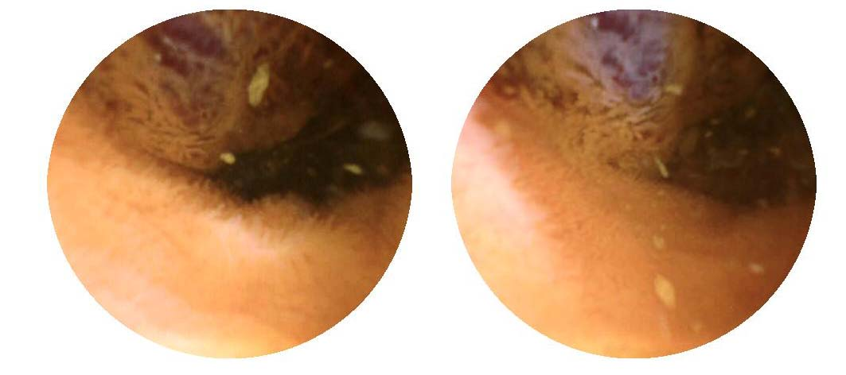
Figure 1 Capsule endoscopic appearance of the lesion. Capsule endoscopy showed a prominent polypoid lesion in the ileum.

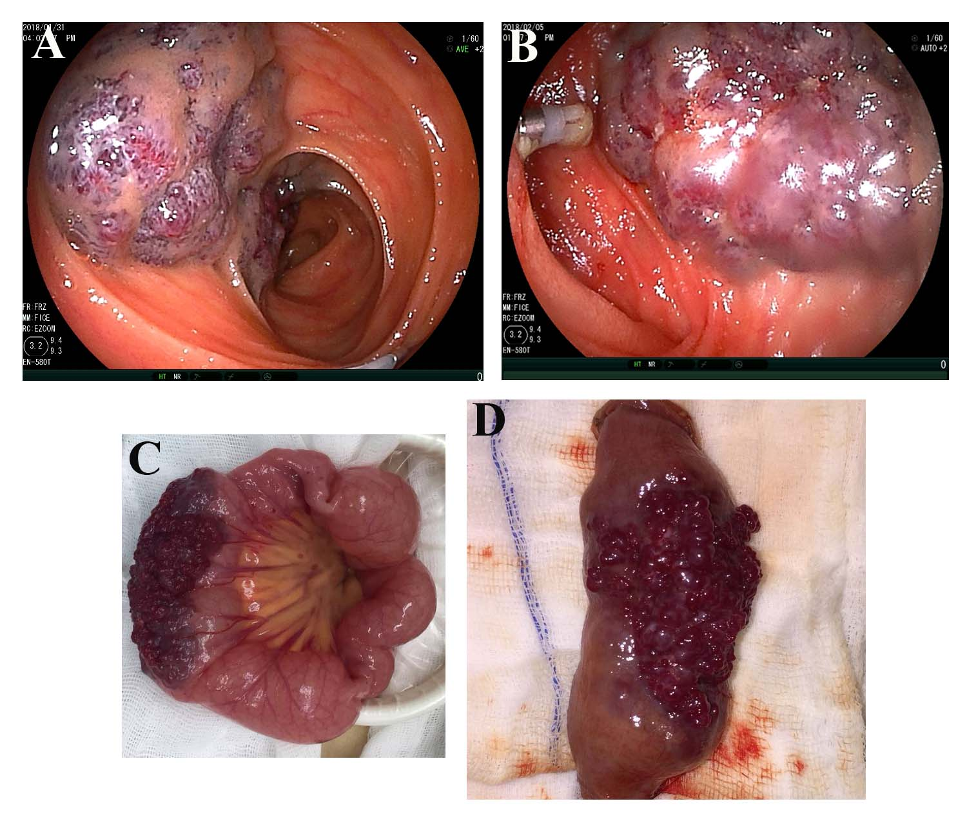
Figure 2 Endoscopic and gross appearance of the lesion. A: Transanal double-balloon enteroscopy revealed a reddish purple lesion in the ileum about 80 cm proximal to the ileocecal valve, and a titanium clip was used to mark the limit reached; B: Transoral double-balloon enteroscopy showed the same lesion and the marked titanium clip; C: Gross intraoperative appearance of the lesion; D: Gross appearance of the lesion after resection.

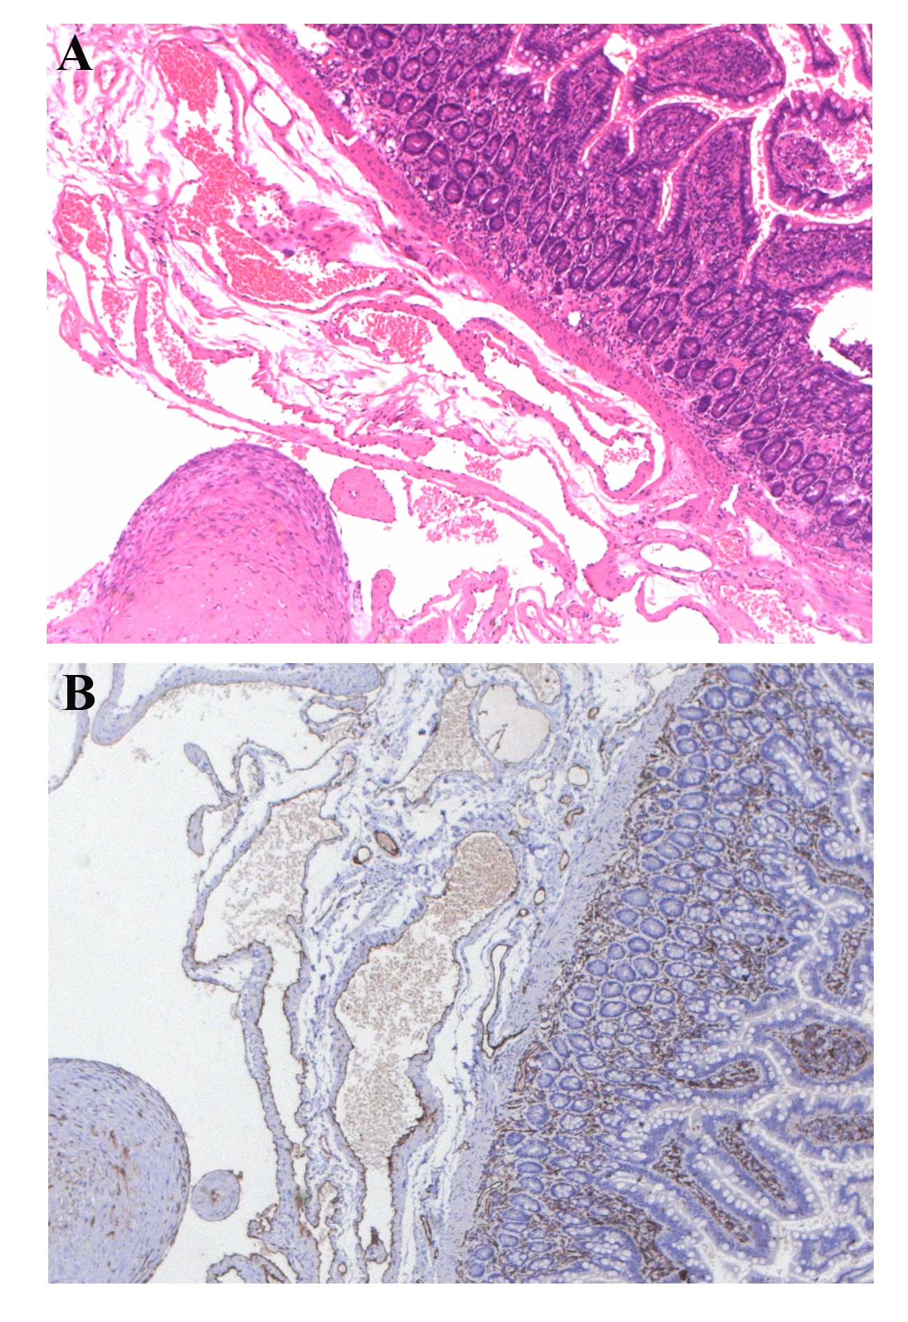
Figure 3 Histopathological examination of the lesion. A: Hematoxylin-eosin staining showed a blood-filled sinus-like space in the whole layer of the ileum (× 50); B: Immunohistochemistry indicated the cells lined with the vascular spaces were CD31-positive (× 50).

