Name of Journal: World Journal of Psychiatry
Manuscript NO: 74162
Manuscript Type: ORIGINAL ARTICLE

Observational Study
Disrupted leptin-fatty acid biosynthesis is an early manifestation of metabolic abnormalities in schizophrenia

Khan MM. Disrupted leptin-fatty acid biosynthesis in schizophrenia

Mohammad M Khan

Mohammad M Khan, Laboratory of Translational Neurology and Molecular Psychiatry, Department of Biotechnology, Era's Lucknow Medical College and Hospital, and Faculty of Science, Era University, Lucknow 226003, India

Mohammad M Khan, Department of Psychiatry and Health Behavior, Medical College of Georgia, Augusta University, Augusta, GA 30912, United States

Author contributions: Khan MM Designed and performed the research, and wrote the paper.

Corresponding author: Mohammad M Khan, PhD, Professor, Laboratory of Translational Neurology and Molecular Psychiatry, Department of Biotechnology, Era's Lucknow Medical College and Hospital, and Faculty of Science, Era University, Sarfarazganj, Hardoi Road, Lucknow 226003, India. mmkhan0@gmail.com

Received: December 31, 2021
Revised: April 3, 2022
Accepted: May 22, 2022
Published online: June 19, 2022

Abstract
BACKGROUND
Insulin resistance (IR) and impaired energy expenditure (IEE) are irreparable metabolic comorbidities in schizophrenia. Although mechanism(s) underlying IR and IEE remains unclear, leptin and fatty acid signaling, which has profound influence on insulin secretion/sensitivity, glucose metabolism and energy expenditure, could be disrupted. However, no association of plasma leptin with erythrocyte membrane fatty acids, body mass index (BMI), and psychotic symptoms in the same cohort of untreated patients with first-episode psychosis (FEP) or medicated patients with chronic schizophrenia (CSZ) is presented before. These studies are crucial for deciphering the role of leptin and fatty acids in the development of IR and IEE in schizophrenia.

AIM
To determine the association between plasma leptin, erythrocyte membrane fatty acids, particularly, saturated fatty acids (SFAs), BMI and psychotic symptoms in patients with FEP and CSZ.

METHODS
In this study, twenty-two drug naive patients with FEP, twenty-one CSZ patients treated with atypical antipsychotic drugs, and fourteen healthy control (CNT) subjects were analyzed. Plasma leptin was measured using sandwich mode enzyme-linked immunosorbent assay. Erythrocyte membrane SFAs were measured using ultrathin capillary gas chromatography. BMI was calculated by using the formula: weight (kg)/height (m²). Psychiatric symptoms were evaluated at baseline using brief psychiatric rating scale (BPRS), and positive and negative syndrome scale (PANSS). The total BPRS scores, positive and negative symptom scores (PANSS-PSS and PANSS-NSS, respectively) were recorded. Pearson correlation coefficient (r) analyses were performed to find the nature and strength of association between plasma leptin, PANSS scores, BMI and SFAs, particularly, palmitic acid (PA).

RESULTS
In patients with FEP, plasma leptin not BMI was significantly lower (P = 0.034), whereas, erythrocyte membrane SFAs were significantly higher (P < 0.005) compared to the CNT subjects. Further, plasma leptin showed negative correlation with erythrocyte membrane SFAs-PA (r = −0.4972, P = 0.001), PANSS-PSS (r = −0.4034, P = 0.028), and PANSS-NSS (r = −0.3487, P = 0.048). However, erythrocyte membrane SFAs-PA showed positive correlation with PANSS-PSS (r = 0.5844, P = 0.0034) and PANSS-NSS (r = 0.5380, P = 0.008). In CSZ patients, plasma leptin, BMI, and erythrocyte membrane SFAs, all were significantly higher (P < 0.05) compared to the CNT subjects. Plasma leptin showed positive correlation with BMI (r = 0.312, P = 0.032) but not with PANSS scores or erythrocyte membrane SFAs-PA. However, erythrocyte membrane SFAs-PA showed positive correlation with PANSS-NSS only (r = 0.4729, P = 0.031). Similar changes in the plasma leptin and erythrocyte membrane SFAs have also been reported in individuals at ultra-high risk of developing psychosis; therefore, the above findings suggest that leptin-fatty acid biosynthesis could be disrupted before the onset of psychosis in schizophrenia.

CONCLUSION
Disrupted leptin-fatty acid biosynthesis/signaling could be an early manifestation of metabolic comorbidities in schizophrenia. Large-scale studies are warranted to validate the above findings.

Key Words: Schizophrenia; Leptin; Fatty acids; Insulin resistance; Impaired energy expenditure

©The Author(s) 2022. Published by Baishideng Publishing Group Inc. All rights reserved.

Citation: Khan MM. Disrupted leptin-fatty acid biosynthesis is an early manifestation of metabolic abnormalities in schizophrenia. World J Psychiatry 2022; 12(6): 827-842
URL: https://www.wjgnet.com/2220-3206/full/v12/i6/827.htm
DOI: https://dx.doi.org/10.5498/wjp.v12.i6.827

Core Tip: Insulin resistance (IR) and impaired energy expenditure (IEE) are untreatable metabolic comorbidities in schizophrenia. Leptin and fatty acids have profound influence on insulin synthesis, secretion and energy metabolism. Although previous studies have measured plasma leptin and membrane fatty acids in schizophrenia, findings are very heterogeneous, and moreover, no single study has ever measured both plasma leptin and membrane fatty acids together in the same cohort of schizophrenia patients. These studies are crucial not only for analyzing the relationship between leptin and fatty acids in the same cohort of schizophrenia patients, but also for deciphering their role in the development of IR and IEE.
INTRODUCTION
Schizophrenia is a complex multisystem disorder, which apart from displaying psychotic symptoms and cognitive deficit also manifests a range of metabolic abnormalities including insulin resistance (IR) and impaired energy expenditure (IEE)^{[1-4]}. Evidence suggests that IR and IEE may develop before the onset of psychosis and deteriorate further following antipsychotic intervention, prompting premature antipsychotic withdrawal, a leading cause of relapse in schizophrenia^{[5-9]}. Deciphering the underlying mechanism(s) may help in developing appropriate therapies for minimizing IR and IEE and increasing treatment adherence and outcome in schizophrenia.
While several mechanisms may contribute in the development of IR and IEE, disrupted adipokine and fatty acid (FA) signaling could play a central role. Leptin is an important adipokine, which at physiologically elevated condition strongly inhibits insulin synthesis and secretion and causes weight gain by stimulating lipogenesis and adipogenesis while concurrently inhibiting fatty acid oxidation^{[10-12]}. Removing leptin from blood circulation has been shown to normalize body weight and hyperglycemia in obese animals^{[13]}.
FAs, specially, saturated FAs (SFAs) stimulate insulin secretion from pancreatic β-cells^{[14]}, but inhibit both leptin synthesis and secretion from adipose tissue^{[15,16]}. Since adipose tissue (adipocytes), like erythrocytes, contain high percentage of SFAs; consequently, SFAs could be the main regulators of leptin synthesis and secretion from adipose tissue. Evidence suggests that elevated SFAs can impair glucose and FA metabolism by inducing endoplasmic reticulum stress and mitochondrial dysfunction^{[17]}. Moreover, while intracellular accumulation of all FAs can provoke IR, effect of SFAs could be more detrimental and persistent due to the development of various inflammatory cues^{[18]}.
Although previous studies have measured plasma leptin and membrane SFAs in schizophrenia, findings are very conflicting and association between leptin, SFAs and body mass index (BMI) has not been studied. Moreover, no study has ever measured plasma leptin, membrane SFAs and BMI together in the same cohort of patients with schizophrenia. These studies are crucial not only for analyzing the relationship between leptin, SFAs, and BMI in schizophrenia, but also for deciphering their role in the development of IR, IEE, and other metabolic comorbidities.
In this study, association between plasma leptin, erythrocyte membrane SFAs, and BMI was determined in the drug-naive patients with first-episode psychosis (FEP), medicated patients with chronic schizophrenia (CSZ), and healthy control (CNT) subjects. While our group has published earlier preliminary data on the membrane FAs including SFAs, monounsaturated FAs and polyunsaturated FAs^{[19]}, data on the plasma leptin and BMI and its association with erythrocyte membrane SFAs, BMI and clinical symptoms in patients with FEP and CSZ is naive and is presented here. In addition, possible mechanisms delineating the role of leptin and SFAs in the development of IR and IEE are discussed.

MATERIALS AND METHODS
Patients and control subjects
A total of twenty-two (n = 22) drug-naïve FEP patients, twenty-one (n = 21) medicated patients with CSZ, and fourteen (n = 14) male control (CNT) subjects were analyzed in this study. Patients with FEP were enrolled from consecutive admissions at the Department of Psychiatry, Dwight David Eisenhower Army Medical Center (DDEAMC), Fort Gordon, GA. The patients were mostly active duty army personal diagnosed with schizophrenia or schizophreniform disorder using DSM IV criteria, and after six months follow-up period during subsequent hospitalization. The BMI was calculated according to the formula BMI = kg/m², where kg is body weight in kilogram and m is the height in meters^{[20]}. Clinical symptoms of the patients were evaluated at baseline using brief psychiatric rating scale (BPRS) and the positive and negative syndrome scale (PANSS)^{[21,22]}. The total BPRS scores, positive symptoms scores (PANSS-PSS: sum of scores on conceptual disorganization, hallucination, delusions, unusual thoughts, contents, and suspiciousness), and negative symptom scores (PANSS-NSS: sum of scores on emotional withdrawal, blunted effect and motor retardation) were examined in this study. The mean age at the onset of psychosis was 22.40 ± 4.08 years. Patients with CSZ were enrolled at the outpatient clinic of Mental Health Service, VA Medical Center (VAMC), Augusta, GA. The clinical symptoms of these patients were analyzed using the same methodologies as used for patients with FEP. The CSZ patients were on treatment with various atypical antipsychotic drugs (AAD) including clozapine (n = 14), olanzapine (n = 4), or risperidone (n = 3) for the past 1-5 years. It is important to point out that FEP patients after discharge from Army Medical Centers such as DDEAMC are admitted to the Psychiatry Services at the VA Medical Centers. Therefore, both patient groups in this study represent unique populations with demographic similarities except, the years of illness and treatment. The CNT subjects (n = 14) consisted of healthy volunteers recruited via advertisements at the Medical College of Georgia (MCG), VAMC, and DDEAMC. The CNT subjects were matched for age and gender with the patients with FEP. The demographic and clinical characteristics of the patients are presented in the Table 1. Institutional Review Boards of DDEAMC and MCG, Augusta, GA approved the research protocol, and a signed consent was taken from all the patients and CNT subjects.
Regarding inclusion and exclusion criteria, all patients with FEP and CSZ were included in this study on the basis of the following criteria; they were medically healthy except psychosis, and none had a history of seizures or severe head injury with loss of consciousness or a history of substance abuse within the last one year. Patients with any of these complications were excluded from the study. Moreover, during the six months follow up period of patients with FEP, those patients who did not meet DSM IV criteria for diagnosis or who turned out to have primary bipolar or major depression were also excluded from the study. A total of 38 patients with FEP were followed up for six months, 29 patients (23 male and 6 female) were found to be eligible. Out of 29 patients, 6 female patients were excluded and 1 male patient plasma sample was not used due to turbidity, so only only 22 male patients with FEP were analyzed.

Analysis of erythrocyte membrane FAs and plasma leptin
The procedures for measuring erythrocyte membrane FAs has been published earlier by our group, it is not discussed here for brevity^{[19,23]}. For measuring plasma leptin, fasting blood was drawn in Lavender vaccutainer containing EDTA. The blood was centrifuged at 2500 rpm for 10 min at 5°C. Plasma was carefully separated and stored at -20°C before use. Sandwich mode enzyme-linked immunosorbent assay (ELISA) was used to measure plasma leptin using a commercially available Kit from Signet Laboratories (Dedham, MA). The ELISA procedure was performed in accordance with the directions of the manufacturer in a sandwich mode using two monoclonal antibodies to leptin: a coating antibody and an HRP-conjugated antibody. The ELISA plates were supplied pre-coated with the coating antibody. All samples were diluted to 1:3000 (in PAT buffer provided with kits) before use. The plates were incubated in duplicates with 100 L of diluted samples overnight at 4°C in dark. The wells were washed three times with 250 L of PT buffer (PBS-Tween 20 buffer provided with kit). Plates were then incubated with 100 L of diluted conjugate (HRP-conjugated leptin antibody) for 2 h at room temperature in the dark. The plates were then extensively (3-4 times) washed with 250 L of PT buffer followed by incubation with 150 L O-Phenylenediamine substrate for 20 min at room temperature in the dark to allow color formation. Reaction was stopped by the addition of 50 L of 5.0 M sulfuric acid and the color intensity was read at dual wavelengths using 492 nm as the test wavelength and 620 nm for the reference wavelength. All samples were analyzed twice simultaneously.

Statistical analysis
All statistical analyses were performed using Prism software and the values are expressed as mean ± SE. The values of slope and intercept for the standard samples were calculated by the linear regression method. The data was further analyzed for significance between groups using Student’s t-test (two-tailed variance) or One-Way ANOVA, and a P value < 0.05 was considered significant. Pearson correlation coefficient (r) analysis was performed to find the nature and strength of association between different variables including SFAs, plasma leptin, BMI, and clinical symptoms including PANSS-PSS and PANSS-NSS.

RESULTS
Table 1 shows the demographic and clinical characteristics of the patients and CNT subjects. Figure 1 shows statistical analyses of plasma leptin, BMI, erythrocyte membrane SFAs including palmitic acid (PA) and stearic acid (SA) in CNT subjects, FEP and CSZ patients. Average plasma leptin (Figure 1A) in FEP patients (4.77 ± 1.35 ng/mL) was significantly (P = 0.028) lower than CNT subjects (5.79 ± 0.80 ng/mL), whereas, in CSZ patients, plasma leptin (8.33 ± 1.25 ng/mL) was significantly higher than FEP patients (P = 0.006). The average BMI value (Figure 1B) of FEP patients (23.21 ± 2.14) was statistically similar to the BMI value of CNT subjects (25.10 ± 2.61, P = 0.144). However, the average BMI value (Figure 1B) of AAD treated CSZ patients (29.86 ± 3.60) was significantly (P = 0.012) higher than FEP patients, and the increase was in parallel with the increase in plasma leptin (Figure 1A). Regarding erythrocyte membrane SFAs, both PA (Figure 1C) and SA (Figure 1D) were significantly (P < 0.005) higher in both FEP and CSZ patients compared to the CNT subjects suggesting that membrane SFA abnormalities in schizophrenia are untreatable.
Figure 2 shows the association of plasma leptin with clinical symptom scores. In patients with FEP, plasma leptin showed negative association with both PANSS-PSS (Figure 2A, r = −0.4034, P = 0.028) and PANSS-NSS (Figure 2B, r = −0.3487, P = 0.05). In CSZ patients, although negative association was observed between plasma leptin and either PANSS-PSS (Figure 2C, r = −0.3055, P = 0.18) or PANSS-NSS (Figure 2D, r = −0.3001; P = 0.13), it did not return significance. This could be due to treatment-induced alterations in both plasma leptin and PANSS scores compared to the drug-naive patients with FEP.
Figure 3 shows the association of erythrocyte membrane SFAs-PA with the clinical symptom scores. In patients with FEP, erythrocyte SFAs-PA showed positive correlation with both PANSS-PSS (Figure 3A, r = 0.5844, P = 0.0034) and PANSS-NSS (Figure 3B, r = 0.5381, P = 0.008). In AAD treated CSZ patients, erythrocyte SFAs-PA showed significant positive correlation with PANSS-NSS (Figure 3D, r = 0.4729; P = 0.031), but it was not significant in case of PANSS-PSS (Figure 3C, r = 0.2485, P = 0.28). These findings suggest that elevated erythrocyte SFAs could be associated more strongly with the negative symptoms in patients with both FEP and CSZ.
Since SFAs strongly inhibit leptin synthesis and secretion, therefore, association of leptin with erythrocyte SFAs-PA and BMI was also determined. In FEP patients, plasma leptin was negatively associated with SFAs-PA (Figure 4A, r = −0.4335, P = 0.0194) but not with BMI (Figure 4B, r = 0.2169, P = 0.3206), whereas, in patients with CSZ, plasma leptin showed positive association with BMI (Figure 4C, r = 0.4135, P = 0.0152) but not with erythrocyte SFAs-PA (Figure 4D, r = 0.3331, P = 0.1401). Moreover, SFAs-PA was elevated in both FEP and CSZ patients (Figure 1C and D), whereas, plasma leptin (Figure 1A) and BMI (Figure 1B) were elevated only in patients with CSZ suggesting that elevated plasma leptin could be involved in increasing BMI in CSZ patients.

DISCUSSION
In this study, significant changes in plasma leptin, BMI, and erythrocyte membrane SFAs were observed in patients with FEP and CSZ compared to the CNT subjects. These changes were also significantly associated with clinical symptoms in both groups of patients. The central message is that in patients with FEP, plasma leptin was significantly low and showed negative association with PANSS scores, whereas, SFAs were significantly higher and showed positive association with PANSS scores. Additionally, plasma leptin showed negative association with SFAs, which is in line with the negative effects of SFAs on leptin synthesis and secretion^{[15]}. In AAD treated CSZ patients, plasma leptin, SFAs and BMI all were significantly higher, which is also in agreement with previous studies showing increased leptin synthesis, and weight gain after AAD treatment^{[24-26]}.
This is the first report that shows disrupted leptin and erythrocyte membrane SFA biosynthesis in the same cohort of drug-naive patients with FEP and ADD treated patients with CSZ. In addition, negative association between plasma leptin and erythrocyte SFAs has not been reported before. These findings together with the literature discussed below, suggest that leptin-fatty acid signaling, which plays a central role in insulin secretion, sensitivity, food-intake and energy metabolism, could be disrupted in schizophrenia.
Before discussing the role of leptin and SFAs in the development of IR and IEE, it can be argued that how elevated erythrocyte SFAs could relate to the changes in adipose tissue where leptin and other adipokines are synthesized^{[27]}. Since both erythrocytes and adipose tissue share developmental relationship, and contain high percentage of SFAs^{[28,29]}, reduced leptin production in patients with FEP could be a result of increased SFA contents in the adipose tissue. And this effect should to be mediated, specifically, by the cytosolic pool of SFAs, accumulated either due to reduced FA oxidation or increased de novo FA biosynthesis or both because, studies have shown that SFAs circulating in the plasma or present in the extracellular space have no significant effect on leptin synthesis and secretion^{[15,30]}. Further, like erythrocytes, SFAs could also be elevated in other tissues of FEP patients as a result of increased oxidative stress and inflammation, as both these conditions strongly stimulate de novo SFA biosynthesis^{[31-35]}. Moreover, excess SFAs can be transported from intracellular space to the membrane and outside the cells by specific fatty acid transporter proteins^{[36]}.

Elevated SFAs in schizophrenia, and their role in the development of IR and IEE
Over the past thirty years, extensive efforts have been made to understand the role of membrane FAs in the pathophysiology and psychopathology of schizophrenia and other psychiatric disorders. Regarding membrane FAs compositions, although there may be some contradictory findings, most studies including our own have shown that erythrocyte membrane PUFAs are reduced, whereas, SFAs are increased in drug-naive patients with FEP^{[19,37-39]}. Similar alterations in PUFAs and SFAs have also been observed in the brain tissue from the patients with FEP^{[40]}. Specially, prefrontal cortex regions have been shown to have deficit in various PUFAs, whereas, proportion of SFAs (particularly, PA) was increased in the specific phospholipid moieties^{[40]}. Likewise, skin fibroblasts from patients with FEP have been shown to have abnormal membrane FA compositions^{[41]}.
Intriguingly, erythrocyte FA abnormalities have also been reported in individuals at ultra-high risk of developing psychosis. In a recent study, significant reduction in various PUFAs and increase in SFAs including PA in the erythrocyte membrane has been reported in individuals at ultra-high risk of developing psychosis^{[42]}. These findings strongly support the observations that we reported nearly 20 years ago in FEP patients, and also corroborate findings published by other groups in recent years^{[15,40]}. In conclusion, disrupted FA biosynthesis comprising of reduced PUFAs and increased SFAs could be an early manifestation of schizophrenia pathophysiology.
Regarding the cause of SFA elevation, hypoxia-induced oxidative stress, and inflammation appear to be the potential causative factors in schizophrenia. Hypoxia has been shown to induce de novo FA biosynthesis in embryonic neurons and potentiate pro-inflammatory effects of SFAs in macrophages^{[32,43]}. In addition, recent studies have shown that elevated SFAs under hypoxic conditions may serve as hydrogen acceptors, an effect that favors a shift towards anaerobic glycolysis leading to increased lactate production, an indication of IEE^{[32,33]}. Since glutamate/glutamine are required for the de novo SFA biosynthesis in neurons under hypoxia^{[32]}, increased SFA biosynthesis therefore also support the findings that have shown impaired glutamate/glutamine ratio in patients with FEP and CSZ^{[44]}.
Concerning the role of FAs in schizophrenia pathophysiology, although reduced membrane PUFAs have been linked with cognitive deficit and psychotic symptoms^{[19,38,45,46]}, consensuses have not reached on the role of elevated SFAs. Since SFAs are the major fuel for energy production and utilization during resting state, increased SFA levels in patients with FEP could be an indication of impaired resting state energy expenditure. Indeed, several recent studies have shown that FEP patients and their first-degree relatives display IEE^{[47-52]}. Also, several lines of evidence suggest that elevated SFAs, particularly, PA could be a major risk factor for IR and IEE^{[53,54]}.
An overwhelming body of evidence suggests that most of the adverse effects including IR, IEE and increased lactate formation induced by SFAs occur as a result of increased oxidative stress and inflammation (see Figure 5 for detail mechanisms). It has been shown that SFAs, particularly, PA can cause abrupt release of Ca²⁺ from endoplasmic reticulum (ER) thereby depleting ER Ca²⁺ store, which in turn leads to a drastic increase in cytosolic and mitochondrial Ca²⁺ concentration via entry through store-operated Ca²⁺ channels^{[55-57]}. This process stimulates reactive oxygen species (ROS) formation causing ER stress and mitochondrial dysfunctions (Figure 5). Evidence suggests that PA can induce ER stress in almost all the cellular systems including pancreas, cardiomyocytes, vascular smooth muscle cells, endothelial cells, skeletal muscle cells, glomerular podocytes, hepatocytes, adipose tissue, and brain by disrupting intracellular Ca²⁺ homeostasis^{[58]}.
Additional toxicity of SFAs can be produced by their ceramide derivatives because; elevated SFAs have also been shown to stimulate ceramide synthesis^{[59,60]}. Indeed, while studies analyzing skin fibroblasts from patient with schizophrenia have found reduced total ceramide concentration, SFAs (PA) based ceramide concentration was increased compared to the CNT subjects^{[61-63]}. Similarly, altered production of ceramides, containing PA and other SFA, has also been reported in other tissues from patients with FEP and CSZ^{[61-63]}. Although ceramides have many important functions, their increased production can be detrimental as they can induce inflammation, obesity-associated insulin resistance, abnormal FA oxidation and other toxic effects in various tissues by inducing ER stress, mitochondrial dysfunction, and ROS formation (Figure 5)^{[59,60,64]}.
Regarding pro-inflammatory effects, SFA accumulation has been shown to induce pro-inflammatory response in adipose tissue, skeletal muscle, and liver^{[34,57,65]}. In these events, PA activated adipocytes as well as intercalated macrophages, particularly inflammatory type (M1 type) have been shown to play a major role by secreting several pro-inflammatory cytokines including IL-1b, IL-6, IL-8, and TNF-α^{[57-59,65]}. These and other inflammatory cytokines have been found elevated in the brain and plasma of patients with FEP and CSZ^{[66]}. Although treatment with AAD has been shown to reduce various cytokines, IL-1b, IL-6, IL-8 and TNF-α remained elevated despite years of treatment^{[66,67]}. Since we observed that like drug-naive patients with FEP, erythrocyte PA and other SFAs were also elevated in AAD treated CSZ patients, therefore, accumulation of SFAs could be the major contributing factor to the elevated pro-inflammatory response throughout the course of schizophrenia illness.

Altered leptin synthesis in schizophrenia and its role in the development of IR and IEE
Although adipose tissue secretes several adipokines^{[68]}, leptin and adiponectin have generated huge interest in schizophrenia. However, here the discussion is limited only to leptin for two reasons. First, several studies have shown that leptin but not adiponectin production is reduced in patients with FEP^{[69]}. Second, if elevated above the normal physiological concentration for longer duration, leptin inhibits insulin secretion, increases fat mass accumulation, and obesity via its pro-inflammatory and pro-adipogenic actions^{[11,13]}.
In schizophrenia, while previous studies have measured plasma leptin in patients with FEP, findings are very conflicting. For instance, a recent meta-analysis and clinical studies found that plasma leptin production was significantly reduced in antipsychotic-naïve FEP patients compared to the CNT subjects^{[69-71]}, whereas other studies found opposite results^{[72-74]}. The reasons for these discrepancies are not clear; however, a number of factors including gender, sex hormones, age, eating behavior, duration of illness, smoking, and other medications may affect leptin production. For instance, plasma leptin levels have been found higher in women than men of the same age, and are also affected by smoking^{[72-75]}.
Regarding the role of leptin in the development of IR and IEE, animal studies have shown that leptin deficiency can lead to IR and hyperglycemia, whereas, leptin administration can reverse these abnormalities^{[76]}. Thus, normal leptin concentration is required for maintaining glucose homeostasis. Although leptin is a potent regulator/inhibitor of insulin secretion from pancreatic β-cells under physiological condition^{[11]}, it can normalize blood glucose level both by insulin dependent and insulin independent mechanisms and with or without involving central nervous system (CNS). For instance, in a rat model of insulin deficiency diabetes, leptin infusion directly into the brain reversed hyperglycemia, suggesting involvement of CNS dependent mechanism^{[77,78]}. Leptin administration in these model animals also normalized plasma levels of glucagon and corticosterone, which are potent hyperglycemic factors. Likewise in mouse model of type-2 diabetes with normal leptin but defect in insulin like growth factor-1 and leptin receptor signaling, leptin administration significantly prevented insulin resistance and hyperglycemia^{[79]}.
Leptin also has profound influence on FA metabolism and energy homeostasis both in adipose and non-adipose tissues. It stimulates FA oxidation and glucose uptake in skeletal and cardiac muscles, inhibits glucose output and lipogenesis in liver^{[80,81]}. In white adipose tissue also, leptin has been shown to directly inhibit de novo FA biosynthesis, and increase the release and oxidation of FA^{[82]}. Thus, low plasma leptin in patients with FEP that is observed in this study, could be one of the contributing factors in the increased membrane SFA levels in patients with FEP.
In the present study, although leptin was significantly low in drug-naive patients with FEP, it was significantly elevated in AAD treated CSZ patients, which is in agreement with previous reports showing increased leptin production by AAD treatment^{[24,25,69]}. Leptin elevation by AAD could be a result of their direct antagonistic action at various calcium channels leading to reduce calcium influx, as optimum intracellular calcium is crucial for optimal leptin synthesis and secretion^{[16,83]}. Several lines of evidence suggest that elevated leptin can cause obesity by inducing pro-inflammatory, pro-lipogenic, and pro-adipogenic response^{[12,13,24]}. Leptin has been shown to increase the production of pro-inflammatory cytokines including TNF-α, IL-10, and IL-6 from adipocytes^{[12]}. Along with TNF-α, leptin can also activate macrophages, intercalated within the adipose tissue, to secrete pro-inflammatory cytokines leading to further amplification of inflammatory response^{[84-86]}. It has been suggested that pro-inflammatory effects of leptin, directly or through TNF-α or both, may lead to the inflammation of the pancreas causing βb-cell dysfunction and reduced insulin secretion^{[10,11,84]}, which are typically seen in patients with schizophrenia after long-term treatment with AAD.
Pro-adipogenic effect of leptin is further potentiated by its pro-lipogenic and pro-inflammatory responses^{[12]}. Leptin has been shown to increase the production of PLIN1, CAV-1, PPARγ, SREBP1C, and/or adiponectin during differentiation^{[12]}. Together, these proteins orchestrate signaling mechanisms that increase transcription of various genes required for adipocyte differentiation. Further, leptin has been shown to induce lipid accumulation in adipocytes via an mTOR-dependent signaling^{[12]}, even in the absence of insulin, which plays a crucial role in pre-adipocyte differentiation. This suggests that leptin may induce adipocyte differentiation and lipogenesis even in the absence of insulin signaling. In support of this, a recent study has shown that removing circulating plasma leptin reduced body weight and normalized hyperglycemia in obese animals^{[13]}. This is an important finding, which may help in designing leptin-based therapies for treating obesity and diabetes in schizophrenia and other psychiatric disorders.
This study has some strengths and limitations. Regarding the strengths: (1) the patients and CNT subjects had comparable socioeconomic and demographic characteristics; (2) FEP patients had shortest reported duration of illness (≤ 5 d); (3) no drug abuse; (4) no prior antipsychotic exposure; (5) minimum smoking (2/21); (6) no sedentary life style of FEP patients as all were active duty army personals; (7) no female hormone (estrogens) influence on plasma leptin and membrane FAs as all patients were male; and (8) restricted food diet. Regarding the limitations: (1) the sample size/number of patients were modest and therefore larger studies are needed to validate the above findings; (2) plasma insulin and IR were not measured in these patients; although, several studies have reported IR in drug-naive patients with FEP, and CSZ; and (3) first visit BMI data of CSZ patients was not available; however, these patients were included mainly for comparison purpose, and similar demographic characteristics of patients and CNT subjects.

CONCLUSION
Over the years it has become increasingly clear that IR and IEE are irreparable metabolic comorbidities in schizophrenia. Although evidence suggests that IR and IEE may appear long before the onset of psychosis, antipsychotic intervention further deteriorates IR and IEE, prompting premature antipsychotic withdrawal, a leading cause of relapse in schizophrenia.
Although various signaling mechanisms could be involved in the development of IR and IEE, in schizophrenia these mechanisms seem to stimulate de novo FA biosynthesis leading to increased intracellular concentration of SFAs and their subsequent incorporation into the membrane. Elevated levels of erythrocyte SFAs have also been reported in individuals at ultra-high risk of developing psychosis, therefore, disrupted de novo FA biosynthesis could be an early manifestation and underlying cause of IR, IEE and other metabolic comorbidities in schizophrenia.
Antipsychotic drugs have been shown to further aggravate the severity of IR and IEE, which could be related to their ineffectiveness in reducing de novo SFA biosynthesis. In addition, all AAD have been shown to increase synthesis of leptin, which if elevated above physiological concentration, stimulates de novo FA biosynthesis and lipogenesis while concurrently suppressing lipolysis and FA oxidation. Consequently, leptin elevation by AAD may coincide with the onset of weight gain in schizophrenia. Further, as leptin has been shown to directly inhibit insulin secretion from pancreatic β-cells, its elevation could be a major risk factor associated with the reduced insulin secretion and hyperglycemia, which is typically observed in patients with CSZ during extended treatment with AAD.
One of the strongest evidence for the role of elevated SFAs in the development of IR and IEE is provided by a recent study, which showed that adipocytes overloaded with both SFAs and PUFAs provoked IR irrespective of the inflammatory response suggesting that intracellular accumulation of FAs is sufficient to induce IR whether it increases inflammatory cytokine secretion or not. However, unlike PUFAs, the effect of SFAs could be more detrimental and persistent due to the development of various inflammatory cues. Since oxidative stress and inflammation are potential stimulators of de novo FA biosynthesis, therapies aimed at reducing oxidative stress and inflammation or de novo FA biosynthesis could be highly effective in reducing IR, IEE and other metabolic comorbidities in patients with schizophrenia and other psychiatric conditions. Additionally, therapies aimed at normalizing leptin level could also be highly effective in increasing insulin level and controlling weight gain during long-term treatment. Since calcium is a potential regulator of leptin synthesis and secretion in adipose tissue, use of calcium supplementation could normalize the plasma levels of both inulin and leptin during schizophrenia treatment.

ARTICLE HIGHLIGHTS
Research background
Apart from classical symptoms of psychosis, patients with first-episode psychosis and their first-degree relatives display a range of metabolic comorbidities including insulin resistance and impaired energy expenditure. One of the major hurdles in treating schizophrenia psychosis is that intervention with antipsychotic drugs further exacerbates the severity of metabolic comorbidities, which leads to premature antipsychotic withdrawal, a leading cause of relapse in schizophrenia. Finding the underlying mechanism(s) is crucial for designing effective therapies for minimizing the development or exacerbation of metabolic comorbidities during antipsychotic treatment in schizophrenia.

Research motivation
Finding the mechanism(s) underlying metabolic comorbidities is crucial for enhancing treatment adherence and outcome in schizophrenia. Finding such mechanism(s) will also help in designing effective therapies for minimizing the development or exacerbation of metabolic comorbidities during antipsychotic treatment in schizophrenia.

Research objectives
Since leptin and fatty acids together have profound influence on insulin secretion/sensitivity, and energy homeostasis, this study is directed to determine the association between plasma leptin, body mass index, and erythrocyte membrane fatty acids, particularly, saturated fatty acids (SFAs) in patients with first-episode psychosis (FEP).

Research methods
Plasma leptin was measured using sandwich mode enzyme-linked immunosorbent assay; whereas, erythrocyte membrane SFAs were measured using ultrathin capillary gas chromatography. Body mass index was calculated by using the formula: weight (kg)/height (m²). Psychiatric symptoms were evaluated at baseline using brief psychiatric rating scale, and positive and negative syndrome scale (PANSS). Pearson correlation coefficient (r) analyses were performed to find the nature and strength of association between plasma leptin, PANSS scores, body mass index (BMI) and SFAs, particularly, palmitic acid (PA).

Research results
Plasma leptin not BMI was significantly lower, whereas, erythrocyte membrane SFAs were significantly higher in patients with FEP compared to the healthy control subjects. Further, plasma leptin showed negative correlation with erythrocyte membrane SFAs-PA, and PANSS scores. However, erythrocyte membrane SFAs-PA showed positive correlation with PANSS scores. Since, similar changes in the plasma leptin and erythrocyte membrane SFAs have also been reported in individuals at ultra-high risk of developing psychosis, the above findings suggest that leptin-fatty acid biosynthesis could be disrupted from the early stage of the illness in schizophrenia.

Research conclusions
Disrupted leptin-fatty acid biosynthesis/signaling could be an early manifestation and underlying cause of metabolic comorbidities in patients with FEP.

Research perspectives
Although large-scale studies are needed for validation of the above results, the data presented above will help in developing appropriate therapies for minimizing the development of insulin resistance and other metabolic comorbidities and increasing treatment adherence and outcome in schizophrenia. Since oxidative stress and inflammation are the major risk factors for the disrupted leptin-fatty acid biosynthesis/signaling, supplementation with calcium, anti-oxidant and/or anti-inflammatory agents will be highly effective in reducing the development or exacerbation of preexisting metabolic comorbidities in schizophrenia.

ACKNOWLEDGEMENTS
I sincerely thank Dr. Sahebarao P Mahadik (Emeritus Professor) and the Department of Psychiatry and Health Behavior, Medical College of Georgia, Augusta University, Augusta, GA, United States for giving valuable suggestions, financial help, and consent for publishing this manuscript. I am also thankful to Dr. Denise R Evans and other co-authors on the previous study^{[19]}, for helping in the evaluation of the patients.

REFERENCES
1 Kahn RS, Keefe RS. Schizophrenia is a cognitive illness: time for a change in focus. JAMA Psychiatry 2013; 70: 1107-1112 [PMID: 23925787 DOI: 10.1001/jamapsychiatry.2013.155]
2 Pillinger T, Beck K, Gobjila C, Donocik JG, Jauhar S, Howes OD. Impaired Glucose Homeostasis in First-Episode Schizophrenia: A Systematic Review and Meta-analysis. JAMA Psychiatry 2017; 74: 261-269 [PMID: 28097367 DOI: 10.1001/jamapsychiatry.2016.3803]
3 Zuccoli GS, Saia-Cereda VM, Nascimento JM, Martins-de-Souza D. The Energy Metabolism Dysfunction in Psychiatric Disorders Postmortem Brains: Focus on Proteomic Evidence. Front Neurosci 2017; 11: 493 [PMID: 28936160 DOI: 10.3389/fnins.2017.00493]
4 Ramos Ferreira S, Moura D, Oliveira P, Santos V, Bajouco M, Morais S, Coroa M, Manadas B, Madeira N. Metabolic parameters as possible diagnostic predictors in first-episode psychosis: An exploratory retrospective cohort study. Early Interv Psychiatry 2021; Epub ahead of print [PMID: 34808705 DOI: 10.1111/eip.13257]
5 Chouinard VA, Henderson DC, Dalla Man C, Valeri L, Gray BE, Ryan KP, Cypess AM, Cobelli C, Cohen BM, Öngür D. Impaired insulin signaling in unaffected siblings and patients with first-episode psychosis. Mol Psychiatry 2019; 24: 1513-1522 [PMID: 29523870 DOI: 10.1038/s41380-018-0045-1]
6 Balõtšev R, Haring L, Koido K, Leping V, Kriisa K, Zilmer M, Vasar V, Piir A, Lang A, Vasar E. Antipsychotic treatment is associated with inflammatory and metabolic biomarkers alterations among first-episode psychosis patients: A 7-month follow-up study. Early Interv Psychiatry 2019; 13: 101-109 [PMID: 28719155 DOI: 10.1111/eip.12457]
7 Freyberg Z, Aslanoglou D, Shah R, Ballon JS. Intrinsic and Antipsychotic Drug-Induced Metabolic Dysfunction in Schizophrenia. Front Neurosci 2017; 11: 432 [PMID: 28804444 DOI: 10.3389/fnins.2017.00432]
8 Bowtell M, Ratheesh A, McGorry P, Killackey E, O'Donoghue B. Clinical and demographic predictors of continuing remission or relapse following discontinuation of antipsychotic medication after a first episode of psychosis. A systematic review. Schizophr Res 2018; 197: 9-18 [PMID: 29146020 DOI: 10.1016/j.schres.2017.11.010]
9 Pillinger T, McCutcheon RA, Vano L, Mizuno Y, Arumuham A, Hindley G, Beck K, Natesan S, Efthimiou O, Cipriani A, Howes OD. Comparative effects of 18 antipsychotics on metabolic function in patients with schizophrenia, predictors of metabolic dysregulation, and association with psychopathology: a systematic review and network meta-analysis. Lancet Psychiatry 2020; 7: 64-77 [PMID: 31860457 DOI: 10.1016/S2215-0366(19)30416-X]
10 Cases JA, Gabriely I, Ma XH, Yang XM, Michaeli T, Fleischer N, Rossetti L, Barzilai N. Physiological increase in plasma leptin markedly inhibits insulin secretion in vivo. Diabetes 2001; 50: 348-352 [PMID: 11272146 DOI: 10.2337/diabetes.50.2.348]
11 Seufert J, Kieffer TJ, Leech CA, Holz GG, Moritz W, Ricordi C, Habener JF. Leptin suppression of insulin secretion and gene expression in human pancreatic islets: implications for the development of adipogenic diabetes mellitus. J Clin Endocrinol Metab 1999; 84: 670-676 [PMID: 10022436 DOI: 10.1210/jcem.84.2.5460]
12 Palhinha L, Liechocki S, Hottz ED, Pereira JADS, de Almeida CJ, Moraes-Vieira PMM, Bozza PT, Maya-Monteiro CM. Leptin Induces Proadipogenic and Proinflammatory Signaling in Adipocytes. Front Endocrinol (Lausanne) 2019; 10: 841 [PMID: 31920961 DOI: 10.3389/fendo.2019.00841]
13 Zhao S, Zhu Y, Schultz RD, Li N, He Z, Zhang Z, Caron A, Zhu Q, Sun K, Xiong W, Deng H, Sun J, Deng Y, Kim M, Lee CE, Gordillo R, Liu T, Odle AK, Childs GV, Zhang N, Kusminski CM, Elmquist JK, Williams KW, An Z, Scherer PE. Partial Leptin Reduction as an Insulin Sensitization and Weight Loss Strategy. Cell Metab 2019; 30: 706-719.e6 [PMID: 31495688 DOI: 10.1016/j.cmet.2019.08.005]
14 Cen J, Sargsyan E, Bergsten P. Fatty acids stimulate insulin secretion from human pancreatic islets at fasting glucose concentrations via mitochondria-dependent and -independent mechanisms. Nutr Metab (Lond) 2016; 13: 59 [PMID: 27582778 DOI: 10.1186/s12986-016-0119-5]
15 Shintani M, Nishimura H, Yonemitsu S, Masuzaki H, Ogawa Y, Hosoda K, Inoue G, Yoshimasa Y, Nakao K. Downregulation of leptin by free fatty acids in rat adipocytes: effects of triacsin C, palmitate, and 2-bromopalmitate. Metabolism 2000; 49: 326-330 [PMID: 10726909 DOI: 10.1016/s0026-0495(00)90154-9]
16 Cammisotto PG, Bukowiecki LJ. Role of calcium in the secretion of leptin from white adipocytes. Am J Physiol Regul Integr Comp Physiol 2004; 287: R1380-R1386 [PMID: 15331383 DOI: 10.1152/ajpregu.00368.2004]
17 Pimenta AS, Gaidhu MP, Habib S, So M, Fediuc S, Mirpourian M, Musheev M, Curi R, Ceddia RB. Prolonged exposure to palmitate impairs fatty acid oxidation despite activation of AMP-activated protein kinase in skeletal muscle cells. J Cell Physiol 2008; 217: 478-485 [PMID: 18561258 DOI: 10.1002/jcp.21520]
18 Kim JI, Huh JY, Sohn JH, Choe SS, Lee YS, Lim CY, Jo A, Park SB, Han W, Kim JB. Lipid-overloaded enlarged adipocytes provoke insulin resistance independent of inflammation. Mol Cell Biol 2015; 35: 1686-1699 [PMID: 25733684 DOI: 10.1128/MCB.01321-14]
19 Khan MM, Evans DR, Gunna V, Scheffer RE, Parikh VV, Mahadik SP. Reduced erythrocyte membrane essential fatty acids and increased lipid peroxides in schizophrenia at the never-medicated first-episode of psychosis and after years of treatment with antipsychotics. Schizophr Res 2002; 58: 1-10 [PMID: 12363384 DOI: 10.1016/s0920-9964(01)00334-6]
20 Nuttall FQ. Body Mass Index: Obesity, BMI, and Health: A Critical Review. Nutr Today 2015; 50: 117-128 [PMID: 27340299 DOI: 10.1097/NT.0000000000000092]
21 Overall JE, Gorham DR. Brief psychiatry rating scale. Psychol Rep 1962; 10: 799-812 [DOI: 10.2466/pr0.1962.10.3.799]
22 Kay S, Fiszbein A, Opler LA. The Positive and Negative Syndrome Scale (PANSS) for schizophrenia. Schizophr Bull 1987; 13: 261-275 [DOI: 10.1093/schbul/13.2.261]
23 Evans DR, Parikh VV, Khan MM, Coussons C, Buckley PF, Mahadik SP. Red blood cell membrane essential fatty acid metabolism in early psychotic patients following antipsychotic drug treatment. Prostaglandins Leukot Essent Fatty Acids 2003; 69: 393-399 [PMID: 14623492 DOI: 10.1016/j.plefa.2003.08.010]
24 Panariello F, Polsinelli G, Borlido C, Monda M, De Luca V. The role of leptin in antipsychotic-induced weight gain: genetic and non-genetic factors. J Obes 2012; 2012: 572848 [PMID: 22523667 DOI: 10.1155/2012/572848]
25 Potvin S, Zhornitsky S, Stip E. Antipsychotic-induced changes in blood levels of leptin in schizophrenia: a meta-analysis. Can J Psychiatry 2015; 60: S26-S34 [PMID: 25886677]
26 Endomba FT, Tankeu AT, Nkeck JR, Tochie JN. Leptin and psychiatric illnesses: does leptin play a role in antipsychotic-induced weight gain? Lipids Health Dis 2020; 19: 22 [PMID: 32033608 DOI: 10.1186/s12944-020-01203-z]
27 McMillen IC, Edwards LJ, Duffield J, Muhlhausler BS. Regulation of leptin synthesis and secretion before birth: implications for the early programming of adult obesity. Reproduction 2006; 131: 415-427 [PMID: 16514185 DOI: 10.1530/rep.1.00303]
28 Malcom GT, Bhattacharyya AK, Velez-Duran M, Guzman MA, Oalmann MC, Strong JP. Fatty acid composition of adipose tissue in humans: differences between subcutaneous sites. Am J Clin Nutr 1989; 50: 288-291 [PMID: 2756915 DOI: 10.1093/ajcn/50.2.288]
29 Harris WS, Pottala JV, Varvel SA, Borowski JJ, Ward JN, McConnell JP. Erythrocyte omega-3 fatty acids increase and linoleic acid decreases with age: observations from 160,000 patients. Prostaglandins Leukot Essent Fatty Acids 2013; 88: 257-263 [PMID: 23375840 DOI: 10.1016/j.plefa.2012.12.004]
30 Arai T, Kawakami Y, Matsushima T, Okuda Y, Yamashita K. Intracellular fatty acid downregulates ob gene expression in 3T3-L1 adipocytes. Biochem Biophys Res Commun 2002; 297: 1291-1296 [PMID: 12372428 DOI: 10.1016/s0006-291x(02)02376-8]
31 Kohjima M, Enjoji M, Higuchi N, Kato M, Kotoh K, Yoshimoto T, Fujino T, Yada M, Yada R, Harada N, Takayanagi R, Nakamuta M. Re-evaluation of fatty acid metabolism-related gene expression in nonalcoholic fatty liver disease. Int J Mol Med 2007; 20: 351-358 [PMID: 17671740]
32 Brose SA, Marquardt AL, Golovko MY. Fatty acid biosynthesis from glutamate and glutamine is specifically induced in neuronal cells under hypoxia. J Neurochem 2014; 129: 400-412 [PMID: 24266789 DOI: 10.1111/jnc.12617]
33 Brose SA, Golovko SA, Golovko MY. Fatty Acid Biosynthesis Inhibition Increases Reduction Potential in Neuronal Cells under Hypoxia. Front Neurosci 2016; 10: 546 [PMID: 27965531 DOI: 10.3389/fnins.2016.00546]
34 Liu L, Mei M, Yang S, Li Q. Roles of chronic low-grade inflammation in the development of ectopic fat deposition. Mediators Inflamm 2014; 2014: 418185 [PMID: 25143667 DOI: 10.1155/2014/418185]
35 Longo M, Zatterale F, Naderi J, Parrillo L, Formisano P, Raciti GA, Beguinot F, Miele C. Adipose Tissue Dysfunction as Determinant of Obesity-Associated Metabolic Complications. Int J Mol Sci 2019; 20: 2358 [PMID: 31085992 DOI: 10.3390/ijms20092358]
36 Schwenk RW, Holloway GP, Luiken JJ, Bonen A, Glatz JF. Fatty acid transport across the cell membrane: regulation by fatty acid transporters. Prostaglandins Leukot Essent Fatty Acids 2010; 82: 149-154 [PMID: 20206486 DOI: 10.1016/j.plefa.2010.02.029]
37 Yao JK, van Kammen DP, Welker JA. Red blood cell membrane dynamics in schizophrenia. II. Fatty acid composition. Schizophr Res 1994; 13: 217-226 [PMID: 7841134 DOI: 10.1016/0920-9964(94)90045-0]
38 Reddy RD, Keshavan MS, Yao JK. Reduced red blood cell membrane essential polyunsaturated fatty acids in first episode schizophrenia at neuroleptic-naive baseline. Schizophr Bull 2004; 30: 901-911 [PMID: 15957200 DOI: 10.1093/oxfordjournals.schbul.a007140]
39 Medema S, Mocking RJ, Koeter MW, Vaz FM, Meijer C, de Haan L, van Beveren NJ; GROUP;Genetic Risk and Outcome of Psychosis investigators, Kahn R, de Haan L, van Os J, Wiersma D, Bruggeman R, Cahn W, Meijer C, Myin-Germeys I. Levels of Red Blood Cell Fatty Acids in Patients With Psychosis, Their Unaffected Siblings, and Healthy Controls. Schizophr Bull 2016; 42: 358-368 [PMID: 26385764 DOI: 10.1093/schbul/sbv133]
40 Taha AY, Cheon Y, Ma K, Rapoport SI, Rao JS. Altered fatty acid concentrations in prefrontal cortex of schizophrenic patients. J Psychiatr Res 2013; 47: 636-643 [PMID: 23428160 DOI: 10.1016/j.jpsychires.2013.01.016]
41 Mahadik SP, Mukherjee S, Horrobin DF, Jenkins K, Correnti EE, Scheffer RE. Plasma membrane phospholipid fatty acid composition of cultured skin fibroblasts from schizophrenic patients: comparison with bipolar patients and normal subjects. Psychiatry Res 1996; 63: 133-142 [PMID: 8878309 DOI: 10.1016/0165-1781(96)02899-5]
42 Alqarni A, Mitchell TW, McGorry PD, Nelson B, Markulev C, Yuen HP, Schäfer MR, Berger M, Mossaheb N, Schlögelhofer M, Smesny S, Hickie IB, Berger GE, Chen EYH, de Haan L, Nieman DH, Nordentoft M, Riecher-Rössler A, Verma S, Thompson A, Yung AR, Amminger GP, Meyer BJ. Comparison of erythrocyte omega-3 index, fatty acids and molecular phospholipid species in people at ultra-high risk of developing psychosis and healthy people. Schizophr Res 2020; 226: 44-51 [PMID: 31301881 DOI: 10.1016/j.schres.2019.06.020]
43 Snodgrass RG, Boß M, Zezina E, Weigert A, Dehne N, Fleming I, Brüne B, Namgaladze D. Hypoxia Potentiates Palmitate-induced Pro-inflammatory Activation of Primary Human Macrophages. J Biol Chem 2016; 291: 413-424 [PMID: 26578520 DOI: 10.1074/jbc.M115.686709]
44 Madeira C, Alheira FV, Calcia MA, Silva TCS, Tannos FM, Vargas-Lopes C, Fisher M, Goldenstein N, Brasil MA, Vinogradov S, Ferreira ST, Panizzutti R. Blood Levels of Glutamate and Glutamine in Recent Onset and Chronic Schizophrenia. Front Psychiatry 2018; 9: 713 [PMID: 30618883 DOI: 10.3389/fpsyt.2018.00713]
45 Sethom MM, Fares S, Bouaziz N, Melki W, Jemaa R, Feki M, Hechmi Z, Kaabachi N. Polyunsaturated fatty acids deficits are associated with psychotic state and negative symptoms in patients with schizophrenia. Prostaglandins Leukot Essent Fatty Acids 2010; 83: 131-136 [PMID: 20667702 DOI: 10.1016/j.plefa.2010.07.001]
46 Kim SW, Schäfer MR, Klier CM, Berk M, Rice S, Allott K, Bartholomeusz CF, Whittle SL, Pilioussis E, Pantelis C, McGorry PD, Amminger GP. Relationship between membrane fatty acids and cognitive symptoms and information processing in individuals at ultra-high risk for psychosis. Schizophr Res 2014; 158: 39-44 [PMID: 25066495 DOI: 10.1016/j.schres.2014.06.032]
47 Nilsson BM, Forslund AH, Olsson RM, Hambraeus L, Wiesel FA. Differences in resting energy expenditure and body composition between patients with schizophrenia and healthy controls. Acta Psychiatr Scand 2006; 114: 27-35 [PMID: 16774658 DOI: 10.1111/j.1600-0447.2005.00700.x]
48 Du F, Cooper AJ, Thida T, Sehovic S, Lukas SE, Cohen BM, Zhang X, Ongür D. In vivo evidence for cerebral bioenergetic abnormalities in schizophrenia measured using 31P magnetization transfer spectroscopy. JAMA Psychiatry 2014; 71: 19-27 [PMID: 24196348 DOI: 10.1001/jamapsychiatry.2013.2287]
49 Cuerda C, Merchan-Naranjo J, Velasco C, Gutierrez A, Leiva M, de Castro MJ, Parellada M, Giráldez M, Bretón I, Camblor M, García-Peris P, Dulín E, Sanz I, Desco M, Arango C. Influence of resting energy expenditure on weight gain in adolescents taking second-generation antipsychotics. Clin Nutr 2011; 30: 616-623 [PMID: 21492975 DOI: 10.1016/j.clnu.2011.03.007]
50 Rowland LM, Pradhan S, Korenic S, Wijtenburg SA, Hong LE, Edden RA, Barker PB. Elevated brain lactate in schizophrenia: a 7 T magnetic resonance spectroscopy study. Transl Psychiatry 2016; 6: e967 [PMID: 27898072 DOI: 10.1038/tp.2016.239]
51 Chouinard VA, Kim SY, Valeri L, Yuksel C, Ryan KP, Chouinard G, Cohen BM, Du F, Öngür D. Brain bioenergetics and redox state measured by ³¹P magnetic resonance spectroscopy in unaffected siblings of patients with psychotic disorders. Schizophr Res 2017; 187: 11-16 [PMID: 28258794 DOI: 10.1016/j.schres.2017.02.024]
52 Yuksel C, Chen X, Chouinard VA, Nickerson LD, Gardner M, Cohen T, Öngür D, Du F. Abnormal Brain Bioenergetics in First-Episode Psychosis. Schizophr Bull Open 2021; 2: sgaa073 [PMID: 33554120 DOI: 10.1093/schizbullopen/sgaa073]
53 Ye J. Mechanisms of insulin resistance in obesity. Front Med 2013; 7: 14-24 [PMID: 23471659 DOI: 10.1007/s11684-013-0262-6]
54 Cheng L, Yu Y, Szabo A, Wu Y, Wang H, Camer D, Huang XF. Palmitic acid induces central leptin resistance and impairs hepatic glucose and lipid metabolism in male mice. J Nutr Biochem 2015; 26: 541-548 [PMID: 25724108 DOI: 10.1016/j.jnutbio.2014.12.011]
55 Cunha DA, Hekerman P, Ladrière L, Bazarra-Castro A, Ortis F, Wakeham MC, Moore F, Rasschaert J, Cardozo AK, Bellomo E, Overbergh L, Mathieu C, Lupi R, Hai T, Herchuelz A, Marchetti P, Rutter GA, Eizirik DL, Cnop M. Initiation and execution of lipotoxic ER stress in pancreatic beta-cells. J Cell Sci 2008; 121: 2308-2318 [PMID: 18559892 DOI: 10.1242/jcs.026062]
56 Cnop M, Ladrière L, Igoillo-Esteve M, Moura RF, Cunha DA. Causes and cures for endoplasmic reticulum stress in lipotoxic β-cell dysfunction. Diabetes Obes Metab 2010; 12 Suppl 2: 76-82 [PMID: 21029303 DOI: 10.1111/j.1463-1326.2010.01279.x]
57 Korbecki J, Bajdak-Rusinek K. The effect of palmitic acid on inflammatory response in macrophages: an overview of molecular mechanisms. Inflamm Res 2019; 68: 915-932 [PMID: 31363792 DOI: 10.1007/s00011-019-01273-5]
58 Ly LD, Xu S, Choi SK, Ha CM, Thoudam T, Cha SK, Wiederkehr A, Wollheim CB, Lee IK, Park KS. Oxidative stress and calcium dysregulation by palmitate in type 2 diabetes. Exp Mol Med 2017; 49: e291 [PMID: 28154371 DOI: 10.1038/emm.2016.157]
59 Manukyan L, Ubhayasekera SJ, Bergquist J, Sargsyan E, Bergsten P. Palmitate-induced impairments of β-cell function are linked with generation of specific ceramide species via acylation of sphingosine. Endocrinology 2015; 156: 802-812 [PMID: 25535826 DOI: 10.1210/en.2014-1467]
60 Raichur S, Brunner B, Bielohuby M, Hansen G, Pfenninger A, Wang B, Bruning JC, Larsen PJ, Tennagels N. The role of C16:0 ceramide in the development of obesity and type 2 diabetes: CerS6 inhibition as a novel therapeutic approach. Mol Metab 2019; 21: 36-50 [PMID: 30655217 DOI: 10.1016/j.molmet.2018.12.008]
61 Schwarz E, Prabakaran S, Whitfield P, Major H, Leweke FM, Koethe D, McKenna P, Bahn S. High throughput lipidomic profiling of schizophrenia and bipolar disorder brain tissue reveals alterations of free fatty acids, phosphatidylcholines, and ceramides. J Proteome Res 2008; 7: 4266-4277 [PMID: 18778095 DOI: 10.1021/pr800188y]
62 Smesny S, Schmelzer CE, Hinder A, Köhler A, Schneider C, Rudzok M, Schmidt U, Milleit B, Milleit C, Nenadic I, Sauer H, Neubert RH, Fluhr JW. Skin ceramide alterations in first-episode schizophrenia indicate abnormal sphingolipid metabolism. Schizophr Bull 2013; 39: 933-941 [PMID: 22589371 DOI: 10.1093/schbul/sbs058]
63 Esaki K, Balan S, Iwayama Y, Shimamoto-Mitsuyama C, Hirabayashi Y, Dean B, Yoshikawa T. Evidence for Altered Metabolism of Sphingosine-1-Phosphate in the Corpus Callosum of Patients with Schizophrenia. Schizophr Bull 2020 [PMID: 32346731 DOI: 10.1093/schbul/sbaa052]
64 Ruvolo PP. Intracellular signal transduction pathways activated by ceramide and its metabolites. Pharmacol Res 2003; 47: 383-392 [PMID: 12676512 DOI: 10.1016/S1043-6618(03)00050-1]
65 Kennedy A, Martinez K, Chuang CC, LaPoint K, McIntosh M. Saturated fatty acid-mediated inflammation and insulin resistance in adipose tissue: mechanisms of action and implications. J Nutr 2009; 139: 1-4 [PMID: 19056664 DOI: 10.3945/jn.108.098269]
66 Capuzzi E, Bartoli F, Crocamo C, Clerici M, Carrà G. Acute variations of cytokine levels after antipsychotic treatment in drug-naïve subjects with a first-episode psychosis: A meta-analysis. Neurosci Biobehav Rev 2017; 77: 122-128 [PMID: 28285148 DOI: 10.1016/j.neubiorev.2017.03.003]
67 Dawidowski B, Górniak A, Podwalski P, Lebiecka Z, Misiak B, Samochowiec J. The Role of Cytokines in the Pathogenesis of Schizophrenia. J Clin Med 2021; 10 [PMID: 34501305 DOI: 10.3390/jcm10173849]
68 Funcke JB, Scherer PE. Beyond adiponectin and leptin: adipose tissue-derived mediators of inter-organ communication. J Lipid Res 2019; 60: 1648-1684 [PMID: 31209153 DOI: 10.1194/jlr.R094060]
69 Misiak B, Bartoli F, Stramecki F, Samochowiec J, Lis M, Kasznia J, Jarosz K, Stańczykiewicz B. Appetite regulating hormones in first-episode psychosis: A systematic review and meta-analysis. Neurosci Biobehav Rev 2019; 102: 362-370 [PMID: 31121198 DOI: 10.1016/j.neubiorev.2019.05.018]
70 Gohar SM, Dieset I, Steen NE, Mørch RH, Vedal TSJ, Reponen EJ, Steen VM, Andreassen OA, Melle I. Association between leptin levels and severity of suicidal behaviour in schizophrenia spectrum disorders. Acta Psychiatr Scand 2019; 139: 464-471 [PMID: 30848483 DOI: 10.1111/acps.13019]
71 Lis M, Stańczykiewicz B, Pawlik-Sobecka L, Samochowiec A, Reginia A, Misiak B. Assessment of Appetite-Regulating Hormones Provides Further Evidence of Altered Adipoinsular Axis in Early Psychosis. Front Psychiatry 2020; 11: 480 [PMID: 32547431 DOI: 10.3389/fpsyt.2020.00480]
72 Stubbs B, Wang AK, Vancampfort D, Miller BJ. Are leptin levels increased among people with schizophrenia versus controls? A systematic review and comparative meta-analysis. Psychoneuroendocrinology 2016; 63: 144-154 [PMID: 26444588 DOI: 10.1016/j.psyneuen.2015.09.026]
73 Martorell L, Muntané G, Porta-López S, Moreno I, Ortega L, Montalvo I, Sanchez-Gistau V, Monseny R, Labad J, Vilella E. Increased levels of serum leptin in the early stages of psychosis. J Psychiatr Res 2019; 111: 24-29 [PMID: 30660810 DOI: 10.1016/j.jpsychires.2019.01.006]
74 Çakici N, Bot M, Lamers F, Janssen T, van der Spek PJ, de Haan L, Bahn S, Penninx BWJH, van Beveren NJM. Increased serum levels of leptin and insulin in both schizophrenia and major depressive disorder: A cross-disorder proteomics analysis. Eur Neuropsychopharmacol 2019; 29: 835-846 [PMID: 31230885 DOI: 10.1016/j.euroneuro.2019.05.010]
75 Wang HC, Yang YK, Chen PS, Lee IH, Yeh TL, Lu RB. Increased plasma leptin in antipsychotic-naïve females with schizophrenia, but not in males. Neuropsychobiology 2007; 56: 213-215 [PMID: 18382119. DOI: 10.1159/000122267]
76 German JP, Wisse BE, Thaler JP, Oh-I S, Sarruf DA, Ogimoto K, Kaiyala KJ, Fischer JD, Matsen ME, Taborsky GJ Jr, Schwartz MW, Morton GJ. Leptin deficiency causes insulin resistance induced by uncontrolled diabetes. Diabetes 2010; 59: 1626-1634 [PMID: 20424233 DOI: 10.2337/db09-1918]
77 German JP, Thaler JP, Wisse BE, Oh-I S, Sarruf DA, Matsen ME, Fischer JD, Taborsky GJ Jr, Schwartz MW, Morton GJ. Leptin activates a novel CNS mechanism for insulin-independent normalization of severe diabetic hyperglycemia. Endocrinology 2011; 152: 394-404 [PMID: 21159853 DOI: 10.1210/en.2010-0890]
78 da Silva AA, Hall JE, do Carmo JM. Leptin reverses hyperglycemia and hyperphagia in insulin deficient diabetic rats by pituitary-independent central nervous system actions. PLoS One 2017; 12: e0184805 [PMID: 29190687 DOI: 10.1371/journal.pone.0184805]
79 Toyoshima Y, Gavrilova O, Yakar S, Jou W, Pack S, Asghar Z, Wheeler MB, LeRoith D. Leptin improves insulin resistance and hyperglycemia in a mouse model of type 2 diabetes. Endocrinology 2005; 146: 4024-4035 [PMID: 15947005 DOI: 10.1210/en.2005-0087]
80 Minokoshi Y, Kim YB, Peroni OD, Fryer LG, Müller C, Carling D, Kahn BB. Leptin stimulates fatty-acid oxidation by activating AMP-activated protein kinase. Nature 2002; 415: 339-343 [PMID: 11797013 DOI: 10.1038/415339a]
81 Atkinson LL, Fischer MA, Lopaschuk GD. Leptin activates cardiac fatty acid oxidation independent of changes in the AMP-activated protein kinase-acetyl-CoA carboxylase-malonyl-CoA axis. J Biol Chem 2002; 277: 29424-29430 [PMID: 12058043 DOI: 10.1074/jbc.M203813200]
82 William WN Jr, Ceddia RB, Curi R. Leptin controls the fate of fatty acids in isolated rat white adipocytes. J Endocrinol 2002; 175: 735-744 [PMID: 12475384 DOI: 10.1677/joe.0.1750735]
83 Choi KH, Rhim H. Inhibition of recombinant Ca(v)3.1 (alpha(1G)) T-type calcium channels by the antipsychotic drug clozapine. Eur J Pharmacol 2010; 626: 123-130 [PMID: 19782679 DOI: 10.1016/j.ejphar.2009.09.035]
84 Tsiotra PC, Tsigos C, Raptis SA. TNFalpha and leptin inhibit basal and glucose-stimulated insulin secretion and gene transcription in the HIT-T15 pancreatic cells. Int J Obes Relat Metab Disord 2001; 25: 1018-1026 [PMID: 11443501 DOI: 10.1038/sj.ijo.0801657]
85 Kuno R, Wang J, Kawanokuchi J, Takeuchi H, Mizuno T, Suzumura A. Autocrine activation of microglia by tumor necrosis factor-alpha. J Neuroimmunol 2005; 162: 89-96 [PMID: 15833363 DOI: 10.1016/j.jneuroim.2005.01.015]
86 Monteiro L, Pereira JADS, Palhinha L, Moraes-Vieira PMM. Leptin in the regulation of the immunometabolism of adipose tissue-macrophages. J Leukoc Biol 2019; 106: 703-716 [PMID: 31087711 DOI: 10.1002/JLB.MR1218-478R]

Footnotes
Institutional review board statement: Institutional Review Boards of DDEAMC and MCG, Augusta, GA approved the research protocol.

Informed consent statement: A signed consent was taken from all the patients and CNT subjects.

Conflict-of-interest statement: Authors declare no conflict of interest.

STROBE statement: The authors have read the STROBE statement, and the manuscript was prepared and revised according to the STROBE statement.

Data sharing statement: No data are available.

Open-Access: This article is an open-access article that was selected by an in-house editor and fully peer-reviewed by external reviewers. It is distributed in accordance with the Creative Commons Attribution NonCommercial (CC BY-NC 4.0) license, which permits others to distribute, remix, adapt, build upon this work non-commercially, and license their derivative works on different terms, provided the original work is properly cited and the use is non-commercial. See: https://creativecommons.org/Licenses/by-nc/4.0/

Provenance and peer review: Invited article; Externally peer reviewed.
Peer-review model: Single blind

Peer-review started: December 31, 2021
First decision: March 13, 2022
Article in press: May 22, 2022

Specialty type: Psychiatry
Country/Territory of origin: United States
Peer-review report’s scientific quality classification
Grade A (Excellent): 0
Grade B (Very good): B, B
Grade C (Good): C, C
Grade D (Fair): 0
Grade E (Poor): 0

P-Reviewer: Aktas S, Turkey; Chakrabarti S, India; Radhakrishnan R, New Zealand A-Editor: Lin FY, China S-Editor: Zhang H L-Editor: A P-Editor: Zhang H

Figure Legends
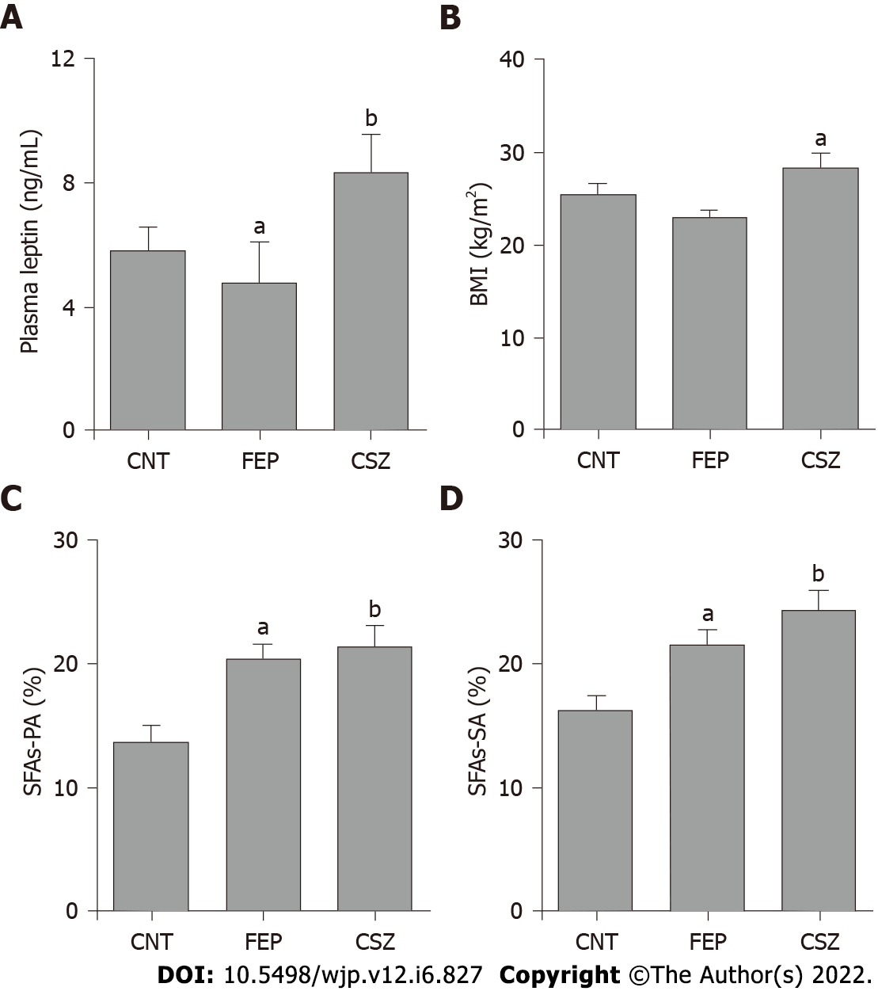
Figure 1 Statistical analyses of plasma leptin, body mass index, erythrocyte membrane saturated fatty acids in healthy control subjects, first-episode psychosis and chronic schizophrenia patients. A: Average plasma leptin (Figure 1A) in first-episode psychosis (FEP) patients (4.77 ± 1.35 ng/mL) was significantly (P = 0.028) lower than healthy control (CNT) subjects (5.79 ± 0.80 ng/mL). In chronic schizophrenia (CSZ) patients, plasma leptin (8.33 ± 1.25 ng/mL) was significantly higher than FEP patients (P = 0.006); B: The average body mass index (BMI) value of FEP patients (23.21 ± 2.14) was statistically similar to the BMI value of CNT subjects (25.10 ± 2.61, P = 0.144). The average BMI value of clozapine treated CSZ patients (29.86 ± 3.60) was significantly (P = 0.012) higher than FEP patients; C and D: Erythrocyte membrane palmitic acid and stearic acid, respectively were significantly (P < 0.005) higher in both FEP and CSZ patients compared to the CNT subjects. CNT: Healthy control; FEP: First-episode psychosis; CSZ: Chronic schizophrenia; BMI: Body mass index; SFAs: Saturated fatty acids; PA: Palmitic acid; SA: Stearic acid. ªP < 0.05 and ^{b}P < 0.01.
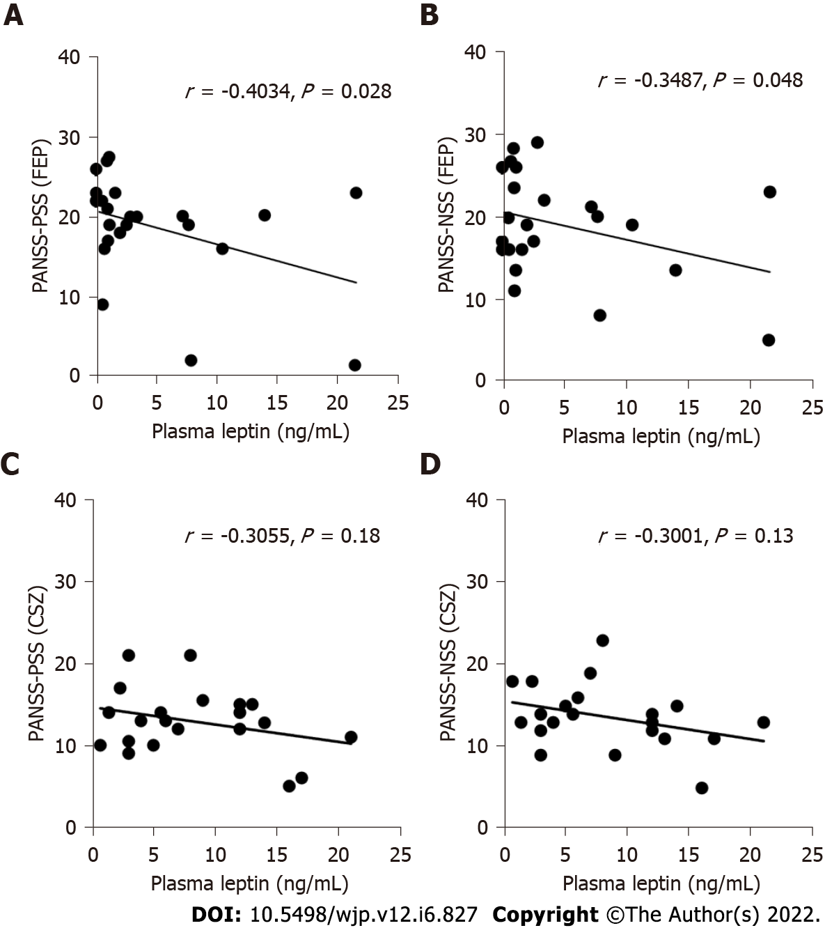
Figure 2 Association of plasma leptin with clinical symptom (positive and negative syndrome scale) scores. A and B: In first-episode psychosis patients, plasma leptin showed negative correlation with both positive symptom score (PANSS-PSS) (r = −0.4034, P = 0.028) and negative symptom score (PANSS-NSS) (r = −0.3487, P = 0.05); C and D: In chronic schizophrenia patients, no significant negative correlation was observed between plasma leptin and either PANSS-PSS (r = −0.3055, P = 0.18) or PANSS-NSS (r = −0.3001; P = 0.13). PANSS-PSS: Positive and negative syndrome scale-positive symptom score; PANSS-NSS: Positive and negative syndrome scale-negative symptom score; FEP: First-episode psychosis; CSZ: Chronic schizophrenia.

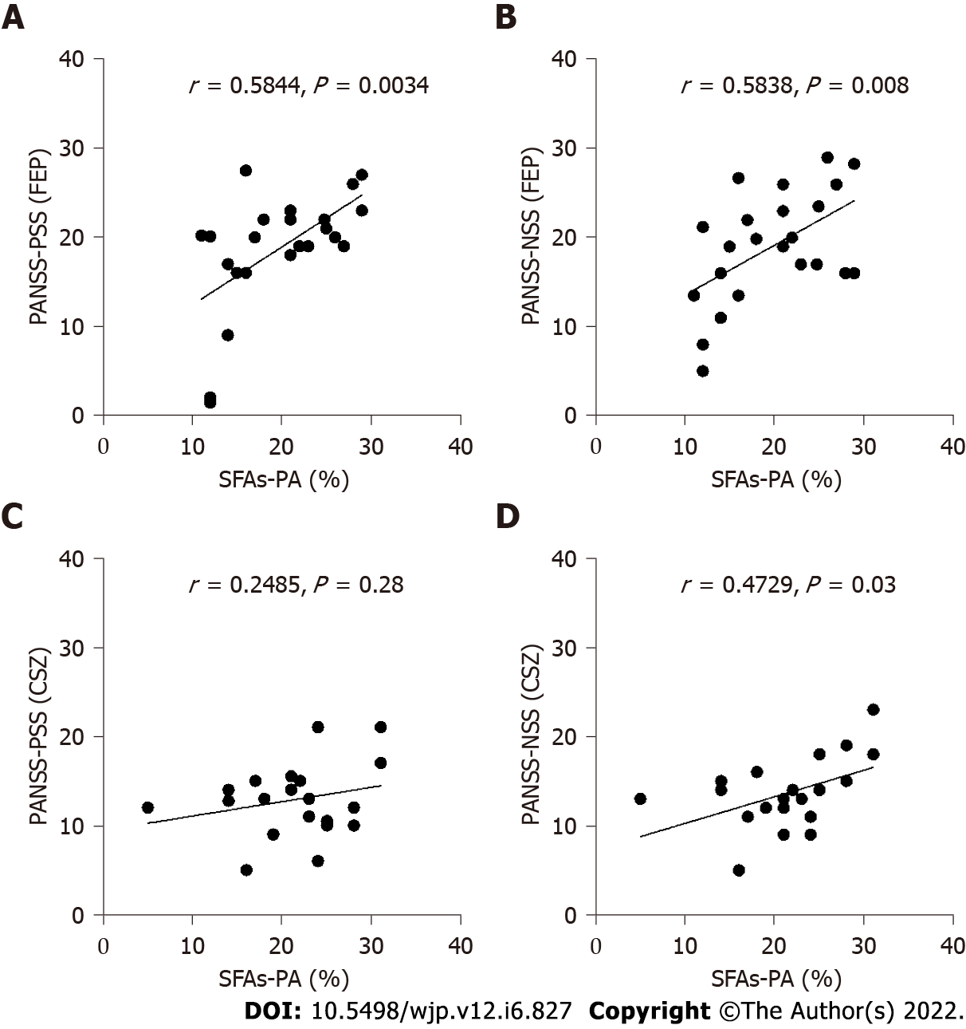
Figure 3 Association of erythrocyte membrane saturated fatty acids-palmitic acid with clinical symptoms (positive and negative syndrome scale) scores. A and B: In first-episode psychosis patients, erythrocyte saturated fatty acids (SFAs)-palmitic acid (PA) showed positive correlation with both positive symptom score (PANSS-PSS) (A, r = 0.5844, P = 0.0034) and negative symptom score (PANSS-NSS) (B, r = 0.5381, P = 0.008); C and D: In chronic schizophrenia patients, erythrocyte SFAs-PA showed positive correlation with PANSS-NSS (D, r = 0.4729; P = 0.031), but it was not significant in case of PANSS-PSS (C, r = 0.2485, P = 0.28). Similar results were obtained with erythrocyte membrane stearic acid (data not shown). PANSS-PSS: Positive and negative syndrome scale-positive symptom score; PANSS-NSS: Positive and negative syndrome scale-negative symptom score; FEP: First-episode psychosis; CSZ: Chronic schizophrenia; SFAs: Saturated fatty acids; PA: Palmitic acid.

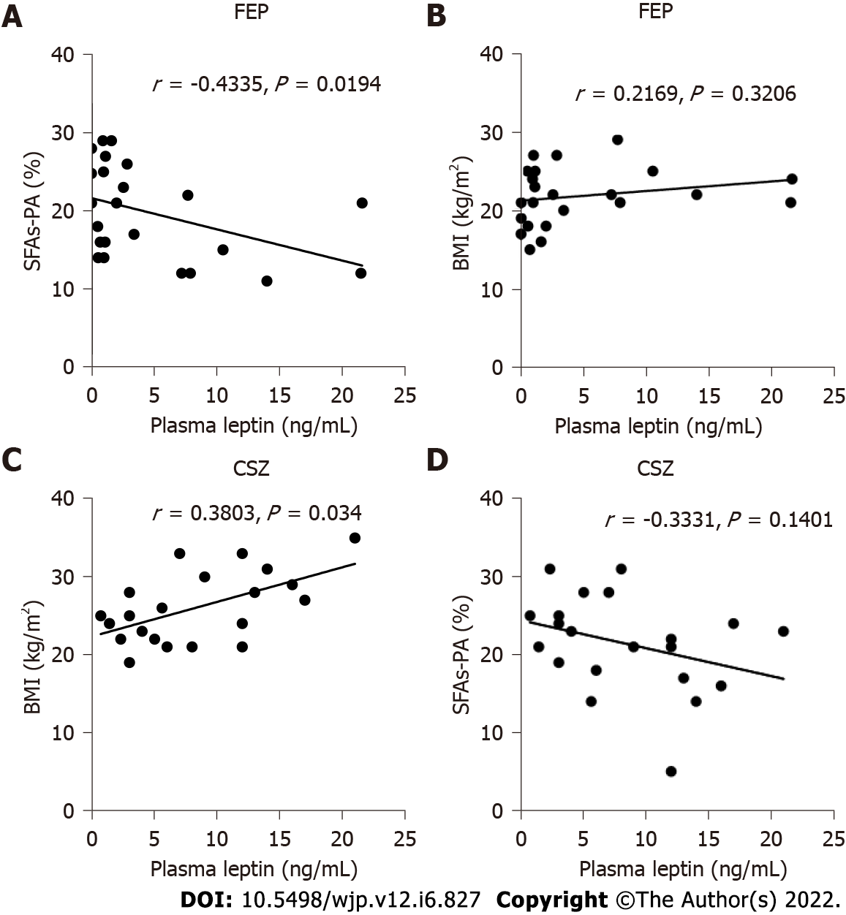
Figure 4 Association of plasma leptin with erythrocyte saturated fatty acids and body mass index. A-D: In first-episode psychosis patients, plasma leptin showed negative correlation with saturated fatty acids (SFAs)-palmitic acid (PA) (A, r = −0.4335, P = 0.0194) but not with body mass index (BMI) (B, r = 0.2169, P = 0.3206), whereas, in chronic schizophrenia patients, plasma leptin showed positive correlation with BMI (C, r = 0.4135, P = 0.0152) but not with erythrocyte SFAs-PA (D, r = 0.3331, P = 0.1401). FEP: First-episode psychosis; CSZ: Chronic schizophrenia; BMI: Body mass index; SFAs: Saturated fatty acids; PA: Palmitic acid.

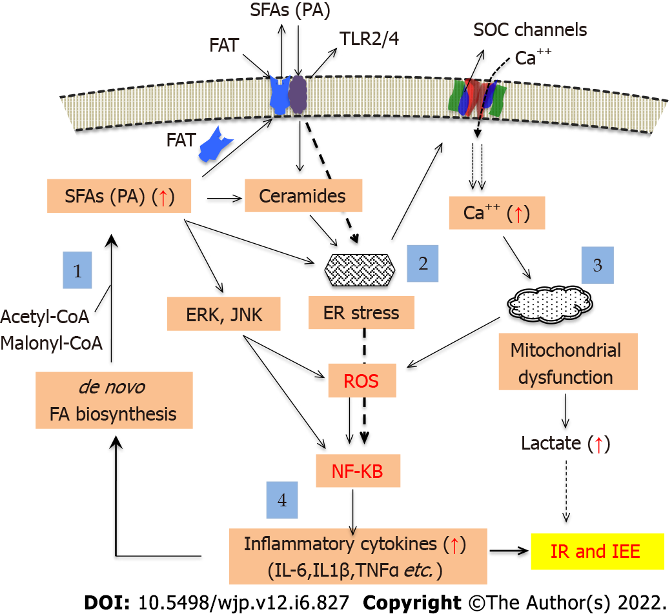
Figure 5 Mechanisms underlying saturated fatty acids-(palmitic acid)-induced insulin resistance and impaired energy expenditure. Saturated fatty acids (SFAs) are synthesized de novo in the cytoplasm from acetyl-CoA and malonyl-CoA (light blue box 1), and are transported by fatty acid transporter proteins from intracellular space to the membrane and to the extra cellular space. Excess SFAs-palmitic acid (PA) can also be converted into ceramides, which together with PA can induce endoplasmic reticulum (ER) stress via depletion of stored calcium (light blue box 2). ER stress leads to increased calcium influx via plasma membrane-bound store operated calcium channels, resulting into the elevation of cytoplasmic and mitochondrial calcium and production of reactive oxygen species (ROS) as a result of mitochondrial dysfunction (light blue box 3). Both PA and ceramides can also activate plasma membrane TLR2/4 receptor resulting in the activation of MAPK/ERK and JNK pathways. Activation of these pathways leads to the production of ROS and NF-κB activation (light blue box 4), which enhances expression of inflammatory cytokine genes resulting into generation of inflammatory response and development of insulin resistance (IR) and impaired energy expenditure (IEE). SFA-induced mitochondrial dysfunction also stimulates anaerobic glycolysis leading to enhanced production of lactate, which also contributes in the development of IR and IEE. SFAs: Saturated fatty acids; PA: Palmitic acid; SOC: Store operated calcium; ROS: Reactive oxygen species; ER: Endoplasmic reticulum; IR: Insulin resistance; IEE: Impaired energy expenditure.
Table 1 Demographic and clinical characteristics of the study subjects
Characteristics | CNT | FEP | CSZ
Age (yr) | 25 ± 7.6 | 23.54 ± 4.65 | 42.23 ± 5.12
Gender (M:F) | 14:0 | 22:0 | 21:0
Age at onset of psychosis |  | 22.80 ± 4.78 | 23.15 ± 6.35
Years of Illness |  | ≤ 5.0 d | 22.77 ± 7.21
Total BPRS Total |  | 45.18 ± 12.53 | 38.17 ± 6.96
Total PANSS-PSS |  | 21.03 ± 4.81 | 12.88 ± 4.10
Total PANSS-NSS |  | 20.91 ± 5.10 | 07.82 ± 2.31
Plasma leptin (ng/mL) | 5.79 ± 0.80 | 4.77 ± 1.35 | 08.33 ± 1.25
BMI (kg/m²) | 25.1 ± 2.61 | 23.2 ± 2.14 | 29.86 ± 3.60
Smoking |  | 2/23 | 3/21
Antipsychotic use |  |  | +++
Tobacco
Cannabis
CNT: Control subjects; FEP: First-episode psychosis; CSZ: Chronic schizophrenia; BPRS: Brief psychiatric rating scale; PANSS-PSS: Positive symptom scores; PANSS-NSS: Negative symptom scores; BMI: Body mass index.

Published by Baishideng Publishing Group Inc
7041 Koll Center Parkway, Suite 160, Pleasanton, CA 94566, USA
Telephone: +1-925-3991568
E-mail: bpgoffice@wjgnet.com
Help Desk: https://www.f6publishing.com/helpdesk
https://www.wjgnet.com

© 2022 Baishideng Publishing Group Inc. All rights reserved.

