Name of Journal: World Journal of Clinical Cases
Manuscript NO: 47981
Manuscript Type: CASE REPORT

Endoluminal closure of an unrecognized penetrating stab wound of the duodenum with endoscopic band ligation: A case report

Kim DH et al. Endoluminal treatment for abdominal penetrating injury

Dae Hoon Kim, Hanlim Choi, Ki Bae Kim, Hyo Yung Yun, Joung-Ho Han

Dae Hoon Kim, Hanlim Choi, Hyo Yung Yun, Department of Surgery, Chungbuk National University Hospital, Chungbuk National University College of Medicine, Cheongju-si 28644, South Korea

Ki Bae Kim, Joung-Ho Han, Department of Internal Medicine, Chungbuk National University Hospital, Chungbuk National University College of Medicine, Cheongju-si 28644, South Korea

ORCID number: Dae Hoon Kim (0000-0001-9873-4907); Hanlim Choi (0000-0003-0130-3292); Ki Bae Kim (0000-0001-6372-432X); Hyo Yung Yun (0000-0002-5592-1371); Joung-Ho Han (0000-0003-4469-9215).

Author contributions: Kim DH wrote the manuscript; Han JH revised the manuscript; Choi H did the case analysis; Kim KB and Yun HY did the data collection. All authors read and approved the final manuscript.

Informed consent statement: Informed written consent was obtained from the patient’s parents for publication of this report and any accompanying images.
Conflict-of-interest statement: The authors declare that they have no conflict of interest.

CARE Checklist (2016) statement: The authors have read the CARE Checklist (2016), and the manuscript was prepared and revised according to the CARE Checklist (2016).

Open-Access: This article is an open-access article which was selected by an in-house editor and fully peer-reviewed by external reviewers. It is distributed in accordance with the Creative Commons Attribution Non Commercial (CC BY-NC 4.0) license, which permits others to distribute, remix, adapt, build upon this work non-commercially, and license their derivative works on different terms, provided the original work is properly cited and the use is non-commercial. See: http://creativecommons.org/licenses/by-nc/4.0/

Manuscript source: Unsolicited manuscript

Corresponding author: Joung-Ho Han, MD, Professor, Department of Internal Medicine, Chungbuk National University Hospital, Chungbuk National University College of Medicine, 1 Chungdae-ro, Seowon-gu, Cheongju-si 28644, South Korea. joungho@cbnu.ac.kr
Telephone: +82-43-2696802
Fax: +82-43-2733252

Received: June 28, 2019
Peer-review started: June 29, 2019
First decision: July 31, 2019
Revised: September 18, 2019
Accepted: October 5, 2019
Article in press:
Published online:

Abstract
BACKGROUND
A penetrating injury of a hollow viscus is an obvious indication for an exploratory laparotomy, but is not typically an indication for endoscopic treatment.

CASE SUMMARY
A 27-year-old man visited the emergency department with a self-inflicted abdominal stab wound. Injuries to the colon and ileum were detected, but an injury to the second portion of the duodenum was missed. On the day following admission to our institution, the patient became hemodynamically unstable with massive hematochezia, although there was no evidence of bleeding in the Levin tube or Jackson-Pratt drain. We thus performed an upper gastrointestinal endoscopy and discovered a missed duodenal injury that was actively bleeding. An endoscopic band ligation was performed for hemostasis and closure of the perforation. The patient was subsequently discharged without any complications.

CONCLUSION
A penetrating injury of the duodenum can be overlooked, so careful abdominal exploration is very important. If a missed duodenal injury is suspected, a cautious endoscopic approach may be helpful.

Key words: Penetrating abdominal injury; Endoluminal treatment; Unrecognized duodenal injury; Case report

© The Author(s) 2019. Published by Baishideng Publishing Group Inc. All rights reserved.

Core tip: Following a penetrating abdominal injury, it is very important for surgeons to find all associated lesions. Insufficient abdominal exploration can result in a missed injury, occasionally leading to the need for reoperation and possibly a fatal outcome. We successfully treated a rare case of perforation and bleeding in the third portion of the duodenum, which was not found by upper-abdominal exploration during the initial surgery. If a missed hollow viscus injury, particularly in the duodenum, remains despite such efforts, an endoscopic approach may be helpful in some cases.

Kim DH, Choi H, Kim KB, Yun HY, Han JH. Endoluminal closure of an unrecognized penetrating stab wound of the duodenum with endoscopic band ligation: A case report. World J Clin Cases 2019; In press
INTRODUCTION
Hollow viscus perforations cause considerable mortality and usually require emergency surgery. Rapid diagnosis and treatment of these conditions are essential to reduce the high morbidity and mortality associated with a late-stage presentation^{[1]}. The majority of missed hollow viscus injuries result from blunt abdominal trauma, with those resulting from stab-penetrating abdominal trauma less prevalent^{[2]}. However, because the duodenum is a retroperitoneal organ, a penetrating duodenal injury can be overlooked. Injuries to the duodenum are associated with high mortality, often associated with a delayed diagnosis^{[3]}. A penetrating intestinal injury is an obvious indication for a laparotomy, but endoscopic treatment is extremely rare^{[4,5]}. Endoscopic treatment for a penetrating intestinal injury is rare because the endoscopic approach is difficult, peritonitis may be exacerbated during the procedure, and peritonitis cannot be resolved by endoscopic treatment^{[6]}. There has been one report of endoscopic treatment for a penetrating gastric injury^{[7]}. However, there have been no reports of endoscopic treatment for a penetrating duodenal injury. Herein, we present the first report of a case of a penetrating duodenal injury treated with endoscopy.

CASE PRESENTATION
Chief complaints
A 27-year-old male requested transfer for a self-inflicted abdominal stab wound.

History of the present illness
The patient had stabbed himself in his upper abdomen with a kitchen knife three times, in front of his family. He then visited the emergency room at another hospital, from which he was transferred to our emergency room. According to his family, he was uncontrollable when angry.

History of past illness
The patient denied a history of hypertension, diabetes mellitus, viral hepatitis, or tuberculosis. He had no known drug or food allergies. He also denied a history of operation, trauma, or blood transfusion.

Physical examination
The patient’s vital signs upon arrival were as follows: blood pressure 100/60 mmHg, heart rate 88 beats/min, respiratory rate 12 times/min, body temperature 37 °C, and oxygen saturation 98% on room air. He was awake, alert, and oriented. However, he complained of tenderness throughout the entire abdomen. We found three stab wounds in the upper-abdominal area. Two stab wounds had not penetrated the peritoneum, but the third had penetrated the peritoneum. There was a 3-cm longitudinal wound in the upper midline abdominal area, and the small bowel and transverse colon were eviscerated.

Laboratory examinations
A complete blood count was obtained showing a white blood cell count of 13.3 × 10⁶/L, hemoglobin 15.3 g/dL, and a platelet count of 229 × 10⁹/L. Electrolyte, coagulation, and blood biochemical tests were all normal.

Image examination
The three wounds in the middle of the upper abdomen were inspected. An exploratory laparotomy detected two perforations in the ileum and mid-transverse colon, which were repaired primarily (Figure 1A). One day after the surgery, the patient became hemodynamically unstable with massive hematochezia, although there was no evidence of bleeding in the Levin tube or Jackson-Pratt (JP) drain. Eight pints of packed red blood cells were transfused, but his hemoglobin value decreased from 10 to 8 mg/dL. Systolic blood pressure was < 80 mg and the patient’s consciousness became unclear. The patient was intubated and transferred to the intensive care unit. An abdominopelvic computed tomography (CT) scan revealed extravasation of contrast medium in the third duodenal portion (Figure 1B). An endoluminal approach for the endoscopic examination was performed in the intensive care unit to identify the bleeding lesions during preparation for the second operation. It showed a large blood clot on the third duodenum; a perforation 0.3 cm in diameter with active bleeding medially into the third duodenal portion was detected (Figure 2).

FINAL DIAGNOSIS
An unrecognized penetrating stab wound in the third portion of the duodenum.

TREATMENT
Several attempts to seal the perforation and stop the bleeding with endoclips failed due to the tangential angle. Next, an endoscopic band ligation (EBL) technique was used to obtain hemostasis and closure of the lesion using a pneumo-active single-band ligator (MD-48709; Akita Sumitomo Bakelite, Tokyo, Japan) (Figure 3A). After EBL, the patient’s hemodynamics stabilized, and no adverse events occurred. Endoscopy 9 d later showed a healing ulcer at the perforation site closed by EBL (Figure 3B).

OUTCOME AND FOLLOW-UP
After EBL, the patient was hemodynamically stable, and there was no evidence of peritonitis or bleeding. He resumed a normal diet 5 d after EBL and was discharged 9 d after surgery.

DISCUSSION
Duodenal injuries are relatively infrequent compared to injuries to other intra-abdominal organs, and most duodenal injuries are penetrating injuries. However, a duodenal injury is often diagnosed late because part of the duodenum is retroperitoneal. In addition, a duodenal injury can be missed, resulting in delayed treatment and increased mortality and morbidity^{[3,8]}. In the present case, the small bowel and transverse colon were eviscerated at the time the patient arrived at the emergency department. Penetrating injuries to the terminal ileum and transverse colon were detected, and there was no active bleeding into the abdominal cavity. However, the patient became hemodynamically unstable on the day after surgery. The Levin tube and JP drain were clear, but he defecated massive hematochezia. We performed an upper gastrointestinal endoscopy and discovered a missed duodenal injury with active bleeding in the third portion of the duodenum. After endoscopic treatment, we reviewed the initial abdominal pelvic CT scan and detected intra-luminal bleeding in the third portion of the duodenum. We missed the duodenal injury because there was no bile contamination or bleeding into the abdominal cavity during the operation. A hollow viscus injury manifesting with intra-luminal bleeding but no peritonitis or hemoperitoneum is an extremely rare condition. Retroperitoneal organ injuries resulting from a penetrating abdominal injury tend to be overlooked, as occurred in our case. This is why in the event of penetrating abdominal injuries it is important to perform a very careful abdominal exploration, including the Kocher maneuver.
Endoscopic closure of acute iatrogenic perforations using endoclips or a band ligator has been suggested^{[4,5]}. Per our previous report, EBL for an iatrogenic colon injury is a feasible and safe method in vivo, and endoscopic EBL is an acceptable method to manage variceal bleeding^{[9]}. Endoscopic clipping for a hollow viscus perforation can be limited in cases with a large perforation or in those with tangential angles^{[4]}. In our case, the missed duodenal injury was accompanied by bleeding, and we closed the missed duodenal injury using EBL.
If a missed duodenal injury has already caused peritonitis, a surgical approach is required because a penetrating abdominal injury that accompanies a hollow viscus injury is an obvious surgical indication^{[10]}. In this case, a Levin tube was inserted to drain gastric and bile juice and to detect internal bleeding, and two JP drains were inserted in the paracolic gutter and pelvic cavity during the first operation to detect leakage or intra-abdominal bleeding. There was no evidence of internal or intra-abdominal bleeding or leakage via the Levin tube or JP drain, and there was no evidence of peritonitis. Thus, we attempted an endoscopic approach to diagnose the bleeding detected on the abdominal CT scan.
There has only been one previous report of endoscopic treatment of a penetrating abdominal injury, and that case was a penetrating gastric injury^{[7]}. There have been no reports on the endoscopic treatment of a traumatic duodenal perforation. Although our case is very rare and limited, it is the first successful endoscopic treatment for a missed duodenal injury found more than 24 h after surgery.

CONCLUSION
A penetrating hollow viscus injury is an indication for surgical treatment^{[11]}. Generally, endoscopic treatment is not indicated for hollow viscus injuries because of peritonitis, leakage, bleeding, and the length of endoscopy. In our experience, an endoscopic approach may be helpful in the event of a suspected duodenal injury. A very careful abdominal exploration, including the Kocher maneuver, is very important for an upper abdominal penetrating injury.

REFERENCES
1 Langell JT, Mulvihill SJ. Gastrointestinal perforation and the acute abdomen. Med Clin North Am 2008; 92: 599-625, viii-viix [PMID: 18387378 DOI: 10.1016/j.mcna.2007.12.004]
2 Sung CK, Kim KH. Missed injuries in abdominal trauma. J Trauma 1996; 41: 276-282 [PMID: 8760536 DOI: 10.1097/00005373-199608000-00013]
3 Hong J, Wang SY, Qian L, Chen ZY. Diagnosis and Treatment of Duodenal Injury: A Clinical Analysis. Hepatogastroenterology 2015; 62: 641-646 [PMID: 26897945]
4 Han JH, Park S, Youn S. Endoscopic closure of colon perforation with band ligation; salvage technique after endoclip failure. Clin Gastroenterol Hepatol 2011; 9: e54-e55 [PMID: 21195795 DOI: 10.1016/j.cgh.2010.12.026]
5 Mangiavillano B, Viaggi P, Masci E. Endoscopic closure of acute iatrogenic perforations during diagnostic and therapeutic endoscopy in the gastrointestinal tract using metallic clips: a literature review. J Dig Dis 2010; 11: 12-18 [PMID: 20132426 DOI: 10.1111/j.1751-2980.2009.00414.x]
6 Al Ghossaini N, Lucidarme D, Bulois P. Endoscopic treatment of iatrogenic gastrointestinal perforations: an overview. Dig Liver Dis 2014; 46: 195-203 [PMID: 24210991 DOI: 10.1016/j.dld.2013.09.024]
7 Addley J, Ali S, Lee J, Taylor M, Lowry P, Mitchell RM. Endoscopic clip closure of penetrating stab wound to stomach. Endoscopy 2008; 40 Suppl 2: E219-E220 [PMID: 18819065 DOI: 10.1055/s-2008-1077438]
8 Carrillo EH, Richardson JD, Miller FB. Evolution in the management of duodenal injuries. J Trauma 1996; 40: 1037-45; discussion 1045-6 [PMID: 8656463 DOI: 10.1097/00005373-199606000-00035]
9 Han JH, Kim M, Lee TH, Kim H, Jung Y, Park SM, Chae H, Youn S, Shin JY, Lee IK, Lee TS, Choi SH. Endoluminal Closure of Colon Perforation with Endoscopic Band Ligation: Technical Feasibility and Safety in an In Vivo Canine Model. Clin Endosc 2015; 48: 534-541 [PMID: 26668801 DOI: 10.5946/ce.2015.48.6.534]
10 Henneman PL. Penetrating abdominal trauma. Emerg Med Clin North Am 1989; 7: 647-666 [PMID: 2663461]
11 Walker ML. Bowel injury. Minerva Chir 2013; 68: 233-240 [PMID: 23774088]

P-Reviewer: Contini B, Garbuzenko DV, Velayos B S-Editor: Dou Y L-Editor: E-Editor:

Specialty type: Medicine, Research and Experimental
Country of origin: South Korea
Peer-review report classification
Grade A (Excellent): 0
Grade B (Very good): 0
Grade C (Good): C, C
Grade D (Fair): D
Grade E (Poor): 0

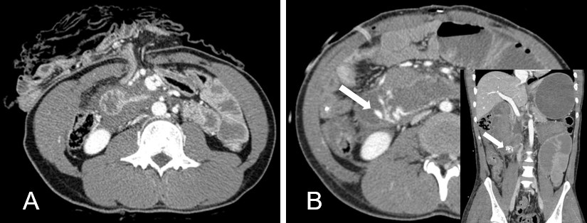
Figure 1 Abdominal computed tomogrpahy. A: Preoperative abdominal computed tomogrpahy (CT) shows paraduodenal fluid collection and transverse colon and small bowel herniation from the abdominal stab wound; B: Postoperative abdominopelvic CT shows extravasation of the contrast medium in the third portion of the duoenum (arrow).

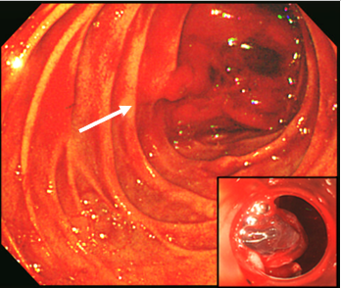
Figure 2 Endoscopy showed active bleeding with a perforation in the third portion of the duodenum. The cap-fitted endoscopy enabled closer observation of the bleeding site.

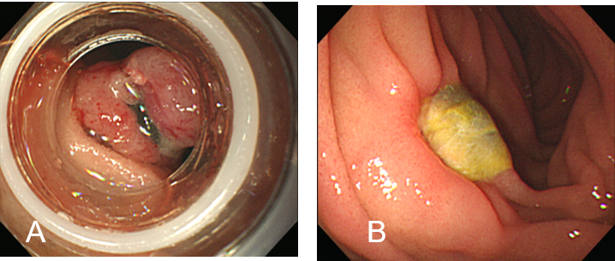
Figure 3 Endoscopy results. A: Endoscopic band ligation was used to make a mushroom-like area of mucosa to obtain complete closure. Additional band ligation was performed to get a more stable anchor; B: Follow-up endoscopy 9 d later showed a healing ulcer at the previous site of bleeding.

