Name of Journal: World Journal of Gastrointestinal Oncology
Manuscript NO: 51370
Manuscript Type: REVIEW

Caffeine and its main targets of colorectal cancer

Cui WQ et al. Effect of caffeine on colorectal cancer

Wen-Qi Cui, Shi-Tong Wang, Dan Pan, Bing Chang, Li-Xuan Sang

Wen-Qi Cui, Shi-Tong Wang, China Medical University 101K class 87, Shenyang 110001, Liaoning Province, China

Dan Pan, Department of Geriatrics, First Affiliated Hospital of China Medical University, Shenyang 110001, Liaoning Province, China

Bing Chang, Li-Xuan Sang , Department of Gastroenterology, First Affiliated Hospital of China Medical University, Shenyang 110001, Liaoning Province, China

ORCID number: Wen-Qi Cui (0000-0003-3499-7817); Shi-Tong Wang (0000-0002-4575-0396); Dan Pan (0000-0003-3297-0037); Bing Chang (0000-0003-1965-5827); Li-Xuan Sang (0000-0002-4562-0022).

Author contributions: Sang LX designed the study; Cui WQ wrote the original draft; Cui WQ, Wang ST, Pan D, Chang B and Sang LX reviewed and edited; All authors read, revised and approved the final manuscript.

Supported by the innovative talents support program of institution of higher learning of Liao Ning province, No. 2018-478; The innovative talents of science and technology support program of young and middle-aged people of Shenyang, No. RC170446.

Conflict-of-interest statement: Authors declare no conflict of interests for this article.

Open-Access: This article is an open-access article that was selected by an in-house editor and fully peer-reviewed by external reviewers. It is distributed in accordance with the Creative Commons Attribution Non Commercial (CC BY-NC 4.0) license, which permits others to distribute, remix, adapt, build upon this work non-commercially, and license their derivative works on different terms, provided the original work is properly cited and the use is non-commercial. See: http://creativecommons.org/licenses/by-nc/4.0/

Manuscript source: Unsolicited manuscript

Corresponding author: Li-Xuan Sang, PhD, Doctor, Department of Geriatrics, First Affiliated Hospital of China Medical University, 155 Nanjing North Street, Heping District, Shenyang 110001, Liaoning Province, China. sanglixuan2008@163.com
Telephone: +86-24-83283764
Fax: +86-24-83283765

Received: September 12, 2019
Peer-review started: September 12, 2019
First decision: October 14, 2019
Revised: October 25, 2019
Accepted: November 13, 2019
Article in press: November 13, 2019
Published online: February 15, 2020

Abstract
Caffeine is a purine alkaloid and is widely consumed in coffee, soda, tea, chocolate and energy drinks. To date, a growing number of studies have indicated that caffeine is associated with many diseases including colorectal cancer. Caffeine exerts its biological activity through binding to adenosine receptors, inhibiting phosphodiesterases, sensitizing calcium channels, antagonizing gamma-aminobutyric acid receptors and stimulating adrenal hormones. Some studies have indicated that caffeine can interact with signaling pathways such as transforming growth factor β, phosphoinositide-3-kinase/AKT/mammalian target of rapamycin and mitogen-activated protein kinase pathways through which caffeine can play an important role in colorectal cancer pathogenesis, metastasis and prognosis. Moreover, caffeine can act as a general antioxidant that protects cells from oxidative stress and also as a regulatory factor of the cell cycle that modulates the DNA repair system. Additionally, as for intestinal homeostasis, through the interaction with receptors and cytokines, caffeine can modulate the immune system mediating its effects on T lymphocytes, B lymphocytes, natural killer cells and macrophages. Furthermore, caffeine can not only directly inhibit species in the gut microbiome, such as Escherichia coli and Candida albicans but also can indirectly exert inhibition by increasing the effects of other antimicrobial drugs. This review summarizes the association between colorectal cancer and caffeine that is being currently studied.

Key words: Caffeine; Colorectal cancer; Epidemiology; Signaling pathway; Immune response; Cell cycle

© The Author(s) 2019. Published by Baishideng Publishing Group Inc. All rights reserved.

Core tip: Increasing evidence indicates that caffeine has wide-ranging effects on pathogenesis, metastasis and prognosis of colorectal cancer. This study systematically reviewed the literature on the targets and effects of caffeine on colorectal cancer. The effects were categorized into five groups: (1) communicating with cell signaling; (2) modulating immune response; (3) influencing gut bacteria; (4) regulating cell cycle; and (5) redox homeostasis.

Citation: Cui WQ, Wang ST, Pan D, Chang B, Sang LX. Caffeine and its main targets of colorectal cancer. World J Gastrointest Oncol 2020; 12(2): 149-172
URL: https://www.wjgnet.com/1948-5204/full/v12/i2/149.htm
DOI: https://dx.doi.org/10.4251/wjgo.v12.i2.149
INTRODUCTION
Colorectal cancer (CRC) is the third most common cancer and the fourth most common cause of cancer-related deaths^{[1]}. It has been reported that there will be 1456000 new cases of CRC in 2019, with an estimated 51020 people dying of this disease in the United States^{[2]}. According to statistics, the incidence and mortality rates of CRC have stabilized or declined in a number of the high human-development-index countries such as the United States, Australia, New Zealand and several Western European countries^{[3]}. However, in Asia the incidence continues to increase at an alarming rate without any sign of abating^{[4]}. Age and gender are both risk factors for CRC. People older than 50 years of age are more predisposed to be affected by CRC, and incidence in males is greater than in females^{[5]}. Additionally, CRC is often accompanied by metastasis; statistics show that one in five patients with CRC suffer from simultaneous metastatic disease^{[6]}. Due to venous drainage of the large bowel being achieved via the portal system, the first site of hematogenous dissemination for CRC is usually the liver, followed by the lungs, bone and brain^{[7]}.
CRC is a multifactorial disease involving genetic changes, the host immune response, gut microbiota and other environmental and lifestyle risk factors, which result in a series of pathologic changes that finally transform normal colonic epithelium into invasive carcinoma^{[1,8]}. CRC involves many genetic changes and certain signaling pathways are clearly singled out as key factors in tumor formation. For example, the activation of the Wnt/β-catenin signaling pathway, which is associated with mutations of adenomatous polyposis coli, is regarded as the initiating event in CRC. The second step is the inactivation of the p53 pathway. Then, the mutational inactivation of the transforming growth factor β (TGF-β) signaling pathway is viewed as the third step in the progression to CRC^{[9]}. Furthermore, aberrational activation of phosphoinositide-3-kinase (PI3K) and the induction of AKT activity can mediate the metastasis of CRC^{[10]}. KRAS expression is also required for CRC, and the loss of its expression can cause the apoptosis of primary and metastatic colon adenocarcinomas^{[11]}.
As for the host immune response, it is well known that chronic inflammation induces dysplasia in intestinal epithelial cells, which can contribute to the initiation or progression of CRC^{[12]}. Pro-inflammatory cytokines such as tumor necrosis factor-alpha (TNF-α) can contribute to inflammation-related tissue damage and are associated with tumor initiation^{[13]}. In the tumor microenvironment, pre-existing T lymphocyte cells play an important role in CRC regression by attacking cancer cells by recognizing abnormally expressed neoantigens^{[14].} Both CD4⁺ and CD8⁺ effector T lymphocytes have anti-tumor properties and independently correlate with improved outcomes of CRC^{[15]}. Additionally, low activity of natural killer (NK) cells is correlated with an increased risk of CRC compared with patients with high NK cell activity^{[16]}. In tumor cases, tumor-derived factors attract circulating monocytes into the tumor tissue where they differentiate into macrophages called tumor-associated macrophages^{[17]}. Tumor-associated macrophages are enriched in tumors compared with normal tissue and confer a poorer prognosis^{[18]}. During the development of CRC, tumor-associated macrophages potentiate the angiogenic capacity of the tumor microenvironment in an oxidative stress-dependent manner and promote CRC cell metastasis^{[19,20]}. Furthermore, oxidative stress, defined as an imbalance between pro- and antioxidants, has been implicated in the initiation, promotion and progression of carcinogenesis^{[21]}.
CRC has increased levels of different markers of oxidative stress, such as increased levels of reactive oxidative species (ROS) and nitric oxide, suggesting that oxidative stress may be one possible pathway to affect CRC^{[22]}. An imbalance of gut bacteria can also lead to abnormal immune activation, chronic inflammation or hyperproliferation, which finally contributes to the development of CRC through specific mechanisms such as enhancing toxic bacterial products, decreasing beneficial bacterial metabolites, disrupting tissue barriers and translocation^{[8]}. For example, H. pylori infection can be a risk factor for CRC and adenomatous polyps^{[23]}. Moreover, E. coli may contribute to microbiome-driven CRC through damaging DNA, inducing senescence and leading to immune activation^{[24]}.

CAFFEINE
Caffeine (1,3,7-trimethylxanthine) is a purine alkaloid that belongs to the methylxanthine group. As one of major components in coffee, it was first isolated in 1820, and it is also present in tea leaves, cocoa beverages, soft drinks and chocolate products^{[25,26]}. Caffeine is even available in a number of over-the-counter remedies, including some pain killers^{[26]}. In both animals and humans, after its oral ingestion, caffeine is rapidly and completely absorbed into the gastrointestinal tract. Then, it enters into the water compartment of tissues, crosses all biological membranes, and eventually distributes in all body fluids. Once it is filtered by the glomeruli, 98% of caffeine is reabsorbed from the renal tubules, and only 0.5%–2% of unmetabolized caffeine is excreted in urine^{[27]}.
The metabolism of caffeine is a complex process that occurs in the liver, which involves successive N-demethylations and a C-8 oxidation by CYP1A2, N-acetyltransferase or xanthine oxidase to form metabolites with variable pharmacological actions^{[27,28]}. The N-demethylation pathways of caffeine mediated by CYP1A2^{[29]} involve the formation of paraxanthine (PX) through N3-demethylation^{[28]}. PX is then metabolized by CYP1A2 in the human liver to an unknown unstable intermediate with an open ring structure. This intermediate is acetylated by N-acetyltransferase to form 5-acetyl-amino-6-formylamino-3-methyluracil, or the ring is closed to form 1-methylxanthine^{[30]}. 1-methyluric acid is also the product of following 7-demethylation of PX. All of the above accounts for 67% of PX clearance. Furthermore, the renal excretion of unchanged PX, 1,7-dimethyluric acid and 7-methylxanthine comprise 9%, 8% and 6% of PX clearance, respectively^{[31]}.
Through N1-demethylation, caffeine gives rise to theobromine. In this case, theobromine can be further metabolized to form 7-methylxanthine, 7-methyluric acid, 3-methylxanthine, 6-amino-5[N-methylformylamino]-1-methyluracil and a small amount of 3,7-dimethyluric acid^{[32]}. Theophylline (TP) formed from N7-demethylation is degraded to both 3-methylxanthine (major product) and 1-methylxanthine (minor product), and they are further demethylated to form xanthine^{[33]}. The N3, N1 and N7 demethylations account for 84%, 12% and 4%, respectively, of caffeine metabolism in humans^{[27,28]}. C8-hydroxylation only takes up 1% of metabolism; it can cause the formation of trimethyluric acid, which further gets degraded to 3,6,8-trimethylallantoin^{[29,34]}. All of the above metabolites are then further metabolized in the liver by additional demethylations and oxidation to urates^{[35]} (Figure 1). Caffeine exerts its functions by regulating important target molecules as described below.

Modulator of Ca²⁺ release channels
Intracellular Ca²⁺ signaling is a universal, evolutionarily conserved and versatile regulator of cell biochemistry, which is involved in angiogenic progression, cell proliferation, differentiation, migration and apoptosis^{[36,37]}. Many of the molecules involved in Ca²⁺ remodeling are expressed differentially in multiple tumor cells and may significantly contribute to cancer hallmarks in a series of cancers including CRC^{[38]}. In electrically inexcitable cells, most Ca²⁺ signals are initiated by receptors that stimulate phospholipase C and thereby induce the transformation from phosphatidylinositol-4,5-bisphosphate (PIP2) to diacylglycerols and inositol 1,4,5-trisphosphate (IP3). IP3 then binds to IP3 receptors to stimulate Ca²⁺ release from the endoplasmic reticulum^{[39]}. The depletion of endoplasmic reticulum Ca²⁺ stores triggers the process called store-operated Ca²⁺ entry, which activates the endoplasmic reticulum-resident Ca²⁺ sensor protein stromal interaction molecule to gate and open the ORAI Ca²⁺ channels in the plasma membrane^{[37,40]}. Caffeine is known to influence intracellular Ca²⁺ homeostasis in two different ways: one is by inhibiting the activation of the IP3 receptors through which the release of Ca²⁺ from intracellular stores and its following activation of store-operated Ca²⁺ entry can be suppressed. Another way is by activating ryanodine receptor (RyR) mediated Ca²⁺ release^{[25,41]}. For the reason that both IP3 and RyR are present in the colonic epithelium, Ca²⁺ remodeling may be one possible mechanism by which caffeine acts on CRC^{[42]} (Figure 2).

Antagonist of adenosine receptor
The tumor microenvironment exhibits high concentrations of adenosine due to the contribution of immune and stromal cells, tissue disruption and inflammation^{[43]}. Adenosine, a purine nucleoside derived from a decrease in cellular adenosine triphosphate, is released into the extracellular space and may have significant influences on the vasculature, resistance to immune attacks, modulation of inflammation and growth of tumor masses by binding to specific G-protein-coupled A1, A2A, A2B, and A3 cell surface receptors^{[44]}. A1R and A3R belong to the group of Gi-coupled proteins that inhibit adenylate cyclase-mediated production of cyclic adenosine 3′,5′-monophosphate (cAMP). In contrast, A2AR and A2BR are Go/Gs-coupled receptors that raise intracellular levels of cAMP^{[45]}. Methylxanthines are inhibitors of adenosine action, most notably caffeine and TP, except those actions that are mediated by A3 receptors, as these methylxanthines are almost 100 times less potent at that receptor than on the other three^{[46,47]}. Caffeine is a less potent inhibitor of adenosine at its receptors than its two metabolites TP and PX^{[46]}.

Antagonist of phosphodiesterase
Compared with cells of the related benign mucosa, CRC cells bind to a significantly increased level of intracellular cAMP and decreased levels of cyclic guanosine 3′-5′ monophosphate (cGMP)^{[48,49]}. cAMP and cGMP levels are normally regulated by the balance between the activities of two types of enzymes, the generating enzymes (adenylate cyclases/guanylyl cyclase) and the degrading enzymes (PDEs)^{[48]}. PDE enzymes are encoded by 21 genes in humans and classified into 11 different families (PDE1–PDE11), several of which contain isoform subfamilies^{[50]}. They are a large superfamily of enzymes that can cause cleavage of the phosphodiester bond in the second messengers like cAMP and cGMP and then degrade them into 5′-GMP and 5′-AMP^{[51]}. Phosphodiesterases 1, 2, 3, 10 and 11 are dual substrate-degrading isozymes, whereas phosphodiesterases 5, 6 and 9 are selective for cGMP and phosphodiesterases 4, 7 and 8 are cAMP selective^{[52]}.
PDEs show different expression levels in CRC. For example, the expression of PDE5 and PDE10 is higher in colon adenomas and adenocarcinomas compared with in the normal colonic mucosa^{[50,53]}, and the inhibition of PDE5 and PDE10 can suppress colon tumor cell growth^{[54]}. Thus, caffeine, as a non-specific PDE antagonist, can lead to an increase in intracellular cAMP and cGMP concentrations, which exert a variety of cell responses such as the inhibition of CRC proliferation^{[41]}. Moreover, its metabolite, theobromine has an approximately equipotent ability to caffeine to inhibit PDE, while TP is more potent, and PX is less potent^{[44]}.
cAMP, accumulated by the inhibition of PDE, influences the initiation of CRC. For example, the β-catenin pathway, an initial step for CRC development, can be activated through positive action of cAMP on protein kinase A^{[9,55]}. Also, cAMP can suppress AKT/mammalian target of rapamycin (mTOR) signaling, which is a critical regulator of CRC development^{[56]}. Meanwhile, the apoptosis of CRC cells can be suppressed by cAMP through the extracellular signal-regulated kinase (ERK)1/2 and p38 mitogen-activated protein kinase (MAPK) pathways^{[57]}. Additionally, cAMP promotes vascular endothelial growth factor expression, resulting in neoplastic vascularization^{[58]}. As for cGMP, when it acts on its effector, protein kinase G, it can exert its functions of opposing intestinal epithelial cell proliferation by upregulating the nuclear transcription of cell cycle inhibitors (p21 and p27) and by suppressing pro-proliferative transcription mediated by the β-catenin/T cell factor^{[59]}. Meanwhile, increasing cGMP in the colon epithelium activates forkhead box class O 3a, which plays important roles in coordinating environmental stressors through the regulation of cell growth and tissue homeostasis, and it can upregulate antioxidant gene expression to protect against redox stress and barrier dysfunction^{[60]}. Also, cGMP signaling promotes the DNA damage repair process and opposes chromosomal instability in healthy tissue. Also, it can inhibit epithelial–mesenchymal transition following tumorigenesis, regulating intestinal inflammation and altering the microbiome composition^{[59]}. Therefore, the dysregulation of cGMP and cAMP signaling can contribute to CRC^{[55,59]} (Figure 3).

Stimulation of adrenergic signaling
Stress, as one of the environmental factors, is reported to enhance CRC cell growth in vivo and in vitro and is linked to the occurrence and progression of CRC^{[61]}. Catecholamines, including norepinephrine and epinephrine, are the primary neurotransmitters involved in stress response and originate from the sympathetic nerves of the autonomic system^{[62]}. In people suffering from acute or chronic stress, both epinephrine and norepinephrine are elevated^{[61]}. Caffeine ingestion is widely associated with stimulation of the sympathetic nervous system and with subsequent elevations in the plasma concentrations of the catecholamines epinephrine and norepinephrine^{[63,64]}. Catecholamines can stimulate beta-adrenergic receptors by the beta-adrenoceptor-adenylylcyclase-protein kinase A cascade.
Beta-adrenergic receptors belong to the family of G-protein coupled receptors, and stimulation of the cascade can cause an accumulation of the second messenger cAMP resulting in modulation of varied pathways^{[65]}. They can influence a lot in CRC because beta-2 adrenergic receptors have a high expression level in the neoplastic cells from colorectal adenocarcinoma. Moreover, it has significant association with tumor grading^{[66]}. Meanwhile, it also has effects on tumor growth including promoting tumorigenesis, tumor cell proliferation, antiapoptotic mechanisms and promoting metastasis by stimulating the expression of angiogenic growth factors such as vascular endothelial growth factor and interleukin (IL)-6 and inducing epithelial–mesenchymal transition, motility and invasion^{[67]}. In addition, it can also cause the modulation of the immune system. For example, it can induce a Th1/Th2 imbalance in the mouse immune system, which is considered critical during colon cancer progression^{[68]}. Moreover, use of blockers of beta-adrenergic receptors has been proven to be associated with longer survival in patients with stage IV CRC^{[69]}.

Antagonist of GABAA receptors
An increasing amount of evidence suggests that the increased migration of tumor cells is not only a consequence of genetic alterations but is also due to chemokines, neuropeptides and neurotransmitters such as γ-aminobutyric acid (GABA)^{[70]} (Figure 4). Caffeine acts as an antagonist of GABAA receptors (GABAAR) at the benzodiazepine-positive modulatory site^{[25]}.

EPIDEMIOLOGY

Coffee is one of the major sources of caffeine and is among the most widely consumed beverages in the world. It contains many substances that affect the human body, the majority of which include caffeine, caffeic acid, trigonelline, chlorogenic acid and diterpenes^{[71]}. Evidence shows a protective effect of coffee consumption on CRC in the United States^{[72]}. Moreover, the results of a large United States prospective cohort study consistent with the former study showed that caffeinated coffee drinkers had a significantly lower risk of CRC. The results also indicated the protective effect can be different at specific anatomic subsites that decrease the risk more for the proximal than for the distal colon^{[73]}. A similar result was found in a prospective cohort study in Japanese men. However, it mentioned that the level of coffee consumption, which decreased the risk for recurrence in the proximal colon, can significantly increase the risk in the distal colon^{[74]}. Furthermore, it has been shown that the association between CRC and coffee consumption can be influenced by the concentration of coffee. A large population-based case-control study demonstrated that modest coffee consumption (≥ 1 and < 2 servings/d) is associated with a 90% reduction in the odds of developing CRC and that the highest category of consumption (> 2.5 servings/d) is associated with a 54% reduction in the odds of developing CRC^{[75]}. Additionally, findings within two large prospective cohort studies suggested that a higher intake of coffee was associated with a lower risk of CRC-specific mortality and all-cause mortality with stage I to III disease (an association that was stronger in stage III disease)^{[76]}. However, some studies have also shown that drinking coffee is not associated with the colon cancer risk^{[77,78]}.
The reason why the results of epidemiological studies exploring the correlation between coffee consumption and CRC risk have been varied may be due to the following reasons. Firstly, the result may vary with ethnicity, which may present with cultural, dietary and genetic variants^{[75]}. Secondly, associations appear to be very complex and are influenced by other factors such as cigarette smoking status. Studies have shown that among non-smoking populations, coffee increases the risk of CRC, while in populations that smoke cigarettes, the opposite has been observed^{[79]}. Finally, many studies did not specify whether the coffee blend was caffeinated or decaffeinated, filtered or unfiltered, processed at a certain roasting level, or made with a certain brewing method. Also, studies did not distinguish between coffee brewed from Coffea arabica and Coffea canephora (robusta) beans^{[71]}.

EFFECT ON SIGNALING PATHWays
Many signaling pathways have been reported to be associated with CRC such as the TGF-β, phosphatase and tensin homolog (PTEN)^{[80]}, PI3K/AKT/mTOR, β-catenin^{[10]}, MAPK^{[81]} and NF-КB^{[82]} pathways (Figure 5).

TGF-β pathway
Caffeine was reported to have the ability to block the elevation of TGF-β in a concentration-dependent manner^{[83,84]}. The TGF-β signaling pathway is one of the most commonly inactivated signaling pathways in CRC^{[80]}. It is well accepted that the TGF-β family members are key regulatory polypeptides that participate in many aspects of cellular function such as proliferation, differentiation and apoptosis^{[85]}. TGF-β functions as a ligand by binding to the type II receptor, which recruits and phosphorylates the type I receptor (TGFBR1)^{[85]}. TGF-β type I receptor then phosphorylates the receptor-associated SMAD2 and SMAD3, and then the activated SMAD2 and SMAD3 bind to the common mediator SMAD4, with the consequent relocation of this molecular complex at the level of the nucleus, resulting in the final regulation of target genes related to a wide range of cellular processes, including cancer initiation and progression, proliferation, differentiation, apoptosis and migration^{[86]}.
Multiple studies have demonstrated that TGF-β can exert a dual function in the process of developing human cancers: In normal cells and early carcinomas, it acts as a tumor suppressor^{[87,88]}, while in aggressive and invasive tumors, it acts as a promoter of tumor metastasis^{[87]}. A possible pathway for the switching of the dual function of TGF-β is that in CRC cells MAPK is activated by TGF-β via a SMAD4-dependent mechanism, leading to the upregulation of expression of cyclin-dependent kinase 2 inhibitor p21^{[89]}, which act as a tumor suppressor and contributes to cell cycle arrest in response to various stimuli^{[90]}. The upregulation of p21 induced by TGF-β decreases over time, which can lead to different cell cycle functions^{[89]}. TGF-β can regulate its downstream factors, CCN-family protein 2 (CCN2) and transgelin, in a TGF-β/SMAD3 dependent fashion^{[91]}. Mediated by the induction of its transcriptional target CCN2, TGF-β plays crucial pro-metastatic, lymphangiogenesis, stromal infiltration and activation roles^{[92]}. CCN2, also known as connective tissue growth factor, is markedly activated in human CRC tissues compared with the corresponding normal colon tissues during both tumorigenesis and metastasis^{[93]}.
Caffeine and its metabolites can suppress both TGF-β-dependent and independent CCN2 expression via a mechanism that involves reduction of the steady state concentration of total SMAD2 protein and the decline of phosphorylation of SMAD3^{[91]}. Transgelin, an actin-binding protein of the calponin family, has the potential to alter cell motility through direct interaction with the actin cytoskeleton, which plays an important role in promoting invasion, survival and resistance to the anoikis of CRC^{[94]}. However, caffeine is able to inhibit transgelin promoter activity in a dose dependent manner^{[91]} (Figure 6).

PI3K/AKT/mTOR pathway and PTEN pathway
Caffeine inactivates PI3K and AKT and activates PTEN, resulting in the apoptosis of tumor cells^{[95,96]}. Apart from the TGF-β pathway, the PI3K/AKT pathway is another commonly dysregulated pathway in CRC^{[80]}, and mutational activation of PI3K and induction of AKT activity can mediate the metastasis of CRC^{[10]}. PI3K is a family of intracellular lipid kinases, including phosphatidylinositol, phosphatidylinositol-4-phosphate (PIP) and PIP2 whose substrate is the phosphatidylinositol lipid matrix. Once activated, PI3K can catalyze the phosphorylation of PIP2 to phosphorylate 3,5,5-triphosphate (PIP3)^{[97]}. PI3K can be divided into three classes: class I, class II and class III^{[98]}. Only class IA PI3Ks play a role in human cancer^{[99]}, and caffeine can directly inhibit both class I and class II PI3Ks^{[100]}. Epidermal growth factor receptor activates survival signaling pathways including the RAS/RAF/ERK, p38 MAPK, JNK and PI3K/AKT/mTOR signaling pathways, leading to cell growth and proliferation^{[101]}. When PI3K is activated, PIP3 is generated, and increased PIP3 recruits AKT to the membrane where it is activated by other kinases that are also dependent on PIP3^{[102]}.
Caffeine exerts pharmacological activity by inhibiting AKT activation via modulating the cAMP level in vitro^{[103]}. Maximal activation of AKT is dependent on the phosphorylation of two residues: Thr308, which is dependent on the activity of the enzyme PI3K-dependent kinase 1, and Ser473. Caffeine has been reported to reduce the phosphorylation of AKT at both Thr308 and Ser473 residues^{[104]}. Activated AKT promotes cell growth and survival by inhibiting the pro-apoptotic proteins of the Bcl-2 family, enhancing the degradation of p53 and stimulating the mTOR group of proteins^{[105]}. mTOR is a serine/threonine protein kinase that regulates protein synthesis and degradation, cell survival, proliferation and longevity^{[103]}. Activation of the mTOR pathway has been noted in squamous cancers including CRC, and caffeine was found to be an inhibitor of mTOR^{[106]}. PTEN acts as an important negative regulator of the PI3K/AKT signaling pathway^{[96,107]}, and its inactivation is a common cause of increased PI3K activity in cancers^{[81]}. PTEN is a lipid phosphatase specific for PIP3, which opposes the effects of PI3K on cellular PIP3 levels and consequently regulates cell proliferation and survival through various signaling molecules. Caffeine can lead to the activation of PTEN through the elevation of intracellular cAMP^{[96]}.

MAPK pathway
MAPKs are serine-threonine kinases that are located downstream of many growth-factor receptors, including epidermal growth factor receptor^{[81,108]}. They mediate intracellular signaling associated with a variety of cellular activities including cell proliferation, differentiation, survival, death and transformation^{[109]}. There are three major subfamilies of MAPK: the extracellular-signal-regulated kinases (MAPK/ERK, RAS/RAF/mitogen-activated ERK-regulating kinase (MEK)/ERK; the c-Jun N-terminal or stress-activated protein kinases (JNK); and p38 MAPKs^{[81]}.

RAS/RAF/MEK/ERK Pathway
There is growing evidence that activation of the RAS/RAF/MEK/ERK pathway is involved in the pathogenesis, progression and oncogenic behavior of human CRC^{[81]}. Moreover, mediated by activation of the MEK/ERK signaling pathway, 20 µM of caffeine can prevent paclitaxel-induced apoptosis in Colo205 CRC cells in vitro^{[26]}.
KRAS belongs to the RAS family of genes that encode GTP-binding proteins^{[81]}. KRAS expression is required for tumor maintenance, even in situations where KRAS activation is not an initiating event. The loss of KRAS expression has been shown to cause the apoptosis of primary and metastatic colon adenocarcinomas^{[11]}. Coffee and its component caffeine reduced KRAS expression in Caco-2 human colon carcinoma cells by activating two miRNAs, miR-30c and miR-96, which are known to target the KRAS gene^{[110]}. In KRAS wild-type tumor cells, the binding of EGF to its receptor, epidermal growth factor receptor, causes GTP-loading of KRAS, which activates RAF to phosphorylate MEK, which phosphorylates ERK^{[111]}. ERK is constitutively active in CRC cells, suggesting that MEK is activated in primary colorectal tumors^{[112]}. A high concentration of caffeine was shown to activate the ERK1/2 pathway and induce autophagy, while a moderate concentration of caffeine is thought to have an inhibitory effect on the ERK pathway^{[95]}.

p38 MAPK pathway
p38 MAPK is a MAPK, and its canonical activation is mediated by the module in which MAPK kinase kinases phosphorylate and activate MAPK kinases, which activates p38 MAPK through dual phosphorylation on threonine and tyrosine residues^{[113]}. p38 MAPK has four family members: p38α (MAPK14), p38β (MAPK11), p38δ (MAPK13) and p38γ (MAPK12)^{[113]}. p38α MAPK signaling has an important protective function in colorectal tumorigenesis. On one hand, p38 MAPK protects intestinal epithelial cells against colitis-associated CRC by regulating the intestinal epithelial barrier function. On the other hand, it suppresses tumor initiation in epithelial cells^{[114]}. Caffeine was reported to trigger the phosphorylation of p38 MAPK through an increase in the intracellular Ca²⁺ concentration and ROS generation in U937 cells^{[115]} (Figure 7).

Other pathways
Compared to normal colorectal epithelial cells, CRC cells exhibit aberrant constitutive NF-КB activation^{[82]}. Caffeine inhibits NF-КB, which plays an important role in multiple signaling cascades related to carcinogenesis, including the survival, invasion and migration of cancer cells^{[95]}. In addition, ultraviolet radiation irradiation stress-induced activation of the apoptosis signal-regulating kinase-1/SEK1/JNK signaling pathway can interact with caffeine^{[116]}, and the activation of JNK signaling pathways was implied to be involved in piperlongumine-mediated apoptosis in human colorectal cancer HCT116 cells^{[117]}. Furthermore, abnormal activation of the Wnt/β-catenin pathway is responsible for the initiation of more than 90% of colon cancers. β-catenin accumulates in the nucleus, binds to T cell factor or lymphoid enhancer factor transcription factors and induces the expression of Wnt target genes that have key roles in tumor progression^{[10]}. Caffeine was shown to increase the frequency of β-catenin mutations, and the colon tumors almost exclusively harbor β-catenin mutants with direct substitutions of glycine 34^{[118]}.

Effect on Intestinal Homeostasis
Intestinal homeostasis is maintained through interactions involving the immune response and the microbial content in the gut^{[119]}.

Effect on the immune system
The immune system plays a crucial role in cancerogenesis, and it can prevent tumor development or the progression of existing neoplasms^{[120]}.

General effects of caffeine on cytokines: The development, growth, activation and functions of innate and adaptive immune cells are controlled largely by cytokines, and their effects on tumor-associated immune cells are extremely influential^{[121]}. Caffeine shows different effects on cytokines at different concentrations. Once caffeine reaches therapeutic levels, preferential blockade of A1R increases cAMP accumulation, thereby decreasing cytokine production. However, because caffeine is a non-specific AR antagonist, a higher concentration also blocks A2Rs, thereby decreasing cAMP and increasing pro-inflammatory cytokine transcription. Thus, it can reverse the anti-inflammatory effect that is observed at a lower concentration^{[122]}.
TNF-α is a well-known pro-inflammatory cytokine that plays important roles in various cellular events, such as cell proliferation, differentiation, cell death, inflammation and carcinogenesis^{[121]}. Increased levels of TNF-α are associated with metastatic disease in several cancer types including CRC^{[123]}. In an in vitro study, caffeine at a concentration of 50 µM in culture was shown to attenuate TNF-α secretion by blocking A1R on lipopolysaccharide-activated human cord blood monocytes^{[124]}, which is mediated by its effect on the cAMP/protein kinase A pathway^{[125]}.
Moreover, caffeine produces transcriptional downregulation of IL-10, which may result from lipopolysaccharide-induced upregulation of A2R expression by caffeine^{[122]}. IL-10 is a potent anti-inflammatory cytokine secreted from T helper cells, monocytes, macrophages, dendritic cells and a myriad of immune effector cell types including B cells, cytotoxic T cells, NK cells, mast cells and granulocytes like neutrophils and eosinophils^{[126]}, which have significantly elevated expression in metastatic colon adenocarcinoma compared with primary colon adenocarcinoma tumors^{[127]}. In CRC cells, the secretion of IL-10 was shown to suppress anti-tumor inflammatory effects by inhibiting T cell–mediated systemic immunity^{[128]}. Besides, IL-10 can cause down-regulation of pro-inflammatory cell signaling pathways like the NF-КB pathway, suppressing Th1 cell activation^{[129]}.
Furthermore, caffeine has also been reported to suppress lymphocyte function by reducing the production of IL-2 and IL-4, which is mediated by RyR^{[130]}. The expression of IL-4 and the IL-4 receptor is involved in the process of local metastasis in CRC^{[131]}. IL-2 is a cytokine that is essential for T-cell proliferation^{[132]} and has emerged as a key cytokine in regulating the survival, proliferation and differentiation of activated T cells and NK cells through activating the key transcription factor signal transducer and activator of transcription 5^{[133]}. The production of IL-2 is mainly regulated at the transcriptional level through multiple transcription factors, and the nuclear factor of activated T cells has been reported to bind to several motifs within the IL-2 promoter^{[134]}. In HL-60 cells, caffeine is also reported to downregulate IL-2 receptor expression. In which case, decreased IL-2 and decreased membrane-bound IL-2 receptor can decline the enhancement effect of monocyte production of superoxide and hydrogen peroxide^{[135]}. Furthermore, caffeine can almost completely inhibit the concanavalin A-stimulated increase of the expression of IL-2 and interferon (IFN)-γ in cells^{[136]}. Endogenous IFN-γ acts as a rate-limiting factor in the development of adenomatous polyposis coli-mediated CRC^{[137]} (Figure 8).

General effects of caffeine on lymph cells: Caffeine interacts with lymph cells mainly by sensitizing calcium channels, inhibiting phosphodiesterases, stimulating release of adrenal hormones and binding to adenosine receptors. Calcium signaling plays important roles in various cell types including lymphocytes, where it has been shown to be essential for both the activation and effector phases^{[138]}. In T lymphocytes, the intracellular Ca²⁺ concentration increases within seconds of T-cell antigen-receptor stimulation and initiates the synthesis and secretion of IL-2^{[132]}. Furthermore, in B lymphocytes, pro-inflammatory transcriptional regulators, like NF-КB and JNK, were found to be selectively activated by a large, transient intracellular calcium increase, while the regulation of nuclear factor of activated T cells was activated by a low and sustained intracellular calcium level. Caffeine alters intracellular calcium signaling in naive and primary lymphocytes via the RyR-mediated pathway (RyR-3 in T lymphocytes and RyR-1 in B lymphocytes) and IP3-induced Ca²⁺ release^{[136,138]}. Additionally, pre-treatment with caffeine can also reduce the concanavalin A-induced rise in cytosolic calcium in lymphocytes^{[136]}.
In T cells, cAMP is known to be a potent negative regulator, which inhibits T-cell antigen-receptor signaling and T-cell activation^{[139]}. In addition, regulatory T-cells mediate their suppressive action by acting directly on conventional T-cells or dendritic cells. One possible mechanism of regulatory T-cell suppression is by increasing the cAMP levels in target cells^{[140]}. Moreover, prolonged elevation of the intracellular cAMP concentration leads to the inhibition of proinflammatory cytokine production and NK cell-mediated cytotoxicity^{[141]}. T and NK cells express both AR (T cells, A2A, A2B and A3; NK cells, A1, A2A, and A2B) and β2-adrenoreceptors, with the density of these receptors increasing following activation^{[63]}. Caffeine might modify the intracellular levels of cAMP in a number of ways including AR antagonism, catecholamine stimulation and PDE inhibition^{[63,64]}.
A2AR modulates intracellular cAMP accumulation via coupling to a heterotrimeric Gs-protein, which stimulates AC and causes an increase in cAMP^{[142]}. ARs also seem to be involved in the regulation of T-cell receptor-triggered activation-related events, such as antibody production, cell proliferation, IL-2 production, upregulation of the IL-2 receptor α-chain and lymphocyte-mediated cytolysis^{[143]}. Cytokine production can be affected via AR. Upregulated A2BARs are functional and elicit a significant reduction in IL-2 production^{[143]}. Additionally, activation of both Th1 and Th2 cells during the early and late stages of lymphocyte activation can be inhibited strongly by activated A2AR. These inhibitory effects can also be extended to other inflammation-inducing Th subsets such as Th17 cells^{[144,145]}. Moreover, differentiation from CD4+ T cell towards regulatory T-cells can be promoted by activated A2AR, probably due to an increase in TGF-β and a decrease in the IL-6 level following A2AR activation^{[144]}. Furthermore, NK cells can also be modulated by caffeine in an AR-dependent manner and exert dual functions. For one thing, the activation of NK cells can be increased via A2AR antagonism. For another, its activation can be decreased via A1R antagonism and/or increased epinephrine stimulation^{[146]}.
Activation of β2-adrenoceptor was also reported as a possible pathway through which caffeine might modify intracellular levels of cAMP^{[63]}. The sympathetic nervous system is able to modulate immune functions via adrenoceptor such as β2-adrenoceptor^{[147]}. Norepinephrine released during stress responses is one of the primary catecholamines of the sympathetic nervous system that can be stimulated by caffeine^{[63,148]}. Moreover, mediated by β2-adrenoceptor, norepinephrine induces inflammatory cytokine production while simultaneously reducing the production of growth-related cytokines, leading to reduced activation-induced expansion of memory CD8+ T cells^{[148]}. Furthermore, β2-adrenoceptor signaling plays the greatest role in the mobilization of many subtypes of CD8+ T cells (e.g., central memory, effector memory and the terminally differentiated cells) and NK cells to the bloodstream^{[149]}.

General Effects of Caffeine on Non-specific Immune Response
Cases of CRC have high macrophage infiltration compared with adenomatous colon polyps. Macrophage infiltration significantly increases in parallel with clinical stage and lymph node metastasis however not with the histologic tumor grade^{[150]}. Macrophages are key cellular components of the innate immunity, acting as the main player in the first-line defense against the pathogens and modulating homeostatic and inflammatory responses^{[151]}. One of the types of receptors on macrophages is the toll-like receptors (TLRs), which recognize pathogen-specific associated patterns and play a crucial role in initiating the innate inflammatory signaling cascade^{[152]}. Adult monocytes express TLR1, TLR2 and TLR4. When exposed to caffeine, lipopolysaccharide-activated cord blood monocytes inhibit TLR1 and TLR2 and the induction of TLR4 expression^{[124]}. Via influencing TLR, caffeine can exert dual functions on the non-specific immune response. On the one hand, it may inhibit TLR-mediated inflammatory cascades in macrophages by suppressing calcium mobilization. On the other hand, it may also trigger inflammation by preventing the AR-mediated antagonism of TLRs and perhaps by changing their expression^{[124]}.
Macrophages exist in two distinct polarized states: the classically activated state is activated by Th1 cytokines and possesses anti-tumor activity; the alternatively activated state is activated by Th2 cytokines and promotes tumor invasion and metastasis^{[150]}. When treated with caffeine, the conditioned medium of mesenchymal stem cells can potentiate the transformation of macrophages toward an anti-inflammatory phenotype by preserving the activity of macrophages, increasing phagocytosis, reducing the production of potentially harmful ROS and NO by macrophages and decreasing inflammatory cytokine IL-12^{[153]}. At a concentration of 1 mM, caffeine interferes with the activity state and viability of macrophages^{[153]}. At low concentrations (< 5 nM), caffeine prevents the apoptosis of macrophages, whereas at moderate concentrations (5–20 nM), caffeine induces apoptosis in macrophages^{[154]} (Figure 9).

Effect on the microbial content in the gut
The human intestine serves as a host for the densest population of microorganisms in the body with over 10¹¹ microbes/mL by intestinal volume^{[59]}. Many studies have recognized caffeine as having an antimicrobial effect. Different mechanisms have been mentioned for the antibacterial activity of caffeine such as inhibiting the incorporation of adenine and thymidine in the synthesis of DNA via inhibiting thymidine kinase and DNA synthesis and increasing the sensitivity of bacterial and human cells to different antibiotics^{[155,156]}.
Under normal conditions E. coli, as part of the intestinal flora, coexists harmoniously with its host, which promotes normal intestinal homeostasis and rarely causes disease. However, some pathogenic strains have acquired the ability to induce chronic inflammation and/or produce toxins, such as cyclomodulin, which can participate in the carcinogenesis process^{[157]}. There is a statistically significant relationship between high levels of mucosa-associated E. coli and poor CRC TNM stages^{[157]}. In an in vitro study, caffeine was reported to inhibit the activity of E. coli K12 strains likely through its interaction with UmuC, a gene that is regulated by the bacterial DNA repair pathway, and the inhibition of translesion synthesis^{[158]}. Moreover, caffeine induced-replication errors of E. coli can result in frameshift mutations^{[159]}. In addition, an in vivo study indicated that the percentages of Blautia, Coprococcus and Prevotella, which have been implicated in inflammation, changed significantly in Tsumura Suzuki obese diabetes mice treated with caffeine or coffee^{[160]}. Furthermore, caffeine can also influence the communication between bacteria as a potential quorum sensing inhibitor. Quorum sensing is a form of cell-cell communication system for bacteria. It enables bacteria to control gene expression in response to the cell density. It regulates a variety of bacterial physiological functions such as biofilm formation, bioluminescence, virulence factors and swarming, which have been shown to contribute to bacterial pathogenesis^{[161]}.
Additionally, caffeine has shown antibacterial properties along with potent antifungal activity against Candida albicans^{[162]}. Secreted aspartic proteases are considered key virulence factors of Candida albicans, and the level of SAP7 expression correlates with the importance of this gene for the early stage of Caco-2 CRC intestinal tissue invasion^{[163]}. Apart from its direct effect on the microbiome, caffeine also indirectly acts on the microbiome in combination with cell-wall-targeting antibiotics such as penicillin and cephalosporin, and the combination can yield synergistic effects that might be due to the antibiotics facilitating the diffusion of caffeine into microorganisms and therefore allowing better interaction with DNA^{[155]}. Moreover, by increasing the antimicrobial actions of carbenicillin, ceftizoxime, and gentamicin, caffeine can enhance their inhibitory effects on Staphylococcus aureus and P. aeruginosa^{[162]}. However, caffeine may have an inverse effect by significantly reducing defensins, which induce a decrease in antimicrobial peptides. Antimicrobial peptides in the intestine are produced mainly by intestinal epithelial cells to protect against pathogens and maintain microbiota–host homeostasis^{[119]}.

Effect on Regulating the Cell Cycle
The intestinal epithelium is continuously exposed to DNA damaging agents including both exogenous agents, such as radiation and microorganisms, and endogenous agents, such as ROS generated by metabolically active crypt cells^{[59]}. In response to these DNA damaging agents, checkpoint pathways are activated, which can result in stoppage of the cell cycle, allowing DNA repair systems to correct replication errors. If the DNA errors can be repaired successfully, checkpoint signals will be attenuated, and the cell cycle will be restarted. If the DNA damage cannot be repaired properly, the cells’ fate may be permanent senescence or apoptosis, or cells will continue to divide with aberrant DNA^{[164]}, which causes accumulated genomic instability and may lead to the development of cancer^{[165]}. The cell cycle consists of four distinct phases: the G1 phase, S phase, G2 phase and the mitosis phase. Thus, tightly controlled checkpoints include the G1/S, G2/M, intra-S phase and mitotic checkpoints^{[166]}. The control of mammalian cell cycle division is subject to numerous cyclin-dependent kinase (Cdk)–cyclin complexes. In the early G1 phase of the cell cycle, Cdk4/6–Cyclin D complexes are activated. Subsequently, entrance into and progression through the S phase are regulated by Cdk2–Cyclin E and Cdk2–Cyclin A, respectively, while the onset of mitosis is governed by Cdk1–Cyclin B^{[166]}. It is well understood that caffeine has an effect on cell cycle function by inducing programmed cell death or apoptosis and perturbing key cell cycle regulatory proteins^{[167]}. Additionally, the effects of caffeine on cell growth inhibition and apoptosis appear to be sustained even after caffeine withdrawal for 0–16 h^{[168]}.
Tumor suppressor protein p53, a key regulator of the G1/S checkpoint, is regarded as the best-characterized guardian of genomic integrity in the DNA repair process^{[166,167]}. When DNA damage occurs, p53 is phosphorylated by ataxia-telangiectasia mutated and ataxia telangiectasia and Rad3-related (ATR), which results in p53 stabilization and accumulation^{[167]}. Caffeine has been shown to inhibit the activation of ataxia-telangiectasia mutated and ATR proteins, which results in a decrease in phosphorylated p53 and dysfunction of its target genes^{[165]}. p53 regulates its target genes p21 and Bax to modulate cellular G1 arrest and apoptosis, and then protect them from mutations and genomic aberrations^{[167]}. Bax protein, a Bcl-2 family member, controls cell death through its participation in mitochondria disruption, and subsequently cytochrome c is released^{[168]}. The relative mRNA expression level of Bax was found to be higher in CRC cells than in adjacent colon tissue^{[169]}. The translocation of Bax from the cytosol to the mitochondria is a novel step in apoptosis^{[170]}, and this event can be promoted by caffeine^{[171]}.
In addition, a low concentration of caffeine can induce p53-dependent apoptosis through the Bax and caspase 3 pathways^{[172]}. During p53-dependent apoptosis, when Bax protein enters the cytosol, cytochrome c induces the oligomerization of APAF-1, which recruits procaspase-9. Then, cytochrome c activates procaspase-9 to caspase-9, and caspase-9 converts procaspase-3 to cleaved caspase-3^{[170,172]}, which is a primary mechanism of apoptosis^{[169]}. However, this apoptosis pathway can be suppressed by Bcl-2^{[173]}. Therefore, the ratio of Bax/Bcl-2 is an essential index that illustrates the apoptosis progression of tumor cells. Research has demonstrated that caffeine reduces the expression level of Bcl-2, while it does not elevate the expression of Bax, leading to augmentation of the ratio of Bax/Bcl-2^{[174]}, which promotes apoptosis.
Additionally, another target, p21 (also known as p21^{cip1/waf1}), is a cyclin-dependent kinase inhibitor controlling cell cycle arrest via cdk1 and cdk2 inhibition and is a master regulator of multiple tumor suppressor pathways via both p53-dependent and independent mechanisms. Moreover, it is a known target gene of TGF-β in CRC^{[175]}. The loss of both the expression and topological regulation of p21 is commonly detected in CRC^{[176]}. Furthermore, researchers have found that caffeine exerts its functions not only through p53-dependent pathways but also through p53-independent pathways^{[167]}. The ATR–Chk1–Cdc25C pathway, which is a p53-independent pathway, has been proven to induce G2⁄M cell cycle arrest in human CRC cells^{[177]} (Figure 10).

Effect on Redox Homeostasis
Normally, the cellular level of ROS is in balance with the body’s natural antioxidant defense system to maintain redox homeostasis. When ROS overproduction occurs or antioxidant function is deficient, a pathological condition called oxidative stress can occur, which ultimately leads to disease development through the oxidation of lipids, proteins and DNA^{[22,178]}. ROS have dual functions depending on their concentration level. A moderate level of ROS leads to cell damage, DNA mutation and inflammation, which promotes the initiation and development of cancer. On the contrary, an excessively high level of ROS induces cancer cell death, showing an anti-cancer role^{[179]}. The activation of oxidative stress-related cell signaling pathways, such as MAPKs and NF-КB, is also involved in the initiation and development of inflammatory bowel disease, which may result in CRC^{[179]}.
There is no antioxidant activity present in caffeine at micromolar concentrations^{[180]}, while at millimolar concentrations caffeine has significant antioxidant activity, protecting membranes from oxidative damage induced by three of the major reactive oxygen species, namely the hydroxyl radical, peroxyl radical and singlet oxygen^{[181]}. The mechanism of caffeine against ROS is mediated by its reaction with the hydroxyl radical as the most reductant substrate, leading to the formation of a caffeine-derived, oxygen-centered radical, involving carbonyl oxygen at C-6^{[159]}. Also, caffeine can influence other sources of ROS such as the immune cells infiltrated in CRC^{[121]} and the altered gut microbiota composition^{[178]}. Meanwhile, the main metabolites of caffeine, 1-methylxanthine and 1-methyluric acid, are also highly effective antioxidants at physiologically relevant concentrations (40 mmol/L)^{[180]}.

Others
Caffeine was reported to induce the inhibition of prostaglandin biosynthesis in rat microglia^{[182]}. Prostaglandin E2 is generated from arachidonic acid by the sequential actions of the cyclooxygenases and terminal synthases. An increased level of COX-2, with a concomitant elevation of prostaglandin E2, is often found in CRC^{[183]}. The suppression of prostaglandin E2 was reported to protect against CRC due to its function in controlling immunoregulatory cell expansion within the colon-draining mesenteric lymph nodes^{[183]}. Evidence is accumulating that folate deficiency is implicated in carcinogenesis, particularly in rapidly proliferative tissues such as the colorectal mucosa. Folate deficiency causes cytogenetic damage in mice, and caffeine acts synergistically with inadequate folate status to augment this damage^{[184]}.

Conclusions
In summary, there is substantial evidence from laboratory, animal, and epidemiological studies suggesting that caffeine can influence the pathogenesis and prognosis of CRC through many aspects. Through antagonizing ARs and GABAARs, inhibiting PDE, sensitizing calcium channels, stimulating adrenal hormones and communicating with signaling pathways such as the TGF-β, PI3K/AKT/mTOR and MAPK pathways, caffeine exerts a broad range of effects, such as modulating the cell cycle, intestinal homeostasis and redox homeostasis. When acting on the cell cycle, caffeine can affect p53-dependent pathways by inhibiting ataxia-telangiectasia mutated and ATR, resulting in a decrease in phosphorylated p53 and dysfunction of its target genes p21 and Bax. On the other hand, it can act through p53-independent pathways such as the ATR/Chk1/Cdc25c pathway. As for antioxidants, at high concentrations caffeine induces the formation of the caffeine-derived oxygen-centered radical, which results in a decrease in ROS and protection from cell damage, DNA mutation and inflammation. Moreover, it can not only affect immune cells like T and B lymphocytes, NK cells and macrophages, but it can also affect cytokines, such as TNF-α and IL-2, which have a variety of functions. Furthermore, caffeine can also directly and indirectly act on the gut microbiome, which plays an important part in CRC formation.
Overall, the majority of studies have consistently expressed the opinion that caffeine has a protective effect on CRC. However, because caffeine-containing drinks are difficult to standardize (filtered or unfiltered, coffee bean roasting level, brewing method and species of Coffea beans), epidemiological studies in humans cannot draw consistent conclusions, which indicates the need for additional high-quality studies, preferably prospective, interventional and randomized, in order to further investigate the relationship and exact mechanism of caffeine’s effects on CRC.

References
1 Mármol I, Sánchez-de-Diego C, Pradilla Dieste A, Cerrada E, Rodriguez Yoldi MJ. Colorectal Carcinoma: A General Overview and Future Perspectives in Colorectal Cancer. Int J Mol Sci 2017; 18 [PMID: 28106826 DOI: 10.3390/ijms18010197]
2 Siegel RL, Miller KD, Jemal A. Cancer statistics, 2019. CA Cancer J Clin 2019; 69: 7-34 [PMID: 30620402 DOI: 10.3322/caac.21551]
3 Arnold M, Sierra MS, Laversanne M, Soerjomataram I, Jemal A, Bray F. Global patterns and trends in colorectal cancer incidence and mortality. Gut 2017; 66: 683-691 [PMID: 26818619 DOI: 10.1136/gutjnl-2015-310912]
4 Sung JJ, Ng SC, Chan FK, Chiu HM, Kim HS, Matsuda T, Ng SS, Lau JY, Zheng S, Adler S, Reddy N, Yeoh KG, Tsoi KK, Ching JY, Kuipers EJ, Rabeneck L, Young GP, Steele RJ, Lieberman D, Goh KL; Asia Pacific Working Group. An updated Asia Pacific Consensus Recommendations on colorectal cancer screening. Gut 2015; 64: 121-132 [PMID: 24647008 DOI: 10.1136/gutjnl-2013-306503]
5 Alam MN, Almoyad M, Huq F. Polyphenols in Colorectal Cancer: Current State of Knowledge including Clinical Trials and Molecular Mechanism of Action. Biomed Res Int 2018; 2018: 4154185 [PMID: 29568751 DOI: 10.1155/2018/4154185]
6 Aakif M, Balfe P, Elfaedy O, Awan FN, Pretorius F, Silvio L, Castinera C, Mustafa H. Study on colorectal cancer presentation, treatment and follow-up. Int J Colorectal Dis 2016; 31: 1361-1363 [PMID: 26744064 DOI: 10.1007/s00384-015-2479-0]
7 Tamas K, Walenkamp AM, de Vries EG, van Vugt MA, Beets-Tan RG, van Etten B, de Groot DJ, Hospers GA. Rectal and colon cancer: Not just a different anatomic site. Cancer Treat Rev 2015; 41: 671-679 [PMID: 26145760 DOI: 10.1016/j.ctrv.2015.06.007]
8 Sun J, Kato I. Gut microbiota, inflammation and colorectal cancer. Genes Dis 2016; 3: 130-143 [PMID: 28078319 DOI: 10.1016/j.gendis.2016.03.004]
9 Markowitz SD, Bertagnolli MM. Molecular origins of cancer: Molecular basis of colorectal cancer. N Engl J Med 2009; 361: 2449-2460 [PMID: 20018966 DOI: 10.1056/NEJMra0804588]
10 Tenbaum SP, Ordóñez-Morán P, Puig I, Chicote I, Arqués O, Landolfi S, Fernández Y, Herance JR, Gispert JD, Mendizabal L, Aguilar S, Ramón y Cajal S, Schwartz S Jr, Vivancos A, Espín E, Rojas S, Baselga J, Tabernero J, Muñoz A, Palmer HG. β-catenin confers resistance to PI3K and AKT inhibitors and subverts FOXO3a to promote metastasis in colon cancer. Nat Med 2012; 18: 892-901 [PMID: 22610277 DOI: 10.1038/nm.2772]
11 Testa U, Pelosi E, Castelli G. Colorectal cancer: genetic abnormalities, tumor progression, tumor heterogeneity, clonal evolution and tumor-initiating cells. Med Sci (Basel) 2018; 6 [PMID: 29652830 DOI: 10.3390/medsci6020031]
12 Lucas C, Barnich N, Nguyen HTT. Microbiota, Inflammation and Colorectal Cancer. Int J Mol Sci 2017; 18 [PMID: 28632155 DOI: 10.3390/ijms18061310]
13 Luo C, Zhang H. The Role of Proinflammatory Pathways in the Pathogenesis of Colitis-Associated Colorectal Cancer. Mediators Inflamm 2017; 2017: 5126048 [PMID: 28852270 DOI: 10.1155/2017/5126048]
14 Zengin M. Prognostic role of tumour-infiltrating T lymphocytes in stage IIA (T3N0) colon cancer: A broad methodological study in a fairly homogeneous population. Ann Diagn Pathol 2019; 41: 69-78 [PMID: 31146180 DOI: 10.1016/j.anndiagpath.2019.05.007]
15 Löfroos AB, Kadivar M, Resic Lindehammer S, Marsal J. Colorectal cancer-infiltrating T lymphocytes display a distinct chemokine receptor expression profile. Eur J Med Res 2017; 22: 40 [PMID: 29020986 DOI: 10.1186/s40001-017-0283-8]
16 Jobin G, Rodriguez-Suarez R, Betito K. Association Between Natural Killer Cell Activity and Colorectal Cancer in High-Risk Subjects Undergoing Colonoscopy. Gastroenterology 2017; 153: 980-987 [PMID: 28625834 DOI: 10.1053/j.gastro.2017.06.009]
17 Richards DM, Hettinger J, Feuerer M. Monocytes and macrophages in cancer: development and functions. Cancer Microenviron 2013; 6: 179-191 [PMID: 23179263 DOI: 10.1007/s12307-012-0123-x]
18 Vinnakota K, Zhang Y, Selvanesan BC, Topi G, Salim T, Sand-Dejmek J, Jönsson G, Sjölander A. M2-like macrophages induce colon cancer cell invasion via matrix metalloproteinases. J Cell Physiol 2017; 232: 3468-3480 [PMID: 28098359 DOI: 10.1002/jcp.25808]
19 Zhang Y, Sime W, Juhas M, Sjölander A. Crosstalk between colon cancer cells and macrophages via inflammatory mediators and CD47 promotes tumour cell migration. Eur J Cancer 2013; 49: 3320-3334 [PMID: 23810249 DOI: 10.1016/j.ejca.2013.06.005]
20 Luput L, Licarete E, Sesarman A, Patras L, Alupei MC, Banciu M. Tumor-associated macrophages favor C26 murine colon carcinoma cell proliferation in an oxidative stress-dependent manner. Oncol Rep 2017; 37: 2472-2480 [PMID: 28260079 DOI: 10.3892/or.2017.5466]
21 Eldridge RC, Goodman M, Bostick RM, Fedirko V, Gross M, Thyagarajan B, Flanders WD. A Novel Application of Structural Equation Modeling Estimates the Association between Oxidative Stress and Colorectal Adenoma. Cancer Prev Res (Phila) 2018; 11: 52-58 [PMID: 29074536 DOI: 10.1158/1940-6207.CAPR-17-0183]
22 Perše M. Oxidative stress in the pathogenesis of colorectal cancer: cause or consequence? Biomed Res Int 2013; 2013: 725710 [PMID: 23762854 DOI: 10.1155/2013/725710]
23 Teimoorian F, Ranaei M, Hajian Tilaki K, Shokri Shirvani J, Vosough Z. Association of Helicobacter pylori Infection With Colon Cancer and Adenomatous Polyps. Iran J Pathol 2018; 13: 325-332 [PMID: 30636955]
24 Wang X, Yang Y, Huycke MM. Microbiome-driven carcinogenesis in colorectal cancer: Models and mechanisms. Free Radic Biol Med 2017; 105: 3-15 [PMID: 27810411 DOI: 10.1016/j.freeradbiomed.2016.10.504]
25 Daly JW. Caffeine analogs: biomedical impact. Cell Mol Life Sci 2007; 64: 2153-2169 [PMID: 17514358 DOI: 10.1007/s00018-007-7051-9]
26 Mhaidat NM, Alzoubi KH, Al-Azzam SI, Alsaad AA. Caffeine inhibits paclitaxel‑induced apoptosis in colorectal cancer cells through the upregulation of Mcl‑1 levels. Mol Med Rep 2014; 9: 243-248 [PMID: 24173825 DOI: 10.3892/mmr.2013.1763]
27 Nehlig A. Interindividual Differences in Caffeine Metabolism and Factors Driving Caffeine Consumption. Pharmacol Rev 2018; 70: 384-411 [PMID: 29514871 DOI: 10.1124/pr.117.014407]
28 Jodynis-Liebert J, Matuszewska A. Effect of toluidines and dinitrotoluenes on caffeine metabolic ratio in rat. Toxicol Lett 1999; 104: 159-165 [PMID: 10048762 DOI: 10.1016/s0378-4274(98)00346-4]
29 Jandova Z, Gill SC, Lim NM, Mobley DL, Oostenbrink C. Binding Modes and Metabolism of Caffeine. Chem Res Toxicol 2019; 32: 1374-1383 [PMID: 31132250 DOI: 10.1021/acs.chemrestox.9b00030]
30 Labedzki A, Buters J, Jabrane W, Fuhr U. Differences in caffeine and paraxanthine metabolism between human and murine CYP1A2. Biochem Pharmacol 2002; 63: 2159-2167 [PMID: 12110375 DOI: 10.1016/s0006-2952(02)01019-5]
31 Lelo A, Kjellen G, Birkett DJ, Miners JO. Paraxanthine metabolism in humans: determination of metabolic partial clearances and effects of allopurinol and cimetidine. J Pharmacol Exp Ther 1989; 248: 315-319 [PMID: 2913277]
32 Tarka SM Jr, Arnaud MJ, Dvorchik BH, Vesell ES. Theobromine kinetics and metabolic disposition. Clin Pharmacol Ther 1983; 34: 546-555 [PMID: 6617078 DOI: 10.1038/clpt.1983.212]
33 Summers RM, Mohanty SK, Gopishetty S, Subramanian M. Genetic characterization of caffeine degradation by bacteria and its potential applications. Microb Biotechnol 2015; 8: 369-378 [PMID: 25678373 DOI: 10.1111/1751-7915.12262]
34 Madyastha KM, Sridhar GR. A novel pathway for the metabolism of caffeine by a mixed culture consortium. Biochem Biophys Res Commun 1998; 249: 178-181 [PMID: 9705852 DOI: 10.1006/bbrc.1998.9102]
35 Mandel HG. Update on caffeine consumption, disposition and action. Food Chem Toxicol 2002; 40: 1231-1234 [PMID: 12204386 DOI: 10.1016/s0278-6915(02)00093-5]
36 Munaron L, Scianna M. Multilevel complexity of calcium signaling: Modeling angiogenesis. World J Biol Chem 2012; 3: 121-126 [PMID: 22905290 DOI: 10.4331/wjbc.v3.i6.121]
37 Xie J, Pan H, Yao J, Zhou Y, Han W. SOCE and cancer: Recent progress and new perspectives. Int J Cancer 2016; 138: 2067-2077 [PMID: 26355642 DOI: 10.1002/ijc.29840]
38 Villalobos C, Sobradillo D, Hernández-Morales M, Núñez L. Calcium remodeling in colorectal cancer. Biochim Biophys Acta Mol Cell Res 2017; 1864: 843-849 [PMID: 28087343 DOI: 10.1016/j.bbamcr.2017.01.005]
39 Keebler MV, Taylor CW. Endogenous signalling pathways and caged IP₃ evoke Ca²⁺ puffs at the same abundant immobile intracellular sites. J Cell Sci 2017; 130: 3728-3739 [PMID: 28893841 DOI: 10.1242/jcs.208520]
40 Zarayskiy V, Monje F, Peter K, Csutora P, Khodorov BI, Bolotina VM. Store-operated Orai1 and IP3 receptor-operated TRPC1 channel. Channels (Austin) 2007; 1: 246-252 [PMID: 18711860 DOI: 10.4161/chan.4835]
41 Orbán C, Vásárhelyi Z, Bajnok A, Sava F, Toldi G. Effects of caffeine and phosphodiesterase inhibitors on activation of neonatal T lymphocytes. Immunobiology 2018; 223: 627-633 [PMID: 30177027 DOI: 10.1016/j.imbio.2018.07.008]
42 Prinz G, Diener M. Characterization of ryanodine receptors in rat colonic epithelium. Acta Physiol (Oxf) 2008; 193: 151-162 [PMID: 18005397 DOI: 10.1111/j.1748-1716.2007.01802.x]
43 Sek K, Mølck C, Stewart GD, Kats L, Darcy PK, Beavis PA. Targeting Adenosine Receptor Signaling in Cancer Immunotherapy. Int J Mol Sci 2018; 19 [PMID: 30513816 DOI: 10.3390/ijms19123837]
44 Gessi S, Cattabriga E, Avitabile A, Gafa' R, Lanza G, Cavazzini L, Bianchi N, Gambari R, Feo C, Liboni A, Gullini S, Leung E, Mac-Lennan S, Borea PA. Elevated expression of A3 adenosine receptors in human colorectal cancer is reflected in peripheral blood cells. Clin Cancer Res 2004; 10: 5895-5901 [PMID: 15355922 DOI: 10.1158/1078-0432.CCR-1134-03]
45 Nowak M, Lynch L, Yue S, Ohta A, Sitkovsky M, Balk SP, Exley MA. The A2aR adenosine receptor controls cytokine production in iNKT cells. Eur J Immunol 2010; 40: 682-687 [PMID: 20039304 DOI: 10.1002/eji.200939897]
46 Fredholm BB, Yang J, Wang Y. Low, but not high, dose caffeine is a readily available probe for adenosine actions. Mol Aspects Med 2017; 55: 20-25 [PMID: 27915051 DOI: 10.1016/j.mam.2016.11.011]
47 Müller CE, Jacobson KA. Xanthines as adenosine receptor antagonists. Handb Exp Pharmacol 2011; : 151-199 [PMID: 20859796 DOI: 10.1007/978-3-642-13443-2_6]
48 Tsukahara T, Matsuda Y, Haniu H. Cyclic phosphatidic acid stimulates cAMP production and inhibits growth in human colon cancer cells. PLoS One 2013; 8: e81139 [PMID: 24282571 DOI: 10.1371/journal.pone.0081139]
49 Mahmood B, Damm MM, Jensen TS, Backe MB, Dahllöf MS, Poulsen SS, Bindslev N, Hansen MB. Phosphodiesterases in non-neoplastic appearing colonic mucosa from patients with colorectal neoplasia. BMC Cancer 2016; 16: 938 [PMID: 27927168 DOI: 10.1186/s12885-016-2980-z]
50 Mehta A, Patel BM. Therapeutic opportunities in colon cancer: Focus on phosphodiesterase inhibitors. Life Sci 2019; 230: 150-161 [PMID: 31125564 DOI: 10.1016/j.lfs.2019.05.043]
51 Savini F, Berardi S, Tatone D, Spoto G. Phosphodiesterase in human colon carcinoma cell line CaCo-2 in culture. Life Sci 1995; 56: PL421-PL425 [PMID: 7746090 DOI: 10.1016/0024-3205(95)00169-7]
52 Whitt JD, Li N, Tinsley HN, Chen X, Zhang W, Li Y, Gary BD, Keeton AB, Xi Y, Abadi AH, Grizzle WE, Piazza GA. A novel sulindac derivative that potently suppresses colon tumor cell growth by inhibiting cGMP phosphodiesterase and β-catenin transcriptional activity. Cancer Prev Res (Phila) 2012; 5: 822-833 [PMID: 22556201 DOI: 10.1158/1940-6207.CAPR-11-0559]
53 Lee K, Lindsey AS, Li N, Gary B, Andrews J, Keeton AB, Piazza GA. β-catenin nuclear translocation in colorectal cancer cells is suppressed by PDE10A inhibition, cGMP elevation, and activation of PKG. Oncotarget 2016; 7: 5353-5365 [PMID: 26713600 DOI: 10.18632/oncotarget.6705]
54 Li N, Chen X, Zhu B, Ramírez-Alcántara V, Canzoneri JC, Lee K, Sigler S, Gary B, Li Y, Zhang W, Moyer MP, Salter EA, Wierzbicki A, Keeton AB, Piazza GA. Suppression of β-catenin/TCF transcriptional activity and colon tumor cell growth by dual inhibition of PDE5 and 10. Oncotarget 2015; 6: 27403-27415 [PMID: 26299804 DOI: 10.18632/oncotarget.4741]
55 Pleiman JK, Irving AA, Wang Z, Toraason E, Clipson L, Dove WF, Deming DA, Newton MA. The conserved protective cyclic AMP-phosphodiesterase function PDE4B is expressed in the adenoma and adjacent normal colonic epithelium of mammals and silenced in colorectal cancer. PLoS Genet 2018; 14: e1007611 [PMID: 30188895 DOI: 10.1371/journal.pgen.1007611]
56 Kim DU, Nam J, Cha MD, Kim SW. Inhibition of phosphodiesterase 4D decreases the malignant properties of DLD-1 colorectal cancer cells by repressing the AKT/mTOR/Myc signaling pathway. Oncol Lett 2019; 17: 3589-3598 [PMID: 30867802 DOI: 10.3892/ol.2019.9996]
57 Nishihara H, Hwang M, Kizaka-Kondoh S, Eckmann L, Insel PA. Cyclic AMP promotes cAMP-responsive element-binding protein-dependent induction of cellular inhibitor of apoptosis protein-2 and suppresses apoptosis of colon cancer cells through ERK1/2 and p38 MAPK. J Biol Chem 2004; 279: 26176-26183 [PMID: 15078890 DOI: 10.1074/jbc.M313346200]
58 Wang S, Zhang Z, Qian W, Ji D, Wang Q, Ji B, Zhang Y, Zhang C, Sun Y, Zhu C, Sun Y. Angiogenesis and vasculogenic mimicry are inhibited by 8-Br-cAMP through activation of the cAMP/PKA pathway in colorectal cancer. Onco Targets Ther 2018; 11: 3765-3774 [PMID: 29997437 DOI: 10.2147/OTT.S164982]
59 Rappaport JA, Waldman SA. The Guanylate Cyclase C-cGMP Signaling Axis Opposes Intestinal Epithelial Injury and Neoplasia. Front Oncol 2018; 8: 299 [PMID: 30131940 DOI: 10.3389/fonc.2018.00299]
60 Wang R, Islam BN, Bridges A, Sharman SK, Hu M, Hou Y, Somanath PR, Venable L, Singh N, Kim S, Sridhar S, Hofmann F, Browning DD. cGMP Signaling Increases Antioxidant Gene Expression by Activating Forkhead Box O3A in the Colon Epithelium. Am J Pathol 2017; 187: 377-389 [PMID: 27998725 DOI: 10.1016/j.ajpath.2016.10.016]
61 Lin Q, Wang F, Yang R, Zheng X, Gao H, Zhang P. Effect of chronic restraint stress on human colorectal carcinoma growth in mice. PLoS One 2013; 8: e61435 [PMID: 23585898 DOI: 10.1371/journal.pone.0061435]
62 Eng JW, Kokolus KM, Reed CB, Hylander BL, Ma WW, Repasky EA. A nervous tumor microenvironment: the impact of adrenergic stress on cancer cells, immunosuppression, and immunotherapeutic response. Cancer Immunol Immunother 2014; 63: 1115-1128 [PMID: 25307152 DOI: 10.1007/s00262-014-1617-9]
63 Bishop NC, Fitzgerald C, Porter PJ, Scanlon GA, Smith AC. Effect of caffeine ingestion on lymphocyte counts and subset activation in vivo following strenuous cycling. Eur J Appl Physiol 2005; 93: 606-613 [PMID: 15578203 DOI: 10.1007/s00421-004-1271-6]
64 Fletcher DK, Bishop NC. Caffeine ingestion and antigen-stimulated human lymphocyte activation after prolonged cycling. Scand J Med Sci Sports 2012; 22: 249-258 [PMID: 22404431 DOI: 10.1111/j.1600-0838.2010.01223.x]
65 Wallukat G. The beta-adrenergic receptors. Herz 2002; 27: 683-690 [PMID: 12439640 DOI: 10.1007/s00059-002-2434-z]
66 Ciurea RN, Rogoveanu I, Pirici D, Târtea GC, Streba CT, Florescu C, Cătălin B, Puiu I, Târtea EA, Vere CC. B2 adrenergic receptors and morphological changes of the enteric nervous system in colorectal adenocarcinoma. World J Gastroenterol 2017; 23: 1250-1261 [PMID: 28275305 DOI: 10.3748/wjg.v23.i7.1250]
67 Qiao G, Chen M, Bucsek MJ, Repasky EA, Hylander BL. Adrenergic Signaling: A Targetable Checkpoint Limiting Development of the Antitumor Immune Response. Front Immunol 2018; 9: 164 [PMID: 29479349 DOI: 10.3389/fimmu.2018.00164]
68 Hou N, Zhang X, Zhao L, Zhao X, Li Z, Song T, Huang C. A novel chronic stress-induced shift in the Th1 to Th2 response promotes colon cancer growth. Biochem Biophys Res Commun 2013; 439: 471-476 [PMID: 24036270 DOI: 10.1016/j.bbrc.2013.08.101]
69 Jansen L, Hoffmeister M, Arndt V, Chang-Claude J, Brenner H. Stage-specific associations between beta blocker use and prognosis after colorectal cancer. Cancer 2014; 120: 1178-1186 [PMID: 24415516 DOI: 10.1002/cncr.28546]
70 Thaker PH, Yokoi K, Jennings NB, Li Y, Rebhun RB, Rousseau DL Jr, Fan D, Sood AK. Inhibition of experimental colon cancer metastasis by the GABA-receptor agonist nembutal. Cancer Biol Ther 2005; 4: 753-758 [PMID: 15970706 DOI: 10.4161/cbt.4.7.1827]
71 Bułdak RJ, Hejmo T, Osowski M, Bułdak Ł, Kukla M, Polaniak R, Birkner E. The Impact of Coffee and Its Selected Bioactive Compounds on the Development and Progression of Colorectal Cancer In Vivo and In Vitro. Molecules 2018; 23 [PMID: 30551667 DOI: 10.3390/molecules23123309]
72 Sartini M, Bragazzi NL, Spagnolo AM, Schinca E, Ottria G, Dupont C, Cristina ML. Coffee Consumption and Risk of Colorectal Cancer: A Systematic Review and Meta-Analysis of Prospective Studies. Nutrients 2019; 11 [PMID: 30909640 DOI: 10.3390/nu11030694]
73 Sinha R, Cross AJ, Daniel CR, Graubard BI, Wu JW, Hollenbeck AR, Gunter MJ, Park Y, Freedman ND. Caffeinated and decaffeinated coffee and tea intakes and risk of colorectal cancer in a large prospective study. Am J Clin Nutr 2012; 96: 374-381 [PMID: 22695871 DOI: 10.3945/ajcn.111.031328]
74 Nakamura T, Ishikawa H, Mutoh M, Wakabayashi K, Kawano A, Sakai T, Matsuura N. Coffee prevents proximal colorectal adenomas in Japanese men: a prospective cohort study. Eur J Cancer Prev 2016; 25: 388-394 [PMID: 26291025 DOI: 10.1097/CEJ.0000000000000203]
75 Schmit SL, Rennert HS, Rennert G, Gruber SB. Coffee Consumption and the Risk of Colorectal Cancer. Cancer Epidemiol Biomarkers Prev 2016; 25: 634-639 [PMID: 27196095 DOI: 10.1158/1055-9965.EPI-15-0924]
76 Hu Y, Ding M, Yuan C, Wu K, Smith-Warner SA, Hu FB, Chan AT, Meyerhardt JA, Ogino S, Fuchs CS, Giovannucci EL, Song M. Association Between Coffee Intake After Diagnosis of Colorectal Cancer and Reduced Mortality. Gastroenterology 2018; 154: 916-926.e9 [PMID: 29158191 DOI: 10.1053/j.gastro.2017.11.010]
77 Dominianni C, Huang WY, Berndt S, Hayes RB, Ahn J. Prospective study of the relationship between coffee and tea with colorectal cancer risk: the PLCO Cancer Screening Trial. Br J Cancer 2013; 109: 1352-1359 [PMID: 23907431 DOI: 10.1038/bjc.2013.434]
78 Zhang X, Albanes D, Beeson WL, van den Brandt PA, Buring JE, Flood A, Freudenheim JL, Giovannucci EL, Goldbohm RA, Jaceldo-Siegl K, Jacobs EJ, Krogh V, Larsson SC, Marshall JR, McCullough ML, Miller AB, Robien K, Rohan TE, Schatzkin A, Sieri S, Spiegelman D, Virtamo J, Wolk A, Willett WC, Zhang SM, Smith-Warner SA. Risk of colon cancer and coffee, tea, and sugar-sweetened soft drink intake: pooled analysis of prospective cohort studies. J Natl Cancer Inst 2010; 102: 771-783 [PMID: 20453203 DOI: 10.1093/jnci/djq107]
79 Slattery ML, Caan BJ, Anderson KE, Potter JD. Intake of fluids and methylxanthine-containing beverages: association with colon cancer. Int J Cancer 1999; 81: 199-204 [PMID: 10188719 DOI: 10.1002/(sici)1097-0215(19990412)81:2<199::aid-ijc6>3.0.co;2-7]
80 Yu M, Trobridge P, Wang Y, Kanngurn S, Morris SM, Knoblaugh S, Grady WM. Inactivation of TGF-β signaling and loss of PTEN cooperate to induce colon cancer in vivo. Oncogene 2014; 33: 1538-1547 [PMID: 23604118 DOI: 10.1038/onc.2013.102]
81 Fang JY, Richardson BC. The MAPK signalling pathways and colorectal cancer. Lancet Oncol 2005; 6: 322-327 [PMID: 15863380 DOI: 10.1016/S1470-2045(05)70168-6]
82 Jana A, Krett NL, Guzman G, Khalid A, Ozden O, Staudacher JJ, Bauer J, Baik SH, Carroll T, Yazici C, Jung B. NFkB is essential for activin-induced colorectal cancer migration via upregulation of PI3K-MDM2 pathway. Oncotarget 2017; 8: 37377-37393 [PMID: 28418896 DOI: 10.18632/oncotarget.16343]
83 Arauz J, Zarco N, Segovia J, Shibayama M, Tsutsumi V, Muriel P. Caffeine prevents experimental liver fibrosis by blocking the expression of TGF-β. Eur J Gastroenterol Hepatol 2014; 26: 164-173 [PMID: 23903851 DOI: 10.1097/MEG.0b013e3283644e26]
84 Tatler AL, Barnes J, Habgood A, Goodwin A, McAnulty RJ, Jenkins G. Caffeine inhibits TGFβ activation in epithelial cells, interrupts fibroblast responses to TGFβ, and reduces established fibrosis in ex vivo precision-cut lung slices. Thorax 2016; 71: 565-567 [PMID: 26911575 DOI: 10.1136/thoraxjnl-2015-208215]
85 Chen QZ, Li Y, Shao Y, Zeng YH, Ren WY, Liu RX, Zhou LY, Hu XL, Huang M, He F, Sun WJ, Wu K, He BC. TGF-β1/PTEN/PI3K signaling plays a critical role in the anti-proliferation effect of tetrandrine in human colon cancer cells. Int J Oncol 2017; 50: 1011-1021 [PMID: 28197642 DOI: 10.3892/ijo.2017.3875]
86 Zhao M, Mishra L, Deng CX. The role of TGF-β/SMAD4 signaling in cancer. Int J Biol Sci 2018; 14: 111-123 [PMID: 29483830 DOI: 10.7150/ijbs.23230]
87 Lebrun JJ. The Dual Role of TGFβ in Human Cancer: From Tumor Suppression to Cancer Metastasis. ISRN Mol Biol 2012; 2012: 381428 [PMID: 27340590 DOI: 10.5402/2012/381428]
88 Tang Y, Katuri V, Srinivasan R, Fogt F, Redman R, Anand G, Said A, Fishbein T, Zasloff M, Reddy EP, Mishra B, Mishra L. Transforming growth factor-beta suppresses nonmetastatic colon cancer through Smad4 and adaptor protein ELF at an early stage of tumorigenesis. Cancer Res 2005; 65: 4228-4237 [PMID: 15899814 DOI: 10.1158/0008-5472.CAN-04-4585]
89 Bauer J, Ozden O, Akagi N, Carroll T, Principe DR, Staudacher JJ, Spehlmann ME, Eckmann L, Grippo PJ, Jung B. Activin and TGFβ use diverging mitogenic signaling in advanced colon cancer. Mol Cancer 2015; 14: 182 [PMID: 26497569 DOI: 10.1186/s12943-015-0456-4]
90 Saijo S, Kuwano Y, Masuda K, Nishikawa T, Rokutan K, Nishida K. Serine/arginine-rich splicing factor 7 regulates p21-dependent growth arrest in colon cancer cells. J Med Invest 2016; 63: 219-226 [PMID: 27644562 DOI: 10.2152/jmi.63.219]
91 Fehrholz M, Speer CP, Kunzmann S. Caffeine and rolipram affect Smad signalling and TGF-β1 stimulated CTGF and transgelin expression in lung epithelial cells. PLoS One 2014; 9: e97357 [PMID: 24828686 DOI: 10.1371/journal.pone.0097357]
92 Ubink I, Verhaar ER, Kranenburg O, Goldschmeding R. A potential role for CCN2/CTGF in aggressive colorectal cancer. J Cell Commun Signal 2016; 10: 223-227 [PMID: 27613407 DOI: 10.1007/s12079-016-0347-5]
93 Alam KJ, Mo JS, Han SH, Park WC, Kim HS, Yun KJ, Chae SC. MicroRNA 375 regulates proliferation and migration of colon cancer cells by suppressing the CTGF-EGFR signaling pathway. Int J Cancer 2017; 141: 1614-1629 [PMID: 28670764 DOI: 10.1002/ijc.30861]
94 Lin Y, Buckhaults PJ, Lee JR, Xiong H, Farrell C, Podolsky RH, Schade RR, Dynan WS. Association of the actin-binding protein transgelin with lymph node metastasis in human colorectal cancer. Neoplasia 2009; 11: 864-873 [PMID: 19724680 DOI: 10.1593/neo.09542]
95 Miwa S, Sugimoto N, Yamamoto N, Shirai T, Nishida H, Hayashi K, Kimura H, Takeuchi A, Igarashi K, Yachie A, Tsuchiya H. Caffeine induces apoptosis of osteosarcoma cells by inhibiting AKT/mTOR/S6K, NF-κB and MAPK pathways. Anticancer Res 2012; 32: 3643-3649 [PMID: 22993301]
96 Miwa S, Sugimoto N, Shirai T, Hayashi K, Nishida H, Ohnari I, Takeuchi A, Yachie A, Tsuchiya H. Caffeine activates tumor suppressor PTEN in sarcoma cells. Int J Oncol 2011; 39: 465-472 [PMID: 21617855 DOI: 10.3892/ijo.2011.1051]
97 Liu X, Xu Y, Zhou Q, Chen M, Zhang Y, Liang H, Zhao J, Zhong W, Wang M. PI3K in cancer: its structure, activation modes and role in shaping tumor microenvironment. Future Oncol 2018; 14: 665-674 [PMID: 29219001 DOI: 10.2217/fon-2017-0588]
98 Edling CE, Selvaggi F, Ghonaim R, Maffucci T, Falasca M. Caffeine and the analog CGS 15943 inhibit cancer cell growth by targeting the phosphoinositide 3-kinase/Akt pathway. Cancer Biol Ther 2014; 15: 524-532 [PMID: 24521981 DOI: 10.4161/cbt.28018]
99 Bahrami A, Khazaei M, Hasanzadeh M, ShahidSales S, Joudi Mashhad M, Farazestanian M, Sadeghnia HR, Rezayi M, Maftouh M, Hassanian SM, Avan A. Therapeutic Potential of Targeting PI3K/AKT Pathway in Treatment of Colorectal Cancer: Rational and Progress. J Cell Biochem 2018; 119: 2460-2469 [PMID: 28230287 DOI: 10.1002/jcb.25950]
100 Foukas LC, Daniele N, Ktori C, Anderson KE, Jensen J, Shepherd PR. Direct effects of caffeine and theophylline on p110 delta and other phosphoinositide 3-kinases. Differential effects on lipid kinase and protein kinase activities. J Biol Chem 2002; 277: 37124-37130 [PMID: 12145276 DOI: 10.1074/jbc.M202101200]
101 Giordano G, Remo A, Porras A, Pancione M. Immune Resistance and EGFR Antagonists in Colorectal Cancer. Cancers (Basel) 2019; 11 [PMID: 31370270 DOI: 10.3390/cancers11081089]
102 Carnero A, Blanco-Aparicio C, Renner O, Link W, Leal JF. The PTEN/PI3K/AKT signalling pathway in cancer, therapeutic implications. Curr Cancer Drug Targets 2008; 8: 187-198 [PMID: 18473732 DOI: 10.2174/156800908784293659]
103 Sugimoto N, Katakura M, Matsuzaki K, Sumiyoshi E, Yachie A, Shido O. Chronic administration of theobromine inhibits mTOR signal in rats. Basic Clin Pharmacol Toxicol 2019; 124: 575-581 [PMID: 30451374 DOI: 10.1111/bcpt.13175]
104 Grant I, Cartwright JE, Lumicisi B, Wallace AE, Whitley GS. Caffeine inhibits EGF-stimulated trophoblast cell motility through the inhibition of mTORC2 and Akt. Endocrinology 2012; 153: 4502-4510 [PMID: 22851680 DOI: 10.1210/en.2011-1930]
105 Papadatos-Pastos D, Rabbie R, Ross P, Sarker D. The role of the PI3K pathway in colorectal cancer. Crit Rev Oncol Hematol 2015; 94: 18-30 [PMID: 25591826 DOI: 10.1016/j.critrevonc.2014.12.006]
106 Zhou H, Luo Y, Huang S. Updates of mTOR inhibitors. Anticancer Agents Med Chem 2010; 10: 571-581 [PMID: 20812900 DOI: 10.2174/187152010793498663]
107 Kim RH, Mak TW. Tumours and tremors: how PTEN regulation underlies both. Br J Cancer 2006; 94: 620-624 [PMID: 16495927 DOI: 10.1038/sj.bjc.6602994]
108 Zhang X, Liu K, Zhang T, Wang Z, Qin X, Jing X, Wu H, Ji X, He Y, Zhao R. Cortactin promotes colorectal cancer cell proliferation by activating the EGFR-MAPK pathway. Oncotarget 2017; 8: 1541-1554 [PMID: 27903975 DOI: 10.18632/oncotarget.13652]
109 Kim EK, Choi EJ. Pathological roles of MAPK signaling pathways in human diseases. Biochim Biophys Acta 2010; 1802: 396-405 [PMID: 20079433 DOI: 10.1016/j.bbadis.2009.12.009]
110 Nakayama T, Funakoshi-Tago M, Tamura H. Coffee reduces KRAS expression in Caco-2 human colon carcinoma cells via regulation of miRNAs. Oncol Lett 2017; 14: 1109-1114 [PMID: 28693281 DOI: 10.3892/ol.2017.6227]
111 Blaj C, Schmidt EM, Lamprecht S, Hermeking H, Jung A, Kirchner T, Horst D. Oncogenic Effects of High MAPK Activity in Colorectal Cancer Mark Progenitor Cells and Persist Irrespective of RAS Mutations. Cancer Res 2017; 77: 1763-1774 [PMID: 28202525 DOI: 10.1158/0008-5472.CAN-16-2821]
112 Kang NJ, Lee KW, Kim BH, Bode AM, Lee HJ, Heo YS, Boardman L, Limburg P, Lee HJ, Dong Z. Coffee phenolic phytochemicals suppress colon cancer metastasis by targeting MEK and TOPK. Carcinogenesis 2011; 32: 921-928 [PMID: 21317303 DOI: 10.1093/carcin/bgr022]
113 Zou X, Blank M. Targeting p38 MAP kinase signaling in cancer through post-translational modifications. Cancer Lett 2017; 384: 19-26 [PMID: 27725227 DOI: 10.1016/j.canlet.2016.10.008]
114 Gupta J, del Barco Barrantes I, Igea A, Sakellariou S, Pateras IS, Gorgoulis VG, Nebreda AR. Dual function of p38α MAPK in colon cancer: suppression of colitis-associated tumor initiation but requirement for cancer cell survival. Cancer Cell 2014; 25: 484-500 [PMID: 24684847 DOI: 10.1016/j.ccr.2014.02.019]
115 Liu WH, Chang LS. Caffeine induces matrix metalloproteinase-2 (MMP-2) and MMP-9 down-regulation in human leukemia U937 cells via Ca2+/ROS-mediated suppression of ERK/c-fos pathway and activation of p38 MAPK/c-jun pathway. J Cell Physiol 2010; 224: 775-785 [PMID: 20432471 DOI: 10.1002/jcp.22180]
116 Wang L, Lu L. Pathway-specific effect of caffeine on protection against UV irradiation-induced apoptosis in corneal epithelial cells. Invest Ophthalmol Vis Sci 2007; 48: 652-660 [PMID: 17251462 DOI: 10.1167/iovs.06-1007]
117 Li W, Wen C, Bai H, Wang X, Zhang X, Huang L, Yang X, Iwamoto A, Liu H. JNK signaling pathway is involved in piperlongumine-mediated apoptosis in human colorectal cancer HCT116 cells. Oncol Lett 2015; 10: 709-715 [PMID: 26622558 DOI: 10.3892/ol.2015.3371]
118 Wang R, Dashwood WM, Löhr CV, Fischer KA, Pereira CB, Louderback M, Nakagama H, Bailey GS, Williams DE, Dashwood RH. Protective versus promotional effects of white tea and caffeine on PhIP-induced tumorigenesis and beta-catenin expression in the rat. Carcinogenesis 2008; 29: 834-839 [PMID: 18283038 DOI: 10.1093/carcin/bgn051]
119 Gao X, Xie Q, Kong P, Liu L, Sun S, Xiong B, Huang B, Yan L, Sheng J, Xiang H. Polyphenol- and Caffeine-Rich Postfermented Pu-erh Tea Improves Diet-Induced Metabolic Syndrome by Remodeling Intestinal Homeostasis in Mice. Infect Immun 2018; 86 [PMID: 29061705 DOI: 10.1128/IAI.00601-17]
120 Märkl B, Paul B, Schaller T, Kretsinger H, Kriening B, Schenkirsch G. The role of lymph node size and FOXP3+ regulatory T cells in node-negative colon cancer. J Clin Pathol 2017; 70: 443-447 [PMID: 27879345 DOI: 10.1136/jclinpath-2016-203978]
121 Francescone R, Hou V, Grivennikov SI. Cytokines, IBD, and colitis-associated cancer. Inflamm Bowel Dis 2015; 21: 409-418 [PMID: 25563695 DOI: 10.1097/MIB.0000000000000236]
122 Chavez Valdez R, Ahlawat R, Wills-Karp M, Nathan A, Ezell T, Gauda EB. Correlation between serum caffeine levels and changes in cytokine profile in a cohort of preterm infants. J Pediatr 2011; 158: 57-64, 64.e1 [PMID: 20691455 DOI: 10.1016/j.jpeds.2010.06.051]
123 Møller T, James JP, Holmstrøm K, Sørensen FB, Lindebjerg J, Nielsen BS. Co-Detection of miR-21 and TNF-α mRNA in Budding Cancer Cells in Colorectal Cancer. Int J Mol Sci 2019; 20 [PMID: 30999696 DOI: 10.3390/ijms20081907]
124 Chavez-Valdez R, Ahlawat R, Wills-Karp M, Gauda EB. Mechanisms of modulation of cytokine release by human cord blood monocytes exposed to high concentrations of caffeine. Pediatr Res 2016; 80: 101-109 [PMID: 26982450 DOI: 10.1038/pr.2016.50]
125 Horrigan LA, Kelly JP, Connor TJ. Caffeine suppresses TNF-alpha production via activation of the cyclic AMP/protein kinase A pathway. Int Immunopharmacol 2004; 4: 1409-1417 [PMID: 15313438 DOI: 10.1016/j.intimp.2004.06.005]
126 Iyer SS, Cheng G. Role of interleukin 10 transcriptional regulation in inflammation and autoimmune disease. Crit Rev Immunol 2012; 32: 23-63 [PMID: 22428854]
127 Townsend MH, Felsted AM, Piccolo SR, Robison RA, O'Neill KL. Metastatic colon adenocarcinoma has a significantly elevated expression of IL-10 compared with primary colon adenocarcinoma tumors. Cancer Biol Ther 2018; 19: 913-920 [PMID: 28812429 DOI: 10.1080/15384047.2017.1360453]
128 Kawamura K, Bahar R, Natsume W, Sakiyama S, Tagawa M. Secretion of interleukin-10 from murine colon carcinoma cells suppresses systemic antitumor immunity and impairs protective immunity induced against the tumors. Cancer Gene Ther 2002; 9: 109-115 [PMID: 11916240 DOI: 10.1038/sj.cgt.7700418]
129 Sharif K, Watad A, Bragazzi NL, Adawi M, Amital H, Shoenfeld Y. Coffee and autoimmunity: More than a mere hot beverage! Autoimmun Rev 2017; 16: 712-721 [PMID: 28479483 DOI: 10.1016/j.autrev.2017.05.007]
130 Horrigan LA, Kelly JP, Connor TJ. Immunomodulatory effects of caffeine: friend or foe? Pharmacol Ther 2006; 111: 877-892 [PMID: 16540173 DOI: 10.1016/j.pharmthera.2006.02.002]
131 Formentini A, Braun P, Fricke H, Link KH, Henne-Bruns D, Kornmann M. Expression of interleukin-4 and interleukin-13 and their receptors in colorectal cancer. Int J Colorectal Dis 2012; 27: 1369-1376 [PMID: 22441356 DOI: 10.1007/s00384-012-1456-0]
132 Negulescu PA, Shastri N, Cahalan MD. Intracellular calcium dependence of gene expression in single T lymphocytes. Proc Natl Acad Sci U S A 1994; 91: 2873-2877 [PMID: 8146203 DOI: 10.1073/pnas.91.7.2873]
133 Sim GC, Radvanyi L. The IL-2 cytokine family in cancer immunotherapy. Cytokine Growth Factor Rev 2014; 25: 377-390 [PMID: 25200249 DOI: 10.1016/j.cytogfr.2014.07.018]
134 Vinh LB, Park JU, Duy LX, Nguyet NTM, Yang SY, Kim YR, Kim YH. Ginsenosides from Korean red ginseng modulate T cell function via the regulation of NF-AT-mediated IL-2 production. Food Sci Biotechnol 2019; 28: 237-242 [PMID: 30815315 DOI: 10.1007/s10068-018-0428-8]
135 Hancock WW, Pleau ME, Kobzik L. Recombinant granulocyte-macrophage colony-stimulating factor down-regulates expression of IL-2 receptor on human mononuclear phagocytes by induction of prostaglandin E. J Immunol 1988; 140: 3021-3025 [PMID: 3129507]
136 Ritter M, Hohenberger K, Alter P, Herzum M, Tebbe J, Maisch M. Caffeine inhibits cytokine expression in lymphocytes. Cytokine 2005; 30: 177-181 [PMID: 15863391 DOI: 10.1016/j.cyto.2004.12.013]
137 Wang L, Wang Y, Song Z, Chu J, Qu X. Deficiency of interferon-gamma or its receptor promotes colorectal cancer development. J Interferon Cytokine Res 2015; 35: 273-280 [PMID: 25383957 DOI: 10.1089/jir.2014.0132]
138 Ritter M, Menon S, Zhao L, Xu S, Shelby J, Barry WH. Functional importance and caffeine sensitivity of ryanodine receptors in primary lymphocytes. Int Immunopharmacol 2001; 1: 339-347 [PMID: 11360934]
139 Wehbi VL, Taskén K. Molecular Mechanisms for cAMP-Mediated Immunoregulation in T cells - Role of Anchored Protein Kinase A Signaling Units. Front Immunol 2016; 7: 222 [PMID: 27375620 DOI: 10.3389/fimmu.2016.00222]
140 Rueda CM, Jackson CM, Chougnet CA. Regulatory T-Cell-Mediated Suppression of Conventional T-Cells and Dendritic Cells by Different cAMP Intracellular Pathways. Front Immunol 2016; 7: 216 [PMID: 27313580 DOI: 10.3389/fimmu.2016.00216]
141 Arumugham VB, Baldari CT. cAMP: a multifaceted modulator of immune synapse assembly and T cell activation. J Leukoc Biol 2017; 101: 1301-1316 [PMID: 28356349 DOI: 10.1189/jlb.2RU1116-474R]
142 Fortin A, Harbour D, Fernandes M, Borgeat P, Bourgoin S. Differential expression of adenosine receptors in human neutrophils: up-regulation by specific Th1 cytokines and lipopolysaccharide. J Leukoc Biol 2006; 79: 574-585 [PMID: 16387843 DOI: 10.1189/jlb.0505249]
143 Mirabet M, Herrera C, Cordero OJ, Mallol J, Lluis C, Franco R. Expression of A2B adenosine receptors in human lymphocytes: their role in T cell activation. J Cell Sci 1999; 112 ( Pt 4): 491-502 [PMID: 9914161]
144 Eini H, Frishman V, Yulzari R, Kachko L, Lewis EC, Chaimovitz C, Douvdevani A. Caffeine promotes anti-tumor immune response during tumor initiation: Involvement of the adenosine A2A receptor. Biochem Pharmacol 2015; 98: 110-118 [PMID: 26296573 DOI: 10.1016/j.bcp.2015.08.092]
145 Csóka B, Himer L, Selmeczy Z, Vizi ES, Pacher P, Ledent C, Deitch EA, Spolarics Z, Németh ZH, Haskó G. Adenosine A2A receptor activation inhibits T helper 1 and T helper 2 cell development and effector function. FASEB J 2008; 22: 3491-3499 [PMID: 18625677 DOI: 10.1096/fj.08-107458]
146 Fletcher DK, Bishop NC. Effect of a single and repeated dose of caffeine on antigen-stimulated human natural killer cell CD69 expression after high-intensity intermittent exercise. Eur J Appl Physiol 2011; 111: 1329-1339 [PMID: 21152932 DOI: 10.1007/s00421-010-1751-9]
147 Riether C, Kavelaars A, Wirth T, Pacheco-López G, Doenlen R, Willemen H, Heijnen CJ, Schedlowski M, Engler H. Stimulation of β₂-adrenergic receptors inhibits calcineurin activity in CD4(+) T cells via PKA-AKAP interaction. Brain Behav Immun 2011; 25: 59-66 [PMID: 20674738 DOI: 10.1016/j.bbi.2010.07.248]
148 Slota C, Shi A, Chen G, Bevans M, Weng NP. Norepinephrine preferentially modulates memory CD8 T cell function inducing inflammatory cytokine production and reducing proliferation in response to activation. Brain Behav Immun 2015; 46: 168-179 [PMID: 25653192 DOI: 10.1016/j.bbi.2015.01.015]
149 Graff RM, Kunz HE, Agha NH, Baker FL, Laughlin M, Bigley AB, Markofski MM, LaVoy EC, Katsanis E, Bond RA, Bollard CM, Simpson RJ. β₂-Adrenergic receptor signaling mediates the preferential mobilization of differentiated subsets of CD8+ T-cells, NK-cells and non-classical monocytes in response to acute exercise in humans. Brain Behav Immun 2018; 74: 143-153 [PMID: 30172948 DOI: 10.1016/j.bbi.2018.08.017]
150 Badawi MA, Abouelfadl DM, El-Sharkawy SL, El-Aal WE, Abbas NF. Tumor-Associated Macrophage (TAM) and Angiogenesis in Human Colon Carcinoma. Open Access Maced J Med Sci 2015; 3: 209-214 [PMID: 27275223 DOI: 10.3889/oamjms.2015.044]
151 Parisi L, Gini E, Baci D, Tremolati M, Fanuli M, Bassani B, Farronato G, Bruno A, Mortara L. Macrophage Polarization in Chronic Inflammatory Diseases: Killers or Builders? J Immunol Res 2018; 2018: 8917804 [PMID: 29507865 DOI: 10.1155/2018/8917804]
152 Al Reef T, Ghanem E. Caffeine: Well-known as psychotropic substance, but little as immunomodulator. Immunobiology 2018; 223: 818-825 [PMID: 30146130 DOI: 10.1016/j.imbio.2018.08.011]
153 Shushtari N, Abtahi Froushani SM. Caffeine Augments The Instruction of Anti-Inflammatory Macrophages by The Conditioned Medium of Mesenchymal Stem Cells. Cell J 2017; 19: 415-424 [PMID: 28836403 DOI: 10.22074/cellj.2017.4364]
154 Jafari M, Rabbani A. Dose and time dependent effects of caffeine on superoxide release, cell survival and DNA fragmentation of alveolar macrophages from rat lung. Toxicology 2000; 149: 101-108 [PMID: 10967407 DOI: 10.1016/s0300-483x(00)00224-9]
155 Bazzaz BSF, Fakori M, Khameneh B, Hosseinzadeh H. Effects of Omeprazole and Caffeine Alone and in Combination with Gentamicin and Ciprofloxacin Against Antibiotic Resistant Staphylococcus Aureus and Escherichia Coli Strains. J Pharmacopuncture 2019; 22: 49-54 [PMID: 30989001 DOI: 10.3831/KPI.2019.22.006]
156 Kang TM, Yuan J, Nguyen A, Becket E, Yang H, Miller JH. The aminoglycoside antibiotic kanamycin damages DNA bases in Escherichia coli: caffeine potentiates the DNA-damaging effects of kanamycin while suppressing cell killing by ciprofloxacin in Escherichia coli and Bacillus anthracis. Antimicrob Agents Chemother 2012; 56: 3216-3223 [PMID: 22391551 DOI: 10.1128/AAC.00066-12]
157 Bonnet M, Buc E, Sauvanet P, Darcha C, Dubois D, Pereira B, Déchelotte P, Bonnet R, Pezet D, Darfeuille-Michaud A. Colonization of the human gut by E. coli and colorectal cancer risk. Clin Cancer Res 2014; 20: 859-867 [PMID: 24334760 DOI: 10.1158/1078-0432.CCR-13-1343]
158 Whitney AK, Weir TL. Interaction of caffeine with the SOS response pathway in Escherichia coli. Gut Pathog 2015; 7: 21 [PMID: 26288658 DOI: 10.1186/s13099-015-0069-x]
159 Azam S, Hadi N, Khan NU, Hadi SM. Antioxidant and prooxidant properties of caffeine, theobromine and xanthine. Med Sci Monit 2003; 9: BR325-BR330 [PMID: 12960921]
160 Nishitsuji K, Watanabe S, Xiao J, Nagatomo R, Ogawa H, Tsunematsu T, Umemoto H, Morimoto Y, Akatsu H, Inoue K, Tsuneyama K. Effect of coffee or coffee components on gut microbiome and short-chain fatty acids in a mouse model of metabolic syndrome. Sci Rep 2018; 8: 16173 [PMID: 30385796 DOI: 10.1038/s41598-018-34571-9]
161 Norizan SN, Yin WF, Chan KG. Caffeine as a potential quorum sensing inhibitor. Sensors (Basel) 2013; 13: 5117-5129 [PMID: 23598500 DOI: 10.3390/s130405117]
162 Fazly Bazzaz BS, Khameneh B, Zahedian Ostad MR, Hosseinzadeh H. In vitro evaluation of antibacterial activity of verbascoside, lemon verbena extract and caffeine in combination with gentamicin against drug-resistant Staphylococcus aureus and Escherichia coli clinical isolates. Avicenna J Phytomed 2018; 8: 246-253 [PMID: 29881710]
163 Staniszewska M, Bondaryk M, Zukowski K, Chudy M. Role of SAP7-10 and Morphological Regulators (EFG1, CPH1) in Candida albicans' Hypha Formation and Adhesion to Colorectal Carcinoma Caco-2. Pol J Microbiol 2015; 64: 203-210 [PMID: 26638528]
164 Wang H, Zhang X, Teng L, Legerski RJ. DNA damage checkpoint recovery and cancer development. Exp Cell Res 2015; 334: 350-358 [PMID: 25842165 DOI: 10.1016/j.yexcr.2015.03.011]
165 Sarkaria JN, Busby EC, Tibbetts RS, Roos P, Taya Y, Karnitz LM, Abraham RT. Inhibition of ATM and ATR kinase activities by the radiosensitizing agent, caffeine. Cancer Res 1999; 59: 4375-4382 [PMID: 10485486]
166 Poehlmann A, Roessner A. Importance of DNA damage checkpoints in the pathogenesis of human cancers. Pathol Res Pract 2010; 206: 591-601 [PMID: 20674189 DOI: 10.1016/j.prp.2010.06.006]
167 Bode AM, Dong Z. The enigmatic effects of caffeine in cell cycle and cancer. Cancer Lett 2007; 247: 26-39 [PMID: 16709440 DOI: 10.1016/j.canlet.2006.03.032]
168 He Z, Ma WY, Hashimoto T, Bode AM, Yang CS, Dong Z. Induction of apoptosis by caffeine is mediated by the p53, Bax, and caspase 3 pathways. Cancer Res 2003; 63: 4396-4401 [PMID: 12907610]
169 Gil J, Ramsey D, Szmida E, Leszczynski P, Pawlowski P, Bebenek M, Sasiadek MM. The BAX gene as a candidate for negative autophagy-related genes regulator on mRNA levels in colorectal cancer. Med Oncol 2017; 34: 16 [PMID: 28035578 DOI: 10.1007/s12032-016-0869-y]
170 Deng Y, Wu X. Peg3/Pw1 promotes p53-mediated apoptosis by inducing Bax translocation from cytosol to mitochondria. Proc Natl Acad Sci U S A 2000; 97: 12050-12055 [PMID: 11050235 DOI: 10.1073/pnas.97.22.12050]
171 Dubrez L, Coll JL, Hurbin A, Solary E, Favrot MC. Caffeine sensitizes human H358 cell line to p53-mediated apoptosis by inducing mitochondrial translocation and conformational change of BAX protein. J Biol Chem 2001; 276: 38980-38987 [PMID: 11489880 DOI: 10.1074/jbc.M102683200]
172 Liu H, Zhou Y, Tang L. Caffeine induces sustained apoptosis of human gastric cancer cells by activating the caspase‑9/caspase‑3 signalling pathway. Mol Med Rep 2017; 16: 2445-2454 [PMID: 28677810 DOI: 10.3892/mmr.2017.6894]
173 McCurrach ME, Connor TM, Knudson CM, Korsmeyer SJ, Lowe SW. Bax-deficiency promotes drug resistance and oncogenic transformation by attenuating p53-dependent apoptosis. Proc Natl Acad Sci U S A 1997; 94: 2345-2349 [PMID: 9122197 DOI: 10.1073/pnas.94.6.2345]
174 Liu JD, Song LJ, Yan DJ, Feng YY, Zang YG, Yang Y. Caffeine inhibits the growth of glioblastomas through activating the caspase-3 signaling pathway in vitro. Eur Rev Med Pharmacol Sci 2015; 19: 3080-3088 [PMID: 26367732]
175 Bauer J, Sporn JC, Cabral J, Gomez J, Jung B. Effects of activin and TGFβ on p21 in colon cancer. PLoS One 2012; 7: e39381 [PMID: 22761777 DOI: 10.1371/journal.pone.0039381]
176 Wang LL, Guo HH, Zhan Y, Feng CL, Huang S, Han YX, Zheng WS, Jiang JD. Specific up-regulation of p21 by a small active RNA sequence suppresses human colorectal cancer growth. Oncotarget 2017; 8: 25055-25065 [PMID: 28445988 DOI: 10.18632/oncotarget.15918]
177 Zhao Y, Wu Z, Zhang Y, Zhu L. HY-1 induces G(2)/M cell cycle arrest in human colon cancer cells through the ATR-Chk1-Cdc25C and Weel pathways. Cancer Sci 2013; 104: 1062-1066 [PMID: 23600770 DOI: 10.1111/cas.12182]
178 Lin J, Chuang CC, Zuo L. Potential roles of microRNAs and ROS in colorectal cancer: diagnostic biomarkers and therapeutic targets. Oncotarget 2017; 8: 17328-17346 [PMID: 28061475 DOI: 10.18632/oncotarget.14461]
179 Lin S, Li Y, Zamyatnin AA Jr, Werner J, Bazhin AV. Reactive oxygen species and colorectal cancer. J Cell Physiol 2018; 233: 5119-5132 [PMID: 29215746 DOI: 10.1002/jcp.26356]
180 Lee C. Antioxidant ability of caffeine and its metabolites based on the study of oxygen radical absorbing capacity and inhibition of LDL peroxidation. Clin Chim Acta 2000; 295: 141-154 [PMID: 10767400 DOI: 10.1016/s0009-8981(00)00201-1]
181 Devasagayam TP, Kamat JP, Mohan H, Kesavan PC. Caffeine as an antioxidant: inhibition of lipid peroxidation induced by reactive oxygen species. Biochim Biophys Acta 1996; 1282: 63-70 [PMID: 8679661 DOI: 10.1016/0005-2736(96)00040-5]
182 Fiebich BL, Lieb K, Hüll M, Aicher B, van Ryn J, Pairet M, Engelhardt G. Effects of caffeine and paracetamol alone or in combination with acetylsalicylic acid on prostaglandin E(2) synthesis in rat microglial cells. Neuropharmacology 2000; 39: 2205-2213 [PMID: 10963764 DOI: 10.1016/s0028-3908(00)00045-9]
183 Nakanishi M, Menoret A, Tanaka T, Miyamoto S, Montrose DC, Vella AT, Rosenberg DW. Selective PGE(2) suppression inhibits colon carcinogenesis and modifies local mucosal immunity. Cancer Prev Res (Phila) 2011; 4: 1198-1208 [PMID: 21576350 DOI: 10.1158/1940-6207.CAPR-11-0188]
184 Larsson SC, Giovannucci E, Wolk A. A prospective study of dietary folate intake and risk of colorectal cancer: modification by caffeine intake and cigarette smoking. Cancer Epidemiol Biomarkers Prev 2005; 14: 740-743 [PMID: 15767361 DOI: 10.1158/1055-9965.EPI-04-0581]

P-Reviewer: Fiori E, Huang HC, Schuller HM S-Editor: Zhang L
L-Editor: Filipodia E-Editor: Qi LL
Specialty type: Oncology
Country of origin: China
Peer-review report classification
Grade A (Excellent): A
Grade B (Very good): 0
Grade C (Good): C, C
Grade D (Fair): 0
Grade E (Poor): 0

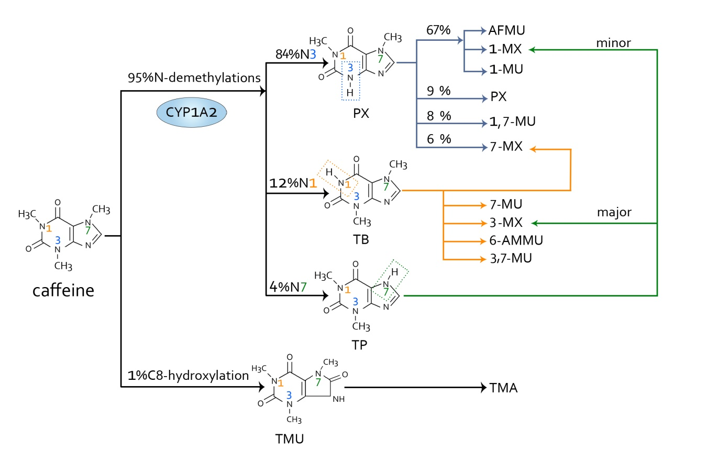
Figure 1 The major metabolism pathways of caffeine. The primary metabolic action of caffeine involves two main pathways. One is N-demethylation, which includes N1, N3 and N7-demethylations. Through N3-demethylation, caffeine can be degraded to form paraxanthine, which may be further degraded to 5-acetyl-amino-6-formylamino-3-methyluracil, 1-methylxanthine, 1-methyluric acid, 1,7-methyluric acid and 7-methylxanthine. A small amount of paraxanthine can be cleared in its unchanged form. Theobromine can be formed through N3-demethylation of caffeine, and it can be metabolized to form 7-methylxanthine, 7-methyluric acid, 3-methylxanthine, 6-amino-5[N-methylformylamino]-1-methyluracil and 3,7-methyluric acid. Moreover, caffeine can be metabolized to theophylline through N7-demethylation, and then theophylline can be further degraded to 1-methylxanthine and 3-methylxanthine. The other pathway is C8-hydroxylation in which caffeine is metabolized to trimethyluric acid and then 3,6,8-trimethylallantoin. PX: Paraxanthine; AFMU: 5-acetyl-amino-6-formylamino-3-methyluracil; 1-MX: 1-methylxanthine; 1-MU: 1-methyluric acid; 7-MU: 7-methyluric acid; 1,7-MU: 1,7-methyluric acid; 7-MX: 7-methylxanthine; TB: Theobromine; 3-MX: 3-methylxanthine; 6-AMMU: 6-amino-5[N-methylformylamino]-1-methyluracil; 3,7-MU: 3,7-methyluric acid; TP: Theophylline; TMU: Trimethyluric acid; TMA: 3,6,8-trimethylallantoin.
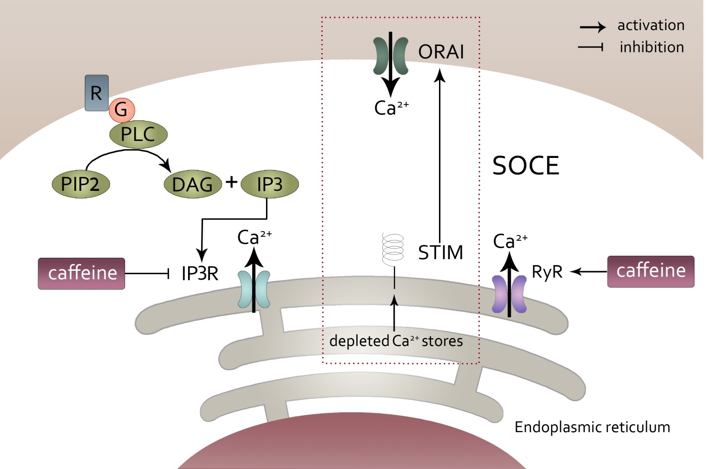

Figure 2 Modulation of intracellular calcium homeostasis by caffeine. Caffeine can modulate intracellular calcium homeostasis of inexcitable cells in two different ways. One way is by inhibiting the inositol 1,4,5-trisphosphate receptor through which Ca²⁺ released from the endoplasmic reticulum can be decreased, which results in a decrease in intracellular calcium levels. However, caffeine can increase the intracellular calcium levels by activating the ryanodine receptor, which causes an increase in Ca²⁺ being released from the endoplasmic reticulum. In this case, the store-operated Ca²⁺ entry, which was initiated from the depletion of Ca²⁺ from the endoplasmic reticulum can be activated and then result in an increase in extracellular Ca²⁺ getting into the intracellular compartment. IP3: 1,4,5-trisphosphate; IP3R: 1,4,5-trisphosphate receptor; ER: Endoplasmic reticulum; RyR: Ryanodine receptor; SOCE: Store-operated Ca²+ entry.
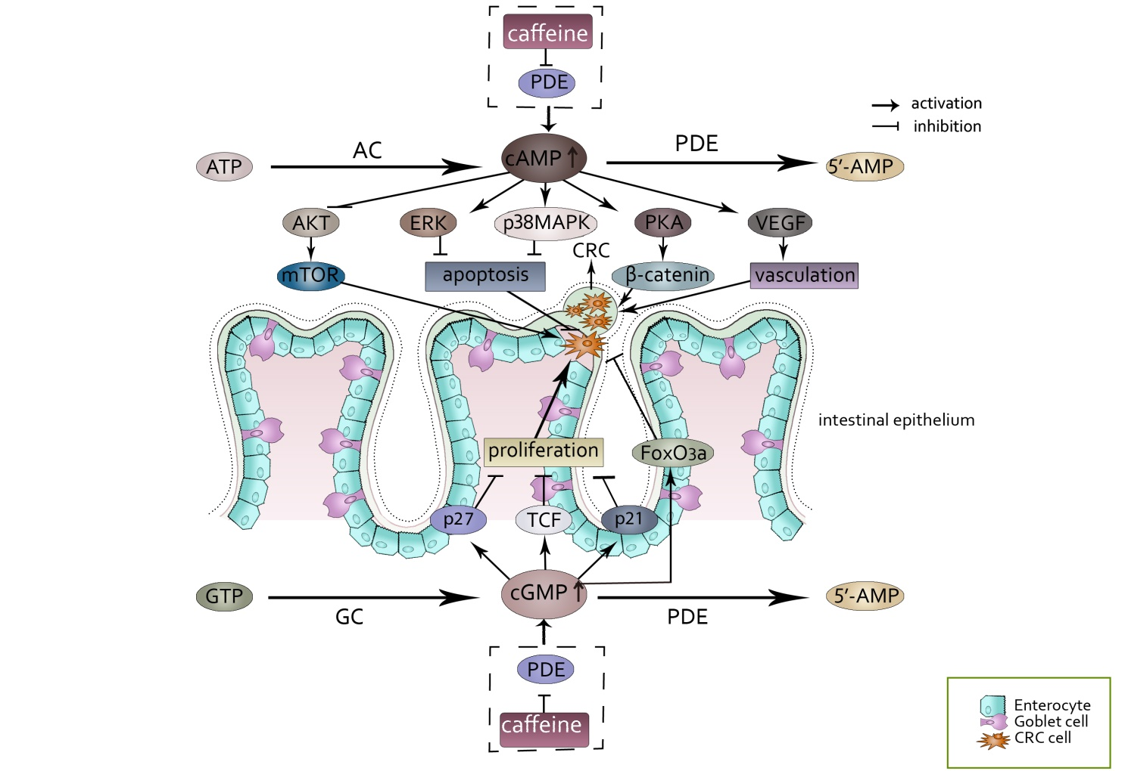

Figure 3 The effect of accumulated cAMP and cGMP caused by the inhibition of phosphodiesterase by caffeine. cAMP and cGMP levels are regulated by the balance between the activities of two types of enzymes, the generating enzymes (adenylate cyclase/guanylyl cyclase) and the degrading enzymes (phosphodiesterase). Caffeine can inhibit the degrading enzymes, which causes the accumulation of cAMP and cGMP. The accumulated cAMP and cGMP can interact with many factors and finally may result in a series of events of colorectal cancer cells. cAMP: Cyclic adenosine 3′,5′-monophosphate; cGMP: Cyclic guanosine 3′-5′ monophosphate; AC: Adenylate cyclases; GC: Guanylyl cyclase; PDEs: Phosphodiesterase; PKA: Protein kinase A; VEGF: Vascular endothelial growth factor; TCF: T cell factor.
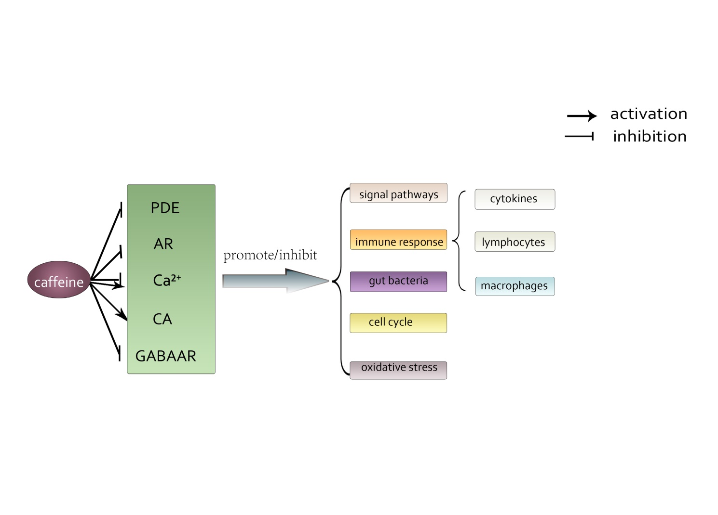

Figure 4 The main acting sites and physiological processes modulated by caffeine on colorectal cancer involved in this article. Through modulating acting sites such as phosphodiesterase, adenosine, Ca²⁺, catecholamines and γ-aminobutyric acid receptor, caffeine can exert varied effects (promote or inhibit) on physiological processes such as signal pathways, immune response, gut bacteria, cell cycle and oxidative stress. PDE: Phosphodiesterase; AR: Adenosine receptor; CA: Catecholamines; GABAAR: γ-aminobutyric acid receptor.

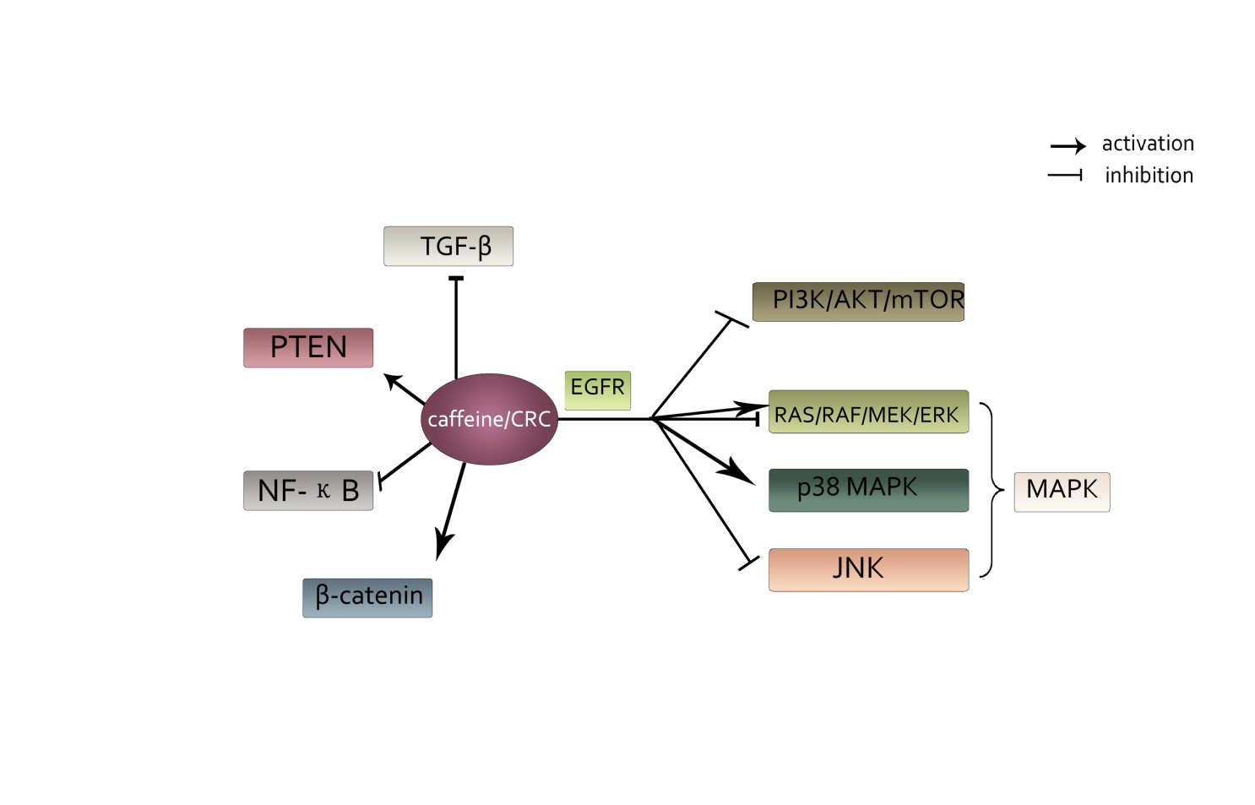
Figure 5 The main signaling pathways associated with colorectal cancer that can be influenced by caffeine involved in this article. Caffeine can interact with a number of signaling pathways. It shows an active effect on phosphatase and tensin homolog, β-catenin and p38 mitogen-activated protein kinase pathways. Additionally, it has negative effects on transforming growth factor β, NF-КB, phosphoinositide-3-kinase/AKT/mammalian target of rapamycin and c-Jun N-terminal kinase pathways. Moreover, caffeine showed a dual function on RAS/RAF/MEK/ERK pathways depending on concentration of caffeine. PTEN: Phosphatase and tensin homolog; MAPK: Mitogen-activated protein kinase; TGF-β: Transforming growth factor β; PI3K: Phosphoinositide-3-kinase; mTOR: Mammalian target of rapamycin; JNK: c-Jun N-terminal kinase.
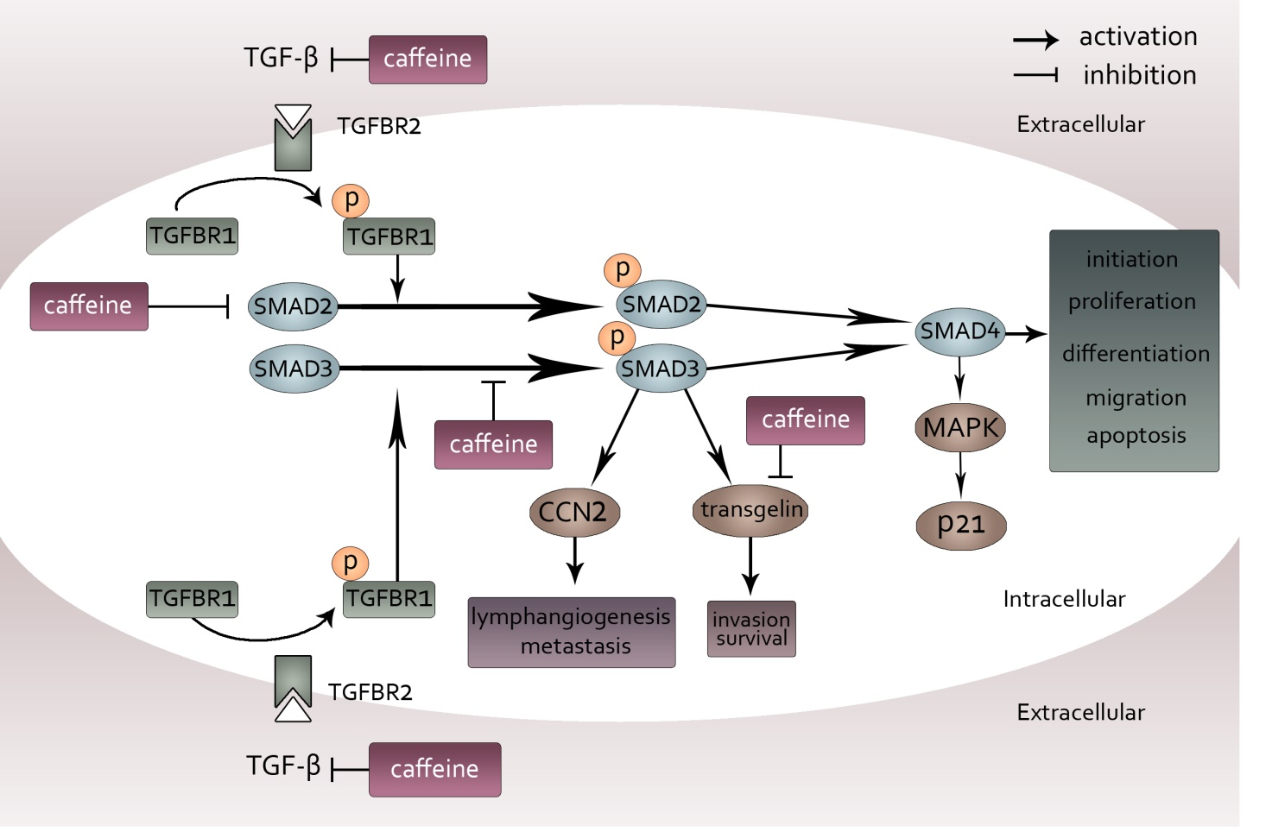
Figure 6 Inhibition of transforming growth factor β pathways caused by caffeine. When transforming growth factor (TGF-β) acts on its type II receptor, the type I receptor can be recruited and phosphorylated. Then, mediated by the activated TGF-β type I receptor, SMAD2 and SMAD3 are phosphorylated and exert their functions by modulating downstream factors such as CCN-family protein 2 and transgelin or by binding to SMAD4. Caffeine may influence this pathway not only through inhibiting TGF-β at the beginning of the pathway but also by reducing the steady state concentration of total SMAD2 and decreasing phosphorylation of SMAD3. Furthermore, caffeine can directly inhibit transgelin downstream of SMAD3, which plays an important part in invasion and survival. TGF-β: Transforming growth factor β; CCN2: CCN-family protein 2; TGFBR2: Transforming growth factor binding to the type II receptor; TGFBR1: Transforming growth factor binding to the type I receptor; MAPK: Mitogen-activated protein kinase.
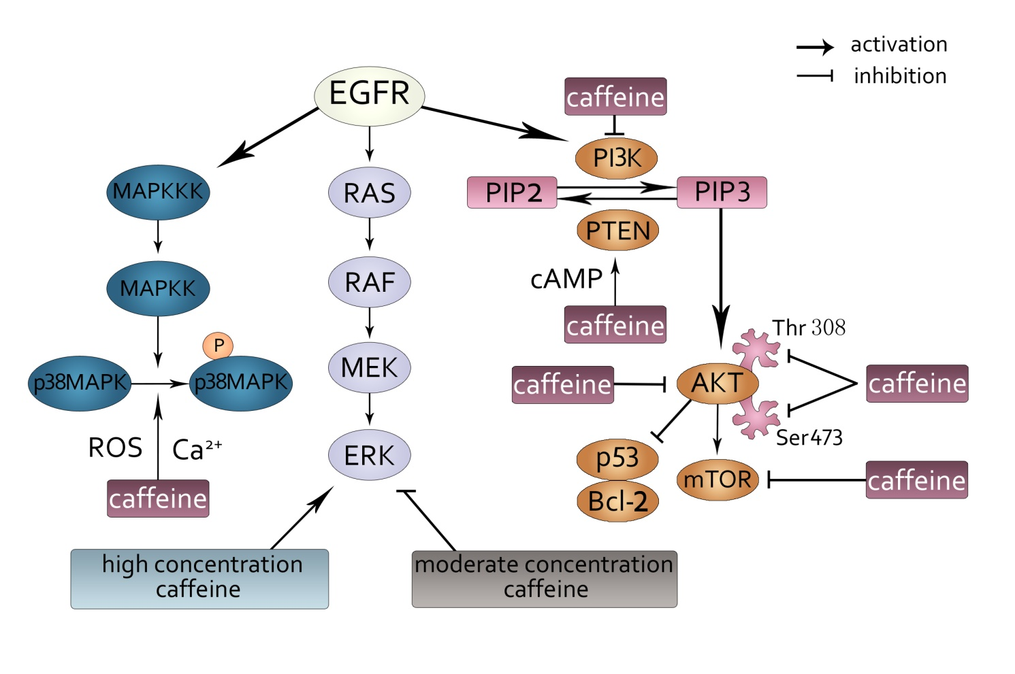Figure 7 Phosphoinositide-3-kinase, phosphatase and tensin homolog, p38 mitogen-activated protein kinase and RAS pathways modulated by caffeine. Three signaling pathways can be initiated by epidermal growth factor receptor: p38 mitogen-activated protein kinase (MAPK), RAS/RAF/MEK/ERK and PI3K/AKT/ mTOR pathways. p38 MAPK can be phosphorylated following the activation of MAPK kinase kinases and MAPK kinases. Caffeine can inhibit the activation of p38 MAPK though modulating the Ca²⁺ concentration and reactive oxygen species generation. Additionally, caffeine can exert a dual function on ERK, the downstream factor of the RAS/RAF/MEK pathway. At a high concentration, caffeine activates the ERK pathway. At a moderate concentration, caffeine shows an inhibitory effect on the ERK pathway. PI3K can convert phosphatidylinositol-4-phosphate (PIP) 2 to PIP3, and PTEN can reverse this conversion. Caffeine can activate PTEN and inhibit PI3K, in which case PIP3 can be reduced and PIP2 can be increased. Then, PIP3 can activate AKT, through which p53 and Bcl-2 can be activated, and the mTOR pathway can be inhibited. Caffeine can inhibit the phosphorylation of AKT by suppressing its residues Thr308 and Ser473. Moreover, caffeine can directly inhibit mTOR pathways. EGFR: Epidermal growth factor receptor; ERK: Extracellular-signal regulated kinases; mTOR: Mammalian target of rapamycin; MAPK: Mitogen-activated protein kinase; MAPKK: MAPK kinases; MAPKKKs: MAPK kinase kinases; ROS: Reactive oxygen species; PI3K: Phosphoinositide-3-kinase; PIP: Phosphatidylinositol-4-phosphate; PTEN: Phosphatase and tensin homolog.

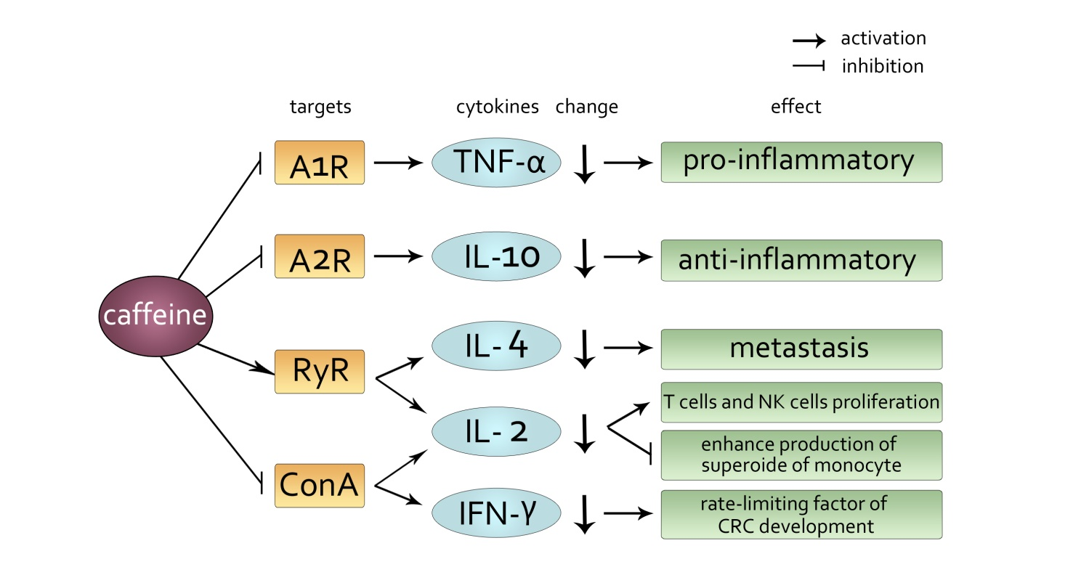Figure 8 The main targets and changes induced by caffeine acting on cytokines and their effects. Examples of mediated targets are A1R, A2R, ryanodine receptor and concanavalin A. Caffeine induces a decline in cytokines, such as tumor necrosis factor-alpha, interleukin (IL)-10, IL-4, IL-2, interferon-γ and exerts a differential effect. RyR: Ryanodine receptor; ConA: Concanavalin A; TNF-α: Tumor necrosis factor-alpha; IL: Interleukin; IFN: Interferon.

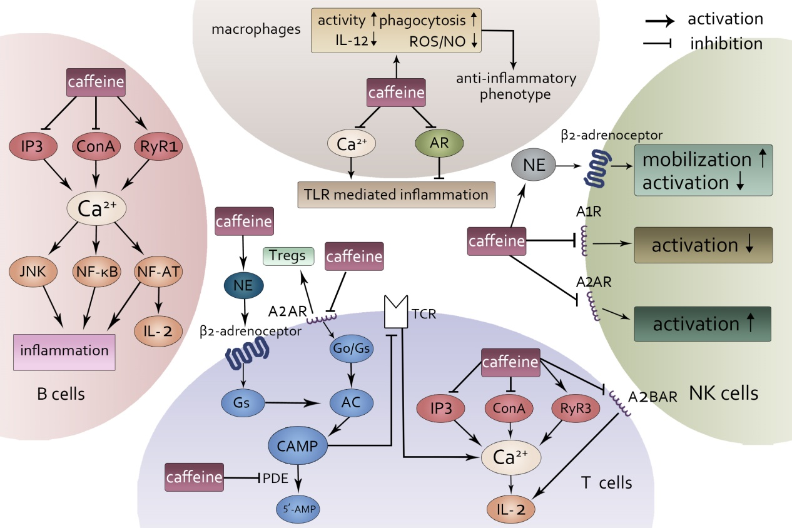

Figure 9 General effects of caffeine on lymphocytes and macrophages. Four types of immune cells can be influenced by caffeine. In T cells, cAMP and Ca²⁺ can be modulated by caffeine through the binding of adenosine receptors, inhibiting norepinephrine and phosphodiesterase. In B cells, caffeine can influence the immune response through interacting with Ca²⁺. In macrophages, caffeine can both inhibit and activate toll-like receptor-mediated inflammation by modulating Ca²⁺ and binding to adenosine. Furthermore, in natural killer cells, caffeine exerts a dual function on its activation. When it acts on A1R, it inhibits. When it acts on A2R, it induces. Moreover, by stimulating norepinephrine , caffeine can promote the mobilization of natural killer cells. AR: Adenosine receptors; NE: Norepinephrine; PDE: Phosphodiesterase; TLR: Toll-like receptor; NK: Natural killer; IL: Interleukin.

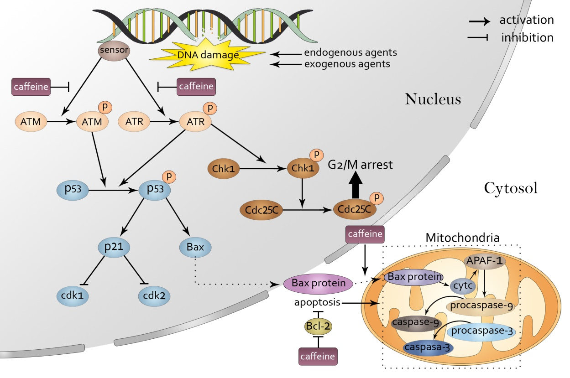

Figure 10 Caffeine influences the DNA repair process. When exogenous and endogenous agents attack DNA, DNA can be damaged, which immediately activates the DNA repair process. In this process, a sensor detects the damage and then causes the phosphorylation of ataxia-telangiectasia mutated and ataxia telangiectasia and Rad3-related. Caffeine can inhibit the phosphorylation of both ataxia-telangiectasia mutated and ataxia telangiectasia and Rad3-related. Phosphorylated ataxia telangiectasia and Rad3-related and ataxia-telangiectasia mutated can activate cyclin-dependent kinase 1, which induces G2/M arrest and p53. p53 then modulates its downstream target p21, which can influence the cell cycle by inhibiting Cdk1 and Cdk2. Moreover, Bax is also downstream of p53, and when it enters the mitochondria, it can initiate the apoptosis process. Caffeine can promote apoptosis by inhibiting the translocation of Bax from the nucleus to the mitochondria and also by suppressing the apoptosis inhibitor Bcl-2. ATM: Ataxia-telangiectasia mutated; ATR: Ataxia telangiectasia and Rad3-related; Chk: Cyclin-dependent kinase.

