Name of Journal: World Journal of Gastrointestinal Oncology
Manuscript NO: 46945
Manuscript type: CASE REPORT

Gastric submucosa-invasive carcinoma associated with Epstein-Barr virus and endoscopic submucosal dissection: A case report

Kobayashi Y et al. EBV-associated submucosal gastric cancer

Yu Kobayashi, Takehito Kunogi, Hiroki Tanabe, Yuki Murakami, Takuya Iwama, Takahiro Sasaki, Keitaro Takahashi, Katsuyoshi Ando, Yoshiki Nomura, Nobuhiro Ueno, Shin Kashima, Kentaro Moriichi, Hidehiro Takei, Mikihiro Fujiya, Toshikatsu Okumura

Yu Kobayashi, Takehito Kunogi, Hiroki Tanabe, Yuki Murakami, Takuya Iwama, Takahiro Sasaki, Keitaro Takahashi, Katsuyoshi Ando, Yoshiki Nomura, Nobuhiro Ueno, Shin Kashima, Kentaro Moriichi, Mikihiro Fujiya, Toshikatsu Okumura, Division of Gastroenterology and Hematology/Oncology Department of Medicine, Asahikawa Medical University, Asahikawa 078-8510, Japan

Hidehiro Takei, Pathological Department of Asahikawa Medical University Hospital, Asahikawa Medical University, Asahikawa 078-8510, Japan

ORCID number: Yu Kobayashi (0000-0002-6196-604X); Takehito Kunogi (0000-0001-7028-1256); Hiroki Tanabe (0000-0001-9029-5081); Yuki Murakami (0000-0002-7738-3578); Takuya Iwama (0000-0002-8641-8605); Takahiro Sasaki (0000-0002-0412-8760); Keitaro Takahashi (0000-0003-4188-0246); Katsuyoshi Ando (0000-0003-3500-5488); Yoshiki Nomura (0000-0002-2607-0029); Nobuhiro Ueno (0000-0001-5448-4766); Shin Kashima (0000-0001-8309-4281); Kentaro Moriichi (0000-0002-1298-3265); Hidehiro Takei (0000-0002-2095-670X); Mikihiro Fujiya (0000-0002-4321-7774); Toshikatsu Okumura (0000-0003-1810-007X).

Author contributions: All authors contributed to this work.

Informed consent statement: All procedures were in accordance with the 1964 Helsinki Declaration and later versions. No identifying information of the patients or human subjects was included in the written descriptions, photographs, or pedigrees. The study participants provided their written informed consent prior to study enrollment.

Conflict of interest statement: The authors declare no conflict of interest in association with the present study.

Open-Access: This article is an open-access article which was selected by an in-house editor and fully peer-reviewed by external reviewers. It is distributed in accordance with the Creative Commons Attribution Non Commercial (CC BY-NC 4.0) license, which permits others to distribute, remix, adapt, build upon this work non-commercially, and license their derivative works on different terms, provided the original work is properly cited and the use is non-commercial. See: http://creativecommons.org/licenses/by-nc/4.0/

Manuscript source: Unsolicited manuscript

CARE Checklist (2016) statement: The authors have read the CARE Checklist (2016), and the manuscript was prepared and revised according to the CARE Checklist (2016).

Corresponding author: Hiroki Tanabe, MD, PhD, Doctor, Division of Gastroenterology and Hematology/Oncology Department of Medicine, Asahikawa Medical University, 2-1-1-1, Midorigaoka-Higashi, Asahikawa 078-8510, Japan. tant@asahikawa-med.ac.jp
Telephone: +81-166-682462
Fax: +81-166-682469

Received: March 6, 2019
Peer-review started: March 8, 2019
First decision: April 15, 2019
Revised: July 24, 2019
Accepted: August 26, 2019
Article in press:
Published online:

Abstract
BACKGROUND
Epstein-Barr virus (EBV)-associated carcinoma is a gastric cancer subtype with a morphology characterized by gastric carcinoma with lymphoid stroma (GCLS). Clinicopathological studies have indicated a better prognosis for GCLS than for common gastric carcinomas. Some previous cases of early gastric cancer associated with EBV had been diagnosed by endoscopic resection.

CASE SUMMARY
We present two GCLS cases subjected to endoscopic submucosal dissection (ESD) for a definitive diagnosis. A protruded gastric lesion was identified by routine endoscopic examination, but forceps biopsy showed no atypical cells before ESD. The resected specimen showed a poorly differentiated adenocarcinoma with lymphoid cells involving the mucosa and submucosa. The final diagnosis was submucosa-invasive poorly differentiated gastric adenocarcinoma. Accordingly, additional gastrectomy was recommended to obtain a complete cure. One patient underwent additional distal gastrectomy with lymph node dissection, but the other was refused because of cardiovascular complications. Both patients remained in remission for more than half a year. EBV positivity was determined by EBV-encoded RNA in situ hybridization. We also conducted a literature review of cases of early gastric cancer associated with EBV that had been diagnosed by ESD.

CONCLUSION
Submucosa-invasive GCLS could be dissected using ESD, and EBV positivity should be subsequently assessed to determine whether or not any additional curative surgery is required. Further prospective investigations on the prevalence of lymph node metastasis in EBV-associated carcinoma should be performed to expand the indications for endoscopic resection.

Key words: Herpesvirus 4; Human; Stomach neoplasms; Gastric carcinoma with lymphoid stroma; Epstein-Barr virus-associated gastric carcinoma; Case report

© The Author(s) 2019. Published by Baishideng Publishing Group Inc. All rights reserved.

Core tip: Two cases of Epstein-Barr virus (EBV)-associated gastric carcinoma were diagnosed by endoscopic submucosal dissection (ESD). Because of its low frequency of lymph node metastasis, EBV-associated carcinoma can be treated with ESD without additional surgery.

Kobayashi Y, Kunogi T, Tanabe H, Murakami Y, Iwama T, Sasaki T, Takahashi K, Ando K, Nomura Y, Ueno N, Kashima S, Moriichi K, Takei H, Fujiya M, Okumura T. Gastric submucosa-invasive carcinoma associated with Epstein-Barr virus and endoscopic submucosal dissection: A case report. World J Gastrointest Oncol 2019; In press

INTRODUCTION
Epstein-Barr virus (EBV), also known as human herpesvirus 4, is associated with Burkitt lymphoma, nasopharyngeal carcinoma, and natural killer/T lymphoma. EBV is also positive in 80%-90% of cases of gastric carcinoma with lymphoid stroma (GCLS), which includes undifferentiated adenocarcinoma with intense lymphoid infiltration^{[1]}.
GCLS was first proposed as a separate entity in 1976^{[2]}, and lymphoepithelioma-like carcinoma associated with EBV was found in 1990^{[3,4]}. The clinical features of EBV-associated gastric carcinoma include its location in the middle or upper stomach and a superficially depressed or submucosal tumor (SMT)-like appearance. Clinicopathological studies have indicated that EBV-positive carcinomas have a better prognosis and lower rate of lymph node metastasis than EBV-negative carcinomas^{[1,5,6]}. In the Cancer Genome Atlas (TCGA) project, gastric cancers are divided into four subtypes, one of which is positive for EBV. EBV-positive gastric cancer has recently attracted much attention due to dramatic advances in drug therapies such as DNA methylation inhibitors and immune checkpoint inhibitors^{[7]}.
EBV-associated GCLS is defined as a poorly differentiated carcinoma admixed with marked subepithelial lymphoid cell infiltration. Because the carcinoma is covered with an overlying normal epithelium, an endoscopic biopsy sometimes fails to yield tissue specimens to be pathologically diagnosed as malignant. We performed an endoscopic mucosal dissection (ESD) in two GCLS cases to obtain a definitive diagnosis. EBV positivity in cancer cells was confirmed by EBV-encoded small RNA in situ hybridization. We also reviewed cases of EBV-associated submucosa-invasive GCLS that were subjected to ESD.

CASE PRESENTATION
Case 1
Chief complaint: A 72-year-old woman complaining of abdominal discomfort had been treated for chronic gastritis in our hospital.

History of present illness: She had a medical history of eradication of Helicobacter pylori without a family history of gastric malignancy.

Physical examination: There were no abnormal findings in physical examination, and the serum chemistry and complete blood count were normal.

Imaging examinations: She underwent esophagogastroduodenoscopy at her routine check-up. A 20-mm protruding lesion with a central depression was noted in the middle gastric body (Figure 1A). Forceps biopsy showed no atypical cells. Computed tomography (CT) did not revealed gastric tumor or lymph node swelling. Four months later, an endoscopic re-examination revealed no significant difference in findings, with no atypical cells in the biopsy specimen, but subsequent endoscopic ultrasonography indicated a hypoechoic lesion that massively infiltrating the submucosa (Figure 1B and C). Due to a strong suspicion of gastric carcinoma, ESD was performed. The ESD specimen showed a poorly differentiated adenocarcinoma with accompanying prominent lymphoid tissues involving the mucosa and submucosa (Figure 2). Lymphatic invasion was observed, and EBV-encoded RNA (EBER) was detected by in situ hybridization.

Case 2
Chief complaint: A 73-year-old man was referred to our hospital due to an SMT in the lower gastric body, which had been followed at a city hospital for 4 years.

History of present illness: A follow-up endoscopic examination showed no apparent changes from previous evaluations. The SMT was further examined because the patient needed treatment for myocardial infarction and abdominal aortic aneurysm at a tertiary hospital.

Physical examination: There was no family history of malignancy. No physical finding in his abdomen was observed in our consultation room.

Laboratory examinations: His complete blood count was normal, and most of the blood parameters were within normal range, except for a slight decrease in the renal function test (estimated glomerular filtration rate, 48.5 mL/min).

Imaging examinations: Annual endoscopy revealed no significant change for the following 3 years, and no atypical cells were obtained by forceps biopsy. CT did not reveal gastric tumor or lymph node metastasis. However endoscopic ultrasonography demonstrated a multinodular hypoechoic lesion, measuring 1.5 cm in the greatest dimension, with submucosal involvement (Figure 3). GCLS was suspected, and ESD was performed for a definitive pathological diagnosis when the patients was 76 years old. The pathological diagnosis (Figure 4) was a carcinoma with lymphoid stroma, 19 x 16 mm, and infiltrating into the deep submucosa (SM2, 5200 m). No lymphovascular invasion was detected. EBV was positive in cancer cells based on EBER in situ hybridization.

FINAL DIAGNOSIS
Case 1 and Case 2
Submucosa-invasive GCLS, EBV-positive. Both patients were recommended to undergo additional distal gastrectomy because there is a risk of lymph node metastasis when poorly differentiated gastric carcinoma is invading the submucosa.

TREATMENT
Case 1
The patient underwent distal gastrectomy, and no residual tumor or lymph node metastasis was observed in the resected specimen.

Case 2
The patient refused surgical operation because of his cardiovascular complications, and was hoping for careful medical observation without chemotherapy or radiotherapy.

OUTCOME AND FOLLOW-UP
Case 1
The patient remained without recurrence at the nine-month follow-up.

Case 2
The patient underwent re-examination by gastroscopy, and no residual atypical cells were pathologically observed at six months after ESD. Helicobacter pylori was positive in the biopsy specimen taken from the gastric body, and eradication therapy was therefore performed.

DISCUSSION
Helicobacter pylori is the major cause of gastric cancer, and its eradication is recommended to decrease the risk of gastric cancer. An association between EBV and gastric cancer has also been suggested, as viral clonality is observed in proliferating cancer cells^{[8]}. EBV-associated gastric cancer is characterized as poorly differentiated carcinoma with prominent lymphoid infiltration, clearly distinguishable from Helicobacter pylori-associated gastric cancer. As the infection rate with Helicobacter pylori is decreasing worldwide, trends in EBV-associated gastric cancer are now being monitored with interest by many researchers.
TCGA classifies gastric cancer into four subtypes: EBV-positive tumors, microsatellite unstable tumors, genetically stable tumors, and tumors with chromosomal instability^{[7]}. The EBV-positive subtype shows DNA hypermethylation in host cell DNA due to methyltransferase 1 transcription induced by EBV latent membrane protein 2A. It displays amplification of programmed death-ligand 1 (PD-L1) and PD-L2, and the immune tolerance of the neoplasms may be associated with carcinogenesis. While patients with EBV-associated gastric cancer tend to have a good prognosis, the underlying molecular mechanism remains unclear^{[9,10]}.
Early GCLS has peculiar clinicopathological features, and its prognosis depends on the EBV infection status^{[11]}. Early GCLS has also been analyzed in relation to lymph node metastasis, and EBV positivity is a predictive marker of a negative lymph node metastasis^{[12,13]}. The risk of lymph node metastasis of mucosal GCLS and that of submucosal GCLS are 0 and 4.0%-10.6%, respectively. Limited to EBV-positive cases, intramucosal gastric cancer displays no lymph node metastasis, as reported by Japanese researchers (Tokunaga et al^{[14]} and Murai et al^{[15]}). Therefore, intramucosal EBV-positive gastric carcinomas could be treated by ESD rather than radical gastric surgery, because these cases are associated with a minimal risk of lymph node metastasis. The association between EBV positivity of submucosa-invasive GCLS and lymph node metastasis has not been previously described. A study in Korea reported that EBV positivity is a favorable risk factor for lymph node metastasis in submucosa-invasive gastric cancer, with a rate of metastasis of 4.7%^{[9]}. The authors suggested that EBV positivity might be considered an additional criterion for the indication of endoscopic resection. We therefore reviewed cases of EBV-positive gastric cancer in which ESD was performed for diagnosis and treatment.
We conducted a database search of PubMed, Scopus and ScienceDirect using the following terms: (“gastric carcinoma” or “gastric cancer”) and (EBV or “Epstein-Barr virus” or “human herpesvirus 4”) and (“endoscopic submucosal dissection” or ESD). An search of reported references was also performed. A total of 9 cases were described with detailed clinical information in six reports^{[16-21]}. Upon the addition of our 2 cases, 11 EBV-positive gastric submucosal cancer cases were ultimately collected by our database search (Table 1). This disease was found to be associated with male sex, proximal location, and depressed or SMT-like appearance. The diagnosis appeared to be difficult, as 5 cases (45.5%) were negative on pathological examination by forceps biopsy. Repeated biopsies failed to yield malignant cells in both of our cases. The depths of the tumor invasion were more than 1 mm into the submucosa from the deepest portion of the muscularis mucosae; however, the horizontal dimension was smaller than 2 cm in most cases. In the five cases that were subjected to subsequent radical gastrectomy with lymph node dissection, no lymph node metastasis was observed. Furthermore, neither local recurrence nor distant metastasis was reported throughout the follow-up periods. Therefore, submucosa-invasive cancer can be completely excised, allowing us to cure the patients with early gastric cancer. Excessive and unnecessary gastrectomy might therefore be avoided and replaced by minimally invasive endoscopic resection.
The European Society of Gastrointestinal Endoscopy guidelines strongly recommend endoscopic resection for the treatment of superficial gastric neoplastic lesions that possess a very low risk of lymph node metastasis^{[22]}. According to the recommendations of Japanese gastric cancer treatment guidelines, “endoscopic resection is considered for tumors that have a very low possibility of lymph node metastasis and are suitable for en-bloc resection” as a general principle regarding the indications for endoscopic resection^{[23]}. The absolute indication as a standard treatment is well-differentiated adenocarcinoma with no ulceration, T1a depth, and diameter < 2 cm. The expanded indication for undifferentiated-type adenocarcinoma is T1a depth, no ulceration, and diameter < 2 cm. Based on our review of the previous reports of GCLS and EBV-associated carcinomas, endoscopic resection may thus be acceptable for mucosal GCLS even if it is of the undifferentiated-type, regardless of its horizontal diameter. For cases of submucosa-invasive EBV-associated carcinoma, ESD can also be a diagnostic procedure unless a diagnosis of GCLS is confirmed by forceps biopsy.

CONCLUSION
Further prospective studies into whether or not endoscopic resection can cure EBV-associated carcinomas are required to expand the therapeutic indications for gastric cancer. Positivity for EBV will be a useful predictive marker of lymph node metastasis, which can help us determine the optimal treatment strategy.

REFERENCES
1 Nishikawa J, Iizasa H, Yoshiyama H, Shimokuri K, Kobayashi Y, Sasaki S, Nakamura M, Yanai H, Sakai K, Suehiro Y, Yamasaki T, Sakaida I. Clinical Importance of Epstein⁻Barr Virus-Associated Gastric Cancer. Cancers (Basel) 2018; 10: pii: E167 [PMID: 29843478 DOI: 10.3390/cancers10060167]
2 Watanabe H, Enjoji M, Imai T. Gastric carcinoma with lymphoid stroma. Its morphologic characteristics and prognostic correlations. Cancer 1976; 38: 232-243 [PMID: 947518 DOI: 10.1002/1097-0142(197607)38:1<232::AID-CNCR2820380135>3.0.CO;2-4]
3 Burke AP, Yen TS, Shekitka KM, Sobin LH. Lymphoepithelial carcinoma of the stomach with Epstein-Barr virus demonstrated by polymerase chain reaction. Mod Pathol 1990; 3: 377-380 [PMID: 2163534]
4 Shibata D, Tokunaga M, Uemura Y, Sato E, Tanaka S, Weiss LM. Association of Epstein-Barr virus with undifferentiated gastric carcinomas with intense lymphoid infiltration. Lymphoepithelioma-like carcinoma. Am J Pathol 1991; 139: 469-474 [PMID: 1653517 DOI: 10.1097/00000433-199109000-00026]
5 Huh CW, Jung DH, Kim H, Kim H, Youn YH, Park H, Kim JW, Choi SH, Noh SH, Kim JH. Clinicopathologic features of gastric carcinoma with lymphoid stroma in early gastric cancer. J Surg Oncol 2016; 114: 769-772 [PMID: 27450278 DOI: 10.1002/jso.24385]
6 Wang HH, Wu MS, Shun CT, Wang HP, Lin CC, Lin JT. Lymphoepithelioma-like carcinoma of the stomach: A subset of gastric carcinoma with distinct clinicopathological features and high prevalence of Epstein-Barr virus infection. Hepatogastroenterology 1999; 46: 1214-1219 [PMID: 10370694 DOI: 10.1046/j.1523-5378.1999.09061.x]
7 Cancer Genome Atlas Research Network.. Comprehensive molecular characterization of gastric adenocarcinoma. Nature 2014; 513: 202-209 [PMID: 25079317 DOI: 10.1038/nature13480]
8 Imai S, Koizumi S, Sugiura M, Tokunaga M, Uemura Y, Yamamoto N, Tanaka S, Sato E, Osato T. Gastric carcinoma: Monoclonal epithelial malignant cells expressing Epstein-Barr virus latent infection protein. Proc Natl Acad Sci U S A 1994; 91: 9131-9135 [PMID: 8090780 DOI: 10.1073/pnas.91.19.9131]
9 Park JH, Kim EK, Kim YH, Kim JH, Bae YS, Lee YC, Cheong JH, Noh SH, Kim H. Epstein-Barr virus positivity, not mismatch repair-deficiency, is a favorable risk factor for lymph node metastasis in submucosa-invasive early gastric cancer. Gastric Cancer 2016; 19: 1041-1051 [PMID: 26573601 DOI: 10.1007/s10120-015-0565-1]
10 Lim H, Park YS, Lee JH, Son DH, Ahn JY, Choi KS, Kim DH, Choi KD, Song HJ, Lee GH, Jung HY, Kim JH, Yook JH, Kim BS. Features of Gastric Carcinoma With Lymphoid Stroma Associated With Epstein-Barr Virus. Clin Gastroenterol Hepatol 2015; 13: 1738-1744.e2 [PMID: 25912839 DOI: 10.1016/j.cgh.2015.04.015]
11 Hissong E, Ramrattan G, Zhang P, Zhou XK, Young G, Klimstra DS, Shia J, Fernandes H, Yantiss RK. Gastric Carcinomas With Lymphoid Stroma: An Evaluation of the Histopathologic and Molecular Features. Am J Surg Pathol 2018; 42: 453-462 [PMID: 29438172 DOI: 10.1097/PAS.0000000000001018]
12 Shin DH, Kim GH, Lee BE, Lee JW, Ha DW, Jeon HK, Baek DH, Song GA, Ahn SJ, Park DY. Clinicopathologic features of early gastric carcinoma with lymphoid stroma and feasibility of endoscopic submucosal dissection. Surg Endosc 2017; 31: 4156-4164 [PMID: 28409376 DOI: 10.1007/s00464-017-5470-8]
13 Lim H, Lee IS, Lee JH, Park YS, Kang HJ, Na HK, Ahn JY, Kim DH, Choi KD, Song HJ, Lee GH, Jung HY, Kim JH, Kim BS, Yook JH, Kim BS. Clinical application of early gastric carcinoma with lymphoid stroma based on lymph node metastasis status. Gastric Cancer 2017; 20: 793-801 [PMID: 28205059 DOI: 10.1007/s10120-017-0703-z]
14 Tokunaga M, Land CE. Epstein-Barr virus involvement in gastric cancer: Biomarker for lymph node metastasis. Cancer Epidemiol Biomarkers Prev 1998; 7: 449-450 [PMID: 9610796 DOI: 10.4055/jkoa.2012.47.3.198]
15 Murai K, Kakushima N, Sugino T, Yoshida M, Kawata N, Tanaka M, Takizawa K, Muramatu K, Kusafuka K, Bando E, Ono H. Epstein-Barr virus positivity among surgically resected intramucosal gastric cancer. Dig Endosc 2018; 30: 667-671 [PMID: 29729036 DOI: 10.1111/den.13181]
16 Gromski MA, Miller CA, Lee SH, Lee TH, Chung IK, Park SH, Kim SJ, Cho HD. Gastric lymphoepithelioma-like carcinoma mimicking a subepithelial lesion treated by endoscopic submucosal dissection. Gastrointest Endosc 2012; 76: 419-421 [PMID: 22817794 DOI: 10.1016/j.gie.2012.03.1397]
17 Lee HL, Kim DC, Lee SP, Lee KN, Jun DW, Lee OY, Han DS, Yoon BC, Choi HS, Hahm JS, Jang KS. Treatment of Epstein-Barr virus-associated gastric carcinoma with endoscopic submucosal dissection. Gastrointest Endosc 2012; 76: 913-915 [PMID: 22196795 DOI: 10.1016/j.gie.2011.09.040]
18 Matsumoto T, Shimeno N, Imai Y, Inokuma T. Gastric carcinoma with lymphoid stroma resembling a hypoechoic submucosal tumor. Gastrointest Endosc 2013; 78: 164-5; discussion 165 [PMID: 23557836 DOI: 10.1016/j.gie.2013.02.023]
19 Lee JY, Kim KM, Min BH, Lee JH, Rhee PL, Kim JJ. Epstein-Barr virus-associated lymphoepithelioma-like early gastric carcinomas and endoscopic submucosal dissection: case series. World J Gastroenterol 2014; 20: 1365-1370 [PMID: 24574813 DOI: 10.3748/wjg.v20.i5.1365]
20 Chen M, Yin L, Yao Y, Wang L, Xu G, Zhang X, Lv Y, Sun QI, Fan X, Zou X. Lymphoepithelioma-like gastric carcinoma in a patient with rectal laterally spreading tumor: A case report. Oncol Lett 2016; 11: 2491-2496 [PMID: 27073504 DOI: 10.3892/ol.2016.4268]
21 Kato M, Hayashi Y, Fukumoto K, Nagai K, Tsujii Y, Shinzaki S, Iijima H, Takehara T. Early gastric cancer with lymphoid stroma presenting as a subepithelial lesion diagnosed by endoscopic submucosal dissection. Clin J Gastroenterol 2018; 11: 382-385 [PMID: 29637432 DOI: 10.1007/s12328-018-0855-3]
22 Pimentel-Nunes P, Dinis-Ribeiro M, Ponchon T, Repici A, Vieth M, De Ceglie A, Amato A, Berr F, Bhandari P, Bialek A, Conio M, Haringsma J, Langner C, Meisner S, Messmann H, Morino M, Neuhaus H, Piessevaux H, Rugge M, Saunders BP, Robaszkiewicz M, Seewald S, Kashin S, Dumonceau JM, Hassan C, Deprez PH. Endoscopic submucosal dissection: European Society of Gastrointestinal Endoscopy (ESGE) Guideline. Endoscopy 2015; 47: 829-854 [PMID: 26317585 DOI: 10.1055/s-0034-1392882]
23 Japanese Gastric Cancer Association.. Japanese gastric cancer treatment guidelines 2014 (ver. 4). Gastric Cancer 2017; 20: 1-19 [PMID: 27342689 DOI: 10.1007/s10120-016-0622-4]

P-Reviewer: Yu SP S-Editor: Yan JP
L-Editor: E-Editor:

Specialty type: Oncology
Country of origin: Japan
Peer-review report classification
Grade A (Excellent): 0
Grade B (Very good): 0
Grade C (Good): C
Grade D (Fair): 0
Grade E (Poor): 0

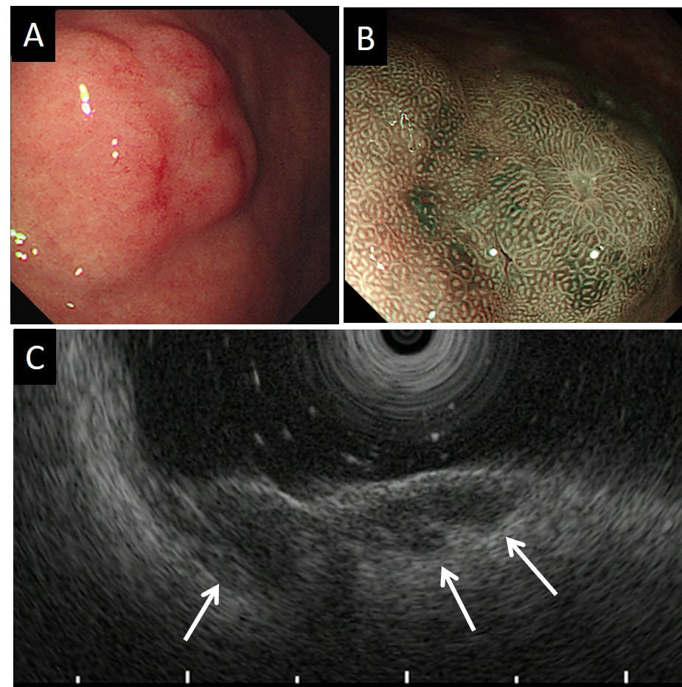
Figure 1 Endoscopic and ultrasonographic images of gastric carcinoma with lymphoid stroma (Case 1). A: A protruding lesion with central depression is covered with mucosa, the surface of which shows slight hyperemia; B: Magnifying narrow-band imaging reveals regular round and oval pits on the surface of the tumor; C: A 7.5-MHz endoscopic ultrasound image shows hypo-echoic lesions projecting into the third hyperechoic layer (white arrows).

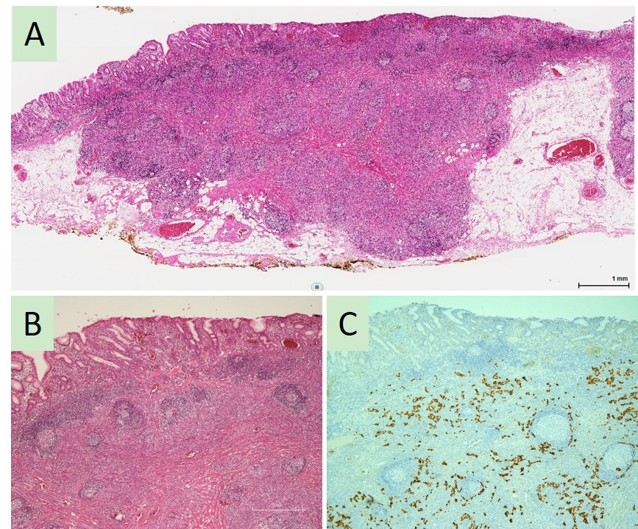
Figure 2 Findings on histological examination of the endoscopically resected specimen (Case 1). A: The low-magnification view shows gastric carcinoma with lymphoid stroma (GCLS) located in the mucosa to deep submucosa (hematoxylin and eosin: HE); B: A microscopic view of the GCLS reveals normal epithelium overlying the tumor (HE, × 100); C: Epstein-Barr virus-encoded RNA in situ hybridization shows intense staining in carcinoma cells (× 100). GCLS: Gastric carcinoma with lymphoid stroma; HE: Hematoxylin and eosin.

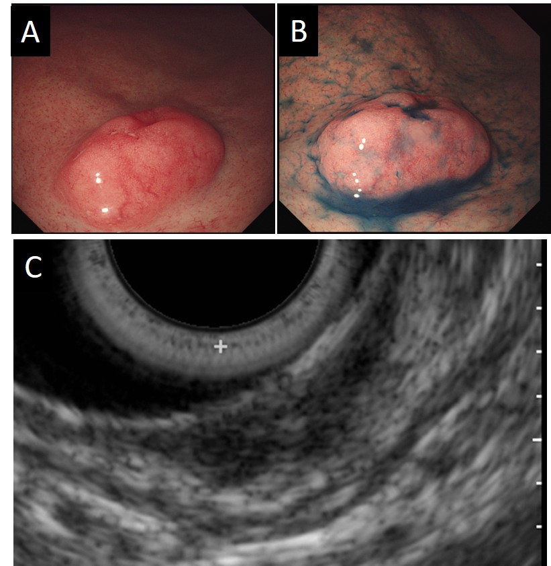
Figure 3 Endoscopic and ultrasonographic images of gastric carcinoma with lymphoid stroma (Case 2). A: Submucosal tumor-like lesion with dilated capillary vessels is found in the lower gastric body at the first endoscopic examination; B: Indigo carmine dye spraying emphasizes the protruded tumor with central depression; C: A 20 MHz endoscopic ultrasound image shows a multinodular hypoechoic mass located in the submucosal layer.

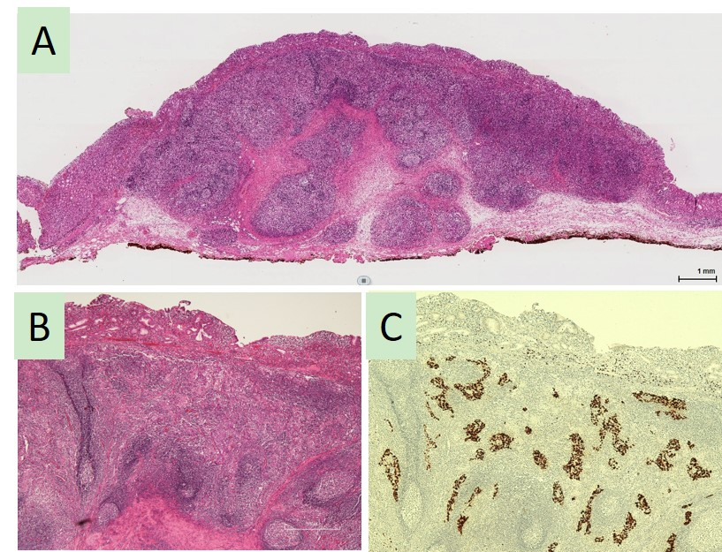
Figure 4 Findings on histological examination of the endoscopically resected specimen (Case 2). A: The low-magnification view shows gastric carcinoma with lymphoid stroma mainly located in the submucosal layer (hematoxylin and eosin: HE); B: A microscopic view reveals massive infiltration of lymphoid cells (HE, × 100); C: Epstein-Barr virus-encoded RNA in situ hybridization shows intensely positive staining in the nests of cancer cells (× 100). HE: Hematoxylin and eosin.

Table 1 A summary of cases of Epstein-Barr virus-associated gastric cancer treated using endoscopic submucosal dissection
 | Study | Age (yr), Sex | Diameter (cm) | Lesions | Features | Biopsy diagnosis | ESD diagnosis | EBV | Depth | Additional surgery | Lymph node metastasis | Prognosis
 | Gromski et al^{[16]}, 2012 | 67, M | 2 × 1.2 | lower body | centrally depressed lesion | chronic gastritis | lymphoepithelioma-like gastric carcinoma | positive | SM2 | not performed | ND | no recurrence for 12 M
 | Lee et al^{[17]}, 2012 | 43, M | NA | NA | multiple elevated erosive lesions with mild central depressions | adenocarcinoma | lymphoepithelioma-like gastric carcinoma with lymphoid-rich stroma | positive | SM2 (1538 m) | not performed | ND | no recurrence for 24 M
 | Matsumoto et al^{[18]}, 2013 | 58, M | NA | upper body | submucosal tumor associated with a slightly depressed lesion | adenocarcinoma | gastric carcinoma with lymphoid stroma | positive | SM2 | formal resection | negative | NA
 | Lee et al^{[19]}, 2014 | 63, M | 2.0 | high body | elevated lesion that displayed surface hyperemia | moderately differentiated adenocarcinoma | lymphoepithelioma-like gastric carcinoma | positive | SM2 (1800 m) | total gastrectomy | negative | no recurrence for 48 M
 |  | 65, M | 1.0 | low body | slightly elevated | moderately differentiated adenocarcinoma | lymphoepithelioma-like gastric carcinoma | positive | SM (1800 m) | not performed | ND | no recurrence for 32 M
 |  | 74, M | 1.5 | low body | slightly elevated lesion with central dimpling | a few markedly atypical cells | lymphoepithelioma-like gastric carcinoma | positive | SM2 (2500 m) | not performed | ND | no recurrence for 28 M
 |  | 84, M | 1.5 | cardia | large reddish and slightly depressed lesion | moderately differentiated adenocarcinoma | lymphoepithelioma-like gastric carcinoma | positive | SM2 (2300 m) | not performed | ND | no recurrence for 27 M
 | Chen et al^{[20]}, 2016 | 50, M | 2.5 × 2.5 | gastric body | a submucosal columnar lesion with surface erosion | moderate chronic superficial gastritis | lymphoepithelioma-like gastric carcinoma | positive | SM | total radical gastrectomy | negative | no recurrence for 12 M
 | Kato et al^{[21]}, 2018 | 53, M | 2.0 | middle body | subepithelial lesion with center depressed | benign gastric mucosa | gastric cancer with lymphoid stroma | positive | SM2 | distal gastrectomy | negative | NA
 | Present cases | 72, F | 2.0 | middle body | protruding lesions with central depression | no atypical cells | gastric carcinoma with lymphoid stroma | positive | SM2 (>4000 m) | distal gastrectomy | negative | no recurrence for 9 M
 |  | 76, M | 1.5 | lower body | submucosal tumor | no atypical cells | gastric carcinoma with lymphoid stroma | positive | SM2 (5200 m) | not performed | ND | no recurrence for 8 M
ESD: Endoscopic submucosal dissection; EBV: Epstein-Barr virus; SM: Submucosa; ND: Not determined; NA: Not available; M: Male.

