Name of Journal: World Journal of Gastroenterology
Manuscript NO: 53063
Manuscript Type: REVIEW

Possible role of intestinal stem cells in the pathophysiology of irritable bowel syndrome

El-Salhy M. Stem cells in IBS

Magdy El-Salhy

Magdy El-Salhy, Section for Gastroenterology, Department of Medicine, Stord Hospital, Stord 54 09, Norway

Magdy El-Salhy, Department of Clinical Medicine, University of Bergen, Bergen 50 21, Norway

Author contributions: El-Salhy M wrote, conceived and edited this aricle.

Corresponding author: Magdy El-Salhy, BSc, MA, MD, PhD, Chief Doctor, Doctor, Professor, Consultant Gastroenterologist, Section for Gastroenterology, Department of Medicine, Stord Hospital, Box 4000, Stord 54 09, Norway. magdy.el-salhy@helse-fonna.no

Received: December 3, 2019
Revised: February 8, 2020
Accepted: March 14, 2020
Published online:

Abstract
The pathophysiology of irritable bowel syndrome (IBS) is not completely understood. However, several factors are known to play a role in pathophysiology of IBS such as genetics, diet, gut microbiota, gut endocrine cells, stress and low-grade inflammation. Understanding the pathophysiology of IBS may open the way for new treatment approaches. Low density of intestinal stem cells and low differentiation toward enteroendocrine cells has been reported recently in patients with IBS. These abnormalities are believed to be the cause of the low density of enteroendocrine cells seen in patients with IBS. Enteroendocrine cells regulate gastrointestinal motility, secretion, absorption and visceral sensitivity. Gastrointestinal dysmotility, abnormal absorption/secretion and visceral hypersensitivity are all seen in patients with IBS and haven been attributed to the low density the intestinal enteroendocrine cells in these patients. The present review conducted a literature search in Medline (PubMed) covering the last ten years until November 2019, where articles in English were included. Articles about the intestinal stem cells and their possible role in the pathophysiology of IBS are discussed in the present review. The present review discusses the assumption that intestinal stem cells play a central role in the pathophysiology of IBS and that the other factors and that the other factors known to contribute to the pathophysiology of IBS such as genetics, diet gut microbiota, stress, and low-grade inflammation exert their effects through affecting the intestinal stem cells. It reports further the data that support this assumption on genetics, diet, gut microbiota, stress with depletion of glutamine, and inflammation.

Key words: Diet; Gut enteroendocrine cells; Gut microbiota; Low grade inflammation; Stress

El-Salhy M. Possible role of intestinal stem cells in the pathophysiology of irritable bowel syndrome. World J Gastroenterol 2020; In press

Core tip: The pathophysiology of irritable bowel syndrome (IBS) is not completely understood. Understanding the pathophysiology of IBS may enable us to find an effective treatment for this disorder. The density of intestinal stem cells is low in patients with IBS. Moreover, the differentiation of stem cells into enteroendocrine cells is abnormal. It seems that these abnormalities in intestinal stem cells is the cause of the low density of enteroendocrine cells seen in patients with IBS. It is believed that the low density of enteroendocrine cells is behind the gastrointestinal dysmotility, abnormal secretion/absorption and hypersensitivity observed in patients with IBS. This review presents the observations that suggest that the factors known to contribute to the pathophysiology of IBS may exert their effects through affecting the intestinal stem cells.

INTRODUCTION
Irritable bowel syndrome (IBS) is a wide spread condition affecting 12.1% of the world population^{[1,2]}. The prevalence of IBS differs considerably between different parts of the world with the lowest prevalence in Asia and the highest in South America^{[1]}. The cardinal symptom of IBS is intermittent abdominal pain accompanied by altered bowel habits and abdominal bloating/distention^{[3]}. There is no biochemical, radiological or clinical test/examination for diagnosing IBS and the IBS diagnosis is based on symptoms assessment^{[4]}. IBS reduces significantly the patients’ quality of life in the same degree as major chronic diseases such heart failure, renal failure, diabetes, and inflammatory bowel disease^{[2,3]}. It has been reported that 12%-14% of primary care patient visit, and 28% of referrals to gastroenterologists are IBS patients^{[5-7]} and consequently IBS patients are more common in the healthcare than patients with diabetes, hypertension or asthma^{[8,9]}. There is no effective treatment for IBS and the available treatment in clinic is directed to symptom relief^{[4]}.
Several factors are known to play pivot role in pathophysiology of IBS. These factors are genetics, diet, gut microbiota, gut endocrine cells, stress and low-grade inflammation^{[2,10]}. Abnormalities in the intestinal stem cells has been reported recently^{[11-13]}. The present review aimed at discussing the possibility that the factors known to contribute. The present review conducted a literature search in Medline (PubMed) covering the last ten years until November 2019, where articles in English were included. Articles about the intestinal stem cells and their possible role in the pathophysiology of IBS are discussed.

FCACORS INVOLVED IN THE PATHOPHYSIOLOGY OF IBS
Genetics
Studies of family history and family cluster as well as twin studies provided strong evidences that IBS is hereditary^{[14-21]}. However, the possible mutant gene(s) responsible for IBS is/are not found yet^{[2]}.

Diet
Patients with IBS avoid certain food items as they believe the worsen/trigger their symptoms^{[22-26]}. However, there is no difference in intake of calories, or the meal patterns between IBS patients and community controls^{[23,27,28]}.
The effect of diet on IBS symptoms cannot be explained by food allergy/intolerance^{[29]}. However, it is generally accepted that poorly absorbed carbohydrates and fibers play an important role in development IBS symptoms^{[29,30]}. The intake of low fermentable oligo-, di-, monosaccharides and polyols-diet and National Institute for Health and Care Excellence-modified diet improve both symptoms and quality of life in IBS patients^{[22,29,31,32]}. However, a recent review and meta-analysis showed that there is very low quality evidence showing that low fermentable oligo-, di-, monosaccharides and polyols diet reliefs IBS symptoms^{[33]}.
Based on a case report published in 1978, non-celiac gluten sensitivity was coined^{[34-36]}. In this case, a patient without celiac disease, suffered from abdominal pain and diarrhea who experienced symptoms improved when she used gluten-free diet. Several studies showed that withdrawal of wheat products in patients with non-celiac IBS-like symptoms improve these symptoms^{[37-42]}. However, a double-blind placebo-controlled study showed that it is fructan in the wheat rather than gluten that trigger IBS symptoms^{[43]}. In a recently published meta-analysis concluded that there is insufficient evidence that gluten-free diet improves IBS symptoms^{[33]}.

Gut microbiota
The gastrointestinal microbiota comprises 12 different bacteria phyla, but most of the gut bacteria belongs to the Proteobacteria, Firmicutes, Actinobacteria and Bacteroidetes^{[44,45]}. The anaerobic Firmicutes and Bacteroidetes phyla dominate the bacterial population in the intestinal of healthy adults, with a few members from of the Proteobacteria and Actinobacteria phyla^{[45,46]}. A low microbial diversity in the gut (dysbiosis) has been reported to be associated with several diseases^{[47,48]}.
In healthy subjects, the intestinal microbiota composition is affected by the individual genetic composition and environmental factors one is exposed for^{[44,48]}. The intestinal microbiota in IBS patients differs from that of healthy subjects^{[48-51]}, and have a lower diversity (dysbiosis)^{[48-51]}. It is believed that this difference in the intestinal microbiota plays a pivot role in the pathophysiology of IBS^{[49]}.

Gastrointestinal endocrine cells
The gastrointestinal endocrine cells are scattered in-between the epithelial cells facing the gut lumen (Figure 1)^{[52-54]}.These cells are localized to the stomach, small-and large intestine^{[53]}. Among the different segments of the gastrointestinal tract the density of the endocrine cells is highest in the duodenum (Figure 2)^{[25]}. These cells secret over 10 different hormones that interact and integrate with the enteric, autonomic and central nervous system to regulate: Gastrointestinal motility, secretion of enzymes and bile acid, absorption of nutrients, visceral sensation, gastrointestinal cell proliferation, local immune defense and appetite^{[3,22,52,55-69]}. These cells have sensory microvilli that project into the gastrointestinal lumen that sense gastrointestinal lumen contents and respond by releasing their hormones into the lamina propria^{[70-82]}. These hormones can act locally on the nearby structures (paracrine mode of action) or reach the blood stream and act on far structure (endocrine mode of action)^{[70-82]}.
Several abnormalities in different endocrine cell types of the stomach, small- and large intestine have been described in IBS patients (Figure 3)^{[53,83-97]}. Generally, IBS patients have a lower gut endocrine cell density than healthy subjects^{[52]}.

Stress
Stress is defined as an acute threat, real or perceived, to the homeostasis of an organism^{[10]}. Stress is a known factor that trigger/worsen the IBS symptoms^{[98]}. The exact mechanisms by which stress affects IBS are not exactly known. However, the negative effect of stress on IBS symptoms is believed to be caused by an interaction between the gut and the central nervous system (gut-brain axis)^{[10]}.

Low grade inflammation
Intestinal low-grade inflammation is believed to be a factor that contribute to the pathophysiology of IBS^{[86]}. Low‐grade inflammation in the intestinal mucosa occurs only in a subset of IBS, i.e., post-infectious IBS, but not in sporadic (non-specific) IBS^{[86,99-102]}.

THE ROLE OF INTESTINAL STEM CELLS IN THE PATHOPHYSIOLOGY OF IBS
Intestinal stem cells
Each intestinal crypt contains four to six pluripotent (stem) cells^{[103]}. Stem cell perform 2 activities, namely self-renewal by dividing into identical stem cell (clonogeny) to maintain a constant number of stem cells and differentiation progeny^{[103]}. In the differentiation progeny, the stem cells differentiate into all cell types of the villus epithelium through 2 cell lineages: The secretory lineage giving raise to goblet cells, endocrine cells and Paneth cells, and the absorptive lineage giving raise to absorptive enterocytes. This differentiation takes place through a series of precursors (progenitors) (Figure 4)^{[68,69,104-112]}.

The relation between the abnormalities in intestinal stem cells and enteroendocrine cells

As mentioned previously, the densities of the gastrointestinal endocrine cells are lower than that of healthy subjects^{[53,83-97]}. The cell density of Musashi 1, and neurogenin 3 immunoreactive cells in the small and large intestine of patients with IBS are lower than that of healthy subjects (Figures 5 and 6)^{[11-13]}. Musashi 1 is marker for intestinal stem cells and their early progeny, and neurogenin 3 is expressed in early intestinal endocrine cell progenitors originated from stem cells^{[103,113-118]}. The low densities of enteroendocrine cells in patients with IBS could be explained by the abnormalities in intestinal stem cells^{[119]}. Thus, low densities of Msi-1 and NEUROG3 small and large intestine in IBS patients indicate that the intestinal stem cells in these patients exhibit reduced clonogenic activity and low differentiation progeny toward endocrine cells^{[119,120]}.

HYPOTHESIS
Based on the data presented above, one may hypothesized that IBS patients may have a gene mutation controlling the number of the stem cells and/or NEUROG3 gene mutation. Furthermore, environmental factors such as diet, inflammation, stress and gut microbiota may affect the stem cells and their progeny (Figure 7). This hypothesis gets support from the following facts: (1) Low density of intestinal endocrine cells has been described in patients with congenital malabsorptive diarrhoea, which is an autosomal recessive disorder^{[121]}. The low density of intestinal endocrine cells in this disorder is caused by loss-of-function mutations in NEUROG3 gene^{[121]}. Similarly, low density of intestinal endocrine cells has been observed in small-intestine allograft rejection, and in NEUROG3-knockout mice^{[117,120]}. The low density of intestinal endocrine cells in these conditions was associated with a reduction in number of intestinal neurogenin 3 cells^{[117,120]}; (2) changing from the common Norwegian diet to a National Institute for Health and Care Excellence-modified diet, which improved symptoms and quality of life in IBS patients is associated with changes in the densities of gastrointestinal cells^{[91,122-127]}; (3) modulation of the intestinal microbiota by fecal microbiota transplantation improved both symptoms and the quality of life in patients with IBS^{[128]}. This improvement was accompanied by a change in in the densities of enteroendocrine cells^{[128]}; (4) glutamine is the main energy source for intestinal enterocytes and plays a major role in intestinal homeostasis and other physiological functions^{[129-133]}. Stress, infection or inflammation cause a depletion of glutamine^{[129-133]} In a randomized placebo-controlled study, dietary glutamine supplements improved symptoms in patients with post-infectious IBS^{[134]}. Glutamine have a trophic effect on the intestinal stem cells and promotes stem cell differentiation^{[129,135,136]}. One may speculate that stress results in the depletion of glutamine, which causes disturbance in the differentiation of the intestinal cells. This in turn would cause low density in enteroendocrine cells and the development of IBS symptoms; and (5) in animal models of human ulcerative colitis and Crohn’s disease, the changes in enteroendocrine cells have been found to be strongly correlated with changes in the intestinal stem cells and their differentiation progeny toward intestinal endocrine cells^{[137,138]}.

CLINICAL IMPLICATIONS
Assuming that IBS is caused by abnormalities in stem cells, which in turn caused by genetic and environmental factors, intestinal stem cell transplantation might be an effective tool in the treatment of IBS.

CONCLUSION
The intestinal stem cells appear to play a central role in the pathophysiology of IBS. Factors thet are known to be involved in the pathophysiology of IBS exert their effects probably through affecting the intestinal cells.

REFERENCES
1 Canavan C, West J, Card T. The epidemiology of irritable bowel syndrome. Clin Epidemiol 2014; 6: 71-80 [PMID: 24523597 DOI: 10.2147/CLEP.S40245]
2 El-Salhy M. Recent developments in the pathophysiology of irritable bowel syndrome. World J Gastroenterol 2015; 21: 7621-7636 [PMID: 26167065 DOI: 10.3748/wjg.v21.i25.7621]
3 El-Salhy M. Irritable bowel syndrome: diagnosis and pathogenesis. World J Gastroenterol 2012; 18: 5151-5163 [PMID: 23066308 DOI: 10.3748/wjg.v18.i37.5151]
4 El-Salhy M, Gilja OH, Hatlebakk JG. Overlapping of irritable bowel syndrome with erosive esophagitis and the performance of Rome criteria in diagnosing IBS in a clinical setting. Mol Med Rep 2019; 20: 787-794 [PMID: 31180516 DOI: 10.3892/mmr.2019.10284]
5 Talley NJ, Gabriel SE, Harmsen WS, Zinsmeister AR, Evans RW. Medical costs in community subjects with irritable bowel syndrome. Gastroenterology 1995; 109: 1736-1741 [PMID: 7498636 DOI: 10.1016/0016-5085(95)90738-6]
6 Jones R, Lydeard S. Irritable bowel syndrome in the general population. BMJ 1992; 304: 87-90 [PMID: 1737146 DOI: 10.1136/bmj.304.6819.87]
7 Hungin AP, Whorwell PJ, Tack J, Mearin F. The prevalence, patterns and impact of irritable bowel syndrome: an international survey of 40,000 subjects. Aliment Pharmacol Ther 2003; 17: 643-650 [PMID: 12641512 DOI: 10.1046/j.1365-2036.2003.01456.x]
8 Schuster MM. Defining and diagnosing irritable bowel syndrome. Am J Manag Care 2001; 7: S246-S251 [PMID: 11474909]
9 Mitchell CM, Drossman DA. Survey of the AGA membership relating to patients with functional gastrointestinal disorders. Gastroenterology 1987; 92: 1282-1284 [PMID: 3557021 DOI: 10.1016/s0016-5085(87)91099-7]
10 Konturek PC, Brzozowski T, Konturek SJ. Stress and the gut: pathophysiology, clinical consequences, diagnostic approach and treatment options. J Physiol Pharmacol 2011; 62: 591-599 [PMID: 22314561]
11 El-Salhy M, Gilja OH. Abnormalities in ileal stem, neurogenin 3, and enteroendocrine cells in patients with irritable bowel syndrome. BMC Gastroenterol 2017; 17: 90 [PMID: 28764761 DOI: 10.1186/s12876-017-0643-4]
12 El-Salhy M, Hatlebakk JG, Hausken T. Reduction in duodenal endocrine cells in irritable bowel syndrome is associated with stem cell abnormalities. World J Gastroenterol 2015; 21: 9577-9587 [PMID: 26327765 DOI: 10.3748/wjg.v21.i32.9577]
13 El-Salhy M, Patcharatrakul T, Hatlebakk JG, Hausken T, Gilja OH, Gonlachanvit S. Enteroendocrine, Musashi 1 and neurogenin 3 cells in the large intestine of Thai and Norwegian patients with irritable bowel syndrome. Scand J Gastroenterol 2017; 52: 1331-1339 [PMID: 28853300 DOI: 10.1080/00365521.2017.1371793]
14 Locke GR 3rd, Zinsmeister AR, Talley NJ, Fett SL, Melton LJ 3rd. Familial association in adults with functional gastrointestinal disorders. Mayo Clin Proc 2000; 75: 907-912 [PMID: 10994826 DOI: 10.4065/75.9.907]
15 Kalantar JS, Locke GR 3rd, Zinsmeister AR, Beighley CM, Talley NJ. Familial aggregation of irritable bowel syndrome: a prospective study. Gut 2003; 52: 1703-1707 [PMID: 14633946 DOI: 10.1136/gut.52.12.1703]
16 Kanazawa M, Endo Y, Whitehead WE, Kano M, Hongo M, Fukudo S. Patients and nonconsulters with irritable bowel syndrome reporting a parental history of bowel problems have more impaired psychological distress. Dig Dis Sci 2004; 49: 1046-1053 [PMID: 15309899 DOI: 10.1023/b:ddas.0000034570.52305.10]
17 Morris-Yates A, Talley NJ, Boyce PM, Nandurkar S, Andrews G. Evidence of a genetic contribution to functional bowel disorder. Am J Gastroenterol 1998; 93: 1311-1317 [PMID: 9707057 DOI: 10.1111/j.1572-0241.1998.440_j.x]
18 Levy RL, Jones KR, Whitehead WE, Feld SI, Talley NJ, Corey LA. Irritable bowel syndrome in twins: heredity and social learning both contribute to etiology. Gastroenterology 2001; 121: 799-804 [PMID: 11606493 DOI: 10.1053/gast.2001.27995]
19 Lembo A, Zaman M, Jones M, Talley NJ. Influence of genetics on irritable bowel syndrome, gastro-oesophageal reflux and dyspepsia: a twin study. Aliment Pharmacol Ther 2007; 25: 1343-1350 [PMID: 17509102 DOI: 10.1111/j.1365-2036.2007.03326.x]
20 Wojczynski MK, North KE, Pedersen NL, Sullivan PF. Irritable bowel syndrome: a co-twin control analysis. Am J Gastroenterol 2007; 102: 2220-2229 [PMID: 17897337 DOI: 10.1111/j.1572-0241.2007.01479.x]
21 Bengtson MB, Rønning T, Vatn MH, Harris JR. Irritable bowel syndrome in twins: genes and environment. Gut 2006; 55: 1754-1759 [PMID: 17008364 DOI: 10.1136/gut.2006.097287]
22 El-Salhy M, Ostgaard H, Gundersen D, Hatlebakk JG, Hausken T. The role of diet in the pathogenesis and management of irritable bowel syndrome (Review). Int J Mol Med 2012; 29: 723-731 [PMID: 22366773 DOI: 10.3892/ijmm.2012.926]
23 Ostgaard H, Hausken T, Gundersen D, El-Salhy M. Diet and effects of diet management on quality of life and symptoms in patients with irritable bowel syndrome. Mol Med Rep 2012; 5: 1382-1390 [PMID: 22446969 DOI: 10.3892/mmr.2012.843]
24 El-Salhy M, Gilja OH, Gundersen D, Hatlebakk JG, Hausken T. Interaction between ingested nutrients and gut endocrine cells in patients with irritable bowel syndrome (review). Int J Mol Med 2014; 34: 363-371 [PMID: 24939595 DOI: 10.3892/ijmm.2014.1811]
25 El-Salhy M, Mazzawi T, Hausken T, Hatlebakk JG. Interaction between diet and gastrointestinal endocrine cells. Biomed Rep 2016; 4: 651-656 [PMID: 27284402 DOI: 10.3892/br.2016.649]
26 El-Salhy M, Lilbo E, Reinemo A, Salmeøid L, Hausken T. Effects of a health program comprising reassurance, diet management, probiotic administration and regular exercise on symptoms and quality of life in patients with irritable bowel syndrome. Gastroenterology Insights 2010; 2: 21-26 [DOI: 10.4081/gi.2010.e6]
27 Jarrett M, Heitkemper MM, Bond EF, Georges J. Comparison of diet composition in women with and without functional bowel disorder. Gastroenterol Nurs 1994; 16: 253-258 [PMID: 8075160 DOI: 10.1097/00001610-199406000-00004]
28 Saito YA, Locke GR 3rd, Weaver AL, Zinsmeister AR, Talley NJ. Diet and functional gastrointestinal disorders: a population-based case-control study. Am J Gastroenterol 2005; 100: 2743-2748 [PMID: 16393229 DOI: 10.1111/j.1572-0241.2005.00288.x]
29 El-Salhy M, Gundersen D. Diet in irritable bowel syndrome. Nutr J 2015; 14: 36 [PMID: 25880820 DOI: 10.1186/s12937-015-0022-3]
30 El-Salhy M, Hatlebakk JG, Gilja OH, Hausken T. The relation between celiac disease, nonceliac gluten sensitivity and irritable bowel syndrome. Nutr J 2015; 14: 92 [PMID: 26345589 DOI: 10.1186/s12937-015-0080-6]
31 El-Salhy M, Gundersen D, Hatlebakk JG, Hausken T. Diet and irritable bowel syndrome, with a focus on appetite-regulating hormones. In: Watson RR. Nutrition in the prevention and treatment of abdominal obesity. San Diego: Elsevier, 2014: 5-16
32 El-Salhy M. Diet in the pathophysiology and management of irritable bowel syndrome. Cleve Clin J Med 2016; 83: 663-664 [PMID: 27618354 DOI: 10.3949/ccjm.83a.16019]
33 Dionne J, Ford AC, Yuan Y, Chey WD, Lacy BE, Saito YA, Quigley EMM, Moayyedi P. A Systematic Review and Meta-Analysis Evaluating the Efficacy of a Gluten-Free Diet and a Low FODMAPs Diet in Treating Symptoms of Irritable Bowel Syndrome. Am J Gastroenterol 2018; 113: 1290-1300 [PMID: 30046155 DOI: 10.1038/s41395-018-0195-4]
34 Ellis A, Linaker BD. Non-coeliac gluten sensitivity? Lancet 1978; 1: 1358-1359 [PMID: 78118 DOI: 10.1016/s0140-6736(78)92427-3]
35 Boettcher E, Crowe SE. Dietary proteins and functional gastrointestinal disorders. Am J Gastroenterol 2013; 108: 728-736 [PMID: 23567359 DOI: 10.1038/ajg.2013.97]
36 Sapone A, Bai JC, Ciacci C, Dolinsek J, Green PH, Hadjivassiliou M, Kaukinen K, Rostami K, Sanders DS, Schumann M, Ullrich R, Villalta D, Volta U, Catassi C, Fasano A. Spectrum of gluten-related disorders: consensus on new nomenclature and classification. BMC Med 2012; 10: 13 [PMID: 22313950 DOI: 10.1186/1741-7015-10-13]
37 Campanella J, Biagi F, Bianchi PI, Zanellati G, Marchese A, Corazza GR. Clinical response to gluten withdrawal is not an indicator of coeliac disease. Scand J Gastroenterol 2008; 43: 1311-1314 [PMID: 18609173 DOI: 10.1080/00365520802200036]
38 Vazquez-Roque MI, Camilleri M, Smyrk T, Murray JA, Marietta E, O'Neill J, Carlson P, Lamsam J, Janzow D, Eckert D, Burton D, Zinsmeister AR. A controlled trial of gluten-free diet in patients with irritable bowel syndrome-diarrhea: effects on bowel frequency and intestinal function. Gastroenterology 2013; 144: 903-911.e3 [PMID: 23357715 DOI: 10.1053/j.gastro.2013.01.049]
39 Kaukinen K, Turjanmaa K, Mäki M, Partanen J, Venäläinen R, Reunala T, Collin P. Intolerance to cereals is not specific for coeliac disease. Scand J Gastroenterol 2000; 35: 942-946 [PMID: 11063153 DOI: 10.1080/003655200750022995]
40 Carroccio A, Mansueto P, Iacono G, Soresi M, D'Alcamo A, Cavataio F, Brusca I, Florena AM, Ambrosiano G, Seidita A, Pirrone G, Rini GB. Non-celiac wheat sensitivity diagnosed by double-blind placebo-controlled challenge: exploring a new clinical entity. Am J Gastroenterol 2012; 107: 1898-1906 [PMID: 22825366 DOI: 10.1038/ajg.2012.236]
41 Biesiekierski JR, Newnham ED, Irving PM, Barrett JS, Haines M, Doecke JD, Shepherd SJ, Muir JG, Gibson PR. Gluten causes gastrointestinal symptoms in subjects without celiac disease: a double-blind randomized placebo-controlled trial. Am J Gastroenterol 2011; 106: 508-514 [PMID: 21224837 DOI: 10.1038/ajg.2010.487]
42 Shahbazkhani B, Sadeghi A, Malekzadeh R, Khatavi F, Etemadi M, Kalantri E, Rostami-Nejad M, Rostami K. Non-Celiac Gluten Sensitivity Has Narrowed the Spectrum of Irritable Bowel Syndrome: A Double-Blind Randomized Placebo-Controlled Trial. Nutrients 2015; 7: 4542-4554 [PMID: 26056920 DOI: 10.3390/nu7064542]
43 Skodje GI, Sarna VK, Minelle IH, Rolfsen KL, Muir JG, Gibson PR, Veierød MB, Henriksen C, Lundin KEA. Fructan, Rather Than Gluten, Induces Symptoms in Patients With Self-Reported Non-Celiac Gluten Sensitivity. Gastroenterology 2018; 154: 529-539 [PMID: 29102613 DOI: 10.1053/j.gastro.2017.10.040]
44 Thursby E, Juge N. Introduction to the human gut microbiota. Biochem J 2017; 474: 1823-1836 [PMID: 28512250 DOI: 10.1042/BCJ20160510]
45 Hugon P, Dufour JC, Colson P, Fournier PE, Sallah K, Raoult D. A comprehensive repertoire of prokaryotic species identified in human beings. Lancet Infect Dis 2015; 15: 1211-1219 [PMID: 26311042 DOI: 10.1016/S1473-3099(15)00293-5]
46 Ley RE, Hamady M, Lozupone C, Turnbaugh PJ, Ramey RR, Bircher JS, Schlegel ML, Tucker TA, Schrenzel MD, Knight R, Gordon JI. Evolution of mammals and their gut microbes. Science 2008; 320: 1647-1651 [PMID: 18497261 DOI: 10.1126/science.1155725]
47 Kriss M, Hazleton KZ, Nusbacher NM, Martin CG, Lozupone CA. Low diversity gut microbiota dysbiosis: drivers, functional implications and recovery. Curr Opin Microbiol 2018; 44: 34-40 [PMID: 30036705 DOI: 10.1016/j.mib.2018.07.003]
48 Wilson BC, Vatanen T, Cutfield WS, O'Sullivan JM. The Super-Donor Phenomenon in Fecal Microbiota Transplantation. Front Cell Infect Microbiol 2019; 9: 2 [PMID: 30719428 DOI: 10.3389/fcimb.2019.00002]
49 El-Salhy M, Mazzawi T. Fecal microbiota transplantation for managing irritable bowel syndrome. Expert Rev Gastroenterol Hepatol 2018; 12: 439-445 [PMID: 29493330 DOI: 10.1080/17474124.2018.1447380]
50 Casén C, Vebø HC, Sekelja M, Hegge FT, Karlsson MK, Ciemniejewska E, Dzankovic S, Frøyland C, Nestestog R, Engstrand L, Munkholm P, Nielsen OH, Rogler G, Simrén M, Öhman L, Vatn MH, Rudi K. Deviations in human gut microbiota: a novel diagnostic test for determining dysbiosis in patients with IBS or IBD. Aliment Pharmacol Ther 2015; 42: 71-83 [PMID: 25973666 DOI: 10.1111/apt.13236]
51 Enck P, Mazurak N. Dysbiosis in Functional Bowel Disorders. Ann Nutr Metab 2018; 72: 296-306 [PMID: 29694952 DOI: 10.1159/000488773]
52 El-Salhy M, Seim I, Chopin L, Gundersen D, Hatlebakk JG, Hausken T. Irritable bowel syndrome: the role of gut neuroendocrine peptides. Front Biosci (Elite Ed) 2012; 4: 2783-2800 [PMID: 22652678 DOI: 10.2741/e583]
53 El-Salhy M, Gundersen D, Hatlebakk JG, Hausken T. Irritable bowel syndrome: diagnosis, pathogenesis and treatment options. New York: Nova Science Publishers, 2012: 35-78
54 El-Salhy M, Hatlebakk JG, Hausken T. Diet in Irritable Bowel Syndrome (IBS): Interaction with Gut Microbiota and Gut Hormones. Nutrients 2019; 11: pii: E1824 [PMID: 31394793 DOI: 10.3390/nu11081824]
55 Mawe GM, Coates MD, Moses PL. Review article: intestinal serotonin signalling in irritable bowel syndrome. Aliment Pharmacol Ther 2006; 23: 1067-1076 [PMID: 16611266 DOI: 10.1111/j.1365-2036.2006.02858.x]
56 Wade PR, Chen J, Jaffe B, Kassem IS, Blakely RD, Gershon MD. Localization and function of a 5-HT transporter in crypt epithelia of the gastrointestinal tract. J Neurosci 1996; 16: 2352-2364 [PMID: 8601815 DOI: 10.1523/JNEUROSCI.16-07-02352.1996]
57 Gershon MD, Tack J. The serotonin signaling system: from basic understanding to drug development for functional GI disorders. Gastroenterology 2007; 132: 397-414 [PMID: 17241888 DOI: 10.1053/j.gastro.2006.11.002]
58 Gershon MD. 5-Hydroxytryptamine (serotonin) in the gastrointestinal tract. Curr Opin Endocrinol Diabetes Obes 2013; 20: 14-21 [PMID: 23222853 DOI: 10.1097/MED.0b013e32835bc703]
59 Gershon MD. Serotonin is a sword and a shield of the bowel: serotonin plays offense and defense. Trans Am Clin Climatol Assoc 2012; 123: 268-280 [PMID: 23303993]
60 El-Salhy M, Mazzawi T, Gundersen D, Hatlebakk JG, Hausken T. The role of peptide YY in gastrointestinal diseases and disorders (review). Int J Mol Med 2013; 31: 275-282 [PMID: 23292145 DOI: 10.3892/ijmm.2012.1222]
61 Dubrasquet M, Bataille D, Gespach C. Oxyntomodulin (glucagon-37 or bioactive enteroglucagon): a potent inhibitor of pentagastrin-stimulated acid secretion in rats. Biosci Rep 1982; 2: 391-395 [PMID: 6125221 DOI: 10.1007/bf01119301]
62 Schjoldager BT, Baldissera FG, Mortensen PE, Holst JJ, Christiansen J. Oxyntomodulin: a potential hormone from the distal gut. Pharmacokinetics and effects on gastric acid and insulin secretion in man. Eur J Clin Invest 1988; 18: 499-503 [PMID: 3147901 DOI: 10.1111/j.1365-2362.1988.tb01046.x]
63 Schjoldager B, Mortensen PE, Myhre J, Christiansen J, Holst JJ. Oxyntomodulin from distal gut. Role in regulation of gastric and pancreatic functions. Dig Dis Sci 1989; 34: 1411-1419 [PMID: 2670487 DOI: 10.1007/bf01538078]
64 Dakin CL, Small CJ, Batterham RL, Neary NM, Cohen MA, Patterson M, Ghatei MA, Bloom SR. Peripheral oxyntomodulin reduces food intake and body weight gain in rats. Endocrinology 2004; 145: 2687-2695 [PMID: 15001546 DOI: 10.1210/en.2003-1338]
65 Wynne K, Park AJ, Small CJ, Patterson M, Ellis SM, Murphy KG, Wren AM, Frost GS, Meeran K, Ghatei MA, Bloom SR. Subcutaneous oxyntomodulin reduces body weight in overweight and obese subjects: a double-blind, randomized, controlled trial. Diabetes 2005; 54: 2390-2395 [PMID: 16046306 DOI: 10.2337/diabetes.54.8.2390]
66 Camilleri M. Peripheral mechanisms in irritable bowel syndrome. N Engl J Med 2012; 367: 1626-1635 [PMID: 23094724 DOI: 10.1056/NEJMra1207068]
67 Jianu CS, Fossmark R, Syversen U, Hauso Ø, Waldum HL. A meal test improves the specificity of chromogranin A as a marker of neuroendocrine neoplasia. Tumour Biol 2010; 31: 373-380 [PMID: 20480408 DOI: 10.1007/s13277-010-0045-5]
68 Gunawardene AR, Corfe BM, Staton CA. Classification and functions of enteroendocrine cells of the lower gastrointestinal tract. Int J Exp Pathol 2011; 92: 219-231 [PMID: 21518048 DOI: 10.1111/j.1365-2613.2011.00767.x]
69 May CL, Kaestner KH. Gut endocrine cell development. Mol Cell Endocrinol 2010; 323: 70-75 [PMID: 20025933 DOI: 10.1016/j.mce.2009.12.009]
70 Sandström O, El-Salhy M. Ageing and endocrine cells of human duodenum. Mech Ageing Dev 1999; 108: 39-48 [PMID: 10366038 DOI: 10.1016/s0047-6374(98)00154-7]
71 El-Salhy M. Ghrelin in gastrointestinal diseases and disorders: a possible role in the pathophysiology and clinical implications (review). Int J Mol Med 2009; 24: 727-732 [PMID: 19885611 DOI: 10.3892/ijmm_00000285]
72 Tolhurst G, Reimann F, Gribble FM. Intestinal sensing of nutrients. Handb Exp Pharmacol 2012; : 309-335 [PMID: 22249821 DOI: 10.1007/978-3-642-24716-3_14]
73 Lee J, Cummings BP, Martin E, Sharp JW, Graham JL, Stanhope KL, Havel PJ, Raybould HE. Glucose sensing by gut endocrine cells and activation of the vagal afferent pathway is impaired in a rodent model of type 2 diabetes mellitus. Am J Physiol Regul Integr Comp Physiol 2012; 302: R657-R666 [PMID: 22160540 DOI: 10.1152/ajpregu.00345.2011]
74 Parker HE, Reimann F, Gribble FM. Molecular mechanisms underlying nutrient-stimulated incretin secretion. Expert Rev Mol Med 2010; 12: e1 [PMID: 20047700 DOI: 10.1017/S146239940900132X]
75 Raybould HE. Nutrient sensing in the gastrointestinal tract: possible role for nutrient transporters. J Physiol Biochem 2008; 64: 349-356 [PMID: 19391461 DOI: 10.1007/bf03174091]
76 San Gabriel A, Nakamura E, Uneyama H, Torii K. Taste, visceral information and exocrine reflexes with glutamate through umami receptors. J Med Invest 2009; 56 Suppl: 209-217 [PMID: 20224183 DOI: 10.2152/jmi.56.209]
77 Rudholm T, Wallin B, Theodorsson E, Näslund E, Hellström PM. Release of regulatory gut peptides somatostatin, neurotensin and vasoactive intestinal peptide by acid and hyperosmolal solutions in the intestine in conscious rats. Regul Pept 2009; 152: 8-12 [PMID: 18992283 DOI: 10.1016/j.regpep.2008.10.002]
78 Sternini C, Anselmi L, Rozengurt E. Enteroendocrine cells: a site of 'taste' in gastrointestinal chemosensing. Curr Opin Endocrinol Diabetes Obes 2008; 15: 73-78 [PMID: 18185066 DOI: 10.1097/MED.0b013e3282f43a73]
79 Sternini C. Taste receptors in the gastrointestinal tract. IV. Functional implications of bitter taste receptors in gastrointestinal chemosensing. Am J Physiol Gastrointest Liver Physiol 2007; 292: G457-G461 [PMID: 17095755 DOI: 10.1152/ajpgi.00411.2006]
80 Buchan AM. Nutrient Tasting and Signaling Mechanisms in the Gut III. Endocrine cell recognition of luminal nutrients. Am J Physiol 1999; 277: G1103-G1107 [PMID: 10600808 DOI: 10.1152/ajpgi.1999.277.6.G1103]
81 Montero-Hadjadje M, Elias S, Chevalier L, Benard M, Tanguy Y, Turquier V, Galas L, Yon L, Malagon MM, Driouich A, Gasman S, Anouar Y. Chromogranin A promotes peptide hormone sorting to mobile granules in constitutively and regulated secreting cells: role of conserved N- and C-terminal peptides. J Biol Chem 2009; 284: 12420-12431 [PMID: 19179339 DOI: 10.1074/jbc.M805607200]
82 Shooshtarizadeh P, Zhang D, Chich JF, Gasnier C, Schneider F, Haïkel Y, Aunis D, Metz-Boutigue MH. The antimicrobial peptides derived from chromogranin/secretogranin family, new actors of innate immunity. Regul Pept 2010; 165: 102-110 [PMID: 19932135 DOI: 10.1016/j.regpep.2009.11.014]
83 Wendelbo I, Mazzawi T, El-Salhy M. Increased serotonin transporter immunoreactivity intensity in the ileum of patients with irritable bowel disease. Mol Med Rep 2014; 9: 180-184 [PMID: 24213511 DOI: 10.3892/mmr.2013.1784]
84 El-Salhy M, Wendelbo IH, Gundersen D. Reduced chromogranin A cell density in the ileum of patients with irritable bowel syndrome. Mol Med Rep 2013; 7: 1241-1244 [PMID: 23426642 DOI: 10.3892/mmr.2013.1325]
85 El-Salhy M, Vaali K, Dizdar V, Hausken T. Abnormal small-intestinal endocrine cells in patients with irritable bowel syndrome. Dig Dis Sci 2010; 55: 3508-3513 [PMID: 20300845 DOI: 10.1007/s10620-010-1169-6]
86 El-Salhy M, Mazzawi T, Gundersen D, Hausken T. Chromogranin A cell density in the rectum of patients with irritable bowel syndrome. Mol Med Rep 2012; 6: 1223-1225 [PMID: 22992886 DOI: 10.3892/mmr.2012.1087]
87 El-Salhy M, Lomholt-Beck B, Hausken T. Chromogranin A as a possible tool in the diagnosis of irritable bowel syndrome. Scand J Gastroenterol 2010; 45: 1435-1439 [PMID: 20602602 DOI: 10.3109/00365521.2010.503965]
88 El-Salhy M, Lillebø E, Reinemo A, Salmelid L. Ghrelin in patients with irritable bowel syndrome. Int J Mol Med 2009; 23: 703-707 [PMID: 19424595 DOI: 10.3892/ijmm_00000183]
89 El-Salhy M, Gilja OH, Gundersen D, Hausken T. Endocrine cells in the oxyntic mucosa of the stomach in patients with irritable bowel syndrome. World J Gastrointest Endosc 2014; 6: 176-185 [PMID: 24891930 DOI: 10.4253/wjge.v6.i5.176]
90 El-Salhy M, Gundersen D, Hatlebakk JG, Hausken T. Chromogranin A cell density as a diagnostic marker for lymphocytic colitis. Dig Dis Sci 2012; 57: 3154-3159 [PMID: 22699394 DOI: 10.1007/s10620-012-2249-6]
91 Mazzawi T, Hausken T, Gundersen D, El-Salhy M. Effects of dietary guidance on the symptoms, quality of life and habitual dietary intake of patients with irritable bowel syndrome. Mol Med Rep 2013; 8: 845-852 [PMID: 23820783 DOI: 10.3892/mmr.2013.1565]
92 El-Salhy M, Gilja OH, Hatlebakk JG, Hausken T. Stomach antral endocrine cells in patients with irritable bowel syndrome. Int J Mol Med 2014; 34: 967-974 [PMID: 25110039 DOI: 10.3892/ijmm.2014.1887]
93 Sjölund K, Ekman R, Wierup N. Covariation of plasma ghrelin and motilin in irritable bowel syndrome. Peptides 2010; 31: 1109-1112 [PMID: 20338210 DOI: 10.1016/j.peptides.2010.03.021]
94 Wang SH, Dong L, Luo JY, Gong J, Li L, Lu XL, Han SP. Decreased expression of serotonin in the jejunum and increased numbers of mast cells in the terminal ileum in patients with irritable bowel syndrome. World J Gastroenterol 2007; 13: 6041-6047 [PMID: 18023097 DOI: 10.3748/wjg.v13.45.6041]
95 Park JH, Rhee PL, Kim G, Lee JH, Kim YH, Kim JJ, Rhee JC, Song SY. Enteroendocrine cell counts correlate with visceral hypersensitivity in patients with diarrhoea-predominant irritable bowel syndrome. Neurogastroenterol Motil 2006; 18: 539-546 [PMID: 16771769 DOI: 10.1111/j.1365-2982.2006.00771.x]
96 Coates MD, Mahoney CR, Linden DR, Sampson JE, Chen J, Blaszyk H, Crowell MD, Sharkey KA, Gershon MD, Mawe GM, Moses PL. Molecular defects in mucosal serotonin content and decreased serotonin reuptake transporter in ulcerative colitis and irritable bowel syndrome. Gastroenterology 2004; 126: 1657-1664 [PMID: 15188158 DOI: 10.1053/j.gastro.2004.03.013]
97 El-Salhy M, Wendelbo I, Gundersen D. Serotonin and serotonin transporter in the rectum of patients with irritable bowel disease. Mol Med Rep 2013; 8: 451-455 [PMID: 23778763 DOI: 10.3892/mmr.2013.1525]
98 Soares RL. Irritable bowel syndrome: a clinical review. World J Gastroenterol 2014; 20: 12144-12160 [PMID: 25232249 DOI: 10.3748/wjg.v20.i34.12144]
99 Weston AP, Biddle WL, Bhatia PS, Miner PB Jr. Terminal ileal mucosal mast cells in irritable bowel syndrome. Dig Dis Sci 1993; 38: 1590-1595 [PMID: 8359068 DOI: 10.1007/BF01303164]
100 O'Sullivan M, Clayton N, Breslin NP, Harman I, Bountra C, McLaren A, O'Morain CA. Increased mast cells in the irritable bowel syndrome. Neurogastroenterol Motil 2000; 12: 449-457 [PMID: 11012945 DOI: 10.1046/j.1365-2982.2000.00221.x]
101 Barbara G, De Giorgio R, Stanghellini V, Cremon C, Corinaldesi R. A role for inflammation in irritable bowel syndrome? Gut 2002; 51 Suppl 1: i41-i44 [PMID: 12077063 DOI: 10.1136/gut.51.suppl_1.i41]
102 Barbara G, Stanghellini V, De Giorgio R, Cremon C, Cottrell GS, Santini D, Pasquinelli G, Morselli-Labate AM, Grady EF, Bunnett NW, Collins SM, Corinaldesi R. Activated mast cells in proximity to colonic nerves correlate with abdominal pain in irritable bowel syndrome. Gastroenterology 2004; 126: 693-702 [PMID: 14988823 DOI: 10.1053/j.gastro.2003.11.055]
103 Montgomery RK, Breault DT. Small intestinal stem cell markers. J Anat 2008; 213: 52-58 [PMID: 18638070 DOI: 10.1111/j.1469-7580.2008.00925.x]
104 Barker N, Clevers H. Tracking down the stem cells of the intestine: strategies to identify adult stem cells. Gastroenterology 2007; 133: 1755-1760 [PMID: 18054544 DOI: 10.1053/j.gastro.2007.10.029]
105 Barker N, van de Wetering M, Clevers H. The intestinal stem cell. Genes Dev 2008; 22: 1856-1864 [PMID: 18628392 DOI: 10.1101/gad.1674008]
106 Barker N, van Es JH, Kuipers J, Kujala P, van den Born M, Cozijnsen M, Haegebarth A, Korving J, Begthel H, Peters PJ, Clevers H. Identification of stem cells in small intestine and colon by marker gene Lgr5. Nature 2007; 449: 1003-1007 [PMID: 17934449 DOI: 10.1038/nature06196]
107 Korinek V, Barker N, Moerer P, van Donselaar E, Huls G, Peters PJ, Clevers H. Depletion of epithelial stem-cell compartments in the small intestine of mice lacking Tcf-4. Nat Genet 1998; 19: 379-383 [PMID: 9697701 DOI: 10.1038/1270]
108 Cheng H, Leblond CP. Origin, differentiation and renewal of the four main epithelial cell types in the mouse small intestine. V. Unitarian Theory of the origin of the four epithelial cell types. Am J Anat 1974; 141: 537-561 [PMID: 4440635 DOI: 10.1002/aja.1001410407]
109 Le Douarin NM, Teillet MA. The migration of neural crest cells to the wall of the digestive tract in avian embryo. J Embryol Exp Morphol 1973; 30: 31-48 [PMID: 4729950]
110 Rawdon BB, Andrew A. Origin and differentiation of gut endocrine cells. Histol Histopathol 1993; 8: 567-580 [PMID: 8358166]
111 Hoffman J, Kuhnert F, Davis CR, Kuo CJ. Wnts as essential growth factors for the adult small intestine and colon. Cell Cycle 2004; 3: 554-557 [PMID: 15044853 DOI: 10.4161/cc.3.5.858]
112 Lee CS, Kaestner KH. Clinical endocrinology and metabolism. Development of gut endocrine cells. Best Pract Res Clin Endocrinol Metab 2004; 18: 453-462 [PMID: 15533769 DOI: 10.1016/j.beem.2004.08.008]
113 Potten CS, Booth C, Tudor GL, Booth D, Brady G, Hurley P, Ashton G, Clarke R, Sakakibara S, Okano H. Identification of a putative intestinal stem cell and early lineage marker; musashi-1. Differentiation 2003; 71: 28-41 [PMID: 12558601 DOI: 10.1046/j.1432-0436.2003.700603.x]
114 Kayahara T, Sawada M, Takaishi S, Fukui H, Seno H, Fukuzawa H, Suzuki K, Hiai H, Kageyama R, Okano H, Chiba T. Candidate markers for stem and early progenitor cells, Musashi-1 and Hes1, are expressed in crypt base columnar cells of mouse small intestine. FEBS Lett 2003; 535: 131-135 [PMID: 12560091 DOI: 10.1016/S0014-5793(02)03896-6]
115 He XC, Yin T, Grindley JC, Tian Q, Sato T, Tao WA, Dirisina R, Porter-Westpfahl KS, Hembree M, Johnson T, Wiedemann LM, Barrett TA, Hood L, Wu H, Li L. PTEN-deficient intestinal stem cells initiate intestinal polyposis. Nat Genet 2007; 39: 189-198 [PMID: 17237784 DOI: 10.1038/ng1928]
116 Fishbein TM, Novitskiy G, Lough DM, Matsumoto C, Kaufman SS, Shetty K, Zasloff M. Rejection reversibly alters enteroendocrine cell renewal in the transplanted small intestine. Am J Transplant 2009; 9: 1620-1628 [PMID: 19519821 DOI: 10.1111/j.1600-6143.2009.02681.x]
117 Schonhoff SE, Giel-Moloney M, Leiter AB. Minireview: Development and differentiation of gut endocrine cells. Endocrinology 2004; 145: 2639-2644 [PMID: 15044355 DOI: 10.1210/en.2004-0051]
118 Schonhoff SE, Giel-Moloney M, Leiter AB. Neurogenin 3-expressing progenitor cells in the gastrointestinal tract differentiate into both endocrine and non-endocrine cell types. Dev Biol 2004; 270: 443-454 [PMID: 15183725 DOI: 10.1016/j.ydbio.2004.03.013]
119 El-Salhy M, Hausken T, Gilja OH, Hatlebakk JG. The possible role of gastrointestinal endocrine cells in the pathophysiology of irritable bowel syndrome. Expert Rev Gastroenterol Hepatol 2017; 11: 139-148 [PMID: 27927062 DOI: 10.1080/17474124.2017.1269601]
120 Jenny M, Uhl C, Roche C, Duluc I, Guillermin V, Guillemot F, Jensen J, Kedinger M, Gradwohl G. Neurogenin3 is differentially required for endocrine cell fate specification in the intestinal and gastric epithelium. EMBO J 2002; 21: 6338-6347 [PMID: 12456641 DOI: 10.1093/emboj/cdf649]
121 Wang J, Cortina G, Wu SV, Tran R, Cho JH, Tsai MJ, Bailey TJ, Jamrich M, Ament ME, Treem WR, Hill ID, Vargas JH, Gershman G, Farmer DG, Reyen L, Martín MG. Mutant neurogenin-3 in congenital malabsorptive diarrhea. N Engl J Med 2006; 355: 270-280 [PMID: 16855267 DOI: 10.1056/NEJMoa054288]
122 Mazzawi T, El-Salhy M. Changes in small intestinal chromogranin A-immunoreactive cell densities in patients with irritable bowel syndrome after receiving dietary guidance. Int J Mol Med 2016; 37: 1247-1253 [PMID: 26987104 DOI: 10.3892/ijmm.2016.2523]
123 Mazzawi T, El-Salhy M. Dietary guidance and ileal enteroendocrine cells in patients with irritable bowel syndrome. Exp Ther Med 2016; 12: 1398-1404 [PMID: 27588061 DOI: 10.3892/etm.2016.3491]
124 Mazzawi T, Gundersen D, Hausken T, El-Salhy M. Increased gastric chromogranin A cell density following changes to diets of patients with irritable bowel syndrome. Mol Med Rep 2014; 10: 2322-2326 [PMID: 25174455 DOI: 10.3892/mmr.2014.2498]
125 Mazzawi T, Gundersen D, Hausken T, El-Salhy M. Increased chromogranin a cell density in the large intestine of patients with irritable bowel syndrome after receiving dietary guidance. Gastroenterol Res Pract 2015; 2015: 823897 [PMID: 25918524 DOI: 10.1155/2015/823897]
126 Mazzawi T, Hausken T, Gundersen D, El-Salhy M. Effect of dietary management on the gastric endocrine cells in patients with irritable bowel syndrome. Eur J Clin Nutr 2015; 69: 519-524 [PMID: 25097003 DOI: 10.1038/ejcn.2014.151]
127 Mazzawi T, Hausken T, Gundersen D, El-Salhy M. Dietary guidance normalizes large intestinal endocrine cell densities in patients with irritable bowel syndrome. Eur J Clin Nutr 2016; 70: 175-181 [PMID: 26603880 DOI: 10.1038/ejcn.2015.191]
128 Mazzawi T, Arslan G, El-Sahy M, Gilja OH, Hatlebakk JG, Hausken T. Effect of fecal microbiota transplantation on the symptoms and duodenal enteroendocrine cells in patients with irritable bowel syndrome. United Eur Gastroe 2016; 4: 677-677 [DOI: 10.26226/morressier.57c53841d462b80296c9c83f]
129 Chen S, Xia Y, Zhu G, Yan J, Tan C, Deng B, Deng J, Yin Y, Ren W. Glutamine supplementation improves intestinal cell proliferation and stem cell differentiation in weanling mice. Food Nutr Res 2018; 62: [PMID: 30083086 DOI: 10.29219/fnr.v62.1439]
130 Chen Y, Tsai YH, Tseng BJ, Tseng SH. Influence of Growth Hormone and Glutamine on Intestinal Stem Cells: A Narrative Review. Nutrients 2019; 11: [PMID: 31426533 DOI: 10.3390/nu11081941]
131 Chen Y, Tseng SH, Yao CL, Li C, Tsai YH. Distinct Effects of Growth Hormone and Glutamine on Activation of Intestinal Stem Cells. JPEN J Parenter Enteral Nutr 2018; 42: 642-651 [PMID: 28510488 DOI: 10.1177/0148607117709435]
132 Kim MH, Kim H. The Roles of Glutamine in the Intestine and Its Implication in Intestinal Diseases. Int J Mol Sci 2017; 18: [PMID: 28498331 DOI: 10.3390/ijms18051051]
133 Wang B, Wu G, Zhou Z, Dai Z, Sun Y, Ji Y, Li W, Wang W, Liu C, Han F, Wu Z. Glutamine and intestinal barrier function. Amino Acids 2015; 47: 2143-2154 [PMID: 24965526 DOI: 10.1007/s00726-014-1773-4]
134 Zhou Q, Verne ML, Fields JZ, Lefante JJ, Basra S, Salameh H, Verne GN. Randomised placebo-controlled trial of dietary glutamine supplements for postinfectious irritable bowel syndrome. Gut 2019; 68: 996-1002 [PMID: 30108163 DOI: 10.1136/gutjnl-2017-315136]
135 Corcoba A, Gruetter R, Do KQ, Duarte JMN. Social isolation stress and chronic glutathione deficiency have a common effect on the glutamine-to-glutamate ratio and myo-inositol concentration in the mouse frontal cortex. J Neurochem 2017; 142: 767-775 [PMID: 28664650 DOI: 10.1111/jnc.14116]
136 Harnett NG, Wood KH, Ference EW 3rd, Reid MA, Lahti AC, Knight AJ, Knight DC. Glutamate/glutamine concentrations in the dorsal anterior cingulate vary with Post-Traumatic Stress Disorder symptoms. J Psychiatr Res 2017; 91: 169-176 [PMID: 28478230 DOI: 10.1016/j.jpsychires.2017.04.010]
137 El-Salhy M, Umezawa K, Hatlebakk JG, Gilja OH. Abnormal differentiation of stem cells into enteroendocrine cells in rats with DSS-induced colitis. Mol Med Rep 2017; 15: 2106-2112 [PMID: 28259987 DOI: 10.3892/mmr.2017.6266]
138 El-Salhy M, Mazzawi T, Umezawa K, Gilja OH. Enteroendocrine cells, stem cells and differentiation progenitors in rats with TNBS-induced colitis. Int J Mol Med 2016; 38: 1743-1751 [PMID: 27779708 DOI: 10.3892/ijmm.2016.2787]

Footnotes
Conflict-of-interest statement: Authors declare no conflict of interests for this article.

Open-Access: This article is an open-access article that was selected by an in-house editor and fully peer-reviewed by external reviewers. It is distributed in accordance with the Creative Commons Attribution NonCommercial (CC BY-NC 4.0) license, which permits others to distribute, remix, adapt, build upon this work non-commercially, and license their derivative works on different terms, provided the original work is properly cited and the use is non-commercial. See: http://creativecommons.org/licenses/by-nc/4.0/

Manuscript source: Invited Manuscript

Peer-review started: December 3, 2019
First decision: January 13, 2020
Article in press:

Specialty type: Gastroenterology and hepatology
Country of origin: Norway
Peer-review report classification
Grade A (Excellent): 0
Grade B (Very good): 0
Grade C (Good): C, C
Grade D (Fair): 0
Grade E (Poor): 0

P- Reviewer: Finsterer J, Gregorio BM S- Editor: Tang JZ L- Editor: E- Editor:

Figure Legends
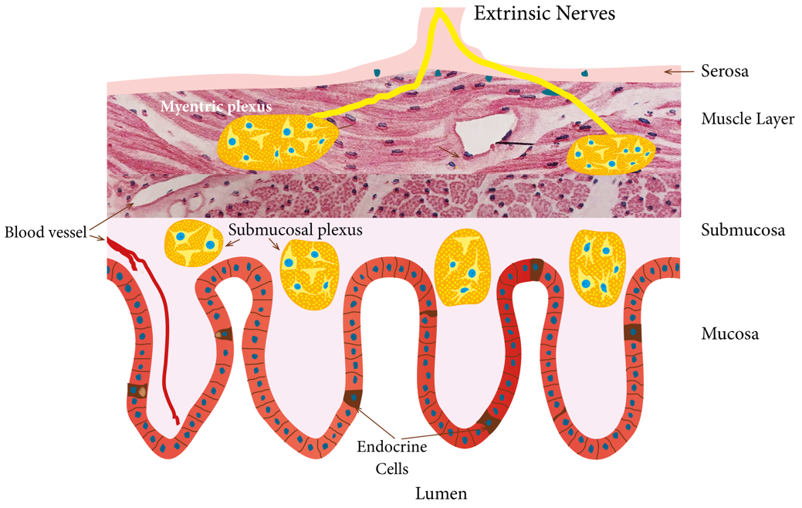
Figure 1 Schematic illustration of the enteroendocrine cells and their anatomic relation to the enteric nervous system. The enteroendocrine cells are scattered among the epithelial cells lining the intestinal lumen. They interact and intergrade with each other’s and with enteric nervous system. Reproduced from El-Salhy et al^{[54]} by permission of the authors and the publisher.

Figure 2 The density of gut endocrine cells as detected by chromogranin a immunoreactivity. Reproduced from El-Salhy et al^{[25]} by permission of the authors and the publisher.

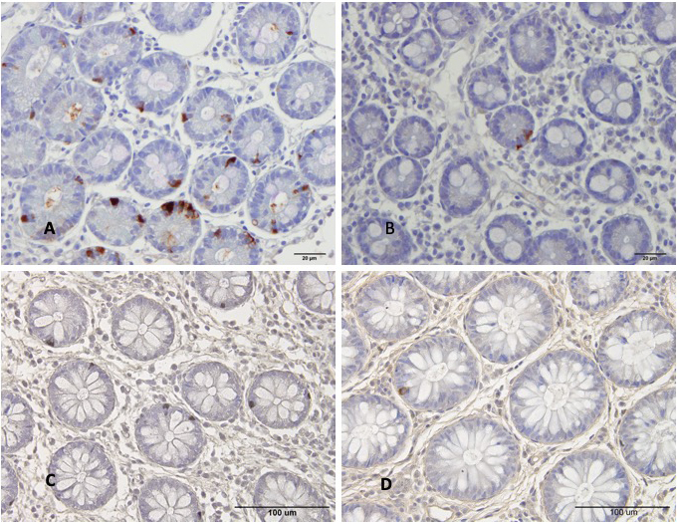
Figure 3 Chromogranin immunoreactive cells in the duodenum of a healthy subject and of a patient with irritable bowel syndrome. A: Chromogranin immunoreactive cells in the duodenum of a healthy subject; B: Chromogranin immunoreactive cells in the duodenum of a patient with irritable bowel syndrome (IBS); C: Chromogranin A cells in the colon of a healthy control; D: Chromogranin A cells in the colon of a patient with IBS. Chromogranin A is a common marker for enteroendocrine cells. The density of Chromogranin A in the duodenum and colon of patients with IBS is lower than that of healthy subjects.

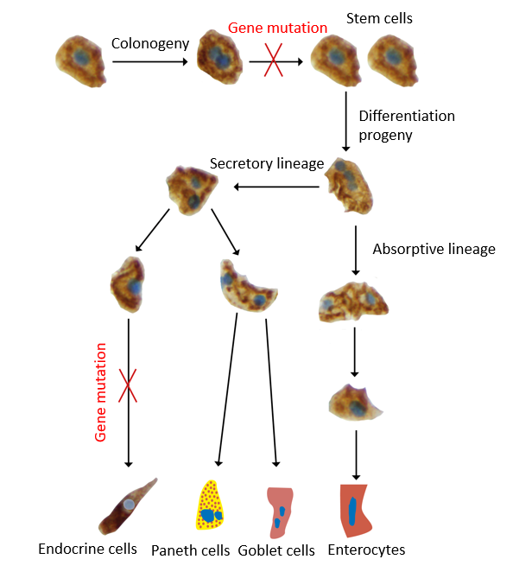
Figure 4 The intestinal stem cell divides into 2 identical cells (clonogeny). One of these cells remain inactive, while the other stem cell differentiates into all cell types of the villus epithelium through 2 cell lineages: The secretory lineage giving raise to goblet cells, endocrine cells and Paneth cells, and the absorptive lineage giving raise to absorptive enterocytes. This differentiation occurs through a series of progenitors. The observations that the density of stem cells and progenitors for enteroendocrine cells, led to the assumption of gene mutations affecting the stem cell and neurogenin 3 gene.

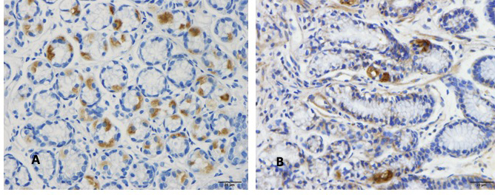

Figure 5 Musashi 1 immunoreactive cells in duodenum. A: A healthy subject; B: A patient with irritable bowel syndrome (IBS). Musashi 1 is a marker for intestinal stem cells and their early progeny. The density of Musahi 1 cells in healthy subjects is higher than that of the IBS patients. Furthermore, Musashi 1 cells in healthy subjects appear to have more proliferation activity than that of IBS patients.

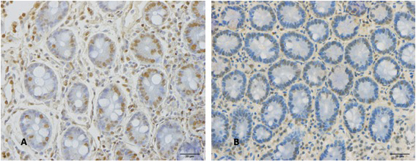

Figure 6 Neurogenin 3 immunoreactive cells in the duodenum. A: A healthy control B: A patient with irritable bowel syndrome. Neurogenin 3 is expressed in the nuclei (brown) of early intestinal endocrine cell progenitors. The healthy subjects have higher density of neurogenin 3 than irritable bowel syndrome patients.

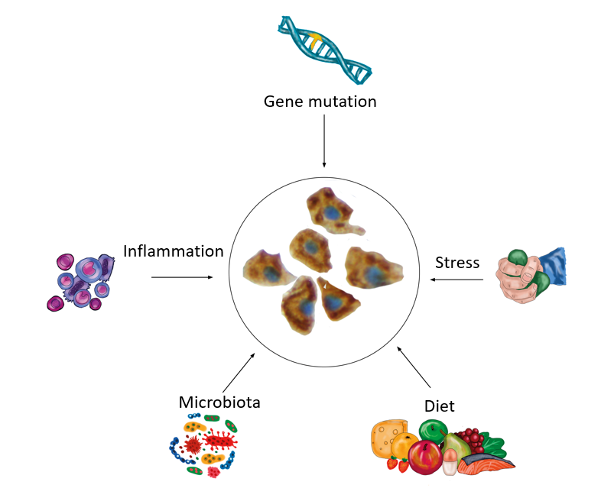

Figure 7 Schematic drawing to illustrate the hypothesis that intestinal stem cells play a central role in the pathophysiology of irritable bowel syndrome. The abnormalities in the intestinal stem cells can be caused by gene mutation or by environmental factors such as diet, intestinal microbiota, stress and low-grade inflammation.

