Name of Journal: World Journal of Respirology
ESPS Manuscript NO: 14227
Columns: Case Report

Myasthenia gravis as a form of clinical presentation of thymic carcinoma

de Macedo JE et al. Is there a distinct clinical-molecular signature?

Joana Espiga de Macedo, Sílvia Lopes, Helena Gouveia, Sofia Oliveira, João Cunha, Ana Luísa Faria, Sónia Rego, Albino Oliveira, Luís Krug, Emílio Macias Bravo

Joana Espiga de Macedo, Sílvia Lopes, Helena Gouveia, Sofia Oliveira, João Cunha, Ana Luísa Faria, Sónia Rego, Emílio Macias Bravo, Department of Medical Oncology of Centro Hospitalar de Entre o Douro e Vouga, 4520-211 Santa Maria Da Feira, Portugal

Albino Oliveira, Department of Pathology of Centro Hospitalar de Entre o Douro e Vouga, 4520-211 Santa Maria Da Feira, Portugal

Luís Krug, Department of Radiology of Centro Hospitalar de Entre o Douro e Vouga, 4520-211 Santa Maria Da Feira, Portugal

Author contributions: All authors contributed to this manuscript.

Ethics approval: The study was reviewed and approved by the Oncology Department of Centro Hospitalar entre Douro e Vouga, Institutional Review Board.

Informed consent: All study participants, or their legal guardian, provided informed written consent prior to study enrollment.

Conflict-of-interest: Joana Espiga de Macedo has received fees for serving as a speaker, such as consultant and/or an advisory board member for Celgene, Merck and Roche. Emílio Macias has received fees for serving as a speaker, such as consultant and/or an advisory board member for Astellas, Merck and Roche. Ana Luisa Faria has received serving as a speaker for Celgene. Sónia Rego has received serving as a speaker for AstraZeneca, Grunenthal and Pharmamar.

Open-Access: This article is an open-access article which was selected by an in-house editor and fully peer-reviewed by external reviewers. It is distributed in accordance with the Creative Commons Attribution Non Commercial (CC BY-NC 4.0) license, which permits others to distribute, remix, adapt, build upon this work non-commercially, and license their derivative works on different terms, provided the original work is properly cited and the use is non-commercial. See: http://creativecommons.org/licenses/by-nc/4.0/

Correspondence to: Joana Espiga de Macedo, MD, Department of Medical Oncology of Centro Hospitalar de Entre o Douro e Vouga, Rua Dr. Cândido de Pinho, 4520-211 Santa Maria Da Feira, Portugal. joanamacedo@hotmail.com

Telephone: +351-93-6050138
Fax: +351-25-6373867

Received: September 25, 2014
Peer-review started: September 26, 2014
First decision: December 17, 2014
Revised: April 18, 2015
Accepted: April 28, 2015
Article in press:
Published online:

Abstract
Thymic carcinomas are a rare carcinoma of the thymus arising in the thymic epithelium. They represent less than 1% of thymic malignancies. They often present with an advanced disease and metastasize to regional lymph nodes and distant sites. They have a worse prognosis with a 5-year survival rate of 30%-50%, while thymomas are much less invasive and have a 5-year survival of approximately 78%. We report a rare form of clinical presentation of a thymic carcinoma in which the diagnosis of myasthenia gravis was the cornerstone of the diagnosis of cancer. Surgery is the considered the salvage treatment when possible. Radiotherapy is a second choice of salvage treatment, when possible depending on its localization and relation to nearby structures namely vascular. Molecular target therapy is a more directed therapy, more expensive but less toxic treatment. Further studies need to be carried out for its approval worldwide, outside clinical trials.

Key words: Myasthenia gravis; Thymic carcinoma; Multidisciplinary approach; Clinical-molecular signature; Prognosis

© The Author(s) 2015. Published by Baishideng Publishing Group Inc. All rights reserved.

Core tip: We report a rare form of clinical presentation of a thymic carcinoma in which the diagnosis of myasthenia gravis was the cornerstone of the diagnosis of cancer. Surgery is the considered the salvage treatment when possible. Radiotherapy is a second choice of salvage treatment, when possible depending on its localization and relation to nearby structures namely vascular. The prognosis is very reserved, when neither surgery nor radiotherapy can be accomplished. Having an unfavorable molecular signature, less than 10% of thymic carcinomas have c-kit mutations, clinical outcome of these patients is detrimental.

de Macedo JE, Lopes S, Gouveia H, Oliveira S, Cunha J, Faria AL, Rego S, Oliveira A, Krug L, Bravo EM. Myasthenia gravis as a form of clinical presentation of thymic carcinoma. World J Respirol 2015; In press

INTRODUCTION
Thymic epithelial neoplasms are a rare, but are nowadays well classified according to the Masaoka–Koga system which is the most widely used current classification^{[1]}. Thymic epithelial neoplasmas comprise thymomas, thymic carcinomas and thymic neuroendocrine tumors. Thymoma is the most common epithelial tumor in the anterior mediastinum in adults. Thymic carcinomas represent less than 1% of the thymic malignancies^{[2]}. They have a worse prognosis with a 5-year survival rate of 30%-50%, while thymomas are much less invasive and have a 5-year survival of approximately 78%^{[2]}. Treatment of Thymic carcinomas may vary from complete surgical resection, being the gold standard, to chemotherapy and or radiotherapy. The main aim of this case report is to share experience in dealing with the optimal treatment of a rare, indolent and malignant carcinoma, where molecular pathways of thymic carcinomas are still on the verge of a new form of knowledge management.

CASE REPORT
A 76-year-old white man with previously known ischemic heart disease, hypertension, dyslipidemia and obstructive sleep apnea syndrome (with domiciliary CPAP), complained of cervical pain, sore throat, dysphagia and mild dyspnea for the past 2 wk. Due to sudden clinical deterioration he was evaluated in the emergency department. The cervical-thoracic-abdominal scan showed an anterior mediastinal mass with 66 mm × 60 mm of diameter, a slight pericardial effusion and a pulmonary nodule with 14 mm in the right superior lobe (Figures 1 and 2).
He was admitted to the Internal Medicine Department and started oxazepam. In the same day, he had a sudden worsen of conscious level and global respiratory insufficiency and was submitted to mechanical ventilation. The patient was transferred to the intensive care unit. The suspicion of myasthenic syndrome was confirmed by positivity to anticholinesterase antibodies. Two weeks later the patient improved and was extubated to spontaneous ventilation. An anterior mediastina biopsy was performed and revealed a thymic carcinoma, poorly differentiated, squamous differentiation, with positivity to CD5 and negative to CD 117 and chromogranin; Conclusion: thymic carcinoma type C (World Health Organization) stage IVB (Masaoka-Koga Staging) (Figures 3 and 4)^{[1]}. The laboratory testing revealed no abnormal values. The patient was transferred to the Internal medicine department clinically improved and was discharged one week later.
The patient was evaluated by a Multidisciplinary team and being a stage IVB (isolated pulmonary metastases), surgical hypothesis was rejected upfront given the vascular invasion of the tumor and highly suspected pulmonary metastasis. He started chemotherapy with carboplatin (area under the curve 6; D1) and paclitaxel (225 mg/m² D1) every 3 wk. The patient completed the 4th cycle of chemotherapy with good tolerance and with a significant response on the computed tomography (CT) scan (Figures 5 and 6). No other secondary lesions were observed.
At this time he was evaluated by Cardiothoracic Surgery and due to his excellent response to chemotherapy, he was proposed for two more cycles and subsequent CT scan and PET-CT evaluation. Concerning a 76-year-old fit patient, surgery shall be considered at a later stage followed by postoperative radiotherapy if indicated.

DISCUSSION
Thymic carcinomas are aggressive tumors which often metastasize to distant sites. In the case, the high suspicion of myasthenia syndrome was confirmed and associated to thymic carcinoma (30%-50% cases)^{[3]}. Total thymectomy and complete surgical excision are the gold standard of treatment and cisplatin-based chemotherapy is recommended in locally advanced, unresectable and metastatic setting.
Due to recent advances in technologies a better understanding of the molecular behavior of these tumors has been accomplished. Thymic carcinomas have a high frequency of KIT expression (73%-86%), but the rate of kit mutations remains low at 7%-9%^{[4]}. Target therapies (Imatinib or Sunitinib) may be useful for patients with c-kit mutations besides its low expression^{[4]}. Further molecular profiling for selecting the specific target therapy, is of upmost importance for defining the molecular signature of these tumors. Tumor characterization by clinical, imagiological and histological means are essential, but molecular profiling will allow us to treat our patients more efficiently, with better quality of live and lower toxicity profile.
Tumor stage, complete surgical resection and histology are the main prognostic factors of thymic carcinomas. Nevertheless, a very reserved prognosis when neither surgery nor radiotherapy can be accomplished is considered, but only 60% of the patients die from tumor progression. Other causes of death are autoimmune diseases and other non-malignant related disorders. Having an unfavorable molecular signature, less than 10% of thymic carcinomas have c-kit mutations, clinical outcome of these patients is detrimental. Besides lacking data on second-line chemotherapy, it remains an option for these patients who present themselves with a recurring disease, with no indication for alternative therapies, namely molecular, surgical or even radiotherapy.

COMMENTS
Case characteristics
A 76-year-old man complained of cervical pain, sore throat, dysphagia and mild dyspnea for the past 2 wk.

Clinical diagnosis
Rapid clinical deterioration.

Differential diagnosis
Other etiologies of anterior mediastinal masses.

Laboratory diagnosis
An anterior mediastina biopsy was performed.

Imaging diagnosis
The cervical-thoracic-abdominal scan showed an anterior mediastinal mass with 66 mm × 60 mm of diameter.

Pathological diagnosis
A thymic carcinoma, poorly differentiated, squamous differentiation, with positivity to CD5 and negative to CD 117 and chromogranin; Conclusion: Thymic Carcinoma type C (World Health Organization) stage IVB (Masaoka-Koga Staging).

Treatment
Chemotherapy with carboplatin (area under the curve 6; D1) and paclitaxel (225 mg/m² D1) every 3 wk.

Related reports
Thymic carcinomas have a high frequency of KIT expression (73-86%), but the rate of kit mutations remains low at 7%-9%. Target therapies (Imatinib or Sunitinib) may be useful for patients with c-kit mutations besides its low expression.

Term explanation
Further molecular profiling for selecting the specific target therapy, is of upmost importance for defining the molecular signature of these tumors

Experiences and lessons
Tumor characterization by clinical, imagiological and histological means is still vital, but molecular profiling will allow us to treat our patients more efficiently, with better quality of live and lower toxicity profile.

Peer-review
The paper is a report of a clinical case about thymic carcinoma that presented with signs and symptoms of a miasthenia gravis.

REFERENCES
1 Eng TY, Fuller CD, Jagirdar J, Bains Y, Thomas CR. Thymic carcinoma: state of the art review. Int J Radiat Oncol Biol Phys 2004; 59: 654-664 [PMID: 15183468 DOI: 10.1016/j.ijrobp.2003.11.021]
2 Detterbeck FC, Nicholson AG, Kondo K, Van Schil P, Moran C. The Masaoka-Koga stage classification for thymic malignancies: clarification and definition of terms. J Thorac Oncol 2011; 6: S1710-S1716 [PMID: 21847052 DOI: 10.1097/JTO.0b013e31821e8cff]
3 Ettinger DS, Riely GJ, Akerley W, Borghaei H, Chang AC, Cheney RT, Chirieac LR, D'Amico TA, Demmy TL, Govindan R, Grannis FW, Grant SC, Horn L, Jahan TM, Komaki R, Kong FM, Kris MG, Krug LM, Lackner RP, Lennes IT, Loo BW, Martins R, Otterson GA, Patel JD, Pinder-Schenck MC, Pisters KM, Reckamp K, Rohren E, Shapiro TA, Swanson SJ, Tauer K, Wood DE, Yang SC, Gregory K, Hughes M. Thymomas and thymic carcinomas: Clinical Practice Guidelines in Oncology. J Natl Compr Canc Netw 2013; 11: 562-576 [PMID: 23667206]
4 Kelly RJ. Systemic Treatment of advanced Thymic Malignancies. ASCO Educational Book, 2014. Available from: URL: http://meetinglibrary.asco.org/content/11400367-144

P-Reviewer: Araujo AMF S-Editor: Ji FF L-Editor: E-Editor:

Figure1 Computed tomography thoracic scan showing an anterior mediastinal mass with lobular contours with 60 mm × 66 mm.
Figure 2 Computed tomography thoracic scan showing a pulmonary nodule with 14 mm.
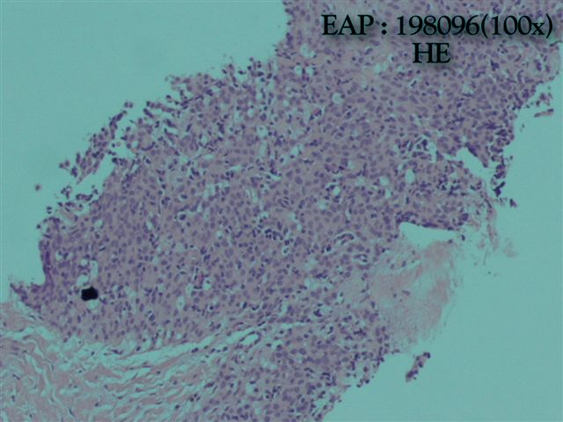
Figure 3 High-power view of non-keratinizing squamous poorly differentiated, thymic carcinoma.
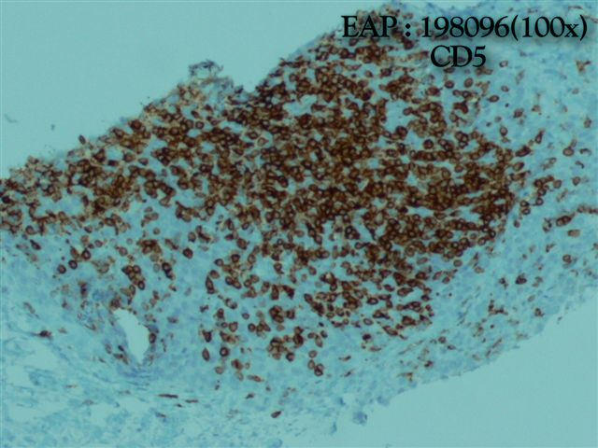
Figure 4 Malignant epithelial tumors of the thymus positive for CD5 which favors thymic carcinoma over thymomas and tumors of non-thymic origin. Thymic Carcinoma type C (World Health Organization) stage IVB (Masaoka- Koga Staging).
Figure 5 Computed tomography thoracic scan showing a 27 mm × 28 mm anterior mediastinal mass.
Figure 6 Computed tomography thoracic scan showing in the right superior lobe a pulmonary nodule with 11 mm.

