Name of journal: World Journal of Gastroenterology
ESPS Manuscript NO: 34445
Manuscript Type: ORIGINAL ARTICLE

Retrospective Study

Ketogenic diet imposes significant effect on imbalanced gut microbiota in infants with refractory epilepsy

Gan X et al. Gut microbiota altered by ketogenic diet on epilepsy

Gan Xie, Qian Zhou, Chuang-Zhao Qiu, Wen-Kui Dai, He-Ping Wang, Yin-Hu Li, Jian-Xiang Liao, Xin-Guo Lu, Su-Fang Lin, Jing-Hua Ye, Zhuo-Ya Ma, Wen-Jian Wang

Gan Xie, He-Ping Wang, Zhuo-Ya Ma, Wen-Jian Wang, Department of Respiratory, Shenzhen Children’s Hospital, Shenzhen 518026, Guangdong Province, China

Jian-Xiang Liao, Xin-Guo Lu, Su-Fang Lin, Jing-Hua Ye, Department of Pediatric Neurology, Shenzhen Children’s Hospital, Shenzhen 518026, Guangdong Province, China

Qian Zhou, Chuang-Zhao Qiu, Wen-Kui Dai, Yin-Hu Li, WeHealthGene Institute, Shenzhen 518129, Guangdong Province, China

Author contributions: Wang WJ managed the project and Dai WK designed the study; Qiu CZ and Zhou Q interpreted data; Xie G and Zhou Q wrote the manuscript; Qiu CZ and Li YH conducted bioinformatics analysis; Wang HP and Ye JH collected sample information; Liao JX, Lu XG, Lin SF and Ma ZY contributed to the study design and patients’ diagnoses; all authors read and approved the final manuscript. Xie G, Zhou Q and Qiu CZ contributed equally to this work.

Supported by the Innovation of Science and Technology Commission of Shenzhen Municipality, China, No.JCYJ20150403100317071.

Institutional review board statement: The study was reviewed and approved by the Institutional Review Board in Shenzhen Children’s Hospital.

Conflict-of-interest statement: The authors declare that they have no competing interests.

Data sharing statement: Sequencing data was available from the NCBI Sequence Read Archive (SRA) database (Accession Number: SRP100388).

Open-Access: This article is an open-access article which was selected by an in-house editor and fully peer-reviewed by external reviewers. It is distributed in accordance with the Creative Commons Attribution Non Commercial (CC BY-NC 4.0) license, which permits others to distribute, remix, adapt, build upon this work non-commercially, and license their derivative works on different terms, provided the original work is properly cited and the use is non-commercial. See: http://creativecommons.org/licenses/by-nc/4.0/

Manuscript source: Unsolicited manuscript

Correspondence to: Wen-Jian Wang, Doctor, Director for Department of Respiratory, Shenzhen Children’s Hospital, No.7019 Yitian Road, Shenzhen 518026, China. dhbk2005@163.com
Telephone: +86-755-83936101
Fax: +86-755-83009800

Received: May 4, 2017
Peer-review started: May 4, 2017
First decision: June 7, 2017
Revised: June 9, 2017
Accepted: July 12, 2017
Article in press:
Published online:
Abstract
AIM
To investigate if patients with refractory epilepsy and healthy infants differed in gut microbiota (GM), and how ketogenic diet (KD) alter GM.

METHODS
A total of 14 epileptic and 30 healthy infants were recruited and seizure frequencies were recorded. Stool samples were collected for 16S rDNA sequencing using Illumina Miseq platform. The composition of GM in each sample was analyzed by MOTHUR, and inter-group comparison was conducted by R software.

RESULTS
After being on KD treatment for a week, 64% of epileptic infants showed an obvious improvement, with a 50% decrease in seizure frequency. GM structure in epileptic infants (P1 group) differed dramatically from that in healthy infants (Health group). Proteobacteria, which had accumulated significantly in P1 group, decreased dramatically after KD treatment (P2 group). Cronobacter was dominated in P1 group and remained at a low level both in Health and P2 group. Bacteroides increased significantly in P2 group, in whom Prevotella and Bifidobacterium also grew in numbers and kept continued to increase.

CONCLUSION
GM pattern in healthy infants differed dramatically from that of epileptic group. KD could significantly modify symptoms of epilepsy and reshape the GM of epileptic infants.

Key words: Ketogenic diet; Epilepsy; Seizures; Gut microbiota; Cronobacter

© The Author(s) 2017. Published by Baishideng Publishing Group Inc. All rights reserved.

Core tip: Many infants with epilepsy are refractory to current antiepileptic drugs, and ketogenic diet (KD) could help to moderate seizures frequency as an alternative treatment. A large number of reports have demonstrated that gut microbiota (GM) can affect children’s neurodevelopment. Concurrently, GM could be dramatically affected by diet. KD could rapidly alter GM and alleviate seizure frequency in infants with refractory epilepsy. The GM structure of epileptic infants—comprising large numbers of pathogens, such as Streptococcus-differs from that of healthy controls. After KD therapy, GM of epileptic patients changed significantly, with fewer pathogens and more beneficial bacteria.

Xie G, Zhou Q, Qiu CZ, Dai WK, Wang HP, Li YH, Liao JX, Lu XG, Lin SF, Ye JH, Ma ZY, Wang WJ. Ketogenic diet imposes significant effect on imbalanced gut microbiota in infants with refractory epilepsy. World J Gastroenterol 2017; In press

INTRODUCTION
Pediatric epilepsy is widespread, with complications including cognitive impairment, delayed neurodevelopment and loss of bodily control^{[1,2]}. Disequilibrium between excitation and depression of the central nervous system is acknowledged as the main factor in epilepsy incidence^{[3]}. Prior reports have identified increased inflammatory reactions and pro-inflammatory cytokines, such as interleukin-6 (IL-6), interleukin-17 (IL-17) and interferon, in the cerebrospinal fluid (CSF)^{[4]}. AEDs and surgery are the main conventional treatments for infants with epilepsy^{[5]}. However, there are still 30% of epileptic infants who suffered from therapeutic futility and recurrent attacks.
A growing number of reports indicated that KD was a promising therapeutic alternative for infants with refractory epilepsy, as it has been shown to ameliorate their clinical symptoms, including the frequency of seizures^{[6-10]}. It remains unclear exactly how this occurs. Several reports implicated changed neurotransmitters after KD therapy, including γ-aminobutyric acid (GABA), monoamines and glutamate^{[7,11]}. Dahlin et al^{[12,13]} also identified increased ketone bodies (KBs) and decreased dopamine as well as serotonin^{[12,13]}. However, Sariego-Jamardo et al^{[14]} found little change of neurotransmitters, pterins and amino acids in the CSF of KD responders as opposed to non-responders. These discrepant findings suggested a need for the further elucidation of the mechanisms of KD therapy.
A variety of findings shown that diet posed significant effect on GM^{[8,15]}. A high-fat diet induced selective enrichment of bile-metabolizing microbiota, such as Bacteroides^{[16]}. Whilst, high-fiber foods promoted the accumulation of plant-polysaccharide fermenting microbial organisms, including Prevotella and Clostridium^{[16]}. A number of reports implicated involvement of GM in enteric nervous system (ENS), blood-brain barrier (BBB) and glial cell development, all of which were pivotal to behavioral control and cognitive progression^{[17,18]}. GM could produce neurotransmitters and gut hormones directly^{[19]} or indirectly by producing signaling molecules to regulate host cells^{[20]}. GM-derived short-chain fatty acids (SCFAs) could stimulate enterochromaffin cells to produce serotonin^{[21]}. Wikoff et al^{[22]} also documented decreased serotonin in peripheral serum in the absence of GM. Moreover, Clostridium sporogenes and Ruminococcus gnavus promoted decarboxylation of tryptophan to tryptamine, which modulated mood and appetite through amine-associated receptors^{[23]}. Based on the involvement of GM in the gut-brain axis, increasing reports demonstrated imbalanced GM in neurogenic diseases (NDs), including autism-spectrum disorder (ASD), Parkinson’s disease, and depression^{[24]}. However, GM dysbiosis in childhood epilepsy remain unexplored.
Previous studies declared that short-term dietary intake could rapidly alter human GM^{[8,15]}. In this study, we performed comparison between diseased infants (before and after KD treatment) and healthy controls, to explore if and how GM of infants with refractory epilepsy differed with age-matched healthy subjects. We also evaluated the therapeutic effect of KD on refractory epilepsy and the changes in GM after treatment. It is hoped that his research will help to bridge some gaps in the current understanding of refractory childhood epilepsy.

MATERIALS AND METHODS
Sample collection
We enrolled 14 pediatric patients with refractory epilepsy (aged 1.95 ± 3.10 years, 11 male and 3 female) in Shenzhen Children’s Hospital, according to the following inclusion criteria: convulsed more than four times per week after ≥ 3 AEDs treatment; no antibiotic exposure for at least 1 mo; no known genetic metabolic disorders or severe systemic illnesses; successive KD therapy for at least 1 wk. KD was provided by Zeneca, Shenzhen, China, including Qitong ketogenic liquid milk (3.4 g protein, 8.0 g lipid and 0.6 g carbohydrate per 100 g milk), Qitong ketogenic cookies and Qitong ketogenic set-meal packages^{[25]}.
Healthy subjects (aged up to 3 years, 15 male and 15 female) were also recruited based on the following criteria: no antibiotic exposure for at least 1 month before this study, no disease symptoms for at least 1 month following recruitment, and no history of seizures (Supplementary Table 1). Fisher’s test was used to evaluate the effect of gender and age on GM composition.

DNA extraction, library construction and sequencing
The genomic DNA of microbiota was extracted from stool samples using the Power Soil DNA Isolation Kit (Mo Bio Laboratories, Carlsbad) following the manufacture’s protocol. The hyper variable V3-V4 region of the 16S rRNA gene was amplified using PCR kit (TransGenAP221-02, Peking), and DNA products were quantified by gel electrophoresis and Qubit (Thermo Fisher, Singapore). After library construction, the qualified libraries were sequenced by Illumina MiSeq Sequencing platform (Illumina, San Diego).

Taxonomy classification and diversity detection
After filtration, overlapped paired reads were assembled as tags by FLASH (v1.2.11), and clustered to operational taxonomic units (OTUs) through USEARCH (v7.0.1090)^{[26]}. Representative OTUs were mapped against the Greengenes database (v201305)^{[27]} and classified by RDP classifier (v2.2)^{[28]}. The diversity of microbiota was calculated by MOTHUR (v1.31.2)^{[29]}.

Principal component analysis and statistical analysis

Principal component analysis (PCA) was performed by R software (v3.2.5). Wilcoxon rank-sum test was used to compare GM in diseased infants and healthy controls. Comparative analysis between the P1 and P2 group was conducted by Wilcoxon signed-rank test. Linear discriminant analysis Effect Size (LEfSe) analysis was used to identify microbial species, which were apparently enriched in specific group.

RESULTS
Data output and patients’ characteristics
High-quality 117196 sequencing reads were produced for each sample on average, ranging from 31900 to 305190. The number of assembled tags averaged 22800, with a range from 12655 to 27337. Both gender and age had no statistical significance for affecting GM, with P-value 0.069 and 0.234 respectively.

GM of healthy individuals differed dramatically with that of diseased infants
Shannon index analysis indicated higher GM diversity in healthy infants, by comparison with infants with refractory epilepsy (Figure 1, Supplementary Table 2). PCA analysis of GM profile also identified that healthy infants could be clearly distinguished from patients (Figure 2, Supplementary Table 3). Phylum Firmicutes was dominated in patients (45.82%) and was unchanged after KD therapy (47.00%) (Supplementary Table 4). Bacteroidetes accounted for 53.01% of GM in healthy infants, followed by Firmicutes (34.38%). After KD treatment, Bacteroidetes increased from 26.75% to 38.71%. Actinobacteria was enriched in healthy infants (8.49%) and occupied fewer percent in patients (2.38% when pre-treatment and 2.92% after treatment). Proteobacteria was highly accumulated in infants with refractory epilepsy (24.34%) and decreased dramatically after KD therapy (10.77%). At genus level, Cronobacter was dominant in the patients (23.30% vs 0.00% in healthy group). By contrast, healthy subjects harbored more than twice Bacteroides (42.68%) than that in infants with refractory epilepsy (17.93%). Prevotella and Bifidobacterium were also accumulated in healthy group (7.25%, 7.84% respectively) (Supplementary Table 5).

KD therapy ameliorated epilepsy and GM of patients started to improve
After a week of KD therapy, 3 patients (21%) were seizure-free and 6 (43%) patients had a 50% to 90% decrease of seizure frequency (Supplementary Table 1). The remaining 5 infants experienced no significant improvement in seizure control (36%) (Supplementary Table 1). GM of P2 group was more similar to that of Health group, by comparison with P1 group (Figure 3 and 4). After KD treatment, Bacteroides increased significantly, by 24.42%. Prevotella also increased in P1 group from 0.37% to 1.85% after KD treatment (Figure 3 and Supplementary Table 5). Cronobacter decreased sharply in after-treatment patients, from 23.3% to 10.44 % (Figure 3, Figure 4 and Supplementary Table 5). KD exposure also induced a decrease in Erysipelatoclostridium (by 8.67% in P1 and 4.89% in P2 group); it represented just 0.64% in healthy infants (Figure 3, Figure 4 and Supplementary Table 5). Streptococcus, Alistipes, Ruminiclostridium, Barnesiella and Enterococcus also decreased after KD therapy (Figure 3, Figure 4 and Supplementary Table 5).

DISCUSSION
KD is increasingly used for the treatment of refractory epilepsy in childhood, but the mechanism remains unclear. Previous reports indicated that GM played an important role in gut-brain-axis^{[24]}, and was affected significantly by intake of high-fat food^{[16]}. This study focused on differed GM structure of healthy with epileptic infants, as well as alteration in the GM of patients after one week of KD treatment. The results pointed to an imbalanced GM in patients and a significant improvement after KD therapy.
Proteobacteria comprise a variety of notorious pathogens, such as Escherichia, Salmonella and Vibrio. It accounted for 24.34% in pediatric patients and decreased dramatically after KD treatment. Bacteroidetes was dominant in healthy infants and increased largely for after-treatment patients.
We identified accumulated Bacteroides in healthy subjects as well as in patients after treatment. Bacteroides was reported to digest and metabolize high-fat food and to regulate the secretion of IL-6 and IL-17 in dendritic cells (DCs), a process strongly associated with seizure severity of epileptic patients^{[4,16]}. However, patients-enriched Cronobacter decreased dramatically after KD therapy. Prior reports demonstrated that there were multiple virulence determinants of Cronobacter, including Cronobacter plasminogen activator and ferric ion transporter protein, which paly a detrimental role in human health^{[30-32]}. Prevotella was robust producer of SCFAs^{[33]}, which could protect intestinal mucosa and function as neurotransmitters. Previous reports also indicated that SCFAs mediatednervous impulse and mitigated Parkinson’s disease^{[33,34]}. Similarly, we identified increased Prevotella in Health and P2 group, when compared with P1 group. Some other genera also offer clues to epilepsy recovery, such as Erysipelatoclostridium, Blautia, Bifidobacterium and Streptococcus. Bifidobacterium was well known to be beneficial to health^{[35]}, and Streptococcus, a common pathogen, played a role especially in respiratory diseases^{[36]}. Although GM imbalance in diseased infants was identified and GM improved after KD treatment, more exploration was needed to elucidate the contribution of a healthy GM to epilepsy onset/recovery.
This study revealed that KD can mitigate the symptoms of epilepsy and correct an imbalanced GM in epileptic infants. However, further analysis is needed to unravel how GM may be involved in epilepsy onset/recovery.
There are some limitations that need to be clarified. Firstly, 16S rDNA analysis identified microbes at genus level, which make it difficult to unravel different microbes at species or function level. Secondly, it would be more useful to evaluate the efficacy of KD treatment and its effect on the GM if this could be done with a longer period of follow-up. Thirdly, an animal model might be applied to demonstrate whether GM imbalance could induce epilepsy associated symptoms. Considering these limitations, we are planning to perform metagenomic analysis on GM of healthy and epileptic infants. This will provide more insights into distinct metabolic networks in imbalanced GM.
In this study, we found that GM of infants with refractory epilepsy differed dramatically from that of healthy infants. Concurrently, epileptic patients harbored significantly enriched pathogens and decreased beneficial bacteria. Although this study provides new insight into the involvement of GM in pediatric refractory epilepsy, the gap between KD and epilepsy recovery is still huge. To uncover the mechanism and pathogens involved refractory infantile epilepsy, further research should underscore functional gene networks in GM. In summary, this work lays a foundation for GM alteration of GM in epilepsy in order to promote the amelioration of this condition.

ACKNOWLEDGMENTS
We thank the staffs of WeHealthGene whose names were not included in the author list, but who contributed to project.

COMMENTS
Background
Infants with refractory epilepsy couldn’t be cured by several AEDs and ketogenic diet (KD) was increasingly used as an alternative therapy to refractory epilepsy. High-fat diet was reported to pose significant impact on gut microbiota (GM), which could regulate neurological system.

Research frontiers
Previous reports demonstrated that GM could affect neural systems by secreting metabolites as neurotransmitters. In parallel, the gut-brain axis is a research hot spot in biomedicine, including the study of autism, Parkinson’s disease, and depression.

Innovations and breakthroughs
This study showed that the GM pattern of diseased infants differs significantly from that of the healthy. The decreased number of dominant pathogens and significantly increased number of beneficial bacteria after KD treatment offers new insight to KD therapy for epilepsy.

Applications
This study found several bacteria representing alterations in the GM; suggesting that these bacteria could be monitored as biomarkers, providing an important reference for epilepsy treatment.

Terminology
The GM-which consist of many kinds of bacteria including pathogens, commensals, and probiotics—play an important role in the human body.

Peer-review
The authors have performed important research in pediatric epilepsy. They discovered that the composition of the GM in health and disease was significantly different, specifically in healthy infants as opposed to those with refractory epilepsy. Bacterial patterns were dramatically changed after KD therapy, and this was associated with a reduction in the frequency of seizures. These findings should enhance our knowledge of the relationship between epilepsy and GM and provide new insight into the clinical treatment of epilepsy. However, environmental factors and clinical parameters should be studied more closely in further research.
REFERENCES
1 Nordli DR Jr. Epileptic encephalopathies in infants and children. J Clin Neurophysiol 2012; 29: 420-424 [PMID: 23027099 DOI: 10.1097/WNP.0b013e31826bd961]
2 Nickels KC, Zaccariello MJ, Hamiwka LD, Wirrell EC. Cognitive and neurodevelopmental comorbidities in paediatric epilepsy. Nat Rev Neurol 2016; 12: 465-476 [PMID: 27448186 DOI: 10.1038/nrneurol.2016.98]
3 Goldberg EM, Coulter DA. Mechanisms of epileptogenesis: a convergence on neural circuit dysfunction. Nat Rev Neurosci 2013; 14: 337-349 [PMID: 23595016 DOI: 10.1038/nrn3482]
4 Mao LY, Ding J, Peng WF, Ma Y, Zhang YH, Fan W, Wang X. Interictal interleukin-17A levels are elevated and correlate with seizure severity of epilepsy patients. Epilepsia 2013; 54: e142-e145 [PMID: 23944193 DOI: 10.1111/epi.12337]
5 Vigevano F, Arzimanoglou A, Plouin P, Specchio N. Therapeutic approach to epileptic encephalopathies. Epilepsia 2013; 54 Suppl 8: 45-50 [PMID: 24571117 DOI: 10.1111/epi.12423]
6 Kossoff EH, Zupec-Kania BA, Amark PE, Ballaban-Gil KR, Christina Bergqvist AG, Blackford R, Buchhalter JR, Caraballo RH, Helen Cross J, Dahlin MG, Donner EJ, Klepper J, Jehle RS, Kim HD, Christiana Liu YM, Nation J, Nordli DR Jr, Pfeifer HH, Rho JM, Stafstrom CE, Thiele EA, Turner Z, Wirrell EC, Wheless JW, Veggiotti P, Vining EP; Charlie Foundation, Practice Committee of the Child Neurology Society; Practice Committee of the Child Neurology Society; International Ketogenic Diet Study Group. Optimal clinical management of children receiving the ketogenic diet: recommendations of the International Ketogenic Diet Study Group. Epilepsia 2009; 50: 304-317 [PMID: 18823325 DOI: 10.1111/j.1528-1167.2008.01765.x]
7 Lima PA, Sampaio LP, Damasceno NR. Neurobiochemical mechanisms of a ketogenic diet in refractory epilepsy. Clinics (Sao Paulo) 2014; 69: 699-705 [PMID: 25518023 DOI: 10.6061/clinics/2014(10)09]
8 van der Louw E, van den Hurk D, Neal E, Leiendecker B, Fitzsimmon G, Dority L, Thompson L, Marchió M, Dudzińska M, Dressler A, Klepper J, Auvin S, Cross JH. Ketogenic diet guidelines for infants with refractory epilepsy. Eur J Paediatr Neurol 2016; 20: 798-809 [PMID: 27470655 DOI: 10.1016/j.ejpn.2016.07.009]
9 Neal EG, Chaffe H, Schwartz RH, Lawson MS, Edwards N, Fitzsimmons G, Whitney A, Cross JH. The ketogenic diet for the treatment of childhood epilepsy: a randomised controlled trial. Lancet Neurol 2008; 7: 500-506 [PMID: 18456557 DOI: 10.1016/S1474-4422(08)70092-9]
10 Noebels JL. The Voltage-Gated Calcium Channel and Absence Epilepsy. In: Noebels JL, Avoli M, Rogawski MA, Olsen RW, Delgado-Escueta AV, editors. Jasper's Basic Mechanisms of the Epilepsies. 4th ed. Bethesda (MD), 2012: 1049-1066
11 Ruskin DN, Masino SA. The nervous system and metabolic dysregulation: emerging evidence converges on ketogenic diet therapy. Front Neurosci 2012; 6: 33 [PMID: 22470316 DOI: 10.3389/fnins.2012.00033]
12 Dahlin M, Mansson Je Fau - Amark P, Amark P. CSF levels of dopamine and serotonin, but not norepinephrine, metabolites are influenced by the ketogenic diet in children with epilepsy. Epilepsy Res 2012; 99: 132-138 [DOI: 10.1016/j.eplepsyres.2011.11.003]
13 Freeman JM, Kossoff EH, Hartman AL. The ketogenic diet: one decade later. Pediatrics 2007; 119: 535-543 [PMID: 17332207 DOI: 10.1542/peds.2006-2447]
14 Sariego-Jamardo A, García-Cazorla A, Artuch R, Castejón E, García-Arenas D, Molero-Luis M, Ormazábal A, Sanmartí FX. Efficacy of the Ketogenic Diet for the Treatment of Refractory Childhood Epilepsy: Cerebrospinal Fluid Neurotransmitters and Amino Acid Levels. Pediatr Neurol 2015; 53: 422-426 [PMID: 26476148 DOI: 10.1016/j.pediatrneurol.2015.07.013]
15 Wu J, Zhang Y, Yang H, Rao Y, Miao J, Lu X. Intestinal Microbiota as an Alternative Therapeutic Target for Epilepsy. Can J Infect Dis Med Microbiol 2016; 2016: 9032809 [PMID: 27882059 DOI: 10.1155/2016/9032809]
16 Arumugam M, Raes J, Pelletier E, Le Paslier D, Yamada T, Mende DR, Fernandes GR, Tap J, Bruls T, Batto JM, Bertalan M, Borruel N, Casellas F, Fernandez L, Gautier L, Hansen T, Hattori M, Hayashi T, Kleerebezem M, Kurokawa K, Leclerc M, Levenez F, Manichanh C, Nielsen HB, Nielsen T, Pons N, Poulain J, Qin J, Sicheritz-Ponten T, Tims S, Torrents D, Ugarte E, Zoetendal EG, Wang J, Guarner F, Pedersen O, de Vos WM, Brunak S, Doré J; MetaHIT Consortium, Antolín M, Artiguenave F, Blottiere HM, Almeida M, Brechot C, Cara C, Chervaux C, Cultrone A, Delorme C, Denariaz G, Dervyn R, Foerstner KU, Friss C, van de Guchte M, Guedon E, Haimet F, Huber W, van Hylckama-Vlieg J, Jamet A, Juste C, Kaci G, Knol J, Lakhdari O, Layec S, Le Roux K, Maguin E, Mérieux A, Melo Minardi R, M'rini C, Muller J, Oozeer R, Parkhill J, Renault P, Rescigno M, Sanchez N, Sunagawa S, Torrejon A, Turner K, Vandemeulebrouck G, Varela E, Winogradsky Y, Zeller G, Weissenbach J, Ehrlich SD, Bork P. Enterotypes of the human gut microbiome. Nature 2011; 473: 174-180 [PMID: 21508958 DOI: 10.1038/nature09944]
17 Braniste V, Al-Asmakh M, Kowal C, Anuar F, Abbaspour A, Tóth M, Korecka A, Bakocevic N, Ng LG, Kundu P, Gulyás B, Halldin C, Hultenby K, Nilsson H, Hebert H, Volpe BT, Diamond B, Pettersson S. The gut microbiota influences blood-brain barrier permeability in mice. Sci Transl Med 2014; 6: 263ra158 [PMID: 25411471 DOI: 10.1126/scitranslmed.3009759]
18 Collins J, Borojevic R, Verdu EF, Huizinga JD, Ratcliffe EM. Intestinal microbiota influence the early postnatal development of the enteric nervous system. Neurogastroenterol Motil 2014; 26: 98-107 [PMID: 24329946 DOI: 10.1111/nmo.12236]
19 Matsumoto M, Kibe R, Ooga T, Aiba Y, Kurihara S, Sawaki E, Koga Y, Benno Y. Impact of intestinal microbiota on intestinal luminal metabolome. Sci Rep 2012; 2: 233 [PMID: 22724057 DOI: 10.1038/srep00233]
20 Batterham RL, ffytche DH, Rosenthal JM, Zelaya FO, Barker GJ, Withers DJ, Williams SC. PYY modulation of cortical and hypothalamic brain areas predicts feeding behaviour in humans. Nature 2007; 450: 106-109 [PMID: 17934448 DOI: 10.1038/nature06212]
21 Yano JM, Yu K, Donaldson GP, Shastri GG, Ann P, Ma L, Nagler CR, Ismagilov RF, Mazmanian SK, Hsiao EY. Indigenous bacteria from the gut microbiota regulate host serotonin biosynthesis. Cell 2015; 161: 264-276 [PMID: 25860609 DOI: 10.1016/j.cell.2015.02.047]
22 Marcobal A, Kashyap PC, Nelson TA, Aronov PA, Donia MS, Spormann A, Fischbach MA, Sonnenburg JL. A metabolomic view of how the human gut microbiota impacts the host metabolome using humanized and gnotobiotic mice. ISME J 2013; 7: 1933-1943 [PMID: 23739052 DOI: 10.1038/ismej.2013.89]
23 Williams BB, Van Benschoten AH, Cimermancic P, Donia MS, Zimmermann M, Taketani M, Ishihara A, Kashyap PC, Fraser JS, Fischbach MA. Discovery and characterization of gut microbiota decarboxylases that can produce the neurotransmitter tryptamine. Cell Host Microbe 2014; 16: 495-503 [PMID: 25263219 DOI: 10.1016/j.chom.2014.09.001]
24 Sharon G, Sampson TR, Geschwind DH, Mazmanian SK. The Central Nervous System and the Gut Microbiome. Cell 2016; 167: 915-932 [PMID: 27814521 DOI: 10.1016/j.cell.2016.10.027]
25 Suo C, Liao J, Lu X, Fang K, Hu Y, Chen L, Cao D, Huang T, Li B, Li C. Efficacy and safety of the ketogenic diet in Chinese children. Seizure 2013; 22: 174-178 [PMID: 23273808 DOI: 10.1016/j.seizure.2012.11.014]
26 Edgar RC. UPARSE: highly accurate OTU sequences from microbial amplicon reads. Nat Methods 2013; 10: 996-998 [PMID: 23955772 DOI: 10.1038/nmeth.2604]
27 DeSantis TZ, Hugenholtz P, Larsen N, Rojas M, Brodie EL, Keller K, Huber T, Dalevi D, Hu P, Andersen GL. Greengenes, a chimera-checked 16S rRNA gene database and workbench compatible with ARB. Appl Environ Microbiol 2006; 72: 5069-5072 [PMID: 16820507 DOI: 10.1128/AEM.03006-05]
28 Wang Q, Garrity GM, Tiedje JM, Cole JR. Naive Bayesian classifier for rapid assignment of rRNA sequences into the new bacterial taxonomy. Appl Environ Microbiol 2007; 73: 5261-5267 [PMID: 17586664 DOI: 10.1128/AEM.00062-07]
29 Schloss PD, Westcott SL, Ryabin T, Hall JR, Hartmann M, Hollister EB, Lesniewski RA, Oakley BB, Parks DH, Robinson CJ, Sahl JW, Stres B, Thallinger GG, Van Horn DJ, Weber CF. Introducing mothur: open-source, platform-independent, community-supported software for describing and comparing microbial communities. Appl Environ Microbiol 2009; 75: 7537-7541 [PMID: 19801464 DOI: 10.1128/AEM.01541-09]
30 Jackson EE, Forsythe SJ. Comparative study of Cronobacter identification according to phenotyping methods. BMC Microbiol 2016; 16: 146 [PMID: 27401027 DOI: 10.1186/s12866-016-0768-6]
31 Bowen AB, Braden CR. Invasive Enterobacter sakazakii disease in infants. Emerg Infect Dis 2006; 12: 1185-1189 [PMID: 16965695 DOI: 10.3201/eid1208.051509]
32 Singh N, Raghav M, Narula S, Tandon S, Goel G. Profiling of Virulence Determinants in Cronobacter sakazakii Isolates from Different Plant and Environmental Commodities. Curr Microbiol 2017; 74: 560-565 [PMID: 28258294 DOI: 10.1007/s00284-017-1219-9]
33 Scheperjans F, Aho V, Pereira PA, Koskinen K, Paulin L, Pekkonen E, Haapaniemi E, Kaakkola S, Eerola-Rautio J, Pohja M, Kinnunen E, Murros K, Auvinen P. Gut microbiota are related to Parkinson's disease and clinical phenotype. Mov Disord 2015; 30: 350-358 [PMID: 25476529 DOI: 10.1002/mds.26069]
34 Miletta MC, Petkovic V, Eblé A, Ammann RA, Flück CE, Mullis PE. Butyrate increases intracellular calcium levels and enhances growth hormone release from rat anterior pituitary cells via the G-protein-coupled receptors GPR41 and 43. PLoS One 2014; 9: e107388 [PMID: 25310566 DOI: 10.1371/journal.pone.0107388]
35 Ghouri YA, Richards DM, Rahimi EF, Krill JT, Jelinek KA, DuPont AW. Systematic review of randomized controlled trials of probiotics, prebiotics, and synbiotics in inflammatory bowel disease. Clin Exp Gastroenterol 2014; 7: 473-487 [PMID: 25525379 DOI: 10.2147/CEG.S27530]
36 Krzyściak W, Pluskwa KK, Jurczak A, Kościelniak D. The pathogenicity of the Streptococcus genus. Eur J Clin Microbiol Infect Dis 2013; 32: 1361-1376 [PMID: 24141975 DOI: 10.1007/s10096-013-1914-9]

P-Reviewer: Daniel F, Prakash N S-Editor: Qi Y L-Editor: E-Editor:
Specialty type: Gastroenterology and hepatology
Country of origin: China
Peer-review report classification
Grade A (Excellent): 0
Grade B (Very good): 0
Grade C (Good): C, C
Grade D (Fair): 0
Grade E (Poor): 0

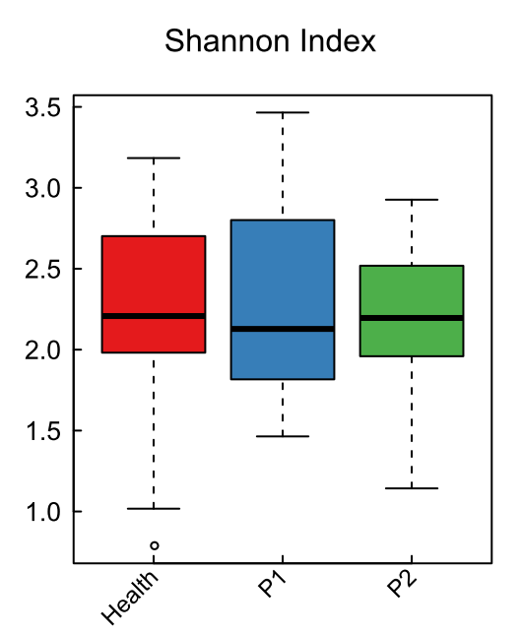
Figure 1 Gut microbial diversity of three groups. Distribution of Shannon index (evenness). Red, blue, and green represent the Health, P1, and P2 groups, respectively. The gut microbiota (GM) of the healthy infants was more stable than that of the other two groups.
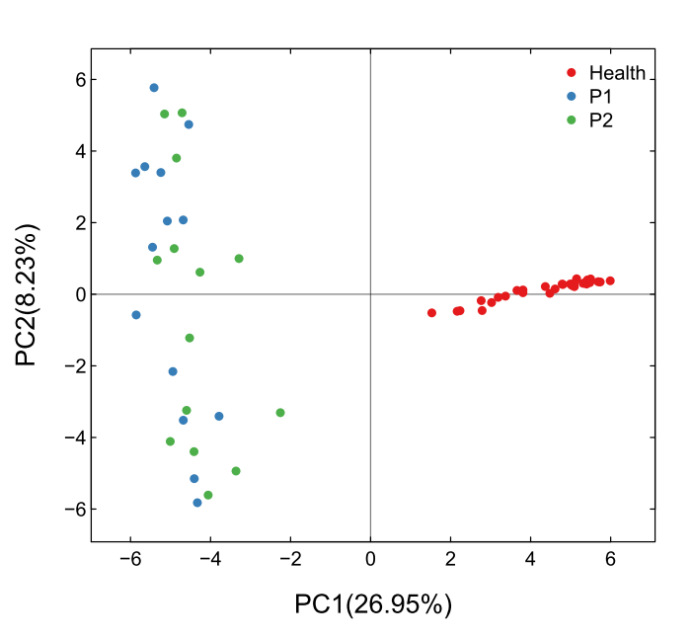
Figure 2 Principal components analysis. Each plot in the Principal components analysis (PCA) graph stands for a sample. Red, blue and green colors represent Health, P1 and P2 group, respectively.
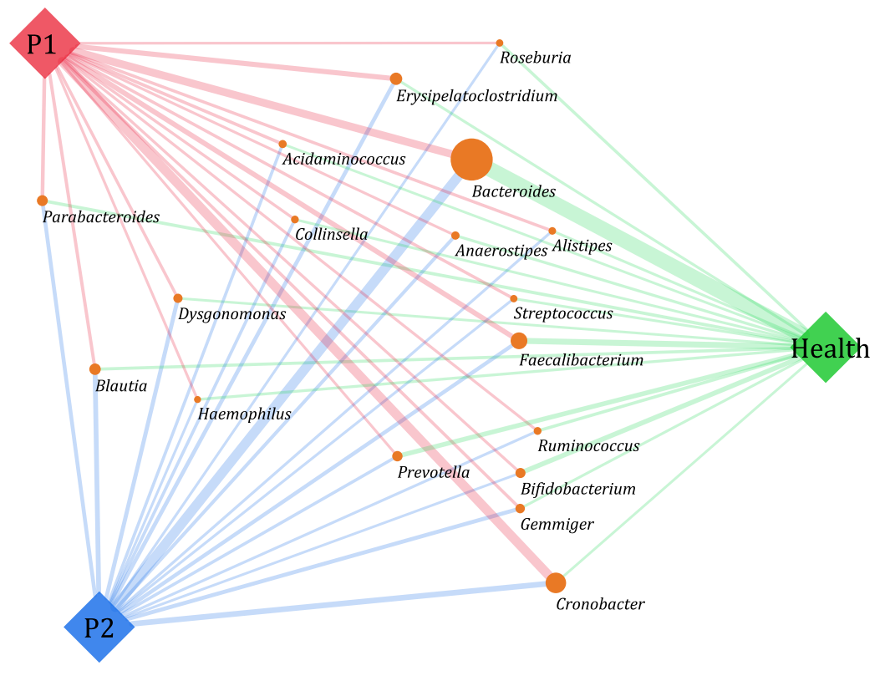
Figure 3 Gut microbiota structure in the Health, P1, and P2 groups at the genus level. SVG package (version 1.1) was used to produce the paragraph. The size of the circle representing each genus was determined by the relative abundance of the three groups, and the width of line linking the P1, P2, and Health groups indicates the relative abundance of each group.
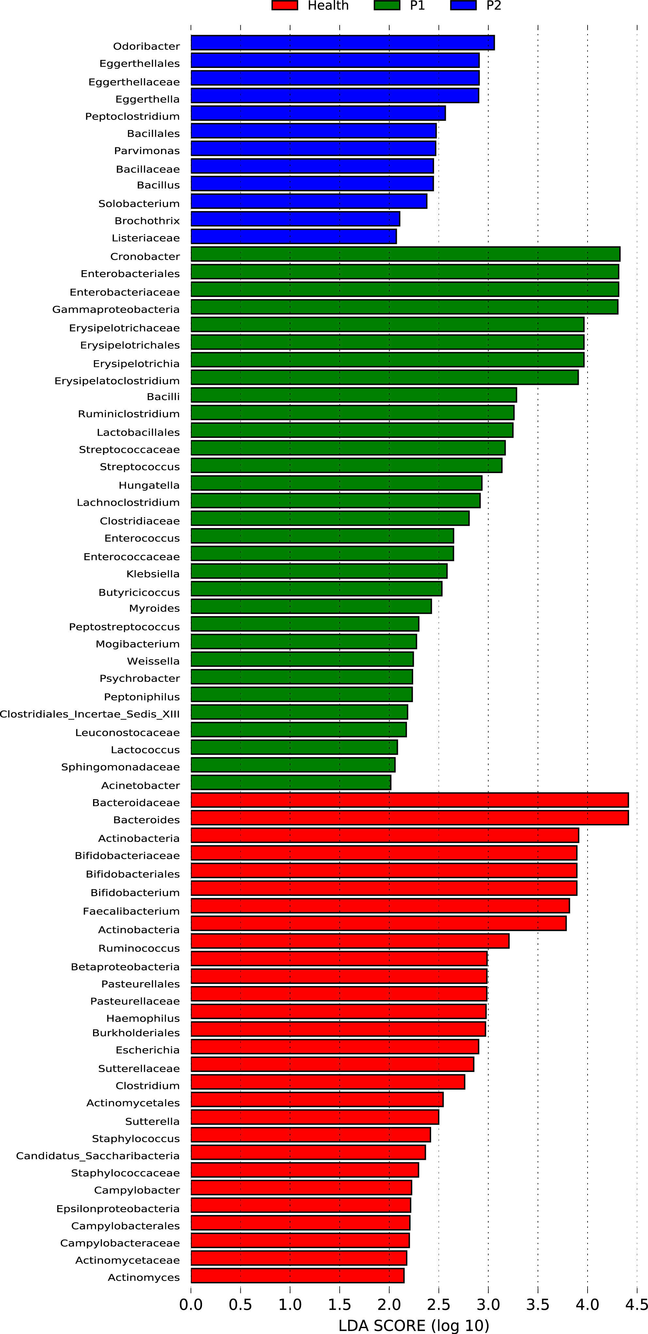
Figure 4 Significantly enriched Gut microbiota components in the Health, P1, and P2 groups. LEfSe analysis was applied to detect the gut microbiota (GM) components in the three groups. Red, green, and blue represent the Health, P1, and P2 groups, respectively. The LDA score was set as ≥ 2. The enrichment degree is proportional to the LDA score.

