Name of Journal: World Journal of Gastrointestinal Oncology
Manuscript NO: 63349
Manuscript Type: ORIGINAL ARTICLE

Basic Study
combination of neutrophil gelatinase-associated lipocalin and matrix metalloproteinase-9 are biomarkers for the detection of tubular adenocarcinoma of colon

Yuan JH et al. NGAL and MMP9 for tubular adenocarcinoma of the colon

Jun-hua Yuan, Li-shuang Xie, Yu-hua Zhu, Xiao-hua Wang, Yi-jing Zhang, Xiao-jun Wang

Jun-hua Yuan, Yi-jing Zhang, Xiao-jun Wang, Department of Geriatric Gastroenterology, Shandong Provincial Hospital affiliated to Shandong First Medical University, Jinan 250021, Shandong Province, China

Li-shuang Xie, Medical Records Room, Yinan County People’s Hospital, Yinan 276399, Shandong Province, China

Yu-hua Zhu, Department of Infectious Diseases, Shandong Provincial Hospital affiliated to Shandong First Medical University, Jinan 250021, Shandong Province, China

Xiao-hua Wang, Department of Infectious Diseases and Liver diseases, Jinan Infectious Disease Hospital, Shandong University School of Medicine, Jinan 250021, Shandong Province, China

Author contributions: Yuan Jh, Xie Ls and Zhang Yj designed the research; Yuan Jh, Wang Xh and Zhu Yh performed the experiments; Xie Ls, Zhang Yj and Wang XJ analyzed the data and participated in the discussion; Yuan Jh and Xie Ls wrote and revised the paper; all authors reviewed the manuscript.

Corresponding author: Jun-hua Yuan, MD, Chief Physician, Department of Geriatric Gastroenterology, Shandong Provincial Hospital affiliated to Shandong First Medical University, no. 324 jingwu weiqi Road, Huaiyin District, Jinan 250021, Shandong Province, China. yjh717299@126.com

Received: February 23, 2021
Revised: April 22, 2021
Accepted: July 21, 2021
Published online:

Abstract
BACKGROUND
Tubular adenocarcinoma of the colon, which originates from the epithelium of the glands, is a major health concern worldwide. However, it is difficult to detect in an early stage. The lack of biomarkers is a main barrier to the diagnosis and treatment of tubular adenocarcinoma. Neutrophil gelatinase-associated lipocalin (NGAL) is a secreted protein that induces the expression of matrix metalloproteinase-9 (MMP-9) and is involved in various tumors. NGAL and MMP-9 have been reported to be associated with tumorigenesis and development. They may have potential as biomarkers for diagnosis of tubular adenocarcinoma of the colon.

AIM
To evaluate whether NGAL and MMP-9 can be used as potential biomarkers to indicate the progression of tubular adenocarcinoma of the colon.

METHODS
Samples were collected from surgically excised tissue from different patients. The content of pro-gastrin-releasing peptide (pro-GRP) in the serum was measured by an electrochemiluminescence immunoassay. The expression patterns of NGAL and MMP-9 and the relationship between NGAL and MMP-9 were examined by quantitative real-time PCR, western blotting and immunohistochemical analysis.

RESULTS
In this study, we found that the two molecules NGAL and MMP-9 could be used as biomarkers for detecting tubular adenocarcinoma of the colon and that their combination improved diagnostic accuracy. By analyzing the expression of NGAL in tubular adenocarcinoma at different levels, we found that NGAL expression was significantly upregulated in primary tubular adenocarcinoma tissues compared with normal tissues. The upregulation of NGAL expression was strongly correlated with both the differentiation degree and the disease stage (I–III), indicating that NGAL could serve as a diagnostic biomarker for tubular adenocarcinoma. When using NGAL as a biomarker for diagnosis, the accuracy was similar to that achieved with the widely used biomarker pro-GRP, suggesting that NGAL is reliable. Moreover, the expression of MMP-9 was also strongly correlated with the differentiation stage, demonstrating that MMP-9 could be used as a biomarker to indicate the progression of tubular adenocarcinoma of the colon. More importantly, the combination of NGAL and MMP-9 could produce a more accurate result for the diagnosis of tubular adenocarcinoma, and the results were further confirmed by immunohistochemical analysis of tissue sections.

CONCLUSION
Our study demonstrated that both NGAL and MMP-9 could be used as biomarkers for the diagnosis of tubular adenocarcinoma in the colon and that results could be further improved by combining them.

Key Words: tubular adenocarcinoma; colon; Neutrophil gelatinase-associated lipocalin; matrix metalloproteinase-9; biomarker

Yuan JH, Xie LS, Zhu YH, Wang XH, Zhang YJ, Wang XJ. Combination of neutrophil gelatinase-associated lipocalin and matrix metalloproteinase-9 are biomarkers for the detection of tubular adenocarcinoma of colon. World J Gastrointest Oncol 2021; In press

Core Tip: Neutrophil gelatinase-associated lipocalin (NGAL) is a secreted protein, which modulates the expression of matrix metalloproteinase-9 (MMP-9) and appears in various cancers. However, it has not been explored whether NGAL or MMP-9 could be used as biomarkers in diagnosis of tubular adenocarcinoma of colon. In the present study, we demonstrated that both NGAL and MMP-9 could be used as biomarkers for diagnosis of tubular adenocarcinoma of the colon. By employing them together, the diagnosis accuracy can be further improved.

INTRODUCTION
Colorectal cancers (CRC) is the third most common cancer worldwide with 1.36 million people being diagnosed in 2012, which contributes to 9.7% of cancer cases^{[1]}. In China, CRC is the fourth common malignant cancer, which increased rapidly, especially in developing regions^{[2,3]}. CRC are caused by numerous factors, which are associated with heritability, lifestyle, chronic inflammation and so on^{[4-6]}. Although the early CRC in stage I-II can be curable via surgical excision, most of advanced CRC in stage III- IV is lethal and incurable^{[7,8]}. Most of CRC cases are tubular adenocarcinomas, which comprise about 95%, with being characterized by peritoneal dissemination and infiltrative growth^{[9]}. As, the early diagnosis of colorectal adenocarcinoma is obviously important in the treatment of primary or recurrent colorectal adenocarcinoma.
Advances in the understanding of colorectal carcinogenesis offer opportunities to identify biomarkers for earlier diagnosis. Recent studies demonstrated that neutrophil gelatinase-associated lipocalin (NGAL) and matrix metalloproteinase-9 (MMP-9) could be used as diagnostic and prognostic biomarkers in various cancers, including breast cancer^{[10]}, bladder cancer^{[11,12]}, gastric cancer^{[13]}, endometrial cancer^{[14]} and kidney tumors^{[15]}. NGAL, also called lipocalin-2 (LCN2), is a small glycoprotein, which is encoded by the LCN2 gene. As a member of the lipocalin family, NGAL participates to the transportation of lipophilic substances. Additionally, it has also been reported that NGAL is associated with the delivery of iron from extracellular space into the inner cell, which may promote the tumor development and support the proliferation of neoplastic cells^{[16,17]}. Previous studies revealed that the increased expression of NGAL contributed to the progression of cancers^{[18,19]}, and in a lot of malignancies, NGAL was over-expressed^{[20,21]}. MMP-9 is one of the matrix-metalloproteinases, whose activity is modulated by the NGAL^{[22]}. MMP-9 can degrade the extracellular matrix (ECM), which is the barrier for cell invasion. The degradation of ECM can provide a favorable environment for promoting the growth and dissemination of cancer cells. The increased expression level of MMP-9 has been observed in several cancers, which was related to the aggressiveness of cancer cells and the overall survival of patients^{[23]}. In combination with NGAL, MMP-9 can avoid to be degraded by proteolytic degradation, which increases its enzymatic activity and movability of malignancies^{[10]}.
The NGAL, MMP-9, and their complex have shown their value as the diagnostic and prognostic biomarkers in several cancers. However, their utilities in tubular adenocarcinoma of the colon remain unknown. Therefore, in this study, we evaluated the potential of NGAL and MMP-9 as biomarkers for the early detection of tubular adenocarcinoma of the colon and explored the possible application of combining these two biomarkers.

MATERIALS AND METHODS
Patients and samples
This study was performed on 15 female and 32 male patients aging from 45 to 80 from Provincial Hospital affiliated to Shandong University. Totally 30 tubular adenocarcinoma of the colon samples were collected from the patients that were subjected to surgical excision during years 2015-2019. 10 cases were with polyps (I), 10 cases were with mild tubular adenocarcinoma (II) and 10 cases were with severe tubular adenocarcinoma (III), respectively, confirmed by the pathologist. Besides, 10 normal samples were included as the control group. All the experiments were in compliance with the ethical standards of the World Medical Association Declaration of Helsinki, and all the samples were only used for research and consented by the patients before the start of the experiment.

Detection of pro-gastrin-releasing peptide
The serum samples were tested via a commercial electrochemiluminescence immunoassay for pro-gastrin-releasing peptide (pro-GRP) with Roche C6000, an automated immunoassay analyzer (Roche Diagnostics GmbH, Penzberg, Germany)^{[24]}.

Quantitative real-time PCR analysis
Total RNA for the serum samples was extracted with TRNzol Reagent (DP405-02, TIANGEN Biotech, Beijing, China), after which cDNA was synthesized with reverse transcriptase (RR047B, Takara, Beijing, China) in accordance with the manufacturer’s instructions. The quantitative real-time PCR (qRT-PCR) was performed with SYBR® Premix Ex Taq™ II (Tli RNaseH Plus, TaKaRa, Japan) to detect the mRNA levels of NGAL and MMP9. Reaction parameters were presented as follows: 95 ºC for 30 s, followed by 45 cycles of PCR at 95 ºC for 5 s and 60 ºC for 40 s. Data were collected and analyzed with Graphpad and SPSS 25.0. The expression of genes within a sample was normalized to GAPDH expression by employing the 2^{ΔΔCt} method. The primers used in the present study are as follows: NGAL (Forward: ACAAAGACCCGCAAAAGATG; Reverse: TTGGGACAGGGAAGACGAT), and MMP9 (Forward: GAGCACGGAGACGGGTATC; Reverse: ACTCGTCATCGTCGAAATGG).

Western blotting
Western blotting was done for NGAL and MMP9. Serum sample lysates were thawed and mixed with equal volume of 2X buffer. 10% sodium dodecyl sulfate polyacrylamide gel electrophoresis (SDS-PAGE) was used to separate proteins and then the proteins was transferred onto membrane of polyvinylidene difluoride (PVDF). Anti-NGAL antibody (ab41105) and anti-MMP9 antibody (ab38898) from Abcam (Cambridge, United Kingdom) and b-actin monoclonal antibody (YM3028) from Immunoway (Plano, United States) were employed as primary antibodies. The membrane was incubated with primary antibodies at 4 ºC for overnight and second antibodies at 37 ºC for 40 min, respectively. Enhanced chemiluminescence (ECL, WBKLS0500, Millipore, MA, United States) solution was used to visualize the bands. The blots were subsequently scanned, and band intensity was quantified based on densitometry software (ImageJ, National Institutes of Health, Bethesda, MD, United States).

Immunohistochemical analysis
For immunohistochemical (IHC) analysis of the tumor tissues, samples were rinsed with PBS and fixed in 4% paraformaldehyde for 1h and embedded in paraffin. Sections at 5 μm thickness were prepared for IHC staining. Briefly, slides were rehydrated with gradient. Sodium citrate buffer solution (pH 6.0) was used for antigen retrieval treatment. To avoid the influence of endogenous peroxidase activity, 0.3% hydrogen peroxide was used for 10 min. In addition, 3% calf serum was applied to block the sections. Subsequently, these sections were stained with the same primary antibodies as above. Subsequently, the samples were incubated with the universal secondary antibody and VECTASTAIN Elite ABC reagent (PK6200, Vector, Germany), reacted with 3,3′-Diaminobenzidine tetra hydrochloride hydrate (DAB, Thermo Fisher Scientific, Waltham, United States), and counterstained with hematoxylin (H3404, Vector, Germany). Besides, the images were captured using the optical microscope.

Statistical analysis
Unless otherwise indicated, all experiments were carried out in triplicate. Error bars represent standard deviations. Data are presented as mean value ± SE from three independent measurements, defined P < 0.05 as statistically significant. Graphs were plotted and analyzed using Graphpad and SPSS 25.0.

RESULTS
The expression of NGAL was positively related with the occurrence of tubular adenocarcinoma of the colon
It has been reported that NGAL could be used as a biomarker to detect some cancers. However, the potential application of NGAL in tubular adenocarcinoma of colon remains unknown. Therefore, we first analyzed 6 samples from patients (Table 1), who were diagnosed with tubular adenocarcinoma of the colon. The mRNA expressional level of NGAL was evaluated by qRT-PCR. Figure 1A showed that the expression of NGAL was significantly higher in tubular adenocarcinoma of the colon in comparison with the control sample. The pro-GRP is a biomarker, which was commonly used in the diagnosis of tubular adenocarcinoma^{[24,25]}. As presented in Figure 1B and Table 1, the pro-GRP could be detected in the serum of these above 6 patients. According to these obtained results, we found that the expression of NGAL was consistent with the expression of pro-GRP in different patients, suggesting that the expression of NGAL in serum was positively correlated with the occurrence of tubular adenocarcinomas of the colon.

NGAL and MMP-9 can indicate the progression of tubular adenocarcinoma
In order to confirm the relationship between NGAL and the occurrence of tubular adenocarcinoma, more samples should be analyzed. We collected more tubular adenocarcinoma of colon samples, including polyps (I), mild tubular adenocarcinoma (II) and severe tubular adenocarcinoma (III), which can be found in Table 2. The qRT-PCR results in Figure 2A revealed the increased gene expression of NGAL in all cases, while the increment varied. In addition, we also found that with the development of tubular adenocarcinoma, the mean expressional levels of NGAL were increased, and the expression of NGAL was higher in stage II and III than that in stage I. Then, we assessed the expression of MMP-9, which could be induced by NGAL. As our expectation, both of NGAL and MMP-9 were gradually increased with the progression of disease, though the gene expression of MMP-9 was extremely low in stage I, which was still slightly higher than control group (Figure 2B).
We further determined the protein level of NGAL and MMP-9 using western blotting. Typical samples (N-4, I-5, II-3, III-6) were selected for tested. According to the results, we found that the hybridization signal of NGAL was gradually enhanced from the control group to the stage III, indicating the progression of tubular adenocarcinoma (Figure 2C), which was in consistence with the results of qRT-PCR. The expression level of MMP-9 in stage I was slightly higher than that in control group, and it continued increasing in stage II and III (Figure 2D), suggesting that MMP-9 was induced by NGAL, and the expression of MMP-9 might start later than NGAL. More importantly, it was also indicated that MMP-9 was increased as the progression of tubular adenocarcinoma of the colon.
IHC staining was further used to detected the in situ expression of NGAL and MMP-9. In the present study, the tissue samples used were from the same patients (N-4, I-5, II-3, III-6). Hybridization with anti-NGAL and anti-MMP-9 antibodies revealed that NGAL and MMP-9 in the lesion were both higher than the control. With the progress of the disease, the signals became stronger (Figure 3). Therefore, it could be concluded that both NGAL and MMP-9 could indicate the progression of tubular adenocarcinoma of the colon as potential biomarkers.

The conbination of NGAL and MMP-9 could improve the accuracy of diagnoses in the tubular adenocarcinoma of the colon
Although both NGAL and MMP-9 exhibited potential value as independent biomarkers for detecting tubular adenocarcinoma of the colon, their accuracies were still a problem for clinical application. In addition, some cases in our study will be misdiagnosed if we detected only one of them. The expression of 10 cases of NGAL did not meet the pathological examination results in the 40 cases, and the accuracy of NGAL was 75% (Table 2). Similarly, the accuracy of MMP-9 was 72.5%. However, we found that the accuracy could be improved to 87.5% when combining NGAL and MMP-9 for diagnosis of the tubular adenocarcinoma of the colon. Besides, only one case was misdiagnosed in 40 cases (Table 2, Figure 4). Therefore, it was suggested that NGAL and MMP-9 may be used as a combination to enhance the diagnostic accuracy in the tubular adenocarcinoma of the colon.

The diagnostic value of the combination of NGAL and MMP-9 in clinical application
As pro-GRP is a commonly used tumor clinical diagnostic marker, we measured the content of pro-GRP in these 40 cases, and 77.5% of the measured pro-GRP values could correctly indicate the progression of the tubular adenocarcinoma of the colon (Figure 5 and Table 2). Through comparing with the diagnostic results from the combination of NGAL and MMP-9, we found that most of results were in consistence, indicating that the combination of NGAL and MMP-9 was reliable in clinical application. Moreover, although using pro-GRP was more accurate than using NGAL or MMP-9 alone, there was still a 22.5% probability of error, which could be diagnosed correctly when using NGAL and MMP-9 together.

DISCUSSION
Despite great medical progress in recent years, cancer is still one of the most common causes of death. Usually, early-stage tubular adenocarcinoma of the colon is curable via surgical excision, but it is difficult to detect this disease in an early stage^{[10,11]}, which is due to the lack of effective biomarkers for detecting early-stage tubular adenocarcinoma of the colon. More importantly, it is necessary to determine the progression of tubular adenocarcinoma of the colon during treatment, which allows efficient evaluation and adjustment of therapeutic strategies.
NGAL and MMP-9 have been reported to be involved in several kinds of cancers and to indicate progression as biomarkers^{[10-15]}. In our study, we found that the expression of NGAL was positively related to the occurrence of tubular adenocarcinoma of the colon by qRT-PCR. The expression of NGAL was closely related to the development of tubular adenocarcinoma of the colon, suggesting that NGAL could be used to indicate progression. The NGAL result was consistent with that for pro-GRP, suggesting that NGAL is reliable for indicating disease progression. On the other hand, we also demonstrated that MMP-9 could be considered another potential biomarker for tubular adenocarcinoma of the colon. According to our results, although the expression of MMP-9 in patients with stage I disease was only slightly higher than that in the control, it was lower than the expression of NGAL in stage I disease, which was consistent with the conclusion of a previous study showing that the expression of MMP-9 was induced by NGAL^{[22]}. The expression of MMP-9 continued to increase as tubular adenocarcinoma of the colon progressed, suggesting that MMP-9 was also suitable for indicating disease progression. We also detected protein expression and observed pathological tissue by western blotting and IHC staining, respectively, and the findings were consistent with the results above and exhibited the potential value of NGAL and MMP-9 as biomarkers for clinical application.
Most importantly, we found that combined use of NGAL and MMP-9 in the diagnosis of 40 clinical cases could significantly improve diagnostic accuracy up to 87.5%, which was higher than that achieved using only NGAL, MMP-9 or the traditional biomarker pro-GPR independently. This result suggests that combining NGAL and MMP-9 for diagnosis has great potential for detecting tubular adenocarcinoma of the colon. In addition, we found one case that could not be identified by NGAL and MMP-9. The mechanism of tumorigenesis in this case may be abnormal and complex, which requires further study.

CONCLUSION
In summary, our study demonstrated that both NGAL and MMP-9 could be used to detect and indicate tubular adenocarcinoma of the colon and that the combination of NGAL and MMP-9 showed greater accuracy in diagnosis than either single marker. Since abnormal expression of NGAL/MMP-9 has been observed in several cancers, such as breast cancer, bladder cancer and gastric cancer, the pair of biomarkers described here for tubular adenocarcinoma of the colon may be potentially useful in other cancers.

ARTICLE HIGHLIGHTS
Research background
Tubular adenocarcinoma of colon, which originates from the epithelium of glands, is one of major health concerns worldwide. However, it is difficult to detect at early stage. The lack of biomarkers becomes a main barrier in the diagnosis and treatment of tubular adenocarcinoma. Neutrophil gelatinase-associated lipocalin (NGAL) is a secreted protein, which induces the expression of matrix metalloproteinase-9 (MMP-9) and is involved in various tumors. The NGAL and MMP-9 has been reported that they were assioated with the tumorigenesis and development. They may have a potential as biomarkers for tubular adenocarcinoma of colon diagnosis.

Research motivation
The combination of NGAL and MMP9 are promising biomarkers for the early detection of tubular adenocarcinoma of the colon. To evaluate whether NGAL and MMP-9 can be used as potential biomarkers to indicate the progression of tubular adenocarcinoma of the colon. It may be beneficial to detect tubular adenocarcinoma of the colon at the molecular level in very early stage. The combination of NGAL and MMP9 are promising biomarkers for the early detection of tubular adenocarcinoma of the colon. To evaluate whether NGAL and MMP-9 can be used as potential biomarkers to indicate the progression of tubular adenocarcinoma of the colon. It may be beneficial to detect tubular adenocarcinoma of the colon at the molecular level in very early stage.

Research objectives
To evaluate whether NGAL and MMP-9 can be used as potential biomarkers to indicate the progression of tubular adenocarcinoma of the colon. We have realized the objective. Realizing this may be beneficial to detect tubular adenocarcinoma of the colon at the molecular level in very early stage. Patients with tubular adenocarcinoma of the colon will acquire early diagnosis and early treatment.

Research methods
Samples were collected from colonic mucosa of different patients. 10 cases were with polyps (I), 10 cases were with mild tubular adenocacinoma (II) and 10 cases were with severe tubular adenocacinoma (III), respectively, confirmed by the pathologist. In additon, 10 normal samples were included as the control group. The content of pro-gastrin-releasing peptide (pro-GRP) in serum was measured by an electrochemiluminescence immunoassay. The mRNA expression of NGAL and MMP-9 were examined by quantitative real-time PCR (qRT-PCR) analysis, and their protern expressions were examined by Western blotting and Immunohistochemical (IHC) analysis. According to the tubular adenocarcinoma of colon, we divided the different patients into three groups. So the clinical grouping in the research had its novelty, which was not adopted in other researches.

Research results
In this study, we found that two molecules NGAL and MMP-9 could be used as biomarkers for detecting tubular adenocarcinoma of the colon and their combination for better accurate diagnosis. By analyzing the expression of NGAL in tubular adenocarcinoma at different levels, we found that NGAL was significantly up-regulated in primary tubular adenocarcinoma compared with normal tissues. The up-regulation of NGAL was strongly correlated with both the differentiation degree and the disease stage (I–III), indicating that NGAL could serve as a diagnostic biomarker for tubular adenocarcinoma. By using NGAL as a biomarker in diagnosis, the accuracy was similar to widely used biomarker pro-GRP, suggesting that NGAL was reliable. Meanwhile, the expression of MMP-9 was also strongly correlated with differentiation stage, demonstrating that MMP-9 can be used as a biomarker to indicating the progress of tubular adenocarcinoma of colon. More importantly, the combination of NGAL and MMP-9 could get a more accurate result in diagnosis of tubular adenocarcinoma, and the results were further confirmed by immunohistochemical analysis of tissue sections.

Research conclusions
In this study, the up-regulation of NGAL and MMP-9 were strongly correlated with both the differentiation degree and tubular adenocarcinoma of the colon. The two molecules NGAL and MMP-9 could be used as biomarkers for detecting tubular adenocarcinoma of the colon and their combination for better accurate diagnosis. Patients who have chances to develop tubular adenocarcinoma of colon will acquire early diagnosis and early treatment.

Research perspectives
There should be more cases involved in the study. There may be many other genes taking part in the progress of tubular adenocarcinoma of colon, which need us deeply explore. The larger scale clinical study may be preceded which maybe the best method for the future research.

REFERENCES
1 Ferlay J, Soerjomataram I, Dikshit R, Eser S, Mathers C, Rebelo M, Parkin DM, Forman D, Bray F. Cancer incidence and mortality worldwide: sources, methods and major patterns in GLOBOCAN 2012. Int J Cancer 2015; 136: E359-E386 [PMID: 25220842 DOI: 10.1002/ijc.29210]
2 Kontos CK, Tsiakanikas P, Avgeris M, Papadopoulos IN, Scorilas A. miR-15a-5p, A Novel Prognostic Biomarker, Predicting Recurrent Colorectal Adenocarcinoma. Mol Diagn Ther 2017; 21: 453-464 [PMID: 28405803 DOI: 10.1007/s40291-017-0270-3]
3 Yu L, Liu ZY, Jiao J, Shi XL, Cui WL, Zhang W, Li QX. [Polymorphisms of mTORC1 genes and risk of primary colorectal adenocarcinoma in Chinese populations]. Zhonghua Bing Li Xue Za Zhi 2018; 47: 492-498 [PMID: 29996312 DOI: 10.3760/cma.j.issn.0529-5807.2018.07.003]
4 Chen L, Zhu YY, Zhang XJ, Wang GL, Li XY, He S, Zhang JB, Zhu JW. TSPAN1 protein expression: a significant prognostic indicator for patients with colorectal adenocarcinoma. World J Gastroenterol 2009; 15: 2270-2276 [PMID: 19437569 DOI: 10.3748/wjg.15.2270]
5 Lualdi M, Cavalleri A, Battaglia L, Colombo A, Garrone G, Morelli D, Pignoli E, Sottotetti E, Leo E. Early detection of colorectal adenocarcinoma: a clinical decision support tool based on plasma porphyrin accumulation and risk factors. BMC Cancer 2018; 18: 841 [PMID: 30134852 DOI: 10.1186/s12885-018-4754-2]
6 Gannam CV, Chin KL, Gandhi RP. Caries risk assessment. Gen Dent 2018; 66: 12-17 [PMID: 30444701]
7 Luo C, Cen S, Ding G, Wu W. Mucinous colorectal adenocarcinoma: clinical pathology and treatment options. Cancer Commun (Lond) 2019; 39: 13 [PMID: 30922401 DOI: 10.1186/s40880-019-0361-0]
8 Wu XL, Wang YY, Wang LK, Xue J, Yang DD, Qu M, Wang CY, Guo F, Yang RM, Liu B. Id-1 expression in colorectal adenocarcinoma tissues and its clinical significance. Rev Assoc Med Bras (1992) 2019; 65: 404-409 [PMID: 30994840 DOI: 10.1590/1806-9282.65.3.404]
9 Reynolds IS, O'Connell E, Fichtner M, McNamara DA, Kay EW, Prehn JHM, Furney SJ, Burke JP. Mucinous adenocarcinoma is a pharmacogenomically distinct subtype of colorectal cancer. Pharmacogenomics J 2020; 20: 524-532 [PMID: 31819162 DOI: 10.1038/s41397-019-0137-6]
10 Metallinou D, Lykeridou K, Karampas G, Liosis GT, Skevaki C, Rizou M, Papassotiriou I, Rizos D. Postpartum human breast milk levels of neutrophil gelatinase-associated lipocalin (NGAL) and matrix metalloproteinase-9 (MMP-9)/NGAL complex in normal and pregnancies complicated with insulin-dependent gestational diabetes mellitus. A prospective pilot case-control study. J Obstet Gynaecol 2020; 40: 461-467 [PMID: 31353996 DOI: 10.1080/01443615.2019.1628191]
11 Candido S, Di Maso M, Serraino D, McCubrey JA, Bortolus R, Zanin M, Battiston M, Salemi R, Libra M, Polesel J. Diagnostic value of neutrophil gelatinase-associated lipocalin/matrix metalloproteinase-9 pathway in transitional cell carcinoma of the bladder. Tumour Biol 2016; 37: 9855-9863 [PMID: 26810191 DOI: 10.1007/s13277-016-4872-x]
12 Ricci S, Bruzzese D, DI Carlo A. Evaluation of MMP-2, MMP-9, TIMP-1, TIMP-2, NGAL and MMP-9/NGAL complex in urine and sera from patients with bladder cancer. Oncol Lett 2015; 10: 2527-2532 [PMID: 26622883 DOI: 10.3892/ol.2015.3558]
13 Smyth EC, Nilsson M, Grabsch HI, van Grieken NC, Lordick F. Gastric cancer. Lancet 2020; 396: 635-648 [PMID: 32861308 DOI: 10.1016/S0140-6736(20)31288-5]
14 Cymbaluk-Płoska A, Chudecka-Głaz A, Pius-Sadowska E, Sompolska-Rzechuła A, Chudecka K, Bulsa M, Machaliński B, Menkiszak J. Clinical Relevance of NGAL/MMP-9 Pathway in Patients with Endometrial Cancer. Dis Markers 2017; 2017: 6589262 [PMID: 29089666 DOI: 10.1155/2017/6589262]
15 DI Carlo A. Evaluation of neutrophil gelatinase-associated lipocalin (NGAL), matrix metalloproteinase-9 (MMP-9) and their complex MMP-9/NGAL in sera and urine of patients with kidney tumors. Oncol Lett 2013; 5: 1677-1681 [PMID: 23760084 DOI: 10.3892/ol.2013.1252]
16 Buonafine M, Martinez-Martinez E, Jaisser F. More than a simple biomarker: the role of NGAL in cardiovascular and renal diseases. Clin Sci (Lond) 2018; 132: 909-923 [PMID: 29739822 DOI: 10.1042/CS20171592]
17 Shalenkova MA, Mikhailova ZD, Klimkin PF. [NGAL as a marker for some extrarenal complications in acute coronary syndrome]. Kardiologiia 2018: 19-26 [PMID: 29782286]
18 Marchewka Z, Tacik A, Piwowar A. [KIM-1 and NGAL as potential biomarkers for the diagnosis and cancer progression]. Postepy Hig Med Dosw (Online) 2016; 70: 329-336 [PMID: 27117109 DOI: 10.5604/17322693.1199716]
19 Dahiya K, Gupta K, Dhankhar R, Atri R, Goyal N, Dalal D, Pal S, Ahlawat R, Kumar S. Chemoradiation in Lung Cancer: Effect on Levels of NGAL and Vitamin D in Serum. Clin Lab 2020; 66 [PMID: 32902227 DOI: 10.7754/Clin.Lab.2020.191246]
20 Chappell WH, Candido S, Abrams SL, Russo S, Ove R, Martelli AM, Cocco L, Ramazzotti G, Cervello M, Montalto G, Steelman LS, Leng X, Arlinghaus RB, Libra M, McCubrey JA. Roles of p53, NF-κB and the androgen receptor in controlling NGAL expression in prostate cancer cell lines. Adv Biol Regul 2018; 69: 43-62 [PMID: 29861174 DOI: 10.1016/j.jbior.2018.05.002]
21 Falzone L, Candido S, Salemi R, Basile MS, Scalisi A, McCubrey JA, Torino F, Signorelli SS, Montella M, Libra M. Computational identification of microRNAs associated to both epithelial to mesenchymal transition and NGAL/MMP-9 pathways in bladder cancer. Oncotarget 2016; 7: 72758-72766 [PMID: 27602581 DOI: 10.18632/oncotarget.11805]
22 Eilenberg W, Stojkovic S, Kaider A, Kozakowski N, Domenig CM, Burghuber C, Nanobachvili J, Huber K, Klinger M, Neumayer C, Huk I, Wojta J, Demyanets S. NGAL and MMP-9/NGAL as biomarkers of plaque vulnerability and targets of statins in patients with carotid atherosclerosis. Clin Chem Lab Med 2017; 56: 147-156 [PMID: 28672747 DOI: 10.1515/cclm-2017-0156]
23 Mondal S, Adhikari N, Banerjee S, Amin SA, Jha T. Matrix metalloproteinase-9 (MMP-9) and its inhibitors in cancer: A minireview. Eur J Med Chem 2020; 194: 112260 [PMID: 32224379 DOI: 10.1016/j.ejmech.2020.112260]
24 Cavalieri S, Morelli D, Martinetti A, Galli G, Nichetti F, de Braud F, Platania M. Clinical implications for pro-GRP in small cell lung cancer. A single center experience. Int J Biol Markers 2018; 33: 55-61 [PMID: 28967066 DOI: 10.5301/ijbm.5000305]
25 Kiseli M, Caglar GS, Yarci Gursoy A, Tasci T, Candar T, Akincioglu E, Pabuccu EG, Boran N, Tulunay G, Umudum H. Pro-Gastrin Releasing Peptide: A New Serum Marker for Endometrioid Adenocarcinoma. Gynecol Obstet Invest 2018; 83: 540-545 [PMID: 29898448 DOI: 10.1159/000488854]
Footnotes
Institutional review board statement: The study was reviewed and approved by the “Shenghua Hospital of Shandong Province, Biomedical Research Ethics Committee” Institutional Review Board (Approval No.2021-005).

Conflict-of-interest statement: The authors declare that they have no conflict of interest.

Data sharing statement: No additional data are available.

Open-Access: This article is an open-access article that was selected by an in-house editor and fully peer-reviewed by external reviewers. It is distributed in accordance with the Creative Commons Attribution NonCommercial (CC BY-NC 4.0) license, which permits others to distribute, remix, adapt, build upon this work non-commercially, and license their derivative works on different terms, provided the original work is properly cited and the use is non-commercial. See: http://creativecommons.org/Licenses/by-nc/4.0/

Manuscript source: Unsolicited manuscript

Peer-review started: February 23, 2021
First decision: April 19, 2021
Article in press:

Specialty type: Oncology
Country/Territory of origin: China
Peer-review report’s scientific quality classification
Grade A (Excellent): 0
Grade B (Very good): B, B
Grade C (Good): 0
Grade D (Fair): 0
Grade E (Poor): 0

P-Reviewer: Arville B, Shimizu Y S-Editor: Gong ZM L-Editor: P-Editor:
Figure Legends
A B
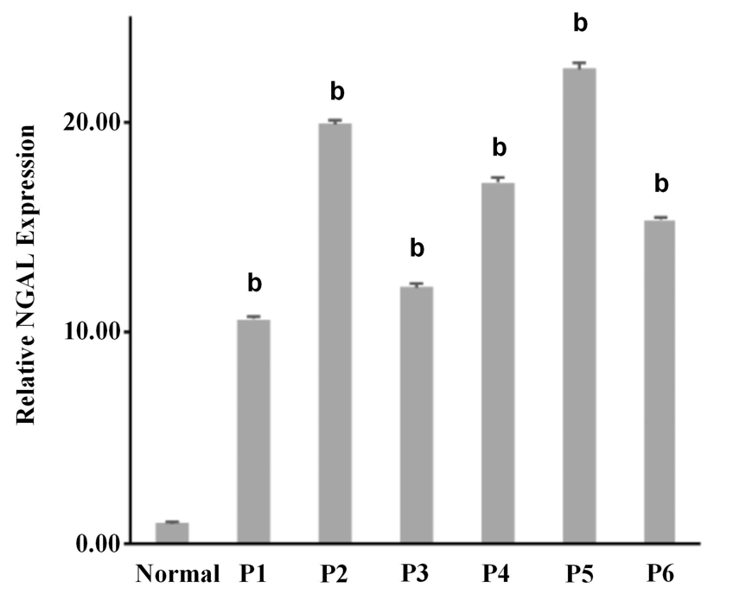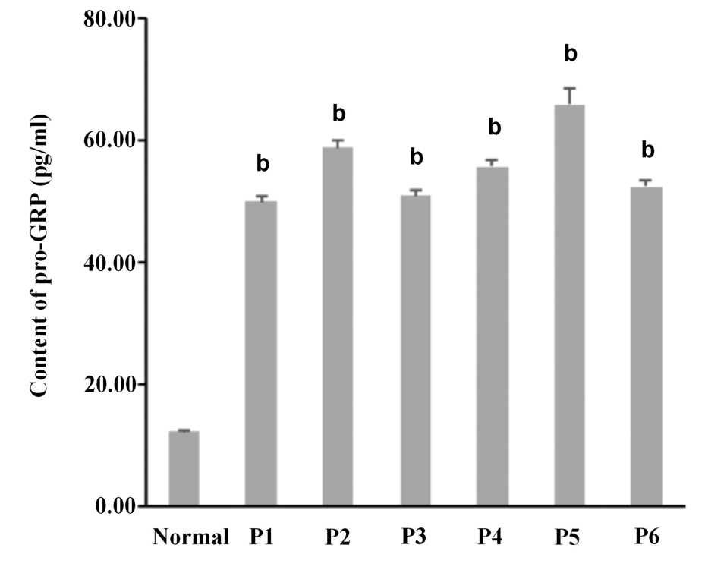
Figure 1 The relative expression of neutrophil gelatinase-associated lipocalin was consistent with the content of pro-gastrin-releasing peptide in serum. A: The relative gene expression of neutrophil gelatinase-associated lipocalin in serum among normal and six samples of tubular adenocacinoma of the colon (P1 to P6); B: The content of pro-gastrin-releasing peptide (pg/mL) in serum. Three independent experiments were carried out for analysis. Data were expressed as mean values ± SE, ^{b}p < 0.01, two-tailed Student’s t-tests. NGAL: Neutrophil gelatinase-associated lipocalin; pro-GRP: pro-gastrin-releasing peptide.

A B
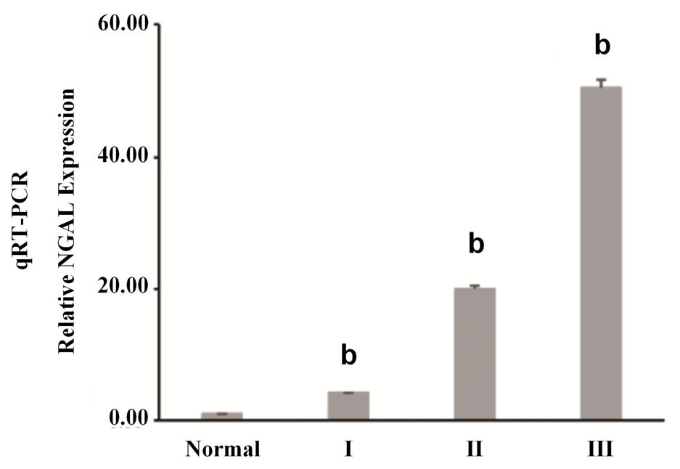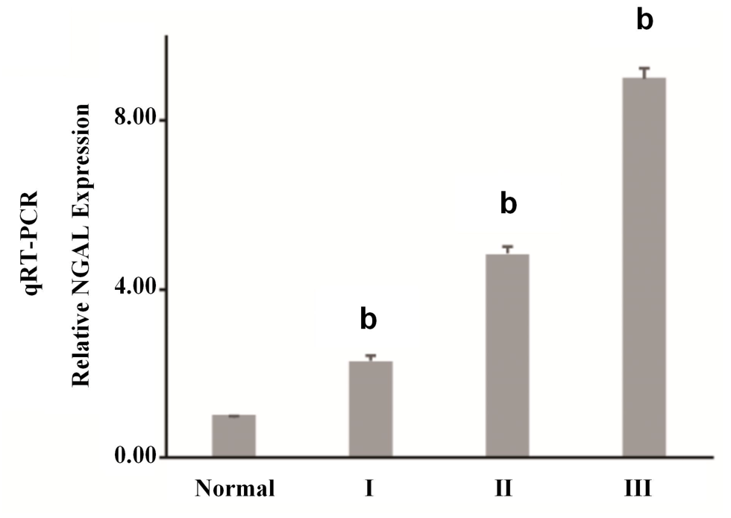
C D
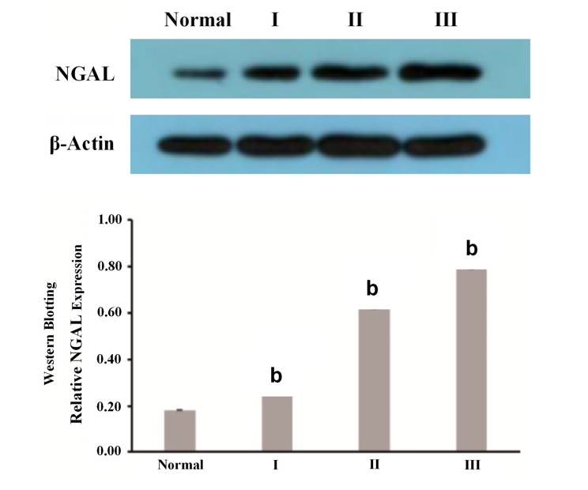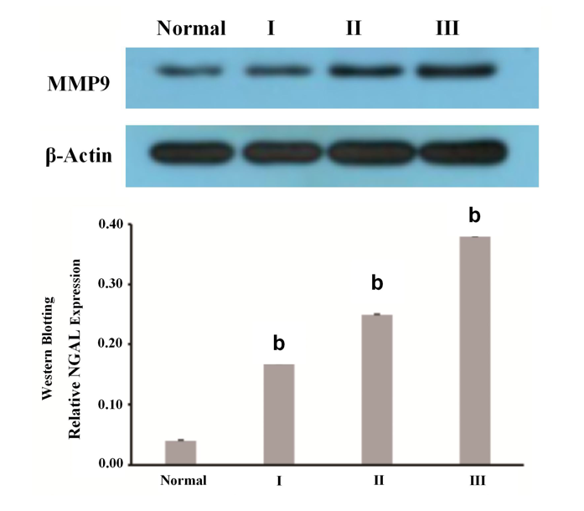
Figure 2 Expression of neutrophil gelatinase-associated lipocalin and matrix metalloproteinase-9 in tubular adenocacinoma of the colon. A and B: The relative neutrophil gelatinase-associated lipocalin (NGAL) (A) and matrix metalloproteinase-9 (MMP-9) (B) gene expression in serum samples among normal (n = 10) and cases from different stages of tubular adenocacinoma of the colon (From I to III) (n = 30); C and D: Western blotting analysis of expression of NGAL (C) and MMP-9 (D) at protein level. Three independent experiments were carried out for analysis. Data were expressed as mean values ± SE, ^{b}p < 0.01, two-tailed Student’s t-tests. NGAL: Neutrophil gelatinase-associated lipocalin; MMP-9: matrix metalloproteinase-9.
Figure 3 Neutrophil gelatinase-associated lipocalin and matrix metalloproteinase-9 immunoexpression in the tubular adenocacinoma of the colon (original magnification, 200 ×). Upper panel: Neutrophil gelatinase-associated lipocalin staining; Beneath panel: matrix metalloproteinase-9 staining. A and E: Control; B and F: Polyps; C and G: Mild tubular adenocacinoma; D and H: Severe tubular adenocacinoma.
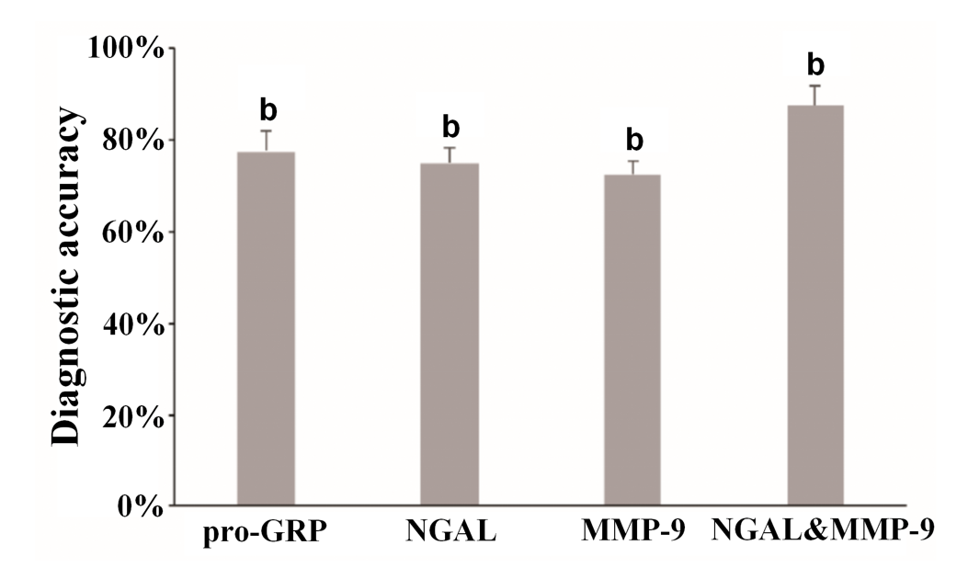
Figure 4 The conbination of neutrophil gelatinase-associated lipocalin and matrix metalloproteinase-9improved the accuracy of diagnoses in the tubular adenocacinoma of the colon. Data were expressed as mean values ± SE, ^{b}p < 0.01, two-tailed Student’s t-tests. NGAL: Neutrophil gelatinase-associated lipocalin; pro-GRP: pro-gastrin-releasing peptide; MMP-9: matrix metalloproteinase-9.

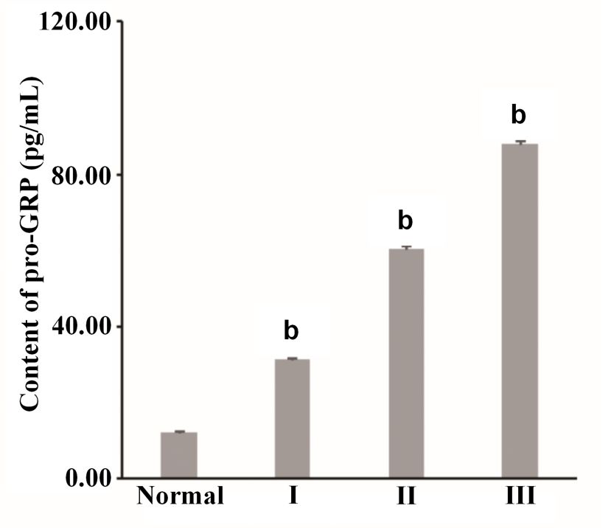
Figure 5 Content of pro-gastrin-releasing peptide (pg/mL) in serum samples from normal (n = 10) and from different stages of tubular adenocacinoma of the colon (stage I-III) (n = 10). Three independent experiments were carried out for analysis. Data were expressed as mean values ± SE, ^{b}p < 0.01, two-tailed Student’s t-tests. pro-GRP: pro-gastrin-releasing peptide.

Table 1 Serum levels of pro-gastrin-releasing peptide and neutrophil gelatinase-associated lipocalin in tubular adenocacinoma patients
Case | Gender | Age | Pathologic grade | pro-GRP (pg/mL) | Relative NGAL expression
Normal | M | 64 | Polyps | 12.32 ± 0.30 | 1 ± 0.02
P1 | M | 76 | Mild tubular adenocacinoma | 50.02 ± 0.80 | 10.62 ± 0.10
P2 | F | 78 | Mild tubular adenocacinoma | 58.86 ± 1.31 | 19.90 ± 0.22
P3 | F | 45 | Mild tubular adenocacinoma | 50.99 ± 0.85 | 12.17 ± 0.15
P4 | M | 74 | Mild tubular adenocacinoma | 55.71 ± 1.15 | 17.14 ± 0.20
P5 | M | 65 | Mild tubular adenocacinoma | 65.87 ± 2.61 | 22.56 ± 0.27
P6 | F | 80 | Mild tubular adenocacinoma | 52.52 ± 1.01 | 15.34 ± 0.19
M: male; F: female; NGAL: Neutrophil gelatinase-associated lipocalin pro-GRP: pro-gastrin-releasing peptide.
Table 2 Serum levels of pro-gastrin-releasing peptide, neutrophil gelatinase-associated lipocalin/matrix metalloproteinase-9 in different group of cases
Group | Case | Gender | Age | Pathologic grade | pro-GRP (pg/mL) | Relative NGAL expression | Relative MMP-9 expression
Normal | N-1 | M | 64 | -- | 11.51 ± 0.31 | 1.00 ± 0.02 | 1.00 ± 0.01
Normal | N-2 | M | 62 | -- | 6.33 ± 0.13 | 0.81 ± 0.01 | 0.98 ± 0.01
Normal | N-3 | M | 59 | -- | 8.54 ± 0.12 | 0.93 ± 0.03 | 0.94 ± 0.02
Normal | N-4 | M | 67 | -- | 15.67 ± 0.37 | 1.03 ± 0.02 | 0.97 ± 0.01
Normal | N-5 | M | 48 | -- | 8.34 ± 0.21 | 1.12 ± 0.03 | 1.02 ± 0.02
Normal | N-6 | M | 52 | -- | 13.51 ± 0.33 | 0.96 ± 0.01 | 1.04 ± 0.02
Normal | N-7 | M | 69 | -- | 16.62 ± 0.41 | 0.89 ± 0.01 | 1.00 ± 0.01
Normal | N-8 | M | 56 | -- | 6.88 ± 0.22 | 1.08 ± 0.04 | 2.03 ± 0.03
Normal | N-9 | M | 70 | -- | 17.36 ± 0.31 | 0.97 ± 0.03 | 0.96 ± 0.01
Normal | N-10 | M | 65 | -- | 18.24 ± 0.35 | 1.21 ± 0.03 | 1.06 ± 0.02
I | I-1 | M | 54 | Polyps | 15.68 ± 0.27 | 1.31 ± 0.02 | 1.02 ± 0.01
I | I-2 | F | 65 | Polyps | 17.83 ± 0.31 | 1.42 ± 0.04 | 1.08 ± 0.02
I | I-3 | F | 66 | Polyps | 20.12 ± 0.35 | 1.90 ± 0.04 | 1.28 ± 0.03
I | I-4 | M | 74 | Polyps | 24.38 ± 0.46 | 2.84 ± 0.06 | 4.32 ± 0.12
I | I-5 | M | 65 | Polyps | 29.67 ± 0.36 | 3.85 ± 0.07 | 2.35 ± 0.06
I | I-6 | F | 71 | Polyps | 62.56 ± 0.83 | 4.24 ± 0.10 | 2.76 ± 0.07
I | I-7 | F | 55 | Polyps | 38.94 ± 0.46 | 2.09 ± 0.06 | 3.00 ± 0.06
I | I-8 | M | 62 | Polyps | 40.54 ± 0.52 | 5.56 ± 0.12 | 5.12 ± 0.13
I | I-9 | M | 64 | Polyps | 43.86 ± 0.49 | 7.21 ± 0.16 | 3.44 ± 0.09
I | I-10 | M | 68 | Polyps | 60.91 ± 0.75 | 8.23 ± 0.20 | 3.71 ± 0.11
II | II-1 | M | 68 | Mild tubular adenocacinoma | 55.32 ± 0.46 | 3.97 ± 0.12 | 4.06 ± 0.12
II | II-2 | M | 72 | Mild tubular adenocacinoma | 30.13 ± 0.36 | 13.81 ± 0.23 | 4.53 ± 0.18
II | II-3 | F | 65 | Mild tubular adenocacinoma | 52.54 ± 0.53 | 15.06 ± 0.25 | 4.89 ± 0.20
II | II-4 | F | 70 | Mild tubular adenocacinoma | 58.25 ± 0.49 | 5.68 ± 0.18 | 4.07 ± 0.17
II | II-5 | M | 75 | Mild tubular adenocacinoma | 35.02 ± 0.56 | 18.37 ± 0.29 | 4.61 ± 0.22
II | II-6 | M | 77 | Mild tubular adenocacinoma | 61.45 ± 0.67 | 21.35 ± 0.35 | 2.92 ± 0.15
II | II-7 | M | 65 | Mild tubular adenocacinoma | 62.38 ± 0.74 | 23.69 ± 0.37 | 4.82 ± 0.27
II | II-8 | F | 63 | Mild tubular adenocacinoma | 64.43 ± 0.48 | 24.92 ± 0.24 | 4.85 ± 0.26
II | II-9 | M | 57 | Mild tubular adenocacinoma | 68.67 ± 0.46 | 26.74 ± 0.30 | 5.68 ± 0.22
II | II-10 | M | 62 | Mild tubular adenocacinoma | 70.5 ± 0.71 | 28.32 ± 0.32 | 6.04 ± 0.17
III | III-1 | M | 67 | Severe tubular adenocacinoma | 72.53 ± 0.83 | 31.03 ± 0.26 | 6.36 ± 0.22
III | III-2 | M | 65 | Severe tubular adenocacinoma | 76.27 ± 0.96 | 37.17 ± 0.32 | 6.47 ± 0.20
III | III-3 | F | 80 | Severe tubular adenocacinoma | 79.81 ± 1.13 | 38.44 ± 0.41 | 7.53 ± 0.31
III | III-4 | F | 76 | Severe tubular adenocacinoma | 84.56 ± 1.41 | 43.68 ± 0.50 | 8.68 ± 0.25
III | III-5 | M | 65 | Severe tubular adenocacinoma | 86.01 ± 1.06 | 45.79 ± 0.55 | 4.70 ± 0.19
III | III-6 | F | 71 | Severe tubular adenocacinoma | 90.12 ± 1.28 | 49.31 ± 0.61 | 9.05 ± 0.35
III | III-7 | M | 66 | Severe tubular adenocacinoma | 93.17 ± 1.33 | 53.81 ± 0.53 | 9.52 ± 0.28
III | III-8 | M | 78 | Severe tubular adenocacinoma | 94.24 ± 1.57 | 54.68 ± 0.62 | 9.35 ± 0.34
III | III-9 | F | 67 | Severe tubular adenocacinoma | 93.08 ± 1.82 | 65.76 ± 0.72 | 9.41 ± 0.27
III | III-10 | F | 72 | Severe tubular adenocacinoma | 107.38 ± 2.34 | 85.91 ± 0.96 | 14.84 ± 0.38
M: male; F: female; NGAL: Neutrophil gelatinase-associated lipocalin pro-GRP: pro-gastrin-releasing peptide; MMP-9: matrix metalloproteinase-9.

