Name of Journal: World Journal of Gastroenterology
Manuscript NO: 46944
Manuscript Type: META-ANALYSIS

Mini-invasive vs open resection of colorectal cancer and liver metastases: A meta-analysis

Ye SP et al. Mini-invasive vs open colorectomy and hepatectomy

Shan-Ping Ye, Hua Qiu, Shi-Jun Liao, Jun-Hua Ai, Jun Shi

Shan-Ping Ye, Hua Qiu, Shi-Jun Liao, Jun-Hua Ai, Jun Shi, Department of General Surgery, First Affiliated Hospital of Nanchang University, Nanchang 330006, Jiangxi Province, China

ORCID number: Shan-Ping Ye (0000-0002-3588-7559); Hua Qiu (0000-0003-0942-0864); Shi-Jun Liao (0000-0002-9496-9458); Jun-Hua Ai (0000-0002-1902-0058); Jun Shi (0000-0002-7333-5448).

Author contributions: Ye SP and Shi J designed the study; Ye SP and Qiu H collected the literature and conducted the analysis of pooled data; Ye SP and Liao SJ helped to draft the manuscript; Ye SP and Ai JH wrote the manuscript; Ye SP and Shi J proofread and revised the manuscript; all authors have approved the version to be published.

Supported by the National Natural Science Foundation of China, No. 81660487.

Conflict-of-interest statement: The authors deny any conflict of interest.

Data sharing statement: No additional data are available.

PRISMA 2009 Checklist statement: This meta-analysis was prepared and revised in accordance with the PRISMA 2009 Checklist.

Open-Access: This article is an open-access article which was selected by an in-house editor and fully peer-reviewed by external reviewers. It is distributed in accordance with the Creative Commons Attribution Non Commercial (CC BY-NC 4.0) license, which permits others to distribute, remix, adapt, build upon this work non-commercially, and license their derivative works on different terms, provided the original work is properly cited and the use is non-commercial. See: http://creativecommons.org/licenses/by-nc/4.0/

Manuscript source: Unsolicited manuscript

Corresponding author: Jun Shi, MD, Chief Doctor, Professor, Department of General Surgery, First Affiliated Hospital of Nanchang University, No. 17, Yongwaizheng Street, Nanchang 330006, Jiangxi Province, China. shijunyfy@sina.com
Telephone: +86-791-88694893
Fax: +86-791-88694893

Received: February 28, 2019
Peer-review started: March 1, 2019
First decision: April 11, 2019
Revised: April 26, 2019
Accepted: May 8, 2019
Article in press:
Published online:
Abstract
BACKGROUND
The safety and feasibility of the simultaneous resection of primary colorectal cancer (CRC) and synchronous colorectal liver metastases (SCRLM) have been demonstrated in some studies. Combined resection is expected to be the optimal strategy for patients with CRC and SCRLM. However, traditional laparotomy is traumatic, and the treatment outcome of minimally invasive surgery (MIS) is still obscure.

AIM
To compare the treatment outcomes of MIS and open surgery (OS) for the simultaneous resection of CRC and SCRLM.

METHODS
A systematic search through December 22, 2018 was conducted in electronic databases (PubMed, EMBASE, Web of Science, and Cochrane Library). All studies comparing the clinical outcomes of MIS and OS for patients with CRC and SCRLM were included by eligibility criteria. The meta-analysis was performed using Review Manager Software. The quality of the pooled study was assessed using the Newcastle-Ottawa scale. The publication bias was evaluated by a funnel plot and the Begg’s and Egger’s tests. Fixed- and random-effects models were applied according to heterogeneity.

RESULTS
Ten retrospective cohort studies involving 502 patients (216 patients in the MIS group and 286 patients in the OS group) were included in this study. MIS was associated with less intraoperative blood loss [weighted mean difference (WMD) = -130.09, 95% confidence interval (CI): -210.95 to -49.23, P = 0.002] and blood transfusion [odds ratio (OR) = 0.53, 95%CI: 0.29 to 0.95, P = 0.03], faster recovery of intestinal function (WMD = -0.88 d, 95%CI: -1.58 to -0.19, P = 0.01) and diet (WMD = -1.54 d, 95%CI: -2.30 to -0.78, P < 0.0001), shorter length of postoperative hospital stay (WMD = -4.06 d, 95%CI: -5.95 to -2.18, P < 0.0001), and lower rates of surgical complications (OR = 0.60, 95%CI: 0.37 to 0.99, P = 0.04). However, the operation time, rates and severity of overall complications, and rates of general complications showed no significant differences between the MIS and OS groups. Moreover, the overall survival and disease-free survival after MIS were equivalent to those after OS.

CONCLUSION
Considering the studies included in this meta-analysis, MIS is a safe and effective alternative technique for the simultaneous resection of CRC and SCRLM. Compared with OS, MIS has less intraoperative blood loss and blood transfusion and quicker postoperative recovery. Furthermore, the two groups show equivalent long-term outcomes.

Key words: Minimally invasive surgical procedures; Laparotomy; Colorectal neoplasms; Synchronous liver metastases; Meta-analysis

© The Author(s) 2019. Published by Baishideng Publishing Group Inc. All rights reserved.

Core tip: For patients with colorectal cancer (CRC) and synchronous colorectal liver metastases (SCRLM), there is no consensus regarding whether minimally invasive surgery (MIS) or open surgery (OS) is more beneficial. We conducted this meta-analysis to compare the treatment outcomes of MIS and OS for the simultaneous resection of CRC and SCRLM. We assessed the two methods in terms of short- and long-term outcomes. Compared with OS, MIS has less intraoperative blood loss and blood transfusion and quicker postoperative recovery. Furthermore, the two groups show equivalent long-term outcomes.

Ye SP, Qiu H, Liao SJ, Ai JH, Shi J. Mini-invasive vs open resection of colorectal cancer and liver metastases: A meta-analysis. World J Gastroenterol 2019; In press

INTRODUCTION
Colorectal cancer (CRC) remains one of the leading causes of cancer-related deaths worldwide. The incidence and mortality of CRC rank third (10.2%) and second (9.2%), respectively, among all cancers worldwide^{[1]}. Moreover, according to the latest global cancer report issued by the International Agency for Research on Cancer for 2018 alone, more than 1.8 million patients were newly diagnosed with CRC, and 881000 patients died of CRC^{[1]}. The liver is the most common organ for metastasis from colorectal neoplasms. Approximately 40% of patients with CRC eventually develop liver metastases, and 15%-20% of CRC patients have synchronous colorectal liver metastases (SCRLM) at the time of initial diagnosis; the metastases are limited to the liver in 70%-80% of these patients, but only a subset of these metastases are resectable^{[2-4]}. Complete radical resection of primary and metastatic lesions is a potential curative treatment strategy for patients with resectable CRC and SCRLM, which is directly related to the prognosis of these patients^{[5,6]}.
The resection methods for CRC and SCRLM include simultaneous resection and staged resection. Staged resection of the initial tumor and SCRLM was first developed and performed, removing the primary CRC tumor, followed by adjuvant chemotherapy and liver metastasis tumor resection^{[7]}. Recently, an increasing number of studies have suggested that the simultaneous resection of primary CRC and SCRLM is safe and acceptable and may become an optimal treatment strategy for patients with resectable CRC and SCRLM^{[8,9]}. Simultaneous resection of CRC and SCRLM was only performed by laparotomy before minimally invasive surgery (MIS) such as laparoscopy or robotics was applied in the treatment of CRC^{[10,11]}. MIS displayed superior short-term and similar long-term treatment outcomes to conventional open surgery (OS) in some studies^{[12,13]}. However, most of the studies were case series or reports, and the sample sizes were small^{[14,15]}. The advantages of MIS over OS remained unclear, particularly concerning the long-term outcomes. Therefore, this meta-analysis was conducted to compare the short- and long-term outcomes of MIS and OS for the simultaneous resection of primary CRC and SCRLM based on the current available literature. The present study followed the principle of PICOS.

MATERIALS AND METHODS
Search strategy
A systematic search of the Web of Science, Cochrane Library, Embase, and PubMed was performed to identify relevant studies comparing MIS and OS for simultaneous resection of CRC and SCRLM published up to December 22, 2018. The search strategy was performed using the following terms: “colon”, “rectal”, “rectum”, or “colorectal”; “liver metasta*”, “hepatic metasta*”; “robot*”, “Da Vinci”, “laparoscop*”, or “minimally invasive”; and “simultaneous”, “coinstantaneous”, “synchronous”, or “combined”. The language of the articles was not limited to any language. The references of relevant reviews and meta-analysis were also manually searched for potentially relevant studies. All relevant studies that met the inclusion criterion were reviewed for data extraction. This meta-analysis was prepared in accordance with the Preferred Reporting Items for Systemic Reviews and Meta-Analysis (PRISMA) statement^{[16]}, and the work was reported in line with the Assessing the Methodological Quality of Systematic Reviews (AMSTAR) guidelines^{[17]}.

Study selection
Two authors (Ye SP and Qiu H) independently scanned the titles and abstracts from the studies identified in the electronic search. Relevant papers were further identified through perusing full texts. Disagreements were resolved by discussion and consensus between authors. Studies were included in this meta-analysis according to the following inclusion criteria: (1) They compared the treatment outcomes of MIS with OS for simultaneous resection CRC and SCRLM, and MIS was only limited to laparoscopic or robotic-assisted procedure; (2) the papers were accepted or published, and the full texts were available; and (3) the articles reported on at least three treatment outcomes mentioned below. The exclusion criteria included were as follows: (1) Patients with metachronous colorectal liver metastasis; (2) hand-assisted laparoscopy; (3) hepatic diseases, including benign liver lesions or primary liver malignancies through preoperative diagnosis; and (4) noncomparative studies, duplicate studies, articles presented at meetings, review articles, conference abstracts, guidelines, case reports or series, or letters.

Data extraction and quality assessment
Two researchers (Ye SP and Qiu H) reviewed each article by a structured list and extracted data into a database independently. Disagreements of opinions were settled through discussion between authors. Data with the following items were extracted: (1) Characteristics, including first author, country, publication year, sample size, gender and age of patients, body mass index, study type, primary CRC tumor location and size, size and number of liver metastases; (2) short-term outcomes, including operation time, intraoperative blood loss, time to intestinal function recovery, time to diet, number of blood transfusions during the operation, length of postoperative hospital stay, type (surgical or general complications) and severity (Clavien-Dindo grade ≥ 3) of postoperative complications (surgical complications including anastomotic leakage, bile leakage, ileus, abdominal abscess, wound infection, and chylous ascites; and general complications including urinary tract infection, pulmonary complications, and pleural effusion); and (3) long-term outcomes, including overall survival and disease-free survival (DFS). Disagreements in data extraction were resolved by discussion. The time to intestinal function recovery was referred to the time to the first flatus after operation. The type and severity of complications were assessed by the sum number of the relevant complications reported in each study. The Newcastle-Ottawa scale (NOS) was used to evaluate the methodological quality of the studies^{[18]}. The scale has three parts: patient selection, comparability, and outcome. Two reviewers (Ai JH and Liao SJ) appraised the quality of studies independently. Disagreements were solved by consensus. The scale changes from 0 to 9 stars, and studies with a score ≥ six stars could be deemed as high quality.

Statistical analysis
The software Review Manager, version 5.3, was adopted to analyze the data. The odds ratio (OR) with 95% confidence interval (CI) was utilized to assess the dichotomous variables. The weighted mean difference (WMD) and 95%CI were analyzed for continuous variables. If continuous variables were presented as medians and ranges in some studies, the mean and standard deviation (SD) of these variables were estimated, as reported by Hozo et al^{[19]}. The hazard ratio (HR) was used to assess the difference in the DFS and overall survival between the groups. If HR was not reported, then HR was estimated from the data of DFS and overall survival extracted from the survival curve in the included papers, as described by Tierney et al^{[20]}. The I² statistic was utilized to evaluate the heterogeneity among the studies^{[21]}. The random-effects model was adopted if I² was > 50%; otherwise, the fixed-effects model was utilized. Potential publication bias was determined by a funnel plot and assessed by the Begg’s test and Egger’s test (STATA software version 12.0 was adopted). A P-value < 0.05 was considered statistically significant.

RESULTS
Search results and study characteristics
In total, 1198 potential articles were initially retrieved from the electronic databases, and 684 potentially relevant articles were obtained for further assessment after eliminating duplicates. Next, 654 articles were excluded by screening the title and abstract. Thirty articles were retrieved for full-text evaluation. Finally, ten comparative cohort studies were included for this meta-analysis^{[22-31]}. A flow chart of the search strategies that contains reasons for the exclusion of studies is shown in Figure 1. The study by Chen et al^{[28]} was also included although it contained six patients with liver tumors not metastatic from the CRC diagnosed based on the postoperative pathological report because this did not influence the intraoperative procedure, and the study excluded these patients for further analysis of long-term outcomes. The characteristics of each study and study quality evaluated using the NOS are presented in Table 1. The preoperative characteristics of all patients from the two groups are shown in Table 2.

Intraoperative outcomes
All studies reported the operative time and intraoperative blood loss. The operative time showed no significant difference between the two groups (WMD = 34.05 min, 95%CI: 0.65 to 67.46, P = 0.05, I² = 84% for heterogeneity, P < 0.00001; Figure 2A). However, the intraoperative blood loss was less in the MIS group than in the OS group (WMD = -130.09, 95%CI: -210.95 to -49.23, P = 0.002, I² = 91% for heterogeneity, P < 0.00001; Figure 2B). Seven studies reported the number of intraoperative blood transfusions in 407 patients^{[24-27,29-31]}. The number of intraoperative blood transfusions was significantly less in the MIS group than in the OS group (OR = 0.53, 95%CI: 0.29 to 0.95, P = 0.03, I² = 0% for heterogeneity, P = 0.81; Figure 2C).

Postoperative outcomes
In this meta-analysis, postoperative outcomes included the time to bowel functional recovery, time to start diet, length of postoperative hospital stay, and postoperative complications. Five studies reported the time to bowel functional recovery in 222 patients^{[23,24,26,30,31]}. The pooled mean time to bowel functional recovery was shorter in the MIS group than in the OS group (WMD = -0.88 d, 95%CI: -1.58 to -0.19, P = 0.01, I² = 94% for heterogeneity, P < 0.00001; Figure 2D). Four studies provided the time to recovery of diet in 162 patients^{[24,26,27,31]}. The time to recovery of diet for MIS was significantly shorter than that for OS (WMD = -1.54 d, 95%CI: -2.30 to -0.78, P < 0.0001, I² = 88% for heterogeneity, P < 0.0001; Figure 2E). All studies reported the length of hospital stay, but only six studies clearly recorded the length of postoperative hospital stay, including 87 patients in the MIS group and 136 patients in the OS group^{[22-24,27,29,30]}. According to the pooled data from the six studies, the patients in the MIS group were discharged earlier than those in the OS group after operation (WMD = -4.06 d, 95%CI: -5.95 to -2.18, P < 0.0001, I² = 69% for heterogeneity, P = 0.006; Figure 2F).
All but one study^{[26]} clearly reported the rate of overall postoperative complications, ranging from 7.1% to 34.8% in the MIS group and from 0% to 50% in the OS group, without a significant difference between the two groups (OR = 0.78, 95%CI: 0.51 to 1.18, P = 0.24, I² = 0% for heterogeneity, P = 0.89; Figure 3A). The severity (Clavien–Dindo grade ≥ 3) of complications was reported in five studies^{[24,25,27,28,31]}, and the number of severe complications was not significantly different in the two groups (OR = 0.75, 95%CI: 0.42 to 1.34, P = 0.33, I² = 31% for heterogeneity, P = 0.21; Figure 3B). Different types (surgical or general complications) of postoperative complications were compared for further analysis. The surgical complications were reported in nine studies^{[22-25,27-31]}, and the pooled data identified that the rate of surgical complications in the MIS group was significantly reduced compared with the OS group (OR = 0.60, 95%CI: 0.37 to 0.99, P = 0.04; I² = 0% for heterogeneity, P = 0.50; Figure 3C). The general complications between the groups retrieved from eight papers^{[22-25,27,28,30,31]} showed no significant difference (OR = 1.23, 95%CI: 0.73 to 2.07, P = 0.44, I² = 0% for heterogeneity, P = 0.84; Figure 3D).

Long-term outcomes
The HR was used to assess the differences in the long-term outcomes (DFS and overall survival) between the groups. The HR was estimated from the survival data that were extracted from the survival curve reported in the studies. All studies provided the Kaplan-Meier curves of overall survival, whereas the 95%CI could not be calculated in half of the studies. Another five studies^{[23-25,29,31]} showed that HR was not significantly different between the groups (HR = 1.15, 95%CI: 0.53 to 2.50, P = 0.73, I² = 0% for heterogeneity, P = 0.94; Figure 4A). Seven studies reported DFS curves, but the 95%CI could not be calculated in one study because it only provided the median follow-up time without a range^{[23-25,27,28,31]}. Thus, synthetic analysis of the DFS data in the other six studies was conducted. The HR of DFS was not significantly different (HR = 1.00, 95%CI: 0.67 to 1.50, P = 1.00, I² = 0% for heterogeneity, P = 0.48; Figure 4B).

Publication bias
As shown in Figure 5, the possible publication bias of the number of intraoperative blood transfusions and overall complications between the groups was assessed by the funnel plot, Egger’s test, and Begg’s test. The funnel plot of the number of intraoperative blood transfusion was symmetrically distributed, and none of the studies included was outside the 95%CI (Figure 5A). No significant publication bias was detected from statistical tests based on the number of intraoperative blood transfusions (Begg’s test P = 1.000; Egger’s test P = 0.897). The funnel plot of the overall complications showed a symmetric distribution of all studies, and all were inside the 95%CI (Figure 5B). The pooled analysis suggested that there was no significant publication bias in the overall complications (Begg’s test P = 0.283; Egger’s test P = 0.127).

DISCUSSION
In past decades, the resection timing of primary CRC and SCRLM has been controversial. Some scholars hold the opinion that staged resection can reduce the rate of operative complications and make the occult micrometastases become perceptible^{[32,33]}. However, some authors believe that simultaneous resection can reduce the burden of tumors, as well as reduce the economic and psychological burden of patients, leading to patients undergoing one operative procedure instead of two^{[34]}. Recently, with the advances in the strategy of perioperative management and overall critical care, the operation strategy for resectable patients has been questioned. An increasing number of authors support that the optimal operation timing is gradually changing from staged resection to simultaneous resection^{[35,36]}.
Traditionally, simultaneous resection of primary CRC and SCRLM is usually performed by laparotomy. Conventional laparotomy always requires a long abdominal incision for adequate exposure of the operative field, causing severe pain and incision complications^{[29]}. Laparotomy is also associated with serious physical and psychological operative trauma to the patients. With the improvements in surgical technique and apparatus, MIS showed great advantages in some surgeries such as proctocolectomy or hepatectomy^{[11,13]}. Furthermore, reports regarding the safety and efficacy of combined resection of CRC and SCRLM have been increased. However, most were case series or reports limited by a small sample size^{[14,15]}. Our meta-analysis of ten comparative studies with 502 patients provided a large body of information and identified the advantages of MIS over OS in simultaneous resection of CRC and SCRLM.
The pooled results revealed that the operative time was similar between the groups. The operation time depended on the characteristics of primary tumors and liver metastases, severe degree of abdominal adhesion and obesity, and experience of the surgical teams^{[37,38]}. These might also be the sources of heterogeneity (P < 0.00001, I² = 84%). The intraoperative blood loss was critical to evaluate the quality of surgery. The most significant finding in this meta-analysis was the reduction of blood loss in MIS vs OS (P = 0.002). Moreover, the number of intraoperative blood transfusions was also less in the MIS group than in the OS group (P = 0.03). Less blood loss indicated a lower blood transfusion rate. Studies have reported that perioperative blood transfusion might lead to poor survival, and transfused patients had more postoperative complications^{[39-41]}. High heterogeneity (P < 0.00001, I² = 91%) among groups was observed in this regard that was likely to be related to the methods used to estimate the blood loss and diverse experience of the surgical teams.
Postoperative recovery was also analyzed in the present meta-analysis. Interestingly, the time to both intestinal function recovery and start of the diet in patients accepting MIS was shorter than that in patients undergoing OS (P = 0.01, P < 0.0001). The cause was that the MIS technique shortened the intestinal exposure time and reduced intestinal irritation. Furthermore, another target to assess the postoperative recovery was the length of postoperative hospital stay. As expected, the length of postoperative hospital stay was shorter in the MIS group than in the OS group (P = 0.01). Different surgical teams had different postoperative management concepts, which might interpret the high heterogeneity in the above indexes of postoperative recovery.
Another issue of concern for MIS is the postoperative complications; all studies reported postoperative complications, but the number of complications reported in one article^{[26]} was too obscure for further analysis. No significant difference was found in the rate (P = 0.24) or severity (Clavien–Dindo grade ≥ 3, P = 0.33) of overall postoperative complications. Our meta-analysis also analyzed the type of postoperative complications. The general complications were not different between the groups, but the surgical complications were fewer in the MIS group than in the OS group. Thus, our results suggested that MIS is a safe and effective technique.
A key factor in evaluating the quality of surgery is the long-term oncological outcomes. Nine studies provided overall survival curves, and seven studies reported DFS curves. However, the 95%CI of HR could not be calculated in some studies according to the data extracted from the studies. Finally, further analysis for overall survival and DFS could only be conducted in six and five studies, respectively. The pooled data showed that the HR of DFS and overall survival was similar in the two groups.
Several limitations should be considered in this meta-analysis such as the heterogeneity. First, the surgeries were performed by different surgical teams with different experience and skills, as well as different perioperative management. Second, although these studies were focused on CRC and SCRLM, the involved types of surgeries were different because of different tumor locations. Third, these were all retrospective studies with a small size, without RCTs available. Finally, the number of studies included in our meta-analysis was not large enough because studies focused on MIS and OS for the simultaneous resection of CRC and SCRLM were limited in the electronic databases. Based on the above limitations, caution must be taken in analyzing the results pooled from the ten studies.

In conclusion, MIS was proven to be a safe and effective technique in the treatment of patients with CRC and SCRLM. Compared with OS, MIS has less blood loss and blood transfusion, a quicker postoperative recovery, and equivalent long-term outcomes. Further randomized controlled trials are needed to further confirm these advantages.

ARTICLE HIGHLIGHTS

Research background
Colorectal cancer (CRC) is a common cause of cancer-related deaths, especially in cases with liver metastases. Simultaneous surgical resection of primary colorectal tumors and synchronous colorectal liver metastases (SCRLM) is an effective strategy to improve the overall survival rate. Application of minimally invasive surgery (MIS) is increasing, but the true benefits of MIS remain unclear.

Research motivation

We hope to offer guidance on the clinical care of MIS in CRC and SCRLM.

Research objectives

To help identify which optimal surgery method is suitable for patients with CRC and SCRLM.

Research methods

A systematic search was conducted in PubMed, EMBASE, Web of Science, and Cochrane Library databases for studies concerning minimally invasive and open surgery (OS) for the simultaneous resection of CRC and SCRLM. We followed the PRISMA agreement. The meta-analysis was performed using Review Manager Software, and the quality was assessed using the Newcastle-Ottawa scale.

Research results
Two hundred and sixteen patients in the mini-invasive group and 286 patients in the open group were included in this study. Intraoperative blood loss (P = 0.002) and blood transfusion (P = 0.03) were less, the recovery of intestinal function (P = 0.01) and diet (P < 0.0001) was faster, the length of postoperative hospital stay (P < 0.0001) was shorter, and the number of surgical complications was lower (P = 0.04) in the MIS group. However, the operation time, rates and severity of overall morbidity, as well as the rates of general morbidity showed no significant difference between the minimally invasive and OS groups. Moreover, the overall survival and disease-free survival after MIS were similar to those after OS.

Research conclusions

The current meta-analysis showed that MIS is an optimal strategy for the simultaneous resection of CRC and SCRLM.

Research perspectives
The results of the current meta-analysis may help researchers to develop guidelines about surgical methods in CRC and SCRLM more perfectly.

REFERENCES
1 Bray F, Ferlay J, Soerjomataram I, Siegel RL, Torre LA, Jemal A. Global cancer statistics 2018: GLOBOCAN estimates of incidence and mortality worldwide for 36 cancers in 185 countries. CA Cancer J Clin 2018; 68: 394-424 [PMID: 30207593 DOI: 10.3322/caac.21492]
2 Veen T, Søreide K. Can molecular biomarkers replace a clinical risk score for resectable colorectal liver metastasis? World J Gastrointest Oncol 2017; 9: 98-104 [PMID: 28344745 DOI: 10.4251/wjgo.v9.i3.98]
3 Manfredi S, Lepage C, Hatem C, Coatmeur O, Faivre J, Bouvier AM. Epidemiology and management of liver metastases from colorectal cancer. Ann Surg 2006; 244: 254-259 [PMID: 16858188 DOI: 10.1097/01.sla.0000217629.94941.cf]
4 Leporrier J, Maurel J, Chiche L, Bara S, Segol P, Launoy G. A population-based study of the incidence, management and prognosis of hepatic metastases from colorectal cancer. Br J Surg 2006; 93: 465-474 [PMID: 16523446 DOI: 10.1002/bjs.5278]
5 Adams RB, Aloia TA, Loyer E, Pawlik TM, Taouli B, Vauthey JN; Americas Hepato-Pancreato-Biliary Association; Society of Surgical Oncology; Society for Surgery of the Alimentary Tract. Selection for hepatic resection of colorectal liver metastases: Expert consensus statement. HPB (Oxford) 2013; 15: 91-103 [PMID: 23297719 DOI: 10.1111/j.1477-2574.2012.00557.x]
6 Mayo SC, Pulitano C, Marques H, Lamelas J, Wolfgang CL, de Saussure W, Choti MA, Gindrat I, Aldrighetti L, Barrosso E, Mentha G, Pawlik TM. Surgical management of patients with synchronous colorectal liver metastasis: A multicenter international analysis. J Am Coll Surg 2013; 216: 707-16; discussion 716-8 [PMID: 23433970 DOI: 10.1016/j.jamcollsurg.2012.12.029]
7 Reddy SK, Pawlik TM, Zorzi D, Gleisner AL, Ribero D, Assumpcao L, Barbas AS, Abdalla EK, Choti MA, Vauthey JN, Ludwig KA, Mantyh CR, Morse MA, Clary BM. Simultaneous resections of colorectal cancer and synchronous liver metastases: A multi-institutional analysis. Ann Surg Oncol 2007; 14: 3481-3491 [PMID: 17805933 DOI: 10.1245/s10434-007-9522-5]
8 Slesser AA, Simillis C, Goldin R, Brown G, Mudan S, Tekkis PP. A meta-analysis comparing simultaneous versus delayed resections in patients with synchronous colorectal liver metastases. Surg Oncol 2013; 22: 36-47 [PMID: 23253399 DOI: 10.1016/j.suronc.2012.11.002]
9 Feng Q, Wei Y, Zhu D, Ye L, Lin Q, Li W, Qin X, Lyu M, Xu J. Timing of hepatectomy for resectable synchronous colorectal liver metastases: For whom simultaneous resection is more suitable--a meta-analysis. PLoS One 2014; 9: e104348 [PMID: 25093337 DOI: 10.1371/journal.pone.0104348]
10 Fleshman J, Branda M, Sargent DJ, Boller AM, George V, Abbas M, Peters WR Jr, Maun D, Chang G, Herline A, Fichera A, Mutch M, Wexner S, Whiteford M, Marks J, Birnbaum E, Margolin D, Larson D, Marcello P, Posner M, Read T, Monson J, Wren SM, Pisters PW, Nelson H. Effect of Laparoscopic-Assisted Resection vs Open Resection of Stage II or III Rectal Cancer on Pathologic Outcomes: The ACOSOG Z6051 Randomized Clinical Trial. JAMA 2015; 314: 1346-1355 [PMID: 26441179 DOI: 10.1001/jama.2015.10529]
11 Fretland ÅA, Dagenborg VJ, Bjørnelv GMW, Kazaryan AM, Kristiansen R, Fagerland MW, Hausken J, Tønnessen TI, Abildgaard A, Barkhatov L, Yaqub S, Røsok BI, Bjørnbeth BA, Andersen MH, Flatmark K, Aas E, Edwin B. Laparoscopic Versus Open Resection for Colorectal Liver Metastases: The OSLO-COMET Randomized Controlled Trial. Ann Surg 2018; 267: 199-207 [PMID: 28657937 DOI: 10.1097/SLA.0000000000002353]
12 Wei M, He Y, Wang J, Chen N, Zhou Z, Wang Z. Laparoscopic versus open hepatectomy with or without synchronous colectomy for colorectal liver metastasis: A meta-analysis. PLoS One 2014; 9: e87461 [PMID: 24489916 DOI: 10.1371/journal.pone.0087461]
13 Rodrigues TFDC, Silveira B, Tavares FP, Madeira GM, Xavier IP, Ribeiro JHC, Pereira RMOS, Siqueira SL. Open, laparoscopic, and robotic-assisted hepatectomy in resection of liver tumors: a non-systematic review. Arq Bras Cir Dig 2017; 30: 155-160 [PMID: 29257855 DOI: 10.1590/0102-6720201700020017]
14 Takorov I, Belev N, Lukanova T, Atanasov B, Dzharov G, Djurkov V, Odisseeva E, Vladov N. Laparoscopic combined colorectal and liver resections for primary colorectal cancer with synchronous liver metastases. Ann Hepatobiliary Pancreat Surg 2016; 20: 167-172 [PMID: 28261695 DOI: 10.14701/ahbps.2016.20.4.167]
15 Hatwell C, Bretagnol F, Farges O, Belghiti J, Panis Y. Laparoscopic resection of colorectal cancer facilitates simultaneous surgery of synchronous liver metastases. Colorectal Dis 2013; 15: e21-e28 [PMID: 23088162 DOI: 10.1111/codi.12068]
16 Liberati A, Altman DG, Tetzlaff J, Mulrow C, Gøtzsche PC, Ioannidis JP, Clarke M, Devereaux PJ, Kleijnen J, Moher D. The PRISMA statement for reporting systematic reviews and meta-analyses of studies that evaluate health care interventions: Explanation and elaboration. J Clin Epidemiol 2009; 62: e1-34 [PMID: 19631507 DOI: 10.1016/j.jclinepi.2009.06.006]
17 Shea BJ, Hamel C, Wells GA, Bouter LM, Kristjansson E, Grimshaw J, Henry DA, Boers M. AMSTAR is a reliable and valid measurement tool to assess the methodological quality of systematic reviews. J Clin Epidemiol 2009; 62: 1013-1020 [PMID: 19230606 DOI: 10.1016/j.jclinepi.2008.10.009]
18 Stang A. Critical evaluation of the Newcastle-Ottawa scale for the assessment of the quality of nonrandomized studies in meta-analyses. Eur J Epidemiol 2010; 25: 603-605 [PMID: 20652370 DOI: 10.1007/s10654-010-9491-z]
19 Hozo SP, Djulbegovic B, Hozo I. Estimating the mean and variance from the median, range, and the size of a sample. BMC Med Res Methodol 2005; 5: 13 [PMID: 15840177 DOI: 10.1186/1471-2288-5-13]
20 Tierney JF, Stewart LA, Ghersi D, Burdett S, Sydes MR. Practical methods for incorporating summary time-to-event data into meta-analysis. Trials 2007; 8: 16 [PMID: 17555582 DOI: 10.1186/1745-6215-8-16]
21 Higgins JP, Thompson SG, Deeks JJ, Altman DG. Measuring inconsistency in meta-analyses. BMJ 2003; 327: 557-560 [PMID: 12958120 DOI: 10.1136/bmj.327.7414.557]
22 Takasu C, Shimada M, Sato H, Miyatani T, Imura S, Morine Y, Ikemoto T, Kanamoto M, Kurita N, Eto S, Utsunomiya T. Benefits of simultaneous laparoscopic resection of primary colorectal cancer and liver metastases. Asian J Endosc Surg 2014; 7: 31-37 [PMID: 24127772 DOI: 10.1111/ases.12066]
23 Lin Q, Ye Q, Zhu D, Wei Y, Ren L, Zheng P, Xu P, Ye L, Lv M, Fan J, Xu J. Comparison of minimally invasive and open colorectal resections for patients undergoing simultaneous R0 resection for liver metastases: A propensity score analysis. Int J Colorectal Dis 2015; 30: 385-395 [PMID: 25503803 DOI: 10.1007/s00384-014-2089-2]
24 Ratti F, Catena M, Di Palo S, Staudacher C, Aldrighetti L. Impact of totally laparoscopic combined management of colorectal cancer with synchronous hepatic metastases on severity of complications: A propensity-score-based analysis. Surg Endosc 2016; 30: 4934-4945 [PMID: 26944725 DOI: 10.1007/s00464-016-4835-8]
25 Tranchart H, Fuks D, Vigano L, Ferretti S, Paye F, Wakabayashi G, Ferrero A, Gayet B, Dagher I. Laparoscopic simultaneous resection of colorectal primary tumor and liver metastases: A propensity score matching analysis. Surg Endosc 2016; 30: 1853-1862 [PMID: 26275554 DOI: 10.1007/s00464-015-4467-4]
26 Gorgun E, Yazici P, Onder A, Benlice C, Yigitbas H, Kahramangil B, Tasci Y, Aksoy E, Aucejo F, Quintini C, Miller C, Berber E. Laparoscopic versus open 1-stage resection of synchronous liver metastases and primary colorectal cancer. Gland Surg 2017; 6: 324-329 [PMID: 28861371 DOI: 10.21037/gs.2017.03.10]
27 Ma K, Wang XY, Chen JH. [Laparoscopic versus open surgery for simultaneous resection of synchronous colorectal liver metastases]. Zhonghua Wai Ke Za Zhi 2018; 56: 516-521 [PMID: 30032533 DOI: 10.3760/cma.j.issn.0529-5815.2018.07.007]
28 Chen YW, Huang MT, Chang TC. Long term outcomes of simultaneous laparoscopic versus open resection for colorectal cancer with synchronous liver metastases. Asian J Surg 2019; 42: 217-223 [PMID: 29804706 DOI: 10.1016/j.asjsur.2018.04.006]
29 Hu MG, Ou-yang CG, Zhao GD, Xu DB, Liu R. Outcomes of open versus laparoscopic procedure for synchronous radical resection of liver metastatic colorectal cancer: A comparative study. Surg Laparosc Endosc Percutan Tech 2012; 22: 364-369 [PMID: 22874690 DOI: 10.1097/SLE.0b013e31825af6b2]
30 Chen KY, Xiang GA, Wang HN, Xiao FL. Simultaneous laparoscopic excision for rectal carcinoma and synchronous hepatic metastasis. Chin Med J (Engl) 2011; 124: 2990-2992 [PMID: 22040541 DOI: 10.3760/cma.j.issn.0366-6999.2011.19.006]
31 Ivanecz A, Krebs B, Stozer A, Jagric T, Plahuta I, Potrc S. Simultaneous Pure Laparoscopic Resection of Primary Colorectal Cancer and Synchronous Liver Metastases: A Single Institution Experience with Propensity Score Matching Analysis. Radiol Oncol 2017; 52: 42-53 [PMID: 29520205 DOI: 10.1515/raon-2017-0047]
32 Vallance AE, van der Meulen J, Kuryba A, Charman SC, Botterill ID, Prasad KR, Hill J, Jayne DG, Walker K. The timing of liver resection in patients with colorectal cancer and synchronous liver metastases: A population-based study of current practice and survival. Colorectal Dis 2018; 20: 486-495 [PMID: 29338108 DOI: 10.1111/codi.14019]
33 Kaibori M, Iwamoto S, Ishizaki M, Matsui K, Saito T, Yoshioka K, Hamada Y, Kwon AH. Timing of resection for synchronous liver metastases from colorectal cancer. Dig Dis Sci 2010; 55: 3262-3270 [PMID: 20112062 DOI: 10.1007/s10620-009-1124-6]
34 Fukami Y, Kaneoka Y, Maeda A, Takayama Y, Onoe S, Isogai M. Simultaneous resection for colorectal cancer and synchronous liver metastases. Surg Today 2016; 46: 176-182 [PMID: 26007322 DOI: 10.1007/s00595-015-1188-1]
35 Lupinacci RM, Andraus W, De Paiva Haddad LB, Carneiro D' Albuquerque LA, Herman P. Simultaneous laparoscopic resection of primary colorectal cancer and associated liver metastases: A systematic review. Tech Coloproctol 2014; 18: 129-135 [PMID: 24057357 DOI: 10.1007/s10151-013-1072-1]
36 Chen J, Li Q, Wang C, Zhu H, Shi Y, Zhao G. Simultaneous vs. staged resection for synchronous colorectal liver metastases: A meta-analysis. Int J Colorectal Dis 2011; 26: 191-199 [PMID: 20669024 DOI: 10.1007/s00384-010-1018-2]
37 Pai A, Alsabhan F, Park JJ, Melich G, Sulo S, Marecik SJ. The Impact of Obesity on the Perioperative, Clinicopathologic, and Oncologic Outcomes of Robot Assisted Total Mesorectal Excision for Rectal Cancer. Pol Przegl Chir 2017; 89: 23-28 [PMID: 28905801 DOI: 10.5604/01.3001.0010.3906]
38 Zhou Y, Xiao Y, Wu L, Li B, Li H. Laparoscopic liver resection as a safe and efficacious alternative to open resection for colorectal liver metastasis: A meta-analysis. BMC Surg 2013; 13: 44 [PMID: 24083369 DOI: 10.1186/1471-2482-13-44]
39 Patel SV, Brennan KE, Nanji S, Karim S, Merchant S, Booth CM. Peri-operative blood transfusion for resected colon cancer: Practice patterns and outcomes in a population-based study. Cancer Epidemiol 2017; 51: 35-40 [PMID: 29032319 DOI: 10.1016/j.canep.2017.10.006]
40 Jagoditsch M, Pozgainer P, Klingler A, Tschmelitsch J. Impact of blood transfusions on recurrence and survival after rectal cancer surgery. Dis Colon Rectum 2006; 49: 1116-1130 [PMID: 16779711 DOI: 10.1007/s10350-006-0573-7]
41 Mazzeffi M, Tanaka K, Galvagno S. Red Blood Cell Transfusion and Surgical Site Infection After Colon Resection Surgery: A Cohort Study. Anesth Analg 2017; 125: 1316-1321 [PMID: 28504993 DOI: 10.1213/ANE.0000000000002099]
P-Reviewer: De Bree E, Ozturk E, Sturesson C S-Editor: Yan JP
L-Editor: Wang TQ E-Editor:
Specialty type: Gastroenterology and hepatology
Country of origin: China
Peer-review report classification
Grade A (Excellent): A
Grade B (Very good): B
Grade C (Good): C
Grade D (Fair): 0
Grade E (Poor): 0

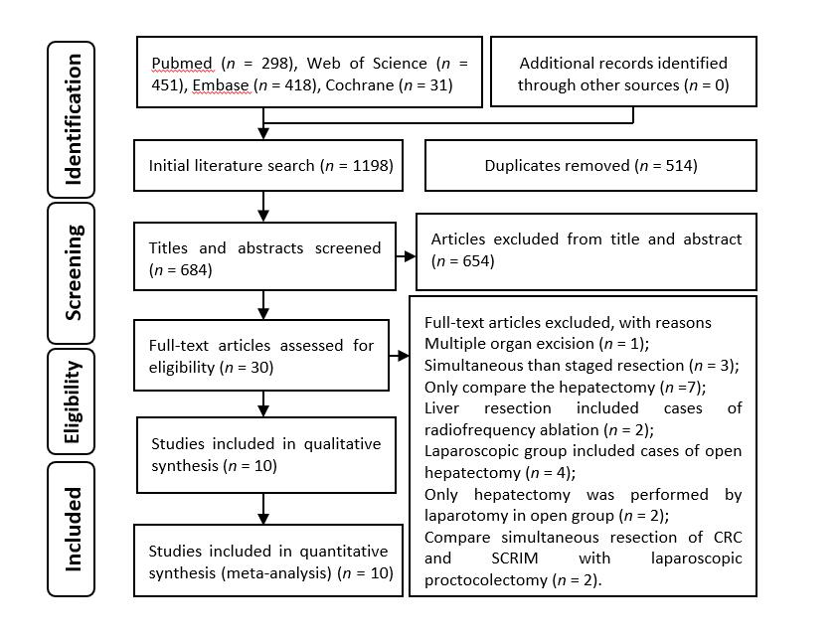
Figure 1 Flow chart of the study search strategies. CRC: Colorectal cancer; SCRLM: Synchronous colorectal liver metastases.

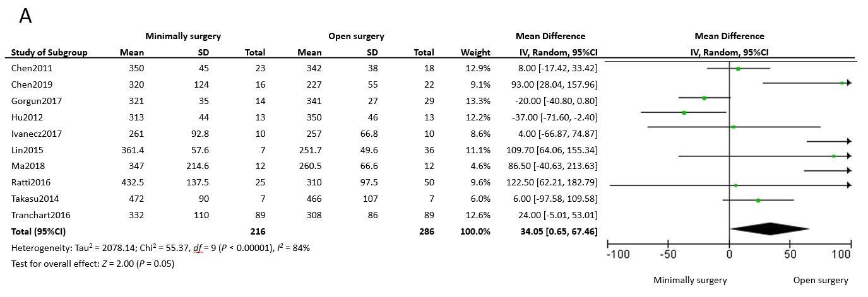
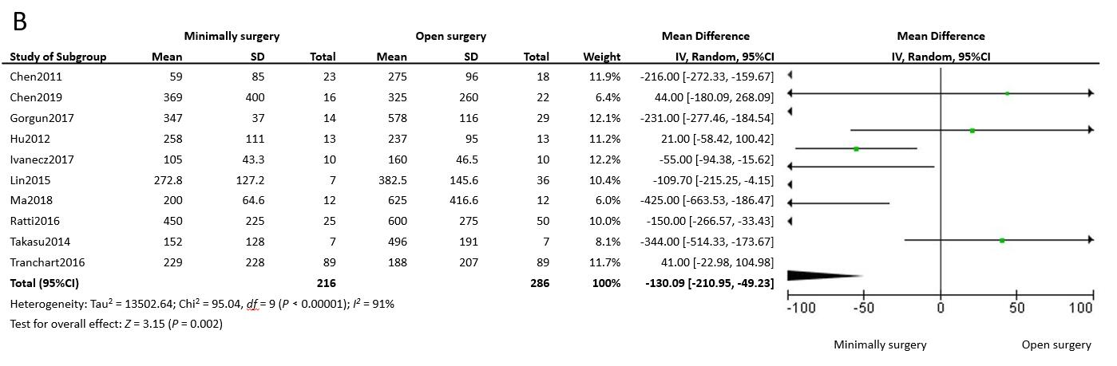
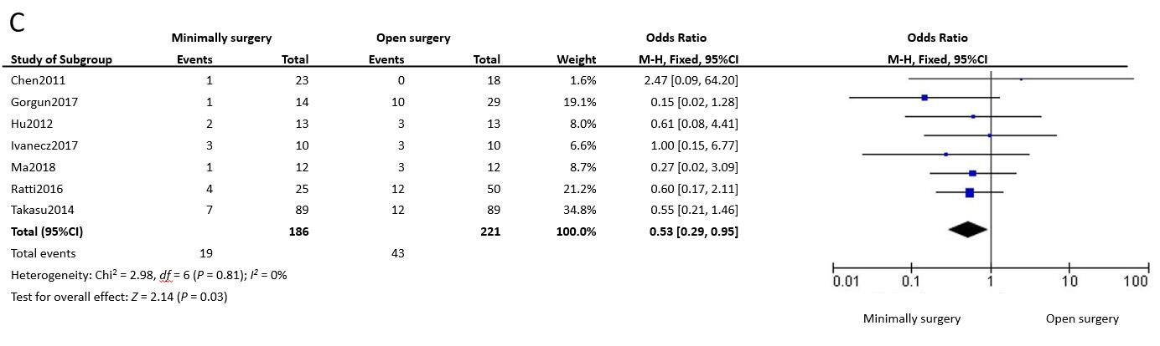
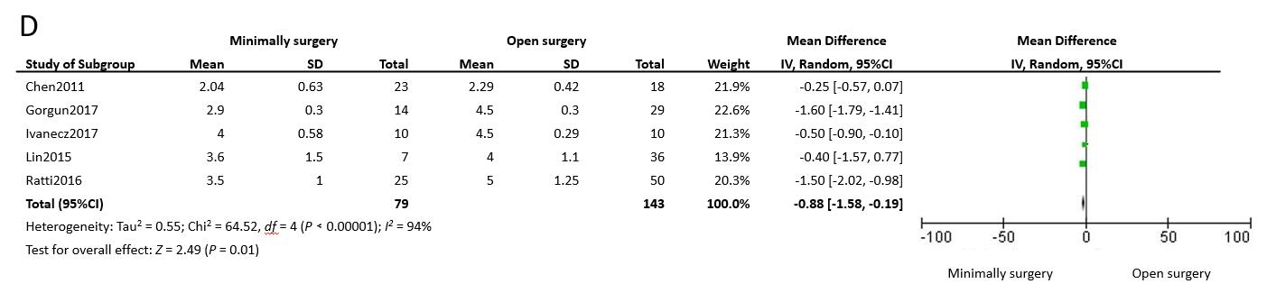
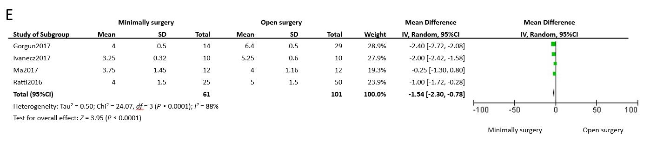

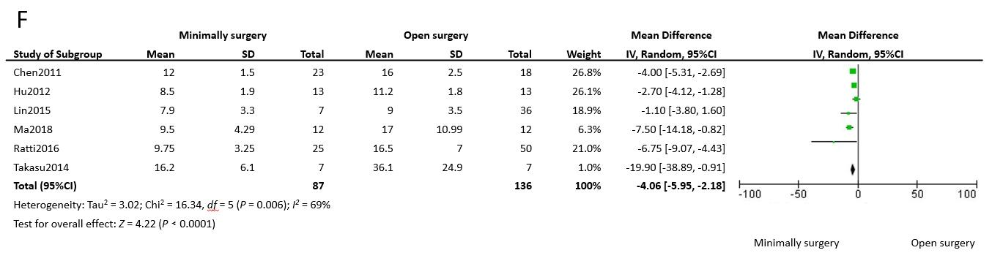
Figure 2 Forest plots of the meta-analysis for intraoperative outcomes. A: The operative time was compared between the minimally invasive surgery (MIS) and open surgery (OS) groups; B: Intraoperative estimated blood loss was compared between the MIS and OS groups; C: Number of intraoperative blood transfusions was compared between the MIS and OS groups; D: Time to bowel functional recovery was compared between the MIS and OS groups; E: Time to start diet was compared between the MIS and OS groups; F: Length of postoperative hospital stay was compared between the MIS and OS groups. MIS: Minimally invasive surgery; OS: Open surgery; CI: Confidence interval; SD: Standard deviation.

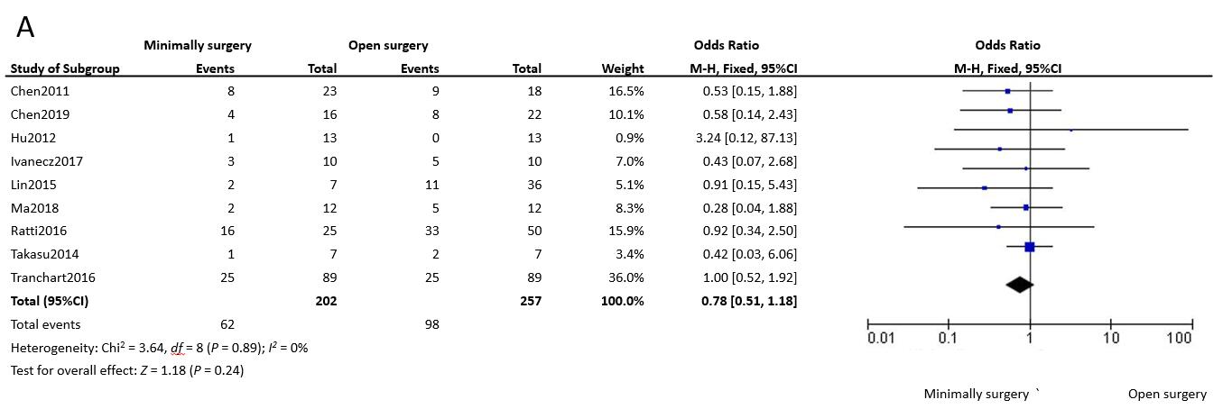
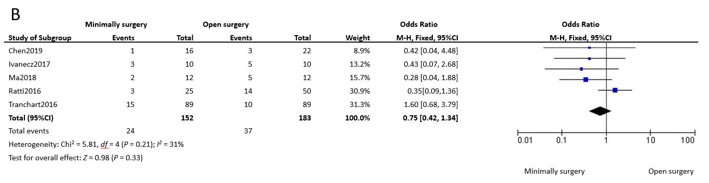
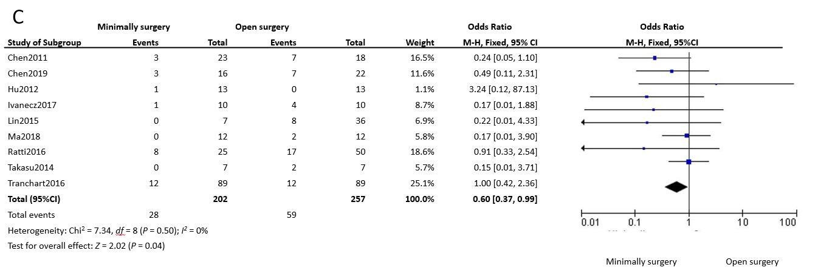
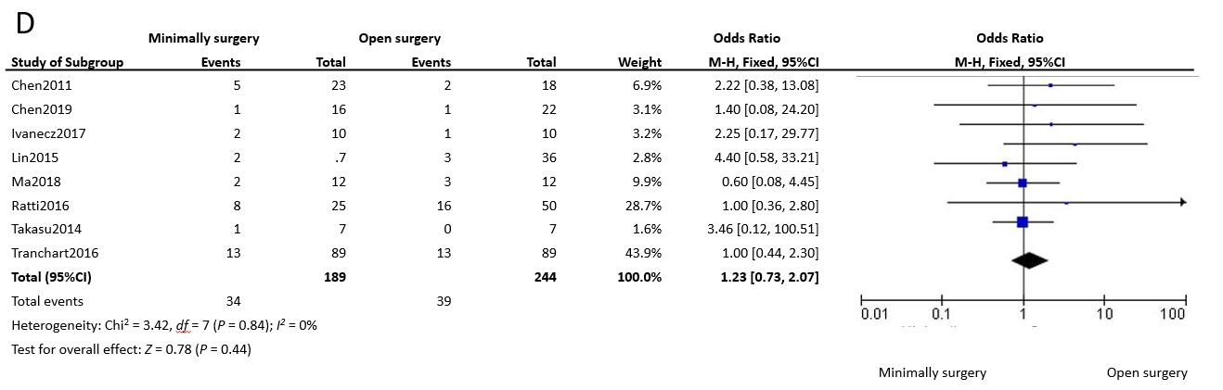
Figure 3 Forest plots of the meta-analysis for complications. A: Overall complications were compared between the minimally invasive surgery (MIS) and open surgery (OS) groups; B: Severe (Clavien–Dindo grade ≥ 3) complications were compared between the MIS and OS groups; C: Surgical complications were compared between the MIS and OS groups; D: General complications were compared between the MIS and OS groups. MIS: Minimally invasive surgery; OS: Open surgery; CI: Confidence interval.

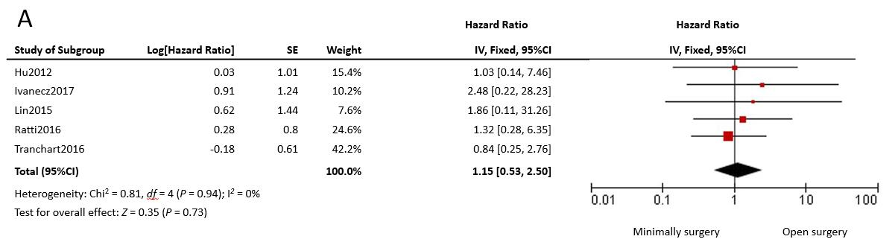
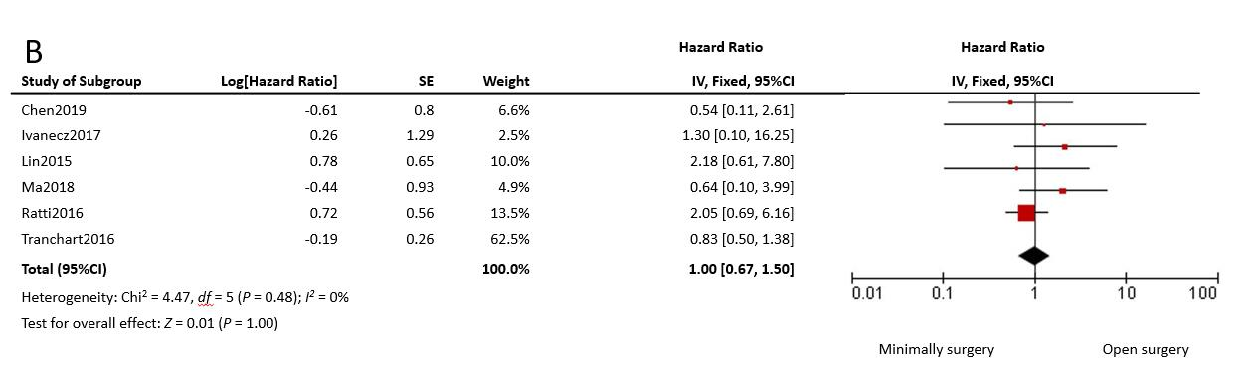
Figure 4 Forest plots of the meta-analysis for long-term outcomes. A: The overall survival was compared between the minimally invasive surgery (MIS) and open surgery (OS) groups; B: Disease-free survival was compared between the MIS and OS groups. MIS: Minimally invasive surgery; OS: Open surgery; CI: Confidence interval; SE: Standard error.

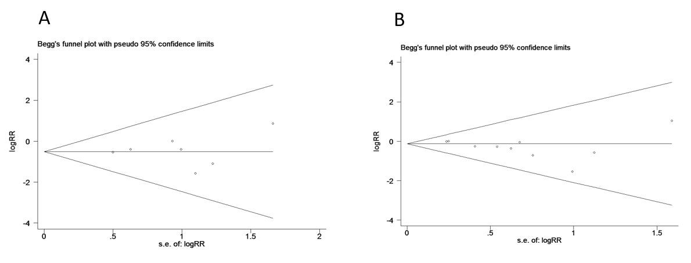
Figure 5 Funnel plots of the number of intraoperative blood transfusions and postoperative complications in patients between the minimally invasive surgery and open surgery groups. A: Intraoperative blood transfusions; B: Postoperative complications. RR: Relative risk.

Table 1 Characteristics of the included studies
Author-year | Country | Study type | Gender (M/F) |  | BMI (kg/m²)² |  | Age (yr)² |  |  | Quality  score³
 |  |  | MIS | OS | MIS | OS | MIS | OS
Chen-2011 | China | Retrospective | 18/5 | 14/4 | NR | NR | 55 ± 10 | 53 ± 9 |  | 8
Chen-2019 | China | Retrospective | 10/6 | 9/13 | 23.8 ± 3.7 | 23.3 ± 4.1 | 66.0 ± 10.4 | 64.8 ± 13.0 |  | 7
Gorgun-2017 | America | Retrospective | 6/8 | 16/13 | 25.1 ± 0.8 | 27.5 ± 1.2 | 56.3 ± 3.3 | 57.7 ± 2.5 |  | 7
Hu-2012 | China | Matched-pair | 10/3 | 9/4 | 21.5 ± 7.8 | 22.2 ± 8.4 | 54.0 ± 10.0 | 53.0 ± 11.0 |  | 8
Ivanecz-2017 | Slovenia | Matched-pair | 6/4 | 6/4 | 26.9 (23.6-32.1) | 24.0 (23.1-25.5) | 62.2 ± 7.9 | 65.4 ± 8.1 |  | 9
Lin-2015 | China | Matched-pair | 5/2 | 21/15 | 21.9 ± 2.2 | 21.2 ± 1.6 | 59.6 ± 3.4 | 57.4 ± 10.4 |  | 7
Ma-2018 | China | Matched-pair | 9/3 | 8/4 | 23.0 (19.3-26.7) | 21.6 (75.5-24.9) | 3/9¹ | 1/11¹ |  | 8
Ratti-2016 | Italy | Matched-pair | 14/11 | 27/23 | NR | NR | 60 (37-80) | 62 (35-81) |  | 8
Takasu-2014 | Japan | Matched-pair | 3/4 | 3/4 | NR | NR | 74.0 ± 12.0 | 62.0 ± 4.0 |  | 7
Tranchart-2016 | France | Matched-pair | 42/47 | 40/49 | 24.0 ± 3.6 | 24.7 ± 2.5 | 66.6 ± 10.8 | 65.0 ± 9.4 |  | 7
¹Dichotomous variables, >60/≤60 years; ²The data are expressed as the mean ± SD or medians (range); ³According to the Newcastle-Ottawa scale classification. BMI: Body mass index; F: Female; M: Male; MIS: Minimally invasive surgery; OS: Open surgery; NR: Not reported.

Table 2 Short- and long-term outcomes of the included studies
Author-year | Size of  CRC (cm) | TD of CRC  W+M/P+O | ID of CRC  T1-T2/T3-T4 | CRC  (C/R) | ASAs  1-2/3-4 | CEA  level | Number of  SCRLM | SCRLM  (U/B) | Size of SCRLM (cm)
Chen2011-MIS | 2.5 ± 0.9 | 16/7 | NR | 3/4 | NR | 38.9 ± 3.5 | NR | NR | 5.5 ± 1.2
Chen2011-OS | 2.3 ± 1.0 | 14/4 | NR | 3/4 | NR | 38.7 ± 3.3 | NR | NR | 5.6 ± 1.4
Chen2019-MIS | 4.0 ± 2.0 | NR | 2/14 | NR | 1.9 (1-3) | 929 ± 1936 | NR | NR | 5.5 ± 4.2
Chen2019-OS | 5.0 ± 3.0 | NR | 2/20 | NR | 2.0 (1-3) | 247 ± 728 | NR | NR | 4.7 ± 3.7
Gorgun2017-MIS | 3.7 ± 0.7 | NR | 2/12 | 6/8 | 0/14 | 36.9 ± 30.4 | 1.6 ± 0.3 | 12/2 | 2.4 ± 0.7
Gorgun2017-OS | 3.7 ± 0.5 | NR | 7/22 | 14/15 | 6/23 | 14.3 ± 4.9 | 2.1 ± 0.2 | 19/10 | 2.7 ± 0.2
Hu2012-MIS | NR | NR | NR | 7/6 | NR | NR | NR | NR | 3.2 ± 1.0
Hu2012-OS | NR | NR | NR | 7/6 | NR | NR | NR | NR | 3.5 ± 0.9
Ivanecz2017-MIS | NR | 10/0 | 1/9 | 4/6 | 8/2 | 7.7 ± 7.7 | 1 (1-2) | 9/1 | 2.0 ± 1.2
Ivanecz2017-OS | NR | 9/1 | 1/9 | 6/4 | 7/3 | 15.2 ± 12.5 | 1 (1-2) | 9/1 | 2.9 ± 1.5
Lin2015-MIS | 5.3 ± 1.1 | 4/3 | 0/7 | 3/4 | 6/1 | 7/2¹ | 1.9 ± 0.9 | 7/0 | 3.3 ± 1.8
Lin2015-OS | 5.7 ± 1.9 | 19/17 | 2/34 | 19/17 | 31/5 | 27/9¹ | 2.1 ± 1.0 | 26/10 | 4.2 ± 2.2
Ma2018-MIS | NR | 10/2 | 1/11 | 7/5 | 12/0 | 7/5² | 1.0 (1-4) | 10/2 | 2.8 (0.5-10.0)
Ma2018-OS | NR | 9/3 | 0/12 | 7/5 | 12/0 | 11/1² | 2.5 (1-7) | 7/5 | 2.5 (1.2-6.5)
Ratti2016-MIS | NR | 21/5 | NR | 13/12 | 20/5 | 35.6 (2-299) | 2 (1-6) | 13/12 | 2.9 (0.5-11)
Ratti2016-OS | NR | 40/10 | NR | 27/23 | 44/6 | 41.6 (3.1-612) | 2 (1-7) | 27/23 | 3.4 (0.9-12)
Takasu2014-MIS | 4 ± 2 | 7/0 | 2/5 | 3/4 | NR | NR | 1.4 ± 0.8 | 5/2 | 1.9 ± 0.9
Takasu2014-OS | 5 ± 0 | 7/0 | 1/6 | 3/4 | NR | NR | 1.5 ± 1.1 | 3/4 | 2.9 ± 1.1
Tranchart2016-MIS | NR | 72/17 | 12/77 | 48/41 | 64/25 | 61 ± 75 | 1.4 ± 0.6 | 81/8 | 2.9 ± 1.9
Tranchart2016-OS | NR | 63/26 | 10/79 | 51/38 | 56/33 | 31 ± 76 | 1.5 ± 0.7 | 78/11 | 2.8 ± 2.0
¹Dichotomous variables, >5/≤5 ng/mL; ²Dichotomous variables, ≥5/<5 ng/mL. B: Bilobar; C: Colon; CRC: Colorectal cancer; ID: Invasion depth; M: Moderate; MIS: Minimally invasive surgery; O: Other; OS: Open surgery; P: Poor; R: Rectal; SCRLM: Synchronous colorectal liver metastases; TD: Tumor differentiation; U: Unilobar; W: Well; NR: Not reported.

