Name of Journal: World Journal of Gastroenterology
Manuscript NO: 80568
Manuscript Type: MINIREVIEWS

Liver involvement in patients with COVID-19 infection: A comprehensive overview of diagnostic imaging features

Ippolito D et al. Liver involvement in COVID-19 infection

Davide Ippolito, Cesare Maino, Federica Vernuccio, Roberto Cannella, Riccardo Inchingolo, Michele Dezio, Riccardo Faletti, Pietro Andrea Bonaffini, Marco Gatti, Sandro Sironi

Davide Ippolito, Pietro Andrea Bonaffini, Sandro Sironi, Milano Bicocca School of Medicine and Surgery, Milano 20126, Italy

Davide Ippolito, Cesare Maino, Fondazione IRCCS San Gerardo dei Tintori, Monza 20900, Italy

Federica Vernuccio, Institute of Radiology (DIMED), University Hospital of Padova, Padova 35128, Italy

Roberto Cannella, Section of Radiology-Department of Biomedicine, Neuroscience and Advanced Diagnostics (BiND), University of Palermo, Palermo 90127, Italy

Roberto Cannella, Department of Health Promotion, Mother and Child Care, Internal Medicine and Medical Specialties (PROMISE), University of Palermo, Palermo 90127, Italy

Riccardo Inchingolo, Michele Dezio, Division of Interventional Radiology, Department of Radiology, Madonna delle Grazie Hospital, Matera 75100, Italy

Riccardo Faletti, Department of Surgical Sciences, University of Turin, Turin 10126, Italy

Pietro Andrea Bonaffini, Sandro Sironi, Department of Diagnostic Radiology, Papa Giovanni XXIII Hospital, Bergamo 24127, Italy

Marco Gatti, Department of Diagnostic Radiology, University of Turin, Turin 10126, Italy

Author contributions: Ippolito D designed the research; Maino C, Vernuccio F, Cannella R, Inchingolo R, Dezio M, Faletti R, Bonaffini PA, Gatti M and Sironi S performed the research; Maino C, Vernuccio F and Cannella R analyzed the data; Ippolito D, Maino C, Vernuccio F, Cannella R, Inchingolo R, Dezio M, Faletti R, Bonaffini PA and Gatti M wrote the paper.

Corresponding author: Davide Ippolito, MD, Associate Professor, Doctor, Milano Bicocca School of Medicine and Surgery, Piazza dell'Ateneo Nuovo, 1, Milano 20126, Italy. davide.atena@tiscali.it

Received: October 3, 2022
Revised: December 6, 2022
Accepted: January 20, 2023
Published online: February 7, 2023

Abstract
During the first wave of the pandemic, coronavirus disease 2019 (COVID-19) infection has been considered mainly as a pulmonary infection. However, different clinical and radiological manifestations were observed over time, including involvement of abdominal organs. Nowadays, the liver is considered one of the main affected abdominal organs. Hepatic involvement may be caused by either a direct damage by the virus or an indirect damage related to COVID-19 induced thrombosis or to the use of different drugs. After clinical assessment, radiology plays a key role in the evaluation of liver involvement. Ultrasonography (US), computed tomography (CT) and magnetic resonance imaging (MRI) may be used to evaluate liver involvement. US is widely available and it is considered the first-line technique to assess liver involvement in COVID-19 infection, in particular liver steatosis and portal-vein thrombosis. CT and MRI are used as second- and third-line techniques, respectively, considering their higher sensitivity and specificity compared to US for assessment of both parenchyma and vascularization. This review aims to the spectrum of COVID-19 liver involvement and the most common imaging features of COVID-19 liver damage.

Key Words: Liver; Fatty liver; Hepatomegaly; Hepatic infarction; Liver diseases; Liver failure; Biliary tract diseases; COVID-19; SARS-CoV-2; Infection; X-Ray computed tomography; Magnetic resonance imaging; Ultrasonography; Adults; Pediatrics

©The Author(s) 2023. Published by Baishideng Publishing Group Inc. All rights reserved.

Citation: Ippolito D, Maino C, Vernuccio F, Cannella R, Inchingolo R, Dezio M, Faletti R, Bonaffini PA, Gatti M, Sironi S. Liver involvement in patients with COVID-19 infection: A comprehensive overview of diagnostic imaging features. World J Gastroenterol 2023; 29(5): 834-850
URL: https://www.wjgnet.com/1007-9327/full/v29/i5/834.htm
DOI: https://dx.doi.org/10.3748/wjg.v29.i5.834

Core Tip: Coronavirus disease 2019 (COVID-19) infection has an impact not only on lung involvement but also in other systems, in particular the gastrointestinal one, with a special focus on the liver. Hepatocytes express the receptor of angiotensin-converting enzyme which is the main door of the entrance of severe acute respiratory syndrome coronavirus 2. Consequently, different mechanisms can lead to different hepatic scenarios, such as hepatomegaly, steatosis, steatohepatitis, and drug-induced liver injury. As for lung involvement, the infection can lead to hepatic vascular involvement, especially portal vein thrombosis. Finally, it has been demonstrated a possible biliary involvement in COVID-19 patients.
INTRODUCTION
Severe acute respiratory syndrome coronavirus 2 (SARS-CoV-2) infection, named coronavirus disease 2019 (COVID-19), represents an epoch-making global healthcare crisis, with 603711760 confirmed cases and 6484136 deaths caused to date worldwide^{[1]}.
Although the lung represents the most affected organ, COVID-19 may present as a multiorgan disease. Clinical manifestations may vary from flu-like symptoms, such as fever, dry cough, myalgia, and fatigue, often coupled with hypo-/anosmia and ageusia^{[2-4]}, to more severe conditions with dyspnea and respiratory impairment requiring admission to the intensive care unit (ICU) and advanced respiratory assistance^{[5]}. A severe course of the disease has been reported in 5%-22 % of COVID-19 patients^{[3,5]}.
In this scenario, we focused our attention on hepatic manifestations of COVID-19 infection. Hepatic involvement in patients with COVID-19 infection is not negligible. Liver damage can occur in different ways, ranging from hepatomegaly, acute hepatitis, steatosis and steatohepatitis, portal vein thrombosis (PVT) and liver infarction, biliary and gallbladder involvement, up to drug-induced liver injury (DILI), with chronic liver disease that needs further long-term studies to be understood (Figure 1).
In this review, we aim to describe the spectrum of COVID-19 liver involvement and the most common imaging features of COVID-19 liver damage with a descriptive correlation to the underlying pathogenesis.

IMAGING TECHNIQUES
The standard radiological approach for liver assessment (i.e. anatomy, focal liver lesions, or diffuse diseases) has been widely described and does acknowledge the use of ultrasound (US), computed tomography (CT), and magnetic resonance imaging (MRI). Technical advances in liver imaging have also been conducted over the last decades, with lots of research on quantitative and functional assessments in different liver pathologies^{[6]}.

US
Brightness-mode (B-mode) transabdominal US generally represents the first-line approach in patients with suspected liver disease^{[7]}. US is widely available, non-invasive, low cost, safe, ionizing radiation-free^{[6]} and can be performed at the bedside, particularly in ICU or isolated patients. Anatomical and vascular imaging and lesion detection are feasible, although limited by the field of view and are dependent on operator experience^{[7]}.
During the last decades, different US developments have been introduced, including elastography, contrast-enhanced US (CEUS), and novel doppler techniques^{[6-9]}.
Moreover, an advanced multiparametric US approach for the evaluation of the liver could be an option, particularly for long-term follow-up of COVID-19 patients. The multiparametric US includes elastography, share wave dispersion, and attenuation imaging. The evaluation by the 2D-shear wave elastography technique allows quantification of the increase in liver stiffness related to the evolution toward fibrosis, but it can be altered in the inflammatory early stages (e.g., steatohepatitis)^{[10]}. Shear-wave dispersion is a measure of liver viscosity that is changed during inflammatory processes in the liver. Finally, hepatic attenuation imaging is a useful tool for quantifying steatosis.
Elastography enables the assessment of liver fibrosis^{[6]}. Usually, a quantitative assessment of liver stiffness is obtained by applying an external force by means either of a US-induced focused impulse (point shear wave elastography) or a mechanically induced impulse (transient elastography)^{[7]}. More recent developments of US elastography include a volumetric assessment of liver stiffness and its real-time variations. Clinical use of US elastography is mainly limited by cutoff values for fibrosis staging that vary across US systems from different vendors^{[6]}.
CEUS is accepted as a second-line imaging modality for the characterization of focal liver lesions after inconclusive baseline US, and its cost-effectiveness is higher compared to CT or MRI^{[6,7,11]}. CEUS interpretation is similar to CT and MRI, relying on the similar post-contrast phases (arterial, portal-venous, delayed), vascular architecture, and phase-specific enhancement of the lesion compared with the adjacent liver parenchyma^{[7]}. CEUS is useful for lesion detection and characterization in several clinical settings, without the use of ionizing radiations and with higher temporal resolution compared to CT or MRI^{[6]}. It can be useful in non-oncologic, non-cirrhotic patients^{[6,9]}, for the assessment of incidental focal lesions, in cirrhotic patients, allowing characterization of contrast enhancement patterns of hepatocellular carcinoma (HCC) with good sensitivity and specificity^{[6]}, and in oncologic patients, providing higher sensitivity compared to the standard US for liver metastases detection and indeterminate CT or MRI lesions characterization^{[12]}. CEUS can also be used to guide, in real-time, both focal lesions procedures^{[7,8]} and locoregional ablative therapies, as well as for treatment response assessment^{[13,14]}. According to the latest guidelines^{[14]}, US contrast agents can be safely administered in various applications, with minimal risks to patients. The reported rate of anaphylactoid-type reactions is extremely rare (0.014%).
Among novel third-generation doppler developments, US manufacturers have introduced techniques such as superb microvascular imaging (SMI) that has improved the sensitivity and accuracy of Doppler US in the assessment of hepatic vascular anatomy^{[9]} and the detection of liver tumors vascularity with a safe, inexpensive, and readily available modality^{[6]}. SMI is based on an adaptive algorithm that separates low flow signals from overlaying tissue motion artifacts; thereby SMI allows visualization of microscopic vessels (either native or within lesions), with no need for contrast agents injection^{[9]}.

CT
CT represents the mainstay technique for liver imaging, with the majority of acquisitions performed with multiphase acquisition protocols, and standardized assessment based on size and density measurements. Due to its wide availability, CT is generally preferred to MRI in daily clinical practice, despite its overall lower sensitivity. Moreover, reproducibility and high temporal and spatial resolutions allow its employment in both standard and emergency settings^{[6,15-17]}.
Contrast-enhanced CT allows the characterization of liver lesions deemed indeterminate on US in non-oncologic and non-cirrhotic patients. In cirrhosis, while the US remains the standard technique for follow-up, contrast-enhanced CT and MRI are the currently recommended techniques for the characterization of US-detected nodules, diagnosis and post-treatment follow-up of HCC^{[6,18]}. In oncologic patients, CT is generally used for staging and follow-up. Accurate timing of image acquisition during the various dynamic phases is critical to enable a correct determination of liver lesion characteristics and enhancement features^{[11]}. In these scenarios, CT acquired during the portal-venous phase is the most common performed study in oncologic patients^{[6]}, but its main limitation is the detection and characterization of small hypoattenuating lesions and lesion detection in the background of liver steatosis^{[6,19]}. On the other hand, multiphase scans (arterial, portal-venous, and delayed phases) are generally used in cirrhotic patients, for focal liver lesions characterization, and in trauma patients^{[6,8]}.
More advanced and emerging techniques include perfusion CT, dual-energy CT (DECT) and photon-counting detector CT (PCD-CT)^{[6,17]}.
DECT is based on CT data acquisition by using X-rays generated at two different energy spectra; therefore, allowing for superior materials discrimination and characterization. Images are obtained either with dual-source, ultra-fast kV switching, or sandwich detector^{[6,16]}. Then, DECT data post-processing generates several types of images: monochromatic image reconstructions, useful to improve iodine contrast visualization; attenuation maps of different elements according to their atomic number, including iodine, calcium, and water^{[6]}. Moreover, the possibility of generating virtual unenhanced (VUE) images may help reduce radiation dose exposure. DECT improves the delineation of hypo- and hypervascular liver lesions by increasing the lesion to parenchyma contrast. Given the possibility of material decomposition, DECT can also allow distinguishing contrast from calcifications, and noninvasively quantifying fat, iron, and other moieties, compensating for the high cost and examination time length of MRI and invasiveness of biopsy^{[6,16,17]}. However, DECT is affected by some shortcomings, including technical limitations (limited field-of-view, reduced spectral separation depending on vendor or scanner) and software challenges (lack of enough research comparing vendors and scanners' variability on VUE and iodine attenuation values)^{[16]}.
PCD-CT is the most recent promising technique but nowadays is still mainly limited to preclinical or small in vivo studies in volunteers. More clinical and validation research is therefore needed over a longer time^{[6]}.

MRI
MRI is fundamental in the workup of patients with liver disease^{[6,17,20]} and has been addressed as the preferred imaging modality for the characterization of equivocal focal lesions detected by other imaging modalities^{[17]}. Along with appropriate clinical information, MRI can also allow a definitive diagnosis, avoiding in most cases invasive procedures such as biopsy^{[21]}.
A properly dedicated MRI liver protocol requires it to be short, comprehensive, standardized, and reproducible^{[6,17,21]}. Pre-contrast MRI, given its higher contrast resolution compared to CT, provides information about tissue and lesion composition (i.e. solid or liquid; iron, fat, glycogen, blood products) and lesions cellularity, either neoplastic or inflammatory^{[6,11,17,22]}. Diffusion-weighted imaging (DWI) has been reported to improve the detection and characterization of focal liver lesions, also allowing differentiation of cysts from solid masses. Moreover, by combining hyperintensity on high b-value DWI (hypercellular lesions) with dynamic multiphasic studies, improvement in lesions detection and characterization (in particular for tumors < 2 cm) can be achieved^{[11]}.
Contrast-enhanced MRI represents a relevant component of any liver MRI protocol. It provides reliable information about focal lesions characterization, vascular and biliary anatomy, and more recently organ function^{[17,20,21]}. Both gadolinium-based extracellular (ECA) and hepatobiliary (HBA) contrast agents can be used for multiphase imaging^{[6,17,21]}. Morphologic and vascular-related information are obtained with ECA and HBA through the dynamic study^{[21]}.
Moreover, HBA provides the ability to acquire images in the hepatobiliary phase (HBP), offering information about hepatocytes uptake and excretion in the biliary system^{[6,11,20,21]}. Therefore, HBP may provide functional information^{[21]}. Indeed, lesions, or abnormalities without hepatocytes or with non-functioning hepatocytes, appear as hypointense compared to the surrounding liver parenchyma^{[20]}. Among reported HBA advantages, it is worth mentioning higher lesion conspicuity with increased sensitivity in lesion detection, and improved lesion characterization with increased ability in the differential diagnosis.
One of the most used advanced MRI techniques useful to detect and characterize focal or diffuse liver disease is DWI. Highly cellular tissues or those with cellular swelling exhibit lower diffusion coefficients, and these aspects can be useful for the evaluation of liver diseases^{[22]}.
The evaluation of the biliary tree can be easily made using highly weighted T2 sequences in different planes. In this setting, magnetic resonance cholangiopancreatography (MRCP) is nowadays considered the reference standard for noninvasive biliary evaluation. Thanks to the improvement of MRI techniques, it is now possible to acquire 3D images that can be reformatted in every plane of space by post-processing techniques^{[23]}.

LIVER DISEASE INVOLVEMENT
COVID-19 liver injury is defined as any liver involvement that occurs during the course of COVID-19, whether there is a known history of liver disease or not^{[24]}. The presence of liver damage from a laboratory point of view is very common: an increase in liver enzymes is described in around 40% of patients^{[24]}, it is greater with severe COVID-19 and at the same time a predictor of adverse events^{[25,26]}.
SARS-CoV-2 primarily infects respiratory epithelial cells via angiotensin-converting enzyme 2 (ACE2). ACE2 is also expressed at high levels in the endothelium layer of tiny blood arteries, cholangiocytes and in hepatocytes. Furthermore, the SARS-CoV-2 virus may use the gut-liver route via the hepatic reticular system to reach the liver^{[25]}. Finally, other organ systems and drugs have a significant influence on the liver. As a result, the causative mechanisms of liver damage in COVID-19 infection are many, including direct cytotoxicity caused by active SARS-CoV-2 replication, immune-mediated liver injury, vascular impairment caused by coagulopathy, endothelium, or cardiac congestion, hypoxic changes caused by respiratory failure, DILI, and exacerbation of the underlying chronic liver disease^{[25]} (Figure 1 and Table 1).

Hepatomegaly and steatosis
COVID-19 causes twice as much liver damage at the cellular level. First, hepatocellular damage occurs, resulting in mild steatosis, lobular and portal inflammation, and areas of apoptosis and necrosis. This type of damage raises aspartate aminotransferase (AST) and alanine transaminase (ALT) levels. Later on, the damage is direct to cholangiocytes, with bile duct damage and increase in gamma-glutamyl transferase (GGT) and bilirubin^{[27]}.
When there is a clinical suspicion of liver involvement in COVID-19, bedside US is the first imaging technique used in the diagnostic workup. A quick and targeted bedside US may be critical in referring selected patients to second-level imaging techniques, to reduce unnecessary exams and diagnostic delays. US can detect morphological or structural changes in the liver: the most encountered findings in COVID-19 patients are hepatomegaly^{[28,29]} and steatosis^{[29,30]}.
According to Abdelmohsen et al^{[28]}, the most common morphological change in the liver in critically ill COVID-19 patients is hepatomegaly (about 55% of patients), which is also consistent with autopsies in COVID-19 patients^{[29-31]}. Spogis et al^{[29]} found hepatomegaly associated with gallbladder wall thickening and decreased echogenicity (i.e. signs of acute hepatitis) in 33% of COVID-19 patients with elevated liver cytolysis indices (> 10-fold). Hepatomegaly is usually identified subjectively during imaging: the "qualitative criteria" include the inferior extension of the right lobe to the lower pole of the right kidney and the rounding of the hepatic inferior border. Otherwise, the quantitative criteria are based on the length of the right liver lobe, with a cutoff of 16.5 cm^{[31]}.
On the other side, the most common liver structural change associated with COVID-19 is the presence of hepatic steatosis^{[28,29]} (Figure 2). Coagulation activation can produce hepatic steatosis, and this could be a unique mechanism that leads to both thrombosis and steatosis that are common findings in COVID-19 patients^{[32]}. US B-mode is the most used technique for diagnosing and classifying hepatic steatosis^{[33]}, particularly in the moderate or severely affected liver. It has an overall sensitivity and specificity of 85% and 93%, respectively^{[33]}. However, the detection of a moderate degree of steatosis remains poor, with about 60% sensitivity^{[34]}. B-mode US imaging is mostly used to analyze the liver qualitatively, searching for characteristic markers of steatosis (i.e. hyperechoic liver in comparison to the spleen or neighboring kidney)^{[29]}. US findings can be confirmed on abdominal CT. According to Lei et al^{[35]}, the most common CT abnormalities in COVID-19 patients include diffuse hypoattenuation of the liver (26%) – more common in severe patients (59%) – and the CT-quantified liver/spleen attenuation that can predict prognosis in COVID-19 patients^{[35,36]}. Furthermore, because the liver is partially included in every chest CT, liver data from chest CT scans performed in many COVID-19 patients can be easily retrieved.
Using a multiparametric US approach, Radzina et al^{[30]} evaluated 90 patients affected with COVID-19 in the previous 3-9 mo demonstrating how liver elasticity, viscosity, and steatosis are altered after COVID-19 and that these alterations well correlate with liver enzyme abnormalities, even better than CT or MRI findings.
Other consequences of chronic liver disease, such as nonalcoholic fatty liver disease (NAFLD), must be considered in addition to COVID-19-induced liver damage^{[37]}. Obesity and other components of metabolic syndrome have been linked to COVID-19 severity. The impact of NAFLD in COVID-19 patients is controversial in the literature^{[37]}. In a meta-analysis of 1851 patients, Singh et al^{[38]} found that, while there was an increase in the course severity of COVID-19 with a 2.60 odds ratio (OR), the adjusted OR (aOR) for mortality risk was 1.01; however, these data should be considered with caution due to the significant heterogeneity among the included studies. Interestingly, Ghoneim et al^{[39]} analyzed 8885 patients with common comorbidities known to be linked with COVID-19 and found out that the cumulative incidence of disease was higher if metabolic syndrome was the primary diagnosis (OR 7.0). COVID-19 patients who were African Americans (aOR 7.45), hypertensive (aOR 2.53), obese (aOR 2.20), diabetic (aOR 1.41), hyperlipidemic (aOR 1.70) or had non-alcoholic steatohepatitis (NASH) (aOR 4.93) had higher aORs. These findings demonstrated that, among all concomitant metabolic disorders, NASH had the strongest connection with COVID-19. In support of these data, Roca-Fernández et al^{[40]} analyzed 41791 people who underwent MRI for assessment of liver fat, liver fibro-inflammatory disease, and liver iron with proton density fat fraction calculation before February 2020 and found that people with fatty liver (> 10%) had a higher likelihood of testing positive (OR 1.35), and people with obesity and fatty liver had a 5.14 times higher risk of hospitalization. Obese people who did not have a fatty liver can have an increased risk (OR 1.75). According to the findings, obese people with fatty liver disease are at a higher risk of COVID-19 infection and hospitalization.
To summarize, COVID-19 patients have a remarkable risk of liver damage, with the main morphologic and structural changes being hepatomegaly and steatosis, which have a significant impact on patients’ prognosis and can be easily studied with US (Table 1). Epidemiologically, people with NAFLD/NASH appear to be at a higher risk of severe COVID-19 infection. However, it is unclear how much of this rise is due to hepatic steatosis or the presence of overlapping risk factors and comorbidities.

Acute hepatitis in COVID-19
Liver test abnormalities are frequently encountered in COVID-19 patients at admission, and their increase is associated with the severity of the disease^{[41,42]}. In the majority of cases, COVID-19-induced hepatitis occurs as benign new transient hepatitis with gradual onset, elevated AST and ALT levels, and lack of any radiological changes^{[29,42,43]}. Occasionally, COVID-19-induced hepatitis may occur in otherwise asymptomatic patients as the sole manifestation of COVID-19 infection^{[44]}. Liver damage in COVID-19-induced hepatitis may be the result of viral infection of hepatocytes or cholangiocytes, hypercoagulability with both microangiopathy and local thrombus formation, immune-mediated damage, systemic inflammation, or hypoxic hepatitis due to the respiratory disease^{[45-49]}. Regarding the first mechanism, the virus enters the hepatocytes, and then viral replication results in rupture of cells, generating elevated serum liver enzymes^{[48,50]}. Thrombotic complications in COVID-19 patients are likely to occur due to a pro-coagulant effect or a progressive endothelial thrombo-inflammatory syndrome^{[49]}. Interestingly, in a systematic review of pathology studies, hemodynamic compromise and thromboembolic disease in the liver were demonstrated in 48.3% and 39.4%, respectively, while liver microthrombi were not identified^{[48]}.
Radiological hallmarks of acute hepatitis in COVID-19 patients are encountered in approximately 8% of patients with mild-to-moderated liver test abnormalities, and the occurrence increases in patients with severe elevation of liver enzymes. Radiological hallmarks of COVID-19-induced hepatitis – particularly in the most severe cases – include thickening of the gallbladder wall, hepatomegaly, reduced echogenicity of the liver on the US or homogeneous/heterogeneous liver hypoattenuation on CT, and reduced Doppler signal in the hepatic artery^{[29,35,51]}. Liver hypoattenuation is significantly more common in the most severe cases, with the decrease of the liver to spleen CT attenuation ratio being significantly correlated with the severity of pulmonary lesions and the overall COVID-19 severity^{[35]} (Figure 3). A pathology-radiology correlation study demonstrated that the histological features in patients with sonographic changes included macrophage activation, centroacinar necrosis, granulocytic and histiocytic infiltrate, endothelial damage, and severe cholestasis^{[29,52]}. Among these, macrophage activation was particularly interesting as it may represent the histopathologic correlate of a hyperinflammatory syndrome^{[29]}. In a case of COVID-19-induced hepatitis being the sole symptom and without any other cause for liver damage, pathology demonstrated periportal and interstitial inflammation with predominantly lymphocytes, rare plasma cells, and neutrophils, hepatocyte rosette formation, apoptotic bodies, centrilobular congestion, and mildly increased portal and pericellular fibrosis^{[52]} (Table 1).

DILI
DILI is a liver dysfunction caused by drugs used as a treatment for COVID-19 disease. Therapeutic choices for COVID-19 have rapidly expanded and changed over time with the increased understanding of the virus and the disease^{[53]}. The various therapeutic treatments used over time included antiviral drugs, antibiotics, antimalarials, immunomodulator agents, antipyretic agents, adjunctive treatments, and several investigational treatments including convalescent plasma administration from COVID-19 recovered patients^{[54]}. Different studies reported that liver injury in patients with COVID-19 infection could be a direct consequence of the administration of different drugs, such as antivirals and monoclonal antibodies, with most patients showing elevation of AST and ALT levels, and some also of bilirubin, lactate dehydrogenase, and C-reactive protein^{[55-59]}. However, in most cases, elevated levels of AST and ALT do not lead to severe liver injury and the outcome is favorable^{[59]}.
The mechanisms underlying DILI in COVID-19 patients are not yet fully understood and they seem to vary depending on drug type^{[59,60]}. A hepatocellular injury has been more often reported than cholestatic or mixed injury in COVID-19 patients with DILI^{[59]}. On one hand, the drug-induced injury may lead to microvesicular steatosis as a result of drug interference with β-oxidation of fatty acids, mitochondrial respiration, or both which leads to the accumulation of non-esterified fatty acids which are subsequently converted into triglycerides^{[61,62]}. On the other hand, there could be a downregulation of cytochromes p450 or CYPs family enzymes involved in oxidative biotransformation of many drugs, thus altering the metabolism of several COVID-19 drugs^{[60,61]}. DILI could be enhanced by the production of reactive oxygen species by inflammatory cells, in addition to immune mechanisms shown in a small subset of DILI cases^{[63,64]}.
The radiological manifestations of DILI in COVID-19 patients are non-specific. One of the most frequent radiological signs of DILI is hepatic steatosis^{[65]}. Hepatic steatosis is seen in the US as a bright liver echo pattern with the markedly increased liver to kidney contrast, and on CT as a reduction of liver attenuation below 40 UH as an absolute value or liver attenuation reduced of more than 10 HU compared to the spleen^{[66]}. MRI is the gold standard for detection and quantification of liver steatosis: new quantitative techniques are now available, and others are still being investigated in US and CT^{[6]}. DILI may occasionally lead to acute hepatitis and, therefore, radiological signs in these cases include hepatomegaly with decreased parenchymal enhancement, periportal edema, gallbladder wall thickening, and ascites^{[29]}. However, the role of traditional and new quantitative techniques for assessing hepatic steatosis and liver injury occurring as a manifestation of DILI in COVID-19 is poorly investigated, and it seems quite difficult to analyze: COVID-19 patients may have more commonly hepatic steatosis and liver injury not related to DILI and there are not specific signs allowing us to differentiate between steatosis and liver injury caused by drugs or by other causes (e.g., steatohepatitis, viral infection)^{[30]} (Table 1).

PVT
The pandemic taught us the great impact of COVID-19 infection on the development of coagulation disorders, especially disseminated intravascular coagulation-like massive intravascular clot formation^{[67]}. In this setting, it has been partially explained that the cytokines’ cascade and endothelial damage can lead to the development of intravascular coagulation in the whole body, as reported by Cui et al^{[68]}: critically ill patients showed a significantly higher incidence of thrombosis, up to 25%.
One of the most important visceral districts to consider in a setting of an altered vascular and endothelial environment is the portal vein, considering its importance in blood drainage from the gastrointestinal tract.
In non-cirrhotic patients, acute PVT may present with pain, even though the majority are found incidentally^{[69]} (Figure 4). Different causes have been demonstrated as key roles in the development of PVT, with infection and inflammation being the most common. Rajani et al^{[70]}, reported that gastrointestinal inflammation accounts for about 14% of all causes of PVT. As for other viral and bacterial infections, COVID-19 can manifest with different gastrointestinal manifestations, including diarrhea, nausea, vomiting, and abdominal pain, which typically present after the respiratory symptoms (9 d vs 7.3 d)^{[71]}.
Even if it is well known that the inflammatory environment can lead to the development of micro- and macro-thrombosis, the current literature has not been focused on the impact of PVT in COVID-19 patients. In fact, by searching medical databases, few studies were published regarding this topic, the majority being case reports.
A meta-analysis published in 2020^{[72]} included 18 studies and reported that all COVID-19 patients were over 15-years-old, and the majority were male (62%). The authors found a pooled prevalence of vascular thrombosis of 29.4%, one of the most representative signs in the autoptic series. Similarly, Kheyrandish et al^{[73]} (2021) reviewed all cases of PVT published in the literature, confirming the higher incidence in males during infection and in females after vaccination. Thrombocytopenia was the most common laboratory finding, followed by high D-Dimer values, and abnormal coagulation tests.
Radiology plays a key role in the diagnosis of PVT. The first imaging technique useful to determine portal vein patency is US, which can be performed at bedside, especially in critically ill or isolated patients. Acute PVT can manifest as the presence of heterogenous material in the portal vein lumen, which can be partial or complete^{[74]}. Occasionally, the portal vein thrombus can be iso- or hypoechoic on US; in this setting, the use of color doppler can support the final diagnosis, showing the lack of flow in all or some parts of the portal vein lumen^{[75]}. Nowadays, CT is the reference standard imaging technique to evaluate PVT and its extension, both intra-hepatic and into the whole mesenteric venous system. On the unenhanced images, a higher attenuation into the portal vein lumen, due to the fresh clot, can be appreciated. The injection of an intravenous iodinated contrast agent is necessary to evaluate the lack of enhancement in the lumen, more evident in the portal-venous phase. Liver enhancement can be inhomogeneous due to areas of hypervascularization during the arterial phase, then becoming homogenous in the portal-venous and delayed phases^{[74]}. The portal trunk can be dilated, and, sometimes, it is possible to appreciate the enhancement of vein walls due to inflammatory response^{[76]}.
Due to the different imaging spectrum of COVID-19 infection, patients may undergo MRI of the upper abdomen. In these settings, acute PVT is represented by an inhomogeneous intraluminal area(s) both on T1- and T2-weighted sequences. On T1-weighted sequences, PVT can manifest as hyperintense to the muscle if it is recent (acute), while isointense if subacute. On T2-weighted sequences PVT can manifest with different grades of hyperintense signal according to the phase (acute or subacute). If MRI is performed also after intravenous injection of contrast agents, the appearance is superimposable to the above-mentioned CT scan (Table 1).
If the PVT is not treated, cavernous transformation can occur (Figure 5): the main portal venous trunk is not appreciable and the development of periportal venous collaterals can help the drainage of venous flow from the gastrointestinal tract to the liver. Considering that chronic PVT is not reported in any patients with COVID19 infection, its findings are out of the scope of the present review.

Biliary and gallbladder involvement
The development of biliary injury in patients with COVID-19 represents an important complication, associated with poor prognosis and clinical outcome^{[77]}. Biliary involvement in patients with COVID-19 often demonstrates clinical and biochemical features similar to sclerosing cholangitis in critically ill patients (SSC-CIP), manifesting as increased cholestasis indexes (GGT and total bilirubin) in patients with prolonged admission to the ICU and no history of biliary or liver disease nor signs of mechanical obstruction^{[77,78]}. Severe cholestasis has been reported in up to 27% of patients with COVID-19 admitted to the ICU^{[79]}. The mechanism of the cholestatic injury in patients with COVID-19 is not completely understood and it is likely multifactorial, with direct viral damage due to the expression of ACE2 on cholangiocytes, immune or inflammatory damage associated with liver injury, toxic bile injury, and ischemic or hypoxic injury of the biliary epithelium^{[80]}. Cholangiopathy has also been observed after chronic exposure to ketamine, a general anesthetic used for sedation of patients with COVID-19 and acute respiratory distress syndrome^{[81]}. The prognosis of patients with SSC-CIP is poor, with mortality in up to 50% of cases due to the development of biliary complications and worsening of liver function^{[82]}. Particularly, patients with pre-existing chronic liver disease have an increased risk of SSC-CIP and higher mortality during COVID-19 infection^{[83]}.
Imaging is important to guide the diagnosis of cholangiopathy in patients with COVID-19 in conjunction with laboratory markers and to exclude other causes of biliary obstruction. US and CT can be performed as first-line imaging examinations and can reveal the presence of bile duct dilatation with intrahepatic stones^{[84]} (Figures 6 and 7). Heterogeneous enhancement of the liver parenchyma with periportal edema can also be observed on contrast-enhanced CT^{[85]}. MRI with MRCP should be performed in patients with persistent cholestasis and elevated liver function tests to assess the extension of biliary damage. MRCP can demonstrate features of secondary sclerosing cholangitis characterized by multifocal biliary strictures alternated with dilated tracts, with a “beaded” appearance^{[79,85]}. Biliary strictures can be complicated by biliary cast, presenting as intraductal filling detects on MRCP and T2-weighted images with corresponding linear hyperintensity on unenhanced T1W images. In a recent study by Ghafoor et al^{[86]}, MRCP findings associated with COVID-19 cholangiopathy included intrahepatic bile duct strictures associated with upstream dilatation in 58% of patients and the presence of biliary casts in 11.8% of cases (Figure 8). Peribiliary changes characterized by hyperintensity on T2W images and DWI restriction were reported in 70.6% of patients, while peribiliary enhancement was observed in 23.1% of cases^{[86]}. Extrahepatic bile duct involvement is rare^{[86]}. Other complications include sepsis with the possible development of hepatic abscesses and progressive liver disease with morphologic features of biliary cirrhosis. Endoscopic retrograde cholangiopancreatography can be performed to confirm the diagnosis of biliary strictures and stones in selected cases and allow treatment of biliary obstruction.
Acalculous cholecystitis has been reported as the most common gallbladder involvement in patients with COVID-19^{[87,88]}. Despite the pathogenesis of acalculous cholecystitis in COVID-19 is still under investigation, the presence of SARS-Cov-2 virus was demonstrated in samples from the gallbladder wall, probably due to the presence of ACE2 receptors in the gallbladder^{[87]}. Other possible causes include mechanical ventilation and prolonged total parenteral nutrition^{[89]}. The US is the first-line imaging modality in patients with suspected acalculous cholecystitis and it may reveal thickened gallbladder wall with peri-cholecystic fluid collection and gallbladder distension, in the absence of gallstones. Contrast-enhanced CT may be performed in case of suspected complications, such as gallbladder perforation, fistula, or necrosis (i.e. gangrenous cholecystitis)^{[90]}. CT findings include distended gallbladder with wall thickening, hyperenhancement of the gallbladder wall during postcontrast phases, and pericholecystic fluid^{[91]} (Table 1).

Chronic findings
The current literature is lacking studies evaluating the chronic findings of COVID-19 on liver imaging. The type of hepatic chronic findings should be related to the sequelae of acute liver damage during COVID-19 infection after recovering from the acute disease. Severe liver cholestatic injury can progress into chronic liver disease with the development of cirrhosis, manifesting as abnormal liver morphology with associated imaging features of portal hypertension and ascites. On US, a prospective multiparametric assessment of post-COVID-19 patients observed increased liver stiffness and steatosis at 3-9 mo after COVID-19 compared to normal controls^{[30]}. Complete PVT can progress to portal vein cavernoma if not promptly recanalized and resulting in chronic findings of noncirrhotic portal hypertension and risk of variceal bleeding^{[49]}.
Further studies are still needed to assess the evolution of hepatic findings and the possible long-term sequelae of liver damage in patients recovering from COVID-19.

CONCLUSION
Even if COVID-19 is extensively reported as a disease that mainly affects the lungs, the viral infection may cause an involvement of abdominal parenchymal organs and the gastrointestinal tract, increasing the risk of both acute and long-term health problems, especially of liver parenchyma. The liver damage may be caused by different mechanisms, including direct hepatocytes involvement from the viral infection, indirect response to the systemic inflammatory status, or hepatotoxicity due to drugs used to manage the infection. In this setting, the diagnostic imaging workup plays a crucial role for early detection of liver manifestations and assessment of long-term complications.
US should be considered as the main diagnostic option for the first evaluation of liver, biliary tree, and vascular district, in patients with abdominal symptoms, or with altered blood test, while abdominal contrast enhanced CT seems to be the most useful diagnostic tool for the overall abdominal assessment offering useful information regarding not only the liver itself, but also other parenchymal organs and vascular system. Finally, MRI should be considered the tool that better clarifies liver alterations in patients with COVID infection deemed indeterminate on US and CT.
It's important to underline that the main limitation in this field which should still be considered is the difficulty to understand the main COVID-19 pathological mechanisms and their related consequences. Further studies should be more focused on the evaluation of COVID-19 patients, in particular those with liver involvement, to quickly address the diagnosis and the best management possible.
A comprehensive knowledge of COVID-19 hepatic involvement assessed through the different diagnostic imaging modalities can help clinicians in addressing the correct treatment and long-term management of the disease.

REFERENCES
1 World Health Organization. Health Emergency Dashboard. [cited 7 September 2022]. Available from: https://score.tools.who.int/tools/survey-populations-and-health-risks/tool/world-health-organization-health-emergency-dashboard-117/
2 Huang C, Wang Y, Li X, Ren L, Zhao J, Hu Y, Zhang L, Fan G, Xu J, Gu X, Cheng Z, Yu T, Xia J, Wei Y, Wu W, Xie X, Yin W, Li H, Liu M, Xiao Y, Gao H, Guo L, Xie J, Wang G, Jiang R, Gao Z, Jin Q, Wang J, Cao B. Clinical features of patients infected with 2019 novel coronavirus in Wuhan, China. Lancet 2020; 395: 497-506 [PMID: 31986264 DOI: 10.1016/S0140-6736(20)30183-5]
3 Guan WJ, Ni ZY, Hu Y, Liang WH, Ou CQ, He JX, Liu L, Shan H, Lei CL, Hui DSC, Du B, Li LJ, Zeng G, Yuen KY, Chen RC, Tang CL, Wang T, Chen PY, Xiang J, Li SY, Wang JL, Liang ZJ, Peng YX, Wei L, Liu Y, Hu YH, Peng P, Wang JM, Liu JY, Chen Z, Li G, Zheng ZJ, Qiu SQ, Luo J, Ye CJ, Zhu SY, Zhong NS; China Medical Treatment Expert Group for Covid-19. Clinical Characteristics of Coronavirus Disease 2019 in China. N Engl J Med 2020; 382: 1708-1720 [PMID: 32109013 DOI: 10.1056/NEJMoa2002032]
4 Lechien JR, Chiesa-Estomba CM, De Siati DR, Horoi M, Le Bon SD, Rodriguez A, Dequanter D, Blecic S, El Afia F, Distinguin L, Chekkoury-Idrissi Y, Hans S, Delgado IL, Calvo-Henriquez C, Lavigne P, Falanga C, Barillari MR, Cammaroto G, Khalife M, Leich P, Souchay C, Rossi C, Journe F, Hsieh J, Edjlali M, Carlier R, Ris L, Lovato A, De Filippis C, Coppee F, Fakhry N, Ayad T, Saussez S. Olfactory and gustatory dysfunctions as a clinical presentation of mild-to-moderate forms of the coronavirus disease (COVID-19): a multicenter European study. Eur Arch Otorhinolaryngol 2020; 277: 2251-2261 [PMID: 32253535 DOI: 10.1007/s00405-020-05965-1]
5 Cummings MJ, Baldwin MR, Abrams D, Jacobson SD, Meyer BJ, Balough EM, Aaron JG, Claassen J, Rabbani LE, Hastie J, Hochman BR, Salazar-Schicchi J, Yip NH, Brodie D, O'Donnell MR. Epidemiology, clinical course, and outcomes of critically ill adults with COVID-19 in New York City: a prospective cohort study. Lancet 2020; 395: 1763-1770 [PMID: 32442528 DOI: 10.1016/S0140-6736(20)31189-2]
6 Vernuccio F, Cannella R, Bartolotta TV, Galia M, Tang A, Brancatelli G. Advances in liver US, CT, and MRI: moving toward the future. Eur Radiol Exp 2021; 5: 52 [PMID: 34873633 DOI: 10.1186/s41747-021-00250-0]
7 Dietrich CF, Bamber J, Berzigotti A, Bota S, Cantisani V, Castera L, Cosgrove D, Ferraioli G, Friedrich-Rust M, Gilja OH, Goertz RS, Karlas T, de Knegt R, de Ledinghen V, Piscaglia F, Procopet B, Saftoiu A, Sidhu PS, Sporea I, Thiele M. EFSUMB Guidelines and Recommendations on the Clinical Use of Liver Ultrasound Elastography, Update 2017 (Long Version). Ultraschall Med 2017; 38: e16-e47 [PMID: 28407655 DOI: 10.1055/s-0043-103952]
8 Ding Y, Marin D, Vernuccio F, Gonzalez F, Williamson HV, Becker HC, Patel BN, Solomon J, Ramirez-Giraldo JC, Samei E, Nelson RC, Meyer M. Variability of quantitative measurements of metastatic liver lesions: a multi-radiation-dose-level and multi-reader comparison. Abdom Radiol (NY) 2021; 46: 226-236 [PMID: 32524151 DOI: 10.1007/s00261-020-02601-8]
9 Collaku E, Simonini R, Balbi M, Bonaffini PA, Valle C, Morzenti C, Faseli RF, Ferrari A, Ippolito D, Marra P, Barbui T, Sironi S. Superb Microvascular Imaging (SMI) Compared with Color Doppler Ultrasound for the Assessment of Hepatic Artery in Pediatric Liver Transplants: A Feasibility Study. Diagnostics (Basel) 2022; 12[PMID: 35741286 DOI: 10.3390/diagnostics12061476]
10 Effenberger M, Grander C, Fritsche G, Bellmann-Weiler R, Hartig F, Wildner S, Seiwald S, Adolph TE, Zoller H, Weiss G, Tilg H. Liver stiffness by transient elastography accompanies illness severity in COVID-19. BMJ Open Gastroenterol 2020; 7 [PMID: 32665398 DOI: 10.1136/bmjgast-2020-000445]
11 Kambadakone AR, Fung A, Gupta RT, Hope TA, Fowler KJ, Lyshchik A, Ganesan K, Yaghmai V, Guimaraes AR, Sahani DV, Miller FH. LI-RADS technical requirements for CT, MRI, and contrast-enhanced ultrasound. Abdom Radiol (NY) 2018; 43: 56-74 [PMID: 28940042 DOI: 10.1007/s00261-017-1325-y]
12 Westwood M, Joore M, Grutters J, Redekop K, Armstrong N, Lee K, Gloy V, Raatz H, Misso K, Severens J, Kleijnen J. Contrast-enhanced ultrasound using SonoVue® (sulphur hexafluoride microbubbles) compared with contrast-enhanced computed tomography and contrast-enhanced magnetic resonance imaging for the characterisation of focal liver lesions and detection of liver metastases: a systematic review and cost-effectiveness analysis. Health Technol Assess 2013; 17: 1-243 [PMID: 23611316 DOI: 10.3310/hta17160]
13 Bansal S, Gui J, Merrill C, Wong JK, Burak KW, Wilson SR. Contrast-enhanced US in Local Ablative Therapy and Secondary Surveillance for Hepatocellular Carcinoma. Radiographics 2019; 39: 1302-1322 [PMID: 31348734 DOI: 10.1148/rg.2019180205]
14 Dietrich CF, Nolsøe CP, Barr RG, Berzigotti A, Burns PN, Cantisani V, Chammas MC, Chaubal N, Choi BI, Clevert DA, Cui X, Dong Y, D'Onofrio M, Fowlkes JB, Gilja OH, Huang P, Ignee A, Jenssen C, Kono Y, Kudo M, Lassau N, Lee WJ, Lee JY, Liang P, Lim A, Lyshchik A, Meloni MF, Correas JM, Minami Y, Moriyasu F, Nicolau C, Piscaglia F, Saftoiu A, Sidhu PS, Sporea I, Torzilli G, Xie X, Zheng R. Guidelines and Good Clinical Practice Recommendations for Contrast-Enhanced Ultrasound (CEUS) in the Liver-Update 2020 WFUMB in Cooperation with EFSUMB, AFSUMB, AIUM, and FLAUS. Ultrasound Med Biol 2020; 46: 2579-2604 [PMID: 32713788 DOI: 10.1016/j.ultrasmedbio.2020.04.030]
15 Roberts LR, Sirlin CB, Zaiem F, Almasri J, Prokop LJ, Heimbach JK, Murad MH, Mohammed K. Imaging for the diagnosis of hepatocellular carcinoma: A systematic review and meta-analysis. Hepatology 2018; 67: 401-421 [PMID: 28859233 DOI: 10.1002/hep.29487]
16 Tsurusaki M, Sofue K, Hori M, Sasaki K, Ishii K, Murakami T, Kudo M. Dual-Energy Computed Tomography of the Liver: Uses in Clinical Practices and Applications. Diagnostics (Basel) 2021; 11 [PMID: 33499201 DOI: 10.3390/diagnostics11020161]
17 Luersen GF, Bhosale P, Szklaruk J. State-of-the-art cross-sectional liver imaging: beyond lesion detection and characterization. J Hepatocell Carcinoma 2015; 2: 101-117 [PMID: 27508199 DOI: 10.2147/JHC.S85201]
18 Shah A, Tang A, Santillan C, Sirlin C. Cirrhotic liver: What's that nodule? The LI-RADS approach. J Magn Reson Imaging 2016; 43: 281-294 [PMID: 25996905 DOI: 10.1002/jmri.24937]
19 Gore RM, Pickhardt PJ, Mortele KJ, Fishman EK, Horowitz JM, Fimmel CJ, Talamonti MS, Berland LL, Pandharipande PV. Management of Incidental Liver Lesions on CT: A White Paper of the ACR Incidental Findings Committee. J Am Coll Radiol 2017; 14: 1429-1437 [PMID: 28927870 DOI: 10.1016/j.jacr.2017.07.018]
20 Kalor A, Girometti R, Maheshwari E, Kierans AS, Pugliesi RA, Buros C, Furlan A. Update on MR Contrast Agents for Liver Imaging: What to Use and When. Radiol Clin North Am 2022; 60: 679-694 [PMID: 35989037 DOI: 10.1016/j.rcl.2022.04.005]
21 Neri E, Bali MA, Ba-Ssalamah A, Boraschi P, Brancatelli G, Alves FC, Grazioli L, Helmberger T, Lee JM, Manfredi R, Martì-Bonmatì L, Matos C, Merkle EM, Op De Beeck B, Schima W, Skehan S, Vilgrain V, Zech C, Bartolozzi C. ESGAR consensus statement on liver MR imaging and clinical use of liver-specific contrast agents. Eur Radiol 2016; 26: 921-931 [PMID: 26194455 DOI: 10.1007/s00330-015-3900-3]
22 Qayyum A. Diffusion-weighted imaging in the abdomen and pelvis: concepts and applications. Radiographics 2009; 29: 1797-1810 [PMID: 19959522 DOI: 10.1148/rg.296095521]
23 Griffin N, Charles-Edwards G, Grant LA. Magnetic resonance cholangiopancreatography: the ABC of MRCP. Insights Imaging 2012; 3: 11-21 [PMID: 22695995 DOI: 10.1007/s13244-011-0129-9]
24 Zarifian A, Zamiri Bidary M, Arekhi S, Rafiee M, Gholamalizadeh H, Amiriani A, Ghaderi MS, Khadem-Rezaiyan M, Amini M, Ganji A. Gastrointestinal and hepatic abnormalities in patients with confirmed COVID-19: A systematic review and meta-analysis. J Med Virol 2021; 93: 336-350 [PMID: 32681674 DOI: 10.1002/jmv.26314]
25 Ji D, Qin E, Xu J, Zhang D, Cheng G, Wang Y, Lau G. Non-alcoholic fatty liver diseases in patients with COVID-19: A retrospective study. J Hepatol 2020; 73: 451-453 [PMID: 32278005 DOI: 10.1016/j.jhep.2020.03.044]
26 Gatti M, Calandri M, Biondo A, Geninatti C, Piatti C, Ruggirello I, Santonocito A, Varello S, Bergamasco L, Bironzo P, Boccuzzi A, Brazzi L, Caironi P, Cardinale L, Cavallo R, Riccardini F, Limerutti G, Veltri A, Fonio P, Faletti R. Emergency room comprehensive assessment of demographic, radiological, laboratory and clinical data of patients with COVID-19: determination of its prognostic value for in-hospital mortality. Intern Emerg Med 2022; 17: 205-214 [PMID: 33683539 DOI: 10.1007/s11739-021-02669-0]
27 Wu J, Song S, Cao HC, Li LJ. Liver diseases in COVID-19: Etiology, treatment and prognosis. World J Gastroenterol 2020; 26: 2286-2293 [PMID: 32476793 DOI: 10.3748/wjg.v26.i19.2286]
28 Abdelmohsen MA, Alkandari BM, Gupta VK, ElBeheiry AA. Diagnostic value of abdominal sonography in confirmed COVID-19 intensive care patients. Egypt J Radiol Nucl Med 2020; 51: 198 [DOI: 10.1186/s43055-020-00317-9]
29 Spogis J, Hagen F, Thaiss WM, Hoffmann T, Malek N, Nikolaou K, Berg CP, Singer S, Bösmüller H, Kreth F, Kaufmann S. Sonographic findings in coronavirus disease-19 associated liver damage. PLoS One 2021; 16: e0244781 [PMID: 33606703 DOI: 10.1371/journal.pone.0244781]
30 Radzina M, Putrins DS, Micena A, Vanaga I, Kolesova O, Platkajis A, Viksna L. Post-COVID-19 Liver Injury: Comprehensive Imaging With Multiparametric Ultrasound. J Ultrasound Med 2022; 41: 935-949 [PMID: 34241914 DOI: 10.1002/jum.15778]
31 Riestra-Candelaria BL, Rodriguez-Mojica W, Jorge JC. Anatomical criteria to measure the adult right liver lobe by ultrasound. Sonography 2018; 5: 181-186 [PMID: 30713828 DOI: 10.1002/sono.12162]
32 Kopec AK, Abrahams SR, Thornton S, Palumbo JS, Mullins ES, Divanovic S, Weiler H, Owens AP 3rd, Mackman N, Goss A, van Ryn J, Luyendyk JP, Flick MJ. Thrombin promotes diet-induced obesity through fibrin-driven inflammation. J Clin Invest 2017; 127: 3152-3166 [PMID: 28737512 DOI: 10.1172/JCI92744]
33 Ferraioli G, Soares Monteiro LB. Ultrasound-based techniques for the diagnosis of liver steatosis. World J Gastroenterol 2019; 25: 6053-6062 [PMID: 31686762 DOI: 10.3748/wjg.v25.i40.6053]
34 Hernaez R, Lazo M, Bonekamp S, Kamel I, Brancati FL, Guallar E, Clark JM. Diagnostic accuracy and reliability of ultrasonography for the detection of fatty liver: a meta-analysis. Hepatology 2011; 54: 1082-1090 [PMID: 21618575 DOI: 10.1002/hep.24452]
35 Lei P, Zhang L, Han P, Zheng C, Tong Q, Shang H, Yang F, Hu Y, Li X, Song Y. Liver injury in patients with COVID-19: clinical profiles, CT findings, the correlation of the severity with liver injury. Hepatol Int 2020; 14: 733-742 [PMID: 32886333 DOI: 10.1007/s12072-020-10087-1]
36 Gul Y, Kilicarslan G, Cilengir AH, Balaban M, Gul E. The Relationship of Liver and Pancreas Density With Chest Computed Tomography Score Progression and Laboratory Findings in Patients With COVID-19. J Comput Assist Tomogr 2022; 46: 848-853 [PMID: 35830381 DOI: 10.1097/RCT.0000000000001354]
37 Marjot T, Eberhardt CS, Boettler T, Belli LS, Berenguer M, Buti M, Jalan R, Mondelli MU, Moreau R, Shouval D, Berg T, Cornberg M. Impact of COVID-19 on the liver and on the care of patients with chronic liver disease, hepatobiliary cancer, and liver transplantation: An updated EASL position paper. J Hepatol 2022; 77: 1161-1197 [PMID: 35868584 DOI: 10.1016/j.jhep.2022.07.008]
38 Singh A, Hussain S, Antony B. Non-alcoholic fatty liver disease and clinical outcomes in patients with COVID-19: A comprehensive systematic review and meta-analysis. Diabetes Metab Syndr 2021; 15: 813-822 [PMID: 33862417 DOI: 10.1016/j.dsx.2021.03.019]
39 Ghoneim S, Butt MU, Hamid O, Shah A, Asaad I. The incidence of COVID-19 in patients with metabolic syndrome and non-alcoholic steatohepatitis: A population-based study. Metabol Open 2020; 8: 100057 [PMID: 32924000 DOI: 10.1016/j.metop.2020.100057]
40 Roca-Fernández A, Dennis A, Nicholls R, McGonigle J, Kelly M, Banerjee R, Banerjee A, Sanyal AJ. Hepatic Steatosis, Rather Than Underlying Obesity, Increases the Risk of Infection and Hospitalization for COVID-19. Front Med (Lausanne) 2021; 8: 636637 [PMID: 33855033 DOI: 10.3389/fmed.2021.636637]
41 Singh S, Khan A. Clinical Characteristics and Outcomes of Coronavirus Disease 2019 Among Patients With Preexisting Liver Disease in the United States: A Multicenter Research Network Study. Gastroenterology 2020; 159: 768-771.e3 [PMID: 32376408 DOI: 10.1053/j.gastro.2020.04.064]
42 Zhang C, Shi L, Wang FS. Liver injury in COVID-19: management and challenges. Lancet Gastroenterol Hepatol 2020; 5: 428-430 [PMID: 32145190 DOI: 10.1016/S2468-1253(20)30057-1]
43 Lo Bianco G, Di Pietro S, Mazzuca E, Imburgia A, Tarantino L, Accurso G, Benenati V, Vernuccio F, Bucolo C, Salomone S, Riolo M. Multidisciplinary Approach to the Diagnosis and In-Hospital Management of COVID-19 Infection: A Narrative Review. Front Pharmacol 2020; 11: 572168 [PMID: 33362541 DOI: 10.3389/fphar.2020.572168]
44 Bongiovanni M, Zago T. Acute hepatitis caused by asymptomatic COVID-19 infection. J Infect 2021; 82: e25-e26 [PMID: 32891635 DOI: 10.1016/j.jinf.2020.09.001]
45 Bangash MN, Patel J, Parekh D. COVID-19 and the liver: little cause for concern. Lancet Gastroenterol Hepatol 2020; 5: 529-530 [PMID: 32203680 DOI: 10.1016/S2468-1253(20)30084-4]
46 Phipps MM, Barraza LH, LaSota ED, Sobieszczyk ME, Pereira MR, Zheng EX, Fox AN, Zucker J, Verna EC. Acute Liver Injury in COVID-19: Prevalence and Association with Clinical Outcomes in a Large U.S. Cohort. Hepatology 2020; 72: 807-817 [PMID: 32473607 DOI: 10.1002/hep.31404]
47 Xu L, Liu J, Lu M, Yang D, Zheng X. Liver injury during highly pathogenic human coronavirus infections. Liver Int 2020; 40: 998-1004 [PMID: 32170806 DOI: 10.1111/liv.14435]
48 Peiris S, Mesa H, Aysola A, Manivel J, Toledo J, Borges-Sa M, Aldighieri S, Reveiz L. Pathological findings in organs and tissues of patients with COVID-19: A systematic review. PLoS One 2021; 16: e0250708 [PMID: 33909679 DOI: 10.1371/journal.pone.0250708]
49 Vernuccio F, Lombardo FP, Cannella R, Panzuto F, Giambelluca D, Arzanauskaite M, Midiri M, Cabassa P. Thromboembolic complications of COVID-19: the combined effect of a pro-coagulant pattern and an endothelial thrombo-inflammatory syndrome. Clin Radiol 2020; 75: 804-810 [PMID: 32829885 DOI: 10.1016/j.crad.2020.07.019]
50 Téllez L, Martín Mateos RM. COVID-19 and liver disease: An update. Gastroenterol Hepatol 2020; 43: 472-480 [PMID: 32727662 DOI: 10.1016/j.gastrohep.2020.06.006]
51 Bhayana R, Som A, Li MD, Carey DE, Anderson MA, Blake MA, Catalano O, Gee MS, Hahn PF, Harisinghani M, Kilcoyne A, Lee SI, Mojtahed A, Pandharipande PV, Pierce TT, Rosman DA, Saini S, Samir AE, Simeone JF, Gervais DA, Velmahos G, Misdraji J, Kambadakone A. Abdominal Imaging Findings in COVID-19: Preliminary Observations. Radiology 2020; 297: E207-E215 [PMID: 32391742 DOI: 10.1148/radiol.2020201908]
52 Balaja WR 3rd, Jacob S, Hamidpour S, Masoud A. COVID-19 Presenting as Acute Icteric Hepatitis. Cureus 2021; 13: e16359 [PMID: 34395136 DOI: 10.7759/cureus.16359]
53 Lopes N, Vernuccio F, Costantino C, Imburgia C, Gregoretti C, Salomone S, Drago F, Lo Bianco G. An Italian Guidance Model for the Management of Suspected or Confirmed COVID-19 Patients in the Primary Care Setting. Front Public Health 2020; 8: 572042 [PMID: 33330317 DOI: 10.3389/fpubh.2020.572042]
54 Abubakar AR, Sani IH, Godman B, Kumar S, Islam S, Jahan I, Haque M. Systematic Review on the Therapeutic Options for COVID-19: Clinical Evidence of Drug Efficacy and Implications. Infect Drug Resist 2020; 13: 4673-4695 [PMID: 33402839 DOI: 10.2147/IDR.S289037]
55 Fan Z, Chen L, Li J, Cheng X, Yang J, Tian C, Zhang Y, Huang S, Liu Z, Cheng J. Clinical Features of COVID-19-Related Liver Functional Abnormality. Clin Gastroenterol Hepatol 2020; 18: 1561-1566 [PMID: 32283325 DOI: 10.1016/j.cgh.2020.04.002]
56 Grein J, Ohmagari N, Shin D, Diaz G, Asperges E, Castagna A, Feldt T, Green G, Green ML, Lescure FX, Nicastri E, Oda R, Yo K, Quiros-Roldan E, Studemeister A, Redinski J, Ahmed S, Bernett J, Chelliah D, Chen D, Chihara S, Cohen SH, Cunningham J, D'Arminio Monforte A, Ismail S, Kato H, Lapadula G, L'Her E, Maeno T, Majumder S, Massari M, Mora-Rillo M, Mutoh Y, Nguyen D, Verweij E, Zoufaly A, Osinusi AO, DeZure A, Zhao Y, Zhong L, Chokkalingam A, Elboudwarej E, Telep L, Timbs L, Henne I, Sellers S, Cao H, Tan SK, Winterbourne L, Desai P, Mera R, Gaggar A, Myers RP, Brainard DM, Childs R, Flanigan T. Compassionate Use of Remdesivir for Patients with Severe Covid-19. N Engl J Med 2020; 382: 2327-2336 [PMID: 32275812 DOI: 10.1056/NEJMoa2007016]
57 Muhović D, Bojović J, Bulatović A, Vukčević B, Ratković M, Lazović R, Smolović B. First case of drug-induced liver injury associated with the use of tocilizumab in a patient with COVID-19. Liver Int 2020; 40: 1901-1905 [PMID: 32478465 DOI: 10.1111/liv.14516]
58 Yamazaki S, Suzuki T, Sayama M, Nakada TA, Igari H, Ishii I. Suspected cholestatic liver injury induced by favipiravir in a patient with COVID-19. J Infect Chemother 2021; 27: 390-392 [PMID: 33402301 DOI: 10.1016/j.jiac.2020.12.021]
59 Teschke R, Méndez-Sánchez N, Eickhoff A. Liver Injury in COVID-19 Patients with Drugs as Causatives: A Systematic Review of 996 DILI Cases Published 2020/2021 Based on RUCAM as Causality Assessment Method. Int J Mol Sci 2022; 23 [PMID: 35563242 DOI: 10.3390/ijms23094828]
60 Sodeifian F, Seyedalhosseini ZS, Kian N, Eftekhari M, Najari S, Mirsaeidi M, Farsi Y, Nasiri MJ. Drug-Induced Liver Injury in COVID-19 Patients: A Systematic Review. Front Med (Lausanne) 2021; 8: 731436 [PMID: 34616757 DOI: 10.3389/fmed.2021.731436]
61 Xu Z, Shi L, Wang Y, Zhang J, Huang L, Zhang C, Liu S, Zhao P, Liu H, Zhu L, Tai Y, Bai C, Gao T, Song J, Xia P, Dong J, Zhao J, Wang FS. Pathological findings of COVID-19 associated with acute respiratory distress syndrome. Lancet Respir Med 2020; 8: 420-422 [PMID: 32085846 DOI: 10.1016/S2213-2600(20)30076-X]
62 Pessayre D, Fromenty B, Berson A, Robin MA, Lettéron P, Moreau R, Mansouri A. Central role of mitochondria in drug-induced liver injury. Drug Metab Rev2012; 44: 34-87 [PMID: 21892896 DOI: 10.3109/03602532.2011.604086]
63 El-Ghiaty MA, Shoieb SM, El-Kadi AOS. Cytochrome P450-mediated drug interactions in COVID-19 patients: Current findings and possible mechanisms. Med Hypotheses 2020; 144: 110033 [PMID: 32758877 DOI: 10.1016/j.mehy.2020.110033]
64 Delgado A, Stewart S, Urroz M, Rodríguez A, Borobia AM, Akatbach-Bousaid I, González-Muñoz M, Ramírez E. Characterisation of Drug-Induced Liver Injury in Patients with COVID-19 Detected by a Proactive Pharmacovigilance Program from Laboratory Signals. J Clin Med 2021; 10 [PMID: 34640458 DOI: 10.3390/jcm10194432]
65 Venitt S, Bartsch H, Becking G, Fuchs RP, Hofnung M, Malaveille C, Matsushima T, Rajewsky MR, Roberfroid M, Rosenkranz HS. Short-term assays to predict carcinogenicity. Short-term assays using bacteria. IARC Sci Publ 1986: 143-161 [PMID: 3305342 DOI: 10.1016/j.aohep.2020.09.011]
66 Dioguardi Burgio M, Bruno O, Agnello F, Torrisi C, Vernuccio F, Cabibbo G, Soresi M, Petta S, Calamia M, Papia G, Gambino A, Ricceri V, Midiri M, Lagalla R, Brancatelli G. The cheating liver: imaging of focal steatosis and fatty sparing. Expert Rev Gastroenterol Hepatol 2016; 10: 671-678 [PMID: 27027652 DOI: 10.1586/17474124.2016.1169919]
67 Iba T, Levy JH, Levi M, Thachil J. Coagulopathy in COVID-19. J Thromb Haemost 2020; 18: 2103-2109 [PMID: 32558075 DOI: 10.1111/jth.14975]
68 Cui S, Chen S, Li X, Liu S, Wang F. Prevalence of venous thromboembolism in patients with severe novel coronavirus pneumonia. J Thromb Haemost 2020; 18: 1421-1424 [PMID: 32271988 DOI: 10.1111/jth.14830]
69 Intagliata NM, Caldwell SH, Tripodi A. Diagnosis, Development, and Treatment of Portal Vein Thrombosis in Patients With and Without Cirrhosis. Gastroenterology 2019; 156: 1582-1599.e1 [PMID: 30771355 DOI: 10.1053/j.gastro.2019.01.265]
70 Rajani R, Björnsson E, Bergquist A, Danielsson A, Gustavsson A, Grip O, Melin T, Sangfelt P, Wallerstedt S, Almer S. The epidemiology and clinical features of portal vein thrombosis: a multicentre study. Aliment Pharmacol Ther 2010; 32: 1154-1162 [PMID: 21039677 DOI: 10.1111/j.1365-2036.2010.04454.x]
71 Patel KP, Patel PA, Vunnam RR, Hewlett AT, Jain R, Jing R, Vunnam SR. Gastrointestinal, hepatobiliary, and pancreatic manifestations of COVID-19. J Clin Virol2020; 128: 104386 [PMID: 32388469 DOI: 10.1016/j.jcv.2020.104386]
72 Díaz LA, Idalsoaga F, Cannistra M, Candia R, Cabrera D, Barrera F, Soza A, Graham R, Riquelme A, Arrese M, Leise MD, Arab JP. High prevalence of hepatic steatosis and vascular thrombosis in COVID-19: A systematic review and meta-analysis of autopsy data. World J Gastroenterol 2020; 26: 7693-7706 [PMID: 33505145 DOI: 10.3748/wjg.v26.i48.7693]
73 Kheyrandish S, Rastgar A, Arab-Zozani M, Sarab GA. Portal Vein Thrombosis Might Develop by COVID-19 Infection or Vaccination: A Systematic Review of Case-Report Studies. Front Med (Lausanne) 2021; 8: 794599 [PMID: 34970570 DOI: 10.3389/fmed.2021.794599]
74 Jha RC, Khera SS, Kalaria AD. Portal Vein Thrombosis: Imaging the Spectrum of Disease With an Emphasis on MRI Features. AJR Am J Roentgenol 2018; 211: 14-24 [PMID: 29792748 DOI: 10.2214/AJR.18.19548]
75 Primignani M. Portal vein thrombosis, revisited. Dig Liver Dis 2010; 42: 163-170 [PMID: 19766546 DOI: 10.1016/j.dld.2009.08.003]
76 Laissy JP, Trillaud H, Douek P. MR angiography: noninvasive vascular imaging of the abdomen. Abdom Imaging 2002; 27: 488-506 [PMID: 12172987 DOI: 10.1007/s00261-001-0063-2]
77 Hunyady P, Streller L, Rüther DF, Groba SR, Bettinger D, Fitting D, Hamesch K, Marquardt JU, Mücke VT, Finkelmeier F, Sekandarzad A, Wengenmayer T, Bounidane A, Weiss F, Peiffer KH, Schlevogt B, Zeuzem S, Waidmann O, Hollenbach M, Kirstein MM, Kluwe J, Kütting F, Mücke MM. Secondary sclerosing cholangitis following COVID-19 disease: a multicenter retrospective study. Clin Infect Dis 2022 [PMID: 35809032 DOI: 10.1093/cid/ciac565]
78 Gelbmann CM, Rümmele P, Wimmer M, Hofstädter F, Göhlmann B, Endlicher E, Kullmann F, Langgartner J, Schölmerich J. Ischemic-like cholangiopathy with secondary sclerosing cholangitis in critically ill patients. Am J Gastroenterol 2007; 102: 1221-1229 [PMID: 17531010 DOI: 10.1111/j.1572-0241.2007.01118.x]
79 Bütikofer S, Lenggenhager D, Wendel Garcia PD, Maggio EM, Haberecker M, Reiner CS, Brüllmann G, Buehler PK, Gubler C, Müllhaupt B, Jüngst C, Morell B. Secondary sclerosing cholangitis as cause of persistent jaundice in patients with severe COVID-19. Liver Int 2021; 41: 2404-2417 [PMID: 34018314 DOI: 10.1111/liv.14971]
80 Shih AR, Hatipoglu D, Wilechansky R, Goiffon R, Deshpande V, Misdraji J, Chung RT. Persistent Cholestatic Injury and Secondary Sclerosing Cholangitis in COVID-19 Patients. Arch Pathol Lab Med 2022; 146: 1184-1193 [PMID: 35657750 DOI: 10.5858/arpa.2021-0605-SA]
81 Keta-Cov research group. Intravenous ketamine and progressive cholangiopathy in COVID-19 patients. J Hepatol 2021; 74: 1243-1244 [PMID: 33617925 DOI: 10.1016/j.jhep.2021.02.007]
82 Edwards K, Allison M, Ghuman S. Secondary sclerosing cholangitis in critically ill patients: a rare disease precipitated by severe SARS-CoV-2 infection. BMJ Case Rep 2020; 13 [PMID: 33168538 DOI: 10.1136/bcr-2020-237984]
83 Hartl L, Haslinger K, Angerer M, Semmler G, Schneeweiss-Gleixner M, Jachs M, Simbrunner B, Bauer DJM, Eigenbauer E, Strassl R, Breuer M, Kimberger O, Laxar D, Lampichler K, Halilbasic E, Stättermayer AF, Ba-Ssalamah A, Mandorfer M, Scheiner B, Reiberger T, Trauner M. Progressive cholestasis and associated sclerosing cholangitis are frequent complications of COVID-19 in patients with chronic liver disease. Hepatology 2022; 76: 1563-1575 [PMID: 35596929 DOI: 10.1002/hep.32582]
84 Ippolito D, Vernuccio F, Maino C, Cannella R, Giandola T, Ragusi M, Bigiogera V, Capodaglio C, Sironi S. Multiorgan Involvement in SARS-CoV-2 Infection: The Role of the Radiologist from Head to Toe. Diagnostics (Basel) 2022; 12 [PMID: 35626344 DOI: 10.3390/diagnostics12051188]
85 Tafreshi S, Whiteside I, Levine I, D'Agostino C. A case of secondary sclerosing cholangitis due to COVID-19. Clin Imaging 2021; 80: 239-242 [PMID: 34364072 DOI: 10.1016/j.clinimag.2021.07.017]
86 Ghafoor S, Germann M, Jüngst C, Müllhaupt B, Reiner CS, Stocker D. Imaging features of COVID-19-associated secondary sclerosing cholangitis on magnetic resonance cholangiopancreatography: a retrospective analysis. Insights Imaging 2022; 13: 128 [PMID: 35939241 DOI: 10.1186/s13244-022-01266-9]
87 Balaphas A, Gkoufa K, Meyer J, Peloso A, Bornand A, McKee TA, Toso C, Popeskou SG. COVID-19 can mimic acute cholecystitis and is associated with the presence of viral RNA in the gallbladder wall. J Hepatol 2020; 73: 1566-1568 [PMID: 32890595 DOI: 10.1016/j.jhep.2020.08.020]
88 Futagami H, Sato H, Yoshida R, Yasui K, Yagi T, Fujiwara T. Acute acalculous cholecystitis caused by SARS-CoV-2 infection: A case report and literature review. Int J Surg Case Rep 2022; 90: 106731 [PMID: 34976597 DOI: 10.1016/j.ijscr.2021.106731]
89 Mattone E, Sofia M, Schembari E, Palumbo V, Bonaccorso R, Randazzo V, La Greca G, Iacobello C, Russello D, Latteri S. Acute acalculous cholecystitis on a COVID-19 patient: a case report. Ann Med Surg (Lond) 2020; 58: 73-75 [PMID: 32895611 DOI: 10.1016/j.amsu.2020.08.027]
90 Caruso D, Zerunian M, Pucciarelli F, Lucertini E, Bracci B, Polidori T, Guido G, Polici M, Rucci C, Iannicelli E, Laghi A. Imaging of abdominal complications of COVID-19 infection. BJR Open 2021; 2: 20200052 [PMID: 34381937 DOI: 10.1259/bjro.20200052]
91 Vadvala HV, Shan A, Fishman EK, Gawande RS. CT angiography of abdomen and pelvis in critically ill COVID-19 patients: imaging findings and correlation with the CT chest score. Abdom Radiol (NY) 2021; 46: 3490-3500 [PMID: 34115186 DOI: 10.1007/s00261-021-03164-y]

Footnotes
Conflict-of-interest statement: Authors declare no conflict of interests for this article.

Open-Access: This article is an open-access article that was selected by an in-house editor and fully peer-reviewed by external reviewers. It is distributed in accordance with the Creative Commons Attribution NonCommercial (CC BY-NC 4.0) license, which permits others to distribute, remix, adapt, build upon this work non-commercially, and license their derivative works on different terms, provided the original work is properly cited and the use is non-commercial. See: https://creativecommons.org/Licenses/by-nc/4.0/

Provenance and peer review: Invited article; Externally peer reviewed.
Peer-review model: Single blind

Peer-review started: October 3, 2022
First decision: November 26, 2022
Article in press: January 20, 2023

Specialty type: Radiology, nuclear medicine and medical imaging
Country/Territory of origin: Italy
Peer-review report’s scientific quality classification
Grade A (Excellent): 0
Grade B (Very good): B, B
Grade C (Good): C
Grade D (Fair): D
Grade E (Poor): 0

P-Reviewer: Ao WQ, China; Gupta MK, Germany; Jiang L, China S-Editor: Zhang H L-Editor: Filipodia P-Editor: Zhang H
Figure Legends
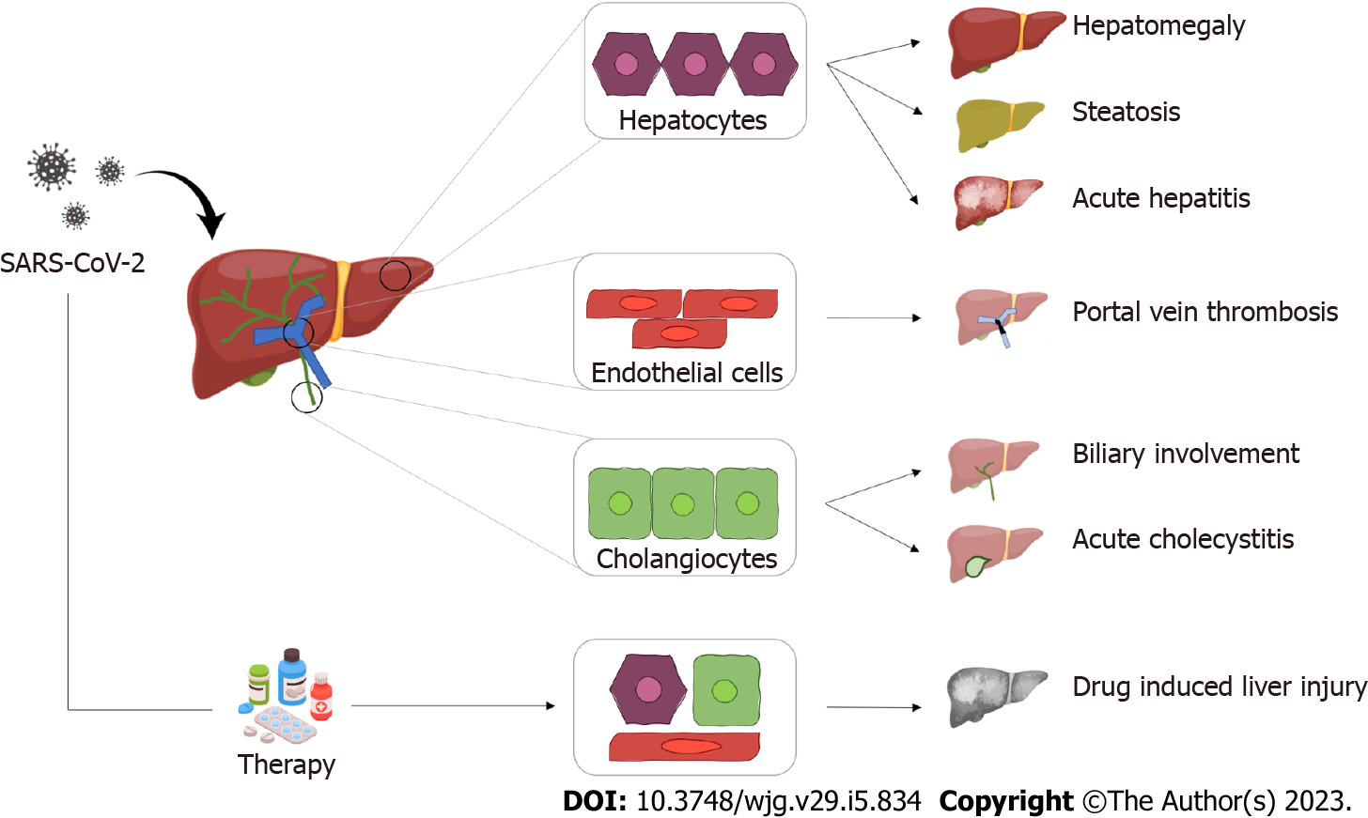
Figure 1 Graphical summary of the most common hepatic pathological findings in coronavirus disease 2019. SARS-CoV-2: Severe acute respiratory syndrome coronavirus 2.

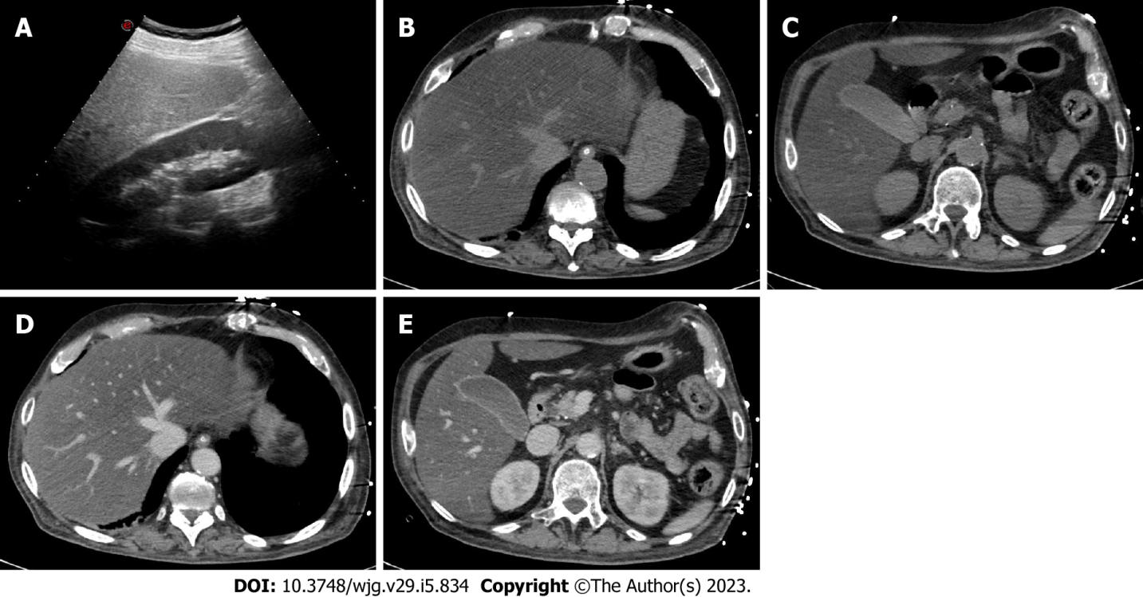
Figure 2 A 45-year-old woman with coronavirus disease 2019 infection underwent abdominal ultrasonography due to elevated liver enzymes. A: As shown on ultrasonography, the liver is hyperechoic in comparison to the renal parenchyma, suggesting marked steatosis; B-E: The patient underwent contrast-enhanced computed tomography; B and C: On unenhanced images, the liver is diffusely hypoattenuating while its main vessels (i.e. portal vein and hepatic veins) appear brighter than the parenchyma due to a marked hepatic fatty infiltration; D and E: On post-contrast images, the liver is homogeneous without any focal lesion; C and E: The gallbladder is filled by sludge, with normal wall thickness. Finally, the combination of clinical and radiological findings allowed the final diagnosis of steatohepatitis.

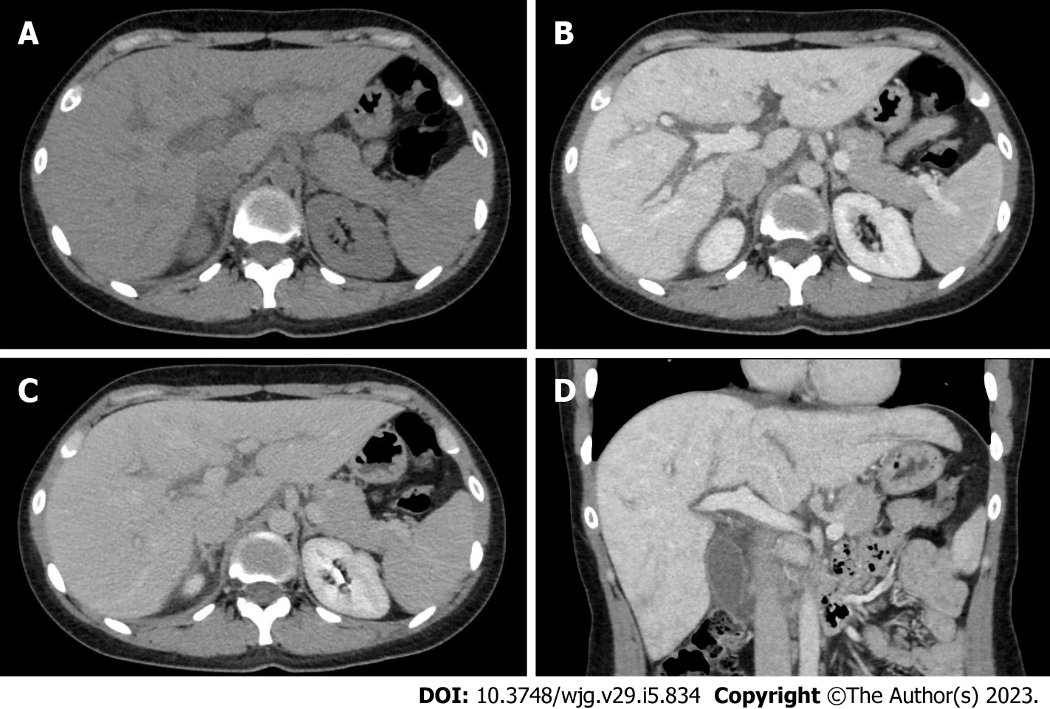
Figure 3 A 33-year-old woman with coronavirus disease 2019 infection underwent contrast-enhanced computed tomography due to a suspicion of portal vein thrombosis. A: On unenhanced phase liver is enlarged, homogeneous and without any focal lesion; B: On the portal venous phase the liver enhancement is slight inhomogeneous associated with peri-portal edema, a typical finding of acute hepatitis; C and D: These aspects can be clearly observed also on the coronal reconstruction acquired on the portal venous phase (D) and the delayed phase (C).

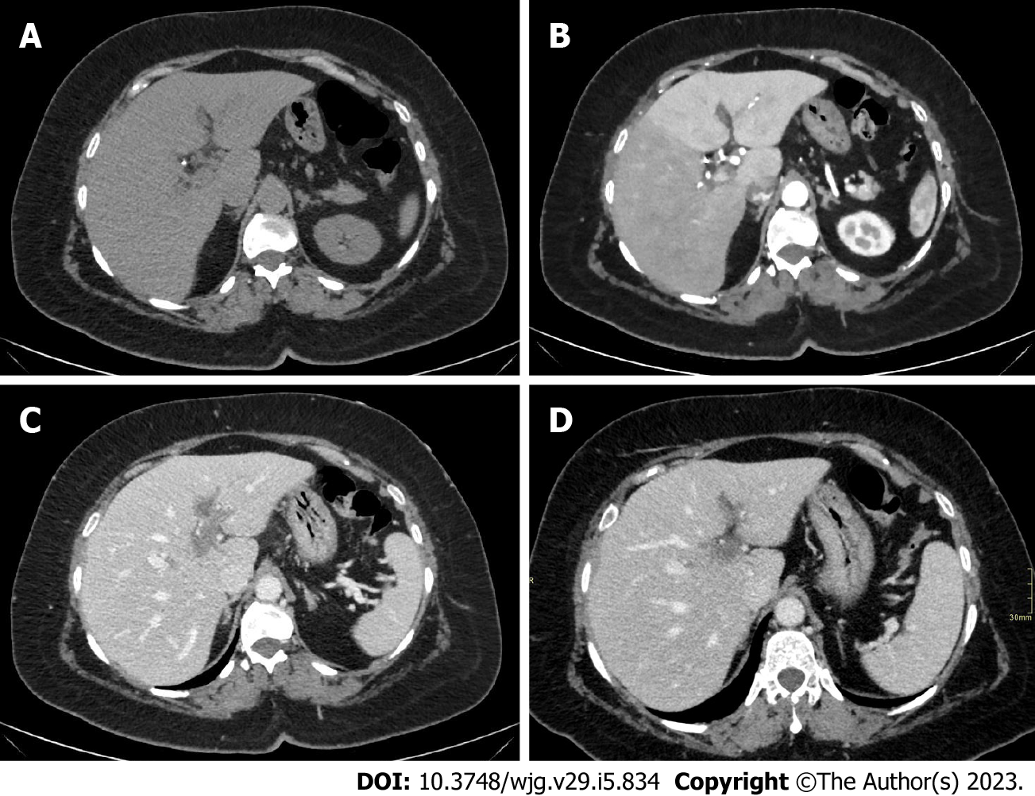
Figure 4 A 40-year-old men with coronavirus disease 2019 infection and marked respiratory symptoms, underwent contrast-enhanced computed tomography due to elevated liver and biliary enzymes. A and B: On unenhanced phase (A) the liver is within normal limits. After the injection of contrast agent, on arterial phase (B) liver parenchyma shows inhomogeneous enhancement, with hypervascularization of the left liver lobe, as in case of transient hepatic attenuation differences; C: On the portal venous phase, the arterial hypervascularization fades to homogeneous enhancement and diffuse thrombosis of the left branch of the portal vein is demonstrated; D: After 6 mo the patient underwent contrast-enhanced computed tomography that demonstrated persistent portal vein thrombosis without venous collaterals.

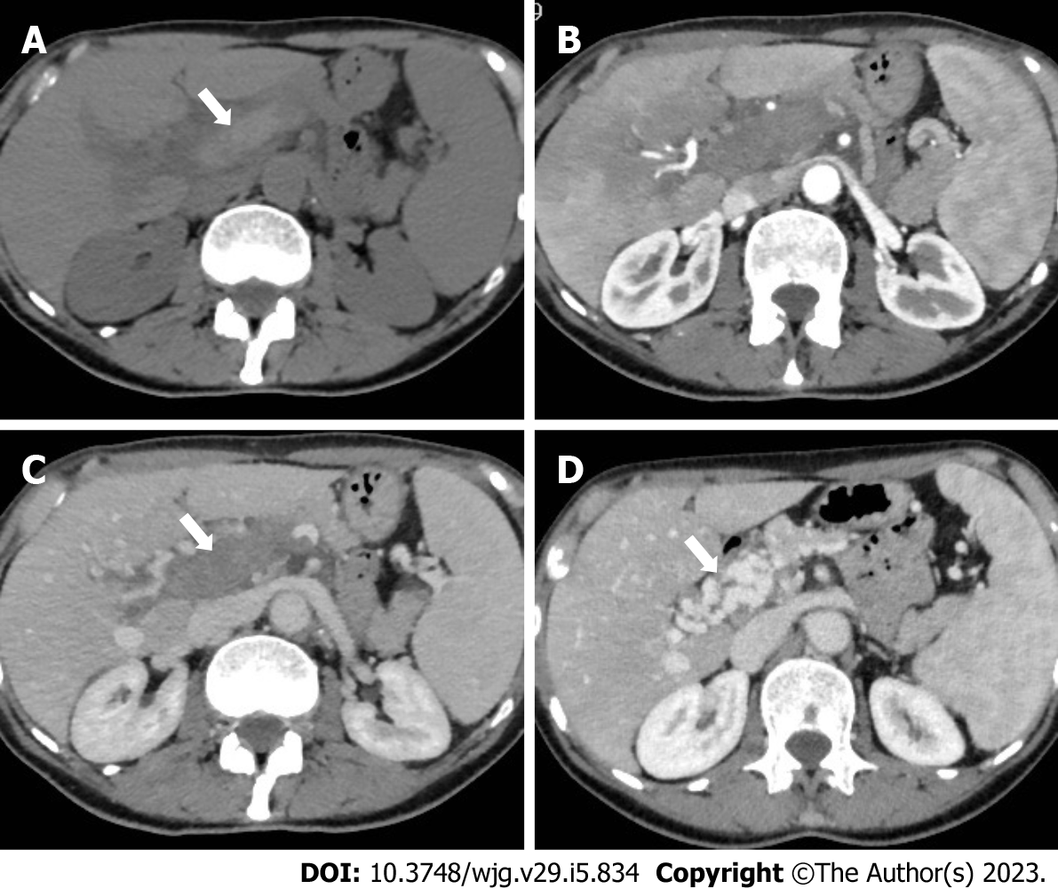
Figure 5 A 62-year-old woman with acute portal vein thrombosis after coronavirus disease 2019 infection. A-C: Computed tomography (CT) images show acute thrombosis with hyperintense thrombus on unenhanced phase (A, arrow), heterogeneous enhancement of the liver parenchyma on hepatic arterial phase (B), and complete portal vein thrombosis on portal venous phase (C, arrow); D: Contrast-enhanced CT at 6-mo follow-up demonstrates chronic findings of portal cavernoma with multiple collateral vessels at the hepatic hilum (arrow).

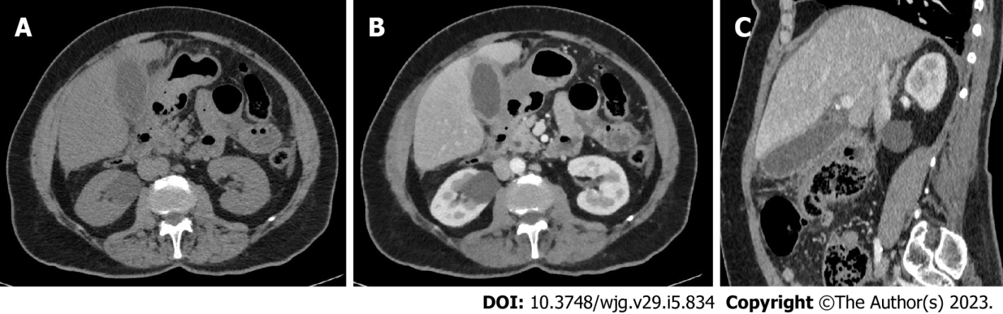
Figure 6 A 66-year-old men with coronavirus disease 2019 infection, associated with abdominal pain in the upper quadrants. A-C: Contrast-enhanced computed tomography showed diffuse thickening of the gallbladder walls (A), with homogeneous contrast enhancement (B), better appreciable on the sagittal reconstruction (C). The gallbladder lumen is filled with biliary sludge (A) without calcified stones. The final diagnosis was acute acalculous cholecystitis.

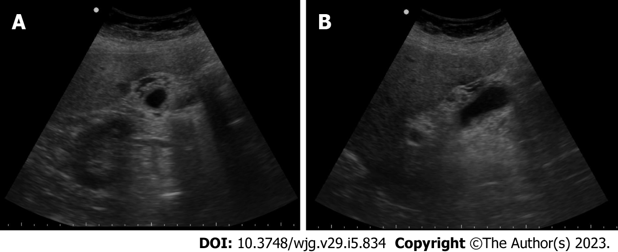
Figure 7 A 53-year-old woman with coronavirus disease 2019 infection and markedly elevated biliary enzymes and C reactive protein levels. A and B: Ultrasonography demonstrates diffuse thickening of the gallbladder wall, associated with multiple small anechoic components into the walls, as in case of intramural abscesses. No stone is appreciated. The final diagnosis was acute acalculous cholecystitis.

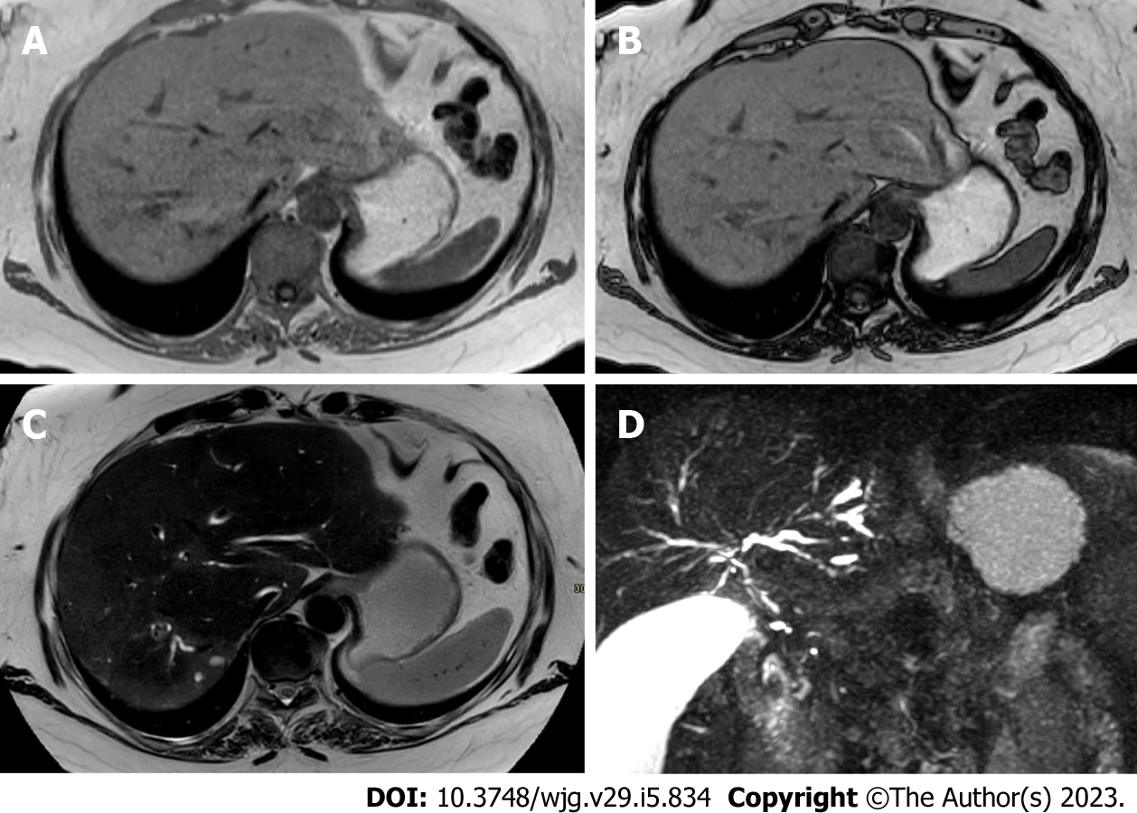
Figure 8 A 44-year-old woman with coronavirus disease 2019 infection underwent magnetic resonance cholangiopancreatography due to elevated biliary enzymes with negative findings on ultrasonography and contrast-enhanced computed tomography. A and B: In-phase (A) and out-of-phase (B) imaging demonstrates hepatic homogeneous parenchyma without areas of fatty infiltration; C: On the T2-weighted image liver inflammation, especially in the right lobe, is characterized by areas of slight hyperenhancement, located nearby the biliary ducts; D: Finally, magnetic resonance cholangiopancreatography allows the evaluation of the biliary tree, showing multiple and diffuse focal biliary stenosis, in particular in the right lobe, with upstream dilation of small biliary ducts. This radiological aspect is typical of sclerosing cholangitis and the final diagnosis was a biliary involvement due to severe acute respiratory syndrome coronavirus 2.
Table 1 Summary of the most common findings in liver involvement due to coronavirus disease 2019 infection
Liver involvement | Ultrasound | Computed tomography | Magnetic resonance
Hepatomegaly | Qualitative criteria: The right lobe extends inferiorly over the lower pole of the right kidney; Rounding of the hepatic inferior border
 | Quantitative criterion: Length of the right liver lobe > 16.5 cm
Steatosis | Hyperechoic liver in comparison to the spleen or neighboring kidney; Absence of the normal echogenic walls of the portal and hepatic veins; Poor visualization of deep portions of the liver | Unenhanced: Relative hypoattenuation: liver attenuation more than 10 HU less than that of spleen; Absolute low attenuation: liver attenuation lower than 40 HU; C+: Does not add information | IP/OOP imaging: Signal drop out on OOP; T2W: Isointense; T1: Isointense; T1 C+: Does not add significant information
Acute hepatitis | Hepatomegaly; Reduced echogenicity; Steatosis; Peri-portal edema; Reduced Doppler signal in the hepatic artery; Thickening of the gallbladder wall | Hepatomegaly; Homogeneous/heterogeneous hypoattenuation (steatosis); Peri-portal edema; Thickening of the gallbladder wall; Periportal/hepatoduodenal enlarged nodes | IP/OOP imaging: Steatosis can be present; T2W: Diffuse mild increase in signal; Increased signal around the portal system (periportal edema); T1 C+: Periportal enhancement; Thickening of the gallbladder wall; Hilar enlarged nodes
DILI | Nonspecific findings: Hepatomegaly, steatosis, and peri-portal edema can be present
Portal vein thrombosis | Absent or reduced flow in the portal vein on Color Doppler; Presence of heterogeneous material (focal or diffuse) in the portal vein lumen | Unenhanced: Higher attenuation into the portal vein lumen; Dilation of the portal trunk; C+: Hypoattenuating material into the lumen; Enhancement of vein walls | T2W: Iso- to hyperintense clot according to the phase (acute or subacute); T1: Hyperintense clot; T1 C+: Hypointense material into the lumen; Enhancement of vein walls
Biliary involvement | Focal or diffuse bile duct dilatation (with/without intrahepatic or extrahepatic stones) | Unenhanced: Does not add information; C+: Focal or diffuse bile duct dilatation (with/without intrahepatic or extrahepatic stones); Heterogeneous enhancement of parenchyma; Peri-portal edema | MRCP: Focal or diffuse bile duct dilatation with/without intrahepatic or extrahepatic stones; Stone(s) in the biliary lumen (hypointense); Multifocal biliary strictures alternated with dilated tracts (beaded appearance); T2W: Hypointense stone; Increased T2 signal around the portal system (periportal edema); T1: Hyperintense stone; T1 C+: Heterogeneous enhancement of peri-biliary parenchyma
Acute cholecystitis | Gallbladder wall thickening (> 3 mm); Pericholecystic fluid; Gallbladder distension; Possible sludge | Unenhanced: Gallbladder distension; Possible sludge (hyperattenuating); Pericholecystic fluid; C+: Gallbladder wall thickening (> 3 mm); Inhomogeneous gallbladder wall; Mural or mucosal hyperenhancement | MRCP: May show an impacted stone in the gallbladder neck or cystic duct; T2W: Gallbladder wall thickening (> 3 mm); Inhomogeneous gallbladder wall due to edema; T1: Sludge (hyperattenuating); T1 C+: Inhomogeneous gallbladder wall; Mural or mucosal hyperenhancement
HU: Hounsfield unit; IP: In-phase; OOP: Out-of-phase; C+: Contrast-enhanced; DILI: Drug-induced liver injury; MRCP: Magnetic resonance cholangiopancreatography.

Published by Baishideng Publishing Group Inc
7041 Koll Center Parkway, Suite 160, Pleasanton, CA 94566, USA
Telephone: +1-925-3991568
E-mail: bpgoffice@wjgnet.com
Help Desk: https://www.f6publishing.com/helpdesk
https://www.wjgnet.com

© 2023 Baishideng Publishing Group Inc. All rights reserved.

