Name of Journal: World Journal of Clinical Cases
Manuscript NO: 81499
Manuscript Type: CASE REPORT

Motor cortex transcranial magnetic stimulation to reduce intractable postherpetic neuralgia with poor response to other threapies: Report of two cases

Wang H et al. rTMS for treatment of PHN

Huan Wang, Yu-Zhong Hu, Xian-Wei Che, Liang Yu

Huan Wang, Yu-Zhong Hu, Liang Yu, Department of Anesthesiology, Zhejiang Chinese Medicine University, Hangzhou 310000, Zhejiang Province, China

Xian-Wei Che, Transcranial Magnetic Stimulation Centre, Deqing Hospital of Hangzhou Normal University, Hangzhou 310000, Zhejiang Province, China

Liang Yu, Department of Pain, Hangzhou First People's Hospital, Hangzhou 310000, Zhejiang Province, China

Author contributions: Wang H contributed to literature search, and manuscript drafting and writing; Che XW contributed to supervision and writing of the manuscript; Hu YZ and Yu L contributed to literature search; all authors made substantial contributions to conception and design and data acquisition, analysis, or interpretation; took part in drafting the article or revising it critically for important intellectual content; gave final approval of the version to be published; and agree to be accountable for all aspects of the work.

Corresponding author: Liang Yu, MD, Chief Physician, Department of Anesthesiology, Zhejiang Chinese Medicine University, No. 548 Binwen Road, Hangzhou 310000, Zhejiang Province, China. yuliang0601@zju.edu.cn

Received: November 14, 2022
Revised: January 5, 2023
Accepted: February 21, 2023
Published online: March 26, 2023

Abstract
BACKGROUND
Postherpetic neuralgia (PHN) is a typical neuropathic pain condition that appears in the lesioned skin regions following the healing of shingles. The pain condition tends to persist, which is often accompanied by negative emotions (e.g., anxiety and depression) and substantially reduces the quality of life. In addition to analgesia (e.g., pregabalin and gabapentin), nerve radiofrequency technology is an effective treatment for intractable PHN. However, there is still a significant portion of patients who do not benefit from this treatment. As a non-invasive form of brain stimulation, repetitive transcranial magnetic stimulation (rTMS) targeting the motor cortex is able to reduce neuropathic pain with grade A evidence.

CASE SUMMARY
Here we report two cases in which motor cortex rTMS was used to treat intractable PHN that did not respond to initial drug and radiofrequency therapies. Moreover, we specifically investigated rTMS efficacy at 3 mo following treatment.

CONCLUSION
Motor cortex rTMS can treat intractable PHN that did not respond to initial drug and radiofrequency therapies.

Key Words: Post herpetic neuralgia; Repetitive transcranial magnetic stimulation; Radiofrequency; Case report

©The Author(s) 2023. Published by Baishideng Publishing Group Inc. All rights reserved.

Citation: Wang H, Hu YZ, Che WX, Yu L. Motor cortex transcranial magnetic stimulation to reduce intractable postherpetic neuralgia with poor response to other therapies: Report of two cases. World J Clin Cases 2023; 11(9): 2015-2020
URL: https://www.wjgnet.com/2307-8960/full/v11/i9/2015.htm
DOI: https://dx.doi.org/10.12998/wjcc.v11.i9.2015

Core Tip: Postherpetic neuralgia (PHN) is a kind of refractory neuropathic pain, which seriously affects the quality of life. Repetitive transcranial magnetic stimulation can be used as an effective complement to the treatment of patients with refractory PHN.

INTRODUCTION
Postherpetic neuralgia (PHN) is a typical neuropathic pain condition that appears in the lesioned skin regions following the healing of shingles^{[1]}. The pain condition tends to persist, which is often accompanied by negative emotions (e.g., anxiety and depression) and substantially reduces the quality of life^{[1]}. In addition to analgesia (e.g., pregabalin and gabapentin), nerve radiofrequency technology is a effective treatment for intractable PHN^{[2,3]}. However, there is still a significant portion of patients who do not benefit from this treatment.
As a non-invasive form of brain stimulation, repetitive transcranial magnetic stimulation (rTMS) targeting the motor cortex (M1) is able to reduce neuropathic pain with grade A evidence^{[4]}. Here we report two cases in which motor cortex rTMS was used to treat intractable PHN that did not respond to initial drug and radiofrequency therapies. Moreover, we specifically investigated rTMS efficacy at 3 mo following treatment^{[4]}.

CASE PRESENTATION
Chief complaints
Case 1: A 65-year-old woman was admitted with persistent pain in the left chest and back (T5/T6) for 6 mo after herpes zoster.
Case 2: A 75-year-old woman was admitted with left lower back pain (T11/12) for 4 mo after herpes zoster.

History of present illness
Case 1: The patient’s pain was characterized by persistent tingling and burning sensations, with a visual analog scale (VAS) score of 8. She was prescribed pregabalin 150 mg bid, but she did not want to continue increasing the dose of the drug because of the side effect of dizziness, and received a spinal nerve radiofrequency surgery. However, there was no clear analgesia following these treatments.
Case 2: The patient was prescribed gabapentin 0.6 g tid. However, she had renal insufficiency so the drug dose was not increased further, as well as a spinal nerve radiofrequency surgery. The patient reported slight pain relief after treatment but still with a VAS score of 6.

History of past illness
Case 1: The patient claimed no history of past illness.
Case 2: The patient had a history of renal insufficiency for 5 years and was on drugs regularly.

Personal and family history
Neither patient had any relevant personal or family history.

Physical examination
Physical examination of both patients revealed no abnormalities.

Laboratory examinations
Laboratory examination of both patients revealed no abnormalities.

Imaging examinations
Imaging examination of both patients revealed no abnormalities.

FINAL DIAGNOSIS
Cases 1 and 2
PHN.

TREATMENT
Both patients provided written informed consent for rTMS treatment. rTMS was delivered to the contralateral motor cortex once daily for 10 consecutive days using an RT-50 stimulation system connected to a figure-of-eight coil (Sichuan Junjian Wanfeng Medical Equipment Co.). Each rTMS session delivered 3000 pulses at 10 Hz with 5-sec trains and 25-sec intervals at 100% resting motor threshold. Patients were assessed at baseline, the fifth treatment, the end of treatment, and 2 wk, 1 mo, and 3 mo after treatment. Clinical assessment included VAS, McGill Pain Questionnaire (McGill), Pittsburgh Sleep Quality Index (PSQI), Hamilton Depression Scale (24 items), Hamilton Anxiety Scale (17 items), Mini-mental State Examination (MMSE), and Perceived Deficits Questionnaire-Depression (PDQ-D). Drug dose remained the same as that before this treatment.

OUTCOME AND FOLLOW-UP
Both patients demonstrated a promising analgesia effect, with pain experience changing from severe to mild-to-moderate level (Figure 1). There was also a protect effect on negative emotions, especially in the first case with an initial mild depressive symptom. We also observed a significant improvement in sleep quality in both cases. More importantly, the protective effects of motor cortex rTMS lasted for 3 mo following treatment (Figure 2).

DISCUSSION
Here we report two cases in which motor cortex rTMS was able to significantly reduce intractable PHN that did respond to first-line drug and radiofrequency therapies. Drugs and radiofrequency therapies are first-line treatments in clinical settings for PHN^{[5]}. Our results indicated that motor cortex rTMS could be considered when the pain become intractable and/or the patient does not seem to benefit from regular drug and radiofrequency therapies. Some studies have shown that rTMS treatment is safe for patients with PHN and has better efficacy at 10 Hz^{[6]}, which is the frequency that we chose for these two patients. More importantly, our results indicated a long-term analgesic effect for 3 mo. Most previous studies have shown that pain relief from neuroplasticity can last for several days, usually a week to a month, after transcranial magnetic stimulation treatment^{[4]}. This long-term 3-mo effect was potentially associated with a relatively large dose of pulses in daily treatment^{[7]}. Previous studies tended to deliver approximately 1500 daily pulses whereby the number of pulses was doubled in these two cases.
TMS is a non-invasive stimulation technique that produces analgesic effects similar to those of invasive techniques by targeting rTMS to M1^{[8]}. High-frequency rTMS delivered to M1 areas obtains analgesic effects by modulating several distant brain regions involved in the processing or control of nociceptive information. This pain relief can last for several weeks beyond the duration of stimulation, especially during repetition, and may be related to the process of long-term synaptic plasticity^{[9]}. rTMS is now mainly used for the treatment of neuropathic pain and requires a trained physician or nurse to perform this procedure, which is a technique that can be widely used. The most common side effects are dizziness and scalp discomfort, which are transient and disappear after the treatment.
The mechanism of rTMS analgesia remains an open question. There is evidence that motor cortex rTMS could drive top-down pain modulation^{[10]}. In addition, motor cortex stimulation is also able to activate cortical and subcortical regions (e.g., insular and cingulate cortex) involved in the processing of affective-emotional aspects of pain^{[11]}. In either case, cortical and/or subcortical responses to rTMS may help explain the poor response to radiofrequency therapies, in which spinal nerves may not be well damaged by the surgery or become recurrent following surgery.
We have also observed a promising effect on negative emotions in these two cases. This is in line with the finding of a study that rTMS treatment had a significant effect on the whole brain functional network in PHN patients with inhibited sensory-motor functions and improvements in mood, cognitive, emotional, and memory functions^{[12]}. rTMS has been approved by the United States Food and Drug Administration to treat depression by targeting the dorsolateral prefrontal cortex. Recent studies have also tried to manage comorbid pain and depression with rTMS in one setting^{[13]}. In addition, we provide an interesting finding that motor cortex rTMS is able to improve sleep quality in the two cases, which has been rarely investigated compared to evidence on depression and neuropathic pain^{[14,15]}.

CONCLUSION
To conclude, we provide two cases in which motor cortex rTMS is able to reduce pain sensations in intractable PHN when first-line drug and radiofrequency therapies had no clear benefits. These findings need to be further validated in large, randomized controlled trials.

REFERENCES
1 Gross GE, Eisert L, Doerr HW, Fickenscher H, Knuf M, Maier P, Maschke M, Müller R, Pleyer U, Schäfer M, Sunderkötter C, Werner RN, Wutzler P, Nast A. S2k guidelines for the diagnosis and treatment of herpes zoster and postherpetic neuralgia. J Dtsch Dermatol Ges 2020; 18: 55-78 [DOI: 10.1111/ddg.14013]
2 Makharita MY, El Bendary HM, Sonbul ZM, Ahmed SES, Latif MA. Ultrasound-guided Pulsed Radiofrequency in the Management of Thoracic Postherpetic Neuralgia: A Randomized, Double-blinded, Controlled Trial. Clin J Pain 2018; 34: 1017-1024 [PMID: 29757758 DOI: 10.1097/AJP.0000000000000629]
3 Huang X, Ma Y, Wang W, Guo Y, Xu B, Ma K. Efficacy and safety of pulsed radiofrequency modulation of thoracic dorsal root ganglion or intercostal nerve on postherpetic neuralgia in aged patients: a retrospective study. BMC Neurol 2021; 21: 233 [PMID: 34162352 DOI: 10.1186/s12883-021-02286-6]
4 Lefaucheur JP, André-Obadia N, Antal A, Ayache SS, Baeken C, Benninger DH, Cantello RM, Cincotta M, de Carvalho M, De Ridder D, Devanne H, Di Lazzaro V, Filipović SR, Hummel FC, Jääskeläinen SK, Kimiskidis VK, Koch G, Langguth B, Nyffeler T, Oliviero A, Padberg F, Poulet E, Rossi S, Rossini PM, Rothwell JC, Schönfeldt-Lecuona C, Siebner HR, Slotema CW, Stagg CJ, Valls-Sole J, Ziemann U, Paulus W, Garcia-Larrea L. Evidence-based guidelines on the therapeutic use of repetitive transcranial magnetic stimulation (rTMS). Clin Neurophysiol 2014; 125: 2150-2206 [PMID: 25034472 DOI: 10.1016/j.clinph.2014.05.021]
5 Finnerup NB, Attal N, Haroutounian S, McNicol E, Baron R, Dworkin RH, Gilron I, Haanpää M, Hansson P, Jensen TS, Kamerman PR, Lund K, Moore A, Raja SN, Rice AS, Rowbotham M, Sena E, Siddall P, Smith BH, Wallace M. Pharmacotherapy for neuropathic pain in adults: a systematic review and meta-analysis. Lancet Neurol 2015; 14: 162-173 [PMID: 25575710 DOI: 10.1016/S1474-4422(14)70251-0]
6 Pei Q, Wu BS, Tang YZ, Yang XH, Song LP, Wang N, Li Y, Sun CL, Ma SM, Ni JX. Repetitive transcranial magnetic stimulation at different Frequencies for postherpetic neuralgia: a double-bind, sham-controlled, randomized trial. Pain Physician 2019; 22: E303-E313 [DOI: 10.36076/ppj/2019.22.E303]
7 Cruccu G, Garcia-Larrea L, Hansson P, Keindl M, Lefaucheur JP, Paulus W, Taylor R, Tronnier V, Truini A, Attal N. EAN guidelines on central neurostimulation therapy in chronic pain conditions. Eur J Neurol 2016; 23: 1489-1499 [PMID: 27511815 DOI: 10.1111/ene.13103]
8 Lefaucheur JP, Drouot X, Keravel Y, Nguyen JP. Pain relief induced by repetitive transcranial magnetic stimulation of precentral cortex. Neuroreport 2001; 12: 2963-2965 [PMID: 11588611 DOI: 10.1097/00001756-200109170-00041]
9 Hosomi K, Sugiyama K, Nakamura Y, Shimokawa T, Oshino S, Goto Y, Mano T, Shimizu T, Yanagisawa T, Saitoh Y; TEN-P11-01 investigators. A randomized controlled trial of 5 daily sessions and continuous trial of 4 weekly sessions of repetitive transcranial magnetic stimulation for neuropathic pain. Pain 2020; 161: 351-360 [PMID: 31593002 DOI: 10.1097/j.pain.0000000000001712]
10 Lefaucheur JP, Drouot X, Menard-Lefaucheur I, Zerah F, Bendib B, Cesaro P, Keravel Y, Nguyen JP. Neurogenic pain relief by repetitive transcranial magnetic cortical stimulation depends on the origin and the site of pain. J Neurol Neurosurg Psychiatry 2004; 75: 612-616 [PMID: 15026508 DOI: 10.1136/jnnp.2003.022236]
11 Moisset X, de Andrade DC, Bouhassira D. From pulses to pain relief: an update on the mechanisms of rTMS-induced analgesic effects. Eur J Pain 2016; 20: 689-700 [PMID: 26471248 DOI: 10.1002/ejp.811]
12 Pei Q, Zhuo Z, Jing B, Meng Q, Ma X, Mo X, Liu H, Liang W, Ni J, Li H. The effects of repetitive transcranial magnetic stimulation on the whole-brain functional network of postherpetic neuralgia patients. Medicine (Baltimore) 2019; 98: e16105 [PMID: 31232955 DOI: 10.1097/MD.0000000000016105]
13 Leung A, Shirvalkar P, Chen R, Kuluva J, Vaninetti M, Bermudes R, Poree L, Wassermann EM, Kopell B, Levy R; and the Expert Consensus Panel. Transcranial Magnetic Stimulation for Pain, Headache, and Comorbid Depression: INS-NANS Expert Consensus Panel Review and Recommendation. Neuromodulation 2020; 23: 267-290 [PMID: 32212288 DOI: 10.1111/ner.13094]
14 Nardone R, Sebastianelli L, Versace V, Brigo F, Golaszewski S, Pucks-Faes E, Saltuari L, Trinka E. Effects of repetitive transcranial magnetic stimulation in subjects with sleep disorders. Sleep Med 2020; 71: 113-121 [PMID: 32173186 DOI: 10.1016/j.sleep.2020.01.028]
15 Guo J, Chen X, Lyu Z, Xiu H, Lin S, Liu F. Repetitive transcranial magnetic stimulation (rTMS) for post-stroke sleep disorders: a systematic review of randomized controlled trials. Neurol Sci 2022; 43: 6783-6794 [PMID: 35980480 DOI: 10.1007/s10072-022-06349-5]

Footnotes
Informed consent statement: Informed written consent was obtained from the patients for publication of this report and any accompanying images.

Conflict-of-interest statement: All the authors declare that they have no conflict of interest to disclose.

CARE Checklist (2016) statement: The authors have read the CARE Checklist (2016), and the manuscript was prepared and revised according to the CARE Checklist (2016).

Open-Access: This article is an open-access article that was selected by an in-house editor and fully peer-reviewed by external reviewers. It is distributed in accordance with the Creative Commons Attribution NonCommercial (CC BY-NC 4.0) license, which permits others to distribute, remix, adapt, build upon this work non-commercially, and license their derivative works on different terms, provided the original work is properly cited and the use is non-commercial. See: https://creativecommons.org/Licenses/by-nc/4.0/

Provenance and peer review: Unsolicited article; Externally peer reviewed.
Peer-review model: Single blind

Peer-review started: November 15, 2022
First decision: December 26, 2022
Article in press: February 21, 2023

Specialty type: Clinical neurology
Country/Territory of origin: China
Peer-review report’s scientific quality classification
Grade A (Excellent): 0
Grade B (Very good): 0
Grade C (Good): C, C
Grade D (Fair): 0
Grade E (Poor): 0

P-Reviewer: Higa K, Japan; Shelat VG, Singapore S-Editor: Liu JH L-Editor: Wang TQ P-Editor: Liu JH
Figure Legends
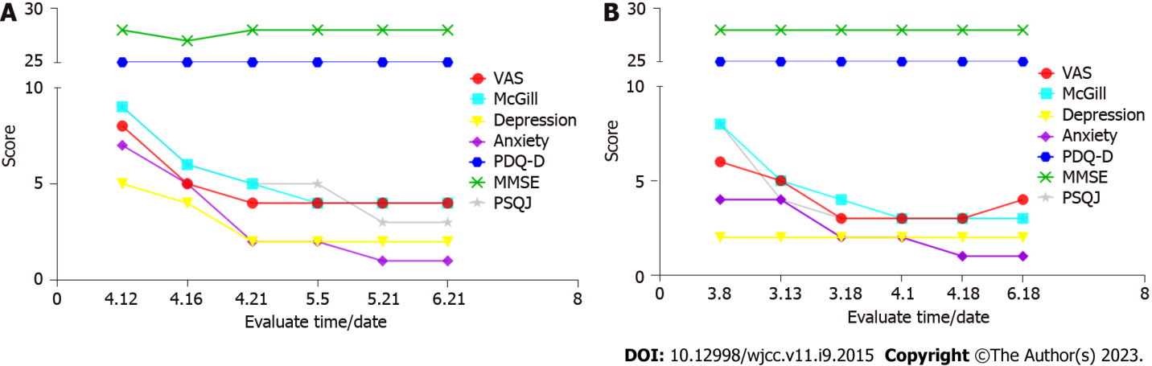
Figure 1 Case results. A: Case 1; B: Case 2. Motor cortex rTMS is able to reduce pain conditions, negative emotions, as well as sleep quality in two cases with intractable postherpetic neuralgia when first-line drug and radiofrequency therapies had no clear benefits. VAS: Visual analogue scale; McGill: McGill Pain Questionnaire; Depression: Hamilton Depression Scale (24 items); Anxiety: Hamilton Anxiety Scale (17 items); PDQ-D: Perceived Deficits Questionnaire-Depression; MMSE: Mini-mental State Examination; PSQI: Pittsburgh Sleep Quality Index.

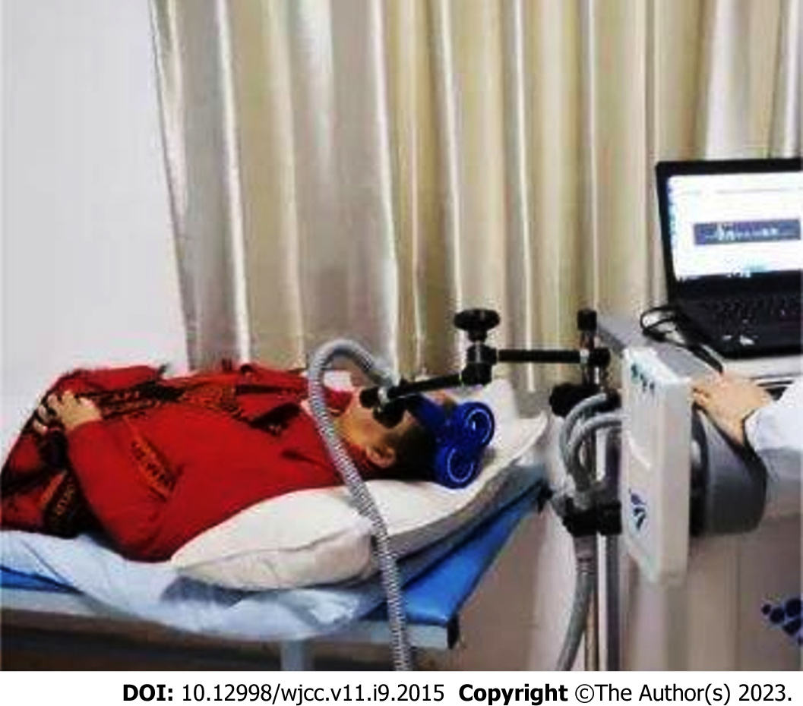
Figure 2 A patient treated by repetitive transcranial magnetic stimulation.

Published by Baishideng Publishing Group Inc
7041 Koll Center Parkway, Suite 160, Pleasanton, CA 94566, USA
Telephone: +1-925-3991568
E-mail: bpgoffice@wjgnet.com
Help Desk: https://www.f6publishing.com/helpdesk
https://www.wjgnet.com

© 2023 Baishideng Publishing Group Inc. All rights reserved.

