Name of Journal: World Journal of Clinical Cases
Manuscript NO: 70332
Manuscript Type: CASE REPORT

Successful multimodality treatment of metastatic gallbladder cancer: A case report and review of literature

Zhang B et al. Successful multimodality treatment of MGC

Biao Zhang, Shuang Li, Zhao-Yi Liu, Karieshinie Ghandalie Kalandika Peiris, Li-Fu Song, Mu-Cang Liu, Peng Luo, Dong Shang, Wei Bi

Biao Zhang, Shuang Li, Zhao-Yi Liu, Karieshinie Ghandalie Kalandika Peiris, Li-Fu Song, Mu-Cang Liu, Peng Luo, Dong Shang, Wei Bi, Department of General Surgery, The First Affiliated Hospital of Dalian Medical University, Dalian 116000, Liaoning Province, China

Author contributions: Zhang B, Li S, and Liu ZY wrote and corrected the manuscript; Peiris KGK and Song LF reviewed and corrected the manuscript; Liu MC, Luo P, Shang D, and Bi W were the patient´s surgeon; Shang D and Bi W supervised and edited the manuscript; all authors approved the final version of the manuscript.

Supported by National Natural Science Foundation of China, No. 81873156 and No. 82000075; Liaoning Province Education Foundation, No. LZ2019051; and National Natural Science Foundation of Liaoning, No. 2020-BS-195.

Corresponding author: Wei Bi, MD, PhD, Chief Doctor, Doctor, Professor, Department of General Surgery, The First Affiliated Hospital of Dalian Medical University, No. 222 Zhongshan Road, Xigang District, Dalian 116011, Liaoning Province, China. biwei1767@sina.com

Received: July 30, 2021
Revised: September 25, 2021
Accepted: March 5, 2022
Published online: April 26, 2022

Abstract
BACKGROUND
Gallbladder cancer is the most common malignant tumor in the biliary system, and it is characterized by high aggressiveness and an extremely poor prognosis. Current treatment for advanced gallbladder cancer remains unsatisfactory. Here, we report a patient with advanced gallbladder cancer who was cured by multidisciplinary treatment.

CASE SUMMARY
A 73-year-old male presented to our hospital with right abdominal pain for 3 d and was diagnosed with stage IVB gallbladder cancer with multiple liver metastases, peritoneum metastasis, diaphragm metastasis and lymph node metastases. The patient initially received chemotherapy, targeted therapy, ¹²⁵I seed implantation and immunotherapy, as there were no specific indications for radical surgery. During these palliative therapies, the level of tumor markers gradually decreased but remained higher than the normal level, lymph node metastases gradually disappeared, and liver metastasis was gradually limited to the left liver. Finally, the patient received radical surgery with left hepatectomy, radical lymphadenectomy and partial diaphragmatic resection. To date, the patient has survived for more than six years posttreatment, the levels of tumor markers are normal, and imaging examinations show no signs of tumor recurrence.

CONCLUSION
Currently, the prognosis of advanced gallbladder cancer remains unsatisfactory. A single treatment method is not sufficient for patients with advanced gallbladder cancer. Multidisciplinary individualized treatment is essential and should be utilized for advanced gallbladder cancer patients to further improve prognosis.

Key Words: Advanced gallbladder cancer; Multidisciplinary treatment; Long-term survival; Case report

©The Author(s) 2022. Published by Baishideng Publishing Group Inc. All rights reserved.

Citation: Zhang B, Li S, Liu ZY, Peiris KGK, Song LF, Liu MC, Luo P, Shang D, Bi W. Successful multimodality treatment of metastatic gallbladder cancer: A case report and review of literature. World J Clin Cases 2022; 10(12): 3856-3865
URL: https://www.wjgnet.com/2307-8960/full/v10/i12/3856.htm
DOI: https://dx.doi.org/10.12998/wjcc.v10.i12.3856

Core Tip: The prognosis of advanced gallbladder cancer is extremely poor. Many clinicians and even experienced surgeons are confused and pessimistic about the treatment of advanced gallbladder cancer. Here, we report a patient with stage IVB gallbladder cancer with multiple liver metastases, peritoneum metastasis, diaphragm metastasis, and lymph node metastases who was cured by multidisciplinary treatment. Although the prognosis of metastatic gallbladder cancer remains extremely poor in the current medical field, the presented case highlights the importance of providing aggressive multidisciplinary treatment to appropriately selected patients with metastatic gallbladder cancer to achieve long-term survival.

INTRODUCTION
Gallbladder cancer is the most common malignant tumor in the biliary system, with a global average incidence of approximately 2.71/100000 and a high incidence in Chile, Japan and India^{[1,2]}. Gallbladder cancer is characterized by its high aggressiveness and an extremely poor prognosis, and the five-year survival rates of stage Ⅰ, IVA and IVB gallbladder cancer are only 50%, 12.4% and 2.5% respectively^{[3-5]}. Radical surgery is the only way to cure gallbladder cancer. However, gallbladder cancer has an insidious onset and is difficult to diagnose at an early stage. In fact, some patients are already in the advanced stage when the diagnosis is made^{[6,7]}. For unresectable or metastatic gallbladder cancer, the National Comprehensive Cancer Network guidelines for hepatobiliary cancers recommend chemotherapy, radiotherapy, immunotherapy and biliary drainage as palliative therapy to prolong patient survival^{[8]}. Here, we report a patient with stage IVB gallbladder cancer who has survived for more than six years and is currently in disease-free survival after multidisciplinary treatment.

CASE PRESENTATION
Chief complaints
In December 2014, a 73-year-old male presented to our hospital with right abdominal pain for 3 d.

History of present illness
The patient suffered right abdominal pain for 3 d.

History of past illness
The patient had no other significant medical history.

Personal and family history
The patient had no family history of cancer or hepatobiliary disease.

Physical examination
Physical examination indicated mild tenderness in the right upper quadrant of the abdomen and positive Murphy’s sign.

Laboratory examinations
In December 2014, the laboratory examinations showed the following for tumor markers: Alpha-fetoprotein, 1.61 IU/mL (normal, 0-5.8 IU/mL); carcinoembryonic antigen (CEA), 115.8 ng/mL (normal, 0-5 ng/mL); carbohydrate antigen19-9 (CA19-9), > 1000 IU/mL (normal, 0-27 IU/mL); and CA12-5, 112.3 IU/mL (normal, 0-35 IU/mL). The blood count, liver function and kidney function examinations of the patient were at normal levels.

Imaging examinations
In December 2014, abdominal magnetic resonance imaging (MRI) indicated gallbladder cancer with a tumor size of approximately 3.2 cm × 4.1 cm, right liver metastasis with a tumor size of approximately 4.7 cm × 4.7 cm, left liver metastasis with a tumor size of approximately 3.6 cm × 4.2 cm, and peritoneum metastasis (Figure 1). ¹⁸F-fluorodeoxyglucose positron emission tomography/computed tomography (¹⁸F-FDG-PET/CT) depicted gallbladder cancer (early SUVmax was 9.6, delayed SUVmax was 12.0) with multiple liver metastases (early SUVmax was 12.9, delayed SUVmax was 22.8), lymph node metastases (early SUVmax was 4.1, delayed SUVmax was 6.1), peritoneum metastasis and diaphragm metastasis (early SUVmax was 2.1, delayed SUVmax was 3.3) (Figure 2).

FINAL DIAGNOSIS
Based on all the above examinations and the 8th edition of the American Joint Committee on Cancer^{[9]}, the patient was diagnosed with clinical T4N2M0 and stage IVB gallbladder cancer with multiple liver metastases, peritoneum metastasis, diaphragm metastasis and lymph node metastases (Figure 3).

TREATMENT
We recommended that the patient first went to the oncology department to receive palliative therapy, as there were no specific indications for radical surgery. In March 2015, the patient began receiving chemotherapy (gemcitabine 1.4 g and oxaliplatin 150 milligrams every 21 d, seven cycles) and targeted therapy (cetuximab 400 milligrams every 21 d, continuing to this day). During chemotherapy and targeted therapy, the level of tumor markers gradually decreased but remained higher than the normal level (Figure 4). In August 2015, abdominal MRI after seven cycles of chemotherapy showed that the gallbladder was malformed and that the right liver metastasis was larger than the prior scan (Figure 5). In October 2015, the patient received iodine-125 (¹²⁵I) seed implantation to treat gallbladder cancer, liver metastases, and lymph node metastases. The ¹²⁵I seed was implanted around the gallbladder under the guidance of CT. In January 2016, the patient began receiving immunotherapy (nivolumab 200 milligrams every 21 d, continuing to this day) and targeted therapy (apatinib 250 milligrams every day). Due to the side effects of hypertension, apatinib was in turn replaced with nintedanib and regorafenib. In March 2016, ¹⁸F-FDG-PET/CT showed that ¹²⁵I seeds were around the gallbladder, but the gallbladder was not clearly visible. The left and right liver metastases still existed, and the hilar and peripancreatic lymph node metastases had disappeared (Figure 6).
In February 2018, abdominal CT and ¹⁸F-FDG-PET/CT showed that the gallbladder had disappeared and that liver metastasis was limited to the left liver (Figure 7). We speculated that a series of adjuvant treatments led to the gradual disappearance of the gallbladder. Then the patient underwent surgery because the liver metastasis was limited to the left liver. During surgery, we detected a lesion in the left liver involving the diaphragm, and a hard mass could be palpated in the gallbladder region. Left hepatectomy with radical lymphadenectomy and partial diaphragmatic resection was subsequently conducted. The entire operation lasted approximately 3 h, and the blood loss was approximately 100 mL. The postoperative pathological examination confirmed moderate poorly differentiated cholangiocarcinoma in the left liver with invasion of the liver capsule and diaphragm, and the liver resection margin was negative (Figure 8). The postoperative immunohistochemical examination indicated ARGINASE-1 (-), CK19 (+), GPC-3 (partial +), hep-par (-), CEA (partial+), CK20 (-), and CK7 (+) (Figure 8). There were no postoperative complications, and the patient was discharged 15 d after surgery.

OUTCOME AND FOLLOW-UP
In October 2019, the patient came to our hospital for follow-up. The patient’s tumor markers had reduced to normal levels as follows: CEA, 2.23 ng/mL; CA19-9, 21.45 IU/mL; and CA12-5, 11.54 IU/mL. Additionally, abdominal CT showed no signs of tumor recurrence (Figure 9A). In March 2021, the patient’s tumor markers were still at normal levels, and abdominal CT showed no signs of tumor recurrence (Figure 9B).

DISCUSSION
The prognosis of advanced gallbladder cancer is extremely poor, and many clinicians and even experienced surgeons are uncertain and pessimistic about the treatment of advanced gallbladder cancer. A study from Kayahara et al^{[10]} found that surgical resection did not improve the prognosis for patients with stage IV gallbladder cancer. However, some studies have shown that surgical resection can provide survival benefits for patients with advanced gallbladder cancer^{[11,12]}. With the development of adjuvant therapies, such as chemotherapy, radiotherapy, targeted therapy and immunotherapy, a study showed that preoperative adjuvant therapy could increase the resectability and survival time of advanced malignancies^{[13]}.
Gemcitabine plus oxaliplatin or gemcitabine plus cisplatin has been shown to significantly increase the survival time of patients with advanced biliary tract cancer (BTC) and is recommended as the first-line chemotherapy for advanced BTC^{[14-18]}. A phase III randomized controlled trial on unresectable gallbladder cancer suggested that, compared with gemcitabine plus cisplatin, gemcitabine plus oxaliplatin could provide a survival improvement, and the survival improvement median overall survival (OS) was 9 mo in the gemcitabine plus oxaliplatin group and 8.3 mo in the gemcitabine plus cisplatin group (P = 0.057)^{[19]}.
Cetuximab is a targeted therapy against epithelial growth factor receptor. A phase II study^{[20]} involving 30 patients with unresectable advanced BTC found that cetuximab and gemcitabine plus oxaliplatin had obvious antitumor activity, and nine patients underwent potential radical secondary resection after a major response to treatment. However, a randomized, open-label, noncomparative phase II trial^{[21]} showed that, compared to chemotherapy alone, cetuximab and gemcitabine plus oxaliplatin in patients with advanced biliary tract tumors did not show a survival improvement or a survival advantage. Whether cetuximab can benefit patients with advanced BTC is still a topic that is under research, and we anticipate that a high-quality result will benefit the future of the medical and surgical fields.
Our patient firstly received chemotherapy with gemcitabine plus oxaliplatin and targeted therapy with cetuximab because there was no specific indication for radical surgery. The tumor markers levels of the patient gradually decreased during chemotherapy and targeted therapy, which suggested that chemotherapy and targeted therapy were beneficial for the patient. After seven cycles of chemotherapy, the patient received ¹²⁵I seed implantation and immunotherapy.
Radioactive seed implantation can provide continuous therapeutic doses in the tumor target area and rapidly decrease the distance of seeding. Thus, seed implantation can cause tumor cell death and delay tumor growth, and it results in only minor injuries to normal tissues^{[22,23]}. Studies have shown that biliary stents combined with ¹²⁵I seed implantation could prolong stent patency and improve survival time for patients with cholangiocarcinoma^{[22,24]}. Furthermore, studies^{[25,26]} have shown that compared with transcatheter arterial chemoembolization (TACE) alone, ¹²⁵I seed implantation combined with TACE can better control the tumor and improve the survival time for liver cancer patients. The treatment of residual liver cancer near complex sites after TACE is challenging, but ¹²⁵I seed implantation is effective and safe for patients^{[27]}.
Immunotherapy based on checkpoint blockers can block the inhibitory pathways of T-cell activation, thereby enabling tumor-reactive T cells to recognize tumor antigens and restore the antitumor immune response^{[28]}. Immunotherapy has been indicated to benefit patients with advanced cancers such as hepatocellular carcinoma, nonsmall cell lung cancer and urothelial carcinoma, but the efficacy of immunotherapy for advanced BTC is still in the exploratory stage^{[29]}. A nonrandomized, multicenter, open-label, phase Ⅰ study^{[30]} showed that, compared with nivolumab only, nivolumab and cisplatin plus gemcitabine could significantly increase OS from 5.2 mo to 15.4 mo and increase PFS from 1.4 mo to 4.2 mo for unresectable or recurrent BTC.
Our patient eventually underwent radical surgery after a series of palliative treatments. Chemotherapy, targeted therapy, ¹²⁵I seed implantation and immunotherapy certainly played an important role in facilitating radical surgery in this patient. However, the patient underwent a very long and complicated treatment process. It is difficult to identify the specific role of each treatment. More studies are needed to investigate this issue, and we look forward to future studies on multidisciplinary treatment for advanced gallbladder cancer.

CONCLUSION
We reported a patient with advanced gallbladder cancer cured by multidisciplinary treatment, which was extremely rare and inspiring. Although the prognosis of metastatic gallbladder cancer remains extremely poor in the current medical field, the presented case highlights the importance of providing aggressive multidisciplinary treatment to appropriately selected patients with metastatic gallbladder cancer to achieve long-term survival.

REFERENCES
1 Weaver AJ, Stafford R, Hale J, Denning D, Sanabria JR; GBD Collaborators. Geographical and Temporal Variation in the Incidence and Mortality of Hepato-Pancreato-Biliary Primary Malignancies:1990-2017. J Surg Res 2020; 245: 89-98 [PMID: 31404895 DOI: 10.1016/j.jss.2019.07.031]
2 Zaidi MY, Maithel SK. Updates on Gallbladder Cancer Management. Curr Oncol Rep 2018; 20: 21 [PMID: 29500514 DOI: 10.1007/s11912-018-0664-3]
3 Imaoka Y, Kuranishi F, Miyazaki T, Yasuda H, Ohno T. Long-lasting complete response status of advanced stage IV gall bladder cancer and colon cancer after combined treatment including autologous formalin-fixed tumor vaccine: two case reports. World J Surg Oncol 2017; 15: 170 [PMID: 28893260 DOI: 10.1186/s12957-017-1245-x]
4 Hickman L, Contreras C. Gallbladder Cancer: Diagnosis, Surgical Management, and Adjuvant Therapies. Surg Clin North Am 2019; 99: 337-355 [PMID: 30846038 DOI: 10.1016/j.suc.2018.12.008]
5 Kawamoto M, Wada Y, Koya N, Takami Y, Saitsu H, Ishizaki N, Tabata M, Onishi H, Nakamura M, Morisaki T. Long-term survival of a patient with recurrent gallbladder carcinoma, treated with chemotherapy, immunotherapy, and surgery: a case report. Surg Case Rep 2018; 4: 115 [PMID: 30219954 DOI: 10.1186/s40792-018-0512-6]
6 Zhong Y, Wu X, Li Q, Ge X, Wang F, Wu P, Deng X, Miao L. Long noncoding RNAs as potential biomarkers and therapeutic targets in gallbladder cancer: a systematic review and meta-analysis. Cancer Cell Int 2019; 19: 169 [PMID: 31297033 DOI: 10.1186/s12935-019-0891-1]
7 Erdem S, White RR. Incidental Gallbladder Cancer: Permission to Operate. Ann Surg Oncol 2020; 27: 980-982 [PMID: 31722073 DOI: 10.1245/s10434-019-08080-6]
8 Benson AB, D'Angelica MI, Abbott DE, Anaya DA, Anders R, Are C, Bachini M, Borad M, Brown D, Burgoyne A, Chahal P, Chang DT, Cloyd J, Covey AM, Glazer ES, Goyal L, Hawkins WG, Iyer R, Jacob R, Kelley RK, Kim R, Levine M, Palta M, Park JO, Raman S, Reddy S, Sahai V, Schefter T, Singh G, Stein S, Vauthey JN, Venook AP, Yopp A, McMillian NR, Hochstetler C, Darlow SD. Hepatobiliary Cancers, Version 2.2021, NCCN Clinical Practice Guidelines in Oncology. J Natl Compr Canc Netw 2021; 19: 541-565 [PMID: 34030131 DOI: 10.6004/jnccn.2021.0022]
9 Amin MB, Edge SB, Greene FL, Byrd DR, Brookland RK, Washington MK, Gershenwald JE, Compton CC, Hess KR, Sullivan DC, Jessup JM, Brierley JD, Gaspar LE, Schilsky RL, Balch CM, Winchester DP, Asare EA, Madera M, Gress DM, Meyer LR. AJCC Cancer Staging Manual. 8th ed. Springer International Publishing; 2018: 308
10 Kayahara M, Nagakawa T. Recent trends of gallbladder cancer in Japan: an analysis of 4,770 patients. Cancer 2007; 110: 572-580 [PMID: 17594719 DOI: 10.1002/cncr.22815]
11 Shimizu H, Kimura F, Yoshidome H, Ohtsuka M, Kato A, Yoshitomi H, Nozawa S, Furukawa K, Mitsuhashi N, Takeuchi D, Suda K, Yoshioka I, Miyazaki M. Aggressive surgical approach for stage IV gallbladder carcinoma based on Japanese Society of Biliary Surgery classification. J Hepatobiliary Pancreat Surg 2007; 14: 358-365 [PMID: 17653633 DOI: 10.1007/s00534-006-1188-z]
12 Mao W, Deng F, Wang D, Gao L, Shi X. Treatment of advanced gallbladder cancer: A SEER-based study. Cancer Med 2020; 9: 141-150 [PMID: 31721465 DOI: 10.1002/cam4.2679]
13 Hakeem AR, Papoulas M, Menon KV. The role of neoadjuvant chemotherapy or chemoradiotherapy for advanced gallbladder cancer - A systematic review. Eur J Surg Oncol 2019; 45: 83-91 [PMID: 30287098 DOI: 10.1016/j.ejso.2018.08.020]
14 Chen X, Wu X, Wu H, Gu Y, Shao Y, Shao Q, Zhu F, Li X, Qian X, Hu J, Zhao F, Mao W, Sun J, Wang J, Han G, Li C, Xia Y, Seesaha PK, Zhu D, Li H, Zhang J, Wang G, Wang X, Li X, Shu Y. Camrelizumab plus gemcitabine and oxaliplatin (GEMOX) in patients with advanced biliary tract cancer: a single-arm, open-label, phase II trial. J Immunother Cancer 2020; 8 [PMID: 33172881 DOI: 10.1136/jitc-2020-001240]
15 Sharma A, Dwary AD, Mohanti BK, Deo SV, Pal S, Sreenivas V, Raina V, Shukla NK, Thulkar S, Garg P, Chaudhary SP. Best supportive care compared with chemotherapy for unresectable gall bladder cancer: a randomized controlled study. J Clin Oncol 2010; 28: 4581-4586 [PMID: 20855823 DOI: 10.1200/JCO.2010.29.3605]
16 Weigt J, Malfertheiner P. Cisplatin plus gemcitabine versus gemcitabine for biliary tract cancer. Expert Rev Gastroenterol Hepatol 2010; 4: 395-397 [PMID: 20678012 DOI: 10.1586/egh.10.45]
17 Valle J, Wasan H, Palmer DH, Cunningham D, Anthoney A, Maraveyas A, Madhusudan S, Iveson T, Hughes S, Pereira SP, Roughton M, Bridgewater J; ABC-02 Trial Investigators. Cisplatin plus gemcitabine versus gemcitabine for biliary tract cancer. N Engl J Med 2010; 362: 1273-1281 [PMID: 20375404 DOI: 10.1056/NEJMoa0908721]
18 Valle JW, Furuse J, Jitlal M, Beare S, Mizuno N, Wasan H, Bridgewater J, Okusaka T. Cisplatin and gemcitabine for advanced biliary tract cancer: a meta-analysis of two randomised trials. Ann Oncol 2014; 25: 391-398 [PMID: 24351397 DOI: 10.1093/annonc/mdt540]
19 Sharma A, Kalyan Mohanti B, Pal Chaudhary S, Sreenivas V, Kumar Sahoo R, Kumar Shukla N, Thulkar S, Pal S, Deo SV, Pathy S, Ranjan Dash N, Kumar S, Bhatnagar S, Kumar R, Mishra S, Sahni P, Iyer VK, Raina V. Modified gemcitabine and oxaliplatin or gemcitabine + cisplatin in unresectable gallbladder cancer: Results of a phase III randomised controlled trial. Eur J Cancer 2019; 123: 162-170 [PMID: 31707181 DOI: 10.1016/j.ejca.2019.10.004]
20 Gruenberger B, Schueller J, Heubrandtner U, Wrba F, Tamandl D, Kaczirek K, Roka R, Freimann-Pircher S, Gruenberger T. Cetuximab, gemcitabine, and oxaliplatin in patients with unresectable advanced or metastatic biliary tract cancer: a phase 2 study. Lancet Oncol 2010; 11: 1142-1148 [PMID: 21071270 DOI: 10.1016/S1470-2045(10)70247-3]
21 Malka D, Cervera P, Foulon S, Trarbach T, de la Fouchardière C, Boucher E, Fartoux L, Faivre S, Blanc JF, Viret F, Assenat E, Seufferlein T, Herrmann T, Grenier J, Hammel P, Dollinger M, André T, Hahn P, Heinemann V, Rousseau V, Ducreux M, Pignon JP, Wendum D, Rosmorduc O, Greten TF; BINGO investigators. Gemcitabine and oxaliplatin with or without cetuximab in advanced biliary-tract cancer (BINGO): a randomised, open-label, non-comparative phase 2 trial. Lancet Oncol 2014; 15: 819-828 [PMID: 24852116 DOI: 10.1016/S1470-2045(14)70212-8]
22 Zhang W, Yang ZQ, Shi HB, Liu S, Zhou WZ, Zhao LB. Placement of ¹²⁵I seed strands and stents for a type IV Klatskin tumor. World J Gastroenterol 2015; 21: 373-376 [PMID: 25574114 DOI: 10.3748/wjg.v21.i1.373]
23 Han T, Yang X, Xu Y, Zheng Z, Yan Y, Wang N. Therapeutic value of 3-D printing template-assisted ¹²⁵I-seed implantation in the treatment of malignant liver tumors. Onco Targets Ther 2017; 10: 3277-3283 [PMID: 28740402 DOI: 10.2147/OTT.S134290]
24 Wang HW, Li XJ, Li SJ, Lu JR, He DF. Biliary stent combined with iodine-125 seed strand implantation in malignant obstructive jaundice. World J Clin Cases 2021; 9: 801-811 [PMID: 33585626 DOI: 10.12998/wjcc.v9.i4.801]
25 Chen L, Sun T, Kan X, Chen S, Ren Y, Cao Y, Yan L, Liang B, Xiong B, Zheng C. Transarterial chemoembolization combined with iodine-125 seed implantation for patients with hepatocellular carcinoma: a retrospective controlled study. J Int Med Res 2020; 48: 300060520944309 [PMID: 33050765 DOI: 10.1177/0300060520944309]
26 Liu W, Xiu N, Zhao J, Zhao L. Enhanced therapeutic effect of transcatheter arterial chemoembolization combined with radioactive I-125 seed implantation on liver cancer. Oncol Lett 2020; 20: 2493-2498 [PMID: 32782568 DOI: 10.3892/ol.2020.11765]
27 Ren Y, Dong X, Chen L, Sun T, Alwalid O, Kan X, Su Y, Xiong B, Liang H, Zheng C, Han P. Combined Ultrasound and CT-Guided Iodine-125 Seeds Implantation for Treatment of Residual Hepatocellular Carcinoma Located at Complex Sites After Transcatheter Arterial Chemoembolization. Front Oncol 2021; 11: 582544 [PMID: 33738247 DOI: 10.3389/fonc.2021.582544]
28 Lee HT, Lee SH, Heo YS. Molecular Interactions of Antibody Drugs Targeting PD-1, PD-L1, and CTLA-4 in Immuno-Oncology. Molecules 2019; 24 [PMID: 30917623 DOI: 10.3390/molecules24061190]
29 Rizzo A, Ricci AD, Brandi G. Recent advances of immunotherapy for biliary tract cancer. Expert Rev Gastroenterol Hepatol 2021; 15: 527-536 [PMID: 33215952 DOI: 10.1080/17474124.2021.1853527]
30 Ueno M, Ikeda M, Morizane C, Kobayashi S, Ohno I, Kondo S, Okano N, Kimura K, Asada S, Namba Y, Okusaka T, Furuse J. Nivolumab alone or in combination with cisplatin plus gemcitabine in Japanese patients with unresectable or recurrent biliary tract cancer: a non-randomised, multicentre, open-label, phase 1 study. Lancet Gastroenterol Hepatol 2019; 4: 611-621 [PMID: 31109808 DOI: 10.1016/S2468-1253(19)30086-X]

Footnotes
Informed consent statement: Informed written consent was obtained from the patient for publication of this report and any accompanying images.

Conflict-of-interest statement: The authors declare that they have no conflict of interest.

CARE Checklist (2016) statement: The authors have read the CARE Checklist (2016), and the manuscript was prepared and revised according to the CARE Checklist (2016).

Open-Access: This article is an open-access article that was selected by an in-house editor and fully peer-reviewed by external reviewers. It is distributed in accordance with the Creative Commons Attribution NonCommercial (CC BY-NC 4.0) license, which permits others to distribute, remix, adapt, build upon this work non-commercially, and license their derivative works on different terms, provided the original work is properly cited and the use is non-commercial. See: http://creativecommons.org/Licenses/by-nc/4.0/

Provenance and peer review: Unsolicited article; Externally peer reviewed.
Peer-review model: Single blind

Peer-review started: July 30, 2021
First decision: September 1, 2021
Article in press: March 5, 2022

Specialty type: Gastroenterology and hepatology
Country/Territory of origin: China
Peer-review report’s scientific quality classification
Grade A (Excellent): 0
Grade B (Very good): 0
Grade C (Good): C, C
Grade D (Fair): 0
Grade E (Poor): 0

P-Reviewer: Chrcanovic BR, Sweden S-Editor: Yan JP L-Editor: A P-Editor: Yan JP

Figure Legends
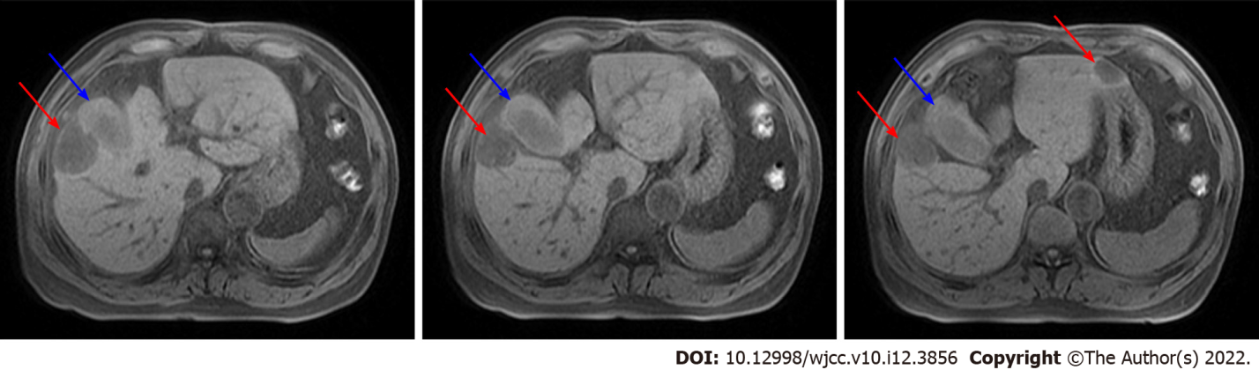
Figure 1 Abdominal magnetic resonance imaging in December 2014. Abdominal magnetic resonance imaging showed the tumor infiltrated the whole stratum of the gallbladder wall (blue arrow) and metastasized to the left and right liver (red arrow).

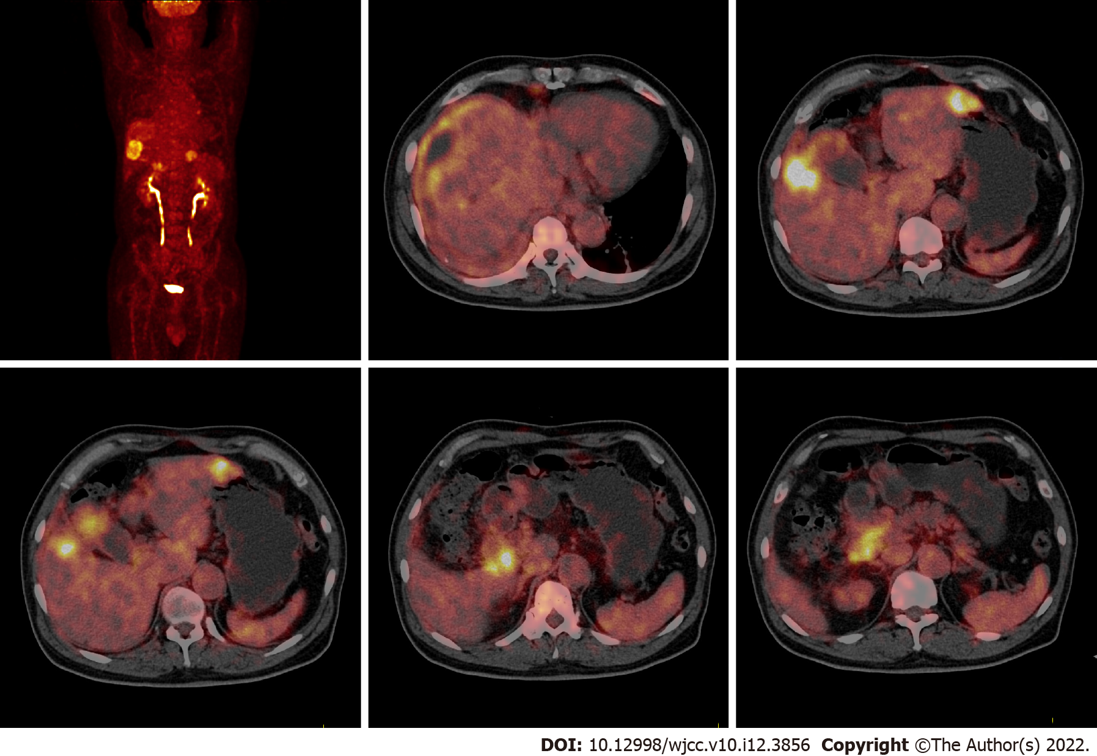
Figure 2 ¹⁸F-fluorodeoxyglucose positron emission tomography/computed tomography in December 2014. ¹⁸F-fluorodeoxyglucose positron emission tomography/computed tomography depicted gallbladder cancer with multiple liver metastases, peritoneum metastasis, diaphragm metastasis and lymph node metastases.

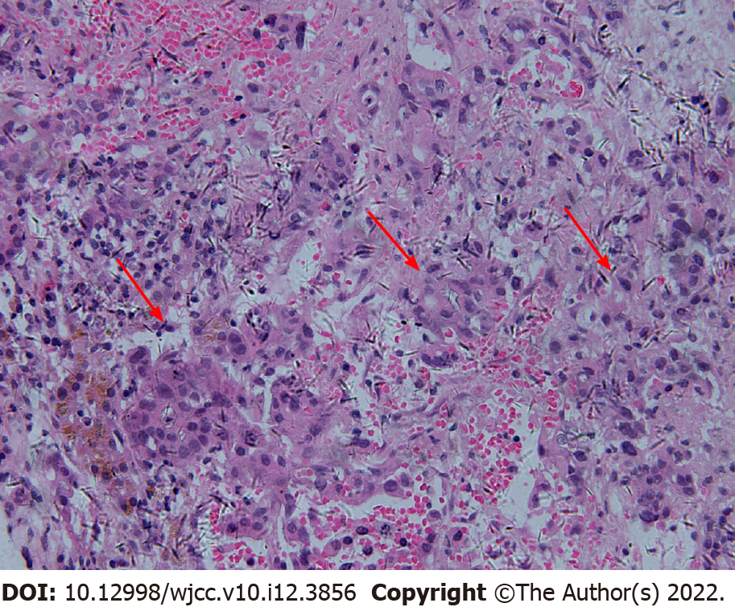
Figure 3 Pathology of fine needle aspiration of the liver metastases in December 2014. Pathological result indicated that adenocarcinoma, and the tumor cells showed a tubular and nested infiltrating growth (red arrow).

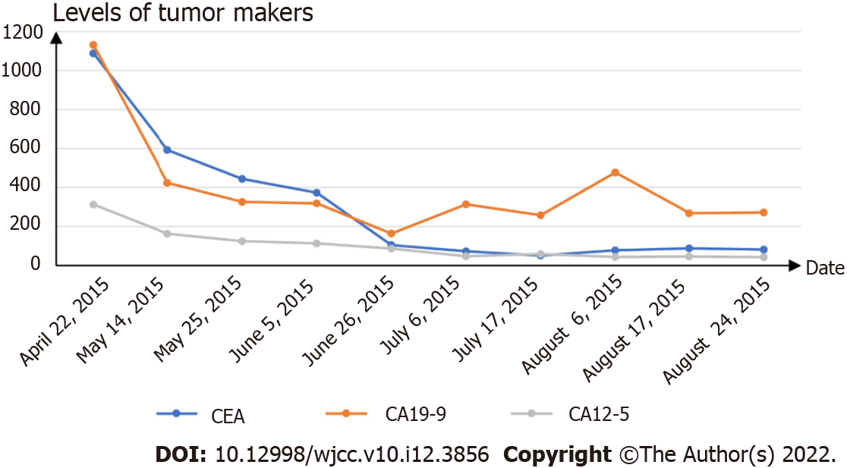
Figure 4 The tumor markers levels during chemotherapy and targeted therapy. The levels of carcinoembryonic antigen, carbohydrate antigen19-9 (CA19-9) and CA12-5 gradually decreased but remained higher than the normal levels during chemotherapy and targeted therapy. CEA: Carcinoembryonic antigen; CA19-9: Carbohydrate antigen19-9; CA12-5: Carbohydrate antigen12-5.

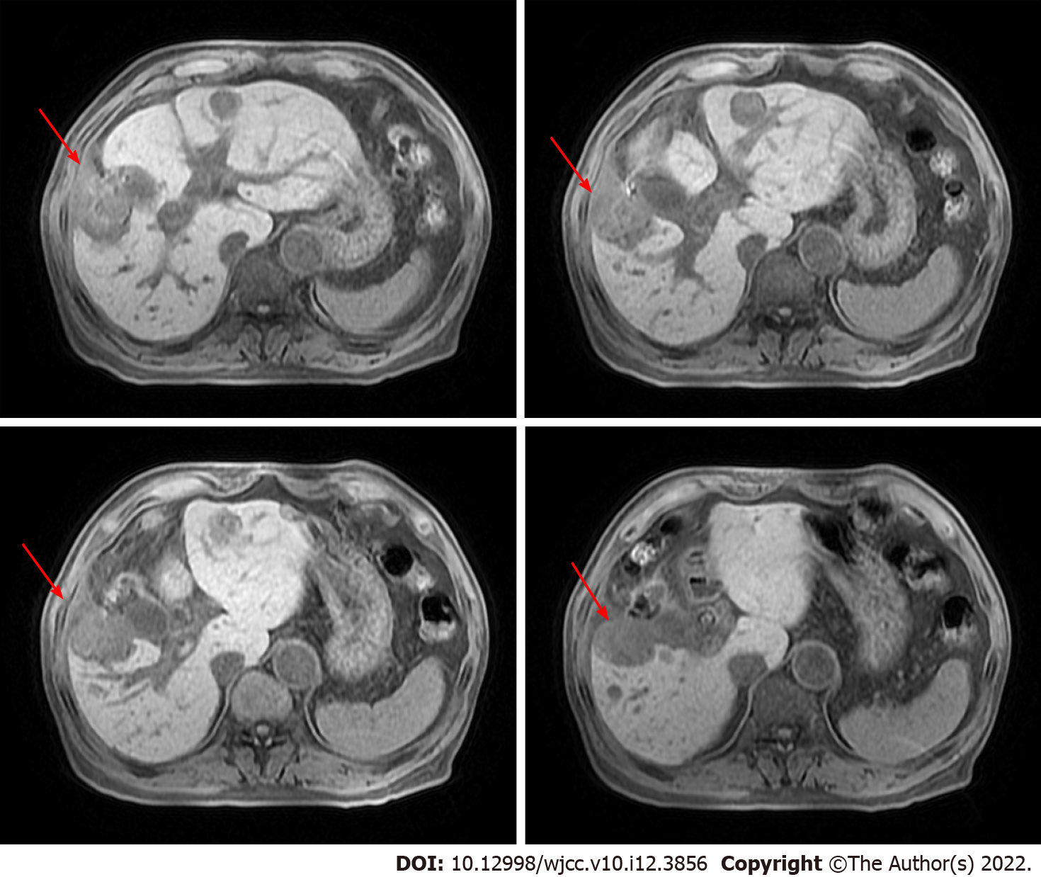
Figure 5 Abdominal magnetic resonance imaging in August 2015. Abdominal magnetic resonance imaging showed that the gallbladder was malformed and that the right liver metastasis was larger than the prior scan (red arrow).

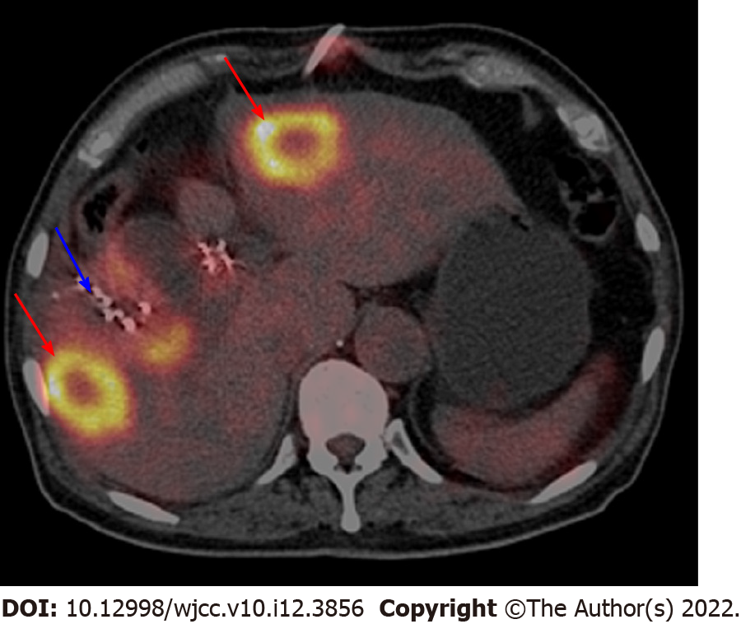
Figure 6 ¹⁸F-fluorodeoxyglucose positron emission tomography/computed tomography in March 2016. ¹⁸F-fluorodeoxyglucose positron emission tomography/computed tomography showed that ¹²⁵I seeds were around the gallbladder, but the gallbladder was not clearly visible (blue arrow). The left and right liver metastases still existed (red arrow).

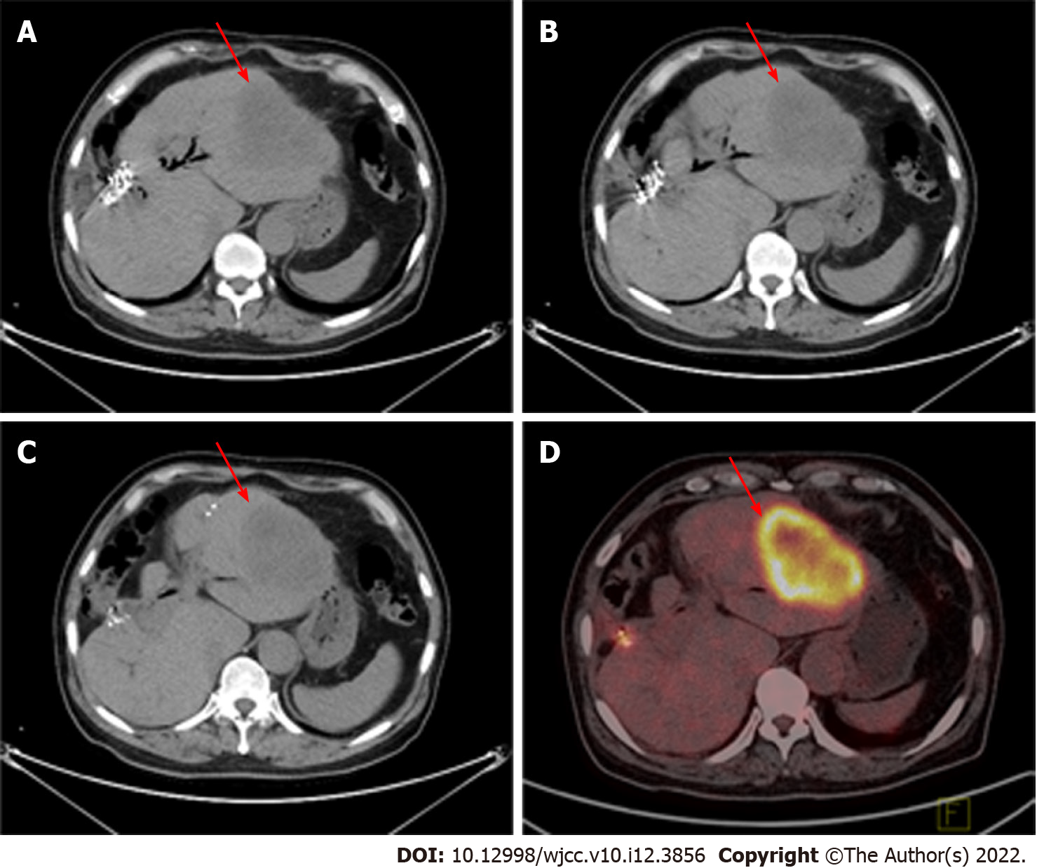
Figure 7 Abdominal computed tomography and ¹⁸F-fluorodeoxyglucose positron emission tomography/computed tomography in February 2018. A-C: Abdominal computed tomography showed that the gallbladder had disappeared and that the liver metastasis was limited to the left liver (red arrow); D: ¹⁸F-fluorodeoxyglucose positron emission tomography/computed tomography showed that the liver metastasis was limited to the left liver (red arrow).

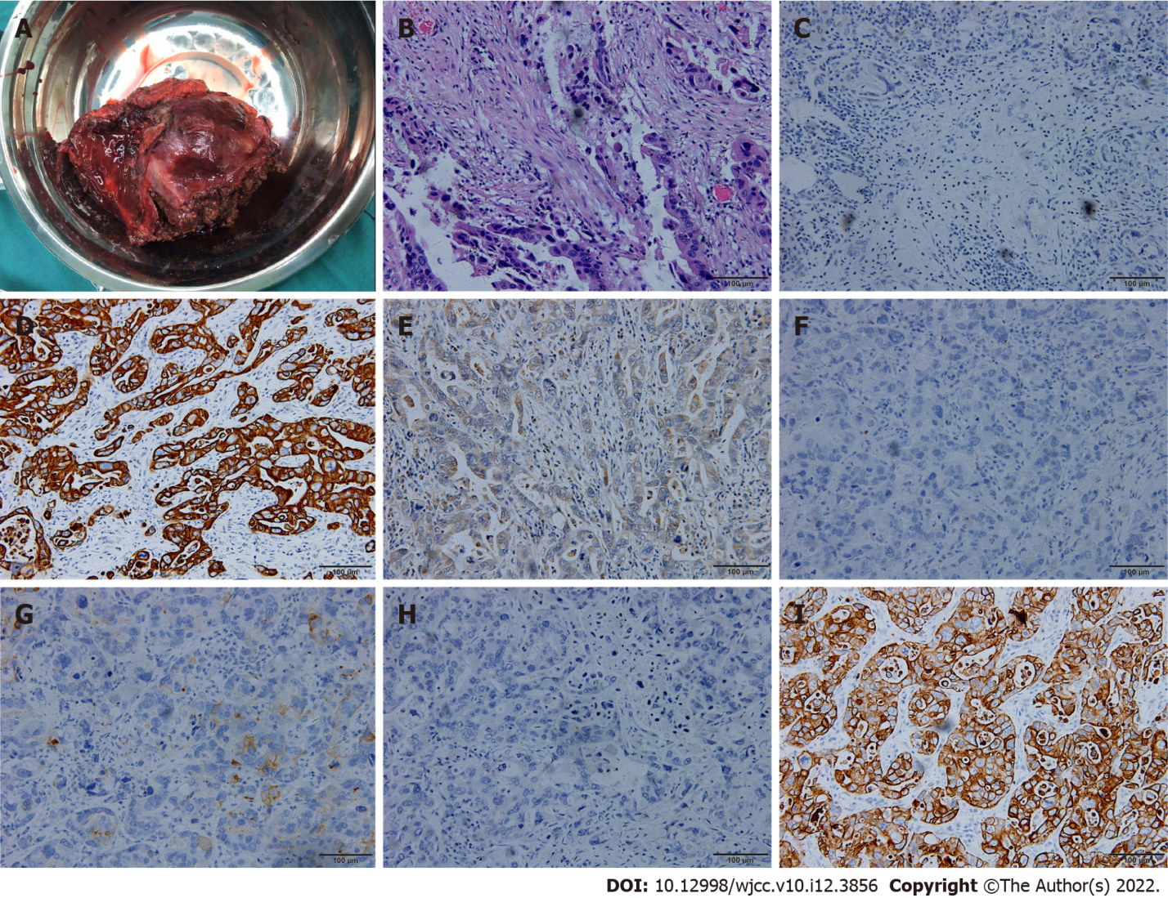
Figure 8 Surgical specimen, hematoxylin-eosin staining and immunohistochemical examination. A: Surgical specimen; B: Hematoxylin-eosin staining showed tumor cells grew in infiltrating glandular ducts and nests (× 200); C: Immunohistochemical examination indicated ARGINASE-1 (-) (× 200); D: Immunohistochemical examination indicated CK19 (+) (× 200); E: Immunohistochemical examination indicated GPC-3 (partial +) (× 200); F: Immunohistochemical examination indicated hep-par (-) (× 200); G: Immunohistochemical examination indicated CEA (partial+) (× 200); H: Immunohistochemical examination indicated CK20 (-) (× 200); I: Immunohistochemical examination indicated CK7 (+) (× 200).

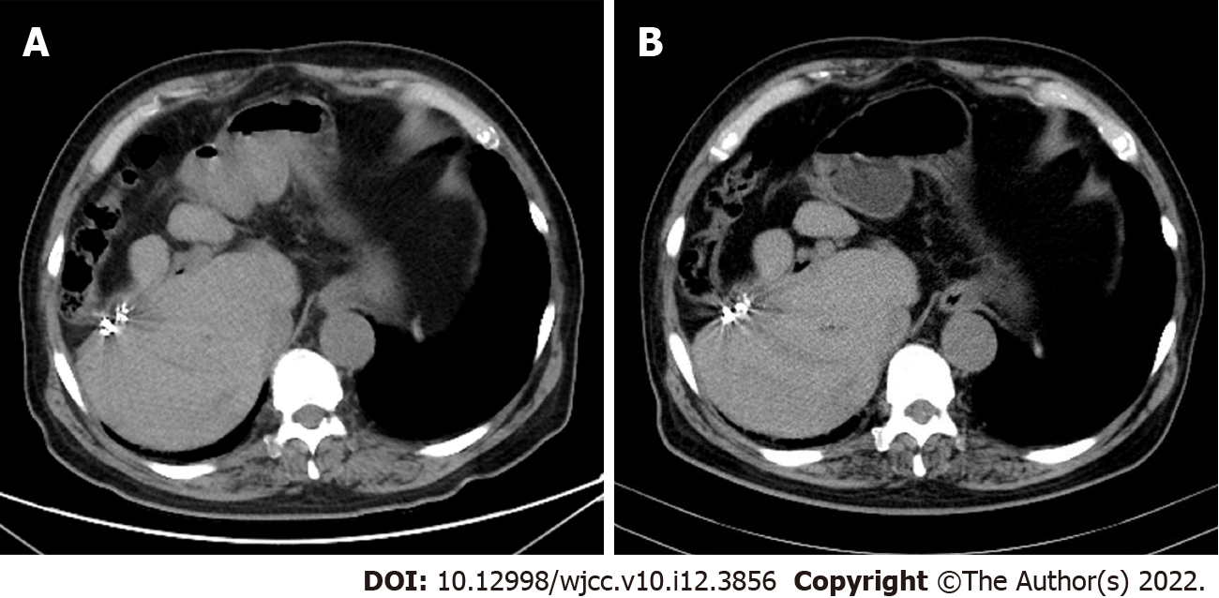
Figure 9 Abdominal computed tomography of follow-up. A: Abdominal computed tomography (CT) in October 2019 showed postoperative changes and no signs of tumor recurrence; B: Abdominal CT in March 2021 showed postoperative changes and no signs of tumor recurrence.

Published by Baishideng Publishing Group Inc
7041 Koll Center Parkway, Suite 160, Pleasanton, CA 94566, USA
Telephone: +1-925-3991568
E-mail: bpgoffice@wjgnet.com
Help Desk: https://www.f6publishing.com/helpdesk
https://www.wjgnet.com

© 2022 Baishideng Publishing Group Inc. All rights reserved.

